March 14, 2014, 1:42 pm

NYT

China’s Online Goliaths Prepare Public Offerings in U.S.
By MICHAEL J. DE LA MERCED
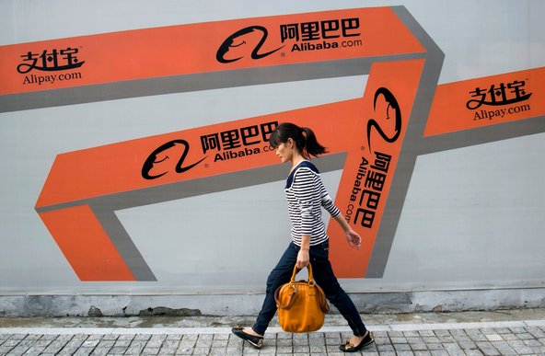
A woman walks past an Alibaba advertisement on a wall in Hangzhou, China.
Updated, 7:38 p.m. | The Chinese Internet industry is coming of age, as some of its biggest players prepare to start new chapters as publicly traded companies — in the United States.
The biggest of them all, the e-commerce behemoth Alibaba Group, is aiming to file for an initial public offering in New York as soon as next month, people briefed on the matter said on Friday. Several analysts value Alibaba at north of $130 billion, and many predict that its I.P.O. may raise more than the $16 billion that Facebook fetched in its market debut nearly two years ago.
And Weibo, a major Chinese microblogging company seen as that country’s answer to Twitter, filed on Friday for its own stock sale.

Related Links
- Sorkin: The Man Behind Alibaba’s Eventual I.P.O. (Jan. 13, 2014)
- Weibo's prospectus
Should the two companies move forward with their plans, they could form the second wave of Chinese Internet I.P.O.s, nearly a decade after Tencent and the search engine Baidu went public.
Earlier this year, JD.com, Alibaba’s principal rival in the e-commerce market in China, filed for its own stock offering in the United States.
Unlike a wave of Chinese companies that sought American stock listings several years ago — some of which have since collapsed in the face of accounting scandals — these are Goliaths.
The latest crop of companies has also chosen to file in the United States, which has enjoyed an abundance of I.P.O.s over the last few years. A swell of American Internet start-ups like Dropbox and Box are primed to join the parade of newly public companies in the next year or two, following in the footsteps of Facebook and Twitter.
Largely unchallenged by foreign competitors, the Chinese companies have come to dominate what is seen as the next frontier of the Internet. E-commerce has become especially important, as Chinese consumers increasingly flock to online marketplaces rather than traditional physical retailers.
And these companies continue to expand into new businesses as they keep up with the migration of online users to mobile devices. (Alibaba, for instance, owns a roughly 19 percent stake in Weibo and has the right to raise that to 30 percent. )
Despite being confined mainly to Chinese-speaking users, Weibo has become one of the most talked-about social networks in the world. The company claimed 129.1 million monthly active users as of year-end, compared with Twitter’s 241 million.
Alibaba’s investment in Weibo last year valued the messaging service at about $3.3 billion. Though its prospectus on Friday listed a fund-raising target of $500 million, the company may seek to raise significantly more.
But by far the most anticipated offering on Wall Street is Alibaba’s. Virtually every major investment bank has journeyed to Hong Kong to make its pitch to Alibaba’s management team, particularly its founder, Jack Ma, and its executive vice chairman, Joseph Tsai. Executives like Jamie Dimon of JPMorgan Chase have dined with Mr. Ma with an aim to secure a coveted role on the forthcoming stock sale.
While the company has yet to formally hire underwriters, two longtime advisers, Credit Suisse and Morgan Stanley, are expected to play big roles in the offering, the people briefed on the matter said.
The company has not yet decided whether it will list itself on the New York Stock Exchange or the Nasdaq market, though both markets have pitched hard to win the listing.
Alibaba’s decision to list in the United States reflects its decision to snub the Hong Kong Stock Exchange, which has resisted overtures to bless the company’s partnership structure. The scheme is meant to help a group of insiders maintain control over the board.
But the Hong Kong exchange, which has traditionally prohibited corporate structures that let minority shareholders preserve control of companies, refused to make an exception. While Alibaba may still change its mind, the company currently plans to seek a listing in New York, two of the people briefed on the matter said.
A spokeswoman for Alibaba said that the company had not yet settled on a timetable, venue or underwriters for its offering. Representatives for Morgan Stanley and Credit Suisse declined to comment.
Founded in 1999 as a marketplace for businesses to trade goods like circuit breakers and hydraulic cylinders with other companies, Alibaba has become a behemoth that is part eBay, part Google and part PayPal. Its sales volume in 2012, $160 billion, was nearly twice that of Amazon.com, according to RetailNet Group.
Over the last several years, the company has posted stunning growth — fast enough that investors grew concerned when in January Alibaba disclosed only a 51 percent gain in revenue for its third quarter, to $1.8 billion.
Among the biggest beneficiaries of Alibaba’s success has been Yahoo, which maintains a 24 percent stake in the Chinese company.
Alibaba, however, does face pressure from rivals like Tencent. Earlier this week, Tencent said that it planned to buy a 15 percent stake in JD.com, strengthening Alibaba’s main rival in online commerce.
Nonetheless, some analysts say they believe that the strength of Alibaba’s platforms will be difficult to overcome for now.
“They have such a strong position that it would be hard to erode that market share in the short term,” Zia Daniell Wigder, an analyst with Forrester Research, said.

NYT

Alibaba I.P.O. May Unleash Global Fight Over Users
APRIL 30, 2014
Farhad Manjoo
STATE OF THE ART
The largest technology stock offering in history is looming, but few in Silicon Valley seem to care.
The initial public offering expected soon in the United States by Alibaba Group Holding, China’s largest e-commerce company, could surpass the amount raised in the I.P.O. of Facebook. It would not even be surprising if it surpassed the combined amounts raised in the I.P.O.s of Facebook, Twitter, Google, Amazon, AOL and Yahoo. But unlike the flurry of attention that accompanies high-profile floats by American tech stars, Alibaba’s stock offering has barely registered among the valley’s tech set.
San Francisco’s artisanal toast bars have not been abuzz with commentary on Jack Ma, Alibaba’s chairman, and Palo Alto’s Tesla dealerships aren’t bracing for a surge in new buyers. In interviews, a few Silicon Valley investors said they didn’t expect the offering to be a big deal in the markets they follow, though they declined to speak on the record about their apathy.
The issue isn’t that the valley is ignorant of the rise of Chinese Internet giants. It’s more that American tech firms have long been spurned and surprised by China’s tech market, and many here aren’t sure how to gauge the ambitions of the giants like Alibaba now bent on crossing the Pacific.
“Chinese Internet companies and American Internet companies are eyeing each other’s markets, but they’re very disconnected from one another,” said Yan Anthea Zhang, a professor at the Jesse H. Jones Graduate School of Business at Rice University who closely studies businesses in China.
A decade ago, American tech companies saw an economically emergent China as the next great frontier, a place where new money and users would combine to form the world’s greatest market for their products.
But cultural, political and technological forces buffeted their dreams. While American firms largely failed to make headway in China, a raft of homegrown companies, Alibaba among them, took over vast swaths of the growing Chinese market.
There are now Chinese analogues to Amazon, Google, Facebook, Twitter, eBay and PayPal. American and Chinese firms operate across a vast gulf, each eyeing global domination — and each essentially pretending the other doesn’t exist.
Alibaba’s gigantic I.P.O. may signal a shift, the end of an era of mutually beneficial provincialism. “They are now going to try to fight more directly in each other’s territory,” Dr. Zhang said. “In both the United States and Chinese markets, we are going to see competition heating up.”
Before we get to that fight, it’s worth examining how American web companies lost the Chinese market. In 2004, Meg Whitman, then the chief executive of eBay, predicted in an interview with CBS News that the company’s Chinese subsidiary, eBay EachNet, would soon become the auction site’s largest moneymaker.
At the time, American web companies were initiating a spree of investments and expansion plans in China. Yahoo invested $1 billion in Alibaba in 2005. Amazon purchased Joyo.com, a Chinese e-commerce firm, which was expected to be the vanguard for the retailer’s plans to dominate China.
Photo
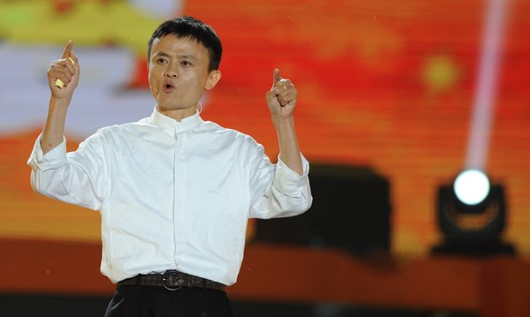
Jack Ma started Alibaba in 1999 with 17 other people. The company's expected initial public offering could surpass the amount raised in the I.P.O. of Facebook. Credit Peter Parks/Agence France-Presse — Getty Images
But many American tech efforts to expand in China proved fruitless, often because the American companies didn’t understand China.
For example, in its early years, eBay EachNet grew to command more than 70 percent of the Chinese e-commerce market for sales between consumers, as William P. Barnett, a professor at the Stanford Graduate Business School, writes in a fascinating case study on the Chinese e-commerce market.
Then in 2003, Jack Ma, of Alibaba, started a consumer-to-consumer site, Taobao, that quickly eroded eBay’s lead by relying on a simple, powerful advantage: Ma gave Taobao features that tapped into the nuances of the Chinese market. “EBay may be a shark in the ocean, but I am a crocodile in the Yangtze River,” Mr. Ma once told an interviewer. “If we fight in the ocean, we lose — but if we fight in the river, we win.”
Unlike EachNet (and the American eBay), Mr. Ma’s company did not charge sellers fees to list their merchandise. This appealed to struggling Chinese who were looking to start small side businesses without a huge investment. Taobao also incorporated tech features that resonated with local culture. An online chat included on the site — again, not available on EachNet — gave users a sense of community that they reported lacking on eBay.
Taobao also let buyers and sellers bargain with one another, and its web design mimicked the departments of offline Chinese retailers, while eBay’s categories were lifted from its American site.
And given its international operation in markets with strict laws around trademarks, eBay was also forced to remain wary of counterfeit merchandise appearing on its pages, a concern that Alibaba didn’t have to consider.
EBay EachNet’s market share began to plummet, and by around 2007, it was dead. Amazon — with which Taobao and its sister site, Tmall, also compete — has been similarly stalled in China; the American online retailer, through its Amazon.cn site, now accounts for less than 1 percent of China’s e-commerce market, according to some estimates.
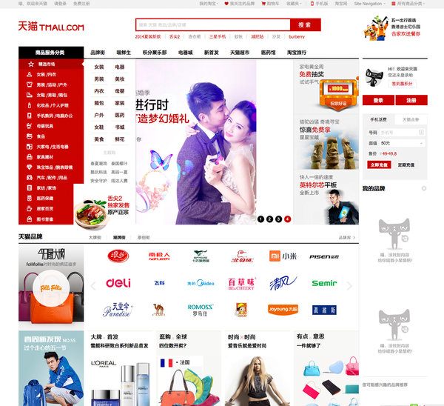
Tmall.com is one of the e-commerce sites run by Alibaba.
Taobao has become one of the jewels of Alibaba’s empire, accounting for more than 70 percent of the Chinese market for consumer-to-consumer online sales. Altogether, Alibaba has been said to account for four-fifths of online purchases in China.
But the problems of American tech firms in China go beyond culture. They have also suffered as a result of politics.
In 2010, after an attack by Chinese hackers on its corporate infrastructure, Google decided to remove its Chinese service. Though the company had acceded to the Chinese government’s demand to censor its site, the firm had long lagged behind the search engine Baidu in China. After Google’s withdrawal, Baidu became even larger.
The Google story — in which government interference creates a difficult business climate for American companies — is a common one in China.
“The Chinese government does not want foreign Internet companies to have a big piece of that market,” said James McGregor, the chairman of the Greater China office of APCO Worldwide, a strategy consulting firm. “They want their own Facebooks, they want their own Twitters. It’s not an open market for foreign Internet companies.”
Alibaba’s offering now raises the opposite question: Will Americans and the American government tolerate the rise of Chinese Internet firms on their soil? More than that, will Alibaba and other rising Chinese companies manage cultural differences any better than American firms did in China?
So far, Alibaba’s approach has been to go slow. The company lately began a string of investments in the United States, including in ShopRunner, an e-commerce company that offers a rival to Amazon’s Prime free-shipping service, and Lyft, a ride-sharing service. WeChat, a messaging application owned by the Chinese web king Tencent, began marketing its app more aggressively to American users this year.
At the same time, the battle for global Web domination has spread far beyond just home turfs. American and Chinese companies are now increasingly competing over emerging markets in Asia and Africa, where Internet infrastructure is just beginning to roll out, and which may prove to be the next great battleground for global Internet hegemony.
To ring in that fight, Tencent’s WeChat recently began airing an ad in South Africa featuring a Mark Zuckerberg impersonator weeping on a therapist’s couch over the customers he’s losing to WeChat. The doctor warns the Facebook founder to pipe down — or else he, too, will drop Facebook for the Chinese app.
Sure, it’s a gimmicky bit of marketing. But maybe the direct approach will finally get American technology giants to pay attention to their Chinese counterparts.
Business Week

Technology

How China's Government Set Up Alibaba's Success
By Bruce Einhorn May 07, 2014

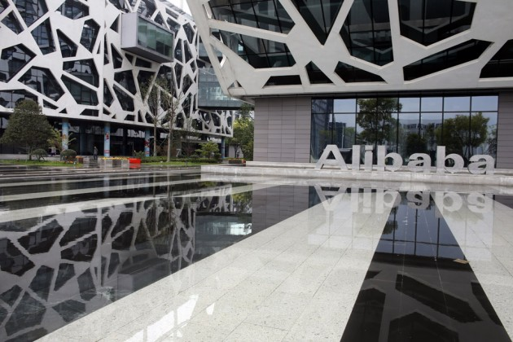
The Alibaba Group headquarters in Hangzhou, China
China isn’t big enough for Alibaba. The e-commerce company has ambitions to expand far beyond China, and by filing yesterday for its initial public offering in the U.S., Alibaba has moved closer to that goal. It could raise as much as $20 billion, making it the biggest-ever U.S. IPO.
As Co-founder and Chairman Jack Ma expands his business around the world, he’ll have a group of influential fans in Beijing. Chinese government officials are eager for a local company to break into the ranks of tech’s global elite, and the huge payoff for Alibaba will highlight just how valuable official Chinese support can be. Alibaba’s rise has been propelled by government policies that have made China a very inhospitable place for U.S. companies—and provided local champions such as Alibaba with the space they need to become viable players globally.
Social networking: Alibaba was relatively slow to move into social networks, but the company has been playing catchup. Last year it became a major shareholder in Sina Weibo (SINA), a microblogging service that would compete with Twitter (TWTR) and Facebook (FB)—if those companies were allowed to operate in China. They aren’t. The Chinese government has banned them. As a result, Alibaba had an unimpeded entry into the world’s largest Internet market, even though it was a relative latecomer, and it will continue to grow without challenge from American competition.
Story: Alibaba Files for an IPO: Why You Should Care
Online video: Just as Chinese can’t check their Facebook pages or send tweets, they can’t access video clips on YouTube (GOOG). The Chinese government has banned Google’s online video service for years. And of late, Ma has shown a lot more interest in video. He owns 5.5 percent of Huayi Brothers Media (300027:CH), a film and TV production company in Beijing, and on April 29, Alibaba and Yunfeng Capital, a private-equity firm co-founded by Ma, agreed to pay $1.22 billion for a stake in Beijing-based Internet television company Youku Tudou (YOKU). As with social networking, the Chinese government has kept the world’s biggest competitor out of Alibaba’s way.
E-commerce. There’s nothing to prevent U.S. companies from trying to take on Chinese e-commerce companies, including Alibaba’s Taobao and Tmall. Taobao first gained prominence as the scrappy challenger that foiled EBay’s (EBAY) ambitions in China. While EBay couldn’t match Alibaba, others are still trying, most notably Amazon (AMZN) and Wal-Mart (WMT). Amazon in 2004 bought Joyo.com, the online retailer co-founded by Lei Jun, an entrepreneur who went on to start smartphone sensation Xiaomi. Walmart in 2012 took control of Yihaodian (“No. 1 Store”), an online retailer.
While the Chinese government doesn’t ban U.S. companies from operating in China, it doesn’t make their lives easy. Regulators seem eager to target foreigners for alleged misdeeds. Walmart is a particularly juicy target; the government has penalized the retailer for offenses such as mislabeling fox meat as donkey meat. (Donkey meat? “Better than veal,” food enthusiast Andrew Zimmern told NPR.)
Story: How Alibaba's IPO Is Even Helping Its Rivals
Amazon hasn’t faced comparable scrutiny in China, but that could just be a sign of how little success the company has had in the country. A decade after it acquired Joyo, since rebranded Amazon.cn, the company has only a 6 percent market share, Bloomberg Industries analysts Praveen Menon and Paul Sweeney wrote in a report published on April 25. Amazon isn’t giving up—Chief Financial Officer Tom Szkutak has said the company is increasing its investments there—but pursuing market share in China and additional markets outside the U.S. contributed to a record $60 million loss for Amazon International in the first quarter.
Still, Jeff Bezos should be grateful. At least Amazon has the chance to compete against Alibaba in the world’s largest country. Other U.S. companies aren’t so fortunate, to Alibaba’s great benefit.

NYT

Alibaba Is Investing Huge Sums in an Array of U.S. Tech Companies
By MIKE ISAAC and MICHAEL J. de la MERCEDJULY 31, 2014
Continue reading the main story Video
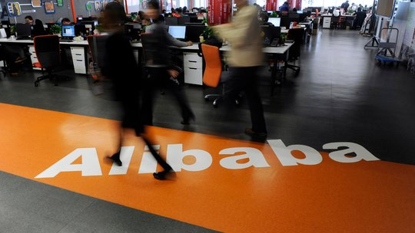
VIDEO @ http://www.nytimes.com/2014/08/01/technology/alibaba-is-investing-huge-sums-in-an-array-of-us-tech-companies.html?hpw&action=click&pgtype=Homepage&version=HpHedThumbWell&module=well-region&region=bottom-well&WT.nav=bottom-well&_r=0
Alibaba, China’s largest e-commerce company, is preparing to go public in New York. When it does, it could be one of the largest public offerings ever in the United States.
Alibaba Group, the Chinese Internet retailer, is coming to America with its checkbook wide open.
In March, Alibaba made a $215 million investment in Tango, a messaging app. It recently contacted Snapchat, another messaging app that this year turned down a $3 billion acquisition offer from Facebook, about making a big investment that would value the young company at $10 billion.
There’s more: Alibaba participated in a $170 million round for Fanatics, an online sports memorabilia retailer. And on Thursday, Kabam, a video game start-up, announced that it has received a $120 million investment from Alibaba. The new round gives Alibaba a board seat and what is likely a significant stake in Kabam, which said it is now worth more than $1 billion.
The recent burst of activity — including a half-dozen investments in the United States over the past year or so — comes as the Internet behemoth prepares one of the most highly anticipated market debuts since Facebook’s two years ago. Alibaba is expected to begin trading in September at a market value of perhaps $200 billion, potentially making it one of the biggest initial public offerings ever.
Photo
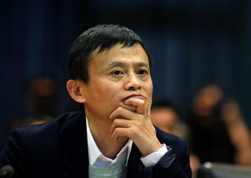
Jack Ma, co-founder of Alibaba, which recently has made a half-dozen major investments in American start-ups. Credit Carlos Barria/Reuters
It would be simple to declare that Alibaba, which became a tech powerhouse by amassing a sprawling collection of businesses in its home country, is trying to take its omnivorous approach to the United States, and it is willing to spend big to make that happen.
But the recent investments aren’t just about size. Alibaba is also rubbing elbows in the sometimes insular world of Silicon Valley-funded start-ups, where a handful of plugged-in financiers can help the company spot the next breakout smartphone app or e-commerce trend before it hits the mainstream.
“With investments like these, they get good products, they make a splash, and most importantly, they build connections and trust amongst the venture capitalists,” said Sameet Sinha, an Internet analyst with B. Riley & Company, a small investment firm.
A spokesman for Alibaba declined to comment on its investment strategy, though the Chinese company has outlined the principles behind its approach in documents filed for its I.P.O. In the formal language of regulatory papers, Alibaba said it wants to get more users, improve how they use its services and improve its customers relations.
It is not so clear, of course, how investments as different as sports memorabilia and messaging apps fit neatly into that plan, but it is clear that Alibaba has made its North American investments a priority.

Alibaba’s American Ambitions
As the company prepares for its initial public offering, it has beefed up its investment strategy to find a stronger foothold in growing markets.
J. Emilio Flores for The New York Times

Messaging
With an exploding market in mobile messaging, Alibaba has been in talks with Snapchat about an investment after putting $215 million into another messaging app, Tango.
Sarah Beth Glicksteen for The New York Times

Retailing
Alibaba took a stake last year in Fanatics, an online sports apparel retailer, giving it a foothold in a category where Amazon is dedicating more resources.
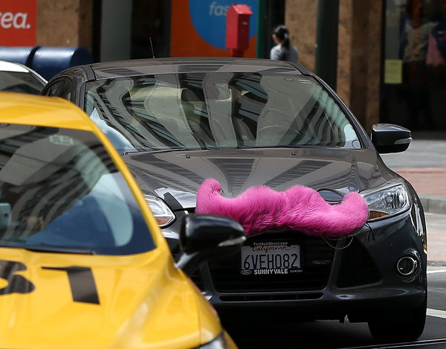
Justin Sullivan/Getty Images

Peer-to-Peer
The so-called sharing economy has also drawn Alibaba’s interest, with its participation in a $250 million funding round this year for the ride-sharing service Lyft.
They are led by Michael Zeisser, a native of France who formerly led the digital commerce division of Liberty Media. Mr. Zeisser was recruited by — and reports to — Joseph C. Tsai, Alibaba’s vice chairman.
Given a broad mandate by Alibaba’s top management, Mr. Zeisser and his team have been charged with nothing less than turning their employer into a global Internet and e-commerce colossus.
“When you own 45 percent of the e-commerce market in China and you want to continue to grow, international market share is obviously a green field that you can go after,” said Eric Setton, Tango’s chief technology officer and co-founder.
That has led to an array of investments in other seemingly disparate companies, including Lyft, a popular ride-sharing service that recently started operating in New York, and ShopRunner, an e-commerce delivery start-up.
Though they may appear loosely connected, many of the stakes that Alibaba has taken have focused on mobile and e-commerce. Tango has hinted that it plans to introduce some form of shopping in its services, while Kabam offers Alibaba the chance to learn about in-app purchases.
Photo
Eric Setton, writing, co-founder of Tango, which received a $215 million investment from Alibaba, as well as strategic advice. Credit Peter DaSilva for The New York Times
Elsewhere, in recent months Alibaba has struck deals to buy full control of AutoNavi, a Chinese mapping service listed in the United States, and a 50 percent stake in one of China’s top soccer teams. According to some reports — and distressingly to some potential investors — Alibaba co-founder Jack Ma decided to buy the stake in Guangzhou Evergrande in about 15 minutes after having had drinks with the club’s owner.
Alibaba’s investment plan is not aimed at directly competing with established American Internet heavyweights like Amazon and eBay, however. In its I.P.O. prospectus, Alibaba says that its investments will remain focused on China, where the company still sees enormous growth potential.
For the American start-ups in Alibaba’s embrace, there are benefits beyond the investment. Kabam, for instance, receives a direct line into China, one of the fastest growing smartphone and gaming markets of the past decade. Some 40 percent of global smartphone shipments in the first quarter of 2014 were bound for Chinese consumers, according to IDC, a research firm.
It is not, however, a simple market for a Western company to enter. Alibaba’s knowledge of China’s web-connected consumers could help American start-ups navigate the unfamiliar landscape.
“Entering Asia is very complex,” said Kent Wakeford, chief operating officer of Kabam. “There are different payments systems, different types of phones and tablets to deal with. Even the culturalization is different.”
Mr. Zeisser and his team have spent significant amounts of time helping their newfound partners, executives at the portfolio companies have said, advising on strategies and helping solve problems.
“They’ve been quite active and contribute significantly on our strategy,” Mr. Setton of Tango said. “They have also given us the financial chops to be able to do things we wouldn’t have been able to do before.

Alibaba’s Next Move: Grow Abroad, or Go Deeper into China?
Oct 01, 2014
- Asia-Pacific
- China
- North America
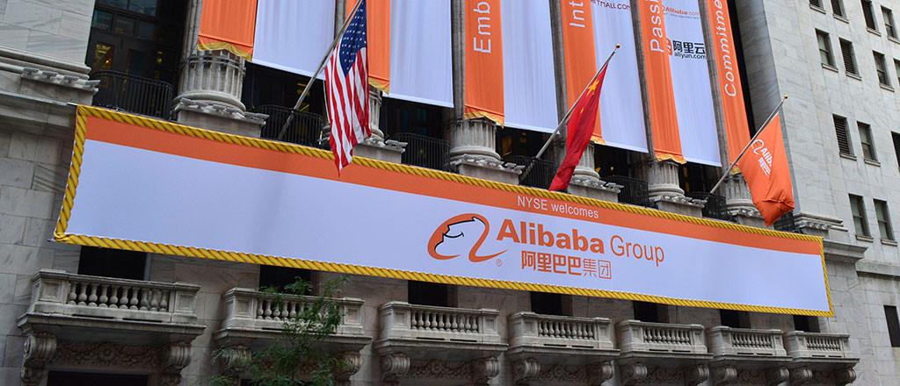
It is hard not to be impressed with Alibaba. After raising $25 billion in a U.S. initial public offering earlier this month, the company that was founded 15 years ago in a modest apartment in southeastern China has officially minted the biggest IPO on record. With a market value of $220 billion, Alibaba is worth more than Facebook, Amazon or eBay. And now that it has a substantial war chest, what is next for the Chinese e-commerce giant?
Co-founder and executive chairman Jack Ma recently shared a bit of his grand vision. “We want to be bigger than Wal-Mart,” he said in a September 19 interview on CNBC, the day Alibaba went public on the New York Stock Exchange, during which investor demand drove up the stock by 38%. “We hope in 15 years, they’ll say this is a company like Microsoft, like IBM, like Wal-Mart. [Those companies] changed, shaped the world.”
Alibaba is well on its way, at least in China. As the largest e-commerce company there, Alibaba counts 279 million annual active buyers who place 14.5 billion orders a year. Three businesses brought in 82% of its fiscal 2014 revenue of $8.46 billion: shopping sites Taobao.com and Tmall.com and group buying marketplace Juhuasuan.com. The company also operates Alibaba.com, which connects small businesses around the world with Chinese suppliers. Taobao and Tmall are the largest companies in their markets when measured by the value of all the goods they handle. Alibaba.com is the largest wholesale marketplace by revenue, while Juhuasuan tops the ranking in monthly active users.
But now Ma and his leadership team have a tough task ahead: positioning the company for its next phase of growth. The strategic path chosen by the executive team is critical to shaping Alibaba’s future. Will the company continue to focus on developing its business in China for the next few years, or will it shift its attention to international expansion through acquisitions or partnerships? Ma himself is still pondering his strategy: “I’ve been thinking about the next five to 10 years, how I can make these shareholders happy,” he told CNBC. But he emphasized that pleasing shareholders will come after taking care of customers and employees, in that order.
“There could be enormous opportunity at the periphery of China.”– Marshall Meyer
A prospectus filed with the U.S. Securities and Exchange Commission on September 22 provides a clearer glimpse of Alibaba’s business plans. The company said it is seeking to increase market share in China by attracting new customers and motivating existing clients to purchase more products through loyalty programs, providing good customer service as well as using marketing and promotional campaigns. It also plans to expand its mobile presence by offering digital content and location-based services, among others. Alibaba will continue to invest in data and cloud computing services to help its own business as well as its cadre of merchant customers. Internationally, the company said it would like to continue facilitating relationships between Chinese merchants and consumers with foreign buyers and sellers.
As a public company, Alibaba will face pressure from investors who are betting on continued robust growth of its business. So far, Alibaba has not disappointed. In fiscal year 2014, which ended on March 31, revenues grew by 52% to RMB 52.5 billion from the prior year. From 2012 to 2013, revenues were up 72%. Profits have continued to soar as well, shooting up 175% in 2014 from the prior year and doubling from 2012 to 2013.
Marshall Meyer, Wharton emeritus professor of management, believes Alibaba will be better off focusing on China and surrounding Asian countries, where e-commerce is not fully developed yet. In those markets, Alibaba’s more advanced platforms would have an advantage over local players, an edge it would not enjoy in more developed nations with entrenched competitors. “There could be enormous opportunity at the periphery of China,” he says. “Go deeper elsewhere in China…. That’s what I would do, rather than fight Amazon here in the U.S.”
Online Shopping Sprees
Qiaowei Shen, Wharton professor of marketing, notes that Alibaba still has plenty of growth opportunities in China because the number of shoppers going online continues to increase. “E-commerce is getting very, very popular in China. It’s amazing how fast it is growing — not only in the big cities, but also in second- and third-tier cities.”
Shen says the dearth of retail stores and the limited product selection available at brick-and-mortar stores have motivated Chinese shoppers to go online. On the Internet, not only will they find a greater variety of products, but also goods tend to have lower prices. As consumers flock to these sites, entrepreneurs are springing up to cater to them. “Even farmers are selling their vegetables on this platform,” Shen says.
By Alibaba’s own reckoning, the Chinese e-commerce market is largely untapped. According to its SEC filing, less than a quarter of China’s 1.35 billion people shop online, even though half of them are on the Internet. Overall, online shopping makes up only 8% of China’s total consumption. While China’s economy has cooled, it remains a growing market, and “that alone could propel [Alibaba] along,” Meyer notes.
But to keep the online shopping market robust, an adequate infrastructure for the delivery of products must be in place, Meyer adds. “They’re in the business of moving goods to customers — that’s where the problem comes,” because delivery can be spotty. But Shen points out that the growth of e-commerce has propelled the development of the logistics infrastructure industry in China as well. “They have grown really, really fast,” she says. Delivery now can be quick and cheap. In its SEC filing, Alibaba said China has an “increasingly extensive and rapidly improving” logistics backbone. The company uses third-party providers of logistics services to deliver its products and China Smart Logistics, a 48%-owned affiliate.
Another Alibaba headache is dealing with the competition. While it is by far the largest player, commanding half of the market, smaller rivals have sprung up and are chipping away at its business. “The competition in China is actually very severe even though it’s a big market,” Shen notes. Competitors are differentiating themselves from Alibaba by specializing in certain goods. The recently public JD.com, for instance, began with a specialty in electronics. In contrast, most of Alibaba’s sites are general in nature; anyone can sell anything.
“The competition in China is actually very severe even though it’s a big market.” –Qiaowei Shen
Wharton marketing professor David Hsu predicts that at some point, the Chinese e-commerce market will become so crowded that it will be difficult for Alibaba to differentiate itself. But the company can stay ahead of its competitors by offering services that are new or needed by Chinese consumers. For instance, Alibaba can offer financial services to its customers as an extension of its core e-commerce business.
While Alibaba has separated from Alipay, its payments platform, Hsu envisions a day when the company will offer insurance and other financial services to its business customers. Indeed, Alibaba is moving in that direction: One of its affiliates that is also the parent of Alipay just got approval from Chinese authorities to set up a privately owned bank, according to a September 29 story in The Wall Street Journal. Similar services might not be far behind.
When it considers branching out into other product lines, Alibaba should think more like Amazon than eBay, Hsu suggests. EBay has not strayed much from its auctions business, but Amazon parlayed its online bookselling operations into areas such as video, cloud services and consumer devices. According to Hsu, areas Alibaba could look into are health apps, smart watches and other connected devices. It could use the money from the IPO for research and development to drive innovation. “They have an opportunity to shape that vision,” he notes. “It will be great to see them break new ground here.”
As for the government possibly reining in Alibaba’s growth in the future, Shen points out that such political risks exist in any Chinese company. Alibaba is no different; it is regulated like any local firm. But she also believes that the Chinese government wants to support Alibaba because it brings in plenty of tax revenue, and its platforms create entrepreneurial jobs for scores of Chinese. In an interview with the news program “60 Minutes” that aired on September 28, Ma said Alibaba has a good relationship with the government. He added that the company brings stability to the country by creating entrepreneurial jobs. “If people have no jobs, the government will be in trouble,” he noted.
Still, Shen acknowledges that there is always an element of uncertainty when it comes to dealing with the Chinese government. Hsu points to the current mass protests in Hong Kong, noting that the world is watching to see how the Chinese government deals with civil disobedience sparked by Beijing’s decision to limit candidate choices in the 2017 election for Hong Kong’s next chief executive.
Acquisition Rumors
While its SEC filing remains circumspect, Alibaba has shown an interest in entering the U.S. through its actions. Earlier this year, the Chinese company launched shopping site 11Main.com focusing on small merchants, and it has invested in several U.S. startups including ride-sharing service Lyft, mobile messaging firm TangoMe and e-commerce site ShopRunner.
“They are trying to learn more about opportunities in the U.S. through these small steps,” says Kartik Hosanagar, Wharton professor of operations and information management. “But these steps seem to be pointing in the direction of a big investment in the U.S.” Hosanagar adds that he doubts websites like 11Main.com will be “big successes, so I fully expect that Alibaba will eventually make a big acquisition in the U.S.” Twitter
“I wouldn’t go head to head with Amazon.” –Marshall Meyer
One name that has been floated as a potential acquisition is eBay. Whether or not the rumor pans out, buying a major U.S. company or entering a partnership with one will go a long way towards helping Alibaba burnish its brand in the country. “They can leverage that by partnering with a U.S. company, by acquiring a U.S. company and co-branding it with Alibaba, or by slowly launching a viral grassroots campaign here,” says Wharton marketing professor Eric Bradlow. “Consolidation and global expansion might be the next opportunity given the worldwide buzz Alibaba’s recent IPO generated.”
Even though it would have adapt to cultural differences, Alibaba probably will have an easier time fitting in than other Chinese companies would because it is much more familiar with the U.S. environment. “Jack personally knows the territory,” Meyer says. “[Alibaba’s] odds would be better.”
If Alibaba does not buy eBay or another big U.S. company but decides to compete instead, it will not be easy for the company to prevail. “It’s a big challenge,” Meyer notes. Amazon, in particular, will be a tough rival to beat because its razor-thin margins ensure it will undercut the prices of everyone else. It also has a logistics infrastructure that works. “I wouldn’t go head to head with Amazon,” he says. “There’s not a lot of room to underprice them.” Twitter
Bradlow agrees that Alibaba is “unlikely” to make major headway into the U.S. markets in the short term due to the “strong Amazon and eBay brands” and strength of their distribution systems.Moreover, American consumers are used to buying from Amazon but unfamiliar with the Alibaba brand. Despite the widespread news coverage of its IPO, “a lot of people don’t know what Alibaba is,” Meyer notes. An Ipsos poll conducted for Thomson Reuters in the week leading up to the IPO shows that 88% of Americans had not heard of Alibaba. A week after the company went public, the number had fallen but remains at a high 76%.
According to Shen, Alibaba has to come up with a unique proposition to entice Americans to switch. It makes no sense for the company to become another Amazon if Amazon is already in the market, she notes. Wharton marketing professor John Zhang says that in light of the competition, it might make more sense for Alibaba to focus its efforts on the Chinese market. “I don’t see why it cannot continue to do well in China,” he notes. “Going abroad is a different proposition.”
NYT

Technology

Alibaba and Others Push to Improve Delivery, on Singles’ Day in China
By SHANSHAN WANG and PAUL MOZURNOV. 11, 2014
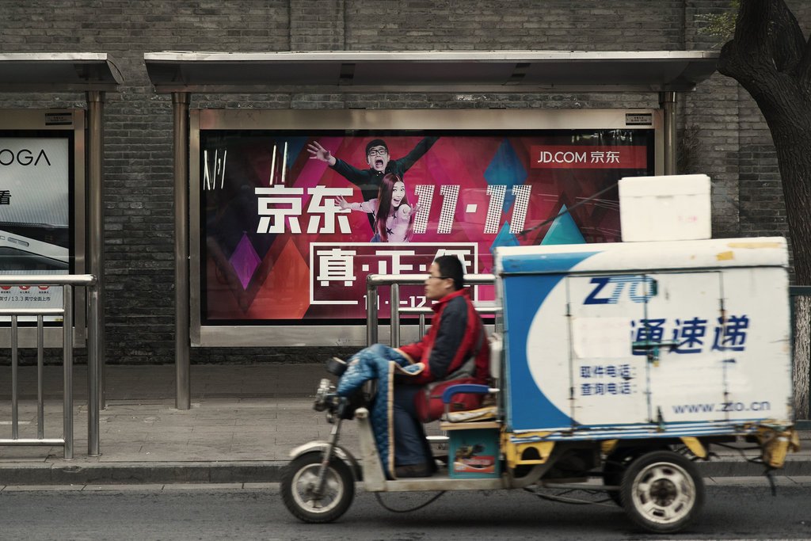

Slide Show|7 Photos

At a Snail’s Pace
CreditGilles Sabrie for The New York Times
HANGZHOU, China — It’s the biggest shopping day of the year in China and the discounts are steep. But Jiang Shan waited to buy some of what she wants.
On Tuesday, tens of millions of Chinese like Ms. Jiang bought more than $9 billion worth of products online in honor of Singles’ Day, China’s de facto e-commerce holiday, and the world’s largest Internet shopping event. But buying is one thing. Delivery is another.
Ms. Jiang, who owns a bakery in the western Chinese city of Urumqi, spent 2,000 renminbi on a water purifier and kitchen supplies, and would have spent even more, she said, were she confident the products she ordered would get to her quickly and undamaged.
“I tend not to buy things on Singles’ Day because the logistics just worry me too much,” she said. “If I get the stuff I ordered this year in 10 to 15 days I’ll be happy.”
China has caught the e-commerce bug. An underdeveloped retail sector and a flourishing network of online merchants offering huge selections at cheap prices has led the Chinese to look to the web first to buy everything from shoes and ovens to toilet paper and toothbrushes.
The Chinese e-commerce market is already bigger than the United States, and by 2020, is projected to be the size of the United States, Britain, Germany, Japan and France combined, according to a KPMG report.
But the country struggles with delivery, largely because of decades of underinvestment in inland logistics infrastructure and inefficient local regulation. Goods are slow to arrive in the interior of the country, and damage is a persistent problem — affecting both consumers and small businesses.
“Imagine having 30 N.B.A. teams but only a few high school gyms to play in — that was China’s logistics infrastructure when e-commerce took off,” said Shen Haoyu, chief executive of the Chinese e-commerce giant JD.com’s business-to-consumer website.
Deliveries within China are so inefficient that the country spent 18 percent of its gross domestic product on logistics in the 2013, 6.5 percent above the global average and 9.5 percent above developed countries like the United States, said Fox Chu, director of Asia Pacific infrastructure and transportation at the consulting firm Accenture.
“Shipping goods from Fujian to Beijing can be more expensive than shipping something from Beijing to California,” he said, referring to the roughly 1,200 mile trip between the southern Chinese province and the country’s capital.
Recently, both Alibaba, China’s main e-commerce company, and its smaller rival, JD.com, have tried to make things more efficient, especially inland.
Alibaba has pledged to invest 100 billion renminbi ($16.3 billion) in an initiative to link up third-party companies that deliver its shipments. The idea is to form an alliance that uses Alibaba’s consumer and shipment data to better anticipate orders and make delivery more efficient.
JD.com, on the other hand, is building its own warehouses and shipping its own goods. Currently, the company can manage same-day deliveries in 100 cities and next-day deliveries in 600 others, said Mr. Shen, the JD.com executive.
As with most things in China, the state of logistics can be broken down by geography and wealth. In the largest and most affluent cities on the country’s eastern coast, just about anything can be delivered within a day.
Zhang Rui, an information technology salesman who lives in Beijing, doesn’t even buy small daily necessities at stores anymore.
“Just about anything I need at home I buy online, whether it’s groceries, toilet paper, rice, cooking oil, salt, a toothbrush or shampoo,” he said.
For Ms. Jiang, living inland, it’s another story. She recalled when a courier refused to help her carry a heavy parcel up the stairs to her apartment. Some won’t wait for her to open the package to ensure the goods she ordered are all there and undamaged. Her friends who live on the east coast and use Alibaba question how she survives out west.
“When the package comes, I don’t expect it to be pretty,” she said. “Even if there’s a few scratches on something I don’t care anymore.”
Safety has also become an issue. In late 2013 one person was killed and seven hospitalized after a toxic liquid sent by a chemical company leaked onto other parcels being delivered. In 2012 a China Southern Airlines plane caught fire when weatherproof matches left inside a parcel ignited.
China’s delivery problems are highlighted on Singles’ Day, which was originally conceived as a way for the unmarried of China to shop away their loneliness. Beginning on Tuesday night, items from the 278.5 million orders placed on Singles’ Day at Alibaba’s e-commerce sites will be shipped, largely by truck, across a land mass the size of the United States and crisscrossed by dizzying mountain ranges.
The trucks will shuttle the packages from warehouses to smaller distribution centers, paying costly tolls and running into traffic jams along the way. After dropping off the goods, many vehicles can’t bring packages back because of convoluted local regulations.
From the distribution centers, equipped only with shelving to hold the deluge of packages, hundreds of thousands of deliverymen will begin the slow process of bringing each parcel to recipients spread out across distant Himalayan hamlets, eastern Chinese megacities and jungle towns on the South China Sea.
Part of Alibaba’s plan to improve things is to establish warehouses at critical choke points to help streamline deliveries. “China is too big, so we cannot buy a lot of land for warehouses,” said Alibaba’s chief operating officer, Daniel Zhang. “Instead, we will choose key areas, very strategic locations where resources are quite limited.”
The company will share the new warehouse space with logistics partners like YTO Express.
As an early partner of Alibaba, YTO grew huge by delivering the millions, and then billions, of goods ordered on the company’s e-commerce sites. Last year, just 13 years after it was founded, YTO’s 130,000 employees filled 1.5 billion orders across China.
For the jump in orders on Singles’ Day orders, YTO hired 30,000 temporary workers. Next year it plans to buy its first airplane.
This year for the first time, Alibaba is hoping to track the location of every item ordered during Singles’ Day.
JD.com’s 538,000-square-feet warehouse in southern Beijing, the largest in the city, shows the advantages it gets by building its own delivery service.
The huge structure is ergonomically organized and employees run full speed, pushing carts loaded with goods in lanes segmented for those going at different speeds. A screen displays how many orders each employee has processed.
It’s a far cry from most warehouses in China, which are often open-air and exposed to the elements, seemingly organized to cause traffic jams.
To help reduce the backlog during Singles’ Day, JD.com has run promotions the week before and brought in temporary workers from around the country for extra help. The warehouse can process more than 200,000 orders a day.
Though it has proved costly to build up what is effectively its own FedEx, the strategy enables JD.com to process orders more quickly than rivals, even as its scale lags.
Most critically, it’s able to train the couriers that Mr. Shen calls “literally the face of JD.com.”
Zhu Sichang, 29, is one of those couriers. Mr. Zhu said his favorite time on his job came after he dashed up several flights of stairs to get an urgent delivery to a customer quickly.
“He saw I was pouring sweat and offered me a cup of water to thank me for my hard work,” he said.

