NYT

The New Bazaar: In India, Online Stores Catch On With Buyers
By MAX BEARAK
July 29, 2014 9:41 pmJuly 30, 2014 9:20 am
Photo
A billboard in New Delhi advertises Snapdeal, an online marketplace in India with $1 billion in sales.Credit Graham Crouch for The New York Times
At first, Kunal Bahl and his high school buddy Rohit Bansal had modest ambitions for their online shopping site, Snapdeal.
Their previous venture — a physical coupon booklet into which they had sunk their combined savings — flopped in just months. And online retailing was still a largely unproven endeavor in 2010, particularly in India, a country where most people don’t have bank accounts, let alone credit cards to make purchases on the Internet. When an angel investor offered $200,000 as seed money, they took only half and aimed for just 100 transactions a day.
Snapdeal is now on track to handle more than $1 billion in sales this year for over 30,000 merchants across more than 500 categories of goods and services.
“We sell a sari every 12 seconds,” Mr. Bahl said.
The rise of Indian e-commerce — which has started to gain traction only in recent years — has captured the attention of international investors.
This year, Snapdeal has raised $233 million, with about half coming from the American Internet company eBay. Mr. Bahl said Snapdeal was considering an initial public offering in a year or two.
At least half a dozen other leading Indian shopping sites have announced major fund-raising deals in recent months. On Tuesday, Flipkart, India’s largest e-commerce company, said that it had raised $1 billion from investors, including American firms like Tiger Global and Accel Partners. The amount represents the largest ever for an Indian Internet company, and globally, it matches Facebook’s fund-raising round in February 2011 and ranks only second to Uber’s $1.2 billion bonanza this June, according to Thomson Reuters.
“E-commerce in India is poised to take advantage of larger shifts in society,” said Vani Kola, now the managing director of Kalaari Capital and formerly of NEA-IndoUS Ventures, Indian-based venture capital firms that both have invested in Snapdeal. “The whole industry has begun swiftly growing and evolving.”
Photo
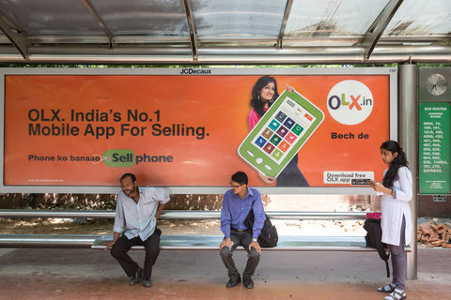
Internet access has rapidly expanded, mostly through mobile devices, and Indians are now shifting many daily activities online.Credit Graham Crouch for The New York Times
The investment surge reflects the changing landscape in India. Internet access has rapidly expanded, mostly through mobile devices, and Indians are now increasingly shifting daily activity online, like reading the newspaper, doing bank transactions and buying goods and services, from shoes to refrigerators (with installation included).
Billboards, text messages and emails bombard people every day with news of deep online-only discounts and special offers. E-commerce is growing at a compound annual rate of 34 percent, according to the Internet and Mobile Association of India, an industry trade group.
But online shopping remains a largely untapped market. While estimates of the total worth of India’s online retail industry vary greatly, most analysts figure that it accounts for less than 1 percent of the country’s $500 billion retail market, which is still mostly cash-driven.
Comparatively, China’s e-commerce sales are expected to top $180 billion this year, accounting for roughly 9 percent of the country’s retail spending, according to iResearch Consulting, which specializes in China’s Internet industry. The country’s largest online retailer, Alibaba, is expected to go public in the coming months with an estimated value of more than $200 billion.
“There’s tremendous headroom still,” Mr. Bahl said. “I think 20 years from now, 20 percent of retail will be online.”
Photo
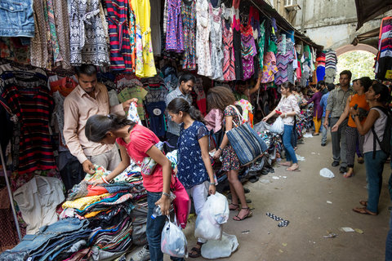
One challenge facing India’s online retailers: Many shoppers still prefer buying from vendors they know in neighborhood shops.Credit Graham Crouch for The New York Times
Yet particularities to India’s shopping culture have impeded the industry’s growth.
By and large, India remains a bastion of the “kirana,” or neighborhood general store, as well as the roving hawkers, whose nasal cries carry the names of their wares through narrow lanes and up to the top floors of apartment buildings.
Most people tend to shop from sellers they know personally and live near, running grains of rice through their fingers and smelling the different varieties to determine their quality before, perhaps, moving to the next shop where they might closely inspect the stitch count of a new batch of shirts sold by the local ready-made clothes dealer.
These entrenched habits, combined with the newness of the Internet and credit cards, have led to a trust gap between online retailers and their customers. To bridge it, the biggest names in e-commerce, including Snapdeal and Flipkart, allow customers to pay cash upon delivery for their purchases and let consumers return items at the very last second, even when the delivery person arrives at their door.
To address the widespread perception that the state’s postal service is unreliable, e-commerce players like Snapdeal, Flipkart and Jabong have developed their own delivery logistics companies. Snapdeal and others have built fulfillment centers and hired delivery workers to help ensure packages arrive in a timely fashion.
The logistic network, in part, has helped Snapdeal court small business owners to its marketplace.
Photo
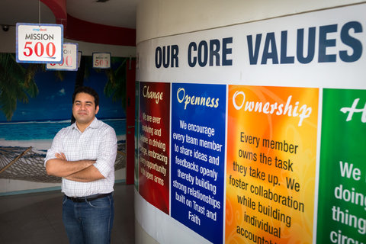
Kunal Bahl, a founder of Snapdeal, which has raised $233 million from investors this year.Credit Graham Crouch for The New York Times
“In the early days,” Mr. Bahl said, “we were calling every family and friend who we knew was running a small business or wanting to start one, and for whom nationwide distribution would be a godsend. It was quite hard to convince them, given many of them hadn’t ever used the Internet themselves.”
Momentum is now on the industry’s side. Mr. Bahl said that the company barely needed to recruit merchants any more, with 80 percent requesting to join Snapdeal. “Virality amongst small business owners is very acute,” Mr. Bahl said. “If one sees success, then word spreads really, really fast.”
Once merchants join the site, Snapdeal works with them to develop their listings and bolster sales. When Rakesh Sareen, 29, started selling his line of traditional women’s clothing made of locally sourced materials, Snapdeal, as part of its services, promoted the introduction and covered the cost of a photo shoot and online catalog.
“They send out targeted newsletters, which promote our products, and their fashion category manager advises us on trends as well as updates on how certain products of mine are selling,” said Mr. Sareen, who had just returned from a trip to the villages where he buys woven fabric.
Looming large over the industry is last year’s entrance in India of Amazon. Huge American online retailers like Amazon and eBay own marketplace platforms here, which, like Snapdeal and Flipkart, connect merchants with consumers. But the country’s regulations prevent Amazon and other overseas players from selling directly to consumers from their own inventory as they do elsewhere. Currently, foreign investment in multibrand retail is limited to 51 percent.
There are hints that the system may be changing, at least in the online space.
The current government, led by the Bharatiya Janata Party, is perceived as backing small business owners who fear that opening retailing to foreign behemoths will put them out of business. But Narendra Modi, India’s new prime minister, recently urged the industry to embrace change at a widely televised rally during his election campaign. “There is no need to fear global challenges,” said Mr. Modi, adding, “this is the age of online marketing, so accept modern science and make use of it.”
Amazon in particular stands to benefit from any change to the existing rules. “Customer loyalty isn’t so strong yet, so it’s conceivable that Amazon would either look to buy big names here, or their expansion might just kill some of the smaller horizontals altogether,” said Nikhil Pahwa, the founder and editor of Medianama.com, which analyzes India’s digital economy. On Monday, Amazon announced that it would open five new fulfillment centers across India to bring its nationwide total to seven.
In a recent email, a spokeswoman for Amazon in India affirmed that the company was in “continual dialogue” with the government and that it strongly supports “opening up this sector” to foreign direct investment.
Mr. Bahl of Snapdeal seems unfazed. “It wouldn’t affect our marketplace,” he said.
Within the next year, he thinks Snapdeal’s network of sellers will reach 100,000, and the company plans to double its number of fulfillment centers as well as engineering employees. As for the prospect of competition from Amazon, he thinks that small businesses will congregate on marketplace platforms like Snapdeal’s so as to collaboratively compete against the giants.
“We’re the ones who are going to help small businesses compete against Amazon,” Mr. Bahl said. “We are that platform.”

NYT

Indian E-Commerce Firm Flipkart Raises Eye-Popping $1 Billion
By MAX BEARAK
July 29, 2014 8:57 amJuly 29, 2014 8:57 am
Photo
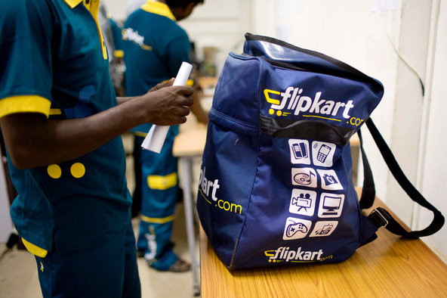
A courier for Flipkart in Bangalore.Credit Kainaz Amaria for The New York Times
India’s largest e-commerce firm, Flipkart, confirmed on Tuesday that it had raised $1 billion in its latest round of fundraising, making it by far the largest venture investment ever received by an Indian Internet company. Globally, the amount raised would rank second only to Uber’s recent $1.2 billion windfall.
Flipkart is an online marketplace that offers products in over 70 categories of goods and services, from electronics to books. The site says it has over 4 million daily visits and 22 million registered users, in a country where roughly a quarter of a billion people are online.
The investment firm Tiger Global and Naspers, a South African firm that invests primarily in e-commerce and media companies, co-led the latest fundraising round. Other investors included the venture capital firm Accel Partners, Morgan Stanley Investment Management, Sofina of Belgium and Singapore’s sovereign wealth fund, GIC.
The announcement comes only months after Flipkart raised $210 million from a group of investors that represent four of the eight firms that participated in this latest round: Tiger Global, Naspers, DST Global and ICONIQ Capital. Before the latest round, Flipkart had raised roughly $770 million since it was founded in 2007.
Indian e-commerce has been growing at rapid pace, thanks in large part to a major infusion of international investment over the last year. At least half a dozen other leading Indian e-commerce sites have announced major fundraising rounds over the last few months. Snapdeal, Flipkart’s main rival, raised $233 million earlier this year, with about half coming from the American giant eBay. Kunal Bahl, Snapdeal’s co-founder, says the company was aiming to hold an initial public offering within the next year or two.
Flipkart’s co-founder, Sachin Bansal, told the Press Trust of India that it was not considering an I.P.O. “We are not thinking about it. We have not settled on a business model that we can take public,” he said.
Sachin Bansal, left, chief executive of Flipkart, and Binny Bansal, the site’s chief operating officer.Credit Kainaz Amaria for The New York Times
Estimates of the total worth of India’s online retail industry vary greatly, but most acknowledge that it makes up for less than 1 percent of the country’s $500 billion retail market, which is mostly cash-driven. Comparatively, China’s e-commerce sales are expected to top $180 billion this year, and one company alone, the Alibaba Group, is expected to go public this August with an estimated value of $200 billion.

Amazon investing $2 billion more in India as online retail booms
Jul 30, 2014 04:33 am | IDG News Service
The announcement comes a day after an Indian retailer got $1 billion in funding
by John Ribeiro
.
Amazon.com is investing US$2 billion more in India, which is witnessing an online retail boom.
The online retailer has been expanding in India, and earlier this week said it was setting up five new fulfillment centers in the country, which will double its total storage capacity to over half a million square feet (over 46,500 square meters).
The investment announcement comes a day after a top Indian online retailer, Flipkart Internet, said it had raised $1 billion in new funding.
India's online retail spending is forecast to reach $16 billion by 2018, an eightfold increase from 2013, according to Forrester Research. "Mobile Internet access will be a catalyst for the growth of online retail in India," wrote Forrester analyst Jitender Miglani in March.
India will be Amazon's fastest country to reach one billion dollars in gross sales if current growth rates continue, Amazon said Wednesday.
The company did not say how or over what period it will make the investment.
"We don't comment on any future plans," a company spokeswoman said. "We are committed to aggressively investing in growing the business and relentlessly focus on raising the bar for online shopping experience in India."
As a result of Indian government restrictions on foreign investment in online retail in India, Amazon set up a marketplace last year, Amazon.in, which offers sales and order fulfillment services to Indian retailers, but does not sell directly.
The company also operates the Junglee.com website, a search and comparison site for Indian shoppers who can browse for a variety of retailers, including offline sellers and vendors of second-hand goods.
The Amazon marketplace offers over 17 million products from thousands of small and medium-size businesses.
- See more at:
http://www.itnews.com/e-commerce/81722/amazon-investing-2-billion-more-india-online-retail-booms?source=ITNEWSNLE_nlt_itndaily_2014-07-30#sthash.IUrYUrDx.dpuf

