EAF

China aims to set the regional cooperation agenda
28 July 2015
Author: Chen Dongxiao, SIIS
In late October 2013, the Chinese Communist Party Central Committee held a conference of Diplomatic Work with Neighbouring Countries in Beijing, where it unveiled new priorities under its New Neighbourhood Diplomacy guidelines. The new approach makes China’s neighbourhood, covering both continental and maritime Asia, the top strategic priority for the first time. The key message of the conference was to reassure to the region that China will step up its proactive engagement with its neighbours. This is to be achieved by converting its rising economic and political clout into more regional public goods and paving the way for a community inspired by a common destiny.
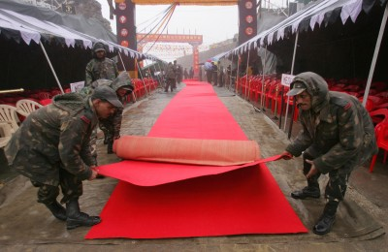
Multiple strategic initiatives underpin China’s new emphasis on regional diplomacy. On the economic side, the prospect of downward pressure on regional growth and the fragmentation of regional trade and investment negotiation processes are two major challenges for China. The Silk Road Economic Belt and the 21st Century Maritime Silk Road—now synthesised as the Belt and Road Initiatives—are arguably Beijing’s boldest flagship proposals under the New Neighbourhood Diplomacy approach. The Belt and Road Initiatives aim to visualise a new mode of regional economic cooperation by tapping the huge potential for regional investment and trade, and taking advantage of economic complementarities between China and other regional countries. It is also expected to further common interests by upgrading regional production, transportation and value chains.
For China, the initiative is already beginning to bear fruit. The Asia Infrastructure Investment Bank (AIIB), a new regional development bank initiated and led by China, has proved popular—attracting 57 founding members, including the UK, Germany, France, Australia, South Korea and many other advanced economies. More than 60 countries have expressed their interest in partnerships with the Belt and Road Initiatives. And many countries along the proposed Silk Road Economic Belt and the 21st Century Maritime Silk Road have already began talks with Beijing on coordinating policy, connecting facilities and better integrating trade and finance, as well as establishing people-to-people ties.
Ambitious as it is, the Belt and Road Initiatives are also the most complex projects Beijing has ever undertaken. Without efficient collaboration between the multiple stakeholders—including governments, NGOs, enterprises and the general public, both at home and abroad—it is unlikely to succeed.
In parallel with the Belt and Road Initiatives, China is also promoting another landmark initiative: the Free Trade Area of the Asia Pacific (FTAAP). The FTAAP has set the tone for the 2014 APEC economic leaders’ meeting in Beijing. China’s endorsement of the FTAAP demonstrates its commitment to more open, liberalised and high-quality trade and investment, as well as a more integrated regional economy.Beijing believes that the FTAAP can provide an overarching framework that transcends the narratives of competition between the Trans-Pacific Partnership (TPP) and Regional Comprehensive Economic Partnership (RCEP)—the two leading regional trade negotiation groups in the Asia Pacific—and help develop a roadmap for mutual accommodation and co-evolution of various regional trade & investment arrangements. Like the Belt and Road Initiatives, FTAAP is a long-term process and can only be realised through cooperation with other key economies, particularly the US, Japan and India.
Even more challenging is the issue of regional security. Today China faces multiple regional security challenges that range from diverging security perceptions, a rising security dilemma and deficiency of security public goods to managing maritime disputes and a plethora of other regional traditional and non-traditional threats. Under the guidelines of the new neighbourhood diplomacy policy, China is now engaging with regional security issues in more a more active way. It is participating in and sometimes leading regional security capacity and confidence building measures (CBMs), such as collective natural disaster relief, joint rescue and patrol, and anti-terrorism exercises, as well as rebuilding security in Afghanistan and mitigating tensions on the Korean Peninsula. China has also been building up regional security institutions by upgrading the security cooperation in the Shanghai Cooperation Organization (SCO), resetting the Conference of Interaction and Confidence-Building Measures in Asia (CICA) and initiating many bilateral and multilateral CBMs meetings with neighbouring countries, including those between China and the ASEAN defence ministers.
China fully recognises that there is not yet a consensus on what kind of security order is appropriate for the Asia Pacific region at a time when there is a major rebalancing between rising and established powers. For instance, there is disagreement over whether the US-led alliance system is still legitimate and sustainable given the relative decline of US influence in the Asia Pacific. The lack of agreement over the regional security order will hamper security cooperation in the long run.
In May 2014, at the CICA summit meeting, President XiJinping talked about developing a commitment to a new security order based on the ideals of common, comprehensive, cooperative and sustainable security. He also encouraged Asian countries to play a leadership role in building this new order, with the engagement of key players outside the region. The Chinese understanding of a new security order in the Asia Pacific implicitly challenges the exclusiveness of the US-led alliance system. It has therefore caused suspicion and scepticism on the part of the US and some of its key allies in the region. How to reconcile these differences and develop a shared definition of regional security order among all major stakeholders? How to work out inclusive regional security architectures where China, the US and many other regional key players can not only peacefully co-exist but also cooperate in providing more security public goods for the whole region? These questions remain key challenges for China if it is to play a bigger role in regional leadership in the future.
Professor Chen Dongxiao is President of the Shanghai Institutes for International Studies.
This article appeared in the most recent edition of the East Asia Forum Quarterly, ‘Leadership in the region‘

The Diplomat

India Needs to Join Asia's Emerging 'Chinese Order'
A new Asian order is emerging and South Asia — including India — needs to be a part of it.
By Akhilesh Pillalamarri
November 20, 2014
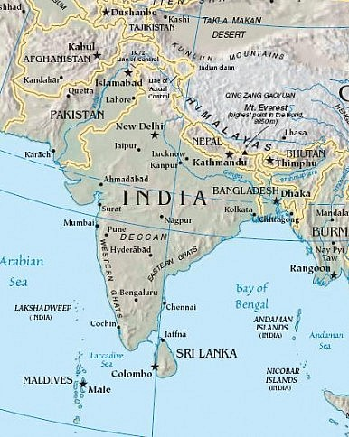
In the aftermath of the G20 and Asia-Pacific Economic Cooperation (APEC) summits, it is becoming increasingly obvious that a new Asian order, complete with an economic architecture, has emerged. Whether this order is referred to as the “Pacific Age” or a New Silk Road or a pan-Eurasian system, all these terms refer to the same thing: a web of economic interdependence in Asia whose hub is the littoral around the East and South China seas, connecting China, Japan, South Korea, Taiwan, and Southeast Asia. This network of economic prosperity is increasingly being spread by Beijing westward to the rest of Eurasia in an initiative called the “New Silk Road.” Thus, it might not be inaccurate to write that the new Asian economic order can be described as described as the “Chinese Order” in which all roads lead to Zhongnanhai. This is because China’s economy and physical location constitute the hub that drives and connects the rest of Asia.
Yet as China invests more than $40 billion in overland routes through Central Asia and Russia into Europe and maritime routes from Southeast Asia to the Middle East and Africa, there is one vital region in Asia that is at risk of missing out on joining this new Asian economic and infrastructure network. This region is South Asia, the region that perhaps needs to become part of this hub the most. This would better integrate South Asian countries with each other as well as with their neighbors in Southeast and East Asia. Economic integration within the region and with countries outside of the region is very low. This is despite the fact that China is both India and Pakistan’s largest trade partner (India and Pakistan hardly trade with each other). Most of this trade is one-sided and has not led to massive Chinese investment in infrastructure in either of these countries. South Asian integration into the Asian economic order would benefit all of the region’s countries and would especially help some of the poorest, like Nepal and Afghanistan.
This is why South Asian countries should very seriously take up the cause of economic integration with the rest of Asia before they are left too far behind. They ought to put more emphasis on connectivity and trade with East Asia so that the New Silk Road won’t go around the region. The countries of South Asia will meet in Kathmandu next week for the annual South Asian Association for Regional Cooperation (SAARC) summit. They should seriously discuss greater economic integration and closer trade ties with the rest of Asia. South Asia cannot afford to be left behind as the Asia-Pacific and Central Asian regions integrate.
The future of South Asia is largely dependent on India, its largest and most economically advanced nation. India has increasingly begun to realize the benefits of foreign investment, trade, and integration, and under the leadership of Prime Minister Narendra Modi, it has taken more steps to “Look East” and improve economic and strategic relations with Southeast Asia, Japan, and even China. However, India, as Asia’s second largest power, faces certain issues that smaller countries do not in deciding to what extent it should integrate into the rest of Asia. As a large country, it can theoretically hope to compete with China and possibly establish its own order but at the same time it is held back by its lack of power and vision. The discrepancy between India’s image of itself and the reality of today’s Asia is alternatively a cause of confusion, angst, and policy paralysis for many of India’s government officials. This is primarily because there is a sharp conflict as to whether India should strike out on its own in order to create its own system and become a great power or become part of what is essentially a Chinese-dominated Asian economic system.
In many ways, the choices have already been made for India. India’s early leaders envisioned a new Asia shaped and led by both India and China. Yet, since then, India has missed the boat and the new Asian economic and political architecture has been primarily been shaped by China and the United States. The countries of East, Southeast and Central Asia are now too vested in this system to not be a part of it, though Indian initiatives for its own order can be complementary to rather than alternatives to Chinese networks. Additionally, however much India is courted by countries like Vietnam and Japan in order to balance China militarily and economically, nothing will change the basic fact that a new Asian order has already been established. There is no alternative for India but to become a part of this order or remain unintegrated, since it is too late for India to set up its own Asian order.
This may be a very bitter pill for many Indian leaders and thinkers to swallow, as well as the country’s media. Indians are very proud and many would like to believe that one day their country will be a superpower. This might not be entirely true, but at the same time, it’s not entirely false. India’s integration into an Asian order is not some sort of surrender or strategic liability. In fact, it can be to India’s advantage to be more closely integrated with the rest of Asia, so that it can more easily influence the direction and shape of the new Asia from the inside rather than the outside while using the existing architecture to its own advantage without expending resources creating its own alternatives.
Nor does it mean that India has to give up on its strategic goals. India can remain a great power with nuclear weapons and a large army with an autonomous foreign policy even as it becomes part of a pan-Asian order. There was a European order before the First World War and many of its members were bitter rivals. Nonetheless, these countries traded and invested with each other and maintained courteous diplomatic relations. In today’s Asia, Russia retains strategic autonomy despite trading heavily with China. Australia retains its cultural distinctiveness despite trading heavily with Asia. Japan remains at odds with China over territory, like India, and is furthermore part of a military alliance with the United States. Nonetheless, Japan and China trade extensively and have both grown economically.
Therefore it is time for India and the rest of South Asia to take cognizance of the new Asian order and seriously consider their place in it. The choices they make might not only require policy shifts in the short-term, but shifts in long term strategy. However, integration into the new Asian order is something that the states of South Asia can no longer afford to put off, if they do not want to be left behind. A new Asian order is emerging and South Asia needs to be a part of it.
The Economist

Economic integration

The flying factory

Asia has built a web of economic interdependence which China would be ill-advised to unravel
Nov 15th 2014 | From the print edition

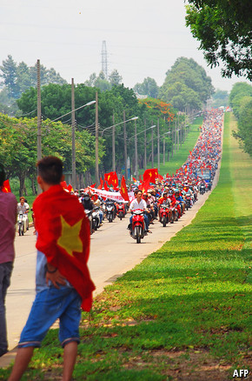
IN 1999 ANDY CHAN, a middle-aged Hong Kong businessman, set up a company in Shenzhen, just over the border on the Chinese mainland, making pretty sets of bath soap to fill American Christmas stockings. They were sold at $10 apiece at retailers like Walmart. His firm made and shipped them, by the hundreds of thousands in each steel container, for just $4. In the first few years his firm made a bomb. He paid his workers a pittance, 290 yuan (then $35) a month, and imported his raw materials from Malaysia for next to nothing. But then China’s exchange rate soared, his workers’ wages rose almost tenfold, the authorities started enforcing overtime rules and competition turned brutal. The business collapsed. Now he is a taxi driver. “You can’t do this business in Shenzhen any more unless you break the law. You have to go to South-East Asia,” he says bitterly.
Hard as it is on Mr Chan, trade in East Asia is ruthlessly opportunistic. Since Japanese multinationals put the “Flying Geese” model of manufacturing into practice in the 1980s, Asian factories have migrated, via the continent’s “miracle” economies, to China and South-East Asia. Fuelled largely by foreign investment, they are on a permanent quest for cheaper labour and greater efficiency. As cities along China’s throbbing coastline are priced out of the market, inland locations such as Chongqing, or lower-wage countries like Vietnam and Cambodia, have become the new goslings.
But the image of flying geese is no longer as fitting as it once was, because the production apparatus has become more like a spider’s web, with components flitting in all directions and goods crossing and recrossing borders. Victor and William Fung, owners of Li and Fung, a Hong-Kong-based company that helps orchestrate these supply chains, have said that this network has “ripped the roof off the factory”. Suppliers can now be anywhere. In their book, “Competing in a Flat World” (written with Yoram Wind), the two Fungs use the example of a pair of shorts they made for an American retailer. The buttons came from China, the zips from Japan, the yarn was spun in Bangladesh and woven into fabric and dyed in China, and the garment was stitched together in Pakistan. “Yet every pair of shorts has to look as if it were made in one factory.”
Tangled web
As a result, East Asia has become one of the most interconnected regions in the world. Trade among EU nations remains even more extensive, but they are part of a single market whereas East Asia has only a tangle of free-trade agreements. As Prema-chandra Athukorala, an economist based in Australia, points out, network trade has been the most dynamic part of world manufacturing exports since the 1990s. The share of East Asian developing countries increased from 14% in 1992-93 to over 30% in 2007-08, with China the main driving force (see chart 1).
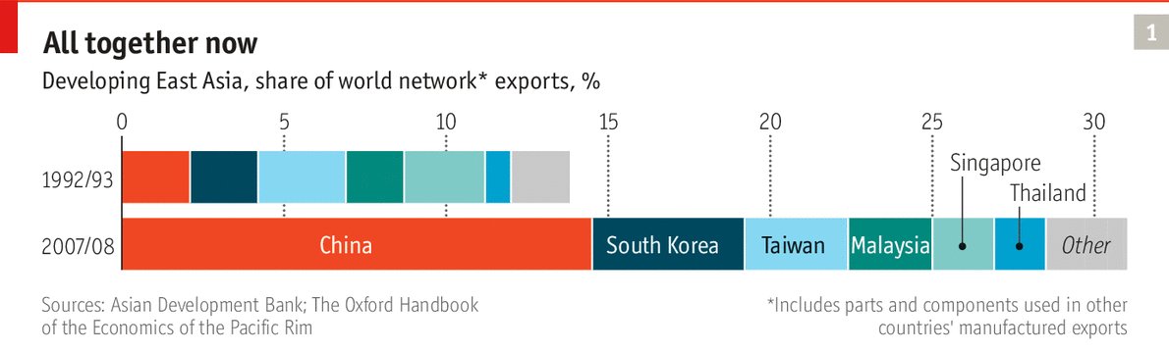
Such is the pull of China within this new “Factory Asia” that the currencies of most countries in the region now track the Chinese renminbi more closely than they do the American dollar, reckon Arvind Subramanian and Martin Kessler, formerly of the Peterson Institute. Yet for all its power, China is still only a part of the spider’s web, not the centre of it. “What makes the region unique is that you have a tight fit between regional and global integration. The supply chain is linked to final-goods markets in the United States and the EU,” says Razeen Sally of the Lee Kuan Yew School of Public Policy in Singapore.
Global trade has slowed down in the past two years, and in 2012 East Asian trade with the rest of the world for the first time made no contribution to growth. Yet despite the lingering fallout from the 2008 global financial crisis the network effect is still going strong. Exports, especially to America, have shown signs of picking up this summer. Sudhir Shetty, the World Bank’s chief economist for East Asia and the Pacific region, expects the emerging countries in his area to grow by 7% this year, far faster than anywhere else in the developing world.
China’s slowing growth rate remains a concern, but the ten members of the Association of South-East Asian Nations (ASEAN), including Indonesia, the Philippines, Singapore and Vietnam, are trying to make their region more self-sustaining. Next year ASEAN plans to establish an “economic community”—a single market to make network trade more seamless.
But China’s assertiveness over disputed territories in the South and East China Seas has put it at loggerheads with important trading partners such as Vietnam and Japan. As yet the economic costs have been bearable, but the risks are high.
James Reilly of the University of Sydney thinks that China’s new posturing is a revival of an old practice known as economic statecraft, meaning it is deploying its wealth for strategic foreign-policy purposes. This practice involves both carrots and sticks. In Asia the carrots have included pipelines, railways and trunk roads that China has provided around the region, mainly to supply its own economy with raw materials, but with wider benefits, especially for its poorer neighbours.
But there is also coercion, even if this is often counterproductive. In 2012, for example, Chinese officials indirectly encouraged a consumer boycott of Japanese goods as Japan reasserted its claim to disputed islands it calls the Senkakus and the Chinese call the Diaoyus. Customs officials tightened up inspections of Japanese imports. Yet Japan did not back down. Instead, it got closer to neighbours in the region who also objected to Chinese aggressiveness, says Mr Reilly. In the same year Chinese restrictions on banana imports from the Philippines led to a backlash among Filipinos that brought their country closer to America.
Last summer Chinese businesses in Vietnam were attacked by locals after a Chinese oil firm put a rig in contested waters
Bonnie Glaser of the Centre for Strategic and International Studies, a think-tank in Washington, says China may even be pursuing economic integration to strengthen its leverage. “China’s strategy is to weave together a network of economic interdependence. It is using the centrality of its power to persuade other nations that to challenge China on territorial issues is simply not worth it.” But its neighbours are not sitting placidly by. Last summer Chinese businesses in Vietnam were attacked by locals after a Chinese state-owned oil firm put an oil rig in waters that both countries lay claim to.
Since then, American officials say, its allies in the region have become somewhat keener to move into America’s economic orbit to keep China in check. Japanese investment in China fell to $9.1 billion in 2013, from $13.5 billion the year before. At the same time Japan’s investment in ASEAN more than doubled, to $23.6 billion. Myanmar, until recently a satrap of China, is opening up to the West.
Even in Singapore, which has a big ethnic Chinese community and sees itself as a cultural bridge between east and west, China’s conduct has raised eyebrows. Simon Tay, chairman of the Singapore Institute of International Affairs, says its treatment of countries such as Vietnam shows that political integration has failed to match the economic sort. “The post-war period has provided a sense of stability that has enabled Asians to mind their own business—literally the business of business,” he says. “There is unease about a China-centric region.”
Some economists say China’s assertive behaviour may also be a way of testing whether America’s economic power in the region is waning, as many of its leaders believe. They think that the Chinese may want to re-establish the old hierarchical system in which they were clearly in control but at the same time felt a sense of noblesse oblige.
Two striking hints of this came during Xi Jinping’s first visits as China’s president to ASEAN countries last year and to the Indian Ocean in September this year. On both tours he spoke of his desire to create a “maritime Silk Road” that would build port infrastructure and establish shipping co-operation with smaller, friendly nations like Cambodia and Sri Lanka along ancient trade routes established when China was the undisputed hegemonic power. He also announced the creation of the Asian Infrastructure Investment Bank, a rival to the Japan-driven Asian Development Bank but with deeper pockets—at least $50 billion in startup funds.
Yet for all its swagger, China is not impregnable. Its economic growth looks increasingly unsustainable, and most of its people are still relatively poor. Though there is a middle-class boom in coastal cities, the country’s average GDP per person is somewhere between that of the Philippines and Malaysia and still a long way from South Korea or Japan. The Communist Party knows that, to a large extent, its legitimacy rests on continuing to improve living standards.
From silk to services
That means taking economic reform further and increasing the value of goods and services produced in China, hoping to emulate the success of Singapore and Hong Kong, which generate far more value from services such as banking than from selling manufactured goods. Mr Xi has made reforms to the service sector a priority. He must also be casting a wary eye to North America where robotics, 3D printing, mass customisation and other new trends could put pressure on Asia’s factory model.
There are some promising alternatives to manufacturing. Last summer’s huge IPO of Alibaba, a Chinese e-commerce firm, underscores the potential of digital business. Tencent, another Chinese internet company, has more revenues and profits than Facebook. Lisa Hanson of Niko Partners, a Silicon Valley-based tech consultancy, says companies like Tencent have turned China into a world leader in online gaming.
One of the best tools for promoting economic reform is to use free trade and foreign competition to force overprotected service industries to modernise. Jiang Zemin, the president at the time, understood that when he took China into the World Trade Organisation in 2001. Japan’s prime minister, Shinzo Abe, has often made the same point when justifying his decision to join the Trans-Pacific Partnership, a free-trade grouping led by America. The big question is whether Messrs Xi and Abe are prepared to use Pacific-wide trade pacts to maintain that reformist zeal—and whether America has the political will to accommodate them.
The Economist

Summitry: The Chinese order

World leaders come to the Chinese capital, where Xi Jinping dispenses magnanimity
Nov 15th 2014 | BEIJING | From the print edition
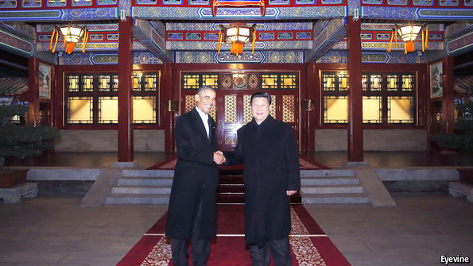
FOR the past week China’s state media have conveyed an almost imperial choreography playing out in the Great Hall of the People, in Zhongnanhai, the Chinese leaders’ compound next to the Forbidden City in Beijing, and at Yanqi Lake just outside the capital. Every day, on television and in newspapers, President Xi Jinping (above, right) is portrayed receiving lines of grateful world leaders. And every day he is seen arranging prosperity, ordering peace or, in an agreement with Barack Obama, America’s president, (above, left) on carbon emissions, even saving the planet. It escaped no visitor that not since Mao Zedong has a Chinese leader conducted foreign affairs with such eye-catching aplomb. Yet this was not only Mr Xi’s moment, but also China’s—a diplomatic coming-out party of sorts.
On several fronts, a country known for a somewhat reactive diplomacy has made the running. China was host this week to the Asia-Pacific Economic Co-operation—APEC, a regional trade gathering that rarely makes waves. Yet in quick succession China declared free-trade agreements with South Korea and Australia, two sizeable Asian economies, all but signed. It announced a breakthrough with America by promising at last to eliminate tariffs on information-technology products. And to the delight of Asian leaders and of Vladimir Putin, president of Russia (reviled in the West but made welcome in Beijing), Mr Xi announced $40 billion in investments to cement a new commercial “Silk Road” that will run overland through Central Asia and Russia eventually to Europe and by sea through South-East Asia to the Middle East and Africa.
Most strikingly, on November 11th Mr Xi urged APEC’s 21 members to move towards a Free Trade Area of the Asia-Pacific (FTAAP). The commitment to “study” the idea over the next two years is in effect to launch it, and for all that an eventual FTAAP is unlikely to be notable for its high standards, the announcement was intended to stand in contrast to the predicament of the 12-nation Trans-Pacific Partnership, sponsored by America, which remains bogged down in negotiations between America and Japan despite earlier hopes of a breakthrough announcement at APEC.
On security matters, Mr Xi appeared to be making the running, too. There had been a “meeting of minds”, according to Benigno Aquino, president of the Philippines, over disputed reefs in the South China Sea. Most striking, though, was an agreement for China to resume high-level contacts with Japan. China has rationed these, and in 2012 began actively challenging Japan’s control of the Senkaku islands (known as the Diaoyu islands to China) in the East China Sea; ties had been frozen entirely since Japan’s prime minister, Shinzo Abe, visited Tokyo’s Yasukuni shrine last December. The shrine, honouring Japan’s war dead, has militarist overtones.
Yet on November 7th China and Japan announced a four-point agreement to reduce tensions (see article). The signal agreement was later sealed when Mr Xi met Mr Abe for the first time as president. Admittedly, the withering handshake and puckery expression he offered Mr Abe lent the impression of a dog owner obliged to pick up another pooch’s turd.
That breakthrough was downplayed in state media, perhaps because Chinese ultranationalists might perceive in it a climbdown from China’s hard line over the islands, and towards Japan in general. But given much more prominence was the summit between the Chinese and American presidents, their second full one after that at Sunnylands in California in 2013. Again, there were welcome breakthroughs in co-operation. One was the agreement on information technology, which should now clear the way for a World Trade Organisation pact on IT products. Another was that both sides agreed to find common confidence-building and other measures to help avoid misunderstandings or accidental military confrontations on or above the East China Sea and South China Sea, where the United States shadows China’s increasingly assertive military presence.
But the biggest surprise was the agreement on greenhouse gases. China and America are the two biggest polluters, together accounting for 44% of global carbon emissions. Without their commitment to cut emissions, any global target is meaningless. On November 12th Mr Obama announced a “historic” agreement in which America will cut emissions by 26-28% by 2025, compared with 2005 levels, while China promises its emissions will peak around 2030. It gives a big boost to getting a global deal on carbon emissions at a crucial gathering in Paris next year. For China, a huge guzzler of coal, setting a date for emissions to peak is a first, even though it is five years later than the Americans would have liked. To bring down emissions after 2030, it aims for a big growth in nuclear power and for a fifth of its electricity to come from non-fossil fuels.
It was all striking choreography. But what mattered, as world leaders headed to the next meeting, in Myanmar, is what had changed in China’s relations with the world. The magnanimity and wisdom on display count as welcome engagement. Some Western analysts see in a desire for better relations, in particular with Japan, the Philippines and Vietnam, a recognition that recent bullying over maritime claims carries a cost for China by increasing regional distrust of it. Behind closed doors, some Chinese policymakers argue as much. Yet little suggests that, taken together, this week’s productive summitry heralds a big change in China’s dealings with the world. They are still coloured by suspicion, vitriol and good old Communist paranoia.
Last month, at a meeting tightening Communist Party control of the arts, Mr Xi endorsed a young Chinese blogger known for his anti-American bile. The state media’s shrill, cold-war warnings of a hostile West plotting to undo China appear to contradict Mr Xi’s call for a “new type of great power relationship”. And for all that Mr Xi says China and America should become an “anchor of world stability and propeller of world peace”, sharp differences emerged in his press conference with Mr Obama at the conclusion of their summit. The Chinese leader admonished a foreign press which has reported on how some of the country’s leaders and their families have enriched themselves. And he warned America not to meddle in Hong Kong, whose student demonstrations in favour of democracy he condemned as “illegal”, his strongest criticism of them to date. At times magnanimous, at times vituperative: China may continue to show both facets to the world for as long as it may not feel as confident about its strengths as it would wish to appear.
Quartz

China is now India’s top trading partner—and one of its least liked
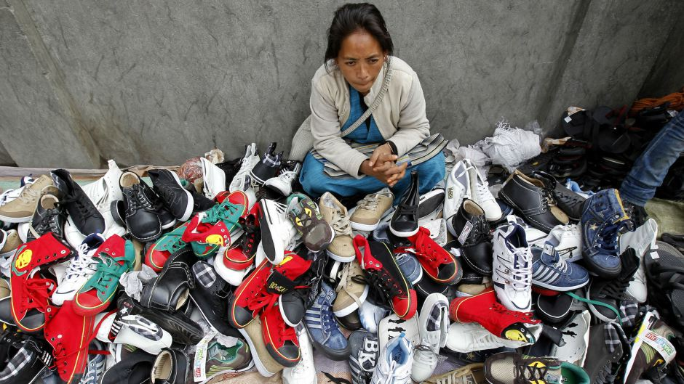
Some of China's mountain of imports into India.(Reuters/Fayaz Kabli)

Written by
Lily Kuo@lilkuo

Obsession
Borders
March 3, 2014
India and China—two massive, neighboring Asian emerging economies, each home to over a billion people—are on the way to forming one of the world’s largest trade relationships. According to a study by the PHD Chamber of Commerce, an industry trade group in New Delhi, China has become India’s largest trading partner, with Sino-Indian trade reaching $49.5 billion during the first nine months of the current fiscal year.
According to the study, China has edged out the United Arab Emirates—India’s previous top trading partner—and is comfortably ahead of the US and Saudi Arabia.
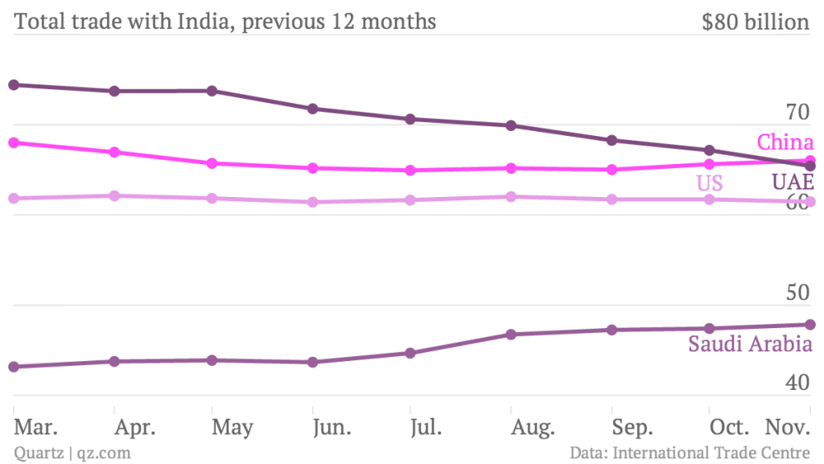
China’s newfound role as India’s top trading partner is a sign of growing “south to south” trade. Both China and India are among the world’s top trading countries, with 35 countries naming China as their top trading partner and six countries naming India as theirs.
But Sino-Indian experts say economic cooperation between the two Asian giants is still hampered by unresolved disputes. Beijing and Delhi have yet to agree on sovereignty over an area along the shared Himalayan border that China calls South Tibet and India calls Arunachal Pradesh—the subject of a brief war in 1962. Last week, the chief minister of the state of Gujarat, Narendra Modi, a front-runner in the race to be India’s next prime minister, called China’s policies regarding the area “expansionist.”
For India, a growing trade imbalance with China has contributed to a current account deficit that pushed the rupee lower last year. While India’s current account deficit has narrowed recently, Indian officials are still pushing for a larger piece of the trade between the two countries.
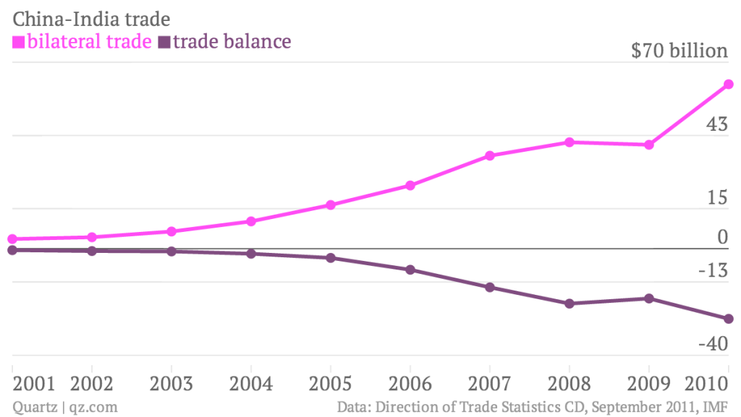
Other problems include tension over how to manage over a dozen rivers that the two countries share. Indian security experts also worry that China is trying to encircle the country with a string of ports and naval bases. And according to a survey released earlier this month, more 18-22 year-olds see China as posing the greatest security threat to the country, ahead of Pakistan. Although India and China have pledged to increase bilateral trade to $100 billion by 2015, it seems there’s still quite a long way to go in the trust department.

The Diplomat

The New Silk Road: China's Marshall Plan?
China’s plan for massive investments along the New Silk Road and Maritime Silk Road is a bid for diplomatic clout.
By Shannon Tiezzi
November 06, 2014

In 2013, Chinese President Xi Jinping unveiled plans for two massive trade and infrastructure networks connecting East Asia with Europe: the New Silk Road (also known as the Silk Road Economic Belt) and the Maritime Silk Road. A little over a year later, these initiatives are rapidly becoming reality as Beijing shows it is more than willing to put its money where its mouth is.
Bloomberg, citing Chinese government officials, reports that China plans to create “a $16.3 billion fund … to build and expand railways, roads and pipelines in Chinese provinces that are part of” the planned Silk Road Economic Belt. China’s state-owned China Daily also picked up the report. The massive investments will help boost economic development in China’s poorer inland regions, a key goal of the Silk Road Economic Belt.
Meanwhile, Beijing also plans to promote policies that encourage Chinese banks to lend money to other countries along the planned route. And that’s in addition to the massive amounts of infrastructure funding China had already promised to Silk Road partners: $1.4 billion for developing port infrastructure in Sri Lanka; $50 billion in infrastructure and energy deals in Central Asia; $327 million in general aid to Afghanistan, some of which will fund “the construction of rail lines, highways, water conservancies, [and] power facilities,” according to China Daily. With the establishment of China’s new Asian Infrastructure Investment Bank (AIIB), expect to see even more money flowing into the region to shore up infrastructure capabilities. Want China Times estimates that the total value of the Silk Road Economic Belt, when all is said and done, will be an astronomical $21.1 trillion.
Xinhua’s recently unveiled an updated, interactive map depicting the extent of two Silk Road projects. A quick comparison to Xinhua’s earlier version of the map reveals a number of new “stops” that have been added in the past six months, including Moscow, Russia; Dushanbe, Tajikistan; Jakarta, Indonesia; and Colombo, Sri Lanka. And Beijing is still expanding its list of potential partners: in his recent visit to China, Afghan President Ashraf Ghani indicated his country’s willingness to be part of the project.
In most cases, the Silk Road is not a hard sell. Regional partners (particularly smaller, and often over-looked countries like the Maldives) are eager to gain Chinese assistance in building critical infrastructure for their people. As Chinese Foreign Ministry spokesperson Hong Lei put it in a recent press conference, “A place needs to have well-functioning roads before it can get rich.” In less prominent countries, China may be the only ready source of international aid. And in countries that have several major power suitors vying for their affections (the Central Asian states, Indian Ocean states, and Eastern Europe in particular), China’s largess may spark a sort of “bidding war” that encourages China’s rivals to commit funding and diplomatic attention in ways they might not otherwise do. For example, Indian Prime Minister Narendra Modi’s concerted outreach to India’s smaller neighbors, including Bhutan, Sri Lanka, and Nepal, is partially motivated by fear that New Delhi is being overshadowed by Beijing in those regions.
For China, the Silk Road Economic Belt and Maritime Silk Road are opportunities to expand Chinese influence while also showcasing Beijing’s softer side. If brought to fruition, the Silk Roads would boost China’s trade with effectively the whole Eurasian continent. Meanwhile, with Beijing footing the bill for much of the requisite infrastructure development, the vast trade network would increase the number of regional governments that view China as a patron and benefactor rather than a threat. To use China’s favorite foreign policy catchphrase, it’s a “win-win” situation – China can foster a softer image for itself even while boosting its regional influence.
China’s economic powers are riding high, and still growing. Beijing is naturally trying to take advantage of its advantageous financial situation to boost foreign policy influence. It’s no coincidence that some are comparing China’s Silk Road Economic Belt and Maritime Silk Road to the Marshall Plan enacted by the U.S. after World War II. In both situations, a rising global power wants to use its economic strengths to secure foreign policy goals (including the basic goal of sustaining its own domestic economy). The Marshall Plan helped establish the U.S. as a bona fide super power; Beijing is betting its twin Silk Roads can do the same.

The Diplomat

Project Mausam: India's Answer to China's 'Maritime Silk Road'
India is using its history, culture and geography to compete with China’s “Maritime Silk Road.”
By Akhilesh Pillalamarri
September 18, 2014
This week, Chinese President Xi Jinping is visiting India. While relations between India and China are expected to improve as a result of Xi’s visit, India and China will continue to compete for influence in the region. This is evidenced by the fact that India’s Prime Minister Narendra Modi will soon launch a new initiative designed to compete with China’s Maritime Silk Road (MSR), known as Project Mausam.
As Shannon pointed out yesterday, Xi Jinping is pushing China’s MSR in India’s backyard with the eager support of countries like Sri Lanka and the Maldives. Even India is interested in potentially joining the MSR as the plan is a boon to the economies of the entire region. However, India has to look out for its own strategic interests as well.
As myself and others on The Diplomat have argued, India is uniquely placed to play a major role in Indian Ocean security and trade. India’s location and power can serve to organize the states of the Indian Ocean littoral. Understanding this, Modi’s government is currently shaping Project Mausam.
The project is considered the Modi government’s most significant foreign policy initiative designed to counter China. It is inspired by India’s historical role as the focal point for trade in the Indian Ocean. In pre-modern times, sailors used seasonal monsoons (mausam, मौसम means weather or season in many South Asian languages) to swiftly journey across the Indian Ocean. This trip usually involved starting from one of the edges of the ocean, around today’s Indonesia or east Africa, sailing to India, stopping, and allowing another crew to wait for another monsoon to sail to the other edge of the Indian Ocean, as different monsoon winds blew in different directions at different times of the year. Crews would frequently winter for months in India or at one of the edges of the ocean waiting for another season of monsoons. This allowed for significant cultural exchanges as diverse people from different places would often spend months at a time living in foreign countries (Islam is said to have entered Indonesia in this manner).
Project Mausam would allow India to reestablish its ties with its ancient trade partners and re-establish an “Indian Ocean world” along the littoral of the Indian Ocean. This world would stretch from east Africa, along the Arabian Peninsula, past southern Iran to the major countries of South Asia and thence to Sri Lanka and Southeast Asia.
According to the Times of India, Indian Foreign Secretary Sujatha Singh discussed how to give shape to the project with Culture Secretary Ravindra Singh. The project is supposed to have both a cultural and serious strategic dimension. Perhaps one thing India could consider is seriously developing its Andaman and Nicobar Islands as a security and trade zone. The Economist recently reported on some Indian steps to do just that, which is sensible given the islands’ location close to the strategically important Straits of Malacca and Thailand. However, India has yet to reveal actual details on the policies and projects that it intends to pursue to advance Project Mausam.
It is clear that India’s government intends to expand its maritime presence, culturally, strategically and psychologically (in order to remind the region why the ocean is called the Indian Ocean). Despite the lack of details, Project Mausam seems like a positive step in that direction and one that will generally be well-received. It is to be hoped, however, that the project is meaningful and does not lack teeth, like many other Indian initiatives of the past. The fact that Narendra Modi’s government is initiating Project Mausam, however, at least gives one assurance that the Indian government is not launching another arbitrary and half-hearted initiative.

In regional economic pact, India faces a Chinese import risk
By: Arun S | New Delhi | December 2, 2014 1:05 am
Share on facebook Share on twitter Share on google_plusone_share Share on reddit Share on linkedin Share on pinterest_share More Sharing Services5
Summary
India has no direct free-trade agreement with China as vast sections of the domestic industry are not equipped to take on competition from Chinese companies.

Other Articles
- US monthly job gains largest in three years; wages rise
- Malnutrition in tribal Gujarat taluka as high as 94 per cent
- India contests UN report on climate financing
The proposed regional comprehensive economic partnership (RCEP) that involves India, China and 14 other countries in the Asia-Pacific region could be detrimental to many sectors of the Indian economy, analysts feel.
RCEP, unless negotiated with caution and keen attention to details, could result in entry of Chinese goods into the Indian market, escaping import taxes. Many segments of the Indian manufacturing sector which are in the throes of acquiring competitiveness could be adversely impacted as RCEP could potentially lead to influx of duty-free Chinese goods through the back door, they say.
Abhijit Das, head and professor, Centre for WTO Studies, Indian Institute of Foreign Trade, said India should try to see what type of investment linkages can be built in with tariff reduction when it comes to China so that Indian industry doesn’t lose out.
He said that unless India manages to improve its infrastructure, it will be difficult to get investments into sectors such as manufacturing as part its ‘Make in India’ campaign.
Incidentally, India has no direct free-trade agreement with China as vast sections of the domestic industry are not equipped to take on competition from Chinese companies.
India’s proposal for one set of schedule of duty concessions for China (including a different implementation period for the duty cuts) and another single set of such concessions for 14 other member countries of the RCEP grouping has not been accepted so far, official sources said. “There are certain concerns with respect to China and we are trying to address those,” a government official said.
Already, citing factors such as its lack of transparency in minimum wages, property rights, government subsidies and loan rates, as well as absence of proper business accounting standards/ principles, India has declined to grant China the coveted “full-fledged market economy” status.
A consequence of the lack of market economy status for China is the large number of anti-dumping cases against products from that country.
As on June 30 this year, of the 690 anti-dumping investigations initiated by India against products from various countries so far (since 1992), 166 pertained to China.
In these cases, following findings of dumping, duty was imposed in 535 cases of which 134 were on products from China.
Of the bilateral trade of $66 billion in 2013-14, imports from China were worth $51 billion as against India’s exports to that country which was just $15 billion, leading to a whopping $36-billion trade deficit. New Delhi has been trying to get Chinese companies to set up shop in India, of late, as part of the ‘Make in India’ initiative. However, nothing significant has materialised so far. Some major imports from China include organic chemicals ($5.4 billion), fertilisers ($2 billion), plastics ($1.3 billion), iron and steel articles ($1.2 billion), electrical machinery and equipment ($14.2 billion), mechanical appliances and boilers ($9.4 billion).
Government sources said since China already has an FTA (with Asean) or is in talks for an FTA (with Japan and South Korea), it will be “foolish” and “impractical” to not engage with China for the regional FTA and take advantage of the duty benefits that it will offer for Indian industries.
The sixth round of RCEP negotiations between the 10-member Asean bloc — China, Japan, Korea, Australia and New Zealand, is being held in Greater Noida from December 1 to 5 to liberalise trade in goods and services between them besides finding ways to further boost investment. The aim is to conclude RCEP negotiations by December 2015.
The 16 countries, in this round of talks, will attempt at fixing timelines for “initial offers” to reduce tariffs in goods aiming for a greater slice of their combined market size of over three billion people. Though the ultimate objective of RCEP is to create a common duty-free market over a period of time, commerce ministry sources said India will give adequate protection to its sensitive sectors including agriculture (products such as spices, vegetables, fisheries, oils, fruit/nuts, rubber, tobacco), automobile, fisheries, chemicals, petroleum products and textiles in the RCEP agreement like it had earlier done in FTAs with Asean-member countries, Japan and Korea.

THE DIPLOMAT

Flashpoints
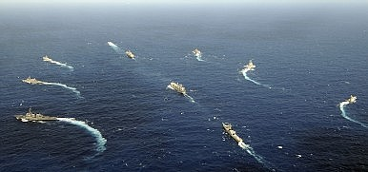
Image Credit: U.S. Navy photo by Mass Communication Specialist 3rd Class Matthew D. Jordan/Released

Asia’s New Geopolitics Takes Shape Around India, Japan, and Australia
Japan, India, and Australia will be instrumental in determining Asia’s fate in the 21st century.
By Harsh V. Pant
July 28, 2015

New configurations in Asian geopolitics are emerging thick and fast. Last month saw the initiative of a new trilateral involving India, Japan, and Australia when Indian Foreign Secretary S. Jaishankar met his Australian counterpart and the Japanese vice foreign minister. Japan will also be a part of bilateral India-U.S. annual naval exercises–the Malabar–slated to be held over the next few months. Though Japan has participated in these exercises in the past as well, this will be only the second time when Japan will join these exercises in the geostrategically critical Indian Ocean region.
There is a growing convergence in the region now that the strategic framework of the Indo-Pacific remains the best way forward to manage the rapidly shifting contours of Asia. Proposed first by Japan and adopted with enthusiasm by Australia under the Tony Abbott government, in particular, the framework has gained considerable currency, with even the U.S. now increasingly articulating the need for it. Though China views the framework with suspicion, many in China are acknowledging that the Indo-Pacific has emerged as a critical regional space for India and China needs to synchronize its policies across the Indian Ocean region and the Pacific.
These developments underscore the changing regional configuration in the Indo-Pacific on account of China’s aggressive foreign policy posture as well as a new seriousness in India’s own China policy. Indian Prime Minister Narendra Modi’s outreach to Japan and Australia has been a significant part of his government’s foreign policy so far as strong security ties with Tokyo and Canberra are now viewed as vital by Delhi.
China’s increasing diplomatic and economic influence, coupled with domestic nationalistic demands, has led to an adjustment of its military power and the adoption of a bolder and more proactive foreign policy. From China’s unilateral decision in 2013 to extend its air defense identification zone (ADIZ) over a contested maritime area in the East China Sea overlapping with the already existing Japanese ADIZ to announcing new fishing regulations for Hainan province in January 2014 to ensure that all foreign vessels need fishing permits from Hainan authorities to operate in more than half of South China Sea, the list of assertive moves has been growing in recent years. China’s land reclamation work in the Spratly Islands has been the most dramatic affirmation of Beijing’s desire to change the ground realities in the region in its favor. This has generated apprehensions about a growing void in the region to balance China’s growing dominance.
With the U.S. consumed by its own domestic vulnerabilities and never ending crises in the Middle East, regional powers such as India, Japan, and Australia have been more proactive than in the past in managing this turbulence. The new trilaterals emerging in Asia go beyond past attempts at rudimentary joint military exercises. In December 2013, the Japanese Maritime Self-Defense Force (JMSDF) conducted its first bilateral maritime exercise with the Indian Navy in the Indian Ocean Region. With growing strategic convergence between the two, in 2014 India invited the JMSDF to participate in the annual Malabar exercises with the U.S. Navy in the Pacific waters.
India and Japan have an institutionalized trilateral strategic dialogue partnership with the United States, initiated in 2011. Maintaining a balance of power in the Asian-Pacific as well as maritime security in the Indo-Pacific waters has become an important element of this dialogue. A similar dialogue exists between the U.S., Japan, and Australia. And now a new trilateral involving India, Japan, and Australia has joined these initiatives, which can potentially to transform into a ‘quad’ of democracies in the Indo-Pacific region. The roots of this potential partnership were laid as early as late-2004, when navies from the U.S., India, Japan, and Australia collaborated in tsunami relief operations all across the Indian Ocean.
Japan was one of the earliest vocal supporters of such initiatives. In 2007, Japanese Prime Minister Shinzo Abe, in his earlier stint as prime minister, lobbied for Asia’s democracies to come together in a ‘quadrilateral.’ This was also actively supported by the United States. Such an initiative resulted in a five nation naval exercise in Bay of Bengal in September 2007. However, China, perceiving a possible ganging-up of Asia’s democracies, issued demarches to New Delhi and Canberra, causing this initiative to lose steam, since both Australia and New Delhi felt it unwise to provoke China. However, as China becomes more aggressive in the region, there are signs that India and Australia may be warming up to the idea again.
The uncertainty of Chinese power and intentions in the region as well as the future of American commitment to maintaining the balance of power in Asia rank high in the strategic thinking of regional powers. This rapidly evolving regional geopolitics is forcing Asia’s middle powers – India, Japan and Australia – to devise alternative strategies for balancing China. Though still continuing their security partnership with the United States, these powers are actively hedging against the possibility of America’s failure to eventually balance China’s growing power. Asia’s geopolitical space is undergoing a transformation. While China’s rise is the biggest story still unfolding, other powers are also recalibrating and their influence will be of equal, if not greater, consequence in shaping the future of global politics in the Asia-Pacific.

