AMTI Detail on Islands

http://amti.csis.org/island-tracker/

Maps

http://amti.csis.org/atlas/

Dialogue between Kerry and Xi on SCS

http://www.nytimes.com/video/world/asia/100000004454952/china-us-xi-jinping-john-kerry.html?version=meter+at+0&contentId=&mediaId=&referrer=&priority=true&action=click&contentCollection=International%20Business&module=RelatedCoverage&region=EndOfArticle&pgtype=article

China’s Island Building

http://www.nytimes.com/interactive/2015/07/30/world/asia/what-china-has-been-building-in-the-south-china-sea.html?hp&action=click&pgtype=Homepage&module=photo-spot-region&region=top-news&WT.nav=top-news&_r=0

Map @ http://www.nytimes.com/interactive/2014/02/25/world/asia/claims-south-china-sea.html

The South China Sea Is the Future of Conflict

The 21st century's defining battleground is going to be on water.

BY ROBERT D. KAPLAN | SEPT/OCT 2011

Foreign Policy
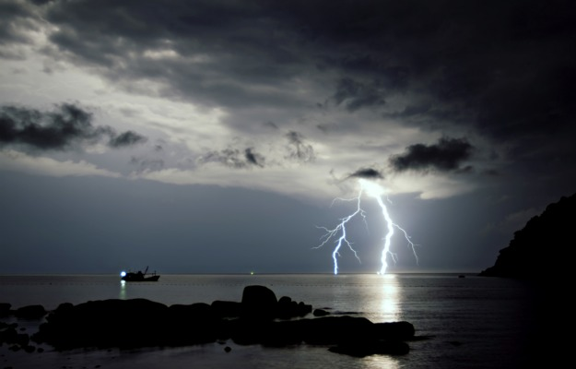

Europe is a landscape; East Asia a seascape. Therein lies a crucial difference between the 20th and 21st centuries. The most contested areas of the globe in the last century lay on dry land in Europe, particularly in the flat expanse that rendered the eastern and western borders of Germany artificial and exposed to the inexorable march of armies. But over the span of the decades, the demographic and economic axis of the Earth has shifted measurably to the opposite end of Eurasia, where the spaces between major population centers are overwhelmingly maritime.

Because of the way geography illuminates and sets priorities, these physical contours of East Asia augur a naval century -- naval being defined here in the broad sense to include both sea and air battle formations now that they have become increasingly inextricable. Why? China, which, especially now that its land borders are more secure than at any time since the height of the Qing dynasty at the end of the 18th century, is engaged in an undeniable naval expansion. It is through sea power that China will psychologically erase two centuries of foreign transgressions on its territory -- forcing every country around it to react.
Military engagements on land and at sea are vastly different, with major implications for the grand strategies needed to win -- or avoid -- them. Those on land enmesh civilian populations, in effect making human rights a signal element of war studies. Those at sea approach conflict as a clinical and technocratic affair, in effect reducing war to math, in marked contrast with the intellectual battles that helped define previous conflicts.
World War II was a moral struggle against fascism, the ideology responsible for the murder of tens of millions of noncombatants. The Cold War was a moral struggle against communism, an equally oppressive ideology by which the vast territories captured by the Red Army were ruled. The immediate post-Cold War period became a moral struggle against genocide in the Balkans and Central Africa, two places where ground warfare and crimes against humanity could not be separated. More recently, a moral struggle against radical Islam has drawn the United States deep into the mountainous confines of Afghanistan, where the humane treatment of millions of civilians is critical to the war's success. In all these efforts, war and foreign policy have become subjects not only for soldiers and diplomats, but for humanists and intellectuals. Indeed, counterinsurgency represents a culmination of sorts of the union between uniformed officers and human rights experts. This is the upshot of ground war evolving into total war in the modern age.
East Asia, or more precisely the Western Pacific, which is quickly becoming the world's new center of naval activity, presages a fundamentally different dynamic. It will likely produce relatively few moral dilemmas of the kind we have been used to in the 20th and early 21st centuries, with the remote possibility of land warfare on the Korean Peninsula as the striking exception. The Western Pacific will return military affairs to the narrow realm of defense experts. This is not merely because we are dealing with a naval realm, in which civilians are not present. It is also because of the nature of the states themselves in East Asia, which, like China, may be strongly authoritarian but in most cases are not tyrannical or deeply inhumane.
The struggle for primacy in the Western Pacific will not necessarily involve combat; much of what takes place will happen quietly and over the horizon in blank sea space, at a glacial tempo befitting the slow, steady accommodation to superior economic and military power that states have made throughout history. War is far from inevitable even if competition is a given. And if China and the United States manage the coming handoff successfully, Asia, and the world, will be a more secure, prosperous place. What could be more moral than that? Remember: It is realism in the service of the national interest -- whose goal is the avoidance of war -- that has saved lives over the span of history far more than humanitarian interventionism.

EAST ASIA IS A VAST, YAWNING EXPANSE stretching nearly from the Arctic to Antarctic -- from the Kuril Islands southward to New Zealand -- and characterized by a shattered array of isolated coastlines and far-flung archipelagos. Even accounting for how dramatically technology has compressed distance, the sea itself still acts as a barrier to aggression, at least to a degree that dry land does not. The sea, unlike land, creates clearly defined borders, giving it the potential to reduce conflict. Then there is speed to consider. Even the fastest warships travel comparatively slowly, 35 knots, say, reducing the chance of miscalculations and giving diplomats more hours -- days, even -- to reconsider decisions. Navies and air forces simply do not occupy territory the way that armies do. It is because of the seas around East Asia -- the center of global manufacturing as well as rising military purchases -- that the 21st century has a better chance than the 20th of avoiding great military conflagrations.
Of course, East Asia saw great military conflagrations in the 20th century, which the seas did not prevent: the Russo-Japanese War; the almost half-century of civil war in China that came with the slow collapse of the Qing dynasty; the various conquests of imperial Japan, followed by World War II in the Pacific; the Korean War; the wars in Cambodia and Laos; and the two in Vietnam involving the French and the Americans. The fact that the geography of East Asia is primarily maritime had little impact on such wars, which at their core were conflicts of national consolidation or liberation. But that age for the most part lies behind us. East Asian militaries, rather than focusing inward with low-tech armies, are focusing outward with high-tech navies and air forces.
As for the comparison between China today and Germany on the eve of World War I that many make, it is flawed: Whereas Germany was primarily a land power, owing to the geography of Europe, China will be primarily a naval power, owing to the geography of East Asia.
East Asia can be divided into two general areas: Northeast Asia, dominated by the Korean Peninsula, and Southeast Asia, dominated by the South China Sea. Northeast Asia pivots on the destiny of North Korea, an isolated, totalitarian state with dim prospects in a world governed by capitalism and electronic communication. Were North Korea to implode, Chinese, U.S., and South Korean ground forces might meet up on the peninsula's northern half in the mother of all humanitarian interventions, even as they carve out spheres of influence for themselves. Naval issues would be secondary. But an eventual reunification of Korea would soon bring naval issues to the fore, with a Greater Korea, China, and Japan in delicate equipoise, separated by the Sea of Japan and the Yellow and Bohai seas. Yet because North Korea still exists, the Cold War phase of Northeast Asian history is not entirely over, and land power may well come to dominate the news there before sea power will.

Southeast Asia, by contrast, is already deep into the post-Cold War phase of history. Vietnam, which dominates the western shore of the South China Sea, is a capitalist juggernaut despite its political system, seeking closer military ties to the United States. China, consolidated as a dynastic state by Mao Zedong after decades of chaos and made into the world's most dynamic economy by the liberalizations of Deng Xiaoping, is pressing outward with its navy to what it calls the "first island chain" in the Western Pacific. The Muslim behemoth of Indonesia, having endured and finally ended decades of military rule, is poised to emerge as a second India: a vibrant and stable democracy with the potential to project power by way of its growing economy. Singapore and Malaysia are also surging forward economically, in devotion to the city-state-cum-trading-state model and through varying blends of democracy and authoritarianism. The composite picture is of a cluster of states, which, with problems of domestic legitimacy and state-building behind them, are ready to advance their perceived territorial rights beyond their own shores. This outward collective push is located in the demographic cockpit of the globe, for it is in Southeast Asia, with its 615 million people, where China's 1.3 billion people converge with the Indian subcontinent's 1.5 billion people. And the geographical meeting place of these states, and their militaries, is maritime: the South China Sea.
The South China Sea joins the Southeast Asian states with the Western Pacific, functioning as the throat of global sea routes. Here is the center of maritime Eurasia, punctuated by the straits of Malacca, Sunda, Lombok, and Makassar. More than half the world's annual merchant fleet tonnage passes through these choke points, and a third of all maritime traffic. The oil transported through the Strait of Malacca from the Indian Ocean, en route to East Asia through the South China Sea, is more than six times the amount that passes through the Suez Canal and 17 times the amount that transits the Panama Canal. Roughly two-thirds of South Korea's energy supplies, nearly 60 percent of Japan's and Taiwan's energy supplies, and about 80 percent of China's crude-oil imports come through the South China Sea. What's more, the South China Sea has proven oil reserves of 7 billion barrels and an estimated 900 trillion cubic feet of natural gas, a potentially huge bounty.

It is not only location and energy reserves that promise to give the South China Sea critical geostrategic importance, but also the coldblooded territorial disputes that have long surrounded these waters. Several disputes concern the Spratly Islands, a mini-archipelago in the South China Sea's southeastern part. Vietnam, Taiwan, and China each claim all or most of the South China Sea, as well as all of the Spratly and Paracel island groups. In particular, Beijing asserts a historical line: It lays claim to the heart of the South China Sea in a grand loop (widely known as the "cow's tongue") from China's Hainan Island at the South China Sea's northern end all the way south 1,200 miles to near Singapore and Malaysia.
The result is that all nine states that touch the South China Sea are more or less arrayed against China and therefore dependent on the United States for diplomatic and military support. These conflicting claims are likely to become even more acute as Asia's spiraling energy demands -- energy consumption is expected to double by 2030, with China accounting for half that growth -- make the South China Sea the ever more central guarantor of the region's economic strength. Already, the South China Sea has increasingly become an armed camp, as the claimants build up and modernize their navies, even as the scramble for islands and reefs in recent decades is mostly over. China has so far confiscated 12 geographical features, Taiwan one, Vietnam 25, the Philippines eight, and Malaysia five.
China's very geography orients it in the direction of the South China Sea. China looks south toward a basin of water formed, in clockwise direction, by Taiwan, the Philippines, the island of Borneo split between Malaysia and Indonesia (as well as tiny Brunei), the Malay Peninsula divided between Malaysia and Thailand, and the long snaking coastline of Vietnam: weak states all, compared with China. Like the Caribbean Sea, punctuated as it is by small island states and enveloped by a continental-sized United States, the South China Sea is an obvious arena for the projection of Chinese power.
Indeed, China's position here is in many ways akin to America's position vis-à-vis the similar-sized Caribbean in the 19th and early 20th centuries. The United States recognized the presence and claims of European powers in the Caribbean, but sought to dominate the region nevertheless. It was the 1898 Spanish-American War and the digging of the Panama Canal from 1904 to 1914 that signified the United States' arrival as a world power. Domination of the greater Caribbean Basin, moreover, gave the United States effective control of the Western Hemisphere, which allowed it to affect the balance of power in the Eastern Hemisphere. And today China finds itself in a similar situation in the South China Sea, an antechamber of the Indian Ocean, where China also desires a naval presence to protect its Middle Eastern energy supplies.
Yet something deeper and more emotional than geography propels China forward into the South China Sea and out into the Pacific: that is, China's own partial breakup by the Western powers in the relatively recent past, after having been for millennia a great power and world civilization.
In the 19th century, as the Qing dynasty became the sick man of East Asia, China lost much of its territory to Britain, France, Japan, and Russia. In the 20th century came the bloody Japanese takeovers of the Shandong Peninsula and Manchuria. This all came atop the humiliations forced on China by the extraterritoriality agreements of the 19th and early 20th centuries, whereby Western countries wrested control of parts of Chinese cities -- the so-called "treaty ports." By 1938, as Yale University historian Jonathan D. Spence tells us in The Search for Modern China, because of these depredations as well as the Chinese Civil War, there was even a latent fear that "China was about to be dismembered, that it would cease to exist as a nation, and that the four thousand years of its recorded history would come to a jolting end." China's urge for expansion is a declaration that it never again intends to let foreigners take advantage of it.

JUST AS GERMAN SOIL constituted the military front line of the Cold War, the waters of the South China Sea may constitute the military front line of the coming decades. As China's navy becomes stronger and as China's claim on the South China Sea contradicts those of other littoral states, these other states will be forced to further develop their naval capacities. They will also balance against China by relying increasingly on the U.S. Navy, whose strength has probably peaked in relative terms, even as it must divert considerable resources to the Middle East. Worldwide multipolarity is already a feature of diplomacy and economics, but the South China Sea could show us what multipolarity in a military sense actually looks like.
There is nothing romantic about this new front, void as it is of moral struggles. In naval conflicts, unless there is shelling onshore, there are no victims per se; nor is there a philosophical enemy to confront. Nothing on the scale of ethnic cleansing is likely to occur in this new central theater of conflict. China, its suffering dissidents notwithstanding, simply does not measure up as an object of moral fury. The Chinese regime demonstrates only a low-calorie version of authoritarianism, with a capitalist economy and little governing ideology to speak of. Moreover, China is likely to become more open rather than closed as a society in future years. Instead of fascism or militarism, China, along with other states in East Asia, is increasingly defined by the persistence of old-fashioned nationalism: an idea, certainly, but not one that since the mid-19th century has been attractive to intellectuals. And even if China does become more democratic, its nationalism is likely only to increase, as even a casual survey of the views of its relatively freewheeling netizens makes clear.
We often think of nationalism as a reactionary sentiment, a relic of the 19th century. Yet it is traditional nationalism that mainly drives politics in Asia, and will continue to do so. That nationalism is leading unapologetically to the growth of militaries in the region -- navies and air forces especially -- to defend sovereignty and make claims for disputed natural resources. There is no philosophical allure here. It is all about the cold logic of the balance of power. To the degree that unsentimental realism, which is allied with nationalism, has a geographical home, it is the South China Sea.
Whatever moral drama does occur in East Asia will thus take the form of austere power politics of the sort that leaves many intellectuals and journalists numb. As Thucydides put it so memorably in his telling of the ancient Athenians' subjugation of the island of Melos, "The strong do what they can and the weak suffer what they must." In the 21st-century retelling, with China in Athens's role as the preeminent regional sea power, the weak will still submit -- but that's it. This will be China's undeclared strategy, and the smaller countries of Southeast Asia may well bandwagon with the United States to avoid the Melians' fate. But slaughter there will be not.
The South China Sea presages a different form of conflict than the ones to which we have become accustomed. Since the beginning of the 20th century, we have been traumatized by massive, conventional land engagements on the one hand, and dirty, irregular small wars on the other. Because both kinds of war produced massive civilian casualties, war has been a subject for humanists as well as generals. But in the future we just might see a purer form of conflict, limited to the naval realm. This is a positive scenario. Conflict cannot be eliminated from the human condition altogether. A theme in Machiavelli's Discourses on Livy is that conflict, properly controlled, is more likely than rigid stability to lead to human progress. A sea crowded with warships does not contradict an era of great promise for Asia. Insecurity often breeds dynamism.
But can conflict in the South China Sea be properly controlled? My argument thus far presupposes that major warfare will not break out in the area and that instead countries will be content to jockey for position with their warships on the high seas, while making competing claims for natural resources and perhaps even agreeing to a fair distribution of them. But what if China were, against all evidential trends, to invade Taiwan? What if China and Vietnam, whose intense rivalry reaches far back into history, go to war as they did in 1979, with more lethal weaponry this time? For it isn't just China that is dramatically building its military; Southeast Asian countries are as well. Their defense budgets have increased by about a third in the past decade, even as European defense budgets have declined. Arms imports to Indonesia, Singapore, and Malaysia have gone up 84 percent, 146 percent, and 722 percent, respectively, since 2000. The spending is on naval and air platforms: surface warships, submarines with advanced missile systems, and long-range fighter jets. Vietnam recently spent $2 billion on six state-of-the-art Kilo-class Russian submarines and $1 billion on Russian fighter jets. Malaysia just opened a submarine base on Borneo. While the United States has been distracted by land wars in the greater Middle East, military power has been quietly shifting from Europe to Asia.
The United States presently guarantees the uneasy status quo in the South China Sea, limiting China's aggression mainly to its maps and serving as a check on China's diplomats and navy (though this is not to say that America is pure in its actions and China automatically the villain). What the United States provides to the countries of the South China Sea region is less the fact of its democratic virtue than the fact of its raw muscle. It is the very balance of power between the United States and China that ultimately keeps Vietnam, Taiwan, the Philippines, Indonesia, Singapore, and Malaysia free, able to play one great power off against the other. And within that space of freedom, regionalism can emerge as a power in its own right, in the form of the Association of Southeast Asian Nations (ASEAN). Yet, such freedom cannot be taken for granted. For the tense, ongoing standoff between the United States and China -- which extends to a complex array of topics from trade to currency reform to cybersecurity to intelligence surveillance -- threatens eventually to shift in China's favor in East Asia, largely due to China's geographical centrality to the region.

THE MOST COMPREHENSIVE SUMMATION of the new Asian geopolitical landscape has come not from Washington or Beijing, but from Canberra. In a 74-page article published last year, "Power Shift: Australia's Future Between Washington and Beijing," Hugh White, professor of strategic studies at the Australian National University, describes his country as the quintessential "status quo" power -- one that desperately wants the situation in Asia to remain exactly as it is, with China continuing to grow so that Australia can trade more and more with it, while America remains "the strongest power in Asia," so as to be Australia's "ultimate protector." But as White writes, the problem is that both of these things cannot go on. Asia cannot continue to change economically without changing politically and strategically; a Chinese economic behemoth naturally will not be content with American military primacy in Asia.
What does China want? White posits that the Chinese may desire in Asia the kind of new-style empire that the United States engineered in the Western Hemisphere once Washington had secured dominance over the Caribbean Basin (as Beijing hopes it will over the South China Sea). This new-style empire, in White's words, meant America's neighbors were "more or less free to run their own countries," even as Washington insisted that its views be given "full consideration" and take precedence over those of outside powers. The problem with this model is Japan, which would probably not accept Chinese hegemony, however soft. That leaves the Concert of Europe model, in which China, India, Japan, the United States, and perhaps one or two others would sit down at the table of Asian power as equals. But would the United States accept such a modest role, since it has associated Asian prosperity and stability with its own primacy? White suggests that in the face of rising Chinese power, American dominance might henceforth mean instability for Asia.
American dominance is predicated on the notion that because China is authoritarian at home, it will act "unacceptably abroad." But that may not be so, White argues. China's conception of itself is that of a benign, non-hegemonic power, one that does not interfere in the domestic philosophies of other states in the way the United States -- with its busybody morality -- does. Because China sees itself as the Middle Kingdom, its basis of dominance is its own inherent centrality to world history, rather than any system it seeks to export.
In other words, the United States, not China, might be the problem in the future. We may actually care too much about the internal nature of the Chinese regime and seek to limit China's power abroad because we do not like its domestic policies. Instead, America's aim in Asia should be balance, not dominance. It is precisely because hard power is still the key to international relations that we must make room for a rising China. The United States need not increase its naval power in the Western Pacific, but it cannot afford to substantially decrease it.
The loss of a U.S. aircraft carrier strike group in the Western Pacific due to budget cuts or a redeployment to the Middle East could cause intense discussions in the region about American decline and the consequent need to make amends and side deals with Beijing. The optimal situation is a U.S. air and naval presence at more or less the current level, even as the United States does all in its power to forge cordial and predictable ties with China. That way America can adjust over time to a Chinese blue-water navy. In international affairs, behind all questions of morality lie questions of power. Humanitarian intervention in the Balkans was possible only because the Serbian regime was weak, unlike the Russian regime, which was committing atrocities of a similar scale in Chechnya while the West did nothing. In the Western Pacific in the coming decades, morality may mean giving up some of our most cherished ideals for the sake of stability. How else are we to make room for a quasi-authoritarian China as its military expands? The balance of power itself, even more than the democratic values of the West, is often the best safeguard of freedom. That, too, will be a lesson of the South China Sea in the 21st century -- another one that idealists do not want to hear.

Our role in Asia's superpower shuffle
- Hugh White
- From: The Australian
- September 04, 2010 12:00AM

As China rises, we may need to convince the US to relinquish primacy in Asia
CHINA'S growing power is the phenomenon of our age. It does not threaten Australia, but it will change our world, because it undermines the international order in Asia that has kept Australia safe and prosperous for a long time.
Whether what follows is peaceful or turbulent does not just depend on China, but on the rest of Asia, the US, and Australia too. We in Australia have to consider how we can help bring about a good outcome, and help prevent a bad one.
This is important because there is a real chance of a bad outcome, which would see our international environment deteriorate sharply and quickly, with consequences for every aspect of our national life. Australians have not faced a foreign-policy challenge like this for a long time, and we are out of practice. For decades our foreign policy has been modest, more concerned with helping other people deal with their problems than with managing our own. Now we face serious problems of our own, from which two tasks flow.
First, we must consider how we can best shape Asia's future in order to suit our interests.
Second, we should consider how Australia can prepare for different outcomes, good or bad. Shaping the future to suit us means, first, recognising the need for change. As Asia's strategic plates shift, trying to preserve the order that has worked so well for us until now might be worse than futile.
None of Asia's probable futures will be as comfortable for us as the recent past, but some would be much better than others.
The larger the role America plays in Asia, the better it will be for Australia, as long as that role is accepted rather than contested by the other major powers.
That makes it clear that the best outcome for Australia would be for the US to relinquish primacy and share power with China and the other major powers in a Concert of Asia. This is also the best outcome for the rest of Asia, and for the US.
But unfortunately it is the hardest to achieve, because each of the great powers has to give up so much to make it happen.
It is particularly hard for the US, because as the strongest power and the current leader, it has to begin the cycle of compromise if it is to gain momentum.
That makes it clear what Australia should do. We should try to persuade the US that it would be in everyone's best interests for it to relinquish primacy in Asia, but remain engaged as a member of a collective leadership; staying in Asia to balance, not to dominate.
It will not be easy. In fact, it is almost certainly the hardest diplomatic task Australia has ever contemplated.
The basic argument is simple enough. The talking points would go something like this:
- China will probably keep growing, and if it does, uncontested US primacy becomes unsustainable.
- Strategic competition with China would be dangerous, costly and quite possibly unsuccessful.
- US withdrawal would destabilise the region.
- The best outcome for all would be for the US to lead Asia's transition to a collective leadership of great powers, based on the principles of the charter of the United Nations;
- The sooner the US starts the better, because time is not on its side.
- Nothing is lost if China refuses to join, and the nature of its future intentions will have become clearer.
That is the easy part. The hard part would be presenting this argument in Washington and getting the Americans to listen. It is not an argument that Americans want to hear.
They are only just beginning to apprehend the scale of the challenge that China poses, and they are still a million miles from accepting that they should share power with China rather than compete with it.
However, it would not break the alliance and it might, in the long run, save it.
America remains a very receptive society, with an open market in ideas. It can be surprisingly easy to launch an idea and have it taken up and developed. To make an impact would require a sustained campaign both inside the US government and in the wider public arena. Who is better placed than Australia to make the argument to Americans?
As its oldest and closest ally in Asia, we have better credentials in Washington than we probably deserve, and we should use them now when it really matters.
We could give the broad message more bite by offering some specific ideas about how to move the US-China relationship in the right direction. One such idea concerns Taiwan. The US and China have managed the Taiwan issue quite well in recent years, but it remains a fundamental point of difference.
The US could start to change that and lower the temperature over Taiwan by formally stating that it would actively support Taiwan's eventual, peaceful, consensual reunification with China.
The other idea concerns nuclear strategy. There is a real risk that fears about each other's nuclear forces could increase suspicion and hostility between America and China. China has very few weapons capable of hitting the US, but Beijing believes that it has sufficient to protect it from nuclear blackmail.
However, there is a suspicion in China that America believes its much larger nuclear and conventional forces, plus its growing national missile defences, could destroy China's retaliatory forces and hence lay China open to American nuclear intimidation.
The Obama administration's recent Nuclear Posture Review did nothing to allay this concern. Like the Bush administration, it refuses to acknowledge China as a nuclear "peer" with whom it has a relationship of mutual nuclear deterrence. Inevitably, China is responding by building more missiles to preserve its ability to strike at the US.
And inevitably, the US in turn sees this as threatening, and the risk is that it will redouble its efforts to neutralise China's deterrent.
The result is likely to be an escalating arms race, creating a spiral of distrust that could easily poison the wider relationship and increase the risk of nuclear war.
There is a simple solution: the US and China could negotiate a nuclear arms-control agreement to prevent the race getting out of hand. The US would have to acknowledge China as a nuclear peer, forgoing any ambitions to use nuclear threats to intimidate Beijing.
China would have to abandon its hopes to build a bigger and more flexible nuclear capability.
In return, both stand to gain a more stable relationship with the other. Australia can help by advocating that Washington and Beijing should start to negotiate such an agreement.
The other way Australia could sharpen its message in Washington would be to get other Asian countries to join in. Everyone else in Asia -- except Japan -- is in the same boat.
We all value America's role in Asia. We all want to avoid US-China conflict. We all want America to stay engaged to balance China, but none of us wants to see tension between them escalate.
Australia should start talking to its neighbours, including Indonesia, South Korea, Singapore, India and even Japan, to encourage them to see the future our way and lend their weight to our diplomacy in Washington.
Finally, of course, we need to talk to China. China needs to be persuaded that it, too, should settle for a shared leadership in Asia, a continued strong role for the US and growing roles for Japan and India. Selling this message in Beijing would be no easier than in Washington, but that is hardly a reason not to try.
First, however, before we start trying to persuade others about the best future for Asia, we need to have our own debate about it here in Australia.
This will be difficult. The suggestion that we would urge the US to relinquish primacy in favour of shared leadership with China runs against our oldest and deepest foreign-policy principles.
We have always believed that our security required the domination of the Western Pacific by an Anglo-Saxon maritime power, and we have always given priority to supporting our ally's primacy however and wherever we could.
That instinct remains as strong today as ever. We can hardly imagine what it would be like to live in an Asia that is not led by the US. All our history and instincts therefore incline us to push the US to contest China's challenge and maintain the status quo for as long as possible.
Yet our interests and our future should incline us to push the other way. We will need to sort this out among ourselves before we start talking to others about what to do. That means the first step in Australia's new strategic diplomacy is for our leaders to start explaining and debating the issues and options and solutions here at home. No one is doing that.
NO matter what we say and do, there is a good chance that things will not go the way we would prefer. A decade or two from now, America could very easily be locked in a struggle with China for regional leadership, or slowly withdrawing from Asia. What would Australia do then?
What are the options for Australia in circumstances so different from those we have known? These questions raise deep issues that we have not debated for a long time.
They now loom, very important for our future, and quite urgent. Key decisions need to be made soon about Australia's role in this very different Asian century, because options will begin to close before long if we do not start to build the armed forces and diplomatic relations we could need.
In broad terms Australia has five alternatives in a more contested Asia, which I discuss in the full article in Quarterly Essay. We can remain allied to America, seek another great and powerful friend, opt for armed neutrality, build a regional alliance with our Southeast Asian neighbours, or do nothing and hope for the best.
Our first option, of course, is to stick with the US. If the US stays to compete with China, this is Australia's default option, the one we end up taking if we cannot reach a clear decision to do something else. It has some attractions. The US will remain a very strong power, so it would still be able to offer us a lot of protection against China, or anyone else.
But being an ally of the US when the US is contending with China would be very different from the alliance we have enjoyed over the past few decades. We have had an easy ride. We think of ourselves as a close and loyal ally of the US, but in fact the alliance costs us little.
We have no US forces based here. None of our forces are permanently based overseas to support the US. The conditions under which we would support US forces in a major conflict are only vaguely delineated. Australian forces have little capacity to support the US in a serious Asian war. All this would change if we remained a close American ally while the US was perennially at risk of war with China.
The more intense that risk became, the more the US would demand of us, and if we cast our lot in with them, there would be no option but to comply.
The costs would be enormous. In an intensifying conflict, our trade relationship with China would, of course, collapse, and relations elsewhere in Asia would become more complex. We would need to do more to support the US militarily, building bigger armed forces, hosting US bases and, if war came, sending big contingents of our armed forces to fight.
If all else looks too hard, Australia's final option would be to opt out and drift towards unarmed neutrality, what we might call the New Zealand option.
Australians tend to laugh at this idea, but we should hold back our giggles until we understand the alternatives better and are sure we are willing to pay what they would cost.
All four other options would all require Australia to spend much more on defence and build much more capable armed forces, either to pull our weight in an alliance or to stand alone. Except for armed neutrality, they also involve the risk of being dragged into conflicts we would rather avoid.
We could instead, like New Zealand, simply rely on neutrality and remoteness to keep us clear of Asia's turmoils, and hope they keep away from us.
This is a serious possibility, either as a deliberate and considered choice, or because we might simply fail to do what is necessary to avoid it.
This is an edited extract from Power Shift by Hugh White, to be published next week in Quarterly Essay by Black Inc, $19.95. White is a professor of strategic studies at the Australian National University and a visiting fellow at the Lowy Institute. He has been an analyst with the Office of National Assessments and was a senior adviser to prime minister Bob Hawke.

NYT

Asia Pacific

Philippine Leader Sounds Alarm on China
By KEITH BRADSHERFEB. 4, 2014
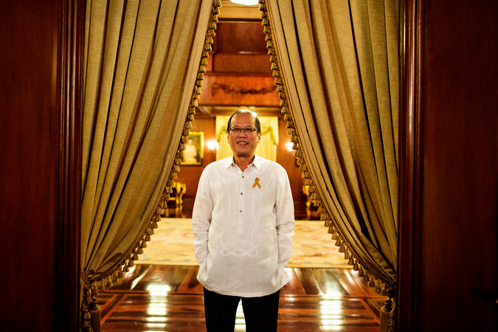
Benigno S. Aquino III, the Philippine president.
MANILA — President Benigno S. Aquino III called on Tuesday for nations around the world to do more to support the Philippines in resisting China’s assertive claims to the seas near his country, drawing a comparison to the West’s failure to support Czechoslovakia against Hitler’s demands for Czech land in 1938.
Like Czechoslovakia, the Philippines faces demands to surrender territory piecemeal to a much stronger foreign power and needs more robust foreign support for the rule of international law if it is to resist, President Aquino said in a 90-minute interview in the wood-paneled music room of the presidential palace.
“If we say yes to something we believe is wrong now, what guarantee is there that the wrong will not be further exacerbated down the line?” he said. He later added, “At what point do you say, ‘Enough is enough’? Well, the world has to say it — remember that the Sudetenland was given in an attempt to appease Hitler to prevent World War II.”
- Graphic: Overlapping Airspace Claims in the East China SeaNOV. 27, 2013

Mr. Aquino’s remarks are among the strongest indications yet of alarm among Asian heads of state about China’s military buildup and territorial ambitions, and the second time in recent weeks that an Asian leader has volunteered a comparison to the prelude to world wars.
Prime Minister Shinzo Abe of Japan caused a stir in Davos, Switzerland, when he noted last month that Britain and Germany went to war in 1914 even though they had close economic ties — much as China and Japan have now.
Japan has been locked in an increasingly tense standoff with China over uninhabited islands in the East China Sea, and even South Korea, which has been quieter about Chinese claims, expressed alarm last year when Beijing announced that it had the right to police the skies above a vast area of ocean, including areas claimed by Japan and South Korea.
While China’s efforts to claim rocks, shoals and fishing grounds off the coast of the Philippines in the South China Sea have been less high-profile, the Chinese have moved faster there.
The Philippines already appears to have lost effective control of one of the best-known places of contention, a reef called Scarborough Shoal, after Philippine forces withdrew during a standoff with China in 2012. The Philippine forces left as part of an American-mediated deal in which both sides were to pull back while the dispute was negotiated. Chinese forces remained, however, and gained control.
In his nearly four years as president, Mr. Aquino, 53, has exceeded expectations in his country and the region for what he would be able to accomplish in a nation once known as the “sick man of Asia.” He was a fairly low-key senator when he was propelled into the presidency in 2010 by a wave of national sympathy after his mother, former President Corazon C. Aquino, died the year before.
Political analysts say that his administration has fought and reduced the corruption that played a role in holding the Philippines back. In one practical measure of that change, the country has been able to pave more roads per 100 million pesos in spending (about $2.2 million) than before — when funds were lost to corrupt officials and incompetence — finally addressing an impediment to commerce.
All of the major credit rating agencies now give the Philippines an investment grade rating, though the recent downturn in share prices and currencies here and in other emerging markets, on fears of further slowing of the Chinese economy, poses an immediate challenge.
In another accomplishment, Mr. Aquino’s negotiators concluded a major peace agreement last month with the main resistance group on Mindanao, the heavily Muslim southern island. Still, the deal remains something of a gamble; it is based in good part on the Muslim group’s ability to hold in check smaller resistance groups, which criticized the pact almost immediately.
Despite those successes, Mr. Aquino was criticized for the country’s slow initial response to last year’s devastating typhoon. He said the storm was so powerful that it overwhelmed the Philippines’ many preparations.
He has also been less aggressive on land reform — the Aquinos are among the country’s biggest landowning families — and he has preferred to shift more of the government’s social spending to poor villages instead. Walden Bello, although a congressman in the president’s governing coalition, said he was one of many who believe that “the lack of real progress on land reform is a real reason why poverty rates have remained” at high levels.
Analysts say the almost feudal power of some entrenched families, including some with militias, is a further obstacle to growth. But Mr. Aquino said he was trying to convince the families that becoming less insular would foster greater prosperity.
Mr. Aquino is prevented by law from seeking re-election when his six-year term expires in 2016, raising uncertainty about whether his changes will continue.
In the wide-ranging interview on Tuesday, Mr. Aquino said he thought the Philippines and the United States were close to a long-delayed deal that would allow more American troops to rotate through the Philippines, enhancing his country’s security. But the subject remains controversial among the political elite in the Philippines, with memories of the country’s past as an American possession making them wary of closer military ties.
The United States is pushing for the deal to aid in its rebalance to Asia, where it hopes to retain a strong influence despite China’s rise.
Speaking of the Philippines’ own tensions with the Chinese, Mr. Aquino said his country would not renounce any of its possessions in the sea between it and China.
China contends that centuries-old maps show that it had an early claim to the South China Sea almost to Borneo. It is trying to use its large and growing fleet to exercise effective control over reefs and islands in the sea, a strategy that could strengthen its legal position.
At the same time, China has strongly resisted applying the procedures and numerical formulas of the United Nations Convention on the Law of the Sea to the many reefs and islands that lie much closer to countries like the Philippines than to China. Officials in Beijing also oppose multilateral discussions, preferring bilateral talks with individual countries in Southeast Asia, an approach that allows Chinese leaders to apply greater pressure.
While China has been improving its military, Mr. Aquino noted that the last flight by a Philippine fighter jet was in 2005 and that the plane dated from before the Vietnam War. Most of the country’s tiny naval and coast guard fleet dates from World War II.
The difficulties with China extend beyond the arguments over the South China Sea. The Hong Kong government, with enthusiastic backing from the Chinese Foreign Ministry in Beijing, plans to stop allowing 14-day visa-free visits by Filipino diplomats and officials starting Wednesday. The sanctions are part of a long-running demand by Hong Kong that the national government of the Philippines apologize over a violent episode in 2010 in which a hostage rescue attempt in Manila failed, leaving eight Hong Kong citizens dead.
In his first public response to the sanctions, Mr. Aquino said he had no plans to apologize, saying that doing so could create a legal liability and noting that China had not paid compensation to the families of Filipinos who have died in episodes there.
Mr. Aquino, who is not married, lives in a small cottage behind the presidential palace instead of in the luxurious palace itself. He said he tries to relax before going to sleep each night either by listening to music — often jazz — or pursuing his passion as an amateur historian, reading military journals, some about World War II.
While recently reading about the predicament of Czechoslovakia’s leaders in the late 1930s, he said, he saw a parallel “in a sense” to his own problems now in facing challenges from China. Appeasement did not work in 1938, he noted; within six months of the surrender of the Sudetenland, Germany occupied most of the rest of Czechoslovakia.
The Philippines, he said, is determined not to make similar concessions. “You may have the might,” he said of China, “but that does not necessarily make you right.”

NYT

In High Seas, China Moves Unilaterally
By JANE PERLEZ and KEITH BRADSHERMAY 9, 2014
BEIJING — It is the pride of China’s state-run oil industry and the nation’s first deepwater drilling rig, a vessel as big as a football field and as tall as a 40-story building, with a $1 billion price tag. Last week, it crawled through the South China Sea, pulled by heavy-duty tugs, and parked in one of the most sensitive spots possible, about 17 miles off a speck of an island claimed by both China and Vietnam.
The Vietnamese, at times embraced in brotherly Communist Party fealty by China, were taken by surprise. Hanoi assumed the rig, known as HD-981, was just passing through, people close to the government said.
At least twice in recent years, China has sought to explore these waters and backed down after protests by Vietnam. Just six months ago, during a visit of the Chinese prime minister to Hanoi, the two sides announced that they would try to find ways to jointly develop oil and gas fields.
That good will evaporated this week when Beijing made clear the drilling rig was staying put. It set off four days of confrontation, with dozens of Chinese and Vietnamese naval vessels ramming one another and China using water cannons in a standoff that threatens to push a region known for its economic development toward military conflict.
China has not been shy in recent years about making broad claims to control much of the South China Sea. But by installing an expensive drilling rig in disputed waters, it now appears more willing to act first and invite diplomacy later. It is in effect creating “facts” in the water that its regional rivals, and ultimately the United States, must either accept or fight.
China signaled it would take unilateral steps last year, when it declared an air defense zone over parts of the East China Sea that includes islands at the center of a long-smoldering dispute with Japan. In the battle of wills with Vietnam, China has unleashed a new and potentially powerful tool in its battle for territory: its oil industry and the rigs a state oil-company official once called “our mobile national territory.”

Editorial: Trouble in the South China SeaMAY 9, 2014

The deployment of the rig is a possible game changer in China’s determination to dominate the South China Sea, as oil exploration requires substantial investment and often protection, which in China’s case would be provided by its ships, including its navy.
“China has been taking incremental steps, escalating and increasing its presence in the South China Sea, but this is crossing a threshold,” said Holly Morrow, a fellow in the Geopolitics of Energy program at Harvard who served on the National Security Council in the George W. Bush administration.
It is unclear if China’s gambit will end up the way its leaders hope. Two years ago, China was able to nudge aside the Philippines from a disputed reef, without a fight, by simply refusing to abide by an American-brokered agreement. The Philippines retreated, as promised. The Chinese did not, and have controlled the reef, the Scarborough Shoal, and its rich fishery ever since.
Vietnam has proved to be a tougher adversary, sending out its own ships to meet the Chinese flotilla and, according to Chinese government reports, using them to ram Chinese ships as many as 171 times in four days.
A prominent Vietnamese political analyst, Nguyen Quang A, summarized the standoff this way: “Invasion is in their blood, and resistance is in our blood.”
The timing of the move was perceived by some in the region as a test not only of the ability of Southeast Asian nations to stand up to their far more powerful northern neighbor, but also of President Obama’s resolve less than a month after he promised to support American allies in Asia as they deal with a stronger China.
China’s action was almost certainly a long-term plan — the deployment of a deep water drilling rig takes months of preparation. But a senior Asian diplomat with deep ties in the region said some officials were left with the impression after Mr. Obama’s visit that the United States was eager to avoid direct confrontation with China over its claims in the South China Sea.
At a news conference in Manila, Mr. Obama sidestepped a question about whether Washington would defend the Philippines if a territorial dispute with China became an armed conflict, instead saying “we don’t think that coercion and intimidation is the way to manage these disputes.” A few days earlier he had made a stronger statement of support for Japan in its maritime disputes with China.
On Friday, Benjamin J. Rhodes, a deputy national security adviser, said the United States had been clear that it opposed unilateral steps or the threat of force by the Chinese and that it was strengthening military ties with its allies, including the Philippines. The United States does not have a defense treaty with Vietnam.
“We have reaffirmed our support for our mutual defense treaties with allies in the region, and have supported the efforts of the Philippines to pursue international arbitration to resolve maritime disputes,” Mr. Rhodes said.
Continue reading the main story

Map: Territorial Disputes in the Waters Near China

Few believe that energy discoveries were the primary reason for the arrival of rig HD-981, which is owned by China National Offshore Oil Corporation, or Cnooc, the state-run energy giant.
For decades, geologists and major energy companies have debated whether the seabed of the South China Sea holds commercially viable deposits of oil and gas. Many are skeptical, especially regarding the area around the Paracel Islands, which the rig expects to explore and which a 2013 assessment by the United States Energy Information Administration deemed to be especially unlikely to hold much oil or gas.
“Cnooc is a business but also a political actor,” said Ms. Morrow of Harvard. “It’s never about energy completely, it’s about sovereignty.”
Still, the company’s enthusiasm for drilling in the area may have been bolstered by three-dimensional seismic tests conducted last May and June, according to a report in the state run news agency, Xinhua.
Previously, only two-dimensional seismic surveys, which are less reliable, had been conducted, said Peter Dutton, professor and director of the China Maritime Studies Institute at the United States Naval War College in Rhode Island.
Another incentive for drilling is that the site is close to two exploratory areas where Exxon Mobil discovered substantial oil and gas reserves in 2011 and 2012, energy lawyers in Hong Kong said.
“China’s location of the drilling rig in this block cannot be attributed solely to provocation,” Mr. Dutton said.
In Vietnam, the Chinese move is challenging the government’s delicate balancing act between strong anti-China sentiment and not wanting to get too close to the United States.
Hanoi maintains a military hotline with the People’s Liberation Army, while resisting Washington’s invitations to participate in joint military exercises and overtures for access to Cam Ranh Bay, a deepwater base on the South China Sea.
Still, Vietnam can ill afford to alienate China; it is increasingly economically dependent on China for cheap parts that are used in its growing manufacturing sector, and for hosting poor agrarian workers in southern China.
The Cnooc oil rig and other acts of Chinese assertiveness in the South China Sea over the past few months will now take center stage, according to Ernest Z. Bower and Gregory B. Poling of the Center for Strategic and International Studies in Washington, who posted an article on its website.
“There is no telling who will blink first,” they wrote.

CSIS
China-Vietnam Tensions High over Drilling Rig in Disputed Waters
- 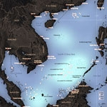
By Ernest Z. Bower, Gregory B. Poling
May 7, 2014

Tensions between China and Vietnam over the disputed South China Sea are at their highest levels in years. On May 2, the state-owned China National Offshore Oil Corporation (CNOOC) placed its deep sea drilling rig HD-981 in disputed waters south of the Paracel Islands. Vietnam objected to the placement, declaring that the rig is located on its continental shelf. China has since sent approximately 80 ships, including seven military vessels, along with aircraft to support the rig. In response, Hanoi dispatched 29 ships to attempt to disrupt the rig’s placement and operations.
The situation escalated dramatically on May 7, when Vietnam accused Chinese vessels of turning high powered water cannons on the Vietnamese ships and eventually ramming several vessels. The incidents reportedly left six Vietnamese injured and several of the country’s ships damaged. Hanoi released photos and videos of the incidents to support its claims.
The implications of these developments are significant. The fact that the Chinese moved ahead in placing their rig immediately after President Obama’s visit to four Asian countries in late April underlines Beijing’s commitment to test the resolve of Vietnam, its ASEAN neighbors and Washington. Beijing may also be attempting to substantially change the facts on the seas by moving while it perceives Washington to be distracted by Russian aggression inUkraine, developments in Nigeria, and Syria. If China believes Washington is distracted, in an increasingly insular and isolationist mood and unwilling to back up relatively strong security assertions made to Japan and the Philippines and repeated during President Obama’s trip, these developments south of the Paracel Islands could have long term regional and global consequences.
Q1: Where is the rig, really?
A1: The war of words between Beijing and Hanoi has largely focused on the status of the area where HD-981 was placed. Vietnamese officials insist that it lies on their continental shelf, where according to the UN Convention on the Law of the Seas (UNCLOS), Vietnam has exclusive rights to all mineral and hydrocarbon resources.
The rig was placed near the edge of two hydrocarbon blocks already created by Hanoi, though not yet offered for exploitation to foreign oil and gas companies. It also sits near blocks 118 and 119, where U.S.-based ExxonMobil discovered substantial oil and gas reserves in 2011 and 2012. In 2013, Exxon and Vietnam’s state-owned PetroVietnam announced plans to build a $20 billion power plant to be fueled by the oil and gas from those blocks. Those discoveries help explain why CNOOC chose to place HD-981 nearby.
China’s Ministry of Foreign Affairs has responded to Vietnam’s complaints by insisting that the rig was placed “completely within the waters of China's Paracel Islands.” This presumably refers to the 200 nautical mile exclusive economic zone and continental shelf that those islands—which are occupied by China but claimed by Vietnam—would generate under UNCLOS if they met certain requirements.
HD-981 was placed at 15°29’58’’ north latitude and 111°12’06’’ east longitude. It is about 120 nautical miles east of Vietnam’s Ly Son Island and 180 nautical miles south of China’s Hainan Island—the two nearest features that indisputably generate a continental shelf. As such, it not only sits on Vietnam’s claimed extended continental shelf, but also well on the Vietnamese side of any median line that might be negotiated between the two shelves from the Chinese and Vietnamese coasts, as indicated by the white lines in the map below.
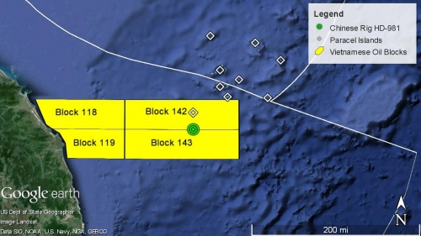
Q2: Who is in the right?
A2: China’s Ministry of Foreign Affairs appears to be basing its case on the assumption that Triton Island, 17 miles to the north of HD-981, or another of the Paracels meets the UNCLOS habitability requirement for generating its own continental shelf. If that were assumed to be true, then HD-981 would indeed fall within the maximum hypothetical area of dispute generated by the Paracels, shown in red below. This is the maximum dispute because it gives the tiny Paracel Islands equal weight in delimitation with the entire Vietnamese coast facing them—a proposition that borders on the absurd.
So China can make a legal case, however flimsy, for control over the continental shelf on which HD-981 sits. But that area is clearly in dispute. To unilaterally drill on it is a violation of UNCLOS’s admonition that states in a dispute, “in a spirit of understanding and cooperation, shall make every effort to enter into provisional arrangements,” and shall not “jeopardize or hamper the reaching of [a] final agreement.” It is also clearly contrary to the 2002 Declaration on the Conduct of Parties in the South China Sea that China signed with the members of the Association of Southeast Asian Nations (ASEAN), including Vietnam. In that agreement, all parties pledged to “exercise self-restraint in the conduct of activities that would complicate or escalate disputes and affect peace and stability.”
Hanoi, on the other hand, has restricted its oil and gas activities in the area to those fields, like blocks 118 and 119, that lie outside the maximum area of legal dispute.
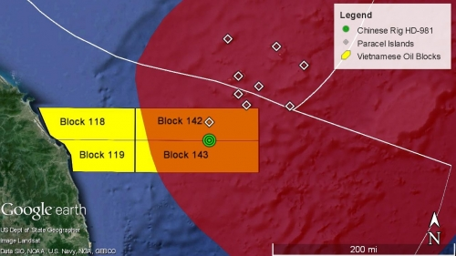

Q3: What comes next?
A3: The deployment of HD-981, which Beijing insists will remain in place until August 15, has clearly ratcheted China-Vietnam tensions to a new level. Hanoi seems determined to disrupt the rig’s operations. And, in contrast to the Philippines, it has the capabilities—Russian-built Kilo-class submarines and an outdated but sizeable surface and air fleet—to do so. This means there is a real threat that acts of brinksmanship, like the recent ramming of Vietnamese vessels, could escalate quickly. Vietnam’s neighbors and outside partners like the United States must use every available channel to urge caution on both sides.
On the other hand, Vietnam’s relative naval capabilities will likely help temper Chinese assertiveness. After all, despite the presence of Chinese naval vessels around HD-981, it appeared that only Chinese Coast Guard vessels were involved in harassing and deterring Vietnamese ships attempting to enter the waters around the rig. The two nations’ and their leaders are as familiar with each other as anyone in the Asia Pacific, and they have substantial channels for communications, including top-level naval hotlines. This could also help avoid a larger crisis.
Vietnam has already launched a diplomatic campaign to build support abroad and paint China as the aggressor. Given other recent provocations by China against its neighbors, this will prove easy. This weekend, Vietnamese prime minister Nguyen Tan Dung will join his fellow leaders from across Southeast Asia at the ASEAN Summit. The placement of the drilling rig, along with China’s patrols at Malaysia’s James Shoal earlier this year and attempts to block resupply of Philippine troops at Second Thomas Shoal in March, will ensure that the South China Sea disputes take center stage. There is no telling who will blink first in the stand-off over HD-981, but the one thing that is certain is that China’s newest provocation will further heighten the threat perception among ASEAN states and drive them closer to each other and interested outside parties, especially Japan and the United States.
Ernest Bower is the Sumitro Chair for Southeast Asia Studies and Gregory Poling is a fellow with the Sumitro Chair for Southeast Asia Studies at the Center for Strategic and International Studies in Washington, D.C.

Critical Questions is produced by the Center for Strategic and International Studies (CSIS), a private, tax-exempt institution focusing on international public policy issues. Its research is nonpartisan and nonproprietary. CSIS does not take specific policy positions. Accordingly, all views, positions, and conclusions expressed in this publication should be understood to be solely those of the author(s).

How Do You Say 'Drill, Baby, Drill' in Chinese?

FP

Beijing's deployment of its billion-dollar oil rig sends a clear message to Vietnam: We'll drill where we damn well please.
- BY Keith Johnson
- MAY 5, 2014

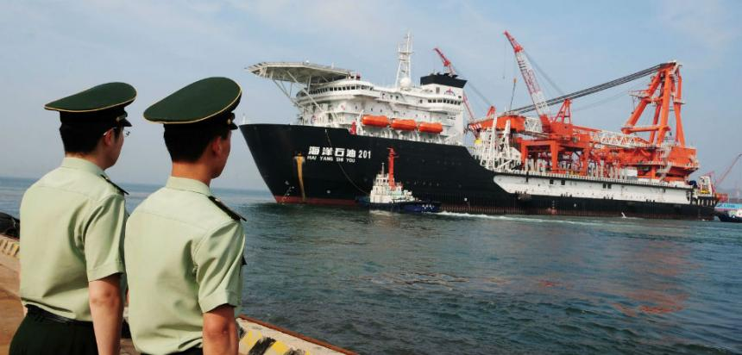
NOTE: This story was updated May 6, 2014 to include State Department comments.

China has triggered a potentially dangerous escalation in tensions in the South China Sea with the dispatch over the weekend of the Haiyang Shiyou 981, a massive billion-dollar rig designed to drill for oil in waters claimed by both Beijing and Hanoi.
Vietnam has vociferously protested the move because the rig is squarely inside the 200-mile exclusive economic zone that extends offshore from every country; China, which claims the nearby Paracel Islands, says the rig is legal because it is working in waters that it says belong to Beijing.
It's hardly the first time that the search for energy has sparked fights between China and its neighbors in the region, but the latest step is a big deal for several reasons.
China had carried out energy survey activities in disputed areas, and prevented other countries, including Vietnam, from carrying out their own surveys in disputed waters, but this seems to be the first time that Chinese oil companies are actually drilling wells in waters claimed by other nations. Just as alarmingly, China and Vietnam have a history of armed conflict, including a bloody land war in 1979 and a series of armed skirmishes over disputed islands in the South China Sea. The oil drilling issue could potentially trigger a new round of sparring.
The Chinese move also represents a slap in the face to President Barack Obama, who just returned from a trip to Asia designed to reassure jittery allies like Japan, South Korea, and the Philippines that the U.S. would deter Chinese maritime bullying. Six days later, Beijing took one of its most provocative steps to date.
"Given the recent history of tensions in the South China Sea, China’s decision to operate its oilrig in disputed waters is provocative and unhelpful to the maintenance of peace and stability in the region," State Department spokesperson Jen Psaki said at a briefing Tuesday.
The dispatch of an oil rig by itself is hardly enough to unleash the dogs of war, but is meant to slowly assert Chinese control over the region, experts said.
The dispatch of an oil rig by itself is hardly enough to unleash the dogs of war, but is meant to slowly assert Chinese control over the region, experts said.
"It's going to be one more of these small, incremental steps that individually won't lead to conflict, but collectively over time gradually will change the status quo," said Mike McDevitt, a retired admiral and head of strategic studies at the CNA Corporation.*
A spokesperson for the Chinese Foreign Ministry defended the deployment of the rig, saying that it is operating "completely within the waters of China's Paracel Islands," Reuters reported. China has occupied the Paracel Islands since the 1970s, and also claims the maritime resources around those specks of land. That's part of Beijing's expansive view of its sovereign rights in the South China Sea, the so-called "nine-dashed-line" that the current regime inherited from Chinese nationalists at the end of the civil war in the late 1940s.
Vietnam's Foreign Ministry and state oil firm PetroVietnam, unsurprisingly, both protested the move. The Foreign Ministry said that the move is a "violation of Viet Nam's sovereign rights," since the rig is located in waters that only Vietnam has the right to exploit for undersea resources. PetroVietnam asked China National Offshore Oil Corporation, a state-owned giant, to remove the rig and cease drilling activities there in the future.
The South China Sea is the biggest flashpoint for potential conflict between China and neighbors like Vietnam and the Philippines, and others; the sea is both a byway for trillions of dollars in international trade and potentially sits atop a mother lode of oil and gas resources coveted by energy-poor countries in the region. Manila recently took Beijing to an international tribunal in The Hague over competing claims to tiny specks of land in the South China Sea, in part because it believes there are plentiful deposits of oil and gas off the Philippine coast.
The quest for oil and gas lies behind the latest incident, at least superficially. China publicly announced in 2012 that it would auction off energy-exploration rights in disputed waters; at the same time, CNOOC took the unusual step of building its own deep-water rig rather than contracting to purchase one from specialized suppliers. That was a costly, but necessary, step for China's oil company to take: CNOOC did not want to have to rely on Western companies to supply drilling gear for contentious areas of the South China Sea because the companies could have potentially refused to lease the equipment to CNOOC if it was going to be used on controversial deepwater projects.
Last weekend, CNOOC dispatched the rig to drill in deep waters about 120 nautical miles east of the Vietnamese coast, not far from where international oil firms such as Exxon Mobil have found potentially large deposits of natural gas. It seems part and parcel of CNOOC's stated strategy of dispatching oil rigs to serve as "mobile national territory" that can extend Chinese sovereignty to open waters.
"I think this is the other shoe dropping, which is the Chinese actually going to go out and drill for oil" in those disputed areas, said Holly Morrow, an expert on the South China Sea at Harvard University's Belfer Center.
China's apparent escalation with the dispatch of the rig is especially surprising because the two countries signed an accord in 2011 to peacefully resolve South China Sea disputes, as they successfully did with maritime borders in the Gulf of Tonkin.
"I thought that agreement cooled down the rhetoric between Vietnam and China, and that China would not go out of its way to humiliate the Vietnamese," said McDevitt.
"I thought that agreement cooled down the rhetoric between Vietnam and China, and that China would not go out of its way to humiliate the Vietnamese," said McDevitt. "But the Chinese seem to feel they have a good argument for going where they're going, and they are going to do it."
The U.S. as a rule doesn't take a position as to who owns what in the disputed areas, but in recent years has stressed the need for states such as Vietnam and China to rely on the rule of law to settle disputes over territory and maritime rights in the South China Sea. In December, Secretary of State John Kerry announced a deal to help strengthen the Vietnamese coast guard, in part to help parry Chinese territorial expansion in the area.
Oil and gas rigs are the pointy ends of the battle over sovereignty, but there is plenty of uncertainty over just how energy-rich the area really is. In part, that is because all the territorial disputes have discouraged large-scale surveys of potential oil and gas resources.
The U.S. Energy Information Administration estimates that the South China Sea holds the modest amount of 11 billion barrels of oil and 190 trillion cubic feet of natural gas. CNOOC believes there could be ten times as much oil and plenty more gas in the South China Sea. Vietnam, bolstered by recent work by firms such as Exxon, is also bullish on the energy prospects in parts of the South China Sea it considers its own.
But regardless of how much energy actually lies under the ocean, Beijing's heavy-handed approach to regional relations and the damage it has caused could hardly be worth tapping some extra barrels of oil, said Morrow of the Belfer Center. That makes the constant tug-of-war, provocations, and brinksmanship more about national sovereignty than a scramble for resources.
"The cost in foreign policy terms of what they are doing is so high, and so outweighs whatever energy security benefit there is," she said.
*Correction, May 6, 2014: Mike McDevitt is with the CNA Corporation; an earlier version of this story said that he was an analyst with the Center for Naval Analyses.

NYT Foreign Factories in Vietnam Weigh Damage in Anti-China Riots
By CHAU DOAN and THOMAS FULLERMAY 14, 2014
Photo
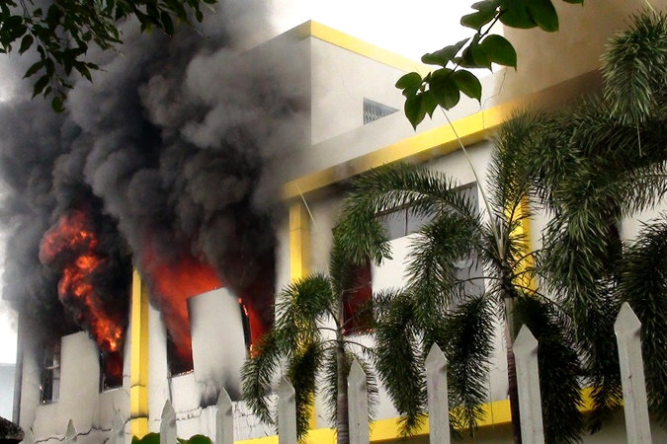
Smoke and flames billowed from a factory window in the southern Vietnamese province of Binh Duong during anti-China protests on Wednesday.
HANOI, Vietnam — Foreign businesses in Vietnam were assessing damage to their factories on Wednesday after thousands of Vietnamese workers rampaged through an industrial area in the south of the country.
The riots, which were the worst in recent Vietnamese history and took place Tuesday night, began as protests against China’s stationing of an oil rig in disputed waters off Vietnam’s coast. But violence spiraled, and the vast majority of factories damaged were owned by companies from Taiwan and South Korea, not from mainland China.
“There was quite a lot of damage,” said Chen Bor-show, the director general for the Taipei Economic and Cultural Office in Ho Chi Minh City, Taiwan’s de facto consulate in the city. Mr. Chen said about 200 companies were affected.
YTN, a South Korean news channel, reported that about 50 Korean companies were attacked by mobs. Five factory personnel were lightly hurt, and one was hospitalized with a leg injury, the channel reported.
Continue reading the main story

Related Coverage

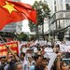

Sinosphere Blog: Taiwan Concerned Over Mistaken Identity in Vietnam ProtestsMAY 14, 2014

Anger Grows in Vietnam Over Dispute With ChinaMAY 14, 2014

About 19,000 workers were involved in the protests Tuesday, said Tran Van Nam, the vice chairman of Binh Duong Province, where the violence occurred. He was quoted in VNExpress, a Vietnamese online news site.
Photo
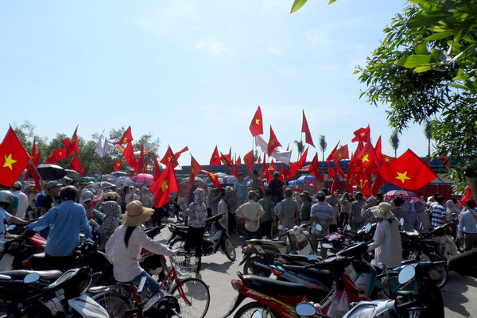
Demonstrators waved Vietnamese flags during a protest at a Chinese-owned factory in Vietnam's northern Thai Binh Province on Wednesday. Credit Reuters
The Chinese Embassy in Hanoi issued a notice on Wednesday that urged Chinese living in Vietnam to “minimize unnecessary outings.” A staff member at the Chutex Garment Factory north of Ho Chi Minh City said 8,000 to 10,000 workers were involved in the rampage at his factory.
“They burned the office,” said the staff member, who agreed to speak on the condition that his name not be used. The rioters “burned everything, all of the materials, computers, machines.” Police units and firefighters arrived at the factory Tuesday and “disbanded” the rioters, he said. On Wednesday morning the police “captured” 15 to 20 men who were attempting to loot the premises, he said.
The Chutex factory, located in Song Than Industrial Park 2 in Binh Duong, is described on its website as one of the largest garment exporters in Vietnam. Chutex International, the parent company, was founded by a garment executive from Taiwan. It is unclear why rioters targeted a factory linked to Taiwan. News outlets in Hong Kong said workers might not have been distinguishing between mainland China and Taiwan, a self-governing island which also has claims to territory in the South China Sea.
Taiwan’s Foreign Ministry condemned the rioting. In a statement, it called on the demonstrators to “exercise self-control, don’t behave irrationally, damage Taiwanese factory equipment or threaten the safety of Taiwanese businesspeople, which could harm Taiwan’s willingness to invest and harm the longstanding friendly relations between the people of Taiwan and Vietnam.”
Yue Yuen, a Taiwan-based company that manufactures many of the shoes sold under brands like Nike and Adidas, said that it had given the day off to workers at its factories in Vietnam on Wednesday and was waiting before deciding whether to reopen on Thursday, even though its factories were not damaged and none of its workers were injured. Jerry Shum, the company’s head of investor relations, said that Yue Yuen expected calm to return quickly to industrial districts in Vietnam and believed that it could still meet monthly shoe production targets.
The company’s shares, listed on the Hong Kong stock market, plunged 4.95 percent in heavy trading on Wednesday. Yue Yuen made 313 million pairs of shoes last year, a third of them in Vietnam, and it is often described as the world’s largest shoe manufacturer, although there are no official international rankings.
A report Tuesday on the website of the state-controlled Tuoi Tre newspaper said hundreds of workers from several firms staged a protest Monday evening against China’s decision this month to place an oil rig in a disputed area of the South China Sea. The report said the workers had marched toward the Vietnam Singapore Industrial Park 1, also in Binh Duong Province. That report, which did not mention violence, remained online Wednesday.
A statement by the Vietnam Singapore Industrial Park on Wednesday said that protests against China began on Monday and that on Tuesday protesters “targeted” companies that were owned or managed by “Chinese as well as Chinese expatriates working for other companies.”
Protesters set fire to three factories, but there were “no casualties,” the statement said. “The local police are on site and have taken over security of both industrial parks,” the statement said.
An article in Phoenix News, which is based in Hong Kong, quoted a businesswoman described only as Yan who said the industrial zone where she worked resembled a “battlefield.” Taiwanese in the area had fled to hotels, she said.
A report Tuesday on the website of the Vietnamese state-controlled Thanh Nien newspaper put the number of workers protesting at the park at 6,000. But by Wednesday morning, the report appeared to have been removed.
Singapore’s Ministry of Foreign Affairs called in Vietnam’s ambassador on Wednesday and had its embassy in Hanoi and consulate in Ho Chi Minh City contact the Vietnamese authorities, asking that the government of Vietnam “restore order urgently.” The ministry said that protests had occurred at two industrial parks in which Singapore-based entities had invested and that “a number of foreign companies have been broken into and set on fire.”
Vietnam Singapore Industrial Park says on its website that it has five locations in Vietnam, two of them in Binh Duong. It says the parks have collectively created more than 140,000 local jobs and attracted nearly 500 “customers” with $6.4 billion worth of investments and $8 billion in export value. The company was established in 1996 as a cooperative venture of the Vietnamese and Singaporean governments.
Demonstrations occur sporadically in Vietnam, typically over alleged land grabs by firms with deep ties to the authoritarian, one-party government. There have also been periodic strikes against working conditions in foreign-owned industrial parks. But demonstrations of thousands of people are rare.
It was unclear on Wednesday whether the activity in Binh Duong had been sanctioned by the state or whether the local police had kept the protesting workers fully under control.
China’s massive oil rig is 140 miles off the coast of Vietnam and about 17 miles from a small island claimed by both countries.
Vietnamese and Chinese vessels have collided a number of times near the rig.
Earlier this week, John Kerry, the American secretary of state, told his Chinese counterpart, Foreign Minister Wang Yi, that the “introduction of an oil rig and numerous government vessels in waters disputed with Vietnam was provocative,” according to an American State Department representative.
At a news briefing on Tuesday, the representative called the placement of the oil rig “unilateral action that appears to be part of a broader pattern of Chinese behavior to advance its claims over disputed areas in a matter that, in our view, undermines peace and stability in the region.”
But China’s state-run news agency, Xinhua, disputed the State Department’s account of Mr. Kerry’s conversation Tuesday.
“In fact, U.S. Secretary of State Kerry made no such comments during the phone conversation,” a Chinese Foreign Ministry spokeswoman, Hua Chunying, was quoted as saying. She said Mr. Kerry did not use the word “provocative.”
Mr. Kerry’s message, the news agency said, was that the United States was not taking sides in the dispute.

NYT China Targeted by Vietnamese in Fiery Riots
By CHAU DOAN and THOMAS FULLERMAY 14, 2014
Photo
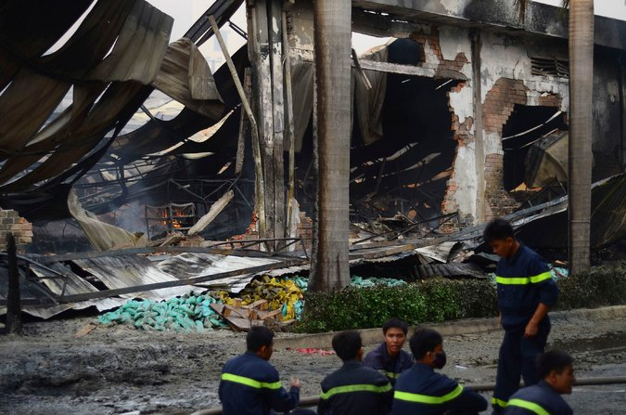
Firefighters rested on Wednesday near a Chinese-owned shoe factory that was set afire in the Binh Duong Province of Vietnam. Credit Thanh Tung Truong/Reuters
BINH DUONG PROVINCE, Vietnam — Dozens of foreign-owned factories near Ho Chi Minh City, Vietnam, lay in charred ruins early Thursday after thousands of Vietnamese workers rampaged over China’s latest efforts to monopolize control of the South China Sea, this time off Vietnam’s coast.
The riots marked a rare demonstration of popular outrage over China’s increasingly insistent claims to resource-rich seas. But in their rage, the Vietnamese workers appeared to misdirect their anger, attacking businesses from countries that took the risk of investing in their country.
The explosion of violence reflected growing animosity in some countries in the region as China works to solidify its claims over vast swaths of two oceans that other nations have long considered their own.
Continue reading the main story

Related Coverage

Philippines Challenges China Over Disputed AtollMAY 14, 2014

Sinosphere Blog: Taiwan Concerned Over Mistaken Identity in Vietnam ProtestsMAY 14, 2014

Anger Grows in Vietnam Over Dispute With ChinaMAY 14, 2014

On Wednesday, the conflict played out not only in Vietnam, but also in the Philippines, which said it lodged a formal protest with China over signs that it is reclaiming land at a contested coral reef. But so far neither the Philippines nor Vietnam has gotten much backing among other Southeast Asian nations, some of which count on China for investment and aid.

China Responds to Riots in Vietnam

China Responds to Riots in Vietnam
China’s foreign ministry spokeswoman responded to the anti-China riots in southern Vietnam that damaged scores of foreign-owned factories.
Credit Vnexpress, via Agence France-Presse — Getty Images
The recent moves by China — covering an area that stretches from Indonesia north to Japan — are part of what analysts see as an effort to create “facts” in the waters that leave China’s less powerful neighbors with few good options. Taken together, the actions escalate a longstanding battle that has only grown with China’s military and economic rise.
In Vietnam, the focus of anger was China’s decision to deploy an oil rig — escorted by a flotilla of coast guard and other ships — off the Vietnamese coast despite promises to settle the dispute by diplomacy.
“It’s just this witches brew of aggrievement and nationalism,” Jonathan D. Pollack, who focuses on Asia at the Brookings Institution in Washington, said of the increasingly dangerous contests for control of the South China and East China seas. “The only option is some sort of move toward shared development, but no one seems to be in the mood for that.”
On Tuesday and Wednesday, the epicenter of those conflicts was the factories in the gritty suburbs north of Ho Chi Minh City, where thousands of poor Vietnamese stitch name-brand sneakers and clothing for sale around the world.
The plants, part of a surge of international investment in recent years, have contributed to more than two decades of uneven — but at times rapid — economic growth.
Continue reading the main story

Map

Territorial Disputes in the Waters Near China
China has recently increased its pursuit of territorial claims in nearby seas, leading to tense exchanges with neighboring countries. A map of some of the most notable disputes.
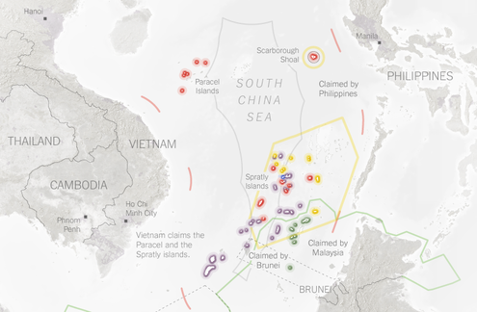
OPEN Map

Early Thursday, Nguyen Van Thong, a worker at an electronics plant he called American-owned, said his fellow workers had been “angry over China’s invasion” when they began driving motorbikes through the streets, hurling gasoline-soaked rags into buildings. His American-owned electronics factory was spared, he said, only when guards trying to fend off an angry crowd pointed to the Vietnamese and American flags flying overhead.
Although Vietnam has been vehement in its opposition to the drilling rig and has loosened tethers on anti-China sentiments in the past, the protests appeared to rattle the authoritarian government wary of protests that could veer into calls for greater democracy. Initial press reports of the violence were scrubbed from the Internet hours later, leaving in their place articles that cited only peaceful protests.
The country’s leaders face difficult choices in on how to respond to China’s latest challenge. Unlike both Japan and the Philippines, it does not have a defense treaty with the United States, which has said it will stand by its allies.
It is also more exposed to China’s growing assertiveness. A war, or even heightened conflict, would almost surely be disastrous, jeopardizing the gains Vietnam has made in recent years after decades of occupation and war.
But so far its efforts at diplomacy have failed. Vietnam attempted bilateral negotiations with China, but the talk of sharing riches seemed hollow after China dispatched the oil rig without negotiations or even a warning. And Vietnam’s attempts to rally support among its fellow Association of Southeast Asian Nations last weekend fell mostly flat, with the nine other countries in the regional bloc offering only a vague call for diplomacy in place of unilateral action.
Demonstrators waved Vietnamese flags during a protest at a Chinese-owned factory in Vietnam's northern Thai Binh Province on Wednesday. Credit Reuters
The lack of choices may have contributed to the pent-up frustration this week. The angry crowds appeared to take their greatest toll on Taiwanese and South Korean factories. The few workers and guards who remained in streets that smelled of burnt plastic early Thursday said they assumed workers were at first confused about the factories’ ownership, then got caught up in indiscriminate looting.
At one Taiwanese factory that had tried to ward off the rampaging workers, a banner outside the ruined building read “No Chinese working here.” And in a stretch of the Vietnam Singapore industrial park, which includes investors from many countries, companies that hung signs in Chinese were destroyed or damaged, while nearby plants flying flags of other countries were mainly untouched.
“There was quite a lot of damage,” said Chen Bor-show, the director-general for the Taipei Economic and Cultural Office, which functions as Taiwan’s de facto consulate in Ho Chi Minh City. Mr. Chen said that around 200 Taiwanese companies were affected. The South Korean Foreign Ministry said 50 Korean-owned factories were damaged in the riots, and one South Korean citizen was hospitalized with injuries that were not life-threatening.
Tran Van Nam, the vice chairman of Binh Duong Province, where the violence occurred, was quoted by a Vietnamese online news site, VnExpress, saying that around 19,000 workers were involved in the protests on Tuesday.
The Chinese Embassy in Hanoi issued a warning on Wednesday to Chinese citizens in Vietnam, urging them to “minimize unnecessary outings.”
Yue Yuen, a Taiwan-based company that manufactures shoes for Nike, Adidas and other brands, said that it had given its workers in Vietnam the day off on Wednesday, and had not yet decided whether to reopen on Thursday, even though its factories were not damaged and none of its workers were injured. Jerry Shum, the company’s head of investor relations, said that Yue Yuen expected calm to return quickly to industrial districts in the country, and believed that it could still meet its monthly production targets.
Even so, the company’s shares, listed on the Hong Kong stock market, fell 4.95 percent in heavy trading on Wednesday.
As a measure of the scale of production in Vietnam and its importance to global trade, Yue Yuen made 313 million pairs of shoes last year, a third of them in Vietnam.
While Taiwanese, South Korean and other international companies have flocked to Vietnam for its relatively cheap labor, Chinese firms have been able to meet most of those needs at home.
Taiwan’s Ministry of Foreign Affairs condemned the rioting and called on the demonstrators to “exercise self-control, don’t behave irrationally, damage Taiwanese factory equipment or threaten the safety of Taiwanese business people.” Further damage, the statement said, “could harm Taiwan’s willingness to invest, and harm the longstanding friendly relations between the people of Taiwan and Vietnam.”
The war of words between Vietnam and China continued on Wednesday. The Chinese foreign minister, Wang Yi, criticized Vietnam for “dispatching a large number of ships to forcibly intervene and brutally ram” Chinese ships, and insisted that the drilling project was nothing new. Vietnam earlier accused Chinese ships of ramming the small armada it sent out to try to stop the rig, and photos showed Chinese coast guard ships training water cannons at Vietnamese vessels.
Many of the workers at the Vietnam Singapore industrial park on Thursday seemed alternately shocked and bemused by how quickly the protests had spiraled out of control.

NYT

Vietnam Fails to Rally Partners in China Dispute
By MIKE IVES and THOMAS FULLERMAY 11, 2014
Photo
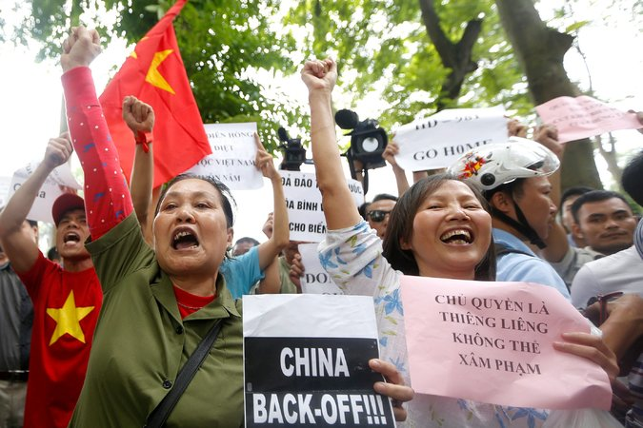
Protesters shouted anti-China slogans during a rally in Hanoi, Vietnam, on Sunday in reaction to a territorial tussle in the South China Sea.
HANOI, Vietnam — Vietnam’s prime minister, Nguyen Tan Dung, accused China on Sunday of “dangerous and serious violations” in a territorial dispute that has raised anger toward China here to the highest levels in years.
Mr. Dung’s comments, which were carried in the Vietnamese state news media, were addressed to leaders of Southeast Asian countries attending a summit meeting in Myanmar. It was his strongest statement since China towed a huge oil rig into disputed waters off the coast of Vietnam this month.
“This extremely dangerous action has been directly endangering peace, stability, security, and marine safety,” Mr. Dung was quoted as saying, adding that Vietnam had acted with “utmost restraint.”
Mr. Dung’s comments were uncharacteristically spirited for the typically anodyne meetings of the 10-country Association of Southeast Asian Nations, but they failed to produce collective criticism of China. The leaders, who work by consensus, did not mention the dispute in their final statement on Sunday. Myanmar then released a statement after the meeting was over that expressed “serious concerns over the ongoing developments in the South China Sea,” but did not mention China. It called for self-restraint and the resolution of disputes by peaceful means.
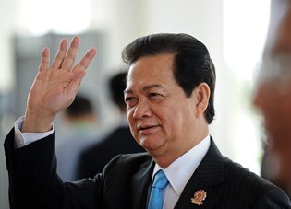
Prime Minister Nguyen Tan Dung of Vietnam arriving at the Asean summit in Myanmar on Sunday. Credit Christophe Archambault/Agence France-Presse — Getty Images
The group’s refusal to weigh in appeared to be a victory for China and underlines how there does not yet appear to be a willingness or ability to address the territorial disputes in the South China Sea collectively. At least five nations claim islands in the sea, a major shipping lane and potential flash point as China becomes more assertive and hungry for resources.
Murray Hiebert, an expert on Southeast Asia at the Center for Strategic and International Studies in Washington, said Vietnam and the Philippines, another vocal critic of Chinese maritime claims in the South China Sea, “clearly wanted something a lot stronger” out of the meeting.
The Association of Southeast Asian Nations, or Asean, has been unable in recent years to reach a common position on the South China Sea even as China’s claims have reached more than 1,000 miles southward from the Chinese mainland. A summit meeting in Cambodia two years ago failed to produce a final statement because leaders quarreled over the issue.
China is the region’s largest trade partner, and countries like Cambodia and Laos are large recipients of its aid.
“Within Asean, you have countries that really don’t want to rock the boat,” Mr. Hiebert said. “They are playing it pretty much down the middle.”
Foreign ministers at the meeting in Myanmar issued an oblique statement on Saturday citing “serious concerns over the ongoing developments in the South China Sea,” but did not mention China by name.
Several hundred protesters demonstrated peacefully outside the Chinese Embassy in Hanoi on Sunday, and Vietnam’s authoritarian government took the rare step of permitting journalists from the state-controlled news media to cover the protest. Signs displayed slogans like “Denounce the Chinese Invasion.”
“We don’t have a problem with Chinese people or their culture, but we resent their government conspiring against us,” Nguyen Xuan Pham, a literary critic, said as the protest swelled in a public park across from the embassy and a military museum.
China towed the oil rig earlier this month to waters near the Paracel Islands, which China controls and Vietnam claims.

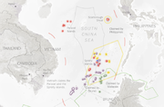

Map: Territorial Disputes in the Waters Near China

China’s state-controlled Xinhua news agency said Sunday that the oil rig was “completely within” China’s territorial waters. The rig is 140 miles off the coast of Vietnam, and about 17 miles from a small island claimed by both countries.
The maritime standoff with China, which has controlled the islands since 1974, has been widely discussed both in Vietnam’s state-controlled news media and on Facebook, which is very popular among the country’s urban middle class.
China is one of Vietnam’s major trading partners, and both countries have nominally socialist one-party governments. But Vietnamese officials sometimes appeal to anti-China sentiments here that are never far from the surface and rooted in a history of conflict between the countries.
The Vietnamese government is balancing a desire to appear strong against China with the fear that anti-China sentiment could unite disgruntled citizens who have festering grievances over land grabs, religious persecution and other social issues.
Protesters on Sunday presumed to be plainclothes agents occasionally shoved and yelled at other protesters, but most uniformed security personnel sat nearby and did not interfere.
Many at the protest were adamant that China remove its oil rig, known as HD-981, from the disputed waters, but some also criticized Vietnam’s handling of the dispute, saying the government should be more assertive. The Foreign Ministry has not issued any statements about the dispute on its website since Wednesday, when it held a high-profile news briefing featuring senior officials and the chief executive of PetroVietnam, the state oil and gas monopoly.
“Vietnam’s top leaders should call a news conference, and top leaders should clearly demonstrate their attitude so that the Vietnamese people can know what they are thinking,” said Lan Le, 40, a fashion designer in Hanoi. She spoke before the prime minister’s comments were published.
Tuong Vu, an expert on modern Vietnamese history and politics at the University of Oregon, said Vietnam’s ruling Communist Party was broadly divided between a conservative faction loyal to China and another that advocates systemic economic reforms and strengthened ties with the United States and other Western countries. He said there would be fierce debate within the party about how to respond to China’s action, fueled by concerns about the long-term economic and political implications of the standoff.
The pro-China faction has held the upper hand since the 1990s, Mr. Vu added, and it would prefer to negotiate a solution to the current impasse through diplomatic back channels rather than by criticizing China too directly. That is partly out of fear that further escalation would do more damage to the bilateral relationship and possibly embolden domestic criticism of the government.
“They’ll just let the issue quiet down slowly and try to gradually return to the status quo,” Mr. Vu said. “But who knows? In the next week, the protests may occur on a much larger scale, and things may take a different direction.”

NYT

Unrest Poses a Risky Choice for Vietnam
By CHRIS BUCKLEY and EDWARD WONGMAY 16, 2014
HA TINH PROVINCE, Vietnam — The hundreds of men on motorbikes who roared into Lee Hsueh Ying’s factory compound north of Ho Chi Minh City were bent on revenge against China. Some clung to red-and-gold Vietnamese flags while they careened around overwhelmed security guards. And in a scene repeated elsewhere in the country’s industrial heartland, they destroyed the building, smashing furniture, snatching computers and shouting “Long Live Vietnam.”
Vietnam has a history of resisting the world’s great powers. It threw out the French after almost a century of colonization and then handed the United States a humiliating defeat. That same spirit has emerged in its latest war of wills, this time over China’s attempts to project its growing power closer to Vietnam’s shores.

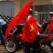

Anti-Chinese Violence Convulses Vietnam, Pitting Laborers Against LaborersMAY 15, 2014

But the target of this week’s violence — foreign businesses that have become a lifeline of Vietnam’s economy — has left Vietnam’s government with a hard choice. Ignoring the popular anger it has helped stoke could leave it open to critics at home. But taking on its longtime rival, China, in a battle it cannot win could jeopardize its standing with investors that have lifted the economy after decades of war and occupation.
Continue reading the main story

Map: Territorial Disputes in the Waters Near China

“Official Vietnamese history is almost all about standing up to China,” said Robert Templer, author of “Shadows and Wind: A View of Modern Vietnam. “So it is hard for the government to criticize the public when they say they are doing exactly that.”
In one sign of that ambivalence, the prime minister, Nguyen Tan Dung, sent a text to millions of citizens after the violence abated, praising the protesters’ defiance but making clear that his authoritarian government would not tolerate continued unrest.
“The prime minister requests and calls on every Vietnamese to boost their patriotism to defend the fatherland’s sacred sovereignty with actions in line with the law,” the text message said, according to news service reports. “Bad elements should not be allowed to instigate extremist actions that harm the interests and image of the country.”
Here in Ha Tinh, where at least one Chinese laborer was killed, many workers could be seen boarding buses for home, hoping to escape a crackdown. But those who remained behind were adamant that their cause was just, even as some denounced the violence and lamented that protesters had targeted non-Chinese companies in their frenzy.
Some likened China’s decision to deploy an oil rig off Vietnam’s coast to an invasion. And many said strident press coverage of Chinese ships training water cannons on Vietnamese vessels near the rig had fed their anger.
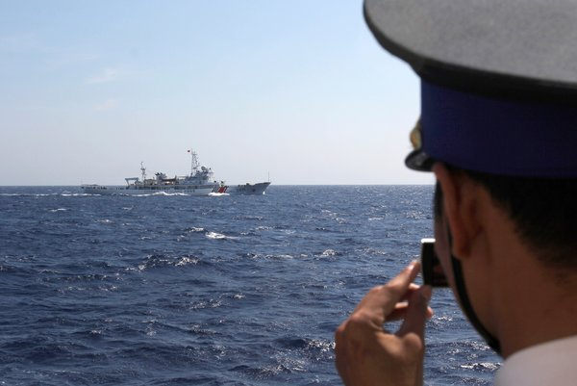
A Vietnamese Coast Guard officer filmed a Chinese vessel in disputed waters. Some saw China’s decision to deploy an oil rig nearby as an “invasion.” Credit Hau Dinh/Associated Press
“We’re a strong, patriotic people,” said one middle-aged worker whose factory suspended production.
The latest struggle with China started early this month, when China moved the drilling rig 140 miles off Vietnam, acting on its claim that those waters are Chinese domain, along with about 80 percent of the South China Sea. Such assertions and other claims in the East China Sea have raised fears throughout the region, where many countries contend that portions of the strategic and resource-rich waters are theirs.
In Vietnam, with its history of occupation, the move was seen as nothing short of a challenge to the country’s sovereignty, inflaming its prickly patriotism.
The government, which critics say has a record of using such sentiments when politically convenient, let loose the press to cover the controversy, and television featured tirades against China. Then officials took the unusual step of allowing the press to cover peaceful protests.
The first protests in city centers were peaceful and generated colorful photos of seas of flag-waving Vietnamese. But analysts say the government was unprepared for what followed, as workers near Ho Chi Minh City and then here in Ha Tinh began turning on foreign-owned factories. Scores of buildings were razed or badly damaged, burned by the marauding crowds.
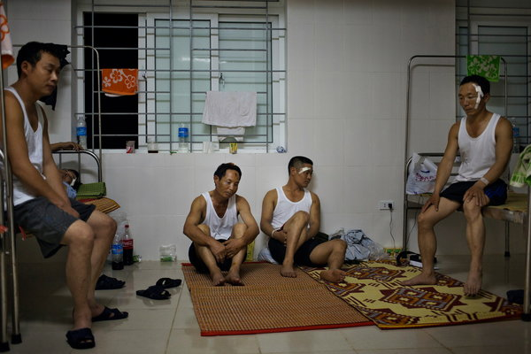
The Formosa Steel mill was the site of protests against Chinese workers. Credit Adam Ferguson for The New York Times
The government arrested more than 400 people and issued anxious statements about the loss of business. But the authoritarian government may have an easier time stopping the protests than quelling the anger that coalesced around the rig. China itself has learned a similar lesson in recent years, when protests against Japan over a maritime dispute and other controversies that were initially tolerated spiraled into attacks on Japanese factories and offices.
Managing nationalist sentiments in this case may be especially difficult because Vietnam’s relationship with China is so complex. The Chinese helped Vietnamese revolutionaries fighting the French, and Beijing has often served as a model for socialist policies. But China has also often been viewed as an aggressor, with its last war with Vietnam starting as recently as 1979.
These days neither the Chinese nor the Vietnamese government likes to discuss that war, which was prompted by Vietnam’s invasion of Cambodia and claimed thousands of lives. But for years after the hostilities, the Vietnamese Communist Party carried out a propaganda campaign against China that “featured extremely harsh, racist language and imagery,” according to Peter B. Zinoman, a professor of Vietnamese history at the University of California, Berkeley, who is currently in Hanoi.
Many of today’s adults were raised on that current of invective, even as the Vietnamese and Chinese Communist Parties patched up their differences and the governments sought to expand cross-border trade.
China’s economic and military rise has added to the conflicted feelings among many Vietnamese. Chinese investors and contractors have been part of a welcome flood of foreign investment in recent years. But critics of the Vietnamese government have maintained that some of those investments benefited party cadres in Vietnam while doing little to help the broader population.
Photo
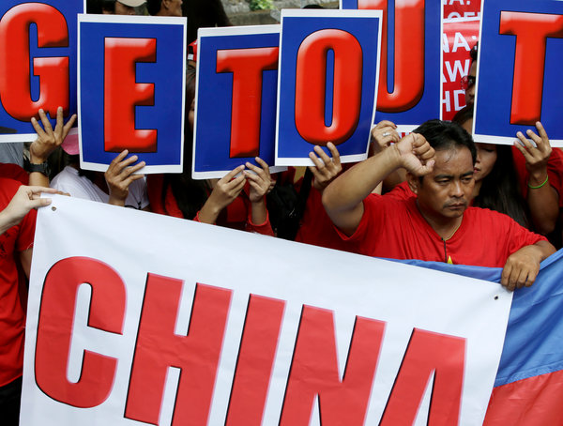
Protesters in Makati City, the Philippines, in front of the Chinese Consulate there on Friday. China’s assertions of ownership in the South China Sea have also raised fears in the Philippines. Credit Bullit Marquez/Associated Press
Still, China’s decision to move the rig into position trespassed into one area that the government and its critics can agree on, analysts say.
Earlier this year, Vietnamese newspapers broke with longstanding reticence about reporting on a military clash in 1974, when China seized control from South Vietnam of the southern Paracel Islands. The news had been avoided in part because of sensitivities of lionizing the South Vietnamese, but the recent news coverage included heroic portrayals of the struggle.
By the time China moved the rig, anti-Chinese feelings were already at a slow boil.
Vietnamese anger with China has “spread from the elite of intellectuals and cadres to workers,” said Carl A. Thayer, an emeritus professor at the University of New South Wales in Australia who studies Vietnamese politics. “This is new. This is populist pressure.”
Analysts say the fact that the explosion of violence targeted businesses was evidence that the motivations went much deeper than nationalism, saying workers tapped into a well of resentment against low wages and against their own government.
“I think the anger that lies underneath this has just as much to do with corruption and incompetence in the government in Hanoi than in any resentment of China,” said Mr. Templer, the expert on Vietnam. “It all adds up to a lot of anger and very few ways to channel that.”
But a number of workers insisted that their reasoning was simpler.
“Our complaint isn’t about wages,” Ho Van Hang said. “It’s about China.”

The Economist

Japan's pacifist constitution

Keeping the peace
May 14th 2014, 1:48 by D.McN. | TOKYO

FOR a document cobbled together during a few hectic days in 1946, in bombed-out Tokyo, Japan’s constitution has weathered the test of time. Written during the American-led occupation, while thousands of starving, war-displaced citizens wandered the capital, the constitution has since remained untouched. That, for Prime Minister Shinzo Abe, is a problem.
Conservatives have long resented the May 1947 constitution, which enshrines Western-style rights and officially ended the god-like status of the emperor, reducing him to a mere “symbol of the state”. In particular, Article 9, in which Japanese people “forever” renounce war as a “sovereign right” and also renounce “the threat or use of force as a means of settling international disputes” rankles Mr Abe’s supporters. Debates about the constitution have grown more heated with China’s rise. In a critical review this year, Japan’s government said China’s military budget has grown thirtyfold over the last decade; by contrast Japan’s military spending has been more or less flat for 20 years. China’s publicly-announced annual spending is twice that of Japan, says its defence ministry.
Mr Abe’s government argues that Japan should be permitted to engage in “collective defence,” so that it can fight alongside a military ally—America—if that ally comes under attack. Until now, legal experts have interpreted the constitution as allowing Japan’s military to open fire only if directly fired upon. The government’s “reinterpretation” is the most profound challenge to the pacifist constitution since 1947.
Mr Abe faces, however, one serious roadblock: the constitution’s popularity. Many ordinary Japanese support Article 9, which they credit with keeping the country out of war for 68 years. An opinion poll last month in the liberal-left Asahi newspaper found 63 percent of respondents oppose Mr Abe’s plans for Article 9. Even readers of the conservative Nikkei have serious doubts.
Opposition has taken some novel forms. One group of campaigners has launched a sex strike. Women Who Don’t Have Sex With Men Who Love War has vowed to withhold the marital prerogative from any husband backing constitutional revision. A potentially greater challenge has emerged from the Norwegian Nobel committee, which last month shortlisted “Japanese people who conserve Article 9” for its peace prize.
The quest for Nobel recognition was launched last year by a Japanese mother-of-two, Naomi Takasu. Michio Hamaji, a former Middle-East oil executive, lent his support, drawing on his business and political connections. A supporter of Mr Abe in “general terms,” Mr Hamaji is nevertheless alarmed by the threat of war with China. He has been joined by Hiroyuki Konishi, a Diet lawmaker who says the government’s attempt to reinterpret the constitution’s legal basis is effectively a “coup d’état”.
The Oslo-based committee has a history of eccentric choices. And among this year’s confirmed candidates are Edward Snowden and Vladimir Putin. But Mr Konishi believes the Article 9 bid, quixotic as it sounds, has a chance of success. “Its simplicity and elegance is the reason why it has survived for so long,” he says. “I believe the world should recognise that.” He and Mr Hamaji hope to enlist the support of 50 lawmakers ahead of the Nobel announcement in November. If their bid were to succeed, one of the more interesting questions would be who goes to Norway to receive the award on behalf of “the Japanese people”—Mr Abe?

NYT

China Tensions Grow After Vietnamese Ship Sinks in Clash
By JANE PERLEZMAY 27, 2014
BEIJING — Hair-trigger tensions in the South China Sea escalated Tuesday as China and Vietnam traded accusations over the sinking of a Vietnamese fishing vessel in the vicinity of a Chinese oil rig parked in disputed waters off Vietnam’s coast.
The incident was almost certain to aggravate the already charged diplomatic and economic tensions between China and Vietnam, whose relations have plummeted to the worst in decades following anti-Chinese riots two weeks ago that killed at least four people.
In the latest incident, a Chinese vessel rammed and sank a Vietnamese fishing boat about 17 nautical miles southwest of the rig on Monday afternoon, the state-run Vietnamese television network, VTV1, reported. All 10 crew members were rescued, the network said.

In High Seas, China Moves UnilaterallyMAY 9, 2014

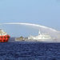

Vietnam Squares Off With China in Disputed SeasMAY 7, 2014

But Beijing labeled Vietnam as the aggressor, with the Chinese state-run news agency, Xinhua, saying the Vietnamese fishing boat “capsized when it was interfering with and ramming” a Chinese fishing vessel from Hainan, a province of China. Then China accused Vietnam of sabotage and interfering with the operations of the oil rig, which has become a flash point of tensions ever since Vietnam learned that the Chinese had set up the rig in waters contested by both nations.
Photo
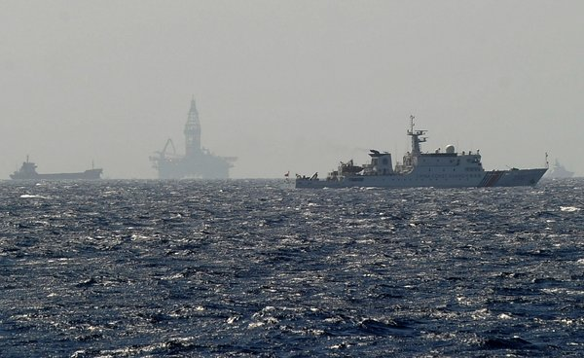
A Chinese coast guard vessel, right, saiied near China's oil drilling rig in disputed waters earlier this month in the South China Sea. Credit Hoang Dinh Nam/Agence France-Presse — Getty Images
At sea, armadas of ships from both countries are jousting with each other as the Chinese try to protect the $1 billion oil rig operated by the energy giant Cnooc and the Vietnamese attempt to disrupt its operations.
Chinese and Vietnamese boats have rammed each other in the area around the oil rig, and the Chinese have acknowledged that they used water cannons to keep the Vietnamese away from the rig, which stands as tall as a 40-story building.
The rig arrived in the waters off the Paracel Islands, which are claimed by both China and Vietnam, on May 1, a unilateral move that showed China was willing to create “facts” establishing its control of the waters of the South China Sea without consulting with other claimants.
“Suddenly Chinese fishing boat #11209 crashed into Vietnamese fishing boat DNa 90152 with 10 fishermen on board,” the VTV1 television report said. A deputy colonel in the Vietnamese Coast Guard, Ngo Ngoc Thu, said the Chinese ship had a steel hull.
An armada of as many as 80 boats, including some from the Chinese Coast Guard, now patrol around the rig, creating a wide perimeter established by the Chinese, according to Vietnamese accounts.
Warships from both countries, including five Chinese frigates, have been observed from outside the perimeter, American officials say.
Chinese social media sites lit up Tuesday with nationalistic postings inspired by the placement of the oil rig and Monday’s clash at sea. Users of ifeng.com, the website of Phoenix Television, a Hong Kong-based satellite network, sent congratulations to the Chinese ship for its action in sinking the Vietnamese vessel.
“Now this is showing some backbone,” said one anonymous user. “Good going, finally seeing some news of concrete action,” said another.
And the depth of anti-Chinese sentiment in Vietnam was on stark display last Friday when a 67-year-old Vietnamese woman set herself on fire and died in Ho Chi Minh City, an echo of the self-immolations by Buddhist monks in South Vietnam in the early 1960s during the Vietnam War.
In the latest incident, the woman burned herself at dawn in the center of the city, and she left behind papers imploring the Vietnamese government to act more aggressively against the Chinese oil rig, city officials said.

Map: Territorial Disputes in the Waters Near China

The episode between the Chinese and Vietnamese fishing vessels came after anti-Chinese riots in Vietnam resulted in the deaths of four Chinese workers and injuries to more than 100. China evacuated several thousand workers from Vietnam last week.
A report by Xinhua on Tuesday cited Cnooc as saying that the rig had finished its first phase of operation and would stay in the area until mid-August. The Vietnamese Fisheries Resources Surveillance Department said the rig was moved about a few hundred feet north on Sunday, but the significance of the move was not immediately clear.
In a signal of how China, under the leadership of President Xi Jinping, now views the South China Sea as a top foreign policy priority, the country’s vice foreign minister said Tuesday that the sea was central to China's very existence as a global economic power.
“Being the lifeline for China, the South China Sea is far more important to China than to other countries,” the minister, Liu Zhenmin, told reporters in Beijing.
China and Vietnam have enjoyed good relations between the Communist parties that run the two governments, and according to people close to the Vietnamese, the parking of the oil rig in disputed waters came as a surprise.
Since May 1, China has declined to hold substantive talks with Vietnam on the rig or the territorial claims in the South China Sea, a further indication of China’s resolve to make its claims unilaterally, Asian diplomats say. In response, Vietnam has threatened to take the matter to international arbitration, as the Philippines has already done.
The United States has urged restraint on both sides, and Adm. Samuel J. Locklear, the commander of the Pacific Fleet, warned last Friday that the proximity of the boats around the oil rig could lead to a collision.
It was initially impossible to determine whether the Chinese government controlled the Chinese fishing vessel involved in the clash, said Dennis J. Blasko, a former military attaché at the American embassy in Beijing. “We don’t know enough yet if this was coordinated or an individual action,” he said.
Many fishing boats are part of the Chinese militia, which are part of the Chinese armed forces, he said. “If the boat was part of the militia, it could have gotten an order fro the People’s Armed Forces Department,” he said.
The Chinese have publicly acknowledged that 80 percent of China’s fishing boats, including those operating out of Hainan, carry navigation equipment that is subsidized by the Chinese government.
The Beidou navigation satellite system, considered to be a Chinese version of GPS, allows the boats to send instant alarms and short messaging services, according to Qi Chengye, a manger of BDStar Navigation, which provides the Beidou system to Chinese vessels.
“The Chinese government is giving large subsidies to encourage fishermen to install BDS,” Mr. Qi said in an interview in Xinhua last year

NYT

U.S. Sway in Asia Is Imperiled as China Challenges Alliances
By HELENE COOPER and JANE PERLEZMAY 30, 2014
Photo
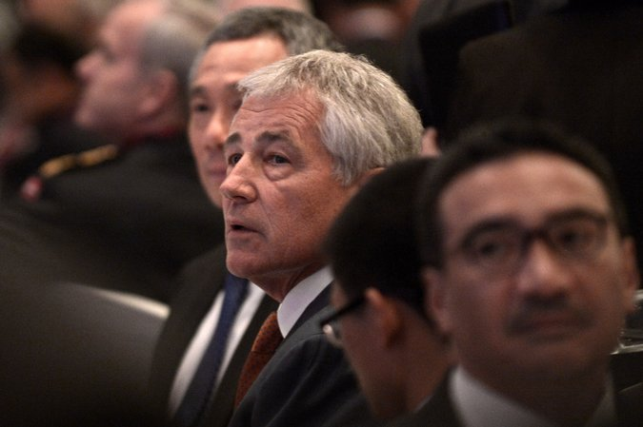
Defense Secretary Chuck Hagel in Singapore on Friday. Credit Roslan Rahman/Agence France-Presse — Getty Images
SINGAPORE — The Obama administration’s three-year-old plan to shift its foreign policy focus to Asia was supposed to shore up interests in a critical region, push new free trade pacts and re-establish United States influence as a balance to a growing China, after a decade of inattention.
But as Secretary of Defense Chuck Hagel visited this city-state for a security conference with all of the interested parties on Friday, that much-vaunted Asia policy appeared to be turning into more of a neighborhood street fight, with the United States having to simultaneously choose sides and try to play the role of referee.
All around Asia, China is pushing and probing at America’s alliances, trying to loosen the bonds that have kept the countries close to Washington and allowed the United States to be the pre-eminent power in the region since World War II.
In just the past week, China traded punches with Vietnam and Japan. A Chinese fishing vessel rammed and sank a Vietnamese fishing boat on Monday near a Chinese deepwater oil rig that was placed in disputed waters off the coast of Vietnam. That confrontation followed a close encounter last Saturday in which two pairs of Chinese fighter jets flew close to Japanese surveillance and electronic intelligence planes, in disputed airspace claimed by both countries.

Map

Territorial Disputes in the Waters Near China
China has recently increased its pursuit of territorial claims in nearby seas, leading to tense exchanges with neighboring countries. A map of some of the most notable disputes.
OPEN Map

By itself, neither encounter rises to the level of the trans-Pacific standoff that occurred in the East China Sea last year after China asserted military authority over airspace that included uninhabited islands claimed by Japan.
But taken together, those episodes form a pattern of escalating maritime and air tensions in the Pacific that have frustrated and worried American officials.
In his strongest words yet on the territorial disputes, Mr. Hagel on Saturday morning implicitly accused China of “intimidation and coercion” as he delivered his keynote address to the conference. China has called the South China Sea “a sea of peace, friendship and cooperation,” Mr. Hagel said. “But in recent months, China has undertaken destabilizing, unilateral actions asserting its claims in the South China Sea.”
China’s goal is to show Washington that if it maintains alliances in Asia, it risks a fight with Beijing, said Hugh White, a former senior Australian defense official who worked closely with Washington and is now professor of strategic studies at the Australian National University.
“China is deliberately doing these things to demonstrate the unsustainability of the American position of having a good relationship with China and maintaining its alliances in Asia, which constitute the leadership of the United States in Asia,” Mr. White said.
China is betting that America, tired and looking inward, will back off, he said, eroding its traditional place of influence in Asia and enhancing China’s power.
But even as Mr. Hagel and the United States have adopted a public posture that backs Japan — and, to a lesser extent, the Philippines, Vietnam and any other country that finds itself at odds with China — some administration officials have privately expressed frustration that the countries are all engaged in a game of chicken that could lead to war.
“None of those countries are helping matters,” a senior administration official said. The official, who spoke on the condition of anonymity in order to talk candidly about American policy, said that the United States would publicly back Japan and that treaty obligations mean that if Japan and China go to war, the United States will almost certainly be dragged into it. But, he added, administration officials have privately prodded their Japanese counterparts to think carefully before acting, and to refrain from backing China into a corner.
“If these are kids in the schoolyard, they are running around with scissors,” said Vikram J. Singh, who until February was the United States deputy assistant secretary of defense for South and Southeast Asia and is now the vice president for national security at the Center for American Progress. “Wars start from small things, often by accident and miscalculation — like dangerous maneuvers by aircraft that result in a collision or aggressive moves that lead to an unexpected military response.”
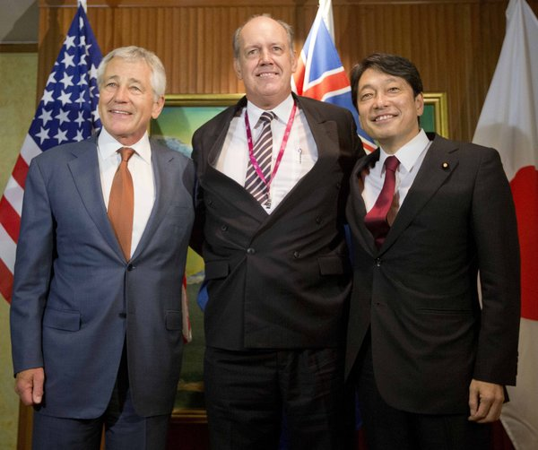
Mr. Hagel, left, with the Australian and Japanese defense chiefs, David Johnston and Itsunori Onodera. Credit Pool photo by
Speaking at the opening session of the conference on Friday, Japan’s prime minister, Shinzo Abe, who has had a role in stirring tensions in the region by embracing a more assertive military stance, bypassed a question about whether he was willing to go to war with China over the disputed islands in the East China Sea, which Japan calls the Senkaku and China calls the Diaoyu. Instead, he said cryptically that it was “important that we all make efforts” so that certain “contingencies can be prevented.”
Mr. Hagel and the large American military contingent on hand, including Gen. Martin E. Dempsey, the chairman of the Joint Chiefs of Staff, and Adm. Samuel J. Locklear III, the commander of the United States Pacific Command, spent their time shuttling from delegation to delegation to make sure those contingencies did not come up.
“Any good teacher knows that you want to get the kids to behave in the first place, rather than try to referee a dispute that breaks out,” said Andrew L. Oros, an associate professor of political science at Washington College in Chestertown, Md., and a specialist on East Asia.
But showing how deep some of the enmity runs, a Chinese officer in the audience took Mr. Abe to task for his visit last year to the Yasukuni Shrine, which honors Japan’s war dead, including several war criminals who were executed after Japan’s defeat in World War II. The visit angered China and South Korea, which suffered under Japan’s empire-building efforts in the 20th century, and it annoyed the United States, which issued a statement calling the visit “an action that will exacerbate tensions with Japan’s neighbors.”
“Millions of people in China, Korea and many countries in this region have been killed by the Japanese Army,” the Chinese officer said, asking whether Mr. Abe planned to honor them. Mr. Abe spoke of the remorse that Japan felt after World War II. But he added that it was common for world leaders to honor those who fought for their country.
While much of the maritime and air disputes go back to ancient territorial claims, the Obama administration may have fanned the tensions with its shift toward Asia, some foreign policy experts said. Many Chinese believe that shift is intended to check China’s rise.
“For that reason, you cannot expect China to welcome the alliance system because it doesn’t serve China’s interest,” said Wu Xinbo, the director of the Center for American Studies at Fudan University in Shanghai.
China’s president, Xi Jinping, gave a strong hint of his objectives in a speech in Shanghai on May 19, when he outlined a new Asian security strategy that would deliberately exclude the United States, analysts said.
“We need to innovate our security concepts, establish a new regional security cooperation architecture and jointly build a shared win-win road for Asian security,” Mr. Xi said at the Conference on Interaction and Confidence Building Measures in Asia, a group that includes China, Russia and Asian countries but not the United States, according to the state-run news agency Xinhua.
At another conference, in Beijing, Adm. Sun Jianguo, the deputy chief of the general staff of the People’s Liberation Army, expanded on Mr. Xi’s ideas, describing the American alliance system as an antiquated relic of the Cold War that should be replaced by an Asia-centric security architecture, participants said.
As word filtered through the region about Mr. Xi’s new concept — so far, only sketched in a bare-bones outline — it was referred to as “ ‘Asia for Asians,’ which means China decides as the biggest guy on the block,” said a senior Asian diplomat from a country allied with the United States, who declined to be named for fear of alienating China.

China, Trying to Bolster Its Claims, Plants Islands in Disputed Waters
By EDWARD WONG and JONATHAN ANSFIELDJUNE 16, 2014
Photo
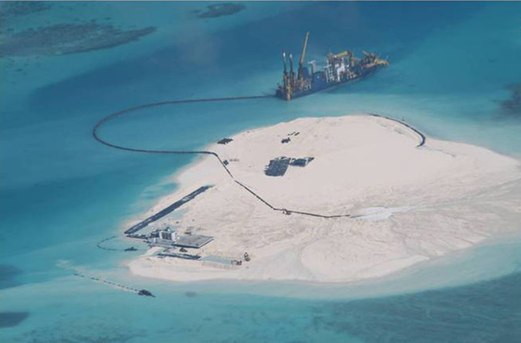
A Philippine surveillance photo shows an island that China has created on a reef among the disputed Spratly Islands in the South China Sea. Credit Philippine Department of Foreign Affairs, via Associated Press
BEIJING — The islands have all that one could ask of a tropical resort destination: white sand, turquoise waters and sea winds.
But they took shape only in the last several months, and they are already emerging as a major point of conflict in the increasingly bitter territorial disputes between China and other Asian nations.
China has been moving sand onto reefs and shoals to add several new islands to the Spratly archipelago, in what foreign officials say is a new effort to expand the Chinese footprint in the South China Sea. The officials say the islands will be able to support large buildings, human habitation and surveillance equipment, including radar.
Continue reading the main story

Related Coverage

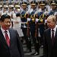

Sinosphere Blog: Xi of Two Minds: Be a Good Neighbor, or Assert China’s Power?JUNE 12, 2014

U.S. Sway in Asia Is Imperiled as China Challenges AlliancesMAY 30, 2014

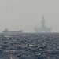

China and Vietnam Point Fingers After Clash in South China SeaMAY 27, 2014

The island-building has alarmed Vietnam, the Philippines and other Southeast Asian nations that also claim sovereignty over the Spratlys. Since April, the Philippines has filed protests to China against land reclamation at two reefs. This month, the Philippine president, Benigno S. Aquino III, criticized the
SINGAPORE
Chinese actions have also worried senior United States officials. Defense Secretary Chuck Hagel scolded China for “land reclamation activities at multiple locations” in the South China Sea at a contentious security conference in Singapore in late May.
Critics say the islands will allow China to install better surveillance technology and resupply stations for government vessels. Some analysts say the Chinese military is eyeing a perch in the Spratlys as part of a long-term strategy of power projection across the Western Pacific.
Perhaps just as important, the new islands could allow China to claim it has an exclusive economic zone within 200 nautical miles of each island, which is defined in the United Nations Convention on the Law of the Sea. The Philippines has argued at an international tribunal that China occupies only rocks and reefs and not true islands that qualify for economic zones.
“By creating the appearance of an island, China may be seeking to strengthen the merits of its claims,” said M. Taylor Fravel, a political scientist at the Massachusetts Institute of Technology.
China says it has the right to build in the Spratlys because they are Chinese territory. “China has indisputable sovereignty over Nansha Islands,” a Foreign Ministry spokeswoman, Hua Chunying, said last month, using the Chinese name for the Spratlys. Chinese officials also contend that Vietnam and the Philippines have built more structures in the disputed region than China, so China is free to pursue its projects.
But analysts note that other countries did not build islands, and that they generally erected their structures before 2002, when China and nine Southeast Asian nations signed the Declaration on the Conduct of Parties in the South China Sea. One clause says the parties must “exercise self-restraint in the conduct of activities” that would escalate tensions and must refrain from inhabiting any currently uninhabited land features.
Although the agreement is nonbinding and does not explicitly ban building on the islands or the creation of new ones, some analysts say those activities are covered.
“It’s changing the status quo,” said Carlyle A. Thayer, an emeritus professor of politics at the University of New South Wales in Australia. “It can only raise tensions.”
Since January, China has been building three or four islands, projected to be 20 to 40 acres each, one Western official said. He added that there appeared to be at least one installation intended for military use, and that the new islands could be used for resupplying ships, including Chinese maritime patrol vessels.
Last month, China set off alarms in the region and in Washington when a state-owned oil company placed an exploratory oil rig farther north in the South China Sea, by the contested Paracel Islands near Vietnam. The rig ignited diplomatic strife and violent anti-China protests in Vietnam.
But the island-building “is bigger than the oil rig,” said the Western official, who spoke on the condition of anonymity to avoid upsetting diplomatic discussions. “These islands are here to stay.”
Officials say Johnson South Reef, which China seized in 1988 after killing about 70 Vietnamese soldiers or sailors in a skirmish, is the most developed of the islands so far. “It’s Johnson Island now; it’s not Johnson Reef anymore,” the Western official said. Filipino officials released aerial photographs last month showing structures and a large ship.

Le Hai Binh, a spokesman for the Vietnamese Foreign Ministry, said in an email statement that Vietnam had sovereignty over the entire Spratly archipelago and that “China has been illegally implementing activities of expansion and construction” around Johnson Reef and other sites claimed by Vietnam.
He said Vietnam demanded that China “immediately stop illegal activities of expansion and construction” on the reef and “withdraw its vessels and facilities from the area.”
The Spratlys comprise hundreds of reefs, rocks, sandbars and tiny atolls spread over 160,000 square miles. Six governments have overlapping claims in the area. China and Vietnam also have competing claims for the Paracel Islands, in the area where the Chinese oil rig still sits. Both areas have abundant fish and some oil and gas reserves.
Jin Canrong, a professor of international studies at Renmin University of China, said he believed that the construction on Johnson South Reef was “a technical test, to see if such things can be done.” Should China want to try island-building on a larger scale, he said, a logical choice would be Fiery Cross Reef, about 90 miles west of Johnson South.
Last month, digital sketches of structures intended for the Spratlys circulated on Chinese news websites, including that of Global Times, a newspaper owned by People’s Daily, the Communist Party mouthpiece. The sketches, labeled a research study, showed a new island with shipping docks, parking lots and an airfield with a runway, airplanes and hangars. Reports said the images were from the China Shipbuilding NDRI Engineering Company, in Shanghai. When asked about the sketches over the phone, a woman at the company said they were “too sensitive” and had been taken off the firm’s website. She declined to comment further.
Wu Shicun, president of the National Institute for South China Sea Studies, a government-linked research group on Hainan Island, said Chinese construction was intended mainly to augment the country’s fisheries administration and humanitarian relief capabilities, not for military purposes.
“Our facilities are worse than those of both the Philippines and Vietnam,” he said. “You see that Vietnam even has a soccer field.”
Vietnamese and Filipino naval personnel played soccer during a June 8 conclave on Southwest Cay Island, which is controlled by Vietnam. “Clearly this was meant to enrage the Chinese people,” Mr. Wu said. The island has been occupied by the Vietnamese military since the 1970s but is also claimed by China and the Philippines.
Christopher K. Johnson, the chief China analyst at the Center for Strategic and International Studies, in Washington, said China’s recent moves were partly to make up for the fact that the Chinese military focused mainly on Taiwan for more than a decade while Vietnam and the Philippines developed facilities on shoals and reefs they controlled.
He said Chinese military officials were probably keeping in mind future long-range naval power projections. “There’s no doubt that they would love to have some kind of a naval facility on one of these things,” he said.
Chinese military leaders have talked in recent years of building up a navy that can operate beyond what is commonly called the “first island chain” — islands closer to mainland Asia that include the Spratlys and Paracels — to penetrate the “second island chain,” which includes Guam and other territories farther east.
Mr. Thayer, the Australian analyst, said he had seen no signs yet that China was building large military facilities or a runway on the new islands. But he said there was a clear conclusion to be drawn from China’s actions in both the South China Sea and the East China Sea, where China contends with Japan over islands.
“None of this is an isolated incident,” he said. “It seems to be a new plan to assert Chinese sovereignty. This isn’t something that will go away. This is a constant thing that will raise tensions, and at the same time no one has a good response to it.”

NYT

China Sends Top Diplomat to Begin Talks With Vietnam
By JANE PERLEZJUNE 17, 2014
HANOI, Vietnam — A senior Chinese official will hold talks here on Wednesday with Vietnam about the contentious deep-sea oil rig stationed by China in disputed waters, the two countries announced Tuesday.
The official, Yang Jiechi, will meet with Deputy Prime Minister Pham Binh Minh of Vietnam in the first high-level discussions between the two countries since early May, when sea vessels from the two sides rammed each other near the installation.
Mr. Yang, a state councilor with a foreign policy portfolio, is known as a blunt promoter of China’s expansion in the South China Sea, and he is unlikely to offer concessions or a breakthrough in the tense situation, said diplomats here, who declined to be named because of the sensitivity of the issue.

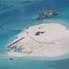

To Bolster Its Claims, China Plants Islands in Disputed WatersJUNE 16, 2014

Sinosphere Blog: Xi of Two Minds: Be a Good Neighbor, or Assert China’s Power?JUNE 12, 2014

video

Video: Aquino on China’s Move in Disputed SeasJUNE 5, 2014

U.S. Sway in Asia Is Imperiled as China Challenges AlliancesMAY 30, 2014

China and Vietnam Point Fingers After Clash in South China SeaMAY 27, 2014

Most likely, they said, Mr. Yang will reiterate China’s opposition to Vietnam’s efforts to win international support for its position that China has violated Vietnam’s sovereignty by parking the rig 120 miles off Vietnam’s coast, close to the Paracel Islands that both countries claim.

Map

Territorial Disputes in the Waters Near China
China has recently increased its pursuit of territorial claims in nearby seas, leading to tense exchanges with neighboring countries. A map of some of the most notable disputes.
OPEN Map
China
Philippines
Vietnam
Malaysia
Taiwan
Mr. Yang will emphasize that Vietnam should not look to the United States for moral or material support, the diplomats said.
The Obama administration condemned the deployment of the oil rig as a “provocative” action but has shown no inclination to get involved in the dispute beyond expressing displeasure at China’s unilateral move.
The question of how far Vietnam should go in seeking support from the international community has bedeviled the Communist Party leadership here. Some of the 16 members of the Politburo are believed to lean toward the United States, while others remain more loyal to China and its Communist Party.
The skirmishes between coast guard boats from China and Vietnam around the rig have alarmed American officials who fear that an episode could lead to conflict.
But in the last several weeks, the situation appeared to have eased into “dangerous stability,” said an American administration official familiar with the flotillas of Vietnam and China.
A foreign ministry spokesman in Beijing, Hua Chunying, said Tuesday that Mr. Yang would encourage a “frank and thorough exchange of views on matters of common concern to all.”
“We hope Vietnam will focus on the broader picture, come together with China and appropriately deal with the current situation,” she said.
The visit of Mr. Yang, China’s top diplomat, comes as relations between Vietnam and China have been essentially frozen since the arrival of the rig on May 2. Anti-Chinese riots spread through several cities, and looting of factories believed to be Chinese-owned resulted in the deaths of at least four Chinese workers. China evacuated several thousand workers after the riots, leaving some companies in Vietnam, which are dependent on China for supplies and skilled labor, short of employees.
Mr. Yang is expected to meet with Mr. Minh, who is also Vietnam’s foreign minister, but it was not known if he would meet with more leaders, officials said.
Prime Minister Nguyen Tan Dung of Vietnam said that he would consider a legal case against China at the United Nations, in the same way that the Philippines has initiated an arbitration case against China. Beijing roundly criticized Mr. Dung’s suggestion.

NYT

China-Vietnam Meeting Does Little to Ease Territorial Tensions
By JANE PERLEZ
JUNE 18, 2014
HONG KONG — China and Vietnam exchanged sharp views Wednesday in their dispute over a Chinese oil rig deployed in contested waters in the South China Sea near Vietnam’s coast and appear to have made little headway in cooling tensions, according to a summary of a top-level meeting in Hanoi released by China’s Foreign Ministry.
China’s state councilor, Yang Jiechi, accused Vietnam, which has sent ships to the area, of conducting “unlawful interference” in the operations of the rig, and told Vietnam that China would “take all necessary measures to safeguard its national sovereignty,” the ministry said in the statement.
The uncompromising language was unusual for a diplomatic statement describing discussions between two Communist countries, and reflected China’s unyielding position since it sent the rig last month to a position 120 miles off the coast of Vietnam and close to the Paracel Islands, which both countries claim.
Mr. Yang, China’s most senior diplomat and a former foreign minister, met in Hanoi with Vietnam’s Foreign Minister, Pham Binh Minh, and then with Prime Minister Nguyen Tan Dung and the general secretary of the Communist Party, Nguyen Phu Trong.
During the meeting with Mr. Minh, the Chinese diplomat said that the Paracel Islands were “China’s inherent territory and that there is no dispute,” the foreign ministry said. Vietnam says the waters around the oil rig are its territory because they fall within its 200-nautical-mile exclusive economic zone.
To protect the rig, China has dispatched a large contingent of Coast Guard vessels that have established a perimeter. A smaller flotilla of Vietnamese Coast Guard and fishing boats try to penetrate the cordon, and the vessels from each side ram each other on a regular basis. The Chinese have used water cannons to keep the Vietnamese boats at bay.
Military ships from both sides are in the general area of the rig, according to American officials.
In a war over the Paracels in 1974, China seized control of the southern islands in the chain from South Vietnam.
To back up its claim to the Paracels, China recently released a 1958 letter from Pham Van Dong, then the prime minister of Vietnam,, to Premier Zhou Enlai of China. It said that Vietnam recognized China’s sovereignty over the islands. Vietnam has argued the letter has no validity because it was written under duress.
Vietnam made no official announcement immediately after Mr. Yang’s visit to Hanoi. But the Chinese foreign ministry noted in its statement that the Vietnamese foreign minister “elaborated on Vietnam’s position and views on maritime issues.”
The arrival of the rig so close to the Paracels has become a defining event in the mounting campaign by China to control the South China Sea, a vital waterway for international commerce.
In an effort to discourage China’s claims, Vietnam has threatened to launch an international lawsuit against Beijing. The Philippines, an ally of the United States, recently opened an arbitration case in the United Nations against China over competing claims in the South China Sea, an action that has infuriated the Chinese government.
Before the Hanoi meeting, the first at a senior level since May 2, experts had predicted both sides would stubbornly stick to their views.
“China and Vietnam have been working on their relationship for 4,000 years, and some days the work goes better than others,” said Brantly Womack, a professor of foreign affairs at the University of Virginia who has written extensively on the two countries.
Mr. Yang, in particular, is known as a fierce proponent of China’s rights to large parts of the South China Sea, and he has confronted American and Asian officials with his hard-line views on the subject.
He took exception in 2010 at a gathering of the Association of Southeast Asian Nations in Hanoi when Secretary of State Hillary Rodham Clinton raised the issue of freedom of navigation in the South China Sea and the need to resolve the various territorial disputes through mediation. In her new book, “Hard Choices,” Mrs. Clinton quotes him as telling delegates that “China is a big country, bigger than any other countries here.”
Mrs. Clinton noted in the book that Mr. Yang’s attitude of China’s superiority towards its Asian neighbors did not go down well.

NYT Analysts Say China May Try to Use Manmade Islands to Bolster Bid for Economic Development
By EDWARD WONG
June 19, 2014 9:09 am
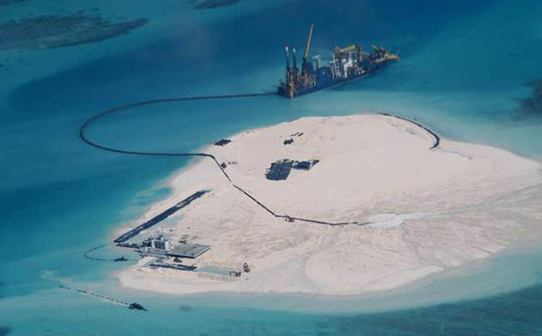Philippine Armed Forces, via ReutersA Philippine surveillance photo shows an island that China has created on a reef among the disputed Spratly Islands in the South China Sea.
China has been moving sand onto some reefs and rocks in the Spratly archipelago of the South China Sea to create islands that can support buildings, equipment and human habitation. The construction is stirring anxiety in the Philippines and Vietnam, which compete with China over territorial claims in the Spratly Islands, and raising alarms in the United States, which sees China’s actions in the South China Sea as destabilizing.
Analysts say China could try to assert that these new islands entitle the country to an exclusive economic zone that extends 200 miles from the islands’ shoreline. Such a zone is defined in the United Nations Convention on the Law of the Sea, to which China is a signatory.
But China might have a tough time convincing an international tribunal that its new islands can generate an exclusive economic zone. A clause under Article 60 of the convention says: “Artificial islands, installations and structures do not possess the status of islands. They have no territorial sea of their own, and their presence does not affect the delimitation of the territorial sea, the exclusive economic zone or the continental shelf.”
The language sounds definitive, though China could argue that its new islands are not entirely artificial, since there were reefs and rocks at the sites before the sand dredging and land reclamation began.
In article 21, the United Nations convention gives this definition for an island: “An island is a naturally formed area of land, surrounded by water, which is above water at high tide.”
Lawrence Juda, a professor of maritime affairs at the University of Rhode Island in Kingston, said in an email that “artificial islands, thus, do not qualify as ‘islands’ with the consequent legal rights of those that are naturally formed.”
If China were to use these new creations to try to claim an exclusive economic zone, “I do not think that this claim would be legitimate or recognized,” Mr. Juda said. “Moreover, such a claim would be unacceptable, not only to the Philippines, but also to important maritime states such as the United States. Acceptance of a Chinese claim to an E.E.Z. around an artificial island would set a terrible precedent and open a potential Pandora’s box to extensive national claims to ocean areas, spawning a wide variety of legal and political problems.”
Perhaps not surprisingly, China has been pushing back against an attempt by Japan, another territorial rival, to claim a continental shelf and exclusive economic zone around a tiny atoll in another body of water. The atoll, called Okinotorishima, sits in the Philippine Sea, east of the Philippines and Taiwan and west of Guam. Only two knobs are visible at high tide. As of 2012, Japan had spent $600 million to surround the atoll with a wall of concrete, according to a report by Foreign Policy. Fishery officials planted extra coral in the area to reinforce the appearance of an island.
Chinese officials have argued that Okinotorishima does not qualify as an island as defined by the United Nations convention and so cannot have a continental shelf or generate an exclusive economic zone. In April 2012, a United Nations commission made a partial ruling on the matter that left fundamental questions unanswered. A post on the blog of Herbert Smith Freehills, a global commercial law firm, said whether Okinotorishima officially qualifies as an island was “a distinction of considerable significance for international law of the sea purposes, as it may determine Japanese sovereignty claims over the surrounding continental shelf and its potentially vast natural resources.”
This March, Asahi Shimbun, a Japanese newspaper, reported that Japan was spending $780 million to build a port at the site. The newspaper reported: “Although the transport ministry’s stated goal is to extract seabed resources in the surrounding areas, observers say the harbor construction may be intended as a warning to China, which is looking for opportunities to weaken Japan’s control over the exclusive economic zone around the tropical islets.”

NYT

China Plans to Send Second Oil Rig to Waters Near Vietnam
By JANE PERLEZJUNE 19, 2014
HANOI, Vietnam — The day after tough talks between Vietnam and China that made no progress over a Chinese oil rig in the South China Sea, Beijing said Thursday it was sending a second rig to waters close to Vietnam.
The move, announced on China’s Maritime Safety Administration website, appeared to be an unabashed signal that China will press ahead to secure what it sees as its rights in the commercially and strategically vital waterway despite rising anxiety in the region.
Last month, in a contentious move, China sent its biggest oil rig, a prized $1 billion platform the size of a football field to explore in an area 17 miles off the Paracel Islands claimed by both Vietnam and China. In what may be a more lasting act, China began shoveling sand and rock onto shoals and reefs in the Spratly archipelago, which is also contested, several months ago to create islands big enough to house buildings and surveillance equipment, including radar.

For Vietnam and China, No Easing of TensionsJUNE 18, 2014

To Bolster Its Claims, China Plants Islands in Disputed WatersJUNE 16, 2014

U.S. Sway in Asia Is Imperiled as China Challenges AlliancesMAY 30, 2014

China and Vietnam Point Fingers After Clash in South China SeaMAY 27, 2014

The dispatch of the second rig, described by its owner, the China National Offshore Oil Company, as the second largest in its growing fleet of rigs, began Wednesday, according to an announcement by the maritime administration. The rig, which is being towed from a location south of Hainan Island in China’s most southern province, is expected to reach its new location in waters near the mouth of the Gulf of Tonkin by Friday, the announcement said.
Photo
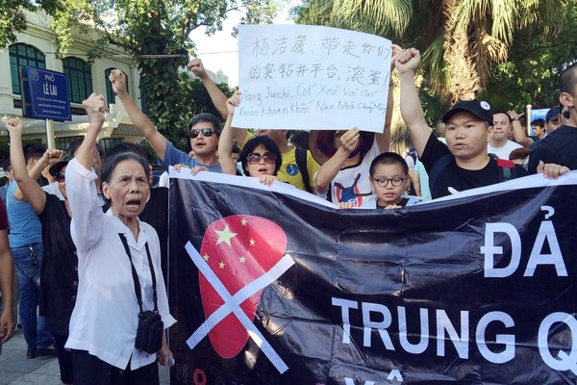
Protesters demonstrating against China in Hanoi on Thursday. The dispatch of a second oil rig in the South China Sea began on Wednesday. Credit Luong Thai Linh/European Pressphoto Agency
It was not immediately clear if the second rig would end up in waters disputed by Vietnam and China. Reports Thursday in the state-controlled press of Vietnam about the movement of the rig did not stipulate that it would be located in waters claimed by Vietnam.
The commander of the Vietnamese Coast Guard, Nguyen Quang Dam, said the coordinates released by China showed the oil rig would be positioned just inside China’s continental shelf. China had sent oil rigs to the same general area five years ago, the general said in an interview Thursday with Vietnam Express, a state-run newspaper.
Still, he said, the Coast Guard was monitoring the developments and was “prepared to deal with any situation.”
The coordinates suggested that the rig’s final position would be right on or close to the equidistant line between Vietnam and Hainan, according to Holly Morrow, a fellow of the Geopolitics of Energy Project at Harvard’s Belfer Center for Science and International Affairs.
The muted response from Vietnam on Thursday might indicate that the authorities were still trying to ascertain whether or not the newly deployed rig will end up in waters claimed by Vietnam, Ms. Morrow said.
She said it would not be surprising if China deliberately drilled in both disputed areas and undisputed waters to underscore the point that, from China’s point of view, all the drilling was “normal” activity.
Continue reading the main story

Map: Territorial Disputes in the Waters Near China

The second rig was purchased in 2013, from “overseas,” according to an article in the newspaper run by the oil company. It was described as a “semi-submersible drilling platform,” and was named South Sea No. 9.
The parking of the first rig, known as 981, in early May to a position 120 miles off the shore of Vietnam and 17 miles off one of the Paracel Islands set off a storm of protest by Vietnam, and sent relations between China and Vietnam plummeting to their lowest point in decades.
China and Vietnam fought a fierce land border war in 1979; in 1974 the Chinese military took possession of islands in the Paracel chain then occupied by South Vietnamese forces.
The simmering hostility to China in Vietnam erupted after the arrival of the rig, igniting riots in several cities. A number of factories thought by the rioters to be Chinese owned were destroyed, though in fact many were owned by Taiwan-based proprietors. Four Chinese people were killed, and China evacuated several thousand workers.
From the tone of the statement by China’s Foreign Ministry after talks between China’s top diplomat, Yang Jiechi, and the leadership here on Wednesday, Mr. Yang appears to have lectured the Vietnamese on China’s indisputable rights in the South China Sea, and in particular, to the Paracel Islands. The Chinese statement denied there was any dispute to discuss with Vietnam.
For their part, the Vietnamese told Mr. Yang they wanted to hold international negotiations on the Paracel Islands and the surrounding waters and called for the application of the Convention of the Law of the Sea. China has repeatedly said it would not consider such talks.
Separate from the issue of the rigs, the Foreign Ministry in Beijing said Thursday it welcomed talks next week sponsored by Asean, the Association of Southeast Asian Nations, on how claimants in the South China Sea could agree on a legally binding code of conduct to govern actions by competing nations.
Talks on such a Code of Conduct have dragged on intermittently for years, and though the United States has encouraged the discussions as a way of ensuring freedom of navigation in the waterway, participants in the talks have said China has showed less enthusiasm.

NYT

Roaring on the Seas

China’s Power Grab Is Alarming
By THE EDITORIAL BOARDJUNE 18, 2014
Few aspects of China’s dynamic emergence as a global power have generated as much insecurity and danger in its neighborhood as its mounting campaign to control the South China Sea, a vital waterway for international commerce. On Wednesday, at a high-level meeting in Hanoi, China’s top diplomat scolded his Vietnamese hosts for complaining about an oil rig that Beijing planted in early May in waters that Vietnam claims, as its own.
The sharp back-and-forth represented one of the lowest points in relations between the two countries since a brief territorial war in 1979, and it added to worries in Washington and elsewhere about Beijing’s continued bullying in energy-rich waters that not only Vietnam but other small Asian nations lay claim to.
In addition to installing the rig, Beijing’s efforts to assert sovereignty over the many specks of rock dotting the South China Sea now includes a novel twist: the piling of sand on isolated reefs and shoals to create what amount to new islands in the Spratly archipelago.
Vietnam, the Philippines and other Southeast Asian nations that also claim sovereignty in the Spratlys have watched this island-building with growing alarm, but despite their protests — and a strongly worded statement last month by Defense Secretary Chuck Hagel condemning China’s “destabilizing, unilateral actions” in the South China Sea — Beijing is showing no intention of changing its ways.
The Spratly Islands are uninhabited and of no economic value in themselves. But the archipelago covers rich fishing grounds and is believed to harbor large oil and gas reserves, and China could claim an exclusive economic zone within 200 nautical miles of each of the three or four islands it is creating. The new islands, projected to reach 20 to 40 acres in area, would also serve the projection of Chinese military power by providing bases for surveillance and resupply.
China insists that the Spratlys, Paracels and other islands have always belonged to China. But Vietnam also claims sovereignty, and parts of them are claimed by the Philippines, Malaysia and Brunei. In 2002, the Association of Southeast Asian Nations and China signed a Declaration on the Conduct of Parties in the South China Sea, agreeing to resolve territorial disputes “without resorting to the threat or use of force.” That declaration is not legally binding, and China has argued that Vietnam and the Philippines have already developed some facilities in the islands, though without adding acreage.
The real problem, in any case, is not the muddled question of sovereignty, but the way China appears to believe that its expanding military and economic power entitle it to a maximalist stance in territorial disputes. Certainly the smaller nations abutting the South China Sea are no match for China in a fight, but the fear and anger that China’s aggressive actions have generated among its maritime neighbors, and the tensions they have raised with Washington, hardly seem to be in Beijing’s interest, or in keeping with the image China’s president, Xi Jinping, tried to project when he said in Paris in March that “the lion that is China has awoken, but it is a peaceful, amiable and civilized lion.”
That is not the lion now roaring over the waters of the South China Sea, threatening the stability and security that have benefited, above all, China. That is all the more reason for Beijing to heed the 2002 declaration’s call for self-restraint in activities that would complicate disputes or disturb the peace.

NYT

Recent Tanker Hijackings Add to Problems in the South China Sea
By KEITH BRADSHERJULY 8, 2014
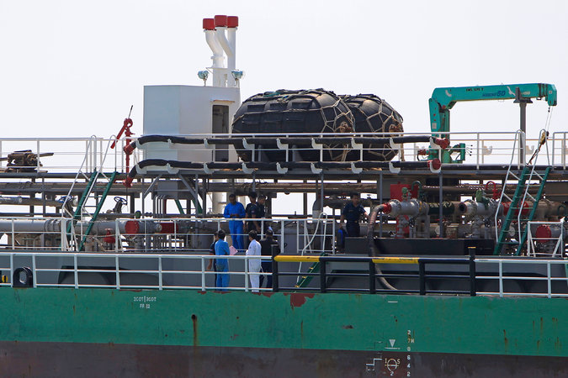
Malaysian marine police officers inspecting a Singapore-owned tanker hit by pirates in April. Credit Lai Seng Sin/Associated Press
KUALA LUMPUR, Malaysia — Add another problem to the rising tensions in the South China Sea this year: a mysterious spate of tanker hijackings since late April, as armed bands of men have boarded and commandeered the ships, siphoned their cargos of diesel and gasoline onto barges or other tankers, and fled into the night.
Complicating matters is the fact that two of the hijackings took place near the heart of Malaysia’s offshore oil and gas production, in waters where China is making an increasingly forceful claim to sovereignty.
Interpol, intelligence agencies and military forces in the region are investigating the eight attacks — the most recent of which was last Friday — and are trying to figure out how to stop further ones, said Noel Choong, the head of the Asia office here of the International Maritime Bureau’s Piracy Reporting Center.
One goal of the investigation is to determine whether the diesel fuel and gasoline are being sold for profit by criminals or are being used to finance political activities, possibly even terrorism.

Map: Territorial Disputes in the Waters Near China

In one incident in late May, “they were wearing ninja-type clothes, black, so they looked professional,” Mr. Choong said.
In contrast to the military assault rifles sometimes carried by pirates off Somalia and Nigeria, the pirates in the South China Sea have tended to be armed with handguns or even machetes. No one is known to have been killed in any of the hijackings, but three tanker crew members were abducted in one of the episodes and have not been seen since.
The hijackings raise geopolitical issues. Seven have taken place close to Malaysia and one close to the Anambas Islands of Indonesia. But two of the hijackings close to Malaysia occurred in waters near James Shoal, a disputed, submerged reef near the north coast of Malaysian Borneo.
Malaysia has had commercial activities there for many years, and it is a center of the country’s extensive offshore oil and gas industry. Oil and gas revenues cover nearly half of the Malaysian government’s budget.
But China has been increasingly assertive over the past several years in claiming that James Shoal lies inside its so-called nine-dash line, a huge expanse of the South China Sea that Beijing has been claiming with increasing boldness, particularly this year. A small flotilla of Chinese naval vessels went to James Shoal in January, and Chinese officers held an oath-swearing ceremony there to pledge that they would defend China’s sovereignty.
Malaysia glossed over the matter, saying that the Chinese vessels had stayed in international waters during their activities. Malaysia has tried to maintain a nearly neutral stance toward China within the Association of Southeast Asian Nations, but it could find the balancing act more difficult next year, when it assumes the rotating chairmanship of the association.
The hijackings also come at a time of considerable nervousness about jihadist recruiting efforts in Malaysia, which is heavily Sunni Muslim. The Malaysian authorities have detained more than a dozen people in the past month, reportedly including a Malaysian naval officer, in an investigation into recruiting and other support activities on behalf of the Islamic State in Iraq and Syria, the militant group that has seized control of a large part of northwestern Iraq.
The International Maritime Bureau, which is part of the International Chamber of Commerce and works closely with the United Nations on shipping issues, has been quietly tracking the hijacking problem and plans to issue a detailed report next week calling for further international attention to the problem, Mr. Choong said. The Malaysian Maritime Enforcement Agency has said that it is trying to solve the crimes and increase security at sea.
Cmdr. William J. Marks, a spokesman for the United States Navy’s Seventh Fleet, said the fleet had not received a request for antipiracy help in more than two years, but generally worked closely with countries in the region, including conducting a joint exercise last year with Brunei, Indonesia, Malaysia, the Philippines, Singapore and Thailand.
In a typical year, one tanker is hijacked in the South China Sea or the adjacent Strait of Malacca, or none at all. Freighters and pleasure boats are sometimes stopped and their crews and passengers robbed and, on rare occasions, kidnapped. From $1 million to $2 million worth of fuel has been stolen from each of six tankers that have lost part or all of their cargos in the South China Sea since mid-April.
Pirates briefly seized two other tankers but did not try to steal their cargos after discovering that they were carrying chemicals that were not readily salable. One of the tankers was carrying methanol, used in making paints and plastics, and the other was carrying bitumen, a thick fuel used for firing boilers.
Mr. Choong declined to identify publicly the owners of the eight tankers, except to say that one was owned by a global oil company and most of the rest were owned by companies in Singapore. None of the tankers were large vessels that carry crude oil, which would take a long time to siphon into another ship and would be harder to resell.
One of the biggest worries, Mr. Choong said, is that if tankers develop a reputation as being profitable, easy targets to attack, then piracy could spread, much as it did off the coast of Somalia over the last several years.
Piracy off the Somali coast dropped steeply after shipping companies began hiring armed guards and putting them aboard vessels. But Indonesia and Malaysia have longstanding bans on any armed private guards aboard ships, reserving the right to bear weapons for their own military and police.
“We don’t want it to get out of control,” Mr. Choong said.

NYT

Asia Pacific

Kerry Urges China to Reduce Tensions in Nearby Seas
By JANE PERLEZJULY 9, 2014
Photo
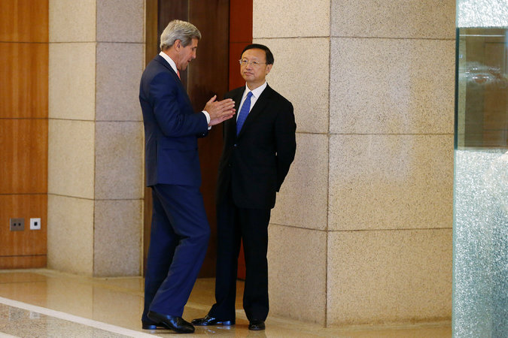
Secretary of State John Kerry spoke with Yang Jiechi, a state councilor who deals with foreign policy, on Wednesday in Beijing. Credit Pool photo by Jim Bourg
BEIJING — In a closed-door session at a high-level gathering of Chinese and American officials here on Wednesday, Secretary of State John Kerry urged China to follow maritime law in nearby seas to reduce regional tensions, a senior American official said.
Mr. Kerry called on China to support the creation of a legally binding code of conduct that other Asian nations are considering to enforce rules of navigation and inhibit unilateral actions in the South China and East China Seas, said the official, who briefed reporters on the condition of anonymity under standard protocol.
The secretary met with Yang Jiechi, a state councilor who deals with foreign policy, on the first day of the Strategic and Economic Dialogue, an annual gathering of senior officials from both countries where differences on issues including national security, the economy, climate change and human rights are aired.
“The secretary emphasized this is not a situation in which countries should or can be permitted simply to act unilaterally to advance their territorial claims or interests,” said the official, alluding to China’s dispatch of a huge oil rig to disputed waters off the coast of Vietnam in May and the virtual takeover in 2012 of a reef, the Scarborough Shoal, that is claimed by the Philippines.
Continue reading the main story

Map

Territorial Disputes in the Waters Near China
China has recently increased its pursuit of territorial claims in nearby seas, leading to tense exchanges with neighboring countries. A map of some of the most notable disputes.
OPEN Map

Mr. Kerry also said efforts to create a “new status quo” at the expense of regional harmony were “unacceptable,” the official said.
Maneuvers by China to assert claims over islands and waters in the South China Sea, and to slow the efforts of a regional group, the Association of Southeast Asian Nations, to complete a code of conduct that would govern maritime rules have become a major point of friction between Washington and Beijing. The South China Sea is one of the world’s busiest trading routes.
President Xi Jinping opened the two-day event, saying that a solid relationship between China and the United States was vital for everyone. “Cooperation between China and the U.S. will benefit the world, while the opposite will bring disaster,” Mr. Xi said.
He also stressed China’s economic and military strength. “The vast Pacific Ocean has ample space to accommodate two great nations,” he said, a comment suggesting that America’s domination of the Asia-Pacific region over the last 60 years will not last.
At his meeting with Mr. Yang, a diplomat known for his frank demeanor, Mr. Kerry set out Washington’s objections to China’s policies on several fronts and defended America’s alliances in Asia, arrangements that have come under stiff criticism from Beijing, the official said.
The secretary discussed China’s deteriorating human rights record, citing specific cases of people imprisoned for many years, as well as those jailed in the last few months during a crackdown on lawyers and journalists, the official said. “In particular, he described our perception of the trend of an increase in arrests and harassment of individuals expressing political views,” the official said.
China declined to hold a human rights dialogue with the United States this year, apparently in retribution for President Obama’s meeting in February with the Dalai Lama, the exiled Tibetan spiritual leader who promotes autonomy from China.
The suspension of the human rights discussion came despite meetings in recent years between Chinese and American officials to discuss human rights and religious persecution in China.
Mr. Kerry called for the human rights talks to resume, the official said. Similarly, he asked that China agree to continue formal talks on cybersecurity that China suspended in May after the indictment of five members of the People’s Liberation Army by a United States grand jury on charges of cyberespionage.
The American special envoy on climate change, Todd Stern, met with his Chinese counterpart, Xie Zhenhua, vice chairman of the National Development and Reform Commission and a powerful figure in the Chinese bureaucracy. “We are making a great effort on our internal reasoning so we can make due contributions to climate change,” Mr. Xie said.
While there was no breakthrough agreement on reducing greenhouse gas emissions, American officials said they detected more determination by the Chinese to curb pollution, which has become so bad that some Chinese leaders see it as a possible cause of political instability.
One of the Chinese participants in the climate change session said that the Chinese needed a war on pollution like the American war on poverty, another American official said.
NYT

Shadow of Brutal ’79 War Darkens Vietnam’s View of China Relations
By JANE PERLEZJULY 5, 2014
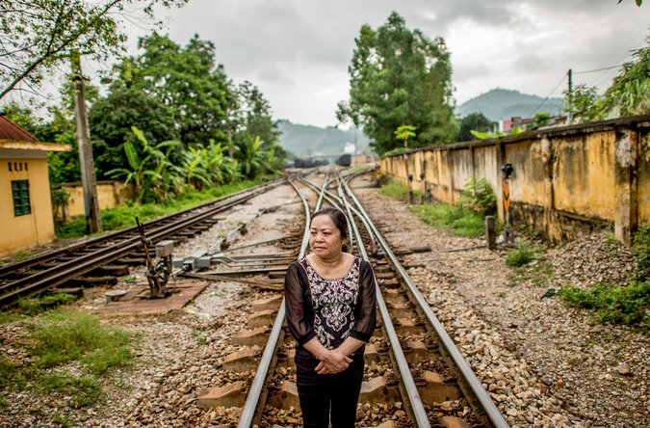
Ha Thi Hien along a rail line in Lang Son connecting Hanoi and Beijing. Credit Justin Mott for The New York Times
Continue reading the main story Share This Page
LANG SON, Vietnam — She was 14 when Chinese artillery fire echoed across the hills around her home in northern Vietnam, and hundreds of thousands of Chinese soldiers swarmed across the border. She remembers sprinting with her parents through the peach trees, her waist-length hair flying, as they fled the invaders. They ran straight into the enemy.
Her mother was shot and killed in front of her; minutes later, her father was wounded. “I was horrified. I didn’t think I would survive. The bullets were flying all around. I could hear them and smell the gunfire,” said Ha Thi Hien, now 49, fluttering her hands so they grazed her head to show how close the bullets came on the first day of the short, brutal war.
The conflict between China and Vietnam in 1979 lasted less than a month. But the fighting was so ferocious that its legacy permeates the current sour relations between the two Communist countries now at odds over hotly contested waters in the South China Sea.
Both sides declared victory then, though neither side prevailed, and both armies suffered horrendous losses.
The gravestone of Ms. Hien’s mother, who was killed in the 1979 conflict with China. Ms. Hien’s father was wounded. Credit Justin Mott for The New York Times
If a war erupted over territorial rights and the recent positioning of a Chinese oil rig off the coast of Vietnam in the South China Sea, China, with its increasingly modernized navy, would likely win, military experts say. So in a situation some liken to that of Mexico astride the United States, Vietnam must exercise the art of living alongside a powerful nation, a skill it has practiced over several thousand years of intermittent occupation and more than a dozen wars with China.
But with China, far richer, militarily stronger and more ambitious than at any time the two countries have faced each other in the modern era, how far to needle Beijing, when to pull back, and how to factor in the United States are becoming trickier.
During the current tensions, the anti-Chinese sentiments of the Vietnamese people seem to have run ahead of the country’s ruling Politburo.
“People in Vietnam want to be outside China’s grip,” said Pham Xuan Nguyen, chairman of the Hanoi Literature Association, who protested against the oil rig outside the Chinese Embassy in Hanoi. “But the Vietnamese people are wondering what is the strategy of the government, and wondering if the government is really against China or compromising.”
In 2012, the United States secretary of defense, Leon E. Panetta, visited Cam Ranh Bay, the site of a major American base during the Vietnam War, but so far the Vietnamese military, still mindful of that war and years of antagonistic relations after it ended in 1975, has kept its distance.
Part of the aloofness is the result of a United States executive order that prohibits the sale of American weapons to Vietnam, a vestige of the Vietnam War. But Washington is showing increasing interest in lifting the ban, and the expected new United States ambassador to Vietnam, Ted Osius, who is awaiting confirmation from the Senate, said in testimony last month that easing the embargo should be considered.
For the moment, Vietnam buys weapons mainly from Russia, Israel and India. It has taken delivery of two Kilo-class submarines from Russia, and has ordered four more. Japan has pledged to provide coast guard vessels. In a move intended to encourage Vietnam to accept more from Washington, Secretary of State John Kerry announced $18 million in nonlethal aid for Vietnam’s maritime security during a visit in December.
Vietnam does not expect, or want, intervention by the United States, said Dang Dinh Quy, president of the Diplomatic Academy of Vietnam. “We don’t expect help from anyone,” he said. “We are confident we can do it ourselves. We will keep to current strategies of trying to prevent a clash, and if it happens we will try to deal with it. We welcome all users of the South China Sea as long as they are conducive to preserving peace, stability and a legal order in the region.”
The shadow of the 1979 war, ordered by the Chinese leader Deng Xiaoping to punish Vietnam for its invasion of Cambodia, endures in places along the border. The memories are strong not only because of the death toll but also because the Chinese pummeled towns and villages as they withdrew, destroying schools and hospitals, in what the Chinese military later called a “goodbye kiss.”
Continue reading the main story

Map

Territorial Disputes in the Waters Near China
China has recently increased its pursuit of territorial claims in nearby seas, leading to tense exchanges with neighboring countries. A map of some of the most notable disputes.
OPEN Map

Lang Son has since been rebuilt, and modest high-rises emblazoned with neon give it the feel of a prosperous trading post. But people here still remember a river full of bodies, both Vietnamese and Chinese, and how long it took for the terrible smell to go away. The combined death toll has been estimated at least 50,000 troops, along with 10,000 Vietnamese civilians.
The Chinese soldiers were instructed to be merciless and resorted to a “frenzy of extreme emotions,” according to a former Chinese intelligence officer, Xu Meihong, who immigrated to the United States and whose account appears in a history of the war, “Chinese Military Strategy in the Third Indochina War” by Edward C. O’Dowd.
The Chinese decision to destroy Lang Son left a deep impression on a high school student named Luong Van Lang, who now works as a security guard.
“My heart was full of hatred, all the city was destroyed, everything was rubble,” he said. Two years after the Chinese left, he was selected for sniper training in a local defense militia to counter Chinese hit-and-run attacks that continued for most of the 1980s.
“I would get up at 2 a.m., positioned on a high ridge, and I could see the Chinese digging tunnels,” he said. “Their hill was lower than ours, and sometimes they would move higher. We would wait for that moment when they moved and shoot at them.” He killed six Chinese in 10 days, he said proudly.
For his bravery and accuracy, Mr. Lang won three medals that he keeps in a satin-lined box.
After China and Vietnam normalized relations in 1991, the government erased all official commemorations of the 1979 fighting, a contrast to the copious memorials to Vietnam’s wars against the French and the Americans in which the Chinese gave vital assistance.
Relations between the fraternal Communist parties thawed, cross-border business flourished and memories were eclipsed.
Those memories resurfaced two months ago with the arrival of the Chinese oil rig in waters claimed by both countries off Vietnam’s coast. There were daily skirmishes between Chinese and Vietnamese coast guard vessels, which led to anti-Chinese riots in Vietnam that left four Chinese citizens dead and damaged foreign-owned factories.
Ms. Hien, who now runs a guesthouse and welcomes Chinese clients, says she still lives with the memories of her teenage terror. After her mother was killed, soldiers found an older woman to look after her, and then told the two lost souls to shelter with others in a limestone cave.
“But several hundred people had been killed in there,” she said. “I saw a woman with her legs cut off, lying on the ground. You could tell from her eyes she was still alive and wanted help, but there was nothing we could do. I will never forget it.”

NYT

Kerry Assures China That the U.S. Can Have Many Allies in Asia
By JANE PERLEZJULY 10, 2014
BEIJING — Seeking to put the best face on a difficult relationship with Beijing, Secretary of State John Kerry said Thursday that the United States and China could find ways to manage their differences and had more in common than not.
Neither side wanted to fall into the “trap of zero sum competition,” Mr. Kerry said at the conclusion of an annual strategic and economic dialogue between top officials of the two countries.
The array of topics with some areas of agreement — climate change, Iran, North Korea and Afghanistan — attested to the viability of the relationship, he said.
Still, Mr. Kerry used fairly blunt language in an effort to persuade President Xi Jinping that the United States did not intend its 60-year system of alliances in Asia to encircle and contain China.
“We mean what we say when we emphasize that there’s no U.S. strategy to try to push back against or be in conflict with China,” he said, as Mr. Xi sat beside him during a farewell session at the Great Hall of the People.
Photo
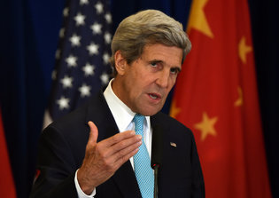
Secretary of State John Kerry, in Beijing on Thursday, said there was no United States strategy to be in conflict with China. Credit Pool photo by Greg Baker
Mr. Kerry was indirectly replying to charges by Chinese officials that President Obama had reinvigorated America’s network of alliances in Asia with the idea of containing China and its fast modernizing military. In response, Mr. Xi has initiated a campaign that calls for a new security architecture of Asia for the Asians.
New accusations that Chinese hackers had attacked highly sensitive American material were brusquely dismissed by China, even as the American delegation, headed by Mr. Kerry and Treasury Secretary Jacob J. Lew, tried to press cyberespionage as an important issue at the conference.
The Foreign Ministry dismissed assertions in an article in The New York Times that Chinese hackers had infiltrated United States government computer systems that house personal information of federal employees.
A Chinese Foreign Ministry spokesman said the article was part of what he called an irresponsible anti-China smear campaign.
The article, first published Wednesday on the newspaper’s website, said the hackers had gained access to some of the databases of the Office of Personnel Management before authorities in the United States detected the breach and thwarted further access. It remained unclear what kind of information, if any, was compromised in the attack, which was said to have happened in March.
Asked about the article at a regular Foreign Ministry press briefing, a spokesman, Hong Lei, repeated China’s longstanding position that it opposes cyberhacking.
“This is what we say and what we have been doing,” he said. “Recently, some American media and Internet security firms keep playing the card of China Internet Threat and smear China’s image. They cannot produce tenable evidence. Such reports and comments are irresponsible and are not worth refuting.”
Asked about the article at a closing news conference, Mr. Kerry said that he and Mr. Lew had been unaware of the attack described in the article and did not raise it with Chinese officials, although the broader subject of cybersecurity was discussed.
“We were notified about this alleged incident minutes before coming out here,” Mr. Kerry said.
He said the article was about attempted “intrusions” that were still being investigated and it did not appear that sensitive material had been compromised.
A senior American official who participated in sessions with the Chinese on Thursday said the case of the hacking into the Office of Personnel Management was not raised by either side. The official spoke on the condition of anonymity in order to talk about a delicate matter.
The Chinese, angered by the indictment by the Justice Department in May of five members of the People’s Liberation Army on charges of cyberespionage, refused a request at the dialogue by the Americans to restart a joint cyber working group.
China suspended the work of the group that brought together American and Chinese negotiators to discuss cyber issues and has complained that National Security Agency documents made public by Edward J. Snowden showed the United States had used cyberespionage to gain economic advantage.
Mr. Xi, who invited the American and Chinese delegations to meet him Thursday afternoon at a session that was partly open to reporters, called on the two countries to work on building a “new model of major country relationship,” a phrase he frequently uses to imply an equal status between the United States and China.
It is an expression that the Obama administration has been reluctant to endorse for fear that it would confer legitimacy to China’s various territorial claims, including in the East China Sea and South China Sea.
The Obama administration sent senior officials to the dialogue, including Janet L. Yellen, chairwoman of the Federal Reserve; Michael Froman, the United States trade representative; Ernest Moniz, secretary of energy; Penny Pritzker, secretary of commerce, and John D. Podesta, counselor to President Obama, who specializes in climate change.
The Americans appeared pleased about what they called serious discussions on how to reduce carbon emissions. The presence of Mr. Podesta, who the Chinese know is close to Mr. Obama and is committed to climate change policies, added weight, they said.
A joint working group on climate change announced that both countries would develop new greenhouse gas emissions and fuel economy standards.
“This effort has to be mutual and has to be accompanied by commitments which are defined by the actions we will actually take,” Mr. Kerry said. “It’s not about one country making a demand of the other.”
Even so, China’s chief climate official, Xie Zhenhua, said China, which still considers itself a developing country, should not be subject to the same rules for greenhouse gas emissions as the United States, suggesting that Beijing will oppose attempts to impose them at next year’s world climate conference in Paris.

Chinese Hackers Pursue Key Data on U.S. Workers
By MICHAEL S. SCHMIDT, DAVID E. SANGER and NICOLE PERLROTHJULY 9, 2014
WASHINGTON — Chinese hackers in March broke into the computer networks of the United States government agency that houses the personal information of all federal employees, according to senior American officials. They appeared to be targeting the files on tens of thousands of employees who have applied for top-secret security clearances.
The hackers gained access to some of the databases of the Office of Personnel Management before the federal authorities detected the threat and blocked them from the network, according to the officials. It is not yet clear how far the hackers penetrated the agency’s systems, in which applicants for security clearances list their foreign contacts, previous jobs and personal information like past drug use.
In response to questions about the matter, a senior Department of Homeland Security official confirmed that the attack had occurred but said that “at this time,” neither the personnel agency nor Homeland Security had “identified any loss of personally identifiable information.” The official said an emergency response team was assigned “to assess and mitigate any risks identified.”
One senior American official said that the attack was traced to China, though it was not clear if the hackers were part of the government. Its disclosure comes as a delegation of senior American officials, led by Secretary of State John Kerry, are in Beijing for the annual Strategic and Economic Dialogue, the leading forum for discussion between the United States and China on their commercial relationships and their wary efforts to work together on economic and defense issues.
Computer intrusions have been a major source of discussion and disagreement between the two countries, and the Chinese can point to evidence, revealed by Edward J. Snowden, that the National Security Agency went deep into the computer systems of Huawei, a major maker of computer network equipment, and ran many programs to intercept the conversations of Chinese leaders and the military.
American officials say the attack on the Office of Personnel Management was notable because while hackers try to breach United States government servers nearly every day, they rarely succeed. One of the last attacks the government acknowledged occurred last year at the Department of Energy. In that case, hackers successfully made off with employee and contractors’ personal data. The agency was forced to reveal the attack because state disclosure laws force entities to report breaches in cases where personally identifiable information is compromised. Government agencies do not have to disclose breaches in which sensitive government secrets, but no personally identifiable information, has been stolen.
Just a month ago, the Justice Department indicted a group of Chinese hackers who work for the People’s Liberation Army Unit 61398, and charged them with stealing corporate secrets. The same unit, and others linked to the P.L.A., have been accused in the past of intrusions into United States government computer systems, including in the office of the secretary of defense.
But private security researchers say the indictments have hardly deterred the People’s Liberation Army from hacking foreign targets, and American officials are increasingly concerned that they have failed in their effort to deter computer attacks from China or elsewhere. “There’s no price to pay for the Chinese,” one senior intelligence official said recently, “and nothing will change until that changes.”
The indictments have been criticized as long on symbolism and short on real punishment: There is very little chance that the Chinese military members would ever see the inside of an American courtroom, even if the F.B.I. has put their pictures on wanted posters.
“I think that it was speaking loudly and carrying a small stick,” said Dennis Blair, the former director of national intelligence during President Obama’s first term, who was a co-author of a report last year urging that the United States create a series of financial disincentives for computer theft and attacks, including halting some forms of imports and blocking access to American financial markets.
Not long after several members of Unit 61398 were indicted, security researchers were able to pin hundreds more cyberattacks at American and European space and satellite technology companies and research groups on a second Shanghai-based Chinese military unit, known as Unit 61486. Researchers say that even after Americans indicted their counterparts in Unit 61398, members of Unit 61486 have shown no signs of scaling back.
The same proved true for the dozen other Chinese military and naval units that American officials have been tracking as they break into an ever more concerning list of corporate targets including drone, missile and nuclear propulsion technology makers.
The intrusion at the Office of Personnel Management was particularly disturbing because it oversees a system called e-QIP, in which federal employees applying for security clearances enter their most personal information, including financial data. Federal employees who have had security clearances for some time are often required to update their personal information through the website.
The agencies and the contractors use the information from e-QIP to investigate the employees and ultimately determine whether they should be granted security clearances, or have them updated.
A representative of the Office of Personnel Management said that monitoring systems at the Department of Homeland Security and the agency office allowed them to be “alerted to a potential intrusion of our network in mid-March.”
In the past, the Obama administration has urged American companies to share intrusion information with the government and reveal breaches to consumers in cases where their personal information was compromised and could be used without authorization.
But in this case there was no announcement about the attack. “The administration has never advocated that all intrusions be made public,” said Caitlin Hayden, a spokeswoman for the Obama administration. “We have advocated that businesses that have suffered an intrusion notify customers if the intruder had access to consumers’ personal information. We have also advocated that companies and agencies voluntarily share information about intrusions.”
Ms. Hayden noted that the agency had intrusion-detection systems in place and notified other federal agencies, state and local governments about the attack, then shared relevant threat information with some in the security industry. Four months after the attack, Ms. Hayden said the Obama administration had no reason to believe personally identifiable information for employees was compromised.
“None of this differs from our normal response to similar threats,” Ms. Hayden said.

NYT

Chinese Oil Rig Near Vietnam to Be Moved
By JANE PERLEZJULY 15, 2014
Photo
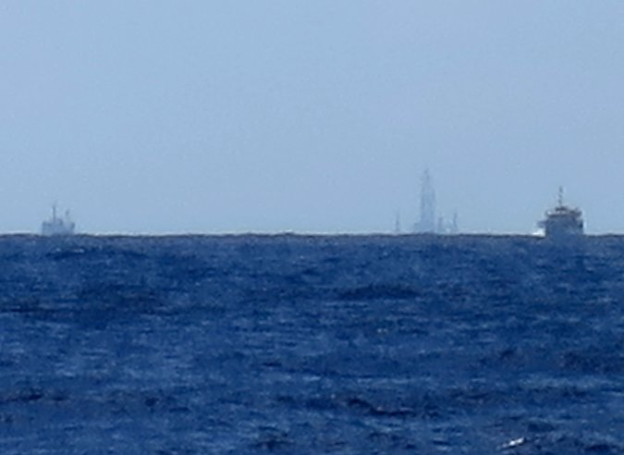
Chinese ships guard the HD 981 in the South China Sea on Tuesday. Credit Martin Petty/Reuters
BEIJING — A Chinese energy company announced Wednesday that a giant oil rig that was deployed in disputed waters off the coast of Vietnam two months ago had completed its exploration work and would be moved.
The China National Petroleum Corporation, a state-owned company, said the billion-dollar rig, known as HD 981, would be relocated to an area around the Qiongdongnan basin, closer to Hainan Island, a southern province of China, and apparently in undisputed waters.
The arrival of the rig off the Paracel Islands in the South China Sea in early May worsened China’s relations with Vietnam, a neighbor, and became a sticking point in the increasing tensions between Beijing and Washington.
The announcement, released by Xinhua, the state-run news agency, came a day after President Obama called President Xi Jinping to talk about what the White House called the “important progress” at meetings between the two countries in Beijing last week, although they did not settle any differences.

In Push to Assert Rights, China Plans to Send 2nd Oil Rig to Waters Near Vietnam JUNE 19, 2014

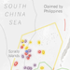

Vietnamese Vessel Sinks in Clash Near Oil RigMAY 26, 2014

Vietnam Squares Off With China in Disputed SeasMAY 7, 2014

There was no indication that the movement of the rig away from the disputed waters with Vietnam was related to the telephone call.
Continue reading the main story

Map: Territorial Disputes in the Waters Near China

When the rig was first deployed close to the Paracels, claimed by both China and Vietnam, Chinese officials said it would remain in place until mid-August, the normal start of the typhoon season.
There was no explanation why the rig was leaving earlier, but the statement by the China National Petroleum Corporation said the operation was ending as planned. During exploration, the rig found “signs of oil and gas,” and the company planned to assess the data and decide on its next steps, the statement said.
The arrival of the rig — more than 40 stories tall and the size of a football field — prompted daily clashes at sea between Chinese vessels sent to protect it and Vietnamese boats that tried to pierce the perimeter of about 12 miles the Chinese had established around it.
Chinese Coast Guard vessels rammed smaller Vietnamese boats, and the Chinese used powerful water cannons to keep the Vietnamese vessels at bay.
Both sides also stationed naval vessels in the distance, and Chinese fighter jets flew over the rig from time to time. In Vietnam, anti-Chinese protests turned violent as two Chinese workers were killed and factories run by Taiwanese and South Korean companies were destroyed.
China’s Foreign Ministry said Wednesday that the movement of the rig should not be seen as a retreat, emphasizing the position that the Paracel Islands were China’s territory and that the rig was operating in “undisputed coastal waters” of the islands.
China, though, could be moving the oil rig to ease relations with Vietnam, said Bonnie Glaser, a senior adviser for Asia at the Center for Strategic and International Studies in Washington. “It could be a face-saving way to end the over two-month-long standoff with Vietnam,” she said.
The Voice of Vietnam, a state-run news agency, said Wednesday that Vietnamese law enforcement officials saw the rig moving away from its position on Tuesday evening. The agency added that the move may have occurred because of the approaching Typhoon Rammasun.
But an influential Vietnamese military official, Maj. Gen. Le Ma Luong, said the Chinese were backing down and were moving the rig because of the “strong reactions”of Vietnam. In an interview in PetroTimes, a Vietnamese state-run news outlet, the general said the typhoon was “just an excuse.”

CFR

Contingency Planning Memorandum

Armed Clash in the South China Sea

Contingency Planning Memorandum No. 14
Author: Bonnie S. Glaser, Senior Fellow, Center for Strategic and International Studies
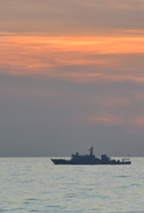
Download Now
Publisher Council on Foreign Relations Press
Release Date April 2012

Introduction
The risk of conflict in the South China Sea is significant. China, Taiwan, Vietnam, Malaysia, Brunei, and the Philippines have competing territorial and jurisdictional claims, particularly over rights to exploit the region's possibly extensive reserves of oil and gas. Freedom of navigation in the region is also a contentious issue, especially between the United States and China over the right of U.S. military vessels to operate in China's two-hundred-mile exclusive economic zone (EEZ). These tensions are shaping—and being shaped by—rising apprehensions about the growth of China's military power and its regional intentions. China has embarked on a substantial modernization of its maritime paramilitary forces as well as naval capabilities to enforce its sovereignty and jurisdiction claims by force if necessary. At the same time, it is developing capabilities that would put U.S. forces in the region at risk in a conflict, thus potentially denying access to the U.S. Navy in the western Pacific.
Given the growing importance of the U.S.-China relationship, and the Asia-Pacific region more generally, to the global economy, the United States has a major interest in preventing any one of the various disputes in the South China Sea from escalating militarily.

The Contingencies
Of the many conceivable contingencies involving an armed clash in the South China Sea, three especially threaten U.S. interests and could potentially prompt the United States to use force.
The most likely and dangerous contingency is a clash stemming from U.S. military operations within China's EEZ that provokes an armed Chinese response. The United States holds that nothing in the United Nations Convention on the Law of the Sea (UNCLOS) or state practice negates the right of military forces of all nations to conduct military activities in EEZs without coastal state notice or consent. China insists that reconnaissance activities undertaken without prior notification and without permission of the coastal state violate Chinese domestic law and international law. China routinely intercepts U.S. reconnaissance flights conducted in its EEZ and periodically does so in aggressive ways that increase the risk of an accident similar to the April 2001 collision of a U.S. EP-3 reconnaissance plane and a Chinese F-8 fighter jet near Hainan Island. A comparable maritime incident could be triggered by Chinese vessels harassing a U.S. Navy surveillance ship operating in its EEZ, such as occurred in the 2009 incidents involving the USNS Impeccable and the USNS Victorious. The large growth of Chinese submarines has also increased the danger of an incident, such as when a Chinese submarine collided with a U.S. destroyer's towed sonar array in June 2009. Since neither U.S. reconnaissance aircraft nor ocean surveillance vessels are armed, the United States might respond to dangerous behavior by Chinese planes or ships by dispatching armed escorts. A miscalculation or misunderstanding could then result in a deadly exchange of fire, leading to further military escalation and precipitating a major political crisis. Rising U.S.-China mistrust and intensifying bilateral strategic competition would likely make managing such a crisis more difficult.
A second contingency involves conflict between China and the Philippines over natural gas deposits, especially in the disputed area of Reed Bank, located eighty nautical miles from Palawan. Oil survey ships operating in Reed Bank under contract have increasingly been harassed by Chinese vessels. Reportedly, the United Kingdom-based Forum Energy plans to start drilling for gas in Reed Bank this year, which could provoke an aggressive Chinese response. Forum Energy is only one of fifteen exploration contracts that Manila intends to offer over the next few years for offshore exploration near Palawan Island. Reed Bank is a red line for the Philippines, so this contingency could quickly escalate to violence if China intervened to halt the drilling.
The United States could be drawn into a China-Philippines conflict because of its 1951 Mutual Defense Treaty with the Philippines. The treaty states, "Each Party recognizes that an armed attack in the Pacific Area on either of the Parties would be dangerous to its own peace and safety and declares that it would act to meet the common dangers in accordance with its constitutional processes." American officials insist that Washington does not take sides in the territorial dispute in the South China Sea and refuse to comment on how the United States might respond to Chinese aggression in contested waters. Nevertheless, an apparent gap exists between American views of U.S. obligations and Manila's expectations. In mid-June 2011, a Filipino presidential spokesperson stated that in the event of armed conflict with China, Manila expected the United States would come to its aid. Statements by senior U.S. officials may have inadvertently led Manila to conclude that the United States would provide military assistance if China attacked Filipino forces in the disputed Spratly Islands.
With improving political and military ties between Manila and Washington, including a pending agreement to expand U.S. access to Filipino ports and airfields to refuel and service its warships and planes, the United States would have a great deal at stake in a China-Philippines contingency. Failure to respond would not only set back U.S. relations with the Philippines but would also potentially undermine U.S. credibility in the region with its allies and partners more broadly. A U.S. decision to dispatch naval ships to the area, however, would risk a U.S.-China naval confrontation.
Disputes between China and Vietnam over seismic surveys or drilling for oil and gas could also trigger an armed clash for a third contingency. China has harassed PetroVietnam oil survey ships in the past that were searching for oil and gas deposits in Vietnam's EEZ. In 2011, Hanoi accused China of deliberately severing the cables of an oil and gas survey vessel in two separate instances. Although the Vietnamese did not respond with force, they did not back down and Hanoi pledged to continue its efforts to exploit new fields despite warnings from Beijing. Budding U.S.-Vietnam relations could embolden Hanoi to be more confrontational with China on the South China Sea issue.
The United States could be drawn into a conflict between China and Vietnam, though that is less likely than a clash between China and the Philippines. In a scenario of Chinese provocation, the United States might opt to dispatch naval vessels to the area to signal its interest in regional peace and stability. Vietnam, and possibly other nations, could also request U.S. assistance in such circumstances. Should the United States become involved, subsequent actions by China or a miscalculation among the forces present could result in exchange of fire. In another possible scenario, an attack by China on vessels or rigs operated by an American company exploring or drilling for hydrocarbons could quickly involve the United States, especially if American lives were endangered or lost. ExxonMobil has plans to conduct exploratory drilling off Vietnam, making this an existential danger. In the short term, however, the likelihood of this third contingency occurring is relatively low given the recent thaw in Sino-Vietnamese relations. In October 2011, China and Vietnam signed an agreement outlining principles for resolving maritime issues. The effectiveness of this agreement remains to be seen, but for now tensions appear to be defused.

Warning Indicators
Strategic warning signals that indicate heightened risk of conflict include political decisions and statements by senior officials, official and unofficial media reports, and logistical changes and equipment modifications. In the contingencies described above, strategic warning indicators could include heightened rhetoric from all or some disputants regarding their territorial and strategic interests. For example, China may explicitly refer to the South China Sea as a core interest; in 2010 Beijing hinted this was the case but subsequently backed away from the assertion. Beijing might also warn that it cannot "stand idly by" as countries nibble away at Chinese territory, a formulation that in the past has often signaled willingness to use force. Commentaries and editorials in authoritative media outlets expressing China's bottom line and issuing ultimatums could also be a warning indicator. Tough language could also be used by senior People's Liberation Army (PLA) officers in meetings with their American counterparts. An increase in nationalistic rhetoric in nonauthoritative media and in Chinese blogs, even if not representing official Chinese policy, would nevertheless signal pressure on the Chinese leadership to defend Chinese interests. Similar warning indicators should be tracked in Vietnam and the Philippines that might signal a hardening of those countries' positions.
Tactical warning signals that indicate heightened risk of a potential clash in a specific time and place include commercial notices and preparations, diplomatic and/or military statements warning another claimant to cease provocative activities or suffer the consequences, military exercises designed to intimidate another claimant, and ship movements to disputed areas. As for an impending incident regarding U.S. surveillance activities, statements and unusual preparations by the PLA might suggest a greater willingness to employ more aggressive means to intercept U.S. ships and aircraft.

Implications for U.S. Interests
The United States has significant political, security, and economic interests at stake if one of the contingencies should occur.
- Global rules and norms. The United States has important interests in the peaceful resolution of South China Sea disputes according to international law. With the exception of China, all the claimants of the South China Sea have attempted to justify their claims based on their coastlines and the provisions of UNCLOS. China, however, relies on a mix of historic rights and legal claims, while remaining deliberately ambiguous about the meaning of the "nine-dashed line" around the sea that is drawn on Chinese maps. Failure to uphold international law and norms could harm U.S. interests elsewhere in the region and beyond. Ensuring freedom of navigation is another critical interest of the United States and other regional states. Although China claims that it supports freedom of navigation, its insistence that foreign militaries seek advance permission to sail in its two-hundred-mile EEZ casts doubt on its stance. China's development of capabilities to deny American naval access to those waters in a conflict provides evidence of possible Chinese intentions to block freedom of navigation in specific contingencies.
- Alliance security and regional stability. U.S. allies and friends around the South China Sea look to the United States to maintain free trade, safe and secure sea lines of communication (SLOCs), and overall peace and stability in the region. Claimants and nonclaimants to land features and maritime waters in the South China Sea view the U.S. military presence as necessary to allow decision-making free of intimidation. If nations in the South China Sea lose confidence in the United States to serve as the principal regional security guarantor, they could embark on costly and potentially destabilizing arms buildups to compensate or, alternatively, become more accommodating to the demands of a powerful China. Neither would be in the U.S. interest. Failure to reassure allies of U.S. commitments in the region could also undermine U.S. security guarantees in the broader Asia-Pacific region, especially with Japan and South Korea. At the same time, however, the United States must avoid getting drawn into the territorial dispute—and possibly into a conflict—by regional nations who seek U.S. backing to legitimize their claims.
- Economic interests. Each year, $5.3 trillion of trade passes through the South China Sea; U.S. trade accounts for $1.2 trillion of this total. Should a crisis occur, the diversion of cargo ships to other routes would harm regional economies as a result of an increase in insurance rates and longer transits. Conflict of any scale in the South China Sea would hamper the claimants from benefiting from the South China's Sea's proven and potential riches.
- Cooperative relationship with China. The stakes and implications of any U.S.-China incident are far greater than in other scenarios. The United States has an abiding interest in preserving stability in the U.S.-China relationship so that it can continue to secure Beijing's cooperation on an expanding list of regional and global issues and more tightly integrate China into the prevailing international system.

Preventive Options
Efforts should continue to resolve the disputes over territorial sovereignty of the South China Sea's land features, rightful jurisdiction over the waters and seabed, and the legality of conducting military operations within a country's EEZ, but the likelihood of a breakthrough in any of these areas is slim in the near term. In the meantime, the United States should focus on lowering the risk of potential armed clashes arising from either miscalculation or unintended escalation of a dispute. There are several preventive options available to policymakers—in the United States and other nations—to avert a crisis and conflict in the South China Sea. These options are not mutually exclusive.

Support U.S.-China Risk-reduction Measures
Operational safety measures and expanded naval cooperation between the United States and China can help to reduce the risk of an accident between ships and aircraft. The creation of the Military Maritime Consultative Agreement (MMCA) in 1988 was intended to establish "rules of the road" at sea similar to the U.S.-Soviet Incidents at Sea Agreement (INCSEA), but it has not been successful. Communication mechanisms can provide a means to defuse tensions in a crisis and prevent escalation. Political and military hotlines have been set up, though U.S. officials have low confidence that they would be utilized by their Chinese counterparts during a crisis. An additional hotline to manage maritime emergencies should be established at an operational level, along with a signed political agreement committing both sides to answer the phone in a crisis. Joint naval exercises to enhance the ability of the two sides to cooperate in counter-piracy, humanitarian assistance, and disaster relief operations could increase cooperation and help prevent a U.S.-China conflict.

Bolster Capabilities of Regional Actors
Steps could be taken to further enhance the capability of the Philippines military to defend its territorial and maritime claims and improve its indigenous domain awareness, which might deter China from taking aggressive action. Similarly, the United States could boost the maritime surveillance capabilities of Vietnam, enabling its military to more effectively pursue an anti-access and area-denial strategy. Such measures run the risk of emboldening the Philippines and Vietnam to more assertively challenge China and could raise those countries' expectations of U.S. assistance in a crisis.

Encourage Settlement of the Sovereignty Dispute
The United States could push for submission of territorial disputes to the International Court of Justice or the International Tribunal for the Law of the Sea for settlement, or encourage an outside organization or mediator to be called upon to resolve the dispute. However, the prospect for success in these cases is slim given China's likely opposition to such options. Other options exist to resolve the sovereignty dispute that would be difficult, but not impossible, to negotiate. One such proposal, originally made by Mark Valencia, Jon Van Dyke, and Noel Ludwig in Sharing the Resources of the South China Sea, would establish "regional sovereignty" over the islands in the South China Sea among the six claimants, allowing them to collectively manage the islands, territorial seas, and airspace. Another option put forward by Peter Dutton of the Naval War College would emulate the resolution of the dispute over Svalbard, an island located between Norway and Greenland. The Treaty of Spitsbergen, signed in 1920, awarded primary sovereignty over Svarlbard to Norway but assigned resource-related rights to all signatories. This solution avoided conflict over resources and enabled advancement of scientific research. Applying this model to the South China Sea would likely entail giving sovereignty to China while permitting other countries to benefit from the resources. In the near term, at least, such a solution is unlikely to be accepted by the other claimants.

Promote Regional Risk-reduction Measures
The Association of Southeast Asian Nations (ASEAN) and China agreed upon multilateral risk-reduction and confidence-building measures in the 2002 Declaration on the Conduct of Parties in the South China Sea (DOC), but have neither adhered to its provisions (for example, to resolve territorial and jurisdictional disputes without resorting to the threat or use of force) nor implemented its proposals to undertake cooperative trust-building activities. The resumption of negotiations between China and ASEAN after a hiatus of a decade holds out promise for reinvigorating cooperative activities under the DOC.
Multilaterally, existing mechanisms and procedures already exist to promote operational safety among regional navies; a new arrangement is unnecessary. The United States, China, and all ASEAN members with the exception of Laos and Burma are members of the Western Pacific Naval Symposium (WPNS). Founded in 1988, WPNS brings regional naval leaders together biennially to discuss maritime security. In 2000, it produced the Code for Unalerted Encounters at Sea (CUES), which includes safety measures and procedures and means to facilitate communication when ships and aircraft make contact. There are also other mechanisms available such as the International Maritime Organization's Regulations for Preventing Collisions at Sea (COLREGS) and the International Civil Aviation Organization's rules of the air. In addition, regional navies could cooperate in sea environment protection, scientific research at sea, search and rescue activities, and mitigation of damage caused by natural calamities.
The creation of new dialogue mechanisms may also be worth consideration. A South China Sea Coast Guard Forum, modeled after the North Pacific Coast Guard Forum, which cooperates on a multitude of maritime security and legal issues, could enhance cooperation through information sharing and knowledge of best practices. The creation of a South China Sea information-sharing center would also provide a platform to improve awareness and communication between relevant parties. The information-sharing center could also serve as an accountability mechanism if states are required to document any incidents and present them to the center.

Advocate Joint Development/Multilateral Economic Cooperation
Resource cooperation is another preventive option that is underutilized by claimants in the South China Sea. Joint development of petroleum resources, for example, could reduce tensions between China and Vietnam, and between China and the Philippines, on issues related to energy security and access to hydrocarbon resources. Such development could be modeled on one of the many joint development arrangements that exist in the South and East China seas. Parties could also cooperate on increasing the use of alternative energy sources in order to reduce reliance on hydrocarbons.
Shared concerns about declining fish stocks in the South China Sea suggest the utility of cooperation to promote conservation and sustainable development. Establishing a joint fisheries committee among claimants could prove useful. Fishing agreements between China and its neighbors are already in place that could be expanded into disputed areas to encourage greater cooperation.

Clearly Convey U.S. Commitments
The United States should avoid inadvertently encouraging the claimants to engage in confrontational behavior. For example, Secretary of State Hillary Clinton's reference in November 2011 to the South China Sea as the West Philippine Sea could have unintended consequences such as emboldening Manila to antagonize China rather than it seeking to peacefully settle their differences.

Mitigating Options
If preventive options fail to avert a crisis from developing, policymakers have several options available to mitigate the potential negative effects.

Defusing a U.S.-China Incident
The history of crisis management in U.S.-China relations suggests that leaders in both countries go to great lengths to prevent a crisis from escalating to military conflict. Nevertheless, pre-crisis steps could be taken to limit the harmful consequences of a confrontation. Political agreements could be reached that would increase the possibility that communication mechanisms in place would be employed in a crisis. Steps should be taken to enhance operational safety at sea between U.S. and Chinese ships. Confidence-building measures should also be implemented to build trust and promote cooperation.

Mitigating a Regional Crisis with China
Dispatching air and naval forces to the immediate vicinity of an armed clash to defend U.S. interests and deter further escalation should always be considered an option. Such actions, however, must be balanced against the possibility that they will produce the opposite effect, encouraging an even stronger response from China and causing further escalation of a confrontation. A less risky option would be to threaten nonmilitary consequences—diplomatic and economic sanctions––to force China to back off and deter further military action. But here again such measures may only inflame hostilities and escalate the crisis. It is also doubtful in any case whether such measures would be supported by many in the region given China's economic importance.
Several less provocative responses might contain a budding crisis while avoiding further escalation. One option for the United States would be to encourage a mediated dialogue between involved parties. However, while Southeast Asian states may welcome a neutral mediator, China would probably oppose it. Thus, such an effort would likely fail.
Direct communication between military officials can be effective in de-escalating a crisis. States involved should establish communication mechanisms, include provisions for both scheduled and short-notice emergency meetings, and mandate consultation during a crisis. Emergency meetings would focus on addressing the specific provocative action that brought about the crisis. Operational hotlines, including phone lines and radio frequencies with clear protocols and points of contact, should also be set up. To be effective, hotlines should be set up and used prior to a crisis, though even then there is no guarantee that they will be used by both sides if a crisis erupts. China and Vietnam have already agreed to establish a hotline; this could be a model for other states in the region and China. The goal would not be to resolve underlying issues, but to contain tensions in the event of a minor skirmish and prevent escalation.

Recommendations
Against the background of rebalancing U.S. assets and attention toward the Asia-Pacific region, the United States should takes steps to prevent a conflict in the South China Sea and to defuse a crisis should one take place. Although the possibility of a major military conflict is low, the potential for a violent clash in the South China Sea in the near future is high, given past behavior of states in the region and the growing stakes. Therefore, both U.S. and regional policymakers should seek to create mechanisms to build trust, prevent conflict, and avoid escalation.
First, the United States should ratify UNCLOS; though it voluntarily adheres to its principles and the Obama administration has made a commitment to ratify the convention, the fact that the United States has not yet ratified the treaty lends credence to the perception that it only abides by international conventions when doing so aligns with its national interests. Ratifying UNCLOS would put this speculation to rest. It would also bolster the U.S. position in favor of rules-based behavior, give the United States a seat at the table when UNCLOS signatories discuss such issues as EEZ rights, and generally advance U.S. economic and strategic interests.
Second, nations with navies active in the South China Sea—including the United States, China, Vietnam, and the Philippines—should better utilize the CUES safety measures and procedures to mitigate uncertainty and improve communication in the event of a maritime incident. Under current arrangements, observing CUES procedures is voluntary. Participating countries should consider making compliance compulsory in order to guarantee standardized procedures. Countries should also engage in multilateral and bilateral maritime exercises to practice these procedures in a controlled environment before a contingency unfolds.
Third, the United States should make clear its support for risk-reduction measures and confidence-building measures among claimants in the South China Sea. The United States should continue to voice its support for full implementation of the China-ASEAN DOC and subsequent agreement on a binding code of conduct. Beijing needs a favorable regional security environment and therefore has important incentives to work out a modus vivendi with its neighbors, but will not likely do so absent pressure. Agreement on a binding code of conduct will require unity among all members of ASEAN and strong backing from the United States. In the meantime, cooperation should be further developed through expanded ship visits, bilateral and multilateral exercise, and enhanced counter-piracy cooperation. In addition, cooperation on energy and fisheries should be further promoted.
Fourth, the creation of new dialogue mechanisms—such as a South China Sea Coast Guard Forum, an information-sharing center, and a joint fisheries committee—would provide greater opportunity for affected parties to communicate directly and offer opportunities for greater coordination.
Fifth, the United States should review its surveillance and reconnaissance activities in the air and waters bordering China's twelve-mile territorial sea and assess the feasibility of reducing their frequency or conducting the operations at a greater distance. Any modification of U.S. close-in surveillance and reconnaissance activities requires assessment of whether those sources are uniquely valuable or other intelligence collection platforms can provide sufficient information about Chinese military developments. The United States should not take such a step unilaterally; it should seek to obtain a concession from Beijing in return lest China interpret the action as evidence of U.S. decline and weakness.
Sixth, the Military Maritime Consultative Agreement process should be made effective or abandoned. There is a pressing need for the United States and China to agree on operational safety rules to minimize the possibility of a conflict in the years ahead. A more formal "incidents at sea" agreement should be considered.
Seventh, Washington should clarify in its respective dialogues with Manila and Hanoi the extent of the United States' obligations and commitments as well as the limits of likely U.S. involvement in future disputes. Clarity is necessary both to avoid a scenario in which regional actors are emboldened to aggressively confront China and to avert a setback to U.S. relations with regional nations due to perceptions of unfulfilled expectations.

Multimedia
Audio: Recent Trends in the South China Sea and U.S. Policy: Day 1, Panel 3
Jul 10, 2014
DURATION: 01:41:13
Defense and Security, Energy and Climate Change, Trade and Economics, Regional Analysis, Governance
Asia, China, Southeast Asia
Video: Power and Order in Asia: A Survey of Regional Expectations
Jun 5, 2014
DURATION: 01:25:11
Regional Analysis
Asia, China, India, Japan, Korea, Southeast Asia

Video: Recent Trends in the South China Sea and U.S. Policy: Day 2, Panel 1
Jul 14, 2014
DURATION: 00:56:02
Defense and Security, Energy and Climate Change, Trade and Economics, Regional Analysis, Governance
Asia, China, Southeast Asia

ASEAN, China, Indonesia, South China Sea, United States

Bali Accord on South China Sea is Overrated

by Bonnie S. Glaser • August 29, 2011 • 7 Comments
By Bonnie Glaser
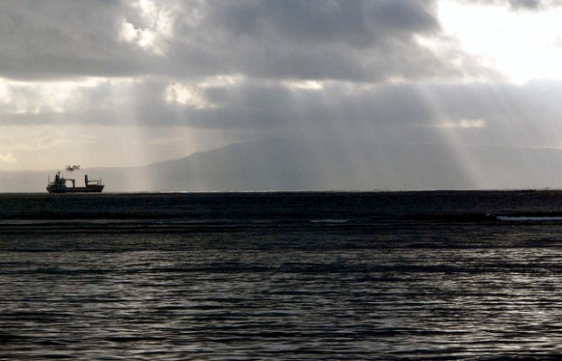
Control over maritime territory is at the center of the ASEAN-China dispute.
Agreement between China and ASEAN on a set of guidelines to implement the 2002 Declaration on the Conduct of Parties in the South China Sea (DOC) is a welcome development, but it is doubtful that this heralds a change in Beijing’s approach to handling the territorial disputes with its neighbors, as claimed by Yang Fang. The eight guidelines have taken nine years to negotiate due to a dispute between China and ASEAN over the inclusion of language permitting the ten member states of ASEAN to confer among themselves before talking to Beijing. ASEAN dropped this demand, paving the way for the signing of the Bali agreement.
The impetus came from a shared desire to set a positive tone and atmosphere at the ASEAN Regional Forum last month. The result was a set of vague statements that fall far short of the needed binding code of conduct that will prevent the reoccurrence of recent incidents such as the severing of cables of a PetroVietnam survey ship, the construction activities on Amy Douglas Bank and other acts of intimidation by China. The document does nothing to identify behaviors that are unacceptable nor does it include consequences for violations. It does not even contain progress toward implementing the basic confidence-building measures that were outlined in the DOC, including holding dialogues among defense officials; notifying other parties of planned military exercises, and exchanging information.
Until these steps are taken, there is little reason to be optimistic that joint development of oil and gas will take place. In the meantime, China continues to insist that territorial disputes be discussed bilaterally, which enables Beijing to bring pressure to bear on its smaller, weaker neighbors. Moreover, the Chinese persist in their stance that the US has no direct interests in the South China Sea, despite Secretary Clinton’s claims to the contrary. And Beijing shows no readiness to clarify the nature of its territorial claims in the South China Sea or provide a justification for its claims on the basis of the UN Convention on the Law of the Sea.
China’s decision to agree to the guiding principles is nothing more than a tactical step aimed at assuaging regional worries about China’s aggressive behavior and constraining Washington’s ability to intervene. It does not signal a strategic shift in Beijing’s handling of maritime territorial disputes. Some reports even suggest that China’s position is already hardening. Barry Wain writes that China has notified ASEAN that it wants to delete it’s one minor concession—ASEAN’s intention to consult—from the summary record of their agreement. It is too early to join hands and sign Kumbaya. The Bali agreement will only be judged a success if it paves the way for a binding accord that sets out rules of the road at sea that can both prevent conflict and promote shared economic prosperity in the region.

NYT

A View From the Sea, as China Flexes Muscle
By AUSTIN RAMZYAUG. 9, 2014
Photo
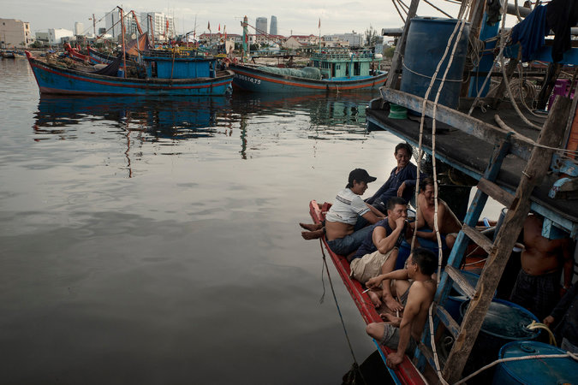
Fishermen in Da Nang. On a two-day trip from that port, a Vietnamese vessel encountered some 70 Chinese ships. Credit Gilles Sabrie for The New York Times
ABOARD CSB-8003, in the South China Sea — As the large white Chinese ship closed in, the smaller Vietnamese Coast Guard vessel could only veer off, black exhaust billowing from its stack. The Vietnamese vessel had advanced to within 13 miles of the Chinese offshore oil rig, and the Chinese decided it could come no closer.
With the rig barely visible on the horizon but the Chinese ship looming close behind, the Vietnamese patrol boat, CSB-8003, blasted a two-minute recorded message in Chinese, from loudspeakers on the back of the boat. These waters belong to Vietnam, the message said, and China’s placement of the rig had “hurt the feelings of the Vietnamese people.”
About six hours after the encounter on July 15, one of the last in a two-and-a-half-month standoff over the rig known as HD 981, China began moving the rig north toward the Chinese island of Hainan and out of waters Vietnam considers its exclusive economic zone. Three weeks later, analysts are still debating whether China, facing international pressure, blinked in its standoff with Vietnam — or whether this was just a tactical retreat before a more aggressive campaign.
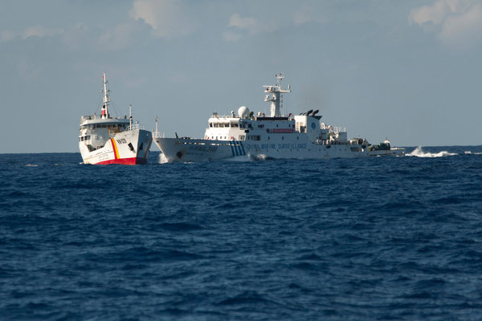
Vietnamese and Chinese vessels near a Chinese oil rig. Credit Gilles Sabrie for The New York Times
While Vietnam claimed success in forcing the departure of HD 981, China National Petroleum Corporation, which managed the project, said the rig had completed its exploration work and was moving as planned.
The relocation of the rig just ahead of the approach of a typhoon in the area also prompted speculation that the storm may have forced its early departure. But the $1 billion rig, which is owned by the state-run China National Offshore Oil Corporation, was moved to a spot about 60 miles southeast of Hainan Island that is also exposed to typhoons.
While the Vietnamese Coast Guard celebrated the departure of the Chinese rig, some officers said they were worried that the episode represented a more aggressive attitude by China.
“From the moment that they installed the rig near the islands, the Chinese began more and more and more attacks, in words and in actions,” said Lt. Col. Tran Van Tho of the Vietnam Coast Guard as he stood smoking a cigarette on the deck of CSB-8003. “Why? It is a part of a Chinese strategy to control the sea. This is a first step to try to make a new base to expand farther south. This not only threatens Vietnam, but the Philippines and other countries. This has been organized systematically, as part of a strategy. It is not random.”
Lyle J. Goldstein, an associate professor at the United States Naval War College’s China Maritime Studies Institute, said that China has long taken an assertive stance toward its claims in the South China Sea, but was now much more able to uphold them.
“If anything is changing it is that China has capabilities to enforce and explore more carefully and it has money to field the cutters — that to me is what is driving the situation,” he said.
Vietnam invited groups of foreign reporters to embed with its Coast Guard vessels in an effort to focus international attention on the standoff over the rig. On the water with CSB-8003, the superior numbers of the Chinese vessels were clear.
On its two-day trip from Da Nang in central Vietnam, CSB-8003 encountered some 70 Chinese vessels, including fishing boats, Coast Guard cutters, patrol ships from other Chinese maritime organizations and two vessels that the Vietnamese Coast Guard identified as Chinese Navy missile corvettes.
Vietnam says there were about four to six Chinese military vessels among the more than 100 Chinese ships that patrolled around the rig, along with the Chinese Coast Guard, other maritime agencies and dozens of fishing boats.
As recently as two years ago, many observers said China’s policy in the South China Sea was dominated by an array of poorly coordinated agencies.
Some encounters showed organizational ability, as when Chinese ships harassed the Impeccable, a United States Navy surveillance ship, in the South China Sea in 2009. But many analysts argued that the Chinese Navy, China Marine Surveillance, the Bureau of Fisheries Administration, local governments and state-owned energy companies operated with high levels of autonomy and fueled regional tensions as they sought to increase their own influence and opportunities.

Map: Territorial Disputes in the Waters Near China

The standoff over the rig shows how things have changed. “The idea that China lacks a coherent policy, that’s clearly not the case with this oil rig,” said Ian Storey, a senior fellow at the Institute of Southeast Asian Studies in Singapore. “It shows a high degree of interagency coordination involving civilian maritime agencies, the People’s Liberation Army and the oil companies.”
Efforts to streamline China’s maritime law enforcement agencies saw significant advancement last year when four of them were joined under the State Oceanic Administration to form a unified Coast Guard.
The placement of the rig indicates the will of China’s leadership to push maritime claims, Mr. Storey said. “Clearly this was sanctioned at the highest level of the Chinese government,” he said. “This is another indication of how Xi Jinping has very quickly consolidated his power in China and is calling the shots.”
Chinese energy companies backed away from plans to explore for oil and gas in the South China Sea after Vietnamese protests in 1994 and 2009. Now it is not so hesitant. HD 981 should be seen as a starting point for future exploration, said Su Xiaohui, a researcher at the China Institute of International Studies, a research institute run by China’s Ministry of Foreign Affairs. “China is sending out a signal to the related countries that it is legal and natural for China to conduct energy exploration and development in the South China Sea,” said Ms. Su.
The Chinese placement of the rig caught Vietnam off guard, and set off protests and riots targeting Chinese-owned factories in Vietnam. Factories owned by Taiwanese, Japanese, South Korean and Singaporean firms were also hit. Four Chinese workers at the Taiwanese-owned Formosa Plastics steel plant were killed by rioters in May.
The rig was first parked about 120 miles off the coast of Vietnam and 17 miles from the farthest southwest islet of the Paracels, islands held by China but claimed by Vietnam.
Both sides have exchanged accusations over who had been the aggressor in the standoff over the rig. In June, China said that over the first month of operations, Vietnamese ships had rammed Chinese ships 1,400 times. But Vietnam appears to have suffered the worst of the skirmishes at sea, with more than 30 of its vessels damaged in collisions during that same period.
The most severe clash was on May 26, when a Vietnamese fishing boat sank after a collision with a Chinese fishing boat. Video later released by Vietnam showed the much larger Chinese boat ramming the wooden-hulled Vietnamese vessel.
The movement of the rig to waters farther north will help defuse the conflict between Vietnam and China. But the broader issues over sovereignty in the South China Sea, and who has the rights to extract oil and gas in the region, remain far from resolved.
At talks among senior diplomats from the Asia-Pacific region on Saturday in Myanmar, Secretary of State John Kerry reiterated a suggestion by the United States that countries in the region refrain from taking steps that would further heighten tensions in the South China Sea. “We need to work together to manage tensions in the South China Sea, and to manage them peacefully, and also to manage them on a basis of international law,” Mr. Kerry said at the regional forum of Asean, the Association of Southeast Asian nations.
China said it would consider proposals to resolve disputes, but said that China and Asean “had the ability and wisdom to jointly protect peace and stability in the South China Sea,” China’s foreign minister, Wang Yi, said, according to a statement posted on the Ministry of Foreign Affairs website. The statement did not mention the United States, but in the past China has criticized Washington for getting involved in its maritime disputes with other countries. In addition to China, Vietnam, Taiwan, Malaysia, Brunei and the Philippines also claim parts of the South China Sea.
China announced last month that it would place four more rigs in the South China Sea, and Vietnam’s inability to block HD 981 will likely give China confidence about its ability to drill in contested locations. “I think China feels it got its point across,” said Bernard D. Cole, a retired United States Navy officer and a professor at the National War College. “I would not all be surprised to see them do it again.”

VietnamNet
21/07/2014

The legend of China’s bogus "cow tongue"

VietNamNet Bridge – The "cow tongue" or "nine dotted line" or “U-shaped line” is a product that has surprised the world, including some Chinese researchers, with some calling it "incomprehensible".

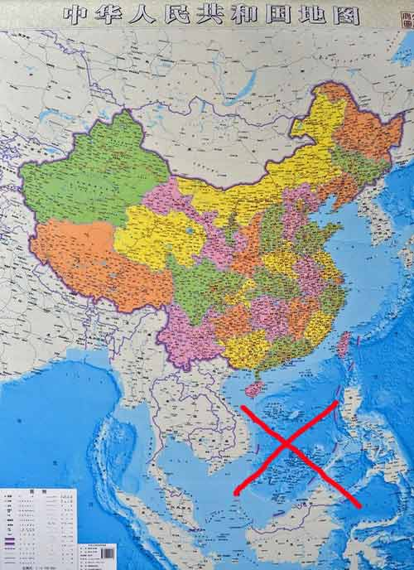
China's vertical map.

A Chinese scholar had to admit: "It's embarrassing when international colleagues ask me about the nine dotted line!”
In 2009, China officially announced the U-shaped line map. Immediately, a well-known commentator of the Hong Kong-based Phoenix TV station – Tiet Ly Thai - warned: "China is making a disaster for itself. The international community will never let that happen."
And many Chinese scholars in China have published articles about the origin of the "cow tongue" with advice to the Chinese government, "Do not make a fool of yourself."
According to two Chinese scholars Li Jinming and Li Dexia, in an attempt to define and declare “the extent of Chinese sovereignty around the Paracel and the Spratly Islands”, in February 1948, the Geography Department in the Ministry of Internal Affairs of the Republic of China published for the first time “the Location Map of the South China Sea Islands”, in which an eleven-dotted line was drawn around the Pratas Islands, the Paracel Islands, the Macclesfield Bank, and the Spratly Islands in the East Sea. The southernmost line was about 4º northern latitude.
The map was made after the Republic of China organized a two-month-long illegal field trip on some islands of the Hoang Sa Archipelago of Vietnam (Paracels Islands).
The Hong Kong-based Phoenix Weekly met with a number of witnesses on the trip who currently live in Taiwan and said that the one who drew the map was the director of the Geography Department, based on the 11-dotted map submitted by members of the field trip to Hoang Sa Archipelago.
According to several newspapers in Hong Kong and China, the "process" to make the U-shaped line map is illegal because no state can arbitrarily draw its own map that covers the territory of other countries.
Li Linghua, a researcher of the China National Ocean Information Centre, and some other Chinese researchers objected to the map, saying that in 1946 Lin Zun led a naval fleet to recapture the islands following Japan’s defeat.
“Some of the islands were unknown to the world. Japan first occupied them and was forced to cede them to us after surrendering. We were happy to receive them (...). Accompanying the fleet was a man from the Ministry of Geology and Resources who demarcated an imaginary line shaped like a bull’s tongue. Upon his return, the line was printed on the national map and was publicized as a new boundary.....”
“There has been no unreal land or marine border demarcating line in the history of international cartography. The nine-dotted line in the East Sea is unreal. Our predecessors invented the line without specific longitudes and latitudes, as well as without legal evidence,” Li Linghua stressed.
Professor Zhang Shuguang, Head of the Academic Committee under the Unirule Institute of Economics, stated: “The nine-dotted line is not legal, a view once shared by Chinese lawmakers and their colleagues from Taiwan. It was unilaterally claimed by China.”
According to a document entitled "The Legal Status of the South China Sea," published in Taiwan in October 1998 by Huang Yi and Wei Jingfen, one of the “inventors” of the "U-shaped line" who was still alive and lived in Taiwan, named Bai, was invited to Beijing in the summer of 1990 to explain the origin of the U-shaped line.
Bai, who was over 80 years old, could not remember all details but he remembered the most important thing is "to draw such a line to indicate that the islands belong to which country having this line".
Commenting on the origin of the U-shaped line, American Professor Mark J.Valencia said: "China's claim of sovereignty over the South China Sea (East Sea) is vague and absurd. The most absurd is the U-shaped line. When they were asked to explain the meaning of this line, as the boundary line or something else, they always had a vague answer that it may be or may not be a boundary line. The world does not have any dotted lines like that!"
In 1949, the Republic of China government was defeated, and had to flee to the island of Taiwan, so the 11 dotted line map fell into oblivion. The People's Republic of China was born and it did not pay attention to the 11 dotted line.
On 4/12/1950, representing the Chinese government, Minister of Foreign Affairs Zhou Enlai said he had approved the Cairo Declaration which was signed on 27/11/1943 by the UK, the US and the Republic of China.
The Cairo Declaration has a paragraph related to Chinese territory as follows: "The Three Great Allies are fighting this war to restrain and punish the aggression of Japan. They covet no gain for themselves and have no thought of territorial expansion. It is their purpose that Japan shall be stripped of all the islands in the Pacific which she has seized or occupied since the beginning of the first World War in 1914, and that all the territories Japan has stolen from the Chinese, such as Manchuria, Formosa, and The Pescadores, shall be restored to the Republic of China.”
It should be noted that at the time of signing of the Declaration of Cairo in 1943, the Paracels and Spratly islands were being occupied by Japan. Thus, the Paracels and Spratly islands are unrelated to the Chinese territory occupied by the Japanese. And, the Chinese government’s representative, Minister Zhou Enlai fully endorsed this statement.
By 1953, however, the U-shaped line which was thought to be dead along with the Republic of China government suddenly appeared. In this year the government of the People's Republic of China reviewed and approved the U-shaped line, reducing it from 11 dots to nine dots. But the boundary of the nine-dotted line is greedier and it is closer to Vietnam, Malaysia and the Philippines. According to China's argument, with the new nine-dotted line, Vietnam, the Philippines and Malaysia "occupied" more China’s waters.
Like the Republic of China, the People's Republic of China announced the nine-dotted line map without explaining the legal, the geographical basis or making it public in the international arena. They only referred it as "historic waters", "historical territory".
More than 50 years later, China revealed its ambition with the U-shaped line to the world.
On May 6, 2009, Vietnam and Malaysia submitted to the UN Commission on the Limit of the Continental Shelf (CLSC) a common report on their expanded continental shelves, and at the same time, Vietnam also sent its own report to the CLCS.
On May 7, 2009, the Government of the People’s Republic of China sent a note opposing the common report on expanded continental shelves of Vietnam and Malaysia as well as Vietnam’s own report on its expanded continental shelf. The note included a map with the “U-shaped line.”
By now the whole world knew about China’s ambition to monopolize the East Sea of China.
In March 2010, China startled the world by declaring the East Sea as its "core interest". The declaration was criticized by even Chinese scholars. However, their warnings could not wake Chinese decision-makers up.
After pulling the oil rig 981 into Vietnam’s water, on June 25, 2014, Chinese newspapers published the “vertical map" with the 10-dash line.
These moves have not only been protested by the international community but also by many Chinese people.
On Weibo, the most popular social network in China, many netizens disagreed with the Chinese government’s vertical map, saying that the map is vague and contrary to international law. Some of them recalled their embarrassment when traveling abroad and hearing criticism of China by local residents.
To be continued…
Duy Chien

relate news
Part 1: Ancient records show Vietnam’s sovereignty over Hoang Sa - Truong Sa
Part 2: Vietnamese emperors claimed sovereignty over Hoang Sa, research shows
Part 3: Nguyen Dynasty rescued French vessels in East Sea
Part 4: Western witnesses of Vietnam’s sovereignty over Hoang Sa
Part 5: Hoang Sa - Truong Sa belong to Vietnam: Chinese documents
Part 6: Vietnam’s sovereignty over Hoang Sa in the French colonial period
Part 7: International conference refutes China’s nominal sovereignty
Part 8: China illegally seizes Hoang Sa Islands
Part 9: The road to the Gac Ma Reef event
Part 10: VN’s sovereignty over Hoang Sa, as reported in early 20th century newspapers
Part 11: The legend of China’s bogus "cow tongue"
Part 12: Behind the vague cow-tongue line established by China

E-IR

Beyond the Scarborough Scare: Joint Resource Management in the South China Sea
David Rosenberg, May 1 2012
Tensions in the South China Sea have been rising in recent years due to two major factors. The first is the growing competition for scarce resources, especially hydrocarbons and fisheries. The other factor is the seemingly intractable disputes over sovereignty claims in the South China Sea. Given the high degree of regional economic inter-dependence, it is not surprising that there have been numerous incidents and conflicts involving survey vessels and fishing boats on the seas. However, there are still no routine or well-tested ways to resolve these low-level but frequent conflicts. These issues are discussed below, along with a consideration of the prospects for joint resource management for the Scarborough Shoal.
Almost every month an incident occurs in the South China Sea that threatens to escalate into an armed conflict. The most recent incident began on 8 April 2012 when a Filipino Navy vessel attempted to detain eight Chinese fishing boats, which had entered waters around Scarborough Shoal, an area that both China and the Philippines claim. An armed boarding party from the Philippines’ frigate BRP Gregoria del Pilar discovered that the fishing boats were in possession of a large illegal catch of coral, giant clams, and live sharks. Before the fishing boats could be detained, two Chinese surveillance vessels blocked the frigate from pursuing any further action. Filipino and Chinese Foreign Ministry officials quickly moved to negotiate a diplomatic end to the confrontation. At the same time, both sides insisted that they would defend their territorial claims. All of the Chinese fishing boats and their illegal catch left the shoal unhindered.[1] At the same time, more than 6,000 American and Filipino troops began joint military exercises off the southwestern island province of Palawan. Further heightening tensions, China demanded that the Philippines immediately remove an archaeological ship from adjacent disputed South China Sea waters.[2]
The confrontation at Scarborough Shoal was distinctive in several ways. First, the area has abundant fishery resources that have been sought after and caught by fishermen from both China and the Philippines for decades. Second, there was a similar incident between Chinese and Filipino fishing vessels and patrol boats at Scarborough Shoal in the mid-1990s. Third, this prior incident has been credited as the catalyst for diplomatic exchanges that eventually resulted in a bilateral code of conduct in 1995, in which the Philippines and China promised to settle their bilateral disputes in accordance with recognized principles of international law, including the UN Convention on the Law of the Sea (UNCLOS). This bilateral code in turn prompted the negotiation of the 2002 ASEAN-China Declaration on the Conduct of Parties in the South China Sea (CoP).[3]
Increased competition for scarce resources
Why do fishermen venture so far into contested waters for legal and illegal, unregulated and unreported fishing? The simple and obvious answer is that it is profitable. Given the growing coastal populations around the South China Sea and their increased living standards and dietary preferences, demand for fish has increased markedly in recent years.
Over 500 million people in China, Hong Kong, Taiwan, Vietnam, Malaysia, Singapore, Indonesia, Brunei, and the Philippines live within 100 miles of the South China Sea coastline. Many of them depend on it for their sustenance and livelihood. Fisheries are important around the South China Sea as an inexpensive form of protein, a means of livelihood, and a source of foreign exchange earnings. The South China Sea provides the habitat and spawning grounds for the world’s most valuable fisheries of shrimp and tuna. A large portion of the coastal workforce is dependent on the marine environment for employment in fishing, marine transportation, offshore exploration and extraction of hydrocarbon and other natural resources, recreation and tourism.
The demand on fish resources has intensified considerably due to coastal urbanization and improvements in fishing methods. This has led to the overexploitation of fisheries in the shared waters of the South China Sea. Fish catch rates began to decline in the 1970s with sharper declines registered in the 1980s, as bottom trawlers came into widespread use. Fisheries depletion is not only evident in declining catch rates, but also in smaller fish sizes and market movements down the food chain from large, high-value fish such as tuna, grouper, and snapper, to smaller, lower-value fish such as sardines, herring, and mackerel. Aquaculture and other substitutes have expanded enormously in the region and have the potential to significantly relieve pressure on capture fisheries. However, intensive, large-scale commercial aquaculture is a relatively recent phenomena; it is not yet clear how sustainable it can be.
Countries with extensive coastlines bordering the sea, such as Indonesia, Malaysia, Vietnam, the Philippines and China, want to protect their sovereign rights and resource control in their Exclusive Economic Zones (EEZs) as provided by UNCLOS. These may extend up to 200 nautical miles beyond their coastlines. Territorial claims to the many islands and reefs in the South China Sea are especially important as an anchor for asserting an EEZ around the disputed islands, and the oil and natural gas resources they are thought to contain.
This has led to numerous overlapping and conflicting territorial claims to the hundreds of small features in the South China Sea, including uninhabited islets, shoals, reefs, banks, sand bars, cays, and rocks. These are divided into four groups of islands and underwater features: the Pratas Islands (Dongsha Qundao), the Paracel Islands (Xisha Qundao), the Macclesfield Bank (Zhongsha Qundao), and the Spratly Islands (Nansha Qundao). The Pratas Islands are under the firm control of Taiwan. No competing claims exist there under the current conception of “One China.” For the Macclesfield Bank, the only claimants are mainland China and Taiwan. The Paracel Islands are under the control of the People’s Republic of China, though contested by the Vietnamese. The dispute over the Spratly Islands involves as many as six parties (mainland China, Taiwan, Malaysia, Vietnam, the Philippines, and Brunei), all of whom have made claims over the Spratly Islands, the whole or in part, and their surrounding water areas.
Shifting Patterns of Cooperation and Confrontation
There is still no well-established judicial or administrative mechanism for settling conflicting territorial claims or routinely resolving the numerous fishing disputes in the South China Sea. As a result, there has been a wide range of ad hoc, cooperative, competitive, and confrontational responses to conflict resolution among coastal states.
For example, for much of the past decade, China has been highly assertive in employing more unilateral and confrontational measures. Beijing publicly challenged the legality of foreign oil companies’ investments in Vietnam’s offshore energy industry, emphasizing its own rights over islands and waters far from the Chinese mainland. It detained hundreds of Vietnamese fishermen near the Chinese-held Paracel Islands. Between 2005 and 2010, China detained 63 fishing boats and their crews, many of which were not released until a hefty fine was paid. It harassed Vietnamese and Philippine vessels conducting seismic surveys in waters that Beijing claims. In May 2011, Chinese patrol ships cut the towed sonar cable of a Vietnamese ship to prevent it from completing a seismic survey.
On the other hand, more recently, in 2011, China employed more cooperative responses. For example, in June, Vietnam and China held talks in Beijing about the countries’ various maritime disputes. In July, China and the ten members of the Association of Southeast Asian Nations (ASEAN) agreed to finally implement the declaration of a code of conduct they had originally drafted in 2002, agreeing to “exercise self-restraint in the conduct of activities that would complicate or escalate disputes.” In October, China reached an agreement with Vietnam on “basic principles guiding the settlement of maritime issues.” The accord stressed following international law, especially the UN Convention on the Law of the Sea. Since then, China and Vietnam have begun to implement the agreement by establishing a working group to demarcate and develop the southern portion of the Gulf of Tonkin near the disputed Paracel Islands. In November, China announced that it would establish a three billion yuan ($476 million) fund for China-ASEAN maritime cooperation on scientific research, environmental protection, freedom of navigation, search and rescue, and combating transnational crimes at sea. In December, China convened several workshops on oceanography and freedom of navigation in the South China Sea. Finally, in January 2012, China hosted a meeting with senior ASEAN officials to discuss implementing the 2002 code of conduct declaration.[4]
Conflicting sovereignty claims
The Philippines asserts that it has exercised effective occupation and jurisdiction over the Scarborough Shoal since independence in 1946. To reinforce this claim it points to a lighthouse it built on the Shoal in 1965, and that it has conducted surveys and research in the waters surrounding the Shoal. China asserts that Scarborough Shoal and its adjacent waters have been Chinese territory for generations, and that it discovered the Shoal, incorporated it into its territory and exercised jurisdiction over it. Further, China also claims that the Shoal is included in the Zhongsha Islands, one of the four archipelagoes inside China’s nine-dashed line map to which it has historic claims to sovereignty. China also argues that the Philippines never disputed Chinese jurisdiction until 1979.
There are a lot of complex aspects to this sovereignty dispute, but one of the most problematic is China’s ambiguous claims in the South China Sea. These claims have been referred to as the “nine-dashed line,” the “nine interrupted-lines,” the “U-shaped line,” as well as the official Chinese name: “traditional maritime boundary line” (chuantong haijiang xian)
The modern history of this line goes back to December 1914, when Hu Jinjie, a Chinese cartographer, published a map with a line around only the Pratas and Paracels, entitled “the Chinese territorial map before the Qianglong-Jiaqing period of the Qing Dynasty (AD 1736–1820).” In 1935, the Land and Water Maps Inspection Committee of the Republic of China (ROC) published a “Map of Chinese Islands in the South China Sea” with an 11-dotted line drawn around 132 islets and reefs of the four South China Sea archipelagos. In 1947, The ROC Ministry of Interior prepared a location map for internal use, renaming the islands in the South China Sea and formally allocating their administration to the Hainan Special Region. One year later, the Atlas of Administrative Areas of the Republic of China was officially published, including the first official map with the line for the South China Sea. An eleven-segment line was drawn instead of the previous continuous line. In 1949, the newly-established People’s Republic of China (PRC) published a “Map of China” with the eleven-dotted line. In 1953, after Premier Zhou Enlai’s approval, the two-dotted line portion in the Gulf of Tonkin was deleted. Chinese maps published since 1953 have shown the nine-dotted line in the South China Sea.[5]
From this brief summary, it is clear that the PRC has inherited and maintained the claims first developed by the ROC. Further, the current claims of the Beijing government and the Taipei government are essentially the same. Indeed, the Taiwan government occupies the largest of the Spratly Islands, Itu Aba (Tai Ping Dao).
Prospects
There are three ways that China and the Philippines might resolve their dispute over the Scarborough Shoal. First, they could continue to arm their marine patrol vessels and intimidate or coerce each other into compliance. Some assert that this is indeed China’s current policy. “China now no longer hesitates to send armed maritime patrol ships (not regular navy) to prevent those fishermen from being arrested by foreign nations.”[6] The China Marine Surveillance (CMS) and the Fishery Law Enforcement Command (FLEC) can both deploy paramilitary vessels to exert Chinese jurisdiction. The CMS appears to be an independent agency that can take action without authorization from the Foreign Affairs Ministry. This approach unfortunately blurs the distinction between traditional and non-traditional security concerns: e.g. when states or their navies support their fishermen, even when they are fishing illegally or poaching. Arming marine police boats increases the risk that a similar incident might escalate into a violent conflict.
Second, they could refer the territorial sovereignty dispute to an international court or tribunal and ask them to decide which State has the better claim to sovereignty. This was done by Malaysia and Indonesia over Sipidan-Ligitan and by Singapore and Malaysia over Pedra Branca/Pulau Batu Puteh. In both cases, the States agreed to refer the sovereignty disputes to the International Court of Justice. This has been tried only infrequently. Nationalist concerns over preserving national sovereignty make it difficult to turn any territorial disputes over to international courts.
Third, they could agree to set aside their sovereignty dispute and jointly manage the fisheries in the disputed area. For example, this was done by China and Vietnam in the Tonkin Gulf Joint Resource Management Zone. China and the Philippines could do something similar in the Scarborough Shoal region. There are several compelling reasons to pursue a joint fishery resource management program for the Scarborough Shoal. Fishery resources, especially migratory species, follow their ecosystem dynamics, not territorial seas or EEZs. They are an intrinsically regional resource. They have high value as a source of protein, food, and jobs. The Scarborough Shoal has had a long history of cooperative traditional fishing practices, including international working groups and an epistemic community of marine biologists and resource managers to provide sustainable resource management.
The international legal framework for resource use in the South China Sea is provided by UNCLOS. It calls for establishing joint resource management areas and provides guidelines for doing so, even where conflicting territorial claims are unresolved. For example, Article 61 of UNCLOS requires countries to monitor their fish catch in relation to both economically- and environmentally-sustainable yields. Articles 116-119 provide for provisional agreements for joint resource management in disputed areas. Hence, China and the Philippines, as signatories to the UNCLOS, should cooperate to manage their fisheries and regulate the behavior of their own fishing vessels.
Ten years ago, the South China Sea territorial disputes, once seen as potential flashpoints, were substantially mitigated by the 2002 Declaration on the Conduct of Parties (CoP). It was China’s first formal multilateral agreement on the South China Sea, and the whole of ASEAN is a party to the agreement. China has a substantial stake in making the agreement effective, as it limits the internationalization of the disputes, which can be used as a pretense for non-ASEAN parties like the United States or Japan to intervene in them.
Fishing traditions around the South China Sea evolved under the assumption of unlimited resources. Fisheries depletion and habitat degradation were already problems before the extension of maritime jurisdictions through EEZ declarations in the 1990s. Now that the limits of fishery resources have been clearly perceived, coastal states are grappling with the challenge of avoiding a maritime tragedy of the commons similar to the collapse of the North Atlantic cod fishery in the 1990s.[7] Ecosystems seldom coincide with territorial boundaries and the Scarborough Shoal and the greater South China Sea are no different in this regard.
Without a joint resource management regime for the Scarborough Shoal, there will also be an increased risk of another confrontation leading to armed conflict. As Sam Bateman has argued, “the South China Sea disputes will only be settled when the bordering countries change their mindsets from one of sovereignty, sole ownership of resources and seeking ‘fences in the sea’ to one of functional cooperation and cooperative management.” However, this approach “has become bogged down in recent years by nationalistic assertions of sovereignty, some of which are ill-founded, which set back any progress towards cooperation with managing the sea, its environment and its resources.”[8] Hence, cooperative fisheries management is more pressing than ever.
—
David Rosenberg is Professor Emeritus of Political Science, Middlebury College, Vermont, USA, Visiting Fellow at the Australian National University’s Department of Political and Social Change, and Editor of www.southchinasea.org

[1] Thayer, Carlyle A., Sovereignty Disputes in the South China Sea: Diplomacy, Legal Regimes and Realpolitik, Paper presented to the International Conference on Topical Regional Security Issues in East Asia St. Petersburg State University St. Petersburg, Russian Federation April 6‐7, 2012. Also see his recent e-IR article, Thayer, Carlyle, “The China-Philippines Face Off at Scarborough Shoal: Back to Square One?” April 26, 2012, http://www.e-ir.info/2012/04/26/the-china-philippines-face-off-at-scarborough-shoal-back-to-square-one/
[2] “U.S.-Philippine War Games Start Amid China Standoff,” New York Times, 16 April 2012, http://www.nytimes.com/2012/04/17/world/asia/amid-standoff-with-china-philippines-holds-war-games-with-us.html
[3] Beckman, Robert, “Scarborough Shoal: Flashpoint for Confrontation or Opportunity for Cooperation?,” RSIS Commentaries, No. 072/2012, 24 April 2012, http://cil.nus.edu.sg/wp/wp-content/uploads/2010/12/ProfBeckman-RSIS-ScarboroughShoal-24Apr2012.pdf
[4] These diverse responses and many others are documented in Fravel, M. Taylor, “All Quiet in the South China Sea. Why China is Playing Nice (For Now),” Foreign Affairs, March 22, 2012, http://www.foreignaffairs.com/articles/137346/m-taylor-fravel/all-quiet-in-the-south-china-sea
[5] Zou Keyuan (2012): “China’s U-Shaped Line in the South China Sea Revisited,” Ocean Development & International Law, 43:1, 18-34, http://www.tandfonline.com/doi/abs/10.1080/00908320.2012.647483#preview
[6] Auslin, Michael, “Scarborough Scare in the South China Sea,” Wall Street Journal Online, April 18, 2012, http://online.wsj.com/article/SB10001424052702303425504577351520139152202.html
[7] Rosenberg, David, “Fisheries Management in the South China Sea,” in Sam Bateman and Ralf Emmers eds., Security and International Politics in the South China Sea: Towards A Cooperative Management Regime, Routledge, 2009. pp. 61-79, http://trove.nla.gov.au/work/34145742?q=isbn%3A9780415469432&c=book
[8] Bateman, Sam, “Managing the South China Sea: Sovereignty is not the Issue,” RSIS Commentaries, No. 136/2011, 29 September 2011, http://www.rsis.edu.sg/publications/Perspective/RSIS1362011.pdf

The China Story

The Paradox of the South China Sea Disputes
Posted on 23 April 2013 by David Rosenberg
Share on print Share on pdfonline Share on email More Sharing Services
David Rosenberg is Professor Emeritus of Political Science, Middlebury College, Vermont, and edits South China Sea. He is currently a Visiting Fellow at The Australian National University.—The Editors
__________
As the maritime commons of Asia’s rapidly-growing, export-oriented countries, the South China Sea is traversed by some of the busiest shipping lanes in the world. In recent years, it has also become a site of increased disputes over sovereign rights.
The paradox of these South China Sea disputes is that the escalation of maritime confrontations, resource conflicts and competing territorial claims has occurred among Asian countries that otherwise reflect an extraordinarily high degree of cooperation on matters of trade and commerce. Hence regional, and global, economic integration has had the unintended effect of intensifying resource competition and territorial nationalism around the South China Sea. Will these discords and tensions lead to a regional arms race? That depends on the intricate interplay of three factors: resource competition, resource nationalism and military modernisation programs.
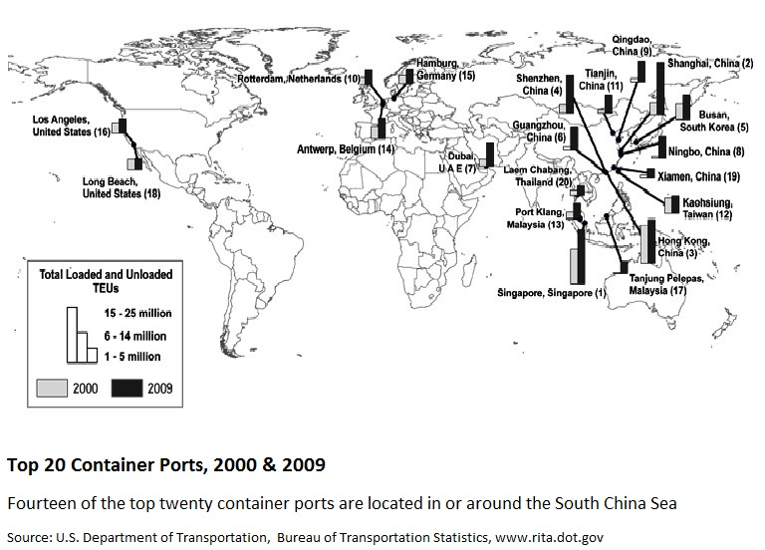
The Top 20 Containers Ports
Resource competition is the result of deeply-rooted, long-term trends of coastal urbanisation, rising consumption, export-oriented industrialisation and the resulting competition for vital resources, especially fisheries and hydrocarbons. A recent example began on 8 April 2012 when a Filipino Navy vessel attempted to detain eight Chinese fishing boats, which had entered waters around Scarborough Shoal, an area that both China and the Philippines claim. An armed boarding party from the Philippines’ frigate BRP Gregoria del Pilar discovered that the fishing boats were in possession of a large illegal catch of coral, giant clams and live sharks. Before the fishing boats could be detained, two Chinese surveillance vessels blocked the frigate from pursuing any further action. Filipino and Chinese Foreign Ministry officials quickly moved to negotiate a diplomatic pause to the confrontation. But why did the Chinese fishermen venture so far into contested waters for illegal fishing in the first place? The simple and obvious answer is that it is profitable. The demand for fish has increased markedly in recent years, surpassing the fish catch supply in coastal waters, and encouraging fishermen to venture further abroad.
Resource nationalism is strong in East Asia where most states actively manage their economies to pursue their national agendas. Coastal states want to assert and extend their Exclusive Economic Zone (EEZ) claims under the 1994 UN Convention on the Law of the Sea (UNCLOS). This is further encouraged by governments seeking to enhance their legitimacy by making a show of protecting national sovereignty and defending the homeland. Displays of patriotism have been a feature of the recent major leadership transitions in North Korea, South Korea, Japan and China, among other countries. In several littoral countries, state patriotism has been further complicated by xenophobic street demonstrations.
Many countries in the region have been pursuing military modernisation programs. Most notable among them is China’s program for upgrading the PLA-Navy’s South Sea Fleet, the development of the Ya Long Naval Base on Hainan Island, and the expansion of China’s paramilitary fleets; e.g., coast guards and fisheries inspection patrols [1]. The threat of a regional arms race has been exacerbated by the seemingly intractable disputes over conflicting claims to several features in the South China Sea. For example, after the confrontation at Scarborough Shoal mentioned above, both China and the Philippines announced plans to expand their maritime patrol capabilities in the contested waters. China now no longer hesitates to send armed maritime patrol ships to prevent their fishermen from being arrested by foreign nations. The China Marine Surveillance (CMS) and the Fishery Law Enforcement Command (FLEC) can both deploy paramilitary vessels to exert Chinese jurisdiction. The CMS appears to be an independent agency that can take action without authorization from the Foreign Affairs Ministry. This approach – when states or their navies support their fishermen, even when they are fishing illegally or poaching – unfortunately blurs the distinction between traditional and non-traditional security concerns. Arming marine police boats, however, increases the risk that a similar incident might escalate into a violent conflict.
These developments have aroused the concern of commercial and naval stakeholders such as Japan and the US who want to preserve the ‘freedom of the seas’, or unrestricted access to the seas and the straits of the South China Sea and its archipelagic waterways for their mercantile and naval vessels.
Conflicting Standards for Asserting Territorial Claims
Perhaps the most controversial maritime territorial claim is China and Taiwan’s nine-dash line claim to the South China Sea. This has also been called the ‘nine-dotted line’, the ‘nine interrupted-lines’, the ‘U-shaped line’, the ‘cow’s tongue’, as well as the official Chinese name: ‘traditional maritime boundary line’ (chuantong haijiang xian 传 统海疆线). The modern history of this line goes back to December 1914 when Hu Jinjie, a Chinese cartographer, published a map with a line around only the Pratas and Paracels, entitled ‘The Chinese Territorial Map Before the Qianglong-Jiaqing Period of the Qing Dynasty (AD 1736–1820)’. In 1935, the Land and Water Maps Inspection Committee of the Republic of China (ROC) published a ‘Map of Chinese Islands in the South China Sea’ with an eleven-dotted line drawn around 132 islets and reefs of the four South China Sea archipelagos. In 1947, the ROC Ministry of Interior prepared a location map for internal use, renaming the islands in the South China Sea and formally allocating their administration to the Hainan Special Region. One year later the Atlas of Administrative Areas of the Republic of China was officially published, including the first official map with the line for the South China Sea. An eleven-segment line was drawn instead of the previous continuous line. In 1949, the newly-established People’s Republic of China (PRC) published a ‘Map of China’ with the eleven-dotted line. In 1953, following Premier Zhou Enlai’s approval, the two-dotted line portion in the Gulf of Tonkin was deleted. Chinese maps published since 1953 have shown the nine-dotted line in the South China Sea [2].
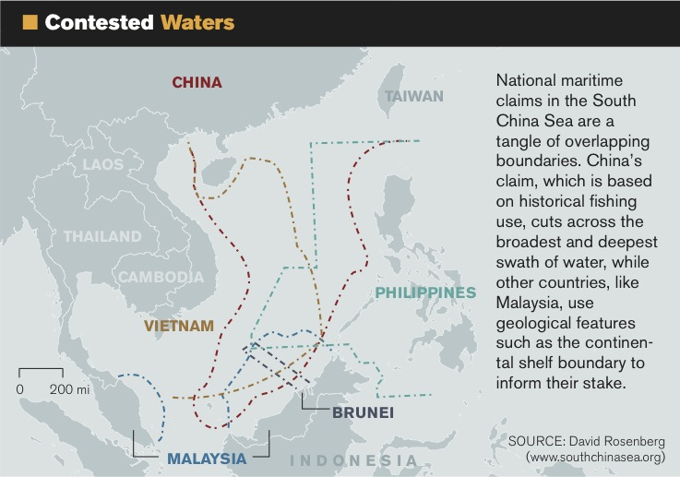
Contested Waters of the South China Sea
In sum, the PRC inherited and maintained the claims first developed by the ROC, the predecessor of the current government on Taiwan. Further, the current claims of the Beijing government and the Taiwan government are essentially the same. Indeed, the Taiwan government occupies the largest of the Spratly Islands, Itu Aba (Taiping Dao).
China’s policy on settling maritime territorial disputes has gone through shifting patterns of cooperation and confrontation over the past decade. However, it became consistently more assertive in 2009 after Malaysia, Vietnam, and the Philippines submitted their claims to the UN Commission on the Limits to the Continental Shelf. In response to these perceived intrusions on its historic claims, China submitted its counter-claim, including its nine-dash line map. This appears to be the first time China has attached this map to an official communication to the UN. The claim is manifestly ambiguous, but has led some to conclude that China is officially claiming all the waters within the U-shaped line as its territorial or historic waters, a position which is contrary to UNCLOS.
What can ASEAN do about China’s claims in the South China Sea? There are major differences among ASEAN members in terms of their history, culture, natural resource endowments, and strategic priorities and capabilities. They disagree on basic economic and security issues, including how to deal with the US and with China. Several littoral states (Brunei, Singapore and Malaysia) support the US-initiated Trans-Pacific Partnership, which excludes China. The mainland ASEAN states (Cambodia, Laos, Myanmar and Thailand) support the China-initiated Regional Comprehensive Economic Partnership, which excludes the US.
With regard to territorial disputes in the South China Sea, Cambodia actively supports China’s policy against internationalising the issue; i.e., not involving the US or any international agencies in dispute settlement. The other mainland states – Laos, Myanmar, and Thailand – maintain a low-profile role but generally defer to China’s preferences.
The four states who have conflicting claims with China – The Philippines, Vietnam, Malaysia and Brunei – are themselves internally divided. The Vietnamese and Philippine governments have both sought some outside support from UNCLOS, from the US, and from Japan to resist the continued pressure from China and Taiwan to assert their claims in the South China Sea. The Philippine government is attempting to stop China’s effective occupation of Scarborough Shoal by appealing to the UNCLOS Arbitration Tribunal for a ruling on the status of the shoal. Malaysia and Brunei avoid public criticism of China’s claims but do support finding a unified ASEAN position on the disputes. Indonesia and Singapore have no conflicting claims with China. They are both strong advocates of maritime security and freedom of navigation, a position shared by the US.
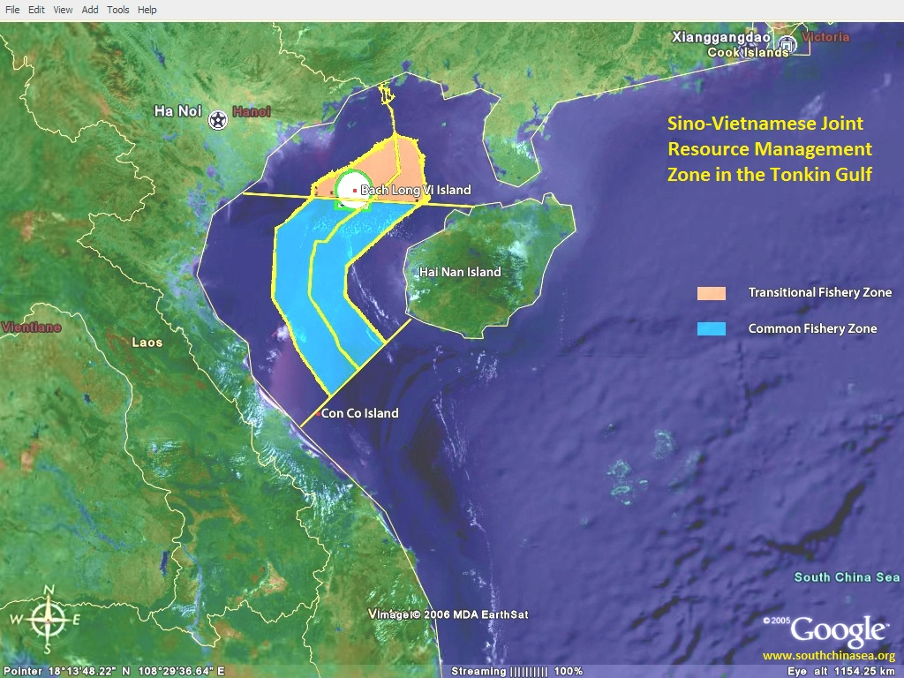
Sino-Vietnamese Tonkin Gulf Joint Resource Management Zone
Additional efforts by all interested parties will be necessary to get China and Taiwan to clarify the delineation of the nine-dash line, and bring it under the jurisdiction of dispute settlement mechanisms under UNCLOS and other courts. In the meantime, and in the absence of any widely-agreed-upon and well-tested way to determine how to govern the resources of the South China Sea, countries have occupied features and based their claims on different standards of justification. For example, China and Taiwan invoke the standard of historical usage and occupation. Malaysia and Vietnam base some of their claims on the continental shelf extension of their national territory. Indonesia, the Philippines and others appeal to the provisions of UNCLOS.
Resolving the Disputes
There are three ways that coastal countries might resolve their disputes in the South China Sea:
- First, they could continue to arm their marine patrol vessels and intimidate or coerce each other into compliance. As noted above, this increases the risk that a local confrontation might escalate into a violent conflict;
- Second, they could refer the territorial sovereignty dispute to an international court or tribunal and ask them to decide which State has the better claim to sovereignty. This was done by Malaysia and Indonesia over a maritime border dispute in the Celebes Sea and by Singapore and Malaysia over several small islands near the entrance to the Singapore Strait. These cases where the states agreed to refer their sovereignty disputes to the International Court of Justice are rare. Current nationalist concerns over preserving national sovereignty make it difficult to turn any territorial disputes over to international courts; and,
- Third, countries could agree to set aside their sovereignty disputes and jointly manage resources in the disputed area. The most successful example of this is the standardisation, automation and regulation of shipping traffic and container movements in the world’s busiest ports of Shanghai, Singapore, Hong Kong, Shenzhen, Busan, Ningbo-Zhoushan, GuangzhouHarbor, Qingdao, Tianjin, Kaohsiung, Taiwan and Port Kelang. Clearly, co-operation pays, especially when it provides prompt and tangible mutual benefits. This is also the case among former adversaries, China and Vietnam, in their Tonkin Gulf Joint Resource Management Zone. China and the Philippines could do something similar in the Scarborough Shoal region [3].
There are several compelling reasons to pursue joint resource management programs. Fishery resources, especially migratory species, follow their ecosystem dynamics, not territorial seas or EEZs. They are an intrinsically regional resource. They have high value as a source of protein, food and jobs. There are several examples of long-standing, cooperative fishing practices in the South China Sea. There are international working groups and an epistemic community of marine biologists and resource managers to provide sustainable resource management.
The international legal framework for resource use in the South China Sea is provided by UNCLOS. It calls for establishing joint resource management areas and provides guidelines for doing so, even where conflicting territorial claims are unresolved. For example, Article 61 of UNCLOS requires countries to monitor their fish catch in relation to both economically – and environmentally -sustainable yields. Articles 116-119 provide for provisional agreements for joint resource management in disputed areas.
The major solution recommended here is for South China Sea stakeholders to begin or expand functional cooperation for joint resource management for marine safety, search and rescue operations, scientific research, disaster relief, protection of the marine environment and other politically feasible areas, even while their sovereignty disputes remain unsettled.
Given the increasing economic growth and inter-dependence within East Asia, it is inevitable that there will be confrontations and conflicts at sea. The South China Sea needs a way to regulate and resolve these conflicts through administrative, legal and police enforcement means. For example, it would be useful to establish an ‘incidents at sea’ agreement to provide a hotline or emergency response system to report confrontations and conflicts involving vessel seizures and crew detentions. The IMB Anti-Piracy Reporting Center and ReCAAP, the Regional Cooperation Agreement on Combating Piracy and Armed Robbery against Ships in Asia, would be useful precedents. In addition, military modernisation programs need to be complemented by confidence-building measures among coastal countries and other international user states to reduce the risk of arousing suspicion and distrust among neighbours, thereby fuelling a regional arms race. As Deng Xiaoping said many years ago, the only viable way to deal with intractable sovereignty disputes in the South China Sea is to set them aside and jointly develop the resources.
__________
Notes:
[1] Carlyle A. Thayer, ‘Chinese Assertiveness and U.S. Rebalancing: Confrontation in the South China Sea?’, presentation to the panel The South China Sea: The New Crucible in U.S.-China Relations?, Association for Asian Studies 2013 Annual Conference, San Diego, California., 21-24 March 2013. Several related reports are available at Thayer’s website, see: http://www.scribd.com/carlthayer.
[2] Michael Sheng-Ti Gau, ‘The U-Shaped Line and a Categorization of the Ocean Disputes in the South China Sea‘, Ocean Development & International Law, vol.43, no.1 (2012): 57-69.
[3] David Rosenberg, ‘Beyond the Scarborough Scare: Joint Resource Management in the South China Sea‘, e-International Relations, 1 May 2012.

NYT
Maps @ http://www.nytimes.com/2014/09/14/world/asia/malaysia-risks-enraging-china-by-inviting-us-spy-flights.html?hpw&rref=world&action=click&pgtype=Homepage&version=HpHedThumbWell&module=well-region&region=bottom-well&WT.nav=bottom-well&_r=0

Asia Pacific

Malaysia Risks Enraging China by Inviting U.S. Spy Flights
By JANE PERLEZSEPT. 13, 2014
BEIJING — Malaysia’s reported invitation to the United States to fly spy planes out of East Malaysia on the southern rim of the South China Sea seems likely to intensify China’s anger at American surveillance of the strategic waterway and its disputed islands, analysts say.
The United States’ chief of naval operations, Adm. Jonathan W. Greenert, told a forum in Washington last week that the recent offer by Malaysia for P-8 Poseidon aircraft to fly out of the country’s most eastern area would give the United States greater proximity to the South China Sea.
Malaysia, which has had warm ties with China, has not confirmed whether it made the offer. The United States has vowed to maintain its influence in the region in the face of China’s rise, and this year won an agreement with the Philippines to give American troops, warships and planes greater access to bases there.
Admiral Greenert spoke the day before Gen. Fan Changlong, a vice chairman of China’s Central Military Commission, warned the national security adviser, Susan E. Rice, during her visit to Beijing that the Obama administration should halt what he called the “close-in” surveillance flights by P-8 Poseidon planes over the South China Sea and along China’s coast.
As China under the leadership of President Xi Jinping asserts claims in the South China Sea and develops a more sophisticated fleet of submarines, it has increasingly contested the right of the United States to conduct surveillance flights over what it says are China’s territorial waters. Among other capabilities, the P-8 Poseidons can detect submarines.
Last month, a Chinese fighter pilot flew within 30 feet of a P-8, nearly causing a collision, the Pentagon said. That P-8, a new fast, high-flying plane built by Boeing and loaded with digital electronics, was based with a squadron of six P-8s that arrived at Kadena air base in Japan last year. The Pentagon has more than 100 P-8s on order from Boeing.
Hishammuddin Hussein, the Malaysian defense minister, was asked at a news conference whether permission had been given for “U.S. fighters” to operate out of East Malaysia. “That is not true,” he said, according to accounts in the Malaysian press. The minister was not asked about surveillance planes.

China Asks U.S. to End Close-Up Military SurveillanceSEPT. 9, 2014

Discussions between Malaysia and the United States for the use of an air base in Sabah, in northeast Malaysia, have been underway for some time, according to a senior Asian diplomat who is familiar with the talks. The diplomat declined to be named because of the secrecy of the matter.
The Chinese Foreign Ministry did not respond to a request for comment on the reported Malaysian offer.
Malaysia, unlike the Philippines and Vietnam, has had good relations with China even though it also has territorial disputes with China in the South China Sea. Malaysia, for example, claims James Shoal, just 50 miles from its shore but more than 930 miles from the Chinese mainland. China says the shoal marks the southernmost tip of the nine-dash line, a demarcation on maps made by the Chinese after World War II that China says forms its boundary in the South China Sea, but which few other countries recognize.
The state-run Malaysian energy giant, Petronas, is exploring for oil and gas inside the nine-dash line without retaliation from China.
Beneath the good will between the two countries, Malaysia has felt China’s increasing military power and has been seeking a balance by reaching out to the United States, the senior Asian diplomat said.
In his speech at the Carnegie Endowment for International Peace, Admiral Greenert said, “We have opportunities here, and I think we’ve got to continue to nurture them.”

Map

Territorial Disputes in the Waters Near China
China has recently increased its pursuit of territorial claims in nearby seas, leading to tense exchanges with neighboring countries. A map of some of the most notable disputes.
OPEN Map

The Malaysian offer to the United States came, in part, because “China has surprised Malaysia by bringing military ships into its waters and tacitly threatening offshore Malaysia oil and gas exploration,” said Ernie Bower, senior adviser for Southeast Asia Studies at the Center for Strategic and International Studies in Washington.
Malaysia has also felt pressure from China after a Malaysia Airlines jet disappeared en route to Beijing with 153 Chinese passengers on board in March.
China would interpret an accord between the United States and Malaysia as a direct challenge to Beijing’s insistence that the American spy flights were an infringement of China’s sovereignty, said Wu Xinbo, the director of the Center for American Studies at Fudan University in Shanghai.
The United States says that foreign aircraft have the right to fly over waters beyond a nation’s 12-mile territorial line. China asserts that foreign aircraft do not have the right to fly within its 200-mile exclusive economic zone without permission.
“By reaching this agreement with Malaysia, the United States is saying: ‘If your neighbors can accept this surveillance, why should you complain?’ ” Mr. Wu said.
The United States’ desire for access to Malaysia for spy flights was one more pressure point on China and its growing military capacity. “The question is, will China bow to U.S. pressure and whether increasing pressure will change China’s activities,” Mr. Wu said.
In his speech, Admiral Greenert said he met with the commander of China’s Navy, Adm. Wu Shengli, four times in the past year and had established good relations, even as he explained that the United States would not be receding from the South China Sea.
“His point to me,” Admiral Greenert said, was “ ‘I’m going to be there too, by the way, because my nation says these are our near seas, these are of interest to us.’ ”
The Diplomat

Why China's South China Sea Diplomacy Will Frustrate Claimants
International frustration over outcomes in the South China Sea is a fine outcome for China.
By Robert Farley
November 21, 2014

What happens the next time people die for an island in the South China Sea? And what happens if some of those people hail from a great power?
Last weekend, the Patterson School of Diplomacy and International Commerce, in conjunction with the Army War College, conducted a negotiation simulation on crisis resolution in the South China Sea. The simulation began shortly after an incident between Chinese and Filipino ships resulted in the deaths of five Indians and 95 Filipinos.
The South China Sea simulation is the third simulation developed by the Army War College. The first two, on the Nagorno-Karabakh dispute and the Cyprus conflict, have become regular features at foreign policy schools around the country. The AWC regularly conducts these exercises in collaboration with several different schools across the country, as well as with students at the AWC.
Patterson engages in these simulations because they give our students the opportunity to develop negotiation, communication, and organizational skills, which will help them in whatever careers they pursue. But the course of this simulation also illuminated some of the problems associated with continuing disagreements in the SCS. This simulation consisted of seven teams (China, the Philippines, India, Japan, the United States, Vietnam, and Indonesia). Each team had an advisor, usually a government diplomatic professional (including advisors from India and Canada). I advised the Chinese team, which began the game with one serious disadvantage: everyone hated us, and we had just killed a hundred people.
As China, we believed our job was to prevent any kind of multilateral agreement with regard to SCS management that involved one of the other great powers. Our assumption was that China held all of the long-term advantages. The United States is a declining power on its way out, Japan remains in a hopeless long-term strategic position, and India lacks real, enduring interests in the area. Consequently, we focused on managing relations with the regional states, even granting the possibility of multilateral arrangements. We assumed that, absent outside interference, China could “revise” any agreement it wanted with its neighbors, using the weight of its military and economic power to push issues slowly in its favor.
Indeed, our team took “What have you done today to ensure that everything fails?” as our motto.
As China, we had no interest in facilitating any agreement that would include extra-regional powers. We decided to treat Japan as a potential junior partner (with the emphasis on junior), treat the United States as an intervening hostile power, and pretend that India didn’t exist. We made some effort to “pick off” one of the regional states, but in the end we faced a united, if unenthusiastic, front.
And nothing happened, because no agreement over sovereignty and conduct in the South China Sea matters without the adherence of the PRC. Did we win? Not really, but nobody else won, either. The simulation ended, as expected, with six angry, frustrated delegations. From China’s perspective, that was just fine.
What lessons? Operating under the assumption that its long-range position will improve, tactics don’t matter overmuch to China. This is not to say that China should deliberately court danger in the SCS. Anything that could draw India and Japan together, or that could pull the United States back in, could delay Chinese control by decades, not to mention endangering China’s position in other areas. But when Beijing feels that it owns the future, it has a lot of freedom in the short and medium team.
The Diplomat

Vietnam, the US, and Japan in the South China Sea
Prospects for regional security hinges heavily on how these actors relate to the South China Sea issue.
By Alexander L. Vuving
November 26, 2014

Between May and July 2014, China unilaterally deployed a giant drilling rig in waters claimed by Vietnam as its exclusive economic zone (EEZ). The move led to a fierce confrontation between Chinese and Vietnamese government vessels and saw relations between the two countries deteriorate to their lowest point since 1988. The standoff also served as a litmus test to identify who will side with whom in this conflict. While most of the world remained neutral, several states came out in support of Vietnam in one form or another. Among these supporters, the United States and Japan stood out as the most powerful and staunchest.
The fault line between Vietnam, the U.S., and Japan on one side and China on the other can be seen as one between status quo and revisionist powers. The former share the same objective of maintaining the balance of power that has kept the region in peace for the last two decades. China, with its long period of rapid economic growth in the last three decades, appears to be determined to use its newfound power to assert its sovereignty claims, which in end effect would amount to its dominance of the region. The prospects for regional security hinges heavily on how these actors relate to the South China Sea (SCS) issue.
The Stakes
The prevailing narrative portrays the SCS issue as a territorial dispute driven by conflict over natural resources between the littoral states. This provides a very truncated picture that fails to illuminate the identity and motives of the stakeholders. Besides its economic value, the SCS also has an enormous strategic value for several countries and an increasing symbolic value for some of the disputants.
China claims a vast area of the SCS that lies within a unilaterally drawn U-shape line as its own territories and waters, while Vietnam claims sovereignty over the Paracel and Spratly Islands and the EEZ and continental shelf surrounding its mainland’s coasts. The SCS is believed to be rich in fish stocks, energy reserves, and mineral ores. Some estimates put the oil and gas reserves in the SCS at about 80 percent of Saudi Arabia’s. With roughly ten percent of the world’s catch, the region also has one of the largest fishing stocks in the world.
The SCS constitutes one of the inner seas that lie within what China’s strategic planners and analysts term the “first island chain.” Offering easy access to the industrial centers of the country, these maritime zones are critical to the defense of the Chinese homeland against invaders coming from the seas. The SCS is even more important to the defense of Vietnam. If it is sometimes likened to China’s backyard, it is literally the front door to Vietnam.
The SCS has strategic value not only for the littoral states but also for other regional and major powers from outside. The shortest shipping routes between the Indian and the Pacific Ocean, the sea lines of communication that pass through the SCS carry nearly one-third of world trade and a half of the global oil and gas shipping. Not only the economies of Southeast Asia but also those of Northeast Asia are heavily dependent on these trading routes. About 80 percent of the oil and gas imports of China, Japan, South Korea, and Taiwan are shipped through the SCS.
While all players in the SCS issue share a large stake in its waterways, powers with hegemonic ambitions such as the United States and China have an additional interest based on the strategic value of those sea lines. Given its location as a chokepoint on the Asian lifeline and one of the global arteries, control of access to the SCS is a sine qua non for naval supremacy in the Western Pacific, which in turn is a critical pillar of regional primacy in East Asia.
Besides its economic and strategic value, the SCS also has an enormous symbolic value for China and Vietnam. Conflicts and stakes in this region have made it a strong symbol of identity for both nations. Vietnam, for example, has declared the Paracel and Spratly Islands to be its territories in the new constitution of 2013.
Vietnam’s Strategies
No single strategy can describe how Vietnam is dealing with the SCS issue. Instead, Vietnam pursues a multitude of approaches that employ a wide range of mechanisms stretching from hard to soft power. At least seven distinct strategies can be identified.
At the hard extreme of the spectrum, Vietnam tries to strengthen its presence and forces, both military and non-military, in the SCS. During the “scramble for the Spratlys” in 1988, when Beijing and Hanoi competed for foothold on the Spratly Islands, Vietnam set up permanent military garrisons on 11 land features in the archipelago, increasing its possessions here from 10 to 21 land features. From 1989 to 1991, Vietnam went out to occupy six underwater shoals on its continental shelf southwest of the Spratlys by putting up permanent high-pillar structures and manning them with garrisons. Slowly but surely, Vietnam continues to consolidate and increase its presence in these areas with more troops, facilities, equipment, and civilians. Since 2007, Vietnam started to populate the largest of its possessions in the Spratly Islands with permanent civilian habitants. Taking a leaf out of China’s playbook, Vietnam decided in 2012 to create a fisheries surveillance force as a third force, after the navy and the coast guard, to patrol its maritime waters, and in 2014, after the oil rig crisis, to lightly arm these vessels. To build a minimum deterrent force on the sea, Vietnam continued to modernize its navy and air force. A key element in this deterrent force is a submarine fleet it is building with six Kilo-class vessels.
Vietnam is well aware that it cannot rely on military force alone to deter China. One strategy to compensate for this deficit is to get powerful third parties involved. Vietnam’s application of this strategy is, however, limited to the oil and gas industry in the SCS only. But perhaps Hanoi has no other option but to give concessions in the oil blocks that lie within China’s U-shaped line to large companies from major powers, something it has done so far to ExxonMobil from the United States, ONGC from India, and Gazprom from Russia. The extent to which Vietnam has limited its pursuit of this strategy is remarkable; it has repeatedly pledged that it will not form an alliance with any other country against a third party, a coded statement to reassure China of Vietnam’s non-aligned posture.
Instead of forming alliances with powerful partners, Vietnam places more emphasis on internationalization of the issue to interlock and deter China. During most of the 1990s and 2000s, Vietnam remained largely modest in its attempt to internationalize the SCS issue. But responding to Chinese assertiveness in the region since 2008, Vietnam has become increasingly proactive and determined to bring the issue to the world’s attention and enlist the support of foreign partners. For example, international conferences on the SCS issue have become a thriving industry in Vietnam since 2009. Hanoi has also tried to include the SCS issue as an agenda item in its talks – and as a rhetorical device, in the joint statements – with most other foreign governments. Starting with the ASEAN and ARF meetings, international forums such as EAS, APEC, the UN, and ASEM have become diplomatic battlegrounds for Vietnam over the SCS dispute.
Vietnam’s effort to internationalize and multilateralize the issue does not come at the expense of its bilateral dialogues with China. Not only does Vietnam take advantage of all possible channels to talk with China, it is also proud of being able to maintain those channels. Besides the government-to-government channel, Vietnam also cultivates ties between the two Communist Parties and the two militaries to keep special access to China. The uniqueness of the party-to-party and the military-to-military relations between Vietnam and China lies in the fact that both sides emphasize their ideological bonds and, particularly for the militaries, their common interests in opposing the West. With regard to negotiation to resolve the territorial disputes, Vietnam accepts a bilateral approach to the Paracel Islands while insisting on a multilateral approach to the Spratly Islands, arguing that the multilateral nature of the dispute over the latter requires multilateral negotiation.
Toward the soft end of the spectrum, self-restraint and self-constraint to reassure China is also a key element in Vietnam’s approach to the SCS. Hanoi’s political leaders and military strategists reason that China, mindful of its superior forces, will seize the moment when Hanoi lets itself be provoked to escalate the conflict and overwhelm Vietnam. But for Hanoi, self-restraint and self-constraint are not only a tactic to avoid being provoked; they are a systematic approach based on the belief that it can convince Beijing of Hanoi’s benign intentions. Hanoi has, for instance, tried to erase public memories of Vietnam’s military conflicts with Communist China, both on the land borders and in the SCS during the 1970s and 1980s. To reassure Beijing, Hanoi has also unilaterally set tight limits on its room of action. One example is its “three no’s” policy, under which Vietnam vows not to participate in any military alliance, not to allow any foreign military bases on its soil, and not ally with any other country against a third country.
Softer than self-restraint, deference is also a principal element of Vietnam’s strategy toward China. Many Vietnamese leaders and strategists argue that combining resistance with deference is key to Vietnam’s ability to survive in China’s shadow for thousands of years. Acts of deference signaled Vietnam’s acceptance of its subordinate position to China in a hierarchy of states, and Hanoi continues to show deference to Beijing. Two recent examples include visits to China by Foreign Minister Pham Binh Minh and Defense Minister Phung Quang Thanh in the wake of the oilrig crisis. Minh used a trade fair in Nanning, China to go to China before traveling to the United States in September 2014. In October, Thanh led a delegation of thirteen high-ranking military officers to China, preceding the long-planned visit to Vietnam by the U.S. secretary of defense in November.
While preparing for the contingency of a military showdown with China in the SCS, Vietnam hopes that ideological bonds will prevent the worst and serve to isolate, compartmentalize, and attenuate the conflict. Predicated on solidarity between the two communist regimes, this strategy enjoys powerful support among the military leadership and Communist Party conservatives. The underlying thinking is best articulated by General Le Van Dung, then-head of the Political General Directorate of the Vietnam People’s Army. In an interview in December 2009, Dung said: “As concerns our issue with China in the East Sea, we are trying our best to resolve it, and in the near future we will be discussing, negotiating, and delimit the maritime borders with our friend. So the situation will be gradually stabilized and we keep strengthening our relations with China in order to fight the common enemy.” Although China’s increasing assertiveness in the SCS, most notably its deployment of the HSYS-891 drilling rig in Vietnamese waters during the summer of 2014, has shattered much of Vietnam’s trust in Beijing, the military leadership in Hanoi continues to cling to solidarity as a strategy to deal with Beijing and the SCS issue.
None of these strategies has been pursued to its fullest capacity, and the intensity and scope with which they have been practiced has varied over time. For most of the period between 1990 and 2008, Vietnam did little to internationalize the issue. The strategies most salient during this period were a gradual and low-key consolidation of presence and forces, self-restraint and self-constraint, and solidarity. The rising tide of tensions since 2009 has changed the intensity and scope of Vietnam’s strategies, with a focus now on strengthening of presence and forces and internationalization. Overall, Vietnam’s approach to the SCS issue combines deterrence with reassurance. While having stabilizing effects, this “hedging” approach has its own problems: Combining deterrence and reassurance undermines the credibility of both. With the increasing tension in the last few years, this hedging approach has proven increasingly ineffective, creating growing frustration with the policy.
The U.S. Commitment
The United States stands out among outside stakeholders to the SCS with its intense interest in the region. Since 2010, American leaders have repeatedly declared that Washington has a “strong national interest” in freedom of navigation and a “strong interest” in the peaceful and lawful settlement of the disputes there. Both the U.S. economy and U.S. global power and regional primacy in the Asia-Pacific depend to various extents on freedom and peace in the waterways running through the SCS.
In fact, the impact of a blockade in the SCS on the U.S. economy would be significant but not extremely high. Less tangible but more important is the role of the SCS for U.S. global power. U.S. naval supremacy in the Western Pacific, of which the SCS is a critical part, is a key to its regional primacy in the Indo-Pacific, which in turn is a major pillar undergirding the U.S.-led liberal world order. Important as it is, this link from the SCS to U.S. interests is not direct and not very visible and tangible. This fact makes it harder to convince the American public of the significance of the SCS to their interests.
American commitment to the SCS is limited by the U.S. need for breathing space after two expensive wars and a severe economic crisis. China has acted to take advantage of this virtual power vacuum, intensifying its revisionist actions in the region. However, as those revisionist actions become more visible to the American public, U.S. commitment to this critical region may once again strengthen.
Japan’s Role
Japan’s interests in the SCS derive primarily from its dependence on the waterways there and its preference for a U.S.-led regional order. If China dominates this chokepoint, it will be able to switch off at will about 60 percent of Japan’s energy supplies, and it will likely replace the United States as the sponsor and leader of a new regional order. A Chinese-led regional order will most likely be far less liberal and favorable to Japan than the current U.S.-led order. Japan thus shares with both the United States and Vietnam a strong interest in maintaining the status quo in the region. What role can Japan play in maintaining stability in the SCS?
First, Japan – and the United States, for that matter – is ill-suited to act as an honest broker to the dispute. The honest broker must be trusted as such by both sides of the dispute, and Japan hardly fits that bill with China, particularly given its own dispute with China in the East China Sea.
Second, Japan is unable to play the role of an external deterrent. Lacking nuclear weapons and perhaps more dependent on China economically than vice versa, Japan is simply unable to deter China in general.
Balancing, therefore, remains the only possible role for Japan to play. Japan is willing to support Vietnam against China, as evidenced by Tokyo’s provision of coast guard ships as gifts to Vietnam during its oilrig crisis with China recently. But does Japan, even when joining forces with Vietnam, have the capacity to balance China? This is an interesting question that needs more study, but a look at the combined military and economic power of the two suggests that they cannot. China possesses several key advantages over a Japan-Vietnam coalition, most obviously its nuclear weapons and its central role in Asia’s economy.
The most effective role for Japan to play in the SCS is to facilitate a coalition with the United States, Vietnam, the Philippines, and other countries that share a common interest in maintaining the status quo. Only a U.S.-led coalition can balance Chinese power in the region. Given its high stakes in the SCS – and the perception of those stakes by its elites – Japan is likely to be willing to play this role. But there is an issue with the coalition leader: With its geographic and psychological distance to the SCS, Washington may be the least willing among this coalition’s members. This may be a factor that prevents the coalition from unilaterally escalating the conflict, but it may also be a factor that encourages China to underestimate the resolve of its rivals and become dangerously provocative.
That in turn suggests the potential for a new era of instability and tension in the SCS, with each stakeholder playing their own role.
Alexander L. Vuving is an associate professor at the Asia-Pacific Center for Security Studies in Honolulu. The views expressed in this article are the author’s own and do not necessarily reflect those of the Asia-Pacific Center for Security Studies, the U.S. Department of Defense, and the U.S. Government.

CFR

Backgrounders
Top of Form

Map @ http://www.cfr.org/china/south-china-sea-tensions/p29790
Bottom of Form
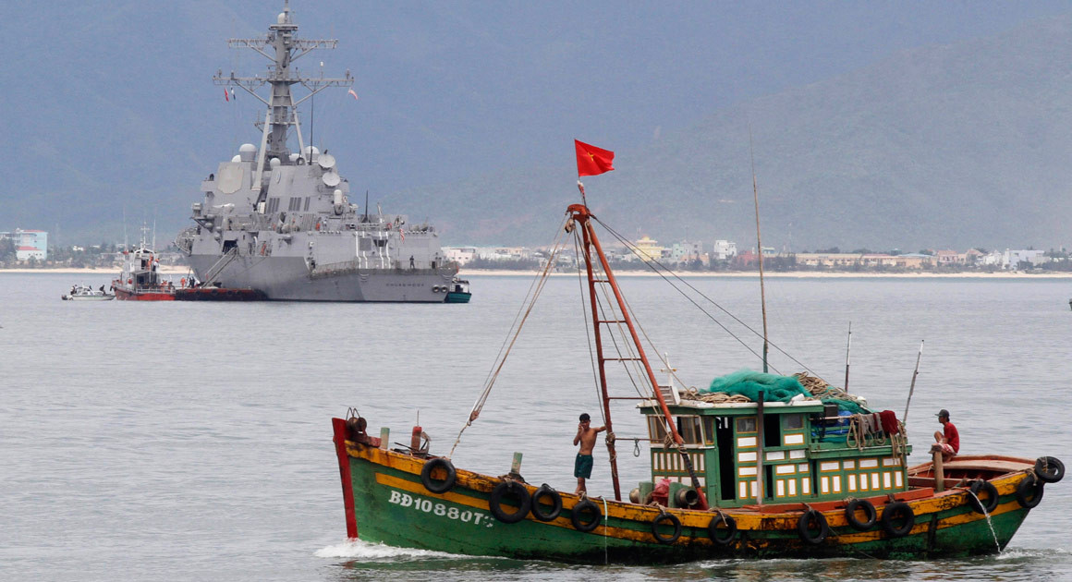

South China Sea Tensions
Author: Beina Xu
Updated: May 14, 2014
Nguyen Huy Kham/Courtesy Reuters

Introduction
Territorial spats over the waters and islands of the South China Sea have roiled relations between China and countries like Philippines, Vietnam, Taiwan, Malaysia, and Brunei in recent years, and tensions continue to escalate in the wake of U.S. President Barack Obama's announced "pivot" of focus to the region. A handful of islands comprise the epicenter of the territorial dispute, making up an area known as the "cow's tongue" that spans roughly the entire South China Sea. The region is home to a wealth of natural resources, fisheries, trade routes, and military bases, all of which are at stake in the increasingly frequent diplomatic standoffs. China's blanket claims to sovereignty across the region and its strong resistance to handling disputes in an international arena have mired attempts at resolving the crises and intensified nationalist postures in all countries involved, particularly Vietnam and the Philippines. Experts say the potential for an escalated conflict in the South China Sea—while seemingly distant for now—presents an ongoing crisis for the region, as well as for U.S. interests in the area.

What territories are involved and disputed?
The South China Sea comprises a stretch of roughly 1.4 million square miles in the Pacific Ocean that encompasses an area from the Singapore and Malacca Straits to the Strait of Taiwan, spanning west of the Philippines, north of Indonesia, and east of Vietnam. The South China Sea islands number in the hundreds, although the largest and most contentious territories include the Spratly Islands, Paracel Islands, Pratas Islands, Macclesfield Bank, and Scarborough Shoal, to which all of the six major Southeast Asian nations lay various claims. The islands are mostly uninhabited and have never had an indigenous population, making the issue of historical sovereignty a thorny one to resolve.

The disputes aren't limited to land, however; each country has an Exclusive Economic Zone (EEZ), prescribed by the 1982 United Nations Convention on the Law of the Sea (UNCLOS), over which it has special rights to marine resources and energy exploration and production. An EEZ spans outward 200 nautical miles from the coast of the each state's territorial sea, and may include the continental shelf beyond the 200-mile limit. These zones come into play during disputes over sea territory, as displayed in China's December 2012 spat with Vietnam over oil and fishing activity in the waters near the Paracel Islands.

What is the 9-Dash Line?
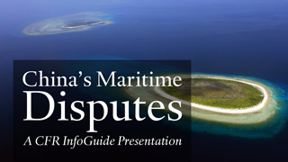
The 9-Dash line is a controversial demarcation line used by China for its claim to territories and waters in the South China Sea, most notably over the Scarborough Shoal and the Paracel and Spratly Islands—the two most important disputed island groups. The line, which is contested by the Philippines, Brunei, Malaysia, Taiwan, and Vietnam, encompasses virtually the entire South China Sea region and caused immediate controversy when China submitted a map to the UN in 2009 that included the demarcation. Beijing's issuance of a new passport in late 2012 containing a map of the disputed region based on the line drew fresh international criticism and backlash.
ASEAN countries have contested this boundary, but China has insisted on the historical legitimacy of the line based on survey expeditions, fishing activities, and naval patrols dating as far back as the fifteenth century, putting it at odds with the boundaries UNCLOS has enforced for the region since 1994.

What resources are at play in the region?
The immediate source of conflict in the region is competition over resources, said David Rosenberg, professor of political science at Middlebury College. There are roughly half a billion people who live within 100 miles of the South China Sea coastline, and the volume of shipping through its waters has skyrocketed as China and ASEAN nations increase international trade and oil imports. The need for resources, especially hydrocarbons and fisheries, also has intensified economic competition in the region, particularly given the rapid coastal urbanization of China. "Behind it all, it's essentially the industrial revolution of Asia," Rosenberg said. "And the South China Sea has become the hub of that."
According to the World Bank, the South China Sea holds proven oil reserves of at least seven billion barrels and an estimated 900 trillion cubic feet of natural gas, which offer tremendous economic opportunity for smaller nations like Malaysia, the Philippines, and Vietnam, and energy security for China's large, growing economy. In December 2012, China's National Energy Administration named the disputed waters as the main offshore site for natural gas production, and a major Chinese energy company has already begun drilling in deep water off the southern coast. Competitive tensions escalated when India's state-run Oil and Natural Gas Corp announced it had partnered with PetroVietnam for developing oil in the disputed waters. In June 2011, Vietnam accused a Chinese fishing boat of cutting cables from an oil exploration vessel inside its EEZ. Hostilities resurfaced in May 2014, when Chinese vessels fired water cannons at a Vietnamese flotilla that allegedly approached a large Chinese drilling rig near the Paracel Islands. The row affected Vietnam's stock markets, which plunged after the incident.
Smaller-scale fishing incidents have instead become the hub of maritime confrontation as declining fish stocks have driven fishermen farther into disputed areas to search for supply, as well as highly profitable illegal species. In the most recent clash, the Philippines' naval forces intercepted eight Chinese fishing vessels in the Scarborough Shoal in April 2012, finding what they viewed as illegally fished marine life on board. The attempted arrest of the poachers led to a two-month standoff between the two countries.
Annual fishing bans and arrests of fishermen are a convenient proxy for sovereignty claims since they can be presented as legitimate attempts to enforce marine resources protection, according to a report by the International Crisis Group. "This is an issue that doesn't make big headlines, but 1.5 billion people live there and rely heavily on fisheries for food and jobs," Rosenberg said. "That's where most of the conflict goes on, and most of these have been dealt with on a routine conflict management basis."

How does the dispute affect trade routes in the sea?
As much as 50 percent of global oil tanker shipments pass through the South China Sea, which sees three times more tanker traffic than the Suez Canal and more than five times that of the Panama Canal, making the waters one of the world's busiest international sea lanes. More than half of the world's top ten shipping ports are also located in and around the South China Sea, according to the International Association of Ports and Harbors. As intra-ASEAN trade has markedly increased—from 29 percent of total ASEAN trade in 1980 to 41 percent in 2009—maintaining freedom of navigation has become of paramount importance for the region.
"This is a very important issue, and has become the main concern of Japan, the United States and even right now the European Union," said Dr. Yann-Huei Song, a fellow at Academia Sinica in Taiwan. However, Yann-Huei says China is unlikely to instigate an interruption in traffic because its business, exploration, and importation rely entirely on freedom of navigation as well. Experts argue that the mutual benefits [PDF] from regional economic integration provide an extremely compelling incentive for cooperation on resources, conservation, and security movements, according to a Harvard Quarterly paper.

What are the military stakes?
The region has also seen increased militarization in response to China's burgeoning power, raising the stakes of a potential armed conflict and making disputes more difficult to resolve. Vietnam and Malaysia have led regional military buildups and increased arms trade with countries like Russia and India, while the Philippines doubled its defense budget in 2011 and pledged five-year joint military exercises with the United States. The Philippines also embarked on a modernization program costing roughly $1 billion that will rely heavily on U.S. sales of cutters and potentially fighter jets.
"Behind it all, it's essentially the industrial revolution of Asia. And the South China Sea has become the hub of that." —David Rosenberg, Middlebury College
Ships are commonly involved in naval disputes, as exhibited in the Scarborough Shoal incident in April when the Philippines said its largest warship—acquired from the United States—had a standoff with Chinese surveillance vessels after the ship attempted to arrest Chinese fishermen but was blocked by the surveillance craft. The involvement of the navy made political compromise more difficult, says the ICG.
"There's nothing like NATO in Asia, and that's what's worrisome," Rosenberg said. "Unlike the United States and EU, which are engaged in other regions of the world, the Southeast Asian countries are compelled to spend more protecting their most immediate interests. It's not the Cold War by any means, but they're still not very open with each other about military modernization."

What is being done to resolve the disputes?
One of the largest impasses to a resolution is China's insistence on conducting most of its diplomacy on a bilateral basis, wrote CFR's Stewart Patrick. Nationalism has also fueled many of these stalemates. International tribunals, like the International Tribunal for the Law of the Sea, are available, but nations use it selectively in light of the potential domestic political ramifications of appearing conciliatory. China also has repeatedly rejected the mechanisms for arbitration provided by the UN.
A July 2012 ASEAN summit attempted to address ways to mitigate the conflict but ended without producing a communiqué, which some experts say highlights the difficulties of multilateral approaches in the region. ASEAN's six-point statement in July made no reference to specific incidents, and only outlined an agreement to draft and implement a regional code of conduct, respect international law, and exercise self-restraint. CFR's Joshua Kurlantzick said in August 2012 that while ASEAN was an appropriate venue to mediate this dispute, the organization still has not yet found its footing in transitioning to a "more forceful, integrated organization that can provide leadership." In a November 2012 IIGG working paper, Kurlantzick looked at how ASEAN could strengthen its role in the region to meet challenges such as the South China Sea.
Consequently, joint management of resources has been widely proposed by experts as the best way to ease current tensions, according to the ICG. China and Vietnam have managed to cooperate on a common fishery zone in the Tonkin Gulf, where the two countries have delineated claims and regulated fishing. However, oil development has remained a highly contentious issue, as both Vietnam and the Philippines have gone ahead with gas exploration projects [PDF] with foreign companies in disputed areas.

What does this mean for the United States' pivot to Asia?
The U.S. pivot to the area, coupled with the region's myriad conflicts, raises concerns about the future of U.S. interests in Southeast Asia. The Obama administration has not only worked to strengthen ties with ASEAN, but has also forged tighter relations with individual countries like Myanmar, where it has developed a new focus and strategy of engagement. The United States has also ramped up security cooperation with Vietnam, while Malaysia and Singapore have also signaled desire for increased security cooperation.
A 2012 Johns Hopkins paper notes that Southeast Asia has transformed in the last two decades to an area where Chinese power and strategic ambition confront an established U.S. military presence, and where a Chinese perception of the status of the South China Sea is fundamentally at odds with a long-settled consensus among major maritime states.
Experts say that the United States faces a dilemma and tough balancing act in the region, as some countries in ASEAN would like it to play a more forceful role to counter what they see as a greater Chinese assertiveness, while others want to see less U.S. involvement. The priority on all sides should be to avoid military conflict, according to Bonnie Glaser of the Center for Strategic and International Studies in this Contingency Planning Memorandum; even as China spars with its Southeast Asian neighbors, it is becoming the largest trading partner and one of the biggest direct investors of most Southeast Asian states since an ASEAN-China free trade area came into effect.

Additional Resources
In this International Institutions and Global Governance program Working Paper, Joshua Kurlantzick analyzes the major obstacles facing ASEAN today and prescribes recommendations for the both the United States and ASEAN that will enable ASEAN to firmly establish itself as the essential regional organization in Asia.
David Rosenberg's article [PDF] for the Harvard Asia Quarterly delves into what's at risk in the South China Sea, including the region's resources profiles, shipping lanes and fisheries.
The Economist discusses ASEAN in crisis and wonders if Indonesia is capable of healing the deepening rifts in Southeast Asia in this article.
The International Crisis Group provides an in-depth report on the South China Sea and its regional responses, examining what the conflicts mean for each country involved, and what risks and factors are at play for all.
In this Contingency Planning Memorandum, Bonnie S. Glaser says the priority on all sides should be to avoid military conflict, even as China spars with its Southeast Asian neighbors.

The Economist

The South China Sea

Oil on troubled waters

Two case studies in a disputed sea
Jan 24th 2015 | From the print edition

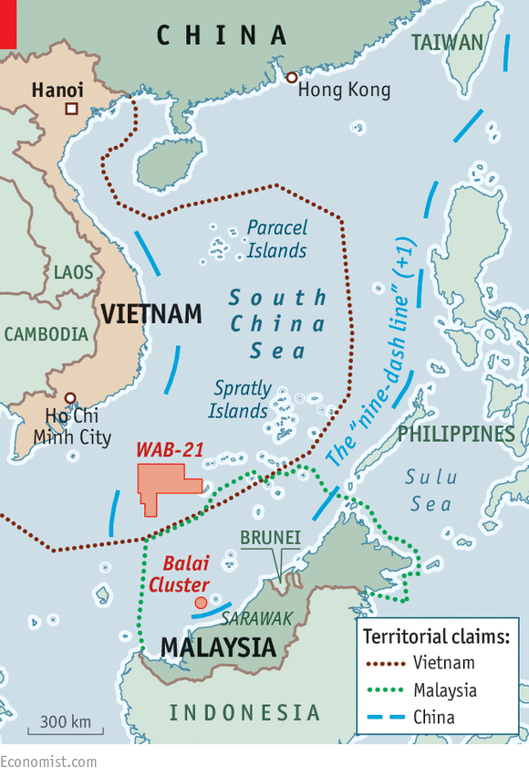

TWO Chinese oil companies show contrasting approaches in their attempts to operate in the South China Sea where, to the discomfort of its smaller neighbours, China’s claims in disputed waters have grown increasingly assertive. One company’s actions are adding to tensions in the area, while the other’s may hint at a way to ease them.
Last July Brightoil, a company listed in Hong Kong with high-level political connections on the mainland, bought the exploration rights to 6.2m acres (2.5m hectares) of seabed from an American company, Harvest Natural Resources. The block, which the Chinese call Wan’an Bei 21 (WAB-21, part of an area known in English as the Vanguard Bank), has a controversial history. Although it lies more than 650 nautical miles (about 1,200km) from the Chinese coast and just 200 nautical miles from Vietnam, China asserts “historic rights” over the area. It lies near the south-western edge of the U-shaped “nine-dash line” that marks Beijing’s ambiguous claim in the sea (see map).

China issued a licence to explore for oil in WAB-21 in 1992. That came as a shock, because it was the first time China had claimed resources in the South China Sea so far away from its own coast. When Chinese vessels attempted to survey the block in 1994, Vietnam sent its navy to stop them. Vietnam then dispatched an oil rig to drill there, and it was China’s turn to impose a blockade. Neither side was able to extract any oil.
In 1996 Benton Oil and Gas, the precursor of Harvest Natural Resources, bought the rights to WAB-21 for $15m. Harvest was never able to develop the block. Instead, Vietnam drew up its own exploration blocks over the same area and awarded them to Talisman of Canada and ExxonMobil of America. China regards the move as a violation of its own claim. Four years ago Beijing organised a flotilla of fishing vessels to block and ensnare a seismic-survey vessel working for Talisman in the area. Talisman continued regardless, and has recently been drilling in a southern part of WAB-21, in a block the Vietnamese call 136/03.
Yet since Brightoil picked up the rights to WAB-21 (for just $3m), the Chinese have muscled back in. In late October a Chinese craft, the Hai Yang 4, guarded by four escort vessels, spent two weeks conducting seismic surveys in the area. The Vietnamese authorities appear to have decided not to force a showdown, unlike earlier in the year when they sent dozens of vessels to challenge a Chinese oil rig drilling off the Paracel Islands further north. Indeed, as the Hai Yang 4 was surveying WAB-21, China was hosting the highest-level Vietnamese military delegation to visit Beijing in years. The visit was intended to repair the damage to bilateral relations caused by the oil-rig incident. Yet renewed surveying by China could strain relations again.
A different approach to finding oil in the South China Sea emerged late last year. In mid-November Fosun, a big, private Chinese conglomerate, bought a small Australian energy company called Roc. Perhaps unwittingly, it also bought into the South China Sea disputes. Among its many interests, Roc has a contract with Malaysia’s state oil behemoth, Petronas, to develop fields off the coast of Sarawak. Crucially, though these fields, known as the Balai Cluster, lie within Malaysia’s 200-nautical-mile exclusive economic zone, they are also inside China’s claimed nine-dash line, whose legitimacy Malaysia contests. Assuming Fosun holds on to these interests, a Chinese company is in effect recognising Malaysia’s claim in this area of the sea at the expense of the Chinese claim.
Both Brightoil and Fosun have powerful connections with China’s political elite. Fosun’s chairman, Guo Guangchang, is a member of the Chinese People’s Political Consultative Conference (CPPCC), an advisory body controlled by the Communist Party. Brightoil’s chairman, Sit Kwong-lam, also sits on the CPPCC and is vice-president of the state-dominated oil industry’s trade body. His company seems to be acting as an arm of Chinese policymaking in the South China Sea, whereas Fosun seems to be acting against it. But by working with the Malaysian authorities rather than against the Vietnamese, Fosun appears much more likely than Brightoil actually to deliver oil to Chinese consumers.

NYT

New Images Show China Literally Gaining Ground in South China Sea
By DAVID E. SANGER and RICK GLADSTONEAPRIL 8, 2015
Photo
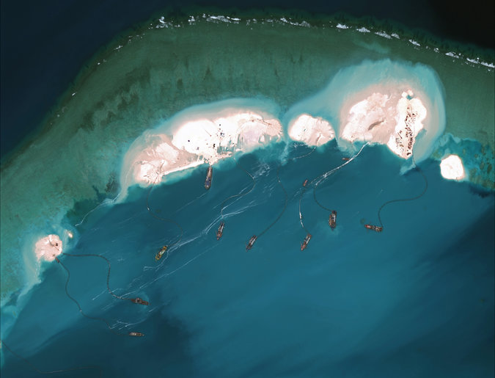
A satellite image from March 16 shows dredgers working at the northernmost reclamation site of Mischief Reef, part of the Spratly Islands, in the South China Sea. Credit Center for Strategic and International Studies via Digital Globe
WASHINGTON — The clusters of Chinese vessels busily dredge white sand and pump it onto partly submerged coral, aptly named Mischief Reef, transforming it into an island.
Over a matter of weeks, satellite photographs show the island growing bigger, its few shacks on stilts replaced by buildings. What appears to be an amphibious warship, capable of holding 500 to 800 troops, patrols the reef’s southern opening..
China has long asserted ownership of the archipelago in the South China Sea known as the Spratly Islands, also claimed by at least three other countries, including the Philippines, an American ally. But the series of detailed photographs taken of Mischief Reef shows the remarkable speed, scale and ambition of China’s effort to literally gain ground in the dispute.
They show that since January, China has been dredging enormous amounts of sand from around the reef and using it to build up land mass — what military analysts in the Pentagon are calling “facts on the water” — hundreds of miles from the Chinese mainland.
The Chinese have clearly concluded that it is unlikely anyone will challenge them in an area believed rich in oil and gas and perhaps more important, strategically vital. Last week Adm. Harry Harris, the commander of the United States Pacific fleet, accused China of undertaking an enormous and unprecedented artificial land creation operation.
“China is creating a great wall of sand with dredges and bulldozers,” Admiral Harris said in a speech in Canberra, Australia.
Defense Secretary Ashton B. Carter, on his first trip to Asia, put the American concerns in more diplomatic language. In an interview to coincide with his visit, published Wednesday in the Yomiuri Shimbun, one of Japan’s largest dailies, Mr. Carter said China’s actions “seriously increase tensions and reduce prospects for diplomatic solutions” in territory claimed by the Philippines and Vietnam, and indirectly by Taiwan.
He urged Beijing to “limit its activities and exercise restraint to improve regional trust.” That is essentially the same diplomatic message the Obama administration has been giving to China since Hillary Rodham Clinton, then the secretary of state, and her Chinese counterpart faced off over the issue at an Asian summit meeting in 2010.
Continue reading the main story

Building Islands on Mischief Reef
These satellite images show Mischief Reef, part of the Spratly Islands in the South China Sea. In the March 16 image there are several dredgers visible at the northern and western edges of the reef, and to the south, where the entrance to the reef has been widened to about 275 meters.
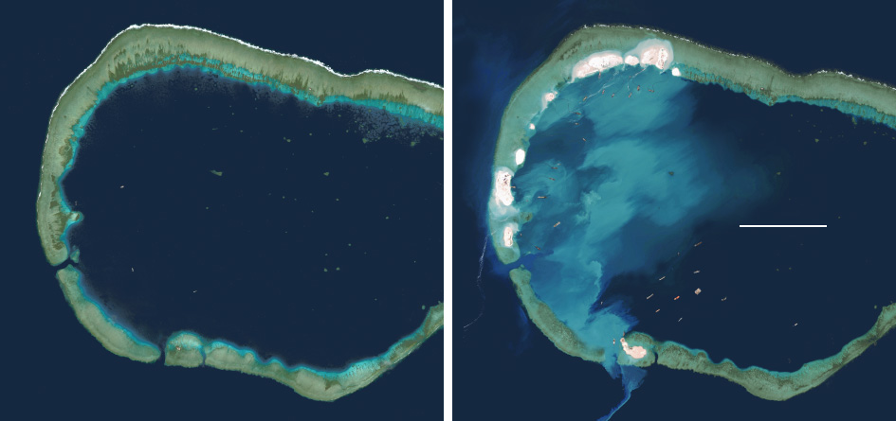
Mischief Reef
1 MILE
January 24, 2012
March 16, 2015
Center for Strategic and International Studies via Digital Globe
Continue reading the main story

Related Coverage

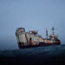
video

From the Magazine: A Game of Shark and Minnow (Oct. 2013)

China Said to Turn Reef Into Airstrip in Disputed Water NOV. 23, 2014

While other countries in Southeast Asia, like Malaysia and Vietnam, have used similar techniques to extend or enlarge territory, none have China’s dredging and construction power.
The new satellite photographs, obtained and analyzed by the Center for Strategic and International Studies, a Washington research group, certainly confirm the worries expressed by both Mr. Carter and Admiral Harris.
“China’s building activities at Mischief Reef are the latest evidence that Beijing’s land reclamation is widespread and systematic,” said Mira Rapp-Hooper, director of center’s Asia Maritime Transparency Initiative, a website devoted to monitoring activity on the disputed territory.
The transformation of Mischief Reef, which the Chinese call Meiji Reef, she said, is within territory claimed by the Philippines and is one of seven small outposts the Chinese have sought to establish in the South China Sea.
“These will allow Beijing to conduct regular, sustained patrols of the airspace and water, and to attempt to press its far-flung maritime claims as many as 1,000 miles from its shores,” she said.
Although these outposts are too vulnerable for China to use in wartime, she said, “they could certainly allow it to exert significant pressure on other South China Sea claimants, such as the Philippines and Vietnam.”

The issue poses a problem for the Obama administration, not simply because the Philippines is a treaty ally. China is working so quickly that its assertion of sovereignty could become a fait accompli before anything can be done to stop it.
The United States has long insisted that the territorial disputes be resolved peacefully, and that no claimant should interfere with international navigation or take steps that impede a diplomatic resolution of the issue. But to the Chinese – already flexing muscle in other territorial disputes and with the creation of an Asian infrastructure bank to challenge the Western-created World Bank — this is not a matter for negotiation.
When Mrs. Clinton raised the issue in Hanoi five years ago at the Asian Regional Forum, her Chinese counterpart, Yang Jiechi, responded with a 25-minute speech, exclaiming: “China is a big country. Bigger than any other countries here.” It seemed to be a reminder that its military could make sure no one would dare challenge its building spree on disputed territory — and so far, no one has, other than with diplomatic protests.
Since then, China has made no secret of its territorial designs on the Spratlys, creating at least three new islands that could serve as bases for Chinese surveillance and as resupply stations for navy vessels, according to IHS Jane’s.
Satellite imagery of the Spratlys publicized by IHS Janes’s in November showed how the Chinese had created an island about 9,850 feet long and 985 feet wide on Fiery Cross Reef, about 200 miles west of Mischief Reef, with a harbor capable of docking warships. IHS Janes said the new island could support runway for military aircraft.
The United States is about to conduct a joint military exercise with the Philippines, part of an emerging Obama administration strategy to keep American ships traversing the area regularly, a way of pushing back on Chinese claims of exclusive rights. The administration did the same when China declared an air defense zone in the region more than a year ago.
The Chinese have said they consider most of the South China Sea to be rightfully theirs — a claim others make as well. China and Japan have a separate territorial dispute over islands that Japan calls the Senkaku and China calls the Diaoyutai. Those tensions have eased slightly in recent times.
Last year China and Vietnam became entangled in an angry exchange after China towed a $1 billion deepwater oil drilling rig to an area 150 miles off Vietnam’s coast. On Tuesday China’s official Xinhua news agency reported that the leaders of both countries wanted to soothe their differences and “control their disputes to ensure that the bilateral relationship will develop in a right track.”

NYT

Images Show China Building Aircraft Runway in Disputed Spratly Islands
By JANE PERLEZAPRIL 16, 2015
Photo
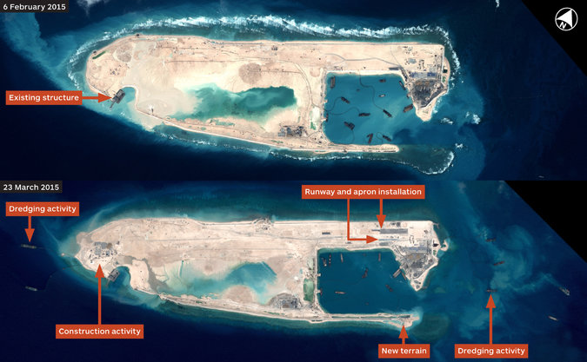
Satellite imagery provided by Airbus shows a before-and-after view of Fiery Cross Reef. Credit CNES, Distribution Airbus DS, via IHS
BEIJING — China is building a concrete runway on an island in the South China Sea’s contested waters that will be capable of handling military aircraft when finished, satellite images released Thursday show.
The first section of the runway appears like a piece of gray ribbon on an image taken last month of Fiery Cross Reef, part of the Spratly Islands, an archipelago claimed by at least three other countries. Adjacent to the runway, work is underway on an apron for taxiing and parking planes.
The runway, which is expected to be about 10,000 feet long — enough to accommodate fighter jets and surveillance aircraft — represents a game changer in the competition between the United States and China in the South China Sea, said Peter Dutton, professor of strategic studies at the Naval War College in Rhode Island.
“This is a major strategic event,” Mr. Dutton said. “In order to have sea control, you need to have air control.”
Analysts had speculated that China planned to build an airstrip on Fiery Cross Reef, but the satellite image from March 23, provided by Airbus and released Thursday by Jane’s Defense Weekly, is the first hard evidence that it is doing so.
In time, Mr. Dutton said, China is likely to install radar and missiles that could intimidate smaller countries like the Philippines, an American ally, and Vietnam, which also have claims to the Spratlys, as they resupply their modest military garrisons in the area.
More broadly, he said, China’s ability to use Fiery Cross Reef as a landing strip for fighter and surveillance aircraft will vastly expand its zone of competition with the United States in the South China Sea.
Over the past decade and a half, a series of tense encounters between American and Chinese forces on the sea and in the air — starting with a near collision in 2001 between an American EP-3 spy plane and a Chinese fighter — have occurred in the sea’s northern waters, near China. The new installations in the Spratlys, about 1,000 miles beyond China’s southernmost point on Hainan Island, will create a much wider arena for potential close calls, Mr. Dutton said.
“This will expand the area in which there are likely to be tensions between the United States and China,” he said.
The construction on Fiery Cross Reef is part of a larger Chinese reclamation project involving scores of dredgers on at least five islands in the South China Sea. China is converting tiny reefs, once barely visible above water, into islands big enough to handle military hardware, personnel and recreation facilities for workers.
Satellite images of the reclamation efforts have been released in steady doses over the last few months, as smaller countries with claims to islands in the area have voiced concern about China’s accelerated construction, and as the United States has stepped up its criticism.
During his recent first trip to Asia as the American defense secretary, Ashton B. Carter said in Japan that the reclamation efforts were seriously aggravating tensions between Beijing and Washington and hurting the prospects for diplomatic solutions.
After Mr. Carter made those remarks, the Center for Strategic and International Studies, a Washington research group, released images of Mischief Reef, also in the Spratly archipelago, that showed large-scale dredging of sand and coral to create land mass on what had been a partly submerged reef.
The construction on Fiery Cross Reef, which is several hundred miles west of Mischief Reef, appears to have taken place within the last several weeks. An image taken by Airbus on Feb. 6, also released Thursday by Jane’s Defense Weekly, shows empty sand where the runway is now being built.
“We absolutely think it is for military aircraft, but of course an airstrip is an airstrip — anything can land on it if it’s long enough,” said James Hardy, Asia-Pacific editor for Jane’s Defense Weekly. “Three thousand meters is big enough for pretty much any aircraft,” he said, noting that the superjumbo Airbus A380’s runway requirement is 2,950 meters, or just under 10,000 feet.
Other runways used by the Chinese military have ranged from around 8,850 feet to more than 13,100 feet, he said. By comparison, the runway maintained by the United States Air Force at Diego Garcia, an island in the Indian Ocean that is much bigger and more developed than Fiery Cross Reef, is 11,800 feet, he said.
“The main question is, What else would land there?” Mr. Hardy said. “Unless they are planning to turn these into resorts — which seems unlikely, not least given the statement from the Foreign Ministry last week — then military aircraft are the only things that would need to land there.”
China’s Foreign Ministry said in a statement last week that the reclamation efforts were intended to serve civilian purposes, such as providing a base for search-and-rescue operations, but also for “satisfying the need of necessary military defense.” Though the statement placed more emphasis on the nonmilitary goals, it was a rare acknowledgment of Chinese military intentions in the South China Sea.
Mr. Hardy said that China’s military appeared to have chosen Fiery Cross Reef as a command-and-control center for its Spratly Islands operations.
China claims more than 80 percent of the South China Sea, on the grounds that a so-called nine-dash line drawn around the waterway by China in the late 1940s conforms to China’s rights in the sea. No other country recognizes the validity of the nine-dash line, and many fear that China’s reclamation activities are part of a drive to create an inevitability about Chinese ownership.
In another example of the Pentagon’s heightened criticism of China’s reclamation efforts, a senior Navy commander, Rear Adm. Christopher J. Paul, said last month in Australia that there are countries “who attempt to constrict movement through international waters, who create land areas where there were none; who create exclusion zones where there should be shared use.”
In response, he said, the Navy was creating “hunter-killer surface action groups” of ships, and he suggested that Australia, one of America’s staunchest allies, would be invited to contribute to the new efforts in offensive naval warfare.

The South China Sea

Making waves

China tries to strengthen its hand in a dangerous dispute
May 2nd 2015 | BEIJING | From the print edition

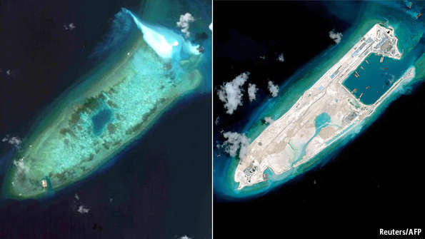
IN NOVEMBER, after months of frantic land reclamation in the South China Sea aimed at boosting its vast territorial claim there, China tried a subtler approach. It opened a think-tank in Arlington, Virginia—an outpost of its National Institute for South China Sea Studies on Hainan, a tropical (and indisputably Chinese) island on the sea’s northern shore. One role for the new think-tank is to make an academic case for China’s vaguely backed assertion that most of the strategically vital waters are within its domain—despite rival claims by South-East Asian countries.
On April 16th the Institute for China-America Studies, as the Virginia-based centre is called, held a conference at a hotel in Washington. Its Chinese-government connections clearly had pull. Henry Kissinger, a former secretary of state whom Chinese leaders much revere, spoke in a pre-recorded video about the importance of ties between Beijing and Washington. Cui Tiankai, China’s ambassador to America, attended in person. Mr Cui told participants that his country would act with “restraint” in the South China Sea, although he also said it would vigorously defend its interests there.

China’s efforts to put a scholarly gloss on its claims (which, on its official maps, are represented by broken lines of striking crudity) are unlikely to convince many in America or in South-East Asia. China’s recent construction spree on more than half a dozen reefs has caused widespread alarm among the other claimants, which include Brunei, Malaysia and Vietnam, as well as the Philippines, an American ally. On April 28th leaders of the ten-member Association of South-East Asian Nations (ASEAN) issued an unusually strong statement. They called the island-building effort, much of it near the Philippines, a potential threat to “peace, security and stability”. In Washington, President Barack Obama, speaking during a visit by Shinzo Abe, Japan’s prime minister, expressed “concern” at the reclamation and accused the Chinese of “flexing their muscles”. In Beijing a foreign-ministry spokesman retorted that China’s actions were “beyond reproach” and not targeted at anyone.
None of the claimants is blameless: island-building has long been a common tactic in efforts to stake out claims (see map). But the pace and scale of China’s construction activities have been remarkable. This month IHS Jane’s, a consultancy, published satellite photographs showing China’s rapid building this year of installations in the sea that could have military uses. These include an airstrip that could, when finished, reach a length of 3km (nearly 2 miles) on Fiery Cross Reef (the pictures above show the reef today compared with its appearance in August). The reef is now three times bigger than the largest natural island in the Spratly archipelago. A few weeks ago satellite images published by IHS Jane’s and the Centre for Strategic and International Studies (CSIS), an American think-tank, showed similar activity on Mischief Reef, also in the Spratlys.
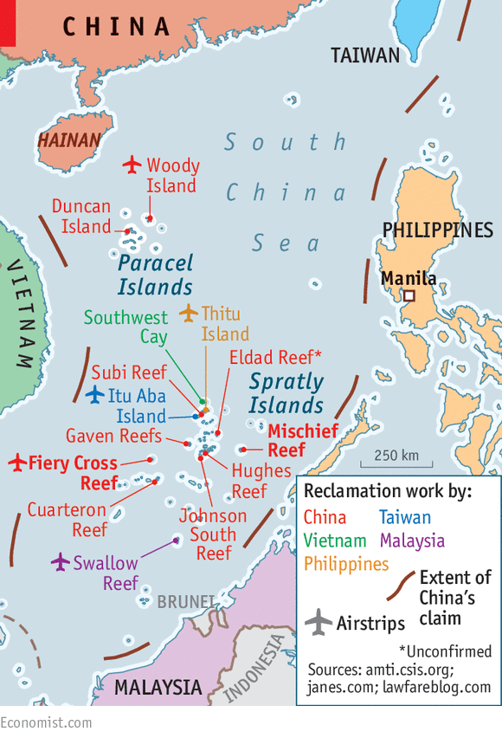
China’s behaviour is also striking for its inconsistency with other recent trends in its foreign policy. These include an effort since late last year to mend fences with Japan, with which it has a separate maritime dispute. And as part of an attempt to draw closer to India, with which it disagrees over long stretches of their land border, China will give India’s prime minister, Narendra Modi, a warm welcome in Beijing next month. In the South China Sea, Chinese authorities say they are just catching up with what others have been doing. But officials in South-East Asia complain that China’s construction activity breaks the spirit of an agreement that it reached in 2002 with ASEAN to exercise “self-restraint” in the area. Many analysts see it as part of efforts to give China more room to project its power in an area previously dominated by the Americans.
China’s reclamation efforts conform to a pattern of assertive behaviour in the South China Sea. In 2011 Chinese patrol boats harassed Vietnamese and Philippine oil-exploration vessels near the Spratlys. In 2012 China occupied Scarborough Shoal after a stand-off with the Philippines, which also has a claim. Last year a Chinese state-owned company sent an offshore oil rig into waters claimed by Vietnam, leading to violent anti-Chinese protests in Vietnamese cities. The rig withdrew months later. China has responded angrily to a case challenging the basis of its claims in the South China Sea which was filed in 2013 by the Philippines at a UN-backed arbitration panel. It has refused to co-operate with the hearings; a defeat, which some Chinese experts acknowledge is likely, will make China even crosser.
It appears prepared, however, to accept the consequences, including the risk that America’s so-called “pivot” to Asia (now referred to as a “rebalancing”)—which has often been seen by America’s friends in the region as something of a fiction—will become more of a reality. The Philippines and America last year agreed on an “enhanced” defence co-operation pact (in recent days the two countries have been holding their biggest combined military exercise in 15 years). During Mr Abe’s trip to Washington, America signed a new defence agreement with Japan that would allow greater military co-operation between them. America has also been establishing closer military ties with its (and China’s) erstwhile enemy, Vietnam.
The Chinese state-controlled media dutifully respond with stridently worded screeds, which appear to enjoy the approval of China’s easily aroused online nationalists. But the new think-tank in Virginia is part of an effort to make China’s case more persuasive abroad. In September the Collaborative Innovation Centre of South China Sea Studies at Nanjing University in eastern China enrolled its first group of doctoral students. One of their intended roles, presumably, will be to scour archives for documents that might support China’s claim (which dates back to the 1940s, shortly before the Communist Party seized power). Shen Dingli of Fudan University in Shanghai, who attended the recent conference in Washington, says the government is particularly keen to invest in research related to the South China Sea. The purpose, he says, is to enable Chinese to “tell our story effectively so that people cannot only hear us, but hear us rightly”.
That will not be easy. One challenge Chinese academics face is the secretive behaviour of the country’s armed forces (even civilian leaders do not always appear entirely aware of what they are up to). It is only thanks to foreign satellites that the recent reclamation work in the South China Sea has come to light. Hong Nong, who heads the new institute in Virginia, admits that she was “surprised” by the recent photographs showing rapid construction on the Spratly reefs (she first saw the images on the website of CSIS). Ms Hong goes so far as to say that she understands the concerns of China’s neighbours, and that China should reassure them by talking more and making itself more “transparent”.
There is a broader message that China is trying to convey, beyond simply (as it sees it) the correctness of its claim. Carlyle Thayer of the University of New South Wales says China’s strategy is, through soft power and other means, to persuade its neighbours “gradually” to accept the idea of a dominant role for China in the East Asian order. Mr Shen essentially admits this. The goal, he says, is that “everybody may win, but China wins more.”

NYT

Kerry Expected to Bring Up China’s Sea Claims During Visit
By ANDREW JACOBSMAY 15, 2015
BEIJING — Secretary of State John Kerry arrives here on Saturday amid rising tensions over China’s expansion of shoals and islets in areas of the South China Sea claimed by at least three countries.
A senior Pentagon official said this week that the United States might consider sending ships and aircraft to within 12 nautical miles of built-up reefs near the Philippines, an American ally, to demonstrate its commitment to freedom of navigation in one of the world’s busiest shipping lanes.
“We are actively assessing the military implications of land reclamation and are committed to taking effective and appropriate action,” David Shear, an assistant secretary of defense, said at a Senate hearing on Tuesday.
State Department officials said Mr. Kerry would arrive in Beijing with a similarly tough message: China’s intensified island-building campaign threatens relations as both countries are seeking to cooperate on several issues, including military ties, bilateral investment and climate change.
In a background briefing on Wednesday, a senior State Department official said Mr. Kerry would leave Chinese leaders with “absolutely no doubt” where the United States stood on the issue of China’s territorial claims.
“He is going to reinforce to them the very negative consequences on China’s image, on China’s relationship with its neighbors, on regional stability, and potentially on the U.S.-China relationship,” the official said.
Beijing, under President Xi Jinping’s more muscular approach to diplomacy, has shown no signs of backing down. Cui Tiankai, China’s ambassador to the United States, accused Washington of unnecessarily stirring up trouble.
“Just who is creating tensions in the South China Sea?” the state-run Xinhua news agency quoted Mr. Cui as saying on Wednesday. “In the past few years, the U.S. has intervened in such a high-profile way. Does it stabilize the situation or further mess it up? The facts are out there.”
Global Times, a reliably nationalist newspaper in China, suggested that China would match any American show of force in the Spratlys, the island chain off the Philippines that has been the focus of frenetic dredging work by China in recent months.
“If U.S. warplanes fly over China’s islands, and if its warships enter the waters 12 nautical miles from China’s islands, then we believe the Chinese military would prove that America’s pirate-style actions picked the wrong place and wrong people,” the newspaper said in an editorial on Friday.
The rancor over the South China Sea is mounting at a difficult time for United States-China relations, which are troubled by continuing clashes over cybersecurity, currency policy and human rights. On Friday, Chinese prosecutors said Pu Zhiqiang, one of China’s best-known human rights lawyers, would stand trial on charges of inciting ethnic hatred.
The police detained Mr. Pu just over a year ago, making him one of the most prominent targets of the Communist Party’s vigorous assault on dissent. The State Department, drawing the ire of Chinese officials, recently called for his release.
But there are bright spots in the relationship. President Obama and Mr. Xi have a good working relationship; a meeting between the two in Beijing in November produced a landmark agreement on carbon emissions and a military accord that seeks to avoid clashes between American and Chinese aircraft in the seas off China.
In addition to laying the groundwork for a planned visit by Mr. Xi to Washington in September, Mr. Kerry and his Chinese counterparts are expected to discuss plans for the United States-China Strategic and Economic Dialogue, an annual gathering of hundreds of officials that Washington will host next month.
Shi Yinhong, a professor of international relations at Renmin University in Beijing, said threats from Washington were unlikely to persuade the government to halt its land reclamation efforts in the disputed waters of the South China Sea.
“For Xi Jinping, this is a must-complete project,” he said. “I don’t see either side backing down from the standoff, and the conflict could get worse even though both sides are eager to stabilize ties.”

China Stands by Its Claims Over South China Sea Reefs
By ANDREW JACOBSMAY 16, 2015
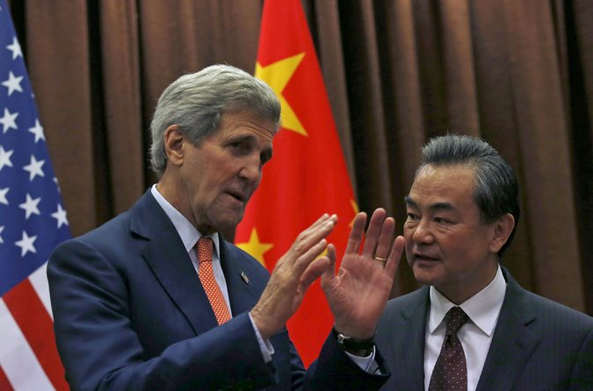
Secretary of State John Kerry met with the Chinese foreign minister, Wang Yi, in Beijing on Saturday. Credit Kim Kyung-Hoon/Reuters
BEIJING — China’s top diplomat, emerging from talks here with Secretary of State John Kerry, suggested Saturday that Beijing had no intention of scaling back island-building efforts in the South China Sea that have aggravated tensions in waters claimed by a number of neighboring governments.
At a news conference, Foreign Minister Wang Yi said Chinese claims over a collection of uninhabited reefs off the coast of the Philippines were “unshakable,” suggesting that Mr. Kerry’s message that China help reduce tensions in the region had fallen on deaf ears.
“The determination of the Chinese side to safeguard our own sovereignty and territorial integrity is as firm as a rock,” Mr. Wang said.
Mr. Kerry, on his fifth visit to China as secretary of state, is ostensibly here to discuss plans for a White House summit meeting between President Obama and President Xi Jinping, and an annual gathering of Chinese and American officials that is scheduled to take place next month in Washington.
During their talks Saturday morning, the two men said they had covered a range of issues that both sides have cooperated on in the past: climate change, Iran’s nuclear program and improved military relations between Washington and Beijing.
“There is no question but that our nations share extraordinary opportunities that are looking at us as we build the history of this century,” Mr. Kerry said. “We have a lot to accomplish together in the coming years.”
But China’s ramped-up dredging efforts in the South China Sea, which began after Mr. Xi took power three years ago, have become an increasingly nettlesome issue for Washington. Although the United States does not have a position on the overlapping territorial claims by China and five other governments, it says it is committed to freedom of navigation in the area, one of the world’s busiest shipping lanes.
The most recent surge of land reclamation in the atolls and outcroppings known as the Spratlys is 1,000 miles from China’s southernmost point, Hainan Island, but just off the coast of the Philippines, an American treaty ally.
Recent satellite images show that the Chinese have vastly expanded a number of reefs in the Spratlys, and that they are building a concrete runway on one island capable of handling military aircraft.
State Department officials said last week that Mr. Kerry would deliver a tough message to Chinese leaders, although his public comments on Saturday were subdued.
“I urged China through Foreign Minister Wang to take actions that will join everybody in helping to reduce tensions and increase the prospect of a diplomatic solution,” Mr. Kerry said.
The news conference was carefully scripted, with Chinese officials allowing only two questions: one from a Western news outlet directed at Mr. Kerry, and another posed to Mr. Wang by a reporter from China’s state news media.
Mr. Kerry, however, declined to respond to what was undoubtedly the most anticipated question of the day: what were his thoughts on the news that the Pentagon was considering sending military aircraft and ships to within 12 nautical miles of the Spratlys as a show of American resolve.
It was Mr. Wang, however, who responded to the question, breaching the agreed-upon protocol and suggesting that the presence of American military aircraft in the region would have little effect on China’s island-expanding venture. “It is the people’s demand of the government and our legitimate right,” he said.

The Economist

South China Sea: Try not to blink

As China asserts itself as a naval and air power, and as America responds, the risks of confrontation are growing
May 30th 2015 | BEIJING | From the print edition

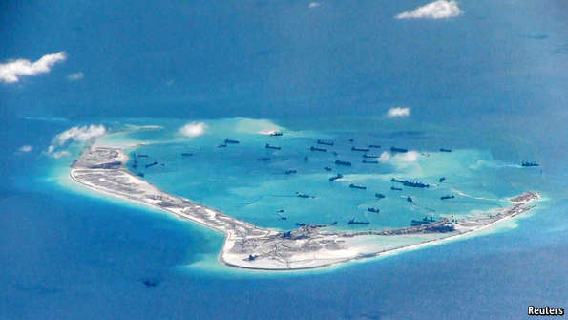
AMERICAN officials are losing patience with China. On May 22nd the vice-president, Joe Biden, was blunt. He warned naval-college graduates of “new fault lines” emerging between the great powers. China, he said, was challenging freedom of navigation in the South China Sea by reclaiming land on disputed reefs on a “massive scale”. Two days earlier America had signalled its annoyance by sending a surveillance aircraft close to one of the reefs where China is building an airstrip. Such secretive flights are common, but this one was different. The plane also took a crew from CNN, which broadcast the Chinese navy’s testy response through a radio transmission in English: “Leave immediately, in order to avoid misjudgment.”
Chinese officials and state-controlled media have reacted angrily to America’s rhetorical offensive (reinforced by CNN’s dramatic footage of the spyplane mission over Fiery Cross Reef, showing sand being sucked from the bottom of the sea and sprayed onto the island-in-the-making by Chinese dredgers). On May 25th a Chinese foreign ministry spokeswoman called on America to end its “provocative behaviour”. Global Times, a state-owned newspaper known for its hardline views, said war would be “inevitable” if America kept complaining about the island-building. On May 24th the People’s Daily, the Communist Party’s main mouthpiece, warned America that those who “hurt others” could “end up hurting themselves”.

Mercifully, the heated words have not so far been matched by hot-headed military behaviour in or above the sea itself. Both America and China are anxious to avoid clashes. But in order to make its point, America is considering moves that might be construed by China as threatening. American spy flights, as well as similar missions by its ships, have so far kept at least 12 nautical miles (22km) away from the reefs they are monitoring. That would be the outer limit of China’s sovereign domain if the reefs were islands (ie, permanently above sea) and were indeed Chinese. Now the Pentagon is considering whether to probe these lines.

China has long said it owns most of the reefs and islands in the South China Sea, and has also asserted vaguely defined rights to most of the sea itself. Other countries around the sea dispute these claims (Vietnam and the Philippines both say they own Fiery Cross Reef). America takes no position in the sovereignty debate, but it says arguments should be resolved peacefully, without affecting freedom of navigation. China’s warnings to American spyplanes suggest that it is already trying to impose restrictions on military traffic.
Despite America’s increasingly public complaints, there has been no change in the frantic pace of China’s reclamation efforts on several reefs (pictured is an American spyplane’s photograph of work on Fiery Cross Reef). On May 26th China’s defence ministry released a “white paper” on military strategy. It said the country should build a “modern maritime military force” to protect China’s “maritime rights and interests”, including in the South China Sea. Ash Carter, America’s defence secretary, said a day later that China’s actions in the area showed it was out of step with “international norms that underscore the Asia-Pacific’s security architecture”.
America and China’s neighbours worry that China may eventually declare an “Air Defence Identification Zone” (ADIZ) over the South China Sea—requiring aircraft to identify themselves to the Chinese authorities before entering. In November 2013 China alarmed the region by establishing an ADIZ over the East China Sea, covering islands claimed by Japan (see map). It said its armed forces had the right to take “defensive emergency measures” against those failing to comply. America quickly sent two unarmed B-52 bombers through the zone without notifying China. Some Chinese experts believe that China is unlikely to declare an ADIZ in the South China Sea soon because it would be even harder to enforce over such a vast area. On May 26th, however, a Chinese foreign ministry official said his country would decide whether to establish one partly on the basis of “whether and to what extent the security of airspace is threatened”—a clear warning to America.
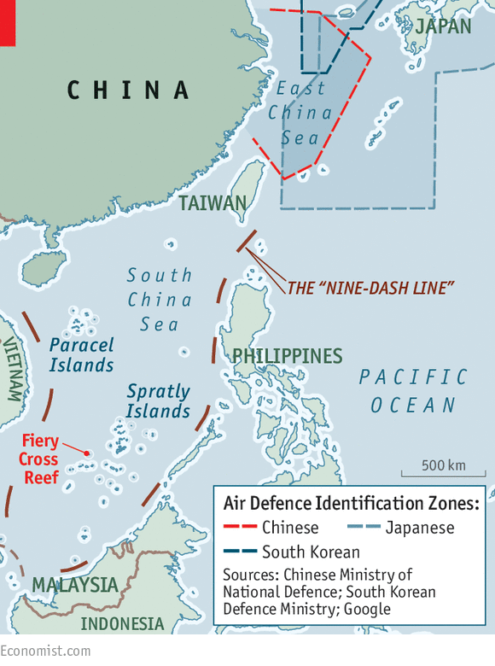
Chinese academics say that testing China’s resolve could prove dangerous. Should America sail a naval ship close to one of the reefs it “may very well force Beijing to respond forcefully,” says Zhu Feng of the China Centre for Collaborative Studies of the South China Sea at Nanjing University. No Chinese leader, he says, wants to be seen as a “chicken”.
Neither, however, does America. It is relieved that China’s neighbours are beginning to speak out more forcefully about the problem as well. In April the ten-member Association of South-East Asian Nations (ASEAN), which is usually at great pains not to antagonise China, called the island-building a threat to “peace, security and stability”. ASEAN countries welcome America’s military presence in the region. But privately they have also been asking the Americans to avoid ratcheting up tensions. No Asian country wants to be forced to make a clear choice between backing America or backing China. For America, staying out of trouble will be tough.

NYT

U.S. Flies Over a Chinese Project at Sea, and Beijing Objects
By HELENE COOPER and JANE PERLEZMAY 22, 2015
Photo
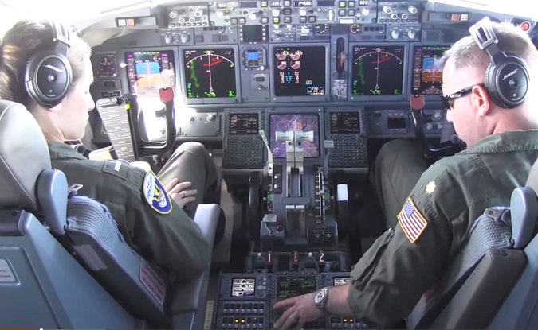
A Navy jet over the South China Sea. China says the flights violate its territorial sovereignty. Credit U.S.Navy
WASHINGTON — The United States and China on Friday escalated their dispute over contested territory in the South China Sea, after the Chinese repeatedly ordered an American military surveillance plane to abandon flights over areas where China has been building artificial islands.
The continued American surveillance flights in areas where China is creating new islands in the South China Sea are intended to challenge the Chinese government’s claims of expanded territorial sovereignty. Further raising the challenge, Pentagon officials said they were discussing sending warships into waters that the United States asserts are international and open to passage, but that China says are within its zone of control.
The Defense Department planning comes in response to China’s accelerated efforts to build new islands in the South China Sea to bolster claims to a vastly expanded area of sovereignty, a direct challenge to the United States and other nations in the region.
The Chinese government expressed “strong dissatisfaction” with the surveillance flights, while urging the United States to cease actions that they said risked increasing tensions. Hong Lei, the Foreign Ministry spokesman, warned that the American flights, which he called “very irresponsible and dangerous,” were “likely to cause an accident.”
But the Obama administration was adamant in saying that the American Navy surveillance flights were made in international airspace. Officials from the State Department and the Pentagon said that China’s land reclamation in the South China Sea was undermining stability in the region and that the Chinese had no business building airstrips on the contested Spratly Islands.
“This land reclamation is going fast,” Cmdr. William Marks, the Navy’s chief of media, said in an interview on Friday. “Really fast — faster than we ever imagined.” He said the Navy had no intention of stopping its almost daily reconnaissance flights.
“We have freedom of flight over international airspace,” he said.
Continue reading the main story

Building Islands on Mischief Reef
These satellite images show Mischief Reef, part of the Spratly Islands in the South China Sea. In the March 16 image there are several dredgers visible at the northern and western edges of the reef, and to the south, where the entrance to the reef has been widened to about 275 meters.
Mischief Reef January 24, 2012 March 16, 2015
Center for Strategic and International Studies via Digital Globe
The Navy on Thursday released video footage of an incident Wednesday when a Chinese military dispatcher issued eight warnings — in English — to a Navy P8-A Poseidon surveillance plane as it flew over Fiery Cross Reef, the site of an extensive Chinese land reclamation project in the Spratly Islands, a group reefs halfway between Vietnam and the Philippines in the South China Sea. The Navy also released video footage that it said documented the continued expansion of the reefs, which have been turned into artificial islands with airport infrastructure, including a runway.
American military officials took a CNN crew along on the Navy reconnaissance flight on Wednesday; a military official said the decision to take a television crew and to release the video footage was deliberate.
“It’s important that the American public, and the Asian public, too, understands what’s going on out there,” the official said, speaking on condition of anonymity because he was not authorized to speak publicly about a delicate international issue.
A second Defense Department official said discussions were underway on whether the military would increase its naval presence in international waters in the area, including additional patrols using frigates, destroyers and small combat ships. Such a move would most likely further annoy China. Disagreement over the Spratly Islands has continued for several years. The Spratlys are claimed by at least three other countries, including the Philippines, an American ally; and Vietnam, which has sought warmer relations with Washington.
Earlier this year, analysts released satellite images of a concrete runway that China was building on Fiery Cross Reef, one of the Spratly Islands. The runway is expected to be about 10,000 feet long. The construction on Fiery Cross Reef is part of a larger Chinese reclamation project involving scores of dredgers on at least five islands. China is converting tiny reefs, once barely visible above water, into islands large enough to handle military hardware, personnel and recreation centers for workers.
The Chinese government has maintained that the reclamation efforts are meant to serve civilian purposes like providing a base for search-and-rescue operations. But the Chinese military has also said that the reclamation is for “necessary military defense.”
A senior administration official expressed concern that China was trying to build up the islands as a way to make a case for Chinese sovereignty — to “create facts on the ground — and we can’t allow that.” Separately, Daniel R. Russel, the assistant secretary of state for East Asia, told reporters that American military aircraft would continue to exercise the right to operate in international airspace.
Under the leadership of President Xi Jinping, China has asserted claims in the South China Sea that have increasingly butted against Asian allies of the United States. In particular, the issue of territorial boundaries has come into play.
The United States says that foreign aircraft have the right to fly over waters beyond a nation’s 12-mile territorial line. China, meanwhile, asserts that foreign aircraft do not have the right to fly within its 200-mile exclusive economic zone without permission.
The contentious issue has flared up before. In late 2013, China set off a trans-Pacific uproar when it declared that an “air defense identification zone” gave it the right to identify and possibly take military action against aircraft near disputed islands in the East China Sea. Japan, which administers the islands, refused to recognize China’s claim, and the United States has since defied China by sending military planes into the zone, unannounced.
The islands, known as the Senkaku in Japanese and the Diaoyu in Chinese, are a seven-hour boat ride from Japan, even farther from China. But they, like the Spratlys, have been at the center of ongoing territorial disputes among China and its neighbors.
Pentagon officials say they worry that China will try to declare another air defense identification zone over the Spratlys. “Is this foreshadowing?” one Defense Department official, who spoke anonymously to discuss a national security matter, said on Friday. “Well, we can certainly see them trying.”
“The Navy flyover was a measured response, meant to signal to the Chinese that the world is watching — literally — their provocative reclaiming of land that people don’t agree that they own,” said Andrew L. Oros, an associate professor of political science at Washington College in Chestertown, Md., and a specialist on East Asia. “This idea that China has, that it can just act unilaterally when other people don’t agree, has to be confronted.”
To build the artificial island, China has dispatched concrete pylons on cargo vessels from the mainland to build a retaining wall and create the island and a harbor, according to Sean O’Connor, a former United States Air Force intelligence analyst who now works as the principal imagery analyst for IHS Janes, a publication that examines military issues.
China has used dozens of dredges that suck up sand and then dump it to make landfill and has constructed concrete manufacturing plants to provide asphalt for runways, he said.
Mr. O’Connor said the Chinese seemed to be particularly focused on the runway. “It looks as though they go over and over it again to make it thick, and can take any kind of plane,” he said in a telephone interview. In particular, he said, the Chinese would be interested in landing bombers and fighter jets.

NYT

Asia Pacific

U.S. Rebukes China on Efforts to Build Artificial Islands
By MATTHEW ROSENBERGMAY 27, 2015
PEARL HARBOR, Hawaii — A day after China laid out its vision for a navy that can project power into the open seas, Defense Secretary Ashton B. Carter on Wednesday criticized Beijing’s efforts to build artificial islands in the South China Sea, making it clear that the United States would not be deterred by Chinese claims to newly built territories.
Though American officials have long insisted that the Obama administration’s so-called pivot or rebalance toward Asia is not aimed at one country, Mr. Carter’s comments left little doubt that Washington shared the concerns of other Asian nations about China’s growing military presence in disputed areas of the South China Sea, and the increasingly assertive posture of its forces in disputed waters around Asia.
The South China Sea is especially sensitive. It is bisected by vital shipping lanes that connect Asia to the Middle East and Europe, and China’s efforts to create artificial islands and build military structures on reefs and other outcroppings have alarmed the Philippines, a close American ally, and other countries, like Vietnam and Malaysia.
“China’s actions are bringing countries in the region together in new ways. And they’re increasing demand for American engagement,” Mr. Carter said during a ceremony at the naval base at Pearl Harbor marking a change of command of United States forces in the Pacific. “We’re going to meet it. We will remain the principal security power in the Asia-Pacific for decades to come.”
American defense officials say that international law does not recognize Chinese claims of sovereignty over artificial territories reclaimed from the sea. And Mr. Carter, apparently in a warning to China, said Wednesday that American forces would not respect territorial claims that they considered illegitimate.
“There should be no mistake about this: The United States will fly, sail and operate wherever international law allows, as we do all around the world,” he said.
At issue is more than an abstract legal dispute: The Pentagon is weighing how aggressively it should send aircraft and warships into what it considers international waters. An American surveillance jet last week flew near Fiery Cross Reef, a contested atoll in the Spratly Islands where China has been dredging in recent months. Chinese forces repeatedly ordered the American aircraft to leave the area, and China’s Foreign Ministry later characterized the flight as “irresponsible and dangerous.”
At the same time, China appears to be pushing ahead with its building spree in the disputed waters. On Tuesday, Chinese state news media announced that construction had begun on two new lighthouses in the Spratly Islands, adding to the growing number of structures that satellite images indicate China is building, including airstrips.
Mr. Carter added that the United States favored “a peaceful resolution to all disputes, and a halt to land reclamation by any claimant.”
Mr. Carter is en route to Singapore to attend an annual security meeting known as the Shangri-La Dialogue, which begins Friday. There, he said, “I’ll call for the region to strengthen its security institutions and relationships to ensure we can maintain lasting peace and stability in a region undergoing significant change.”

NYT

Chinese Weapons Spotted on Disputed Island, U.S. Says
By MATTHEW ROSENBERGMAY 29, 2015
SINGAPORE — The United States has spotted a pair of mobile artillery vehicles on an artificial island that China is building in the South China Sea, a resource-rich stretch of ocean crossed by vital shipping lanes, American officials said.
China’s construction program on previously uninhabited atolls and reefs in the Spratly Islands has already raised alarm and drawn protests from other countries in the region, whose claims to parts of the South China Sea overlap China’s.
Defense Secretary Ashton B. Carter called this week for China to halt the construction, saying that international law did not recognize Chinese claims of sovereignty over the new territories and that American warships and military aircraft would continue to operate in the area.
The artillery was spotted by satellites and surveillance aircraft about a month ago, and the two vehicles have since been either hidden or removed, according to an American official who spoke about intelligence matters on the condition of anonymity. The official added that even if the weapons remain on the island, they pose no threat to American naval forces or aircraft in the region, though the guns could reach some nearby islands claimed by other countries.
With Mr. Carter in Singapore to attend the Shangri-La Dialogue, a high-profile annual Asian security meeting that Chinese officials are also attending, American officials were reluctant to publicly discuss the intelligence they had collected about the artillery.
Brent Colburn, a spokesman traveling with Mr. Carter, would say only that the United States was aware of the weapons, whose detection was first reported by The Wall Street Journal.
Senator John McCain, the Arizona Republican who heads the Senate Armed Services Committee, criticized China’s deployment of artillery on the island as “a disturbing development and escalatory development.”
“Their actions are in violation of international law, and their actions are going to be condemned by everyone in the world,” Mr. McCain was quoted by Reuters as saying in Ho Chi Minh City, Vietnam, where he stopped on Friday on his way to Singapore for the security conference.
“We are not going to have a conflict with China,” he said, “but we can take certain measures which will be a disincentive to China to continue these kinds of activities.”
There was no immediate comment from Chinese officials about the weapons.
A top Chinese military official, Adm. Sun Jianguo, is scheduled to speak at the conference in Singapore about Chinese military policies. Admiral Sun, the deputy chief of staff of the People’s Liberation Army, which includes the navy, will lead the strongest delegation of military officials that China has yet sent to the annual forum.
China released a military strategy document earlier this week that, for the first time, called for its navy to project force beyond its coastal waters into the open oceans. Western officials said because of its timing, the document seemed intended as a challenge to other participants in the conference.
The heightened tensions between the United States and China over the South China Sea were on display last week when the United States sent a surveillance plane close to Fiery Cross Reef, which China has built into an island with a runway that military aircraft can use. The Chinese told the American plane to leave the area, according to a CNN television crew that was aboard the flight at the Pentagon’s invitation.
When an American littoral combat ship, the Fort Worth, conducted a weeklong patrol of waters near the Spratly Islands, including Fiery Cross Reef, a Chinese guided missile frigate, the Yancheng, followed the American vessel for a time, the Pentagon announced. Other American warships will conduct similar patrols, which will be the “new normal” for the Navy in the South China Sea, the Pentagon said.
China has said that it was building the artificial islands in the sea largely for civilian purposes, but it has not denied that it also envisions a military role for them.
In April, Hua Chunying, the spokeswoman for China’s foreign ministry, told reporters that the islands would be used to aid the country’s defense, though she did not provide details. “Such constructions are within China’s sovereignty and are fair, reasonable, lawful and do not affect nor target any country, and are beyond reproach,” she said.
The United States disagrees, and American officials have stressed in recent days that the American-dominated security order in the region should be respected because it has brought calm and prosperity.
The implication is that China is threatening to upend that system, but the American officials have hesitated to say so directly, preferring to talk in generalities about all countries needing to find diplomatic solutions to their disputes in the South China Sea.
Still, American officials have not been shy about pointing out that China has created roughly 2,000 acres of new land in the South China Sea, three quarters of it this year. The United States has also released video images taken by surveillance aircraft showing Chinese ships and dredges building runways and harbors on remote outcroppings in the sea.

NYT

The Opinion Pages | Editorial

Pushback in the South China Sea
By THE EDITORIAL BOARDMAY 29, 2015
Photo
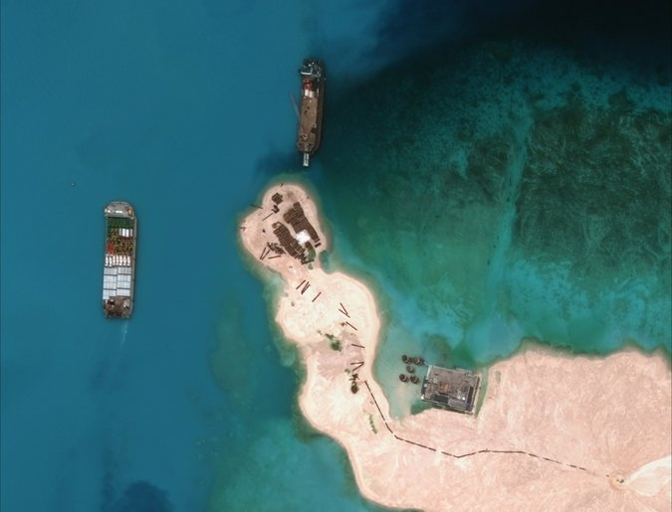
A satellite image taken in March showed Chinese vessels in the Spratly Islands. Credit Digitalglobe/Agence France-Presse — Getty Images

The United States has good reason to push back more forcefully against China’s grab for power in the South China Sea, as Defense Secretary Ashton Carter did on a trip to Asia this week. Beijing has repeatedly ignored earlier warnings to moderate the aggressive behavior that is unsettling its regional neighbors and further undermining its relations with the United States.
On Friday, American officials disclosed that China had installed two mobile artillery vehicles on an artificial island it is building in the sea, which is rich in natural resources like oil and gas and where China clearly hopes to establish some form of hegemony.
The weapons are not considered a threat to American naval forces. Still, they reinforce fears that China intends to militarize the Spratly Islands, a collection of reefs and rocks also claimed by the Philippines, Vietnam, Malaysia and Taiwan, and use them to control the waterway’s shipping lanes and dominate its smaller neighbors.
China’s ambitions have become increasingly clear since 2012 when it publicly asserted a claim to 80 percent of the South China Sea. In recent months, photographic evidence from commercial satellites and American spy planes has left little doubt that China is moving with alarming speed to turn the Spratlys into more substantial land masses, complete with runways and harbors.
Some American officials now believe China regards its claims in the South China Sea as nonnegotiable. If so, that’s terrible news for the region but also ultimately for China, which claims it prizes stability but will find it impossible to realize its economic goals if Asia is in constant tension. China’s bullying on the South China Sea has already caused many Asian countries to forge closer defense ties with the United States.
Now, the Obama administration has decided to more firmly underscore America’s intention to remain a Pacific power and to ensure that the region and its waters remain accessible to all nations. That is a role the United States has played constructively for decades, promoting a stability that has allowed Japan, South Korea and other countries, including China, to develop. “There should be no mistake: the United States will fly, sail and operate wherever international law allows, as forces do around the world,” Mr. Carter said in his speech. He also called for “an immediate and lasting halt to land reclamation by all claimants.”
Although the administration would obviously prefer a peaceful resolution of all South China Sea disputes, it cannot allow China’s claims to go unchallenged. It sent a surveillance plane close to one of China’s artificial islands, is considering air and sea patrols that could go closer to disputed reefs and shoals, and is expanding military exercises with regional partners.
President Obama and President Xi Jinping of China plan to meet later this year. In the meantime, American officials and their Chinese counterparts must avoid any miscalculation that could lead to a direct confrontation.

NYT

China Says It Could Set Up Air Defense Zone in South China Sea
By EDWARD WONGMAY 31, 2015
BEIJING — A Chinese admiral said on Sunday that Beijing could set up an air defense zone above disputed areas of the South China Sea if it felt it was facing a large enough threat, according to Chinese news media.
Adm. Sun Jianguo, deputy chief of staff of the People’s Liberation Army, told a regional security forum in Singapore that China had not said it would create a so-called air defense identification zone, but that any decision would be based on an aerial threat assessment and the general security situation. He also said other nations should not overemphasize the issue.
The creation of an air defense zone would be viewed by the United States and Southeast Asian nations as a huge provocation. In recent years, foreign officials have speculated whether one of Beijing’s next moves in the South China Sea would be to set up such a zone, whose existence would further solidify China’s military presence in the waters.
In November 2013, to the dismay of Japan and the United States, China declared an air defense identification zone over disputed waters in the East China Sea. Chinese military aircraft began requiring all other aircraft flying through the zone to identify themselves, and commercial airliners complied, though the United States sent B-52 bombers through the zone without advance warning to challenge Beijing.
Admiral Sun’s remarks came during a question-and-answer session after he delivered the main Chinese speech at the annual Shangri-La Dialogue security conference in Singapore. As at previous such meetings, much of the focus of the conference, which ended on Sunday, was on territorial disputes in the South China Sea, where China, Taiwan and Southeast Asian nations all have competing claims to waters, islands, reefs, shoals and sandbars. In recent weeks, the United States has criticized China for island-building and land reclamation efforts on disputed reefs and atolls that were uninhabited until recently.
On Saturday, Ashton B. Carter, the United States defense secretary, reiterated an earlier demand for China and other nations to stop such island-building. The United States has said that China is building much faster than any other nation and has completed 2,000 acres of land reclamation in the last 18 months. Vietnam and the Philippines have built structures on some land formations, but much of that construction took place before 2002, when China and rival claimants to territory signed a nonbinding agreement to cease any provocative activity in the region.
About a month ago, the United States military spotted a pair of mobile artillery vehicles on one of the new islands, but those soon vanished, American officials said last week. China has said its islands will be used for maritime aid as well as military defense.
“China and the Chinese military have never feared the devil or an evil force, and we are convinced by reason but not by hegemony,” Admiral Sun said on Sunday, according to a transcript of his speech posted by the Chinese Defense Ministry. “Don’t ever expect us to surrender to devious heresies or a mighty power. And don’t ever expect us to swallow the bitter fruits that would harm our sovereignty, security and development interests.”
He added that the United States was guilty of hypocrisy, since it had criticized China’s military deployment on the islands while its officials had, at the same time, said they would bring weapons of their own to bear on the regional situation.
China has maintained that its right to construction is based on its understanding that the territory belongs to China. On Saturday, Hua Chunying, a Foreign Ministry spokeswoman, released a long, six-point rebuttal to Mr. Carter’s statements, including some phrases that Admiral Sun also used, saying that “the U.S. side made inappropriate remarks on China’s longstanding sovereignty as well as rights and interests in the South China Sea to foment dissension and criticized China’s normal and justified construction activities on islands and reefs.”
Admiral Sun said Sunday that the situation in the South China Sea had been “peaceful and stable” and that there was no problem with freedom of navigation in the sea.
He added that China remained committed to resolving the disputes with its neighbors through talks. But China has long insisted that any such talks be undertaken bilaterally, not by more than two countries at a time.
“We can’t enter the 21st century with our bodies alone while leaving our heads in the past, under the limits of colonial expansionism, a Cold War mentality and a zero-sum game,” he said, adding that China wanted to promote “win-win cooperation.”
The United States and countries in the region say China’s actions are taking place at the expense of other nations’ interests and are jeopardizing diplomatic relations. Most notably, in May 2014, China placed an exploratory oil rig near the Vietnamese coast and off the shores of the Paracel Islands, land formations also claimed by Vietnam. That prompted daily clashes between Chinese Coast Guard vessels and Vietnamese boats, along with deadly rioting in Vietnamese cities against factories perceived to have Chinese workers.
In a possible sign of the growing importance of the Chinese Navy, Admiral Sun was the first naval officer appointed by Beijing to lead its delegation to the Shangri-La Dialogue since China began attending in 2007. He was also the most senior military officer to lead the delegation since 2011.
Admiral Sun, 63, is the only naval officer in the current eight-person leadership of the People’s Liberation Army general staff headquarters, which oversees the navy. He joined the navy at age 16, when he began a decade of training at the main submarine college. He then served for many years as a captain of both conventional and nuclear submarines, earning the nickname Iron Captain. In 1985, he commanded a crew for a voyage of 90 days straight on a nuclear submarine, breaking a record held by the United States Navy, according to a report on the website of The People’s Daily, the flagship Communist Party newspaper. He was promoted to the rank of admiral in 2011.
Admiral Sun’s submarine background dovetails with the growing emphasis of the Chinese military on open-water force projection. On Tuesday, the Chinese military issued a strategy paper, its first in two years, that said it intended to project naval power in the open ocean in addition to defending coastal waters.
NYT

Building of Islands Is Debated, but China and U.S. Skirt Conflict at Talks
By MATTHEW ROSENBERGMAY 30, 2015
Photo
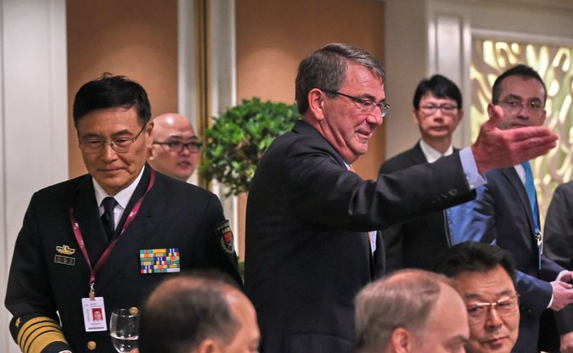
Adm. Sun Jianguo of China, left, and Defense Secretary Ashton B. Carter at the Shangri-La Dialogue in Singapore on Saturday. American officials made it clear that disputes in the South China Sea would not hinder nascent military cooperation with China. Credit Roslan Rahman/Agence France-Presse — Getty Images
SINGAPORE — It was an unexpectedly direct exchange: With nearly every significant Asian defense official gathered in a single room, a senior Chinese military officer on Saturday defended his country’s island-building spree in the South China Sea and rebuked Defense Secretary Ashton B. Carter for saying it threatened the region’s stability.
If anything, “the region has been peaceful and stable just because of China’s great restraint,” said Senior Col. Zhou Bo, the Chinese officer.
Yet a few moments later, away from the crowd and cameras, Colonel Zhou’s defiant tone gave way to a seemingly more subtle appreciation of the complex relationship that binds the United States and China together and, at the same time, pushes them apart. The speech by Mr. Carter that prompted his comments had “balance,” Colonel Zhou said in a brief interview.
“We do not disagree on all things,” he added, before rushing off to huddle with fellow Chinese officers at the conference.
After a week of public rancor over China’s rush to build artificial islands on reefs, rocks and atolls in the disputed waters of the South China Sea, the first full day of the Shangri-La Dialogue, an annual security meeting in Singapore that attracts almost every major and minor player in Asia, gave both sides the chance to lower the temperature.
Though Mr. Carter did not hold any formal meetings with Chinese officials, lower-ranking American officials did, and it was apparent that they in effect agreed to disagree on what constitutes sovereign Chinese territory for the time being. But American officials made it clear that the dispute would not hinder nascent military cooperation with China or threaten the deep economic ties that are the bedrock of Asia’s stability and prosperity.
Adm. Harry Harris, the new chief of American forces in the Pacific, summed it up succinctly in a briefing with reporters at the end of the day: “Conflict is bad for business.”
The dispute over the South China Sea has festered for decades with China, Vietnam, the Philippines and a handful of other countries all making overlapping claims to a stretch of ocean rich with natural gas and other resources. While this issue simmered in the background for a long time, disputes have escalated in recent years, most notably when China placed an oil rig near Vietnam last year, but also with skirmishes between naval forces and fishing boats from the various claimants.
Those tensions have heightened as the scope of the Chinese building spree became apparent — American officials say 2,000 acres of land were added in the past 18 months — and a pair of mechanized artillery pieces were briefly spotted on two of the islands, raising fears that China was moving to back up its claims to the new islands with military force.
Chinese forces also this month ordered an American surveillance plane to leave the skies over Fiery Cross Reef, where China has built an island with a landing strip. The American aircraft did not comply.
Then last week China released a document outlining a strategic vision for its navy to project force beyond its coastal waters into the open oceans. Western officials said the release appeared timed to challenge participants at the conference.
Other countries have also built outposts in the South China Sea. But the construction was done before 2002, when China and nine Southeast Asian nations signed a nonbinding agreement to “exercise self-restraint” and refrain from trying to inhabit any land features that were uninhabited at that time. And the pre-2002 construction was never done at the pace and on the scale of China’s recent land reclamation efforts.
Mr. Carter, whose speech opened the day, reiterated a call he made earlier in the week for China to halt the construction, saying that American warships and military aircraft would continue to operate in the area, which the United States still considers to be international waters, not Chinese territory. He also listed numerous weaponry that the United States could bring to bear in Asia — though he did not directly link any of it to China — and unveiled a new American effort to help China’s neighbors build up their naval capabilities.
But he balanced his tough talk with entreaties to China to work with its neighbors and the United States to ensure stability in the region, saying that through cooperation “everybody wins.”
He also sought to assuage Chinese fears that the United States was using the dispute over the sea simply to keep China in check. The United States expected countries like China to broaden the scope of their interests as they grew more powerful, and it was ready to work with them to keep the peace, he said.
The United States “has never aimed to hold any nation back or push any country down,” he said.
Mr. Carter also cited areas where the American and Chinese militaries were already cooperating, and new initiatives, such as a measure the two sides are working on that would help prevent dangerous air-to-air encounters between military aircraft.
The official Chinese response was to come Sunday when Adm. Sun Jianguo, the deputy chief of the general staff of the People’s Liberation Army, addresses the conference. American, European and Asian officials here said they expected blustery language, and that had little expectation that the Chinese would suddenly halt their effort to construct new territory in the South China Sea.
Colonel Zhou may have provided a preview on Saturday during the question-and-answer period that followed Mr. Carter’s speech.
After calling Mr. Carter’s criticism groundless, he said that freedom of navigation in the South China Sea was not a problem because it was never really free, and then concluded with a loaded question. “The U.S. has taken some measures, such as harsh criticism toward China, and military reconnaissance activities, your military threat,” he said. “Do these measures help to resolve the dispute in the South China Sea and maintain peace and stability?”
The American answer was that its military has always flown and sailed in international airspace and water, and that it is China that is trying to alter the facts on the ground, not the United States.
But neither side for now appears willing to do much more than demand that the other stop.
In the meantime, American officials said they would continue to build the military capacity of allies in the region, and forge closer ties with former adversaries like Vietnam, so they too could benefit from American military assistance. Over time, the hope is that stronger neighbors backed by the United States would serve as a deterrent to China.
Senator John McCain, who led a Congressional delegation to the conference, told reporters that he planned to introduce legislation next week to lift parts of an embargo on sending weapons to Vietnam.
American allies, though, did not appear entirely convinced that the United States had a long-term plan, or that it would back up its talk about freedom of navigation and the need to respect international laws with action.
“If we leave any unlawful situation unattended, order will soon turn to disorder, and peace and stability will collapse,” Gen Nakatani, the defense minister of Japan, told the forum. “I hope and expect all the countries, including China, to behave as a responsible power.”
But few, if anyone, seemed willing to see order enforced at the risk of war. “This has the potential to escalate into one of the deadliest conflicts of our time, if not history,” said Hishammuddin Hussein, the defense minister of Malaysia. “Inflamed rhetoric does not do any nation any good.”

The Economist

Banyan

Whose splendid isolation?

In the dock for its aggressive expansionism in the South China Sea, China seems undeterred
Jun 6th 2015 | From the print edition

THE Shangri-La Dialogue, an annual powwow in Singapore for Asia-Pacific defence chiefs, has begun to follow a pattern: America and its friends in Asia line up to criticise China for its alleged transgressions in the seas around its coast; China issues fierce, mendacious and unconvincing rebuttals; everybody goes home. Last year, China’s crimes were its declaration of an Air-Defence Identification Zone (ADIZ) over an area including islands it disputes with Japan; and its dispatch of an oil-rig to drill in waters claimed by Vietnam. The row was vitriolic. This year, it has been building frantically in contested waters in the South China Sea. At Shangri-La, both the criticism and its response were more measured. But the disagreements seem even more profound and irreconcilable than a year ago, and China even more isolated.
Five of the six countries with claims to all or some of the reefs and islets in the South China Sea have built structures on them, often after reclaiming land. China, however, has taken this to unprecedented lengths. In his speech at the Dialogue, America’s defence secretary, Ash Carter, said China had filled in over 2,000 acres (810 hectares), “more than all other claimants combined…and more than in the entire history of the region”; and all in the past 18 months. He called this a “source of tension”.

China argues that the sea is peaceful and stable—far from the kind of security threat the Dialogue should have been discussing. It insists its sovereignty is “indisputable”, and that its building work is for the international common good: search and rescue; disaster; meteorology; conservation; and so on. But American officials believe otherwise. They say satellite pictures show that China brought two mobile-artillery vehicles to one of its man-made islands (though the weapons since seem to have been removed). It has also added harbours and, on one or two islands, airstrips. This has enhanced their military potential and, China presumably hopes, created evidence of its control and sovereignty. Mr Carter warned against “further militarisation” of the sea.
America takes no position on the sovereignty disputes, of which those with Vietnam and the Philippines are the most active. But like many other countries it is worried about “freedom of navigation”: a huge chunk of global trade traverses the sea. To show the threat that this freedom is under, an American surveillance plane in late May flew close to the expanding islands, with a television-news crew on board. The Chinese navy told it repeatedly to go away. China’s neighbours worry that eventually it will declare an ADIZ over these waters too.
Around the world, American forces sail and fly through areas of tension to prove that they have the freedom to do so. But such behaviour in the South China Sea infuriates China, which claims that freedom of navigation is not under threat. It has always objected to America’s insistence that one such freedom is the right to send surveillance planes and ships up to the edge of China’s territorial waters. This disagreement has led to incidents such as one in 2001 when a Chinese jet collided with an American spy-plane; and another in 2009 when America complained about Chinese “harassment” of one of its surveillance ships.
Another potentially alarming confrontation looms. Mr Carter demanded an “immediate and lasting halt” to the land reclamation by China and other claimants. China shows no sign of stopping, and it seems inconceivable that America would resort to force. But it is under pressure to go further in asserting its right to use the contested waters and airspace. Also at the Dialogue was a delegation of senators led by John McCain, who is chairman of the Senate’s Armed Services Committee. Mr McCain said he hoped America would disregard any “territorial waters” China may claim around the man-made islands.
This is a complicated issue. China’s claims are unclear. Its maps show a “nine-dash line” encompassing most of the sea. But under the United Nations Convention on the Law of the Sea (UNCLOS), sovereignty depends on the land. Countries can claim 12 nautical miles (22km) of territorial sea and 200 nautical miles of “exclusive economic zone” (EEZ) off the coast of their mainlands and habitable islands. Uninhabitable “rocks” get the territorial waters but no EEZ; rocks that are submerged at high tide have no waters at all. The status of the places where China is building is uncertain. It is clear that, pre-construction, they were not “islands”; but some may be rocks with territorial waters; some “low-tide elevations” with none. Only “natural” features count, however, and America does not want to give the impression a low-tide elevation can become a rock, or a rock an island, thanks to construction. Despite never having ratified it, America does adhere to UNCLOS. And though it is not clear who does own these rocks and reefs (America, as one naval officer jokes, is “pretty sure they’re not ours”), the United States takes a keen interest in whether territorial lines have a basis in international law.
Don’t be troublesome, please
The impression the Dialogue gave was of a world united in outrage at China’s bullying in the South China Sea. But if America goads it with intensive surveillance around its maritime claims, China may succeed in portraying the United States as the troublemaker. Moreover, China knows America itself does not want to ruin what both countries regard as a crucial relationship just to make a point about island-building. The two countries have their annual high-level get-together, the Strategic and Economic Dialogue, in Washington, DC, at the end of June; and China’s president, Xi Jinping, is due for a state visit in September. Preparations for both events are on track, despite the bickering.
As for the complaints it endures at the Shangri-La Dialogue, China may simply respond by stepping up efforts to develop its own, friendlier, alternative: an annual meeting in Beijing called the Xiangshan Forum, “Asia’s own platform for security dialogue”. Interfering American officials are not invited.

EIU
June 3rd 2015
Print Share

South China Sea tensions toned down at security summit
Recent arguments over Chinese island reclamation activities in the South China Sea (SCS) were toned down at an annual gathering of military officers, known as the Shangri-La Dialogue (SLD), which was held in Singapore on May 29th–31st. However, with a diplomatic solution a still-distant prospect, regional tensions will persist. There is a risk that an accidental confrontation or political miscalculation could develop into an incident damaging for regional peace and stability.
Tensions stemming from competing territorial and maritime claims held in the SCS by Brunei, China, Malaysia, the Philippines, Taiwan and Vietnam have been bubbling away for decades. However, in recent years diplomatic confrontations between the various claimants have intensified in form and frequency. Underlying these tensions has been China's determination to assert its sovereign claim to islands in the region, which fall within an expansive "nine-dashed line" covering most of the SCS.
Since 2009 there have been periodic clashes between China and the Philippines and Vietnam, while the US has also become more involved in the various disputes, strengthening defence ties with members of the Association of South-East Asian Nations (ASEAN) and criticising perceived Chinese aggression. In April 2015 the Philippines and the US held their largest joint military exercises in 15 years, while in May the Philippine and Japanese navies held historic drills close to the disputed Scarborough Shoal—an area that has been occupied by China since 2012 but which sits within the Philippines' exclusive economic zone (EEZ).
Castles of sand
The most recent escalation in the SCS dispute has centred on China's land reclamation activity in the region. Since 2014 reports have proliferated about dredging work by Chinese vessels, seemingly focused on turning reefs, atolls and rocks in disputed parts of the SCS into artificial islands. Satellite images released in April showed that China was making rapid progress in building an airstrip on the previously semi-submerged Fiery Cross Reef in the Spratly Islands. ASEAN leaders voiced their "serious concern" about China's island-building activities at a summit in April.
The root of the contention between China and the other countries is the clashing territorial claims, rather than the development of the artificial islands specifically. Malaysia, the Philippines, Taiwan and Vietnam have also conducted land reclamation work and built outposts in the region, albeit not recently at the pace and scale of China. Countries that have established an occupying presence on such atolls will be hard to dislodge. Such changes to the "facts on the ground" are likely to prove irreversible.
The bigger and more important issue is over the maritime claims and the EEZs attached to man-made islands. The UN Convention on the Law of the Sea (UNCLOS) is clear that such entities do not possess the status of islands. As such, they do not possess a 12-nautical mile territorial sea or EEZs. Under UNCLOS, most of the SCS is made up of international waters, or EEZs belonging to ASEAN members. Artificial islands, installations and structures are not allowed to be established if they interfere with the use of recognised sea lanes and international navigation.
However, China's actions have suggested that elements within its government believe that the development of these atolls give it the right to control the waters and airspace around them. The Chinese military has been challenging aircraft entering airspace above the features, a point publicised in May by the US military when it allowed a CNN television crew to join a US surveillance plane conducting a fly-over the Spratly Islands. The flight was duly challenged by the Chinese navy and told to depart in order to "avoid misunderstanding".
China's building airstrips on the reefs, as well as reports of it moving weaponry to some man-made islands, has further stoked concerns that the land reclamation work has a military purpose. Many assume that China's goal is to enforce an Air Defence Identification Zone (ADIZ) in the SCS similar to that which it unilaterally implemented in the East China Sea in 2013. Officially, China argues that its island-building activity is aimed at providing "international public services", such as search-and-rescue operations and meteorological work.
A brief lull
Against this backdrop, the SLD provided an opportunity to dampen regional tensions. The US defence secretary, Ashton Carter, was critical of efforts by any country to change the "status quo" and reiterated the determination of the US to protect international freedom of navigation. However, a call for a halt to land reclamation in the SCS was directed at all claimants, rather than just China, and Mr Carter's comments were restrained compared with those made at the same event last year by the former defence secretary, Chuck Hagel. While stressing the legitimacy of China's island-building, Sun Jianguo, an admiral who led the Chinese delegation at the SLD, refrained from direct criticism of the US in his speech and signalled that an ADIZ was not yet under consideration.
These warmer words may raise hopes about a possible ratcheting down in tensions and even a diplomatic resolution to the problem. ASEAN is pushing for the adoption of a regional Code of Conduct (CoC) to help to guide interactions in the SCS, a discussion in which China is participating. In the longer term it is possible to envisage a solution under which the various claimants agree to recognise the control that each exercises over the various reefs and atolls, with fisheries and mineral rights being shared, and China's access rights being guaranteed. Although China's rhetoric on the SCS has been unyielding, there may be private acknowledgement that it could struggle to defend militarily the features, some of which lie over 1,500 km from the Chinese mainland.
Persistent risk
More likely, however, is that tensions in the SCS will rumble on and that a diplomatic solution will remain a distant prospect. China's president, Xi Jinping, is due to visit the US in September, which may have explained efforts to smooth over disagreements at the SLD. But China's underlying determination to enforce its sovereignty claims remains unchanged and island reclamation work will continue. Tellingly, the main theme of an official defence white paper released by China on May 26th was the safeguarding of its "maritime rights and interests". The pace of discussions between China and ASEAN over a CoC remains glacial. Rather than search for compromise, China is leveraging its financial largesse to stall regional opposition, such as in the form of Mr Xi's One Belt, One Road initiative.
Meanwhile, there are signs in the US that attitudes toward China are hardening. This will continue as the country gears up for presidential and congressional elections in 2016. ASEAN countries do not want to be forced to choose between the US and China. But strong nationalist sentiment gives little room to back down over claims. The Philippines has sought international arbitration over whether China's territorial claims in the SCS are consistent with UNCLOS, with a decision expected in late 2015 or 2016. Vietnam gave tacit approval to the Philippine-initiated trial and is also mulling legal action against China. Meanwhile, Indonesia, which has traditionally taken a "neutral" stance over the dispute, is adjusting its position, wary that China's nine-dashed line extends to its Natuna Islands. Its president, Joko Widodo, has described China's territorial claims in the SCS as having "no basis" in international law.
Those involved in the SCS dispute are keen to avoid a military clash. However, with tensions unlikely to fade away and in the absence of a regional crisis management system, the risk that an accidental confrontation or political miscalculation could spiral into an incident threatening to regional peace and stability will persist.

NYT

Asia Pacific

Kerry Urges Beijing to Halt ‘Problematic Actions’ in South China Sea
By MICHAEL R. GORDONAUG. 5, 2015
Photo
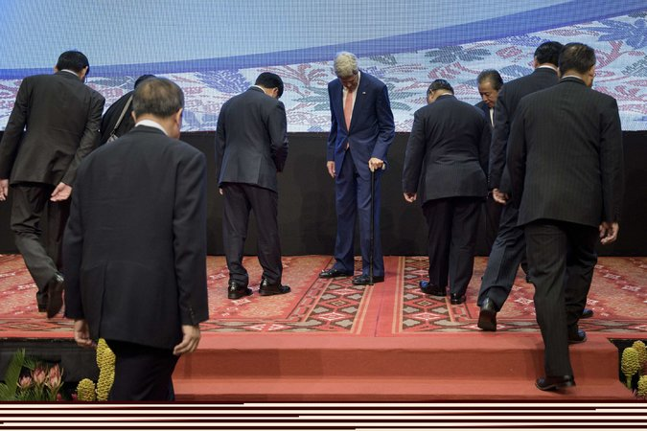
Secretary of State John Kerry, center, looking for his place before a group photo at a meeting of the Association of Southeast Asian Nations in Kuala Lumpur, Malaysia. Credit Brendan Smialowski/Agence France-Presse — Getty Images
KUALA LUMPUR, Malaysia — With tensions mounting over China’s land reclamation projects in disputed South China Sea waters, Secretary of State John Kerry urged his Chinese counterpart on Wednesday to halt “problematic actions” in the area to provide an opportunity for diplomacy, a senior State Department official said.
Mr. Kerry met with China’s foreign minister, Wang Yi, on the sidelines of a meeting here of the Association of Southeast Asian Nations that has been marked by concern over Beijing’s effort to pile sand around reefs in the South China Sea and to construct buildings, harbors, radar towers and airstrips there. More than 2,000 acres of artificial island have been created, according to United States officials.
Continue reading the main story

Related Coverage

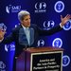

Kerry Hails Progress Toward Trans-Pacific Trade Pact, Despite DelaysAUG. 4, 2015

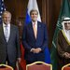

John Kerry Wins Gulf States’ Cautious Support for Iran DealAUG. 3, 2015

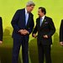

Kerry, in Asia, Urges Focus on Law in China Disputes OCT. 9, 2013

Mr. Kerry told Mr. Wang that the United States was concerned about the large-scale nature of China’s land reclamation and the “militarization of features there,” said the State Department official, who spoke on the condition of anonymity under the agency’s protocol for briefing reporters.
Continue reading the main story
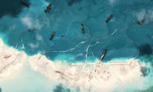

Interactive Feature: What China Has Been Building in the South China Sea

Mr. Kerry later told diplomats here that he had a “good meeting” with Mr. Wang and expressed hope that headway in defusing the South China Sea disputes would be made in the coming days.
“I hope very much that at this meeting, over the course of today and tomorrow, we will find a way to move forward effectively together, all of us,” Mr. Kerry said. “We want to ensure the security of critical sea lanes and fishing grounds, and we want to see that disputes in the area are managed peacefully and on the basis of international law.”
Though Mr. Kerry believes his conversation with Mr. Wang was constructive, the two diplomats did not agree on any specific proposals, American officials said.
Mr. Wang’s public comments about the South China Sea in recent days have not provided American officials with much grounds for optimism. This week, he dismissed previous calls by the United States for a freeze on the construction of artificial islands as “unrealistic,” insisted that all of China’s reclamation work was being done in Chinese territory and asserted that efforts to establish a code of conduct for the South China Sea were not a proper subject for the meeting of Southeast Asian nations here.
Of the nations represented here, the Philippines and Vietnam — which have claims to South China Sea waters that overlap with China’s — have been among the most vocal about China’s recent actions, while countries like Cambodia, Myanmar and Thailand have expressed less concern.
“As we speak, we see no letup on the unilateral and aggressive activities of our northern neighbor in the South China Sea,” Albert F. del Rosario, the Philippines’ foreign secretary, said on Tuesday.
Mr. del Rosario has said he supports the United States’ call for a freeze on the construction of artificial islands, saying that the Philippines would halt its own land reclamation work if China did. But such a freeze, if agreed upon, should not be interpreted as legitimizing China’s recent construction, he has argued.
For all the Obama administration’s talk of shifting more focus to Asia, Mr. Kerry has also used meetings like the one here to confer on an array of other issues, especially Syria. On Wednesday afternoon, he met with Mevlut Cavusoglu, Turkey’s foreign minister, who was also attending the gathering.
Turkey and the United States recently agreed to clear Islamic State militants from a strip of Syrian territory near the Turkish border and to provide air cover for a moderate Syrian opposition force there. But the small number of moderate Syrian fighters that the Pentagon has trained have since been attacked by the Nusra Front, a rebel group that the United States claims is linked to Al Qaeda.
Mr. Cavusoglu suggested on Wednesday that the difficulties the moderate Syrian rebels have encountered would be eased once Turkey became more involved in the fight. “We will also start our fight against Daesh very effectively soon,” he told reporters, using an alternate name for the Islamic State, also known as ISIS or ISIL. “Then the ground will be safer for the moderate opposition that are fighting Daesh.”
Mr. Kerry planned to meet Wednesday evening with Russia’s foreign minister, Sergey V. Lavrov. On Monday, the two diplomats and Saudi Arabia’s foreign minister, Adel al-Jubeir, held an unusual three-way meeting in Doha, Qatar, on the Syria crisis.
Amid the seemingly intractable disputes over the South China Sea and Syria, there was visible progress on Wednesday in at least one area: Mr. Kerry’s recovery from the broken leg he suffered in May during a cycling accident.
During his round-the-world trip, Mr. Kerry has progressed from using crutches to walking with a silver-handled cane lent to him by Victoria Reggie Kennedy, the widow of Senator Edward M. Kennedy.
“This cane has a history,” said Mr. Kerry, noting that it had belonged to Joseph P. Kennedy Sr., the family patriarch, when he served as ambassador to Britain.
It was used by his son John F. Kennedy before he became president, and later by John’s brother Edward, who twice lent the cane to Mr. Kerry after knee surgery.
“It’s the third time I’ve used it,” Mr. Kerry said. “Three times is lucky, right? No hard breaks.”

NYT

China Building Airstrip on 3rd Artificial Island, Images Show
By JANE PERLEZSEPT. 15, 2015
Photo
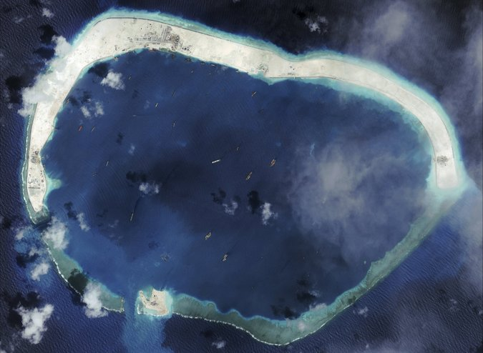
A satellite image of Mischief Reef taken on Sept. 8. Credit Center for Strategic and International Studies, via Reuters

BEIJING — New satellite images show that China has started construction of an airstrip on a third artificial island in the South China Sea that will strengthen Beijing’s military capacity in the contested waters, Western analysts say.
The photographs, released by the Center for Strategic and International Studies in Washington, show preparation for airfields on Mischief Reef and Subi Reef, submerged reefs in the contested Spratly Islands that China has transformed into islands, according to the center.
The airstrip on Mischief Reef is about 20 miles from a small Philippine military garrison on an existing tiny island and will put the installation under great pressure, said James Hardy, Asia-Pacific editor of IHS Jane’s Defense Weekly.

That airstrip will most likely be used for turboprop patrol, but it could easily be equipped for “full military action” if needed, Mr. Hardy said. The most important function of the strip, he said, will be as yet another site for Chinese listening devices and early warning radar, much like the technology being installed on Woody Island in the Paracel Islands of the South China Sea, which are also contested. Evidence of that will probably appear soon on Mischief Reef, he said.
Continue reading the main story

Interactive Feature: What China Has Been Building in the South China Sea

China completed a 10,000-foot runway several months ago on Fiery Cross Island, one of five artificial islands it has created in a large reclamation project in the South China Sea this year.
The South China Sea is one of the top areas of disagreement between China and the United States that will be discussed during a state visit by President Xi Jinping to Washington next week.
The Obama administration has called on China to stop land reclamation, construction and militarization of South China Sea outposts, a policy that Washington calls the “three noes.”
Washington has expressed concern that the military capacity on the reclaimed islands will interfere with freedom of navigation in the area, one of the world’s busiest waterways. With these military runways, the zone of competition between the United States and China across the South China Sea has expanded significantly, experts say.
But China has rebuffed Washington, repeatedly saying that it has “indisputable sovereignty” over about 80 percent of the South China Sea and the right to build what it wants on the Spratly and Paracel archipelagoes.
In June, China’s Foreign Ministry said Beijing would stop reclamation on the five artificial islands but would continue to build facilities on them. At the time of the statement, Beijing appeared to have finished much of the reclamation carried out by large flotillas of dredges.
After a speech to Chinese and Western journalists in Beijing on Tuesday, Yang Xiyu, a senior fellow at the China Institute of International Studies, said “difficulties between the United States and China on the South China Sea will continue for a long time.”
There is little chance, he said, that the sharp differences will be resolved at the meeting between Mr. Xi and President Obama. The best that can be expected is a “consensus” to manage the differences, he said.
In April, when satellite images showed that China was building the 10,000-foot runway on Fiery Cross, 170 miles west of Mischief Reef, American military analysts called the installation a strategic game changer. The size of the runway meant a fighter jet could land on the island, they said.
NYT

Warily Eyeing China, Philippines May Invite U.S. Back to Subic Bay
By JAVIER C. HERNÁNDEZSEPT. 19, 2015
Inside
Supported by
Photo
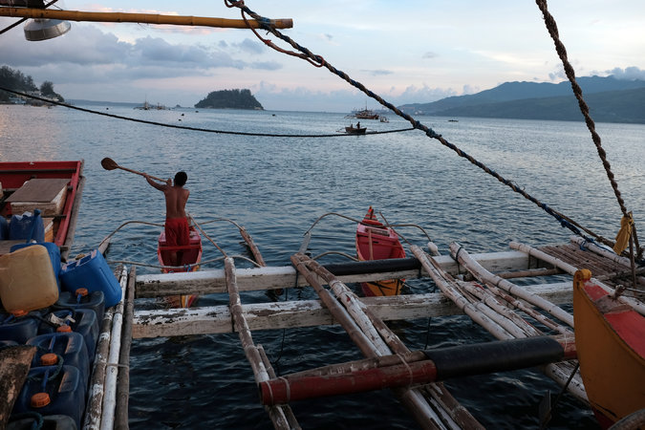
The crew of a small fishing vessel docked in the waters of Subic Bay. Credit Jes Aznar for The New York Times
SUBIC BAY, Philippines — In a flash of anticolonialist fervor nearly a quarter-century ago, lawmakers in the Philippines expelled the United States from an enormous naval base here, then the largest overseas outpost of the American military. Promising to break free from the “shackles of dictatorship,” they declared that foreign troops would never return.
But with China forcefully pressing its claim to a vast expanse of sea west of here, the Philippines is now debating whether to welcome the United States Navy back to the deepwater docks, airstrips and craggy shores of Subic Bay, which served as a haven for bruised battleships and weary soldiers during the Vietnam War.
It is also asking Washington for hundreds of millions of dollars in new funding to strengthen its own military, one of the weakest in Asia.
The change of heart is just one sign of the shifting strategic calculations in the region as President Xi Jinping of China has sought to reinforce Beijing’s claim to almost all of the South China Sea by turning reefs into islands and putting military facilities on them. Satellite photos taken last week appear to show China preparing to build a third airstrip on one of the new islands.
Photo
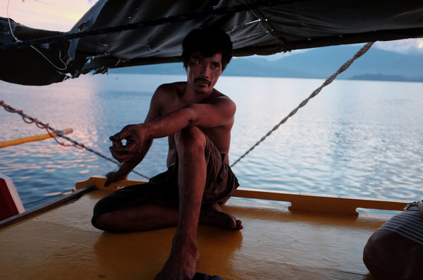
Renato Etac, 35, the boat’s captain, says Chinese vessels routinely chase and try to ram his ship. “I can’t even count the Chinese ships I see, there are so many,” he said. Credit Jes Aznar for The New York Times
United States officials have objected to the buildup in contested waters, and the dispute is expected to be high on the agenda when Mr. Xi meets President Obama in Washington on Thursday. Even as China has accelerated construction, though, the Obama administration has struggled to coordinate a response in Asia, where many leaders are not sure how hard they should push back against China, the region’s economic giant, and how much they should rely on the United States, its dominant military power.
Several nations lay claim to parts of the South China Sea, through which pass some of the world’s busiest shipping routes and which is believed to hold significant oil and natural gas deposits. But China’s push to establish the sea as its own has hit closer to home in the Philippines than almost anywhere else.
An island with a civilian Filipino population is in the disputed area, and Chinese forces have occupied reefs and shoals the Philippines once controlled. “The fight hasn’t even started yet, and it looks like the Philippines government has already surrendered,” said Renato Etac, 35, a fishing boat captain who says Chinese vessels there routinely chase and try to ram his ship. “I can’t even count the Chinese ships I see, there are so many.”
Last year, the government in Manila signed a 10-year agreement that would let the United States station troops, weapons and matériel at bases across the Philippines, setting the stage for an American return to several facilities, including Subic Bay and the sprawling Clark Air Base nearby. But the pact has been tied up by a legal challenge.
Filipinos, by a wide margin, hold favorable views of the United States, polls show. There is ambivalence, however, about allowing American troops to be stationed in the country — a concern amplified by the Philippines’ history as an American territory from 1898 to 1946 — and anxiety over how China might respond.
“When the elephants brawl, ants should be spared,” said Rene Augusto V. Saguisag, one of a group of former senators who voted to expel American troops in 1991 and has petitioned the Philippines Supreme Court to block the military agreement. “The U.S. and China should leave us alone and not involve us in the quarrels of the strong.”
Washington has expressed frustration with the delay in carrying out the agreement, which President Obama announced with fanfare during a visit to Manila last year. The case is not expected to be decided in the Philippines Supreme Court until later this fall at the earliest.
Photo
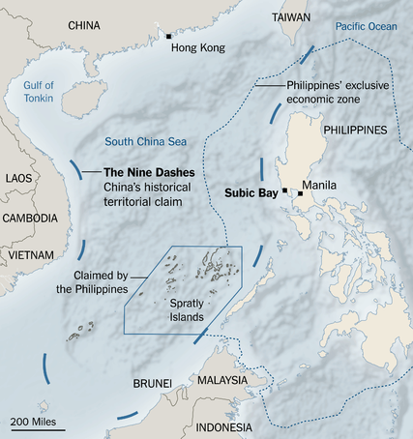
If it goes forward, the pact would give the United States the ability to operate a stronghold on the shores of the South China Sea, less than 500 miles from the new islands built by the Chinese. Currently, American forces in the region rely largely on bases more than 1,500 miles away, in Japan and the United States territory of Guam, for repairs.
The Philippines, prized for its deep, sheltered waters, is a linchpin in the Pentagon’s effort to shift resources toward Asia. The Subic Bay base, roughly the size of Singapore, played a role in virtually every American conflict of the 20th century. United States and Japanese forces battled to control it in World War II, and millions of American personnel passed through it every year during the Vietnam War.
The base was reborn as an economic development zone after the American withdrawal in 1992. Luxury villas were erected atop former ammunition bunkers, and a marine park was built along the shore. Outside the local government here, a statue of a woman holding a dove celebrates the American withdrawal and a plaque reads: “Unchain us now.”
In addition to the legacy of American rule of the Philippines, another hurdle to military cooperation is the decrepit state of the Philippine armed forces, which have long suffered from waste and corruption.
Despite a recent effort to modernize its military, the Philippines still lacks basic equipment, including submarines and fighter jets. The most famous vessel in its fleet may be the Sierra Madre, a decaying World War II-era ship that the government ran aground nearly two decades ago to protect a contested reef. American military aid to the Philippines has increased significantly in recent years, more than doubling last year to $50 million. But that is less than the hundreds of millions the United States provided during the Cold War, when the Philippines was used to counterbalance Soviet support of Vietnam.
In private talks, the government of President Benigno S. Aquino III has pressed the United States for up to $300 million in aid this year, arguing that it needs a substantial buildup of planes and ships to deter Chinese expansionism, according to a senior Philippine official who spoke on the condition of anonymity because United States officials have asked to keep the talks confidential.
But the Obama administration has so far rebuffed the request because it worries about corruption and the Philippines’ capacity to handle such an influx of resources. A spokeswoman for the State Department noted that the Philippines was already the largest recipient of American military aid in Southeast Asia.
“The issue of the West Philippines Sea is a shared responsibility of the Philippines and the United States,” said Fernando I. Manalo, a Philippine defense official, who used the local term for the South China Sea in arguing for joint investments in military upgrades.
But Senator Dan Sullivan of Alaska, a Republican member of the Armed Services Committee, said it would take time to rebuild trust between the two countries.
“If you look at what happened in Subic Bay, that was a pretty abrupt turnaround by the Philippines,” he said, referring to the American expulsion in 1992. “I think memory probably lingers in both the Philippines and the United States.”
On Pag-asa island, home to about 100 residents in territory claimed by the Chinese, Mayor Eugenio B. Bito-onon Jr. has promised to resist what he calls the “Chinese invasion.”
“This is a question of preserving our existence,” he said during a visit to Puerto Princesa, a nearby city, pointing to a wall-sized map that he uses to track the advances of Chinese ships and construction work.
Mr. Bito-onon, 59, said he was worried that the Philippines was too weak to stand up to China, and that allies like the United States were too timid. “We seem to have lots of leaders and allies with no strong direction,” he said.
The Philippines has deployed coast guard ships in an effort to protect reefs and shoals from Chinese advances, and it has announced plans to station fighter jets and frigates at Subic Bay next year. It has also lodged a complaint before an international tribunal at The Hague, arguing that China’s claim to almost the entire 1.4 million square miles of the South China Sea violates international law. Chinese officials have said they will ignore the court’s ruling, contending that territorial disputes should be resolved through direct negotiations between the two countries.
In Manila last month, the top United States commander in the Pacific, Adm. Harry B. Harris Jr., told Philippine officials that the United States did not want to take any military action that might distract from the case at The Hague, according to an individual briefed on the talks. But Admiral Harris also said that the United States planned to conduct more patrols in the South China Sea, the individual said.
Some Filipinos are worried that relying on the United States will delay efforts by the Philippines to build its own military. Others are concerned that the United States, despite its mutual defense treaty with the Philippines, is too distracted by its fight against terrorism in the Middle East to help them.
“We can’t simply trust that others will come to save the day,” said Maria Turco, 42, a teacher in Subic Bay. “We have to take ownership.”

Book Review: The South China Sea Arbitration: A Chinese Perspective
Odgaard, Liselotte. The China Quarterly220 (Dec 2014): 1140-1141.

(ProQuest: ... denotes non-US-ASCII text omitted.)
The South China Sea Arbitration: A Chinese Perspective . Edited by STEFAN TALMON and BING BING JIA . Oxford and Portland, OR : Hart Publishing , 2014. xxiv + 249 pp. £30.00. ISBN 978-1-84946-547-2
Book Reviews
The book The South China Sea Arbitration: A Chinese Perspective, edited by Stefan Talmon and Bing Bing Jia, presents a Chinese perspective on the legal issues involved in the South China Sea dispute between the Philippines and the People's Republic of China (PRC). The setting of the book is the decision of the Philippines to institute arbitral proceedings against the PRC under the United Nations Convention on the Law of the Sea (UNCLOS) with regard to disputes between the two countries in the South China Sea. The PRC announced that it would not take part in the arbitral proceedings. As a consequence, the Chinese position will go unheard. The book aims to advance possible legal arguments on behalf of the absent respondent rather than the official position of the Chinese government.
The introduction outlines the geographical setting and main issues of the dispute and of the decision to submit the case to arbitration. The chapter by Stefan Talmon discusses whether China's rejection of arbitration is justified in international law and the possible political motives of the Philippines for instituting arbitral proceedings. The chapter by Michael Sheng-ti Gau addresses the consequences for the arbitral tribunal of China's refusal to participate in the proceedings. Bing Bing Jia's chapter discusses the question of whether the arbitral tribunal has jurisdiction to deal with the claims advanced by the Philippines, arguing that in this case the tribunal does not have jurisdiction. As such, it cannot proceed to deal with the merits of the case at hand. In their chapter, Haiwen Zhang and Chenxi Mi argue that the Philippine action in bringing its bilateral dispute with China in the South China Sea before an arbitral tribunal is not in accordance with the principles and spirit of international law. Instead, bilateral negotiations as advocated by China are appropriate for achieving a peaceful and definitive settlement of the disputes. The book contains useful annexes on the Chinese and Philippine claims in the South China Sea and the exchanges leading up to the Philippine action to bring the dispute before an arbitral tribunal, a select bibliography on the South China Sea disputes, and a glossary of place names in the South China Sea.
The book is partially successful in achieving the aim of presenting a perspective on the legal arguments of the PRC. The arguments of the book are well documented, and the authors make appropriate use of judicial methodology. Moreover, the book covers the main legal issues of the bilateral dispute between the PRC and the Philippines. As such, the book constitutes a valuable contribution to the field of international law and the law of the sea. The debate on the maritime disputes in Asia suffers from insufficient presentation of the Chinese case. Examples of issues that are largely missing from the debate are arguments on the PRC's interpretations of international law and Beijing's use of these to justify China's claims as well as the political and historical reasons for China to adopt its particular view on the maritime disputes.
The authors' efforts to present a Chinese perspective on the South China Sea arbitration case deserve to be acknowledged and taken into account by practitioners and academics in the field of international law and the law of the sea. However, that being said, a few caveats should also be mentioned. Most importantly, the South China Sea disputes are heavily politicized. The book does not explicitly address this political context since it only promises to look at some of the main legal arguments from a Chinese perspective. This choice limits the relevance of the book to an audience of predominantly legal experts. To reach a wider audience interested in the political aspects of the maritime disputes, it would have been useful to link the legal arguments to issues such as the changing role and positions of the United States on the disputes and how Washington's position is related to the freedom of the high seas. Another interesting topic that could have been addressed is the issue that the provisions of the law of the sea concerning semi-enclosed seas is largely limited to requesting the parties to peaceful negotiations on delimitation issues, in practice encouraging political rather than legal arguments to dominate settlement processes. A more thorough understanding of the diplomatic, strategic and historical issues that influence the legal arguments and how they are used to defend claims would have required embedding the legal arguments in a political contextual discussion. The fact that it is in practice impossible to present a Chinese perspective as distinct from the views of the Chinese government and from the political aspects of the South China Sea disputes becomes clear in the book's treatment of topics such as the possible Philippine motives for instituting arbitral proceedings and the arguments in favour of bilateral negotiations as requested by the PRC. The book's arguments would have been more convincing if these political aspects had been dealt with explicitly. Despite these caveats, the book is valuable as a thorough and well-documented presentation of a Chinese position on the main legal issues to be addressed by the tribunal.

NYT

Asia Pacific

U.S. Tells Asian Allies That Navy Will Patrol Near Islands in South China Sea
By JANE PERLEZ and JAVIER C. HERNÁNDEZOCT. 12, 2015
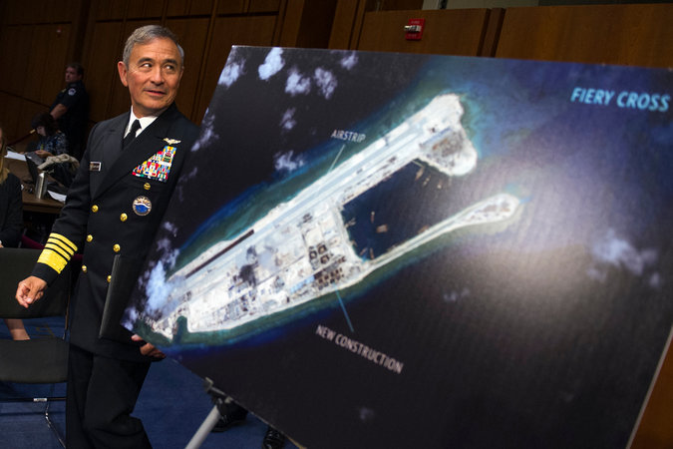
The head of the United States Pacific Command, Adm. Harry B. Harris Jr., by a photograph of an island that China is building on the Fiery Cross Reef in the South China Sea. Credit Cliff Owen/Associated Press
BEIJING — The United States has been briefing its allies in Asia on plans to conduct naval patrols near artificial islands built by China in the disputed South China Sea, a move that could escalate tensions with Beijing after President Xi Jinping’s recent visit to Washington, American and Asian officials have said.
The “freedom of navigation” patrols, which would come within 12 nautical miles of at least one of the islands, are intended to challenge China’s efforts to claim large parts of the strategic waterway by enlarging rocks and submerged reefs into islands big enough for military airstrips, radar equipment and lodging for soldiers, the officials said.
Though China claims much of the South China Sea as sovereign territory, the 12-mile zone around the new islands is particularly delicate because international law says such artificial islands do not have sovereign rights up to the 12-mile limit.
The United States has refrained from venturing that close to Chinese-occupied islands in the South China Sea since at least 2012. In May, a United States Navy surveillance plane flew near three of China’s five artificial islands but did not go within their 12-mile territorial zones. Chinese Navy radio operators warned the Americans to leave the area.
Officials in the Philippines said they had been told of the planned patrols in the last several days, and Senator Antonio F. Trillanes IV, the chairman of the national defense and security committee, said Monday that he welcomed the decision.
The United States secretary of defense, Ashton B. Carter, and the secretary of state, John Kerry, were scheduled to discuss the patrols with their counterparts from Australia on Monday and Tuesday in Boston.
The head of the United States Pacific Command, Adm. Harry B. Harris Jr., whom the White House asked several months ago to offer options for how to respond to the Chinese actions in the South China Sea, was also scheduled to attend the meetings.
The senior adviser on China at the National Security Council, Daniel Kritenbrink, told a gathering of American analysts of the region at a meeting in Washington that the White House had decided to proceed with the patrols, according to a participant who requested anonymity to discuss a closed-door briefing.
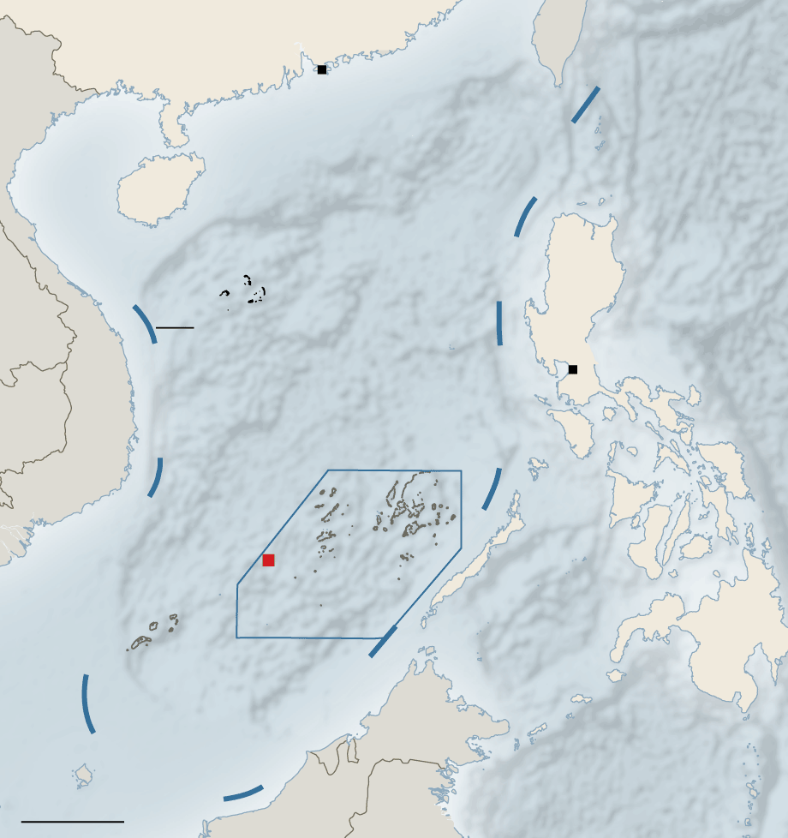
INDONESIA
By The New York Times
Mr. Kritenbrink did not specify when the patrols would take place, but he suggested that they had been delayed so as not to disrupt Mr. Xi’s visit, the participant said.
The Obama administration and America’s allies in Asia have debated at length how best to respond to China’s moves in the South China Sea, with some urging patrols to push back against Beijing, and with others fearful that the Chinese might use the patrols as justification for a further military buildup.
The Chinese have indicated that they will respond to American warships entering the 12-mile territorial waters around the artificial islands.
“There is no way for us to condone infringement of China’s territorial sea and airspace by any country under the pretext of maintaining the freedom of navigation and overflight,” the Chinese Foreign Ministry said Friday. China is “severely concerned” about reports that the United States planned patrols around the artificial islands in the Spratly archipelago, the ministry’s spokeswoman, Hua Chunying, said. Five other governments also make territorial claims in those waters.
During a news conference with President Obama at the White House, Mr. Xi said China had no intention of militarizing islands in the South China Sea. But exactly what Mr. Xi meant was unclear, American officials said, because he had not said anything like that in the private meetings with Mr. Obama and his senior aides.
One purpose of the patrols would be to test Mr. Xi’s statement, a United States military official said.
At the news conference with Mr. Xi, Mr. Obama emphasized the importance of freedom of navigation, saying, “The United States will continue to sail, fly and operate anywhere that international law allows.”
The United Nations Convention on the Law of the Sea recognizes 12-mile territorial limits on naturally formed islands but does not recognize such limits on submerged reefs that have been built by land reclamation into above-the-waterline islands.
The Chinese have recently built five such islands in the Spratly archipelago. On Fiery Cross Reef, they have completed a 10,000-foot runway capable of accommodating fighter jets.
Continue reading the main story

Interactive Feature

What China Has Been Building in the South China Sea
China has been feverishly piling sand onto reefs in the South China Sea for the past year, creating seven new islets in the region. It is straining geopolitical tensions that were already taut.
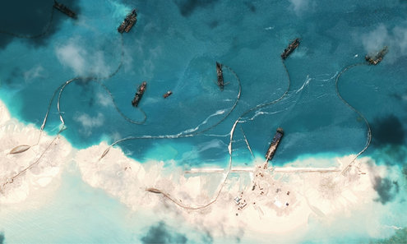
OPEN Interactive Feature

The new Australian prime minister, Malcolm Turnbull, would be less inclined to support the patrols than his more hawkish predecessor, Tony Abbott, said Hugh White, a defense analyst. Mr. Turnbull called China’s island-building “counterproductive” before he took office last month, but he is likely to be cautious about confronting China, Mr. White said.
In Manila, Mr. Trillanes said the patrols should move ahead. “It’s quite risky, but we need to know right now to what extent China is willing to go in order to defend these newly created islands,” he said in a telephone interview.
Mr. Trillanes said he was not concerned that such a move might increase the likelihood of conflict in the region. “The United States has done the math, and they wouldn’t do this if tensions would escalate beyond what they would expect,” he said.
Albert F. del Rosario, the Philippine secretary of foreign affairs, said the American patrols would help maintain stability in the region.
“Failure to challenge false claims of sovereignty would undermine this order and lead China to the false conclusion that its claims are accepted as a fait accompli,” Mr. del Rosario said in a statement.
But other countries have seemed less receptive to the idea of aggressive action by the Americans.
In an interview in August, Ng Eng Hen, the Singaporean defense minister, said the United States had a right to protect its interests, but he urged caution. “It does no good for the region if there are incidents,” he said.
The United States has several options as to what kind of ships to send on the patrols, and the type of vessel will indicate how big a statement it wants to make, said James Hardy, the Asia-Pacific editor of IHS Jane’s Defense Weekly.
A littoral combat ship that works close to shore has been used in the past for such patrols, Mr. Hardy said. The United States could also send an Arleigh Burke class destroyer accompanied by a couple of smaller ships, thus sending a firmer message, he said.
The Chinese would also have choices of how to respond, Mr. Hardy said. They could buzz American ships with aircraft or target them with radar, as they have with Japanese vessels in the East China Sea, he said. Other options would include deploying coast guard vessels to shadow the United States Navy ships or using fishing vessels to get in the way of the patrols.

NYT

Challenging Chinese Claims, U.S. Sends Warship Near Artificial Island Chain
点击查看本文中文版 Read in Chinese
By HELENE COOPEROCT. 26, 2015
Photo
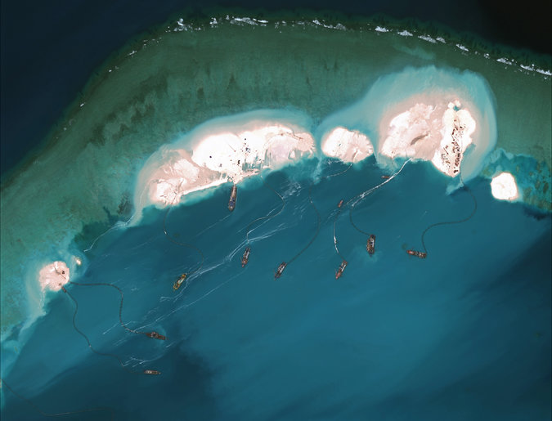
A satellite image from March showed work on an emerging artificial island at Mischief Reef, part of the Spratly Islands in the South China Sea. China has been turning submerged reefs into islands to bolster its territorial claims. Credit Center for Strategic International Studies, via Digital Globe
WASHINGTON — A United States Navy destroyer entered waters near the Spratly Islands in the South China Sea late Monday, Defense Department officials said, directly challenging China’s claims that the artificial island chain is within its territorial borders.

The Lassen, a guided missile destroyer, sailed within 12 nautical miles of the islands, making a long-anticipated entry into the disputed waters, an American military official said. American officials did not inform their Chinese counterparts as they planned the provocative maneuver, saying that to do so would have undercut their message.
“You don’t need to consult with any nation when you are exercising the right of freedom of navigation in international waters,” John Kirby, the State Department spokesman, said at a news conference.
Mr. Kirby said that such a challenge to what he called a questionable sovereignty claim was “one of the reasons you have a navy — to be able to exert influence and defend freedom of navigation on international waters.”
China has been reclaiming land in the South China and East China Seas for several years, and the projects in the vicinity of the Spratlys have come under increasing criticism from the United States and its regional allies, including the Philippines. The United States and several Asian nations dispute the legitimacy of the islands built by China.
As news of the American maneuver circulated in Beijing, China’s foreign minister, Wang Yi, urged the United States to “think twice before taking any reckless action,” China’s national broadcaster, CCTV, reported.
The Obama administration did not make an immediate announcement of the maneuver, and Pentagon officials would only confirm that it had occurred, as they forecast weeks ago.
The White House declined to share any details about the operation, referring questions to the Defense Department. But Josh Earnest, the press secretary, noted that President Obama stood next to President Xi Jinping of China at a Rose Garden news conference last month and said that the United States would operate, fly or sail anywhere that international law allowed.

“That certainly includes the ability of our Navy to operate in international waters,” Mr. Earnest said. “This is a critically important principle, particularly in the South China Sea, because there are billions of dollars of commerce that flow through that region of the world every year — maybe even more than that — and ensuring the free flow of this commerce, and that freedom of navigation of those vessels is protected, is critically important to the global economy.”
American officials had said for the last month that the Navy would send a surface ship into the waters claimed by China, a vow widely viewed as a signal to the Chinese that most of the rest of the world does not recognize its claim on the island chain. Mr. Obama approved the move this month, administration officials said.

The president signaled the Navy maneuver last month at the annual meeting of the United Nations General Assembly, when he said that the United States had an “interest in upholding the basic principles of freedom of navigation and the free flow of commerce and in resolving disputes through international law, not the law of force.”
China, in what some Asia analysts interpreted as a gesture to pre-empt the American naval maneuver, sent warships into United States territorial waters in August. Five Chinese ships came within 12 miles of the coast of Alaska while Mr. Obama was visiting the state.
News Clips By REUTERS 00:41 China and Japan React to U.S. Navy Move
Continue reading the main story Video

China and Japan React to U.S. Navy Move
China’s national broadcaster on Tuesday carried a first reaction to a United States Navy ship’s maneuver in the South China Sea. Japan’s government also issued a statement.
But American military officials said that the two maneuvers were not comparable, citing international maritime laws that allow passage such as the Chinese transit near Alaska if there is no other passageway for a ship to reach its destination.
In the case of the Spratly Islands, one American military official said, there were several other routes that the United States destroyer could have used, but the military deliberately chose to enter the waters that China claims as its territory.
In recent years, China has been claiming large parts of the strategic waterway by enlarging rocks and submerged reefs into islands big enough for military airstrips, radar equipment and lodging for soldiers, American officials said.
Although China claims much of the South China Sea as sovereign territory, the 12-mile zone around the new islands is particularly delicate because international law says that artificial islands do not have sovereign rights up to the 12-mile limit.
The United States had not traveled close to the Chinese-occupied islands in the South China Sea since at least 2012. In May, a United States Navy surveillance plane flew near three of China’s five artificial islands but did not go within the 12-mile zones. Chinese Navy radio operators warned the Americans to leave the area.

Beijing Calls U.S. Warship’s Route in South China Sea a ‘Provocation’
By JANE PERLEZ
OCT. 27, 2015
News Clips By REUTERS 00:41 China and Japan React to U.S. Navy Move
Continue reading the main story Video
BEIJING — China on Tuesday accused the United States of committing a “deliberate provocation” by sending a Navy destroyer into waters claimed by Beijing, adding that such actions would force China to speed up its building program in the South China Sea.

“China will firmly react to this deliberate provocation,” Lu Kang, a spokesman for the Chinese Foreign Ministry, said at a regularly scheduled news conference. He added, “China will not condone any action that undermines China’s security.”
The American ambassador, Max Baucus, was called to the Foreign Ministry on Tuesday evening and told by the deputy foreign minister, Zhang Yesui, that the United States should stop “threatening Chinese sovereignty and security interests,” the national broadcaster CCTV said.
Mr. Zhang delivered a “solemn representation and strong protest,” CCTV said.
Separately, the Chinese Defense Ministry said on Tuesday night that two navy vessels, a missile destroyer, the Lanzhou, and a patrol boat, the Taizhou, had warned the American ship to get out of the disputed waters.
The statements came hours after the Lassen, a guided missile destroyer, sailed within 12 nautical miles of Subi Reef, one of several artificial islands that China has built in the disputed Spratly Islands chain. The United States had signaled for weeks that it would undertake the mission, which it called an exercise of the right to freedom of navigation in international waters.
China’s statements on Tuesday amounted to a relatively mild response, repeating much of its standard language about its rights in the South China Sea.
In an earlier statement on the Foreign Ministry’s website, Mr. Lu called the move an illegal incursion, adding, “The relevant Chinese authorities have monitored, followed the U.S. warship and issued warnings.”
Earlier, the Pentagon had said that the Lassen, accompanied by surveillance aircraft, had completed its mission without incident.
A Pentagon official, who spoke on the condition of anonymity because he was not authorized to speak for attribution, said that the plan had been to stay on a defined path, not to loiter and not to be provocative. He said the Lassen, which is part of the Navy’s Seventh Fleet, was headed back to its base at Yokosuka, in Japan.
Pressed on whether China would undertake a military response, Mr. Lu said that reporters should contact “relevant departments,” an apparent reference to the Defense Ministry.
Subi Reef is one of several artificial islands that the Chinese have built in the Spratly archipelago, which is closer to the Philippines, an American ally, than to China. Satellite images show that China has built the reef into an island, using massive dredging, and that it has started constructing a runway capable of accommodating military aircraft. It has completed another such runway in the Spratlys, on Fiery Cross Reef, and is working on a third.
The artificial islands built by China, and the broader issue of its claims over islands and small reefs in nearly 90 percent of the strategically important South China Sea, are among the most contentious issues between Washington and Beijing. The naval maneuver came a month after China’s president, Xi Jinping, and President Obama met in Washington and failed to reach an agreement on China’s claims, many of which are disputed by the Philippines, Vietnam and other governments.
Mr. Xi said at a news conference during his Washington visit that China had no intention of militarizing islands in the South China Sea, but he did not expand on that pledge during his private talks with Mr. Obama, administration officials said. Officials had said before the Lassen’s mission that one purpose of such a patrol would be to test Mr. Xi’s words.
The Pentagon apparently chose Subi Reef, which is known as a low-tide elevation, with great care, said Andrew S. Erickson, associate professor at the China Maritime Studies Institute, at the United States Naval War College in Rhode Island.
Under the United Nations Convention on the Law of the Sea, a low-tide elevation — meaning it is naturally submerged at high tide — is not entitled to a 12-nautical-mile territorial limit, Mr. Erickson said. Beyond a 500-meter safety zone, foreign ships and aircraft are free to operate at will without consultation or permission, he said.
Asked on Tuesday whether Subi Reef was entitled to a 12-mile territorial limit now that it had been built into an island, Mr. Lu replied, “China has indisputable sovereignty of the Nansha Islands and adjacent waters,” using China’s name for the Spratlys. He said that China was building in the South China Sea for the “public good.”
Referring to the United States, Mr. Lu said: “If the relevant party keeps stirring things up, it will be necessary for China to speed up its construction activities.”
Many Chinese social media users were critical of what they saw as a weak response to the American patrol. “If you can’t even safeguard sovereignty, what else you can do to win the trust of the people?” read one of about 100 comments, most of them critical of China’s response, under an article by Xinhua, the state-run news agency.
The Lassen’s patrol came a week before the head of United States Pacific Command, Adm. Harry B. Harris Jr., is scheduled to hold talks in Beijing with senior Chinese military officials. Admiral Harris, who has criticized China for moving “walls of sand” to create the artificial islands, has been an outspoken proponent of freedom-of-navigation patrols and has warned that the United States will conduct such forays whenever it sees fit.
Earlier this month, one of Admiral Harris’s predecessors, Adm. Dennis C. Blair, warned a conference of Chinese analysts that China’s “massive land-building projects” in the South China Sea and its claims of sovereignty were inviting a strong response from the United States Navy.
“This is simply unacceptable to the United States, and the United States will take strong military action, which will tend to move the issues from the civilian law enforcement to the military realm,” he said at a meeting of the China Institutes of Contemporary International Relations, an influential research institute allied with China’s intelligence services.
“There is a general feeling outside of China that it has now settled on a sustained policy of aggressive actions to support its claims, especially in the South China Sea, and that China has abandoned any ideas of compromise and negotiated solutions to the disputes,” Admiral Blair said.

NYT

U.S. Admiral, in Beijing, Defends Patrols in South China Sea
By JANE PERLEZNOV. 3, 2015
Photo
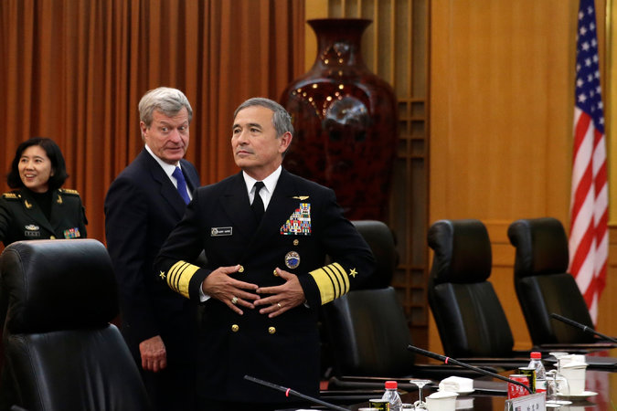
Adm. Harry B. Harris Jr., right, who oversees the United States Pacific Command, and Max Baucus, United States ambassador to China, in Beijing on Tuesday.
BEIJING — The head of the United States Pacific Command, Adm. Harry B. Harris Jr., said in Beijing on Tuesday that the Navy would continue to conduct freedom of navigation operations similar to one in the South China Sea last week that China criticized.
Speaking to a small audience at the Stanford Center at Peking University, Admiral Harris defended the operation last week, which involved sending a destroyer inside the 12-nautical-mile radius that China claims as its territorial waters around Subi Reef, an artificial island built by the Chinese in the South China Sea.
“We’ve been conducting freedom of navigation operations all over the world for decades, so no one should be surprised by them,” Admiral Harris said. “The South China Sea is not, and will not, be an exception.”
Admiral Harris emphasized that the United States had carried out such operations around the world “while avoiding military conflict, and that remains our goal.”
Admiral Harris arrived in China on Monday night for a long-planned visit that is part of regular exchanges between senior American and Chinese military officials. The admiral is an outspoken advocate of freedom of navigation operations in the South China Sea and accused China this year of building “a great wall of sand” in the strategic waterway, a reference to artificial islands that the Chinese have constructed.
Continue reading the main story

Interactive Feature

What China Has Been Building in the South China Sea
China has been feverishly piling sand onto reefs in the South China Sea for the past year, creating seven new islets in the region. It is straining geopolitical tensions that were already taut.
OPEN Interactive Feature

In an apparent effort by the Obama administration to insulate his visit, the Pacific Command and the Pentagon kept Admiral Harris’s itinerary largely under wraps.
Spokesmen at the United States Embassy in Beijing and at Pacific Command headquarters in Hawaii said they could not say who the admiral would meet or where he would go in the Chinese capital. His address at the Stanford Center, which is operated by Stanford University, the alma mater of the American ambassador, Max Baucus, was closed to the news media.
A transcript released afterward indicated that Admiral Harris took questions from the audience, but the contents of that discussion were not available, a spokesman at the United States Embassy said.
About 15 professors and students from Peking University, all Chinese, were in the audience, and 15 scholars studying at Stanford in California, all American, listened by video, said Andrew J. Andreasen, the executive director of the center.
While Admiral Harris has frequently spoken about the need for freedom of navigation operations to challenge China’s claims in the South China Sea, the Obama administration is also trying to prevent relations with the Chinese military from deteriorating.
In his speech, Admiral Harris said that two Chinese vessels, including a Navy hospital ship, the Peace Ark, were visiting American ports. The commander of the United States Pacific Fleet, Adm. Scott H. Swift, will visit Shanghai this month, he said.
“We must not allow the areas where China and the U.S. disagree to impact our ability to make progress on the areas where we do agree,” he said.
The dispatch of the destroyer Lassen last week to the waters inside the 12-nautical-mile perimeter of Subi Reef was meant to show that China could not claim territorial waters on an artificial island built from what is known as a low-tide elevation. Before the construction, Subi Reef was visible only during low tide.
A Chinese Navy vessel followed the Lassen as it entered the waters but did not interfere with its operations. The Chinese military objected to the operation, saying it was “illegal” and a “provocation.” The Foreign Ministry called in the American ambassador, Mr. Baucus, and made a formal objection.
A professor at Peking University, Jia Qingguo, who was in the audience for Admiral Harris’s talk, said the Chinese government had made clear that the operation by the Lassen had endangered China’s national security.
“China thinks the two countries should enhance communication and mutual trust rather than doing things like this to escalate the situation,” said Mr. Jia, the dean of the school of international studies at Peking University.
China has constructed seven artificial islands on top of submerged reefs in the Spratly archipelago, where the Philippines and several other governments also have claims. A military-size runway has been completed on one of the new islands, and China is working on runways on two more.

The Economist

Sea power

Who rules the waves?

China no longer accepts that America should be Asia-Pacific’s dominant naval power
Oct 17th 2015 | From the print edition
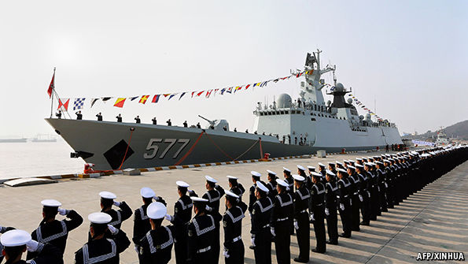
IN THE next few days, out of sight of much of the world, the American navy will test the growing naval power of China. It will do so by conducting patrols within the putative 12-mile territorial zone around artificial islands that China is building in the disputed Spratly archipelago. Not since 2012 has America’s navy asserted its right under international rules to sail so close to features claimed by China. The return to such “freedom of navigation” patrolling comes after a visit to Washington by Xi Jinping, China’s president, that failed to allay concerns about the aggressive island-building in the South China Sea.
China will protest, but for now that is probably all it will do. The manoeuvres are a clear assertion of America’s sea power, which remains supreme—but no longer unchallenged. The very notion of “sea power” has a 19th-century ring to it, summoning up Nelson, imperial ambition and gunboat diplomacy. Yet the great exponent of sea power, the American naval strategist Alfred Thayer Mahan, who died in 1914, is still read with attention by political leaders and their military advisers today. “Control of the sea,” he wrote in 1890, “by maritime commerce and naval supremacy, means predominant influence in the world; because, however great the wealth product of the land, nothing facilitates the necessary exchanges as does the sea.”
Sea power of both the hard, naval kind and the softer kind that involves trade and exploitation of the ocean’s resources is as vital as ever. Bits and bytes move digitally, and people by air. Physical goods, though, still overwhelmingly go by sea: a whopping 90% of global trade by weight and volume. But the sea’s freedom and connectivity are not inevitable. They rely on a rules-based international system to which almost all states subscribe for their own benefit, but which in recent decades only America, in partnership with close allies, has had the means and will to police.
Since the second world war, America’s hegemonic power to maintain access to the global maritime commons has been challenged only once, and briefly. In the 1970s the Soviet Union developed an impressive-looking blue-water navy—but at a cost so huge that some historians regard it as among the factors that brought the Soviet system to collapse less than two decades later. When the cold war ended, most of that expensively acquired fleet was left to rust, abandoned in its Arctic bases.
That may now be changing. On October 7th Russia ostentatiously fired 26 cruise missiles from warships in the Caspian Sea at targets in Syria (it denied American claims that some fell in Iran). Vladimir Putin, Russia’s president, milked the propaganda value: “It is one thing for the experts to be aware that Russia supposedly has these weapons, and another thing for them to see for the first time that they really do exist.” Western military planners must now contend with Russia’s demonstrated ability to hit much of Europe with low-flying cruise missiles from its own waters.
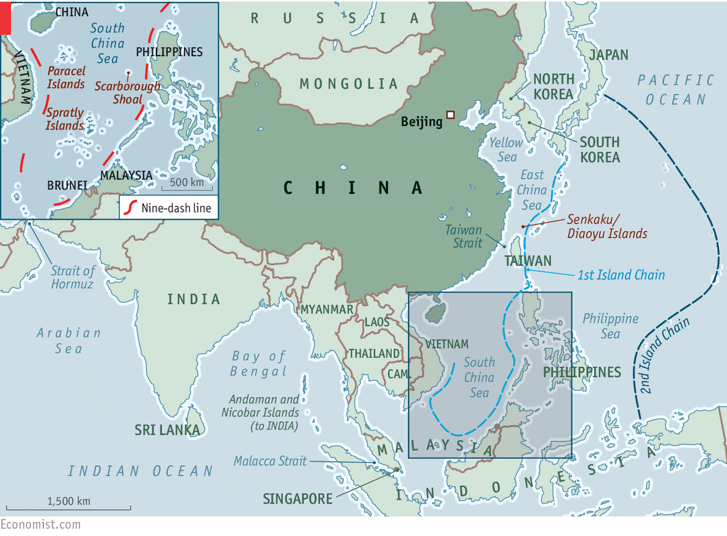
But by far the more serious naval challenger is China. From modest beginnings it has created a navy that has grown from a purely coastal outfit to a potent force in its “near-seas”, ie, within the first island chain from Japan to the Philippines (see map). It is now evolving again, into something even more ambitious. Over the past decade, long-distance operations by the People’s Liberation Army Navy (PLAN) have become more frequent and technically demanding. As well as maintaining a permanent counter-piracy flotilla in the Indian Ocean, China conducts naval exercises far out in the western Pacific. Last month a group of five Chinese naval vessels passed close to the Aleutian Islands after a Russian-Chinese military exercise.
The sea’s the thing
In May China issued a military white paper that formalised the addition of what it calls “open-seas protection” to the PLAN’s “offshore-waters defence” role. A strategy that used to put local sea control first now emphasises China’s expanding economic and diplomatic influence. The primacy China once gave its land forces has ended.
The traditional mentality that land outweighs the sea must be abandoned, and great importance has to be attached to managing the seas and oceans and protecting maritime rights and interests. It is necessary for China to develop a modern maritime force structure commensurate with its national security.
Taiwan remains at the centre of these military concerns. China seeks to develop not only the means to recover the renegade province (as it sees it), by military means if necessary, but also to fend off Taiwan’s main protector, America. China has not forgotten its humiliation in 1996 when America sent two carrier battle groups, one through the Taiwan Strait, to deter Chinese missile tests aimed at intimidating the Taiwanese government. America’s then-defence secretary, William Perry, crowed that, although China was a great military power, “the strongest military power in the western Pacific is the United States.”
China is determined to change the balance. It has invested heavily in everything from shore-based anti-ship missiles to submarines, modern maritime patrol and fighter aircraft, to try to keep America beyond the first and, ultimately, second island chains. China is also seeking the ability to patrol the choke points that give access to the Indian Ocean, through which most of its oil imports enter. About 40% comes through the Strait of Hormuz and over 80% through the Malacca Strait. Among the goals it appears to have set itself are to protect economically vital sea lanes; to constitute a dominating presence in the South and East China Seas; and to be able to intervene wherever its expanding presence abroad, whether in terms of investment or of people, may be threatened.
In August the Pentagon announced a new Asia-Pacific Maritime Security Strategy. It stresses three objectives: to “safeguard the freedom of the seas; deter conflict and coercion; and promote adherence to international law and standards”. It confirmed that America was on schedule to “rebalance” its resources by deploying at least 60% of its naval and air forces to the Asia-Pacific by 2020, a target announced in 2012. Ray Mabus, the navy secretary, has asked Congress for an 8% increase in his budget, to $161 billion for the next fiscal year; he wants the navy to grow from 273 ships to at least 300. Some Republicans say that 350 is the right number.
Is America right to be worried? The way China is going about becoming a global maritime power differs somewhat from the Soviet Union’s great period of naval expansion. Apart from the powerful Soviet submarine fleet, the main purpose of which was strategic nuclear strike and stopping American reinforcements crossing the Atlantic to come to Europe’s aid, the Soviet navy was mostly concerned with expressing great-power status and extending Soviet influence around the world through “presence” missions that impressed allies and deterred enemies.
Power plays
These matter to China, too: a central element of what Mr Xi calls the “China dream” is its transformation into a military power that can cut a dash on the world stage. When large naval vessels exercise or enter port far from home they can be used to influence and coerce. It is understandable that a country of China’s size, history and economic clout should want some of that. Nor is it strange that China should want to prevent a possible adversary (ie, America) from operating with impunity near its own shores.
What makes China’s rise as a sea power troubling for the countries that rely on America to maintain the rules-based international order and the freedom of the seas are its behaviour and where it lies. The Indian Ocean, South China Sea and East China Sea are vital transit routes for the world economy. Eight out of ten of the world’s busiest container ports are in the region. Two-thirds of the world’s oil shipments travel across the Indian Ocean on their way to the Pacific, with 15m barrels passing through the Malacca Strait daily. Almost 30% of maritime trade goes across the South China Sea, $1.2 trillion of which is bound for America. That sea accounts for over 10% of world fisheries production and is thought to have oil and natural-gas deposits beneath its floor.
Much of this is contested, with China the biggest and most aggressive of the claimants. In the South China Sea Beijing’s territorial disputes include the Paracel Islands (with Taiwan and Vietnam); the Spratlys (with Taiwan, Vietnam, the Philippines, Malaysia and Brunei) and Scarborough Shoal (with the Philippines and Taiwan). China vaguely claims sovereignty within its so-called nine-dash line over more than 90% of the South China Sea (see map). The claim was inherited from the Kuomintang government that fled to Taiwan in 1949; whether this applies only to the islands and reefs, or to all the waters within it, has never been properly explained. In the East China Sea a dispute with Japan over the Senkaku Islands (which Japan controls) rumbles on, though the mutual circling of coastguard vessels has become more ritualised of late.
America takes no position on these disputes, insisting only that they should be resolved through international arbitration rather than force, and that all sovereignty claims should be based on natural land features. Yet China is using its growing sea power coercively, carrying out invasive patrols, encroaching on other claimants’ waters and, most recently, creating five artificial islands in vast land-reclamation projects on previously submerged features (which, under the UN Convention on the Law of the Sea, do not grant entitlement to the 12-mile territorial waters). These are being equipped as advanced listening posts and three are getting runways and hangars, meaning they can rapidly be put to military use.
China is not the first to build in the area. But in less than two years it has reclaimed nearly 20 times as much artificial land as rival claimants together have in the past 40. Its bases would be easy for America to neutralise; but, short of war, they allow China to project military power much farther than hitherto. No wonder America’s national security adviser, Susan Rice, recently vowed that American forces will “sail, fly and operate anywhere that international law permits”, and that those “freedom of navigation” patrols would resume.
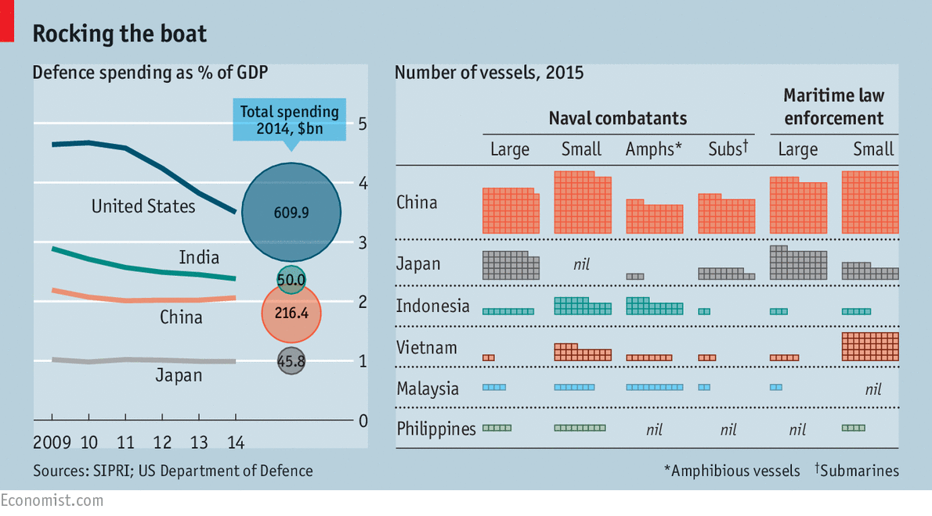
The Pentagon document notes that the PLAN now has the largest number of vessels in Asia, with more than 300 warships, submarines, amphibious ships and patrol craft. Indonesia, Japan, Malaysia, the Philippines and Vietnam can muster only about 200 between them, many of those older and less powerful than China’s (see table). This preponderance is hardly less daunting when it comes to maritime law-enforcement vessels: it has 205 compared with 147 operated by those five countries, which it often uses to stake its territorial claims while more lethal naval forces lurk over the horizon. Although nearly all the countries in dispute with China are trying to buy or build new ships, the capability gap continues to widen.
On the horizon
China could therefore threaten, if so minded, the rules and norms governing maritime boundaries and resources, freedom of navigation and the peaceful resolution of disputes. Would America be ready to face that challenge? Those who fear that America’s ultimate retreat is inevitable are almost certainly wrong. Although growing fast, China’s entire (official) defence budget is not much more than that of America’s navy alone. America has ten nuclear-powered supercarriers, one of which is permanently based in Japan. China has just one, a small, refurbished Soviet-era affair, and two more under construction. All three of America’s latest Zumwalt-class stealth destroyers (pictured), the world’s most advanced surface warships, will be deployed in the Asia-Pacific region along with other new ships and aircraft. Chinese military experts believe that the PLAN will take another 30 years to match the efficiency of the American navy.
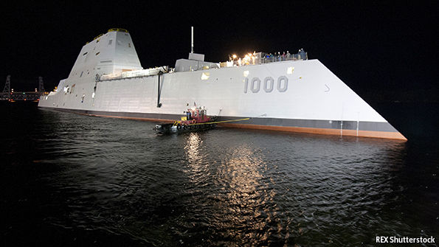Stealthily present
America also has the advantage of having other navies to work with and alongside, both in the region and globally. Japan’s Maritime Self-Defence Force lacks power-projection, but is regarded as the fifth-best navy in the world and is used to exercising with the American navy. The relaxation of national-security laws last month, allowing the Japanese navy to co-operate much more closely with allies on a greater range of missions, went down badly in Beijing. And Japan is working hard with regional neighbours who are in territorial disputes with China. It has made soft loans to the Philippines and Vietnam for new patrol vessels and older destroyers.
The Indian navy is another powerful ally. As concern about China has grown, it has started to drill with Western navies, who rate its competence highly. The annual Malabar exercise with the American navy now also includes ships from Australia, Singapore and, this year for the first time, Japan. The newish government of Narendra Modi is aiming for a 200-ship navy by 2027, with three carrier task groups and nuclear-powered submarines.
Catching up with the PLAN is impossible, but the Indian navy is determined to stop the Indian Ocean becoming a “Chinese lake”. Indian strategists have long believed that China is establishing a network of civilian port facilities and underwriting littoral infrastructure projects to boost its vessels’ ability to operate in waters which the Indian government thinks should be under its dominion. China now often sends its nuclear-powered submarines into the Indian Ocean.
China has benefited as much as any other country from the hegemonic power of the American navy to preserve peace in the Asia-Pacific region. This has helped its remarkable growth. Yet it seems determined to challenge that order. It is understandable that China should want to make it riskier for the American navy to operate close to its own littoral. And for a country that wants a “new type of great power relationship”, relying on America to police the seas is demeaning, though the notion that America and its allies are threatening to blockade the sea lanes of communication that are the arteries of China’s, and the world’s, trade is fanciful in any scenario short of war. But should it ever come to war over, say, a Chinese invasion of Taiwan, China will want to deny America the ability to come to Taiwan’s aid, or at least delay it. The flip-side is that by developing a navy which intimidates its neighbours, China is driving them ever more closely into America’s embrace.
Moreover, being a strong but still second-best sea power can result in disastrous miscalculation. Germany challenged British naval supremacy early in the 20th century by provoking ruinously expensive competition in battleship construction. But it was still powerless to break Britain’s blockade during the first world war. As for Japan, six months after its surprise attack on Pearl Harbour during the second world war, it lost the decisive battle of Midway and with it a large part of the fleet it had built with such hubris.
There is nothing wrong with China regarding a powerful blue-water navy as essential to its prestige and self-image, particularly if it eventually concludes that it should be used to reinforce international rules rather than undermine them. The worry is that China itself may not know what it will do, and that the temptation to use it for more than flag-waving, diplomatic signalling and discreet bullying will become hard to resist. As Mahan observed: “The history of sea power is largely, though by no means solely, a narrative of contests between nations, of mutual rivalries, of violence frequently culminating in war.” It does not have to be like that, but America must prepare for the worst.

NYT

Dispute Over South China Sea Prompts Asian Officials to Cancel Joint Statement
By JANE PERLEZ
NOV. 4, 2015
Photo
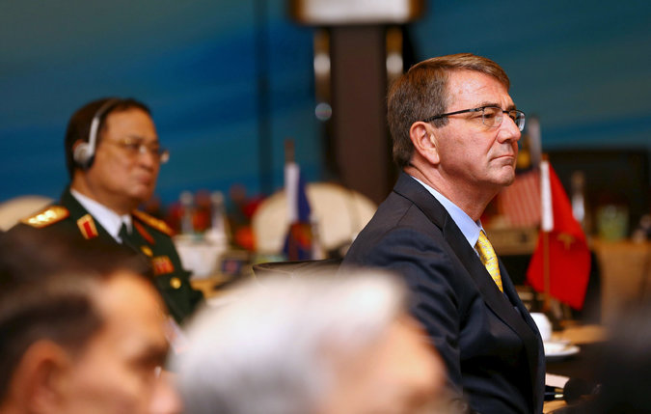
Secretary of Defense Ashton B. Carter at the meeting of the Association of Southeast Asian Nations, in Kuala Lumpur, Malaysia, on Wednesday. Credit Reuters
BEIJING — Differences over the South China Sea forced countries from Southeast Asia, along with China and the United States, to cancel a joint statement at a meeting of defense ministers in Malaysia on Wednesday.
The Chinese Ministry of Defense confirmed that the meeting of the Association of Southeast Asian Nations, or Asean, had failed to conclude a joint declaration, and it blamed “the individual country (countries) out of the region.” In a statement on its website, the ministry implied, but did not name, the United States as the main reason for the breakdown in the discussions.
The ministry did not mention the South China Sea or China’s insistence that the statement not include any mention of the strategic waterway.
Diplomats from countries in the region said that China had pushed for even a factual statement of the South China Sea to be absent from the joint declaration scheduled for the end of the gathering Wednesday afternoon.
The meeting was split between countries that agreed with China and those that strongly disagreed, including Australia, Japan and the United States, two senior diplomats involved in the talks said.
China maintains that its territorial claims in the South China Sea must be discussed with individual countries that also have claims. It has consistently opposed efforts to have conflicting claims discussed in a regional setting like Asean, whose defense ministers are meeting in Kuala Lumpur, the Malaysian capital, with their counterparts from Australia, India, Japan and the United States.
“The responsibility fully rests on the individual country (countries) out of the region as the meeting failed to issue the joint statement as scheduled,” the Chinese Defense Ministry said on its website.
The American defense secretary, Ashton B. Carter, was attending the meeting, and the United States led the effort to have the sea accorded a place in the communiqué, the diplomats said. Mr. Carter met with China’s minister of defense, Chang Wanquan, on Tuesday in Malaysia, where the South China Sea was high on the agenda.
Continue reading the main story

Interactive Feature

What China Has Been Building in the South China Sea
China has been feverishly piling sand onto reefs in the South China Sea for the past year, creating seven new islets in the region. It is straining geopolitical tensions that were already taut.
OPEN Interactive Feature

The gathering in Malaysia comes a week after the United States carried out a freedom of navigation operation inside the 12-nautical-mile radius of Subi Reef, in the Spratly archipelago not far from the Philippines. The operation was devised by the Pentagon to show that the reef, which China has built into an artificial island with an airfield, was in international waters and was not entitled to a 12-mile territorial claim. China has built seven artificial islands in the South China Sea in the last several years.
China’s extensive island construction could bolster it militarily in the strategic waterway, something that has unnerved countries in the region. Some nations, like the Philippines, an American ally, and Vietnam, a former enemy, have asked the United States for more military assistance since China’s policy on the South China Sea has hardened.
“The countries of Southeast Asia are going to have to decide to push back against China, or see the South China Sea turn into a Chinese lake,” one of the diplomats involved in the defense ministers gathering said.
The sea was the most contentious issue among the Asean defense ministers in Malaysia. Both the Philippines and Vietnam were among the Asian countries unwilling to sign the declaration if it had no mention of the South China Sea, the diplomats said.

Asia Pacific

Xi Again Defends China’s Claim to South China Sea Islands
By EDWARD WONGNOV. 7, 2015
BEIJING — President Xi Jinping of China said in a speech on Saturday morning in Singapore that islands in the South China Sea “have been China’s territory since ancient times,” and that countries from outside the region should respect the need of Asian nations for a “peaceful and stable environment” so the nations can develop rapidly.
Mr. Xi’s remark about outside countries was an obvious reference to the United States, which has loudly criticized China’s efforts to build sand islands atop submerged features in the South China Sea. Late last month, the United States sent a guided missile destroyer, the U.S.S. Lassen, within 12 nautical miles of Subi Reef, a natural feature submerged at high tide on which China has done land reclamation using huge piles of sand. The United States was challenging China’s claimed authority over waters around the land feature, and American officials said they would continue to regularly do such operations.

Then on Thursday, the American defense secretary, Ashton B. Carter, flew to the U.S.S. Theodore Roosevelt, an aircraft carrier that was sailing through the South China Sea, to stress the stabilizing presence of the United States in the region and blame China for activities in the past year that had led to rising tensions.
Continue reading the main story

Interactive Feature

What China Has Been Building in the South China Sea
China has been feverishly piling sand onto reefs in the South China Sea for the past year, creating seven new islets in the region. It is straining geopolitical tensions that were already taut.
OPEN Interactive Feature

Mr. Xi made his speech Saturday at the National University of Singapore hours before he had a historic meeting at the Shangri-La Hotel with President Ma Ying-jeou of Taiwan, who is a longtime member of the Kuomintang, the party that the Communists militarily defeated in 1949 to seize full control of China.
“The most important issue Asian countries currently face is how to achieve sustainable and rapid development, which requires a peaceful and stable environment,” Mr. Xi said at the university. “This is the biggest common ground for the region’s states, and countries from outside the region should understand and respect that, as well as make a constructive contribution.”
Mr. Xi acknowledged that nations in Southeast Asia had been concerned about China’s actions in the South China Sea, but said that “islands in the South China Sea have been China’s territory since ancient times, and the Chinese government must take responsibility to safeguard its territorial sovereignty and legitimate maritime interests.”
Official statements by Chinese officials on contested islands and waters in the South China Sea, where six governments have overlapping claims to territory, have increasingly emphasized the notion that the sea has belonged to China since “ancient times” and that ancestors of today’s Chinese had significant control of land there. Before arriving in Singapore, Mr. Xi visited Vietnam, where leaders of the Vietnamese Communist Party maintain regular ties with counterparts in China but also compete intensely with China on claims in the South China Sea.
The United States, the premier military power in the Pacific, has said that it does not take sides in the territorial disputes but will enforce freedom of navigation. On Saturday, Mr. Xi said, “Freedom of navigation and aviation has never been a problem and will never be a problem in the future, because first of all China is the one who most needs smooth navigation.”
Seeking to assure other Asian nations about China’s broad interests, Mr. Xi said “the idea of peaceful development is the inner gene of Chinese culture.”
“Some people have been hyping China’s threat,” Mr. Xi added. “This is either due to the ignorance of Chinese history, culture and current policy, or out of some misunderstanding and prejudice, and probably for some ulterior reasons.”
Mr. Xi emphasized that Southeast Asian nations could benefit from closer economic ties with China. Chinese officials have long clung to the idea that the desire by other countries to reap economic benefits from good relations with China will overcome any objections to China’s strategic moves involving territory and the military or in other areas.
“China wishes to integrate its development closer with that of its neighbors,” Mr. Xi said, “and China welcomes neighboring countries to take a fast and free ride with China’s development so that it can better benefit the neighborhood and allow everyone to enjoy the good life.”

NYT

Obama Calls on Beijing to Stop Construction in South China Sea
By MICHAEL D. SHEARNOV. 18, 2015
Photo
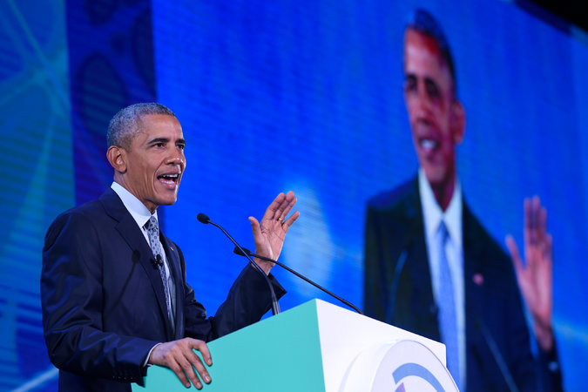
President Obama addressed the Asia-Pacific Economic Cooperation summit meeting in Manila, where he discussed China, trade and climate change. Credit Susan Walsh/Associated Press
MANILA — President Obama called on China on Wednesday to halt its construction on reclaimed islands in the South China Sea, raising the contentious issue at the start of a two-day economic summit meeting at which he and other Pacific Rim leaders also discussed trade and climate change.
Speaking to reporters after a meeting with President Benigno S. Aquino III of the Philippines, Mr. Obama directly confronted the disputed Chinese claims over islands in the critical waterway. He urged the Chinese to stop military activities there and endorsed a process of arbitration to settle differences between Beijing and its Southeast Asian neighbors.
“We agree on the need for bold steps to lower tensions, including pledging to halt further reclamation, new construction and militarization of disputed areas in the South China Sea,” Mr. Obama said.

The United States takes no position on the territorial claims in the region of various Asian governments, but Mr. Obama has aggressively sought to defend the right of free navigation through the South China Sea, a vital route for commerce and trade. On Tuesday, he announced $250 million in military contributions to several Asian nations to support their efforts to stand up to China.

The president’s comments on Wednesday came at the start of the Asia-Pacific Economic Cooperation summit meeting, at which leaders from 19 regional economies have gathered for a series of discussions about growth and trade.
The centerpiece of those discussions on Wednesday was the Trans-Pacific Partnership Agreement, which was reached recently by a dozen countries, including the United States. Mr. Obama hailed the deal at a meeting with other leaders.
“This is the highest standard and most progressive trade deal ever concluded,” he said, standing beside Michael Froman, the United States trade representative, who helped negotiate the pact. “It includes strong protections for workers, prohibitions against child labor and forced labor. It has provisions to protect the environment, to help stop wildlife trafficking, to protect our oceans.”
The agreement still faces an intense debate in the United States as Congress considers it. But Mr. Obama expressed confidence that it would be approved.
“The fact that everyone here has stepped up and made some hard decisions that are going to pay off for decades to come I think is testimony to the vision that was reflected,” he said.
Mr. Obama also used the summit meeting to push for his climate change agenda, telling a group of chief executives that the world must face what he called an “urgent and growing threat of climate change” before time runs out.
He said the economic and social threats from climate change should be of particular concern to the people of Southeast Asia, where many low-lying islands could face disaster as sea levels rise.
“Few regions have more at stake in meeting this challenge than the Asia-Pacific region,” he said.
Mr. Obama is scheduled to travel to Paris at the end of the month to kick off a climate change summit meeting that aims to reach an accord dedicating many nations to reducing their carbon emissions in the interest of slowing global warming.
The president used the topic of climate change on Wednesday to host a discussion at a chief executives’ forum along with Jack Ma, founder of the e-commerce giant Alibaba, and Aisa Mijeno, an entrepreneur from the Philippines who invented a lamp that runs on saltwater.
In response to a question about her lamp from Mr. Obama, Ms. Mijeno said that it provided about eight hours of light, as well as power to a USB port for charging a phone.
“And all you need to do is you just have to replenish the saltwater solution,” she said, “and then you have another eight hours of lighting.”
Mr. Ma offered the president the perspective of a very large company that, he said, spends 0.3 percent of its revenue to encourage young people to find creative ways to help the environment. He said that when he was 12, he almost drowned in a lake, and now that lake is dry.
“If we do not care about this earth, we do not care about the water, food, environment, I think nobody can survive, whether you’re big or small,” Mr. Ma said. “So this is the concern. This is the worry I have.”
Mr. Obama was scheduled to end the day with a working dinner to further discuss economic issues.

The Economist

Hot water

As America challenges China, the temperature rises in the South China Sea
Oct 31st 2015 | From the print edition

YOU might have thought an American invasion of China was under way. A warship had “illegally entered” waters in the South China Sea threatening “China’s sovereignty and security interest”, declared Lu Kang, a Chinese spokesman. In fact, all that had happened was that a destroyer, USS Lassen, had peacefully sailed within 12 nautical miles of Subi Reef, one of seven specks of rock and coral in the much-disputed Spratly archipelago where China has been engaged in frenetic construction over the past two years, creating artificial islands.
Chinese admirals may be fuming, but nobody expects a war over the incident. America, however, has said it will not be the last such sail-by. So tension in the South China Sea is likely to mount; relations between America and China will be under strain as their leaders meet at a series of multilateral summits in November; and the unspoken strategic rivalry, as China seeks to displace America as the predominant military power in the western Pacific, will come into sharper focus.
America called USS Lassen’s patrol a routine “freedom of navigation” operation (FONOP in the jargon), of a type it conducts all over the world “in accordance with international law”. In fact America has never ratified the relevant treaty, the United Nations Convention on the Law of the Sea (UNCLOS), despite efforts by successive presidents to persuade Congress to do so. As the name suggests, the point of a FONOP is to protect the freedom of the seas. No government is threatening that freedom in the South China Sea, a vital artery for maritime trade. But America has been alarmed by China’s building spree, seeing the artificial islands as military bases in the making.
Before this incident, China seemed to have decided that the United States was all bark and no bite over this issue. America stopped FONOPs around Chinese-occupied features in 2012; it did no more than make verbal protests when China that year evicted the Philippines from the Scarborough Shoal to the north of the Spratlys, just as it did when China sent an oil rig to drill off Vietnam last year, and when China began building long airstrips and big harbours on the artificial islands it was building.
But in recent months America has been losing patience. Pentagon officials began recommending FONOPs as a way of conveying annoyance at China’s moves. The administration apparently delayed making a firm decision on this until after President Xi Jinping’s state visit to America last month. During his trip, Mr Xi promised not to “militarise” the new islands, but was otherwise dismissive of American concerns. Barack Obama decided to authorise a FONOP almost as soon as Mr Xi left. But by refraining for so long he had shown that he understood it would provoke China. Whatever American officials publicly insist, this is not business as usual or no big deal.
The aim of this FONOP is not to take sides in a sovereignty dispute over Subi Reef, which is also claimed by the Philippines, Taiwan and Vietnam. America is officially neutral on the rival claims—and says it will also carry out FONOPs near features built on by other countries. The limited point the patrol made was that, whoever owns Subi, UNCLOS would not grant the island “territorial waters”. Under UNCLOS, habitable islands are entitled to territorial waters extending 12 nautical miles around their periphery, as well as a 200-nautical-mile “exclusive economic zone” (EEZ). Uninhabitable rocks get the territorial waters but not the EEZ. “Low-tide elevations”, ie, reefs like Subi that before the building were wholly submerged at high tide, get neither.
China has ratified UNCLOS, but has not spelled out how its claims in the South China Sea accord with it. Instead it resorts to vague and sweeping historical assertions—in America Mr Xi said that the islands and reefs had been Chinese territory “since ancient times”. China’s map of its claim shows a vast and mysterious U-shaped “nine-dashed line” around virtually the entire sea.
China also seems ambiguous about UNCLOS’s Article 17, on the “right of innocent passage”, which allows warships to pass freely even through territorial waters if they do so without any menacing behaviour. To no American protests at all, five Chinese naval ships sailed in American waters off Alaska in August—just as Mr Obama was visiting the state. So it is unreasonable that China is so infuriated by America’s sailing in a part of the sea China has not even formally claimed as its territorial waters under UNCLOS. China seems neither embarrassed by the inconsistency nor interested in explaining it.
Part of the reason lies in different interpretations of UNCLOS as it relates to what foreign navies can get up to. In the past the argument has centred over EEZs. America thinks it has the right to conduct military exercises and surveillance in them. China, like some other countries, disagrees. Several times China has harassed American ships and planes engaged in what it sees as espionage. (An American defence secretary once claimed America was merely investigating “mysteries”, which he blamed on China’s lack of openness.) China now thinks it is powerful enough to enforce its interpretation. America is pushing back.
Perverse incentives
America’s friends in South-East Asia will be relieved that it is belatedly standing up on their behalf to China’s bullying, and reasserting the naval dominance that has underpinned a Pax Americana under which Asia has thrived for decades. With apparently little risk of actual conflict, it seems America can only gain from the FONOPs. But if they do indeed continue, there are other risks. One is that China eventually succeeds in portraying America as the destabilising force in the sea. Another is that it uses what it calls American aggression (and Chinese public anger about it) as a pretext to militarise the new islands just as America and its friends fear. It looks almost as if America has been tricked into giving China the excuse it wanted.

NYT

With China in Mind on a Visit to Manila, Obama Pledges Military Aid to Allies in Southeast Asia
By MICHAEL D. SHEARNOV. 17, 2015
- Share Obama Tours Philippine Navy Vessel
After touring a Philippine navy vessel on Tuesday, President Barack Obama asserted the United States’ commitment to the freedom of navigation in the South China Sea.
By THE ASSOCIATED PRESS on Publish Date November 17, 2015. Photo by Susan Walsh/Associated Press. Watch in Times Video »
MANILA — Standing in front of a former United States Coast Guard ship that is now the flagship of the Philippine Navy, President Obama on Tuesday sent a message intended for a single country: China.
Kicking off five days in Asia by visiting the home port of the 378-foot ship, now known as the BRP Gregorio del Pilar, Mr. Obama announced that the United States would spend an additional $250 million over the next two years to help ensure maritime security for countries in Southeast Asia.
That money will bolster the naval capabilities of Indonesia, Japan, the Philippines, Malaysia and Vietnam for one main purpose: to stand up to China’s increasingly aggressive claims on the South China Sea, where in recent months, that country has enlarged submerged reefs into islands capable of hosting military airstrips, equipment and soldiers.
“We have a treaty obligation, an ironclad commitment to the defense of our ally the Philippines, who can count on the United States,” Mr. Obama said in brief remarks after touring the Gregorio del Pilar. “My visit here underscores our shared commitment to the security of the waters of this region and to the freedom of navigation.”
Officially, the United States takes no position on the competing territorial claims on the South China Sea by China and its neighbors. But fears that Beijing’s behavior in the strategic waterways could hamper the free flow of commerce from the region, which has become increasingly important, have prompted Mr. Obama to act.
Last month, he ordered a Navy destroyer into the disputed area to demonstrate American resolve behind the idea that no single nation could stand in the way of free navigation through open, international waters.
The president’s visit to the Philippine harbor on Tuesday was meant to emphasize that message without directly challenging the Chinese before the start of the Asia-Pacific Economic Cooperation summit meeting here on Wednesday.
In his remarks after his tour, Mr. Obama did not mention China’s activities in the South China Sea. But Susan E. Rice, the president’s national security adviser, made clear ahead of the trip that concerns about China would be a “central issue of discussion.”
In a fact sheet about the president’s announcement, White House officials said that the additional money was intended to “address the evolving dynamics of the region” and that it would increase “the maritime security capacity of our allies and partners, to respond to threats in waters off their coasts.”
Once named the Coast Guard Cutter Hamilton, the ship that Mr. Obama toured on Tuesday now carries the name of a Filipino hero who fought in the revolution against Spanish rule and in the Philippine-American war, before he was killed in 1899.
The ship conducts missions in the waters near the Spratly Islands, a disputed set of hundreds of reefs, islets and islands that are in critical shipping lanes. Mr. Obama flew over the South China Sea in Air Force One as he arrived in the Philippines.
“The ship that I just toured, a former U.S. Coast Guard vessel, helps the Philippines respond to disasters, perform counterterrorism missions and patrol the South China Sea,” Mr. Obama said, adding, “More capable navies and partnership with the United States are critical to the security of this region.”
As part of the $250 million commitment, Mr. Obama announced that the United States would transfer two ships to the Philippines — another Coast Guard cutter and a research vessel. The Philippines is already the largest recipient of American maritime assistance in the region; it will get $79 million this year.
Mr. Obama made no mention of the agreement that the United States and the Philippines reached a year ago to open several bases on the island here to American personnel and equipment. That agreement has been delayed by legal wrangling and is awaiting a decision by the Philippine Supreme Court and that country’s legislature.
Photo
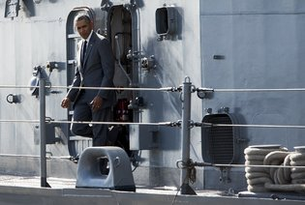
President Obama on the Gregorio del Pilar, a former American ship that is now the Philippine Navy’s flagship, Tuesday in Manila. Credit Saul Loeb/Agence France-Presse — Getty Images
Once approved, that agreement could mean a return of United States forces to the Subic Bay military base, which once served as the largest overseas outpost for the American military.
The Philippines ejected the United States from the base in 1992, declaring itself free of the “shackles of dictatorship.” Since then, however, the political dynamics of the region have shifted, and the Philippines is eager to welcome back the Americans as a counterweight to China.
If the United States military returns to Subic Bay, it would provide a significant new base from which to assert its influence in the region. And it would be a powerful symbol of what the Obama administration calls its “rebalance” of foreign policy toward Asia.
That effort relies partly on harnessing the spending power of the emerging economies in the region — something that could be threatened if the countries do not find ways to stand up to Chinese claims on the waters that surround them.
After touring the Gregorio del Pilar, Mr. Obama said the effort to do that was well on its way.
“I can tell you that after inspection, your ship looks like it is in tiptop shape,” he said.

NYT

Brinkmanship in the South China Sea
By THE EDITORIAL BOARDNOV. 20, 2015
Few issues are more important to Asia than the free flow of navigation through the South China Sea, a channel for some $5 trillion in annual trade. And no threat to that trade is as grave as China’s claim to “indisputable sovereignty” over fully 90 percent of the sea. It is no surprise that President Obama and several other leaders were giving the issue high priority this week during back-to-back summit meetings in the region.
Regrettably, there is as yet no sign that these discussions will make progress on resolving the dispute, which many fear could get out of hand. A big reason is China’s refusal to even discuss the issue in multinational talks or a judicial proceeding.
China ratified the 1982 United Nations Convention on the Law of the Sea, guaranteeing unimpeded passage on the high seas for trade, fishing and oil exploration. But in recent years, China has asserted greater control by turning seven obscure reefs and rocks into more substantial islets, some big enough to hold military bases, and claiming jurisdiction of the waters around them. This has effectively rewritten the treaty and put China at odds with its neighbors, including the Philippines and Vietnam, which assert similar claims.
In Manila on Wednesday, Mr. Obama strongly reiterated a call for China to halt construction and military activities on and around the islands. Some other countries have also built up disputed reefs, but none has been as aggressive as China. On Friday, China’s top admiral, Wu Shengli, said his forces had shown “enormous restraint” in the face of American provocations and were prepared to “defend our national sovereignty.”
The United States has taken a neutral position on the specific claims, but Mr. Obama has defended the right of free navigation in the South China Sea, encouraged a peaceful resolution of the dispute and reinforced ties with countries that fear being bullied by Beijing. In Manila, he sent an unmistakable message of support by announcing plans to spend an additional $250 million over the next two years to bolster the naval capabilities of the Philippines, Indonesia, Malaysia, Vietnam and Japan.
Twice recently, Mr. Obama also challenged Beijing by sending a naval destroyer and then two B-52 bombers to transit waters and airspace claimed by China. But experts for Lawfare, a legal blog, say the moves were executed in a confused way, muddying the message and the legal principle.
The United States and others have every right to send their ships and planes across the South China Sea. Of great importance now is a peaceful resolution of the controversy. Last month, an international arbitration court agreed to hear a case in which the Philippines is challenging China’s sweeping claims. Indonesia and Vietnam have raised the possibility of doing the same thing, and Mr. Obama has endorsed this arbitration process.
Although China has refused to participate in the case, it may be forced to rethink its approach if it loses in court. Asian leaders, at the East Asia summit meeting in Malaysia this weekend, could make an important contribution by endorsing the Philippine case. They also need to think creatively about a diplomatic resolution that could start with negotiating fishing rights and then rights to oil and gas resources.

https://www.lawfareblog.com/cant-anybody-play-game-us-fon-operations-and-law-sea

South China Sea

Can’t Anybody Play This Game? US FON Operations and Law of the Sea
By Raul "Pete" Pedrozo, James Kraska
Tuesday, November 17, 2015, 10:57 AM
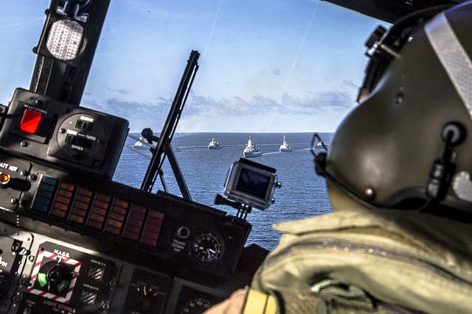
Credit: German navy photo by photographer PO1/OR-6 Alyssa Bier/released

The United States has been unable to synchronize successful air and sea freedom of navigation (FON) operations in the South China Sea with an erratic diplomatic message and a legal case that is too clever by half. Our colleagues Bonnie Glaser and Peter Dutton tried to reconnect these dimensions when they wrote in the The National Interest that while the administration has not done a “stellar job of explaining its actions,” the U.S. approach was still a sophisticated signaling mechanism. But their laudable effort to square the circle is not supported by the law of the sea.
Here’s why.
The past two FON operations in the South China Sea – the USS Lassen (DDG 82) surface navigation on October 27 and the flight of B-52s on November 8-9 – are models in how to squander flawless operational execution with confused, inconsistent, and ultimately damaging messaging that in some ways left the United States in a worse position than it would have been had it not done the operations.
After more than a month of dithering, the United States ordered the USS Lassen to challenge something – many are still unsure what – in the South China Sea. Some American officials characterized the operation as “innocent passage,” while others described it as “not innocent passage.” As confusion over the true nature of the FON challenge mounted, Senator John McCain requested the Department of Defense to “publicly clarify…the legal intent behind this operation.” Just days later, the U.S. did it again. Air Force B-52 bombers from Guam overflew the South China Sea. A U.S. official told The Hill that the aircraft did fly within 12 nm of China’s artificial islands, whereas another U.S. official said it did not. The confusion in both cases appears to be a mixture of politics combined with a lack of understanding of the law of the sea, presenting the United States with two unforced errors that should not be repeated.
The legal implications of the Lassen operation are inexplicable to this day. The Lassen could not have transited near Subi Reef in innocent passage because the feature is a low-tide elevation (LTE) that does not generate a territorial sea. High seas freedoms apply around low-tide elevations. Although Subi Reef is a an LTE, it is located within 12 nautical miles (nm) of Sandy Cay, an uninhabited rock that is entitled to a 12 nm territorial sea. Under article 13 of UNCLOS, an LTE located within the 12 nm territorial sea of a “mainland or island” may generate a territorial sea as though it were itself a rock. Accordingly, Glaser and Dutton conclude that Subi Reef was used “as a baseline to ‘bump out’ the territorial sea” of Sandy Cay. Under this theory, the USS Lassen was compelled by law to transit the territorial sea of Sandy Cay/Subi Reef in innocent passage.
There are four reasons why this rationale is unsupported by the law of the sea. First, article 13 of UNCLOS clearly states that an LTE within 12 nm of a “mainland or island” may extend out the territorial sea of the primary feature as though it were a rock. This is called a “parasitic” LTE, since its territorial sea depends on an adjacent mainland or island. But Sandy Cay is neither a mainland nor an island – it is a rock, so it may not be used by Subi Reef to generate a territorial sea.
Our colleagues appear to suggest that “mainland or island” includes mere rocks – that islands are just a form of rock. This argument confuses the text in Article 121 on the regime of islands, which forms Part VIII of the Convention and addresses what features are entitled to an exclusive economic zone (EEZ) with the rules in Part II on the territorial sea. Islands are naturally formed areas above water at high tide [Article 121(1)]. Islands are entitled to the full suit of zones of sovereignty, sovereign rights, and jurisdiction [Article 121(2)]. All that Article 121(3) says is that “rocks which cannot sustain human habitation or an economic life of their own” are not entitled to an EEZ or continental shelf. This text does not mean that islands are simply a type of rock – they are not and to make this argument is a circular reading that defies the negotiating history of the convention that sought to distinguish rocks from islands, as well as common sense that would have the two distinct words imbued with two discrete meanings.
Furthermore, the feature of one country cannot be used to generate maritime entitlements for a feature of another country. The only way for Subi Reef to be a parasitic LTE and have a territorial sea generated from Sandy Cay’s territorial sea is if the same country has lawful sovereign title to both features. Is the United States ceding both features to China?
Second, perhaps more fundamentally, no feature in the Spratly Islands, including Subi Reef, has a territorial sea. None. UNCLOS Article 3 allows states to “establish” a territorial sea – it is not automatic. Neither China nor any other claimant has established a territorial sea around a feature in the Spratly Islands. The law of the sea requires affirmative action by a sovereign state – China has not done so, so why does the United States appear to recognize (and therefore encourage) such action? There is no territorial sea around Subi or any other Chinese occupied feature, and therefore no purported requirement in Chinese law for prior consent of transit for the Lassen to challenge. Whether U.S. ships or aircraft stay beyond or transit within 12 nm of any these features is legally immaterial – none of them have a territorial sea.
Third, in order for a rock to generate a territorial sea it must be under the sovereignty of a coastal state. The United States does not recognize any country as having sovereignty over the features occupied or claimed by China, and in fact China has the weakest claim to the features of any nation in the region. No country recognizes China’s claim of sovereignty over any Spratly feature. Consequently, even if China declared a territorial sea around one or more feature, which it has not, the declaration would be legally nugatory. It would be the same as the United States declaring a territorial sea around Antarctica – no other state would recognize it. So why does the United States appear to recognize Chinese sovereignty over any of these features by trying to challenge provisions of Chinese law that even China has refrained from imposing?
Fourth, Glaser and Dutton suggest the Lassen challenged China’s law that purports to require prior notification for innocent passage in its territorial sea. Yet the operation appears to have been leaked to the media by a U.S. official the day before it was conducted, giving de facto notice – probably in a vain effort to “reduce tension” over the transit. That move undermined the U.S. legal case and created operational risk. It was not a coincidence that China’s maritime militia was already in position to harass the Lassen when the U.S. warship approached Subi Reef – potentially placing the security of the mission and the lives of U.S. Sailors at risk.
So did the FON operations challenge anything at all? Yes, but not what the United States or outside observers have claimed. Both the Lassen and the B-52s challenged China’s ubiquitous nine-dashed line claim to “indisputable sovereignty” over the South China Sea. Of course nobody, including our interlocutors in Beijing, have any idea what China’s preposterous claims mean in terms of the law of the sea. The difficulty in trying to fit U.S. FON operations into the prism of the law of the sea – combined with a lack of understanding of the law of the sea – has driven U.S. officials and pundits bananas. This falls into the trap laid by China, which has, at least since 1995, intentionally used confusion and ambiguity over its maritime claims in the South China Sea as a strategic weapon. It would be far better for the United States to continue to operate freely, persistently, and without the hand-wringing and drama, with ships on the surface, submarines under the water, and aircraft in overflight of the South China Sea, within and beyond 12 nm of all the features in the region.
Topics:
- South China Sea,
- China,
- Maritime,
- International Law
Tags:
- USS Lassen,
- Freedom of Navigation Operation (FONOP),
- Subi Reef,
- Spratly Islands,
- China,
- South China Sea,
- UN Convention on the Law of the Sea (UNCLOS)

The National Interest

The U.S. Navy’s Freedom of Navigation Operation around Subi Reef: Deciphering U.S. Signaling
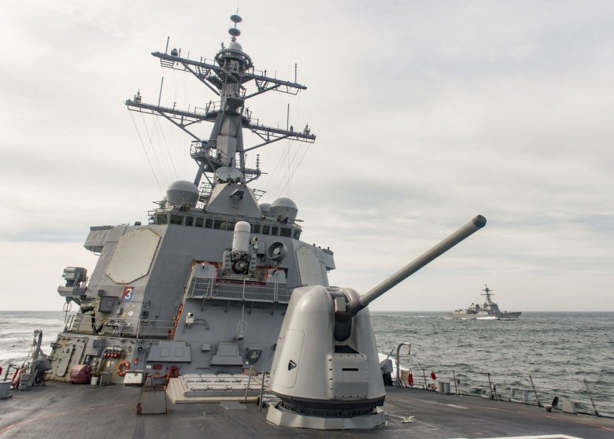
"To ensure that China and other nations around the world fully understands what took place, the Pentagon should explain the legal basis for its operation and clarify what message it intended to send."
Bonnie S. Glaser Peter A. Dutton
November 6, 2015

Since the United States sailed in the waters close to Subi Reef, a low-tide elevation (LTE) that China has built up into a massive artificial island, some experts have charged that the U.S. bungled the operation by conducting an “innocent passage,” implicitly granting China a 12 nautical mile territorial sea around the LTE to which it is not entitled. This accusation is not valid, however, and reflects an incomplete understanding of what is admittedly a complicated element of the Law of the Sea Convention.
Critics of the naval maneuver have contended that to underscore the message to China that it is not entitled to a territorial sea around Subi Reef it was necessary to conduct a freedom of navigation operation in a manner that blatantly challenges an excessive maritime claim that goes beyond what is entitled under the United Nations Convention on the Law of the Sea (UNCLOS). In other words … no innocent passage. However, the geography of the Spratly archipelago, which contains more than 120 scattered islands, isles, shoals, banks, atolls, cays and reefs situated in close proximity to one another, is key to understanding the nature of the U.S. Navy’s freedom of navigation operation. Before analyzing this criticism, the relationship between maritime geography and the law of the sea must also be set out.
First, if a vessel, any vessel including a warship, passes within 12 nautical miles of another country’s territory it must do so in innocent passage. These waters are the coastal state’s territorial sea and, although all ships have a right to pass through them without the coastal state’s permission, the coastal state has important security interests that must be respected. What constitutes territory around which there can be territorial waters? When it comes to islands, rocks, and reefs, any naturally formed land feature, no matter how small, that is above water at high tide and is occupied or controlled by a sovereign state is that state’s territory. Ultimate ownership may be disputed, but it is control of the feature that confers security rights. Passage through the territorial sea is innocent if it is done in a manner that is continuous and expeditious and non-threatening to the coastal state. Article 19 of UNCLOS provides further specifics as to how to interpret these requirements. It is worth emphasizing that innocent passage is a right all ships enjoy and coastal states cannot normally require prior notification of permission.
Second, some features are submerged at high tide and are therefore not territory. These features are generally called Low Tide Elevations or LTEs. Since they are not territory, there is no right to a territorial sea around them and therefore no limitations on high seas freedoms of navigation in their vicinity. If one of these features is on a coastal state’s continental shelf, the state can build it up but cannot accrue new water space rights by doing so. In other words, once an LTE, always an LTE, no matter how big the feature becomes. The most UNCLOS allows coastal states to claim is a 500-meter safety zone around them. All ships retain the right to exercise high seas freedoms up to that 500-meter limit.
There remains a third possibility. What if a coastal state builds up an LTE that sits within 12 nautical miles of a recognized island or rock? That island or rock is entitled to the full 12 nautical mile territorial sea. Additionally, according to UNCLOS article 13, if an LTE is located inside the territorial sea of another island or rock, then that LTE can be used as a baseline to "bump out" the territorial sea of the originating feature. Accordingly, high seas freedoms do not apply around the built-up LTE. Innocent passage applies, as does the 500-meter safety zone.

Which of these circumstances apply to the recent FONOP in the vicinity of Subi Reef? Subi Reef is located within 12 nautical miles of Sandy Cay (not to be confused with Sand Cay, which is occupied by Vietnam and does not lie within 12 nm of Subi Reef), and can be used as a base point for Sandy Cay's territorial sea.Sandy Cay is unoccupied, but is claimed by China, the Philippines, Vietnam and Taiwan. Nonetheless, there is a 12 nautical mile territorial sea around Subi Reef, generated by Sandy Cay. To whom the territorial sea belongs to is irrelevant. It is an example of the third circumstance described above—a territorial sea extended by an LTE in which innocent passage rights apply.

The U.S. recognizes that Subi Reef is inside a legal territorial sea. Contrary to the claims of many experts, the USS LASSEN (DDG 82) operation was not intended to assert that the U.S. challenges the existence of a territorial sea around Subi Reef. Rather, it was intended to exercise freedom of navigation consistent with international law and to demonstrate that China’s building of artificial islands will not change how the U.S. operates in the waters and airspace of the South China Sea. Additionally, contrary to international law, Chinese domestic law requires prior notification for warships to exercise innocent passage. The U.S. gave no formal prior notification to any of the claimants of the exercise by USS LASSEN of innocent passage in the vicinity of Subi Reef and Sandy Cay. Accordingly, such innocent passage acted as a freedom of navigation operation because it challenged China’s attempt to put illegal restrictions on the movements of warships.
U.S. officials have stated that the operation in the waters close to LTEs and rocks that China has transformed into artificial islands will continue in the future. A future military operation could take place near Mischief Reef, which is the only LTE occupied by China that is not within 12 nautical miles of another land feature. That is an example of the second circumstance described above. If a U.S. navy ship sails within 12 nautical miles around Mischief Reef, it is likely to conduct a military operation only allowed in the exercise of high seas freedoms in order to signal that China cannot legally claim a territorial sea around that elevation.
The Obama administration has not done a stellar job of explaining its actions at Subi Reef. That said, the exercise of the right of a freedom of navigation operation was timely and necessary. To ensure that China and other nations around the world fully understand what took place, the Pentagon should explain the legal basis for its operation and clarify what message it intended to send.
Bonnie Glaser is senior adviser for Asia and director of the China Power Project at the Center for Strategic and International Studies.
The Economist

The East Asia Summit
All latest updates

Disagreements over the South China Sea worsen as China digs in

China's hard line on the disputed waters shows no sign of softening
Nov 26th 2015 | Singapore | Asia

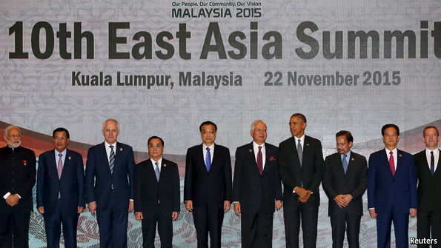
AN ANNUAL round of Asian regional summitry has ended with few signs of progress towards easing rising tensions in the South China Sea. No sooner had the leaders left the meetings that it was reported in China that the People’s Liberation Army had commissioned a new logistics vessel, the largest-ever, to supply its troops on the far off islands, rocks and reefs China controls in the disputed waters. And a foreign-ministry official confirmed that China will continue building on the controversial man-made islands it has created on top of tiny rocks and reefs.
If any international forum offered hope of cooling tempers, it was the East Asia Summit, which convened in Kuala Lumpur, Malaysia’s capital, on November 22nd. It groups the ten members of the Association of South-East Asian Nations (ASEAN), four of which have territorial claims in the sea, with eight other countries, including China, which claims virtually all the sea, and America, which says it has a vital national interest in safeguarding the freedom of navigation there. It got nowhere.

America made much of the fact that President Barack Obama was at least there, despite crises elsewhere. He was able to repeat America’s objections to China’s massive island-building spree in the sea over the past two years. This reinforced the signal sent in late October when an American naval destroyer conducted a “freedom of navigation operation” near one of the artificial islands.
The message that sortie was meant to send was that since the island was built on top of a reef that was submerged at high tide, China was not entitled under the United Nations Convention on the Law of the Sea (UNCLOS) to claim any territorial waters around it. Reinforcement of that message was necessary, since some American officials had dangerously muddied it by wrongly suggesting that the ship had made an “innocent passage”—a provision of UNCLOS that applies to territorial waters.
In ASEAN, only the Philippines has spoken out in support of freedom-of-navigation exercises. Others, wary of China, which criticised it as a provocation, nevertheless quietly welcome a more active American role in the South China Sea. Feeling bullied by China, and weary of an interminable ASEAN-led process of trying to bind China to an agreed code of conduct in the sea, many South-East Asian governments are stepping up security co-operation with America, Japan and each other. This month the Philippines and Vietnam, whose disputes with China are the most acute, signed a “strategic partnership”.
South-East Asian countries are also standing up to China in other ways. This week a tribunal in The Hague has begun hearings on the Philippines’ attempt to have China’s claims in the South China Sea—as defined by a “nine-dash line” on its maps encircling most of it—ruled invalid under UNCLOS. Now that the court is hearing the Philippines’ case, other countries may lodge cases too. Even Indonesia, which disputes no territory with China but whose oil-rich sea off the Natuna islands is traversed by the nine-dash line, is contemplating legal action. Malaysia has in the past ignored Chinese marine incursions. But it protested when a Chinese coastguard vessel in June sailed close to Sabah, in Malaysian Borneo. In a speech made on a visit to Sabah, Ahmad Zahid Hamidi, the deputy prime minister, complained about Chinese island-building.
In response to all this, China has tried to show its smiley face, and has reached for its chequebook. It made clear that it does not dispute Indonesia’s sovereignty over the Natunas (not the point at issue). And in Kuala Lumpur it said it would provide $10 billion in loans for infrastructure projects in ASEAN, along with a further $560m in aid to the group’s poorer members. It also did the summit’s host, the Malaysian prime minister, Najib Razak, a favour. A Chinese state-owned firm won an auction with a higher-than-expected offer for power assets being sold by a troubled Malaysian state investment fund, 1MDB, whose travails have embroiled Mr Najib in allegations of corruption and ineptitude. Besides buying goodwill, such economic largesse also makes the point that China is the big, rising power in the region and is not going to go away.
China has given no hint that it might moderate its claims in the South China Sea, nor that it will stop building on its new-made islands. And despite having said it had no intention of “militarising” the islands, a spokesman said in Kuala Lumpur said that, since the islands and reefs are so far from the mainland, “it is necessary to build and maintain military facilities”. Elsewhere the navy chief, Wu Shengli, stressed the “enormous restraint” China has shown in the face of supposed American provocations. America’s Pacific commander, Harry Harris, was probably not alone in seeing this as a “veiled threat”. And China conducted large-scale naval exercises in the sea just before the summit. There, China’s prime minister, Li Keqiang made a five-pronged proposal “to uphold peace and stability in the South China Sea”. It paid lip-service to UNCLOS and to ASEAN’s code of conduct and was eminently reasonable. Maybe the rest of the Chinese government should read it.

K@W

Video @ http://knowledge.wharton.upenn.edu/article/the-pacific-ocean-and-the-coming-collision-of-the-worlds-superpowers/?utm_source=kw_newsletter&utm_medium=email&utm_campaign=2015-12-03

Public Policy

The Coming Collision of Superpowers in the Pacific
Dec 03, 2015

mic Listen to the podcast:
Audio Player
00:00
00:00
Use Up/Down Arrow keys to increase or decrease volume.

In the new book Pacific: Silicon Chips and Surfboards, Coral Reefs and Atom Bombs, Brutal Dictators, Fading Empires, and the Coming Collision of the World’s Superpowers, bestselling author Simon Winchester examines the role of the Pacific Ocean in the modern world.
Recently, Wharton emeritus management professor Stephen J. Kobrin sat down with Winchester to discuss his book and the geopolitics of the Pacific Ocean.
An edited transcript of that conversation follows.
Stephen J. Kobrin: At the beginning of the book, you talk about the fact that the Pacific Ocean is coming to symbolize the future and that the Mediterranean was once the inland sea of the ancient world, the Atlantic to some people was the inland sea of the modern world and that you can argue that the Pacific Ocean will be the inland sea of tomorrow’s world. What does that mean?
Simon Winchester: It’s the place where … the two great civilizations finally meet and confront each other. We have humankind originating in Ethiopia with one group going off east to Mesopotamia and the Indus Valley and Peking, and the other group going through the Balkans and up into Europe. Many Europeans cross[ed] the Atlantic into the Americas and, under the impress of the Manifest Destiny, [made] their way west to the shores of the Pacific. Then after [Vasco Núñez de] Balboa first saw it in [1513], crossing it and then confronting the other great civilization.
You’ve got the Eastern civilization on the West side of the Pacific and the Western civilization on the East side of the Pacific. It’s a bit of a geographical topsy-turvy-dom. How do these two peoples deal with each other? [I]n the past, they have, generally speaking, colonized or brutalized or enslaved or in some way spoiled the lives of the Easterners…. In the 1970s, the Americans withdrew from Southeast Asia, and the British withdrew from their vast colonial imperium in the Pacific Ocean. The Germans, the Japanese have left and the Pacific peoples are now essentially standing on their own two feet for the first time since we, Europeans, began interfering with their lives.
It seems to me that these two great civilizations have the potential to cooperate at long last with one another. As a consequence of that, we’re seeing a real hinge point of history. We’re going to see a shift in the sort of dominance of, let’s say, Rome, and it’s going to move now to the dominance of, let us say, Peking or Beijing, very roughly. That change of order is going to happen in and around the Pacific, which is why I think the Pacific is important in all of humankind’s futures.
“It seems to me that these two great civilizations have the potential to cooperate at long last with one another. As a consequence of that, we’re seeing a real hinge point of history.”
Kobrin: In the book, you note the end of Vasco da Gama era, the sudden and very wholesale redistribution of world power, and [argue that] after half a millennium of the West dominating Pacific, it now seems to be the turn of the Asians. You argue that that would be a good thing, that the Asia for the Asians offers a possibility of greater stability for the region. Why should the Asians do a better job than the Westerners did?
Winchester: Because with the single exception of the Japanese in a spasm of unpleasantness from the 1930s to the middle of the 1940s, the Asians have been much more benign in their management of the world than we Westerners have. The Chinese, to give a classic example, have the most populous country on Earth and have not — with the single exception of Tibet — really overreached itself. They have remained contentedly within their own borders, and they have been the Middle Kingdom, Zhōngguó. They have been content with who they are and not wishing to export themselves culturally or imperially in the way that we Westerners have done. We Westerners have gone around the world dominating and enslaving and influencing millions, billions of people.
[Despite] the British and the Americans leaving the legacy of the English language … certain types of legal frameworks, and one might argue railways and postal systems and so forth, generally speaking, we have left a legacy which has embedded in it the seeds of all sorts of conflict. When you go to look in the Middle East and look at the borders that we drew, look at India-Pakistan, look at Northern Ireland, look at Israel. Eastern countries have not done that kind of thing, generally speaking. Yes, there have been some excesses. So I think I would rather live in a world run by Asians than in a world run by us.
Kobrin: Is it likely to be that smooth of a transition? Are we likely to go from a world run by us to a world run by Asians without conflict and disorder?

Sponsored Content:
Winchester: That’s my hope. No, there are going to be all sorts of rough patches, which may take many decades to resolve. The classical situation is the one evolving at the moment in the South China Sea, which is the Chinese have this fairly worked out stratagem of expanding their Navy into the Pacific. They have already, as it were, taken de facto, if not de jure, control of the South China Sea. [They have the] Bastian chains of islands extending outwards all the way out to Hawaii. They think, and in my view quiet reasonably, the Americans have dominated the Pacific Ocean navally for the last 60 years, we’re a Pacific nation, we have a big Navy, we’re rich and influential; why can’t we at least have maritime equivalents?
The Pentagon regards that as threatening. I don’t regard it as threatening in the slightest because the Chinese are not likely to do what we have done, which is to colonize and enslave and dominate. Twitter They just want to, as I say, enjoy equivalence. But so long as that is feared by people, then there’s the potential for conflict. There’s also the potential for accidents of course, so the potential for conflict will lead undeniably to confrontations here and there. But in overall, general, long-term, historical sense, nothing that can’t be dealt with. Then it will all settle down into this new world order.
Kobrin: One hopes. China does seem to be extending its territoriality sequentially in the Pacific from the first chain to the second chain to the third chain.
“We Westerners have gone around the world dominating and enslaving and influencing millions, billions of people…. I would rather live in a world run by Asians than in a world run by us.”
Winchester: Yes.
Kobrin: How should the United States react to that?
Winchester: I think by trying to understand why China is seeking this maritime equivalence and not being fearful of its potential because I don’t think that it is dangerous. A classic example is the Yangtze River. I was watching recently this wonderful film … called “The Sand Pebbles” with Candice Bergen and Steve McQueen on an American gun boat in the Yangtze putting down all sorts of problems in the 1920s and ‘30s. It reminds us that American, Italian, German, French and British warships were able to operate deep inside China on the Yangtze River for 50 years. If anyone committed a crime, if a ship sailor got involved in a fight in Wuhan or Chongqing, that wouldn’t be judged by the Chinese courts. Heaven no, we were not going to have one of our people judged by Chinese Magistrate. We’ll try them in our own courts.
It was this principle of extraterritoriality, which we arrogantly assumed was right. But how would we feel if the Chinese Navy were operating in the Mississippi and one of their sailors gets involved in a fight in Hannibal, Missouri, and says, “We don’t want to be judged by your Missouri courts. We’ll be judged by our Naval courts.” Because we have behaved in a certain way in the Pacific doesn’t necessarily mean that the rest of the civilized world [would do the same], and no one would argue that China is not part of the civilized world because, after all, their civilization is 20 times as old as ours. They will behave in a perfectly civilized manner. They simply want equivalence, and they want respect, and I think they should be given it.
Kobrin: You characterize Western dominance in terms of aircraft carriers, nuclear tests, coral bleaching and pollution, and argue that the Chinese warships — and I’m being a little unfair — will lead to reverence, accommodation, admiration and awe. The question is why should the Chinese warships going out to the second and third chain of islands be more benign than the Western warships were in the same place?
Winchester: Because they’re simply seeking equivalence. They’re not suggesting that their warships are there for any malign purpose. It’s simply a symbol of the extension of Chinese influence. Chinese cultural influence will follow the flag if you like in the same way that trade tended to follow the flag. I just don’t think we need to fear them, but the Pentagon does. What does the military industrial complex demand? “Oh, the Chinese are ramping up their Navy. So we need to get a second aircraft carrier into the Western Pacific, and we need to buy more submarines.” We all know that leads nowhere, except to an ever-increasing tax burden on the American people.
Kobrin: Let me shift gears. You talk about climate change and the increasing extreme weather events in the Western Pacific and North America, but then you argue that the planet may heal itself…. How will the Pacific Ocean help to provide some self-regulating remedy to the man-made destruction of the global climate?
Winchester: There are two answers to that. One is that undeniably the Pacific, simply because of its vastness, is an enormous absorber of heat from the sun. Its water holds heat much longer than rocks do. If you stand under a rock in the desert at night, the rock goes cold. But if you stand in a body of water, it will retain that heat for a very much longer time. The Pacific absorbs heat, and as it does so it produces — because it’s taking so much more heat at the moment — more ferocious weather locally [such as] storms, all of that sort of thing.
But nonetheless it is there to absorb the heat and to create, by doing so, inconveniences for humankind. Nonetheless, for the planet as a whole, the fact that it is absorbing heat is a good thing because this helps the planet as a whole, disregarding humankind, survive. It helps it weather these changes, these distortions in the atmosphere.
But there’s another aspect of this, which I found completely fascinating and which I discovered when I was writing a book about the Atlantic Ocean. There is this creature we didn’t even know existed until 1989, which exists in all of the oceans of the world in the warm waters … called Prochlorococcus, a single-celled algae creature that absorbs carbon dioxide and expels oxygen. This is the most numerous creature on the planet — trillions upon trillions of these things which emit oxygen such that one in five of the breaths that you are taking in this studio today has been generated by a creature that we didn’t even know existed as recently as 1989.
“The Chinese are not likely to do what we have done which is to colonize and enslave and dominate. They just want to … enjoy equivalence.”
The thing about Prochlorococcus is it loves warm water, so the warmer the waters get, the higher the temperature of the oceans … the more Prochlorococcus there will be…. This is a classic example of the planet healing itself: the Gaia theory, James Lovelock’s theory that the planet as a whole is a self-regulating mechanism. We, humans, are an irrelevance really. We’re just soon going to be fossils. We’ll be like Ammonites and Trilobites. We’ll just be another slightly more annoying, temporary inhabitant of the planet. The planet will be okay. We’ll disappear….
Kobrin: You close by talking about sailing canoes and navigation, and the attempt to replicate some of the older, Trans-Pacific ventures. Could you talk about that a little bit and its relevance to where we’re going in the future?
Winchester: Hokulea is a traditional, Hawaiian sailing canoe — a huge thing, about 60-feet long, twin hulls, two sails, built in 1976 by a group of Hawaiians as Hawaii’s gift to America for the bicentenary. They weren’t just gifting the physical object of the canoe. They were gifting the skill of navigating without instruments because that’s what the Polynesians did for thousands of years before we came along. There’s this big triangle with Hawaii in the north and Easter Island in the East and New Zealand or Eritrea in the West. The Polynesians would happily sail from Easter Island to New Zealand without using any instruments, without any compass, without any sextant — just by studying the movement of clouds, the stars, the feel of the waves, the tracks of sea birds and things.
If they wanted to go 5,000 miles from Easter Island, they could in the old days until we came along and said, “Sorry, Easter Island is Chilean and the next islands are French, and then those are British and these are American islands. To sail through them you’ll need a passport.” They said, “Well, what’s a passport?” [The Westerners] said, “Well, you need application forms.” And they said, “Well, we can’t read or write. We’ve never seen a need to.” The navigation effectively died. People stopped doing the thing.
“The planet as a whole is a self-regulating mechanism. We, humans, are an irrelevance really. We’re just soon going to be fossils. We’ll be like Ammonites and Trilobites…. The planet will be okay. We’ll disappear…”
There were one or two people who knew how to do it. One in particular … taught a group of local Hawaiians how to sail this canoe without any instruments. He said, “We can get to Tahiti in six weeks,” and they got to Tahiti in exactly six weeks. This encouraged the Hawaiians and they set to learning these skills. And they took their little boat up to Japan, reminding the Japanese that they were very much a Pacific people. They took it to Vancouver, they took it to Chile and now they’ve become incredibly good at it.
And now they’re sailing it around the world and this little craft is — at the time we’re talking, she’s just arrived in South Africa in Mossel Bay and she’ll be going ’round Cape of Good Hope up into the Atlantic Ocean and the aim is that by sometime this coming summer — she will sail up the Potomac and show herself and introduce the crew of this remarkable venture to their Hawaiian President — to remind him what Polynesian people should do. And then they’ll scoot down the East Coast to South American through the Magellan Straits and up to — towards Hawaii and home. It’ll take four years to do the whole — do the whole journey.
My feeling is that if they get adequate publicity, and we come to realize this extraordinary nature of this achievement, then we will give to them and the ocean on which they’re sailing something which has been sorely lacking from us Westerners, and that is our respect. That’s what I’m hoping for, and I think that’s what they’re hoping for….

Asia Pacific

http://www.nytimes.com/interactive/2015/07/30/world/asia/what-china-has-been-building-in-the-south-china-sea.html?ref=world
From Reef to Island in Less Than a Year
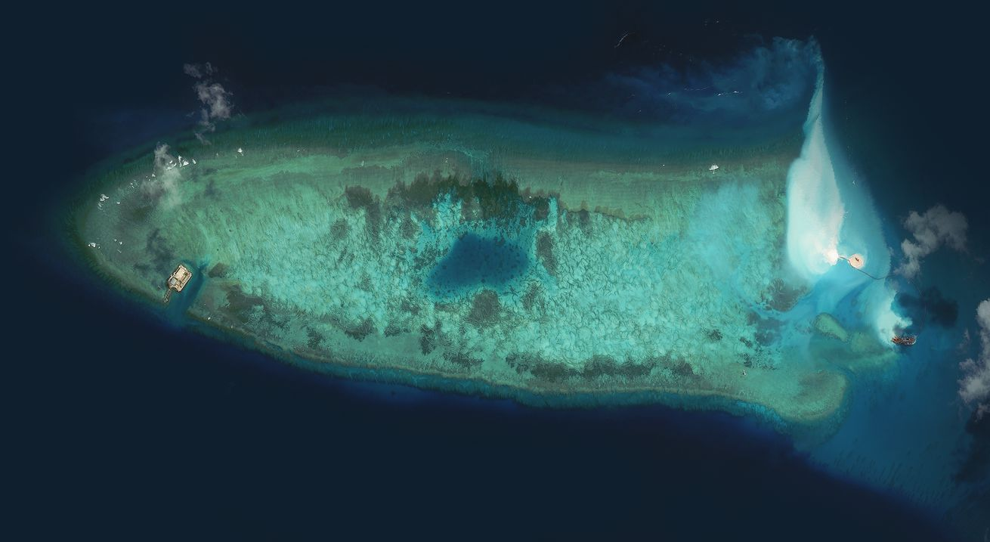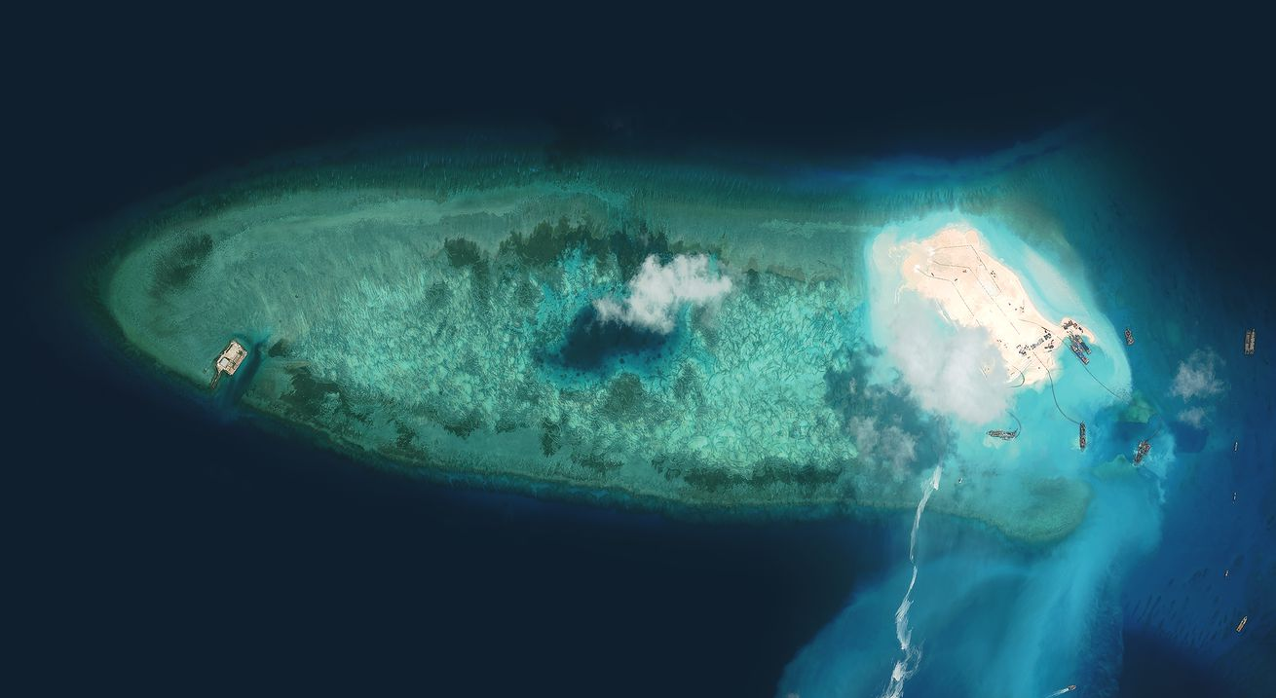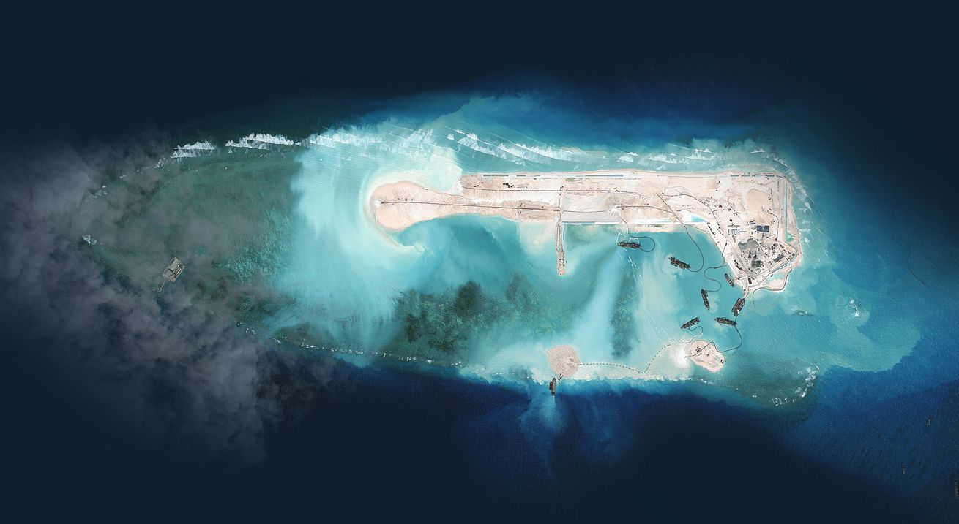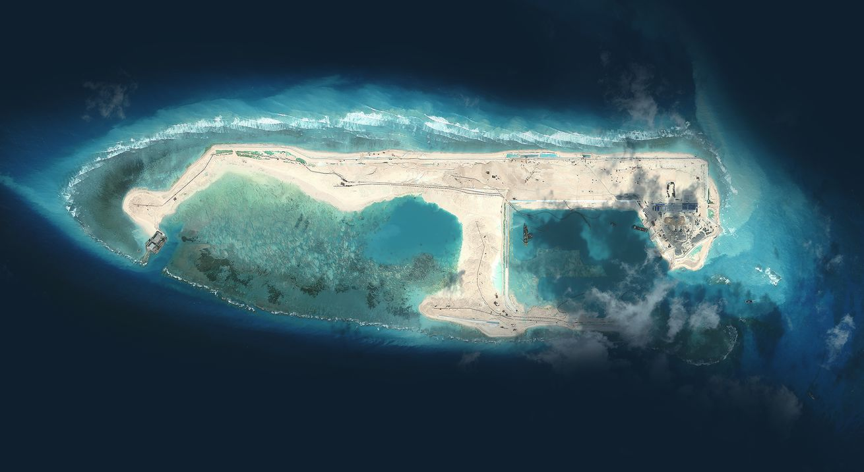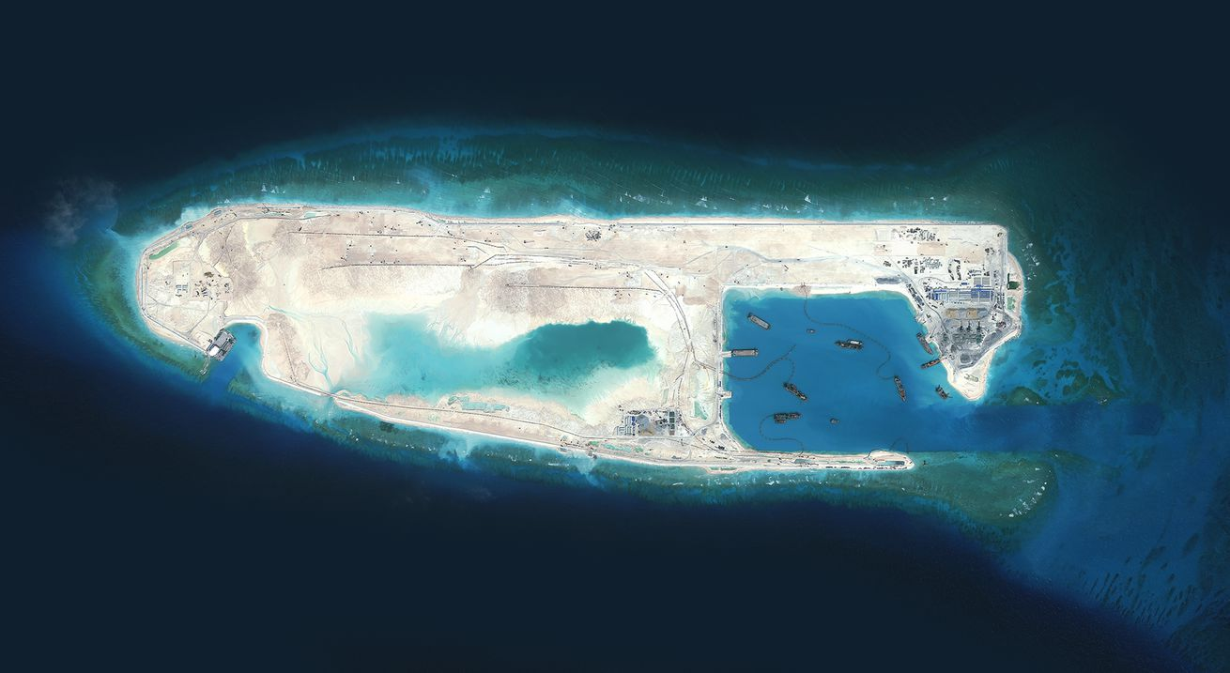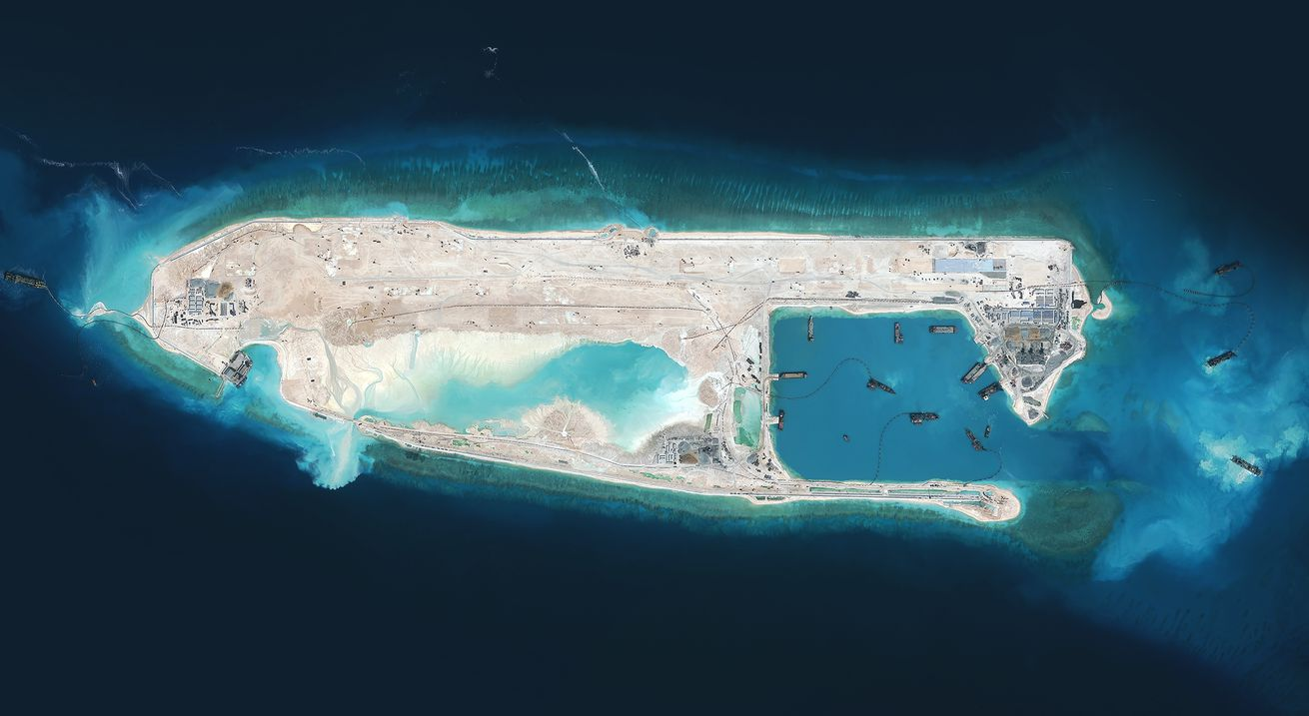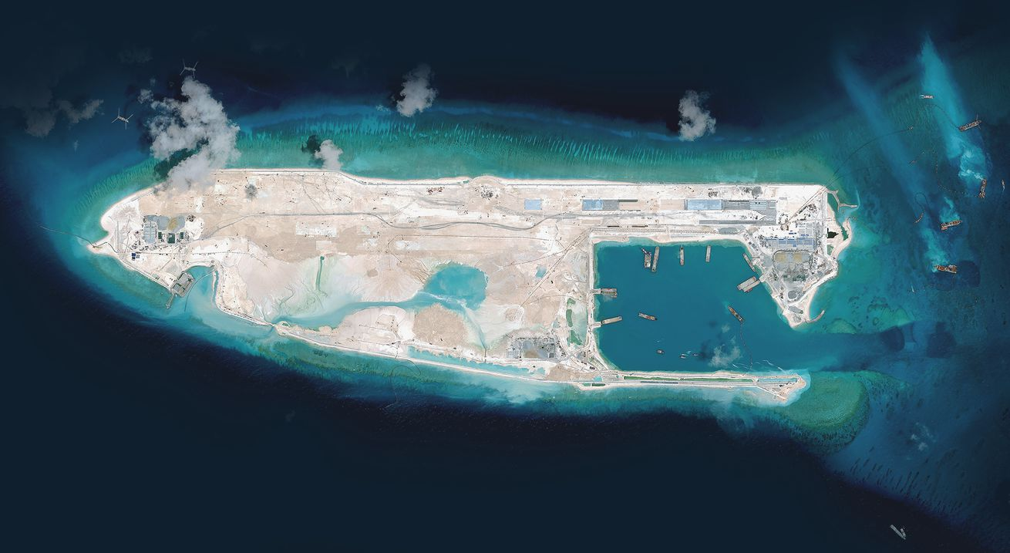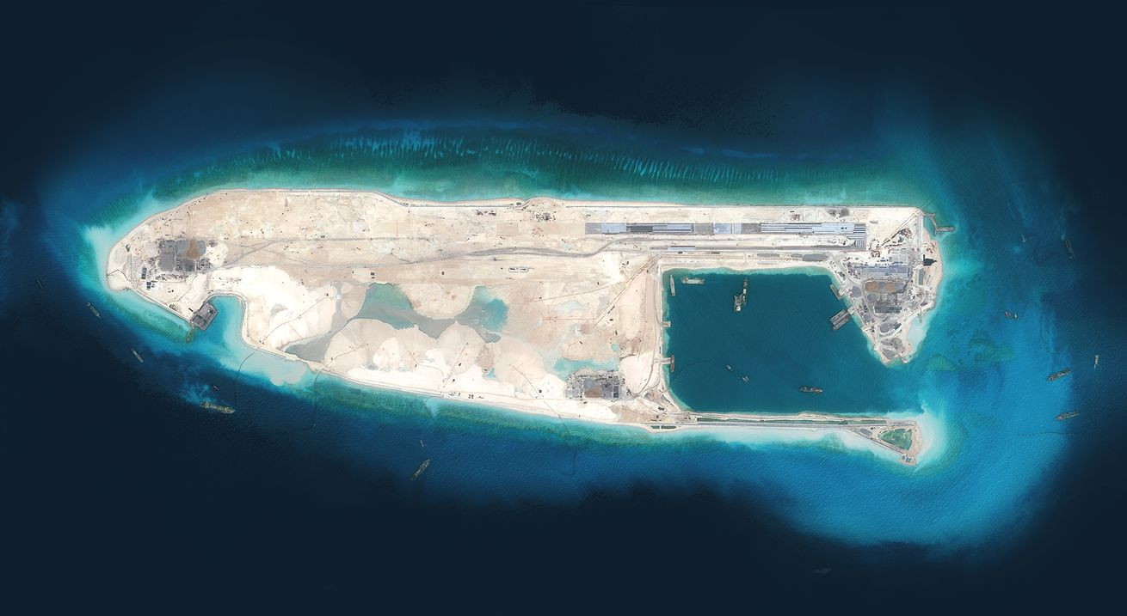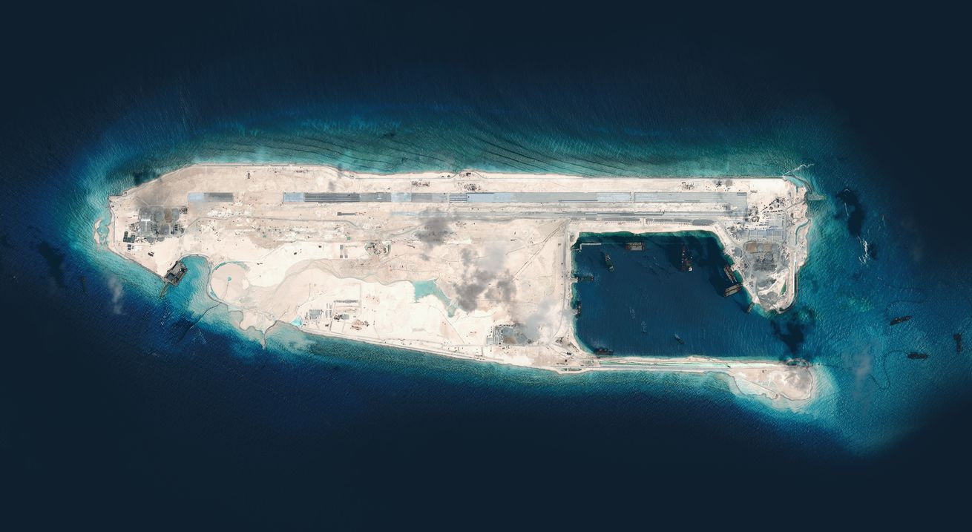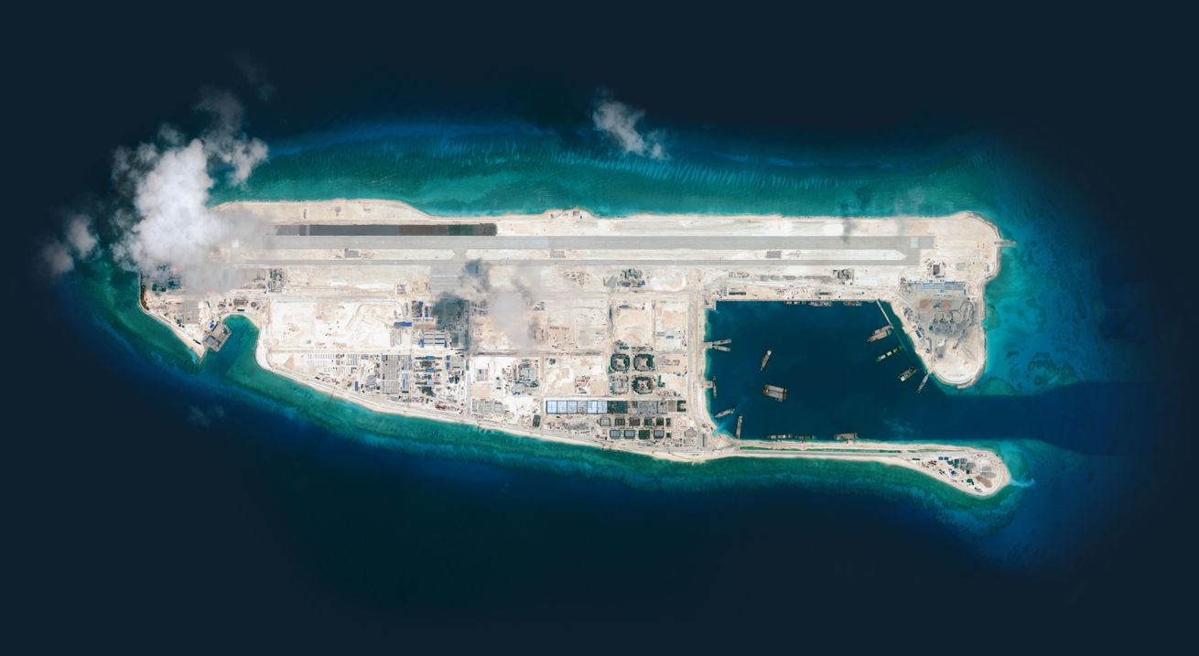
August 2014
Images by DigitalGlobe, via the CSIS Asia Maritime Transparency Initiative, and CNES, via Airbus DS and IHS Jane’s

What China Has Been Building
in the South China Sea
By DEREK WATKINS
UPDATED October 27, 2015
China has been rapidly piling sand onto reefs in the South China Sea, creating seven new islets in the region. It is straining geopolitical tensions that were already taut. 点击查看本文中文版
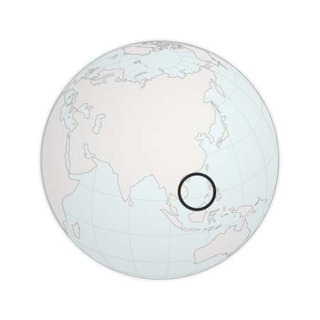
Asia
Pacific Ocean
South China Sea
Africa
Australia
The speed and scale of China’s island-building spree have alarmed other countries with interests in the region. China announced in June that the creation of islands — moving sediment from the seafloor to a reef — would soon be completed. Since then, China has focused its efforts on construction. So far it has constructed port facilities, military buildings and an airstrip on the islands, with recent imagery showing evidence of two more airstrips under construction. The installations bolster China’s foothold in the Spratly Islands, a disputed scattering of reefs and islands in the South China Sea more than 500 miles from the Chinese mainland. China’s activity in the Spratlys is a major point of contention between China and the United States and was a primary topic of discussion between President Obama and President Xi Jinping of China during the Chinese president’s visit to the White House in September. On Monday, the United States sent a Navy destroyer near the islands, entering the disputed waters.

Guangzhou
Hong Kong
Kunming
China
Luzon
Hanoi
Pacific Ocean
South China Sea
Hainan
Manila
Vietnam claims the Paracel and the Spratly Islands.
Myanmar
Laos
Paracel Islands
Philippines
Claimed by the Philippines
China has long marked its claim with a “nine-dash line” that skirts the coasts of other countries.
Visayas
Thailand
Mindanao
Palawan
Vietnam
Yangon
Sulu Sea
Cambodia
Spratly Islands
Bangkok
Fiery Cross Reef
100 Miles
Ho Chi Minh City
Phnom Penh
Celebes Sea
Claimed by Brunei
Gulf of Thailand
Malaysia
Andaman Sea
Claimed by Malaysia
Brunei
Indonesia
Sulawesi
Claimed by Indonesia
Borneo
Islands are colored by occupying country: China, the Philippines, Malaysia, Vietnam or Taiwan. Lines in the same colors show the extent of territorial claims.
Sources: C.I.A., NASA, China Maritime Safety Administration
The new islands allow China to harness a portion of the sea for its own use that has been relatively out of reach until now. Although there are significant fisheries and possible large oil and gas reserves in the South China Sea, China’s efforts serve more to fortify its territorial claims than to help it extract natural resources, said Mira Rapp-Hooper, formerly the director of the Asia Maritime Transparency Initiative at the Center for Strategic and International Studies, a Washington research group.Though too small to support large military units, the islands will enable sustained Chinese air and sea patrols of the area. The United States has reported spotting Chinese mobile artillery vehicles in the region, and the islands could allow China to exercise more control over fishing in the region.
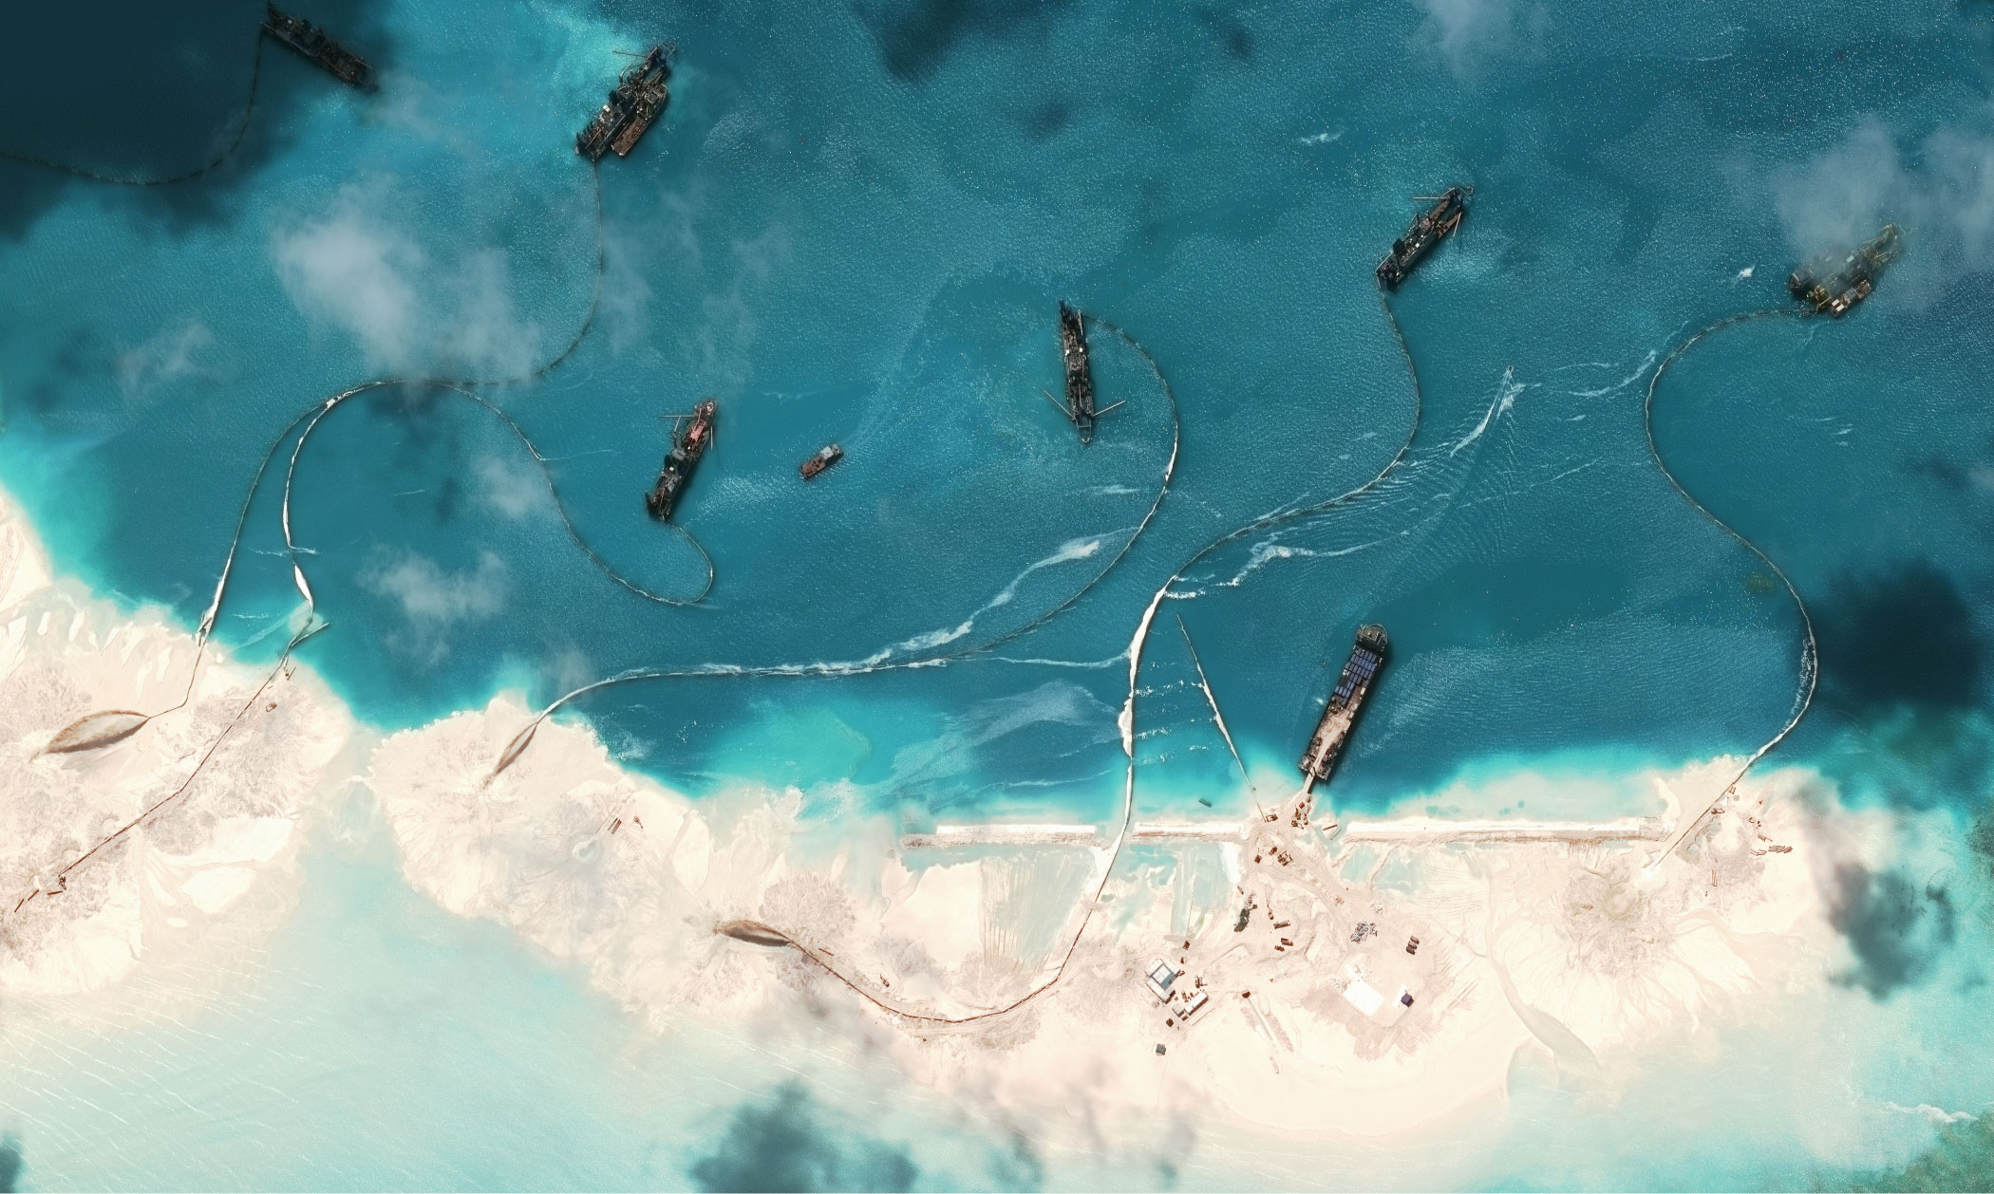
Dredgers
Sediment stream
Dredgers pump sediment onto Mischief Reef, March 2015.
Image by DigitalGlobe, via CSIS Asia Maritime Transparency Initiative
Several reefs have been destroyed outright to serve as a foundation for new islands, and the process also causes extensive damage to the surrounding marine ecosystem. Frank Muller-Karger, professor of biological oceanography at the University of South Florida, said sediment “can wash back into the sea, forming plumes that can smother marine life and could be laced with heavy metals, oil and other chemicals from the ships and shore facilities being built.” Such plumes threaten the biologically diverse reefs throughout the Spratlys, which Dr. Muller-Karger said may have trouble surviving in sediment-laden water.
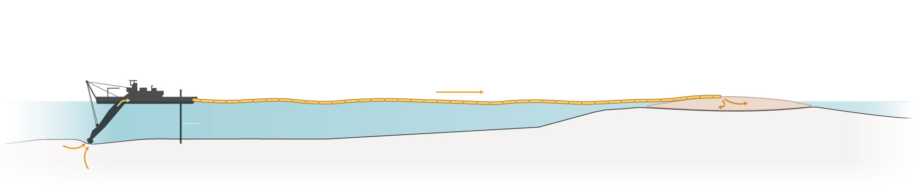
Sediment is broken up and sucked from the seabed.
Material is transported through a floating pipe.
Dredged material is deposited on the reef.
Anchor pole
Submerged reef
Ocean floor
The Chinese were relative latecomers to island building in the Spratly archipelago, and “strategically speaking, China is feeling left out,” said Sean O’Connor, principal imagery analyst for IHS Jane’s. Still, China’s island building has far outpaced similar efforts in the area, unsettling the United States, which has about $1.2 trillion in bilateral trade go through the South China Sea every year. Defense Secretary Ashton B. Carter criticized China’s actions in the region in May, asserting that, “The United States will fly, sail and operate wherever international law allows, as we do all around the world.” The United States reinforced that assertion on Monday and angered the Chinese when it sent the Lassen, a guided-missile destroyer, within 12 nautical miles of the islands, the conventional limit for territorial waters. According to statements from David Shear, the top Pentagon official in charge of Asia and the Pacific, the last time the United States sent ships or aircraft that close to the islands was in 2012.
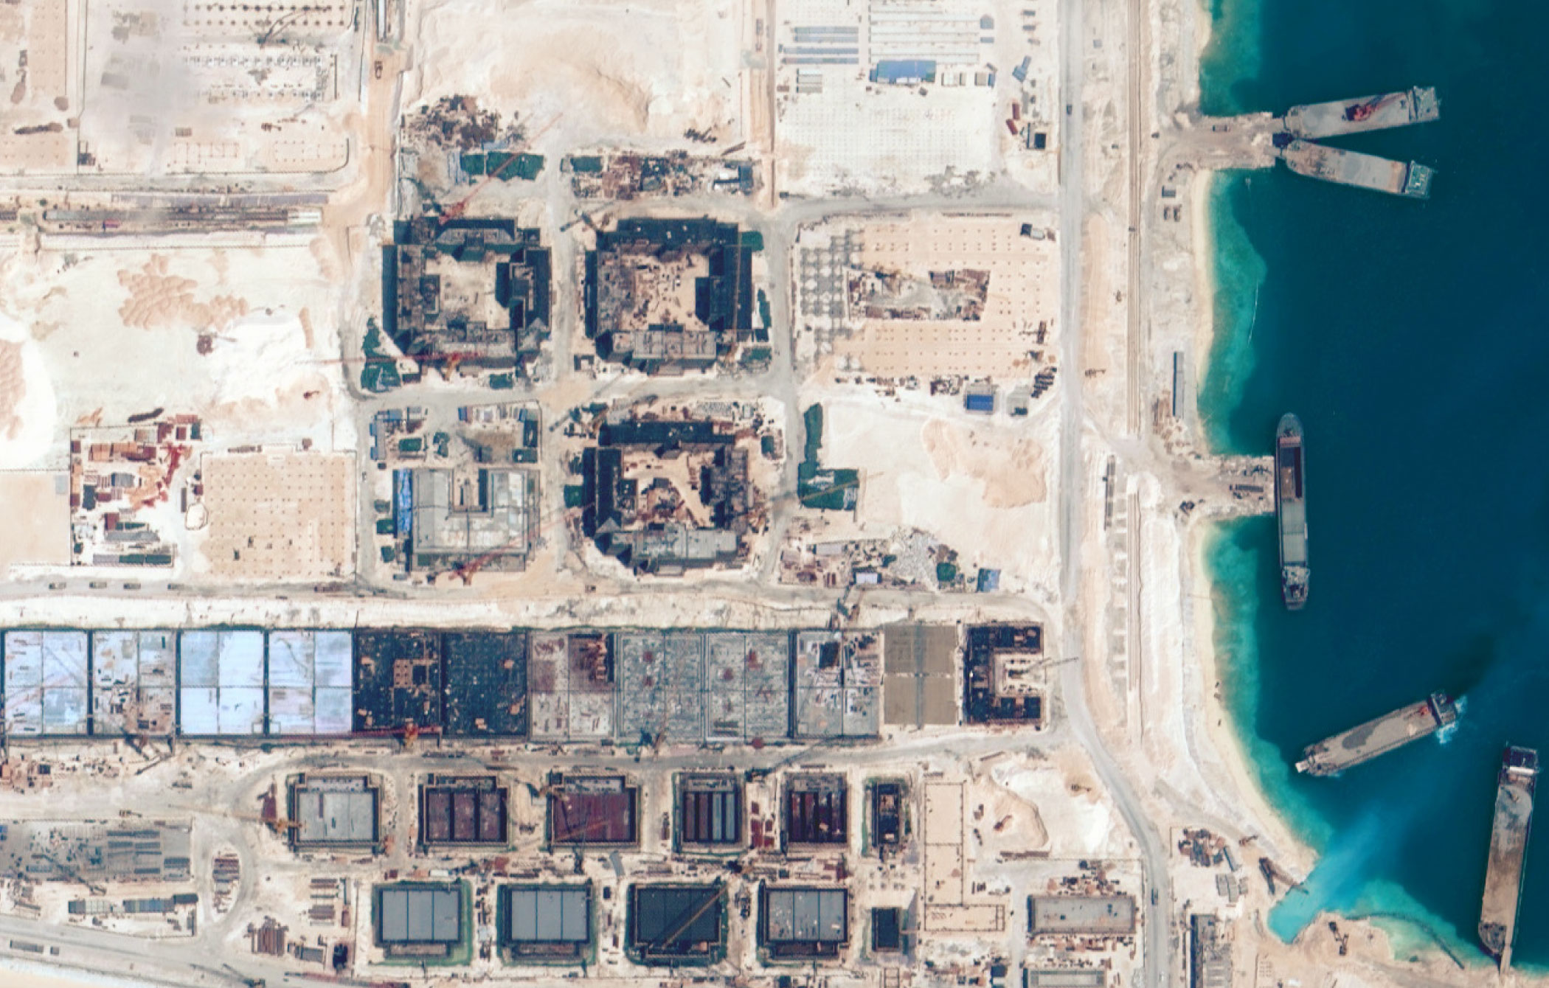
Buildings under construction at Fiery Cross Reef, September 2015.
Image by DigitalGlobe, via CSIS Asia Maritime Transparency Initiative

What Is on the Islands?
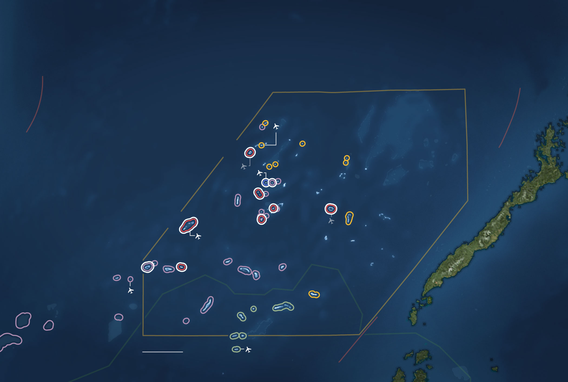
Philippine claim
Reed Bank
Existing airstrip
Subi Reef
Sand Cay
Gaven Reef
Mischief Reef
Fiery Cross Reef
Johnson South Reef
Hughes Reef
South China Sea
Under construction
Philippines
Spratly Islands
West Reef
Malaysian claim
Sulu Sea
50 Miles
Chinese claim
Islands and reefs that have undergone recent construction are shown with a white ring. Colored rings show whether the feature is occupied by China, the Philippines, Malaysia, Vietnam or Taiwan.
Sources: C.I.A., NASA, China Maritime Safety Administration
Vietnam, Malaysia, the Philippines and Taiwan have all expanded islands in the Spratlys as well, but at nowhere near the same scale as China.
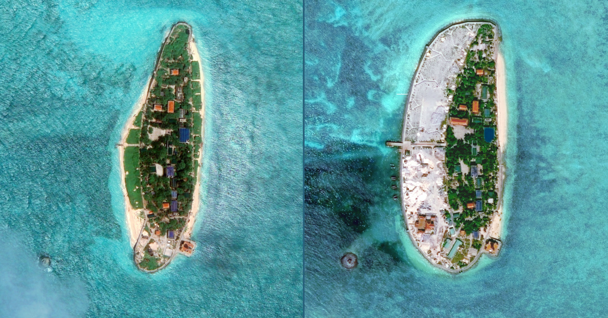
2011
2015
Island expansion
Land reclamation at Vietnam’s Sand Cay.
Image by DigitalGlobe, via CSIS Asia Maritime Transparency Initiative
For China, the Fiery Cross Reef is the most strategically significant new island, with an airstrip that is long enough to allow China to land any plane, from fighter jets to large transport aircraft. But China’s airstrip is not the first in the region — every other country that occupies the Spratlys already operates one as well.
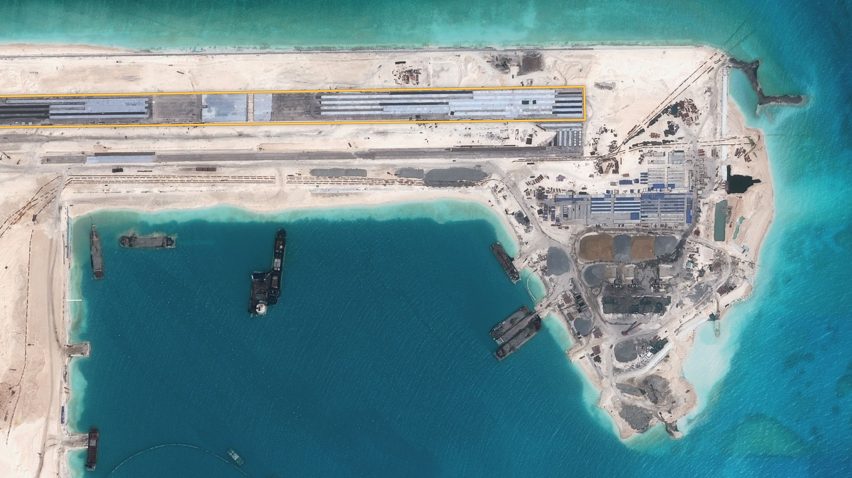
Dredging pipes
Seawall
10,000-foot airstrip
Apron
Support buildings
Cement plant
Seawall under construction
Temporary loading pier
Harbor
Construction on Fiery Cross Reef, April 2015.
Image by CNES distributed by Airbus DS, via IHS Jane’s
China’s reefs hosted smaller structures for years before the surge in construction. By preserving these initially isolated buildings, China can claim that it is merely expanding its earlier facilities, similar to what other countries have done elsewhere in the region.
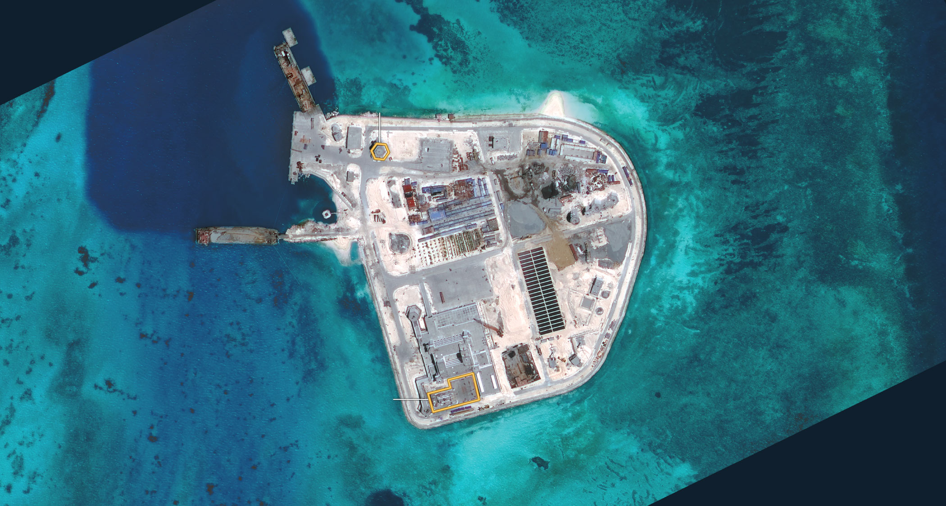
Possible radar facility
Harbor
Cement plant
Pier
Solar panels
Existing structure
Construction on Johnson South Reef, May 2015.
Image by DigitalGlobe, via CSIS Asia Maritime Transparency Initiative
In recent months, China has nearly completed two of its largest island building projects, at Mischief Reef and Subi Reef. Current imagery shows that China has likely started building airstrips on long, straight sections of each of those islands, which would give the country three airstrips in the area.
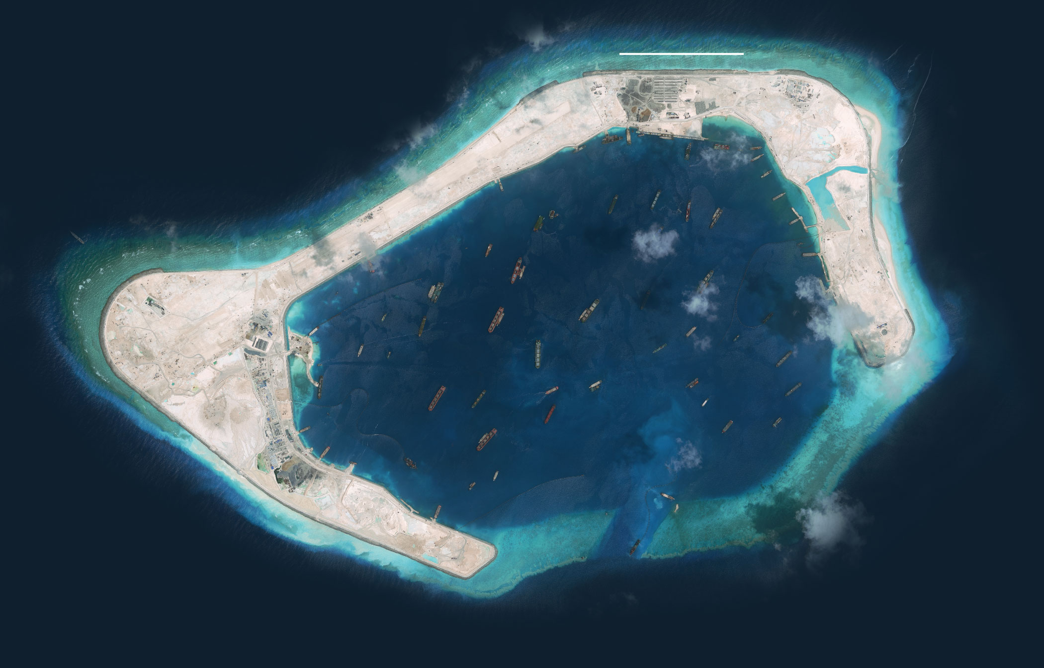
Half a mile
Airstrip under construction
Existing structure
Lagoon
Access channel
China’s land reclamation efforts and airstrip construction at Subi Reef, September 2015.
Image by DigitalGlobe, via CSIS Asia Maritime Transparency Initiative

NYT

U.S. Navy Commander Implies China Has Eroded Safety of South China Sea
By JANE PERLEZDEC. 15, 2015
Photo
Admiral Scott H. Swift, the commander of the United States Pacific Fleet Credit Aly Song/Reuters
BEIJING — A senior American naval commander has implicitly accused China of creating “so-called military zones” close to artificial islands it has built in the South China Sea, declaring that such actions are eroding the security of one of the world’s busiest waterways.
In a speech in Honolulu on Monday, the commander, Adm. Scott H. Swift of the United States Pacific Fleet, said commercial ships that had previously sailed freely through international shipping lanes were being diverted from areas deemed to be too close to the artificial islands built by the Chinese in the Spratly archipelago.
Admiral Swift, who visited China last month, said that routine commercial and military operations in the South China Sea had become subject to warnings, interrupting the freedom of navigation, as well as air rights, to such an extent that the “unilateral assertiveness” was becoming a trend that was “unacceptable.”
Continue reading the main story

Related in Opinion

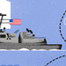

Op-Ed Contributor: China’s Dangerous Ambiguity in the South China SeaDEC. 10, 2015

Countries in the region are being forced to finance their navies beyond what is needed for self-defense, he said, implying that this was heightening the risk of an arms race.
News Clips: Asia Pacific By REUTERS 00:38 China Reacts to South China Sea Critics
Video http://www.nytimes.com/2015/12/16/world/asia/us-navy-commander-implies-china-has-eroded-safety-of-south-china-sea.html?emc=edit_ae_20151215&nl=todaysheadlines-asia&nlid=64888777

China Reacts to South China Sea Critics
A spokesman for China’s Foreign Ministry on Tuesday accused “some countries” of exaggerating tensions in the South China Sea after a United States admiral warned of an arms race in Asia.
Although Admiral Swift did not say as much, it was clear he was referring to China.
By mentioning “so-called military zones,” he was offering a counterpoint to an assertion by President Xi Jinping of China during a visit to Washington in September that China did “not intend to pursue militarization” of islands in the South China Sea.
The admiral’s speech, delivered to a regional security forum, was his second concerning the South China Sea since October, and was tougher in tone than his previous warnings about the situation. Officials from China were invited to the forum but did not attend, a Pacific Fleet official said.
The South China Sea has become one of the most serious strategic problems between China and the United States, largely because Washington challenges Beijing’s right to enlarge tiny specks in the waterway into islands big enough to accommodate military runways and radar equipment. The waterway is important to China militarily and commercially: About 75 percent of its oil imports arrive by sea, according to China Energy News, a state-run publication.
In October, the United States dispatched a guided missile destroyer, the Lassen, on a freedom-of-navigation patrol within the 12-nautical-mile limit of Mischief Reef, one of the new artificial islands in the Spratly archipelago claimed by China. Other claimants of reefs and islands in the Spratlys include Malaysia, the Philippines, Taiwan and Vietnam.
Admiral Swift said that fishermen from the region were also threatened.
“Intimidated by the manner in which some navies, coast guards and maritime military enforce claims in contested waters, fishermen who trawled the seas freely for generations are facing threats to their livelihoods imposed by nations with unresolved, and often unrecognized, claims,” he said.
In reaction to Admiral Swift’s speech, a spokesman at the Chinese Foreign Ministry, Hong Lei, said on Tuesday that “some country” — an obvious reference to the United States — was “deliberately” exaggerating tensions in the region with the purpose of creating “chaos.”

A Pacific Fleet spokesman, asked for specific examples of commercial ships that had been forced to change their route because of orders from the Chinese Navy, said he would need time to research the answer.
Tussles between Chinese vessels and fishing trawlers from other nations around the South China Sea have occurred for years. But the Chinese vessels have been emboldened by a new Chinese law this year that requires foreign fishing vessels to obtain permission to enter waters that China claims.
Trawlers from the Philippines and Vietnam have reported being hosed by Chinese water cannons this year and of being robbed at gunpoint. In September, Vietnam said a Chinese vessel had sunk one of its fishing boats near the Paracel Islands, which are claimed by China and Vietnam.
Admiral Swift’s remarks came as the BBC reported that a single-engine Cessna 206 aircraft rented by one of its television crews for filming the creation of artificial islands in the South China Sea had been warned by the Chinese Navy to turn back as it neared each of three artificial islands.
Continue reading the main story

Interactive Feature

What China Has Been Building in the South China Sea
China has been feverishly piling sand onto reefs in the South China Sea for the past year, creating seven new islets in the region. It is straining geopolitical tensions that were already taut.
OPEN Interactive Feature

The plane was identified incorrectly by the Chinese as a military aircraft and ordered to leave the airspace around the islands China has built, the BBC said.
When the plane headed southwest toward Fiery Cross Reef, known as Yongshu Jiao in Chinese, and was close to 20 nautical miles to the reef where the Chinese have built a major runway, a voice came over the radio, the BBC said.
“Foreign military aircraft to northwest of Yongshu Island, this is the Chinese Navy. You are threatening the security of our station,” the voice said, according to the BBC account.
When the plane flew toward Gaven Reef and Mischief Reef, also places where the Chinese have undertaken construction, there were similar warnings from the Chinese, the BBC said.
As the BBC plane turned back toward the Philippines, it came across a military aircraft of the Royal Australian Air Force patrolling the region that had apparently received orders from the Chinese to leave.
The BBC reported the Australian pilot saying: “China Navy, China Navy. We are an Australian aircraft exercising international freedom-of-navigation rights, in international airspace in accordance with the international civil aviation convention and the United Nations Convention on the Law of the Sea. Over.”
In the Australian capital, Canberra, the country’s Defense Department said that an AP-3C Orion had conducted routine maritime patrols from Nov. 25 to Dec. 4 as part of a regular surveillance operation intended to preserve “regional security and stability” in Southeast Asia.
As Washington’s strongest ally in the Pacific region, the Australian government has increasingly expressed concerns about China’s behavior in the South China Sea.
Australia has operated the Orion aircraft from a base in the Malaysian state of Penang for a range of duties in the Asia Pacific region, including during the war in Afghanistan, according to Peter Jennings, executive director of the Australian Strategic Policy Institute in Canberra.
Australia conducts surveillance flights for its own intelligence purposes and not as part of a joint operation with the United States, he said. So far, the flights over the South China Sea have been irregular and conducted without much fanfare, although the former Australian defense minister David Johnston mentioned them in a speech in Singapore last year, Mr. Jennings said.
The tone of Admiral Swift’s speech showed that the standoff between China and the United States and its allies over the South China Sea was becoming increasingly difficult to resolve, Mr. Jennings said.
“It’s very hard to see how there can be a compromise between China’s assertion of sovereign control over the vast majority of the South China Sea inside the Nine Dash Line and freedom of navigation,” he said, referring to a line drawn by the Chinese that roughly encircles more than 80 percent of the waterway.
Asked on Tuesday about the BBC flight and the warning from the Chinese Navy, Mr. Hong of the Chinese Foreign Ministry said that China had “indisputable sovereignty” over the Spratly Islands.

NYT

Vietnam Objects to Chinese Oil Rig in Disputed Waters
By MIKE IVESJAN. 20, 2016
Photo
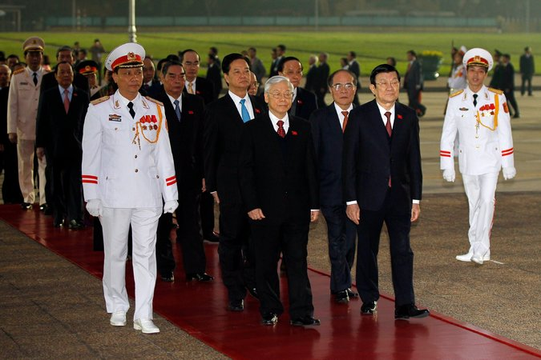
Nguyen Phu Trong, the Vietnam Communist Party’s secretary general, foreground; President Truong Tan Sang, right; and Prime Minister Nguyen Tan Dung, behind Mr. Trong; before the party congress in Hanoi on Wednesday. Credit Pool photo by Luong Thai Linh
HANOI, Vietnam — The Vietnamese government has lashed out against the presence of a Chinese oil rig in the disputed waters of the South China Sea, the latest in what Vietnam says are a series of provocative actions by Beijing this month.
While the dispute raised tensions between the Communist neighbors, there were no signs yet of the heated escalation that characterized a similar incident in 2014, when relations between the two countries plummeted and anti-Chinese demonstrations spiraled into deadly riots.
Late Tuesday, the Vietnamese Foreign Ministry said that Haiyang Shiyou 981, the same rig that caused the 2014 dispute, had entered disputed waters in the South China Sea on Saturday, according to a statement on the ministry’s website.

The rig was still 25 miles from an “assumed median line” between the two countries, the statement said, but it was in “an overlapping area between the two continental shelves” of Vietnam and Hainan Island, China, which “has not yet been delimited.”
Continue reading the main story

Interactive Feature

What China Has Been Building in the South China Sea
China has been feverishly piling sand onto reefs in the South China Sea for the past year, creating seven new islets in the region. It is straining geopolitical tensions that were already taut.
OPEN Interactive Feature

A Vietnamese official met with a Chinese Embassy official on Monday to register Vietnam’s “concern,” the statement said. It added that China should remove the rig from the disputed waters in accordance with international law.
China insisted that the rig was still in its territorial waters.
“To our knowledge, China’s Haiyang Shiyou 981 drilling platform is working in totally indisputable waters under China’s jurisdiction,” Hong Lei, a Chinese Foreign Ministry spokesman, said at a news conference on Wednesday. “It is hoped that the Vietnamese side can view it calmly, work with China in the same direction and make joint efforts to properly handle the maritime issue.”
The dispute came as Vietnam’s top leaders convened here on Wednesday for the start of a Communist Party national congress, which will choose the country’s leaders for the next five years. Analysts said the dispute was unlikely to affect those decisions, and the party appeared to be taking pains not to alienate China.
But the presence of the oil rig has raised anxiety here, and it comes after several other diplomatic scrapes.
Vietnam asked China to investigate the ramming of a Vietnamese fishing vessel this month by a boat that the captain said was marked with Chinese characters. In recent weeks, Vietnam has also complained about several unannounced, state-sponsored Chinese flights through Vietnamese-administered airspace in the South China Sea.
Also this month, Vietnam formally accused China of violating its sovereignty, as well as a recent confidence-building pact, after Beijing landed a plane on an artificial island built by China.
“Speculation as to whether and how the timing of these actions might affect Vietnam’s leadership succession misses the more glaring point that Beijing appears not to care about international norms or Vietnamese claims and sensibilities,” Jonathan London, a Vietnam expert in the Department of Asian and International Studies at the City University of Hong Kong, said in an email.
Le Hong Hiep, a visiting fellow at the ISEAS-Yusof Ishak Institute in Singapore, said the timing of the oil rig’s movements — at the moment when Vietnam begins a twice-a-decade power transfer — may be a coincidence. But whatever the reason, he added, Vietnam is unlikely to immediately “take strong actions that will cause tension,” such as sending Coast Guard ships to the area to challenge the oil rig, as it did in 2014.
“The party wants to make sure the party congress is a success,” he said.
Photo
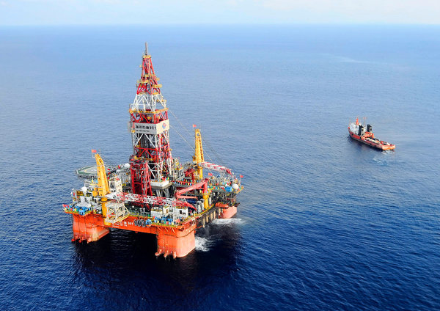
The oil rig Haiyang Shiyou 981 in the South China Sea in 2012. Credit Jin Liangkuai/Xinhua, via Associated Press
The oil rig, China’s first domestically built mobile-drilling platform, is 449 feet tall and the covers an area the size of a football field. It is owned by the China National Offshore Oil Corporation, a state-owned oil giant that handles most of China’s offshore drilling, according to a report last month in Global Times, a state-run Chinese newspaper.
Starting in May 2014, the rig lingered for weeks in disputed waters close to the disputed Paracel Islands and the central Vietnamese coast.
The dispute led to daily clashes at sea between Chinese vessels and Vietnamese boats, with larger Chinese vessels ramming smaller Vietnamese boats, and the Chinese using powerful water cannons to keep the Vietnamese vessels at bay.
In Vietnam, anti-Chinese demonstrations turned violent as two Chinese workers were killed and factories run by companies from Taiwan and South Korea were destroyed.
China ultimately withdrew the rig, a month earlier than its announced plan, saying its work had been completed.
Vietnam and China have been attempting to mend their relations ever since, but the episode generated a heated national debate among Vietnamese about the country’s political and economic dependence on its giant northern neighbor. Analysts say it also accelerated Vietnam’s long-running effort to improve relations with the United States and other global powers.
A pending reshuffle of party leadership, to be decided at the congress over the next week, is said to hinge on an internal power struggle between Nguyen Phu Trong, the party’s incumbent general secretary, and Nguyen Tan Dung, the prime minister. Mr. Dung is generally seen as more friendly to American officials and the international business community, although Mr. Trong visited the White House last year and has supported Vietnam’s membership in the American-led Trans-Pacific Partnership trade deal.
Mr. Hiep said the rig appeared to be on the Chinese side of a line running between Hainan, a Chinese resort island, and the Vietnamese central coast, but he added that Vietnam may take stronger actions if the rig crossed the line, although not until after the party congress ends in late January.
Nguyen Hung Cuong, a lawyer and South China Sea expert at Vietnam’s Scientific Research Institute of Sea and Islands in Hanoi, said the rig’s return to disputed waters appeared to be a deliberate escalation by China of its efforts to claim vast swaths of territory in the South China Sea.
But Mr. Cuong said it was unclear as of Wednesday whether the oil rig was just passing through disputed waters to exercise freedom of navigation, or whether it had already started to drill.
“We need to wait for a few days to know,” Mr. Cuong said. “In case the oil rig unilaterally carries out drilling activity in the disputed waters, that is completely illegal” under United Nations law.

The Economist

Taiwan wades in: the South China Sea
Today Ma Ying-jeou, the president who leaves office in May, is making a rare and controversial visit to Itu Aba, the biggest natural island in the Spratly archipelago, in the much-disputed South China Sea. It is garrisoned by Taiwan, but also claimed by China, the Philippines and Vietnam. The Philippines and Vietnam are incensed; China less so: it maintains the fiction that there is “one China”, and Taiwan’s territorial claims are its own. Mr Ma wants to show that the island can sustain human life, and so is entitled under international law to a 200-nautical-mile (370km) exclusive economic zone. He will also advertise his own “South China Sea Peace Initiative”, announced last May but largely ignored. The risk is that the Philippines and Vietnam retaliate, in turn provoking China. Alarmed, America issued a sharp denunciation of Mr Ma’s “extremely unhelpful” day-trip as soon as it was announced.
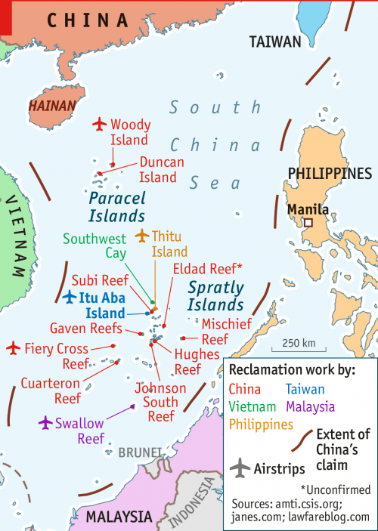

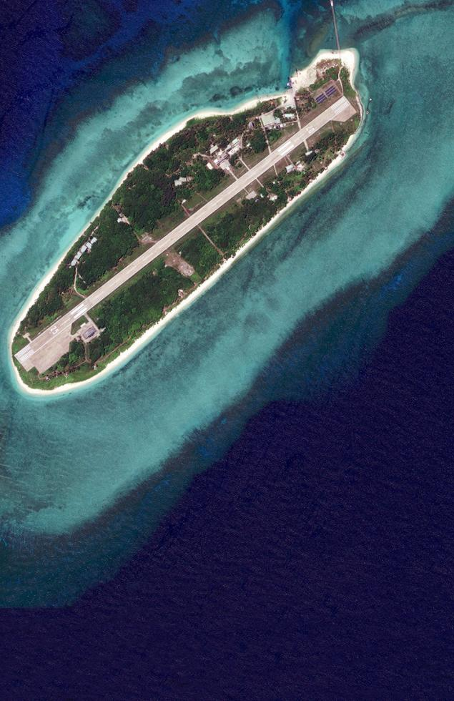

The South China Sea

Making a splash

Taiwan’s outgoing president further roils troubled waters
Jan 30th 2016 | From the print edition

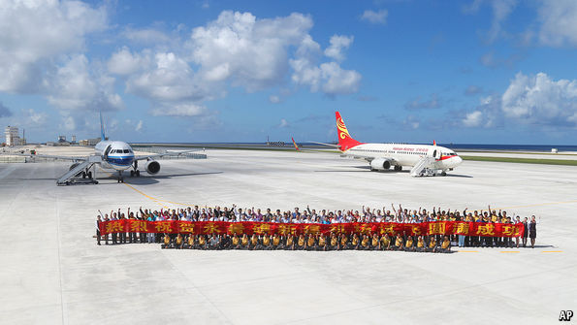

AS PARTING gestures go, it was a risky one. Taiwan’s president, Ma Ying-jeou, leaves office in May, having lost an election on January 16th. But rather than slink out quietly, this week he visited Itu Aba, known in Chinese as Taiping, the biggest natural island in the Spratly archipelago in the South China Sea, garrisoned by Taiwan but also claimed by China, the Philippines and Vietnam. The Philippines and Vietnam were incensed, China much less so: it appreciates Mr Ma’s adherence to the fiction that there is but “one China”. From its point of view, Taiwan’s territorial claims in the much-disputed sea are its own.
Besides reasserting Taiwan’s claim, Mr Ma wanted to rebut arguments made by the Philippines, in a case it has brought before the Permanent Court of Arbitration in The Hague. This argues that under the UN Convention on the Law of the Sea (UNCLOS), Itu Aba is a rock that cannot sustain human life. So it is entitled to 12 nautical miles of territorial waters, but not the 200-mile exclusive economic zone accorded to habitable islands. Mr Ma also possibly hoped to advertise his own “South China Sea Peace Initiative”, which he announced last May but which was largely ignored.
The risk is that the Philippines and Vietnam may retaliate in some way—perhaps even with high-profile visits to islands they occupy, though this is unlikely—and that this, in turn, provokes China. America is so alarmed that its representative in Taiwan issued an unusually forthright denunciation of Mr Ma’s “extremely unhelpful” day-trip as soon as it was announced.

Tensions over the sea have been rising in any case. China has been building frenetically, turning rocks and reefs in the Spratlys into islands, three of them already bigger than Itu Aba, with airstrips. It has recently landed civilian aircraft carrying “tourists” on one (see picture). And China has again moved a large oil rig into waters claimed by Vietnam—as it did in 2014 when it provoked fatal anti-Chinese riots.
China derides all criticism. One Chinese official compares rival claimants’ complaints to “smashing the windows of your neighbours’ house and then saying, ‘We are being threatened’.” China believes America is stoking alarm as part of a broader strategy to contain it. It is true that its neighbours are gradually stepping up security co-operation with each other and with America. Just this week Vietnam approved an Indian satellite-tracking centre on its soil to share imagery, including pictures of the South China Sea.
The worry is that China is steadily expanding its presence until its dominance of the sea becomes an incontestable fact. This also concerns America: the sea is a vital trade artery, and China threatens 70 years of American naval supremacy in the western Pacific. In a report published in January, commissioned by the Pentagon to look at America’s strategic “rebalance” towards Asia, the Centre for Strategic and International Studies, a Washington think-tank, projected that by 2030, on current trends, “the South China Sea will be virtually a Chinese lake, as the Caribbean or Gulf of Mexico is for the United States today.”
Three approaches are being tried to moderate China’s behaviour—legal, diplomatic and military. The broader aim of the Philippines’ case under UNCLOS is to show that China’s historic claim—a “nine-dash line” on maps encompassing most of the sea—has no legal basis. In October China suffered a setback when the court in The Hague accepted that the case fell within its jurisdiction. But even if the court rules in the Philippines’ favour, China has made clear that it will ignore it. South-East Asian claimants in the sea—the Philippines, Vietnam, Brunei and Malaysia—have hoped that their regional club, ASEAN, can show a united front. But China prefers to negotiate with (and bully) ASEAN members individually. And it skilfully exploits the body’s internal differences.
As for military deterrence, a marked increase in defence spending across the region in recent years still leaves America as the only power capable of standing up to China. As a reminder of this, in November the American navy conducted a “freedom of navigation operation” in the South China Sea. These operations, conducted around the world, involve sending warships to challenge excessive maritime claims by sailing through the claimed waters. In the South China Sea, America says it takes no position on the sovereignty disputes but does want international law to apply. In this exercise, the USS Lassen sailed close to Subi reef, where China has built an artificial island on what was once a feature submerged at high tide.
Yet the message was muddied. In January Ashton Carter, America’s secretary of defence, explained that the operation had been conducted as “innocent passage”, ie, under a provision of UNCLOS that allows warships to enter even territorial waters so long as they do nothing that might have a military purpose. So it is not clear quite what point America was trying to make.
John Kerry, America’s secretary of state, was in China this week (see article), after a trip that took in Cambodia and Laos, which holds the chairmanship of ASEAN this year. He spoke of the need to avoid a “destabilising cycle of mistrust or escalation” in the South China Sea. At a gathering on February 15th and 16th at a ranch in Sunnylands, California, Barack Obama will play host to the leaders of all ten ASEAN countries. The unprecedented summit is a symbolic demonstration of American support for ASEAN. China will probably scent another attempt to rally the region against it. But nothing suggests it will be deterred from trying to turn the sea into its own lake.

NYT

U.S. Challenges China’s Claim of Islands With Maritime Operation
By JANE PERLEZJAN. 30, 2016
BEIJING — China on Saturday accused the United States Navy of violating its laws by sending a warship within the 12-mile territorial zone of an island it claims in the South China Sea after the Pentagon said a Navy vessel had conducted a freedom of navigation operation.
The United States vessel, the missile destroyer Curtis Wilbur, entered the waters off Triton Island in the Paracel Islands chain on Saturday without giving China notice in an exercise intended to challenge “excessive maritime claims” by China and two other countries, said Mark Wright, a Pentagon spokesman. Vietnam and Taiwan also claim Triton Island, though the Navy operation appeared to be aimed at China.
The goal of the operation was to send a message to China, Taiwan and Vietnam that their attempts to restrict navigational rights by requiring other countries to obtain permission before entering the waters around the island were “inconsistent” with international law, Mr. Wright said.
In a statement on the website of the Chinese Foreign Ministry, Hua Chunying, a ministry spokeswoman, said, “The U.S. warship’s arbitrary entrance of China’s territorial water has violated the relevant Chinese law, and the Chinese side has taken relevant measures in accordance with the law including monitoring and warning.
“We urge the U.S. side to respect and abide by the relevant Chinese law, and do more things that may contribute to the mutual trust between China and the U.S., as well as regional peace,” the statement added.
Ms. Hua did not elaborate on what kind of warnings the Chinese had made to the American warship, or if Chinese vessels followed the Curtis Wilbur as it sailed inside the 12-mile zone around the island, which China claims as its territory.
In a harsher reaction, the Chinese Defense Ministry said a garrison on the island, as well as navy ships and planes, had “immediately” identified the American warship and warned it to leave.
The statement said the American operation was a “severe” violation of law which undermined the “peace, security as well as the good order in the relevant waters.” It called the operation “highly unprofessional and irresponsible for the safety of soldiers for both sides.”
The operation by the Curtis Wilbur was the second such operation since October when the destroyer Lassen sailed within 12 miles of Subi Reef, one of seven artificial islands built by China in another archipelago in the South China Sea, the Spratly Islands, not far from the Philippines.
The Obama administration has warned Beijing that it would challenge China’s claim that much of the South China Sea is its sovereign territory. The freedom of navigation operations are intended to show that American vessels can sail in international waters at any time they desire.
During an appearance in Washington at the Center for Strategic and International Studies on Thursday, the commander of the United States Pacific Fleet, Adm. Harry B. Harris Jr., said the Navy would conduct more freedom of navigation operations, but he gave no notice that the patrol by the Curtis Wilbur would come so soon.
The United States has taken particular exception to China’s enlargement of tiny atolls and reefs into larger islands equipped with military-size runways and the capacity to park fighter jets and berth naval ships.
In the past 18 months, China had reclaimed more than 3,000 acres to build the artificial islands compared with 215 acres of land reclaimed by Vietnam, Malaysia, the Philippines and Taiwan in the past 40 years, Admiral Harris said during his talk at the center.
Triton Island, known by the Chinese as Zhongjian Island, is close to the area in the South China Sea where the China National Offshore Oil Corporation, a major energy company, moved an oil rig in 2014, resulting in a standoff between vessels of Vietnam and China, and a sharp deterioration in relations between the countries.

China Retools Its Military With a First Overseas Outpost in Djibouti
点击查看本文中文版 Read in Chinese
By JANE PERLEZ and CHRIS BUCKLEYNOV. 26, 2015
Photo
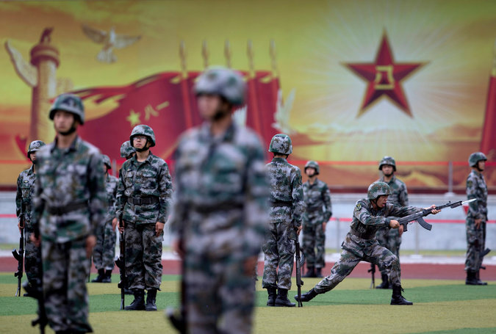
A People's Liberation Army training drill near Beijing last year. China said on Thursday that it would build a logistics facility in Djibouti, in a sign of the growing reach of its navy. Credit Andy Wong/Associated Press
BEIJING — China announced on Thursday that it would establish its first overseas military outpost and unveiled a sweeping plan to reorganize its military into a more agile force capable of projecting power abroad.
The outpost, in the East African nation of Djibouti, breaks with Beijing’s longstanding policy against emulating the United States in building military facilities abroad.
The Foreign Ministry refrained from describing the new installation as a military base, saying it would be used to resupply Chinese Navy ships that have been participating in United Nations antipiracy missions.
Yet by establishing an outpost in the Horn of Africa — more than 4,800 miles away from Beijing and near some of the world’s most volatile regions — President Xi Jinping is leading the military beyond its historical focus on protecting the nation’s borders.
Together with the plan for new command systems to integrate and rebalance the armed forces, the two announcements highlight the breadth of change that Mr. Xi is pushing on the People’s Liberation Army, which for decades has served primarily as a lumbering guardian of Communist Party rule.
Mr. Xi told senior military officers this week that he wanted to “build a robust national defense and a strong military that corresponds to our country’s international stature, and is adapted to our national security and developmental interests,” the Xinhua news agency reported.
A presence in Djibouti would be China’s first overseas logistics facility to service its military vessels since the Communists took power, said David Finkelstein, director of China studies at CNA, an independent research institute in Arlington, Va.
“In the grand sweep of post-1949 Chinese history, this announcement is yet another indicator that Chinese policy is trying to catch up with national interests that have expanded faster than the capacity of the People’s Republic of China to service them,” Mr. Finkelstein said.
The new facility would enable the navy to live up to a strategy laid down this year by the Communist Party in a major defense document, known as a white paper, that outlined its ambitions to become a global maritime power.
The United States maintains its only military base on the African continent in Djibouti, which it uses as a staging ground for counterterrorism operations in Africa and the Middle East. Last year, President Obama renewed the lease on that base for 20 more years.
China has invested heavily in Djibouti’s infrastructure, including hundreds of millions of dollars spent upgrading the country’s undersize port. It has also financed a railroad extending from Addis Ababa, the capital of Ethiopia, to Djibouti, a project that cost billions of dollars. The country has a population of about 900,000, many of whom live in poverty.
Strategically, Djibouti offers an excellent place from which to protect oil imports from the Middle East that traverse the Indian Ocean on their way to China, military experts say. From Djibouti, China gains greater access to the Arabian Peninsula.
The news on Thursday of broad changes to the Chinese military signaled a major step forward in Mr. Xi’s program to shift its focus from traditional land armies to a more flexible, cohesive set of forces. China’s military planning and spending have increasingly focused on territorial disputes in the South China Sea and in waters near Japan.
Mr. Xi told a gathering of more than 200 senior military officers that the planned changes would take years and were essential to ensuring that the People’s Liberation Army could shoulder its increasingly complex and broad responsibilities, the official Xinhua news agency said Thursday.
But until now, efforts to revamp the way the military is run have stumbled because of the entrenched power of land forces that have dominated seven military regions, as well as the sheer complexity of reorganizing a force of over two million.
Enactment of the military reforms would be a political victory for Mr. Xi, who since coming to power in November 2012 has enforced an intense campaign against corruption that took down dozens of senior military officers. They have included two former vice chairmen of the Central Military Commission, Gens. Guo Boxiong and Xu Caihou.
Continue reading the main story

Interactive Feature: What China Has Been Building in the South China Sea

That military graft was lubricated by rapidly rising defense budgets. In the decade up to 2014, China’s official military budget grew an average of 9.5 percent annually, after taking inflation into account, according to a recent Congressional Research Service study. That budget is set to grow an additional 10 percent this year, reaching about $145 billion. But many foreign analysts say China’s real military spending is higher.
Despite Beijing’s traditional rejection of what it calls American imperialism and hegemony, some Chinese experts believe that it is time to reconsider the need for overseas military facilities.
Shen Dingli, a professor of international relations at Fudan University in Shanghai, who has argued that China should develop bases commensurate with its growing military power, said on Thursday that in doing so, China would only be doing what America had done.
“The United States has been expanding its business all around the world and sending its military away to protect those interests for 150 years,” Mr. Shen said. “Now, what the United States has done in the past, China will do again.”
Mr. Shen, who referred to the planned facility in Djibouti as a “base,” said it was necessary because “we need to safeguard our own navigational freedom.”
He added, “If whoever — pirates, ISIS or the U.S. — wants to shut down the passage, we need to be able to reopen it.”
The head of the United States Africa Command, Gen. David M. Rodriguez, said in Washington last week that China planned “to build a base in Djibouti” and had reached a 10-year agreement with the country’s government to do so. He said the installation would serve as a logistics hub and would enable the Chinese to “extend their reach.”
The United States military has praised China’s participation in the international antipiracy operations, which protect vital commercial shipping in a volatile part of the world.
But some American military experts, concerned about Beijing’s growing military capacity, have expressed unease about China having a land facility in Djibouti so close to Camp Lemonnier, a major American base where 4,000 service members, including Special Forces, and civilians train and carry out counterterrorism operations.
Hong Lei, the Foreign Ministry spokesman, offered few details about the Djibouti facility, but said it would provide Chinese ships with reliable supplies and enable crews to rest. “These facilities will help Chinese vessels to better carry out Chinese missions like escort and humanitarian operations,” he said.
Such statements suggest a far more modest facility than the sprawling American base at Camp Lemonnier. Washington announced in 2013 that $1.4 billion would be spent on expanding the base, from which drone operations over Somalia and Yemen are conducted.
France also maintains a base in Djibouti, which is a former French colony. Japan, which also participates in the United Nations antipiracy operations, keeps surveillance aircraft and several hundred personnel there.

NYT

China Is Arming South China Sea Island, U.S. Says
By MICHAEL FORSYTHEFEB. 16, 2016

The New York Times
The Pentagon has evidence that the Chinese military has deployed surface-to-air missiles on an island in the South China Sea, a United States official said on Tuesday night.
The deployment escalates tensions in the region and comes after officials in Beijing pledged not to militarize islands in the sea, where China’s territorial claims are disputed by several nations.
The official said the Chinese appear to have deployed HQ-9 missile systems on Woody Island in the Paracels, which is claimed by China, Vietnam and Taiwan. Taiwan’s defense ministry, in a statement, confirmed on Wednesday morning that China had placed antiaircraft missiles on the island.
The American official, who requested anonymity to discuss intelligence matters, did not comment on when the missiles might have been deployed, how many there were or whether they were operational.

The missile deployment was first reported by Fox News, which said pictures from ImageSat International showed the missile systems appeared on the island sometime between Feb. 3 and Sunday.
The Chinese-made Hongqi-9 missiles have a range of about 124 miles and are capable of destroying aircraft and other missiles. They are capable of destroying aircraft, cruise missiles and ballistic missiles, according to missilethreat.com, a website run by the George C. Marshall Institute in Arlington, Va.
Word of the deployment came as President Obama was concluding a summit meeting with leaders from the Association of Southeast Asian Nations in California.
Several member nations, including Vietnam and the Philippines, have expressed concern over China’s efforts to construct artificial islands in the Spratlys, low-lying islands, reefs and shoals that lie to the southeast of the Paracels.
Last month, China’s top admiral, Wu Shengli, told Adm. John Richardson, the U.S. chief of naval operations, that China’s island-building in the Spratlys was for civilian, not military purposes.
“The United States continues to call on all claimants to halt land reclamation, construction and militarization of features in the South China Sea,” the Pentagon said in a statement Tuesday.

NYT

Chinese Missiles on Disputed Island Underscore Growing Conflict Risk
By MARK LANDLER and MICHAEL FORSYTHEFEB. 17, 2016
Photo
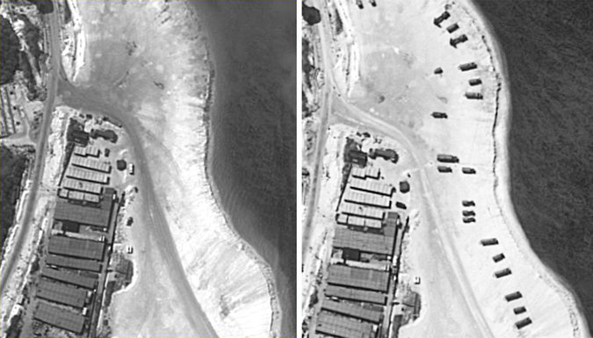
Satellite images show a part of Woody Island in the Paracel chain in the South China Sea on Feb. 3, left, and on Sunday, right. Credit ImageSat International
WASHINGTON — China’s deployment of surface-to-air missiles on a disputed island in the South China Sea, at the very moment that President Obama is trying to buttress American influence in the region, underscores the growing risk of conflict among the Chinese, their neighbors and the United States.
A day after Mr. Obama gathered 10 leaders from Southeast Asian countries for a summit meeting in California, a United States official said the Pentagon had evidence that China had placed missile batteries on an island that is part of an archipelago claimed by Vietnam and Taiwan, as well as by China.
At the meeting, Mr. Obama sent a warning to China, declaring that the United States would “continue to fly, sail and operate wherever international law allows” and that “we will support the right of all countries to do the same.” He said he had discussed with the leaders the need to halt further reclamation and militarization of islands in the South China Sea.

“What China is doing is worrisome because they’re obviously increasing their capacity for surveillance and for sustaining a presence that is well beyond what they’ve had before,” said Kenneth G. Lieberthal, a senior fellow and an expert on China at the Brookings Institution.
But even as Beijing reclaims land to bolster its claims to sovereignty over most of the South China Sea and its many reefs and islets, the United States is likely to move cautiously, current and former officials said. It does not want to set off a military confrontation with China over territorial claims on which the United States has not taken a position.
Moreover, the Asian countries remain divided over how robustly to resist China’s expansion. Maritime countries like the Philippines and Vietnam, which have competing claims with Beijing, are pushing for more vigorous action, while continental countries like Laos and Cambodia, which have close economic ties to China, are reluctant to provoke their neighbor.
Those divisions were evident in the wording of a joint statement issued at the end of the California meeting, which asserted the need for freedom of navigation and the peaceful resolution of disputes, but made no direct mention of China or the South China Sea.
A senior administration official said the specific weapons system that China had placed on the island was less of an issue than the signal it sent to neighbors.
China’s move appeared to be a coincidence, despite its disclosure just hours after the end of the summit meeting.
Continue reading the main story Video

Officials on South China Sea Activity
Representatives from Japan, the Philippines and Taiwan condemned China’s move to deploy missiles from an artificial island in the South China Sea.
By REUTERS and THE ASSOCIATED PRESS on Publish Date February 17, 2016. Photo by Pool photo by Wu Hong. Watch in Times Video »
The United States official who described the missile batteries, speaking on the condition of anonymity to discuss intelligence matters, did not give details about how many missiles were on the island, known as Woody Island, or how long they had been there. But another official said they appeared to be operational. Taiwan’s Defense Ministry also issued a statement on Wednesday saying that antiaircraft missiles were present on the island.
The Chinese Defense Ministry did not confirm or deny the deployment, but noted that the Chinese Navy and Air Force had maintained forces on the Paracel Islands “for many years.”
“The Paracel Islands have always been a part of China’s territory,” the ministry said in a statement. “China has the legitimate and legal rights to deploy defense facilities within its territory, in order to defend the sovereignty and security of the country.” It dismissed the reports about the missile deployment as “hype by certain Western media outlets.”
Tensions are also rising elsewhere in the region. The United States is in formal talks with South Korea about moving an antiballistic missile system to the peninsula to deter an attack from North Korea. The Chinese government has objected to the system, known as the Terminal High Altitude Area Defense system, or Thaad, saying it would be a threat to its security.
The Chinese missile deployment in the Paracel Islands in the South China Sea was reported by Fox News, which said pictures from ImageSat International showed that two missile batteries had appeared on the island sometime between Feb. 3 and Sunday. The missiles have a range of about 200 kilometers, or 125 miles, and are capable of destroying aircraft, cruise missiles and ballistic missiles, according to Missile Threat, a website run by the George C. Marshall Institute in Arlington, Va.
“It’s not that they would use the missiles to shoot down a plane,” said Mr. Lieberthal, of the Brookings Institution. “That would be a game changer. The question is, are we going to see a situation where they turn targeting radar on a ship conducting a freedom of navigation mission?”
Adm. Harry B. Harris Jr., the head of the United States Pacific Command, said on Wednesday that the missile deployment, if verified, would go against pledges not to militarize the South China Sea that China’s president, Xi Jinping, made at the White House in September.
But Mr. Xi, in his remarks in Washington, referred specifically to the Spratlys, a different chain of islets and reefs, and not to the Paracels when saying that China “does not intend to pursue militarization.”
Zhu Feng, a professor at Nanjing University who studies China’s foreign policy, said the Chinese made a distinction among South China Sea island groups. He noted that the Paracels were much closer to the Chinese mainland than the Spratlys, which are more than 250 miles to the south and have been the focus of much of China’s island-building efforts.
Woody Island, known as Yongxing in China, has a military airstrip that juts out from both ends of the small island and is used by fighter aircraft. It also has a military garrison and a civilian government building.
The missiles may give the United States and other nations pause before they send aircraft over the area to challenge China’s maritime claims, said Euan Graham, the director of the International Security Program at the Lowy Institute for International Policy in Sydney, Australia. “There may be a military element to this, but also a signaling element,” Mr. Graham said.

NYT

Asia Pacific

South China Sea Buildup Brings Beijing Closer to Realizing Control
By MICHAEL FORSYTHE and JANE PERLEZMARCH 8, 2016
Photo
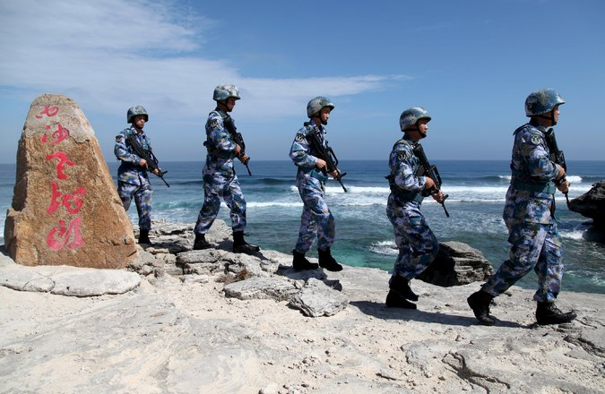
The People’s Liberation Army Navy patrolling on Woody Island, in the Paracel chain, in January. Credit Reuters
HONG KONG — When the aircraft carrier John C. Stennis and four other American warships sailed into the South China Sea last week for what were described as routine exercises, the message was clear: The United States is the dominant military power in the region and plans to keep it that way.

But numerous Chinese naval ships were operating nearby, the United States Navy said, noticeably more than in past years. A Chinese officer told the state-run news media that the ships were there to “monitor, identify, follow and expel” foreign vessels and aircraft, depending on how close they came “to our islands.”
The encounter, which passed without incident, was the latest episode in a wary standoff between the United States and China over two contested island chains known as the Paracels and the Spratlys.

Since taking office three years ago, President Xi Jinping has used the isles to expand China’s military footprint in the region, taking one step after another to build and equip outposts far from the Chinese mainland over protests from its neighbors and from Washington.
Continue reading the main story

Interactive Feature

What China Has Been Building in the South China Sea
China has been feverishly piling sand onto reefs in the South China Sea, creating seven new islets in the region and straining already taut geopolitical tensions.
OPEN Interactive Feature

The scale of the multibillion-dollar effort has raised tensions in the region and strengthened China’s disputed claim to the entirety of the South China Sea, home to some of the world’s busiest shipping lanes.
The buildup has also challenged the military status quo in the Western Pacific since the end of World War II, bringing China closer to its goal of establishing a security buffer extending far from its coast — a dream of Chinese strategists since the Korean War.
“China wants a bathtub,” said Marc Lanteigne, a senior research fellow at the Norwegian Institute of International Affairs who studies Chinese foreign policy, drawing a comparison with American dominance in the Caribbean. “China wants waters that are theirs, that they can operate military and police vessels in, without having to worry about the presence of the U.S. or the Philippines or Vietnamese or Indian naval forces.”
The buildup has proceeded incrementally but remarkably swiftly given that China and its neighbors have been locked in a stalemate over the islands that has simmered for decades. Dredging of sand to build artificial islands atop coral reefs in the Spratlys began as early as 2014 but accelerated last year, and the isles now feature deepwater harbors and long runways suitable for warships and fighter jets.
Then surface-to-air missile batteries appeared last month in the Paracels, more than 300 miles to the north. Now satellite photos show what seem to be powerful radar facilities, potentially extending the kill zone of missiles on the Chinese mainland that are devised to sink aircraft carriers.
The new fortifications pose little threat to the United States military, which could easily destroy them in a conflict.
Photo
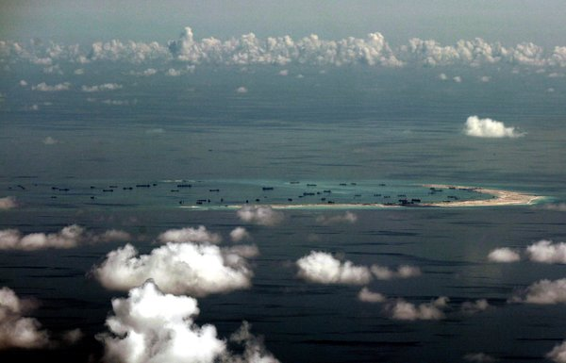
An aerial view of the artificial islands that China is said to have built in disputed waters in the South China Sea, west of Palawan, Philippines, in 2015. Credit Pool photo by Ritchie B. Tongo
But American officials are increasingly worried that the buildup, if unchecked, will give China de facto control of an expanse of sea the size of Mexico and military superiority over neighbors with competing claims to the waters. That, some say, could prompt a regional arms race and increase the risk of conflict.
While officials in Washington say China is nowhere near gaining the capacity to keep American forces out of the South China Sea, analysts say the buildup will make it more difficult for the United States Navy to quickly defend allies with weaker militaries, like the Philippines. The deployment of fighter jets, antiship missiles and more powerful radar in particular could embolden the Chinese Navy while giving American commanders pause, they said.
Testifying before the Senate Armed Services Committee last month, Adm. Harry B. Harris Jr., commander of the United States Pacific Command, warned that China’s actions were “changing the operational landscape in the South China Sea.” And in written answers submitted to the committee, the Obama administration’s top intelligence official, James R. Clapper, forecast that China would “have significant capacity to quickly project substantial military power to the region” by early next year.
Though China has not finished construction, he wrote, it can already deploy fighter aircraft, surface-to-air missiles, coastal defense cruise missiles as well as large warships and sizable Coast Guard vessels to the new artificial islands in the Spratlys.
Mr. Clapper also confirmed that military radar had been installed more than 600 miles from the Chinese island province of Hainan on Cuarteron Reef, the southernmost of the seven artificial islets. In theory, that could improve the ability of China’s so-called carrier-killer missile, the DF-21D, to strike faraway targets and complicate United States Navy efforts to develop countermeasures against it.
Last month, Vietnam lodged a formal protest after satellite photos indicated that China had deployed HQ-9 surface-to-air missile batteries on the largest island in the Paracels, Woody Island. Vietnam claims both the Paracels and the Spratlys, and nationalist sentiment has been running high since the appearance of a Chinese oil drilling platform near the Paracels led to anti-Chinese demonstrations and riots two years ago.
Photo
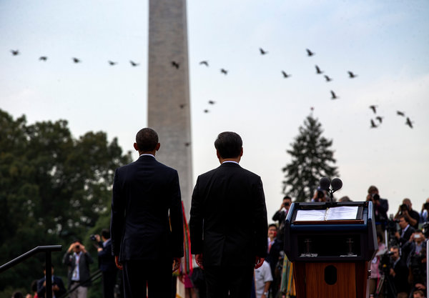
President Obama, left, with President Xi Jinping of China at the White House during Mr. Xi’s state visit in September. Credit Doug Mills/The New York Times
China’s buildup in the Spratlys has also angered the Philippines. Chinese forces wrested control of Scarborough Shoal in the Spratlys from the Philippines after an extended standoff four years ago, a move that President Benigno S. Aquino III later compared to Nazi Germany’s annexation of Czechoslovakia.
Senator John McCain, the Republican chairman of the Senate Armed Services Committee, warned recently that China seemed poised to expel Philippine forces from another outpost and urged the Obama administration to clarify how it would respond. Last month, Chinese vessels drew protests by blocking Philippine fishing boats from reaching a disputed atoll.
Analysts said the buildup had made it easier for Chinese ships to operate for long periods in the Spratlys without returning to the Chinese mainland. “Now Chinese ships can stay out in the Spratlys whenever they want, pretty confidently,” said Gregory B. Poling, director of the Asia Maritime Transparency Initiative at the Center for Strategic and International Studies in Washington.
Mr. Poling said the new radar installations on Cuarteron Reef could give China the ability to see over the horizon and perhaps track targets as far away as the vital Malacca Strait hundreds of miles to the southwest.
At his summit meeting with President Obama in September, Mr. Xi pledged not to “pursue militarization” of the Spratlys, but he did not include the Paracels, and Beijing has since insisted that it is entitled to “limited defensive facilities” across the South China Sea, comparing them to United States bases in Hawaii.
Chinese analysts argue that the buildup preserves peace by deterring others with territorial claims to the sea, including Brunei, Indonesia, Malaysia and Taiwan. “The main reason for the construction is to tell other countries to stop their provocations, because if they continue to push, we have the capability to push back,” said Xu Liping, a researcher at the Chinese Academy of Social Sciences.
United States officials said they expected China to build large fuel storage tanks on the islands next, which would allow its fighter jets to remain in the region longer, and then to declare an “air defense identification zone” over the South China Sea as it did for a contested part of the East China Sea in late 2013.
China claimed the right to require aircraft entering the zone to identify themselves and to take military action against those that did not follow orders. Japan and the United States refused to recognize the claim or cooperate.
The Obama administration has struggled, however, to come up with a policy to slow or stop what it has called China’s militarization of the South China Sea.
A senior defense official, who requested anonymity to speak more freely about American policy, noted that while China might be gaining in the “maritime arena,” its progress had also prompted neighbors like the Philippines and Vietnam to expand military ties with the United States.
In recent months, the Pentagon has also stepped up “freedom of navigation” patrols in the South China Sea, sending United States warships and aircraft into territory claimed by Beijing to assert Washington’s view that these areas remain international waters and airspace.
But China has responded by using the patrols to argue that it is the United States that is militarizing the South China Sea — and by continuing to build.
“China was the first country to discover, name, develop and manage the South China Sea islands,” the Chinese foreign minister, Wang Yi, told a news conference on Tuesday. “History will prove who is a mere guest and who is a real host.”

The Economist

The South China Sea

China v the rest

As the sea becomes more militarised, the risks of conflict grow
Mar 26th 2016 | From the print edition

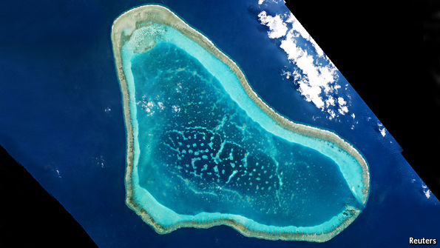
FOR years China has sought to divide and rule in the South China Sea. It worked hard to prevent the countries challenging it over some or all of its absurdly aggrandising territorial claims in the sea from ganging up against it. So when tensions with one rival claimant were high, it tended not to provoke others.
Not any more. In a kind of united-front policy in reverse, it now seems content to antagonise them all at the same time. This is both encouraging closer co-operation among neighbours and driving them closer to external powers including India, Australia, Japan and, above all, America.

The latest fight China has picked is with a country with which—unlike Brunei, Malaysia, the Philippines, Taiwan and Vietnam—it has no territorial dispute: Indonesia. On March 21st the chargé d’affaires at China’s embassy in Jakarta was hauled in to receive a stiff protest. A Chinese coastguard vessel had rammed free a Chinese fishing boat as it was towed into port after being caught allegedly fishing in Indonesian waters. The crew of eight was already in detention. In a similar incident three years ago, Indonesia released detained crew members when confronted by an armed “maritime law-enforcement” vessel belonging to China’s fisheries bureau.
Since that incident Indonesia has elected a new president, Joko Widodo, one of whose trumpeted policies has been to look after the interests of fishermen. To deter illegal interlopers, Indonesia now impounds and blows up foreign vessels caught poaching. In this case, it seems clear that the Chinese were in Indonesian waters. Indonesia claims that the boat was just four kilometres off the Natuna islands, well within Indonesia’s 12 nautical-mile territorial limit, let alone its 200-nautical-mile “exclusive economic zone” (EEZ).
China explicitly acknowledges Indonesian sovereignty over the Natunas. Yet instead of apologising, China’s foreign ministry demanded the fishermen’s release, claiming that they had been carrying out “normal operations” in “traditional Chinese fishing grounds”. China is a party to the UN Convention on the Law of the Sea (UNCLOS), under which countries are entitled to territorial waters and EEZs. Yet the government’s implicit argument is that a self-proclaimed “tradition” trumps international law. By extension, with 5,000 years of sacred history touted ad nauseam by its Communist Party leaders, who is to deny China anything it wants?
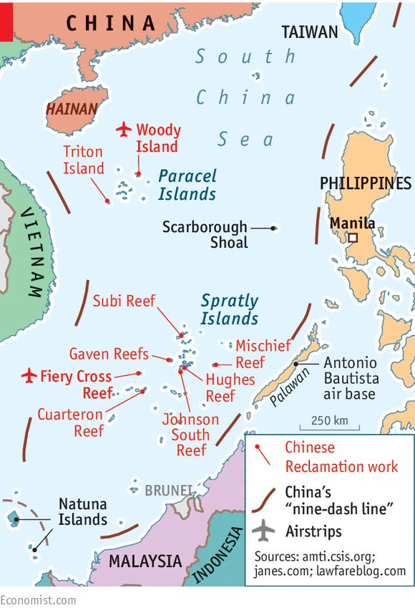
China’s tradition-based argument also has implications for its “nine-dash line” (see map) delimiting its claim to virtually all of the South China Sea (and passing just north of the Natunas). It would suggest China believes it has rights over not just land features inside the line, and their territorial seas and EEZs, but also over all the water itself—a concept alien to UNCLOS.
Flaky claims, fake islands
China has declined to explain how its claims fit within UNCLOS parameters. Indeed it has a record of flouting the law and international agreements when it comes to the sea. In 2002 it signed a joint declaration with the ten-member Association of South-East Asian Nations, in which the parties undertook to “exercise self-restraint” in the South China Sea, and in particular to refrain from occupying uninhabited features such as reefs. That commitment is hard to square with the massive building spree on which China has been engaged for the past two years in the Spratly archipelago, turning seven uninhabitable rocks and reefs submerged at high tide into artificial islands. Vietnam and the Philippines, rival claimants, have naturally been outraged. And this month an American admiral has reported Chinese activity at Scarborough Shoal, north of the Spratlys, that suggests it might be the “next possible area of reclamation”. China bullied the Philippines away from the shoal four years ago.
The Philippines has asked an international tribunal, the Permanent Court of Arbitration in The Hague, to rule on some of China’s claims under UNCLOS. The court is expected to announce its verdict soon. If it rules broadly in favour of the Philippines, it would have the effect of making clear that China’s nine-dash line has no legal basis. China is boycotting the case and says it will ignore the verdict. The ruling might embarrass China. But it will not stop it creating artificial islands, or indeed make it dismantle those it has already built.
It seems increasingly likely that the islands will have a military purpose. China denies that, but it is hard to see why else it needs the long airstrip it is building on the Fiery Cross reef in the Spratlys. It is in this context that the threat of building at Scarborough Shoal causes such alarm. China has controlled the whole of the Paracel chain in the north of the South China Sea since 1974, when it drove out the former South Vietnamese from part of it. It has recently installed missile batteries on Woody Island there. In the Spratlys to the south it is building what look like potential air and naval bases, complete with military-grade radars. Scarborough Shoal would complete a “strategic triangle” that would allow it to dominate the sea. China is widely expected one day to declare an “air defence identification zone” over the sea, as it has over parts of the East China Sea, including areas contested with Japan.
Aggressors rarely see themselves as such. Indeed China accuses the United States of being the driving force behind the “militarisation” of the sea. Certainly America is responding to Chinese moves. Last year it resumed naval “freedom of navigation” operations, sending warships close to disputed features. This month it sent an aircraft-carrier strike group into the sea. American naval and marine-corps commanders have been in Vietnam to explore co-operation. Worse, from China’s viewpoint, American forces have just obtained access to five Philippine bases, including an airbase on Palawan, just opposite the Spratlys. For this, China’s official news agency accused America of “muddying the waters” and “making the Asia-Pacific a second Middle East”.
China will not be deterred, confident that America is unlikely to risk a serious crisis, let alone conflict. China’s throwing its weight around in the sea erodes America’s credibility as the pre-eminent military power in the western Pacific, but does not directly threaten it. By contrast, rather than cow China, America’s enhanced military role gives it a pretext to carry on with its build-up. There is still the danger, however, of an accidental flare-up—a skirmish over illegal fishing, for example, and an ensuing escalation. Armed conflict in the South China Sea is a long way from being inevitable. But it is far from unthinkable.

NYT

Patrolling Disputed Waters, U.S. and China Jockey for Dominance
By HELENE COOPERMARCH 30, 2016
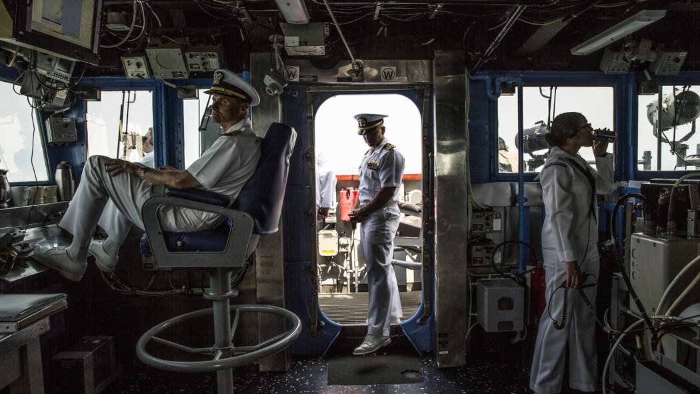

In the South China Sea, a Near-Continuous State of Alert
CreditBryan Denton for The New York Times
ABOARD THE U.S.S. CHANCELLORSVILLE, in the South China Sea — The Navy cruiser was in disputed waters off the Spratly Islands when the threat warning sounded over the ship’s intercom: “Away the Snoopie team. … Away the Snoopie team.”
As the sailors of the “Snoopie team” went on alert and took up positions throughout the ship, a Chinese naval frigate appeared on the horizon, bearing down on the cruiser Chancellorsville last week from the direction of Mischief Reef. More alarming, a Chinese helicopter that had taken off from the frigate was heading straight for the American cruiser.
“This is U.S. Navy warship on guard,” Ensign Anthony Giancana said into his radio from the ship’s bridge, trying to contact the helicopter. “Come up on Frequency 121.5 or 243.”
Ominously, there was no response.
Here in the hot azure waters off the Spratly and Paracel Islands — which encompass reefs, banks and cays — the United States and China are jockeying for dominance in the Pacific. From Mischief Reef, where China is building a military base in defiance of claims by Vietnam and the Philippines, to Scarborough Shoal, where the Chinese are building and equipping outposts on disputed territory far from the mainland, the two naval forces are on an almost continuous state of alert.
Although the South China Sea stretches some 500 miles from mainland China, Beijing has claimed most of it. Tensions have risen sharply, and the topic is expected to dominate President Obama’s meeting in Washington this week with the Chinese president, Xi Jinping.
America’s goal is to keep the South China Sea, one of the world’s busiest shipping lanes, open to all maritime traffic. But administration officials are increasingly worried that tensions will only deepen if an arbitration panel in The Hague rules as expected in the coming months on a 2013 case brought by the Philippines, which has accused China of making an “excessive claim” to most of the sea.
Photo
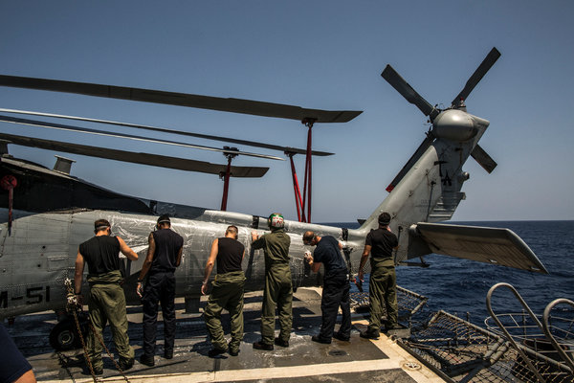
Crew members washed an MH-60 on the flight deck of the Chancellorsville as it sailed the South China Sea. Credit Bryan Denton for The New York Times
At the Pentagon two weeks ago, the day before a meeting of Mr. Obama’s national security team on Chinese expansion in the Pacific, Gen. Joseph F. Dunford Jr., the chairman of the Joint Chiefs of Staff, was talking with Adm. Harry B. Harris Jr., the commander of the United States Pacific Command, in the reception area of Defense Secretary Ashton B. Carter.

“Would you go to war over Scarborough Shoals?” General Dunford asked Admiral Harris, in a conversation overheard by a reporter. If Admiral Harris responded, it could not be heard.
The White House and the Pentagon have made clear that they do not want a war with China over a group of uninhabited islands. But neither does the White House want to cede the South China Sea to China, which is what administration officials fear will happen if Beijing continues on its current course. James R. Clapper, Mr. Obama’s director of national intelligence, told the Senate Armed Services Committee last month that by early next year China would “have significant capacity to quickly project substantial military power to the region.”
That could mean that other countries could eventually need Beijing’s permission to traverse the heavily trafficked sea.
And so for the moment, the Obama administration is sending Navy patrols through the Spratlys and other disputed island chains in the region, to drive home the message that the sea is free to all. Some 700 American patrols have gone through in the past year, Navy officials say. Three weeks ago the aircraft carrier John C. Stennis and four other American warships sailed into the South China Sea for routine exercises, meant to convey the message, Pentagon officials said, that the United States is the dominant military power in the region.
Aboard the Chancellorsville last week, the minutes — and the tension — stretched out as the Chinese helicopter pilot refused to answer. The helicopter kept circling and eventually flew back to the Chinese frigate, which then continued toward the American warship. At the helm, Capt. Curt A. Renshaw, who had skipped his morning shower to race up to the bridge when the Chinese helicopter approached, huddled with his officers.
Photo
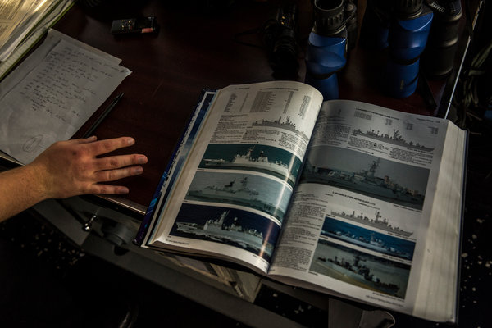
Ensign Anthony Giancana, 25, of Minneapolis, searched a maritime guide to naval vessels as the Chancellorsville encountered a Chinese frigate. Credit Bryan Denton for The New York Times
The day before, Captain Renshaw had warned the entire ship over the intercom that the Chancellorsville would be transiting through the Spratlys, and he told the crew members to be on their toes and alert to trouble. He had been expecting the Chinese to show up — Beijing, in recent months, has taken to shadowing American warships that have dared to enter the South China Sea.
On a stand near the captain’s chair, a copy of “Jane’s Fighting Ships” was open to Page 144: “China Frigates.”
“You’ve ever been shadowed before?” Captain Renshaw asked Ensign Kristine Mun, a navigations officer. He turned to Ensign Niles Li, one of several officers who spoke Chinese, and wondered aloud at the Chinese helicopter’s refusal to answer the radio message.
Finally, when the Chinese frigate was six miles away and clearly visible to the naked eye on the horizon, the ship-to-ship radio crackled with the sounds of accented English. “U.S. Navy Warship 62. ... This is Chinese Warship 575.”
And so began an elaborate diplomatic dance.
“This is U.S. Warship 62. Good morning, sir. It is a pleasant day at sea, over.”
No response.
“This is U.S. Warship 62. Good morning, sir. It is a pleasant day to be at sea, over.”

Interactive Feature

What China Has Been Building in the South China Sea
China has been feverishly piling sand onto reefs in the South China Sea, creating seven new islets in the region and straining already taut geopolitical tensions.
OPEN Interactive Feature

Still no response.
Captain Renshaw turned to Ensign Li. “You’re up,” he said. “They can’t pretend they don’t speak Chinese.”
“Chinese Warship 575, this is U.S. Warship 62,’’ Ensign Li said in Chinese. “Today is a sunny day for a sea voyage, over.”
More minutes ticked by. Ensign Anthony Giancana, the junior officer on deck for the morning, was getting antsy. “This is like Opening Day,” he said to no one in particular. “We’ve done spring training.’’
Suddenly, the radio crackled again as the frigate responded in Chinese: “U.S. Warship 62, this is Chinese Warship 575. Today’s weather is great. It is a pleasure to meet you at sea.”
Ensign Li responded, also in Chinese: “This is U.S. Warship 62. The weather is indeed great. It is a pleasure to meet you, too, over.”
Preliminaries dispensed with, the Chinese ship got down to business, switching to English. “How long have you been since departing from your home port? Over.”
Photo
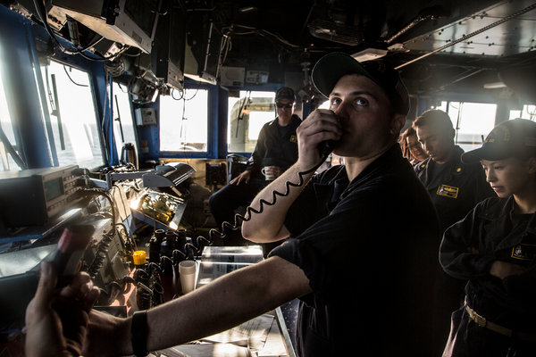
Ensign Giancana directed a message to the Chinese frigate that had begun shadowing the Chancellorsville. Credit Bryan Denton for The New York Times
Captain Renshaw was immediately shaking his head. “No, we’re not answering that. I would never ask him that.”
Ensign Giancana picked up the radio again. “Chinese Warship 575, this is U.S. Navy Warship 62. We do not talk about our schedules. But we are enjoying our time at sea, over.”
And on it went as the two warships, each loaded with missiles, torpedoes and heavy artillery, confronted each other with an exchange of weather pleasantries at sea. Testing whether the Chinese were openly following, the Chancellorsville made a turn, and its officers stood back and waited.
A shout came from another one of Captain Renshaw’s junior officers: “He just turned, sir!” The Chancellorsville now had a tail. But for how long?
Apparently the Chinese ship wanted an answer to that question as well.
“U.S. Navy Warship 62, this is Chinese Navy Warship 575,” came a new message. “Do you continue to have long-term voyage at sea? Over.”
Another no-no. Telling the Chinese the intended duration of the trip could be an inherent acknowledgment that they had the right to know, Captain Renshaw said. And that is not considered freedom of navigation.
“This is U.S. Navy Warship 62,’’ Captain Renshaw responded. “Roger, all of our voyages are short because we enjoy our time at sea no matter how long we are away from home. Over.”
As it happened, the Chinese ship had a ready answer for that.
“U.S. Navy Warship 62, this is Chinese Navy Warship 575,” came the reply. “Copy that I will be staying along with you for the following days. Over.”
That was Tuesday. On Wednesday, the Chinese frigate was replaced by a destroyer, which followed the Navy warship until midnight Thursday, when the American vessel exited the South China Sea.

NYT

One Envoy’s Take on China’s Hardball Diplomacy
点击查看本文中文版 Read in Chinese
Sinosphere
By JANE PERLEZ MARCH 31, 2016

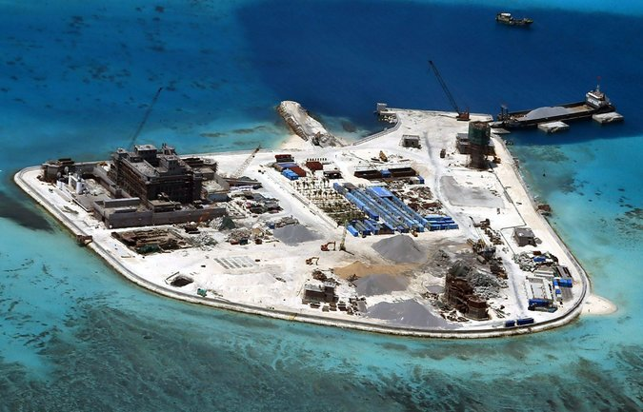
A photograph provided by the Philippine military of Chinese construction on Johnson South Reef in the disputed Spratly Islands. The Philippines and several other Southeast Asia countries have unresolved territorial disputes with China in the South China Sea. Credit Armed Forces of The Philippines, via European Pressphoto Agency
BEIJING — Chinese diplomats are known to be tough, but it is rare to hear descriptions of how tough. A senior Singaporean diplomat has pulled back the veil and has talked about China’s efforts to put smaller Asian countries in their place.
In a speech on Wednesday, the diplomat, Bilahari Kausikan, ambassador at large and policy adviser in Singapore’s Ministry of Foreign Affairs, who is known around Asia and in Washington for his candor, said that Chinese diplomats “perversely” often go out of their way to “accentuate rather than assuage anxieties.”
While his address, delivered at the Institute of Policy Studies at the National University of Singapore, dealt mainly with the complex power relationships among China, the United States and Southeast Asian nations, and particularly with the contentious issue of the South China Sea, Mr. Kausikan could not resist citing some examples of China’s heavy hand.
If a negotiation in Southeast Asia does not suit China, he said, its diplomats blame the other party. “It is our fault, and ours alone,” he said, explaining China’s usual attitude toward members of the Association of Southeast Asian Nations, a regional group that includes Singapore and nine other countries.
He presented some examples. After Prime Minister Lee Hsien Loong of Singapore spoke about the disputed waters of the South China Sea at a 2012 summit meeting of Southeast Asian countries, a senior Chinese diplomat turned to a younger Singaporean counterpart, and said, “Silence is golden.”
“If he meant to suggest that we were not entitled to a view on an important issue that affects our interests,” Mr. Kausikan said, “he only undermined the credibility of China’s claim to ‘peaceful development.’ ”
Chinese diplomats get agitated when it comes to protocol involving their leaders, he said. For example, the Chinese ambassador to an Asian country demanded that Wen Jiabao, China’s premier at the time, be allowed to stay at a hotel during a meeting of the Association of Southeast Asian Nations even though that hotel was reserved by another delegation.

Interactive Feature

What China Has Been Building in the South China Sea
China has been feverishly piling sand onto reefs in the South China Sea, creating seven new islets in the region and straining already taut geopolitical tensions.
OPEN Interactive Feature

“The ambassador insisted on this, although the hotel allocated to Premier Wen was of equal quality,” Mr. Kausikan recounted. “Did Premier Wen know where he was staying? Would he have cared if he had known? But the episode certainly left a deep impression on my counterpart, and no doubt on the Asean delegation that was forced to move as well.”
Chinese diplomats often express bewilderment that China’s generosity toward Southeast Asia — in trade and investment — does not engender gratitude, or at the least, diminish mistrust, Mr. Kausikan said. Chinese behavior, he suggested, is best understood as “passive-aggressive” and an effort to “force acceptance of China’s inherent superiority” as the natural order of Southeast Asian regional affairs.
The current dispute over the artificial islands China has constructed in the South China Sea is a case in point, he said. The islands are “inconsequential in military terms,” because, if necessary, they could easily be attacked and destroyed by the United States.
But, he added, they are a potent reminder to Southeast Asia that “China is a geographic fact whereas the U.S. presence in the South China Sea is the consequence of a geopolitical calculation.”
This is a point, Mr. Kausikan said, that China’s diplomats never tire of “seeding, in ways subtle or direct.”

NYT

U.S. and Philippines, United by China, Ramp Up Military Alliance
By FLOYD WHALEYAPRIL 12, 2016
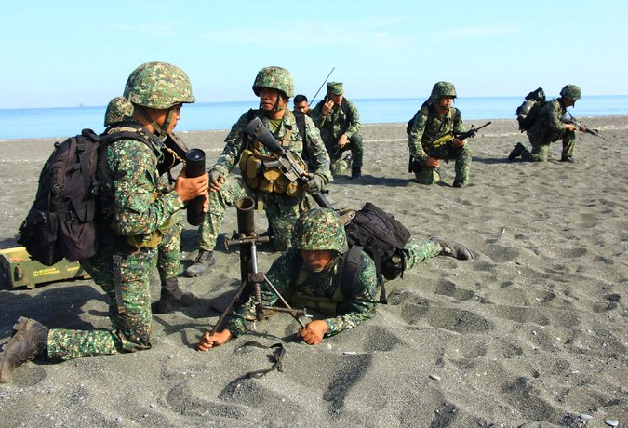
Marines from the Philippines during joint exercises with the United States in Antique Province this week. Credit Agence France-Presse — Getty Images
MANILA — After a rocky patch of 25 years, the United States and the Philippines will solidify a new, increasingly complex military relationship this week, driven partly by China’s assertive actions in the South China Sea.
A new agreement that allows the United States to build facilities at five Philippine military bases will spread more American troops, planes and ships across the island nation than have been here in decades.
Joint military exercises this week and the arrival of Defense Secretary Ashton B. Carter on Wednesday will allow the two countries to show off their cozy relations and will include events rich in military symbolism.
Mr. Carter is scheduled to observe the firing of a long-range missile system, one that could cover all the Philippines’ maritime claims in the South China Sea if needed, though the United States has not confirmed that the missiles will be deployed here. Mr. Carter will also tour the location of a planned new United States military facility on the edge of disputed waters with China.
Analysts say the resurrected American presence here could tilt the balance of power in this part of the South China Sea.
The Philippines currently defends its claims in the sea with two nearly 50-year-old former United States Coast Guard cutters, which sometimes break down, and two fighter jets. This allows China to control territory, build artificial islands and chase off Filipino fishermen with little risk.
The new agreement could change that.
“The Chinese goal is not to pick a fight,” said Gregory B. Poling, chairman of Southeast Asia studies at the Center for Strategic and International Studies, based in Washington. “The Chinese goal is to put enough pressure that someone else blinks first. Just the ability to impose any kind of cost, to get any kind of vessel out there on site, forces the Chinese to make a decision about how much they really want to engage in a certain activity.”

The Philippines has been a strategic partner with the United States since World War II, and it is one of the oldest American allies in Asia. For decades, it hosted major American military bases at Subic Bay and Clark Air Base.
But in a wave of nationalist sentiment, Philippine lawmakers ejected the American military from the country in 1991. Years of strained military relations followed, but the two countries have come together in recent years over concerns about China’s claims in the South China Sea, which encompass more than 80 percent of the 200-mile exclusive economic zone of the Philippines in waters that Filipinos call the West Philippine Sea.

Interactive Feature

What China Has Been Building in the South China Sea
China has been feverishly piling sand onto reefs in the South China Sea, creating seven new islets in the region and straining already taut geopolitical tensions.
OPEN Interactive Feature

Mr. Carter said last week that the United States would also provide about $40 million in military aid to the Philippines to be used in part to improve the country’s patrol vessels, as well as to operate unmanned surveillance blimps that can watch over the islands controlled by the Philippines in the South China Sea.
China claims most of the South China Sea, a 1.4-million-square-mile expanse of the Pacific Ocean. The country says it is entitled to shoals and islets also claimed by Brunei, Malaysia, Taiwan and Vietnam, as well as much of what the Philippines says is its exclusive economic zone. Beijing has asserted its right to these areas in part by reclaiming land and building fortified artificial islands with military facilities.
The Philippines has sought international arbitration on the dispute, which could yield a decision in the next few weeks, but China has refused to participate.
The military agreement with the United States, which the Philippine Supreme Court approved in January, will allow the United States to build and operate facilities at five Philippine military bases for at least 10 years. The deal includes the country’s largest army base and four air bases, including one on the western island of Palawan, which runs for 270 miles along one side of the South China Sea.
That base, the Antonio Bautista Air Base in Puerto Princesa, will be used by the Philippines to monitor its economic zone in the South China Sea and by the Americans to protect their interests further afield, said Col. Restituto Padilla, a Philippine military spokesman.
“The American side has interests beyond our exclusive economic zone, including freedom of navigation throughout the South China Sea, so they will be using it to patrol beyond our areas,” he said.
But the four other bases are far from the South China Sea, and none of the five are naval bases, facts that have perplexed some observers.
Likewise, the vast facilities of Clark and Subic, which still contain long runways left by the Americans and a deep, protected harbor that can accommodate the largest United States vessels, were not included in the agreement.
Security analysts point out that ships can operate from long distances and that the United States has naval bases not far away, in Japan and Guam, and can use ports in Subic Bay and Manila to resupply. Airfields, on the other hand, need to be nearby in order to allow rapid response in the South China Sea.
“With air power, you need to be much closer to the action,” said Mr. Poling of the Center for Strategic and International Studies. “They clearly prioritized that.”
There were probably also budgetary considerations on the American side, according to Mr. Poling. “We are in an era of pretty constrained budgets in the U.S., and it is going to be difficult to get Congress to sustainably fund anything,” he said. “So you have to prioritize.”
The former United States military bases at Clark and Subic were not on the list because their uses have shifted in the 25 years since the Americans left.
Subic Bay has become a busy commercial port and industrial zone. Clark now includes a Philippine Air Force base, but it is also one of the country’s busiest civilian airports and a booming special economic zone.
The new agreement allows the United States to operate only within Philippine military facilities, Col. Padilla said.
The selection of bases makes sense, he said, when taking into account the broad mandate of the agreement, which includes helping the Philippines modernize its military and improve its response to natural disasters.
The agreement also covers joint efforts to address terrorism, an increasing concern in the southern Philippines, where extremist groups that have pledged allegiance to the Islamic State are holding 20 foreigners. On Saturday, 18 Philippine soldiers were killed in a daylong battle with Abu Sayyaf, the rebel group believed to be behind the kidnappings.
One facility the Americans will use is Lumbia Air Base, on the island of Mindanao, which is home to several groups the United States classifies as terrorist organizations. According to the Philippine Constitution, the United States cannot conduct military operations there but can support the Philippine forces with intelligence and training.
The other bases the Americans will use include Mactan-Benito Ebuen Air Base, a crucial staging point for disaster relief during Typhoon Haiyan, which killed more than 6,000 people in 2013, and Fort Magsaysay, a sprawling facility north of Manila with extensive space for positioning supplies.
“It is shortsighted for people to focus solely on the South China Sea,” Col. Padilla said. “There is a bigger picture here. We didn’t enter into this agreement for just one reason. We are modernizing our military.”
The Philippines still has a long way to go in that regard. For that reason, Matt Williams, country director in the Philippines for the risk management company Pacific Strategies & Assessments, says expectations about the impact of the new agreement on the balance of power in the South China Sea should be tempered.
“Even with a blank check and substantial political will, the Philippines is decades away from having a credible defense force,” he said. “China is playing a winning strategy in the South China Sea.”

NYT

In South China Sea Visit, U.S. Defense Chief Flexes Military Muscle
By MICHAEL S. SCHMIDTAPRIL 15, 2016
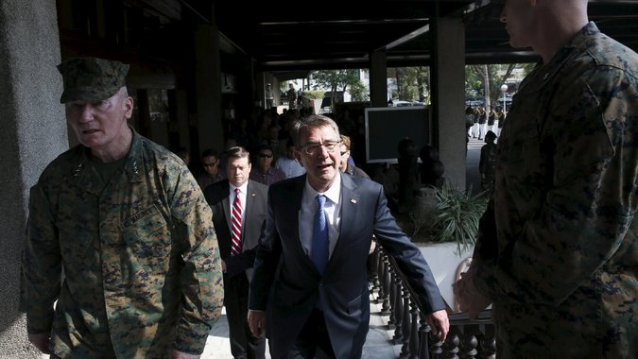
Defense Secretary Ashton B. Carter attended the closing ceremony of a joint United States-Philippine military exercise in Quezon City, Philippines, on Friday. Credit Erik De Castro/Reuters
ABOARD THE U.S.S. JOHN C. STENNIS, in the South China Sea — Over the last week in Asia, Defense Secretary Ashton B. Carter has visited two aircraft carriers, revealed new military agreements with India and the Philippines, and generally signaled that the Obama administration had decided to lean more on military power to counter China’s territorial ambitions in the region.
But the newly muscular approach on display during Mr. Carter’s tour represents a gamble. While it sends a message that the United States will work with its allies to challenge Beijing’s expanding presence in the disputed South China Sea, it also plays into fears within the Chinese leadership about American efforts to halt China’s rise.
That may mean that the more the Pentagon steps up in the region, the more China may feel it needs to accelerate its military buildup, including the construction of new islands equipped with radar and airstrips in contested waters.
With a mix of showmanship and concrete initiatives during a six-day visit to India and the Philippines, Mr. Carter left little doubt that the United States intended both to strengthen alliances and move more hardware and troops here to counter China’s growing military reach.
On Friday, he rode a helicopter to a symbol of American power projection in the Pacific, a Nimitz-class nuclear-powered aircraft carrier, as it cruised through the South China Sea near waters claimed by the Chinese.
News Clips: Asia Pacific By THE ASSOCIATED PRESS 00:41 Carter on Security in South China Sea
Video

Carter on Security in South China Sea
@ http://www.nytimes.com/2016/04/16/world/asia/south-china-sea-us-ash-carter.html?emc=edit_ae_20160415&nl=todaysheadlines-asia&nlid=64888777&_r=0
During his six-day trip to India and the Philippines this week, Ashton B. Carter, the secretary of defense, emphasized the importance of American military presence in the Asia-Pacific region.
By THE ASSOCIATED PRESS on Publish Date April 15, 2016. Photo by Erik De Castro/Reuters. Watch in Times Video »
Before visiting the carrier John C. Stennis, he marked the end of 11 days of military exercises between the United States and the Philippines and said some American troops would stay behind “to contribute to regional security and stability.”
He also said the United States had begun joint patrols of the South China Sea with the Philippine navy and would soon do the same with the country’s air force.
Earlier in the week, Mr. Carter toured an Indian aircraft carrier, the first time an American defense secretary had boarded such a ship, and said the United States would help India upgrade its carriers. He also revealed a new logistics agreement and said the two nations would work together on other military technologies.

Together, the measures announced by Mr. Carter hint at a potential American military resurgence in a part of the world where China believes it is destined to surpass the United States in influence. The Obama administration seems to be betting that China will back off rather than continue making moves that lead its neighbors to embrace the American military.
More than once in the last week, Mr. Carter cited China’s actions as the driving force behind tensions in the region and, implicitly, the reason for its neighbors’ increased engagement with the Pentagon.
Below deck, he said China should not see the carrier’s presence as a provocation.
“We have been here for decade upon decade. The only reason that question even comes up is because of what has gone on over the last year, and that’s a question of Chinese behavior,” he said. “What’s not new is an American carrier in this region. What’s new is the context and tension that exists, which we want to reduce.”

Interactive Feature

What China Has Been Building in the South China Sea
China has been feverishly piling sand onto reefs in the South China Sea, creating seven new islets in the region and straining already taut geopolitical tensions.
OPEN Interactive Feature

But some analysts warn that China could react to the Pentagon’s moves by taking more aggressive actions, challenging America’s commitment to the region in a high-profile game of chicken and raising the risk of a military conflict.
The Chinese have been closely watching Mr. Carter’s tour, which had included a stop in Beijing before it was scrubbed from the schedule a few weeks ago. In a late-night statement on Thursday, the Chinese Defense Ministry accused the United States of reverting to a “Cold War mentality” and said the Chinese military would “pay close attention to the situation and resolutely defend China’s territorial sovereignty and maritime interests.”
On Friday, China also disclosed that its most senior uniformed military commander had visited the disputed Spratly Islands, which appeared intended to signal Beijing’s resolve in the South China Sea, most of which it considers Chinese territory.
The Obama administration has declined to describe its approach toward China as a revival of “containment,” the Cold War strategy aimed at preventing the spread of Communism. Instead, Mr. Carter said the new military initiatives in the region were consistent with longstanding American policy to work closely with countries that share its interests.
“America’s policy continues to be one valued on principles of peaceful resolutions of disputes, lawful settlement of things like territorial disputes like the South China Sea, or anywhere else, freedom of navigation, freedom of commerce,” he said.
“Now countries who don’t stand for those things, who don’t stand with those things, are going to end up isolating themselves,” he added. “That will be self-isolation, not isolation by us.”
For decades, neither India nor the Philippines was particularly interested in military cooperation with the United States. As a leader of the Non-Aligned Movement, India has been suspicious of alliances with other countries, particularly world powers. And the Philippines expelled American forces in the early 1990s, ending a military presence that began with the United States’ capture of the islands from Spain in 1898.
But both countries have grown wary of China’s rising military profile — more wary than they are of the United States.
The initiatives that Mr. Carter announced with India were largely symbolic but could signal greater cooperation in the future, like joint patrols in the South China Sea and the sale of heavy weaponry and other equipment. In a significant policy shift, India is already in talks with Japan, an American ally, to upgrade civilian infrastructure in the Andaman and Nicobar Islands, an Indian archipelago seen as a potential strategic asset in efforts to counter Chinese naval expansion.
A sweeping 10-year deal with the Philippines, approved by the nation’s Supreme Court in January, will allow American forces to build military facilities and assign personnel, planes and ships to existing Philippine bases. Mr. Carter announced that more than 200 American pilots and crew members, as well as six aircraft and three helicopters, would remain in the country.
The developments represent a setback for President Xi Jinping of China, who has overseen the acceleration of Beijing’s buildup in the South China Sea and could be accused of needlessly drawing the United States back into the region.
But analysts in China said the Obama administration’s initiatives were unlikely to achieve its goal of persuading Mr. Xi to back off. Instead, they could heighten fears in the Chinese leadership that Washington is using Beijing’s claims in the South China Sea as an excuse to encircle China and halt its global rise.
“China sees its actions in the South China Seas as legitimate in protecting its own sovereignty and integrity,” Su Hao, a professor at China Foreign Affairs University in Beijing. “China will not just change its behaviors or deployment plan simply because of the Americans.”

NYT

U.S. and India Agree to Strengthen Military Ties
By MICHAEL S. SCHMIDTAPRIL 12, 2016
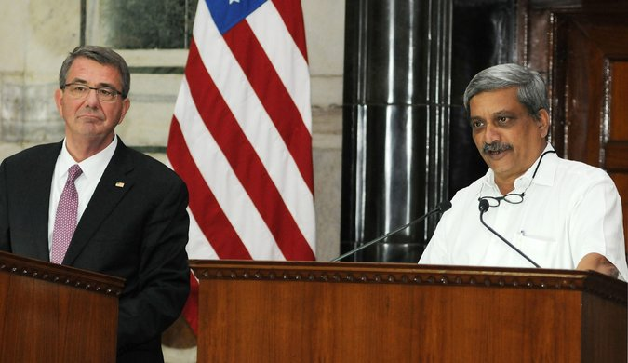
Defense Secretary Ashton B. Carter, left, and his Indian counterpart, Manohar Parrikar, at a news conference announcing stronger military ties between the two nations in New Delhi on Tuesday. Credit European Pressphoto Agency
NEW DELHI — The United States and India on Tuesday agreed in principle to a series of initiatives between their militaries that the Obama administration hopes will strengthen American ties in the region as it seeks to counter China’s growing influence.
Continuing recent steps to build closer collaboration between their militaries, the United States and India said they would allow their armed forces to share logistics abilities and enhance the exchange of defense technologies and other information.
The initiatives, announced by Ashton B. Carter, the defense secretary, and his Indian counterpart, Manohar Parrikar, at a news conference here, were a further demonstration of India’s increased willingness to work with the United States on military and security issues.
For decades as a leader of the Non-Aligned Movement, India shied away from entering into strong alliances with other countries, particularly large world powers. But under Prime Minister Narendra Modi, and wary of the growing power of its regional rival, China, the Indian government has moved closer to the United States.
The measures announced here, however, are largely symbolic. They provide India with few major military capabilities it does not already have. And they do not call for concrete actions like joint patrols in the South China Sea, which China has claimed as its own.
In a statement released after the news conference, Mr. Carter and Mr. Parrikar said they had “reaffirmed the importance of safeguarding maritime security and ensuring freedom of navigation and overflight throughout the region, including in the South China Sea.”
The Obama administration has gone to great lengths to build a close relationship with India. Mr. Obama has visited the country twice, more than any president, and he and Mr. Modi seem to have built a close working relationship. Mr. Carter has spent more time with the defense minister, Mr. Parrikar, than any other counterpart. And the United States ambassador to India, Richard R. Verma, has worked closely with Indian officials to find ways the countries can collaborate more where they have common interests.
“As we stand here, our two countries and our two militaries are closer than we have ever been — brought together by shared values, mutual interests and a promising destiny,” Mr. Carter said.
He added: “The U.S.-India relationship is destined to be one of the defining partnerships of the 21st century. And that destiny is rapidly and surely becoming a reality.”
The logistics agreement will allow the Indian and American militaries to use each other’s bases to refuel and as staging areas during emergencies or natural disasters. The pact has not yet been signed, Mr. Carter said, adding that the signing would be in coming weeks after a final draft of the agreement is completed.

NYT

Eye on China, U.S. and Philippines Ramp Up Military Alliance
点击查看本文中文版 Read in Chinese
By FLOYD WHALEYAPRIL 12, 2016
Marines from the Philippines during joint exercises with the United States in Antique Province this week. Credit Agence France-Presse — Getty Images
MANILA — After a rocky patch of 25 years, the United States and the Philippines will solidify a new, increasingly complex military relationship this week, driven partly by China’s assertive actions in the South China Sea.
An agreement that allows the United States to build facilities at five Philippine military bases will spread more American troops, planes and ships across the island nation than have been here in decades.
Joint military exercises this week and the arrival of Defense Secretary Ashton B. Carter on Wednesday will allow the two countries to show off their cozy relations and will include events rich in military symbolism.
Mr. Carter is scheduled to observe the firing of a long-range missile system, one that could cover all the Philippines’ maritime claims in the South China Sea if needed, though the United States has not confirmed that the missiles will be deployed here.
Analysts say the resurrected American presence here could tilt the balance of power in this part of the South China Sea.
The Philippines currently defends its claims in the sea with two nearly 50-year-old former United States Coast Guard cutters, which sometimes break down, and two fighter jets. This allows China to control territory, build artificial islands and chase off Filipino fishermen with little risk.
The new agreement could change that.
“The Chinese goal is not to pick a fight,” said Gregory B. Poling, director of the Asia Maritime Transparency Initiative at the Center for Strategic and International Studies in Washington. “Just the ability to impose any kind of cost, to get any kind of vessel out there on site, forces the Chinese to make a decision
China has responded to the agreement by assailing the United States for “militarizing” the South China Sea, borrowing a term the United States has used to describe China’s actions there.

China, which claims most of the South China Sea, has also insisted that any conflicts there should be resolved by countries in the region, not outside powers.
The Philippines has been a strategic partner with the United States since World War II, and it is one of the oldest American allies in Asia. For decades, it hosted major American military bases at Subic Bay and Clark Air Base.
But in a wave of nationalist sentiment, Philippine lawmakers ejected the American military from the country in 1991. Years of strained military relations followed, though the two countries have come together in recent years over concerns about China’s claims in the South China Sea, which encompass more than 80 percent of the 200-mile exclusive economic zone of the Philippines in waters that Filipinos call the West Philippine Sea.
Mr. Carter said last week that the United States would also provide about $40 million in military aid to the Philippines to be used in part to improve the country’s patrol vessels, as well as to operate unmanned surveillance blimps that can watch over the islands controlled by the Philippines in the South China Sea.
China says it is entitled to shoals and islets also claimed by Brunei, Malaysia, Taiwan and Vietnam, as well as much of what the Philippines says is its exclusive economic zone. Beijing has asserted its right to these areas in part by reclaiming land and building fortified artificial islands with military facilities.
The Philippines has sought international arbitration in the dispute, which could yield a decision soon. But China claims “indisputable sovereignty” over the territory, and rejects arbitration as “a political provocation in the guise of law,” Lu Kang, a Foreign Ministry spokesman, said Tuesday.

Interactive Feature

What China Has Been Building in the South China Sea
China has been feverishly piling sand onto reefs in the South China Sea, creating seven new islets in the region and straining already taut geopolitical tensions.
OPEN Interactive Feature

The agreement with the United States, which the Philippine Supreme Court approved in January, will allow the United States to build and operate facilities at five Philippine military bases for at least 10 years. The deal includes the country’s largest army base and four air bases, including one on the western island of Palawan, which runs for 270 miles along one side of the South China Sea.
That base, the Antonio Bautista Air Base in Puerto Princesa, will be used by the Philippines to monitor its economic zone in the South China Sea and by the Americans to protect their interests further afield, said Col. Restituto Padilla, a Philippine military spokesman.
“The American side has interests beyond our exclusive economic zone, including freedom of navigation throughout the South China Sea, so they will be using it to patrol beyond our areas,” he said.
But the four other bases are far from the South China Sea, and none are naval bases, facts that have perplexed some observers.
Likewise, the vast facilities of Clark and Subic, which still have long runways left by the Americans and a deep, protected harbor that can accommodate the largest American vessels, were not included in the agreement.
Security analysts point out that ships can operate from long distances and that the United States has naval bases not far away, in Japan and Guam, and can use ports in Subic Bay and Manila to resupply. Airfields, however, need to be nearby to allow rapid response in the South China Sea.
The former United States military bases at Clark and Subic were not on the list because their uses have shifted in the 25 years since the Americans left.
Subic Bay is now a busy commercial port and industrial zone. Clark includes a Philippine Air Force base, but is also one of the country’s busiest airports and a booming economic zone.
The new agreement allows the United States to operate only within Philippine military facilities, Colonel Padilla said.
The selection of bases makes sense, he said, when taking into account the broad mandate of the agreement, which includes helping the Philippines modernize its military and improve its response to natural disasters.
The agreement also covers joint efforts to address terrorism, an increasing concern in the southern Philippines, where extremist groups that have pledged allegiance to the Islamic State are holding 20 foreigners. On Saturday, 18 Philippine soldiers were killed in a daylong battle with Abu Sayyaf, the rebel group believed to be behind the kidnappings.
One facility the Americans will use is Lumbia Air Base, on the island of Mindanao, home to several groups the United States classifies as terrorist organizations. According to the Philippine Constitution, the United States cannot conduct military operations there but can support Philippine forces with intelligence and training.
The other bases the Americans will use include Mactan-Benito Ebuen Air Base, a crucial staging point during Typhoon Haiyan, which killed more than 6,000 people in 2013, and Fort Magsaysay, a sprawling facility north of Manila.
“It is shortsighted for people to focus solely on the South China Sea,” Colonel Padilla said. “ We didn’t enter into this agreement for just one reason. We are modernizing our military.”
The Philippines still has a long way to go in that regard. For that reason, Matt Williams, director in the Philippines for the risk management company Pacific Strategies & Assessments, said expectations about the impact of the agreement on the balance of power in the South China Sea should be tempered.
“Even with a blank check and substantial political will, the Philippines is decades away from having a credible defense force,” he said.
See Military Base map @ http://www.nytimes.com/2016/04/13/world/asia/philippines-south-china-sea-ash-carter.html?action=click&contentCollection=Asia%20Pacific&module=RelatedCoverage&region=EndOfArticle&pgtype=article

NYT

Chinese General Visits Disputed Spratly Islands in South China Sea
By CHRIS BUCKLEYAPRIL 15, 2016
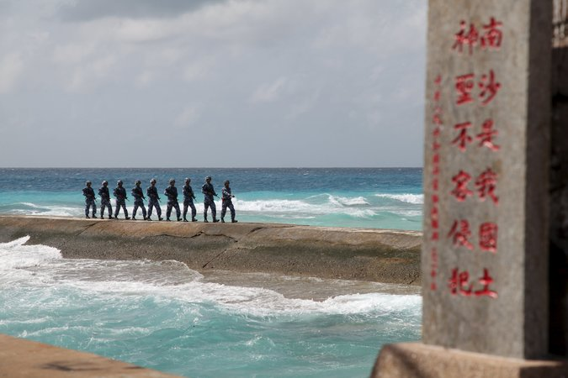
Chinese soldiers on the Spratly Islands, known in China as the Nansha Islands, in February. The sign at the right reads, “Nansha is our national land, sacred and inviolable.” Credit Reuters
BEIJING — China’s most senior uniformed military commander paid a visit in recent days to the disputed Spratly Islands in the South China Sea, the country’s Ministry of National Defense said on Friday.
The commander, Gen. Fan Changlong, appears to have been the highest-ranking People’s Liberation Army officer ever to visit the Spratly group, a sprawling collection of islands that extends close to the Philippines.
Photo
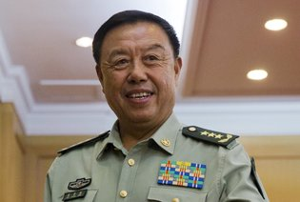
Gen. Fan Changlong appears to have been the highest-ranking People’s Liberation Army officer ever to visit the Spratly group. Credit Pool photo by Ng Han Guan
Although the details made public about General Fan’s visit were sparse, his tour appeared intended to show China’s determination to ward off any challenges to its claims over the islands, which are also the subject of claims by the Philippines, Malaysia, Vietnam, Brunei and Taiwan. China calls them the Nansha Islands.
General Fan led a delegation to the “relevant Nansha Islands to offer good wishes to officers and personnel stationed there, and also to understand the construction of facilities on the islands,” said a brief statement from the Ministry of National Defense.

Interactive Feature

What China Has Been Building in the South China Sea
China has been feverishly piling sand onto reefs in the South China Sea, creating seven new islets in the region and straining already taut geopolitical tensions.

General Fan is a vice chairman of the Central Military Commission, the council that runs the People’s Liberation Army forces. He is outranked only by the chairman, Xi Jinping, who is also president of China and head of the country’s Communist Party. Under Mr. Xi, the Chinese military has accelerated efforts to secure domination of islands also claimed by Southeast Asian countries.
The growing reach of the Chinese Navy, and the rival claims of other Asian powers, have turned the Spratlys and other islands across the South China Sea into a volatile mosaic of disputes. In past decades, Chinese military and civilian leaders have visited the Paracel Islands, which are closer to the Chinese mainland.
China claims sovereignty over much of the sea, but it faces not only rival claims from Southeast Asian countries but also growing wariness from Washington and its allies. They say that Beijing is risking a dangerous escalation of regional tensions by expanding barren reefs and outcrops into artificial islands and by installing military outposts, lighthouses, airstrips and other infrastructure on islands under its control.
On Friday, the United States secretary of defense, Ashton B. Carter, visited an American Navy aircraft carrier in the South China Sea, a gesture that seemed likely to draw ire from Beijing. The Chinese government says that Washington should play no part in trying to settle the territorial disputes in the South China Sea, and it has criticized operations by United States Navy ships that have passed close by islands controlled by China.
The Obama administration has said those operations are to show that China cannot deny other nations freedom of navigation through waters near islands under its control. China says that its island facilities, including lighthouses and weather stations, serve valuable civilian functions for all countries.

Chinese Navy in South China Sea Draws U.S. Admiral's Praise
Rosalind Mathieson RosMathieson
April 25, 2016 — 9:42 PM EDT Updated on April 26, 2016 — 1:19 AM EDT
Share on FacebookShare on Twitter
South China Sea: The Next Global Flashpoint?
- `Completely professional' interactions, says Admiral Hitchcock
- U.S. aircraft carrier is currently sailing in South China Sea
Standing on a nuclear-powered U.S. aircraft carrier the length of more than three football fields as it plows through one of the world’s most contested seas, Rear Admiral Marcus Hitchcock has only high praise for the navy of his biggest military rival: China.
Around 125 nautical miles from the Malaysian coast in the South China Sea, Hitchcock, the newly-minted commander of the carrier strike group led by the USS John C. Stennis, says his ships have been engaged on almost a “twenty four-seven basis” with a “completely professional” People’s Liberation Army Navy.

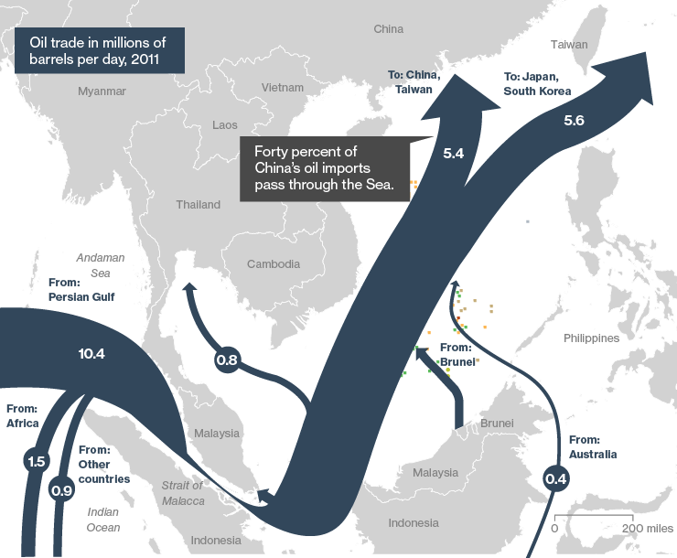
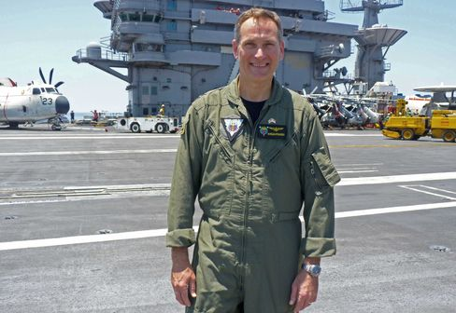
Rear Admiral Marcus Hitchcock.
Photographer: Rosalind Mathieson/Bloomberg
“We have had nothing but professional interactions,” he said on Monday on the flag deck of the John C. Stennis, over the near-constant roar of fighter jets taking off and landing. “The ocean is a very connected environment, and the sailors that are on it, the navies that are on it are very connected, no matter what their nations are going through diplomatically.”
Those diplomatic issues are, however, increasingly bleeding into the military sphere, amid accusations by the U.S. and China that the other is militarizing the South China Sea, a key shipping lane that’s the subject of overlapping territorial claims by China and Southeast Asian nations like Vietnam. The deployment of the carrier comes against the backdrop of tensions over China’s land reclamation that has enabled it to build airstrips and base missiles in the area.
Flanked by three destroyers, and with a guided missile cruiser also in the strike group, the John C. Stennis doesn’t need to venture into waters claimed by China to send a message. China currently has just one aircraft carrier, the Liaoning, commissioned in 2012 and built in a hull purchased from the Ukraine. It is building a second one domestically.
The two countries’ navies have been abiding by a code they set up for unplanned encounters at sea, Hitchcock said. The code is “going very well.”

Coast Guard
But it doesn’t extend to groups including the coast guard, and with China increasingly using its coast guard in the South China Sea as a de facto navy, security analysts have warned of the increased risk of a clash. In March, an Indonesian patrol ship was caught in a scuffle with Chinese coast guard vessels over a fishing boat that was snared inside Indonesian waters, and the country has now pledged to deploy F-16 fighter jets to the area.
QuickTake Territorial Disputes
Hitchcock is among the senior navy officers urging coast guards to develop a similar code. “It’s an absolutely reasonable way to make sure we are number one understanding each other and communicating our intent,” he said. “Once people understand each other and communicate their intent, I think you find reasonable people make reasonable decisions to go about their business in a responsible fashion.”
The presence of the John C. Stennis and a recent visit to the region by Defense Secretary Ashton Carter -- including a trip to the carrier -- coincided with a ramping up of activity by China. Central Military Commission vice chairman Fan Changlong, second-only in military rank to President Xi Jinping, made a visit this month to Fiery Cross Reef. A PLA plane also landed on a reef this month in what the official Xinhua news agency described as a medical rescue mission.
On Monday China’s defense ministry said in a statement it was concerned by news that six U.S. Air Force planes flew in international airspace in the vicinity of Scarborough Shoal on April 19. “The Chinese military will take all necessary measures to safeguard national sovereignty and security,” the ministry said.
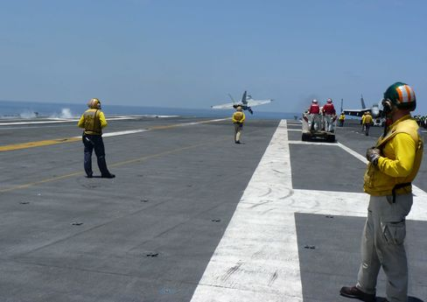
USS John C. Stennis.
Photographer: Rosalind Mathieson/Bloomberg
Hitchcock said the increased U.S. military presence in Southeast Asia did not risk making things worse. Last year, the U.S. began to challenge China by sailing warships near its reclaimed reefs in so-called freedom of navigation operations.
“This is a routine, scheduled deployment,” Hitchcock said. “We’ve committed to unimpeded commerce in this region.”
The resumption of freedom of navigation operations in the area is not a challenge to sovereignty, he added. “They are challenges to excessive territorial claims. We take no position on sovereignty other than to say we hope there is a peaceful and diplomatic resolution to sovereignty challenges here in this region.”

NYT

A U.S. Admiral’s Bluntness Rattles China, and Washington
The Saturday Profile
By JANE PERLEZ MAY 6, 2016
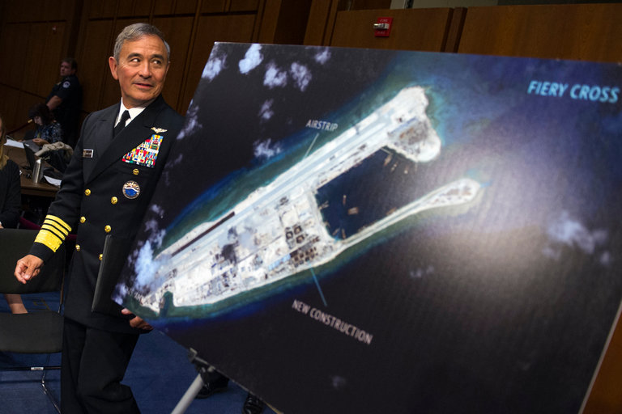
Adm. Harry B. Harris Jr., who leads the United States Pacific Command, preparing to testify on Capitol Hill last year. The photograph near him shows an island that China has built and equipped with an airstrip on Fiery Cross Reef in the South China Sea. Credit Cliff Owen/Associated Press
HONOLULU — He has called China “provocative and expansionist,” accusing it of “creating a Great Wall of sand” and “clearly militarizing” the disputed waters of the Western Pacific. “You’d have to believe in a flat earth to think otherwise,” he said in one appearance before Congress.
These are the words of the American commander in charge of military operations in the Asia-Pacific region, Adm. Harry B. Harris Jr., who has turned heads — and caused headaches — in Beijing as well as in Washington with language starker than any coming from his commander in chief, President Obama.
Admiral Harris makes no apologies for his candor, which has unsettled a more cautious White House. As China builds militarily fortified islands in the South China Sea, a strategic waterway long dominated by the United States, it is his job, he says, to talk to Congress, the American public and allies abroad about the threat.
“There is a natural tension between elements of the government and the chain of command, and I think it’s a healthy tension,” he said during an interview in his office, perched high above Pearl Harbor. “I’ve voiced my views in private meetings with our national command authorities. Some of my views are taken in; some are not.”
For the Chinese, Admiral Harris, 59, is not only a tough talker. He was born in Japan, the son of a Japanese mother and an American father who was a chief petty officer in the American Navy. The Chinese have zeroed in on his ethnicity as a mode of attack.
“Some may say an overemphasis on the Japanese background about an American general is a bit unkind,” Xinhua, the official Chinese news agency, wrote. “But to understand the American’s sudden upgraded offensive in the South China Sea, it is simply impossible to ignore Admiral Harris’s blood, background, political inclination and values.”
The derogatory comments had two goals, the admiral said. First, they were meant to show that the Pacific Command was “disconnected from the rest of government,” an idea that was “completely untrue.”
Second, they seemed intended to tarnish him. “You know when I am described as a Japanese admiral it’s not true. I am not sure why they have to have an adjective in front of admiral.”
When his family moved back to rural Tennessee, his mother refused to teach him Japanese, insisting that her son was 100 percent American. In that vein, the admiral does not make much of the fact that he is the first Asian-American to be appointed a combatant commander.
That insistence on his American identity makes the Chinese comments particularly galling to him. “In some respects, they try to demonize me, and that’s really ugly,” he said. “I think in a lot of ways the communications that come out of the Chinese public affairs organ, they are tone deaf and insulting.”

Interactive Feature

What China Has Been Building in the South China Sea
China has been feverishly piling sand onto reefs in the South China Sea, creating seven new islets in the region and straining already taut geopolitical tensions.
OPEN Interactive Feature

A United Nations tribunal in The Hague is expected to rule soon on a case brought by the Philippines that could make China’s recent fortifications on islands in the South China Sea illegal. The panel could declare Beijing’s claim over most of the South China Sea, which stretches from the coast of China to the beaches of Southeast Asian nations, invalid.
The decision is widely expected to be unfavorable for Beijing, with potentially sharp consequences for the increasingly brittle relationship between China and the United States.
How boldly China reacts to the ruling is a major concern for Admiral Harris, whose task is to recommend military options should China push forward, either in the short or longer term, with its efforts to control a waterway through which trillions of dollars in trade, including oil and gas, passes every year.
Chinese military commentators have said China plans to make the Scarborough Shoal, an atoll Beijing grabbed from the Philippines four years ago, into a fortress. Only 120 miles from the Philippine coast, it would be a potential threat to an American ally. Beijing could also declare an air defense zone over parts of the South China Sea, forcing civilian airliners to make long and expensive detours to avoid risking encounters with the Chinese Air Force.
The stakes are so high that Mr. Obama warned the Chinese leader, Xi Jinping, during their recent meeting in Washington not to move on the Scarborough Shoal or invoke an air defense zone, said an American official who was briefed on the details of the encounter and spoke anonymously because of the diplomatic sensitivities.
Neither side wants conflict over specks in the sea. But the possibility has to be considered, and Scarborough Shoal is now the place Pentagon officials say the United States might take a stand.
The chairman of the Joint Chiefs of Staff, Gen. Joseph F. Dunford Jr., recently asked Admiral Harris just that question. In a conversation overheard by a reporter while the two men chatted at the Pentagon, the admiral’s answer was indistinct.
Asked later — war or not over the Scarborough Shoal — the admiral chuckled.
“It is good that my voice is low,” he said, popping a Coca-Cola as he sat on a couch in his expansive office. “I will say I’m a military guy. I look through the lenses darkly, and that’s what I’m paid to do.”
To defend American interests, he said, “I have to do it with the tools I have, and they are military tools, and they are great tools.”
“In the China piece, we just have to be ready for all outcomes from a position of strength,” Admiral Harris said, “all outcomes whether it is Scarborough, South China Sea in general, or some cyberattack.”
He said he was worried not so much about miscalculations in the South China Sea between the Chinese military and the forces of other countries. “I view them as a professional military.” The bigger risk, he said, is a clash caused by China’s paramilitary ships that could bring American forces to bear in defense of American allies.
The job of a United States combatant commander — there are nine across the globe — is to serve as soldier, diplomat and an advocate of his theater to just two bosses, the president and the defense secretary.
The admiral has added another facet to his job: communicator, an unusual objective for a military leader. In his “commander’s intent,” a document he drew up last year describing his goals, he wrote, “We must communicate clearly with key audiences, including allies, partners and potential adversaries.”
Wherever he goes, he points out that his responsibilities cover not just China but also North Korea, a pressing current danger, and beyond. “From Bollywood to Hollywood, from polar bears to penguins,” is how he puts it.
He recently carried his message to New York City, speaking to 30 members of the Council on Foreign Relations. He met with Henry A. Kissinger (and whipped out a first edition of Mr. Kissinger’s “Nuclear Weapons and Foreign Policy” for an autograph).
Then it was on to Malaysia to fly in an American P-8 spy plane with Malaysian defense officials, a trip intended to persuade that country to align more closely in the South China Sea dispute with the United States over its chief economic benefactor, China.
After graduation from the United States Naval Academy at Annapolis, Md., Admiral Harris trained as a naval flight officer. In 1991, he flew over the Persian Gulf during a naval war in which the United States sank the Iraqi Navy in 48 hours.
Although most of the admiral’s assignments have been in Asia, he has made some detours.
About a decade ago, he served as the commander at Guantánamo Bay. He studied the ethics of war at Oxford. Then came a posting as the military adviser to Secretary of State Hillary Clinton, when he monitored the “road map” for the final status accord between Israel and the Palestinians.
“Harry — Thanks for traveling the world with me — Hillary” reads a handwritten note on a photograph of the two of them that hangs on a wall in his office.
A wall map of the South China Sea sprinkled with islands hangs to the left of his desk. Black circles show the three artificial islands in the Spratly archipelago where the Chinese have built military-capable airstrips and other assets. Admiral Harris refers to those islands as Chinese bases.
Behind his desk, bookshelves are stacked with accounts of world affairs. “In reading history, it is those countries with militaries who are prepared and ready that fare much better than countries that have no militaries and aren’t,” he said.
The admiral talks about how his forces must be ready “to fight tonight.” One of his recent reads, “This Kind of War,” by T. R. Fehrenbach, about the Korean War, drove that point home. “He says the United States was not ready,” he said. “It is really a powerful book.”

NYT

Asia Pacific

U.S. Sails Warship Near Island in South China Sea, Challenging Chinese Claims
By JANE PERLEZMAY 10, 2016
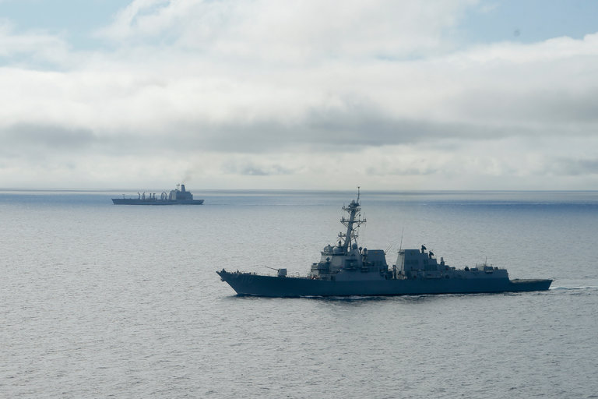
The William P. Lawrence, a guided missile destroyer, in Coronado, Calif., in January. The ship ventured into the vicinity of Fiery Cross Reef, an artificial island that China constructed in the South China Sea, on Tuesday. Credit Gregory Bull/Associated Press
HONG KONG — An American warship sailed on Tuesday within 12 miles of an artificial island built by China in the South China Sea, an operation intended to show that the United States opposes China’s efforts to restrict navigation in the strategic waterway, the Pentagon said.
The warship, the William P. Lawrence, a guided missile destroyer, ventured into the vicinity of Fiery Cross Reef, a 700-acre artificial island China constructed in the last 18 months on top of two small rocks.
The operation on Tuesday, known as a freedom-of-navigation patrol, came as tensions between the United States and China escalated ahead of a United Nations arbitration ruling on whether Beijing has the right to claim 12-mile territorial waters and 200-mile exclusive economic zones around reefs and atolls in the South China Sea.
The ruling, in a case brought by the Philippines, an American ally, is expected in the coming weeks.
China has built a military-capable runway and dredged a deepwater port on Fiery Cross Reef, one of seven specks in the Spratly archipelago close to the Philippines that it has enlarged. China contends that other countries must request transit rights for their ships around its claims in the South China Sea, the Pentagon said.
To emphasize its rights to Fiery Cross Reef, the vice chairman of China’s Central Military Commission, Gen. Fan Changlong, recently visited there, and the Chinese Army sent a performance group to entertain military personnel and the construction workers who built the island.
Cmdr. Bill Urban, a spokesman for the Pentagon, said in a statement that the William P. Lawrence “exercised right of innocent passage” as it transited within 12 miles of Fiery Cross Reef. That means the vessel was not conducting military operations.

Interactive Feature

What China Has Been Building in the South China Sea
China has been feverishly piling sand onto reefs in the South China Sea, creating seven new islets in the region and straining already taut geopolitical tensions.
OPEN Interactive Feature

In response, China said the American destroyer had sailed through Chinese waters illegally. The ship was tracked and warned, said a spokesman at the Foreign Ministry, Lu Kang.
“This action by the U.S. side threatened China’s sovereignty and security interests, endangered the staff and facilities on the reef, and damaged regional peace and stability,” Mr. Lu said at a regular news briefing.
Later, the Chinese Ministry of Defense said that three Chinese aircraft and three warships had “expelled” the American vessel from China’s waters.
“It once again demonstrates that China’s installation of defensive facilities on the Nansha Islands is totally reasonable and very necessary indeed,” the ministry spokesman, Yang Yujun, said in a statement.
Nansha Islands is the name Beijing uses for the Spratlys.
The United States operation was carried out to demonstrate the right of freedom of navigation, the Pentagon said. Taiwan and Vietnam also claim Fiery Cross Reef, and like China, require prior notice for navigation within the 12-mile zone, the statement said. The Philippines, also a claimant to Fiery Cross Reef, makes no such demands, the Pentagon said.
As an indication of the mounting tensions, China’s military said that it was conducting exercises in the South China Sea this week with warships, submarines, aircraft and troops from the garrisons in the Spratly archipelago and the Paracel Islands.
The United States Navy conducted a freedom-of-navigation operation in January around the Paracel Islands, and another in October around Subi Reef, in the Spratly archipelago. None of the countries that make claims to the disputed rocks and atolls were notified of the freedom-of-navigation operation on Tuesday, the Pentagon said.
The Pentagon said it did not make judgments on the territorial rights to the disputed islands.

NYT

Soft Power: Beijing Puts On a Show on Disputed South China Sea Island
点击查看本文中文版 Read in Chinese
Sinosphere
By JANE PERLEZ and YUFAN HUANG MAY 5, 2016
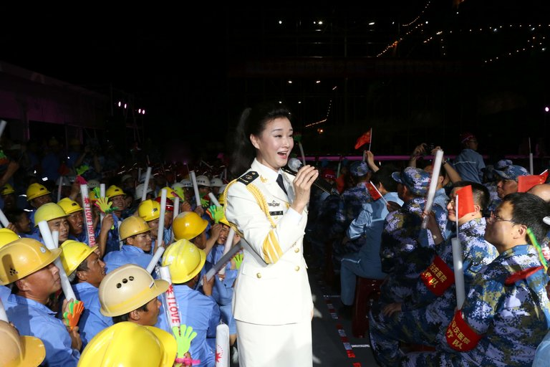
The Chinese folk singer Song Zuying performed on Monday for construction workers and military personnel on Fiery Cross Reef in the disputed Spratly Islands in the South China Sea. Credit Agence France-Presse — Getty Images
BEIJING — Now that China had completed a 10,000-foot runway fit for fighter jets and dredged a huge harbor at Fiery Cross Reef, an artificial island at the center of a territorial dispute in the South China Sea, the time had come to reward the workers who built them.
One of China’s biggest navy ships, a type of amphibious assault vessel, arrived at Fiery Cross Reef this week loaded with a performance group from the People’s Liberation Army. They danced and sang for two and a half hours before a cheering crowd of military personnel and construction workers.
A video of the performance by CCTV, the Chinese state broadcaster, showed the gray hull of the Kunlunshan, a 20,000-ton warship and the second-largest vessel in the Chinese fleet, as the backdrop for the temporary stage rigged up portside.
A CCTV report (in Chinese) on the performance staged for workers and troops on Fiery Cross Reef. CCTV/YouTube
One of the most applauded songs of the evening was “This Is the Kind of Man We Want to Marry,” a patriotic ballad about a navy man who postpones his wedding because of his duties far from home. Eventually, the man’s fiancée comes to the island, and they marry on the construction site.
The audience, dressed in blue military fatigues and hard hats, cheered when the singer onstage delivered the “I do” line.
An enthusiastic construction worker told a CCTV interviewer, “This is exactly our lives: wife and children waiting for us to come home.” He wore a helmet bearing the name of the China Communications Construction Company, a state-owned enterprise specializing in port, airstrip and bridge building.
“Song and dance is always a way to show gratitude,” said Gary Li, an analyst at APCO Worldwide, a consulting firm on geopolitical affairs. The vessel the performers arrived on was similar to ships used by the United States Marines to carry vehicles, helicopters and troops, he said.

Interactive Feature: What China Has Been Building in the South China Sea

“The performance was a sign that Fiery Cross Reef is considered a long-term garrison,” Mr. Li said.
Live theater is not the only distraction for workers and troops on Fiery Cross Reef. Last month, satellite images showed a newly built soccer field and basketball and tennis courts.
“The football field and tennis courts are all to enrich the spare time of the soldiers who are all young men working there under tough conditions,” said Xu Guangyu, a retired major general. “Now they can even watch television and use mobile phones. Before, we didn’t even have stable radio signals.”
Fiery Cross Reef, now a 700-acre island where once just a couple of low-lying rocks were lapped by the tides, is the subject of an arbitration case filed by the Philippines at a United Nations tribunal in The Hague.
A ruling is expected in the coming weeks, and there is wide expectation that the panel will decide that China’s construction in the last 18 months on Fiery Cross Reef and other islands in the Spratly archipelago contravenes international law.
Before the ruling, China is making various military and diplomatic moves to show that it is standing firm on its claims to seven disputed islands in the Spratlys, about 500 miles from China and less than 150 miles from the Philippines.
A large-scale Chinese naval exercise will soon be underway in the South China Sea, The People’s Liberation Daily announced on Wednesday.
This week, three warships from the South Sea Fleet left Hainan Island, the southernmost province of China, for the exercise, and three more will soon join them, the newspaper said. The exercise is intended to “strengthen the combat spirit and foster the concept of war preparation,” it said.

NYT

Beijing Tries to Whip Up Support for Its South China Sea Claims
By MICHAEL FORSYTHEMAY 13, 2016
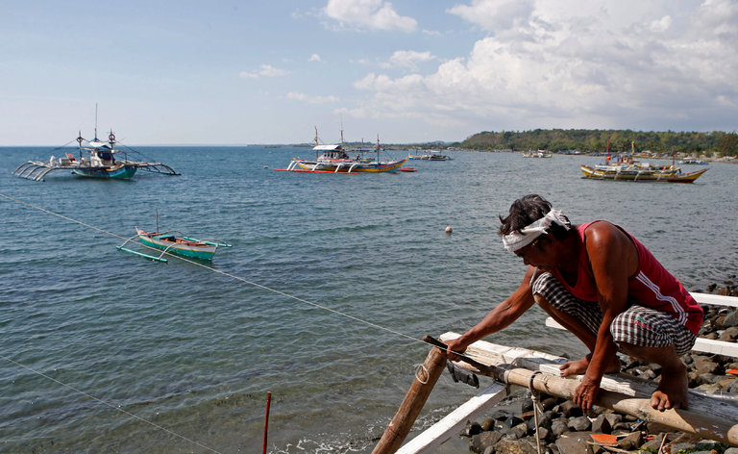
A Filipino fisherman repaired his boat near a fleet of boats that fish at Scarborough Shoal. Concern is growing that China may try to build an island on the shoal, which is close to Manila and to bases in the Philippines used by the United States. Credit Erik De Castro/Reuters
HONG KONG — China is undertaking a diplomatic and public relations blitz to rally support for its sweeping maritime claims in the South China Sea ahead of a decision by an international court that may rule against Beijing.
Beijing says it owns the islands, rocks and shoals — and the waters around them — in a giant expanse of the South China Sea, overlapping with claims made by countries such as Indonesia, the Philippines and Vietnam. In the past month, China has said that countries like Cambodia and Russia have taken positions supportive of its stance.
In a bid to make its control of the area a fait accompli, China in the past two years has built seven artificial islands in the South China Sea, equipped with airstrips, radars and ports and staffed by thousands of workers and soldiers.

Interactive Feature

What China Has Been Building in the South China Sea
China has been feverishly piling sand onto reefs in the South China Sea, creating seven new islets in the region and straining already taut geopolitical tensions.
OPEN Interactive Feature

Now, concern is mounting that China may start building an eighth island on Scarborough Shoal, a reef much closer to Manila and to bases in the Philippines used by the United States, potentially setting off a diplomatic crisis and a military standoff between China and the United States, the world’s two biggest economies. China wrested control of the shoal, used by Filipino fishermen, in 2012. In early 2013, the Philippines filed suit at the Permanent Court of Arbitration in The Hague, challenging China’s territorial claims to the sea. They are demarcated on Chinese maps by a so-called nine-dash line, which the Philippines says is excessive and conflicts with its own claims.
A ruling by the court, which may favor the Philippines, is expected in the coming weeks. China has refused to take part in the proceedings, saying the international agreement on which the Philippines is basing its claim, the United Nations Convention on the Law of the Sea, does not apply in this case.
China has been taking its case to the international news media, with a senior diplomat holding a news conference on Thursday in Beijing. On Friday, Chinese diplomats spoke to reporters in Hong Kong. Officials at both venues sharply criticized the action by the Philippines and the decision by the international court to take the case.
“By unilaterally initiating the arbitration, the Philippine side is imposing its own will on others,” Song Ru’an, deputy commissioner for the Chinese Foreign Ministry in Hong Kong, told reporters on Friday. “It is only natural for China not to participate in such arbitration that has become tainted and gone astray. And China will not accept or recognize the award of the arbitration whatever it might be.”
In its campaign to win international support for its position, China has focused mostly on small nations that depend on Chinese trade or aid, with limited success. On April 13, China’s state-run Xinhua news agency reported that Fiji had declared its support for China’s position, which holds that any disputes countries have over the sea should be handled bilaterally. Fiji’s Information Ministry quickly replied, saying the Pacific island nation did not back China’s stance and took no sides in the matter, the Fiji Broadcasting Corporation reported.
China also claims the support of Brunei, Cambodia and landlocked Laos. In April, Russia’s foreign minister, Sergey V. Lavrov, meeting his counterpart in Beijing, said that outside nations should not interfere in the South China Sea, a reference to the United States. The United States has been challenging what it considers China’s excessive maritime claims by sailing warships close to China’s artificial islands, most recently on Tuesday, when a guided missile destroyer passed within 12 nautical miles of Fiery Cross Reef.
Euan Graham, director of the International Security Program at the Lowy Institute for International Policy in Sydney, Australia, said the court might issue a ruling that did not address the legality of China’s nine-dash line, which was first put forth in the years before the Chinese Communist Party’s victory in 1949. The court may rule that the shoals and outcroppings claimed by China are not islands, meaning that China cannot make the case that it should have exclusive economic zones around them, limiting its jurisdiction in the waters of the South China Sea, he said.
“It is likely to go predominantly the Philippines’ way,” Mr. Graham said by telephone. “That explains why China is rolling out in a very communist way this propaganda barrage.”

NYT

Rodrigo Duterte, Poised to Lead Philippines, Is Expected to Take New Approach to China
点击查看本文中文版 Read in Chinese
By RICHARD C. PADDOCKMAY 11, 2016
Asia Pacific By EDWARD FETNER 2:03 Rodrigo Duterte’s Inflammatory Remarks
Video

Rodrigo Duterte’s Inflammatory Remarks
The Filipino presidential candidate Rodrigo Duterte is no stranger to controversy. Here are some of his provocative comments.
By EDWARD FETNER on Publish Date May 10, 2016. Photo by Bullit Marquez/Associated Press. Watch in Times Video »
- embed
- Share
- Tweet
MANILA — Rodrigo Duterte, poised to be the Philippines’ next president, has signaled that he will try a new approach toward China by emphasizing economic ties.
During the campaign, he talked tough about China’s activities in the South China Sea, saying he would ride a Jet Ski to the contested Spratly Islands and plant the Philippine flag there. Yet he also said he would seek Beijing’s help in building a rail line that would link Manila to the southern island of Mindanao, where he served as mayor of Davao City for nearly two decades.
He even proclaimed he would “shut up” about the South China Sea if China built the railway.
“Development rather than deterrence — that is going to be doctrine on the South China Sea,” said Richard Javad Heydarian, a political science professor at De La Salle University in Manila. “The Jet Ski, planting the flag, that is Duterte the entertainer. But you will see the contemplative president developing foreign policy.”
Though the bombastic Mr. Duterte has yet to assume the role, some analysts say his unpredictability will help him negotiate with foreign powers. At the same time, they expect him to maintain a close relationship with the United States, which has strong military ties with the Philippines.
Photo
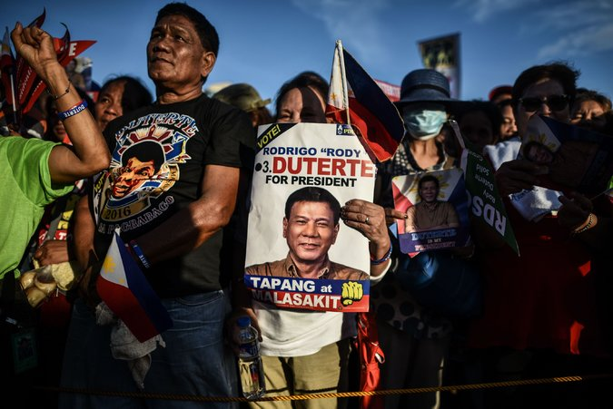
Supporters of Rodrigo Duterte during an election campaign rally in Manila on Saturday. Ballots were still being tabulated on Wednesday, but Mr. Duterte was far ahead of his nearest rival. Credit Mohd Rasfan/Agence France-Presse — Getty Images
With 96 percent of the votes from Monday’s election counted on Wednesday, Mr. Duterte led with 38.5 percent, far ahead of his rivals. In the Philippine system, only a plurality is required to win.
Though there are no official results yet, President Benigno S. Aquino III congratulated Mr. Duterte on his victory and pledged to cooperate in the transfer of power. He said his administration had formed a transition team to work with Mr. Duterte’s staff.
“We are committed to effecting the smoothest transition possible,” Mr. Aquino said.
Mr. Duterte, who would be the first mayor and the first official from impoverished Mindanao to win the presidency, faces formidable challenges in governing the island nation of 100 million people. Despite recent economic growth, a quarter of the nation lives in poverty.
He promised during the campaign to lead a ruthless battle against crime. His first priority will be keeping that pledge, analysts say. “I will become a dictator against all bad guys,” he told reporters on Monday.
Another pressing issue is China’s expansion in the South China Sea, where it has built islands and military bases in the areas claimed by the Philippines and other Southeast Asian nations.

The Contenders
Jejomar Binay, 73, is a former mayor of Makati, the capital's financial district, and vice president. Corruption allegations, which he denies, have tarnished his image.
- 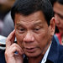
Rodrigo Duterte, 71, is the mayor of Davao City, where he gained a reputation for reducing crime rates, although some have questioned the legality of his actions in the process.
Grace Poe, 47, is the adopted daughter of actors. Ms. Poe, a senator, faced a legal battle over questions about her citizenship.
Mar Roxas, 58, is the son of a senator and grandson of a president. President Aquino endorsed the candidacy of Mr. Roxas, who was interior minister in his administration.
Under Mr. Aquino, the Philippines challenged China’s claims in a United Nations arbitration court. A decision is expected before Mr. Duterte takes office on June 30, and experts say the Philippines is likely to prevail. However, China has refused to participate in the case, and the court has no enforcement mechanism.
Mr. Duterte is likely to use a decision in the Philippines’ favor as leverage to win concessions from China, particularly investment in infrastructure, like the rail line to Mindanao, analysts say.
“He will talk to China, not like President Aquino,” said Ramon Casiple, executive director of the Institute for Political and Electoral Reform, a nonprofit organization promoting democracy. “He is willing to explore other realms of relations, economic cooperation and joint development.”
Beijing views relations with the Philippines to be at a low and sees room for improvement, an editorial in the state-run Global Times said this week.
“China will not be too naïve to believe that a new president will bring a promising solution to the South China Sea disputes between Beijing and Manila,” the editorial said. “Only time will tell how far the new leader, be it Duterte or not, will go toward restoring the bilateral relationship.”
Filipinos overwhelmingly favor close ties to the United States, which once governed the islands as a territory, and many are suspicious of China and its intentions in the South China Sea.
The United States and the Philippines have a mutual defense pact. In addition, in Mindanao the United States is helping to combat Abu Sayyaf, a gang of kidnappers that has pledged allegiance to the Islamic State.
Clarita Carlos, a retired political science professor at the University of the Philippines, said that with those realities she expects Mr. Duterte to find a middle course between the United States and China, which both have significant trade with the Philippines.
“People say it’s the U.S. versus China,” she said. “But they are both our friends. China is also dependent on us. Let them learn the lesson that cooperation is the name of the game.”
She also expects Mr. Duterte to become less spontaneous in his comments when he is the nation’s leader.
“I’m sure he will become more temperate as he sees the enormity of the task,” she said.

NYT

Asia Pacific

Access to Bay Adds Enticement as U.S. Weighs Lifting Vietnam Embargo
By JANE PERLEZMAY 19, 2016
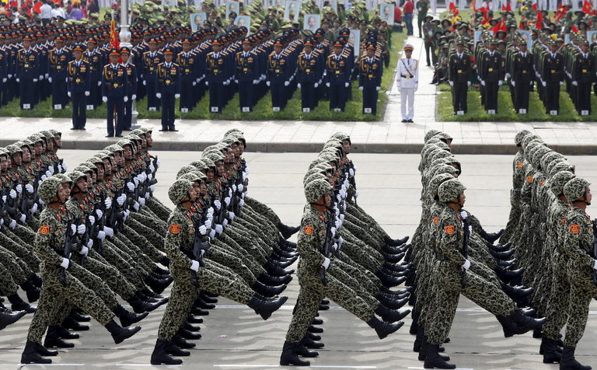
Vietnamese soldiers in September during a parade observing the 70th National Day in Hanoi. President Obama will visit Vietnam on Sunday. Credit Reuters
CAM RANH BAY, Vietnam — The ghosts of the Vietnam War have finally faded at the strategic port of Cam Ranh Bay. More than 40 years ago, United States forces left this massive base where Marines landed, B-52s loaded up for bombing raids, and wounded American soldiers were treated.
Now, some Vietnamese say they are yearning for the American military to return.
“On Facebook, there was a question recently: What do you want from President Obama’s visit?” said Vo Van Tao, 63, who fought as a young North Vietnamese infantry soldier against the United States. “Some people said they wanted democracy. I said I wanted the Americans to come back to Cam Ranh Bay. A lot of people agreed with me.”
Mr. Obama is scheduled to arrive in Vietnam on Sunday, the third visit by an American president since the war ended. The big question he is expected to answer is whether Washington will lift a partial arms embargo and allow Vietnam to buy lethal weapons from the United States. The Communist government has long asked for the ban to be revoked, and American access to Cam Ranh Bay could be part of the payoff.
For the White House, the decision on lifting the embargo has come down to a debate over trying to improve Vietnam’s poor human rights record versus enabling Vietnam to better defend itself against an increasing threat from China in the South China Sea.
Washington has for years made lifting the ban contingent on Vietnam’s improving human rights for its people, and has prodded Vietnam to allow more freedom of speech and to release political prisoners. But as tensions with China have escalated in the South China Sea, the sentiment in the Obama administration has shifted toward lifting the ban, American officials familiar with the discussions said.
Vietnam’s government, pressed by an ever more powerful China, knows it cannot stand up to Beijing alone and is cautiously moving toward increased ties with the United States.
Despite their shared Communist ideology, Vietnam and China fought over islands in the South China Sea in the 1970s and ’80s. Two years ago, China sent an oil rig into disputed waters close to the Paracel Islands, which are claimed by both countries, leading to clashes at sea and anti-Chinese riots in Vietnamese cities.

More recently, China has built artificial islands with military runways in the South China Sea just 300 miles from the Vietnamese coast.
Vietnam’s needs dovetail with those of the United States, which has been encouraging maritime states in Southeast Asia to better defend themselves, an effort partly aimed at keeping the United States from being dragged into a direct naval conflict with China.
The prospect of access to Cam Ranh Bay, where the Vietnamese have built a new international port, provides another enticement for lifting the ban.
Photo
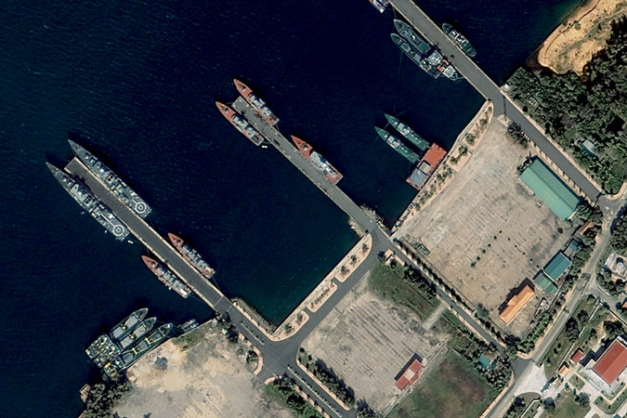
A satellite image of the Cam Ranh Bay Naval Base in 2013. Credit DigitalGlobe, via Getty Images
An American presence there would allow United States forces to use the port on the western edge of the South China Sea, complementing American facilities in the Philippines on the sea’s eastern edge.
“If the United States can get regular access to Cam Ranh Bay, it would be very advantageous to maintaining the balance of power with China,” said Alexander L. Vuving, a Vietnam specialist at the Asia-Pacific Center for Security Studies in Honolulu. “If something happens in the South China Sea, it takes a while for the U.S. to get there. China can get there more quickly.”
The Vietnamese, who shun alliances and forbid foreign bases, have made clear they would not entertain exclusive use of the facilities by the United States but would allow it to share the base with others. Singaporean and Japanese vessels this year were the first to use the facility.
Deputy Secretary of State Antony J. Blinken assured Hanoi during a recent visit to Vietnam that Washington was not seeking a base here.
Lifting the embargo would go a long way toward shoring up Washington’s credibility among conservatives in the Vietnamese military who fear the Obama administration sees improved relations as a way to bring multiparty democracy to Vietnam, experts said.
“To get over the resistance of the Vietnamese military, the U.S. has to show its good intentions by lifting the arms embargo,” Dr. Vuving said. Doing so would “open the door” to closer military cooperation, he said, and access to Cam Ranh Bay would most likely follow.
Defense Secretary Ashton B. Carter said in a Senate hearing last month that he favored lifting the embargo.
But the human rights side of the equation remains problematic for a country Human Rights Watch describes as one of the world’s most repressive.
Last week, the assistant secretary of state for democracy, human rights and labor, Tom Malinowski, met with human rights leaders and government officials in Hanoi for a final human rights assessment before the Obama visit. The State Department said he urged Hanoi to “release political prisoners without condition” and make other human rights improvements.
Vietnam still has more than 100 political prisoners, activists here say, including bloggers and lawyers whose only crime was to criticize the government.
An American official who was briefed on the visit said there had been positive signals from the Vietnamese. Mr. Blinken had praised the government in a speech last month for “some progress” on human rights, notably allowing independent trade unions for the first time.
Surprisingly, a leading dissident has come out in favor of lifting the arms embargo, telling Mr. Malinowski the issue should not be linked to the release of political prisoners.
“If Obama lifts the embargo totally that would be great for Vietnam and Vietnam-U.S. relations,” said Nguyen Quang A, the founder of the Civil Society Forum in Hanoi. “The Communists say the U.S. needs to respect our legitimacy and don’t make trouble. That’s the negative from our point of view. But the positive is it starts a new era with the United States.”
Lifting the embargo is not expected to produce a windfall for American defense suppliers.
Since Washington partly lifted the embargo in 2014, allowing the purchase of nonlethal equipment for maritime defense, Vietnam has not acquired any American equipment, not even coastal radar systems for its Coast Guard, said Carl Thayer, a defense analyst in Canberra, Australia, who specializes in Vietnam. This was largely for lack of money, he said.
It would also be costly for Vietnam to switch from heavy equipment made in Russia, long Vietnam’s main arms supplier, to American-made equipment.
But Vietnam wants to diversify from its reliance on Russian arms. It is using India to train its crews on Russian-built submarines, and is looking to Israel for some weapons.
Last week, Vietnamese officials met with American military suppliers, including Boeing and Lockheed Martin, at a symposium in Hanoi to discuss the needs of the Vietnamese military.
Christopher W. Sfedu, who attended the meeting and is director of international expansion for EDI-USA, a Philadelphia-based supplier of communications equipment, said communications software appeared to be near the top of the military’s wish list.
The Russians still have privileged rights at Cam Ranh Bay, using the base for tanker aircraft that refuel reconnaissance flights over Guam.
Protected on its southern and eastern flanks by hills looming up from the South China Sea, Cam Ranh Bay juts inland for 20 miles, the largest sheltered harbor in Southeast Asia, and its most strategic because of its deep water.
For Mr. Tao, a local resident, the return of the Americans cannot happen fast enough.
“The Vietnamese people are very angry at the Chinese airstrips in the Spratlys,” he said, referring to the disputed islands in the South China Sea. “We figured out it will take them only one hour to come and bomb Saigon.”

NYT

China, Denying Close Encounter With American Plane, Points Finger at U.S.
By CHRIS BUCKLEYMAY 19, 2016
BEIJING — China rejected suggestions that its fighter jets flew dangerously close to an American surveillance aircraft and instead accused the United States on Thursday of threatening its security by regularly sending such flights near the Chinese coast.
A spokesman for the Chinese Ministry of Foreign Affairs made the counteraccusations after the Pentagon raised concerns about a close encounter on Tuesday with an American surveillance plane, which the United States said was approached by two Chinese military jets that flew within 50 feet of it.
“American military vessels and aircraft frequently engage in surveillance in close proximity to China’s coastal waters, and this constitutes a grave threat to China’s security on land and sea,” the spokesman for the ministry, Hong Lei, told a daily news briefing in Beijing. “China requests that the United States immediately halt this kind of close-proximity surveillance, thereby avoiding the recurrence of such incidents.”
The flare-up of competing charges reflected continuing tensions in the South China Sea, where the episode occurred. It also rekindled memories, for both sides, of 2001, when a collision between an American surveillance plane and a Chinese fighter jet off the Chinese coast precipitated a diplomatic crisis.

Interactive Feature

What China Has Been Building in the South China Sea
China has been feverishly piling sand onto reefs in the South China Sea, creating seven new islets in the region and straining already taut geopolitical tensions.
OPEN Interactive Feature

Beijing has been at odds with Washington over Chinese territorial claims across much of the South China Sea, which are contested by Vietnam, the Philippines and other Southeast Asian nations.
Washington says it takes no side in the disputes but wants to protect freedom of navigation in the waterway. Beijing has repeatedly accused it of dangerous meddling in the disputes.
China has been building up islands and outcrops in the sea under its control into well-equipped outposts. The Obama administration has sent naval ships to pass near those outposts in a challenge to suggestions that China has effective, if not legal, control over waters near those outposts, which Washington says should be open to free passage.
Last week, China said it had sent out fighter jets when a United States Navy destroyer passed near Fiery Cross Reef in the sea, which China has been rebuilding into an island outpost.
In the 2001 episode, the pilot of the Chinese fighter jet plunged to his death after the two planes collided, and the American plane had to make an emergency landing on Hainan, an island province in China’s far south. That led to a standoff that lasted a week and a half, until the 24 American crew members were released.
At the time, Washington and Beijing offered diverging accounts of what happened and who bore the blame. This time, too, both sides offered accounts that, without differing on particulars, put the fault on the other side.
Pentagon officials said on Wednesday that the American plane was on a routine patrol in international airspace when the Chinese aircraft flew close to it. The Pentagon said that it was still investigating the encounter, but that “initial reports characterized the incident as unsafe.”
But on Thursday, the Chinese Foreign Ministry gave its own version. Without specifying the position of the American craft, the ministry spokesman, Mr. Hong, said it was flying near Hainan Island, which juts into the South China Sea and is home to many Chinese naval facilities, including a submarine base.
“The American claims are not factual,” Mr. Hong said.
He said that an American Lockheed EP-3 surveillance plane was flying over the sea close to Hainan Island.
“Two Chinese jet fighters engaged in tailing and surveillance in keeping with laws and regulations, and they always maintained a safe distance,” he said. “They did not take any dangerous actions. Operationally, they were totally in compliance with professional and safety standards.”

NYT

Despite Obama’s Moves, Asian Nations Skeptical of U.S. Commitment
点击查看本文中文版 Read in Chinese
By DAVID E. SANGERMAY 23, 2016
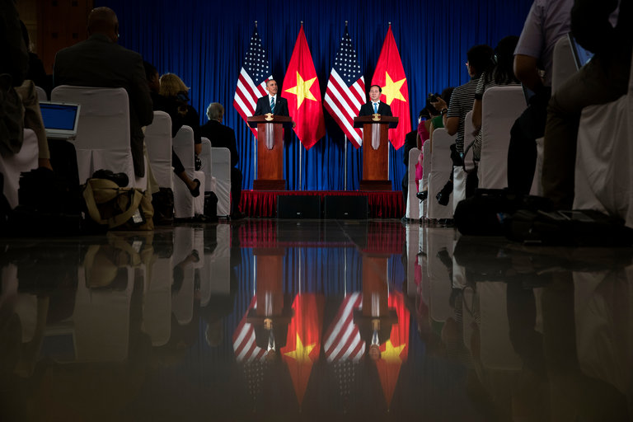
President Obama during a news conference with President Tran Dai Quang of Vietnam on Monday in Hanoi. Credit Doug Mills/The New York Times
SINGAPORE — When President Obama announced Monday that he was ending a half-century-long arms embargo against Vietnam, it was another milestone in his long-running ambition to recast America’s role in Asia — a “pivot” as he once called it, designed to realign America’s foreign policy so it can reap the benefits of Asia’s economic and strategic future.
Yet as Mr. Obama’s time in office comes to an end, Asian nations are deeply skeptical about how much they can rely on Washington’s commitment and staying power in the region. They sense that for the first time in memory, Americans are questioning whether their economic and defense interests in Asia are really that vital.
Mr. Obama is the first president to have grown up in the region — he lived in Indonesia as an elementary school student — and he has never doubted that America is underinvested in Asia and overinvested in the Middle East.
In visit after visit, he has capitalized on the palpable nervousness about Beijing’s intentions while also cautioning that China’s growing influence and power are unstoppable forces of history. In Mr. Obama’s view, that means both the United States and the rest of the region will have to both accommodate and channel China’s ambitions rather than make a futile attempt to contain them, while reassuring the Chinese of America’s peaceful intentions.
At the core, the policy has been building on the two-decade-old opening to Vietnam; the establishment of a new relationship with Myanmar as it lurches toward democracy; closer relations with the two largest treaty allies in the region, Japan and South Korea; and renewed military ties with the Philippines. The administration has also pushed the Trans-Pacific Partnership, which would set new terms for trade and business investment among the United States and 11 other Pacific Rim nations.
Photo
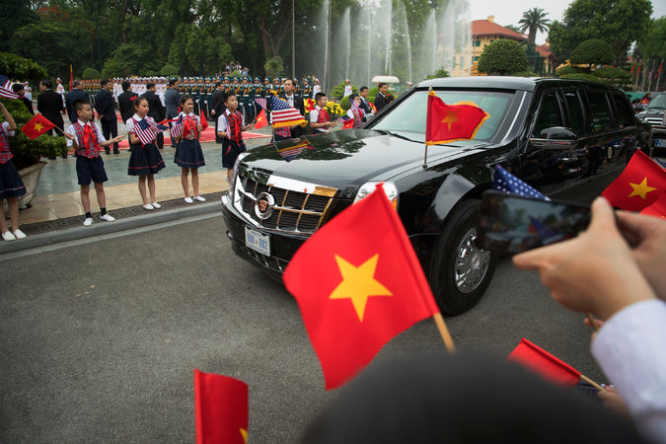
Vietnamese waved flags on Monday as President Obama’s limousine arrived at the presidential palace compound in Hanoi. Credit Doug Mills/The New York Times
Perhaps most important, Mr. Obama has received unexpected help from the Chinese themselves, who have so overplayed their hand in the South China Sea that smaller neighbors suddenly took a new interest in deepening their relations with Washington.
Countering those developments, though, is the American political mood, which has darkened toward longstanding alliances and international trade itself. For Asian allies, this means the United States might pivot away.
“Every country in Asia views the problem differently, and through their own lenses, but they all see a twofold risk of things getting out of balance quickly,” Kurt M. Campbell, one of the architects of Mr. Obama’s strategy in his first term, said on Monday. “One is that China seriously overplays its nationalism” and that conflict breaks out in the South China Sea.

But Mr. Campbell, who is about to publish an account of Mr. Obama’s efforts titled “The Pivot: The Future of American Statecraft in Asia,” also noted that Asian nations were equally worried that America is no longer willing to be a steadying power.
“Asian countries are prone to anxiety about the behavior of major powers, for good reasons — they have seen a lot go wrong over the past thousand years,” said Daniel R. Russel, the assistant secretary of state for Asia. “And now there is angst about what comes next and the sustainability of the rebalance.”

Interactive Feature

What China Has Been Building in the South China Sea
China has been feverishly piling sand onto reefs in the South China Sea, creating seven new islets in the region and straining already taut geopolitical tensions.
OPEN Interactive Feature

Not surprisingly, uncertainty begets hedging, in big ways and small.
The Vietnamese gave Mr. Obama a huge welcome on Monday, lining the streets in ways reminiscent of Bill Clinton’s first presidential trip there 16 years ago. But missing from the news conferences was the hard-core group in the leadership that remains deeply suspicious that Washington’s real long-term goal is regime change.
So while almost certainly they will buy American arms — especially the high-tech gear they need to keep an eye on what the Chinese are doing at the edge of Vietnam’s territorial waters — they have no intention of building the kind of alliance the United States has with Japan and South Korea. “Now that the U.S. fully lifted the weapons ban, I think U.S. Navy vessels will come to Cam Ranh Bay later this year,” said Alexander L. Vuving, a specialist on Vietnam at the Asia-Pacific Center for Security Studies in Honolulu.
Last week, as the streets of Hanoi were being cleaned up for the president’s visit, the Chinese were meeting with Vietnam’s defense minister, pledging to strengthen their military ties.
In the Philippines, the firebrand who has just been elected president, Rodrigo Duterte, once promised to ride a Jet Ski to plant a flag on one of the artificial islands the Chinese have constructed. More recently, he is backing away from the current government’s effort to press its sovereignty arguments, saying he wants to negotiate directly with the Chinese, perhaps swapping a little sovereignty for some economic concessions. That is just the kind of invitation the Chinese wanted to hear.
Mr. Obama’s vision is certainly nuanced. As Mr. Campbell writes in his book, the trick in the pivot is to build a deep relationship with the Chinese to convince not only “China but also China’s neighbors that our China policy is not intended to produce needless and unproductive friction.”
Photo
President-elect Rodrigo Duterte of the Philippines on Monday. Mr. Duterte has signaled that he may retreat from the current government’s effort to press its sovereignty arguments against China in international courts. Credit Manman Dejeto/Agence France-Presse — Getty Images
Containment “has little or no relevance to the complexities of an interdependent Asia in which most states have deep economic ties with China.”
The Chinese are unconvinced. One of the key military elements of the strategy is for American troops to “rotate” through strategically important Asian ports — not to be based there, but to be able to land, refuel, train and build partnerships.
It started with Darwin, Australia. Now Mr. Obama is trying to do the same in the Philippines, which the United States left more than two decades ago, and at the deepwater port of Cam Ranh Bay, if the unspoken deal with Vietnam works out. That would give Washington more reason to regularly traverse waters the Chinese claim as their exclusive zone. But it is unclear that presence is large enough to deter further Chinese expansion.
The biggest challenge, however, is on the home front. Donald J. Trump’s threat to withdraw American forces from South Korea and Japan unless they pay far more of the cost — and they already pay much of it — may just be a negotiating position. But it suggests that the United States has no independent national interests in the Pacific. That would be a rejection of a post-World War II order that goes back to the Truman administration.
The real glue may well be the Trans-Pacific Partnership — the big, unwieldy trade deal that involves a dozen nations, but not the Chinese. Mr. Russel notes that for President Obama, the agreement “fulfills the strategic promise of the rebalance, as a system that integrates the U.S. with the Asian-Pacific region.”
Good geopolitics, though, often makes for bad domestic politics. Even some of Hillary Clinton’s top foreign policy aides were astounded by her decision to declare herself against a deal she often praised. After all, in November 2012, just before she left the State Department, she did not sound like she had a lot of doubts: “Our growing trade across the region, including our work together to finalize the Trans-Pacific Partnership, binds our countries together, increases stability and promotes security,” she said then.
The question is whether the opposite is also true: Having put America’s Pacific strategy on the line, if the deal fails does that mean the binding glue will loosen, and stability and security will be imperiled? And if so will the leaders of Asia see that as another reason to welcome Mr. Obama’s successor one week, and visit Beijing and Moscow the next?
The Economist

America and Vietnam

Pull the other one

America’s president plays the Vietnam card
May 28th 2016 | SINGAPORE | From the print edition

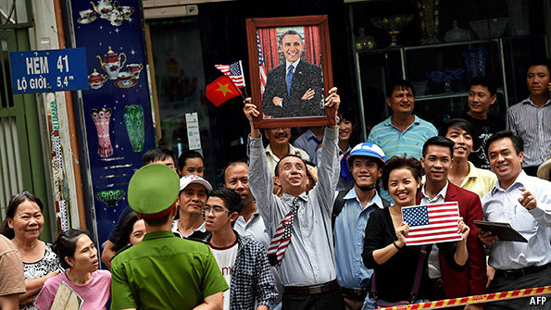

BARACK OBAMA fooled no one this week when, having announced that America was lifting its embargo on selling weapons to Vietnam, he denied that the decision was “based on China or any other considerations”. It was a tactful fib, to portray the move as merely part of Mr Obama’s legacy-building mission of reconciliation with historic enemies, to be followed days later by a historic visit to the site of America’s atom-bombing of Hiroshima. But at a time of increased tension in the South China Sea, where Vietnam is among the countries disputing territory with China, America’s policies there are bound to be seen in a different context. The headline in Global Times, a fire-breathing Chinese tabloid, read simply: “Washington uses past foe to counter China”.
The American president made his announcement a few hours into his first state visit to Vietnam, following a meeting with the country’s new president, Tran Dai Quang, in Hanoi. Official enthusiasm was mirrored in the thick crowds lining the streets in the capital and in Ho Chi Minh City to greet Mr Obama, whose visit between May 23rd and 25th was only the third by an American leader since the end of the Vietnam war in 1975. His star power contrasted with the indifference most Vietnamese show for the stiff apparatchiks of the ruling Communist Party. Locals in Hanoi gawped at Mr Obama tucking into bun cha, a cheap meal of grilled pork and rice noodles bought from a street stall.
The end of the arms ban will have little immediate impact. America had already twice loosened it, first in 2007 and again in 2014, allowing the sale of needed patrol vessels. It will take years for the Vietnamese, short on cash and largely reliant on Russian weaponry, to integrate American hardware. Moreover, weapon sales to Vietnam (like to anywhere else) will still need to be approved case by case, and the first purchases are likely to be of relatively inoffensive systems, such as radar. China’s press has warned that America risks turning the region into a “tinderbox of conflicts”, yet its diplomats, not normally slow to accuse America of stoking tensions, played down the decision. A spokeswoman for the foreign ministry welcomed the normalisation of ties between Vietnam and America, and painted the arms ban as a kooky anachronism.
America’s move is partly a sop to conservative factions within Vietnam’s Communist Party in need of reassurance. Behind this week’s smiles they still fret that America harbours hope of overthrowing the party. Bigwigs in government feel bounced into their friendship with America by virulent anti-Chinese sentiment among ordinary Vietnamese, some of whom accuse the cadres of going soft on Vietnam’s overbearing northern neighbour. Trust earned by dropping the embargo might eventually gain advantages for America’s own armed forces, such as a return to Cam Ranh Bay, once an American naval base on the south-eastern coast.
America had previously insisted that lifting the embargo would depend on Vietnam’s progress on human rights, which even Mr Obama admits has been only “modest”. The regime’s thuggishness makes even a largely symbolic concession hard to swallow. The party was seen to have eased up on critics during 2015, when it was negotiating access to the American-led Trans-Pacific Partnership (TPP), a free-trade deal—but it has since reverted to form, and its new leadership, reshuffled in January, contains several former secret policemen. Mr Obama’s arrival in Vietnam coincided with a ludicrous parliamentary “election”, boasting a 96% turnout, and with a crackdown on environmentalists who have been gathering in the cities to protest about polluted canals and seas. The authorities even sabotaged Mr Obama’s efforts to meet critics of the party by briefly detaining several campaigners whom the president had invited to his hotel for a chat.
China plays the Gambia gambit
Boosters say that improving Vietnam’s human-rights record is bound to be a long slog, and that gaining the regime’s trust is a prerequisite. They say that arms sales are far from America’s only bargaining chip: the terms of the TPP, for example, oblige Vietnam to begin tolerating independent unions, a reform that could loosen the Communists’ monopoly on public life. But that deal will have no impact if, as seems all too possible, America’s Congress refuses to ratify it.
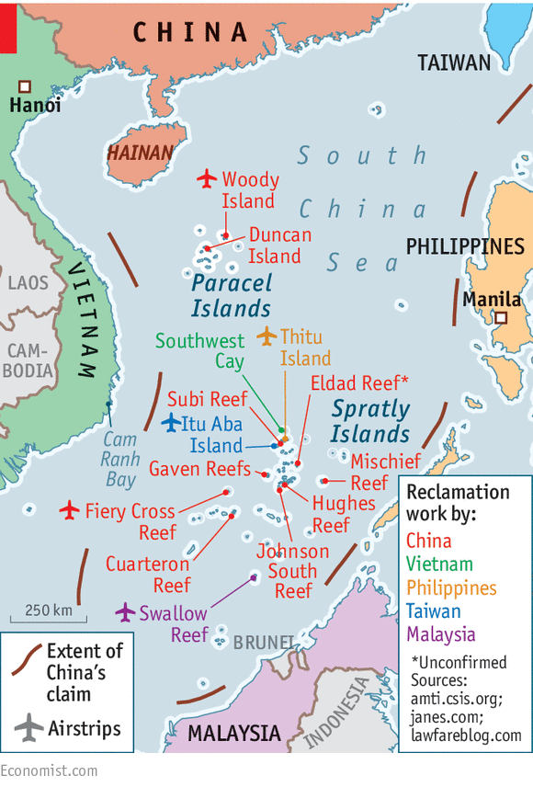
So Mr Obama is taking the long-term view that closer partnership with Vietnam is worth sacrificing some principles for. America and its regional friends are alarmed by China’s forcefulness in the South China Sea—notably its building boom, turning disputed rocks and reefs into artificial islands, which may well, despite Chinese denials, become military bases. Both diplomacy and American displays of might have failed to stop this.
America currently has an aircraft-carrier battle group in the South China Sea to remind the world of its military strength. To Chinese protests, it has sent ships and planes close to Chinese-claimed rocks and reefs. Meanwhile, the Philippines has challenged China’s territorial claims at an international tribunal in The Hague, which is expected to rule soon. China has said it will ignore the ruling. The Philippines’ new president, Rodrigo Duterte, has not made clear how he would react to a decision in his country’s favour.
Although nobody expects America and China to go to war over some remote rocks and man-made islands, an accidental clash in or over the South China Sea remains a risk. On May 17th Chinese fighter jets dangerously intercepted an American reconnaissance plane over the sea. China denies its planes did anything provocative.
China does seem to worry about its image, however. Its foreign minister, Wang Yi, recently toured the smallest South-East Asian countries—Brunei, Cambodia and Laos—and announced that China had reached “consensus” with them on handling disputes in the sea. This was news to the countries concerned, and alarmed their fellow members of the Association of South-East Asian Nations, who saw a blatant attempt to divide them. China has also lobbied G7 countries in the hope that the statement their leaders issue on May 27th after their summit in Japan will not scold China over the South China Sea. Already China’s newest diplomatic partner, the Gambia, in distant west Africa has, bizarrely, confirmed China’s “indisputable sovereignty” over the sea. So that’s that, then.

The Economist

The Economist explains

Why Sino-American relations are likely to become stormier
Jun 12th 2016, 23:35 by J.P.

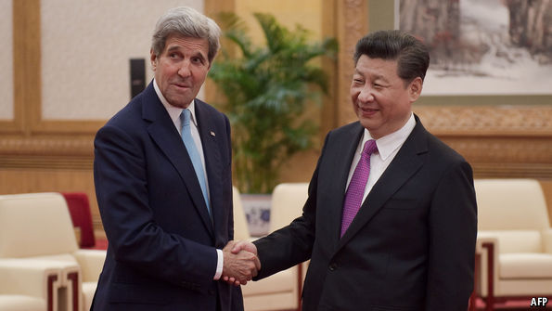

AS THE world’s two largest economies, and possessors of the two largest armies, China and America make the weather in Asia and much of the world. Partly for that reason the two sides have a routine exchange, called the Strategic and Economic Dialogue (S&ED), so their cabinet-level leaders and top bureaucrats know what each other is thinking—and can minimise dangerous surprises. The most recent S&ED, which took place in Beijing on June 6th and 7th, suggests that the need to avoid surprises has rarely been more necessary.
It is not merely that the two sides have much to disagree about. At their meeting, they differed about China’s claims in the South China Sea; about what to do next in North Korea (though they promised to impose sanctions agreed in March) and about the pace of Chinese economic reform (the Americans want China to go faster). Some disputes are inevitable.
The worry is that they might become confrontations. There are three reasons for thinking this is a possibility. One is the timing. An international panel is likely to rule soon on a case involving conflicting claims in the South China Sea brought by the Philippines, an American ally. Though the ruling is likely to be fairly technical, such as whether some features count as rocks (which have territorial waters) or low-tide elevations (which do not), China has become increasingly assertive about its maritime claims, and could react harshly if (as is thought likely) the court backs the Philippines. Next, America fears that Chinese assertiveness in the South China Sea reveals more than a difference over a particular matter of interest: it may be part of a wholesale rejection of the rules-based global order that America sponsors. America’s defence secretary, Ash Carter, said on May 27th that “China sometimes plays by its own rules”, resulting in “a Great Wall of self-isolation”. Third, the strong economic and business interests that used to underpin the bilateral relationship and helped smooth over political differences seem weaker now. At the S&ED, America’s treasury secretary, Jacob Lew, gave a blunt warning that “foreign businesses [are] questioning whether they are welcome in China.”
If relations do get worse, it is hard to imagine them improving again any time soon. There are few bright spots to offset the gloom, as there were in the past couple of years, for instance when America and China found common cause in limiting carbon emissions. Moreover, both Donald Trump and Hillary Clinton, America’s presumptive presidential candidates, are notably more hawkish about China than Barack Obama has been. The next few months seem likely to be a period when both sides shout past one another.

The Economist

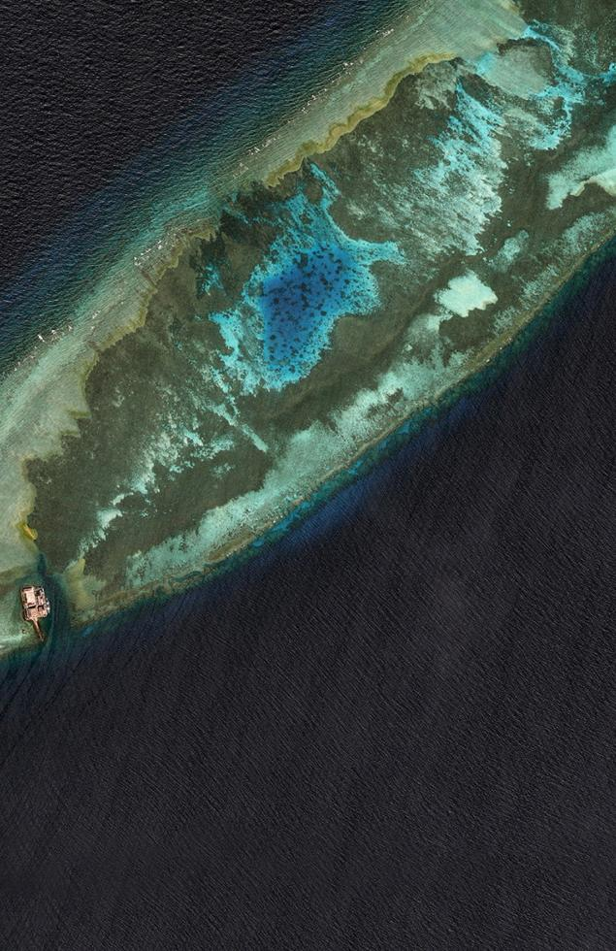
Photo:
Reuters
Sea of troubles: China and ASEAN
Foreign ministers from China and the ten-member Association of South-East Asian Nations gather today in Kunming, in south-west China. Their minds, as ever, will be on the nerve-jangling South China Sea, where China continues to turn disputed features into man-made islands. The meeting follows a rare public row: China claimed a “consensus” with three of ASEAN’s smaller members—Brunei, Cambodia and Laos—on handling the sea’s many territorial wrangles without ASEAN’s help. Diplomats from Singapore, ASEAN’s current China “co-ordinator”, accused Beijing of seeking to divide the organisation by undermining the hallowed principle of its own (full) consensus. China says the Singaporeans simply have the wrong end of the stick, but shows little real interest in what has interested ASEAN for years: a binding code of conduct, including, for example, a building ban, to avoid conflict in the sea. That is, once again, on the agenda; it will be for years to come.
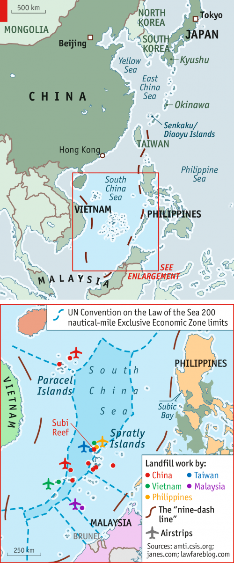
NYT

U.S. Carriers Sail in Western Pacific, Hoping China Takes Notice
By JANE PERLEZJUNE 18, 2016
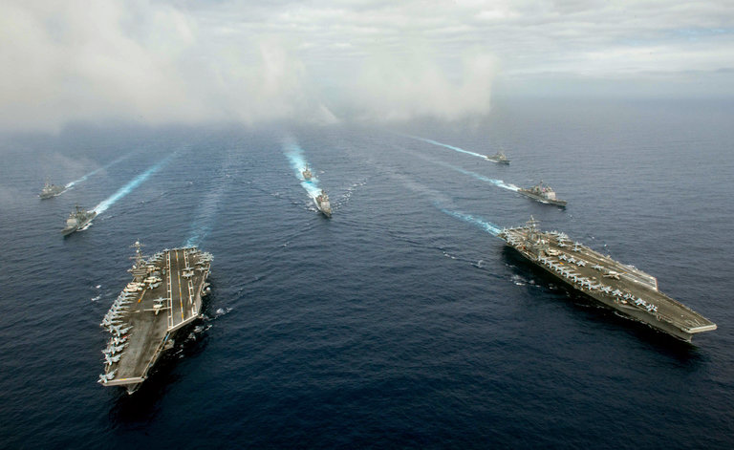
The aircraft carriers John C. Stennis, left, and Ronald Reagan, right, and other warships on Saturday in the Philippine Sea. Credit Specialist 3rd Class Jake Greenberg/U.S. Navy
BEIJING — In a show of strength before an international court’s ruling on China’s claims in the South China Sea, the United States Navy sent two aircraft carriers and their accompanying ships on training drills in the western Pacific Ocean on Saturday.
The carriers John C. Stennis and Ronald Reagan sailed close together in the Philippine Sea as part of air defense and sea surveillance operations that involved 12,000 sailors, 140 aircraft and six smaller warships, the United States Pacific Fleet in Hawaii said in a statement.
“We must take advantage of these opportunities to practice war-fighting techniques that are required to prevail in modern naval operations,” Rear Adm. John D. Alexander said in a statement.
The operations occurred on the eastern side of the Philippines, in a body of water that is not adjacent to the South China Sea but is close, a spokesman for the Pacific Fleet said. China seeks to dominate the western Pacific Ocean as part of its long-term strategy, American strategists say.
The message of the exercise by the two carriers and their attendant warships was unmistakable, and the timing was deliberate, said an American official familiar with the planning of the operation who spoke on the condition of anonymity because he was not authorized to speak publicly on the matter. It could have been conducted later, he said.
An international arbitration court in The Hague is deliberating a case filed by the Philippines in 2013 against China’s claims in the South China Sea, and its decision is expected in the coming weeks.
The Philippines is challenging China’s claims to what has come to be known as the nine-dash line, an area that covers almost all of the South China Sea, including waters close to the Philippine coast.
The issue of the nine-dash line is delicate because China has claimed it since ancient times as its territory, and the South China Sea has become part of the increasingly nationalistic vocabulary of President Xi Jinping.
In the past two years, China has built artificial islands equipped with military runways in the Spratly archipelago, inside the line and not far from the Philippines.
In a statement on the exercise involving the carriers, the Pacific Fleet said: “As a Pacific nation and a Pacific leader, the United States has a national interest in maintaining security and prosperity, peaceful resolution of disputes, unimpeded lawful commerce, and adherence to freedom of navigation and overflight throughout the shared domains of the Indo-Asia-Pacific.”
The Stennis conducted exercises with Japanese and Indian naval forces in the western Pacific and the South China Sea earlier in the week, an operation that was shadowed by a Chinese surveillance vessel.
The Stennis then joined the Reagan, which had been undergoing maintenance at a United States base in Japan, the Pacific Fleet spokesman said.
Early this month, Senator John McCain, Republican of Arizona and the chairman of the Senate Armed Services Committee, foreshadowed the dual-carrier exercise during a speech in Singapore, saying it was part of the United States’ increased vigilance in the Pacific.
“The United States will soon have two aircraft carriers operating together in the Pacific, which is a strong statement about America’s enduring commitment to regional security,” Mr. McCain said.
Also this past week, the United States dispatched four Navy electronic attack aircraft, known as Growlers, and 120 military personnel to Clark Air Base in the Philippines.
At a conference in Beijing on Saturday hosted by Global Times, a state-run newspaper known for its strident coverage, some analysts warned of an arms race in the western Pacific.
“The Chinese side is determined to increase its power, and Obama is determined to defend the United States’ position,” said Shi Yinhong, a professor of international relations at Renmin University in Beijing.
Both militaries need to be cautious in the South China Sea, said another participant, Teng Jianqun, the director of the department of American studies at the China Institute of International Studies. “Any misunderstanding could lead to a disaster between the two countries,” Mr. Teng said.

The Economist

Indonesia and the South China Sea

Annoyed in Natuna

China turns a would-be peacemaker into yet another rival
Jul 2nd 2016 | JAKARTA | From the print edition

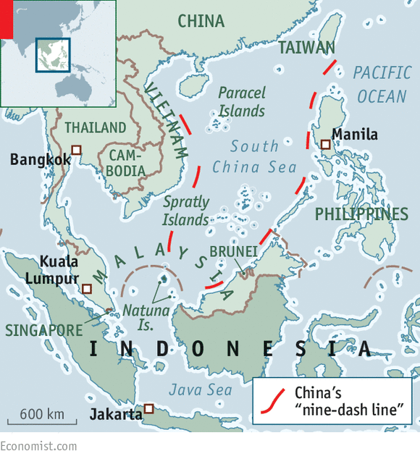
ON JUNE 23rd Indonesia’s president, Joko Widodo, flew to the Natuna archipelago in the South China Sea, along with several ministers, to hold a cabinet meeting on board a warship patrolling the surrounding waters. Only days earlier the same warship had fired warning shots at Chinese trawlers, detaining one of them and its crew, in the latest sign of escalating tensions in the area. Mr Joko, universally known as Jokowi, wanted to send a message to China.
Indonesian diplomats might once have registered their objections in private. But Jokowi has criticised China more openly than his predecessors. After one clash in March, when a Chinese coastguard vessel freed a Chinese trawler from the Indonesian patrol boat that had caught it, Jokowi summoned China’s ambassador for a scolding. The recent visit to the warship was Jokowi’s most public display of sovereignty yet.

It marks a sharp shift for Indonesia, which for decades positioned itself as a regional peacemaker. Unlike other South-East Asian maritime countries, it claims none of the contested rocks, reefs or islands in the South China Sea. China recognises Indonesian sovereignty over the Natuna islands themselves. But its “nine-dash line” overlaps with Indonesia’s 200-nautical-mile exclusive economic zone surrounding the islands. Luhut Panjaitan, Jokowi’s chief security minister, says that the government’s position is simple: it does not recognise that claim. But Yohanes Sulaiman, a lecturer in government studies at Jenderal Achmad Yani University in Bandung, reckons Indonesia’s policy towards China still lacks clarity.
Indonesia’s foreign-affairs ministry cheerily insists there is no dispute, even as China’s foreign ministry referred to “overlapping claims for maritime rights and interests” in a statement condemning Indonesia’s actions during the latest skirmish off the Natunas. The thinking seems to be that acknowledging a dispute would both provoke China, which Jokowi sees as a crucial source of trade and investment, and lend credence to its claims. But Indonesia’s uncertain stance seems to be encouraging China to encroach farther into its waters.
Whether Indonesia’s armed forces are up to the job remains unclear. Although the country is building up its defences on the Natunas, Ryamizard Ryacudu, the defence minister, seems more preoccupied with fighting the phantom threat of homosexuals and others he imagines are waging a “proxy war” than facing up to the real risk of conflict.
Meanwhile, diplomatic efforts to check Chinese expansion have floundered. Earlier this month foreign ministers from the ten-nation Association of South-East Asian Nations—of which Indonesia is by far the largest member—issued an unusually strong statement expressing “serious concerns” over developments that “have the potential to undermine peace, security and stability”, only to retract it hours later.
On July 12th an international tribunal in The Hague will rule on a petition brought by the Philippines intended to show that China’s claims have no legal basis. Indonesia will be watching closely, and insists that the ruling be respected. Mr Panjaitan is proud of his country’s good (for now) relations with China. But, he says, “we don’t want to be dictated to by any country about our sovereignty.”

Asia Pacific

Decision, Maybe Momentous, Nears in Case China Has Tried to Ignore
By JANE PERLEZJULY 6, 2016
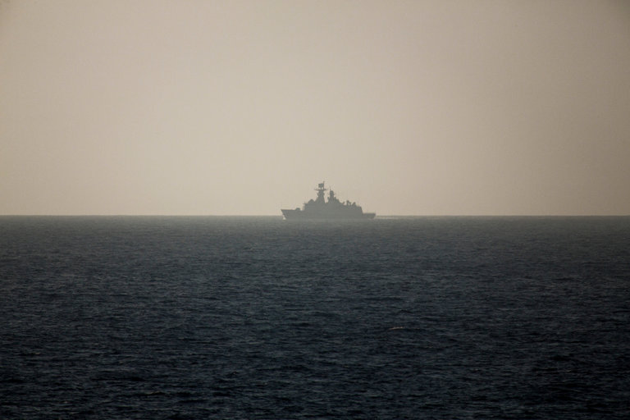
A frigate for the Chinese Navy patrolling near the Spratly Islands, in the South China Sea, in March. For more than three years, Beijing has refused to participate in the proceedings of an international tribunal considering a challenge to its expansive claims in the waters. Credit Bryan Denton for The New York Times
BEIJING — Five judges and legal scholars from around the world presided over a hearing last fall in an elegant, chandeliered room in The Hague. Arranged before them on one side of the chamber were lawyers for the Philippines, armed with laptop computers and notepads.
On the other side were three empty chairs.
For more than three years, China has refused to participate in the proceedings of an international tribunal considering a challenge to its expansive claims in the South China Sea, arguing that the panel has no jurisdiction to rule on the dispute with the Philippines.
But with a decision scheduled to be announced next week, Beijing seems to be getting nervous. In a show of strength, it kicked off a week of naval exercises in the South China Sea on Tuesday near the disputed Paracel Islands, where the Chinese military has installed surface-to-air missiles.
And in recent months, it has mounted an arduous campaign outside the courtroom to rebut the Philippines and undermine the tribunal, enlisting countries from Russia to Togo to support its claim to waters that include vital trade routes and may hold oil and other natural resources.
The flurry of activity is a sign of how much is at stake in what was once an obscure legal case before an obscure arbitration panel. The outcome could alter the dynamics of the South China Sea conflict, shifting it from a race to establish physical dominance over the waters to a conspicuous test of Beijing’s respect for international law and multilateral institutions.
Photo
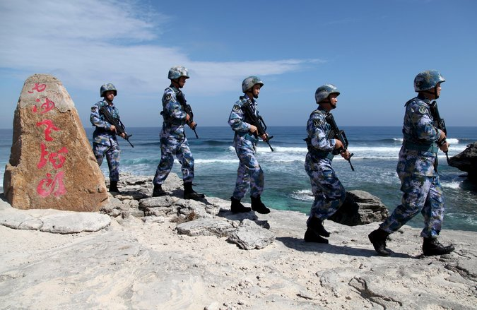
The Chinese Navy on Woody Island, in the Paracel chain, in January. China is said to have installed surface-to-air missiles on the island. Credit Reuters
China has pulled ahead in the physical race, dredging sand to build one island after another over the objections of its neighbors and the United States, and equipping many of the islands with airstrips and radar. But if the tribunal rules in favor of the Philippines on key issues, it could put President Xi Jinping of China on the defensive — or, some worry, push him into a corner.
“This is a matter of wider significance than the South China Sea,” said Bilahari Kausikan, a Singaporean ambassador at large, noting that China has signed the United Nations Convention on the Law of the Sea, which is the basis of the Philippine complaint and the tribunal’s deliberations.
“The importance of the issue is whether international rules will be obeyed,” Mr. Kausikan said. China, he added, “cannot pick and choose which rules to follow or only comply when convenient.”

Sensing an opportunity, the Obama administration has begun a diplomatic push of its own, backing the tribunal and persuading allies to speak out for a “rules-based order at sea” and the use of international law to settle territorial disputes.
Neither Washington nor Beijing paid much attention when the Philippine foreign secretary, Albert del Rosario, began the case before the Permanent Court of Arbitration in 2013, not long after China wrested control of an atoll known as Scarborough Shoal from the Philippines.
The State Department’s senior diplomat for East Asia, Daniel R. Russel, has said he was unaware of the Philippine case at the time. The Chinese leadership quickly dismissed the tribunal without extensive consultation with the foreign policy establishment, several Chinese scholars said.

Interactive Feature

What China Has Been Building in the South China Sea
China has been feverishly piling sand onto reefs in the South China Sea, creating seven new islets in the region and straining already taut geopolitical tensions.
OPEN Interactive Feature

Beijing’s position has not changed. Because the sovereignty of scattered reefs, rocks and islands in the South China Sea is in dispute, it argues, the tribunal cannot rule on competing claims to the waters surrounding them. The Convention on the Law of the Sea says nothing about the sovereignty of land.
But the Philippines has been careful to frame its complaint in a way that sidesteps the question of who has sovereignty over the islands and reefs.
For example, it has asked the tribunal to declare that nine specific reefs and rocks, including some that China has built into artificial islands, are too small to be used to assert economic rights to the waters around them, regardless of who controls them.
The Convention on the Law of the Sea allows a nation to exercise sovereignty over waters up to 12 nautical miles from its coast, and it grants economic rights over waters on a nation’s continental shelf and to 200 nautical miles from its coast. But the treaty says reefs that are entirely submerged at high tide and artificial islands cannot be used to justify any maritime rights.
Philippine officials have asked the tribunal to find that China has violated the treaty by building islands in the Philippines’ economic waters, interfering with its fishermen, endangering its ships and damaging the marine environment.
The Philippines’ most sweeping demand is for the tribunal to reject China’s claim to sovereignty over waters within a “nine-dash line” that encircles almost all of the South China Sea.
Photo
An aerial view of what the Philippines has said is an extensive reclamation project by China on Johnson South Reef, called Mabini by the Philippines and Chigua by China. Credit Armed Forces of the Philippines, via European Pressphoto Agency
China seeks to justify the nine-dash line by citing what it calls historical evidence, including maps published in the 1940s and ’50s that show the dashes. But it has never drawn a continuous line clearly marking its claim, nor has it been specific about what rights it is asserting in the area.
Critics say the Chinese government gave up any special claim to the sea when it signed the United Nations treaty in 1996, during a period when it sought respectability on the global stage.
Now, Beijing may believe it has enough clout to ignore the treaty. It has labeled the arbitration court a “law-abusing tribunal” and its proceedings a “farce.” Chinese diplomats have suggested that the government may even renounce the treaty.
“We will not accept it or recognize it,” a Foreign Ministry spokesman, Lu Kang, said of the coming ruling.
That position has made some in China uncomfortable, including foreign policy experts who have privately criticized the government’s position, saying that China has ceded the moral high ground in its rivalry with the United States.
The United States signed the United Nations treaty but never ratified it.
The Obama administration has struggled to deter Beijing from building islands and military outposts in the South China Sea, with increased naval patrols and stronger alliances in the region having little effect.
But it concluded last year that the tribunal case presented an opening to push back in a different way.
When President Park Geun-hye of South Korea visited Washington in October, President Obama said he expected Seoul to speak out on the need for China to “abide by international laws and rules.”
Mr. Russel, the assistant secretary of state for East Asia, was sent to Germany, where he made the case at a prominent public policy school in Berlin.
“The Chinese are fond of saying that the Pacific is big enough for both of us,” he told the audience. “What that does not mean is that they can draw a line in the center of the Pacific and say, ‘You stay on the east, and we’ll have control over everything west of the nine-dash line.’ That’s unacceptable.”
The administration also persuaded the Group of 7 nations to issue two joint statements on the South China Sea, drawing a complaint from Beijing that the group should stick to economic policy. A State Department official, Robert Harris, even traveled to landlocked Laos to explain the Philippine case.
China’s Foreign Ministry says that dozens of countries have endorsed its position, and reports about foreign politicians denouncing the tribunal appear in the state-run news media almost daily. But Beijing has adopted a broad interpretation of what it means to have won over a country. Russia, for example, agrees that the tribunal should not resolve the dispute, but it has been silent on the Chinese buildup, in part because of its close relationship with Vietnam, which also claims part of the sea.
Photo
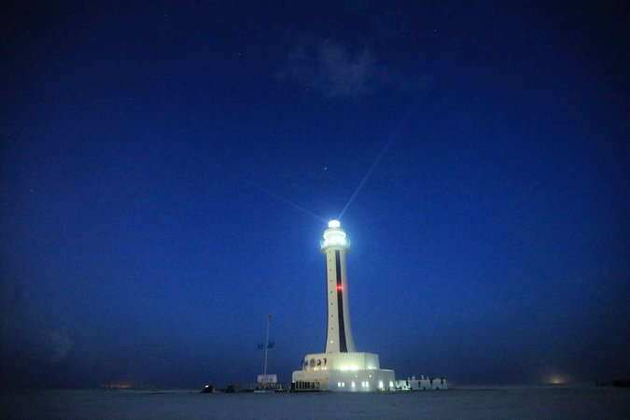
A lighthouse on Zhubi Reef in the Spratly Islands, known in China as the Nansha Islands, in April. Credit Xing Guangli/Xinhua, via Associated Press
At a contentious meeting it hosted last month, China pressured the 10-member Association of Southeast Asian Nations not to issue a joint statement on the subject. (In a fit of pique, Malaysia leaked the draft statement anyway.)
The new president of the Philippines, Rodrigo Duterte, who favors closer ties with China than his predecessor, said Tuesday that he was ready to open talks on maritime cooperation.
But it may be difficult President Xi to back down. He has used his defense of China’s territorial claims to fan nationalist sentiment, bolstering the ruling Communist Party, and to strengthen his authority over the Chinese military.
Some analysts have suggested that he might respond to a ruling against China by moving even more aggressively in the South China Sea and taking steps to transform Scarborough Shoal into an artificial island.
Doing so would give Beijing its first outpost on the eastern side of the sea, more than 400 nautical miles from the Chinese island province of Hainan and just 120 nautical miles from the Philippine coast.
Paul S. Reichler, the Washington lawyer retained by the Philippines as chief counsel in the case, said that if China refused to accept the tribunal’s ruling, other countries would line up against it.
“China’s choice would be to reach an accommodation, or embitter its neighbors and endure a prolonged period of chaos and instability in the region,” he said.

The Diplomat

Why China Won’t Stop Island Building in the South China Sea
China’s island building is aimed at securing a weak link in its maritime trade networks.
By Frederick Kuo
July 02, 2016
112

1
19

132 Shares

As the U.S. navy and rival Asian claimants respond to China’s building of military-grade infrastructure on disputed islands, heightened risks of conflict raise alarm bells over destabilization in a vital arena of global trade. The world awaits the deliberation of the Hague on the matter, but its decision will have little impact on China’s actions, which are anchored by Beijing’s grand ambitions to secure an unrivaled commercial empire throughout Eurasia and Africa.
The tropical warm waters of the South China Sea betray an idyllic calm, but the region has become the center of a great international flashpoint. Developing what were once half submerged reefs into sizable islands, China has frenetically reclaimed and built 3200 acres of new territory on the islands within its control. In addition, it has built sizable military and civilian infrastructure that have decisively tipped the fragile balance of power in the hotly contested region.
China’s ambitions have provoked the ire of rival claimants like the Philippines and Vietnam, while stoking tensions with the United States. However, despite loud condemnation, China has refused to bend to pressure, and instead has pushed forward with its ambitious plans of power projection, causing many to fear the terrible fallout that may occur due in an atmosphere fraught with heightened tensions.
Enjoying this article? Click here to subscribe for full access. Just $5 a month.
A cursory analysis of China’s growing trade and investment patterns points to two primary motivations underpinning its South China Sea strategy: China’s commercial ambitions and its relative naval weakness.
China’s growing commercial empire, bolstered by trade with Europe, Africa, the Middle East, and South Asia, possesses one glaring weak link — that much of its maritime borders are vulnerable to the control of foreign powers. This reality guarantees that tensions in the region will undoubtedly continue to rise, though the chances of full blown conflict remain slim.
After two decades of rapid industrialization and economic growth, China has emerged as the world’s largest trading nation, registering a combined volume of over $4.3 trillion dollars in 2015. Chinese outward foreign investment has soared from a trickle ten years ago to nearly $120 billion in 2015. China has become the largest trading partner in Africa, with trade passing $160 billion in 2015. China ranks as the second largest trading partner to Europe, with trade standing near $580 billion annually. Meanwhile, China has also made significant headway in trade and investment into the Middle East and South Asia.
In order to consolidate and link its massive and continually expanding commercial empire, China has promoted the strategy of “One Belt, One Road,” a resurrection of the ancient Silk Road. If it succeeds, this project will fundamentally shift the global balance of power in China’s favor, substantially building an infrastructure of trade throughout Eurasia and Africa with all roads ultimately leading to China.
With current projected spending surpassing $1.3 trillion, the new Silk Road will link over 60 nations throughout Eurasia and Africa with a combined population of 4.4 billion through a colossal number of infrastructure projects from rail and pipelines to ports and maritime infrastructure. China’s brimming ambition seeks to facilitate the development of cohesive infrastructure linking three continents and uniting them into a trade empire unrivaled in history.
China’s One Belt, One Road project is composed of two primary routes. One is a land route that winds through the great Eurasian hinterland linking China with its ancient trading partners in Central Asia and the Middle East and then on to Europe. The other route is the maritime route, which runs through the South China Sea and the Malacca Straits, and onward through the Indian Ocean to Africa and to the Middle East and Europe.
China’s rapidly growing commercial empire presents it with immense security challenges. While China has traditionally been a continental power, it has not fielded a great navy since the 15th century when Zheng He’s gargantuan fleet sailed to Africa. In the modern era, China went from defeat at the hands of Western gunboats to imperial collapse and then the chaos of the Maoist era. Since China is a latecomer to the modern arena of great power politics, it has found its maritime borders to be dominated by foreign powers, from the United States to regional Asian states.
This fact leaves China’s colossal investments and trade vulnerable to the whims of foreign navies, a situation which is the cause of anxiety in Beijing. This insecurity has driven China’s substantial focus in modernizing and upgrading its navy, which now boasts of one aircraft carrier, with another currently being built and two more planned in the next decade.
In the South China Sea, China’s claims have existed since at least the Republican era. However, beset by domestic problems, China has been slow to enforce its claims. China’s recent actions reflect a significant increase in investment on the contested islands within its control. These are all part and parcel of China’s attempts to establish a beachhead of control in order to monitor and protect the trade routes that it increasingly depends on.
To put it simply, China’s obsession with building up fortifications in the South China Sea is driven by its fear of losing control over its vital trade routes and thus having its national interests effectively denied by use of naval force. As China moves forward with its ambitious Silk Road project, its sense of urgency has kept pace to make sure it will have the naval infrastructure to protect its commercial interests from the South China Sea to Djibouti, where China has established its first overseas military base.
Inarguably, China’s continued development of its naval capabilities in the South China Sea, through which $5.3 trillion of global trade passes each year, has raised the ire of rival claimants to the Spratly and Paracel Islands. China has managed to push both the Philippines and Vietnam into the arms of the United States. The Philippines have signed new pacts with the U.S. navy, upgrading its presence in its military bases, while Obama’s recent visit to Vietnam signaled a new era of cooperation with the lifting of the arms embargo. In addition, American jets continually cross into spheres around China’s artificial islands, which heighten the possibilities of potential conflict.
At the same time, a “hot war” with the U.S. navy would be potentially disastrous for China’s economy. Therefore, the likelihood of China taking over the islands controlled by rival claimants and exacerbating tensions are low. China does not need to take more islands in order to establish effective dominance of the waters. China’s control of this key gateway can be secured by the expansion of its current islands and their increasing fortifications. Therefore, Beijing will likely continue to walk a fine balance where it can incrementally gain the strategic upper hand without letting tensions spill over into a direct military confrontation.
Clearly, these events ultimately hurt China’s attempts at promoting an image of its “peaceful rise” and itself as a partner for development in Southeast Asia. However, despite frayed relationships with the Philippines and Vietnam, and a potentially disastrous military clash with the U.S. navy, there is little doubt that these risks are a price that China is willing to pay in order to establish effective control over vital maritime links to its vast commercial empire beyond the Indian Ocean. Therefore, the region is likely to head towards more tensions before a status quo will be reached.
Frederick Kuo is a San Francisco-based published writer. His writing focuses on current events and economic analyses within a social and historical framework. His articles have been published on Quartz, The National Interest, Citymetric, SF Examiner and much more. You can follow his writing on his website amberpen.com.

NYT

Philippines v. China: Q. and A. on South China Sea Court Case
By JANE PERLEZJULY 10, 2016
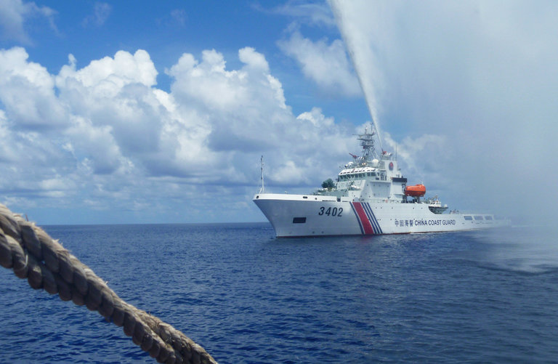
The Chinese Coast Guard confronted Filipino fishermen near Scarborough Shoal in the South China Sea last year. Credit Renato Etac/Associated Press
An international court in The Hague is scheduled to release a landmark ruling on Tuesday in a dispute between China and the Philippines over the South China Sea. Here are answers to six questions about the case.
What is this case about?
The Philippines filed a complaint in 2013 after China took control of a reef about 140 miles from the Philippine coast. It accused China of violating international law by interfering with fishing, endangering ships and failing to protect the marine environment at the reef, known as Scarborough Shoal.
But the Philippines also went further, asking an international tribunal to reject China’s claim to sovereignty over waters within a “nine-dash line” that appears on official Chinese maps. The dashes encircle as much as 90 percent of the South China Sea, an area the size of Mexico that is vital to global trade and rich in natural resources, including potential oil deposits.
The Philippines also accused China of violating international law by dredging sand to build artificial islands out of several reefs in the South China Sea, including one it says is in its waters.
What does international law say?
The Philippines filed its complaint under the United Nations Convention on the Law of the Sea, which lays out rules for the use of the world’s oceans. The treaty came into force in 1994 and has been ratified by both China and the Philippines, as well as 165 other states and the European Union.
The treaty says a country has sovereignty over waters extending 12 nautical miles from its coast, and control over economic activities in waters on its continental shelf and up to 200 nautical miles from its coast, including fishing, mining, oil exploration and the construction of artificial islands.
Photo
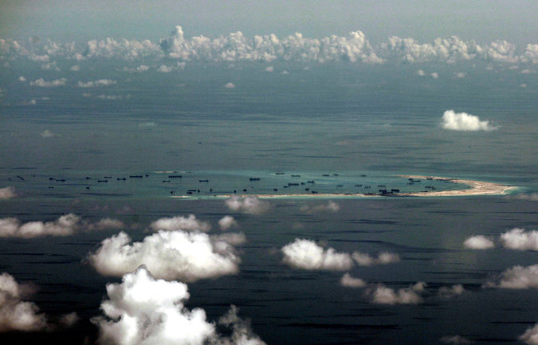
China’s reclamation of Mischief Reef in the South China Sea. China has conducted enormous dredging operations to transform reefs into artificial islands with military runways. Credit Pool photo by Ritchie B. Tongo
The treaty sets out detailed rules for defining these zones, what to do when two nations’ zones overlap and how to resolve disputes.
China’s nine-dash line includes waters beyond these zones, and Beijing has cited what it calls historical evidence to support it.
The treaty does include exceptions for historic rights, but the Philippines says China’s claims in the South China Sea do not qualify.
The Obama administration has backed the Philippines on this question, saying historic rights can apply only to bays or other coastal waters, not the high seas. But the United States has not ratified the treaty.
What does China say?
China has boycotted the international tribunal that was set up to hear the case.
It says the panel of five judges and legal experts has no jurisdiction because the sovereignty of reefs, rocks and islands in the South China Sea is disputed.
The argument goes like this: If you don’t know what countries these specks of land belong to, you can’t use the treaty to draw territorial and economic zones in the waters around them. And the judges can’t decide whom the specks of land belong to because the Law of the Sea deals only with maritime disputes, not land disputes.
Photo
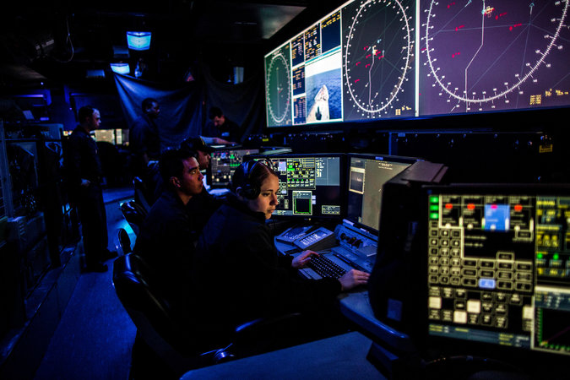
United States Navy sailors monitoring radar and other instruments aboard the guided-missile cruiser Chancellorsville in the South China Sea. Credit Bryan Denton for The New York Times
China also says it reached a deal with the Philippines years ago to settle disputes in the South China Sea through negotiations. That agreement, it says, prohibited the Philippines from taking the case to the tribunal.
Why is this case important?
In addition to China and the Philippines, five states — Brunei, Indonesia, Malaysia, Taiwan and Vietnam — claim parts of the South China Sea. Their differences sometimes escalate into skirmishes, and people are worried that an incident could erupt into a broader conflict.
Tuesday’s ruling will be the first time an international tribunal has ruled on any of these disputes. It could set a precedent or establish principles for easing tensions. It could also alter the political dynamic in the region, restraining some countries while emboldening others.
China probably has the most at stake. Since the case was filed, it has conducted enormous dredging operations to transform reefs into artificial islands with military runways and naval harbors, over the objections of countries with competing claims as well as those of the United States. The tribunal could declare some of this construction illegal, or it could leave the question unresolved.
Either way, China’s response to the ruling will be seen as a test of what kind of country it is becoming — a global leader committed to international law and institutions, or a superpower willing to take unilateral action against its neighbors.

Interactive Feature

What China Has Been Building in the South China Sea
China has been feverishly piling sand onto reefs in the South China Sea, creating seven new islets in the region and straining already taut geopolitical tensions.
OPEN Interactive Feature

Why does the Chinese government care so much about the South China Sea?
Chinese military strategists say China needs to control the sea to defend itself, to push the United States out of the Western Pacific and to become a naval power.
China also depends on the shipping routes that go through the sea, and is eager to lay claim to oil and other resources to fuel its voracious economy.
There are domestic political factors, too. Chinese schoolchildren are taught that the sea has belonged to China since ancient times, and President Xi Jinping has used the construction of artificial islands in the sea to fan nationalist sentiment and strengthen his authority over the Chinese military.
What happens if the tribunal rules against China?
The Chinese government has said it will not “accept, recognize or execute” the decision.
While the ruling will be binding, the tribunal has no power to enforce it, and no one expects that China will volunteer to dismantle its artificial islands and return the sand to the ocean floor.
But the United States, the region’s dominant military power, could use the decision to justify more naval patrols in the area, to recruit new allies and give more support to old ones, and to rally world opinion against Beijing’s behavior.
While it will denounce the ruling in public, the Chinese leadership may decide to back off and begin easing tensions with neighboring countries. It could start with the new Philippine president, Rodrigo Duterte, who says he wants to improve relations with China and has proposed talks on maritime cooperation.
But some analysts are worried that President Xi will respond instead with defiance.
Chinese diplomats have already suggested China might withdraw from the Convention on the Law of the Sea.
It could also begin transforming the reef at the center of the dispute, Scarborough Shoal, into a military outpost, risking a clash with the Philippines, an American ally.
And it might try to impose a new “air defense identification zone” over part of the South China Sea, asserting the right to identify, monitor and take military action against planes in the area.

