WSJ

What Is Alibaba?
It is a marketplace, a search engine and a bank, all in one.

Defining Alibaba
Alibaba is China’s — and by some measures, the world’s — biggest online commerce company. Its three main sites — Taobao, Tmall and Alibaba.com — have hundreds of millions of users, and host millions of merchants and businesses. Alibaba handles more business than any other e-commerce company.

E-COMMERCE
Alibaba is the most popular destination for online shopping, in the world's fastest growing e-commerce market. Transactions on its online sites totaled $248 billion last year, more than those of eBay and Amazon.com combined.
China's E-Commerce Market
$74 billion$295 billion$713 billionEstimated201020132017Source: iResearch
80%
of China's online shopping market is dominated by Alibaba.
Source: CLSA

MARKET CAPITALIZATION
Alibaba became one of the most valuable tech companies in the world after raising $25 billion from its U.S. IPO. It is also one of the most valuable Chinese public companies, ranking among some of the country’s state-owned enterprises.
How Alibaba Compares With the Biggest Tech Firms
Market cap, as of Sept. 23, in billions
Apple
$615
Google
397
Microsoft
384
Alibaba
215
Facebook
204
IBM
191
Oracle
172
Samsung Electronics
170
Intel
170
Tencent
142
Sources: S&P Capital IQ; staff reports

FINANCIALS
Alibaba's financials paint a more complicated picture. Click the arrows to explore:
Gross Merchandise Volume, 3Q 2014
In billions
Alibaba*eBay**020406080$100
*Taobao and Tmall only.
**Total value of all successfully closed transactions.
Sources: the companies
Because Alibaba runs marketplaces and has a huge customer base, the amount of business that flows over its sites dwarfs that of other e-commerce companies…

Inside Taobao
Taobao is Alibaba's biggest shopping site. It's home to seven million merchants selling everything from tiger-striped leather jackets to origami decorations. It’s free for users, but sellers can pay for ads to stand out from the crowd.

The Man Behind Alibaba
Alibaba founder Jack Ma is the company’s spiritual leader. When Alibaba needs a new innovation, it goes back to his old apartment for inspiration. Mr. Ma stepped down as CEO, but Alibaba’s current corporate structure will let Mr. Ma and other top brass nominate more than half of Alibaba's board members. Alibaba chose to list in the U.S. because the Hong Kong exchange refused to accept the structure.
Jack Ma was an English teacher in 1995. Porter Erisman
Mr. Ma’s apartment in Hangzhou in the early days. Alibaba
Most companies, when they're doing good, they enjoy today's wonderful life. They don't worry about five years later—but I worry about five years later.
Jack Ma

PHILOSOPHY
What's Jack Ma's philosophy? Investors can get a taste from a letter Mr. Ma sent to employees, on the day Alibaba filed its IPO prospectus. In it, Mr. Ma warned about the ruthlessness of the capital markets and pledged the company would stay true to Alibaba's principles, which put customers before shareholders.

CONTROL
Alibaba’s current corporate structure will let Mr. Ma and other top brass nominate more than half of Alibaba's board members. Alibaba chose to list in the U.S. because the Hong Kong exchange refused to accept the structure.
Who Owns Alibaba Now?
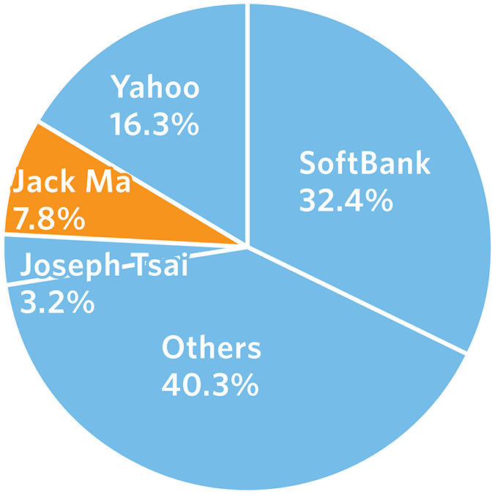
Note: Numbers do not add up to 100% due to rounding.
Sources: the companies (SoftBank and Yahoo); staff reports (Ma)

WEALTH
After the IPO, Mr. Ma became China’s richest man with a net worth of $25 billion, according to the Hurun Rich List. Mr. Ma owns a 7.8% stake in Alibaba and a 46% stake in the Alipay electronic payment affiliate.
China's Richest, Sept. 2014
In billions
1. Jack Ma (tech)
$25
2. Wang Jianlin (real estate, entertainment)
24.2
3. Zong Qinghou and family (beverages)
20.8
3. Li Hejun (renewable energy)
20.8
5. Ma Huateng (tech, entertainment)
18.1
Source: Hurun China Rich List Sept. 2014

The Challenges
The world is going mobile, and Alibaba is competing for China's smartphone users with new rivals. In its search for growth, Alibaba is forging into new businesses — and bumping into powerful players like Chinese banks and regulators. And will U.S. investors buy the IPO of a company that is still largely unknown to them?

SELLING THE ALIBABA STORY
Alibaba's IPO is the largest in the world. China's e-commerce market is still going strong and expectations for Alibaba are high. Still, Alibaba is facing a slew of new business challenges.
Tech IPOs, in billions
$25
Alibaba (2014)
16
Facebook (Priced: 2012)
2.1
Twitter (2013)
1.9
Google (2004)
1
Zynga (2011)
0.4
LinkedIn (2011)
0.1
eBay (1998)
Source: Dealogic

THE RACE TO GO MOBILE
China's 600 million-plus Internet users are migrating to smartphones, setting off a scramble among the country's Internet giants. Alibaba's toughest rival is Tencent, which runs the WeChat mobile messaging application, with 355 million users. The companies are spending billions of dollars to invest in businesses that can help them compete.

NEW FRONTIERS
The newest frontier for Alibaba is financial services. You can use Alibaba's Alipay payments app to buy theater tickets and pay for taxis. You can also use it to invest in a money-market fund. That fund, called Yu'e Bao, has already collected $87 billion in assets. China's banks and regulators are starting to get alarmed.

FAKES
Many brands say Alibaba's sites — particularly Taobao — are rife with counterfeits. That could be awkward for the company, as it readies its global IPO. Alibaba says it spends millions of dollars a year battling fakes, and some merchants say Taobao has gotten faster at taking down suspect listings.
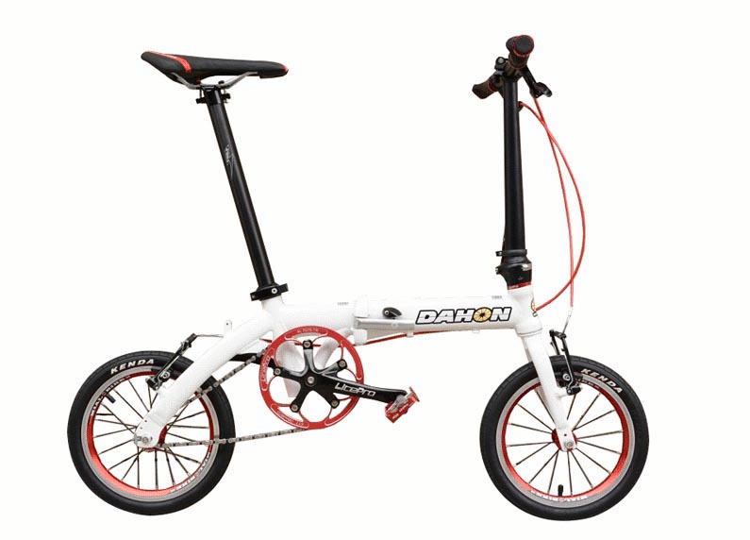
A fake Dahon bike and fake SylvanSport campers were listed on Taobao.com. The companies

The Economist

Alibaba

The world’s greatest bazaar

Alibaba, a trailblazing Chinese internet giant, will soon go public
Mar 23rd 2013 | HANGZHOU AND HONG KONG | From the print edition

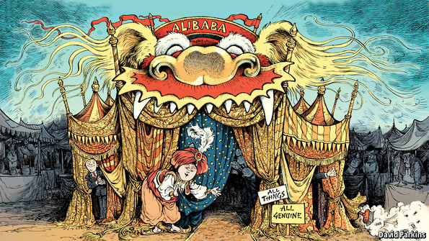
IN 1999 Trudy Dai used to spend all night sending e-mails from her friend Jack Ma’s apartment, trying to answer queries from American customers without letting on that she was Chinese. Ms Dai was one of the first dozen employees of Alibaba, an online listings service Mr Ma, a teacher, had just started. It was already having some success connecting small Chinese manufacturers to potential customers, including the overseas ones Ms Dai was reassuring over e-mail. But the friends and students who made up the workforce were earning just 550 yuan (then $66) a month.
Mr Ma, though, already had big dreams. That year he said: “Americans are strong at hardware and systems, but on information and software, all of our brains are just as good…Yahoo’s stock will fall and eBay’s stock will rise. And maybe after eBay’s stock rises, Alibaba’s stock will rise.”
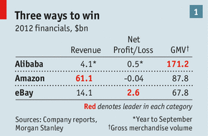
Since then, Alibaba has come to dominate internet retailing in China, which will soon be the biggest e-commerce market in the world. It has moved beyond its original remit of connecting businesses to each other to ventures that let companies sell directly to the public (Tmall) and enable members of the public to sell to each other (Taobao). Between them, Taobao and Tmall processed 1.1 trillion yuan ($170 billion) in transactions last year, more goods than passed through Amazon and eBay combined (see table 1).
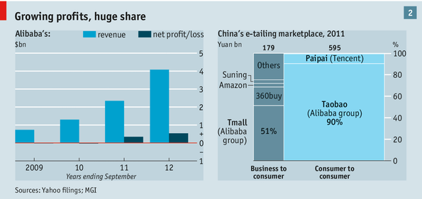
The company that started in Mr Ma’s apartment now employs 24,000 workers at its headquarters in Hangzhou and elsewhere; Ms Dai is president of human resources. A few years ago Alibaba began to turn a profit; in the year to September 2012 it made $485m on revenues of $4.1 billion (see chart 2). Following a recent reorganisation it has 25 separate business units, and on May 10th it will have a new chief executive, Jonathan Lu; Mr Ma will stay on as executive chairman.
The rules of the market
In one respect things are as they were in 1999: Alibaba is privately owned. But this will not remain the case for long. The reorganisation into 25 business units is widely seen as preparation for an initial public offering (IPO) that would take most of them public. A deal with Yahoo, which once owned 40% of Alibaba, means that the IPO, if done soon, would allow Alibaba to buy back its shares and end the often stormy relationship. Asked about the IPO, Mr Ma says “We are ready.”
Analysts predict that the IPO will value the company somewhere between $55 billion and more than $120 billion. Tencent, a Chinese gaming and social-media firm now getting into e-commerce, has a market capitalisation of $62 billion, just shy of Facebook’s current valuation. Mark Natkin of Marbridge, a Beijing-based technology consultancy, thinks Alibaba could easily be worth more than Tencent, given that “there is so much room to grow its businesses in China”.
The top-end estimates would imply a remarkably high ratio of value to profits. But such a ratio might make sense to investors if they think that the company is investing in yet more growth to come. Amazon, in some ways a similar company, supports a market value of $117 billion with no profits to speak of. And Alibaba will provide an attractive platform for investors trying to profit from China’s booming internet economy.
There will be some caution. Part of Alibaba floated on the Hong Kong exchange in 2007, but the shares ended up being bought back by the company after losing much of their value. The experience with Facebook’s IPO suggests a certain wariness about internet stocks is wise. But many think it will be different with Alibaba this time. “This will be bigger than Facebook,” predicts Bill Bishop, a Beijing-based technology expert. Mr Ma seems to agree. Though he will say only that the IPO will be “very very big”, asked about Facebook he cannot help but smile and say “Our revenues and profits speak for themselves.” (In the last quarter of 2012 Facebook’s revenues were $1.6 billion.)
Gordon Orr, a senior partner at McKinsey, thinks a healthy IPO valuation could be just the beginning. He says that if Alibaba can sustain its leadership in its current market and expand strongly into finance, the management of the supply chain and other services, “it could become one of the world’s most valuable companies five years from now, with potentially more than $1 trillion of sales passing through its platforms each year.”
Those are sales through Alibaba, not by Alibaba. In America 76% of online retailing involves people buying from individual merchants, according to a new report by the McKinsey Global Institute (MGI), a think-tank. In China, in 2011, that figure was 10%. The other 90% was sold through marketplaces that simply allow buyers and sellers to find each other. Alibaba has grown so big because early on Mr Ma had two insights into what could make such marketplaces work.
The first was that many Chinese are tight-fisted. So Alibaba made all the basic services it offers free to both buyers and sellers. It earns money through online advertisements and extra services it offers clients, such as website design. With 6m vendors Taobao is a cluttered-up cyberspace. Many sellers think it worthwhile to pay for fancy storefronts and online advertisements to help them stand out.
The second is that many Chinese are reluctant to trust strangers. So Alibaba has provided tools to build trust. One is an independent verification service through which third parties vet the claims made by sellers; the sellers pay for the process. Another is the Alipay payments system. Unlike PayPal, used by many Western internet companies, Alipay takes money up front and puts it in an escrow account. Vendors can be sure that payments made through it will be honoured. Alipay—a source of much bad blood with Yahoo, which felt Mr Ma seized control of it illegitimately, something Alibaba strongly denies—has roughly half of China’s online-payments market. The vast majority of Alipay transactions are for deals made through Alibaba, but the firm says that use elsewhere is growing fast.
Alibaba also now has the advantages that come with dominating its domain. In the West, shoppers often search for items on Google, and then follow a link, possibly one in an ad, to a retailer’s website or to Amazon; the ads are what make Google its money. In China Taobao’s scale means it can afford to block the “spiders” that search engines like Google, or its local equivalent, Baidu, use to find out what is on a site. It can do this because shoppers more or less have to come to it anyway. This makes adverts on Taobao more valuable; it gets a fair whack of the revenue that would otherwise go to the search engines.
This is just one way that the marketplace model works better the bigger a firm gets. The more buyers come, the more sellers need to; the more sellers come, the more buyers want to. As a result, domestic and foreign rivals are having a hard time. This goes for purely online firms like DangDang (which resembles Amazon) and 360buy (in which Prince Alwaleed bin Talal of Saudi Arabia recently invested) and for high-street retailers fighting defensive battles online like Suning and Gome, two appliance giants.
The founders of 7gege.com (translated as seven princesses), a women’s fashion firm, tried the bricks-and-mortar route but flopped. They turned to Alibaba’s web portals and found eventual success. The firm now spends up to 100,000 yuan a day on banner ads with Alibaba, as well as money on search optimisation and special promotion days; last year, its online shops on Alibaba earned over 350m yuan.
A torrent of customers
International brands like Adidas and Samsung are still pouring money into Tmall. Some use Tmall as the exclusive channel for online purchases in China; others are experimenting with having both their own site and a Tmall storefront. Günther Hake of Disney says his firm has had good experiences advertising and selling on Tmall. With a new Shanghai theme park opening in two years, he expects to sell ten times more merchandise in greater China. Tmall will see a lot of that action.
But Alibaba will not necessarily get things all its own way. Tencent has set up a stand-alone e-commerce division; it runs Paipai, a Taobao competitor, and recently bought 51buy.com, which competes with Tmall. Tencent is a potent rival, says Marbridge’s Mr Natkin, because other businesses such as gaming give it a lot of cash. Alibaba will probably need to invest heavily to maintain its lead. That helps explain the $8 billion in loans and other outside financing the company is pursuing. Most of the money will go to refinance older loans at better rates, says Joseph Tsai, the group’s chief financial officer. But some $3 billion might be used for acquisitions.
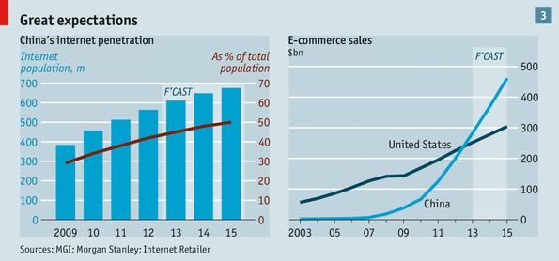
What of the company’s prospects? To some extent they are good simply because of where it is. China’s e-commerce market has grown by 120% a year since 2003, says MGI. This year it is set to surpass America’s, with a total value of $283 billion—7% of retail sales—according to Morgan Stanley (see chart 3). The number of Chinese online shoppers has surged to 250m, more than doubling in three years. And there is a lot of room for growth. Online penetration in China was 43% in 2012, well below the 70% or higher seen in developed economies. And fewer Chinese internet users shop online than in other markets.
With more non-shoppers starting to shop and the rest of China’s population getting online, MGI predicts the market will be between $420 billion and $650 billion in 2020. Mr Ma says that the rudimentary nature of much Chinese offline retailing will allow e-commerce to grow faster and further in China than in the developed world; in rich countries, he says, e-commerce is just “the dessert”. In China it’s the main course. This may be particularly true in smaller cities where consumer spending power is outgrowing the shops available.
The changing nature of China’s growth offers new possibilities to the company. Peter Williamson of Cambridge University’s Judge Business School argues that a big reason Alibaba’s original business-to-business platform thrived is that by helping buyers and sellers overcome a lack of information and high search costs it was perfectly placed to help and profit from the first wave of China’s integration into the global economy. Now Alibaba is well positioned for the next wave. “The rise of Chinese consumers, Chinese tourists, Chinese companies going global and so on [will offer] lots of new opportunities,” he says.
But the company plans to do more than simply ride the waves of China’s growth. One of its strategies will be to use the data it gets from e-commerce to expand into new areas. “We have the best data mindset in the world,” boasts Wang Jian, Alibaba’s chief technology officer. Zeng Ming, the company’s chief strategy officer, points to finance as a way its data can give the company an edge in new markets.
For three years Alibaba has been making small loans (average size $8,000) to merchants trading on its platforms, using the data it holds on them to guide its decisions. Mr Tsai says its loan book was $600m in 2012, and that by the end of this year it should top $2 billion; the non-performing-loan ratio is below 2%. “The people we are focusing on are completely below the radar screen for the big banks,” he points out. The company turns the loans into products that can be sold to investors. The firm is expanding into loans to individuals, and into insurance, where it has announced a joint venture with Tencent and Ping An, a Chinese insurer. The financial division is likely to be spun out soon, and run at arm’s length rather as Alipay is today. Regulators would probably not allow foreigners to hold a big stake in a financial firm—and any Alibaba IPO would bring in lots of foreign investors.
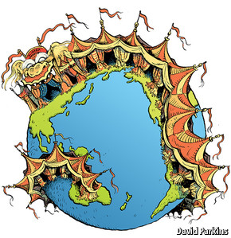
Another growth opportunity is that China is now the world’s biggest market for smartphones. Purchases on mobile phones leapt from 2 billion yuan in 2010 to 53 billion yuan last year, 4% or so of total e-commerce. A company dedicated to serving this market might be a serious competitor. Mr Ma recently ordered a large number of engineers to be shifted to the firm’s mobile division. Mr Wang acknowledges that “mobile is a new game where we don’t have the edge yet”—but he reckons nobody else does either.
Then there are the opportunities (and risks) of going global. Alibaba makes no secret of its global aspirations, but some of the things that make it a success at home may not transfer well. Alipay, for example, may offer few advantages in markets which are better supplied with banking and credit services. The marketplace approach that lets the company do without warehouses and other tangible assets has not proved the winning business model around the world that it has in China.
Its most promising overseas markets will be low-trust, underbanked emerging economies—the markets in Africa, Latin America and Asia where other Chinese pioneers leaving the home market, such as Huawei, a telecoms giant, cut their teeth. Being a platform for retail, rather than a retailer itself, may be a winning proposition in those countries too; but it is not a sure thing. And outside China there are serious competitors in the form of Amazon and a resurgent eBay.
Among the advantages those competitors might have is that the goods they offer are highly likely to be kosher. This has not always been the case with Alibaba. China has a history of making and consuming counterfeit goods, and vendors on Taobao have not been a notable exception.
Up until the end of last year, Taobao was on the American government’s list of “notorious markets”. Its removal reflects the effort the firm has put into cracking down on fakes by working with multinationals and lobbies like the Motion Picture Association of America. But managers of Western brands sold through Tmall grumble that fakes are still too readily available on Taobao. Judging by the $12 Manolo Blahniks found in a quick browse they have a point. McKinsey’s Mr Orr tells of a Chinese shoe manufacturer selling through a number of stores on Taobao and Tmall competing with several thousand dodgy operators peddling unauthorised or counterfeit goods, many sourced from within the company’s own supply chain. “Taobao has not yet changed the culture of counterfeiting in China,” he concludes. If it is to become a global giant, it must do more to clean things up.
As well as an old problem to overcome, there is also a new one: the sharing of power at the top. Mr Ma is not leaving the firm; he is staying on as executive chairman. But his stepping aside as chief executive clearly changes things. Microsoft, to take the obvious example, was already a global giant and successful public firm when Bill Gates made a similar move. Few people outside China know Alibaba well, and what they know centres on its dynamic founder.
The change has been long planned inside the company, though. In a little discussed move three years ago Alibaba reorganised its top brass into a partnership structure. Mr Tsai says this was explicitly designed to ensure continuity at the top and a smooth transition from boss to boss. Pressed on whether such a cabal could continue to run things once the firm goes public, he immediately points to Goldman Sachs, an investment bank, as an example of a publicly traded company with a close-knit partnership structure. Edward Tse of Booz & Company, a consultancy, observes that such partnerships (his firm is one too) cannot rely on rules and top-down control to make quick decisions. Shared values are much more important.
Change China, change the world
Alibaba seems to take its culture seriously. Assessment on key values, which include integrity and teamwork, make up half of performance reviews, and Mr Ma spends a third of his time teaching such values—which, as one of China’s few revered entrepreneurs, he promotes far beyond the bounds of the company. He claims Alibaba is about improving people’s lives—going beyond Google’s “Don’t be evil” to “Do good”. When corruption was uncovered in the Alibaba.com business a few years ago, Mr Ma showed the division’s high-flying boss, and a lot of other people, the door.
Thus Alibaba may continue to grow. Even if it does not its legacy of creating trust, encouraging a shift to consumption, and increasing the overall productivity of the retail sector will persist, to the benefit of the country as a whole. Any company that surpasses it will do so by building on those gains, not reversing them. That is why Harvard’s William Kirby, an expert on Chinese business, calls Alibaba a transformative firm—“a private company that has done more for China’s national economy than most state-owned enterprises.”

March 14, 2014, 1:42 pm

NYT

China’s Online Goliaths Prepare Public Offerings in U.S.
By MICHAEL J. DE LA MERCED
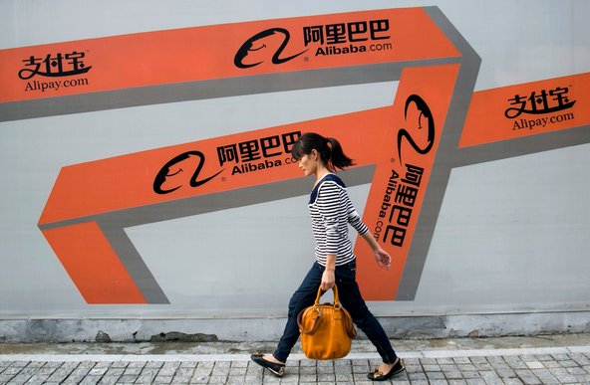
A woman walks past an Alibaba advertisement on a wall in Hangzhou, China.
Updated, 7:38 p.m. | The Chinese Internet industry is coming of age, as some of its biggest players prepare to start new chapters as publicly traded companies — in the United States.
The biggest of them all, the e-commerce behemoth Alibaba Group, is aiming to file for an initial public offering in New York as soon as next month, people briefed on the matter said on Friday. Several analysts value Alibaba at north of $130 billion, and many predict that its I.P.O. may raise more than the $16 billion that Facebook fetched in its market debut nearly two years ago.
And Weibo, a major Chinese microblogging company seen as that country’s answer to Twitter, filed on Friday for its own stock sale.

Related Links
- Sorkin: The Man Behind Alibaba’s Eventual I.P.O. (Jan. 13, 2014)
- Weibo's prospectus
Should the two companies move forward with their plans, they could form the second wave of Chinese Internet I.P.O.s, nearly a decade after Tencent and the search engine Baidu went public.
Earlier this year, JD.com, Alibaba’s principal rival in the e-commerce market in China, filed for its own stock offering in the United States.
Unlike a wave of Chinese companies that sought American stock listings several years ago — some of which have since collapsed in the face of accounting scandals — these are Goliaths.
The latest crop of companies has also chosen to file in the United States, which has enjoyed an abundance of I.P.O.s over the last few years. A swell of American Internet start-ups like Dropbox and Box are primed to join the parade of newly public companies in the next year or two, following in the footsteps of Facebook and Twitter.
Largely unchallenged by foreign competitors, the Chinese companies have come to dominate what is seen as the next frontier of the Internet. E-commerce has become especially important, as Chinese consumers increasingly flock to online marketplaces rather than traditional physical retailers.
And these companies continue to expand into new businesses as they keep up with the migration of online users to mobile devices. (Alibaba, for instance, owns a roughly 19 percent stake in Weibo and has the right to raise that to 30 percent. )
Despite being confined mainly to Chinese-speaking users, Weibo has become one of the most talked-about social networks in the world. The company claimed 129.1 million monthly active users as of year-end, compared with Twitter’s 241 million.
Alibaba’s investment in Weibo last year valued the messaging service at about $3.3 billion. Though its prospectus on Friday listed a fund-raising target of $500 million, the company may seek to raise significantly more.
But by far the most anticipated offering on Wall Street is Alibaba’s. Virtually every major investment bank has journeyed to Hong Kong to make its pitch to Alibaba’s management team, particularly its founder, Jack Ma, and its executive vice chairman, Joseph Tsai. Executives like Jamie Dimon of JPMorgan Chase have dined with Mr. Ma with an aim to secure a coveted role on the forthcoming stock sale.
While the company has yet to formally hire underwriters, two longtime advisers, Credit Suisse and Morgan Stanley, are expected to play big roles in the offering, the people briefed on the matter said.
The company has not yet decided whether it will list itself on the New York Stock Exchange or the Nasdaq market, though both markets have pitched hard to win the listing.
Alibaba’s decision to list in the United States reflects its decision to snub the Hong Kong Stock Exchange, which has resisted overtures to bless the company’s partnership structure. The scheme is meant to help a group of insiders maintain control over the board.
But the Hong Kong exchange, which has traditionally prohibited corporate structures that let minority shareholders preserve control of companies, refused to make an exception. While Alibaba may still change its mind, the company currently plans to seek a listing in New York, two of the people briefed on the matter said.
A spokeswoman for Alibaba said that the company had not yet settled on a timetable, venue or underwriters for its offering. Representatives for Morgan Stanley and Credit Suisse declined to comment.
Founded in 1999 as a marketplace for businesses to trade goods like circuit breakers and hydraulic cylinders with other companies, Alibaba has become a behemoth that is part eBay, part Google and part PayPal. Its sales volume in 2012, $160 billion, was nearly twice that of Amazon.com, according to RetailNet Group.
Over the last several years, the company has posted stunning growth — fast enough that investors grew concerned when in January Alibaba disclosed only a 51 percent gain in revenue for its third quarter, to $1.8 billion.
Among the biggest beneficiaries of Alibaba’s success has been Yahoo, which maintains a 24 percent stake in the Chinese company.
Alibaba, however, does face pressure from rivals like Tencent. Earlier this week, Tencent said that it planned to buy a 15 percent stake in JD.com, strengthening Alibaba’s main rival in online commerce.
Nonetheless, some analysts say they believe that the strength of Alibaba’s platforms will be difficult to overcome for now.
“They have such a strong position that it would be hard to erode that market share in the short term,” Zia Daniell Wigder, an analyst with Forrester Research, said.

NYT

Alibaba I.P.O. May Unleash Global Fight Over Users
APRIL 30, 2014
Farhad Manjoo
STATE OF THE ART
The largest technology stock offering in history is looming, but few in Silicon Valley seem to care.
The initial public offering expected soon in the United States by Alibaba Group Holding, China’s largest e-commerce company, could surpass the amount raised in the I.P.O. of Facebook. It would not even be surprising if it surpassed the combined amounts raised in the I.P.O.s of Facebook, Twitter, Google, Amazon, AOL and Yahoo. But unlike the flurry of attention that accompanies high-profile floats by American tech stars, Alibaba’s stock offering has barely registered among the valley’s tech set.
San Francisco’s artisanal toast bars have not been abuzz with commentary on Jack Ma, Alibaba’s chairman, and Palo Alto’s Tesla dealerships aren’t bracing for a surge in new buyers. In interviews, a few Silicon Valley investors said they didn’t expect the offering to be a big deal in the markets they follow, though they declined to speak on the record about their apathy.
The issue isn’t that the valley is ignorant of the rise of Chinese Internet giants. It’s more that American tech firms have long been spurned and surprised by China’s tech market, and many here aren’t sure how to gauge the ambitions of the giants like Alibaba now bent on crossing the Pacific.
“Chinese Internet companies and American Internet companies are eyeing each other’s markets, but they’re very disconnected from one another,” said Yan Anthea Zhang, a professor at the Jesse H. Jones Graduate School of Business at Rice University who closely studies businesses in China.
A decade ago, American tech companies saw an economically emergent China as the next great frontier, a place where new money and users would combine to form the world’s greatest market for their products.
But cultural, political and technological forces buffeted their dreams. While American firms largely failed to make headway in China, a raft of homegrown companies, Alibaba among them, took over vast swaths of the growing Chinese market.
There are now Chinese analogues to Amazon, Google, Facebook, Twitter, eBay and PayPal. American and Chinese firms operate across a vast gulf, each eyeing global domination — and each essentially pretending the other doesn’t exist.
Alibaba’s gigantic I.P.O. may signal a shift, the end of an era of mutually beneficial provincialism. “They are now going to try to fight more directly in each other’s territory,” Dr. Zhang said. “In both the United States and Chinese markets, we are going to see competition heating up.”
Before we get to that fight, it’s worth examining how American web companies lost the Chinese market. In 2004, Meg Whitman, then the chief executive of eBay, predicted in an interview with CBS News that the company’s Chinese subsidiary, eBay EachNet, would soon become the auction site’s largest moneymaker.
At the time, American web companies were initiating a spree of investments and expansion plans in China. Yahoo invested $1 billion in Alibaba in 2005. Amazon purchased Joyo.com, a Chinese e-commerce firm, which was expected to be the vanguard for the retailer’s plans to dominate China.
Photo
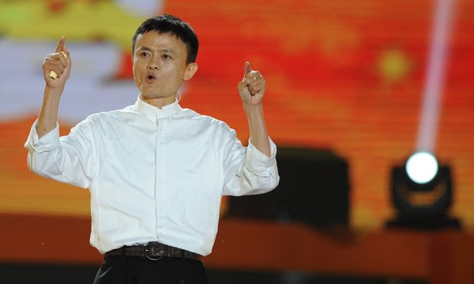
Jack Ma started Alibaba in 1999 with 17 other people. The company's expected initial public offering could surpass the amount raised in the I.P.O. of Facebook. Credit Peter Parks/Agence France-Presse — Getty Images
But many American tech efforts to expand in China proved fruitless, often because the American companies didn’t understand China.
For example, in its early years, eBay EachNet grew to command more than 70 percent of the Chinese e-commerce market for sales between consumers, as William P. Barnett, a professor at the Stanford Graduate Business School, writes in a fascinating case study on the Chinese e-commerce market.
Then in 2003, Jack Ma, of Alibaba, started a consumer-to-consumer site, Taobao, that quickly eroded eBay’s lead by relying on a simple, powerful advantage: Ma gave Taobao features that tapped into the nuances of the Chinese market. “EBay may be a shark in the ocean, but I am a crocodile in the Yangtze River,” Mr. Ma once told an interviewer. “If we fight in the ocean, we lose — but if we fight in the river, we win.”
Unlike EachNet (and the American eBay), Mr. Ma’s company did not charge sellers fees to list their merchandise. This appealed to struggling Chinese who were looking to start small side businesses without a huge investment. Taobao also incorporated tech features that resonated with local culture. An online chat included on the site — again, not available on EachNet — gave users a sense of community that they reported lacking on eBay.
Taobao also let buyers and sellers bargain with one another, and its web design mimicked the departments of offline Chinese retailers, while eBay’s categories were lifted from its American site.
And given its international operation in markets with strict laws around trademarks, eBay was also forced to remain wary of counterfeit merchandise appearing on its pages, a concern that Alibaba didn’t have to consider.
EBay EachNet’s market share began to plummet, and by around 2007, it was dead. Amazon — with which Taobao and its sister site, Tmall, also compete — has been similarly stalled in China; the American online retailer, through its Amazon.cn site, now accounts for less than 1 percent of China’s e-commerce market, according to some estimates.
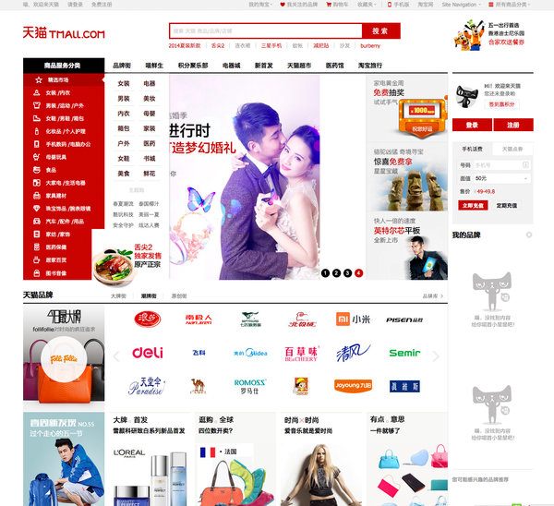
Tmall.com is one of the e-commerce sites run by Alibaba.
Taobao has become one of the jewels of Alibaba’s empire, accounting for more than 70 percent of the Chinese market for consumer-to-consumer online sales. Altogether, Alibaba has been said to account for four-fifths of online purchases in China.
But the problems of American tech firms in China go beyond culture. They have also suffered as a result of politics.
In 2010, after an attack by Chinese hackers on its corporate infrastructure, Google decided to remove its Chinese service. Though the company had acceded to the Chinese government’s demand to censor its site, the firm had long lagged behind the search engine Baidu in China. After Google’s withdrawal, Baidu became even larger.
The Google story — in which government interference creates a difficult business climate for American companies — is a common one in China.
“The Chinese government does not want foreign Internet companies to have a big piece of that market,” said James McGregor, the chairman of the Greater China office of APCO Worldwide, a strategy consulting firm. “They want their own Facebooks, they want their own Twitters. It’s not an open market for foreign Internet companies.”
Alibaba’s offering now raises the opposite question: Will Americans and the American government tolerate the rise of Chinese Internet firms on their soil? More than that, will Alibaba and other rising Chinese companies manage cultural differences any better than American firms did in China?
So far, Alibaba’s approach has been to go slow. The company lately began a string of investments in the United States, including in ShopRunner, an e-commerce company that offers a rival to Amazon’s Prime free-shipping service, and Lyft, a ride-sharing service. WeChat, a messaging application owned by the Chinese web king Tencent, began marketing its app more aggressively to American users this year.
At the same time, the battle for global Web domination has spread far beyond just home turfs. American and Chinese companies are now increasingly competing over emerging markets in Asia and Africa, where Internet infrastructure is just beginning to roll out, and which may prove to be the next great battleground for global Internet hegemony.
To ring in that fight, Tencent’s WeChat recently began airing an ad in South Africa featuring a Mark Zuckerberg impersonator weeping on a therapist’s couch over the customers he’s losing to WeChat. The doctor warns the Facebook founder to pipe down — or else he, too, will drop Facebook for the Chinese app.
Sure, it’s a gimmicky bit of marketing. But maybe the direct approach will finally get American technology giants to pay attention to their Chinese counterparts.
Business Week

Technology

How China's Government Set Up Alibaba's Success
By Bruce Einhorn May 07, 2014

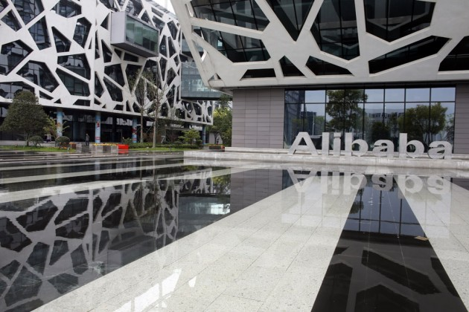
The Alibaba Group headquarters in Hangzhou, China
China isn’t big enough for Alibaba. The e-commerce company has ambitions to expand far beyond China, and by filing yesterday for its initial public offering in the U.S., Alibaba has moved closer to that goal. It could raise as much as $20 billion, making it the biggest-ever U.S. IPO.
As Co-founder and Chairman Jack Ma expands his business around the world, he’ll have a group of influential fans in Beijing. Chinese government officials are eager for a local company to break into the ranks of tech’s global elite, and the huge payoff for Alibaba will highlight just how valuable official Chinese support can be. Alibaba’s rise has been propelled by government policies that have made China a very inhospitable place for U.S. companies—and provided local champions such as Alibaba with the space they need to become viable players globally.
Social networking: Alibaba was relatively slow to move into social networks, but the company has been playing catchup. Last year it became a major shareholder in Sina Weibo (SINA), a microblogging service that would compete with Twitter (TWTR) and Facebook (FB)—if those companies were allowed to operate in China. They aren’t. The Chinese government has banned them. As a result, Alibaba had an unimpeded entry into the world’s largest Internet market, even though it was a relative latecomer, and it will continue to grow without challenge from American competition.
Story: Alibaba Files for an IPO: Why You Should Care
Online video: Just as Chinese can’t check their Facebook pages or send tweets, they can’t access video clips on YouTube (GOOG). The Chinese government has banned Google’s online video service for years. And of late, Ma has shown a lot more interest in video. He owns 5.5 percent of Huayi Brothers Media (300027:CH), a film and TV production company in Beijing, and on April 29, Alibaba and Yunfeng Capital, a private-equity firm co-founded by Ma, agreed to pay $1.22 billion for a stake in Beijing-based Internet television company Youku Tudou (YOKU). As with social networking, the Chinese government has kept the world’s biggest competitor out of Alibaba’s way.
E-commerce. There’s nothing to prevent U.S. companies from trying to take on Chinese e-commerce companies, including Alibaba’s Taobao and Tmall. Taobao first gained prominence as the scrappy challenger that foiled EBay’s (EBAY) ambitions in China. While EBay couldn’t match Alibaba, others are still trying, most notably Amazon (AMZN) and Wal-Mart (WMT). Amazon in 2004 bought Joyo.com, the online retailer co-founded by Lei Jun, an entrepreneur who went on to start smartphone sensation Xiaomi. Walmart in 2012 took control of Yihaodian (“No. 1 Store”), an online retailer.
While the Chinese government doesn’t ban U.S. companies from operating in China, it doesn’t make their lives easy. Regulators seem eager to target foreigners for alleged misdeeds. Walmart is a particularly juicy target; the government has penalized the retailer for offenses such as mislabeling fox meat as donkey meat. (Donkey meat? “Better than veal,” food enthusiast Andrew Zimmern told NPR.)
Story: How Alibaba's IPO Is Even Helping Its Rivals
Amazon hasn’t faced comparable scrutiny in China, but that could just be a sign of how little success the company has had in the country. A decade after it acquired Joyo, since rebranded Amazon.cn, the company has only a 6 percent market share, Bloomberg Industries analysts Praveen Menon and Paul Sweeney wrote in a report published on April 25. Amazon isn’t giving up—Chief Financial Officer Tom Szkutak has said the company is increasing its investments there—but pursuing market share in China and additional markets outside the U.S. contributed to a record $60 million loss for Amazon International in the first quarter.
Still, Jeff Bezos should be grateful. At least Amazon has the chance to compete against Alibaba in the world’s largest country. Other U.S. companies aren’t so fortunate, to Alibaba’s great benefit.

NYT

Alibaba Is Investing Huge Sums in an Array of U.S. Tech Companies
By MIKE ISAAC and MICHAEL J. de la MERCEDJULY 31, 2014
Continue reading the main story Video
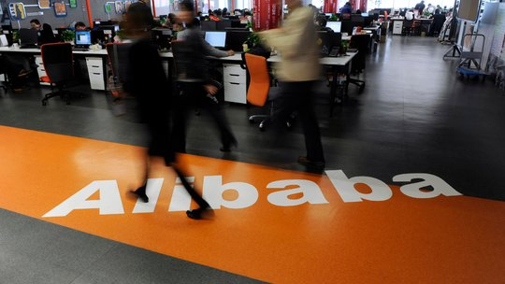
VIDEO @ http://www.nytimes.com/2014/08/01/technology/alibaba-is-investing-huge-sums-in-an-array-of-us-tech-companies.html?hpw&action=click&pgtype=Homepage&version=HpHedThumbWell&module=well-region&region=bottom-well&WT.nav=bottom-well&_r=0
Alibaba, China’s largest e-commerce company, is preparing to go public in New York. When it does, it could be one of the largest public offerings ever in the United States.
Alibaba Group, the Chinese Internet retailer, is coming to America with its checkbook wide open.
In March, Alibaba made a $215 million investment in Tango, a messaging app. It recently contacted Snapchat, another messaging app that this year turned down a $3 billion acquisition offer from Facebook, about making a big investment that would value the young company at $10 billion.
There’s more: Alibaba participated in a $170 million round for Fanatics, an online sports memorabilia retailer. And on Thursday, Kabam, a video game start-up, announced that it has received a $120 million investment from Alibaba. The new round gives Alibaba a board seat and what is likely a significant stake in Kabam, which said it is now worth more than $1 billion.
The recent burst of activity — including a half-dozen investments in the United States over the past year or so — comes as the Internet behemoth prepares one of the most highly anticipated market debuts since Facebook’s two years ago. Alibaba is expected to begin trading in September at a market value of perhaps $200 billion, potentially making it one of the biggest initial public offerings ever.
Photo
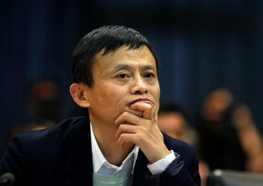
Jack Ma, co-founder of Alibaba, which recently has made a half-dozen major investments in American start-ups. Credit Carlos Barria/Reuters
It would be simple to declare that Alibaba, which became a tech powerhouse by amassing a sprawling collection of businesses in its home country, is trying to take its omnivorous approach to the United States, and it is willing to spend big to make that happen.
But the recent investments aren’t just about size. Alibaba is also rubbing elbows in the sometimes insular world of Silicon Valley-funded start-ups, where a handful of plugged-in financiers can help the company spot the next breakout smartphone app or e-commerce trend before it hits the mainstream.
“With investments like these, they get good products, they make a splash, and most importantly, they build connections and trust amongst the venture capitalists,” said Sameet Sinha, an Internet analyst with B. Riley & Company, a small investment firm.
A spokesman for Alibaba declined to comment on its investment strategy, though the Chinese company has outlined the principles behind its approach in documents filed for its I.P.O. In the formal language of regulatory papers, Alibaba said it wants to get more users, improve how they use its services and improve its customers relations.
It is not so clear, of course, how investments as different as sports memorabilia and messaging apps fit neatly into that plan, but it is clear that Alibaba has made its North American investments a priority.

Alibaba’s American Ambitions
As the company prepares for its initial public offering, it has beefed up its investment strategy to find a stronger foothold in growing markets.
J. Emilio Flores for The New York Times

Messaging
With an exploding market in mobile messaging, Alibaba has been in talks with Snapchat about an investment after putting $215 million into another messaging app, Tango.
Sarah Beth Glicksteen for The New York Times

Retailing
Alibaba took a stake last year in Fanatics, an online sports apparel retailer, giving it a foothold in a category where Amazon is dedicating more resources.
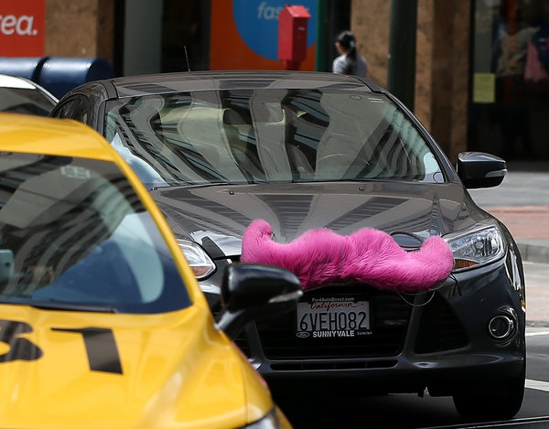
Justin Sullivan/Getty Images

Peer-to-Peer
The so-called sharing economy has also drawn Alibaba’s interest, with its participation in a $250 million funding round this year for the ride-sharing service Lyft.
They are led by Michael Zeisser, a native of France who formerly led the digital commerce division of Liberty Media. Mr. Zeisser was recruited by — and reports to — Joseph C. Tsai, Alibaba’s vice chairman.
Given a broad mandate by Alibaba’s top management, Mr. Zeisser and his team have been charged with nothing less than turning their employer into a global Internet and e-commerce colossus.
“When you own 45 percent of the e-commerce market in China and you want to continue to grow, international market share is obviously a green field that you can go after,” said Eric Setton, Tango’s chief technology officer and co-founder.
That has led to an array of investments in other seemingly disparate companies, including Lyft, a popular ride-sharing service that recently started operating in New York, and ShopRunner, an e-commerce delivery start-up.
Though they may appear loosely connected, many of the stakes that Alibaba has taken have focused on mobile and e-commerce. Tango has hinted that it plans to introduce some form of shopping in its services, while Kabam offers Alibaba the chance to learn about in-app purchases.
Photo
Eric Setton, writing, co-founder of Tango, which received a $215 million investment from Alibaba, as well as strategic advice. Credit Peter DaSilva for The New York Times
Elsewhere, in recent months Alibaba has struck deals to buy full control of AutoNavi, a Chinese mapping service listed in the United States, and a 50 percent stake in one of China’s top soccer teams. According to some reports — and distressingly to some potential investors — Alibaba co-founder Jack Ma decided to buy the stake in Guangzhou Evergrande in about 15 minutes after having had drinks with the club’s owner.
Alibaba’s investment plan is not aimed at directly competing with established American Internet heavyweights like Amazon and eBay, however. In its I.P.O. prospectus, Alibaba says that its investments will remain focused on China, where the company still sees enormous growth potential.
For the American start-ups in Alibaba’s embrace, there are benefits beyond the investment. Kabam, for instance, receives a direct line into China, one of the fastest growing smartphone and gaming markets of the past decade. Some 40 percent of global smartphone shipments in the first quarter of 2014 were bound for Chinese consumers, according to IDC, a research firm.
It is not, however, a simple market for a Western company to enter. Alibaba’s knowledge of China’s web-connected consumers could help American start-ups navigate the unfamiliar landscape.
“Entering Asia is very complex,” said Kent Wakeford, chief operating officer of Kabam. “There are different payments systems, different types of phones and tablets to deal with. Even the culturalization is different.”
Mr. Zeisser and his team have spent significant amounts of time helping their newfound partners, executives at the portfolio companies have said, advising on strategies and helping solve problems.
“They’ve been quite active and contribute significantly on our strategy,” Mr. Setton of Tango said. “They have also given us the financial chops to be able to do things we wouldn’t have been able to do before.

Alibaba’s Next Move: Grow Abroad, or Go Deeper into China?
Oct 01, 2014
- Asia-Pacific
- China
- North America
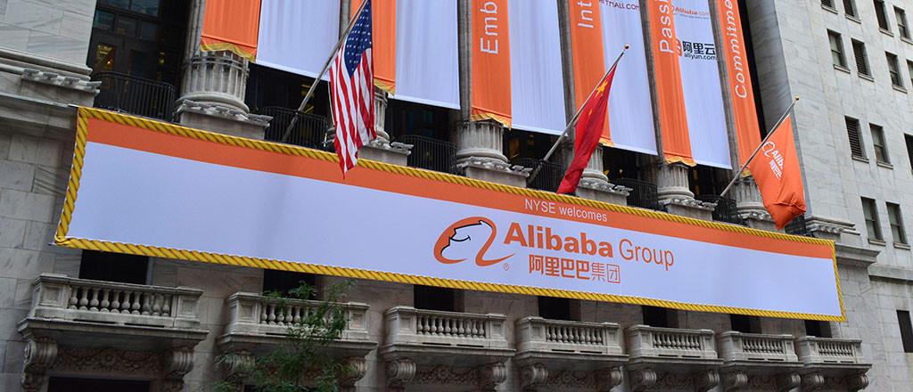
It is hard not to be impressed with Alibaba. After raising $25 billion in a U.S. initial public offering earlier this month, the company that was founded 15 years ago in a modest apartment in southeastern China has officially minted the biggest IPO on record. With a market value of $220 billion, Alibaba is worth more than Facebook, Amazon or eBay. And now that it has a substantial war chest, what is next for the Chinese e-commerce giant?
Co-founder and executive chairman Jack Ma recently shared a bit of his grand vision. “We want to be bigger than Wal-Mart,” he said in a September 19 interview on CNBC, the day Alibaba went public on the New York Stock Exchange, during which investor demand drove up the stock by 38%. “We hope in 15 years, they’ll say this is a company like Microsoft, like IBM, like Wal-Mart. [Those companies] changed, shaped the world.”
Alibaba is well on its way, at least in China. As the largest e-commerce company there, Alibaba counts 279 million annual active buyers who place 14.5 billion orders a year. Three businesses brought in 82% of its fiscal 2014 revenue of $8.46 billion: shopping sites Taobao.com and Tmall.com and group buying marketplace Juhuasuan.com. The company also operates Alibaba.com, which connects small businesses around the world with Chinese suppliers. Taobao and Tmall are the largest companies in their markets when measured by the value of all the goods they handle. Alibaba.com is the largest wholesale marketplace by revenue, while Juhuasuan tops the ranking in monthly active users.
But now Ma and his leadership team have a tough task ahead: positioning the company for its next phase of growth. The strategic path chosen by the executive team is critical to shaping Alibaba’s future. Will the company continue to focus on developing its business in China for the next few years, or will it shift its attention to international expansion through acquisitions or partnerships? Ma himself is still pondering his strategy: “I’ve been thinking about the next five to 10 years, how I can make these shareholders happy,” he told CNBC. But he emphasized that pleasing shareholders will come after taking care of customers and employees, in that order.
“There could be enormous opportunity at the periphery of China.”– Marshall Meyer
A prospectus filed with the U.S. Securities and Exchange Commission on September 22 provides a clearer glimpse of Alibaba’s business plans. The company said it is seeking to increase market share in China by attracting new customers and motivating existing clients to purchase more products through loyalty programs, providing good customer service as well as using marketing and promotional campaigns. It also plans to expand its mobile presence by offering digital content and location-based services, among others. Alibaba will continue to invest in data and cloud computing services to help its own business as well as its cadre of merchant customers. Internationally, the company said it would like to continue facilitating relationships between Chinese merchants and consumers with foreign buyers and sellers.
As a public company, Alibaba will face pressure from investors who are betting on continued robust growth of its business. So far, Alibaba has not disappointed. In fiscal year 2014, which ended on March 31, revenues grew by 52% to RMB 52.5 billion from the prior year. From 2012 to 2013, revenues were up 72%. Profits have continued to soar as well, shooting up 175% in 2014 from the prior year and doubling from 2012 to 2013.
Marshall Meyer, Wharton emeritus professor of management, believes Alibaba will be better off focusing on China and surrounding Asian countries, where e-commerce is not fully developed yet. In those markets, Alibaba’s more advanced platforms would have an advantage over local players, an edge it would not enjoy in more developed nations with entrenched competitors. “There could be enormous opportunity at the periphery of China,” he says. “Go deeper elsewhere in China…. That’s what I would do, rather than fight Amazon here in the U.S.”
Online Shopping Sprees
Qiaowei Shen, Wharton professor of marketing, notes that Alibaba still has plenty of growth opportunities in China because the number of shoppers going online continues to increase. “E-commerce is getting very, very popular in China. It’s amazing how fast it is growing — not only in the big cities, but also in second- and third-tier cities.”
Shen says the dearth of retail stores and the limited product selection available at brick-and-mortar stores have motivated Chinese shoppers to go online. On the Internet, not only will they find a greater variety of products, but also goods tend to have lower prices. As consumers flock to these sites, entrepreneurs are springing up to cater to them. “Even farmers are selling their vegetables on this platform,” Shen says.
By Alibaba’s own reckoning, the Chinese e-commerce market is largely untapped. According to its SEC filing, less than a quarter of China’s 1.35 billion people shop online, even though half of them are on the Internet. Overall, online shopping makes up only 8% of China’s total consumption. While China’s economy has cooled, it remains a growing market, and “that alone could propel [Alibaba] along,” Meyer notes.
But to keep the online shopping market robust, an adequate infrastructure for the delivery of products must be in place, Meyer adds. “They’re in the business of moving goods to customers — that’s where the problem comes,” because delivery can be spotty. But Shen points out that the growth of e-commerce has propelled the development of the logistics infrastructure industry in China as well. “They have grown really, really fast,” she says. Delivery now can be quick and cheap. In its SEC filing, Alibaba said China has an “increasingly extensive and rapidly improving” logistics backbone. The company uses third-party providers of logistics services to deliver its products and China Smart Logistics, a 48%-owned affiliate.
Another Alibaba headache is dealing with the competition. While it is by far the largest player, commanding half of the market, smaller rivals have sprung up and are chipping away at its business. “The competition in China is actually very severe even though it’s a big market,” Shen notes. Competitors are differentiating themselves from Alibaba by specializing in certain goods. The recently public JD.com, for instance, began with a specialty in electronics. In contrast, most of Alibaba’s sites are general in nature; anyone can sell anything.
“The competition in China is actually very severe even though it’s a big market.” –Qiaowei Shen
Wharton marketing professor David Hsu predicts that at some point, the Chinese e-commerce market will become so crowded that it will be difficult for Alibaba to differentiate itself. But the company can stay ahead of its competitors by offering services that are new or needed by Chinese consumers. For instance, Alibaba can offer financial services to its customers as an extension of its core e-commerce business.
While Alibaba has separated from Alipay, its payments platform, Hsu envisions a day when the company will offer insurance and other financial services to its business customers. Indeed, Alibaba is moving in that direction: One of its affiliates that is also the parent of Alipay just got approval from Chinese authorities to set up a privately owned bank, according to a September 29 story in The Wall Street Journal. Similar services might not be far behind.
When it considers branching out into other product lines, Alibaba should think more like Amazon than eBay, Hsu suggests. EBay has not strayed much from its auctions business, but Amazon parlayed its online bookselling operations into areas such as video, cloud services and consumer devices. According to Hsu, areas Alibaba could look into are health apps, smart watches and other connected devices. It could use the money from the IPO for research and development to drive innovation. “They have an opportunity to shape that vision,” he notes. “It will be great to see them break new ground here.”
As for the government possibly reining in Alibaba’s growth in the future, Shen points out that such political risks exist in any Chinese company. Alibaba is no different; it is regulated like any local firm. But she also believes that the Chinese government wants to support Alibaba because it brings in plenty of tax revenue, and its platforms create entrepreneurial jobs for scores of Chinese. In an interview with the news program “60 Minutes” that aired on September 28, Ma said Alibaba has a good relationship with the government. He added that the company brings stability to the country by creating entrepreneurial jobs. “If people have no jobs, the government will be in trouble,” he noted.
Still, Shen acknowledges that there is always an element of uncertainty when it comes to dealing with the Chinese government. Hsu points to the current mass protests in Hong Kong, noting that the world is watching to see how the Chinese government deals with civil disobedience sparked by Beijing’s decision to limit candidate choices in the 2017 election for Hong Kong’s next chief executive.
Acquisition Rumors
While its SEC filing remains circumspect, Alibaba has shown an interest in entering the U.S. through its actions. Earlier this year, the Chinese company launched shopping site 11Main.com focusing on small merchants, and it has invested in several U.S. startups including ride-sharing service Lyft, mobile messaging firm TangoMe and e-commerce site ShopRunner.
“They are trying to learn more about opportunities in the U.S. through these small steps,” says Kartik Hosanagar, Wharton professor of operations and information management. “But these steps seem to be pointing in the direction of a big investment in the U.S.” Hosanagar adds that he doubts websites like 11Main.com will be “big successes, so I fully expect that Alibaba will eventually make a big acquisition in the U.S.” Twitter
“I wouldn’t go head to head with Amazon.” –Marshall Meyer
One name that has been floated as a potential acquisition is eBay. Whether or not the rumor pans out, buying a major U.S. company or entering a partnership with one will go a long way towards helping Alibaba burnish its brand in the country. “They can leverage that by partnering with a U.S. company, by acquiring a U.S. company and co-branding it with Alibaba, or by slowly launching a viral grassroots campaign here,” says Wharton marketing professor Eric Bradlow. “Consolidation and global expansion might be the next opportunity given the worldwide buzz Alibaba’s recent IPO generated.”
Even though it would have adapt to cultural differences, Alibaba probably will have an easier time fitting in than other Chinese companies would because it is much more familiar with the U.S. environment. “Jack personally knows the territory,” Meyer says. “[Alibaba’s] odds would be better.”
If Alibaba does not buy eBay or another big U.S. company but decides to compete instead, it will not be easy for the company to prevail. “It’s a big challenge,” Meyer notes. Amazon, in particular, will be a tough rival to beat because its razor-thin margins ensure it will undercut the prices of everyone else. It also has a logistics infrastructure that works. “I wouldn’t go head to head with Amazon,” he says. “There’s not a lot of room to underprice them.” Twitter
Bradlow agrees that Alibaba is “unlikely” to make major headway into the U.S. markets in the short term due to the “strong Amazon and eBay brands” and strength of their distribution systems.Moreover, American consumers are used to buying from Amazon but unfamiliar with the Alibaba brand. Despite the widespread news coverage of its IPO, “a lot of people don’t know what Alibaba is,” Meyer notes. An Ipsos poll conducted for Thomson Reuters in the week leading up to the IPO shows that 88% of Americans had not heard of Alibaba. A week after the company went public, the number had fallen but remains at a high 76%.
According to Shen, Alibaba has to come up with a unique proposition to entice Americans to switch. It makes no sense for the company to become another Amazon if Amazon is already in the market, she notes. Wharton marketing professor John Zhang says that in light of the competition, it might make more sense for Alibaba to focus its efforts on the Chinese market. “I don’t see why it cannot continue to do well in China,” he notes. “Going abroad is a different proposition.”

Alibaba in major initiative to court China consumer for U.S. retailers
By Edwin Chan, Paul Carsten and John Ruwitch
1/15/15
SAN FRANCISCO/BEIJING/SHANGHAI, Jan 16 (Reuters) - China's Alibaba Group Holding Ltd plans a major move to win U.S. business this year, by offering American retailers new ways to sell to China's vast and growing middle class.
Anchored by Alipay, the dominant Chinese electronic payments system that works closely with Alibaba and is controlled by its executives, the world's largest Internet retailer is using the calling card of China's consumers to attract U.S. partners, two sources close to the company told Reuters.
Long seen as the most potent threat to Amazon.com Inc with $300 billion in global sales, the moves add up to a conservative approach to expanding in the United States, contrary to industry speculation that the company may be plotting a direct assault on U.S. soil.
That considered strategy, outlined to Reuters for the first time by the sources and executives who work directly with the Chinese company, is intended to heighten awareness in the United States of what Alibaba does, gain goodwill in an important Western market, and lay the groundwork for a longer-term play.
At the heart of its push are Alibaba's and Alipay's trial deals to handle Chinese sales, payment and shipping for some of the biggest names in U.S. retail from Neiman Marcus Group to Saks Inc. Both confirmed the agreement but would not talk about how the pilots are faring.
The Chinese companies will also work with U.S. startup Shoprunner, an online mall for U.S. retailers in which it owns a stake, and retail services provider Borderfree Inc to court Chinese consumers.
And Alibaba is preparing a marketing campaign to raise awareness among U.S. businesses of its global business-to-business wholesale platform, Alibaba.com, so they can buy and sell to and from global suppliers.
"They own the toll road into China," said Michael DeSimone, Chief Executive Officer of Borderfree. "What really puts the jetpack on things when you deal with an Alipay is, they're on the ground and they know the Chinese consumer so well."
Industry insiders point to just $15 billion in annual U.S.-to-China, cross-border consumer sales now. But Daiwa estimates cross-border purchases, which exclude sales of American products within the country, can grow to 1.8 trillion yuan ($291 billion) by 2020.
"It's not a big thing right now, but within the next 12 to 18 months what you'll see more of is bringing 300 million Chinese consumers to retailers in the U.S.," Alibaba Vice Chairman Joseph Tsai said in an interview with Reuters last year. He laid out the broad plan, and sources have now described details.
Still, there's no guarantee of success.
China's middle class is over 250 million strong and growing, spurred by government policy to create a more consumer-driven economy. Apple iPhones and General Motors cars have become big-selling status symbols, but the market remains a challenge for Western companies, especially those lacking a global footprint. Home Depot Inc decided in 2012 to shut all seven of its big box China stores, while in December, Best Buy said it will sell its struggling China business.
And Alibaba's 10-month-old effort to help foreign retailers set up shop in China, Tmall Global - its business-to-consumer website, has had muted success. Of 5,000-plus brands and 650 merchants that now sell on that site, just 30 have accumulated more than 10 million yuan in sales, according to the company.
But there are signs of traction. Costco Wholesale Corp , which began selling on Tmall Global in November, saw sales of more than 40 million yuan in its first month of operations, according to data Alibaba provided to Reuters. And the site has attracted some 90 million unique visitors since launch, buying from 90 percent of listed merchants.
KNOWING THE NAME
Part of Alibaba's aim is to counter official concerns about Chinese mega-corporations. In 2014, Alibaba hired former Treasury chief of staff James Wilkinson to help tailor its international strategy, and it has enlisted Korn Ferry to search for a Washington-based international government affairs chief.
Alipay and a logistics-partner network that took years to assemble are central to Alibaba's U.S. effort.
Major brands, such as Nike, that have a large physical presence in China already sell directly on Tmall. But Alipay's effort directly connects American merchants with China, without the need for investment in a physical presence.
It also allows U.S. retailers and Chinese consumers to avoid difficulties associated with foreign exchange. Chinese consumers pay in yuan; U.S. companies get paid in dollars.
Alibaba's and Alipay's program for U.S. companies is called ePass. It includes a customs pre-approval process, a sort of "fast lane" that shaves days off delivery. Daiwa analysts John Choi and Alex Liu call that capability Alibaba's biggest advantage over rivals such as JD.com.
Alibaba and Alipay have made pilot agreements to handle payments and shipping to China for department stores Neiman, Saks, Macy's Inc, Macy's Bloomingdale's chain, Ann Taylor, luxury fashion site Gilt, and apparel label Aeropostale, according to Borderfree. The companies declined to comment, although Neiman, Saks and Ann Taylor confirmed the deal.
If a Chinese consumer bought a pair of shoes from Saks, for instance, Alipay would handle the financial transaction. The shoes go to a U.S.-based Alipay facility that handles the transfer to China. After clearing customs, a local partner typically would handle final delivery.
Alibaba has even taken on a role akin to a cultural liaison for U.S. retailers. Tracey Weber, chief operating officer of online retailer Gilt, said that as their Alipay trial progressed, the Chinese company began increasingly to help with marketing and even product selection: advising them to use more red for instance, or to more prominently display cross-body handbags popular in China.
"It is such a different environment," she said.
Shoprunner, meanwhile, hired an ex-Amazon executive to head up a new Shanghai office last year, and Chief Executive Scott Thompson said the startup is preparing a major marketing campaign in China in 2015.
TARGETING COUNTERFEIT
Alibaba also aims to draw in more U.S. businesses to its Alibaba.com portal, as buyers and sellers. One strategy is to reduce the number of counterfeit goods, a major problem in China and a concern for companies considering sharing intellectual property such as technology and designs.
To that end, Alibaba has enlisted data company Dun & Bradstreet Credibility Corp, among others, to beef up a supplier-certification program it hopes will help draw in many of the estimated 27 million small-time American businesses and manufacturers that now operate mostly offline.
Validation could allow both sides to assure themselves that they are working with legitimate partners.
Jeff Stibel, who is heading up Dun & Bradstreet Credibility Corp's effort with Alibaba, said integration was starting, and it will launch its certification program early this year.
Alibaba also has some plans to sell to Americans.
Alibaba has a small U.S.-based portal, 11Main.com, a collection of Internet storefronts for smaller businesses and products from yoga mats to scented candles. While it focuses on U.S. consumers, a quarter of its 1.4 million listed products can already be shipped to Asia. It hopes eventually to help sellers gain access to Alibaba's U.S.-Chinese corridor, 11Main President Mike Effle told Reuters.
Alibaba.com itself is an avenue to sell to Americans, as businessman Michael Sorrentino found at the Consumer Electronics Show in Las Vegas this year.
The chief executive of smartphone case maker Eyepatch estimates about 20 percent of U.S. retailers he spoke with asked if they could buy his gear through Alibaba.com.
"That quickly taught me, whether I'm familiar or not with that platform, that I need to be on it," he said. ($1 = 6.1957 Chinese yuan renminbi) (Additional reporting by Malathi Nayak and Deepa Seetharamanin San Francisco and Nathan Layne in Chicago; editing by Peter Henderson, Martin Howell and Bernard Orr)

Alibaba Sales Up 39% on Increased Consumer Spending in China
点击查看本文中文版 Read in Chinese
By PAUL MOZUR
MAY 5, 2016
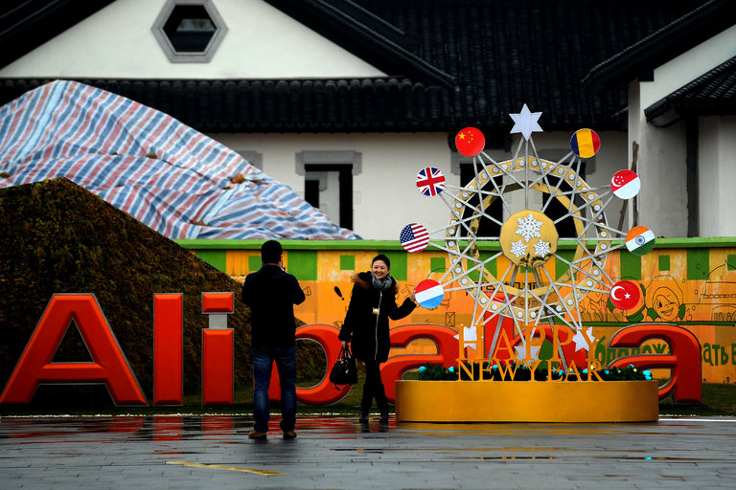
A sagging Chinese economy and a slowdown in spending growth on Alibaba’s platforms have hurt the company’s share price. Credit Chinatopix, via Associated Press
HONG KONG — The Alibaba Group, which owns China’s biggest online marketplaces, is squeezing more money out of slowing growth.
The Chinese e-commerce giant, which lists shares on the New York Stock Exchange, reported on Thursday a surge in profit and revenue in the first three months of the year compared with the same period last year. The company made more money by charging retailers to use its platforms, which connect vendors small and large with China’s growing ranks of connected consumers.
But the figures, covering the fourth quarter of the company’s fiscal year, also showed stalling growth in the volume of sales over its platforms. Gross merchandise volume, a closely watched measure of the transactions on the company’s websites, grew 24 percent compared with the same period a year earlier, about the same pace in the prior quarter.
Still, investors bid Alibaba’s shares up on Thursday. In a blog post released with the earnings report, Alibaba’s executive vice president, Joseph C. Tsai, said the company was able to buck the trend of broader global economic troubles because of the resilience of Chinese consumers, which economists say must make up for China’s weakening manufacturing and construction sectors.
“Chinese consumers, with their healthy balance sheets and ability to spend, will propel China’s shift from an export- and investment-led economy to a consumption-driven economy,” Mr. Tsai said.
For American investors, Alibaba has become a proxy for the Chinese economy. Though a sizable portion of China’s retail sales take place on Alibaba’s marketplace websites — Chinese consumers spent almost $500 billion on Alibaba last year — the company’s sales growth outperformed the rise in transactions on its site.
The results also showed the growing toll that Alibaba’s forays into hypercompetitive areas outside its core business are taking on its finances. It said that its Koubei business, which allows Chinese consumers to order food and other items and services on their smartphones, had generated $135 million in losses for its parent company in the quarter.
In his post, Mr. Tsai pointed to the patience involved in creating the company’s Taobao marketplace, now the major sales driver of the company. He said the company would take a similar long-term view and continue spending on new businesses it thinks can help it grow.
When Alibaba was listed in late 2014, the hype the company had built up helped it raise more than $20 billion, the largest public listing in United States history. Since then, a sagging Chinese economy and a slowdown in spending growth on Alibaba’s platforms have meant that despite solid results, the company’s share price has not returned to the level it reached on the first day of trading.
Still, Alibaba has made progress making more money from its main business.
Unlike Amazon.com in the United States, which keeps its own inventory and sells directly to customers, Alibaba serves as a middleman and makes money from getting vendors on its services to buy advertising and other services. Although the amount spent on Alibaba’s marketplaces has grown about 20 percent this quarter and last, its revenue from ads and commissions on those sites has grown 30 percent or more. In the longer term, investors expect those numbers to align more closely, meaning slower sales growth.
Spending growth on Alibaba’s e-commerce sites will most likely continue to moderate. The company also faces rising competition from JD.com, which operates a business model similar to Amazon’s, as well as continued expenses from some of its strategic investments and acquisitions.
Still, Chi Tsang, an HSBC analyst in Hong Kong, pointed to its continued strong cash position and dominance in online shopping as advantages. “People don’t think about how much cash this company generates,” he said.
Alibaba said on Thursday that sales rose 39 percent in the fourth quarter, to $3.75 billion. Gross merchandise volume rose 24 percent, to $115 billion. Its profit rose more than 80 percent, to $832 million. Minus one-time items, the company posted a profit of 3.02 renminbi, or 46 cents, a share, lower than the 3.60 renminbi a share that analysts had expected.

Forbes

Apr 13, 2016 @ 01:34 PM 1,321 views The Little Black Book of Billionaire Secrets

Why Is Alibaba Expanding Beyond China?

Trefis Team, Contributor
Alibaba recently announced that it is acquiring a controlling stake in Lazada, a leading e commerce platform in Southeast Asia, facilitating Alibaba’s expansion in the region. Lazada currently operates e-commerce platforms in Indonesia, Malaysia, Philippines, Singapore, Thailand and Vietnam and Alibaba’s investment in the company will be around $1 billion. Because Alibaba seeks growth opportunities outside China, the deal makes sense. Lazada’s growing consumer base is in a region with population of more than 550 million, including around 200 million internet users. Alibaba already holds stakes in several e-commerce companies in India and is now looking to directly enter the Indian e-commerce market. We believe expansion beyond China will be a key growth driver for the company. As emerging markets witness significant e-commerce growth in future, they will provide a boost to Alibaba’s revenues in the long term.
Southeast Asia Poised For Significant Growth In E Commerce
E-commerce in southeast Asian countries such as Malaysia, Thailand and Vietnam is at a very nascent stage, with online commerce accounting for less than 1% of the total retail market. If this number reaches 5% of the total retail market, the Southeast Asian e-commerce market would be $ 20 billion in size. With a growing middle class, strong mobile penetration and a younger population, the region has all the ingredients for high growth in e-commerce in future.
According to a Credit Suisse survey, e-commerce as a share of total retail sales may soon be larger in emerging markets than in developed countries. Total annual retail sales across the markets surveyed by Credit Suisse (Brazil, China, India, Indonesia, Mexico, Russia, Saudi Arabia, South Africa and Turkey) could reach up to $3.5 trillion as internet access rises rapidly in these regions and disposable incomes expand. The survey also found that these regions could add nearly 1 billion online shoppers as internet usage rises to the levels of developed nations. Of the countries surveyed, Alibaba is already expanding into India and Indonesia, thus tapping into this significant growth.

China continues to remain a key market for Alibaba, as the company looks to tap the growing e-commerce in rural and urban parts of the country. It additionally seeks to establish a strong presence in other emerging economies where e-commerce is underpenetrated, so as to boost Alibaba’s revenues as the Chinese economy matures. According to eMarketer, retail e-commerce sales, as a percentage of total retail sales, are likely to be around 30% in China by 2018. As e-commerce forms a significant part of total retail sales in China, growth in e-commerce will slow over the long term. Other emerging economies such as India and Southeast Asia, where e-commerce accounts for less than 5% of total retail sales, will continue to see significant growth
While Alibaba aspires to become a global company, its strategy to expand into developing regions will ensure that the company continues to witness high growth in revenues, even as the Chinese economy matures.

