The Economist

<http://www.economist.com/news/special-report/21663327-despite-chinas-recent-troubles-prospects-its-entrepreneurial-private-sector>

**Special report:** [**Business in China**](http://www.economist.com/specialreports?year%5Bvalue%5D%5Byear%5D=2015&category=76984)

**Business in China**

**Back to business**

**Despite China’s recent troubles, the prospects for its entrepreneurial private sector remain bright, says Vijay Vaitheeswaran**

Sep 12th 2015 | [From the print edition](http://www.economist.com/printedition/2015-09-12)

SHANGHAI’S WUKANG ROAD has a long history. In 1897 John Calvin Ferguson, the American head of what is now Jiao Tong University, had it built in the city’s French concession so students could get to class. The road boasts several dozen listed buildings, among them a graceful mansion that is the old family home of Marjorie Yang, China’s cotton queen. Its interior garden is sheltered by tall trees that have survived Japanese occupation, civil war and the Cultural Revolution.

Ms Yang’s family has proved just as resilient. Tsai Shengbai, her grandfather, began his studies at America’s Lehigh University in 1915, the same year that the British and American Chambers of Commerce opened in Shanghai. Inspired by Frederic Taylor’s theories on scientific management, he took over Mayar Silk Mills, founded by his father-in-law (Ms Yang’s great-grandfather), and turned it into one of China’s largest silk firms by introducing modern machinery and professional management.

A century ago Shanghai was a cosmopolitan city bursting with entrepreneurial energy. Then came the years of upheaval. The family moved to Hong Kong and started again. It gave up its mansion and its factories but kept its knack for business. In time, a younger generation set up Esquel, a new textile firm, and as soon as China opened the door to private investment in 1978 the family went back to the mainland. Esquel has since grown into one of the world’s best thread-to-shirt textile firms, with some 56,000 employees and operations the world over. Among its clients are such famous brands as Ralph Lauren, Hugo Boss and Nike. Privately held, it has annual revenues of more than $1 billion. Ms Yang has even managed to get back the mansion in Shanghai.

Esquel has invested around $200m to transform its manufacturing complex in Gaoming, in southern China, and spent a further $30m on wastewater treatment. In one giant room warping machines made in Europe are creating enormous spider’s webs of yarn. Each of the $500,000 Staubli drawing-in machines in another room saves 12 workers. Mechanisation improves efficiency and quality and cleans up the dirty processes of dyeing, weaving and finishing. The enormous sewing rooms are air-conditioned. The seamstresses think their work is better and safer than most factory jobs. Ms Yang insists that “industry is not just about labour input…knowledge has value.” She teaches her workers a simple software-coding game developed by the Massachusetts Institute of Technology to encourage logical thinking.

Esquel’s story challenges three widely held beliefs about China Inc: that the outlook for business in China is gloomy because the economy is set for a long period of stagnation or worse; that China’s economic miracle was the result of large-scale planning by the state, not private-sector enterprise; and that Chinese firms are mere copycats that cannot innovate. This special report will argue that all these contentions are wrong.

“The Chinese economy is faced with the onset of a permanent slowdown. To mitigate its adverse effects, the Chinese government needs to change its old ways,” according to an annual assessment of the economy by the European Union Chamber of Commerce in China, released in the wake of recent turmoil in the stock- and currency markets. The country’s growth rate has dropped from double digits to around 7% (according to official data) and the debt-to-GDP level has soared. China’s clumsy devaluation in August, coming at a time of tumbling oil and commodity prices, unnerved many investors. The subsequent plunge in the Shanghai stockmarket, and the government’s ham-fisted policy response, set off a global rout in shares. Doomsters are already predicting a long period of stagnation, reminiscent of Japan’s “lost decade”, or even an economic collapse.

The power of numbers

There is cause to worry about China’s economy, but this special report will show that there are plenty of reasons to be hopeful as well. Growth may be sagging, but even if, as many believe, it is only 5% today, that represents more economic output than the 14% seen in 2007 because the economy is so much bigger. And as Louis Kuijs of the Royal Bank of Scotland points out, China’s income per person at market exchange rates in 2013 was only 13% of America’s, so there is plenty of scope for catch-up growth, particularly if the government adopts reforms that free up the private sector.

And many of China’s people are getting richer all the time. McKinsey, a consultancy, estimates that by 2020 the proportion of urban households with annual incomes of $15,000-33,000 (a rough definition of the country’s middle class) will be 59%, against only 8% in 2010. Manufacturing, far from being on its way out, is benefiting from investment in labour productivity, automation and regional supply networks. And the underdeveloped services sector represents a huge opportunity.

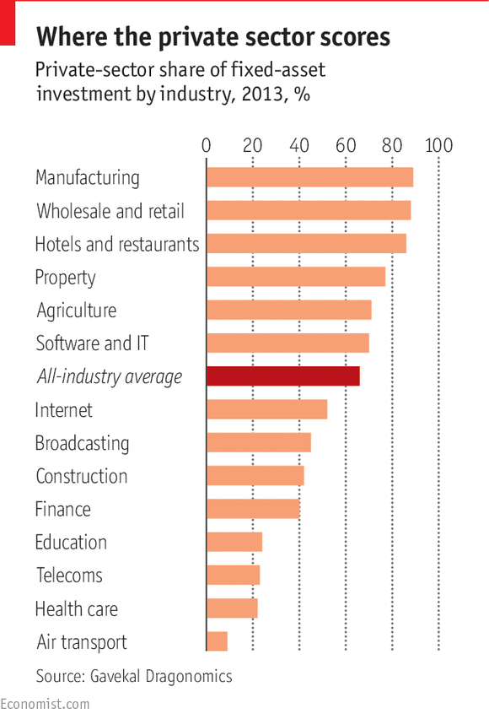

Even Jörg Wuttke, the boss of the EU Chamber of Commerce in China that has just delivered such a critical assessment, remains guardedly optimistic: “China’s economy is headed for a rough year or two, but the longer-term outlook for business remains positive. Our members are staying here and investing in China’s future growth.”

John Rice, the vice-chairman of GE, accepts that the easy gains in China have been made, but reckons that “many firms haven’t tried hard enough.” With a population of 1.4 billion, China packs such a punch that even niche markets like online dining and nail salons can amount to more than the entire car industry in a smaller country.

Up to now, China’s leaders have relied on state planning and heavy investments in infrastructure and property. To its credit, President Xi Jinping’s government has acknowledged that this model has run out of steam, and has introduced reforms to encourage a shift to growth driven by consumption and services. But there is much more to do. China’s control-obsessed planners were never going to find it easy to give free rein to market forces, and many of the recent policy stumbles and resulting financial panics reflect their ambivalence about market reform.

At first blush, the argument for state capitalism seems plausible. China’s investment-driven model has produced lots of infrastructure that ties this vast country together. State-owned enterprises (SOEs) control a large share of assets in important industries. Gavekal Dragonomics, a consultancy, estimates that SOEs account for perhaps a third of China’s capital spending, against 5% or less in most developed countries.

Yet on closer inspection the SOEs’ achievements look less impressive. The private sector, it turns out, is responsible for perhaps two-thirds of all economic output today and almost all of the 250m-plus jobs created in cities since 1978. It also accounts for nine-tenths of exports. Its investment is growing far faster than that of the SOEs. China’s best chance of weathering the current storm lies in the resilience and dynamism of the private sector.

The late Ronald Coase, a Nobel prize-winning economist, noted in a paper entitled “How China Became Capitalist”, co-written with Wang Ning, that “the fact that the Chinese Communist Party has survived market reform, still monopolises political power and remains active in the economy has helped to sell the statist account of reform.” But, he continued, what really fuelled the economy were the “marginal revolutions” that enabled entrepreneurship and markets. Private farmers, rural enterprises and small urban entrepreneurs did more from the fringes to advance the economy than did central planners in Beijing.

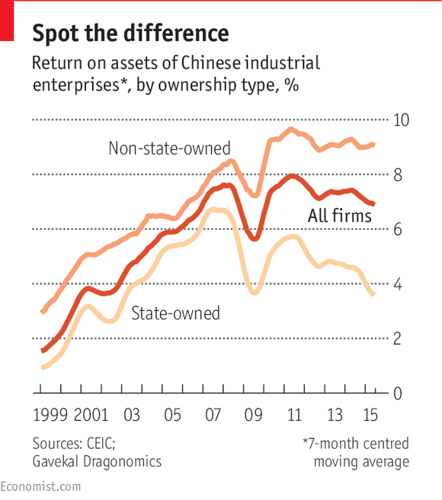

The distinction between China’s state-owned and private firms is not always as clear-cut as it might seem. A company’s formal status can be misleading (see [article](http://www.economist.com/news/special-report/21663334-telling-state-controlled-private-firm-can-be-tricky-how-red-your-capitalism" \t "_self)). And the Communist Party is everywhere: article 19 of China’s company law states that a party cell must be set up in every firm above a certain size, public or private. Still, on the whole SOEs and private firms behave very differently, and the entrepreneurial energy now in evidence in China is largely confined to the private sector.

Edward Tse, a former boss of the Chinese operations of both the Boston Consulting Group (BCG) and Booz & Company (now part of PwC), identifies four entrepreneurial waves that have defined the modern Chinese economy. The first arrived in the 1980s, when the end of Maoism enabled private-sector firms to take off. Zhang Ruimin took control of Haier, Liu Chuanzhi launched Legend and Ren Zhengfei set up Huawei. Most new entrepreneurs at that time had little business experience.

The second wave began in 1992, when Deng Xiaoping’s “southern tour” rekindled reforms. A number of entrepreneurs from this period—which produced Liu Jiren at Neusoft and Guo Guangchang at Fosun, among others—were well-educated. Many had left academic or government sinecures to start their own businesses.

The third wave started to roll when China joined the World Trade Organisation in 2001, which opened it up to global business. Many internet pioneers, such as Pony Ma at Tencent, Jack Ma at Alibaba and Robin Li at Baidu—date from that period.

Now the fourth—and highly disruptive—wave has arrived, bearing entrepreneurs like Lei Jun of Xiaomi, a smartphone-maker. Many are using the mobile internet to challenge inefficient domestic incumbents. They are more global in outlook, more willing to accept outside investors and more innovative.

“I challenge you, name me one innovative project, one innovative change, one innovative product that has come out of China,” harrumphed Joseph Biden, America’s vice-president, last year. And in the past Chinese firms have indeed often copied from the West. But this is changing fast as local entrepreneurs come up with innovative products, services and technologies.

Innovation nation

China has a long history of invention. All diligent schoolboys know about gunpowder, papermaking, printing, the compass and the waterwheel. The harder-working ones may also be aware of cast iron, the ploughshare, the stirrup and the clockwork mechanism. But historic Chinese innovation did little to improve the lives of ordinary people. The emperor and his officials sometimes confiscated inventions and prevented their spread. David Ahlstrom of the Chinese University of Hong Kong points out that inventive entrepreneurs not only lacked protection for their intellectual property but also had little social status in a society that put bureaucrats on a pedestal.

Now Chinese leaders have started to praise innovation. Reluctantly, they are beginning to accept that their top-down approach may not be up to the challenges ahead. One of the biggest of those is that, largely thanks to the one-child policy first adopted in 1980, China has begun to age before becoming comfortably rich. The country’s labour force is expected to peak this year and shrink by 16% by 2050, and the ranks of pensioners are swelling. So China will have to squeeze more output from fewer people.

McKinsey calculates that if the country is to maintain GDP growth of 5.5-6.5% a year to 2025, a third to half of that growth must come from improvements in total factor productivity. SOEs have grown inefficient and indebted, so most of that productivity growth will come from the private sector. Inventors are now encouraged to commercialise new technologies, and protection for intellectual-property rights is being strengthened.

China’s leaders need to stop coddling bloated state enterprises and let them be managed by professionals in competitive markets. They must also ease their grip on academia and the internet so that China’s bright sparks can benefit from the free flow of ideas needed to sustain world-class innovation. In their book, “Can China Lead?”, William Kirby of Harvard University and his co-authors observe that Chinese entrepreneurs enjoyed freer markets for most goods than any nation in Europe as late as the early 19th century; and the private-sector boom in the early 20th century in Shanghai, as well as in other parts of China, set the foundations of modern capitalism. It lay dormant in the years of war and upheaval that followed but is now reviving. The spectacular rise of China’s private sector can be seen as a renaissance.

This report will argue that private firms have been responsible for the vast bulk of modern China’s economic advance. They are agents of change, risk-takers and, these days, true innovators that take full advantage of the potential of new technology. They are delivering not only ever better manufactured goods but also increasingly sophisticated high-tech-based services. More and more of them are venturing abroad to increase their reach and improve their offerings. As long as the government does not interfere too much, there is every reason to think that they can help deliver the required growth and turn the Middle Kingdom into the world’s largest and most dynamic economy.

**Definitions**

**How red is your capitalism?**

**Telling a state-controlled from a private firm can be tricky**

Sep 12th 2015 | [From the print edition](http://www.economist.com/printedition/2015-09-12)

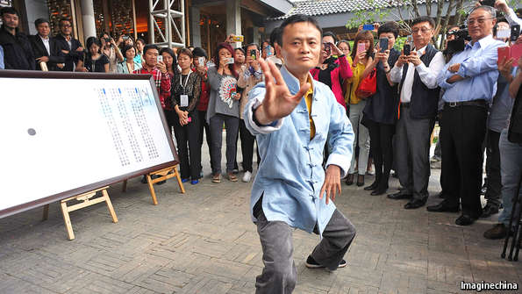Ma shows how

“THERE ARE NO genuinely private companies in China,” declares a veteran adviser to multinational companies. In one sense he is right. The state and the party are omnipresent and their role is enshrined in the law. Moreover, as Kent Kedl of Control Risks, an investigative firm, explains, “you don’t become successful in China as a purely private entity, you need a powerful connection. But this can prove an asset or a liability.” Cronies of Bo Xilai, a once-powerful Communist Party boss who is now in jail, know this only too well.

To find out whether a given local firm is likely to behave like a state champion or a market-minded entity, you need to ask three questions. First, how strategic is its industry? Peter Williamson of Cambridge University’s Judge Business School argues that the government will always meddle with firms in industries it sees as strategic, even if they are multinationals. But the opposite is true, too. State firms that operate in sectors of little concern to the government can behave like private ones. Gree Electric, which makes appliances, is state-owned, but Dong Mingzhu, its fiercely independent boss, has transformed it into a highly competitive firm.

Second, who decides on pay, promotion and hiring? For big state-owned enterprises like Sinopec, an oil giant, the party’s organisation department deals with senior executives. Jack Ma, Alibaba’s boss, thinks that if the board and top executives are selected by shareholders, the firm is private.

Looks can deceive. The Chinese Academy of Sciences still controls about a third of Legend Holdings, a giant conglomerate founded by Liu Chuanzhi, which seems to make it a SOE. But thanks to shareholding reforms introduced by Mr Liu, its management is independent. Yang Yuanqing, the boss of its offspring, Lenovo, points out that many of his company’s top managers have been foreigners: “If the government controlled our firm, this would never happen.”

The trickiest question concerns the firm’s relationship with the party. Some business leaders proudly don the red hat. Wang Jianlin, the billionaire boss of Dalian Wanda, a vast private-sector conglomerate, was born an elite “princeling” and cunningly cultivates connections. Many of his group’s divisions, ranging from films to theme parks, fit with the leadership’s desire to promote soft power. This “is very beneficial”, he beams, as his firm gets “more financial support and especially policy support”.

But just because an entrepreneur has good *guanxi* (connections) does not mean the party controls his firm. SOEs enjoy huge advantages, which forces private firms to get close to the party if they want to succeed, argues Scott Kennedy in a report by Gavekal Dragonomics. “China’s entrepreneurs are more pink than red,” he says.

If employees are party members, where do their loyalties lie? Mr Kedl found that the party units within companies are usually pretty benign. Mr Ma of Alibaba, who is not a Communist, notes that party members are among his top employees. Mr Liu says the same about Legend. Then the man who has done most to modernise business in China drops a bombshell: he reveals that he is the head of his firm’s party cell.

## Private firms

### Paper tiger, roaring dragon

# It is the private sector, not state capitalism, that is responsible for modern China’s economic rise

Sep 12th 2015 | [From the print edition](http://www.economist.com/printedition/2015-09-12)

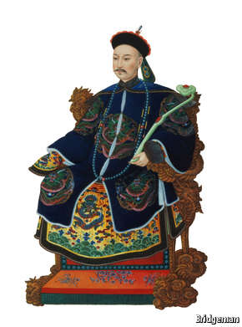

IN 1984, ELEVEN researchers from the Chinese Academy of Sciences (CAS) gathered in a cramped guardhouse in the elite institution’s grounds. Liu Chuanzhi, their leader, had managed to find about $25,000 to start a technology company. They had little knowledge of business, but Mr Liu was determined to revive entrepreneurship in his country.

The company he founded, Legend, is now a leading force in Chinese capitalism. In June its initial public offering valued it at $13 billion. Its most successful offshoot is Lenovo, the world’s biggest computer-maker, in which it holds a one-third stake.

Inspired by his father, a leading patent lawyer, Mr Liu has devoted his professional life to bringing modern business practices (including respect for intellectual property) to his country. He pushed Legend, and later Lenovo, to become more market-oriented, and insisted on professional managers, long-term strategy and teamwork.

China has millions of successful private-sector businesses. Its internet companies are among the world’s biggest. The fortunes of its 200-plus billionaires were earned in a range of industries (see charts). And yet the private sector is often given insufficient credit for China’s economic rise.

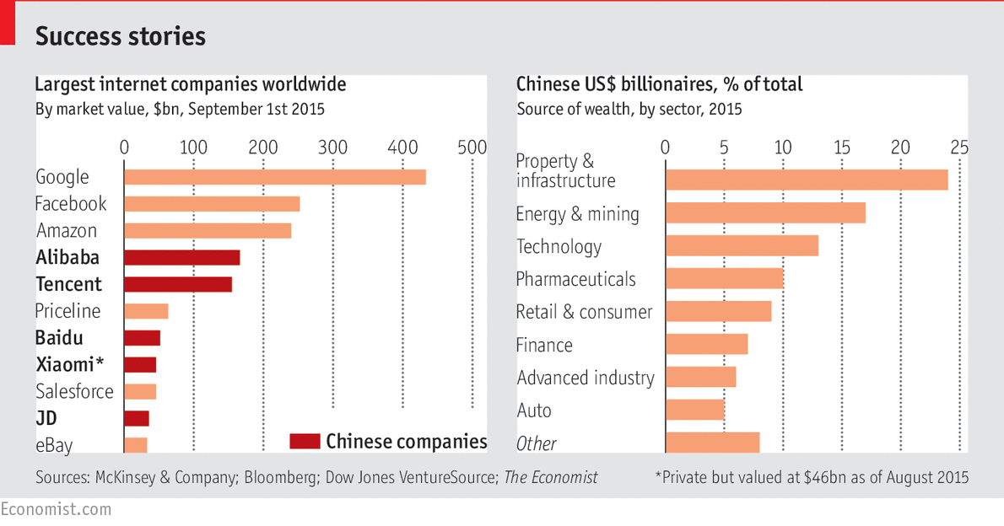

That may be because central planning has created an outsized state sector. Assets of SOEs are nearly twice the size of GDP, high by international standards. Most of the 100 or so Chinese firms on the Fortune 500 list of biggest companies are SOEs. But these lumbering giants are not the drivers of China’s economy; they are millstones around its neck.

The real engine of China’s growth has been the private sector. In his book “Markets Over Mao”, Nicholas Lardy of the Peterson Institute for International Economics makes the bold claim that China has transformed itself from a “state-dominated economy into a predominantly market economy”, and points to the private sector as the main engine of this transformation.

As noted earlier in this report, it can be hard to determine whether a company is private or not, given the strong role of the state and the Communist Party. Mr Lardy, who has written extensively on the subject, defines the private sector to include all self-employment, all registered private firms and all companies in which the sole or dominant shareholder is private. On this reasonable definition, private firms now contribute about two-thirds of GDP.

Average growth in output for industrial private firms since 2008 has been 18%, twice as much as for industrial SOEs. After several decades when state-controlled banks showered favoured SOEs with subsidised loans, official credit is now flowing to private entrepreneurs too. In 2009 the private sector received only about a quarter of all new loans, but between 2010 and 2013 it got over half.

The return on assets for private-sector industrial firms is well above that for industrial SOEs, and the gap is widening. The average state firm makes insufficient returns to cover the cost of its capital, despite some highly profitable outliers such as the tobacco monopoly and the energy and telecoms oligopolies. In effect, many state firms are deathless zombies.

The bureaucrats’ most important achievement in recent times has been to stop killing free enterprise

By contrast, the private sector is full of young dragons exposed to the Schumpeterian forces of creative destruction. More than half of all private firms that were on the register in 2012 had been set up in the previous five years. Some 96% of the 60m-odd companies registered in China are private.

The private sector’s success caught the Communist Party by surprise. In their book “Capitalism From Below”, Victor Nee and Sonja Opper point out that party bosses had not expected so many startups to grow so quickly, so the legal structures did not keep up. Many private firms registered as collective enterprises to make life easier for themselves. Limited liability for big private companies was not brought in until 1994, and extended to small firms only in 2006. Private firms have endured unfair competition from subsidised state rivals, extortion by local party bosses and in some cases outright seizure of their assets.

Local entrepreneurs are hassled even more than are foreign firms. The World Bank’s “Doing Business” report for 2015 ranks China an unimpressive 90th out of 189 economies assessed. Starting a firm in Beijing takes an average of 11 procedures and 33 days, compared with an OECD average of only five procedures and nine days, though an effort to cut red tape in China seems to have improved matters of late. Du Jun of Birmingham’s Aston University and Liu Xiaoxuan of the Chinese Academy of Social Sciences noted in a recent paper that foreign investors are allowed to invest in 62 out of 80-odd officially designated sectors, but that private Chinese firms may do so in only 42.

The real heroes

The official histories sing the praises of visionary reformers for embracing capitalism with Chinese characteristics. In fact, most officials did little to help private firms. As Harvard’s William Kirby and his colleagues say, “the real story of the China miracle is about how the Chinese people opened their own doors and found other means to economic prosperity by working around the barriers posed by the party.”

To be fair, the Chinese state has supported economic development by building lots of good roads, bridges and railways. It also deserves credit for forging a national market, needed for regional competition to take off. Deng’s initial reforms in the late 1970s encouraged lots of private enterprise in the countryside. Research by Yasheng Huang at MIT shows that this also created a lot of new jobs, wealth and demand for goods and services that attracted millions of rural entrepreneurs. And in the late 1990s Zhu Rongji, a former prime minister, cut back the number of SOEs and persuaded the old guard to accept China’s accession to the World Trade Organisation in 2001.

The bureaucrats’ most important achievement in recent times has been to stop doing things that killed free enterprise. That vital task is not finished, however. The vast majority of prices are set by supply and demand, but the government still meddles in many things, from the cost of capital to the price of electricity and water. As Arthur Kroeber of Gavekal Dragonomics puts it, “just walk onto the street and it’s clearly a market economy. Yet in the background state interference is pervasive.”

## Entrepreneurship and technology

### It’s all go

# Technology is offering Chinese business a cornucopia of new opportunities

Sep 12th 2015 | [From the print edition](http://www.economist.com/printedition/2015-09-12)

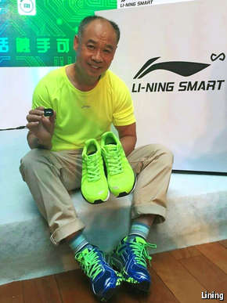Brainy trainers

ZHEJIANG IS THE most entrepreneurial place in China. Fan Li, celebrated as the ancestor of all Chinese merchants, worked there some 2,500 years ago. Li Linde, commemorated as China’s first international businessman for trading with Japan in the 9th century, also hailed from this province. In modern times, too, it has produced private-sector titans. Li Shufu, the boss of Geely, a carmaker, acquired Sweden’s Volvo. Lu Guanqiu, Wanxiang’s chairman, controls the world’s top independent car-parts firm. Zong Qinghou, founder of Wahaha, went from street hawker to drinks magnate. Guo Guangchang of Fosun, a Shanghai-based conglomerate, was born in Zhejiang, and the family of Ren Zhengfei, the founder of Huawei, came from there.

Since the province lacks natural resources and good farmland, locals have always had to use their ingenuity to scratch a living. Its rugged mountains make it hard to control. Its proximity to Taiwan worried the party, ruling it out as a location for many state-run industries. That turned out to be a blessing: in the absence of state capitalism, entrepreneurship flourished.

The Zhejiang Merchants Museum displays portraits of dozens of local business heroes on its walls. In the centre hangs a large picture of Jack Ma, who was born and brought up in the province and still lives there. His company, Alibaba, an online-commerce giant, is based in Hangzhou, Zhejiang’s capital. “The others have complicated feelings toward him,” says Yang Yiqing, the museum’s curator. They admire him, but “he has upset their businesses in retail, financial services and other areas.”

The 102-year war

Mr Ma is just getting started. He is not satisfied with building an e-commerce company whose platforms sell more than do eBay and Amazon combined, and pulling off one of the biggest-ever public flotations, in New York last year. When its share price plunged during the recent financial turmoil, Daniel Zhang, Alibaba’s chief executive, reminded employees of Mr Ma’s vision: “We are in it for 102 years to win the war.”

Alibaba wants to transform large parts of China’s economy through internet finance and cloud computing. Ant Financial, a firm controlled by Mr Ma, contains Alibaba’s huge microlending portfolio as well as Alipay, a pioneering payment system. And Alibaba has been investing heavily in cloud computing for years, building all its systems in-house. Aliyun is China’s biggest cloud provider and will spend a billion dollars to go global.

Entrepreneurs were once seen as oddballs, and failure was considered shameful. Neil Shen of Sequoia Capital, an American venture-capital fund, thinks China has reached a cultural inflection point. Li Keqiang, the prime minister, has been trying to encourage people to take risks and start companies.

Locals used to worship American firms and tried to copy them. Sceptics derided their efforts as “copy to China” (C2C) and Just Good Enough (JGE). Kai-fu Lee of Innovation Works, a technology incubator in Zhongguancun, Beijing’s answer to Silicon Valley, retorts that Western firms copy too. He insists that local Chinese firms are as good as Apple at integrating technologies and finding market opportunities.

Xiang Bing, dean of the Cheung Kong Graduate School of Business, goes further. During the time when China’s backward economy was rushing to catch up with the West, it made sense to copy, he points out: “Many firms tried to innovate and failed, whereas those who copied became billionaires.” But now, he says, local firms need to innovate in sophisticated industries like cars to compete in global markets.

Chinese consumers’ rising expectations and intensifying competition in consumer-facing industries are already pushing firms towards more innovation. One example is WeChat, a popular social-media and payments platform run by Tencent. “Chinese consumers are now so demanding and globally minded that you can’t get away with JGE…you need to be world-class to serve China,” says Gary Rieschel of Qiming Ventures, a venture-capital firm.

Money is flooding into startups, and there is talk of a tech bubble. Venture-capital investment in China reached a record $15.5 billion in 2014, more than triple the previous year’s level. China has more than a dozen “unicorns” with a valuation of over a billion dollars. Apus, which makes an app organiser for Android smartphones, is worth $1 billion. Didi Kuaidi, a rival to Uber, a taxi app, is valued at $15 billion. Valuations have been bid up by competition among Baidu, Alibaba and Tencent (known collectively as BAT). These internet giants have spent billions on swallowing startups in areas from video streaming to online travel to big data.

Mr Lee predicts that eventually there will be more billion-dollar startups in China than in America, though Silicon Valley will have more firms of higher value. It is easier in China than elsewhere to achieve scale quickly because the local market is both enormous and fairly homogeneous—and Western rivals are deterred by both the unfamiliarity of Chinese culture and by censorship. Chinese consumers can use Google, Facebook and Twitter only with cumbersome (and illegal) software to get round the Great Firewall.

The biggest opportunities are provided by the Chinese economy’s egregious inefficiency, a legacy of decades of state capitalism. “China has more old-economy, non-transparent and unreasonably profitable firms than does America…the streets are just paved with gold for disrupters,” says Mr Lee.

Do you want Mi?

Lei Jun puts it more colourfully: “Even a pig can fly if it is in the middle of a whirlwind.” Mr Lei’s first notable achievement was to lead Kingsoft, a software developer, into a public flotation. He also co-founded YY, a hybrid of a social network and online video platform, and Joyo, an e-commerce firm that he sold to Amazon. His latest brainchild is Xiaomi, a smartphone company that has shot to global prominence in five years. It has become one of the top-selling brands in China and is now pushing into Indonesia, India and Brazil. Last year it sold over 60m handsets worldwide, behind only Samsung and Apple, and earned revenues of $12 billion. At $46 billion, it is valued more highly than Airbnb or Snapchat.

Xiaomi is hardly a flying pig. It borrows ideas, but then improves them in many ways. The company sells lots of phones, but hardware is not its main business. “We are first and foremost an internet company,” explains Hugo Barra, a top Google executive whom Xiaomi poached to run its international operations.

Xiaomi launched intelligent trainers that log the user’s movements with a motion sensor

The firm sells its high-quality handsets at just above cost and makes money from selling additional services. Its marketing is done almost entirely through social media, which keeps its advertising costs low. It releases only a few new models every year, so each remains profitable for longer. It has nurtured dozens of startups to make smart appliances, ranging from air and water purifiers to home-security cameras that connect with its phones. In July, together with Li Ning, a local sportswear firm, it launched intelligent trainers that log the user’s movements with a motion sensor, selling for a mere $32.

The firm’s use of open innovation is also distinctive. Unlike Apple’s dictatorial operating system, Xiaomi’s user interface, MIUI, is highly interactive. The firm taps into the experience of its millions of registered fans, many of whom regularly submit ideas for improvement, and updates the operating system weekly, which makes it more robust and keeps its fans loyal.

India’s consumers have already embraced MIUI to solve local problems. If you ring an office or a bank there, you are likely to encounter annoying “interactive voice recognition” (IVR) systems. Xiaomi’s unpaid fans are painstakingly mapping all the options (“for billing, press 3”) on those IVRs and uploading the results onto the fan site. Xiaomi then adds the results to its next update, so if you dial one of those IVR systems from a Xiaomi phone, you can use MIUI’s visual cues to navigate it in seconds rather than waste many minutes.

Like Xiaomi, many other startups are looking beyond China. An example is OnePlus, a private smartphone-maker based in Shenzhen, a remarkably open city near Hong Kong that is the world’s best place to start a hardware firm. The company’s headquarters feature psychedelic murals, table football, musical instruments and a dog named Una. Employees walk around in shorts and beach sandals. The firm makes high-quality smartphones that Western reviewers rave about, selling at prices below Apple’s and Samsung’s. It has over 100 patents pending.

The headquarters of Da-Jiang Innovations (DJI), a short ride from the OnePlus office, is more minimalist. The lines are sleek, the gadgets are high-tech and everything is ethereally white. An enormous screen displays futuristic videos filmed by drones in exotic locations. Commercial drones are the firm’s business. Its founder, Frank Wang, says the flight-control, stabilisation and wireless-video technologies needed to make inexpensive drones did not exist, “so we spent three years building our own.” His company has filed for many patents to protect its spectacular flying robots, which sell for about $1,000 each. DJI now commands over half of the global market and is valued at $10 billion.

Mr Wang is already planning future conquests. “We invented a whole new category of product…we are not limited to drones,” he says. He expects many firms like his to emerge soon, as “now more and more Chinese have room to dream bigger.”

#### Special report: [Business in China](http://www.economist.com/specialreports?year%5Bvalue%5D%5Byear%5D=2015&category=76984)

## Innovation

### Fast and furious

# Chinese private firms are embracing innovation

Sep 12th 2015 | [From the print edition](http://www.economist.com/printedition/2015-09-12)

* [imekeeper](http://www.economist.com/news/special-report/21663325-chinese-private-firms-are-embracing-innovation-fast-and-furious)

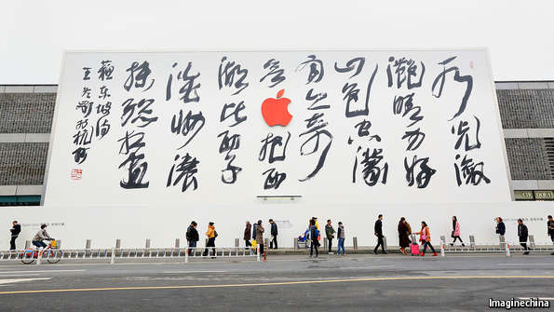How long to wait for a Chinese Apple?

“CHINA MUST RELY on innovation to achieve continuous and healthy economic development.” To anyone outside China, that seems to be stating the obvious. What makes it striking is who said it: none other than President Xi Jinping, speaking last December.

China has long pursued an industrial policy of “indigenous innovation”, obliging multinational companies to transfer technology and propping up SOEs in strategic sectors. That has not worked, so now the country is pouring money into a renewed push from the top down. It is spending more than $200 billion a year on R&D, up fourfold in a decade. As a proportion of GDP the figure, at 2%, now slightly exceeds that for the EU.

Thomson Reuters, a research firm, claims that China is an “undisputed patent leader”. Central planners now want to triple the number of patents by 2020, to 14 per 10,000 people. They aim to increase R&D spending further and eventually match America’s current level of 2.8% of GDP, in the hope that all this will make China an innovation superpower. Already a fifth of the world’s technical graduates are Chinese.

The government could help boost innovation, for example by ensuring a sound legal framework and functioning financial markets, but so far it has failed to do so. Instead, it is overreacting in unhelpful ways. That is partly because it is confusing innovation with invention, which involves lots of research spending, patents and engineers. Innovation may or may not involve those things, but is essential to an economy’s wellbeing. Simply put, it is fresh thinking that creates value in the market. It may not require new technologies but simply the adaptation of products and business models from one industry or market to another.

Research spending, subsidies for high tech and PhDs are inputs. Spending more is no guarantee of better outputs, whether in the form of high-quality patents or rising sales. China’s official R&D funds often go to the well-connected rather than the deserving. The number of patents filed has soared thanks to government incentives, but many are worthless. After adjusting for quality, using a range of criteria, China still lags (see charts).

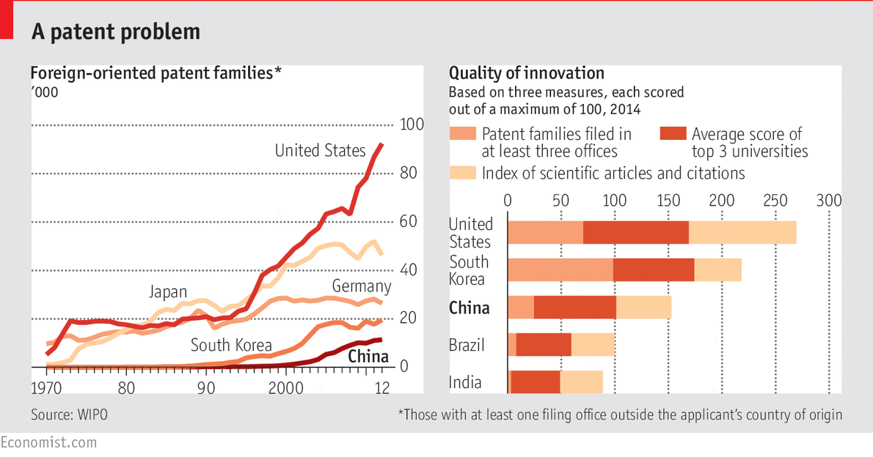

Gordon Orr, a former head of McKinsey’s Asia operations, thinks that SOE bosses find it easier to woo regulators to support existing products than to come up with new ones. New businesses are typically required to make money in the first year, which inhibits risk-taking. Guan Jiancheng of the University of Chinese Academy of Sciences and Richard Yam of the City University of Hong Kong quizzed over 2,000 manufacturing and technology firms in Beijing to see whether state aid in the 1990s led to more patents or higher sales and profits. They found that state money funnelled to SOEs was not only ineffective but “even occasionally had a negative impact on innovation”.

The World Bank reviewed various studies and concluded that the innovation effort at SOEs “tends to be unproductive and poorly integrated with the rest of their operations”. One reason is that big state firms are less efficient than smaller private firms at converting resources into innovations and patents. Total factor productivity has been growing three times as fast at private firms as at SOEs.

If China is becoming a lot more innovative, the private sector can take much of the credit. A recent report by the McKinsey Global Institute, the consultancy’s research arm, shows that Chinese firms are good at innovating in a number of industries. The authors avoid the trap of just counting patents and PhDs, relying instead on “the ability of companies to expand revenue and raise profits” as the proof of successful innovation. Having examined financial data for 20,000 publicly held firms in China and abroad, they conclude that Chinese firms sparkle in consumer-facing industries, such as e-commerce, and in efficiency-driven ones, such as manufacturing, but that they lag in industries that rely on the latest science and technology.

There are notable exceptions. Huawei, for instance, has emerged as a world-class telecoms-equipment firm. It spends some $5 billion a year on R&D and has research centres close to technology hotspots. It is one of the world’s biggest generators of high-quality patents. Along with Sweden’s Ericsson, it is now at the forefront of research on 5G technology for the next generation of mobile phones.

BGI, a privately run research outfit, is one of the world’s most highly regarded genomics institutes. It started life in 1999 when a handful of researchers left the Chinese Academy of Sciences to found a new genomics institute. They ended up in Shenzhen, where local officials, unusually for China, support businesses without trying to control them. BGI has hundreds of PhDs on its staff and owns half the world’s genome-sequencing capacity. It has won accolades for sequencing the SARS virus and decoding the genomes of birds and of the friendly microbes that live in the human gut. It advises most of the world’s large pharmaceutical companies on drug discovery and development.

Just think what else they could do

Chinese organic chemists are among the world’s best, and China’s Tianhe-2 supercomputer is the world’s fastest. China’s National Institute of Biological Sciences found the elusive hepatitis B virus receptor. Venus Medtech, which makes aortic heart valves, and Nurotron, which makes cochlear implants, are cutting-edge startups. Chipscreen Biosciences won Chinese approval for a breakthrough cancer therapy this year. Lu Xianping, its co-founder, thinks it will be the first drug developed entirely in China to go global.

Peter Williamson of the Judge Business School in Cambridge argues that Chinese firms are good at adapting new ideas and technologies to the mass market quickly. For example, WuXi AppTec is applying mass-production techniques to drug research by breaking it down into many steps and throwing lots of researchers at each of them. BeiGene has a drug-testing model based on a vast bank of human cancer samples rather than human subjects; the resulting speed and accuracy helped it get four cancer drugs to clinical trials within two years.

“I look for hot-blooded passion in my engineers,” says Saad Metz, a suave former motocross rider who is the head of R&D at Audi China. The company has built a smart new research centre in 798, a funky arts district in Beijing. From inside the loft-like space you see an elevated track evocative of Manhattan’s High Line park. “We want our thinkers to be more innovative, and being in this neighbourhood inspires them,” says Mr Metz.

The combination of local scientific talent and market size now justifies a strong R&D presence in China

The big investments that multinational companies such as Audi are making in research on the mainland are perhaps the most compelling evidence that China is becoming a global hotspot for innovation. In the past, foreign firms have been wary of bringing their crown jewels into the country because of the relaxed attitude towards intellectual-property (IP) protection. Many firms built fancy-looking R&D centres in Beijing or Shanghai but did little real research there. That is changing. IP protection is getting stronger, and as Mr Metz argues, the combination of local scientific talent and market size now justifies a weighty R&D presence in China.

Ideas factory

George Yip of the China Europe International Business School (CEIBS) points to GE’s development of ultrasound technology in China, which has gone global. Chen Xiangli, head of GE’s China Technology Centre in Shanghai, lists many examples of world-leading research done there. One team has developed membrane systems that help dirty industries such as coal meet requirements for zero liquid discharge. Another team is pioneering the development of superconducting magnets with a significant reduction in the use of liquid helium.

Mr Yip and colleagues have recently published a study of research done by foreign firms in China in strategy+business, a magazine published by PwC Strategy&, a consulting firm. They found that 28% of these firms now work on cutting-edge R&D. In addition to GE, firms ranging from Microsoft to ABB have top researchers in China pursuing advanced projects for the global market. Novartis has committed $1 billion to its R&D centre in China, which has already come up with a novel treatment that promises to tackle liver cirrhosis.

If China is so innovative, sceptics often ask, why has it not produced a world-class car yet? A successful car industry requires decades of engineering experience and complex global supplier networks. Foreign car firms that set up in China were forced into joint ventures with SOEs, so the local firms involved have had access to global technology for 20 years. But when they try to make cars under their own brands, they still produce clunkers. China needs time to catch up, just as Japan and South Korea did, argues Neil Shen of Sequoia Capital.

Perhaps, but there may be another explanation. One of the most senior foreign businessmen in China exclaims that SOEs “have the smartest people in science and technology but cannot get a branded product out the door that people outside China want to buy”. There is too much control from the top, he says, and not enough faith in markets and competition.

In Japan and South Korea, it was private firms such as Honda and Hyundai that developed cars. By competing in the global market, they learned to innovate. In China, the state has decreed and protected national champions. Shanghai Automotive has joint ventures with both Volkswagen and General Motors. The resulting easy money and access to global designs has given it little incentive to innovate, says a manager at the firm.

But some privately run car companies are getting better. A few years ago, when your correspondent went to Shenzhen to visit BYD, a maker of electric cars, its engineers boasted that apart from the glass and the tyres, they made every single part themselves. It showed: the vehicles were awful. But recently, with advice from Mercedes-Benz and parts from outside suppliers, its quality, safety and styling have improved dramatically.

Chinese firms might even leapfrog current technology and make the internet-connected electric vehicles of the future. Not only car firms, but China’s internet giants and manufacturers like Foxconn are investing huge sums in this idea. Day Chia-Peng, a technology expert at Foxconn, thinks there are four reasons why Chinese firms could lead the world. First, thanks to its expertise in making electric motors and electronics, the country has top-notch suppliers. Second, electric vehicles lend themselves to being made by a number of smaller firms, so today’s car giants may lose their grip. Third, e-commerce, another area in which China excels, is changing the way people buy cars. And fourth, the involvement of China’s “BAT” (Baidu, Alibaba and Tencent) internet trio and Xiaomi may give it an edge in developing such cars.

On the minus side, the absence of academic freedom is an important brake on Chinese innovation. China’s universities, just like its SOEs, are run by party committees. This politicisation limits the flow of ideas. So, too, does the Great Firewall, which chokes access to global websites and popular collaborative tools like Google Docs.

Chinese firms have come a long way. What holds back the country’s innovators today is not lack of resources. It is certainly not lack of resourcefulness. The greatest obstacle is the oppressive hand of the state.

## Consumers

### The wild, wild east

# A booming middle class is creating the world’s most dynamic consumer market

Sep 12th 2015 | [From the print edition](http://www.economist.com/printedition/2015-09-12)

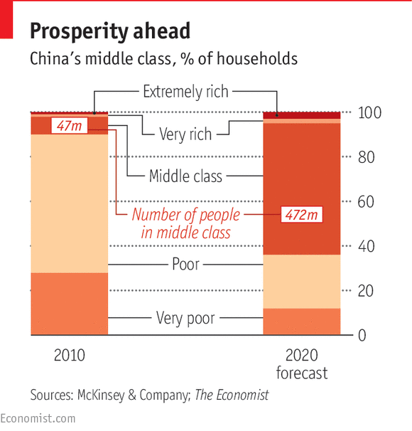

MORE THAN FIVE centuries ago Christopher Columbus scrawled in his copy of Marco Polo’s “Travels” that the Middle Kingdom would bring mercacciones innumeras (an immeasurable amount of commerce). Columbus never reached that promised land. China has continued to disappoint foreign businessmen ever since, not least because many ordinary Chinese people have been too poor to buy anything.

That is changing as the country’s middle class is growing explosively (see chart). In 2010 mainstream consumers—those with enough money to buy cars, fridges and phones but not Rolls-Royces—made up less than a tenth of urban households. In a new forecast, McKinsey predicts that by 2020 they will make up well over half. BCG reckons that urban private consumption will rise from $3.2 trillion today to $5.6 trillion in 2020.

Apple expects China soon to become a bigger market for its products than America. In the quarter ending in June, its sales in greater China were 112% up on the same period a year earlier. Six of its ten busiest stores across the globe are in China. At the height of the recent turmoil in the Chinese stockmarkets Apple’s boss, Tim Cook, reassured investors that “I continue to believe China represents an unprecedented opportunity over the long term.” Apple’s shares bounced back.

Where should intrepid marketers go to capitalise on these riches? The wealthy east coast is now widely believed to be saturated, which suggests that firms should head inland. The Economist Intelligence Unit (EIU), a sister firm of this newspaper, recently pinpointed the top emerging cities, based on forecasts for things like long-term growth in population and disposable income (see map). It found that a few inland cities like Chongqing and Chengdu are indeed attractive, but many excellent prospects remain in the east. Obscure but booming cities within reasonable distance of the coast, like Suqian and Xuzhou, are likely to do well, and lucrative niches remain even in well-established magnets such as Beijing, Shanghai, Guangzhou and Shenzhen.

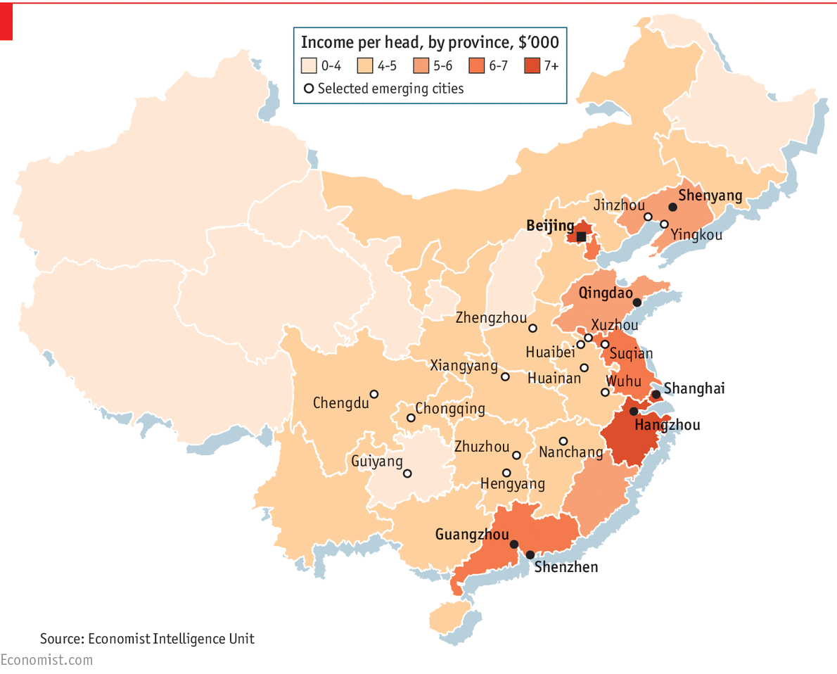

As the middle class expands, so it evolves. Some may grow tired of blingy offerings, but millions of others will try their first Western brand this year. “Every three years a new generation is created here,” explains Charles Hayes of Ideo, a consultancy. Even within cities, consumer groups are highly segmented. Donald Blair of Nike, an American sportswear giant, says his firm maps consumer behaviour here “by shopping district and even by street”, so it can customise offerings and outlets.

A big winner has been China’s e-commerce, a market that is now larger than America’s. Forrester, another consulting firm, expects gross merchandise value in this sector to exceed $1 trillion by 2019. Outside the big cities bricks-and-mortar stores are thinner on the ground, so online shopping is becoming increasingly important. Even where shops are readily accessible, consumers often go “showrooming”, looking at goods in physical outlets but buying them more cheaply online. This is happening the world over, but in China the trend has been accentuated by the ubiquity of smartphones, the reliability of online-payment systems and the spread of same-day delivery services.

How would you like your shirt?

This poses a grave threat to old-fashioned retailers. Li & Fung, a supply-chain firm based in Hong Kong, pioneered global outsourcing two decades ago. Fung Retailing Limited, a related firm, has over 3,000 outlets, a third of them in China. Victor Fung, its honorary chairman, sees the era of mass production giving way to one of mass customisation. Markets are fragmenting and smartphones are empowering consumers to get “directly involved in what they buy, where it is made and how they buy it”. Zhao Xiande of CEIBS in Shanghai points to Red Collar, a firm that used simply to make and export garments. Now it lets customers the world over design their own shirts online and makes them to order. Another outfit, Home Koo, offers custom-built furniture online.

All this e-commerce is producing some remarkable business-model innovations. Thanks to the convergence of mobile commerce and social media, observes Miles Young, chairman of Ogilvy & Mather, an advertising firm, China is the world’s epicentre of “social commerce”. Studies by BCG show that Chinese consumers are much more likely than American or European ones to interact with brands through social media.

To try to keep up with all these changes, Mr Fung has kitted out a shopping mall in Shanghai with technologies from IBM that allow detailed tracking of shoppers on site and online. Known as the “Explorium”, it allows retailers to experiment with various multi-channel business models and promotions. Digital disruption challenges retailers everywhere, he says, but in his view China is the most promising place to look for answers.

Chinese consumers are fast becoming the world’s most discriminating and knowledgeable. They are also quite brand licentious. The choice of top global brands there is much wider than in America, Europe or Japan. This has resulted in fierce competition, pushing firms to come up with ever more inventive offerings. Audi developed longer saloon cars to cater to wealthy Chinese with chauffeurs, which are now sold globally. Chinese consumers prefer pulpy juices, so Coca-Cola modified its juice formulations; Minute Maid Pulpy is now a billion-dollar global brand. Even Apple’s Mr Cook says his company takes Chinese tastes into account when it designs new products for the world.

Mr Young believes that China is leading the world in bringing together the “internet of things” (which connects machines to each other) with the internet used by people. Firms such as Suning, an electronics retailer, Haier and Xiaomi are all connecting smart gadgets with consumers through WeChat and other social media. This seems to be happening more quickly in China than in the West.

Are you being served?

Much of this new economy is moving on from supplying goods to providing services. In most rich countries services make up at least three-quarters of GDP, but in China they account for only half. The rising middle class is demanding better services in everything from health care to finance to entertainment. Both foreign and local investors are rushing in to fill the gap.

Two decades ago films made by Walt Disney, an American entertainment giant, were banned on the Chinese mainland, but now China is Disney’s most promising market. The company’s latest “Avengers” film earned over $200m in local theatres in its first two weeks. In May Disney opened its largest-ever retail store in Shanghai. And next year Shanghai Disney, a $5.5 billion theme park, will be ready to receive the crowds. Dalian Wanda, which made its fortune in property, is building a massive $8 billion film studio in Qingdao and will be spending over $30 billion on theme parks across China, confronting Disney head on.

Kai-fu Lee of Innovation Works believes that service startups are capable of creating billion-dollar industries. He points to Helijia, a firm valued at $300m that provides pedicures in people’s homes. “They can train workers affordably; Chinese love getting pampered; and our urban density allows this…you can’t do this in Kansas.” His firm is funding firms delivering services ranging from haircuts to car maintenance.

Jean Liu, president of Didi Kuaidi, thinks the sharing economy will allow scarce resources to be used more efficiently. Her ride-sharing firm counts both Tencent and Alibaba as investors. It offers everything from fancy cars and taxis to shuttle buses and car pools—or even someone on a bicycle to drive you home in your own car. It clocks up 6m rides a day, far outpacing Uber.

Neusoft, based in Shenyang, a city in China’s gritty industrial north-east, was started in 1991 with just $3,000 by Liu Jiren, an erstwhile academic. It is now one of China’s biggest IT-services providers. Having created a computer operating system that quickly got ripped off, his firm nearly went under. That taught him the value of protecting intellectual property. When he was a visiting scholar at an American government laboratory, he noticed that academics worked closely with corporate researchers. That inspired him to invest heavily in R&D. Among many other things, Neusoft makes systems that allow medical records to be viewed on mobiles. It is also developing a shared-services business model for medical equipment that will allow users to pay by transaction.

What helped Neusoft take off, says Mr Liu, was that there were no SOEs to block new software firms. “The Chinese state today is technologically sophisticated…but that was not the case at the start of the IT boom,” says Mr Liu. “We got lucky because the IT sector was so new, so driven by talent, that the government didn’t understand how it worked.”

## Manufacturing

### Still made in China

# Chinese manufacturing remains second to none

Sep 12th 2015 | [From the print edition](http://www.economist.com/printedition/2015-09-12)

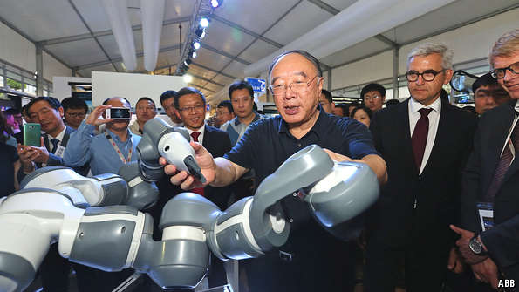

AMID ALL THE excitement about high tech and the push into services, it is easy to forget that China’s modern economy was built on the strength of a solid and often low-tech manufacturing sector. Now manufacturing is widely thought to be in trouble. Factories are squeezed, labour costs are rising and jobs are being reshored to America. Competitors such as Germany are said to be leaving China behind by using robotics.

Chinese officials have responded in the only way they know. In May the State Council, China’s ruling body, approved “Made in China 2025”, a costly scheme that will use mandates, subsidies and other methods to persuade manufacturers to upgrade their factories. The plan is for China to become a green and innovative “world manufacturing power” by 2025.

China is already the world’s largest manufacturer, accounting for nearly a quarter of global value added in this sector. Research by Morris Cohen of the Wharton Business School finds that the country leads in many industries and that “reshoring to the developed economies is not happening on a large scale.” Even though some production is moving to countries nearer its consumers, China remains at the heart of a network known as Factory Asia. It has an excellent infrastructure and an enormous, hard-working and skilled workforce. Though wages are rising, its labour productivity is far higher than that of India, Vietnam and other rivals, and is forecast to keep growing at 6-7% a year to 2025.

Manufacturing is almost entirely controlled by private firms, both Chinese and foreign, which unlike SOEs will not be pushed by bureaucrats into making unprofitable investments. Marjorie Yang, Esquel’s boss, says that subsidies may feel good but distort investment decisions: “The government loves to fund flashy hardware and robotics, but there’s no money for the software and data analytics needed to make proper use of it.” And in any case most of these private firms are already innovating at a cracking pace without prompting from government.

Manufacturing is almost entirely controlled by private firms, both Chinese and foreign

Michael McNamara, the boss of Flex, a big American contract manufacturer, says product cycles have become much faster. Factories in China used to serve export markets, but are now reorganising to concentrate on the booming local market. They are sensibly investing in automation, worker training and new methods. In the process, he says, China is “moving from work engine of the world to genuine innovator”.

Liam Casey, an Irish entrepreneur who has worked in Chinese manufacturing for two decades, believes that “a huge amount of innovation” is happening around manufacturing supply chains. PCH, his firm in Shenzhen, is a supply-chain manager that now helps foreign manufacturers with design and mass customisation. A private firm with revenues of over $1 billion last year, it moves up to 10m components a day and ships merchandise worth $10 billion a year.

Kirk Yang of Barclays, a bank, believes the manufacturing sector is moving from “Made in China” to “Made by China”. In the 1980s and 1990s most factories were owned by firms from Taiwan (like Foxconn) or the West (like Flex). Increasingly, he predicts, the sector will be run by Chinese firms. Taiwan used to dominate the market for upmarket electronics components, but he thinks many Chinese parts-suppliers—like BYDE, an arm of the electric-car firm BYD—are now excellent.

China is the world’s largest market for industrial automation and robots. Ulrich Spiesshofer, chief executive of ABB, a Swiss engineering giant, reckons that the latest robots “elevate the nature of work” because they improve safety and eliminate the need for heavy lifting. ABB’s local engineers developed China Dragon, a robot made specifically for the computer industry, which sells well globally. In many industries China is still learning from the world, say the engineers, but its electronics manufacturing is so advanced that “the world is learning from China.”

Mr Spiesshofer sees China pushing ahead with robots like YuMi, which was partly developed there. This affordable two-armed creation (pictured above) can be deployed safely next to humans on assembly lines and is able to do fine work like inspecting phones for scratches. At its factory in Shanghai, ABB is scaling up YuMi to mass production this month.

Terry Gou, Foxconn’s boss, claims that within five years the 30% of his labour force doing the most tedious work will be replaced by robots, releasing them to do something more valuable. The highly inventive firm, which holds many American patents, is building all its automation in-house.

Staying ahead of the game allows manufacturers to keep their best clients. Nike, a global sportswear firm, has seen a lot of its suppliers decamp to cheaper Vietnam, but still gets 30% of its components from the mainland. Eric Sprunk, its chief operating officer, looks for suppliers capable of developing novel techniques that can inspire new products.

We have a plan

What about the government’s “Made in China 2025” plan? It might succeed on its more modest goals, says Stephen Dyer of Bain, a consulting firm. Its immediate aims are to improve quality, productivity and digitisation, and to expand the use of numerically controlled machines. All these things, he notes, are already in common use by world-class manufacturers in other countries. A push to invest might well help Chinese laggards catch up.

China’s state planners also want to help companies leapfrog to the forefront of technology. Their plan involves policies to encourage the adoption of robotics, 3D printing and other advanced techniques. But factories will invest in advanced kit only if it makes commercial sense. “You can’t push this onto firms,” says Mr Dyer. “They just won’t do it if it’s irrational.”

A visit to a middling factory in a middling city illustrates the point. The Guangneng Rongneng Automotive Trim Company in Chongqing is not a fancy place. Stock is piled hither and yon. Owned by a privately held firm, the factory makes injection-moulded and welded automotive parts, mostly for Ford. Chen Gang, its director of operations, says wages have gone up so much that he has to pay itinerant workers the same as they can earn in Shenzhen.

He points to a fancy ABB robot on one side of an aisle that makes complex parts to go on instrument panels. Across the aisle sits a Chinese robot made by Kejie, which lacks the range and precision of the foreign model but is one-third the price. And plenty of the work at his firm is, and will remain, done by hand. “China is headed in this direction,” he says, pointing to the robots, but the pace of adoption will vary from factory to factory.

Thanks to Deng’s liberalisation and China’s subsequent accession to the World Trade Organisation, the country’s manufacturers rose to become export powerhouses. Because exporters must compete in the global market, the weak and inefficient—which includes most SOEs—have been driven out.

## Foreign investment

### The new Silk Road

# China’s latest wave of globalisers will enrich their country—and the world

Sep 12th 2015 | [From the print edition](http://www.economist.com/printedition/2015-09-12)

AN ENORMOUS MAP of the historic Silk Road hangs on a wall at Wensli, a leading Chinese silk producer. Nearby exhibits put China’s silkmaking tradition into context. The Chinese first encountered silkworms about 6,000 years ago. Two millennia later they built the first silk machine. When France emerged as Europe’s silk centre in the 16th century, it learned techniques from China, then the world’s most advanced economy.

The Chinese love invoking their country’s rich and glorious past, so they lapped up President Xi Jinping’s “One Belt, One Road” plan, announced in late 2013, which aims to restore the country’s old maritime and overland trade routes. Mr Xi hopes to lift the value of trade with more than 40 countries to $2.5 trillion within a decade, spending nearly $1 trillion of government money. SOEs and state financial institutions are being pushed to invest overseas in such areas as infrastructure and construction. According to the EIU, planners see this as an outlet for the vast overcapacity in industries such as steel and heavy equipment. It seems likely to lead to a massive spending binge, but companies should remain wary. Government support will not necessarily ensure success.

Li Jianhua, Wensli’s chief executive, is quick to praise the president’s initiative. He tweets a silk-themed message on WeChat every day in support of One Belt, One Road. Wensli, a private conglomerate with revenues approaching $1 billion, has long been close to the Communist Party. Shen Aiqin, Wensli’s founder (and Mr Li’s mother-in-law), served as a deputy to the National People’s Congress. But Mr Li is not a party member and insists that “nothing in our operations has to do with the government.” A good relationship with officials helps, he explains, if only so he can refuse when they press him to invest in “strategic” industries: “This happens a lot…but I say no, we are a silk firm.”

Wensli is reviving the Sino-French silk connection, but on its own initiative. Two years ago the company acquired Marc Rozier, an old-established French silk firm. Mr Li says he bought it to find out how the French make the world’s best luxury goods. Wensli’s supply-chain expertise and cash are helping Marc Rozier expand. In turn, the French firm is helping its Chinese owner improve quality and develop a global brand.

Robots and teapots

Many more Chinese firms like Wensli are venturing abroad. Ninebot, a transport-robotics startup backed by Xiaomi and Sequoia Capital, bought Segway of the United States (and its IP) in April. Segway’s products are too pricey and heavy for the mass market; Ninebot has the supply-chain and engineering expertise to change that. Sequoia’s Neil Shen says that “today it’s not just copycats…China will expand, through its own innovations and through acquisitions.”

Chinese firms are also trying to revive old traditions of craftsmanship, which may help them develop authentic brands. Jiang Qiong Er says she founded Shang Xia, with help from Hermès, a French luxury-goods maker, out of a burning desire to prove that it is possible to create a “Chinese brand of excellence”. The firm’s flagship store is on Huai Hai Road, Shanghai’s most elegant shopping promenade. Her luxury boutiques design, make and sell hand-crafted tea sets, jewellery, clothes and furniture from local materials such as bamboo and silk. She has opened a shop in Paris and hopes in time to become a global brand.

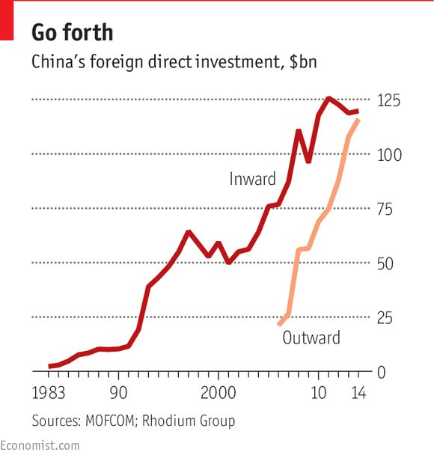

Last year Chinese investment overseas almost caught up with foreign direct investment in China (see chart). According to the China Global Investment Tracker, a research service, Chinese investment abroad in the first half of this year amounted to $56 billion, a rise of 14% on a year earlier. Rhodium Group and the Mercator Institute, two other research firms, reckon that the total stock of Chinese direct investment abroad could rise to $2 trillion by 2020, from less than $800 billion at the end of 2014.

Not everyone will be pleased by that prospect, remembering an earlier wave of Chinese globalisation led by SOEs. They made clumsy forays, and enemies, in such places as Africa and Latin America on a quest for oil, agricultural land and other resources. Many deals were politicised and some were corrupt. The resulting backlash was understandable but overdone. In particular, the decision in 2012 by a committee of America’s Congress to blacklist Huawei and ZTE, another big Chinese telecoms firm, on national-security grounds was shameless techno-nationalism. It has given Chinese officials cover for their own misguided attempts to favour firms like Lenovo and Huawei at the expense of IBM, Cisco and other American technology firms.

Fortunately, future Chinese would-be investors abroad are more likely to be market-minded entrepreneurs than national champions. Chinese firms are getting fed up with paying licensing fees and royalties to foreigners. So instead of renting or stealing intellectual property, says Harvard’s William Kirby, they are looking abroad to acquire top talent and technologies. And despite Huawei’s troubles, their favourite target is America.

Earlier Chinese attempts to capture foreign markets and technologies did not go well. In 2004 Shanghai Automotive acquired 49% of SsangYong, a South Korean carmaker, for $500m, hoping that the acquisition would help it enter the American market, but cultural clashes, union troubles and rising oil prices got in the way. In 2009 SsangYong went bust and Shanghai Automotive had to write it off. TCL, a big electronics firm in Guangdong province, bought majority control of the television arm of France’s Thomson in 2004, giving it the Thomson and RCA brands. But TCL’s inexperience and the technological disruption caused by flat-screen technology scuppered the effort, and the venture was shut down.

These examples highlight some of the problems Chinese firms face when going overseas, and explain why many have failed. Chinese firms have few managers with international experience. Their brands and management processes tend to be poorly developed. They are also reluctant to pay outside experts for advice even when they desperately need it.

But Chinese firms are getting better. A study by Claudio Cozza and colleagues published last year by the Bank of Finland looked at Chinese investments in the EU, which went from almost nothing in 2004 to €14 billion ($18 billion) in 2014. They chose Europe because Chinese firms tend to look for new markets and to acquire brands, technologies and knowledge there. Such outbound Chinese investments in the EU, they found, had “a positive effect on [Chinese] firms’ efficiency and performance” and pushed up their overall sales.

Some Chinese firms are already veterans of globalisation. Huawei’s intrepid staff have long been selling telecoms equipment in remote parts of Africa and Latin America. One executive recalls that in the period following America’s invasion of Iraq the only foreigners granted safe passage by all sides were Huawei’s Chinese engineers, who were repairing vital communications infrastructure. Another example is Lenovo, which unusually for a Chinese firm has many nationalities on its senior management. In 2005 it bought IBM’s personal-computer business, and last year it took over Motorola’s handset business (from Google) and IBM’s low-end server division. Haier has acquired part of Sanyo Electric’s home appliances division and Fisher & Paykal of New Zealand in recent years and is now the world’s biggest white-goods maker.

That is only the beginning. In “China’s Disruptors”, Edward Tse argues that “China’s entrepreneurial companies will become far more active internationally, entering new markets, acquiring companies and hiring executives.” He believes they will pose an enormous threat to established businesses in many industries. And yet global Chinese entrepreneurs could also be good for the world, as Wanxiang’s example shows.

“A country that cannot support entrepreneurship has no hope,” says Lu Guanqiu, the septuagenarian boss of Wanxiang, once a humble township-and-village enterprise in Zhejiang province but now one of the world’s biggest independent car-parts firms. Township-and-village enterprises were left out of state plans and denied access to raw materials and to the official distribution system. In the early hardscrabble days, Mr Lu collected spent artillery shells and made them into ploughs to sell to farmers. These days Wanxiang’s sales top $20 billion a year, of which over $3 billion are made in America, where the firm sells components to the big three carmakers in Detroit. It has also bought two dozen companies in America.

Take a deep breath

A sexy electric roadster is parked outside A123 Systems, a battery firm in Michigan. It is made by Fisker Automotive, a failed American firm acquired by Wanxiang, and it is meant to inspire. Jason Forcier, A123’s boss, says his firm would not be there except for Mr Lu’s dream about solving China’s pollution problem. Wanxiang bought the company at a bankruptcy auction in 2012 for about $250m and imposed strategic focus and cost discipline on the free-spending startup. Mr Forcier expects a profit this year.

Wanxiang has come to America to learn how to make China, and maybe the world, a cleaner place to live in. It has built a solar plant outside Chicago and invested in coal-to-natural-gas technology in Massachusetts. Back in China, it is accumulating the in-house expertise and alliances needed to make affordable electric vehicles for the mass market.

Mr Lu’s quest is not as Quixotic as it seems. China is the world’s best place to scale up clean technologies, wherever they are invented. His effort is just a tiny fraction of the $2.5 trillion that the UN expects to be invested in clean energy in China by 2030. In future, says the green billionaire, Chinese firms “will contribute more merit and value to the world”.

China’s best firms are standing ready to go global. As Thomas Hout and David Michael write in a recent issue of the Harvard Business Review: “If there’s a business equivalent to the Cambrian period of explosion and extinction of species, China from 1991 to the present is it.” Many have failed, but the survivors are straining at the leash.

## Reform

### The good, the bad and the ugly

# The bloated state-owned sector must be reformed so that private firms can compete on equal terms

Sep 12th 2015 | [From the print edition](http://www.economist.com/printedition/2015-09-12)

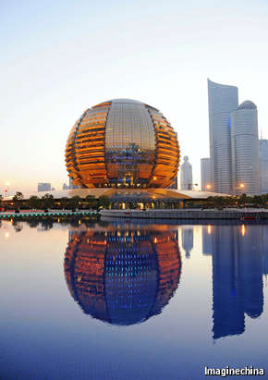The future is private

“THE PURPOSE OF SOE reform is not to get rid of them from the market; on the contrary, we want to make them bigger…we need to maintain the status of state ownership as the dominant power in the Chinese economy.” Fu Chengyu, then the boss of Sinopec, a state-owned oil giant, was speaking exactly a year ago, at the Summer Davos conference, an annual gathering in China of global business executives and Chinese leaders organised by the World Economic Forum (this year’s meeting is taking place this week). His remarks prompted a sharp response from Dong Mingzhu, the chairman of Gree Electric, a state-owned firm and the world’s largest manufacturer of domestic air conditioners. She noted that Sinopec operated in a “monopolistic industry” whereas Gree had to fight for customers as a “private, market-oriented company”. She went on: “What we really need is an environment of free competition instead of support from the government.”

The two bosses’ exchange illustrates official China’s competing visions for SOE reform. The leadership is painfully aware of flagging economic growth and soaring debt and knows it must boost productivity and innovation. That is why it has formally committed itself to giving market forces a “decisive role”. But as Mr Fu’s statement made clear, not all SOE bosses agree on what that means.

Both the number and the output of China’s SOEs is shrinking, but they remain politically powerful. By gobbling up a disproportionate share of resources, especially credit, they crowd out the private sector. They are also responsible for many of China’s economic excesses, ranging from poor investment decisions to too much leverage. The IMF calculates that the SOEs’ average debt-to-equity ratio rose to roughly 1.6 in 2014, from about 1.3 in 2005; the ratio for private firms in 2005 was also around 1.3, but by last year it had fallen below 0.8.

If Chinese leaders want to put the economy on a sounder footing and develop the private sector’s full potential, they must embrace Ms Dong’s version of SOE reform. That will require an effort on three fronts: first, speeding up financial liberalisation so that credit goes to the most dynamic firms, not the best-connected; second, enforcing the rule of law so that all firms, domestic or foreign, are treated equally; and third, encouraging competition across the economy, including in “strategic” sectors.

China’s progress on these three fronts can be summed up as good, bad and ugly. The good news is that China’s reformers have, in fits and starts, begun to ease the state’s iron grip on finance. In the past, ordinary Chinese often got negative returns on their savings so that SOEs could enjoy subsidised capital from state banks. Private companies were largely left out. A World Bank report published in June said that in China “the state has interfered extensively and directly in allocating resources through administrative and price controls, guarantees, credit guidelines, pervasive ownership of financial institutions and regulatory policies. These interventions have no parallel in modern market economies.” The report quickly disappeared from the bank’s website, to be replaced later by a more anodyne version.

Still, things are getting better. The authorities are liberalising interest rates and have introduced a useful deposit-insurance scheme. They have encouraged private firms to experiment with online finance. And in August they heeded the IMF’s advice by moving (bumblingly) towards what looks like a more flexible exchange-rate regime. Much more needs to be done, but the outline of a market-based financial sector is emerging.

Progress on the rule of law has been much more halting. Business in China would clearly benefit from a move to a fair and transparent legal system. Michael Spence, a Nobel prize-winning economist at New York University, points out that such a reform would improve the enforcement of contracts, encourage new entrants and help reduce financial fraud. Last October China’s leadership agreed on the importance of “comprehensively advancing the rule of law”, but many observers are sceptical. The law still bars private Chinese firms from operating in many sectors, and foreign firms have suffered from an uneven and unfair application of the anti-monopolies law, among others.

Competition remains the ugliest aspect of market reform. Extreme competition and none at all exist side by side. Peter Fuhrman of China First Capital, an investment bank, describes competition among private firms as so ruthless that “parts of China may be the most capitalist place on Earth.” At the same time large swathes of the economy controlled by the zombies of the state sector are not subject to any competition at all.

Over 100 big state firms are controlled centrally, and many thousands more are in the hands of provincial and local government. Having observed the looting of Russia’s assets by oligarchs, China’s leaders strongly oppose outright privatisation, and indeed a “big bang” sale of SOEs would probably line the pockets of princelings. Officials have dabbled in partial privatisation, but that has done nothing to boost competition.

Yet SOEs are a drag on growth and innovation that China cannot afford, so if privatisation is not workable, other ways must be found to make them more effective. The most promising approach is to end state protection for all SOEs. As Andrew Batson of Gavekal points out, any such reform must allow state firms to go bust. SOEs should also be allowed to recruit professional managers and pay market wages. Together, such changes would expose state firms to competition from new entrants, forcing them to improve or die.

Unfortunately, however, the government seems set to reduce competition still further. It has recently merged the big SOEs in nuclear-power construction and in train manufacturing. There are strong rumours that it wants to consolidate the 100-odd central SOEs into 40 or 50 mega-zombies. It is keeping party hacks in the most senior jobs at these firms—and cutting their salaries, a sure way to discourage top talent from the private sector.

Demands for genuine market reform are growing louder. In a report on China’s economy published in August, the IMF noted that the country is making progress on structural reforms, but warned that a huge amount of work remains to be done. Mark Schwartz, the head of Goldman Sachs in Asia, is hopeful about China’s future but thinks progress will take time: “I see this as the beginning of a 30-year historic period of reform.”

The biggest reform needed is a change in mindset. Caixin, an influential Chinese financial magazine, recently ran a striking editorial arguing that, despite official promises, the private sector still suffers legal discrimination in market access, finance and investment. China needs “a transformation” to become more innovative and efficient, it said, which “requires a break from the old practices of a planned economy”.

Shaking the world

China shakes the world, its admirers liked to say of the country’s meteoric economic rise in recent years. Alas, the stomach-churning volatility of Chinese markets this summer, and the global shockwaves this has caused, have given the phrase a new meaning.

Western experts once praised China’s state planners for their technocratic brilliance, but their faith has been shattered by the government’s ham-fisted attempts to boost the stockmarket and its inept moves to liberalise its currency. All this has prompted former boosters to conclude that China’s economy is destined for disaster and the good times for business are over.

The biggest reason for optimism is the emergence of China Inc as a powerhouse of innovation

This special report has made a different argument. China’s economy is indeed in a tight spot, and its handlers are hardly inspiring confidence. But beyond the storm clouds, there are still good reasons to think that business has a bright future in China.

Double-digit economic growth was never going to be sustainable indefinitely. For an economy that in purchasing-power-parity terms is already the world’s largest, continued growth of even a more modest 5-6% would still mean rapid progress. Thanks to that, and to increasing urbanisation, the middle class, until recently just a small sliver of the population, is expanding fast and will soon make up the majority. Investment-led growth is giving way to growth driven by domestic consumption. And the opening of the long-repressed services sector could represent, on one estimate, a $12 trillion prize in the longer term.

But the biggest reason for optimism is the emergence of China Inc as a powerhouse of innovation. If the country is to sustain strong growth in the future, it must rely on fresh waves of entrepreneurialism and innovation of the kind that have recently propelled it forward. As this report has shown, such dynamism has not, and will not, come from stodgy state firms. It can be delivered only by the private sector.

For this to happen, though, the government must push ahead with difficult reforms to curb the power of the state and improve the rule of law. It must expose state firms to the discipline of genuine market competition and the scrutiny of independent antitrust regulators.

Entrepreneurial private firms in China, both local and foreign, have demonstrated their vibrancy and resilience. If the government embraces bold reforms that let them compete on equal terms, they will remain the engine of China’s success.

# Sources and acknowledgments

## A special report on business in China

**Selected Sources**

**Books:**

Regina M. Abrami, William C. Kirby, F. Warren McFarlan. Can China Lead? Reaching the Limits of Power and Growth. Harvard Business Review Press, 2014.Victor Nee and Sonja Opper, Capitalism from Below: Markets and Institutional Change in China. Harvard University Press, 2012Nicholas R. Lardy. Peterson. Markets over Mao: The Rise of Business in China. Institute for International Economics, 2014Edward Tse, China's Disruptors: How Alibaba, Xiaomi, Tencent, and Other Companies are Changing the Rules of Business. Portfolio, 2015

**Reports:**

International Monetary Fund, “People’s Republic of China: Staff Report For the 2015 Article IV Consultation” (2015)McKinsey Global Institute, “The China Effect on Global Innovation” (2015)The American Chamber of Commerce in Shanghai, “2015 China Business Report” (2015)The Boston Consulting Group, [“The World’s Next E-Commerce Superpower: Navigating China’s Unique Online-Shopping Ecosystem](http://www.bcg.com/documents/file91905.pdf" \t "_blank)” (2011)The European Union Chamber of Commerce in China, “European Business in China: Business Confidence Survey” (2015)The European Union Chamber of Commerce in China, “European Business in China Position Paper 2015/2016” (2015)The World Bank, “China Economic Update”, (2015)The World Bank, [“Doing Business 2015: Going Beyond Efficiency”](http://www.doingbusiness.org/%7E/media/GIAWB/Doing%20Business/Documents/Annual-Reports/English/DB15-Chapters/DB15-Report-Overview.pdf" \t "_blank) (2014)The World Bank and Development Research Center of the State Council, the People’s Republic of China, [“China 2030: Building a Modern, Harmonious, and Creative Society”](http://www.worldbank.org/content/dam/Worldbank/document/China-2030-complete.pdf" \t "_blank) (2013)

**Papers:**

Jason Field, Michael Garris, Mayuri Guntupalli, Vishaal Rana and Gabriela Reyes, [“Chinese Township and Village Enterprises: A Model for Other Developing Countries”](http://www.umich.edu/%7Eipolicy/IEDP/2006china/5%29%20Chinese%20Township%20and%20Village%20Enterprises,%20A%20Model%20for%20Oth.pdf" \t "_blank) (2006) Jian Cheng Guan and Richard C.M. Yam, “Effects of government financial incentives on firms’ innovation performance in China: Evidences from Beijing in the 1990s”, Research Policy (2015)Jun Du and Xiaoxuan Liu, “Selection, Staging and Sequencing in the Recent ChinesePrivatization”, Forthcoming in Journal of Law and Economics (2015)Lily Fang, Josh Lerner and Chaopeng Wu, [“Intellectual Property Rights Protection, Ownership, and Innovation: Evidence from China”](http://socialsciences.cornell.edu/wp-content/uploads/2015/03/Intellectual-Property-Protection.pdf" \t "_blank), an INSEAD working paper (2015)Margit Molnar and Wei Wang, [“A Snapshot of China's Service Sector”](http://www.oecd-ilibrary.org/economics/a-snapshot-of-china-s-service-sector_5js1j19lhbkl-en" \t "_blank), an OECD Economics Department Working Paper (2015)Neelima Mahajan and Major Tian, [“The Going Gets Tough for MNCs in China”](http://knowledge.ckgsb.edu.cn/2014/08/20/china/the-going-gets-tough-for-mncs-in-china/" \t "_blank) CKGSB Knowledge (2014)Peter J. Williamson and Eden Yin, [“Accelerated Innovation: The New Challenge from China”](http://sloanreview.mit.edu/article/accelerated-innovation-the-new-challenge-from-china/" \t "_blank), MIT Sloan Management Review (2014)Ronald Coase and Ning Wang, “How China Became Capitalist”, Cato Policy Report (2013)Thomas Hout and David Michael, [“A Chinese Approach to Management”](https://hbr.org/2014/09/a-chinese-approach-to-management" \t "_blank), Harvard Business Review (2014)Y. Chen, Morris A. Cohen, Shiliang Cui, Ming Dong, Shaoxuan Liu, and David Simchi-Levi, [“Global Operations Sourcing Strategy: A Chinese Perspective”](http://papers.ssrn.com/sol3/papers.cfm?abstract_id=2623770" \t "_blank), a Wharton working paper (2015)Yasheng Huang, “Just How Capitalist is China?” a MIT Sloan School Working Paper (2008)