Special report: China

China

Building the dream

By 2030 Chinese cities will be home to about 1 billion people. Getting urban China to work properly is vital to the country’s economic and political future, says James Miles

http://www.economist.com/news/special-report/21600797-2030-chinese-cities-will-be-home-about-1-billion-people-getting-urban-china-work
Apr 19th 2014 | From the print edition
SOME HISTORIANS BELIEVE that Marco Polo never went to China. But even if the 13th-century Venetian merchant did not lay eyes on the coastal city of Hangzhou himself, he certainly reflected the awe it inspired in other foreign traders when he described it as “beyond dispute the finest and the noblest in the world”. And, “incredible as it may seem”, he wrote, Hangzhou (which he called Kinsay) was but one of more than 1,200 “great and wealthy cities” in southern China. “Everything appertaining to this city is on so vast a scale…that it is not easy even to put it in writing.”
In Marco Polo’s day it was the ornate palaces, paved roads and meticulously planned layouts of Chinese cities that impressed visitors; in today’s megacities it is some of the world’s tallest skyscrapers and largest shopping malls, interlinked by the world’s longest bullet-train network. And if all goes according to the Communist Party’s plan, the coming two decades will evoke a few more gasps.
Audio and Video content on Economist.com requires a browser that can handle iFrames.
Special report
- Building the dream
- A billion shoppers
- Ending apartheid
- Emerging from the shadows
- People, not paving
- Dreaming spire
- Let us breathe
- The urban voice
- Pushing the boundaries
Sources & acknowledgmentsReprints
By 2020 the high-speed rail network will expand by nearly two-thirds, with the addition of another 7,000km (4,300 miles). By then almost every city with a population of half a million or more will be connected to it. Tens of millions more migrants will have poured in from the countryside. Between now and 2030, says the World Bank, the average rise in the number of city-dwellers each year is likely to be around 13m, roughly the population of Tokyo. In 2030 China’s cities will be home to close to 1 billion people, or about 70% of the population, compared with 54% today. By some estimates the urban population will peak around 2040, still just shy of the 1 billion mark but close enough. As James McGregor, an American businessman, put it in his book, “One Billion Customers”, published in 2005, the notion of a billion Chinese spenders has come to symbolise “the dream of staggering profits for those who get here first, the hype and hope that has mesmerised foreign merchants and traders for centuries”.
After taking over as party chief in 2012, Xi Jinping (now also president) launched his expected decade in power with a catchphrase: “The Chinese dream”. It was a striking break from the party’s tradition of ideology-laden slogans. Now endlessly invoked in official speeches and the subject of numerous books and songs, the phrase is clearly intended to appeal to upwardly mobile urban residents striving for the comforts of their rich-world counterparts.
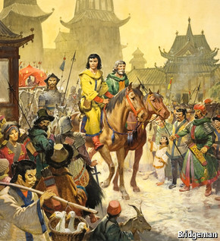
Only 15 years ago such a middle class barely existed in China. In 2011, when the country reached 50% urbanisation, it had become obvious that the party’s fate rested with the stability of cities and the contentedness of their middle-class residents. The largely rural country that Deng Xiaoping (himself of peasant stock) set out to “reform and open up” in the late 1970s had become overwhelmingly urban in its economic and political focus. Thanks mainly to a tide of migration, China’s urban population had grown by more than 500m since Deng launched his reforms: the equivalent of all the people in the United States plus three Britains.
Li Keqiang, who took over as prime minister in 2013, sees further urbanisation as critical to China’s economic success. He has called it a “gigantic engine” for growth. Mr Li and other officials are fond of quoting Joseph Stiglitz, a Nobel prize-winning American economist, who said that technological innovation in America and urbanisation in China would be “two keys” to mankind’s development in the 21st century.
A new grand plan for China’s cities, overseen by the prime minister and published last month, admits to a number of problems, such as worsening pollution, urban sprawl and congestion as well as growing social tensions. It also points out that China’s urbanisation lags behind that of other countries at similar levels of development (typically around 60%), and that there remains “quite a lot of room” for further urban growth.
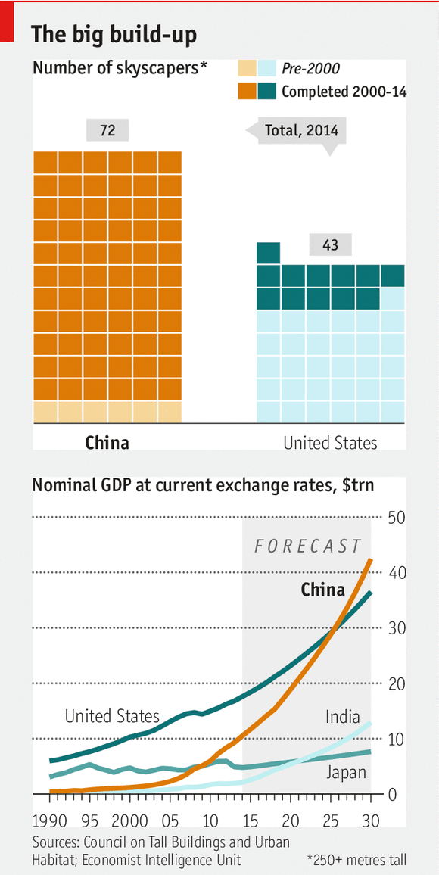
Getting cities right will help China to keep growing fast for years to come. Getting them wrong would be disastrous, bringing worsening inequality (which the World Bank says has approached “Latin American levels”, although Chinese officials insist it has recently been improving), the spread of slums, the acceleration of global climate change (cities consume three-quarters of China’s energy, which comes mainly from coal) and increasing social unrest.
After more than a decade of spectacular growth in China, much of it in double digits, doubts are setting in both at home and abroad about the sustainability of the “Chinese model”. Growth is slowing. Lavish spending by local governments has piled up huge debts. Increasing numbers of middle-class Chinese are looking for boltholes abroad for themselves, their families and their assets. Scandals involving senior officials have revealed corruption on a gargantuan scale. Censors generally succeed in preventing anti-party messages from spreading widely, but microbloggers with thousands of followers still boldly relay damning critiques.
Mr Xi describes the country’s problems and his approach to solving them in colourful terms. Reforms, he says, have entered a “deep-water area”. China must “venture along dangerous paths to break through barriers to reform”. In tackling corruption it will need the resolve of a man who must “cut off his own snake-bitten hand to save his life”. At a plenum of the Central Committee in November the party declared that market forces must play a “decisive role”, the strongest support it has ever expressed for the market. This seems all the more stirring after years of vacillation under Mr Xi’s predecessor, Hu Jintao, who retreated from reform in the face of powerful resistance by vested interests, above all local governments, huge state-owned enterprises and, ironically, the new middle class, which would rather not share the fruits of growth with rural migrants.
Why cities matter
All the most important reforms that Mr Xi needs to tackle involve the movement to China’s cities. He must give farmers the same property rights as urban residents so they can sell their homes (which is currently all but impossible) and leave the land with cash in hand. He must sort out the mess of local-government finances, which depend heavily on grabbing land from farmers and selling it to developers. He must loosen the grip of state-owned enterprises on the commanding heights of the economy and make them hand over more of their profits to the government. He must move faster to clean up the urban environment, especially its noxious air, and prevent the growth of China’s cities from exacerbating climate change. And he must start giving urban residents a say in how their cities are run.
This list is both daunting and urgent. The recent growth of China’s cities has created two new social forces whose concerns Mr Xi cannot afford to ignore. One is a vast migrant population (including the urban-born children of recent migrants from the countryside) that now makes up more than one-third of the urban total of 730m. It is far harder for a member of this group to gain official recognition as a city-dweller in his own country, with all the welfare benefits and access to public services that status confers, than to gain citizenship in America or Europe if he were to migrate there. The harsh treatment of China’s internal migrants is creating huge social divisions that could erupt in serious unrest.
The other new force is the urban middle class, now thought to be roughly the same size as the migrant population, which numbers around 260m. It has been kept reasonably content by the rapid growth of the past few years, but that may not last. China’s middle classes, like those elsewhere, worry about property: how to protect it from the whims of urban planners and party officials, what is happening to prices, and what to do if the bubble bursts. Increasingly unaffordable house prices, or conversely a steep drop, might prompt different ends of the middle-class spectrum to protest. So too might the party’s many sins and blunders: a food-safety scandal, perhaps, linked to official corruption.
Like his predecessors, Mr Xi is nipping signs of unrest in the bud. Dissidents who have done little more than briefly raise protest banners in tiny groups are being thrown into jail. But there are also some positive signs. He has taken charge of a new party organ, a small group of officials with a wide range of portfolios, who are working to improve policy co-ordination and overcome bureaucratic resistance to change. It even has a task force dedicated to building “democracy and the legal system”, although that may not get very far. Mr Xi has also launched a fierce campaign against high-level corruption which, though unlikely to offer a lasting cure to the endemic problem of graft, could scare officials into compliance with his reform plans.
A dwindling labour supply
As economic growth slows and the pool of surplus labour in the countryside shrinks, the speed of urbanisation will diminish. For the past few years about 9m people have been moving into cities every year. The number will fall to 7m in the second half of this decade and 5m in the 2020s, according to Jin Sanlin of the Development Research Centre, a government think-tank. By 2017, he writes, that supply of surplus labour in the countryside will have all but disappeared.
Chinese officials note that the speed of urbanisation in China has been far faster than in Western countries during their industrial transformations. It took China only 30 years to climb from 20% urbanisation to today’s 54%. In Britain the equivalent journey took 100 years and in America 60. However, in more recent times population growth in urban China has been slower than in countries such as South Korea and Indonesia during their period of rapid economic development, mainly because of China’s discriminatory policies against migrants and its state monopoly on rural-land sales.
By any measure, the country’s urbanisation has been impressive. Shanghai is about to finish a 121-storey American-designed skyscraper that will be the world’s second-tallest building (after Dubai’s Burj Khalifa). Whole new urban districts, underground railways, modern airports and intercity expressways have been built on a scale and at a pace most countries would be proud of. But China has failed to reap the full benefits of city growth. This is becoming a pressing problem in the face of diminishing returns from pouring ever more concrete.

Spreading the wealth

A billion shoppers

Chinese consumers are spending plenty, but they could do even better
Apr 19th 2014 | From the print edition

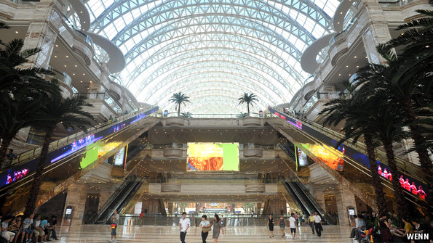
DENG HONG’S AMBITION, according to a Chinese newspaper, was to build a city inside a single building; a “temperature-controlled paradise”. Last September his dream edifice, the New Century Global Centre, formally opened in the south-western city of Chengdu (pictured). China’s official media call it the world’s largest building. Its centrepiece is a shopping mall of such arresting dimensions that many visitors pause on arrival to take souvenir photographs. It boasts a 300-metre indoor beach, a skating rink and an IMAX cinema. The Chinese often say that theirs is a country of too many people and too little land. The cavernous Global Centre building begs to differ.
The Global Centre is a monument to consumption—an increasingly essential ingredient of China’s economic development
Mr Deng did not attend the launch ceremony. He was in custody, suspected of being involved in a corruption scandal that has also ensnared a former mayor of Chengdu, who in turn may be linked to an even bigger case linked to a former member of the Politburo Standing Committee, Zhou Yongkang. Mr Deng’s troubles are an uncomfortable reminder of the perils of hubris. Massive buildings help to boost local officials’ egos and brand their cities. According to the Council on Tall Buildings and Urban Habitat, an American industry association, China has about 200 skyscrapers over 250 metres tall, four times as many as America. Close to Mr Deng’s building is an office complex reminiscent of Beijing’s “bird’s nest” stadium that cost 1.2 billion yuan ($175m) to build. It was supposed to become the city government’s headquarters, but after a public outcry over its extravagance its leaders decided to move to more modest buildings nearby.
The Global Centre, though, is also a monument to an increasingly essential ingredient of China’s economic development: consumption on a scale that helps to lessen the country’s dependence on infrastructure investment as an engine of growth. China’s leaders want citizens to save less and spend more. Mr Deng’s brainchild is a proud declaration by a local government far inland that it wants a consumer culture like that in megacities such as Beijing, Shanghai, Guangzhou and Shenzhen. The capital’s most iconic new structures are stadiums, office buildings and a colossal egg-shaped centre for the performing arts. Chengdu’s is a jaw-dropping shopping experience.
Chengdu, the capital of Sichuan province, is a “second-tier” city, a loosely defined category that includes most provincial capitals; yet it is rapidly gaining the “first-tier” status of Shanghai, 1,600km (1,000 miles) to the east. That suits China’s leaders, who are trying to boost consumption in regions that have fared less well in China’s almost uninterrupted boom of the past 35 years. Thanks to massive government investment since the turn of the 21st century, the gap between the wealthy east and the far less developed west of China has narrowed. According to the Economist Intelligence Unit, a sister organisation of this newspaper, average GDP per person in China’s western provinces in the late 1990s had dropped to about one-third the figure in the nine eastern coastal provinces; but by 2012 it had recovered to more than half, the highest level since China launched its economic reforms in the late 1970s.
The Global Centre seems to be reckoning on a fair number of wealthy spenders in Chengdu: it provides 15,000 parking spaces. It is also readily accessible by the city’s first metro line, which opened in 2010 (there are now two lines, and plans for an underground network of more than 350km by 2020, close to the length of London’s). But Chengdu’s new middle classes much prefer to drive. The city has more than 3m private cars, second only to the number in Beijing. And at weekends the centre already seems to be packing visitors in.
Consuming passions, continued
Like the rest of the country, though, Chengdu is beginning to slow down. The city estimates that its GDP last year grew by about 10%, two percentage points less than it was aiming for and the lowest rate since 1999. Nationally the picture is much the same. This year’s overall growth target is for 7.5%, the same as last year’s and a far cry from the double-digit advances of most of the past decade. But that does not mean household spending will falter. Andy Rothman of Matthews Asia, an investment firm, calls China “hands down the best consumption story on the planet”. Retail sales last year went up by 11.5% in real terms, after 12.1% in 2012 and 11.6% in 2011. China’s household spending over the past few years was holding up well, he argues. It was just that investment grew even faster.
A “rebalancing” may be under way. Except for a dip last year, the share of GDP growth contributed by households and the government has been rising (see chart). In 2011 and 2012 it exceeded that contributed by investment for the first time since the middle of the past decade. Last year China overtook Japan to become the world’s second-largest consumer economy.
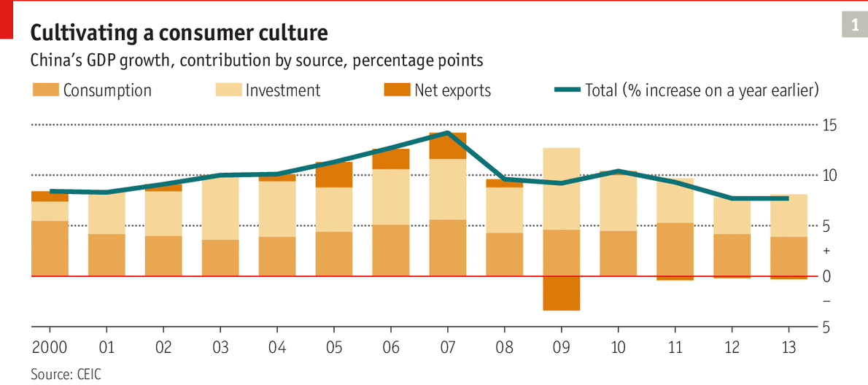
However, there is a lot more that China’s leaders could do to achieve the goal set by the prime minister in March: that the country should “fully tap the enormous consumption potential of more than a billion people”. The Global Centre was not built for the mass market, as attested by a display inviting shoppers to invest in luxury resort property in Thailand. A large group of people living in China’s cities is, in effect, “shut out of the urban consumer economy”, says Tom Miller, author of “China’s Urban Billion”: the one-third of urban residents who have migrated from the countryside. They make up about 40% of urban labour and the majority of China’s workforce in manufacturing and services, but they spend very little.
As Mr Miller notes, this is changing, thanks to a shift in China’s demography. In 2012 China’s working-age population (those between 15 and 59; most Chinese retire young) began to shrink. In response to shortages of young, unskilled labour, local governments have been raising minimum wages. This has been good for inland cities like Chengdu, which have benefited from production shifting westward in search of lower labour costs. It has also been great for migrants: their average wages doubled between 2005 and 2011, to about 2,050 yuan ($322) a month, and last year rose by nearly 14%. But a lot remains to be done to turn these migrants into big spenders.
A good start would be to change their official household registration, or hukou, to the city, entitling them to the welfare benefits and access to public services enjoyed by other city-dwellers and thus releasing some of their spending power. Migrants have an unusually high savings rate, far higher than that of either urbanites or rural dwellers, perhaps to compensate for the absence of welfare benefits. According to Chi Fulin of the China Institute for Reform and Development, rural migrants on average spend 2.7 times as much when they move to urban areas as they did at home. But they still need to save to make up for their lack of entitlement to housing and other benefits. If they also change their hukou, their expenditure more than triples.
Yet for most migrants changing hukou is next to impossible. They continue to be called mingong (peasant workers) no matter how long they have been living in the city, and so do their children, even if urban-born and raised. For reasons of equity as well as economic advantage, hukou reform has become urgent.

The rural-urban divide

Ending apartheid

For China’s reforms to work, its citizens have to be made more equal
Apr 19th 2014 | From the print edition

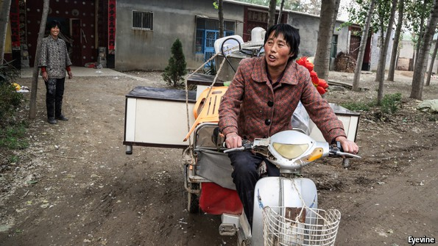Going to a better place
MIGRANTS ENCOUNTER BARRIERS of speech, habits and manners the world over, but in China these are heavily reinforced by the system of hukou, or household registration, which permits routine discrimination against migrants by bureaucrats as well as by urbanites (a term applied in this special report to city-dwellers who have no rural connections themselves, and nor do their parents). In a survey conducted by the Chinese Academy of Social Sciences, nearly one-third of respondents in Shanghai said they would not like to live next door to a migrant, against only one-tenth who said they would rather not live next to a poor person. In Changchun, a less outward-looking city in the north-east, nearly two-thirds said they did not want to live next to a migrant. Chinese urbanites seem as anxious as Europeans about migration from poor to rich places, even though in China the migrants are fellow citizens.
In one crucial respect, however, they fall short of that status. A migrant may have been living in a city for many years, but his hukou will still identify him as rural. The document acts as an internal passport. China’s first constitution in 1954 said that citizens enjoyed “freedom of residence and freedom to change their residence”. Four years later Mao Zedong introduced the hukou system in order to prevent a flood of migrants pouring into the cities. It was eased only in the 1980s when China needed cheap labour for its factories. But the pernicious legacy of hukou-induced apartheid persists today.

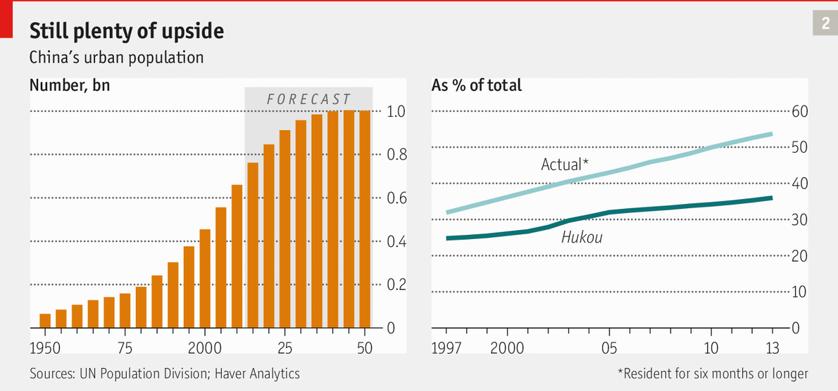Going to a better place
If China’s level of urbanisation were calculated on the basis of hukou, rather than residency, it would be a mere 36%, not far ahead of India’s (31%). Very few of those who have migrated to the cities over the past three decades have obtained urban hukou. This matters a lot because a person’s hukou, rather than his place of residence, determines the level of welfare benefits he is entitled to. The city-born children of migrants suffer the same discrimination, often being denied access to urban state-run schools and having to clear higher hurdles to get into university.
The hukou divide is sharpest of all in China’s “first-tier” megacities, which are among the biggest magnets for migrants. In some, including Beijing, they are not allowed to buy cars or houses unless they meet what for most would be impossibly exacting conditions. Thus, as China’s middle class has expanded rapidly, a similarly large group of urban “second-class citizens” (as even the official media have sometimes called the migrants) has grown in parallel. Not that it matters in a one-party autocracy, but migrants and their urban-raised offspring are not even allowed to vote in the cities.
In the decade to 2010 the migrant population living in cities grew by more than 80%, a colossal influx that pushed up the total number of urban residents by some 200m. China has been remarkably successful in controlling the spread of urban slums: over the same period the proportion of city-dwellers living in slums fell by one-quarter to below 30%, according to a UN study. And many of these slum-dwellings are relatively smart compared with their counterparts in other developing countries, thanks to tough controls on building shanty towns.
Risking an explosion
Even so, migrants often live in grim conditions. Out of sight are pockets of wretchedness similar to slums in developing countries such as India. One such is the village of Dongxiaokou north of Beijing, just beyond the edge of the city’s urban core. A village only in name, it is essentially a centre for processing waste. Thousands of migrants, most of them from impoverished villages in a single prefecture of the central province of Henan, prepare sackfuls of tin cans, piles of iron scrap and mountains of plastic bottles for bulk sale to recycling plants.
It is a scene of Dickensian poverty, with migrants packed into tiny brick shacks off muddy, rubbish-strewn streets. Their children go to ramshackle private schools that charge around 4,500 yuan ($725) a year, several weeks’ income for many migrants. For most of them there are no places at state schools. If migrants fall seriously ill, they have little choice but to go back to their villages; their government-subsidised rural medical insurance is often not valid in a different province (or even, until last year, in a different part of Henan). The only migrants who have urban health insurance are those with formal job contracts, but not even one in five enjoys that privilege.
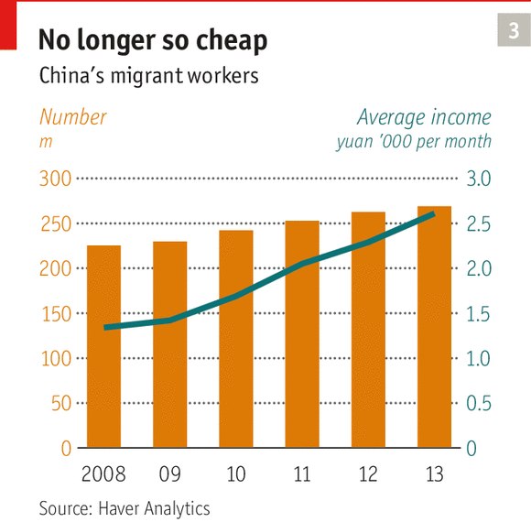
The party appears to be waking up to the disruptive potential of an urban underclass. Early in 2013 Li Keqiang, the prime minister, began calling for a “human-centred new style of urbanisation”. In November last year the party decided to speed up the pace of hukou reform. Officials have been calling for “equal rights” for all urban residents. A new word has entered the party lexicon: shiminhua, which means turning a migrant into an urbanite with all the perks of a city hukou-holder. The declared aim of urbanisation now is not just to move people into cities, but more importantly to make urbanites of them.
That will be both costly and hugely contentious. Mr Li’s plan for a new style of urbanisation was published in March after many months of bickering among officials. It glossed over the crucial question of how to pay for it all, which hints at strong resistance by local governments that do not want to foot the bill, and by urbanites who fear their privileged access to education and health care will be stripped away. Li Tie, a government researcher, in a book last year wrote that online support for hukou-related reforms was “not running high”. Part of the problem, he said, was that policymakers, journalists and online commentators were themselves urban hukou-holders and as such formed a “rigid interest group”, posing a “severe” challenge to reforms.
At the same time many holders of rural hukou, despite the discrimination they suffer, are suspicious of moves to give them urban status. They fear that it might lose them the right (conferred by rural hukou) to a small patch of farmland and a residential plot in their village of registration. Mr Li’s urbanisation plan failed to provide reassurance.
In July last year the agriculture ministry conducted a survey of nearly 7,000 rural hukou-holders, mostly male and living in the countryside, which found that only about a quarter regarded getting an urban hukou as important. Even among those whose entire families were living in urban areas, the share was only just over half. The main reason for not wanting urban hukou, the survey found, was fear of losing entitlements to land. Last October a senior official on the National Health and Family Planning Commission said that as many as 70% of rural migrants wanted to stay in the cities but had no wish to give up their rural hukou. That chimes with the views of the waste-recycling migrants of Dongxiaokou village. One middle-aged man standing by the roadside says he would far rather have his tiny patch of land in backward Henan province than a promise of a pension in wealthy Beijing.
Losing the plot
Given the discrimination they face, it seems odd that migrants themselves resist reform, but they will continue to do so until the government allows them to sell their land and sever their ties with the countryside for good. Mr Li has promised this, but local governments, used to seizing land at will, are loth to give up that privilege.
The new urbanisation plan calls for 100m migrants to be given urban hukou by 2020, but there will still be conditions: at a minimum, applicants will need a stable job and a legal place of residence. That would rule out most migrants, who often live in unauthorised lodgings and work without contracts.
Officials sometimes hold up the city of Zhongshan in the southern province of Guangdong as an example of how hukou reform could work. Since 2007 migrants into the city (who make up more than half its population) have been able to apply for city hukou on the basis of points scored for educational qualifications, ownership of property, payments of social-security contributions and volunteer work (such as giving blood). Yet since the scheme was launched, only around 30,000 out of a total migrant population of 1.6m have gained local hukou this way. Migrants can also use their points to apply for just some of the benefits associated with urban hukou, which has enabled them to secure places at state-run schools for about 25,000 of their children. But that is out of a total of 200,000 migrant children attending school in Zhongshan (and many more who are studying in their parents’ villages of origin). All the same, in January Zhongshan won a prestigious award in Beijing for its points system.
In June 2012 three days of large-scale rioting erupted in Shaxi, a satellite town of Zhongshan, fed by rumours that security agents had maltreated the son of a migrant worker who was involved in a fight. Peng Ronghui of Zhongshan’s department in charge of migrant management admits that the city’s migrant population has created “a problem of social control”. She says they “lack a sense of belonging and their morale and self-discipline is relatively poor”.
Cities like Zhongshan worry that lifting hukou restrictions would require massive extra spending on public services such as education, health care and housing. Yet most local governments would simply not be up to the task.

Local government

Emerging from the shadows

Seizing land and running up debts is no way to finance local government
Apr 19th 2014 | From the print edition

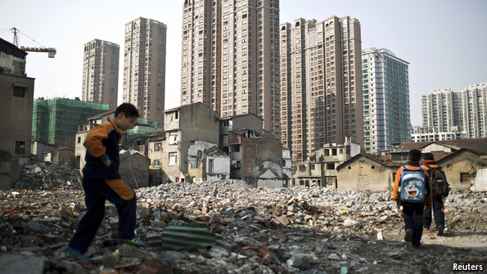
RESIDENTS OF CHAOBEI NEW CITY know what it is like to be “upstairsed”—the word for turfing farmers off their land, pushing them out of their homes and making them move into newly built clusters of blocks of flats without lifts. It is forced urbanisation, to which local governments have taken with relish in their rush to acquire precious land. Chaobei New City is the reincarnation of six flattened villages: a desolate, prison-like, rubbish-strewn ghetto. On a concrete wall along one side, billboards spell out the risks of protesting. For example, depositing funeral wreaths, ashes from cremations or corpses at government petitioning offices could be treated as crimes.
Chaobei New City’s very name conveys the mindset of those who ordered it built: officials who hoped that by destroying the villages and building 56 blocks of flats in their place they could create a semblance of urbanity. The residents would still be classified as peasants for welfare purposes, but the statistics would count them as urban. To local officials, who take enormous pride in urbanisation rates, such numbers matter. Xianghe county, to which the “new city” belongs, is in Hebei province, about 45km (30 miles) east of Beijing. Like almost every other local government in China, Xianghe’s has an urbanisation target: 60% by 2017, up from around 50% today and ahead of the national target of 60% by 2020. Since the global financial crisis in 2008, governments have been hardening such objectives as a way of stimulating growth, and have been borrowing heavily to meet them. The result has been a rapidly growing pile of debt that has spooked global investors.
Seizing land is an easy way of acquiring cash or collateral for borrowing, and since the 1990s this technique has become a favourite of local governments. Some have used the pretext of building what they call “new-style rural communities”, such as Chaobei New City. Such schemes have uprooted millions of farmers around the country. In one prefecture alone, Chinese media quoted a local leader in 2010 as saying he planned to flatten villages with a total population of 1m within three to five years. The coastal province of Shandong has moved more than 12.5m villagers into nearly 5,200 “new-style rural communities” since 2009, according to the local government. It calls this “urbanisation on the spot”.
Mod cons from hell
Central-government officials have expressed alarm and (ineffectually) reminded local governments that resettlement must be voluntary. Beijing newspapers have run several exposés of the horrors of being “upstairsed”, comparing the phenomenon to Britain’s enclosure movement of the 18th and 19th centuries when landlords stripped farmers of their right to use common land. Last September Xinmin Evening News, a Shanghai newspaper, described cracks in Chaobei New City’s buildings, flooded basements, sagging ceilings and a leaky sewage system.
Angry victims of forced appropriations are legion. According to state-controlled media, seizures of rural land by local governments are the cause of 60% of mass petitionings in China and of nearly 4m disputes every year. Lynette Ong of the University of Toronto says almost all compulsory relocations involve gangs or secret societies, often hired by local governments to push farmers out. Occasionally evictions trigger large-scale protests, but strong-arm tactics usually deter farmers from putting up much resistance. The thuggery, often brought to light by social media, is a political embarrassment to the central government. But what is behind these land grabs is of far greater concern: a financial system that has gone wrong and a system of local governance that has become dangerously dysfunctional.
Chaobei New City is symptomatic of both. The local government sold ten hectares (25 acres) of the land seized from the villagers to a local developer, Xiu Lan Real Estate Group. The company is using it to build Rivedroite Town, a cluster of lavish French-style houses separated by a wide road from the farmers’ new flats. It is unclear how much Xiu Lan is investing or where the money is coming from, but the company’s website suggests it has a close relationship with large state-owned trust companies. Such institutions are a widespread and openly acknowledged source of financing for property projects. Their lending is less strictly regulated than that of formal banks. A cosy relationship between both types of institution has enabled what Stephen Green of Standard Chartered calls “shadowy activity” by formal banks, which use their informal counterparts to channel lending into property and other risky projects.
Some trust companies and banks raise funds by selling fixed-term investments known as wealth-management products (WMPs). These promise better returns than bank deposits, interest rates on which are capped at extremely low or even negative real levels—a legacy of Maoist banking that has proved hard to shake off. But this short-term finance often supports long-term projects, creating a dangerous maturity mismatch. And some institutions may be repaying maturing products with fresh funds raised from new ones. In 2012 Xiao Gang, then chairman of the state-owned Bank of China and now in charge of regulating the country’s stockmarkets, described this as “to some extent…a Ponzi scheme”.
In theory banks are not liable when WMPs go wrong. In practice, when defaults have occasionally loomed, ways are almost always found of keeping investors from losing much, if anything (including in the biggest potential default so far, of a $490m trust product issued through China’s biggest bank, ICBC, that was due to mature in January; a stalled mining venture related to the project suddenly got official permission to go ahead).
Local governments, which in China cannot borrow from formal banks or sell municipal bonds without central-government backing, are among the biggest borrowers through such shadow channels. They mostly use the money to finance public works (including knocking down villages in the hope that resulting “urbanisation” might stimulate growth). In response to the global financial crisis of 2008 the central government loosened controls on bank lending. The volume of new loans doubled in 2009. Much of the money found its way indirectly into the hands of local governments which used it in a spending binge in an effort to maintain growth. As a result, debts soared. Along with WMPs, this has become the biggest worry to bearish observers of China’s economy.
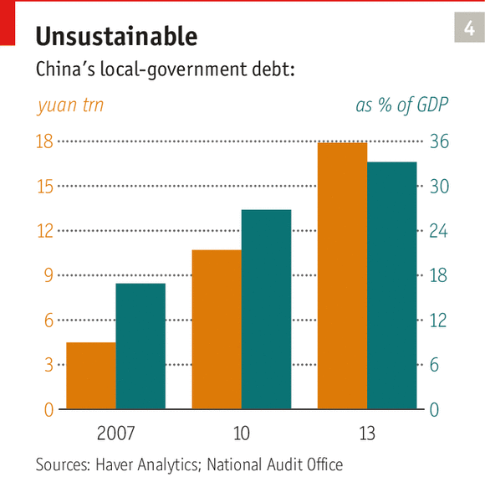
There are good reasons for concern about local-government borrowing, and about the banks and trust firms, but financial meltdown looks unlikely. An audit made public in December showed that in mid-2013 local governments directly owed 10.9 trillion yuan ($1.8 trillion), an increase of more than 60% on 2010. This is by no means crippling. Taken together with other debts for which local governments are, or might be, liable, such as those of local state-owned enterprises, it amounts to one-third of GDP. The central government would never allow a local government to default, so these debts are for the centre to worry about. GK Dragonomics, a research firm, says total government debt may be 70-80% of GDP, still well below the levels of many rich countries with lower growth.
Risks are certainly growing. Standard & Poor’s, a credit-rating agency, points out that projects which once looked viable may cease being so as growth slows. It outlines a possible scenario: a WMP fails, investors stop buying new products and non-bank credit dries up. Investment slows and property prices drop. Non-performing loans rise, putting pressure on banks. Credit slows further, and growth with it. In the event of such a crisis, however, the central government could take bad loans off the banks’ books and order them to resume lending. It could also ramp up its own spending. It would not solve the problem, but could avert an immediate crisis.
To reduce such risks, China must introduce a range of reforms. The most pressing of these is to lift controls on bank-deposit interest, which would reduce depositors’ incentives to shift money into riskier WMPs. There are signs that it is gradually moving that way, but for all the recent talk of the importance of markets, progress remains slow. Zhou Xiaochuan, the governor of China’s central bank, in March held out the possibility of full liberalisation of interest rates in a year or two. Banks themselves are not keen because higher rates would cut their profit margins.
Local governments receive half the nation’s fiscal revenue but are responsible for 80% of spending
Reform is also slow in two areas that are key to local governments’ woes: the way in which their spending obligations, such as on public works, are funded; and the ownership of rural land. Changes in both are vital if China’s new “human-centred” urbanisation is to succeed and officials’ rapacious instinct to grab land is to be tamed.
Local governments’ lack of money to cover their spending needs is a problem of the Communist Party’s own making. In 1994, worried about the central government’s rapidly declining share of the country’s total revenue, the party reorganised the tax system to boost the centre’s takings. But it failed to reduce the burden on local governments, which have remained responsible for such coffer-draining activities as providing education and health care. The central government transfers funds to local ones (via provincial governments) to cover basic costs, but this is often far from enough. Local governments receive half of the nation’s fiscal revenue but are responsible for 80% of spending.
To make up shortfalls, local officials turn to rural land. Whereas the property rights of urbanites were strengthened from the late 1990s, thanks to the privatisation of urban housing and legislation to protect it from government interference, the property rights of villagers have remained vulnerable to abuse. Landesa Rural Development Institute, an American NGO, found that in 1,791 villages it surveyed, the number of land seizures had nearly tripled between 2007 and 2011. Land-related income, which in 2001 made up one-sixth of local-government revenue, had soared to three-quarters a decade later.
Counting the cost
Giving urban benefits to migrants will cost a lot of money. Unless a new way of funding local governments can be found, they are likely to solve the problem in the time-honoured manner: by seizing yet more land. The central government might help, but could it afford to? Estimates of the likely expense vary widely. A report this year by the Chinese Academy of Social Sciences put the cost of providing a migrant worker with full urban benefits at 130,000 yuan. A government study in 2010 came up with a figure of 80,000 yuan. But Kam Wing Chan of the University of Washington writes that even at about 100,000 yuan per migrant, the total would still be manageable.
Mr Chan calculates that it would add up to around 23 trillion yuan, or more than 44% of China’s GDP in 2012. That would be more than any economy could cope with, but it would not happen all at once. If it were done gradually, bringing in 20m migrants annually, it would mean spending a far more manageable 3.8% of 2012 GDP a year. But in fact those 100,000 yuan of health-care and other expenses would be stretched out over a lifetime, so the actual annual cost of converting 20m people to full urbanite status would be 0.1% of 2013 GDP, Mr Chan reckons: about one-fifth of what China spent on the 2008 Olympic games.
That would leave the task of giving full property rights to farmers. Doing so would make it more difficult for local governments to seize land, which in turn would make it harder for them to find ready collateral for piling up huge debts. Most importantly, it would empower farmers, and perhaps even end the tyranny of village officials who use their control over land to fill their pockets. Last November the party pledged to allow rural land (though not arable land) to enter the market on the same terms as any other property. This will take time: even deciding who owns what in the countryside will be tricky. And local governments are not keen to dispense with a ready source of cash.
But the party has to press ahead. If financial and social stability are not sufficiently powerful incentives, there is another to consider: the rampant urban sprawl encouraged by local governments’ ability to seize rural land at will. Such unrestrained expansion may work in parts of America where there is plenty of empty land (albeit at a cost to the environment and often to the quality of life). In China, where urbanisation has forced around 40m farmers off their land over the past three decades, usually with little or no compensation, it will not.

Urban sprawl

People, not paving

China’s largest cities can mostly cope with population growth. The spread of concrete is a bigger problem
Apr 19th 2014 | From the print edition

TO GRASP THE size of China’s largest cities, and the pace of expansion of even the remotest of them, consider the south-western city of Kunming. Looking at a map, it would be easy to dismiss it as a backwater, tucked in a mountainous subtropical corner of China that borders on some of South-East Asia’s poorest countries: Vietnam, Laos and Myanmar. Yunnan, the province of which Kunming is the capital, is one of China’s most backward, with a nominal GDP per person roughly that of Albania. By the standards of China’s provincial capitals Kunming’s urban population is merely middling, yet at 3.8m it roughly equals that of America’s second-largest city, Los Angeles. By the end of this decade it is likely to have risen by 50%.
There will, however, be no mushrooming of shanty towns along the shore of Dian Lake, Yunnan’s largest and the one-time pride of Kunming (ill-regulated urban growth has since turned it so toxic that its water is deemed unfit even for industrial use). Officials have what they think is a far better plan: building a new suburb called Chenggong. This will account for most of a projected 40% expansion of the built-up area of the city of Kunming. Kunming’s urban-planning exhibition promises “a beautiful environment” for Chenggong.
Work on the new addition is already well under way. Thickets of residential tower blocks and office buildings are sprouting. Chenggong was connected to Kunming’s new metro network last year. City-government offices and local universities have already moved there. By 2016 it will have a $525m bullet-train station with one of its 30 tracks connecting to Shanghai, 2,000km (1,200 miles) to the east. By the end of this decade the population of Chenggong is expected to reach nearly 1m, three times its current level. Not so long ago Chenggong was derided as a ghost city in the making. Few are now so scornful.
Kunming’s orgy of urban expansion sits oddly with a long-established Chinese policy of seeking to limit the population growth of large cities. An urban-planning law adopted in 1989 calls for strict control. Even after a decade of huge expansion in which the urban population of Beijing (including its satellite towns) grew by about 7m to nearly 17m, the party still clings to the hope that it can keep such expansion in check. When it unveiled plans for wide-ranging economic reforms last November, it called again for “strict control over the population size of extra-large cities”. For all the party’s recent emphasis on the role of market forces, they are still not allowed to determine people’s movements.
Kunming could now argue that it is not “extra-large”. The central government’s new urbanisation plan released in March suggests that the term applies only to cities with urban populations over 5m. On this definition only about 15 cities qualify, and they do not include Kunming. Previously, however, “extra-large” had meant any city with more than 1m people, of which China has more than 130. (America, by contrast, has a mere nine in this category.) A little redefinition goes a long way.
The central government wants cities to grow, but prefers the smaller ones to grow faster than the rest. Its new urbanisation plan calls for hukou barriers to be scrapped altogether in cities with fewer than 500,000 urban residents. Those bigger than 500,000 have been asked to remove or relax hukou rules, but in an “orderly” or “reasonable” manner, meaning not all at once. In extra-large cities tough hukou restrictions are to remain in place. Yet in the past decade the populations of small cities have been shrinking, largely because bigger ones have proved to be a much more powerful draw for migrants.
Plenty of room for more
The government’s worries about population size are overblown. Chinese cities are by no means unusually crowded. Three Chinese scholars, Ming Lu and Zhao Chen of Shanghai’s Fudan University and Zheng Xu of the University of Connecticut, argue in a recent paper that apart from cities with 10m people or more, the average big city in China has “a lot of room for growth”. Even greater Beijing, which city officials think is bursting at the seams, is far less densely populated than greater Tokyo.
Rather than try to control population size, the central government would do better to have a go at curbing the spatial expansion of cities. Local bureaucrats have a predilection for vast areas of concrete. Plazas, broad boulevards and colossal airports and railway stations have become their badges of honour. In the central city of Zhengzhou, what local officials called the largest bullet-train station in Asia opened in 2012: a $2.4 billion edifice with a plaza in front which together cover around 240 hectares (about 340 football pitches). The station is half-deserted.
Such extravagant use of land and money will only increase if the government continues to encourage cities to expand their populations. Built-up areas across the country have recently been growing by an average of 8% a year whereas their populations have been rising by only 5%. In western China the gap is far wider, with urban areas growing three times faster than their populations, according to Fudan University’s Mr Lu. Kunming provides evidence of extravagant habits. Luo Chun, a professor at Yunnan University, reckons his institution’s new campus in Chenggong district is five times the size of its old one in the centre of Kunming. The original campus remains in use.
Central officials are concerned about this, but for the wrong reasons. They fear that urban sprawl could make it more difficult for China to maintain near-self-sufficiency in staple foods. The country is already hovering close to what officials describe as a “red line” of 120m hectares available for planting such crops. Even so, grain production has been rising. Thanks to fewer people in the countryside, farming is becoming more efficient.
A better reason to worry about sprawl is that it is making China’s cities less “harmonious and liveable”, to use a phrase in vogue among the country’s city planners. Old neighbourhoods are being demolished, their inhabitants scattered into far-flung gated communities, commuting times are lengthening, car-dependence is growing and the spatial divide between rich and poor is widening. All this contributes to what officials call the country’s growing “urban disease”.

A Shanghai suburb that is forever England
Apr 19th 2014 | From the print edition

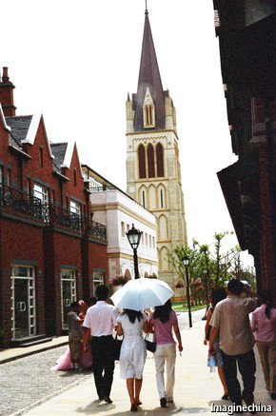
OXFORD STREET IS a quiet cobbled lane, with Tudor-style shop fronts and lights supposed to look like gas lamps. At one end it opens out onto a small square. A bronze statue of Winston Churchill stands in front of the open-air colonnade of Thames Bar, looking towards an elderly man sitting on a bench on the other side of the plaza. He is petting his two pugs, one dressed in a yellow jacket and the other in blue. It is so much cheaper here than in central Shanghai, he says—and, traffic permitting, it is only an hour away by car.
President Xi Jinping may be having a Chinese dream, but the country’s city planners are often inspired by foreign examples. Thames Town has Victorian- and Georgian-style housing for 10,000 people, red phone booths and, perhaps oddest of all, a church (pictured) with a spire closely modelled on a mid-19th century Anglican one in Bristol. A columnist in Global Times, an English-language newspaper in Beijing, accused Shanghai officials of being “unconcerned about cultural affinity or national ethos”, succumbing to “the appeal of the foreign”.
Thames Town is often scoffed at as one of China’s most peculiar “ghost towns”. For years most of its houses remained empty. Its town centre attracted far more people in search of a novel background for wedding photographs than for suburban homes. (Cashing in on this, many of Thames Town’s shops offer photographic services and wedding regalia for hire.) But in the environs of a city like Shanghai, one of China’s most prosperous, building the town was probably a good long-term bet. Soaring property prices in the city centre are forcing buyers ever farther out.
Shanghai has a record of proving doomsayers wrong. Thames Town and other European-themed suburbs like it are but tiny specks compared with the vast endeavour that the city undertook in the 1990s, clearing a semi-industrial, semi-rural area of tens of thousands of people to make way for a new financial centre on the east side of the Huangpu river. In 2000 this newspaper called the new Pudong zone a “ghost town of a business district”. It is now a skyscrapered icon of Chinese economic power.
New shops are opening in Thames Town, and residents say occupancy is picking up. Three years ago even the church acquired a congregration—though that was just transplanted from a Catholic church nearby, demolished to make way for yet more urban growth.

Greenery

Let us breathe

Pollution in cities is becoming a political issue
Apr 19th 2014 | From the print edition

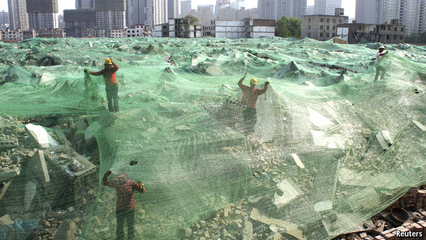
THE WORD “ECO-CITY” first took off with a book written in 1987 by Richard Register, a green thinker based in California. Now what may become the world’s first city with the word in its name is beginning to take shape in the unlikely setting of a smog-shrouded expanse of salty mud on the northern Chinese coast. Around a lake that not so long ago was a sewage farm, energy-efficient apartment blocks are going up. Electric buses ply the still largely empty streets. Public litter bins are equipped with solar lighting so that residents can find them more easily at night. China’s urban growth is warming up the planet, and the elaborately named Sino-Singapore Tianjin Eco-City is being touted as a cool solution.
Few other countries could dream of building a large city from scratch, let alone an eco one, but China has the advantage of an autocratic approach to urban planning (and to governance in general). It can decree that a piece of land will become a green city, commandeer it and sell it cheaply to developers. That is how the eco-project began in 2007 when Singapore proposed a co-operative green-city venture. China’s leaders agreed, having recently awoken to the environmental horrors wrought by breakneck urban expansion. Later that year the party formally declared that its goal was to build an “ecological civilisation”. The 30 square kilometres of inhospitable terrain near the northern port city of Tianjin became a test bed.
China has tried a couple of eco-city projects before and failed. About 60km (40 miles) farther along the coast to the east of Tianjin, in Caofeidian, work began in 2009 on an eco-city aiming for 500,000 residents by 2020. Yet most of the site remains a wilderness, too remote to attract developers. In Shanghai, plans a decade ago for a similar-sized eco-city on an alluvial island became entangled in local corruption and never got off the ground. But Tianjin’s, with strong backing from central and local governments, is making progress.
To give it a flying start, officials designated it as China’s first industrial park devoted to the animation industry. The $690m state-funded zone opened in 2011 and has attracted hundreds of businesses. To lure in more residents, the government built a Victorian-style school in brown brick with lavish facilities, including a room full of stuffed animals to help children learn about nature (“all real, except the tiger and the panda,” says a proud teacher). A 350-bed hospital, supposedly one of the best in China, is due to be completed next year, at a cost of $110m.
Public resentment of China’s deteriorating environment, particularly the noxious haze over its cities, is growing
At a control centre a dozen officials watch a giant screen displaying readings from heating and water systems, as well as feeds from closed-circuit cameras at traffic intersections. “If an emergency happens, we can respond,” says an official surveying the images of lifeless streets. Officials are not deterred by the “ghost city” label. The city opened two years ago and now has 10,000 residents. By 2030 it aims to have 350,000. Work is due to begin this year on subway lines that will make it easier for locals to get to Tianjin, currently about an hour’s drive away, and nearby industrial zones.
The government has a powerful incentive to support the project. Within China, public resentment of its deteriorating environment, particularly the noxious haze over its cities, is growing, and abroad the country is being criticised for its contribution to global warming. In 2006 China became the world’s biggest emitter of carbon from energy, overtaking America; it is now spewing out nearly double America’s level (see chart 5). The spread of Chinese smog across the region is worrying neighbours such as South Korea and Japan.
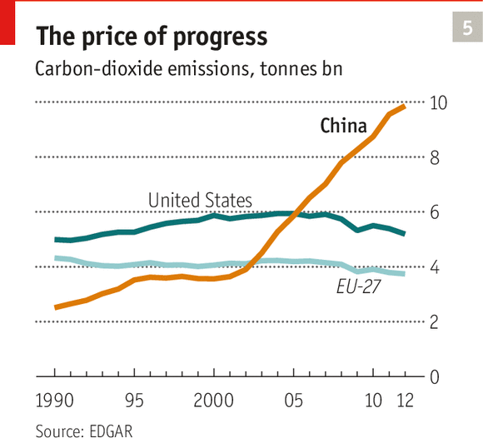
Ho Tong Yen, the Singaporean CEO of the eco-city’s development company (and a director of Mr Register’s Californian consultancy, Ecocity Builders), says he believes many of the eco-city’s methods will eventually become “a key part of urbanisation in China”. A decade ago, he recalls, Chinese officials he met at conferences would boast about their cities’ GDP growth. Now they brag about how green their cities are.
A work in progress
This sounds like a bit of a stretch. China’s urban landscapes appear to be the antithesis of green: smog, foul-smelling streams and canals, roads jammed with exhaust-belching cars, shoddy buildings erected with little heed to building codes. But growing public discontent with the urban environment is beginning to change at least the rhetoric of officials, and in some cities their actions as well. In recent years about a third of China’s 600-plus municipalities have announced plans to turn themselves into eco-cities. The central government has imposed stricter controls on emissions of carbon and smog-forming pollutants. In March the prime minister, Li Keqiang, declared “war” on pollution. Smog, he said, was nature’s “red-light warning against the model of inefficient and blind development”. It was a remarkable admission of urbanisation gone wrong.
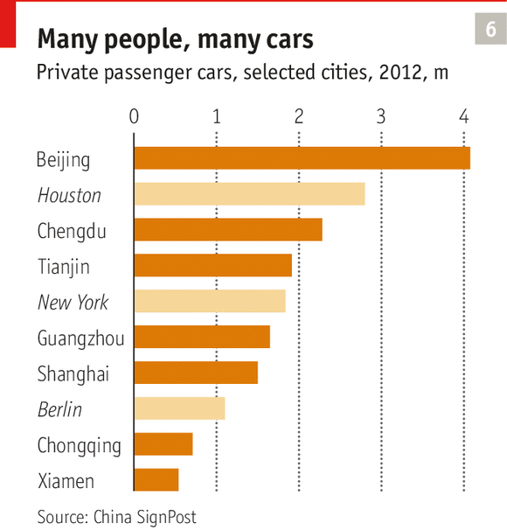
Since there is no agreed definition of an eco-city, local governments interpret the term to suit themselves. They often use it as an excuse for prettification, or worse, for seizing yet more land from farmers and using it to build luxury housing, with golf courses next to them (because grass is “green”). Even the eco-city in Tianjin, a drought-prone area, has a golf course, supposedly irrigated with recycled water. Mr Register himself is not altogether bowled over by the project. In 2012 he wrote that its layout, with the wide streets and long blocks typical of modern Chinese cities, looked “every bit as if created to encourage driving”. Its plan for 20% of its energy to come from renewable sources does not sound much bolder than the nationwide target of 15% by 2020, against 9% now.
And for all its claims to greenery, the eco-city lacks a vital ingredient: a thriving civil society that is free not only to protest about the environment but to put pressure on the government to live up to its promises. The party talks green and sometimes even acts tough, but all the while it has been machinating to prevent the growth of an environmental movement. It does not want residents to set their own agenda for the way cities are run.

Politics

The urban voice

China’s new middle classes, quiescent so far, may soon become more demanding
Apr 19th 2014 | From the print edition

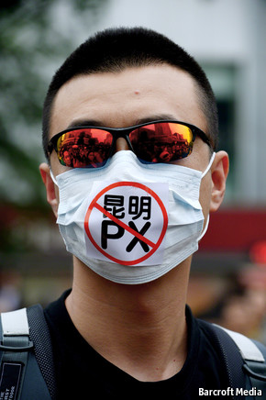
CAO TIAN IS a property dealer who dreamed of changing his city. As a poet and writer chosen by the government of Henan in central China as one of the province’s ten cultural personalities of the year in 2006, he clearly did not lack imagination. When in May 2011 the mayor of Zhengzhou, Henan’s capital, announced he was stepping down, Mr Cao said that he would stand for election to replace him. Not only would he take no salary, he would put up 100m yuan ($15.4m) as a guarantee of good behaviour while in office.
It was a good try, but he knew it was doomed. Chinese law says that independent candidates can stand for the post of mayor in cities. In theory all they need is the support of 20 members of a city’s legislature, which in Zhengzhou is less than 4% of the total. But legislators are hand-picked by the Communist Party. Most of them are officials and party members. Mr Cao says he spoke to half a dozen he knew and got nowhere; they were all “very obedient” to the party. “You can eat with them, you can gamble with them, but you cannot talk [about standing for election],” he says. The authorities made that clear enough. They launched a tax investigation into his company, a common tactic for intimidating dissenters. Mr Cao left town for a few months. To no one’s surprise, the acting mayor, Ma Yi, was elected by Zhengzhou’s legislators to fill the post.
Mr Cao’s challenge was an act of rare bravado. In China, entrepreneurs like him are usually reluctant to cross the line into political activism because business deals often depend on good ties with the party. At the time of Mr Cao’s mayoral bid China’s leaders were more than usually jittery following a series of pro-democracy uprisings in the Arab world. Internet activists were anonymously calling for China to stage its own “jasmine revolution”, the name given to Tunisia’s revolt in late 2010. Online censors were busy trying to expunge any reference to the word “jasmine”; police were rounding up dissidents and even telling florists not to sell the flower.
It was a bad moment to provoke the authorities, especially for someone like Mr Cao, who had form. After the pro-democracy unrest of 1989 he had been sentenced to 12 years in prison for “counter-revolutionary” behaviour (he had organised a protest against the bloody crackdown in Beijing). Thanks, he believes, to foreign pressure on China he served less than three years, but recalls jail as “hell”. His punishment, he says, included having to watch condemned prisoners being shot.
The rapid growth of a middle class in China increases the risk, as the party sees it, that more people like Mr Cao will begin to find their political voice. Unusually for a man who makes his living from property, Mr Cao says that as mayor he would have tried to control soaring prices. He thinks a property tax would help, but would be opposed by the many corrupt officials who own expensive properties.
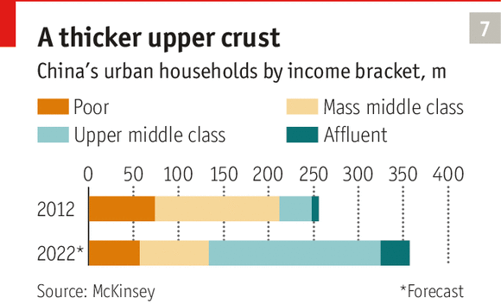
Many argue that China’s new middle class is largely in favour of the political status quo; many of its more affluent members are officials, former officials or closely in league with officialdom. But the economic make-up of middle-class China is rapidly changing. McKinsey, a consultancy, reckons that in 2012 only 14% of urban households belonged to what it calls the “upper middle class” (with an annual household income of 106,000-229,000 yuan, or $16,000-34,000, in 2010 real terms) and 54% to the “mass middle class” (with an income of 60,000-106,000 yuan). By 2022, it estimates, the upper segment will have expanded to more than half and the mass part will have shrunk to 22% (see chart 7). With this rise of what McKinsey calls “sophisticated and seasoned shoppers” will come demands for a bigger say in how their cities are run. “Unmet, these demands could raise social tensions,” as the World Bank and China’s Development Research Centre observed in a joint report in 2012. A second joint report by the two organisations, “Urban China”, published in March, called for comprehensive reforms.
Very few are challenging the party politically, but growing numbers are getting involved in campaigns to protect their neighbourhoods from government projects that might affect their health and comfort or the value of their property. Such protests occasionally take on a political hue, providing cover for a wealth of grievances about the opacity of city management, the high-handedness of officials and pervasive corruption.
The biggest middle-class protests have been mostly about factories producing paraxylene (PX), which some fear might release poisonous fumes
The biggest middle-class protests have been mostly about factories producing paraxylene, a chemical used in the production of polyester. Since 2007 large-scale protests have erupted in five cities over plans to build such facilities, the main concern being that the factories might release poisonous fumes. The fears are probably overblown, but reflect widespread and profound distrust in officialdom. The demonstrators’ ability to gather in public places in their tens of thousands, with the help of mobile text messages and microblogs, has highlighted the weakness of China’s censorship system. PX, as the chemical is often called, has become a cover for poking at the party. Those of dissident bent gleefully count off the cities that have witnessed PX protests: Xiamen in June 2007, Dalian in August 2011, Ningbo in October 2012, Kunming in May 2013 and Maoming earlier this month.
Zhou Min, a restaurant reviewer in Kunming, is one of them. She says she used not to care about politics. But in response to the protests in her city last May the police detained dozens of activists. Officials even briefly attempted to stop the sale of medical face-masks for fear they might be donned by demonstrators. “Now I’ve changed my mind,” says Ms Zhou, who was herself interrogated by police, accused—falsely, she says—of being an organiser. “If only we had the vote, then we could veto projects like these,” she says, visibly angry. During the recent anti-PX protests in the southern city of Maoming police used tear gas and batons against demonstrators.
Most of the time urban China displays few obvious signs of discontent. Since the late 1990s the party has managed a period of rapid middle-class growth, along with huge urban expansion thanks to an upsurge of migration, with remarkably little unrest in the cities. Protests have been far more common in the countryside, mainly against the government’s seizure of land from farmers. The mostly peaceful PX protests have been a rare exception to widespread middle-class quiescence.
Looking on the dark side
But the mood in China’s cities could be changing. Middle-class urban residents look ahead with greater anxiety: about the slowing of China’s growth; about the harmful effects of air pollution and contaminated food; about rising house prices that are making middle-class dreams of property ownership ever less achievable; about the burden of looking after an ageing population that is growing ever faster; and (especially among recent graduates) about the difficulty of finding a job. Richer Chinese worry about whether they can protect the wealth they have accumulated in the past few years. Could a marginalised urban underclass turn against them? Could an anti-corruption campaign such as President Xi Jinping’s current drive land them in jail? Growing numbers are voting with their feet. When in 2012 and 2013 researchers at Shanghai University surveyed nearly 2,000 people in urban areas of Shanghai and five provincial capitals across China, nearly one in five said they would emigrate if they had the chance. Those in the wealthiest cities were most eager to leave. In Shanghai one-third said they would go if they could, and in Guangzhou nearly 40%. Hurun Report, a company that monitors China’s rich people, said in January that 64% of nearly 400 Chinese with personal wealth of at least 10m yuan ($1.6m) that it surveyed were emigrating or planning to do so, compared with 60% a year earlier.
With his talk of a “Chinese dream”, Mr Xi has prompted debate among his countrymen about how far they feel they are from a dream state. A survey last year by the Chinese Academy of Social Sciences (CASS) on attitudes to the “Chinese dream” found that only just over half of the 7,300 respondents believed they lived in a “good society”. Equality, democracy and being rich and powerful were rated most highly as the hallmarks of such a society. The party itself bandies around such terms, but Li Chunling of CASS says that what China’s middle class understands by democracy is closer to Western ideas.
China’s leaders clearly worry about this, as evidenced by the cottage industry that has sprung up to produce translations and analyses of Alexis de Tocqueville’s work on the French revolution, “The Old Regime and the Revolution”, published in 1856. This was prompted by a recommendation of the book in 2012 by Wang Qishan, who is now a member of the Politburo’s Standing Committee. Exactly what drew Mr Wang to the book is not known, but Chinese media have focused on one of its main arguments: that revolution is more likely to occur when an authoritarian society begins to reform than during its period of maximum repression. China Daily, a government-controlled newspaper, notes that copies of the book have been prominently displayed in the Beijing bookshop of the Communist Party’s main training school for senior officials. New versions carry blurbs such as “Recommended by Wang Qishan”. One is subtitled: “Why Does Prosperity Hasten the Advent of Revolution?”
The possibility of revolution still appears remote, but the risk of larger-scale social unrest in urban areas is growing. To divert attention from trouble at home, China’s leaders may be tempted to flex their muscles abroad.

A new society

Pushing the boundaries

The rapid move to the cities has handed Xi Jinping a daunting challenge
Apr 19th 2014 | From the print edition

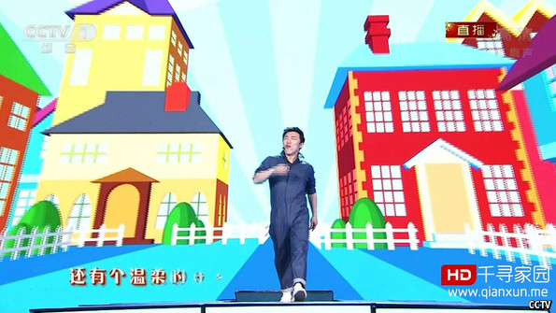Sansha, city of dreams
FEW OUTSIDE CHINA have heard of Sansha, the country’s biggest city. Its administrative area is 150 times larger than Beijing’s, or roughly the size of Kazakhstan. Yet Sansha’s population is no bigger than that of a village and consists mostly of fishermen. Its government is on an island too small even to fit in an airport; the military airstrip stretches out into the South China Sea, where most of the city’s watery territory lies. It is a city only in name, set up to assert China’s claims in a vast swathe of sea encompassing some of the world’s busiest sea lanes. If Shanghai inspires awe, Sansha causes alarm.
The city was created (in bureaucrats’ minds, though probably not the fishermen’s) seven years ago and upgraded in 2012 to “prefectural level”. Its tiny land area comprises about 200 islets clustered in three groups that are bitterly contested. Two of the groups, the Spratlys (Nansha in Chinese) and the Paracels (Xisha), are claimed by Vietnam. The third, known as Zhongsha in Chinese, includes Scarborough Shoal, which is claimed by the Philippines but has in effect been controlled by China since 2012. Some of the Paracels were controlled by South Vietnam until 1974, when it was expelled after a battle with China. It was on one of these, Woody Island (pictured), that the party installed Sansha’s legislature, which duly elected a man likely to be the country’s least busy mayor.
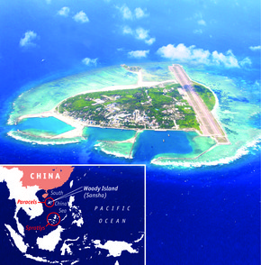
An empty threat
Sansha is one of China’s most bizarre, and unsettling, attempts at city-building; an undertaking motivated by a desire to stake out territory and scratch the itch of nationalism. Some 2.6m of the South China Sea’s total area of 3.5m square kilometres are said to be under the city’s jurisdiction, giving access to a wealth of resources: an estimated 5m tonnes of harvestable fish and huge reserves of oil and natural gas. Parts of the vast area are also claimed by five other countries. The creation of Sansha was intended to rebuff them.
China’s spectacular urban-led growth in recent years has been changing the way the country behaves abroad in important ways. First, it has been fuelling a voracious demand for imports of commodities, from oil to iron ore. More than half of China’s supplies of both are now bought from abroad. As a result, much more of China’s diplomatic attention is being focused on cultivating relations with commodity-exporting countries, mostly in the Middle East, Africa and Latin America (several of them no friends of the West).
Second, China is now much more worried about the security of its supplies. It feels uneasy about leaving America to patrol vital shipping lanes such as those through the South China Sea. And third, China’s growth has given it much greater confidence, increased by the West’s economic malaise in recent years. The country is asserting itself more visibly, especially in nearby seas that have long been under America’s sway.
Mr Xi himself also happens to be a far more confident leader than his predecessor. He has not been afraid to take steps that raise tensions with American allies, notably Japan and the Philippines. This suggests to some in Asia that China has had enough of America as the region’s dominant power and is beginning to do something about it. Certainly the risk has increased that a small incident might escalate into a bigger conflict. For now, however, Mr Xi does not appear to be spoiling for a fight. China cosies up to America’s rivals, most notably Russia, but it also sees its economic interests, and hence its strategic ones, as closely linked with America’s.
It is developments inside China, in real cities, that should worry the outside world more. Urbanisation, especially over the past decade, has handed Mr Xi a daunting legacy. When his predecessor, Hu Jintao, came to power in 2002, urban China was far less of a challenge. The country was recovering well from the Asian financial crisis of 1997-98. Its north-east had been wracked by large-scale protests by workers laid off during the massive downsizing of the state sector from the 1990s, but Mr Hu kept the region largely quiet by directing dollops of cash to it. The internet was still the preserve of a small urban minority.
A harder place to run
The picture today is very different. Economic growth is slowing. As this special report has explained, rapid urbanisation has spawned two huge new social forces: a middle class and an underclass. Both are much bigger than they were a decade ago; both are suspicious of, and sometimes hostile towards, each other; and both often distrust the Communist Party.
Just in the past five years social media such as Sina Weibo and WeChat have connected hundreds of millions of Chinese in a conversation held in near-real time, much of it less than flattering about the party. More than 60% of urban residents now use the internet. The shoots of civil society are beginning to grow; small, scattered groups are working on everything from helping HIV/AIDS sufferers to cleaning up the environment. The security apparatus keeps close tabs on them but rightly worries that urban China may be changing too fast for it to keep up.
Double-digit growth for much of this century has not only made many ordinary Chinese better off but bestowed breathtaking riches on the families of some members of the political elite (including some of Mr Xi’s extended family). This has proved impossible to cover up. Mr Xi’s anti-corruption efforts risk causing strife among political clans eager to protect their privileges. He may be China’s strongest leader since Deng Xiaoping, but urbanisation has fuelled the growth of other, often countervailing, powers too: large state-owned enterprises that have gorged on property and commodities, local governments bloated by reckless borrowing to build ever bigger cities, and an internal security apparatus that now spends more than the army, most of it on policing cities.
Mr Xi and his team have correctly identified the need for a better approach to urbanisation: one that will help ease social tensions which have built up over the past decade, bring local governments into line and make big SOEs contribute much more to welfare and share more of their markets with the private sector. They have been making encouraging noises about the need to reform the iniquitous hukou system, strengthen farmers’ property rights and make cities more “liveable”.
But Mr Xi needs to go much further. The party still cannot bring itself to talk of a “middle class” (too unsocialist-sounding), much less acknowledge that its aspirations are more than just material ones. In January a famous actor, Huang Bo, introduced a new song about the “Chinese dream” on state television’s most popular show of the year, the Spring Festival gala. It was called “My Needs Are Modest”. The middle-class fantasy it described (without naming it as such) was an advance on the usual calls for selfless devotion to the nation, but it was still politically sterile: “I can earn money, and still have time to go to Paris, New York and the Alps. I stroll through the shopping mall and go skiing in the mountains. Days like these are so carefree.”
Optimists still wonder whether Mr Xi might eventually allow a little more political experimentation. At the party’s 19th congress in 2017, five of the Politburo Standing Committee’s seven members are due to step down, leaving only Mr Xi and Mr Li, the prime minister. Of the replacements expected to join them, at least two are thought to have liberal(-ish) leanings. But few observers are holding their breath.
In 1997 China’s leaders set a goal of making China “moderately well off” by 2020, just in time for the party’s 100th-birthday celebrations the following year. Judgment on whether this has been achieved will be passed while Mr Xi is still in office. As long as China’s GDP keeps on growing at about 7% a year (as is plausible, possibly even making China’s economy bigger than America’s by then), it will not be hard for him to tick off the economic targets. But the party has said that “moderately well off” also means a more democratic China, and one that respects human rights. Ignoring those aspects risks antagonising the constituency that has become most vital to sustaining the party’s power: the urban middle class. Mr Xi would do so at his peril.

http://www.andrewerickson.com/2013/06/china-signpost-71-counting-cars-rising-private-automobile-ownership-in-chinese-cities-paves-road-for-gasoline-demand/
23 June 2013 ~ 0 Comments

China SignPost™ (洞察中国) #71—“Counting Cars: Rising Private Automobile Ownership in Chinese Cities Paves Road for Gasoline Demand”
China SignPost™ 洞察中国
Gabe Collins and Andrew Erickson, “Counting Cars: Rising Private Automobile Ownership in Chinese Cities Paves Road for Gasoline Demand,” China SignPost™ (洞察中国) 71 (24 June 2013).
China SignPost™ 洞察中国–“Clear, high-impact China analysis.”©
“Texas-sized” used to be the benchmark for large-scale car ownership, but “China-sized” is emerging as the new metric. We assembled statistical data for 36 cities that account for 30% of China’s 93 million-strong private passenger car fleet and found that Metro Beijing now has more than four million private passenger cars. That’s 45% more passenger cars than are registered in Harris County, Texas, home to car-crazy Houston and several of its major suburbs. At present, no Chinese metropolitan areas other than Beijing have attained Houston’s raw car ownership levels, but three Chinese metro areas now each have more private passenger cars than New York City, with its 1.8 million cars (Exhibit 1).
Exhibit 1: Private Passenger Car Ownership by Selected Metro Area in China and Abroad
Thousand vehicles
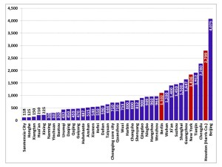
Note: For Chongqing “core city” is specified because the data provided are specific to the metro downtown. Chongqing municipality is much larger geographically than China’s three other provincial-level municipalities (Beijing, Shanghai, Tianjin), and the majority of its territory lies outside its central urban area.
Source: Municipal statistical bureaus, TexasSure, NYS DMV, China SignPost™ estimate
Why focus on private passenger car ownership in China? We do so for three core reasons. First, private passenger cars are sold and owned in far greater numbers than business-oriented private vehicles, accounting for roughly 80% of passenger cars in China, and thus constitute the largest piece of China’s gasoline demand pie. Second, sales and ownership of these cars are closely correlated with consumer economic activity and the economic well-being of China’s emerging consumer class. Third, ownership of private passenger cars creates a set of economic opportunities that China lacked until recently. Vehicle owners will need services and parts, roads to drive on, places to park, etc. Each link in this vehicular value chain creates direct opportunities for selling goods and services.
Greater use of cars and changing social attitudes regarding car use and ownership also hold significant potential to change basic life patterns in ways that meaningfully impact local economies. Consider the rural farming family who is finally able to purchase a small truck and can now drive goods directly to market instead of spending days waiting for a third party hauling service. This can help to improve China’s sluggish and uneven rural food distribution network, which still suffers significant losses from produce damage and spoilage. While such changes percolate unpredictably through societies as vehicle ownership rises, we believe passenger car ownership levels in key Chinese cities are reaching critical mass and becoming a force in their own right as car owners find new ways to use their prized steeds.
In per capita terms, Xiamen is China’s highest car ownership metro area at present, with 30.5 cars for every 100 residents (Exhibit 2). Guangzhou has a private passenger car ownership rate of just over 20 cars per 100 residents, close to that of Beijing. Suzhou, meanwhile, has an ownership rate of just under 23 cars per 100 residents. Such ownership levels are right on a par with New York City’s 22 cars per 100 residents.
We believe that a per capita private passenger car ownership rate of 25-30 cars per 100 residents is where most Chinese cities will reach a “saturation point” at which car ownership growth plateaus. Car ownership on Taiwan—the PRC’s closest global cultural analogue—has stabilized at approximately 31 cars per 100 residents and gives a sense of how car buyers may behave as some large costal mainland Chinese cities began to approach Taiwanese per capita wealth levels. Indeed, China’s wealthy coastal enclave of Xiamen—opposite Taiwan—now has a per capita private passenger car ownership rate of just under 31 cars per 100 residents.
Second, the car ownership levels seen in foreign cities such as New York and Berlin—which, like many large Chinese cities, have invested heavily in public transport and where cars are expensive to own—give a sense of where a saturation point might reasonably lie under broadly analogous physical conditions in large Chinese metro areas. Car ownership rates in rural China underserved by public transport could ultimately rise to roughly 35 cars per 100 residents.
Exhibit 2: Car Ownership per 100 Residents, By Metropolitan Area
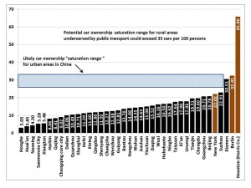
Source: Municipal statistical bureaus, TexasSure, NYS DMV, China SignPost™ estimate
While China’s most widely recognized car owning cities are located on the country’s Eastern Seaboard, a significant number of large inland metro areas have per capita private passenger car ownership rates nearly as high as coastal cities’. For instance, Chengdu has car ownership rates of nearly 20 cars per 100 residents, while Urumqi and Xi’an each fall just shy of 18 cars per 100 residents.
Other large, booming inland cities have much lower ownership rates—12.27 cars per 100 residents in Changsha and 11.20 per 100 residents in Hefei. Most notably, populous areas that are predominantly rural in layout (the so-called Tier 3, 4 and 5 areas) tend to be poorer and typically have much lower rates of car ownership. If economic growth that drives personal incomes continues, these locales are likely to be centers of car sales growth moving forward.
For instance, Honghe in Yunnan Province presently has a car ownership rate of only 3.03 per 100 residents—less than half the national average rate for private passenger cars. Current sales trends indicate that the Honghe-type cities are already seeing significant car sales increases. The China Automobile Dealers Association says that in 2012 sales volumes increased by only single digits in the first-tier cities (albeit from a high baseline), but rose 131% in second and third-tier cities.
Evolving car ownership patterns
There appears to be a “fan out” effect where a region in China first sees car sales in its largest cities and then smaller municipalities also evolve into demand centers. For example, in 2006, Chengdu was home to 92.7% of Sichuan’s private passenger car fleet but now houses around 70% of the province’s private passenger cars, a clear sign that sales are taking off strongly in Sichuan’s smaller cities and townships. We expect such geographical diversification of sales to continue as places like Beijing and Shanghai enforce increasingly restrictive policies on car sales and use.
China’s domestic car brands already heavily focus their sales efforts on the smaller and inland cities and now the Western automakers and their Chinese JV partners are doing the same. For instance, GM plans to expand its dealership network in China by more than 34% by 2015, adding 1,300 additional dealerships and focusing much more heavily on Tier 3 and Tier 4 cities. Other carmakers are also striving to expand their sales networks in Central and Western China. In the near term, this sets dealers up for thinner margins and tough price competition. But in the three-to-five-year timeframe, growing dealer networks signify that, along with road and highway construction, the elements are aligning for a significant rise in car sales and ownership in China’s interior, a diverse region nearly as physically large as, and more populous than, the U.S.
What’s Motivating Chinese Car Buyers?
In China’s largest cities, car ownership has some practical benefits, but also comes with a significant set of financial and administrative headaches, as New Yorkers will thoroughly appreciate. For instance, researchers at the Centre for Global Engineering at the University of Toronto emphasize that Shanghai charges license fees as high as US$10,000 per vehicle, along with a 10% sales tax, and parking fees of up to US$10/hr in the city’s downtown. For a wealthy person driven by the social status conferred by owning an Audi or BMW, such costs are bearable. However, for a lower income buyer purchasing his/her first entry-level BYD sedan, costs of this level essentially erase the practical benefits of convenience in transportation that the car would otherwise confer.
Car sales in China are driven by a mix of practical concerns, as well as considerations about how cars reflect social status. The best empirical data we could find from a Chinese source that speaks to what influences potential car buyers came from a team of researchers who obtained survey responses from 963 college students at Fudan University in Shanghai and Jiangsu University in Zhenjiang, Jiangsu.^{[1]} Social status issues likely help seal the deal for many car sales—especially among young men on the make looking to impress prospective spouses—but, at least for survey respondents, social considerations still find many potential buyers in the “neutral” category, meaning car sellers must make persuasive marketing pitches.
On the other side of the ledger, the study suggests that potential car buyers’ opinions are more strongly formed with respect to the practical benefits of owning private cars. Indeed, no more than 8% of respondents chose “neutral” when asked about the practicality driven aspects of owning a car (Exhibit 3). Overall, for each of the four statements about practical benefits a car confers, the respondents overwhelmingly agreed or strongly agreed with the statement.
Exhibit 3: Prospective Chinese Car Buyers Driven By Practicality and Perceptions
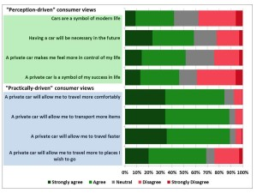
Source: C. Zhu et al., Journal of Transport Geography
These students represent an analytically useful sample for a number of reasons. First of all, they represent a social cohort—future college graduates—who are on average more likely than less-educated members of society to attain an income level capable of supporting car ownership. Second, they are a representative slice of a large group, as China churns out just under seven million new university graduates each year.
Third, the students in the sample are a diverse group, both from the perspective of where they come from and in terms of their prior auto ownership experiences. At one end of the spectrum, roughly one-quarter hail from large cities, and of these 4 in 10 come from families who own cars. At the other end of the spectrum, 29% of the students come from small townships or rural areas, and of this group, fewer than one in twelve come from families who own cars. Most interestingly, despite the wide variance in prior personal experiences with cars, nearly 2/3 of the student respondents (65%) agreed that when they have the financial means, they will “definitely buy” cars, while only 14% disagreed with that statement.
Rubber Meets Road: Examining National and City-Level Gasoline Demand in China
Detailed academic studies conclude that Chinese cars consume 7.9 liters of gasoline per 100 km driven and that the average private passenger car in China travels in the neighborhood of 20,000 km each year.[2] The National Bureau of Statistics says that at year-end 2012, Chinese drivers owned just over 93 million private passenger cars. On this basis, China’s private passenger car fleet is likely consuming approximately 2.28 million bpd of gasoline at present.
Examining gasoline demand by city helps to situate national gasoline demand hotspots relative to the country’s oil production, import, refining, and product transport infrastructure. Beijing leads Chinese private passenger car gasoline consumption at an estimated 97 kbd (Exhibit 4). Tianjin, Chengdu, and Guangzhou come next, at 65 kbd, 47 kbd, and 45 kbd, respectively.
To put these numbers into perspective, the thirstiest U.S. gasoline metropolis—Los Angeles—uses around 123 kbd of gasoline. Given that the majority of gasoline consumption is automotive, this suggests the average Beijinger uses around 15% less gasoline than the average Angeleno and around 60% less than the average Houstonian. On this basis, the total and per capita passenger car ownership rates and gasoline consumption figures in large Chinese cities suggest that even with saturation points significantly lower than those found in the U.S. or Europe, Chinese gasoline and crude oil demand still has meaningful room to grow.
Exhibit 4: Estimated Private Passenger Car Gasoline Use by Selected Metro Area
Thousand bpd
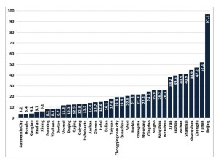
Note: For Chongqing “core city” is specified because the data provided are specific to the metro downtown. Chongqing municipality is much larger geographically than China’s three other provincial-level municipalities (Beijing, Shanghai, Tianjin), and the majority of its territory lies outside its central urban area.
Source: Municipal statistical bureaus, Energy Policy, China SignPost™ estimate
Within China’s gasoline market, locations poised for significant demand growth include heavily populated inland provinces such as Hunan, Henan, and Hubei, as well as myriad Tier 3, 4, and 5 cities across the country. For instance, Yunnan Province—home to 46 million people—saw its oil products demand, which is more than 90% gasoline and diesel fuel, rise from 8.5 million tonnes in 2011 to more than 10 million tonnes in 2012. Demand is expected to reach 14 million tonnes per year by 2015.
If the inland cities shown in Exhibit 4 each experienced a 50% increase in gasoline demand in the next several years, China’s passenger car gasoline consumption would rise by 570 kbd or 25% above the present level. This number is reasonable in light of the 15% and higher annual growth rates in private passenger car ownership in many of the cities covered. Moreover, Exhibit 4 only captures a snapshot of the hundreds of small and medium-sized Chinese cities that will drive car ownership growth as China’s 7,200+ car dealerships compete to outsell each other in coming years.
The Road Ahead
Future passenger car fleet growth in China will hinge upon Three Ps:Perception, practicality, and policy. The effects that perception and practicality concerns have on potential car buyers in China are discussed at length above. Policy is a major wildcard, as the level of permissiveness or restrictiveness cities maintain toward car sales and ownership will play a pivotal role in determining consumers’ car acquisition activity, particularly in lower reaches of the income spectrum.
Academic researchers have shown the elasticity of 3.6 between increases in GDP and rises in car ownership in Beijing, which until the five years ago maintained a permissive regime towards car owners.^{[3]} Shanghai, in contrast, has applied tough measures to constrain car sales and has an elasticity of only 1.0 between GDP increases and car ownership increases.^{[4]} Shanghai’s policies have skewed car ownership in favor of business vehicles, as opposed to private passenger cars. When people do purchase passenger cars, they tend to be higher-end models because less-well-off car buyers are effectively priced out of the market by high license plate fees and other barriers.
Evidence suggests inland cities may be more willing than their coastal cousins to tolerate car congestion and pollution as a price of development. Xi’an, which is rapidly becoming one of China’s largest car-owning cities, had planned to emulate Beijing. Shanghai, and Guangzhou and restrict license plate issuance to control car fleet growth, but had to rescind the plan in August 2012 following vociferous public outcry against the proposed restrictions. To be sure, not all inland cities share Xi’an’s attitude. Guiyang, Guizhou Province’s capital, has restricted license plate issuancesince summer 2011 despite public outcry, but does offer an unlimited number of plates for drivers willing to forego entering the city’s downtown.
Car sales in China’s Tier 3, 4 and 5 areas are likely to have GDP elasticities exceeding 3.0
The combination of the Xi’an approach, which allows unrestricted growth in car ownership, and the Guiyang approach, which only affect drivers wishing to use their vehicles in the city’s core, point to a future in which vehicle ownership in China’s interior has a Beijing-style elasticity of around 3.5 to GDP growth. Under such conditions, even if China’s economic growth were to slow significantly, many areas could still see double digit annual car sales increases.
Used Cars Will Also Gradually Help Drive Higher Car Ownership Levels
As China’s private passenger car fleet grows, vehicles age, and owners look to trade up, the country’s used car market is likely to expand, which provides an additional channel for lower income consumers to become car owners. Wealthier consumers buying new cars and allowing their old models to percolate through the market as used vehicles is only a nascent factor at present, as China’s used car market remains small—1.25 million vehicles sold in 2012, according to the China Automobile Dealers Association.
That said, used car sales are likely to substantially increase in the next 2-3 years as cars sold during the stimulus-fueled car sales boom in 2009-10 age sufficiently that their original owners seek to trade up for newer models. Moreover, cultural factors that place a premium on ownership of new cars are already clearly visible in South Korea and Taiwan; upper class mainland Chinese can be expected to mirror such trends as their wallets allow.
A Chinese government eager to prop up economic growth and local governments keen to boost local manufacturers and joint ventures are likely to cultivate such societal preferences. A mature auto market such as the U.S. will have used car sales volumes that are 2.5-3.0 times larger than new car sales. China is many years away from this, but within three years, we expect used car transactions to reach 5-6 million per year.
Commodity impacts
Chinese private passenger car fleet growth is very positive for gasoline demand. We estimate that each million new cars sold in China creates 20 kbd of gasoline demand. Based on the average gasoline yields of Sinopec and PetroChina’s refineries, approximately 100 kbd of crude oil are needed to produce 20 kbd of gasoline.
Even lower-end cars will still have substantial gasoline and crude oil market impacts. Carmakers are tailoring their product portfolios in inland parts of China to match offerings to lower income ranges than will be found in wealthier coastal areas. However, a car in Xiangtan, Hunan whose sticker price is 30% lower than a fancier model sold in Shanghai will in many cases still use approximately as much gasoline as its upmarket counterpart. Options and fancy styling consume a lot more money in terms of sticker price, but don’t usually enhance gasoline consumption significantly unless the upmarket vehicle uses a substantially larger engine. However, as more used cars penetrate lower tiers of the market and wealthier consumers upgrade to larger, thirstier SUVs, the net increases in car ownership stand to drive increased gasoline demand.
China’s rising passenger car ownership is reshaping how the country’s refiners operate. During the peak of China’s emergence as a major global oil consumer between 2004 and 2007, refiners worked to favor diesel fuel, which was badly needed to run trucks, earthmovers, and generator sets that kept factory lights on when the power grid overloaded (Exhibit 5). A significant tipping point came in 2012, when Sinopec and PetroChina, the country’s two largest oil refiners, began shifting their output slates back toward the gasoline craved by China’s burgeoning private passenger car fleet.
Exhibit 5: Sinopec and PetroChina Are Once Again Favoring Gasoline Production
Barrels of gasoline produced per barrel of diesel fuel produced
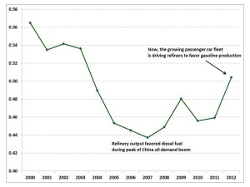
Source: Company Reports, China SignPost™ analysis
Other Commodities Positioned to Benefit
As increased car numbers drive greater gasoline demand, they also increase demand for natural and synthetic rubber as cars require original tires when produced, and periodic replacements thereafter.
China’s moves to implement Euro 4 and Euro 5 emission control standards on cars also bodes well for producers of platinum group metals such as platinum, palladium, and rhodium, which are used on automobile exhaust catalysts. In this area, the chronic instability in the mining sector of South Africa—the world’s largest PGM producer—bears close attention.
Wild Cards Affecting Investment Risk
–What proportion of emerging auto market cities will impose restrictive policies vis-à-vis current and aspiring car owners? While cities like Xi’an are adopting relatively laissez faire policies toward private auto ownership, other emerging car markets such as Shijiazhuang are planning to impose restrictions on ownership and use of private passenger cars within the next year.
–Will Chinese car buyers become more willing to buy on credit? When one of the authors visited a BYD Dealership in Shanghai in 2010, the salespeople told him that the vast majority of buyers paid cash for their vehicles. Gathering up US$10,000 or more in cash for a car purchase is a tall order. As such, using at least some degree of financing could effectively enable the millions of Chinese who have decent disposable incomes, but may not have this level of cash, to begin accessing the lower end of the car market. A number of our contacts in China say that face-conscious Chinese consumers prefer new vehicles and that they like to buy the very best they can afford. This demand pattern was dramatized to one of the authors in 2011 when he visited Bentley and Lamborghini dealerships in Qingdao and was informed of the companies’ extensive national networks, which today cover 35 and 18 cities respectively.
Greater use of financing plans such as those widely used in the U.S. could significantly expand the horizon of opportunity for many prospective car buyers; the question is whether these consumers will be willing to assume meaningful levels of debt. China’s rising credit card ownership suggests consumers might be more willing to assume debts than before, as the country’s number of credit cards in circulation rose 16% year on year in 2012 to 331 million cards. But by the same token, card users’ behavior appears relatively debt averse. Chinese cardholders tend to pay off their balances more quickly than Americans, with only 3% to 8% of cardholders rolling over balances and incurring interest charges, as opposed to 40% of American credit card holders.
–Will car ownership undermine use of widely available public transport in larger cities? The answer to this question will depend largely on whether individual buyers are purchasing cars for practical or perception reasons (i.e., because everybody else is doing so). For a person living well inside the core city, public transport is certainly cheaper than car travel; and in the more congested cities, is also likely faster between points than driving one’s own car would be.
–Will higher levels of car ownership shift Chinese long-distance travel culture away from railways? The idea of “road trips” that is so popular in North America is not widely shared in China, but as highway infrastructure between cities improves and more people own cars, this could change meaningfully. For trips that would require more than several hours of driving, we believe the wealthier consumers will choose to fly and middle class and below, even if they have a car, would find it cheaper and more convenient to travel by rail.
–Will a Chinese analog to Zipcar emerge? Zipcar says each one of its cars can replace 20 privately-owned ones. If social perception reasons are the root driver of car purchases, the emergence of a popular Chinese membership-based car sharing company is unlikely to undermine demand growth. If practical demands (i.e., transporting personal items on an irregular basis) predominate, however, then this could have a major impact in congested Chinese cities in which car ownership may be expensive and inconvenient.
–Will alternative vehicles (e.g., electric vehicles and natural gas-powered vehicles/NGVs) make substantial inroads into the passenger car market?At this point we believe that NGVs will primarily be used a taxis and fleet vehicles due to logistical challenges of obtaining natural gas fuel and the cost of converting gasoline powered cars to run on NG, but more generous government incentives to adopt NGV could change this. Similar dynamics would likely apply to electric vehicles, which might also be promoted by government policies designed to support Chinese companies attempting to capture share of an emerging green vehicle market.

Additional information:
–Gabe Collins and Andrew Erickson, “Downturn to “New Normal”? China’s Consumer Economy is Rolling Over and Sales of Chicken, Cars, and Shoes Are Taking a Hit,” China SignPost™ (洞察中国) 60 (1 August 2012).
–Gabe Collins and Andrew Erickson, “Electric Bikes are China’s Real Electric Vehicle Story,” China SignPost™ (洞察中国) 49 (7 November 2011).
–Gabe Collins and Andrew Erickson, “The 10 Biggest Cities in China That You’ve Probably Never Heard of,” China SignPost™ (洞察中国) 37 (1 June 2011).
–Gabe Collins and Andrew Erickson, “Chinese Now Pay 33% More for Gasoline and 16% More for Diesel Than Americans,” China SignPost™ (洞察中国) 23 (21 February 2011).
–Gabe Collins and Andrew Erickson, “Counting the Barrels: Heavy Truck Sales are a Better Barometer Than Car Sales of China’s Oil Demand Growth,”China SignPost™ (洞察中国) 20 (31 January 2011).
–Gabe Collins and Andrew Erickson, “Dying for a Spot: China’s Car Ownership Growth is Driving a National Parking Space Shortage,” China SignPost™ (洞察中国) 17 (10 January 2011).

http://greaterpacificcapital.com/the-china-dream-the-role-of-chinas-urbanisation-and-the-rise-of-an-independent-class-of-citizen/

November 2013

The China Dream: The Role of China’s Urbanisation and the Rise of an Independent Class of Citizen
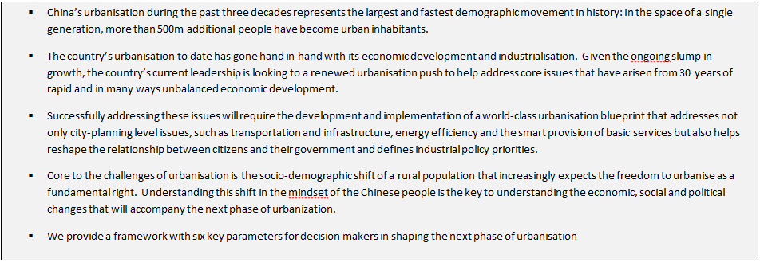

In 1980, at the beginning of China’s economic reform and 30 years after the Communist Party implemented the country’s rapid industrialization, China’s urban population stood at 200m people. By the end of 2011, this number had grown to over 700m. Between these two dates lies the largest and fastest social movement in history, in which the country’s urbanisation rate increased from less than 20% to over 50%. China today has the world’s largest urban population by far, with over 170 cities with populations above 1m, of which seven have populations above 10m.^{[1]} Moreover, this demographic trend is still on-going. In the next phase, nearly 70% of China’s population is expected to live in urban areas by 2025, bringing it on par with countries like Germany and Italy. And in the third phase, China will move to 80% in line with the urbanisation rates of Japan, the US, France and the UK.[2] To make just the next shift a successful one, China, having built out the world’s largest urban infrastructure, will need to create housing, employment, security and services for an additional 250m urban residents within the next 12 years. However, the China of the 1980s had a rural population that felt privileged to have the opportunity to move to the cities while today’s population increasingly expects this as a right. Moreover, a large section of this urban population made their own choice to move to urban centres and, because of their decision they have fallen outside of the state’s social benefits net, are the new independent China. Understanding this shift in the mind-set of the Chinese people is key to understanding the economic, social and political changes that will accompany the next phase of urbanisation.
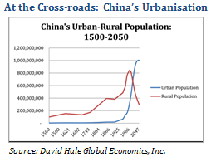
Managing China’s continuing urbanisation appears to be one of the cornerstones of Premier Li Keqiang’s first administration. Having reportedly rejected the National Development and Reform Commission’s US$6.5 trillion urbanisation plan earlier this year^{[3]}, reportedly over concerns that the proposed plan would trigger another spending binge that pushes up government debt levels, Premier Li has repeatedly spoken of the importance of urbanisation as “the key to unlocking China’s domestic demand”^{[4]} and as a “huge engine” for China’s economic growth.^{[5]} In China, as in other countries, economic growth and urbanisation have gone hand in hand. However, in most countries, urbanisation is a result rather than a cause of growth while in China’s top down development model urbanisation has been a key driver of economic growth. China’s massive fixed asset investments in the past decades have not only increased agricultural productivity and freed up rural populations, they have also created the urban infrastructures that have absorbed these excess populations. Moreover, urbanisation has pushed up land prices and resulted in real estate investment becoming one of the largest contributors to the Chinese economy, contributing 13% of GDP in 2011. Accordingly, for China, managing urbanisation is indeed a core issue for the country’s continued economic development and growth, and it is no surprise that the country’s Five Year Plan’s include growing urbanisation rate targets among the key economic development metrics to be worked towards. More fundamentally, managing urbanization is key to the political stability of the country too.Key Urbanisation ChallengesGiven the direct causality between urbanisation and economic growth, China’s current model of urbanisation has directly contributed to many of the issues facing the economy today. As China seeks to rebalance its development model and transition to a developed economy, it will need to address the core issues created or exacerbated by China’s urbanisation model to date.The Key Physical Challenges in Managing Urban Change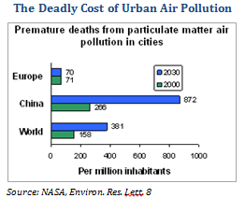
Environmental Issues. China’s environmental issues, of which pollution is one of the most pressing ones, are widely recognised and well understood today, and while pollution is not exclusively an urban problem, China’s cities are among the key contributors to the country’s pollution problem, as well as being areas of high pollution themselves. China today is home to 16 of the 20 most polluted cities in the world.[6] China’s cities have been built for speed and scale rather than efficiency and its buildings on average require twice as much energy to heat and/or cool as comparable buildings in the US or Europe[7], creating the need for additional power plants (mainly coal fired) to be built nearby, creating significant incremental air pollution to that produced by automobiles. World class public transportation (Beijing and Shanghai already have the world’s third and fourth largest metro systems in the world) and wider roads have not been able to adequately address these issues, particularly as car ownership in China continues to increase. Further, in addition to air pollution, China’s cities are a key source of waste production and a large consumer of scarce water resources by nature of their poor planning. While China’s leaders have recognised many of these environmental problems and taken initial corrective measures, implementation remains the key challenge, with for example, 95% of new buildings constructed in the country, currently not meeting the government’s energy efficiency regulations.
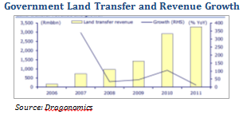Need for Land Reform.
The growth of China’s cities is additionally hampered by the current system of land rights, in which rural land is communally owned and leased by individuals for farming. As cities grow and expand into rural areas, local governments rezone farmland for urban development, providing additional space for cities to grow and in theory providing rural inhabitants with attractive compensation for the sale of their increasingly valuable land. In practice, local governments finance their budgets by acquiring rural land at below market value, rezoning it, and selling it on to developers for a significant profit. Land sales by local government in 2012 totalled US$230bn, representing over 10% of their total income. With the estimated compensation paid to farmers as low as 2% of the land’s market value,[8] China land sale system exacerbates the negative impact of the hukou system, with rural inhabitants being forced to give up their land for little compensation and subsequently resettle in cities without receiving urban benefits, thereby losing out on both sides of the rural-urban transition. It is therefore unsurprising that conflicts over land accounted for 65% of the 187,000 mass conflicts in China in 2010. The combination of land rights and the hukou system are among the key drivers of China’s rising income inequality, with average urban incomes nearly 3.5x higher than rural ones. Addressing these issues is clearly critical not only for China’s urbanisation but also for continued social stability.
Financing Additional Housing. Following decades of rapid investment, local governments don’t have the money to further build out cities. With development to date largely financed through bank debt, local government debt in China is estimated at up to 20 trillion yuan (US$3.3 trillion), or almost 40% of GDP, following the massive economic stimulus program enacted to counter the global financial crisis in 2008 and subsequent lending designed to counter the country’s recent overall macro-economic slowdown. The build-out of China’s cities, particularly housing, is increasingly dependent on private developers. However, there is a huge mismatch between land development, property prices and housing need. China’s urban boom has created one of the history’s largest house price bubbles, with average housing costs in Beijing at more than 10x the average annual household income. Today, over 100m urban inhabitants, particularly migrant workers, live in housing units built by former farmers whose villages have been encompassed by growing cities. As increasingly valuable land is rezoned and transferred to developers, these focus on building middle class and luxury housing, creating a net loss of housing space that pushes lower income inhabitants to the outskirts of the city, where the development cycle starts anew. China’s government needs to find a way to finance and build appropriate housing for up to 400m current and expected urban inhabitants in the next 12 years, which implies building housing not only where it is actually required (rather than in empty “ghost” cities) but also creating a development model that creates profitable opportunities for the private real estate developers and investors required to finance the build-out.
“China’s government needs to find a way to finance and build appropriate housing for up to 400m current and expected urban inhabitants in the next 12 years”

The Challenge from the People in Mass Urban Change
1.) Creating New and Meaningful Urban Employment. While agricultural productivity gains and rural land development are creating the population and the space for continued urbanisation, the government will need to ensure sufficient volume and quality employment to meet the expectations of the urban migrants. China will also need to direct migration flows to high growth areas with urban labour markets that can absorb excess workers. However, China’s current growing mega-cities with high costs of living and increasing space restrictions are not ideally suited for the labour intensive manufacturing that has employed past generations of urban migrants. Moreover, the country’s leaders increasingly see cities as the key drivers of the country’s shift to consumption led growth rather than the past formula of industrialisation. This in turn requires increasing levels of disposable incomes its cities, rather than the creation of more entry level lower income jobs. China’s ongoing urbanisation therefore faces a dual challenge of simultaneously growing to absorb new urban populations and transforming their existing populations into high value consumers, with one requiring a low cost of living to execute and other triggering increasing costs of living.
2.)Integration of the Growing “Independent Class”. China’s urbanization has created a large class of citizens living outside of the state system in every major urban centre. The roots of the issue lie in China’s hukou system. In China, the provision of basic welfare services is tied to a citizen’s hukou, or registered residency status, which in turn is tied to an individual’s registered household. Official employment, education, residency status and any other government service are only provided to citizens in the location that matches their hukou, with little or no ability for migrants to obtain urban hukous when they move to cities. This system has in the past provided cities with a cheap source of migrant labour (for whom they do not need to provide basic services), and enabled rapid growth without needing to scale expensive facilities such as hospitals and schools. In Shanghai, for example, the demand for primary schooling outstrips supply by a factor of three. The increased cost of living this creates for migrant workers decreases the attractiveness of living in high cost cities, with many large eastern cities now experiencing labor shortages. To date, this class has been willing to forego their basic right to state support in search of economic opportunity, however, with the cost of living rising and the population ageing, it is clear that cities will need to raise the level of benefits provided to continue to attract labour and talent. China’s cities today are unable to finance the cost of providing urban level benefits even to their existing populations. There are an estimated 300 million urban residents not receiving services on account of their rural hukous in China today: providing benefits to these people would cost an additional 3.8% of GDP every year. Adding and effectively integrating an additional 250m urban residents over the next decade will clearly require a fundamental reform of this system. While this class of citizen is not the same as India’s slum population (See The Sign of the Times, “Transforming India’s Slums”, October 2013[9]), it shares some important characteristics with that group: living outside of the state system of benefits, providing a significant portion of entry level jobs and intensive labour, willing to work in the system at rates that undercut the next level in the economic ladder, enterprising and hard-working, and most importantly, economically and socially independent of the state, and thereby independent of the ruling Communist Party. The new China could well be defined by the will of this new independent class of citizen rather than the physical engineering of its urban infrastructure.
China’s Shifting Urbanisation Priorities: A Blueprint
China’s urbanisation and industrialisation in many ways is following a well-understood path, first trodden by Western Europe and the US in the 19th century and subsequently by Japan and the Asian Tigers in the 20th. Urbanisation in these countries has seen the rise of world cities such as New York, Paris and Tokyo. China’s tier one cities (Shanghai, Beijing, Guangzhou) are widely seen as aspirants to this league. However, the sheer scale of China’s urbanisation will force its planners to focus their attention on transforming the increasing number of tier two, three and four cities which will witness the strongest growth in the next 20 years. Further, given the advances in information technology, environmental technology, energy, material sciences and transportation, it is unlikely that China’s cities of the future will seek to emulate the blueprints (both literally and figuratively) laid down by the previous waves of urbanisation. China’s urban planners today have the unique opportunity to develop the template for urban living in the 21st century, which will not only create cities that complete the country’s industrialization but also provide a testing ground for the validation and commercialization of new technologies and models of habitation. Doing so will require a massive departure in focus for China’s urban planners from the previous growth model, requiring the government to effect fundamental changes across six dimensions of urbanisation policy.
The Issue: Unsustainable First Wave. China’s urbanisation to date has been focused on building out cities and infrastructure as fast as possible, both to absorb the waves of rural immigration and to maintain high rates of investment (and therefore economic growth). This has been a great success. However, the quality of both planning and building suffered as a result and today many of China’s cities face dysfunctional urban sprawl and pre-mature urban decay, with 20 year old buildings appearing ready to begin (and in some cases actually) tumbling down.
The Challenge: From Speed to Sustainability. In the next wave of urbanisation, China will need to focus on the sustainability of its urban environments, both in terms of the quality of the infrastructure as well as in the quality of the design. Urban planners will need to significantly improve the environmental footprint of China’s cities, reducing water usage, energy consumption and carbon emissions. This will require among other things the introduction and use of smart materials, new models of power generation, integrated recycling technologies and improved urban transport systems.[10] Implementing all of these technologies will likely radically alter the face of urban environments, with fewer ultra-high rise buildings, increased mixed usage development and widespread car-free zones, among other features. Creating the sustainable cities of tomorrow today does not require fundamental technological innovation, it requires the innovative application and integration of well-established and validated technologies on a massive scale, a model that China is well familiar with, having successfully followed it for the past 20 years with regards to industrialisation. Given the experience of the last 20 years, it will no doubt require a new wave of foreign businesses to help China grow who, given their compatriots’ lessons learnt, may well require new commitments, new incentives and new protections for their intellectual property and capital.
The Issue: Risk of Mass Instability from Demand-Supply Gap. China’s current urbanisation strategy is focused on absorbing (and in many cases) attracting rural migrants into cities, thereby supporting infrastructure build out and fixed asset investment. Actually keeping China’s growing urban populations in the cities and, moreover, keeping them happy requires more than simply creating living space, however. Failure to deliver on the rising imbalances caused by growing urban populations without a massive increase in basic services will lead to significant deterioration in the quality of life for urban inhabitants – regardless of their hukou status – and threaten social stability in the long run.
The Challenge: Delivering Increased Quality of Life. While the first generation of urban settlers are happy to have a job, their children expect quality of life. If China’s cities are to support personal and social development, they will need to be oriented to enabling people to focus on family, community alongside material advancement, wealth creation and so will ultimately allow the enjoyment of urban lifestyles. This requires a fundamental rethink of the delivery and financing of basic urban services, including primary and secondary schooling, hospitals and health services, government services, care for the elderly retirement homes, and other services. Successfully executing the above will require not only building (significantly) more of the same, but rethinking the delivery of these services as well, for example through the adoption of e-government services or a reform of the urban healthcare system, where large hospitals continue to serve as the primary point of care for all healthcare needs. Changing the models of education, health and the bureaucracy involved is clearly a tall order that will require massive buy-in across municipal, provincial and even central governments. However, failing to deliver on urban level services creates an unhappy citizen and ultimately one that is willing to act against the government programme. While the majority of China’s civil unrest has historically occurred in the countryside, China’s cities, with their much denser and technologically networked populations, have the potential to be tinderboxes for disorder on a scale not witnessed since the protests of Tiananmen Square in 1989, an event that continues to shape China’s domestic policy even today.
The Issue: Urban Development Building Unsustainable Scale. Today, well over 20m people live in each of the metropolitan areas of Shanghai, Beijing and Chongqing, and it is clear that these cities cannot continue to grow at the same rate indefinitely. Even if the ensuing logistical, geographical and environmental problems of continued mega-city growth could be successfully addressed, the sheer scale of China’s urbanisation implies that simply scaling large cities will not be sufficient to integrate the onslaught of rural migrants expected to arrive there during the next decade.
The Challenge: From MegaCities to MegaTowns. China’s next wave of urbanisation needs to focus on developing smaller cities and towns that effectively, economically and socially, integrate rural environments; much like medieval European market towns served as an economic and political focal point for the surrounding agricultural countryside. By developing strong urban-rural linkages facilitating the flow of people, good services and capital, China can significantly increase the economic performance and the quality of life for both regions. Properly managed, the per-urban zone connecting the two regions becomes the foundation linking multi-centric metropolitan areas with green infrastructure and advanced transport links. This will require the creation of mega-towns and villages that positively impact the nature of rural urban flows, partially absorbing and in some cases reversing the otherwise one way flow into cities. However, improperly managed the per-urban zone becomes an expanding belt of suburban sprawl surrounding an overcrowded city core. Further, the peri-urban zone will also need to fulfil the tourism and leisure needs of urban populations. Chinese cities have no equivalent to a Central Park and public spaces are generally overcrowded. With increasing urban wealth and mobility the transition zone will become an increasingly important destination for leisure spending and China’s urban planners will need to develop land accordingly.
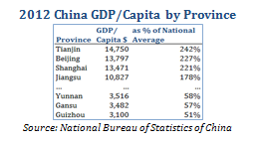

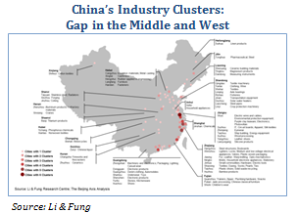
The Issue: Fragmented Growth, Fragmented Loyalty.
China’s commitment to developing its central and western region is clear. Indeed, balanced geographic growth was identified as a key priority over a decade ago with the enactment of policies such as the “Open Up the West Program” and the “Rise of Central China Plan”, which poured billions of renminbi into infrastructure investments in the regions. However, these regions have failed to close the gap with the richer regions on China’s eastern seaboard.
The GDP per capita of the southwestern provinces of Guizhou and Yunnan, collectively home to over 80m people, is less than a third of the GDP per capita enjoyed by Jiangsu or Zhejiang, the provinces at the mouth of Yangtze River. Places like the former or the marginally better off provinces of Anhui Henan and Sichuan (home to a total 230m people) are the leading sources of China’s future rural migrant populations and therefore need to be at the forefront of the country’s urbanisation planning. This will require much more than infrastructure investment.
The Challenge: From East to West. Successful urbanisation strategies in Western and Central China require significant industrial and economic planning and investment, in addition to more traditional urban planning. To do this, city planners will need to attract large industries to ring the major urban centres. From the perspective of development strategy, the country has the case study of having built a number of world-class industry hubs in cities on its eastern seaboard, with many cities host to multiple industry clusters. Multi-cluster cities in central China are few and far between, however, while in western China, even single industry urban hubs remain the exception, rather than the rule. Although cities such as Wuhan and Chongqing in central China have already built large industrial bases (in fact, both cities are vying to be the “Detroit of China” for their large automotive industries), China’s leaders will need to develop much more focused and faster industry cluster strategies to push industrialization and urbanisation into its middle and western regions.
The Issue: China Remains the Workshop of the World. As the US shale gas discovery heralds a new age of repatriation of certain industries to the US, the best case might well be that China retains its status as the workshop of the world. This is clearly not good enough given the aspirations of China. China’s envisaged “smart cities” of the future will be smart not only because of their technology and communications infrastructure but because of the intelligence and creativity of their inhabitants. As China transitions to a fully developed and more balanced economy it will need to leverage and continue to nurture its urban middle class. The growing middle class is not only the main engine of the desired rebalancing to more consumption, it also provides the educated creative classes that will innovate the high value goods and services develop new technologies and even entire industries. China’s next wave of planning will need to fully unlock the potential of its human capital, implying not only the creation of high value jobs in technology sectors but also high end education, healthcare and welfare policies to ensure the continuing flow of talent to these sectors.
The Challenge: Shift from Industrial to Knowledge Economy. Previous efforts by China to build knowledge industries have, unsurprisingly, focused largely on fixed asset infrastructure: Shanghai’s Zhangjiang Hi-Tech Park has been dubbed China’s Silicon Valley but in reality has been largely a real-estate play that provided favourable rental and local tax terms to “high-tech” companies. Creating a true competitor to Silicon Valley requires much more: the coordinated integration of “soft” infrastructure including government research facilities, universities and higher education, and banking and finance, alongside more traditional urban planning that creates attractive spaces for work and living as well as the build-out of smart infrastructure. More fundamentally, however, nurturing and attracting creative talent over the long term will require not only coordinated planning and management but an open society that embraces the free exchange of information.[11] Failing to provide the freedom to information and ideas – no matter how radical – is a natural limiter on development past a certain point; a point that China is already at.

Issue: A New Independent Class Grows that Challenges the State. China’s urbanisation to date has led to the development of a large rural migrant underclass outside of the systems of rewards and benefits controlled by the country’s ruling Communist Party. The party has enjoyed absolute control over the country’s governance for over 64 years, making it the longest standing political party in power globally today. However, the CCP’s ability to remain in power is largely dependent on fulfilling the implied social contract upon which its continuing legitimacy rests. Unlike imperial China, where legitimacy was derived from the “Mandate of Heaven”, or modern democracies, which derive legitimacy from regular popular elections, the CCP has needed to establish legitimacy from other sources. Originally seeking to legitimise its rule from revolutionary and Marxist ideology, China’s rulers have since implemented economic reforms, shifted to legitimacy based on delivering economic growth and competent government while maintaining social harmony, thereby providing a better life for all citizens. However, the creation of an urban class without state benefits in a system of increasing wealth inequality has created an independent group of people with fragmented loyalty to the state or ruling party and with the potential to call in question the CCP’s continued legitimacy, thereby creating the risk for considerable political instability. On the flip side, this new breed of citizen is a great asset since it is one that is self-dependent and enterprising.
The Challenge: Creating Partners for On-going Development. While previous generations of Chinese have willingly forfeited their political voice in exchange for the care provided by a paternalistic communist state, the current generation, including both migrant workers and young urban professionals, expects the continuing delivery of economic opportunities and are less likely to trade freedom of expression for this right. While China will certainly need to provide adequate social services to its citizens overall, the country’s smart, independent and ambitious urban class are self-starters who require no state hand-outs to be successful, instead looking to the provision of a transparent and level playing field free of corruption within which to make rational economic decisions and to take risks. If managed properly, China’s ambitious urban class can be partners for the necessary economic transformation currently underway, acting as entrepreneurs, innovators and business leaders. If managed improperly, this class could represent a major threat to the country’s social stability and the communist party’s continued political legitimacy. Successful management will require a continued systematic and widespread crackdown on government corruption, a further roll-back of state economic activity to create opportunities for the private sector and further liberalization of the financial sector to enable capital allocation via market mechanisms rather than political policy.
Conclusion: Starting the Next Wave of Urbanisation
Within the next few weeks, Premier Li Keqiang is expected to announce the roadmap for China’s “new type of urbanisation.” It will doubtless contain a number of headline grabbing mega-scale infrastructure projects such as the linking of nine major cities in Guangdong into a single city of more than 40m. The development plan for China’s 170 smaller cities will be an important test of the credibility of the overall plan. Given the long-term perspective typically taken by the Chinese Communist Party and the clarity of the issues the country is currently facing, it would be very surprising if the new urbanisation plan did not seek to address, in some form or another, the six transitions laid out above. The devil, as always, is in the detail and how the grand vision is translated into specific actions at the local level will determine the ultimate success or failure of the plan. This will require the alignment of incentives with the local government officials who will be responsible for implementing the country’s urbanisation plan on the ground. China has published environmental goals in its five year plans for many years but has failed to translate these into concrete performance targets by which local officials were measured. Accordingly, the environmental targets in the country’s five year plans were consistently missed. Only recently have government officials been held accountable for local environmental outcomes, with a significant increase in protection measures subsequently ensuing. Successful urbanisation will require a similar alignment of incentives between national targets and local government accountability.

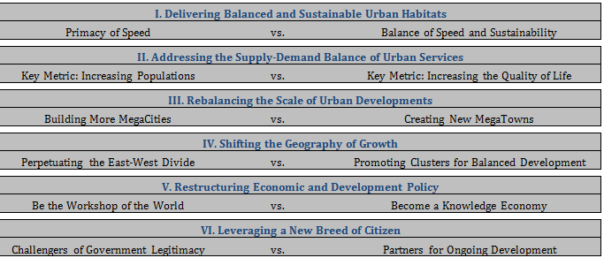
More importantly perhaps, the list above of the six strategic shifts for the next wave of urbanisation demonstrate that China’s urbanisation challenges are closely tied to its broader economic, social and political challenges and cannot be answered by simple urban planning, no matter how well thought out or executed. Stated more precisely, urbanisation is chiefly an economic phenomenon with significant social and therefore political implications and an effective urbanisation strategy will need to be comprehensively tied into development initiatives across these three fields. Among the list of the six challenges above, the first four can largely be met by traditional urbanisation strategies, determining where to build, how to build, what to build and for whom to build. The last two however tie more deeply into the shifting underlying economic strategies and priorities of China and the ensuing social development models it needs to adopt to deliver continued growth and stability. Economic reform, political transparency, endorsing openness and freedom, market mechanisms and economic liberalism are all critical elements of this continued growth and as the Sign of the Times has explored frequently and cannot be addressed in isolation. As China’s leaders prepare for the upcoming Third Plenum of the 18th Party Congress, which many observers expect will be a landmark event in China’s economic reforms as well as the platform for announcing the country’s revised urbanisation blue-print, they will also need to give analytic and creative energy to the interconnectedness of China’s challenges.

[1] Source: http://english.people.com.cn/data/China_in_brief/Administrative_divisions/Cities.html
[2] Source: World Urbanization Prospects
[3] Reported by Reuters 23/5/13
[4] Source: http://www.primeeconomics.org/wp-content/uploads/2013/06/Li-Keqiang-China-urbanization-speech.pdf
[5] Source: http://www.independent.co.uk/news/world/asia/li-keqiang-urges-deeper-urbanization-to-support-chinas-growth-8343013.html
[6] Source: http://www.nytimes.com/2007/08/26/world/asia/26china.html
[7] Source: World Bank
[8] Source: http://www.landesa.org/china-survey-6/
[9] Source: www. http://greaterpacificcapital.com/transforming-indias-slums-a-critical-step-in-creating-the-new-india/
[10] Nobuyuki Idei explored what smart urban infrastructures of the future might look like in the earlier Sign of the Times http://greaterpacificcapital.com/article/grand-design-and-society-creating-the-cities-of-tomorrow/
[11] See the April 2012 Sign of the Times: China and the Freedom Advantage http://greaterpacificcapital.com/china-and-the-freedom-advantage/

The Economist

Urbanisation

Where China’s future will happen

For the world’s sake, and its own, China needs to change the way it builds and runs its cities
Apr 19th 2014 | From the print edition
Video @ http://www.economist.com/news/leaders/21601027-worlds-sake-and-its-own-china-needs-change-way-it-builds-and-runs-its
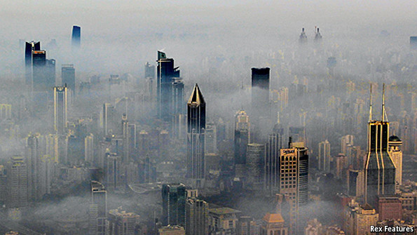
“A GREAT city”, said Benjamin Disraeli, “…is the type of some great idea. Rome represents conquest; faith hovers over the towers of Jerusalem; and Athens embodies the pre-eminent quality of the antique world, art.” In building its cities, China’s officials have had only one great idea in mind: growth. That has brought huge benefits, and problems too.
In the three decades since economic liberalisation began, China’s urban population has risen by more than 500m, the equivalent of America plus three Britains. China’s cities, already home to more than half the country’s people, are growing by roughly the population of Pennsylvania every year. By 2030 they will contain around a billion people—about 70% of China’s population, and perhaps an eighth of humanity. China’s fate, and that of the Communist Party, will be determined by the stability of its cities (see special report).
Much of what has happened is breathtakingly exciting. Shanghai, a drab communist-era sprawl with a few 19th-century relics until the 1990s, has been used as the cosmopolitan backdrop for a James Bond film. Chengdu, whose population has grown by 50% since 2000, boasts the world’s largest building: the New Century Global Centre, which includes a shopping mall and a 300-metre-long indoor artificial beach. Zhengzhou now claims the largest bullet-train station in the world: the $2.4 billion edifice and surrounding area covers the equivalent of 340 football pitches. China’s urbanites whizz from city to city at 300kph (186mph) on a bullet-train network that did not exist six years ago yet now is longer than all of Europe’s. By 2020 it will expand by another two-thirds, or 7,000km (4,300 miles), and every city with a population of 500,000 or more will be connected to it.
Cracks in the façade
Yet the model of pell-mell urbanisation is breaking down. Even the government recognises this. In March the prime minister, Li Keqiang, described the noxious smog that shrouds China’s cities as a “red-light warning against the model of inefficient and blind development”. The World Bank and a Chinese government think-tank have just produced a 544-page report on urban China. It praises China for avoiding ills common in the developing world such as urban poverty, squalor and unemployment. But it says that “strains are starting to show” and that the model is “running out of steam”.
Two flaws in the Chinese model of urbanisation are causing these strains. The first is economic. Farmers in China have no property rights, so officials are able to grab agricultural land on the peripheries of urban areas and make money for themselves and their cities by selling it to developers. This is not only unjust; it has also led to a relentless pouring of concrete that has given rise to “ghost cities”—half-empty forests of high-rise office and residential buildings that have sprung up around many cities. The vast debts local governments have incurred as a result of this over-hasty development are the focus of foreign worries about the country’s economic stability.
This urban sprawl is also exacerbating China’s environmental problems. People need cars to get around the country’s American-style cities. Beijing now has more cars than Houston, as well as some of the dirtiest air on the planet. And it is not just affecting the Chinese. The nation passed America in 2006 as the biggest emitter of carbon dioxide from energy, and is now pumping out nearly twice America’s level.
The second flaw in the urbanisation model is a social one. China’s cities are now largely made up of two classes, each with a population roughly the size of America’s: a property-owning middle class which enjoys new social freedoms (see article), takes holidays in Europe (see article) and spends like its Western counterparts; and a migrant underclass which toils in factories and menial jobs but is denied public services because its hukou (household registration) is still in the countryside. Both groups have fared well in the boom years; but discontent is growing (see article), and they distrust each other, as well as the party.
On March 16th the government unveiled a long-awaited plan for managing urbanisation. Under the new approach, some 100m migrants will be given urban hukou, and thus full access to urban services by the end of the decade. But that will still leave 200m unregistered, and the issue of who should pay the bill unresolved. Reformers want a new tax on property—the soaring value of which is enriching the middle classes—to provide local governments with a steady revenue stream. The central government fears that this could spur demands by homeowners for more say in how cities are run.
House of cards
The challenge for Xi Jinping, China’s president, and his team is as immense as the cities themselves. But there are two obvious steps for them to take. The first is to give farmers property rights and thus the ability to sell their land. If the market were allowed to operate, prices would be high. Overall, China has less habitable space than America but four times as many people. Much of the country is mountain or desert, unusable for development. High prices, reflecting this shortage, would force urban planners to regard land as a scarce resource and to use it efficiently. That would discourage them from allowing American-style sprawl and encourage them to build dense, energy-efficient European-style cities in which people walk, cycle or take public transport to work.
The second necessary step is to open up decision-making. One reason why so many Chinese cities are grim is that residents have so little say in how they are planned, built and run. If people had the right to elect their mayors and legislators, they would—assuming they behaved like city-dwellers elsewhere in the world—insist on planning controls to constrain development and improve the environment.
The document unveiled in March called the government’s urbanisation plan “people-centred”. If the next stage of China’s phenomenal urban transformation is to bring prosperity and stability rather than conflict and chaos, the party needs to live up to the phrase.

