NYT

China Leading Global Race to Make Clean Energy
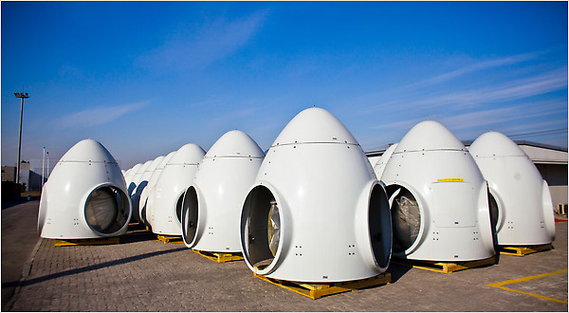
Components of wind turbines at a factory in Tianjin, China. Shifting to sustainable energy could leave the West dependent on China, much as the developed world now depends on the Mideast.

By KEITH BRADSHER
Published: January 30, 2010
TIANJIN, China — China vaulted past competitors in Denmark, Germany, Spain and the United States last year to become the world’s largest maker of wind turbines, and is poised to expand even further this year.
China has also leapfrogged the West in the last two years to emerge as the world’s largest manufacturer of solar panels. And the country is pushing equally hard to build nuclear reactors and the most efficient types of coal power plants.
These efforts to dominate renewable energy technologies raise the prospect that the West may someday trade its dependence on oil from the Mideast for a reliance on solar panels, wind turbines and other gear manufactured in China.
“Most of the energy equipment will carry a brass plate, ‘Made in China,’ ” said K. K. Chan, the chief executive of Nature Elements Capital, a private equity fund in Beijing that focuses on renewable energy.
President Obama, in his State of the Union speech last week, sounded an alarm that the United States was falling behind other countries, especially China, on energy. “I do not accept a future where the jobs and industries of tomorrow take root beyond our borders — and I know you don’t either,” he told Congress.
The United States and other countries are offering incentives to develop their own renewable energy industries, and Mr. Obama called for redoubling American efforts. Yet many Western and Chinese executives expect China to prevail in the energy-technology race.
Multinational corporations are responding to the rapid growth of China’s market by building big, state-of-the-art factories in China. Vestas of Denmark has just erected the world’s biggest wind turbine manufacturing complex here in northeastern China, and transferred the technology to build the latest electronic controls and generators.
“You have to move fast with the market,” said Jens Tommerup, the president of Vestas China. “Nobody has ever seen such fast development in a wind market.”
Renewable energy industries here are adding jobs rapidly, reaching 1.12 million in 2008 and climbing by 100,000 a year, according to the government-backed Chinese Renewable Energy Industries Association.
Yet renewable energy may be doing more for China’s economy than for the environment. Total power generation in China is on track to pass the United States in 2012 — and most of the added capacity will still be from coal.
China intends for wind, solar and biomass energy to represent 8 percent of its electricity generation capacity by 2020. That compares with less than 4 percent now in China and the United States. Coal will still represent two-thirds of China’s capacity in 2020, and nuclear and hydropower most of the rest.
As China seeks to dominate energy-equipment exports, it has the advantage of being the world’s largest market for power equipment. The government spends heavily to upgrade the electricity grid, committing $45 billion in 2009 alone. State-owned banks provide generous financing.
China’s top leaders are intensely focused on energy policy: on Wednesday, the government announced the creation of a National Energy Commission composed of cabinet ministers as a “superministry” led by Prime Minister Wen Jiabao himself.
Regulators have set mandates for power generation companies to use more renewable energy. Generous subsidies for consumers to install their own solar panels or solar water heaters have produced flurries of activity on rooftops across China.
China’s biggest advantage may be its domestic demand for electricity, rising 15 percent a year. To meet demand in the coming decade, according to statistics from the International Energy Agency, China will need to add nearly nine times as much electricity generation capacity as the United States will.
So while Americans are used to thinking of themselves as having the world’s largest market in many industries, China’s market for power equipment dwarfs that of the United States, even though the American market is more mature. That means Chinese producers enjoy enormous efficiencies from large-scale production.
In the United States, power companies frequently face a choice between buying renewable energy equipment or continuing to operate fossil-fuel-fired power plants that have already been built and paid for. In China, power companies have to buy lots of new equipment anyway, and alternative energy, particularly wind and nuclear, is increasingly priced competitively.
Interest rates as low as 2 percent for bank loans — the result of a savings rate of 40 percent and a government policy of steering loans to renewable energy — have also made a big difference.
As in many other industries, China’s low labor costs are an advantage in energy. Although Chinese wages have risen sharply in the last five years, Vestas still pays assembly line workers here only $4,100 a year.
China’s commitment to renewable energy is expensive. Although costs are falling steeply through mass production, wind energy is still 20 to 40 percent more expensive than coal-fired power. Solar power is still at least twice as expensive as coal.
The Chinese government charges a renewable energy fee to all electricity users. The fee increases residential electricity bills by 0.25 percent to 0.4 percent. For industrial users of electricity, the fee doubled in November to roughly 0.8 percent of the electricity bill.
The fee revenue goes to companies that operate the electricity grid, to make up the cost difference between renewable energy and coal-fired power.
Renewable energy fees are not yet high enough to affect China’s competitiveness even in energy-intensive industries, said the chairman of a Chinese industrial company, who asked not to be identified because of the political sensitivity of electricity rates in China.
Grid operators are unhappy. They are reimbursed for the extra cost of buying renewable energy instead of coal-fired power, but not for the formidable cost of building power lines to wind turbines and other renewable energy producers, many of them in remote, windswept areas. Transmission losses are high for sending power over long distances to cities, and nearly a third of China’s wind turbines are not yet connected to the national grid.
Most of these turbines were built only in the last year, however, and grid construction has not caught up. Under legislation passed by the Chinese legislature on Dec. 26, a grid operator that does not connect a renewable energy operation to the grid must pay that operation twice the value of the electricity that cannot be distributed.
With prices tumbling, China’s wind and solar industries are increasingly looking to sell equipment abroad — and facing complaints by Western companies that they have unfair advantages. When a Chinese company reached a deal in November to supply turbines for a big wind farm in Texas, there were calls in Congress to halt federal spending on imported equipment.
“Every country, including the United States and in Europe, wants a low cost of renewable energy,” said Ma Lingjuan, deputy managing director of China’s renewable energy association. “Now China has reached that level, but it gets criticized by the rest of the world.”

