NYT
China Grows More Picky About Debt

China has actually bought Treasury bonds at an accelerating pace over the last year, but the borrowing needs of the United States government have grown even faster.

By KEITH BRADSHER
Published: May 20, 2009

HONG KONG — Leaders in both Washington and Beijing have been fretting openly about the mutual dependence — some would say codependence — created by China's vast holdings of United States bonds. But beyond the talk, the relationship is already changing with surprising speed.

China is growing more picky about which American debt it is willing to finance, and is changing laws to make it easier for Chinese companies to invest abroad the billions of dollars they take in each year by exporting to America. For its part, the United States is becoming relatively less dependent on Chinese financing.

China has actually bought Treasury bonds at an accelerating pace over the last year — notwithstanding Chinese officials' complaints about American profligacy. But the borrowing needs of the United States government have grown even faster. So China represents a rapidly shrinking share of overall purchases of Treasury securities. "China's demand for Treasuries has increased over the past year, but it hasn't increased at anything like the pace of the Treasury's sale of new Treasury bonds," said Brad W. Setser, a specialist in Chinese financial flows at the Council on Foreign Relations.

Americans and investors elsewhere are buying Treasuries instead. They are saving more and have been shifting out of other investments — including equities until the past two months — and into Treasuries.

China bought less than a sixth of the Treasuries issued in the 12 months through March. Less than two years ago, by contrast, Chinese purchases of Treasuries, which included purchases in the secondary market as well as newly issued securities, briefly exceeded the entire borrowing needs of the United States.

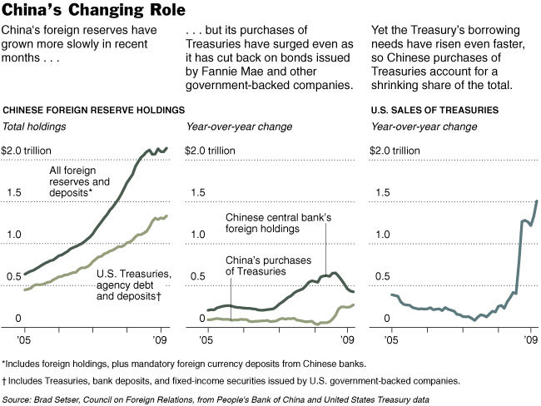

Financial statistics released by both countries in recent days show that China paradoxically stepped up its lending to the American government over the winter even as it virtually stopped putting fresh money into dollars.

This combination is possible because China has been exchanging one dollar-denominated asset for another — selling the debt of government-sponsored enterprises like Fannie Mae and Freddie Mac in a hurry to buy Treasuries. While this has been clear for months, new data shows that China is also trading long-term Treasuries for short-term notes, highlighting Beijing's concerns that inflation will erode the dollar's value in the long run as America amasses record debt.

So China's rising purchases of Treasuries do not represent the confident bet on America's future that they might seem to be on the surface. For instance, China does not appear to be dumping euros or yen to buy Treasuries, economists said.

That said, recent Chinese and American data suggest that an astounding 82 percent of China's $2 trillion in foreign reserves is in dollars, according to calculations by Standard Chartered.

The development has caught the attention of the leaders of both countries.

"The long-term deficit and debt that we have accumulated is unsustainable — we can't keep on just borrowing from China," President Obama said last Thursday.

Wen Jiabao, prime minister of China, also has expressed concern.

"We have lent a huge amount of money to the U.S. Of course we are concerned about the safety of our assets. To be honest, I am definitely a little worried," Mr. Wen said earlier this year.

China now earns more than $50 billion a year in interest from the United States, Mr. Setser at the Council on Foreign Relations calculated.

China's leaders were able to buy more Treasuries in recent months without buying more dollars because they have abruptly turned their back on the market for securities issued by government-sponsored enterprises.

China was the world's biggest buyer of these securities a year ago, splashing out more than $10 billion a month.

But in the 12 months through March, it actually had net sales of $7 billion, and ramped up purchases of Treasuries instead.

China has also changed which Treasuries it buys. It has done so in ways calculated to reduce its exposure to inflation or other problems in the United States. As recently as a year ago, China actively bought long-dated bonds, seeking the extra yield they could bring compared to Treasury securities with short maturities, of which China bought virtually none.

But in each month since November, China has been buying more Treasury bills, with a maturity of a year or less, than Treasuries with longer maturities. This gives China the option of cashing out its positions in a hurry, by not rolling over its investments into new Treasury bills as they come due should inflation in the United States start rising and make Treasury securities less attractive.

The big question now for policy makers and economists alike lies in whether the Chinese government's purchases of American securities will rise or fall in the coming months.

Two big forces are at work — but they are pushing Chinese investments in opposite directions and might cancel each other out.

The first big shift is that Chinese foreign exchange reserves might start growing again, after shrinking early this year.

A senior Chinese economic policy maker, Xu Lin, expressed concern here on Monday that the reserves might grow faster if speculators started pushing more foreign exchange into China in the months ahead.

China is strongly opposed to any significant appreciation or depreciation of its currency, Mr. Xu said at a press conference. But if international investors conclude that the Chinese economy has stabilized ahead of economies elsewhere, they may start pumping more money into the Chinese economy, he said.

To keep its currency at the same level, the Chinese government buys foreign currency flowing into the country in excess of China's needs. If overseas demand for Chinese exports recovers, then China's trade surplus could start widening again as well. This would also tend to fatten Chinese reserves.

But the countervailing trend is that the Chinese government is trying to foster channels for foreign currency to be pumped out of the country without the involvement of the central bank. The government has been buying a wider range of assets and encouraging the private sector to invest more money overseas.

"That's part of a strategic move by the authorities to diversify," said Wensheng Peng, the head of China research at Barclays Capital. "The reserves growth should accelerate because of inflows, but it will not be as large as what we observed in 2007 and the first half of 2008."

The State Administration of Foreign Exchange, which is part of the central bank, issued draft regulations on Monday that would make it considerably easier for private companies to raise dollars in China to spend on overseas investments — a step that would lessen the need for the Chinese government to buy up those dollars.

This spring China has also been stepping up its purchases of commodities, which are usually bought in dollars. Iron ore has been piling up on Chinese docks, government stockpiles of crude oil and grain are being expanded and stockpiles are being started for products like gasoline, diesel and sugar.

After six years of silence, China unexpectedly disclosed last month that it had been gradually buying gold from domestic producers. The country's reserves had climbed from 600 tons in 2003 to 1,054 tons, worth $31.8 billion at prices late Wednesday.

The disclosure, which produced a frisson of excitement in gold markets, may have been aimed at reassuring a domestic audience that the Chinese government was not putting all the nation's savings into American dollars. But the actual investment was tiny compared with China's foreign exchange reserves — and showed that China was accumulating gold at a much slower rate than foreign currency.

A person in periodic contact with China's central bank, who insisted on anonymity to preserve his access, said that a Chinese central banker complained to him last year that "we have so much money and there's so little gold, we can't buy much without driving up the price."

