The Economist

China’s handset manufacturers

Smartening up their act

Chinese phonemakers are preparing to take on the world
Oct 25th 2014 | SHANGHAI | From the print edition

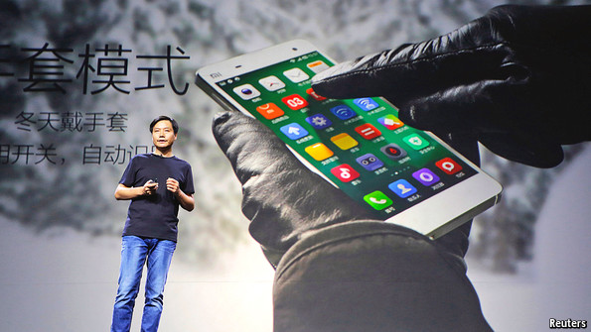
IF YOU want to understand how China innovates, look no further than its hyper-competitive market for smartphones. Though Samsung and Apple dominate the business globally, the technology superpowers are being squeezed in China by aggressive local manufacturers. Now Chinese firms are selling their handsets abroad in ever-greater numbers and a battle is set to be fought that will reshape the global marketplace for handsets.
China’s smartphone-makers have a ready launchpad. Thanks to the frugal but feature-rich offerings from local firms, domestic sales have exploded. Over 100m smartphones were sold in the second quarter, accounting for over a third of global sales and making China the world’s largest market. Strikingly, eight of the top ten vendors were local firms. Xiaomi, a startup that only sells online, shot past Samsung to become the leading brand of smartphones in the country. After selling 15.4m in the second quarter (see chart), the firm is on track to peddle 60m handsets this year, and wants to sell 100m in 2015.
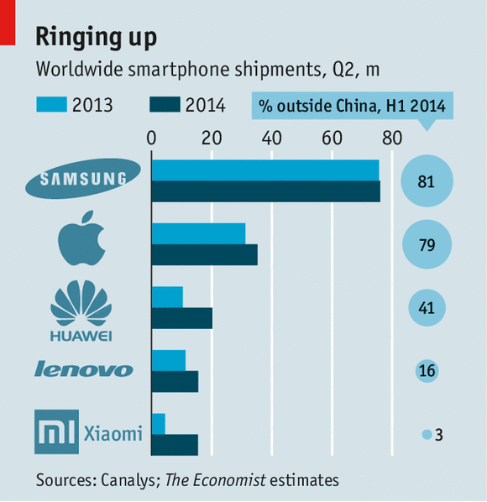
The rise of the inexpensive smartphone is a boon for Chinese consumers, many of whom are going online for the first time. However, Chinese firms are no longer content to scrap for a share of the spoils at home. They are increasingly eyeing lucrative foreign markets.
With much fanfare, Xiaomi launched in India in July. It did so in partnership with Flipkart, a leading local e-commerce firm. Xiaomi’s handsets are now also available in most of South-East Asia and the firm plans to sell in Brazil next. Though it does not officially sell its phones in America, GPS patterns suggest that around 1m of its snazzy handsets have been detected in the country. As foreigners find it hard to pronounce its name, Xiaomi has even grabbed the website mi.com, perhaps to rebrand itself overseas as “Mi”.
Another local firm on the move is OnePlus. Reviewers in developed markets have been raving about its clever handsets, which offer top-notch performance and features for around $300—less than half the list price of the latest iPhone. Carl Pei of OnePlus argues that unlike its rivals, his firm was “born a global company”. Since its founding late last year, it has targeted 16 countries—including such challenging markets as America and Britain. “It helps that a lot of people don’t know that we are a Chinese firm,” he confides.
Adding to the advance are those Chinese firms that have long been global, even if they are relatively new to the smartphone business. Huawei has sold unbranded “white label” handsets to telecoms carriers for a while, but is now keenly pushing its own Ascend and Honor brands. Lenovo has spent $2.9 billion to acquire Motorola Mobility, Google’s handset division, which dramatically expands its reach in North and South America. It, too, has announced plans for a line of smartphones to be sold only on the internet.
Rumours resurfaced this week that Lenovo might even buy BlackBerry, an ailing Canadian handset-maker. That seems unlikely as it makes little sense for a rising star to join hands with a sinking firm: Lenovo already turns a profit on the phones it sells outside China. Moreover, concerns that the Chinese government uses local tech companies to spy—unproven claims that prompted America’s Congress to blacklist Huawei and ZTE, another Chinese telecoms-equipment firm—might prompt Canadian regulators to block any deal.
They are emerging in force, but how will Chinese firms fare outside their sheltered home market? Some observers are sceptical, dismissing Chinese technology firms as shameless copycats incapable of innovation—the beneficiaries of a dodgy legal system that allows local firms to infringe international patents and keeps out world-class foreign competition. Google services, including the app store for its popular Android operating system, are effectively blocked in China.
Jonathan Ive, Apple’s lead designer, gave succour to the naysayers with recent comments dismissing Xiaomi’s designs as derivative: “it really is theft and it’s lazy and I don’t think it’s OK at all”, he complains. Some things about Xiaomi are clearly borrowed from Apple, from its sleek designs and pleasing user interface to the Jobsian jeans-and-black-top presentations given by Lei Jun, the firm’s charismatic founder (see picture).
A serious threat to Chinese firms as they head overseas is lawsuits from Apple and Samsung, who themselves have long been entangled in nasty battles over intellectual property (IP). Ben Qiu of Cooley, an American law firm, believes that “Xiaomi is in dangerous waters of potential patent-infringement claims on the international markets.” But he argues that the firm’s clever management team, which includes former Google executives, can navigate these perilous seas because it is well prepared for legal and regulatory battles.
He points out that Tencent, a Chinese internet giant, expanded abroad successfully in part because its general counsel is a seasoned Silicon Valley lawyer. In addition to lawyering up, Chinese handset-makers must also build up arsenals of licences from existing patent holders. To sell phones in rich countries (which, unlike developing ones, strictly enforce IP rights) they have been forced to pay a quarter of revenues to patent holders. Building patent banks can reduce this burden: a mighty arsenal may scare off lawsuits, and patents can be sold or cross-licensed as necessary, to avoid conflict. Lenovo has spent pots of money of late to acquire thousands of patents from NEC, a Japanese firm, from Motorola and from patent trolls. Most importantly, they must come up with valuable inventions in-house. To their credit, Huawei and ZTE are among the world’s most prolific generators of new patents.
That intense rivalry and race to generate new ideas is the best reason to believe the Chinese upstarts can make it. The confluence of a giant market and cost-conscious consumers has forced them to squeeze component costs, make contract manufacturing more efficient and adopt technological innovations more quickly. This has prepared the best of the local firms to do battle with global titans.
There is no denying that many Chinese firms got their start by copying foreign ones at the leading edge. But imitation has often been the starting point for innovation at companies in the rich world. Apple did not invent the compact music player or smartphone. Steve Jobs even flew a pirate’s flag atop the old Macintosh headquarters as a reminder to his employees that innovators need to be rule-breakers. That transition from imitation to innovation is happening now at a breathtaking pace in Chinese technology firms.

China's Xiaomi surges to become world's third largest smartphone vendor
More like this
- China's Xiaomi rises to fifth place in smartphone rankings
- Xiaomi passes Samsung in China as largest smartphone vendor
- Huawei's smartphones shipments rise on international sales
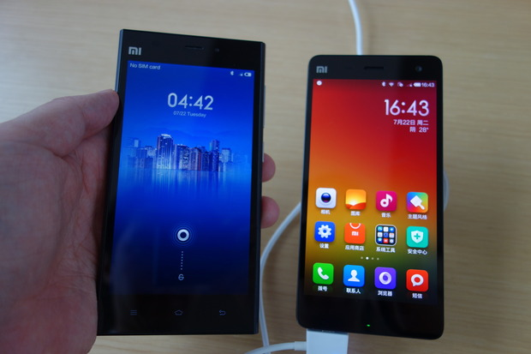
Xiaomi has shot up to become the the third largest smartphone vendor. Shown here are the company's Mi 4 smartphone, right, and its previous generation flagship phone.
Credit: Michael Kan/IDG News Service

Samsung saw its smartphone market share dip, while Apple iPhone shipments continued to grow, according to two research firms
By Michael Kan
Follow
IDG News Service | Oct 30, 2014 4:57 AM PT
Phones from Xiaomi still haven't arrived in the U.S., but the company's booming sales in China have been enough to make it the third largest smartphone vendor in the world.
Xiaomi reached the ranking, behind Apple and Samsung, in the third quarter, said research firms IDC and Strategy Analytics on Thursday.
The Chinese vendor only began selling phones three years ago but it has quickly risen to become a leading vendor in its home market, by offering feature-packed Android phones at affordable prices.
In the third quarter, Xiaomi had a 5.3 percent share of the smartphone market, still far behind second place Apple, which had a 12 percent share, according to IDC. But unlike its rivals, Xiaomi posted triple-digit year-over-year growth in smartphone shipments, of 211 percent, making it the fastest growing among the top vendors.
It is the first time Xiaomi has entered in the top five smartphone rankings, IDC said. During the quarter, the company began selling its latest flagship phone, the Mi 4, a device that has all the latest specs, but with a selling price starting at 1999 yuan (US$326).
Xiaomi this year has also begun expanding to other foreign markets, including India, where its phones have routinely sold out in online sales. "What remains to be seen is how quickly the company can move beyond its home territories to drive volumes higher," IDC said in a statement.
As for the leading smartphone vendor Samsung, the Korean company continued to struggle amidst heated competition from Apple and Chinese rivals including Xiaomi, Lenovo and Huawei Technologies. In the third quarter, Samsung's market share was 24.7 percent, down from the 35 percent share it had a year ago, according to Strategy Analytics.
Samsung's smartphone shipments could pick up later in 2014, with sales of its new Galaxy Note 4 and the Galaxy Note Edge, Strategy Analytics said in a statement. But in a Thursday earnings report, the Korean company said it expects competition in the market to remain stiff.
Rival devices are already taking a toll on the company's earnings. In this year's third quarter, Samsung said its operating profit from its mobile devices division dropped by 74 percent from the same period a year ago. This was partly due to reduced prices for its older models, and more consumers buying its middle and lower-end smartphones.
Apple, on the other hand, is still growing, with its third quarter smartphone shipments up 16 percent year over year, IDC said. At the end of the third quarter, the company began selling its new iPhone 6 and iPhone 6 Plus in select markets.
Helped by iPhone 6 sales at the end of the quarter, Apple posted its largest third-quarter smartphone shipments ever, IDC said. Older iPhone models, such as the 5s and 5c, however, made up most of the shipment volume during the period.
In total, vendors shipped 327 million smartphones worldwide, up 25.2 percent from a year ago, according to IDC. Much of the smartphone demand is coming from emerging markets, where growth is over 30 percent. Developed markets, meanwhile, are posting single-digit growth, IDC added.

Quartz India

How Xiaomi’s Hugo Barra plans to conquer India
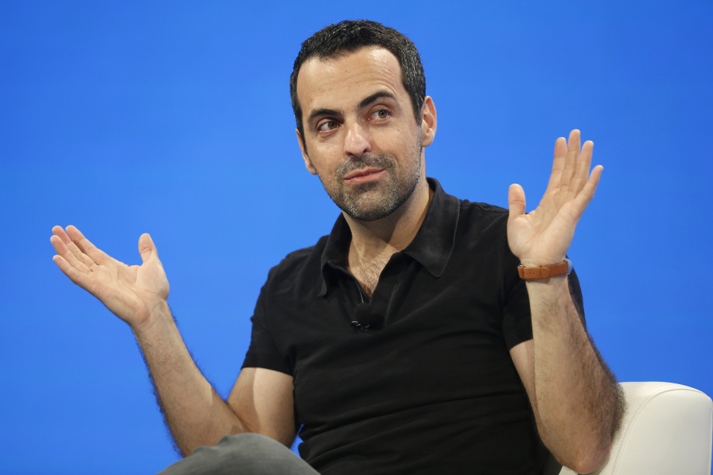
Raise your hands if you've got big plans.(Reuters/Lucy Nicholson)

Written by
Sruthijith KK@sruthijith

Obsession
the mobile web
November 11, 2014
This post has been corrected.
Xiaomi has broken out of the pack to become China’s biggest smartphone manufacturer, surpassing Samsung and Apple and drawing ahead of domestic rivals like Lenovo. And the company, which is reportedly raising new funds that will give it a $50 billion valuation, isn’t stopping there. Its slow expansion into southeast Asia and especially India belies a grand ambition to apply its low-margin, high-spec model across the developing world and beyond.
Xiaomi’s India unit—called just Mi, which the company is using as an easier-to-pronounce brand outside of China—is run by Hugo Barra, the former Google executive in charge of Android who raised many industry eyebrows when he defected to Xiaomi last year. The Brazilian-born Barra has also been Xiaomi’s point person for complaints that it has copied the iPhone’s design and doesn’t adequately protect customer data. He spoke with Quartz about his admiration for Apple, Xiaomi’s plans to become an e-commerce giant, and why India is the company’s biggest focus outside of mainland China.
Could you tell us your plans for Xiaomi in India?
We are essentially building a company from scratch here. It’s not Xiaomi, it’s not Xiaomi India, it’s Mi India. That is the brand.
But it is a 100% subsidiary of Xiaomi.
Of course. But I do think of it as building another company and that is an important distinction. It’s not like we are just building a sales office. That is why it was important to spend time finding the right people to run the business here.
Already we have a significant operation here. It involves getting our products from the plants to here and to Flipkart’s warehouses. That in itself is getting fairly complicated. In October, we had [an] entire plane full of products flying down from Hong Kong.
This means we need people here who are paying attention to delivery. We have a customer support operation that is well trained. And we have to focus on building an after-sales network. People from more and more remote areas in India are buying Mi phones now and right now people are having to travel long distances to get to a service centre. We only have about 40 service centers, but even when we get to 100, that is of course nearly not enough to cover the whole country.
Then of course there is the big piece, which is building our own e-commerce business here.
You are going to build your own platform here?
We are China’s third largest e-commerce company. We sell our own products from our own website.
Selling Xiaomi products alone makes you China’s third largest e-commerce company?
Soon the second. We are going to pass JD soon.
So how come you can’t seem to get enough Xiaomi phones to Indian customers who clearly can’t seem to get enough of them?
We are here not to sell phones and dominate. We are here for the long run, and we want to brand ourselves into the fabric of this country. We need to start small, we need to listen, iterate. We probably could sell 10 lakh (1 million) phones at one go—I’m not sure, but we probably could. But just imagine the burden that comes with supporting that many phones all at once. What if there is a problem?
So we take our time, we ramp up carefully; we take feedback very, very seriously. The whole operation has to scale, we can’t just have a sales spike.
The third part is getting the whole R&D machinery to build and layer all the India-specific services into the Mi experience. There is a lot that we want to do and for that we have to build an R&D team here.
Are you going to one day make Xiaomi products in India?
We will, for sure, write software here. We certainly are also considering the possibility of manufacturing through partners. We don’t make products ourselves. We use Foxconn and others to do the manufacturing for us. We are here for the long run and it might make a lot of sense to be able to make [devices] here.
When you came to India, how many phones were you expecting to sell and how many have you actually ended up selling?
When we came here, we were planning to sell a few thousand phones and we were concerned if that target might be met. In the first two weeks alone, we sold 20,000 phones. The first sale was a bit turbulent because we had some technical issues with Flipkart facing enormous traffic. By the end of October, we will be selling up to 100,000 phones per week.
1
In a market with every possible kind of phone available, both by international and local brands, why do you think there is still this kind of demand for Mi phones?
I think it’s a combination of factors. First of all we make really good products. The reviews have been amazing. I pay very close attention to reviews and see what we need to do differently and what we are doing well. For Redmi, the return rate has been less than 1%.
What about Mi 3 phones?
It’s a little bit higher because of the SIM tray issue. Because of a logistics goof-up, we couldn’t ship the micro SIM card tray with the phones. Huge mistake. Even so, the return rates were very low, particularly considering the fact that Flipkart has a thirty-day, no-questions-asked return policy.
You don’t have the same returns policy in China?
No, we don’t. There it’s seven days and there are some conditions. We go by the market standards there.
And the third factor of course is the price. We are selling incredibly high-spec devices at very aggressive prices.
Is it true that when the lifecycle of a Xiaomi product begins, you sell it at cost and make money as the cost of components come down?
We sometimes sell it at cost, sometimes a bit above cost and sometimes a bit below cost. We don’t make that many products. If you look at our portfolio, it’s very small. And we really build products that we think can sell for a long time.
To give you an idea, Redmi and Redmi 1S, which are basically the same device—as in the fixed costs are the same for us—have been selling for more than a year. And it’s ramping up. Mi 2S is just coming to end of life, two years later.
This is more than what most manufacturers manage to get out…
Much, much more. Very few products, such as the (Samsung) Galaxy S3, manage to survive that long. The Galaxy S3 is still selling. Very few products have that kind of longevity.
What has happened to the Mi 3? Have you stopped selling it?
We are shifting the production capacity for Mi 3. In India, Mi 4 will replace Mi 3. Mi 3 is a great example of a product where the cost of the materials and components came down fast enough that we were able to bring the prices down. So rather than making very large margins, we are able to keep prices aggressive.
Why did you decide to move to Bangalore?
Because we are here to build Mi India. We are not here to open a sales office or a branch office. India is currently the company’s biggest focus after our domestic market.
What new things are you planning to do in India?
We want to build an Internet platform that is delivered through these devices. We plan to partner with a whole lot of companies and build layers of services into the operating system. Take for instance the process of topping up your phone account or checking the balance. It’s incredibly cumbersome with a majority of the operators. Why isn’t it just integrated into the operating system? Why can’t you just go to the dialer on a phone and just use a tab there to recharge? You shouldn’t need a whole app or a web platform for this. We are going to do a whole lot of these, many of which involves working with startups.
It’s a major undertaking. It’s a task with the same level of complexity as building an operating system.
Truecaller, for instance, is a great example of a company that is not an Indian company but has done really well in India. They have built a whole dialer app. The dialer is a special kind of app. Nobody will let them replace the native dialer with their product. We are going to partner with them and integrate their dialer directly into our dialer. The result would be a native dialer that is much smarter and much more interesting that what is commonly found.
Why do you need your own e-commerce business to sell your products?
Because it becomes an integrated experience. You can log on to our website with the same username and password that you use to set up the Mi account on your phone. You feel like you are home the whole time. If you have a problem, you are talking to our people. You can track your order on our website. We like to have control over the complete experience for a customer.
Flipkart is our partner for life. We will work with them a very long time. Flipkart is one of the world’s foremost e-commerce companies. I put them right up there with Amazon and I put them ahead of most other e-commerce companies anywhere in the world.
Since you moved here, what has been your assessment of India’s tech ecosystem?
I think India is right in the middle of a tech renaissance, where it is definitely transitioning from being an IT outsourcing, business process automation, back-end type of work to a source of innovation.
Where our office is in Bangalore, we are right next to InMobi and a bunch of other exciting companies. It feels like Silicon Valley. Bangalore feels like Silicon Valley in many ways already. India today has the same number of Internet users as China had, say, in 2007-08.
You see that as sort of an inflection point?
Yes, except that India is going to go through that inflection point at a much faster rate. If you compare what the internet and startup scene was in China seven or eight years ago, it doesn’t even begin to compare with how thriving it is in India right now.
In many ways I feel privileged and honoured to be here at this point in time. Because I know that five years down the line, I’ll be able to say, I was there, in 2014!
The amazing thing about India is that India has scale, both as a consumer market and as a source of talent. You have amazing engineering schools. We also have an influx of people coming back. One of my friends from Google is coming back. Flipkart is in fact hiring most of them. It is on a mission to hire from around the world all the Indian engineers who wants to come back and they are very successful at it.
One of the things I’m trying to do here is to build bridges with the local startup scene with a couple of things in mind. One of the things is to find companies that are building stuff that we can integrate into our system. We also believe that being part of the ecosystem, being a local, means we should try and help develop it. So we firmly intend to make small, seed investments in companies, alongside, of course, bigger investments. That is a small contribution, but that is also a good way to build friends. We love to have as many friends as we can.
How did the controversy over Mi phones sending data back to Chinese servers affect your business? What are you doing about it?
We take personal data very seriously. They were reports in the media that were both exaggerated and inaccurate in many ways. We have addressed most of the concerns that were raised. I myself wrote a couple of very detailed posts explaining the accurate position.
You will also see more communication from us in coming months about what exactly happens with our servers, and what kind of data is collected or stored and what isn’t.
But as a consequence, are you for instance considering moving some of the servers to India?
So we are in the process of moving most of our servers dealing with our international users to Singapore, which is, from a network perspective, an ideal hub, because Singapore has good connections both to the US as well as to Asia. We use AWS (Amazon Web Service) and they have their data centre in Singapore. We will eventually move most of our backend to Singapore with one goal in mind—performance optimization.
The consequence of that is that it brings some level of confidence in some people.
Does Apple still make the best smartphones in the world, or are competitors like Xiaomi and One Plus One closing the gap?
Well, I’m a huge Apple fan. I’m very biased. I don’t think there is a company in the world today or there will be a company in the world today that operates at such a distance from its rivals. I think Apple is extraordinary.
What are your thoughts on One Plus One?
I really like what they are doing. I really love the One Plus One phone. I love some of the backs [rear phone panels] that they have introduced. I think it’s a beautiful device. The software is not quite my preference, it’s not something I would choose, but I think it’s an extraordinary device.
What other devices are you bringing to India?
Redmi Note is next. We have already brought the power bank. Then we will see. There is the Mi4. And the TV is something we want to do. We have an amazing TV. It’s 4k, 49 inches. It retails for under Rs40,000. I’m not saying this will be the price in India, I’m just converting the price.

