NYT

Current air pollution reports

http://www.nytimes.com/interactive/2015/12/18/world/asia/air-pollution-widespread-china-beijing-red-alert-maps-charts.html

On Scale of 0 to 500, Beijing’s Air Quality Tops ‘Crazy Bad’ at 755
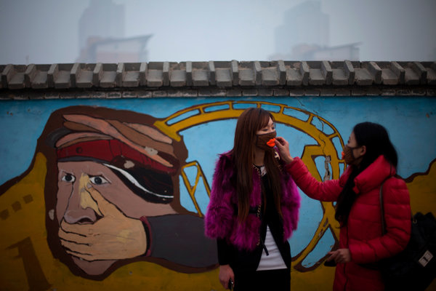
Fashionably masked women on Saturday outside an amusement park in Beijing. The World Health Organization has standards that judge an air-quality score above 500 to be more than 20 times the level of particulate matter in the air deemed safe.

By EDWARD WONG

Published: January 12, 2013
BEIJING — One Friday more than two years ago, an air-quality monitoring device atop the United States Embassy in Beijing recorded data so horrifying that someone in the embassy called the level of pollution “Crazy Bad” in an infamous Twitter post. That day the Air Quality Index, which uses standards set by the United States Environmental Protection Agency, had crept above 500, which was supposed to be the top of the scale.
So what phrase is appropriate to describe Saturday’s jaw-dropping reading of 755 at 8 p.m., when all of Beijing looked like an airport smokers’ lounge? Though an embassy spokesman said he did not immediately have comparative data, Beijing residents who follow the Twitter feed said the Saturday numbers appeared to be the highest recorded since the embassy began its monitoring system in 2008.
The embassy’s @BeijingAir Twitter feed said the level of toxicity in the air was “Beyond Index,” the terminology for levels above 500; the “Crazy Bad” label was used just once, in November 2010, before it was quickly deleted by the embassy from the Twitter feed. According to the Environmental Protection Agency, levels between 301 and 500 are “Hazardous,” meaning people should avoid all outdoor activity. The World Health Organization has standards that judge a score above 500 to be more than 20 times the level of particulate matter in the air deemed safe.
In online conversations, Beijing residents tried to make sense of the latest readings.
“This is a historic record for Beijing,” Zhao Jing, a prominent Internet commentator who uses the pen name Michael Anti, wrote on Twitter. “I’ve closed the doors and windows; the air purifiers are all running automatically at full power.”
Other Beijing residents online described the air as “postapocalyptic,” “terrifying” and “beyond belief.”
The municipal government reported levels as high as 500 on Saturday evening from some monitoring stations. The Chinese system does not report numbers beyond 500. Nevertheless, readings in central Beijing throughout the day were at the extreme end of what is considered hazardous according to the United States Environmental Protection Agency standards. (By comparison, the air quality index in New York City, using the same standard, was 19 at 6 a.m. on Saturday.)
Pollution levels in Beijing had been creeping up for days, and readings were regularly surging above 300 by midweek. The interior of the gleaming Terminal 3 of the Beijing Capital International Airport was filled with a thick haze on Thursday. The next day, people working in office towers in downtown Beijing found it impossible to make out skyscrapers just a few blocks away. Some city residents scoured stores in search of masks and air filters.
Still, there was little warning that the United States Embassy reading would jump above 700 on Saturday. Some people speculated that the monitoring system, which measures fine particles called PM 2.5 because they are 2.5 microns in diameter or smaller, might have malfunctioned once it got beyond 500.
But Nolan Barkhouse, an embassy spokesman, said the monitor was operating correctly.
It was unclear exactly what was responsible for the rise in levels of particulate matter, beyond the factors that regularly sully the air here. Factories operating in neighboring Hebei Province ring this city of more than 20 million. The number of cars on Beijing’s streets has been multiplying at an astounding rate. And Beijing sits on a plain flanked by hills and escarpments that can trap pollution on days with little wind. Meanwhile, one person hiking at the Great Wall in the hills at Mutianyu, north of Beijing, took photographs of crisp blue skies there.
Xinhua, the state news agency, reported on Dec. 31 that Beijing’s air quality had improved for 14 years straight, and the level of major pollutants had decreased. A municipal government spokesman told Xinhua that the annual average concentration of PM 10, or particles 10 microns in diameter or smaller, had dropped by 4 percent in 2012, compared with one year earlier.
Chinese officials prefer to publicly release air pollution measurements that give only levels of PM 10, although foreign health and environmental experts say PM 2.5 can be deadlier and more important to track.
There has been a growing outcry among Chinese for municipal governments to release fuller air quality data, in part because of the United States Embassy Twitter feed. As a result, Beijing began announcing PM 2.5 numbers last January. Major Chinese cities have had the equipment to track those levels, but had refused for a long time to release the data.
The existence of the embassy’s machine and the @BeijingAir Twitter feed have been a diplomatic sore point for Chinese officials. In July 2009, a Chinese Foreign Ministry official, Wang Shu’ai, told American diplomats to halt the Twitter feed, saying that the data “is not only confusing but also insulting,” according to a State Department cable obtained by WikiLeaks. Mr. Wang said the embassy’s data could lead to “social consequences.”

Beijing Journal

Outrage Grows Over Air Pollution and China’s Response
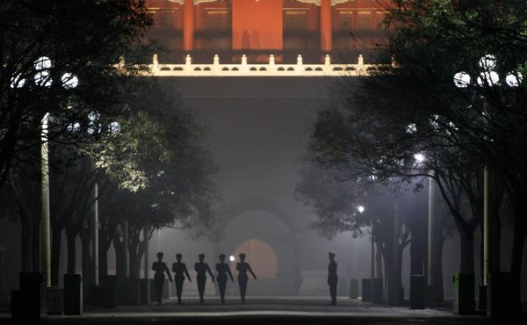
Jason Lee/Reuters
Paramilitary police officers practiced drills inside the Forbidden City during a night heavy with haze and smog in central Beijing on Sunday.

By EDWARD WONG

Published: December 6, 2011
BEIJING — The statement posted online along with a photograph of central Beijing muffled in a miasma of brown haze did not mince words: “The end of the world is imminent.”
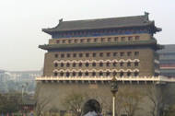

Beijing's Smoggy Skies
The ceaseless churning of factories and automobile engines in and around Beijing has led to this: hundreds of flights canceled since Sunday because of smog, stores sold out of face masks, and many Chinese complaining on the Internet that officials are failing to level with them about air quality or make any improvements to the environment.
Chronic pollution in Beijing, temporarily scrubbed clean for the 2008 Summer Olympics, has made people angry for a long time, but the disruptions it causes to daily life are now raising questions about the economic cost, and the government’s ability to ensure the safety of the population.
“As a Chinese citizen, we have been kept in the dark on this issue for too long,” said Yu Ping, the father of a 7-year-old boy, who has started a public campaign to demand that officials report more accurately about Beijing’s air quality. “The government is just so bureaucratic that they don’t seem to care whether we common people live or die. And it’s up to us, the common people, to prod them and to put pressure on them so that they can reflect on their actions and realize that they really just have to do something.”
When the frustration of parents boils over, Communist Party leaders start worrying about their legitimacy in the eyes of the people. That was the case in 2008 when parents vented anger over deadly school collapses in the Sichuan earthquake and over adulterated milk.
The motionless cloud of pollution that has smothered the capital and its surroundings in recent days has frayed tempers. Long stretches of highway have been shut down because of low visibility, hobbling transportation of people and goods. Workers at Capital International Airport have faced crowds of irate travelers whose flights have been grounded. From Sunday to 11 a.m. Tuesday, more than 700 outbound and inbound flights were canceled, one airport official said. A tour guide, Wang Lanhuizi, 23, clutched dozens of passports from a stranded group. “I’m really worried, but there’s nothing we can do,” she said.
An announcement at the airport made no mention of pollution, attributing the cancellations and delays to “the weather condition.” That has long been the government line: the haze is fog, not fumes. But increasingly, Chinese know better. People like Mr. Yu, a newspaper editor, are lobbying officials to stop whitewashing their air quality reports.
Many people now follow a Twitter feed from the United States Embassy that gives hourly updates on air quality; gauges on top of the embassy in central Beijing measure, among other things, the amount of fine airborne particles, which are extremely damaging to the lungs. Since Sunday, the air has been rated “very unhealthy” or “hazardous,” meaning that people should avoid any outdoor activity; on Sunday, the particulate measurement exceeded the scale’s maximum of 500, a reading that the embassy once called “crazy bad” on its @BeijingAir Twitter feed.
The fine particles, called PM 2.5 because they are 2.5 microns in diameter or smaller, make up much of the pollution in the city, but they are not included in the air quality ratings issued by the Chinese government. The published ratings take into account only a larger class of particles (up to 10 microns in diameter) called PM 10. As a result, Beijing officials have announced good or excellent air quality nearly 80 percent of the time over the last two years, while the embassy’s assessment says the air was unhealthy more than 80 percent of the time, according to an analysis by Steven Q. Andrews, an American environmental consultant, that was published Monday on the Web site China Dialogue.
Experts say the filthy air shortens lives in the capital. One authoritative study “indicates that if Beijing’s fine particulate concentration even reached the polluted levels of Los Angeles, life expectancy may increase by over five years,” Mr. Andrews wrote.
The air readings from the embassy mysteriously stopped on Tuesday afternoon. “We’re checking on it,” the embassy spokesman, Richard L. Buangan, said on Twitter. (Although Twitter is blocked in China, the embassy’s air quality ratings are reposted by many Chinese on unblocked sites.)
In July 2009, a Chinese Foreign Ministry official, Wang Shu’ai, told American diplomats to halt the embassy’s air quality Twitter feed, saying that the data “is not only confusing but also insulting,” according to a State Department cable obtained by WikiLeaks. The embassy’s data, Mr. Wang said, could lead to “social consequences.”
Chinese officials recently acknowledged that Beijing and other cities have the equipment to measure PM 2.5, the smaller particles, but do not reflect that data in their air quality ratings.
Prominent Beijing residents have called for changes. One is Pan Shiyi, a real estate magnate who asked his seven million microblog followers last month to vote on whether the authorities should use a stricter standard to assess air quality. Officials have not been helped by news reports that revealed that a Chinese manufacturer, the Broad Group, advertises that more than 200 of its pricey air purifiers are in the offices and homes of China’s top leaders.
Ma Jun, an environmental advocate, said officials made some progress this year by committing to ensuring that cities report PM 2.5 data starting in 2016. But that is too far away, he said.
Mr. Yu, the editor, is pushing for immediate disclosure of the data. His campaign has attracted attention online this week as Beijing residents cough and squint in the haze. Mr. Yu said he filed an application to the Beijing Environmental Protection Bureau last month to have the bureau release PM 2.5 data, and was turned down; he posted the bureau’s answer on his microblog. He said he was considering suing the bureau or asking the Ministry of Environmental Protection for a review. “With the government not being totally open about this issue,” he said, “many people don’t realize how bad the situation is.”
On Tuesday, the English-language China Daily published an article under the headline “Exposure to Smog Is Severe Hazard.” It said the lung cancer rate in Beijing had increased by 60 percent in the last decade even though the smoking rate did not change.

NYT

China Allows Media to Report Alarming Air Pollution Crisis

By EDWARD WONG

Published: January 14, 2013
BEIJING — The Chinese state news media on Monday published aggressive reports on what it described as the sickening and dangerous air pollution in Beijing and other parts of northern China, indicating that popular anger over air quality had reached a level where Communist Party propaganda officials felt that they had to allow the officially sanctioned press to address the growing concerns of ordinary citizens.
The across-the-board coverage of Beijing’s brown, soupy air, which has been consistently rated “hazardous” or even worse by foreign and local monitors since last week, was the most open display of coverage on the issue in recent memory. Since 2008, when Beijing made efforts to clean up the city before the Summer Olympics, the air has appeared to degrade in the view of many residents, though the official news media has often avoided addressing the problem.
The wide coverage on Monday appears to be in part a reaction to the conversation that has been unfolding on Chinese microblogs, where residents of northern China have been discussing the pollution nonstop in recent days.
The problem is so serious — the worst air quality since the United States Embassy began recording levels in 2008 — that hospitals reported on Monday a surge in patient admissions for respiratory problems, and Beijing officials ordered government cars off the road to try to curb the pollution, which some people say has been exacerbated by a weather phenomenon, called an inversion, that is trapping dirty particles.
“I’ve never seen such broad Chinese media coverage of air pollution,” said Jeremy Goldkorn, a business consultant in Beijing who tracks the Chinese news media. “From People’s Daily to China Central Television, the story is being covered thoroughly, without trying to put a positive spin on it.”
People’s Daily, the official party mouthpiece, published a front-page signed editorial on Monday under the headline, “Beautiful China Starts With Healthy Breathing.” “The seemingly never-ending haze and fog may blur our vision,” it said, “but makes us see extra clearly the urgency of pollution control and the urgency of the theory of building a socialist ecological civilization, revealed at the 18th Party Congress.”
The 18th Party Congress, a meeting of party elites held in Beijing last November, was part of a once-a-decade leadership transition. In a political report delivered on the first day, Hu Jintao, the president and departing party chief, said China must address environmental problems worsened by rapid development. The inclusion of sections in the report on the need for “ecological progress” could be opening the door for greater dialogue on such issues under the watch of Xi Jinping, the new party chief, and his colleagues on the Politburo Standing Committee.
Even before the congress, the official news media had some latitude to publish critiques of environmental policy and investigate environmental degradation, in contrast to strict limits on what they can say on “core interest” issues like Tibet and Taiwan. Nevertheless, the coverage unfolding now represents a new level of depth in addressing air pollution.
Bill Bishop, the editor of Sinocism, a daily online newsletter about news media coverage of China, wrote on Monday that “Chinese media is all over the story in a remarkably transparent contrast to today’s haze in Beijing.”
Mr. Bishop said: “Clearly it is impossible to pretend that the air is not polluted or that the health risks are not significant, so are the propaganda authorities just recognizing reality in allowing coverage? Or is there something more going on here, as perhaps the new government wants to both demonstrate a commitment to transparency and accountability as well as use this crisis to further the difficult reforms toward a more sustainable development model?”
China Youth Daily, a state-run newspaper, published a scathing signed commentary on Monday under the headline, “Lack of Responsive Actions More Choking Than The Haze and Fog.” The commentary questioned basic economic policies and the China growth model: “This choking, dirty and poisonous air forces the Chinese to rethink the widespread, messy development model.”
Global Times, a newspaper that often defends the party, said in an editorial that the government in the past had erred by releasing pollution information in a “low-key way.” It said: “In the future, the government should publish truthful environmental data to the public. Let society participate in the process of solving the problem.”
On Saturday, when a Twitter feed from the United States Embassy rated the air in central Beijing an astounding 755 on an air quality scale of 0 to 500, China Central Television, the main state network, devoted a big part of its 7 p.m. newscast to the pollution. That night, the Beijing government reported alarming levels of a potentially deadly particulate matter called PM 2.5; in some districts, it exceeded 900 micrograms per cubic meter, on par with some of the worst days of the killer smog in London in the mid-20th century.
Under pressure from the existence of the embassy monitor and growing anger among prominent Chinese Internet users, Chinese officials have been releasing more data on PM 2.5 levels, in a sign of creeping transparency. Beijing began reporting PM 2.5 levels in January 2012. Xinhua, the state-run news agency, announced late last year that the Ministry of Environmental Protection had required 74 cities to start releasing PM 2.5 data. For years, Chinese officials had been trying to limit public information to data on PM 10 or other pollutants that are generally considered less deadly than PM 2.5, which is invisible and can lodge deep in the lungs.
“Last year, Chinese media began to report with regularity on air pollution, especially in Beijing and concerning PM 2.5 in particular,” Mr. Goldkorn said. “But the apocalyptic skies above the capital this last weekend seemed to have encouraged an even greater enthusiasm for reporting this story.”

Wrapped in smog

Something in the air?

As measures of air pollution go off the scale, public impatience rises
Jan 19th 2013 | BEIJING |From the print edition

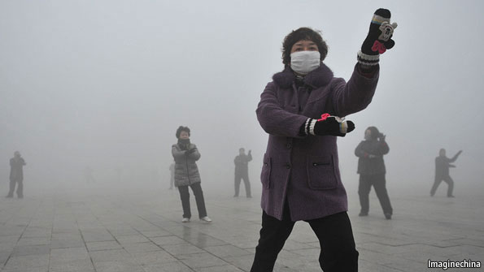
THE city of Beijing got worldwide attention last weekend as its readings for air pollution soared to unconscionably high levels, even for the usually smog-smothered residents of the Chinese capital. By mid-week readings had receded from “beyond index” to merely “hazardous”. But by then Shanghai was grappling with its own bout of abnormal pollution.
China’s crisis in air quality is indeed a national one. This month dozens of other cities, from Shandong province in the east to Guizhou in the south-west, recorded pollution spikes. Experts attribute this to an exceptionally cold winter that has caused more burning of coal and other fuels than usual, to temperature inversions over some places, and to unfortunate wind patterns in others.
Even in the absence of such spikes, air quality in much of China routinely fails to meet basic standards laid down by the World Health Organisation (WHO). The smallest and most dangerous particles are called PM2.5 because they measure 2.5 microns or less in diameter, fine enough to enter deep into the lungs and into the bloodstream. The WHO deems 25 micrograms of such matter per cubic metre of air to be an achievable and acceptable level. In Beijing, readings hit nearly 1,000 micrograms.
The health impact is vast. Tens of thousands of Chinese are reckoned to die each year because of foul air. For instance, in the past three decades, coinciding with a mad dash towards growth and industrialisation, China has seen a more than fivefold jump in mortality rates for lung cancer. John Cai, director of the Centre for Healthcare Management and Policy at the China Europe International Business School (CEIBS), says rates of smoking, which might have explained this, have not risen dramatically.
The economic impact is large, too. Tourists kept away last week, even if sellers of masks did a roaring trade. Beijing ordered production to be halted at polluting enterprises and on construction sites. Flights were cancelled and travel in government cars was banned (though perhaps this improved productivity).
Splutter and cough
Now officials must contend with the political impact of bad air. China’s government has long staked its legitimacy on being able to generate improved standards of living, and people have grown used to complaining about things they do not like. Adding chronically poisoned air to the mix could prove volatile, some think.
Dai Qing, a veteran environmental activist, says that the angry reaction to this month’s extreme pollution shows that the issue now overshadows other pressing problems such as corruption and infringements on people’s liberties. “For years, we environmentalists have been telling the authorities that GDP growth at any cost is a mistake,” she says.
The authorities deserve credit for some initiatives, such as improved standards for vehicle and factory emissions, converting urban-heating systems from coal to gas, and investing in sources of renewable energy. Improving air quality is a long-term project. Western cities took decades to clean their air.
However, authorities must also shoulder blame for not taking the problem seriously enough. For years they persisted in underreporting levels of pollution. The American embassy in Beijing has long irritated the government by monitoring pollution and publishing the results hourly. Last year China asked the Americans to desist, but was rebuffed. Among ordinary Chinese, the service is extremely popular.
Despite the methodological shortcomings of this single-point monitor, the independent readings have led the authorities to release more detailed data. In 2012 the Beijing municipal government began reporting PM2.5 data for the first time. And from the start of this year, the country’s environment ministry announced, 74 cities around the country were to begin monitoring and reporting on all sorts of pollutants, including PM2.5, sulphur dioxide, carbon monoxide and ozone.
These moves, combined with the state media’s criticism of this month’s pollution, suggest that the authorities are having to abandon the idea of downplaying the problem. Newspapers and broadcasters, some of them usually cautious, have reported prominently just how severe and intolerable the pollution is. Mr Cai of CEIBS says the episode should come as “a serious warning” to the government that it must begin taking radical action.

NYT

Beijing Takes Emergency Steps to Fight Smog
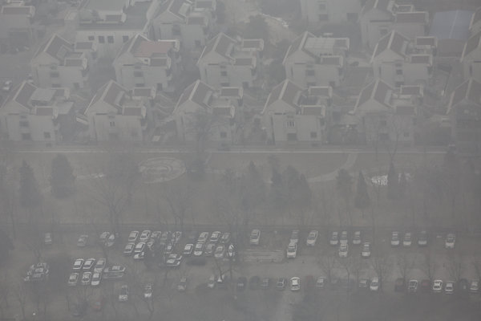
A view of Beijing on Wednesday.

By EDWARD WONG

Published: January 30, 2013
BEIJING — The Beijing government put in place emergency measures on Wednesday to try to combat thick smog that has encased the city, which the Communist Party has hailed as a showcase capital, in brown and gray soot. The measures include temporarily shutting down more than 100 factories and ordering one-third of government vehicles off the streets, according to official news reports.
The effort came on the second straight day of air that was rated “hazardous” by the standards of the United States Environmental Protection Agency. That rating, in which the air quality index surpasses 300, means people should not venture outdoors at all. This month, Beijing has writhed in the grip of the most polluted air days on recent record. The surge in pollution, which is happening across northern China, has angered residents and led the state news media to report more openly on air quality problems.
Officials have also begun acknowledging the severity of the problem. Xinhua, the state news agency, reported that Wang Anshun, the newly appointed mayor of Beijing, said Monday that the government had come up with a preliminary plan to curb the pollution.
“I hope we can have blue skies, clean water, less traffic and a more balanced education system,” Mr. Wang said at a session of the municipal legislature.
Mr. Wang also told lawmakers that “the current environmental problems are worrisome.” He said the number of vehicles in Beijing should be allowed to increase, but slowly. The Xinhua report said there were an estimated 5.18 million vehicles in Beijing, compared with 3.13 million in early 2008.
Mr. Wang told the legislature on Jan. 22 that the Beijing government was aiming to cut the density of major air pollutants by 2 percent this year. To that end, officials are ordering 180,000 older vehicles off the roads, promoting the use of “clean energy” for government vehicles and heating systems, and growing trees over 250 square miles of land in the next five years, Xinhua reported.
Prime Minister Wen Jiabao also addressed the pollution issue at seminars on economic development in the past week, Xinhua said. Mr. Wen said efforts should be made to “optimize industrial structure, promote energy saving and emission reduction, and advance ecological progress,” it said.
In the past three decades, China has adopted a growth-at-any-cost attitude to build its economy, and the resulting environmental damage is now widespread and severe. Analysts say it will take years to clean up the air in northern China, even if serious measures are taken now.
Beijing sits in the middle of an industrial belt of coal-burning factories, and there is little incentive for officials or executives to slow down work there. Traditionally, officials’ performance ratings have been closely tied to economic growth and the maintenance of stability. In recent years, some policy makers have urged that a measure of environmentalism be taken into account.
The United States Energy Information Administration released a report on Tuesday that said China now accounts for 47 percent of global coal consumption, almost equal to all other countries in the world combined. Coal consumption in China grew by more than 9 percent in 2011, or 325 million tons, which equaled 87 percent of the total global rise in coal use.
The report said the heavy demand for coal use was because of an increase of more than 200 percent in electricity generation since 2000. China’s coal demand growth averaged 9 percent a year from 2000 to 2010. If China were excluded from measurements of global growth during that time, the average annual growth would have been only 1 percent, the report said.
On Tuesday morning, the air quality index as measured by a device atop the United States Embassy in central Beijing reached 517, which was so high that the rating was labeled “beyond index” on an embassy Twitter account, @BeijingAir. (Once before, the account had labeled a rating of more than 500 “crazy bad,” but embassy officials quickly deleted that tweet.) Index readings on a Web site run by the Beijing government had similar numbers.
The indexes are based primarily on measurements of a potentially deadly particulate matter called PM 2.5. In mid-January, some monitoring devices set up by the government in the Beijing municipality, which includes more than 20 million people, recorded PM 2.5 concentrations of nearly 1,000 micrograms per cubic meter, which was on par with the worst days in industrial London during the mid-20th century.
Beijing announced in early 2012 that it would report PM 2.5 levels, in response to an outcry from residents demanding the information. A total of 74 Chinese cities are supposed to release that data this year. Among the prominent voices calling for greater disclosure is Pan Shiyi, a real estate tycoon.
This week, Mr. Pan has asked the 14 million followers of his microblog whether China should adopt a “clean air act” that would be much stronger than current laws. As of Wednesday afternoon, 99 percent of the more than 42,000 replies had voted in favor of the act.
“In order to control air pollution, we need everyone to participate,” Mr. Pan wrote. “The most important thing is legislation.”
Mr. Pan did not give details on what the legislation would say. He said that as a member of the Beijing municipal people’s congress, he would bring up the idea of an act to other legislators and officials. In China, though, legislatures have little power; senior party officials make important policy.
Zhang Xin, Mr. Pan’s wife and business partner, said on her microblog that after thousands of people died as a result of air pollution in Britain in the 1950s, the government vigorously tackled its air quality problems with strict laws.

NYT

As Pollution Worsens in China, Solutions Succumb to Infighting
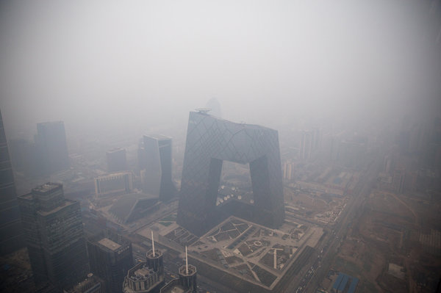
A heavy smog shrouded the China Central Television building in Bejing. Li Keqiang, the new prime minister, said the air pollution had made him “quite upset.”

By EDWARD WONG

Published: March 21, 2013 4 Comments
BEIJING — China’s state leadership transition took place this month against an ominous backdrop. More than 13,000 dead pigs were found floating in a river that provides drinking water to Shanghai. A haze akin to volcanic fumes cloaked the capital, causing convulsive coughing and obscuring the portrait of Mao Zedong on the gate to the Forbidden City.
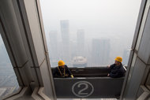

Sim Chi Yin for The New York Times
Two window cleaners ride past the 80th floor of a hotel in Beijing. Officials say vehicle emissions and coal-fired factories account for much of the city's air pollution.
So severe are China’s environmental woes, especially the noxious air, that top government officials have been forced to openly acknowledge them. Fu Ying, the spokeswoman for the National People’s Congress, said she checked for smog every morning after opening her curtains, wore a face mask when it looked bad and strapped one on her daughter, too. Li Keqiang, the new prime minister, said the air pollution had made him “quite upset” and vowed to “show even greater resolve and make more vigorous efforts” to clean it up.
What the leaders neglect to say is that infighting within the government bureaucracy is one of the biggest obstacles to enacting stronger environmental policies. Even as some officials push for tighter restrictions on pollutants, state-owned enterprises — especially China’s oil and power companies — have been putting profits ahead of health in working to outflank new rules, according to government data and interviews with people involved in policy negotiations.
For instance, even though trucks and buses crisscrossing China are far worse for the environment than any other vehicles, the oil companies have delayed for years an improvement in the diesel fuel those vehicles burn. As a result, the sulfur levels of diesel in China are at least 23 times that of the United States. As for power companies, the three biggest ones in the country are all repeat violators of government restrictions on emissions from coal-burning plants; offending power plants are found across the country, from Inner Mongolia to the southwest metropolis of Chongqing.
The state-owned enterprises are given critical roles in policy-making on environmental standards. The committees that determine fuel standards, for example, are housed in the buildings of an oil company. Whether the enterprises can be forced to follow, rather than impede, environmental restrictions will be a critical test of the commitment of Mr. Li and Xi Jinping, the new party chief and president, to curbing the influence of vested interests in the economy.
Last month, after deadly air pollution hit record levels in northern China, officials led by Wen Jiabao, then the prime minister, put forward strict new fuel standards that the oil companies had blocked for years. But there are doubts about whether the oil companies will comply, especially since oil officials resisted a similar government order for higher-grade fuel four years ago. State-owned power companies have been similarly resistant. The companies regularly ignore government orders to upgrade coal-burning electricity plants, according to ministry data. And as with the oil companies, the power companies exert an outsize influence over environmental policy debates.
In 2011, during a round of discussions over stricter emissions standards, the China Electricity Council, which represents the companies, pushed back hard against the proposals, saying that the costs of upgrading the plants would be too high.
“During the procedure of setting the standard, the companies or the industry councils have a lot of influence,” said Zhou Rong, a campaign manager on energy issues for Greenpeace East Asia. “My personal opinion is even if we have the most stringent standards for every sector, the companies will violate those.”
On Feb. 28, Deutsche Bank released an analysts’ note saying that China’s current economic policies would result in an enormous surge in coal consumption and automobile sales over the next decade. “China’s air pollution will become a lot worse from the already unbearable level,” the analysts said, calling for drastic policy changes and “a strong government will to overcome the opposition from interest groups.”
The report estimated that the number of passenger cars in China was on track to hit 400 million by 2030, up from 90 million now.
For the most part, Chinese automakers have supported upgrading cars with cleaner technology, which makes them more marketable worldwide, environmental advocates say. But better technology cannot operate properly without high-quality fuel, and this is where the bottleneck occurs.
The system of forging fuel standards has led to fierce bureaucratic infighting.
The Ministry of Environmental Protection is the main government advocate for both higher fuel standards and better automobile technology. It has the power to force automakers to use new technology by issuing stricter tailpipe emissions standards, but it cannot unilaterally impose new fuel standards or enforce compliance from the oil companies. Instead, it can merely lobby other relevant ministries or agencies to take action.
When fuel standards do not keep pace with vehicle technology, the environmental ministry has to delay issuing new tailpipe emissions standards, and so cars do not get upgraded.
Fuel standards are issued by the Standardization Administration of China, which convenes a committee and a subcommittee to research standards.
They each have 30 to 40 members, almost all of whom are from oil companies, said Yue Xin, a scientist who sits on one of the groups on behalf of the Ministry of Environmental Protection.
The members from the oil companies “will represent more of the company’s interests,” Mr. Yue said. Sinopec and PetroChina, two of the biggest oil companies, have insisted that consumers or the government pay to upgrade their refineries to produce cleaner fuel, and they have delayed approving higher standards unless there is consensus on who pays.
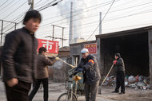
Workers at a rubbish disposal center near the billowing chimney of a power plant in Beijing.
“Sinopec for years has never argued against the need to improve China’s standards,” said David Vance Wagner, a senior researcher at the International Council on Clean Transportation who used to work under the Chinese Ministry of Environmental Protection. “They’ve just argued about the finance of it.”
In late January, Fu Chengyu, chairman of Sinopec, acknowledged that the oil companies bore some responsibility for air pollution, but he also argued that the government’s fuel standards were not high enough, according to Xinhua, the state news agency. What Mr. Fu failed to explain was that oil company representatives on the committees researching fuel standards have been the main impediment to pushing through better standards.
Mr. Yue and others say that because of constant haggling by the oil companies, the government for years delayed issuing upgraded China IV diesel standards that are on par with European standards. On Feb. 6, after the uproar over record-breaking air pollution, the State Council, China’s cabinet, smashed the gridlock by putting out guidelines that called for a nationwide adoption of the new China IV diesel standards by the end of 2014.
It also set deadlines on the issuing and phasing in of even cleaner China V standards. The next day, the Standardization Administration of China issued the upgraded China IV diesel standards that the oil companies had been trying to delay for years.
But the costs of upgrading could still lead the oil companies to ignore the new standards, which is what they did when the State Council in 2009 ordered a phase-in of the China III diesel standard.
In the Feb. 6 announcement, the State Council said the government needed to create a fiscal policy to support the refinery upgrades, but the Ministry of Finance has yet to make the policy.
Another big concern lies in the debate over the cleaner China V gasoline standard, which the State Council said must be issued by December and phased in by the end of 2017. In the committee debates, Sinopec argues that it is expensive to meet the requirements for sulfur levels.
Oil company representatives did not reply to requests for comment. In public, oil company executives are trying to shift the blame. Mr. Fu told reporters this month that “in fact the biggest killer is coal.”
Beijing officials have said that vehicle emissions account for 22 percent of the main deadly particulate matter in the air, known as PM 2.5, and another 40 percent is from coal-fired factories in Beijing and nearby provinces.
In February, the Ministry of Environmental Protection issued stricter factory emissions standards for six coal-burning industries. First on the list is the power industry, which accounts for about half the coal consumption in China.
But compliance by the state-owned enterprises could be a problem. The environmental ministry publishes annual lists of factories that have violated emissions regulations. A review shows that the factories are all run by the biggest power companies.
The annual lists represent only a fraction of the plants in violation, since installation by the factories of monitoring equipment is spotty, and the equipment readings can be manipulated, said Kevin Jianjun Tu, an energy scholar at the Carnegie Endowment for International Peace.
Another problem is the low penalties: fines are generally capped around $16,000, not much of a deterrent, said Ms. Zhou, the Greenpeace representative. She said the violating factories “should be required to stop production temporarily — that would then force companies to take this seriously.”
NYT

Cost of Environmental Damage in China Growing Rapidly Amid Industrialization
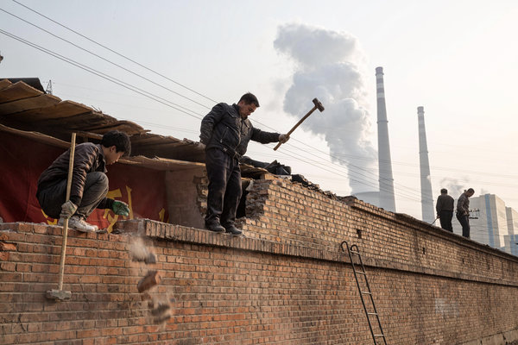
Workers demolishing the wall of a house as a power plant billowed smoke in east Beijing. State-owned enterprises have blocked antipollution policies.

By EDWARD WONG

Published: March 29, 2013
BEIJING — The cost of environmental degradation in China was about $230 billion in 2010, or 3.5 percent of the nation’s gross domestic product — three times that in 2004, in local currency terms, an official Chinese news report said this week.
The statistic came from a study by the Chinese Academy of Environmental Planning, which is part of the Ministry of Environmental Protection.
The figure of $230 billion, or 1.54 trillion renminbi, is based on costs arising from pollution and damage to the ecosystem, the price that China is paying for its rapid industrialization.
“This cuts to the heart of China’s economic challenge: how to transform from the explosive growth of the past 30 years to the sustainable growth of the next 30 years,” said Alistair Thornton, a China economist at the research firm IHS Global Insight. “Digging a hole and filling it back in again gives you G.D.P. growth. It doesn’t give you economic value. A lot of the activity in China over the last few years has been digging holes to fill them back in again — anything from bailing out failing solar companies to ignoring the ‘externalities’ of economic growth.”
And the costs could be even higher than the ministry’s estimate, he said. The $230 billion figure is incomplete because the researchers did not have a full set of data. Making such calculations is “notoriously difficult,” Mr. Thornton said.
The 2010 figure was reported on Monday by a newspaper associated with the ministry, and so far only partial results of the study are available. In 2006, the ministry began releasing an estimate of the cost of environmental degradation. The ministry has issued statistics only intermittently, though its original goal was to do the calculation — what it called “green G.D.P.” — annually.
The rapidly eroding environment across the country has become an issue of paramount concern to many Chinese. In January, outrage boiled over as air pollution in north China reached record levels, well beyond what Western environmental agencies consider hazardous. The public fury forced propaganda officials to allow official Chinese news organizations to report more candidly on the pollution.
Chinese state-owned enterprises in the oil and power industries have consistently blocked efforts by pro-environment government officials to impose policies that would alleviate the pollution.
There have also been constant concerns over water and soil pollution. The discovery of at least 16,000 dead pigs in rivers that supply drinking water to Shanghai has ignited alarm there. This week, China Central Television reported that farmers in a village in Henan Province were using wastewater from a paper mill to grow wheat. But one farmer said they would not dare to eat the wheat themselves. It is sold outside the village, perhaps ending up in cities, while the farmers grow their own wheat with well water.
The Beijing government on Thursday released details of a three-year plan that is aimed at curbing various forms of pollution, according to a report on Friday in China Daily, an official English-language newspaper. The report quoted Wang Anshun, Beijing’s mayor, as saying that sewage treatment, garbage incineration and forestry development would cost at least $16 billion.
In 2006, the environmental ministry said the cost of environmental degradation in 2004 was more than $62 billion, or 3.05 percent of G.D.P. In 2010, it released partial results for 2008 that totaled about $185 billion, or 3.9 percent of G.D.P. Several foreign scholars have criticized the methods by which Chinese researchers have reached those numbers, saying some crucial measures of environmental degradation are not included in the calculations.
There is consensus now that China’s decades of double-digit economic growth exacted an enormous environmental cost. But growth remains the priority; the Communist Party’s legitimacy is based largely on rapidly expanding the economy, and China officially estimates that its G.D.P., which was $8.3 trillion in 2012, will grow at a rate of 7.5 percent this year and at an average of 7 percent in the five-year plan that runs to 2015. A Deutsche Bank report released last month said the current growth policies would lead to a continuing steep decline of the environment for the next decade, especially given the expected coal consumption and boom in automobile sales.

NYT

Air Pollution Linked to 1.2 Million Premature Deaths in China
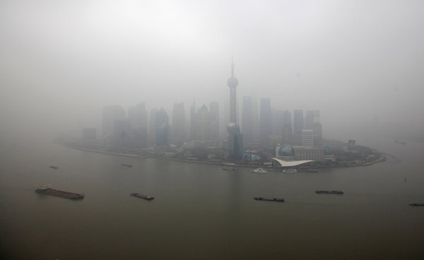
Shanghai in January. Researchers said the toll from China’s pollution meant the loss of 25 million healthy years in 2010.

By EDWARD WONG

Published: April 1, 2013 Comment
BEIJING — Outdoor air pollution contributed to 1.2 million premature deaths in China in 2010, nearly 40 percent of the global total, according to a new summary of data from a scientific study on leading causes of death worldwide.
Figured another way, the researchers said, China’s toll from pollution was the loss of 25 million healthy years of life from the population.
The data on which the analysis is based was first presented in the ambitious 2010 Global Burden of Disease Study, which was published in December in The Lancet, a British medical journal. The authors decided to break out numbers for specific countries and present the findings at international conferences. The China statistics were offered at a forum in Beijing on Sunday.
“We have been rolling out the India- and China-specific numbers, as they speak more directly to national leaders than regional numbers,” said Robert O’Keefe, the vice president of the Health Effects Institute, a research organization that is helping to present the study. The organization is partly financed by the United States Environmental Protection Agency and the global motor vehicle industry.
What the researchers called “ambient particulate matter pollution” was the fourth-leading risk factor for deaths in China in 2010, behind dietary risks, high blood pressure and smoking. Air pollution ranked seventh on the worldwide list of risk factors, contributing to 3.2 million deaths in 2010.
By comparison with China, India, which also has densely populated cities grappling with similar levels of pollution, had 620,000 premature deaths in 2010 because of outdoor air pollution, the study found. That was deemed to be the sixth most common killer in South Asia.
The study was led by an institute at the University of Washington and several partner universities and institutions, including the World Health Organization.
Calculations of premature deaths because of outdoor air pollution are politically threatening in the eyes of some Chinese officials. According to news reports, Chinese officials cut out sections of a 2007 report called “Cost of Pollution in China” that discussed premature deaths. The report’s authors had concluded that 350,000 to 400,000 people die prematurely in China each year because of outdoor air pollution. The study was done by the World Bank in cooperation with the Chinese State Environmental Protection Administration, the precursor to the Ministry of Environmental Protection.
There have been other estimates of premature deaths because of air pollution. In 2011, the World Health Organization estimated that there were 1.3 million premature deaths in cities worldwide because of outdoor air pollution.
Last month, the Organization for Economic Cooperation and Development, based in Paris, warned that “urban air pollution is set to become the top environmental cause of mortality worldwide by 2050, ahead of dirty water and lack of sanitation.” It estimated that up to 3.6 million people could end up dying prematurely from air pollution each year, mostly in China and India.
There has been growing outrage in Chinese cities over what many say are untenable levels of air pollution. Cities across the north hit record levels in January, and official Chinese newspapers ran front-page articles on the surge — what some foreigners call the “airpocalypse” — despite earlier limits on such discussion by propaganda officials.
In February, the State Council, China’s cabinet, announced a timeline for introducing new fuel standards, but state-owned oil and power companies are known to block or ignore environmental policies to save on costs.
A study released on Thursday said the growth rate of disclosure of pollution information in 113 Chinese cities had slowed. The groups doing the study, the Institute of Public and Environmental Affairs, based in Beijing, and the Natural Resources Defense Council, based in Washington, said that “faced with the current situation of severe air, water and soil pollution, we must make changes to pollution source information disclosure so that information is no longer patchy, out of date and difficult to obtain.”
Chinese officials have made some progress in disclosing crucial air pollution statistics. Official news reports have said 74 cities are now required to release data on levels of particulate matter 2.5 micrometers in diameter or smaller, which penetrate the body’s tissues most deeply. For years, Chinese officials had been collecting the data but refusing to release it, until they came under pressure from Chinese who saw that the United States Embassy in Beijing was measuring the levels hourly and posting the data in a Twitter feed, @BeijingAir.
Last week, an official Chinese news report said the cost of environmental degradation in China was about $230 billion in 2010, or 3.5 percent of the gross domestic product. The estimate, said to be partial, came from a research institute under the Ministry of Environmental Protection, and was three times the amount in 2004, in local currency terms. It was unclear to what extent those numbers took into account the costs of health care and premature deaths because of pollution.

NYT

Pollution Is Radically Changing Childhood in China’s Cities
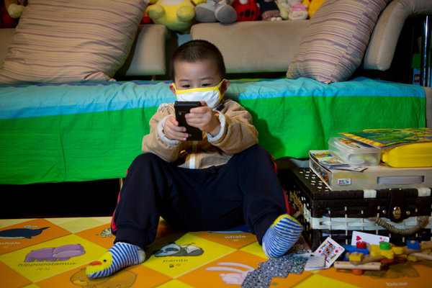
Wu Xiaotian, 3, who has breathing problems, played a game while wearing a mask this month at his home in Beijing, China.

By EDWARD WONG

Published: April 22, 2013
BEIJING — The young boy’s chronic cough and stuffy nose began last year at the age of 3. His symptoms worsened this winter, when smog across northern China surged to record levels. Now he needs his sinuses cleared every night with saltwater piped through a machine’s tubes.
The boy’s mother, Zhang Zixuan, said she almost never lets him go outside, and when she does she usually makes him wear a face mask. The difference between Britain, where she once studied, and China is “heaven and hell,” she said.
Levels of deadly pollutants up to 40 times the recommended exposure limit in Beijing and other cities have struck fear into parents and led them to take steps that are radically altering the nature of urban life for their children. Parents are confining sons and daughters to their homes, even if that means keeping them away from friends. Schools are canceling outdoor activities and field trips. Parents with means are choosing schools based on air-filtration systems, and some international schools have built gigantic, futuristic-looking domes over sports fields to ensure healthy breathing.
“I hope in the future we’ll move to a foreign country,” Ms. Zhang, a lawyer, said as her ailing son, Wu Xiaotian, played on a mat in their apartment, near a new air purifier. “Otherwise we’ll choke to death.”
She is not alone in looking to leave. Some middle- and upper-class Chinese parents and expatriates have already begun leaving China, a trend that executives say could result in a huge loss of talent and experience. There are also reports of foreign parents turning down prestigious jobs or negotiating for hardship pay from their employers, citing the pollution.
There are no statistics for the flight, and many people are still eager to come work in Beijing, but talk of leaving is gaining urgency around the capital and on Chinese microblogs and parenting forums. Chinese are also discussing holidays to what they call the “clean-air destinations” of Tibet, Hainan and Fujian.
“I’ve been here for six years and I’ve never seen anxiety levels the way they are now,” said Dr. Richard Saint Cyr, a new father and a family health doctor at Beijing United Family Hospital, whose patients are half Chinese and half foreigners. “Even for me, I’ve never been as anxious as I am now. It has been extraordinarily bad.”
He added: “Many mothers, especially, have been second-guessing their living in Beijing. I think many mothers are fed up with keeping their children inside.”
Few developments have eroded trust in the Communist Party as quickly as the realization that the leaders have failed to rein in threats to children’s health and safety. There was national outrage in 2008 when more than 5,000 children were killed when their schools collapsed in an earthquake and hundreds of thousands were sickened in a tainted milk formula scandal the same year. Officials tried to suppress angry parents, sometimes by force or with payoffs.
But the fury over air pollution is much more widespread and is just beginning to gain momentum.
“I don’t trust the pollution measurements of the Beijing government,” said Ms. Zhang’s father, Zhang Xiaochun, a retired newspaper administrator.
Scientific studies justify fears of long-term damage to children and fetuses. A study published by The New England Journal of Medicine showed that children exposed to high levels of air pollution can suffer permanent lung damage. The research was done in the 1990s in Los Angeles, where levels of pollution were much lower than in Chinese cities today.
A study by California researchers published last month suggested a link between autism in children and the exposure of pregnant women to traffic-related air pollution. Columbia University researchers, in a study done in New York, found that prenatal exposure to air pollutants could result in children with anxiety, depression and attention-span problems. Some of the same researchers found in an earlier study that children in Chongqing, China, who had prenatal exposure to high levels of air pollutants from a coal-fired plant were born with smaller head circumferences, showed slower growth and performed less well on cognitive development tests at age 2. The shutdown of the plant resulted in children born with less difficulties.
Analyses show little relief ahead if China does not change growth policies and strengthen environmental regulation. A Deutsche Bank report released in February said the current trends of coal use and automobile emissions meant air pollution was expected to worsen by an additional 70 percent by 2025.
Some children’s hospitals in northern China reported an extraordinary number of patients with respiratory illnesses this winter, when the air pollution soared. During one bad week in January, Beijing Children’s Hospital admitted up to 9,000 patients a day for emergency visits, half of them for respiratory problems, according to a report by Xinhua, the state news agency.
Parents have scrambled to buy air purifiers. IQAir, a Swiss company, makes purifiers that cost up to $3,000 here and are displayed in shiny showrooms. Mike Murphy, the chief executive of the company’s China division, said sales had tripled in the first three months of 2013 over the same period last year.
Face masks are now part of the urban dress code. Ms. Zhang laid out half a dozen masks on her dining room table and held up a simple one with a picture of a teddy bear that fits Xiaotian. Schools are adopting emergency measures. Xiaotian’s private kindergarten used to take the children on a field trip once a week, but it has canceled most of those this year.
At the prestigious Beijing No. 4 High School, which has long trained Chinese leaders and their children, outdoor physical education classes are now canceled when the pollution index is high.
“The days with blue sky and seemingly clean air are treasured, and I usually go out and do exercise,” said Dong Yifu, a senior there who was just accepted to Yale University.
Elite schools are investing in infrastructure to keep children active. Among them are Dulwich College Beijing and the International School of Beijing, which in January completed two large white sports domes of synthetic fabric that cover athletic fields and tennis courts.
The erecting of the domes and an accompanying building began a year ago, to give the 1,900 students a place to exercise in both bad weather and high pollution, said Jeff Johanson, director of student activities. The project cost $5.7 million and includes hospital-grade air-filtration systems.
Teachers check the hourly air ratings from the United States Embassy to determine whether children should play outside or beneath the domes. “The elementary schoolchildren don’t miss recess anymore,” Mr. Johanson said.
One American mother, Tara Duffy, said she had chosen a prekindergarten school for her daughter based in part that the school had air filters in the classrooms. The school, called the 3e International School, also brings in doctors to talk about pollution and bars the children from playing outdoors during increases in smog levels. “In the past six months, there have been a lot more ‘red flag’ days, and they keep the kids inside,” said Ms. Duffy, a writer
Ms. Duffy said she also checked the daily air quality index to decide whether to take her daughter to an outdoor picnic or an indoor play space.
Now, after nine years here, Ms. Duffy is leaving China, and she cites the pollution and traffic as major factors.
That calculus is playing out with expatriates across Beijing.
One American couple with a young child discussed the pollution when considering a prestigious foundation job in Beijing, and it was among the reasons they ultimately turned down the offer. James McGregor, a senior counselor in the Beijing office of APCO Worldwide, a consulting company, said he had heard of an American diplomat with young children who had turned down a posting here. That was despite the fact that the State Department provides a 15 percent salary bonus for Beijing that exists partly because of the pollution. The hardship bonus for other Chinese cities, which also suffer from awful air, ranges from 20 percent to 30 percent, except for Shanghai, where it is 10 percent.
“I’ve lived in Beijing 23 years, and my children were brought up here, but if I had young children I’d have to leave,” Mr. McGregor said. “A lot of people have started exit plans.”

Yakushima Journal

NYT

Scientist Says Pollution From China Is Killing a Japanese Island’s Trees
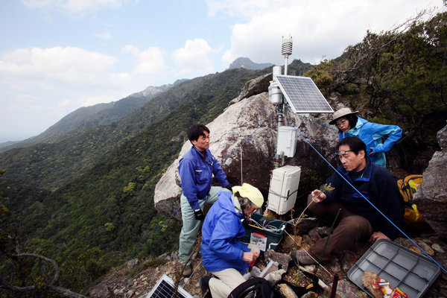
Osamu Nagafuchi, second right, an environmental engineer, checks a monitoring station around Yakushima to measure levels in the air of ozone and sulfur emissions, which are typically the byproducts of burned coal or automobile exhaust.

By MARTIN FACKLER

Published: April 24, 2013
YAKUSHIMA, Japan — A mysterious pestilence has befallen this island’s primeval forests, leaving behind the bleached, skeletal remains of dead trees that now dot the dark green mountainsides. Osamu Nagafuchi, an environmental engineer with a passion for the island and its rugged terrain, believes he knows the culprit: airborne pollutants from smog-belching China, hundreds of miles upwind.
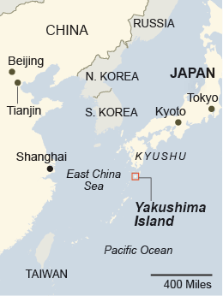
For years, Mr. Nagafuchi’s theory was ignored by fellow scientists and even mocked by bureaucrats in the national government who administer the forests on this southwestern island. But Japan has begun taking his warnings more seriously, as the nation has been gripped by a national health scare over rising levels of potentially dangerous airborne particles that have swept into other parts of Japan and that many now believe were produced by China, its huge and rapidly industrializing neighbor.
These fears have reached a new level recently as China itself has issued more public warnings about the growing health risks from its cities’ gray, soupy air. While Mr. Nagafuchi and a small number of collaborators say their research is not politically motivated, they admit that they may be finding more receptivity among a public that already resents China for supplanting Japan as Asia’s largest economy, and for what is seen as its haughty attitude in a territorial dispute over islands both countries claim.
Japanese officials still dispute whether airborne pollutants are responsible for killing the pine trees. But they and other scientists have at least begun to view Yakushima, which is far from Japan’s own industrial centers, as a pristine laboratory for understanding how China’s growing environmental problems could be affecting its neighbors.
Many islanders are already believers, and they worry that the pollutants may be threatening their health.
“We are starting to feel like the canary in a coal mine,” said the island’s mayor, Koji Araki. “Our island is right downwind from China, so we get the brunt of it.”
Whatever the cause, the tree die-off is a worrisome turn for this small, mountainous island off Kyushu, the southernmost of Japan’s main islands, whose moss-carpeted forests provide a rare patch of primitive nature in an otherwise densely populated nation. There are fears here that a growing smog problem could scare off the hikers and other ecotourists upon whom many of the island’s 14,000 residents depend for their livelihoods.
Most visitors come to see Yakushima’s majestic cedar trees, which have so far been unaffected by the mysterious ailment killing the pines. The cedars won the island the distinction of a Unesco World Heritage site in 1993.
The cedars were logged for centuries to build some of the great Buddhist temples in the ancient capital, Kyoto. The biggest remaining tree, the gnarled Jomon cedar, measures 16 feet around at the base and is estimated to be at least 2,600 years old.
The dying trees are from an endangered species of pine that is found only on Yakushima and a neighboring island. Mr. Nagafuchi, a professor of ecosystem studies at the University of Shiga Prefecture in central Japan, said he noticed the problem when satellite photographs showed a large increase in the number of dead trees between 1992 and 1996.
Mr. Nagafuchi, then a public employee for a city in Kyushu, had already found blackened snow while hiking to Yakushima’s mountaintops in 1992. He started collecting and analyzing the snow as a sort of weekend hobby. To his surprise, he found it contained silicon, aluminum and other byproducts from the burning of coal, which is used to heat homes in China. Using maps of winds, he theorized that the pollutants were carried here from China, across the East China Sea.
The discovery drove Mr. Nagafuchi to quit his city job and eventually become a university professor, doing much of his research on Yakushima. He has set up small monitoring stations around the island to measure levels in the air of ozone and sulfur emissions, which are typically the byproducts of burned coal or automobile exhaust.
On a recent afternoon, Mr. Nagafuchi climbed to the highest of those stations, atop Mt. Kuromi, a windswept peak that rises 6,000 feet above the sea below. After hooking up his laptop to download data from the station’s small digital recorder, he pointed out the thin, gauzy haze that clouded what he said should have been pristine air.
“The worst is when winds blow from Beijing and Tianjin,” two Chinese cities about 900 miles to the northwest, said Mr. Nagafuchi, 62, who visits Yakushima once a month to collect the data readings. “This is proof that when such a big country industrializes, its effect will spread everywhere.”
When they first started publicizing the findings in the mid-1990s, Mr. Nagafuchi and his main partner, Kenshi Tetsuka, an islander who started a small environmental group to protect the pines, were at first derided by forestry officials and established scientists who said they were sensationalizing the die-off to get public attention. Some scientists questioned why the tree deaths slowed even as China’s pollution problems have grown. Mr. Nagafuchi says he believes the pollution quickly killed off the weak trees, leaving the hardier ones.
His ideas began to win limited acceptance in the early 2000s, amid evidence of a growing influx of Chinese pollutants across Japan. The national government’s Forestry Agency began to allow Mr. Nagafuchi to set up his monitoring stations, and is doing joint research with him and Mr. Tetsuka, though it still believes the deaths are caused by an infestation of bugs and a runaway population of deer, which can strip small trees of pine needles.
They point out that there had been die-offs of pine trees on Yakushima even before China’s economic takeoff.
“We don’t agree with him, but we respect his research,” said Hiroharu Ijima, a Forestry Agency official on Yakushima.
Public anxieties about environmental effects from China have soared this year, after Beijing recorded alarming increases in pollution levels. That was followed by officials in western Japan issuing warnings in their own cities of high levels of particulate matter measuring 2.5 micrometers or less, known as PM 2.5, that are small enough to become embedded in human lungs. Several Japanese cities have issued warnings this year for residents to stay indoors when the pollutant levels spike.
When the air grew particularly hazy on Yakushima one day last month, local officials asked if they could use one of Mr. Nagafuchi’s monitoring stations to measure PM 2.5. The level was above government-recommended safe levels, prompting officials to order a local elementary school to cancel a field trip to a nearby forest.
Residents who believe the pollution is caused by China described feeling helpless, saying they doubt there is any action their government can take even if it becomes convinced Mr. Nagafuchi is right.
“There is not much we can do about this, except ask the Chinese to spend more money on environmental cleanup,” said Mr. Tetsuka, Mr. Nagafuchi’s research assistant. “I’m afraid it will only get worse and worse.”

NYT

China Sets New Rules Aimed at Curbing Air Pollution

By KEITH BRADSHER

Published: June 15, 2013
HONG KONG — China’s cabinet has adopted 10 measures to improve air quality in the latest move aimed at responding to the dense smog that has repeatedly enveloped Beijing and other major Chinese cities in recent years.
Many of the measures had previously been enacted by some cities, or were the subject of national experiments that had not yet received the imprimatur of the cabinet, which is known as the State Council. The measures, adopted Friday, were announced Saturday in state-controlled news media.
The newest and least-expected of them is a mandate that heavy polluters like coal-fired power plants and metal smelters must release detailed environmental information to the general public.
Ma Jun, the director of the Institute of Public and Environmental Affairs, one of the best-known independent environmental advocacy groups in Beijing, said that 5,000 of the country’s biggest factories account for three-fifths of its industrial pollution, but that the public knows few details about their emissions.
“In China, the factories can just discharge without letting people know,” he said. “If we can bring them under public supervision, it would make a big difference.”
Still, Mr. Ma cautioned that while national leaders may want a cleaner environment, enforcing tough pollution regulations at the local level could prove difficult.
The cabinet also ordered that heavy polluters reduce their emissions for each renminbi or unit of economic output by 30 percent by the end of 2017. But if the economy grows 7 percent or more a year, as forecast, the decrease in total pollution would be modest.
During the past two years, China has seen a rapid growth of environmental protests. Crowds numbering in the thousands have taken to the streets in coastal cities including Dalian, Tianjin and Xiamen to prevent the construction or continued operation of large chemical plants.
Coal-fired power plants have been blocked in the southern provinces of Guangdong and Hainan. And rock-throwing mobs forced the cancellation of a copper smelter a year ago in Shifang, a town near Chengdu in Sichuan Province, in western China.
The new 10-part program calls for greater cooperation among cities and provinces. For example, Beijing is trying to reduce its consumption of heavily polluting coal, but the nearby city of Tianjin and adjacent Hebei Province are expanding their already huge coal-dependent industries in sectors like petrochemicals and steel.
The cabinet’s action includes some measures already taken by very large municipal governments like Beijing and Shanghai. Both cities already require much cleaner gasoline and diesel, so that cars and trucks emit less tailpipe pollution, and those policies are now supposed to be applied nationwide.
The State Council also called for more cities to prepare emergency response plans for heavy pollution, including traffic restrictions and limits on local industries.
In addition, it ordered heavier fines for polluters and stricter requirements for environmental impact statements. Concerns about street protests over environmental disputes had already led the cabinet to announce last November that it would require a “social risk assessment” before allowing major industrial projects to proceed.
Corporate leaders say that the Chinese public has rapidly become more prone to question the wisdom of big investment projects, particularly in the chemical industry.
“This is quite fast, how this reaction has stepped up, particularly in China,” Martin Brudermüller, the vice chairman of the German chemicals giant BASF, said in a meeting with reporters in Hong Kong on June 4.
With the protests, he later added, “China becomes a little bit more like the West.”

NYT

Silver Lining in China’s Smog as It Puts Focus on Emissions
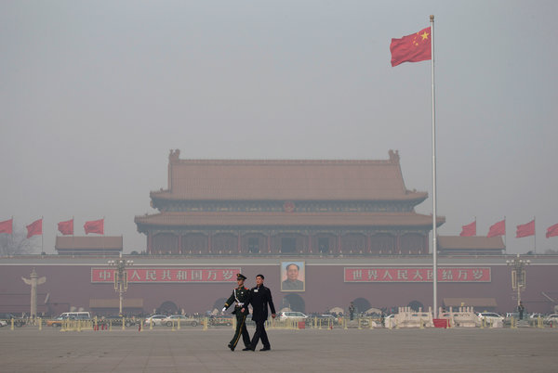
Andy Wong/Associated Press
DAYS OF HAZE A typical smoggy day in Tiananmen Square in Beijing this year.

By CHRIS BUCKLEY

Published: August 31, 2013
HONG KONG — Jiang Kejun may be one of the few Beijing residents who see a ray of hope in the smog engulfing the city. A researcher in a state energy institute, he is an outspoken advocate of swiftly cutting China’s greenhouse gas output, and he says public anger about noxious air has jolted the government, which long dismissed pollution as the necessary price of prosperity.
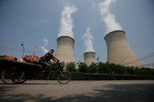

Diego Azubel/European Pressphoto Agency
Cooling towers in Beijing. China has been the world’s biggest emitter of carbon dioxide from fuel use since about 2006.
The grimy haze blanketing Beijing and other Chinese cities comes from motor vehicles, factories, power plants and furnaces that also emit carbon dioxide, the main global warming gas from human activities. The widespread ire about air pollution has forced China’s new leadership to vow firmer, faster measures for cleaner air that are likely to reduce carbon dioxide output, especially from coal, experts said. “The public concern about the air pollution has helped raise awareness about broader environmental problems,” said Mr. Jiang, a researcher at the Energy Research Institute, which advises the Chinese government. “This will be a big help in pushing China.”
Mr. Jiang is an unusual hybrid — part policy insider, part maverick — in a growing debate among Chinese officials, policy advisers and academics about how fast and far to limit greenhouse gas pollution, which now well exceeds that of any other country. The debate, increasingly vigorous but in typical Chinese fashion playing out largely behind the scenes, pits the demands of industrialization and urban growth against the realities of global warming.
Defying the habitual caution of government advisers, Mr. Jiang has developed a proposal to swiftly limit the growing volume of carbon dioxide that China produces from consuming fossil fuels, which constitute over a quarter of the world’s total such emissions. In his blueprint, China’s emissions would reach a peak by around 2025, at least five years earlier and at a much lower level than many Chinese experts have said is possible.
“I’m not saying it will be easy, but it’s feasible,” Mr. Jiang said. “Time for effective action is very limited.”
His plan appears far from winning government endorsement, but is “one of those trial balloons that wouldn’t be floated unless there’s serious discussion opening up about what China should do,” said Barbara Finamore, Asia director at the Natural Resources Defense Council, a New York-based advocacy group.
Chinese policy advisers have developed proposals to control greenhouse gases in the nearer term, government-sponsored studies show. They include a carbon tax on fossil fuels, and beginning in 2016 setting annual guiding limits for carbon dioxide emissions from energy use. China will explore expanding nascent local carbon credit markets into a nationwide plan starting in 2015, Xie Zhenhua, an official who oversees climate change policy, said in late July.
In part, China is responding to international pressure, as governments negotiate a proposed new global agreement on climate change, scheduled to be settled in 2015 and go into force in 2020. In June, President Obama and President Xi Jinping agreed to discuss how to phase out hydrofluorocarbons, a potent class of manufactured greenhouse gases.
But domestic economic, energy and environmental worries are also forcing China’s leaders to consider policies that could limit greenhouse gases, analysts said. The new leadership wants to reinvigorate the economy by reducing reliance on heavy industry that produces high amounts of pollution. Mr. Xi and Prime Minister Li Keqiang have vowed to clean up contaminated soil, air and water, and achieving those goals could also bring carbon reductions in their wake.
“Air pollution was the perfect catalyst,” said Wai-Shin Chan, director of climate change strategy in Asia for HSBC Global Research in Hong Kong. “Air pollution is clearly linked to health, and the great thing is that everybody — that’s government officials and company executives alike — breathes the same air.”
There are, though, formidable obstacles facing proponents of rapidly cutting China’s emissions. Robust economic growth remains imperative for leaders, who fear that slowing growth and rising joblessness would imperil the Communist Party’s rule. China remains dependent on coal, the source of about 70 percent of the country’s energy. And officials and companies in China are likely to resist steps they fear could jeopardize their industrial investments.
“They will not be happy to see that the investment in new capacity they made a few years ago may have to be scrapped,” said Wang Tao, an expert on climate change and energy issues at the Carnegie-Tsinghua Center for Global Policy in Beijing. “It really all depends on how quickly China can transform the current economic structure.”
In April, Mr. Xie, the climate change official, announced a reassessment of when and how high China’s greenhouse gas pollution could peak. “There is very limited room for putting more carbon emissions into the atmosphere,” said Yang Fuqiang, an expert on Chinese climate change policy at the Natural Resources Defense Council. “Determining when China could peak, and what the level will be, is extremely important for everyone and for working out a global pathway.”
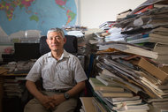

Jiang Kejun, a researcher in a state energy institute, is an outspoken advocate of swiftly cutting China’s greenhouse gas output, and he has developed a plan to accomplish that goal.
The magnitude of that issue is evident in every Chinese city. Factories and homes run on power from plants that overwhelmingly use coal; and in the winter, many heating boilers in the north also burn coal. More cars and trucks crowd the roads. The expanding cities consume cement, steel and chemicals — all industries that emit large amounts of carbon dioxide.
China has been the world’s biggest emitter of carbon dioxide from fuel use since about 2006, when it passed the United States. In 2009, the Chinese government introduced a policy to reduce the carbon dioxide emitted in the production of each unit of economic activity by 40 to 45 percent by 2020, compared with levels in 2005. That means emissions grow along with China’s economy, but at a slower rate than if there were no improvements.
Even with such efforts, China’s size and feverish growth have pushed its emissions well past those of the United States. By 2011, China’s carbon dioxide emissions from fossil fuels accounted for 28 percent of the global total, and the United States’ for 16 percent, according to the Global Carbon Project, a consortium of researchers. The International Energy Agency estimates that China’s emissions grew by another 3.8 percent in 2012.
“I do not see anything coming out of China that would suggest a significant change in emissions in the short term,” said Glen Peters, a researcher at the Center for International Climate and Environmental Research in Oslo. “There would need to be some really radical policies to come out of China for a large change in the pathway to occur.”
Mr. Jiang, who has studied energy emissions for two decades, has that grand shift in mind. China must expand wind, solar and nuclear power beyond current targets, and curb heavy industry, forcing carbon dioxide emissions to peak within a dozen years, he argues. If China’s effort is accompanied by big emissions cuts by rich countries, he says, then there is a good chance of avoiding rises in the global average temperature of beyond 3.6 degrees Fahrenheit above the preindustrial average, which most governments have agreed is a dangerous threshold.
But other Chinese government experts said their country must not risk its prosperity on such a shift.
Wang Zheng, a researcher at the Chinese Academy of Sciences, estimated that China’s emissions were likely to reach their peak by around 2030 at up to almost a fifth higher than Mr. Jiang wants. “If we aim for earlier, that may mean wrecking stable economic growth and triggering an economic crisis,” Mr. Wang said.
Mr. Jiang said he would keep trying to persuade scientists and officials to back his proposal. Several years ago, some scoffed at his earlier, less ambitious idea for an emissions peak by 2030, which is now widely accepted.
“I’ve been in constant communication with the government,” he said. “They’re listening, and at least they haven’t yet said no.”

NYT

China’s Plan to Curb Air Pollution Sets Limits on Coal Use and Vehicles

By EDWARD WONG

Published: September 12, 2013
BEIJING — The Chinese government announced an ambitious plan on Thursday to curb air pollution across the nation, including setting some limits on burning coal and taking high-polluting vehicles off the roads to ensure a drop in the concentration of particulate matter in cities.
Enlarge This Image
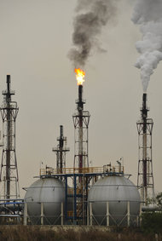
The government is responding to criticism over the abysmal condition of the country’s air, soil and water.
The plan, released by the State Council, China’s cabinet, filled in a broad outline that the government had issued this year. It represents the most concrete response yet by the Communist Party and the government to growing criticism over allowing the country’s air, soil and water to degrade to abysmal levels because of corruption and unchecked economic growth.
The criticism has been especially pronounced in some of China’s largest cities, where anxious residents grapple with choking smog that can persist for days and even weeks. In January, the concentration of fine particulate matter in Beijing reached 40 times the exposure limit recommended by the World Health Organization.
Environmental advocates, including some at Greenpeace East Asia, said the plan did not go far enough, while others praised it for at least acknowledging some of the basic causes of the country’s chronic air pollution. But there was wide agreement that the ultimate test would come in how it is carried out and enforced.
Chinese cities suffer from some of the worst air pollution in the world, with outdoor pollution having accounted for 1.2 million premature deaths in China in 2010, according to the 2010 Global Burden of Disease Study. Increasingly, air pollution is changing everyday life. Face masks are becoming more ubiquitous in the cities, and some affluent parents increasingly choose schools more for their air filtration systems than for their academics. The environment is emerging as a potent political issue.
For years China has had an array of strict environmental standards on paper, and its leaders talk constantly about the need to improve the environment. But enforcement has been lax, and the environment has continued to deteriorate at an alarming rate.
“The plan successfully identifies the root cause of air pollution in China: China’s industrial structure,” said Ma Jun, a prominent environmental advocate. “Industrialization determines the structure of energy consumption. If China does not upgrade its coal-dependent industries, coal consumption can never be curbed.” he said. “The key to preventing air pollution is to curb coal burning — China burns half of all the coal consumed in the world.”
Under the new plan, concentrations of fine particulate matter must be reduced by 25 percent in the Beijing-Tianjian-Hebei area in the north, 20 percent in the Yangtze River Delta in the east and 15 percent in the Pearl River Delta in the south, compared with 2012 levels.
All other cities must reduce the levels of larger particulate matter, known as PM 10, by 10 percent. It is unclear why the plan calls for a looser standard for other cities, since the fine particulate matter, known as PM 2.5, is considered deadlier than PM 10 because it can penetrate deep into the lungs and enter the bloodstream
The plan said Beijing must also bring its average concentration of PM 2.5 down to 60 micrograms per cubic meter or less. That would be two and a half times the recommended exposure limit set by the World Health Organization.
For years, Chinese officials kept measurements of PM 2.5 from the public. But many Chinese in Beijing turned to a Twitter feed from the United States Embassy to see the hourly PM 2.5 reading from a monitoring machine on the embassy rooftop. That, in turn, put pressure on the government to have cities start releasing their PM 2.5 measurements. Beijing began reporting PM 2.5 levels in January 2012, and the official Xinhua news agency has reported that 74 cities are supposed to be releasing their PM 2.5 data this year.
On Thursday, pollution climbed to levels that the embassy rated “very unhealthy,” with a PM 2.5 concentration at 10 p.m. at 213 micrograms per cubic meter. Much of the city’s downtown skyline was obscured by a thick haze.
Coal consumption has grown rapidly in China, and the plan places only modest limits on consumption, with coal to account for no more than 65 percent of energy use in 2017, compared with around 67 percent last year. Some of the plan’s critics said they were disappointed that there were no specific limits on coal consumption by region. The plan allows local governments to set those limits on their own.
“Instead of setting a goal to reduce coal burning for each province, the action plan gives each province the power to set goals for themselves, which leads to the goals being very conservative,” said Huang Wei, who works on climate and energy advocacy at Greenpeace East Asia.
The plan addressed vehicle emissions by removing all high-polluting “yellow label” vehicles that were registered before the end of 2005 from the roads by the end of 2015. In the three regions with heavy industry, all such vehicles are to be taken off the roads by 2015, and the same for all of China by 2017.
In those three regions, gasoline and diesel of a high standard, China V, will be provided in certain cities. But the plan did not set targets for new vehicle emissions standards, which some environmental advocates say is a major omission. “We had been waiting for months for the new action plan,” Ms. Huang said. “We thought it might be a pivot point in history. Now it’s here, and we think it has very much fallen short of our expectations.”

NYT
October 17, 2013, 11:39 pm

Amid Heavy Pollution, Beijing Issues Emergency Rules to Protect Citizens
By DIDI KIRSTEN TATLOW
Snappily titled the Six Stops and One Wash, a new and complex string of regulations by the Beijing city government is aimed at combating the effects of persistent, heavy air pollution on the populace. A major rule will take private vehicles off the roads on alternate days, depending on their license plates, when pollution is especially bad.
The new measures were announced Thursday as air in the capital was deemed “heavily polluted,” according to government air quality readings. Air pollution is a chronic problem in large parts of China.
The regulations consist of a system of four colored alerts that will kick in when heavy pollution is forecast.
The World Health Organization’s cancer agency, the International Agency for Research on Cancer, said Thursday that it was classifying air pollution as a Group 1 human carcinogen. Particulate matter, a main component of air pollution, was also being classified as a carcinogen, said the agency, based in Lyon, France. “Our conclusion is that this is a leading environmental cause of cancer deaths,” Christopher P. Wild, the agency’s director, said at a news briefing in Geneva, according to Reuters.
That puts both air pollution and air-suspended particulate matter with more than 100 other known cancer-causing substances in the agency’s Group 1 category, including asbestos, plutonium, silica dust, ultraviolet radiation and tobacco smoke, Reuters reported.
Beijing, along with much of northern China, suffers from consistently heavy air pollution that can be especially bad in the winter, when coal-powered heating systems are widely used.
The plan seems to rest on being able to predict pollution patterns with great accuracy.
When one day of “heavy” pollution, defined as an air quality index reading of 201 to 300, is predicted, a blue alert will be put in place and extra street washing will be carried out. Street washing is intended to hold down the dust that accumulates from things like construction activity and sand from the desert, though some here see it as a mostly cosmetic measure.
A yellow alert applies to one day of “serious” pollution, defined as an index reading of more than 300, and will also lead to extra street washing.
When three days of heavy pollution are predicted, an orange alert will be put in place and more action will be taken: factories will close, work on construction sites will stop, and the use of barbecues and firecrackers will be banned.
A red alert will be put in place when three days of serious pollution are forecast, leading to the full Six Stops and One Wash plan. As well as all the above measures, kindergartens and elementary and high schools will close, and cars will be driven only on alternate days; those with license plates that end in odd numbers can be driven on odd-numbered days, and those with plates ending in even numbers on even-numbered days. Some people can get around this rule, like those lucky enough to have more than one car with the right plates.
Xinhua, the state-run news agency, said this measure will cause about two million more people to squeeze onto public transportation. Extra buses will be deployed, and the subway will run for half an hour longer in the evening, it said.
While the plan has received quite a bit of attention already, with many people sending or forwarding messages with details on Sina Weibo, a Chinese microblog site, its usefulness is already being called into question.
“The target of getting this policy out there is the pollution,” said Manpaozhe Robin on Sina Weibo. “So the point is whether the odd and even car rule will solve the air pollution problem. I don’t believe this is a good policy. It’s a simple and crude measure that leaves the skies still smoggy.”
China has also announced a long-term plan to clear the air, but the government has warned it will not be easy or quick.
Another person, with the user name Jihe de dipan, said: “Starting from today, I will use my mobile phone to follow the air pollution index. Even though we are helpless against the serious pollution that worsens day by day, the least I can do is use my goodness and this record to warn my loved ones and friends to protect their health!” On Thursday, the person noted, “The air pollution level is 285.”

WP

Choking smog paralyzes cities in northeast China, closing schools, airports
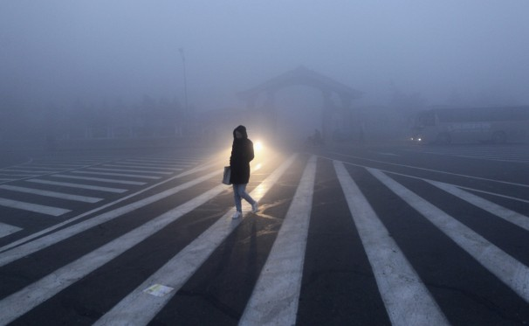
CHINA DAILY/Reuters - A woman walks along a street during a smoggy day in Changchun, Jilin province on Oct. 22, 2013. The severe smog continued to shroud major cities in north-east China including Changchun, according to local media.

By Simon Denyer, Tuesday, October 22, 7:22 AM E-mail the writer
BEIJING – Thick, choking smog enveloped cities in northeast China for a second day Tuesday, closing schools, airports and highways, snarling traffic and reducing visibility in some places to a few yards.
In the industrial city of Harbin, home to more than 10 million people, the PM 2.5 level of fine particulate matter in the air reached 1,000 micrograms per cubic meter in parts of the city Monday, 50 times above what the World Health Organization considers safe. It is the first major pollution emergency of the coming winter
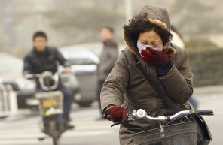
Beijing’s bad air days: Air pollution in Beijing has been particularly bad this winter. Here’s a look at the Chinese capital in the midst of the miasma.
Vehicles crawled through the smog with fog lights on or emergency lights flashing. Buses were canceled and a major highway was closed, while hospital admissions soared by 30 percent, local media reported.
Visibility was so low in the city, about 780 miles northeast of Beijing, that two city buses got lost while plying their regular routes. Pedestrians wore masks or clutched their hands in front of their faces in an effort to breathe more easily.
“I did not even dare to cross the street,” said Zhang Xiaofeng, a 24-year-old bulldozer driver who said his eyes hurt and he was coughing as a result of the smog. “I waited and waited at the intersection and looked again and again, but I couldn’t see if any cars were coming. Even the traffic lights were invisible.”
While the air quality had improved by lunchtime, the fog descended again in the afternoon; primary and middle schools and the airport remained closed.
“I can’t even see the next apartment building next to mine, which is only 10 or 20 meters away,” said 42-year-old housewife Li Li. “I’m not going out, and I won’t let my child go out.”
In the city of Changchun, which lies 180 miles closer to Beijing by road, the PM 2.5 reading peaked at 700 in some areas Tuesday, and the airport was closed for several hours.
On the weibo microblogging service, one resident of Harbin complained of having been forced to walk to work through the smog with stinging eyes and throat because buses were canceled and cabs hard to find.
“The weather made me panic, I even wonder if human beings will become extinct or not,” she posted under the user name “AlwaysBelieveIn.”
The local government blamed the widespread use of coal-fired heaters for the smog as temperatures dropped in China’s colder northeast, as well as straw-burning in surrounding villages at the end of the harvest season.
“I live in a country making people desperate,” posted another Weibo user. “The environmental pollution is not scary. What’s scary is the no-action government and the silence of people like slaves.”
China’s breakneck dash for economic growth has badly damaged the environment, and the rapid deterioration in air and water quality increasingly has become a source of public unrest. As a result, improving environmental standards has become a major priority for the government.
Last month, China unveiled its most ambitious plan yet to reduce air pollution, calling for significant cuts in coal use in industrial regions in the country’s north, and targeting an overall improvement in PM 2.5 levels of 10 percent over five years.
Beijing, routinely blanketed by a gray smog, has also made a “declaration of war” on air pollution. This month, it said it would close schools and factories and further restrict car use – allowing only odd or even numbered license plates to drive at specific times — when pollution reaches dangerous “red alert” levels.
“The central government has recognized the fundamental cause — which is its overuse of coal — and what sort of solution should be taken,” said Huang Wei, of the environmental group Greenpeace in Beijing. But Huang said the plan did not go far enough in addressing the problem nationally. As a result, she said, “more and more places are going to have bad air quality days.”
Previous efforts to improve air quality have foundered because of poor implementation by local governments, which continue to protect heavy industries and tolerate widespread violation of environmental norms, said Ma Jun, director of the Institute of Public & Environmental Affairs in Beijing.
Wang Tao, a climate and energy specialist at Carnegie-Tsinghua Center for Global Policy in Beijing, said large-scale investments in heavy industries as part of a recent economic stimulus plan meant any cuts in coal use would be hard to achieve.
In Beijing, inadequate investment in public transport and poor urban planning also meant that choking exhaust fumes were likely to remain a fact of life for the foreseeable future, Wang added. “It is quite difficult to see things getting better in terms of air quality in the short-term.”

October 21, 2013, 3:15 am 93 Comments

‘Airpocalypse’ Hits Harbin, Closing Schools
By MIA LI
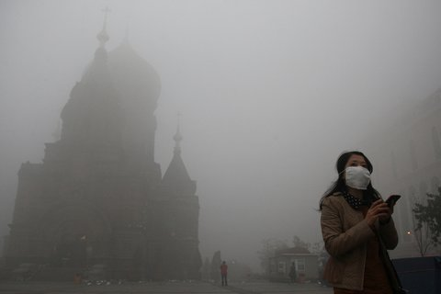
Harbin’s landmark San Sophia church was barely visible Monday as heavy pollution forced the closure of schools and highways.
Updated, 8:22 a.m. | School was canceled, traffic was nearly paralyzed and the airport was shut down in the northeast Chinese city of Harbin on Monday as off-the-charts pollution dropped visibility to less than 10 meters in parts of the provincial capital.
A dark, gray cloud that the local weather bureau described as “heavy fog” has shrouded the city of 10 million since Thursday, but the smoke thickened significantly on Sunday, soon after the government turned on the coal-powered municipal heating system for the winter.
“You can’t see your own fingers in front of you,” the city’s official news site explained helpfully. In the same vein, a resident of Harbin commented on Sina Weibo, the popular microblog platform, “You can hear the person you are talking to, but not see him.” Another resident added that he couldn’t see the person he was holding hands with.
The airport in Harbin said on its official microblog Monday morning that dozens of flights had been delayed or diverted due to the smog, which it said brought visibility down to about 100 meters at 1 p.m. In the early evening, it announced that all flights scheduled on Monday had been canceled.
The Harbin government reported an air quality index (AQI) score of 500, the highest possible reading, with some neighborhoods posting concentrations of PM2.5 — fine particulate matter that are 2.5 microns in diameter or smaller and especially harmful to health — as high as 1,000 micrograms per cubic meter, according to the China News Service.
(By comparison, the air quality index in New York was 41 on Monday morning.)
The Chinese government describes air with an AQI between 301 and 500 as “heavily polluted” and urges people to refrain from exercising outdoors; the elderly and other vulnerable populations are supposed to stay indoors entirely. The U.S. Environmental Protection Agency uses a similar index that labels any reading between 301 and 500 as “hazardous.”
Both scales reach their limit at 500, leaving creative citizens of polluted cities to come up with their own labels when the air gets worse. Foreign residents in Beijing declared an “airpocalpyse” last January when the U.S. Embassy reported an AQI equivalent of 755, with a PM2.5 concentration of 866 micrograms per cubic meter. The World Health Organization has standards that judge a score above 500 to be more than 20 times the level of particulate matter in the air deemed safe.
On Monday, people in Harbin were covering their heads and mouths with scarves and masks to ward off the choking smell in the air. Despite government warnings to stay home, cars with headlights turned on were moving no faster than pedestrians and honking frequently as drivers struggled to see traffic lights meters away, the city’s official news site said.
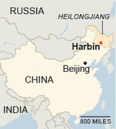The New York Times
At an emergency meeting called at 6 a.m., the authorities decided to close all schools and kindergartens, the report said. The local police also shut several highways at 7 a.m., but not before the smog caused two pile-ups, which left one truck driver injured, the official Xinhua news agency reported. (Nearby Jilin Province also reported 14 road accidents on Sunday night; the authorities there issued a red alert for pollution Monday morning.)
The pollution in Harbin has caused a 30 percent surge in hospital admissions of patients with respiratory problems, according to the local news media. Residents have been told by doctors to wear masks and eat pears, a fruit commonly believed in northern China to help heal lungs.
The city weather bureau blamed the pollution on three factors: a lack of wind; local farms burning corn leaves and stalks after the harvest; and the start of the municipal central heating system, which provides heat to millions of homes and offices and relies on large coal-burning boilers across the city.
The system pumps hot water into radiators and is supposed to heat residences to at least 18 degrees Celsius (64 degrees Fahrenheit). But Harbin, located not far from the Russian border in Heilongjiang Province, is one of China’s coldest cities, and its coal-dependent heating system means it must choose each year between heat and clean air.
Harbin has been battling air pollution for years, destroying hundreds of smaller boilers, banning the use of high-sulfur coal, and adopting cleaner fuel standards for cars. On Monday, the city dispatched environmental protection personnel to conduct inspections of factory smokestacks, traffic police to perform spot checks of motor vehicle emissions, and village officials to stop farmers from burning corn waste.
Temperatures are forecast to drop to the freezing point this week, but the local weather bureau said the cold front could also bring rain that could clear out some of the pollution.
In the meantime, residents were left comparing the air to something out of a horror film. Said an Internet user going by the screen name Han Doudou, “If you think this is the movie set for ‘Silent Hill,’ ‘Resident Evil’ or ‘The Walking Dead,’ you are wrong — this is Harbin.”

NYT

Response to a City’s Smog Points to a Change in Chinese Attitude
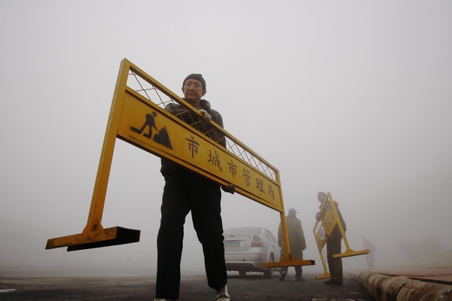
Government workers moved signs to block roads in Harbin, China, where hazardous smog reduced visibility this week.

By EDWARD WONG

Published: October 24, 2013
BEIJING — Emergency measures came swiftly in Harbin, the northeastern city blanketed with hazardous smog this week: Schools were shut down, buses ordered off the roads, the airport closed, police roadblocks set up to check tailpipe emissions from cars. City officials even fanned out in the surrounding countryside, ordering farmers to stop burning the cornstalks left in their fields after the harvest.

Related

Sinosphere Blog: With Winter Ahead, Can China’s Smog Get Anything But Worse? (October 24, 2013)

Sinosphere Blog: Chinese City’s Pollution Goes Off the Charts (October 21, 2013)
They were reacting to the first notable surge of air pollution in China this autumn. Residents across the nation’s north fear that the smog is a sign of things to come. With winter approaching, cities north of the Huai River are turning on their coal-fired municipal heating systems, whose emissions were found in one study to shorten residents’ life spans by an average of five years.
In Harbin, moist air trapped the pollution at ground level, leaving people to walk through a gray miasma wearing face masks. Visibility was so bad that two buses got lost plying their routes.
But the emergency measures showed that the government was trying to address the problem rather than merely cover it up, as it might have done in past years, some environmental activists said.
Action plans in Harbin, Beijing and other cities, along with broad national policies meant to curb air pollution announced last month, signal that some officials are serious about tackling the chronic problem. On Thursday, the Ministry of Environmental Protection said it was sending inspection teams to cities across China for the winter to ensure that environmental regulations were enforced.
Awareness of various kinds of pollution — air, water and soil — has risen quickly this year, especially among middle-class urbanites. Chinese news media, including official state outlets, are reporting more aggressively on the causes and effects of pollution. An editorial in Beijing News on Wednesday took note that last week the World Health Organization had classified air pollution as a leading cause of cancer, and said that on days when the air is hazardous, “containing the pollution and protecting the health of residents is the highest priority.”
But the advocates say enforcement is often a weak point, even when leaders understand that cleaning up the environment has become critical to maintaining social and political stability.
“I give credit to the local government for taking these measures,” Ma Jun, an environmental advocate, said of the emergency actions in Harbin. “Of course, they will have some problem with their image, the city’s image — but on the other hand, it shows they put people’s health ahead of saving face.
“Having said that, I think it’s not enough,” he added. “I think people won’t be satisfied with just knowing which day to put on face masks or not go to school or keep their children indoors. They really want blue-sky days.”
Under pressure from the public, Beijing in 2012 became the first Chinese city to announce levels of an especially hazardous category of particulate matter, known as PM 2.5, in the air. Since then, 113 other cities have followed suit. The data can be seen online in real time, which was how much of China followed the crisis in Harbin.
On Monday and Tuesday, air-quality monitoring stations in some parts of the city reported PM 2.5 concentrations that exceeded 1,000 micrograms per cubic meter — 40 times the level deemed safe by the W.H.O.
Since 2007, the Ministry of Environmental Protection has published an annual list of high-polluting industrial plants around China. The latest identifies 4,189 factories that, together, release 65 percent of China’s total industrial air pollutants. “We need to know where they are, what kinds of pollutants they discharge, the volume and whether they are in compliance with discharge standards,” Mr. Ma said, adding that local governments gather that data but do not release it.
Advocates hope that identifying the polluters publicly will help to shame them into improving, Mr. Ma said, with pressure coming from “whoever invests in the polluting factories, the banks giving them loans, the brands that source from these polluters.”
The central government is apparently stepping up pressure as well. One goal of the national plan announced last month was to reduce the concentration of PM 2.5 in three heavily populated industrial regions by 15 percent to 25 percent, compared with 2012 levels. Prime Minister Li Keqiang said last month that the cities of Beijing and Tianjin and the province of Hebei, all in northern China, would cut down their use of coal, the main source of air pollution, by 80 million tons a year in the near future.
Still, environmentalists worry that growth-minded local officials and businesses will be reluctant to go along. “Chinese leaders have produced an impressive flurry of policies on air pollution this year, but regulators still suffer from insufficient authority; rapid economic growth means that a steady stream of pollution sources come on line every day; and vested business interests are sure to scream bloody murder every step of the way,” Alex L. Wang, a scholar of Chinese environmental policy and a law professor at the University of California, Los Angeles, said in an e-mail.
“It’s one thing to have a strategy, and another to execute it well,” he added.
Huang Wei, who works on climate and energy issues at Greenpeace East Asia, said officials needed to focus on bigger solutions, not stopgap measures. “The situation will not change as long as China has an over 70 percent energy dependency on coal,” she said. “The long-term solution is to get rid of heavy energy-consuming industries.”
Until that happens, Chinese citizens are bracing for many more days of heavy pollution, and officials are announcing a wider array of emergency measures for the worst days. On Tuesday, the Beijing government adopted a plan for emergencies when the forecast calls for three or more days with pollution rated as serious. A “red alert” would be issued, schools would be shut down and use of private cars would be limited to alternate days, depending on their license plate numbers.
Skeptics point out that wealthier households can buy extra vehicles to get around that rule. And Beijing News said in its editorial that on “red alert” days, everyone should stay home, not just children. “Faced with the increasingly serious pollution levels in Beijing,” it said, “coupled with the carelessness of residents in protecting themselves against pollution, the emergency plan is still inadequate.”

Op-Ed Contributors

NYT

Clearing the Air in China

By CHRIS P. NIELSEN and MUN S. HO

Published: October 25, 2013
CAMBRIDGE, Massachusetts — IN the northeast Chinese city of Harbin last week, the air pollution was so thick that schools were closed, traffic became gridlocked and flights in and out of the metropolis were canceled. For years, severe air pollution and rising carbon emissions have been downsides to China’s economic growth, even as that growth has lifted more than 600 million people out of poverty.
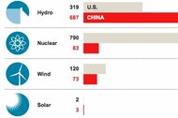Graphic

Clean and Dirty: China’s Energy Binge

Related News

Beijing Takes Steps to Fight Pollution as Problem Worsens (January 31, 2013)

On Scale of 0 to 500, Beijing’s Air Quality Tops ‘Crazy Bad’ at 755 (January 13, 2013)
It may come as a surprise, then, that China has spent enormously to reduce air pollution and to limit carbon dioxide emissions, the main driver of climate change. In fact, its investments to decarbonize its energy system have dwarfed those of any other nation. And its forceful regulation to reduce sulfur dioxide emissions from power plants may be one of the most swiftly effective air pollution policies ever implemented anywhere. Those emissions fell sharply from 2006 to 2010, according to a new study by Chinese and American researchers that we took part in, preventing as many as 74,000 premature deaths from air pollution in 2010.
So why are China’s efforts at emissions control falling short?
There are several reasons. One of them is China’s instinctual response to such challenges: a top-down approach to try to engineer its way through them according to master plans. The result is that China may be winning battles but not the wars on emissions control, because its faith in mandates has met its match: an economy that is growing too fast, and atmospheric challenges that are too multifaceted for even the smartest planners to tame.
Indeed, air quality in many cities has sometimes been terrible this year, especially in the north. Last January, Beijing’s level of fine particles, 2.5 microns in diameter or under and known as PM 2.5, reached at least 20 times the level recommended by the World Health Organization for a 24-hour period. This prompted a scrambling government to ram through new air-quality protections.
You might think that China’s success in reducing sulfur dioxide, which reacts with other chemicals to form PM 2.5, might have resulted in a lasting reduction of these fine particles, which are dangerous because they penetrate deep into the lung and can enter the bloodstream. But PM 2.5 takes many chemical forms and is produced in many ways, including from other gases.
And this is one reason China’s successful control of sulfur dioxide is hardly incompatible with a rise in PM 2.5 since 2010. In fact, research by Wang Yuxuan and colleagues at Tsinghua University suggests that reducing sulfur dioxide emissions can even increase fine particle levels in north China in winter, because it frees another pollutant, ammonia, to react instead with nitric acid to form PM 2.5. Evidence is also growing that China’s winter climate may be changing in ways that foster episodic accumulation of fine particles, consistent with unusually stagnant meteorological conditions last January.
Such complexities caution against assuming that poor air quality results only from a failure to try to prevent it. The atmosphere is an extremely complicated physical and chemical system that varies by region, and China’s atmospheric knowledge base is still developing. Air quality prescriptions are only as good as the science that informs them, and China’s air pollution is both rapidly evolving and only partly understood.
China’s faltering progress on air quality resembles its record on carbon dioxide. Those emissions have risen by about 8 percent a year since 2007 and increased from nearly 14 percent of global emissions in 2000 to 27 percent in 2011.
This is in spite of China’s enormous investments to decarbonize its energy system. In less than 10 years it has built the world’s largest wind power capacity, with plans to triple it by 2020. Its hydropower capacity, also the largest in the world, is expected to triple from 2005 to 2020, and its nuclear capacity will multiply at least sixfold over that same period. And China is increasing imports and production of natural gas, the cleanest fossil fuel.
But all of this is cold comfort to a Beijing citizen wheezing behind her face mask day after smoggy day, or a Sichuan farmer wondering if climate change is to blame for his declining rainfall.
China’s longstanding reliance on central planning and a piecemeal approach to pollution control may be a cause. Its abatement of sulfur dioxide, for example, resulted from the mandated deployment of scrubbers and forced replacement of inefficient old power plants, motivated by numerical reduction targets to reduce sulfur emissions and increase energy efficiency. Similar targets were included in the current five-year plan, and others have driven the development of low-carbon energy supply and consumption.
This use of national targets and technology mandates reflects the continuing legacy and institutional power of central planning in China. It is also a result of careful study of what has worked in the West. Much of the credit for the largely blue skies in America today goes to command-and-control regulations, and America’s carbon policy consists of similar mandates, notably fuel-efficiency standards for cars and now, proposed
But the unprecedented pace of China’s economic transformation makes improving China’s air quality a moving target. Focusing on one key pollutant from one major industry, as China’s planners did from 2006 to 2010, is beneficial but insufficient, because growth in emissions from other sectors and of other pollutants overwhelms the gains. And it is hard to see how China can centrally decarbonize its energy system more than it is already attempting to do, which is not succeeding fast enough to protect the climate.
Many environmental economists lament the inefficiencies of technology mandates, promoting instead policies to put prices on emissions and allow markets, not the government, to determine the best technological responses. If economic growth is overwhelming the best efforts of China’s planners, harnessing the power of markets may offer the most hopeful prospect for a more pervasive, truly economywide, solution.
Carbon can be priced by either a cap-and-trade system, with which China has begun experimenting, or more simply with a tax, as China’s finance minister, Lou Jiwei, and several government research institutes have been promoting.
Like these institutes, our group has studied the impact of carbon tax policies. We estimate that a modest tax on carbon dioxide, starting small and rising to about $10 per ton in 2020, could sharply lower the growth of emissions with little effect on G.D.P. growth and consumption over the long run. In the short run, some energy-intensive industries and segments of the population would incur losses, but the tax revenues offer a source for compensating them during an adjustment period.
This illustrates the same economic reasoning that drives advocacy of carbon taxes globally, including by American economists across the political spectrum.
In China’s case, however, there is a huge bonus that should raise some smiles behind its ubiquitous face masks. Precisely because China’s severe pollution results chiefly from coal and oil combustion, a carbon tax would deliver a potent ancillary benefit: reduced concentrations of an array of air pollutants. We estimate that the same tax would prevent as many as 89,000 premature deaths a year from pollution by 2020, and even improve crop productivity. A larger tax, of course, would bring greater benefits.
While a carbon tax cannot substitute for a comprehensive air quality strategy — including expanded support for atmospheric sciences — it would be a powerful jump-start in the right direction.
This approach offers a real chance for China to limit both carbon emissions and air pollution at little cost to economic growth, all in one relatively straightforward policy. It may be an opportunity that nobody, in or out of China, can afford to ignore.

SA

Smog shuts down Harbin, China, as seen from space.
By David Wogan | October 29, 2013 | Comments Off

Remember the smog that paralyzed Harbin, China – a city of 10 million last week? Here is what that looks like from space:
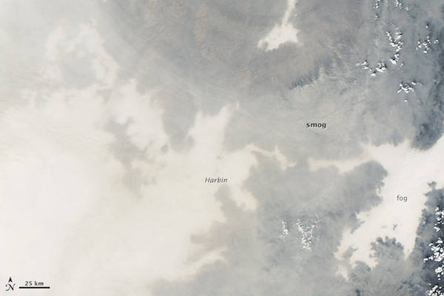
NASA image courtesy Jeff Schmaltz, LANCE MODIS Rapid Response
From NASA’s Earth Observatory:
Some neighborhoods experienced concentrations of fine particulate matter (PM2.5) as high as 1,000 micrograms per cubic meter. For comparison, the U.S. Environmental Protection Agency’s air quality standards say PM2.5 should remain below 35 micrograms per cubic meter. It is extremely rare for particulate levels to reach that high in the absence of a dust storm or forest fire.
Chinese authorities grounded airplanes, shuttered thousands of schools, and closed major roads in response to the surge in pollution. A few days after pollution levels started to rise, Harbin hospitals reported a 30 percent increase in admissions related to respiratory problems, and several Harbin pharmacies were sold out of pollution facemasks, according to media reports.
Cold weather and the lack of wind helped fuel the pollution outbreak, but human factors also played an important role. Wheat and corn farmers in the region light fires in the fall to burn off debris following the harvest. Also, city officials turned on Harbin’s city-wide, coal-powered heating system just prior to the pollution outbreak, according to China’s state-run Xinhua News Agency.
We used to experience something similar, albeit not nearly as severe, here in Austin, Texas when Mexican farmers would burn their crops. A gray haze would envelope the city for several days until the winds picked up or rains scrubbed the air.

Care2

China Shows Us How to Not Fight Air Pollution
- by Kristina Chew
- November 13, 2013
- 10:00 am
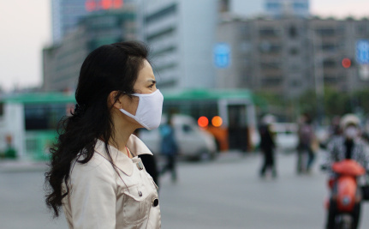
Top of Form
Bottom of Form
The air pollution in China has become the stuff of legend, or rather of nightmare. The number of lung cancer cases in the capital of Beijing has increased by more than 50 percent in the past decade. Just last week, an eight-year-old girl in the province of Jiangsu was diagnosed with lung cancer. In September, the government announced its Air Pollution Control Action Plan, its latest initiative to address air pollution so bad that the smog over northeast China for the past two weeks has been visible from space.
China’s plan only offers a short-term solution for the thick air pollution wreaking havoc on its citizens’ health, to say nothing of the country’s environment. The government proposes to cut down on its dependence on coal (which currently provides three-quarters of its energy needs) by, first of all, prohibiting the construction of new coal-fired plants around Beijing, Shanghai and Guangzhou; a number of coal-fire plants are being shut down.
But China’s replacement for coal will cause numerous environmental hazards. The government plans to building 18 synthetic natural gas plants to achieve its goal of a 65 percent reduction in coal’s part in meeting its national energy needs. But using natural gas as an alternative to coal poses many concerns.
China is proposing to convert its supplies of coal into synthetic natural gas (SNG). While SNG can help to cut down on particulate air pollution — reducing particulate matter by 25 percent in the North China Plain is another of the government’s goals — a study (pdf) published in Nature Climate Change has shown that the entire process of mining coal and converting it into natural gas can yield 36 percent to 82 percent more total greenhouse gas emissions than burning coal directly.
Proposed SNG Plants Could Create Water Insecurity
SNG plants have been approved for construction in northern and western China, far from the country’s major metropolitan cities. For instance, Beijing is to be powered by a natural gas plant built in Inner Mongolia. Bluer skies may be in store for China’s capital, but remoter regions could see murkier ones.
SNG plants pose another serious threat to China’s climate and to the livelihood of its many inhabitants. Converting coal to SNG necessitates “uniquely high volumes of water: six to 10 liters for every cubic meter of SNG.” That is, SNG’s water consumption is an average 18 times higher than that of coal.
China’s planned SNG plants are to have 75.1 billion cubic meters of natural-gas production capacity per year. As the World Resources Institute (WRI) points out, based on its Aqueduct Water Risk Atlas, 75 percent of those plants are located in semi-arid or arid areas that have limited supplies of water or simply very little. SNG plants could use around 20 percent of the region’s industrial water use. If water is in short supply, the plants could have to reduce capacity or even face temporary outages.
SNG Plants Are Planned For Remote Regions Where Ethnic Minorities Live
Even more, residents of regions where SNG plants are located (Mongolia and Xinjiang) could see their livelihoods affected. The SNG plant located in Inner Mongolia is to generate at least 4 billion cubic meters of gas a year and will require 32 billion liters of fresh water. That is the amount of water needed to meet the domestic needs of one million Mongolian herders, farmers, households and more for a year.
China’s plans for reducing carbon emissions do not take into account the impact of its planned efforts on the rest of its environment and on the people, many of whom are, like the Uighurs in Xinjiang, ethnic minorities who have criticized the central government for repressing their culture and for encouraging Han Chinese (the dominant ethnic group in China) to settle in their homelands.
The WRI is calling on the Chinese government to include those who oversee policy about water and environmental protection in its energy planning process. Most of all, the WRI urges China to “stay away from shorter-term, more narrowly focused solutions like SNG.”
As it seeks to keep up its economic growth, China needs to consider industrial restructuring and energy efficiency measures as part and parcel of its air pollution plan. Otherwise, it will find itself having to contend with ecological and health issues just as and even more serious before too long.
Read more: http://www.care2.com/causes/china-shows-us-how-to-not-fight-air-pollution.html#ixzz2keck3LTy

WP

China’s air pollution prompts creative, sometimes wacky, solutions
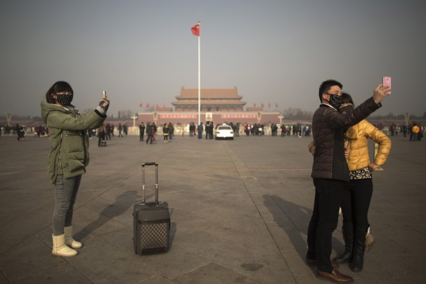Tourists in masks use cellphone cameras to snap shots of themselves on a heavily polluted day in Tiananmen Square in Beijing. (Alexander F. Yuan/AP)
Written by William Wan
Published: January 25
E-mail the writer
In Beijing — This is how bad the smog has gotten in China.
Officials are looking at washing away air pollution with artificial rain or sucking it up with giant vacuum cleaners. Shanghai has given its cops mini-filters to put in their noses.
Beyond the government, a cottage industry has popped up, tinkerers who are producing anti-pollution devices — some practical, others wacky artistic statements.
There is a bicycle that purifies air as you pedal. And a growing spectrum of do-it-yourself air-filtering machines, from simple duct-tape concoctions to elaborately engineered models.
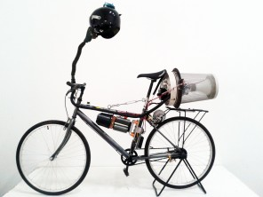
British artist Matt Hope, 37, lives in Beijing and after encountering the pollution here created a bicycle that filters air as you pedal along. (Matt Hope/Matt Hope)
A workshop in Shanghai teaches people how to make an air filter to combat pollution by buying a cheap HEPA filter and strapping it to a fan. (James Le/Smart Filter)
Desperate times call for desperate measures
“It’s a perfectly natural response when you are confronted with a problem,” said Gong Zhiqiang in Beijing, a mechanical engineer who spends his nights fine-tuning his designs for amateur air filters.
After Gong posted his prototypes online in 2012, requests flooded in for step-by-step instructions. Obsessing over air, he said, has become a nationwide pastime.
The urgent search for ways to alleviate pollution has been spurred by the problem’s growing visibility as well as the public’s increased access in recent years to hourly measurements of the filth they’re breathing.
Chinese cities have some of the world’s most polluted air. The haze is often so thick it blots out the sun. On especially bad days in cities such as Harbin, in northeast China, residents can’t even see across the street. Airports struggle regularly to land planes in thick fog. A study published in the British medical journal the Lancet attributed 1.2 million premature deaths in 2010 to bad air.
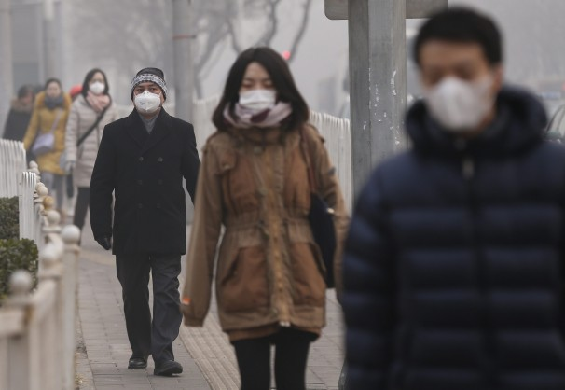Chinese citizens wear masks on a hazy day in Beijing. (Rolex Dela Pena/EPA)
Other countries have cut air pollution by limiting emissions from factories and cars. China’s leaders have been reluctant to sacrifice economic growth, and state-run industries have used their economic clout to resist stricter rules.
So people have looked to more novel ideas.
This animation, produced by Studio Roosegaarde, shows how a giant electrostatic �vacuum cleaner� would be used to attract smog particles. The video shows the machine miraculously cutting a small circle in the city�s haze to reveal blue skies and a shining sun.
In the western city of Lanzhou — deemed by the World Health Organization as having the worst air in China — officials have proposed digging gullies into surrounding mountains. Others have talked in recent years of leveling mountains altogether. But the ideas, requiring mountain-sized funding, have stalled.
On the sci-fi end of the spectrum, a Dutch artist is designing a giant electrostatic “vacuum cleaner.” The device — which resembles a giant hula hoop — uses an electrified wire to attract smog particles. The artist’s firm says it has successfully tested prototypes. In an online video demonstrating the concept, the machine miraculously cuts a small circle in the city’s haze to reveal blue skies and a shining sun.
“It’s not going to cure smog on a large scale, but at least we can remind people what clean air looks like,” said artist Daan Roosegaarde. He said Beijing’s mayor has shown interest. Beijing officials declined to comment, but the Dutch Embassy, which has been assisting Roosegaarde, confirmed that he has meetings scheduled with Beijing officials next month.
A news report by Caixin media in China shows a segment on the smog vacuum project and how it would work.
Wash and rinse
But what’s garnered the most attention in recent weeks is confirmation that the Chinese government is researching the use of artificial rain to rinse out bad air.
A document released by China’s Meteorological Administration in November said that all local weather officials would be able by 2015 to use artificial rain to clear away smog. Shortly after, in a closed meeting, Beijing’s vice mayor told subordinates his city was researching the method, according to state-run media.
Bloggers reacted with equal parts surprise, jokes and skepticism. Officials in the city and Meteorological Administration have refused to elaborate further. Reached by phone, a Beijing government spokesman confirmed the vice mayor’s comment but declined to say more.
In many ways, the idea is unsurprising. Because of China’s chronic water shortages, it has invested heavily in artificial rain since the late 1950s. The country boasts the world’s largest rainmaking force, with 6,902 cloud-seeding artillery guns, 7,034 launchers for chemical-bearing rockets, more than 50 planes and 47,700 employees, according to a 2012 government tally.
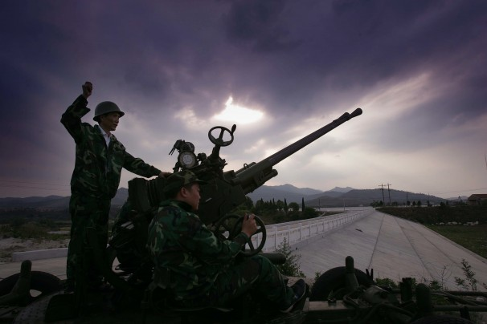A Chinese worker fires rockets for cloud-seeding in an attempt to make rain in Huangpi, central China. (AFP/Getty Images)
The massive infrastructure was most famously deployed in Beijing to ensure clear skies for the opening ceremony of the 2008 Olympics.
But applying rainmaking to smog is a relatively new idea. Several scientists at government think tanks and universities declined a journalist’s requests this month to discuss it. Such information remains, like many things in China, under the tight control of the government.
According to the few scientists who were willing to talk, as well as explanations in state-run media, the science involves using rockets, cannons or planes to sow clouds with catalysts such as dry ice, silver iodide and salt powder. The substances augment the clouds’ natural rainmaking processes.
The resulting rainfall in theory scavenges polluting particles from the air through a process called “wet deposition.”
What goes up
But the plan has serious flaws, many experts say.
The right moisture conditions are needed for cloud-seeding to work. The location of a city’s largest concentration of pollution must be determined. And the rainfall can be fickle and difficult to aim.
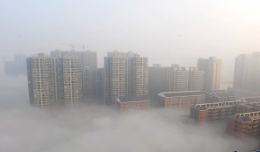
Smog shrouds buildings in Changsha, in Hunan province. (ChinaFotoPress/Getty Images)
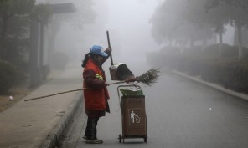
A streetcleaner works in Wuhan’s heavy smog in Hubei province. (ChinaFotoPress/Getty Images)
“It’s complicated. Scientists here can’t even agree on how much rainfall cloud-seeding actually causes,” said Wang Shaowu, a retired atmospheric professor at Peking University. “Say you have 20 millimeters of rain” — about 0.8 inches — “did 5 millimeters come from artificial methods or 15 millimeters?”
Then there’s the matter of unintended side effects.
Whatever chemicals go up to seed the clouds eventually come down, said Zhao Lijian, a pollution expert at the Energy Foundation, a nonprofit group that promotes clean energy. “You’re also sending all those heavy pollutants in the air into the water system.”
And there’s the issue of stealing rain from other areas where it might have fallen.
Hard choices
The only real solution to China’s pollution problems, Zhao and other scientists stress, is to cut emissions from its power plants, factories and cars. But that is hugely difficult.
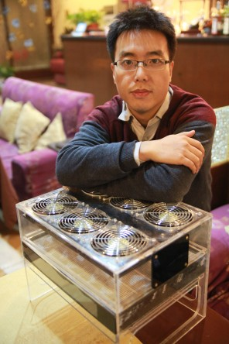Gong Zhiqiang spends his nights fine-tuning his amateur air-filter designs.
It would mean cutting into China’s heavy dependence on coal-burning electrical plants. It also would require taking on powerful state-owned industries, such as China’s oil and power companies, which have long resisted stricter environmental controls.
But Chinese leaders recently unveiled an ambitious $280 billion plan that includes limiting coal use and banning high-polluting vehicles.
Salivating at the prospects, U.S. and European clean-technology companies are stampeding to sell China solutions. A U.S. Department of Commerce analysis has predicted that China’s clean-tech market will reach $555 billion by 2020.
The market has benefited small-scale vendors such as Gong, who has sold more than 40 of his homemade air filters in the past two years.
As he and his wife have talked about having a baby, he’s begun thinking about pollution problems their child might face.
“I want to design a really good mask for children,” he said. “I’ve got a few ideas already.”
Liu Liu and Li Qi contributed to this report.

NYT
January 27, 2014, 5:22 am

India and China, Besieged by Air Pollution
By EDWARD WONG
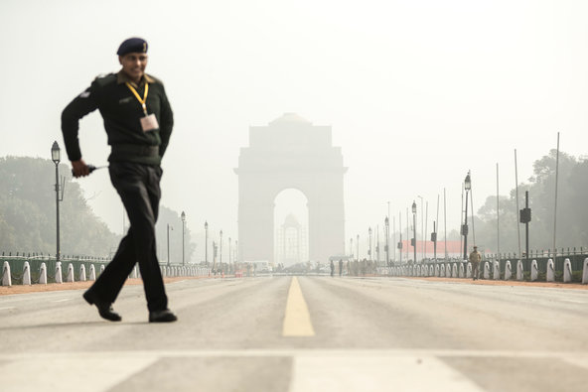 Heavy smog shrouding New Delhi on a recent January day.
The United States space agency published a map in September that showed how rates of premature deaths from air pollution vary around the world. It indicated that northern China has one of the worst rates, attributed to the density of a deadly fine particulate matter, known as PM 2.5, that often results from coal burning. The map was based on data collected by a research team led by Jason West, an earth scientist at the University of North Carolina.
The map also showed that the rate in northern China — what appears to be about 1,000 or more deaths each year per 1,000 square kilometers, or 386 square miles — is matched by that of northern India, in a diagonal belt stretching from New Delhi southeast to Calcutta. Those acutely polluted areas are colored dark brown on the NASA map. (Europe was perhaps surprisingly colored a deep brown too, though the rate was not as bad as that of the two Asian nations.)
Various recent studies and data suggest that air quality in Delhi is worse than in Beijing, though India’s air pollution problems do not get nearly as much attention on the world stage as those of Beijing. One study shows that Indians have the world’s weakest lungs. The World Health Organization says India has the world’s highest rate of death caused by chronic respiratory diseases, and it has more deaths from asthma than any other nation.
Yet, Indians and foreigners living in Delhi do not express anxiety about the air the way that residents of Beijing and other Chinese cities do. Air purifiers are a rarity in homes there, and face masks are generally not seen on the streets. The Indian news media do not cover air pollution to nearly the same extent the Chinese media do. (Government censors in China had blocked widespread coverage of the problem for years, but they loosened the restrictions during an infamous surge in pollution across northern China in January 2013; now even official state-run Chinese news organizations report regularly on air pollution.)
Ananth Krishnan, the China correspondent for The Hindu, has been mulling over this disparity in public dialogue on air quality. He posted tweets about it in December, during a bad pollution day in Delhi. One of his conclusions was that the United States Embassy in Beijing had helped raise awareness in China by posting on Twitter for the past several years the air quality readings from a rooftop monitoring device.
The embassy “did play a role in PM 2.5 awareness; maybe right time to start @USAndIndia air monitor,” Mr. Krishnan wrote on Twitter.
In part because of the public release of PM 2.5 readings by the United States Embassy, prominent Chinese commentators like the real estate tycoon Pan Shiyi began asking on microblogs why the Chinese government was not making available data that it had collected. This helped put the issue in the spotlight, and Chinese officials then agreed to release the data for many cities across the country.
Mr. Krishnan said in an interview that Delhi had been making the same kind of data available to the public well before Chinese officials agreed to release their numbers, and that the Indian numbers proved without a doubt that the air quality in the Indian capital was poor. However, he said, there has never in India been populist demand for the government to change policy to improve the air, as there is now in China.
“I think when you have the sense that they’re hiding something, it galvanizes public attention in a counterintuitive way,” said Mr. Krishnan, who has lived in Beijing since early 2010.
“I don’t think the Indian media has given enough attention to this issue,” he added. “I remember an Indian environmental scholar visited Beijing a few months ago, and he was surprised that pollution was getting so much attention in the press here.”
Coverage of air quality by the Indian news media “will have to change very soon,” Mr. Krishnan said.
On Saturday, China Daily, an official English-language newspaper, reported that December was the worst month of 2013 for air quality in China. More than 80 percent of the 74 cities with official air monitoring devices failed to meet the national air quality standard for at least half of December, the report said, citing information from the Environmental Protection Ministry. That was twice as many cities as the number in November.
In some of the smog attacks in December, visibility in cities was reduced to less than 10 meters, or 33 feet. Levels of five major pollutants increased that month. The monthly average of PM 2.5, the same particulate matter that scientists deem to be most harmful to human health, rose by almost 56 percent.
The report also said Beijing officials would issue “guidance” to tell the public whether the weather would be conducive to the setting-off of fireworks and firecrackers during the Lunar New Year holiday, which begins this week. Officials have said that smoke from the explosives contributes to air pollution. The four levels of guidance are: proper, not quite proper, not proper and extremely improper.
WP

In China’s war on bad air, government decision to release data gives fresh hope
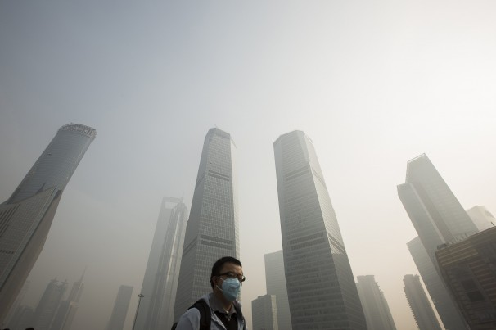
Aly Song/Reuters - A man wears a mask while walking on a bridge during a hazy day in Shanghai. Starting this year, the government has required 15,000 factories to publicly report details on their air emissions and water discharges in real time.

By Simon Denyer, Published: February 2 E-mail the writer
BEIJING — China’s Communist state is hardly known for its transparency. So when environmental groups appealed to the government last year to disclose official data on air pollution, they were not expecting much.
“Way beyond our expectations, the government actually said yes,” said Ma Jun, head of the Institute of Public and Environmental Affairs in Beijing. “I am quite amazed.”
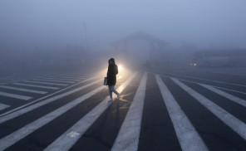
Smog paralyzes cities in northeast China: Thick, choking smog enveloped cities in northeast China in October snarling traffic and closing schools, airports and highways. In some places, visibility was reduced to a few yards.

Since Jan. 1, the central government has required 15,000 factories — including influential state-run enterprises — to publicly report details on their air emissions and water discharges in real time, an unprecedented degree of disclosure that is shedding light on the who, what, when and where of China’s devastating environmental problems.
The reporting requirement is part of a striking turnaround by China’s government, which is also publishing data on the sootiest cities and trying to limit the use of coal. The country’s appalling air is blamed for more than a million premature deaths a year, for producing acid rain that damages the nation’s agriculture, for driving away tourists and even for encouraging the brightest students to study abroad. Perhaps just as important, Beijing’s bad air has been making its Communist leaders lose face.
Cleaning up China’s bad air will take years, even in the best of circumstances. The economy is dependent on coal, and there are many powerful interests involved. But activists say the new steps could at least represent the beginning of change.
Linda Greer of the Natural Resources Defense Council in Washington says the reporting requirement for factories is the “biggest thing” China has done to address its pollution problems, and the most likely to produce results.
“It brings them from the back of the pack globally, in terms of public information disclosure, to the front of the pack,” Greer added by telephone. “Inevitably it will strengthen the hand of regulators when they have bad air pollution days, to look at real-time data.”
Roots of the disclosure
The seeds of the new transparency were sown by the U.S. Embassy when it began monitoring and publishing data on the fine particles in Beijing’s air that cause the most harm to human health — those that measure less than 2.5 micrometers in diameter. Today, the air-quality readings by the U.S. Embassy and consulates around the country are a major topic on China’s microblogs and are widely watched through a smartphone app.

Worst air pollution in China and the U.S.

PM2.5 is a technical term for microscopic particles about one-thirtieth the width of a human hair. PM2.5 particuate pollution comes mostly from burning fossil fuels. It is extremely damaging to human health because the tiny particles have the ability to enter lung and blood tissue and can lead to asthma, cardiovascular disease and cancer.
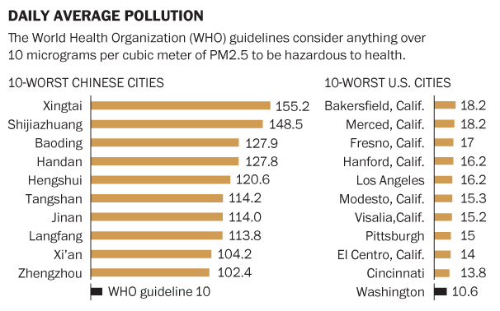
Sources: Chinese Ministry of Environmental Protection, American Lung Association and WHO. Simon Denyer and Richard Johnson/The Washington Post. Published on February 2, 2014, 5:46 p.m.

The Chinese government initially pushed back against such disclosure, requesting in 2009 that the United States stop making public the data.
But in 2012, Chinese authorities ordered cities to publish their own data on PM2.5 pollution levels; today, 179 cities issue real-time figures, while the Ministry of Environmental Protection has begun ranking the worst offenders. Those rankings have been dynamite.
Everyone knew that heavy industry around Beijing was responsible for much of the capital’s bad air, but few people fully appreciated the scale of the problem. The ministry’s rankings showed that seven of the 10 most polluted cities in China in 2013 were in Hebei province, which surrounds the capital and is the center of the nation’s steel industry, as well as being a major glass, coke and cement producer.
The data made one conclusion inescapable: Beijing’s pollution would never be tackled unless Hebei’s heavy industry was either cleaned up or shut down.
The data disclosure was part of a new resolve in China’s government to confront its environmental problems, which have increasingly been the subject of protests.
In September, the Chinese government unveiled a $280 billion plan to improve air quality, including limiting coal use and banning high-polluting vehicles. Under the plan, the Beijing-Tianjan-Hebei area is required to cut concentrations of PM2.5 fine particles by 25 percent by 2017.
Of course, China has set and missed environmental targets before. And a real cleanup would involve significant social and economic costs, especially for Hebei. In 2012, the province produced more crude steel than the entire European Union and twice as much as the United States, according to the economics research firm Dragonomics. Its steel plants are not only massive polluters, but also massive tax and employment generators. No one in government wants a sea of unemployed factory workers at Beijing’s doorstep.
Nevertheless, as part of a plan to cut overcapacity in heavy industry and limit pollution, China declared in October that it would reduce steel production by 10 percent, or 80 million tons, by 2017, with the bulk of the adjustment forced on Hebei.
At provincial party congress meetings in January, cleaning up the nation’s air seemed to garner as much attention as preserving its economic growth. Beijing’s mayor promised to cut coal use as part of an “all-out effort” to curb air pollution, while Hebei’s governor threatened to sack party secretaries and industry managers if production of steel, glass and cement was even one ton above target.
Public pressure
But it is the focus on individual factories that really gives environmentalists such as Ma reason for optimism. Although several provinces have yet to comply with the government’s edict to publish data, figures from Hebei are available and show factories brazenly flaunting limits on emissions.
Ma is working with experts to design a phone app that could vividly expose the offenders, with factories meeting emissions targets showing up as blue and those breaking the law coded red.
“What we aim to do, through public pressure, is help the environment protection bureau to enforce the law,” he said.
In the United States, the Toxics Release Inventory, created in 1986, was one of the Environmental Protection Agency’s most successful programs, Greer said. China’s real-time disclosure program is bigger than anything the EPA has done, she said.
On a recent day in Hebei, a thick carpet of gray smog blanketed the province and the smell of sulphur hung in the air. Near one factory outside the city of Tangshan, a worker on a bicycle angrily confronted journalists trying to photograph smoke and steam billowing into the air.
“Recently journalists have been complaining about pollution, and all the factory owners have come under pressure,” he said. “We are very afraid they will lay us off. Each worker has a family to raise. We have no land, or other industry. Everything we have depends on steel factories.”
But in the village of Wushizhuang, near the Zhengda steel works, locals were as angry as anyone about the pollution that was harming their lungs and ruining their crops — even though many had relatives employed in the surrounding factories.
One man said the apples and pears in his orchard grew so black with grime that they could never be sold, while another wiped thick black dust off a car that he said had been washed the day before.
Transparency obviously still has its limits in China — the Ministry of Environmental Protection and the provincial government in Hebei declined requests for an interview. But the new information may drive action.
Greer said that officials could focus on forcing factories that were egregiously violating pollution limits to use control devices.
“Making them run their pollution control devices is a lot easier than closing them down,” she said. “First, I would see what happens if they all ran those devices. We might see a meaningful reduction.”

NYT

India's Particulate Problem
By MICHAEL GREENSTONE and ROHINI PANDEFEB. 9, 2014
CAMBRIDGE, Mass. — Two years ago, China seemed oblivious to the extraordinary levels of air pollution in many of its cities and the health consequences. But over the past six months, there has been an explosion of information on pollution concentrations, warnings from the media and new policies from the government. It took a long time, but change is happening.
Could India be next? In January, India was startled by the release of the annual country rankings of the Yale Environmental Performance Index, which highlighted its troubling air pollution. The calls for change have started: On Monday, the country’s powerful Supreme Court will hear an amicus plea on the worsening pollution in New Delhi.
Despite a national election coming in May, air pollution has been largely absent from the debate between the two major political parties, Bharatiya Janata and the Indian National Congress. But many successful Indian environmental policies have come from the Supreme Court, and we encourage it to proceed in this vein by embracing more transparent and flexible market-based regulations to better protect the health of its citizens and allow robust economic growth to continue.
Particulate matter air pollution, which is produced primarily by power plants, industry and vehicles, is deadly, causing short- and long-term cardiorespiratory problems such as strokes, heart attacks and cancer. Throughout India, the extreme levels of this pollution are cause for concern.
According to the most recent data from India’s Central Pollution Control Board, the 2010 average for respirable particulate matter concentration across 180 monitored Indian cities was six times what the World Health Organization considers safe and twice India’s own national standards. And the concentration in Delhi is about 13 times higher than the W.H.O. guideline.
A 2013 study (co-written by one of us, Michael Greenstone) measured the effects of particulate matter on life expectancies in China. It found that an additional 100 micrograms per cubic meter of particulate matter in the atmosphere reduced life expectancy at birth by about three years. Using this metric, we estimated that the 200 million people who live in the 180 Indian cities would lose an average of 3.3 years of life because of particulate matter concentrations that exceed India’s standards.
This translates into the loss of about 650 million years of life for just the one-sixth of India’s population that lives in these cities. Satellite data makes clear that pollution also exists outside the monitored zones where the other one billion people who make up the rest of India live. So the total loss of life expectancy is much greater.
The recent decades of economic growth reflected, in part, significant reductions of regulatory constraints, and the fear of slowing growth has reduced the political will to increase regulations on emissions. But India can continue that growth and provide its citizens with a healthier environment by adopting a regulatory system that is both effective and efficient.
India’s current command-and-control style of regulating is handicapped on both counts. It mandates that industrial plants purchase expensive pollution abatement equipment and specifies common pollution standards across the board. Because emissions reductions are much more costly for some plants than for others, these standards are excessively onerous for some and fail to compel the most cost-effective reductions.
Regulators at undersourced pollution control boards must rely on infrequent and often unreliable manual monitoring samplings of emissions by their staffs, which in the best case occur only a couple of times per year, to identify the plants that are violating the standards. As a result, expensive pollution abatement technologies that plants are mandated to install are not used efficiently and sometimes not at all.
So the outcome is doubly bad: Regulations impose substantial costs on the economy while pollution emissions often exceed the state-mandated limit.
Even worse, any violations of these standards are criminal offenses. This means that to penalize violators, regulators must file and win a criminal case in India’s overburdened justice system, making enforcement difficult. So the only potential, swift alternative for regulators is to close down a business — but this, too, is often challenging to enforce.
Cap-and-trade would impose a cost on polluters for every unit of pollution emitted and create incentives to reduce those emissions. At the same time, it would decrease the economic burden of regulation by allowing the regulated firms to coordinate among themselves to hit a specific emissions reduction target in the most cost-effective manner.
In the 1980s, the United States instituted a cap-and-trade market to solve the problem of acid rain; it greatly reduced sulfur-dioxide emissions at a fraction of the projected cost. However, the American experience makes clear that cap-and-trade succeeds only when governments are fully committed to the enforcement of the rules.
India has taken initial steps toward implementing cap-and-trade markets for particulate matter pollution. With guidance from the national regulator, some state regulators are already piloting continuous emissions monitoring and training potential participants for cap-and-trade markets. But more support is necessary to get India’s fledgling cap-and-trade markets off the ground.
When the Supreme Court takes this up on Monday, it should consider two key policy changes that would allow India to more efficiently regulate pollution.
First, stationary sources, like power and industrial plants, should be required to install continuous emissions monitoring equipment in order to provide reliable real-time reporting of emissions by polluters and to make these data publicly available. While increased transparency about pollution greatly enhances regulators’ effectiveness in its own right, it is also a critical ingredient for a cap-and-trade market.
The second critical ingredient: Instead of having to take polluters to court for breaking the law, regulators should be authorized to impose financial penalties on firms that breach emissions regulations. The United States’ successful cap-and-trade markets were, in part, made possible by a little-known but very important part of the 1990 Clean Air Act Amendments that enhanced the Environmental Protection Agency’s ability to levy large civil fines on environmental violators.
It is also essential that the pilot markets are rigorously evaluated in stages to ensure that regulators and the public are informed about costs and benefits.
Pollution is not simply an unavoidable side effect of economic growth, but a reflection of societal choices. Seizing these opportunities for reform would lead to longer and healthier lives.
Michael Greenstone is a professor of economics at the Massachusetts Institute of Technology. Rohini Pande is a professor of public policy at Harvard.

China’s parliament

The smog of war

The prime minister opens parliament by declaring pollution the enemy
Mar 8th 2014 | BEIJING | From the print edition

THE annual session of China’s rubber-stamp parliament, the National People’s Congress, is rarely remarkable for the rhetorical flourishes of the leaders who address it. But at the opening on March 5th of this year’s nine-day meeting the prime minister, Li Keqiang, in his maiden speech, deviated at least a little from the usual stodgy fare. China, he said, must “declare war” on pollution. The blanket of smog that often shrouds much of the country, he said, was nature’s “red light”, warning about the risks of “blind development”. Growing public furore about pollution has at last goaded China’s leaders into admitting the urgency of the problem.
On February 21st the capital issued its first “orange” smog alert since it introduced a new four-tier warning system last October, with orange as its second-highest level. The warning meant schools were supposed to suspend outdoor activities. As the noxious haze lingered, microbloggers expressed outrage that a top-level “red” alert was not issued. Many accused the government of failing to deal with the smog.
Such criticism has clearly stung. Mr Li’s state-of-the-nation speech dwelt on the problem of air pollution much more than those of his predecessors. He acknowledged that smog was affecting an increasingly wide area and said authorities would fight pollution “with the same determination with which we battled poverty”.
That may be an unfortunate comparison, much of China’s success in dealing with poverty having been a by-product of the same rapid growth that has wreaked environmental havoc. But Mr Li is not aiming for another boom. He said China’s GDP would grow this year by about 7.5%, slightly slower than last year’s rate of 7.7% and considerably below the double-digit rates of the first decade of the century. He said that plans to shut down “backward” production facilities in the steel, cement and glass-manufacturing industries would be completed a year earlier than forecast.
Mr Li also said the amount of energy consumed per unit of GDP growth would be cut this year by 3.9%, after a 3.7% drop last year. He omitted to mention that coal consumption, China’s biggest source of energy and a major cause of smog, is expected to continue rising. But he did say that emissions of sulphur dioxide (which result from burning coal and contribute to smog) fell by 3.5% last year and would drop another 2% this year. Smog notwithstanding, researchers at Harvard University last year said China’s cuts in sulphur-dioxide emissions in recent years may have been “one of the most swiftly effective air-pollution policies ever implemented anywhere”.
In recent days internet users have heaped scorn on a Chinese general who said on state television that smog might protect China from attack by American laser weapons. Mr Li wisely avoided repeating the claim. But his government is not scrimping on defence. A draft budget submitted to the legislature calls for a 12.2% increase in military spending this year (up from 10.7% last year); overall government spending will rise by 9.5%. In a pointed jab at Japan, he said that China “would not allow anyone to reverse the course of history”. The war on pollution was, however, the only one he declared.

Clean technology in China

Red light, green light

China’s anti-pollution drive will make it a good place for clean-energy firms
Mar 8th 2014 | SHANGHAI | From the print edition

“ENVIRONMENTAL pollution has become a major problem, which is nature’s red-light warning.” Those green-tinged words do not come from an activist. Rather, they come from China’s leaders, who gathered this week in Beijing for a big annual meeting. On March 5th Li Keqiang, the prime minister, vowed to declare war on pollution.
The timing could not have been better, then, for the launch of a firm devoted to the manufacture of greener engines. The same day EcoMotors, a startup backed by Bill Gates and Khosla Ventures (supported by Vinod Khosla, a Californian venture capitalist), unveiled its joint venture with a division of China FAW Group, a local carmaker. The Chinese partner vowed to spend more than $200m on a factory in Shanxi, a northern province, that will produce 100,000 of the new engines a year.
The venture’s “OPOC” two-stroke engine, a novel twist on a century-old idea, consists of a pair of cylinders, each containing two opposing pistons. Its backers claim its fuel-efficiency will be up to 45% better than the four-stroke engines commonly used in cars. The technology was developed with financial help from the Defence Advanced Research Projects Agency, an arm of the Pentagon with a record of promoting breakthroughs (robot legs and self-driving cars are two others).
The engine can run on a variety of fuels. The plan is first to make diesel engines for use in lorries, and only later to consider petrol versions for cars. However, local boosters in Shanxi also want future configurations to burn methanol, which can be made from abundant local coal supplies.
Another noteworthy aspect of this deal, argues Andrew Chung of Khosla Ventures, is that it suggests the best way for inventive energy startups to achieve scale: make a big push in China. Despite the downturn in the solar business there (see article), Bloomberg New Energy Finance, a research firm, estimates that the clean-technology market in China exceeded $60 billion last year, whereas America’s was less than $50 billion.
Commercialising new technologies is not easy in rich countries, says Amit Soman, the president of EcoMotors, since slow growth and legacy assets make incumbent manufacturers reluctant to take a punt on unproven new kit. But in China his firm has already reached two non-exclusive deals. In one of these, EcoMotors signed a $200m licensing agreement last April to let Zhongding Power make a version of its engines for diesel generators.
“The innovation cycle is being completed in China and other emerging economies, not America,” says Mr Chung. Maybe so, but there are two caveats. The first is that Chinese firms will not pay much for intellectual property, and will copy it as soon they figure out how. The second, observes Jonathan Woetzel of McKinsey, a consulting firm, is that only technology firms that “fit conveniently into the Chinese ecosystem”, to the benefit of local companies, will be allowed to prosper.
Consider the much-trumpeted recent arrival of Tesla Motors in China. The American electric-car firm unarguably has cutting-edge clean technology, but its business model of importing all its vehicles does not enrich powerful Chinese firms or transfer intellectual property to local joint ventures. So the subsidies and tax breaks lavished by China’s central and local governments on buyers of even the most wretched “new energy vehicles” made there will not be offered to purchasers of Tesla’s gorgeous green machines.

China’s environment

A small breath of fresh air

The government gives its Davids a sling to use against polluting Goliaths
Feb 8th 2014 | From the print edition
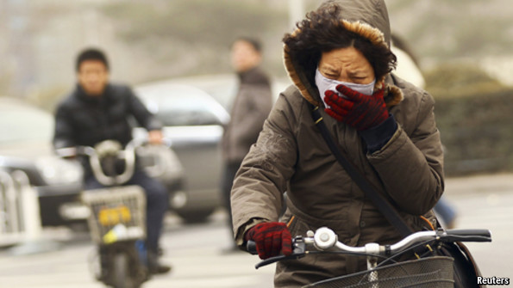
WHEN, in 2008, the American embassy in Beijing started publishing a measure of the fetid smog enveloping the capital, China’s government protested and ordered the publication to stop. Its instinct was to sweep unwelcome facts about the nauseating level of pollution in the country under the carpet. Now that seems to be changing. New rules on pollution say that official data, formerly held secretly, should be published. It is an important step, not just for China’s environment, but also because it gives new power to the large and growing movement of citizen activists who have been lobbying for the government to clean up.
China is now emitting almost twice as much carbon dioxide as the next-biggest polluter, America. At current rates, it will produce 500 billion tonnes of carbon dioxide between 1990 and 2050—as much as the whole world produced between the start of the Industrial Revolution and 1970. Pollutants in the air in Beijing have hit 40 times the level decreed safe by the World Health Organisation. Yet China did not have a ministry devoted to environmental protection until 2008, and the government has done its best to keep information about the levels of filth in the air and water under wraps. Even now, the state is keeping secret a nationwide survey of soil pollution.
The new rules that have just come into effect signal the beginning of a move towards openness. They require 15,000 enterprises, including some of the biggest state-owned ones, to make public in real time details of their air pollution, waste water and heavy-metals discharges (see article). In the past, polluters gave the data on their emissions only to the government. In future NGOs such as the Institute of Public and Environmental Affairs, run by Ma Jun, a former investigative journalist who has been badgering the government on green issues for years, will get these data to analyse and publicise as they wish. Things are opening up at a local level, too. In 2012 only a few cities, including Beijing, published statistics on air quality. Now 179 do. And more firms are volunteering information about pollution—especially those that need foreign investors.
Unwilling liberals
The impetus behind this new transparency is not a sudden enthusiasm for liberalism. Rather, the government is worried that people are increasingly angry about pollution—a recent Pew survey of the concerns of Chinese citizens found that pollution was fourth, behind inflation, corruption and inequality, but was rising fast—and attempts to clean the country up by central-government fiat are foundering.
The government sets a national target for carbon-dioxide emissions per unit of GDP. It determines how much coal may be burned. It requires companies to install certain pollution-control devices. But all these rules—like most Chinese environmental controls—operate through the central-planning system. And that system is subject to “regulatory capture”—getting nobbled by the enterprises it is supposed to control and by the local governments who own or influence them. Factories evade targets by, for example, operating illegally at night, or by dissolving carbon-dioxide or sulphur emissions in water—and then dumping the toxic brew in the local water supply.
More public disclosure will not, by itself, end such baleful practices. But by exposing levels of pollution to public scrutiny, it will allow people to make better-informed choices, to lobby factories and officials for change and to keep an eye on the implementation of environmental laws. The new rules should thus expose polluters to a scissor-style pressure: from above, through the central-planning system, and from below, from the media and organisations such as Mr Ma’s.
Much more is needed. Cracking down on polluters will require provincial or city governments to fine them or take them to court—which they will be reluctant to do, since they often own them. The new disclosure rules have only milk teeth, not real bite. They talk, for example, merely of “urging” enterprises to fulfil “due responsibilities”. And, just as the government is encouraging bottom-up activism on environmental matters, it is cracking down on China’s hyperactive microbloggers.
This points to a tension at the heart of China. The government is nervous of active citizens, yet it needs them. If it gives them more freedom, they can be more useful; if it suppresses them they may be easier to control. These new environmental rules are a move in the right direction. For China’s sake, may there be many more.
Real-time Asian air pollution index
http://aqicn.org/map/

NYT

Most Chinese Cities Fail Pollution Standard, China Says
By EDWARD WONGMARCH 27, 2014
Photo
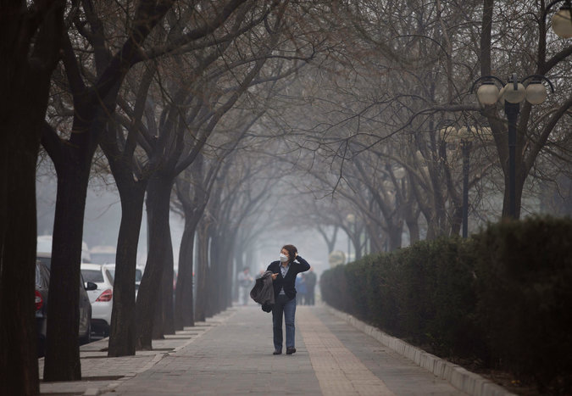
Beijing, with 20 million people, only met air quality standards 48 percent of days in 2013.
BEIJING — Only three of the 74 Chinese cities monitored by the central government managed to meet official minimum standards for air quality last year, the Ministry of Environmental Protection announced this week, underscoring the country’s severe pollution problems.
The dirtiest cities were in northern China, where coal-powered industries are concentrated, including electricity generation and steel manufacturing. The ministry said in its announcement, which was posted on its website on Tuesday, that in the broad northern region that includes the large cities of Beijing and Tianjin as well as the province of Hebei, which surrounds Beijing, the air quality standards were met on only 37 percent of days in 2013. Beijing, with 20 million people, did so on only 48 percent of days, the ministry said.
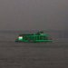

Pollution Killed 7 Million People Worldwide in 2012, Report FindsMARCH 25, 2014

The report underscored the immense challenges facing ordinary Chinese as they try to pressure Communist Party leaders to change growth policies and enforce regulations that would lead to cleaner air. Awareness of toxic air has risen sharply since January 2013, when a stretch of severe pollution in northern China nicknamed the “airpocalypse” resulted in widespread outrage and forced propaganda officials to allow the Chinese news media to report on the problem. Some leaders acknowledge the issue — Prime Minister Li Keqiang announced this month that China would “declare war against pollution” — but environmental scholars say it will be at least five years or even a decade before there is any notable improvement to the air.
On Wednesday and Thursday, the air monitor at the United States Embassy in Beijing rated the air as “hazardous,” which meant people should avoid all outdoor activity. Many cities across northern and eastern China also had poor ratings this week, as shown by figures from local monitoring equipment.
Many tourists are deciding not to visit China because of the reports of pollution. This week, Samuel L. Jackson, the American actor, has been writing to his 3.4 million Twitter followers about the poisonous air in Beijing, where he is promoting a new film, “Captain America: The Winter Soldier.”
“Even w/ lights, you can only see 2 1/2 blocks . . . maybe! AQ 312!!” he wrote in one of a series of messages, referring to an air-quality reading that by American standards falls in the hazardous range.
In an earlier post, he wrote: “Landing in Beijing, Air Quality 216 VERY UNHEALTHY!! Oh well…..”
Foreign workers in Beijing are also becoming much less willing to tolerate the toxic air. That was reflected in an annual survey released on March 19 by the American Chamber of Commerce in the People’s Republic of China. Almost half of the 365 companies in the survey, most of them in the Beijing area, said they had problems recruiting or retaining senior executives because of the poor air. That figure was only 19 percent in the chamber’s 2008 survey.
As a result, some companies are now offering bonuses or higher salaries to fill openings in China, which foreign workers are calling pollution pay — and a few are even announcing the policy publicly, as Panasonic, the Japanese electronics maker, did in mid-March.
On Tuesday, the World Health Organization announced that air pollution, both indoors and outdoors, contributed to seven million deaths worldwide in 2012. More than one-third of those deaths occurred in fast-developing nations in Asia, including China and India. In both those countries, nearly the entire population is exposed to fine particles in the air known as PM 2.5, which can penetrate deep into the lungs and enter the bloodstream, researchers reported on Wednesday in an article posted on Scientific American’s website. They wrote that a recent global environmental index showed that China and India ranked worst in terms of populations affected by poor air.

Most Chinese Cities Fail Minimum Air Quality Standards, Study Says
By EDWARD WONGMARCH 27, 2014
Photo
In Beijing, where some residents wear masks to protect themselves from the poor air, the pollution standards were met on only 48 percent of days last year. Credit
BEIJING — Only three of the 74 Chinese cities monitored by the central government managed to meet official minimum standards for air quality last year, the Ministry of Environmental Protection announced this week, underscoring the country’s severe pollution problems.
The dirtiest cities were in northern China, where coal-powered industries are concentrated, including electricity generation and steel manufacturing. The ministry said in its announcement, posted on its website on Tuesday, that in the broad northern region that includes the large cities of Beijing and Tianjin as well as the province of Hebei, which surrounds Beijing, the air quality standards were met on only 37 percent of days last year. Beijing, with 20 million people, did so on only 48 percent of days, the ministry said.
The three cities that met the standards were Haikou, Zhoushan and Lhasa.

Pollution Killed 7 Million People Worldwide in 2012, Report FindsMARCH 25, 2014

The report underscored the immense challenges facing ordinary Chinese as they try to pressure Communist Party leaders to change growth policies and enforce regulations that would lead to cleaner air.
Awareness of toxic air has risen sharply since January 2013, when a stretch of severe pollution in northern China nicknamed the “airpocalypse” resulted in widespread outrage and forced propaganda officials to allow the Chinese news media to report on the problem.
Some leaders acknowledge the issue — Prime Minister Li Keqiang announced this month that China would “declare war against pollution” — but environmental scholars say it will be at least five years or even a decade before there is any notable improvement in the air.
On Wednesday and Thursday, the air monitor at the United States Embassy in Beijing rated the air as “hazardous,” which meant people should avoid all outdoor activity. Many cities across northern and eastern China also had poor ratings this week, as shown by figures from local monitoring equipment.
Many tourists are deciding not to visit China because of the reports of pollution. This week, Samuel L. Jackson, the American actor, has been writing to his 3.4 million Twitter followers about the air in Beijing, where he is promoting a new film, “Captain America: The Winter Soldier.”
“Even w/ lights, you can only see 2 1/2 blocks ...maybe! AQ 312!!” he wrote in one message, referring to an air-quality reading that by American standards falls in the hazardous range. Earlier, he wrote: “Landing in Beijing, Air Quality 216 VERY UNHEALTHY!! Oh well....” And another post said, “7:30 AM AQ still jacked!”
Foreign workers in Beijing are also becoming much less willing to tolerate the toxic air. That was reflected in an annual survey released on March 19 by the American Chamber of Commerce in China. Almost half of the 365 companies in the survey, most of them in the Beijing area, said they had problems recruiting or retaining senior executives because of the poor air. That figure was only 19 percent in the chamber’s 2008 survey.
As a result, some companies are now offering bonuses or higher salaries to fill openings in China, which foreign workers are calling pollution pay — and a few are even announcing the policy publicly, as Panasonic, the electronics maker, did in mid-March.
On Tuesday, the World Health Organization announced that air pollution, both indoors and outdoors, contributed to seven million deaths worldwide in 2012. More than one-third of those occurred in fast-developing nations in Asia, including China and India. In both those countries, nearly the entire population is exposed to fine particles in the air known as PM 2.5, which can penetrate deep into the lungs and enter the bloodstream, researchers reported on Wednesday in an article posted on Scientific American’s website. They wrote that a recent global environmental index showed that China and India ranked worst in terms of populations affected by poor air.

NYT

In Beijing, Clearer Views Hide Real Life
By DIDI KIRSTEN TATLOWNOV. 7, 2014
Photo
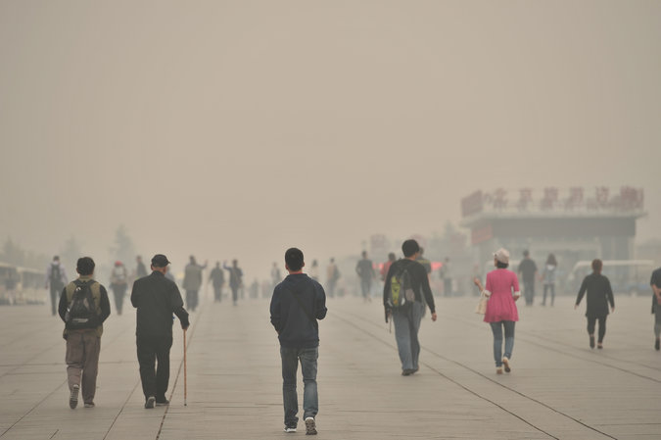
Pollution shrouded the Olympic Green, built for the 2008 Games, on Oct. 9. Officials want to show a cleaner version of Beijing during the summit talks. Credit Imaginechina, via Associated Press
BEIJING — As she does every year on the same day, Ms. Zhu hauled a large wreath of multihued paper chrysanthemums to Babaoshan Revolutionary Cemetery in western Beijing. Ms. Zhu, who declined to give her full name, planned to burn it, as Chinese tradition dictates, to honor her husband and parents, who are buried here.
But when she reached the cemetery’s Office of Burning on Thursday, she found the ritual had been banned during daytime hours for two weeks.
“APEC restrictions,” her friend explained.
The ban on burned offerings was one of a cascade of government orders, from the draconian and sweeping to the picayune and puzzling, aimed at reducing air pollution and securing azure skies when government leaders meet in Beijing for the Asia-Pacific Economic Cooperation forum, which began Wednesday and runs through Tuesday.

China and Japan, in Sign of a Thaw, Agree to Disagree on a Disputed Island Group NOV. 7, 2014

Determined to offer visiting heads of government, including President Obama, a cleaner, emptier version of China’s capital, where the air is often dirty and the streets always full, the authorities have ordered dozens of temporary changes that are upending people’s lives and dampening commerce, affecting activities like marrying, driving, eating and mourning the dead.
Photo
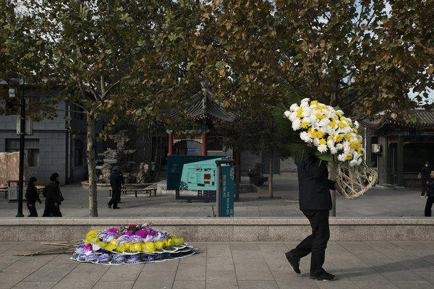
A temporary, daytime ban has been imposed on the ritual burning of flowers at Babaoshan Revolutionary Cemetery in Beijing. Credit Gilles Sabrie for The New York Times
Thousands of factories have closed and thousands more have been ordered to reduce emissions by 30 percent. Around Beijing, in an area nearly the size of California, tens of millions of people in 17 major cities can drive only on alternate days, depending on whether their license plates end in an odd or even number. Trucks carrying goods can enter Beijing only between midnight and 3 a.m., affecting deliveries of supplies like furniture and milk.
Gas stations have been barred from selling gas in canisters, and some have been shut entirely, though these measures may be aimed more to discourage the making of firebombs than to clear the air.
The government has also tried to shed some of the city’s 21 million people, declaring an APEC Golden Week, a six-day vacation modeled on the Golden Week public officials get each year around National Day in early October. Public schools have been closed, work has been halted on construction sites, and public services such as issuing marriage licenses and passports have been suspended.
Newlyweds may not set off firecrackers, a common feature of a wedding celebration. Hospitals have closed nonessential departments and are turning away patients with nonemergency ailments.
One prestigious government institute told researchers to avoid “dangerous locations” like rivers, reservoirs, ponds or wells, and to avoid crowds, but if they could not, then to avoid causing stampedes by not pushing people.
Some residents are furious.
“All this is such an overreaction,” said a Beijing resident who gave his name as Chen. “Ridiculous.”
Shopkeepers are complaining.
“Business is down, since the day they cut the cars,” said Tang Wen, who was behind the counter at his liquor and cigarettes store in Goldfish Lane. “If people can’t get here, they can’t buy.”
At the landmark red-and-gold Buddhist Yonghe Temple, a monk said worshipers could burn only incense sold by the temple, which is said to produce less smoke, and visitors were being checked for unauthorized incense.
With trucks largely barred from entering Beijing, deliveries have dropped. “Usually I deliver about 100 parcels in a morning,” said Liu Minghuan, a worker at Yunda, a delivery company. “But now I’m only delivering about 60 and it’s getting fewer.” He predicted a surge in deliveries would overwhelm the system after the APEC meetings. “But that’s something for the bosses to worry about,” he said.
A suburban milk company warned customers that it could not deliver any milk during the APEC event.
Peking Union Medical College Hospital, the country’s top hospital, has restricted access, reportedly to keep the usually jampacked aisles clear for potentially ill dignitaries, though emergency services remain open.
A notice in the reception area, normally packed with people buying a $3 “see the doctor” ticket, said treatment was available half days from Friday through Sunday and not at all from Monday to Wednesday, when the leaders of more than 20 Asian and Pacific Rim countries will be in Beijing.
Outside, a scalper offered tickets for $49.
“This is a total pain,” said a woman named Ms. Huang, who was trying to book a chest examination for her mother.
Some joked. A post circulating on the text service WeChat said APEC stood for “Air Pollution Eventually Controlled.”
State news media has taken note of the inconveniences, publishing reports in which those affected seem to come around to accepting that it is for the greater good.
Xinhua, the state news agency, told the story of Qu Nan, a waitress at the APEC venue, who had to wean her baby early in order to go into the required work lockdown for several days before the meeting.
“I felt like I couldn’t handle weaning my baby,” she said. “On the evenings before, whenever I thought about it, I’d cry and say I couldn’t bear to be parted from my baby.”
But her husband comforted her and said, “Never mind.”
“He really got it,” Ms. Qu said. “I guess there are some personal problems that you just have to deal with yourself.”
In Fangezhuang village, in the chilly mountains north of Beijing, Zhang Yongfu, 73, lamented that the ban on wood burning would hurt children and the elderly, who would not be able to fire up their kangs, the wood fire or coal briquette-warmed stone beds common in the countryside, Chinese Business View, a Shaanxi Province newspaper, reported.
But Mr. Zhang, too, saw the bigger picture, the newspaper noted.
“APEC is a big deal,” he said. “We can all overcome our difficulties.”
Despite these measures, the air was foul on Friday morning but had cleared somewhat by the time Secretary of State John Kerry landed in the afternoon.
Ultimately, the authorities would have to pray for a good strong wind, but nature was not cooperating.
Meteorologists expected air quality to deteriorate as northwest winds from Mongolia moved in. They projected pollution would build over the weekend and continue during the week.
At Babaoshan cemetery, a crestfallen Ms. Zhu left with her wreath intact. “I’ll just have to burn it at home later,” she said.

Sierra Club Magazine

Clearing Skies
A journalist who fled China's air pollution looks back and sees rays of hope.
By Adam Minter
Show All Slides
- 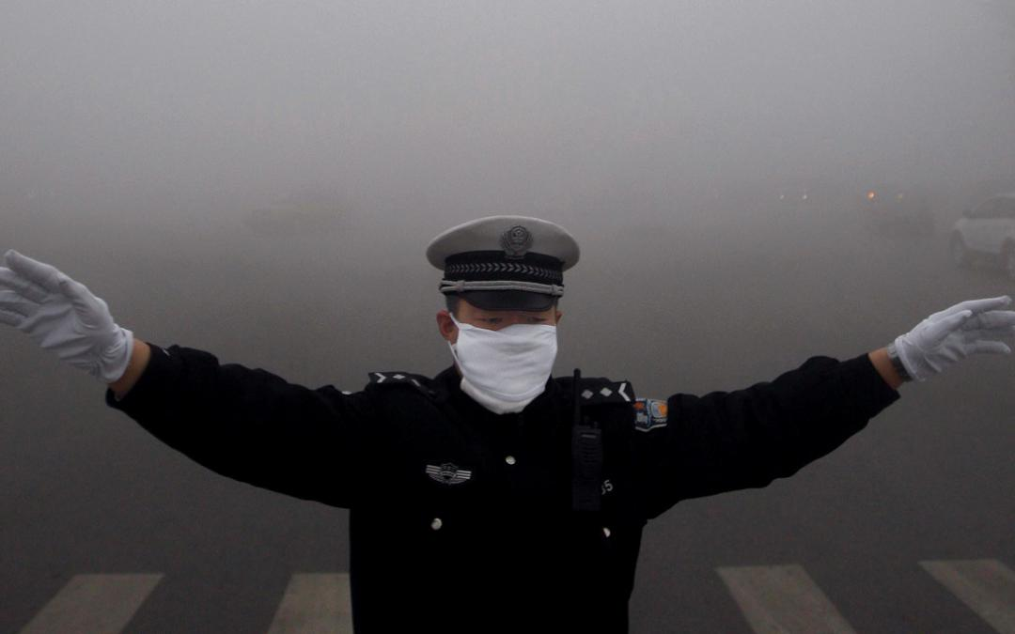
Directing traffic in Harbin, China, October 21, 2013, when the local government reported an air quality index score of 500, the highest possible reading. | Photo ROPI/ZUMAPRESS
- 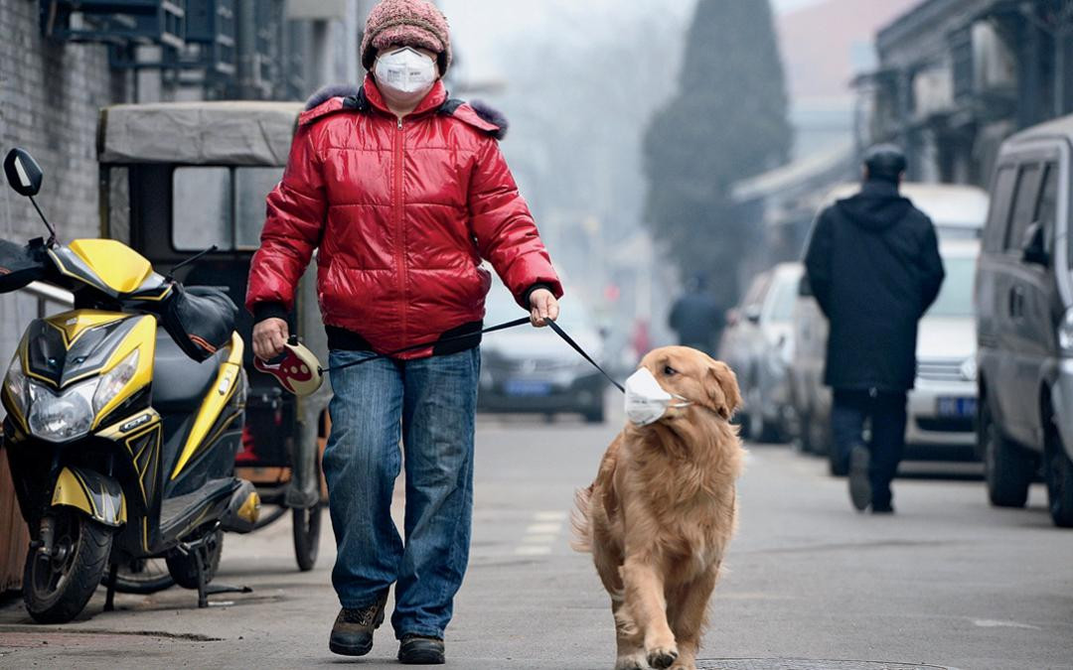
A man and his dog, both wearing masks, walk along a small alley on a hazy day in Beijing, February 23, 2014. China's capital Beijing, under fire to take effective measures against air pollution, raised its four-tiered alert system to "orange" for the first time on Friday, as heavy smog was forecast to roll into the city over the next three days. | Photo by REUTERS.
- 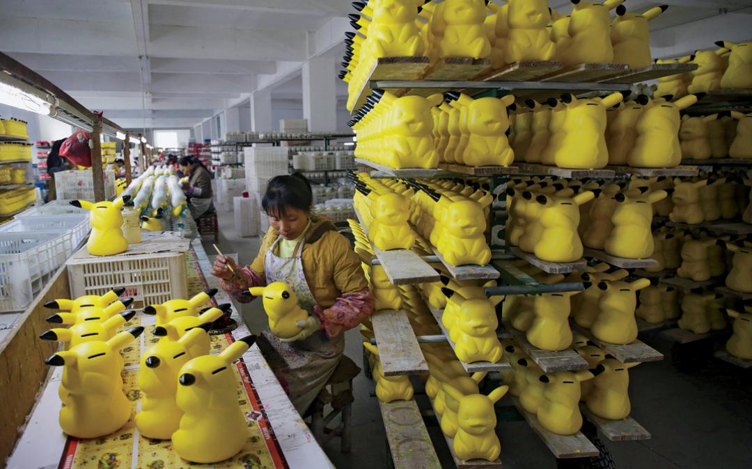
A worker paints money boxes in the shape of cartoon character Pikachu at a pottery factory in Dehua, Fujian province, December 7, 2014. | Photo by Darley Shen/REUTERS
A model presents a creation featuring a facial mask during the QIAODAN Yin Peng Sports Wear Collection of the China Fashion Week 2015 S/S Collection in Beijing, capital of China, October 28, 2014. | Photo by Chen Jianli/Xinhua/ZUMA Wire
- 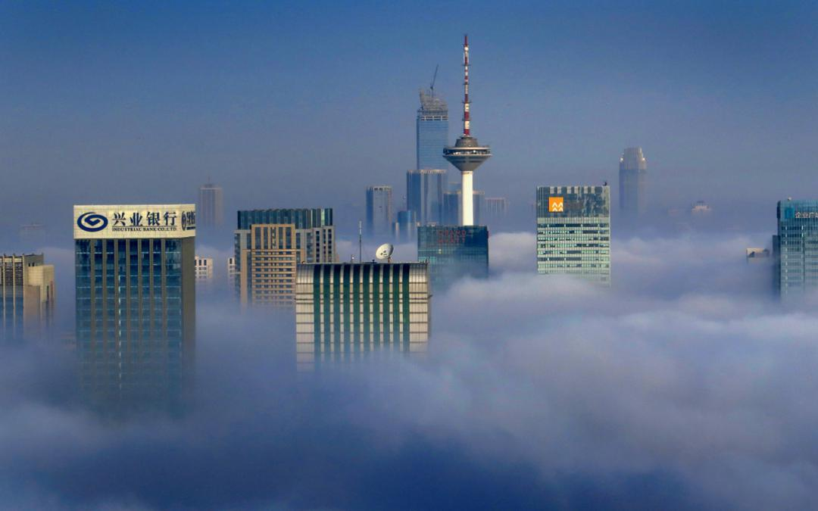
Smog smothers Shenyang, the capital of Liaoning Province and the largest city in northeast China, November 21, 2014. Visibility dropped to 65 feet in some areas, forcing the closure of highways and the city's airport. Meteorological authorities issued a red alert, the highest possible, four times. | Photo by Imaginechina via AP Images

After dark is when the pollution arrives on the outskirts of Shanghai. On a bright night, when moonlight refracts through the smog, you can see black clouds of soot pouring out of small workshop smokestacks silhouetted against the sky. In case you miss it in the dark, there's always the morning's first deep breath and the feeling of something raw in your throat.
I lived and breathed in Shanghai for 12 years, from 2002 to 2014, and those mornings seemed to grow worse. During my last three years, the first thing I'd do after waking--even before checking the weather--was to open the air-quality app on my phone. If the air was rated anything worse than "unhealthy"--the equivalent of "hazardous" under U.S. EPA guidelines, which happened at least monthly in the winter--I'd work from home. Eventually, my wife and I decided that it was time to leave the country--if not for our health, then for that of our first child.
The source of all that pollution isn't hard to track down. It's fossil fuels, and coal in particular. The numbers are astonishing, and speak to both the growth in China's economy and the penalty it pays for not taking a cleaner route to development. In 2002, for example, China consumed 1.6 billion tons of coal; in 2012 it consumed 4.15 billion tons. Much of that was high-sulfur "dirty" coal burned in factories and power plants where emissions standards were widely ignored. (See below, "Coal Turnabout.") But coal isn't the sole culprit. Between 2000 and 2013, annual new-vehicle sales in China grew by more than 900 percent, to 22 million (Americans bought 15.6 million cars in 2013). In part to fuel those vehicles, China went from burning 4.8 million barrels of oil per day to 10.1 million barrels per day.
Other, less obvious sources of pollution can be even more damaging. For example, unlike the United States and the European Union, China allows oil tankers and container vessels to burn high-sulfur oil in its ports. Just one such ship cruising the Chinese coast can emit as much pollution in a day as 500,000 trucks. Shipping emissions lead to at least 1,600 deaths per year in China's Pearl River Delta (which includes Guangzhou, Shenzhen, and Hong Kong), according to a 2014 Natural Resources Defense Council study. Altogether, in 2010 air pollution contributed to 1.2 million premature deaths in China, according to data from the 2010 Global Burden of Disease Study. In all likelihood, that number has only increased in recent years.
In spite of this, I am more optimistic than ever about China's commitment to tackling its pollution. In the past five years, in particular, Chinese citizens, newly empowered by social media (China has more people connected to the Internet than any other country), have become loud and powerful critics of China's debilitating air quality, and the government is taking notice.
"It's causing an uproar, and it's a threat to the leadership and the government--which they take very seriously," explained Knut Alfsen, a Norwegian climate scientist and an adviser to the China Council for International Cooperation on Environment and Development, a high-level advisory body to the Chinese government.
The government is starting to take actions small and large. In November, China handed the residents of Beijing a six-day vacation, enacted traffic restrictions, shut down factories, and even closed crematoriums. All so 21 heads of state, including President Barack Obama, attending the Asia Pacific Economic Cooperation (APEC) meeting there, and the international media accompanying them, wouldn't arrive in a smog-choked city.
The resulting blue skies--quickly dubbed "APEC blue" by locals--were temporary. But the stunt, according to Ma Jun, perhaps China's most influential environmental advocate and the founder of the Beijing-based Institute of Public and Environmental Affairs, had value. "APEC blue demonstrated to people that we don't need to take 30 or 50 years to get our sky back," he said. "This public recognition, emphasized by [Chinese] President Xi [Jinping], is helpful for us."
How helpful? At the end of the APEC meeting, Presidents Obama and Xi agreed to a landmark deal on reducing greenhouse gas emissions. The details are impressive, including a Chinese promise to cap its total greenhouse gas emissions no later than the year 2030 and to make renewable power 20 percent of its overall energy mix by then. They're also extremely ambitious. "They need to increase renewables by 6 to 8 percent per year to get there by 2030," Alfsen says. That won't be easy, but Alfsen has good reason to believe it'll happen. "When they set targets," he said, referring to Chinese officials, "they usually deliver."
Despite the significant and long-term challenges to cleaning up China's air and greenhouse gas emissions, four important developments suggest that--just maybe--China's challenges can be met over the long-term.

I. Economic Developments
For environmentalists outside China, the country's air pollution problem is an ongoing good-versus-evil emergency. But viewed from within, it's a bit more morally ambiguous. That's not to defend China's pollution but rather to highlight the rapid changes in living standards and life expectancy that three-plus decades of unregulated, fast-growth development have brought to hundreds of millions of China's 1.3 billion citizens.
When people ask me what changed most during my years in Shanghai, I always answer that each freshman class of kids at the high school up the street from my apartment of eight years was noticeably taller than the last. "Everybody is richer now," one of my friends, a teacher at a different high school, told me. "They can buy better food." That wealth comes from a lot of places, but one of the sources is undoubtedly a fast-growing economy fueled by cheap carbon.
The health benefits run deeper yet. Consider that between the start of Communist Party rule in China in 1949 and today, the average life span more than doubled to 75 years. A country with no middle class to speak of only three decades earlier suddenly had the world's largest.
As long as living standards and life expectancy kept moving up--and they did, for decades--air pollution assumed a lower priority than it would have in a developed country. Of course, at some point, economies slow, people have enough to eat, and there are only so many mobile phones you can buy. China reached that point in the mid-2000s. The comeuppance, especially for the government, was powerful. "No country becomes so rich that its citizens do not need to breathe," says Nathaniel Bullard, an analyst at Bloomberg New Energy Finance who covers clean energy and energy technology from Hong Kong. "The data on health impacts are clear, and just as clear to the government are the social implications of this reduced health, welfare, and happiness."

II. An Avalanche of Data
It was also in the mid-2000s that the Institute of Public and Environmental Affairs began to post publicly available--but never before collected or collated--data on water pollution to the Web. Suddenly citizens who'd been willing to ignore pollution were waking up to clear evidence of diminishing returns from fast economic growth. In 2013, only 3 of the 74 cities that China monitors for air quality met the country's very modest standards. China's mass drive to urbanize, once a source of wealth and better health, now increasingly looked like a pollution-addled trap.
Still, it has taken time for the government to get the message. As recently as 2011, Chinese state media regularly referred to the thick white haze that hung over China's cities as "fog" rather than "smog." But several years earlier, the U.S. embassy in Beijing had begun releasing hourly data on China's air pollution via Twitter. The feed and eventually Twitter itself were blocked, but savvy Internet users just went about reposting the information to Chinese social media sites. Now many Chinese know what they're breathing and, predictably, they're not happy. "We are seeing pressure to drive the serial polluters to change," says the Institute of Public and Environmental Affairs' Ma.
• Privileged Chinese have the means to protect themselves from pollution, and for many, the solution is simple: flee.
The avalanche of data is beginning to affect policy. In January 2013, Beijing experienced what came to be known as an "airpocalypse"--a smog incident (and not the first) in which pollution levels were off the EPA's air-quality scale. The events, which can last for days, are disturbing, dangerous, and galvanizing. Chinese social media users began demanding action from the government, and the government--an authoritarian institution whose legitimacy is drawn largely from its promise to improve living standards--fast-tracked the installation of air-quality monitors across the country. More significantly, it responded in September 2013 with a comprehensive action plan to tackle China's air pollution that will eliminate coal-fired boilers and upgrade the quality of fuel oil, among other measures. It also requires coal to be reduced to 65 percent of China's energy mix by 2017.
The increasing volume of data on the sources of Chinese pollution is also making it easier for the committed central government in Beijing to pick its internal fights, and win them.
For example, real-time pollution data from power plants in highly polluted Hebei and Shandong Provinces, collected by the Institute of Public and Environmental Affairs, show that the 21 largest polluters account for 90 percent of nitrogen oxide emissions. Those emissions could be halved if those plants were held to the new air-quality standards that President Xi announced in 2013. Will such measures solve China's air pollution woes? "That's not something that's fixed in a five-year plan," climate scientist Alfsen said, referring to the social and economic development programs that have guided China since 1953 and are now in their 12th iteration. But the popular sentiment inspiring them is moving China in the right direction. "I'm impressed by the willingness and the priorities of the government, but also the priorities and willingness of the Chinese public," Alfsen said.

III. Elites Are Fed Up Too
In the late fall of 2011, right about the time that Chinese social media was about to revolt over air pollution, the Broad Air Conditioning Company in Changsha, Hunan Province, made a marketing error. In hopes of juicing up sales for its high-end air purifiers, the company decided to reveal one of its most exacting customers: the Chinese government. In an advertisement, Broad announced that it had placed more than 200 such pollution-fighting filters in the very centers of Chinese power, including the Great Hall of the People, the Zhongnanhai leadership compound, and even the office of then-president Hu Jintao.
Needless to say, the ad didn't go over well with China's government or its furious social media users, and it was pulled. But the air purifiers? Presumably they're still scrubbing away, making Beijing's air safe for its leaders.
Privileged Chinese have the means to protect themselves from pollution, and for many, the solution is simple: flee. "North China's air quality is driving away wealthy citizens and making it hard to attract and retain global executives," Bloomberg's Bullard said. According to one study, 64 percent of Chinese millionaires have already emigrated or are planning to. Among the most cited reasons: pollution, food safety, and educational opportunities.
It's an economic and a public relations disaster, and it's not just the rich and powerful who are leaving. In 2014, 274,000 Chinese citizens were studying in U.S. universities, and less than half of them will return to China. Job opportunities and other socioeconomic factors play a role. But so does pollution and its effect on children.
It's not clear whether reducing pollution will bring them back, but China's air filter-possessing leaders know personally why large numbers of the country's increasingly wealthy citizens want to leave, so they're willing to give antipollution measures a try.

IV. Headway on Conservation
The horror-show photos of China's winter smog that can be seen on websites and in newspapers remind people of the toll that fossil fuels are taking on China. But if there's a downside to such photos, it's that they tend to put the focus on the energy-generation side of China's pollution problem rather than on the consumption side. Ultimately, pollution is caused by energy use, whether by factories making iPhones, buses transporting students to school, or homes being heated during the north China winter.
For the Chinese government, now committed to huge reductions in energy-related emissions, efficiency measures are enticing, low-hanging fruit--much easier to implement than, say, converting coal-burning power plants to renewables. "A lot of the progress in energy efficiency can be achieved via low-cost, no-cost measures," said BarbaraFinamore, Asia director for the Natural Resources Defense Council. "There's a tremendous amount of energy wasted through poor management, lack of training, things like that. And that's where the biggest bang for the buck is."
Up to 26 percent of energy use in China is related to powering buildings. That's less than the global average of 40 percent, but China's number is set to grow: The country's building floor space and energy consumption are both projected to double by 2050. That, in itself, is reason to question whether China can meet its new greenhouse gas commitments. But it's even more frightening when you take into account that only 5 percent of China's buildings currently meet the country's meager building energy-conservation standards. Fortunately, the government began spending money on energy-efficient-home retrofit projects back in the 1990s, converting millions of square feet of leaky, poorly insulated homes into green ones. Meanwhile, factories that depended on coal burning for energy are being moved to other, cleaner-burning power sources. "Energy efficiency is the cheapest, cleanest, and fastest energy resource there is," Finamore said. "And they're really using it."
These trends, however shaky, suggest that China is beginning to turn in the right direction. Bloomberg's Bullard believes that China is inherently capable of maintaining its momentum. "Only a country with China's level of coordination and commitment could build so much fossil fuel-generation capacity so quickly," he said. "And now the economic development that extraordinary power output created gives China the wealth, wherewithal, and willpower to change its path."
This story has been corrected from the print version.

Coal Turnabout
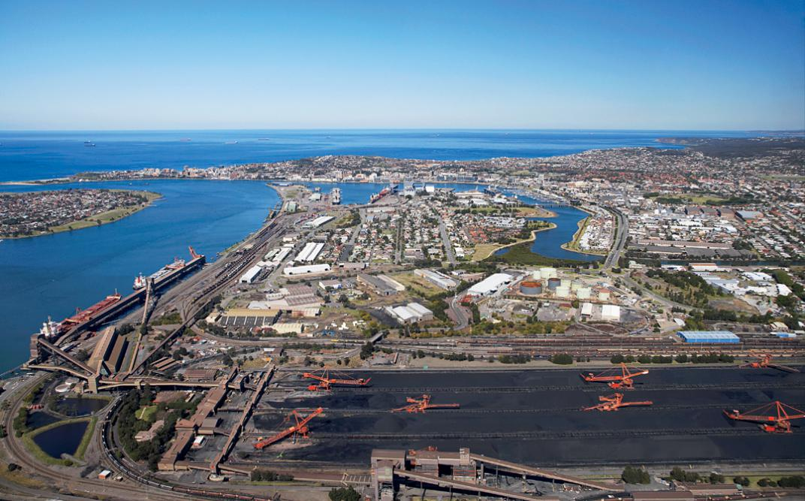
Carrington Coal Terminal, Newcastle, New South Wales, Australia | Photo by David Wall Photo.
At the stroke of midnight, New Year's Eve 2015, residents of some of China's biggest cities started breathing just a little easier, thanks to a new ban on the burning of high-sulfur, high-ash-content coal in major population centers. China also imposed restrictions on the import and mining of such "dirty" coal. It's a definite, throat-clearing step in the right direction.
Unless you're an Australian coal boss, that is.
Coal is Australia's second-most-valuable export, and China has been its second-biggest coal customer for years, importing around 49 million tons annually. That status may not last much longer, however--much to the discomfort of some Australians. The dirty-coal restriction alone threatens to impact roughly 40 percent of that trade, by some estimates.
And the pace of change will likely accelerate. Over the past few years, China has been making massive investments in renewables. In the first half of 2014, for example, China added enough hydropower to its grid to replace 26 million tons of coal per year. Of course, China has many other sources of coal--including its own mines. But the move away from coal is undeniable and historic. Indeed, according to a landmark October 2014 energy analysis by Greenpeace, coal use in China dropped by roughly
1 percent in the second and third quarters of 2014--a first for China in the 21st century. And in November 2014, the Chinese government announced that it would cap its coal use by 2020. Meanwhile, defying decades of doomsayers who insisted that China and coal grow together,
China's economy expanded more than 7 percent in 2014. The impact on China's skies is yet to be seen. But in Australia, it's already being felt. In November, international mining goliath Glencore announced three-week production shutdowns at its Australian mines as a result of "over supply."
The geopolitical and economic factors that influence the global coal trade make it hard to predict, but there's plenty of reason to believe that the world's biggest coal consumer can wean itself from its biggest pusher. "Let me remind you: China is also the world's biggest manufacturer of solar panels, its biggest installer of wind turbines and solar panels, and it has very deep financial markets to fund expansion and installation," Bloomberg New Energy Finance analyst Nathaniel Bullard said in an email from Hong Kong. "The toolbox for changing China's carbon footprint is in place; it just needs to be opened further."--A.M.
This article was funded by the Sierra Club's Beyond Coal campaign.
SEE MORE Feature STORIES
Adam Minter is an Asia-based columnist for Bloomberg View. He contributed to "Addicts and Enablers," Sierra, May/June 2010 (sc.org/addictsandenablers).

China Pledges to Halt Growth of Carbon Emissions in Climate Plan
点击查看本文中文版 Read in Chinese
By CHRIS BUCKLEYJUNE 30, 2015
HONG KONG — China, the world’s biggest greenhouse gas polluter, pledged on Tuesday to wean its economy away from reliance on fossil fuels as it grows, and to try to bring the rise in its carbon emissions to an earlier end.
The Chinese government offered the goals as building blocks for a new international agreement on countering global warming, which governments hope to reach at a conference in Paris late this year.
How quickly and how much China’s emissions will grow is crucial to the arithmetic of global climate change, which is driven by rising levels of greenhouse gases in the atmosphere, especially carbon dioxide. China’s motor vehicles, factories, power plants and boilers released 29 percent of the world’s carbon dioxide emissions in 2013 — twice the amount released by the United States, the world’s largest economy and second-largest carbon polluter.

The proposals “reflect China’s biggest effort to respond to climate change, and embody its thoroughgoing participation in global governance,” Prime Minister Li Keqiang of China said on Tuesday in Paris, according to the Chinese government’s website. He described the proposals in a meeting with President François Hollande of France, whose government will host the international conference.
China’s latest proposals will be closely scrutinized by policy makers in other capitals, especially in Washington, where China looms large in political debates over climate change. And while many analysts were heartened that China had declared its resolve to reduce its greenhouse gas emissions, some experts said the proposed steps fell short of what the country could and should achieve.
The proposals “may reflect a desire by the Chinese government to have a ‘safe’ international goal,” Bill Hare, a senior scientist with Climate Analytics, which analyses greenhouse gas emission trends, wrote in an emailed comment.
“The bigger picture remains that China’s national actions and policies are already set to drive a large decarbonization of its economy, but that further action is needed,” Mr. Hare wrote.
Mr. Li said on Tuesday that China would “strive for the earliest possible peak” in its emissions. And he announced a new goal: to further reduce the country’s carbon intensity, a measure of how much pollution it generates for every percentage point of economic growth it achieves.
In his meeting with Mr. Hollande, Mr. Li reiterated that China would try to make its emissions of carbon dioxide — the main greenhouse gas produced by the burning of coal, oil and natural gas and by industrial activity — stop growing by 2030 or before, according to the Chinese government’s website.
As for carbon intensity, the Chinese government had promised in 2009 to cut it by 40 to 45 percent from its 2005 level, and to do so by 2020. Mr. Li announced a new goal, to extend the cut to 60 to 65 percent by 2030. China had already fulfilled much of its original commitment: by late last year, according to government data, carbon intensity was down by 33.8 percent from the 2005 level.
By outlining China’s goals in Paris, Mr. Li gave a lift to the government of Mr. Hollande, which has staked considerable prestige on the success of the Paris conference, which is scheduled to convene Nov. 30.
In advance of the conference, participating governments must submit plans for climate change action to the United Nations. China published its submission soon after Mr. Li’s meeting with Mr. Hollande, laying out measures to clean up economic production and consumer behavior.
“It’s very detailed, and suggests the seriousness with which China takes its climate policy goals,” said David Sandalow, a fellow at the Center on Global Energy Policy at Columbia University and former top Energy Department official.
The stagecraft of China’s announcement sent an encouraging signal for the negotiations, said Jennifer Morgan, the Global Director of the Climate Program for the World Resources Institute in Washington.
“That this was done at the meeting with President Hollande, and not just by submitting it into a web portal, I think that really demonstrates that the upper levels of the Chinese government are fully engaged in this,” Ms. Morgan said in a telephone interview.
Still, years of international negotiations have brought little agreement on how to assign responsibility for cutting greenhouse gas pollution. A conference in Copenhagen in 2009 ended in acrimony between wealthy and developing economies, especially between the United States and China.
Secretary General Ban Ki-moon of the United Nations warned on Monday that the preparatory talks for the Paris conference were “far too slow.”
“It’s like snails,” he told a meeting of the General Assembly.
However, since 2009, China and the United States have found more common ground in the negotiations. When President Xi Jinping of China announced his government’s 2030 goal for halting the growth in its carbon dioxide pollution in a joint statement with President Obama in November, it was the first time that Beijing had formally proposed a time frame.
“I think Paris will be different from Copenhagen,” said Fuqiang Yang, a senior adviser on climate change and energy policy in Beijing for the Natural Resources Defense Council, an international environmental advocacy group based in New York. “Everyone understands that this time they cannot leave empty-handed.”
Public discontent at home about hazardous air pollution has magnified the pressure on China to cut its use of coal, the dominant source of both its smog and its carbon emissions.
But China’s leaders have not yet detailed just how high the country’s emissions are likely to rise before they peak, or how rapidly they might decline afterward — important elements in forecasting global concentrations of greenhouse gases. Mr. Li’s new carbon intensity target does not directly answer those questions because it is a relative measure, yoked to the rate of economic growth, which can rise or fall.
China would probably be able to adopt more stringent goals to reduce emissions, but prefers a more conservative approach in international negotiations, said several analysts.
“A 65 percent carbon intensity reduction is a goal that we can reach with some effort, but if we try harder, then 70 percent would be possible,” said Mr. Yang of the Natural Resources Defense Council. “With effort, too, a 2025 emissions peak would be possible.”

Economist

Wind power

Need a weatherman

Though wind generation is growing fast, much remains wrong with the industry
Aug 1st 2015 | DABANCHENG, XINJIANG | From the print edition

image: http://cdn.static-economist.com/sites/all/modules/custom/ec_bookmark/assets/timekeeper-btn.png

image: http://cdn.static-economist.com/sites/default/files/imagecache/full-width/images/2015/07/articles/main/20150801_cnp001.jpg
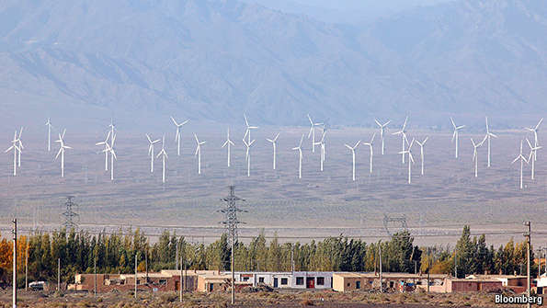
ROW after giant row of wind turbines marches towards the snowy peaks of the Tian Shan range, harvesting energy from the air. On a blustery July day in Xinjiang in China’s far west, it is hard to stand upright beside the structures, each 90m (nearly 300 feet) high. China is better known as a land of coal and smog, but it is now increasing the generation of electricity from renewable sources faster than any other country, with more than 100 gigawatts a year of installed generating capacity from wind, a third of the world’s total (see chart). In future, wind power will be a vital source of renewable energy. If it can integrate large-scale wind generation into its electricity network, China will be an example for other countries.
image: http://cdn.static-economist.com/sites/default/files/imagecache/original-size/images/print-edition/20150801_CNC200.png
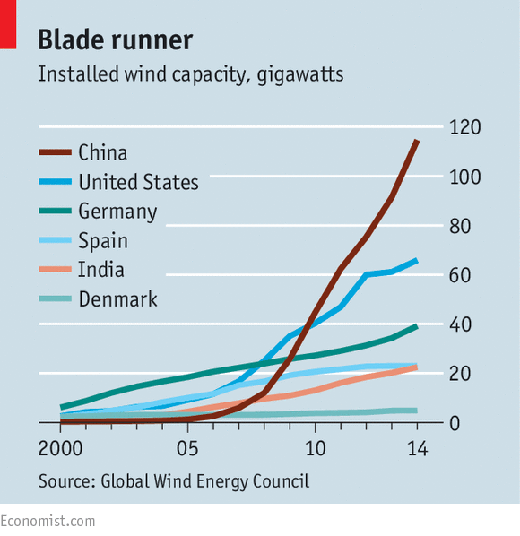
By many counts wind generation in China is a success story. Over the past decade generating capacity has increased tenfold, while the cost of building wind farms has fallen. Three of the world’s top ten turbine manufacturers are Chinese. The industry has not suffered from the boom-and-bust nature of China’s solar industry, the world’s biggest, which sharply increased production of panels even as global prices plummeted, with plenty of dodgy financing and dirty manufacturing processes along the way.
Wind power has tripled its share of China’s electricity generation since 2010, to 3% of the total. If that still seems puny, it is enough to power 110m Chinese homes. And fast growth is likely to continue for a long while. The prime minister, Li Keqiang, says that by 2030 China must cut its emissions of carbon dioxide per unit of GDP to 60-65% of the levels prevailing in 2005. Wind projects will be crucial to meeting the target; coal now generates nearly two-thirds of China’s electricity.
Wind power is clean and safe. It uses far less water than fossil-fuel generation. It is much cheaper to build and run than hydroelectric or nuclear power. And while local communities in other countries often oppose wind turbines littering their pleasant lands, the Chinese government rarely gives a fig about local feeling (or conserving local ecosystems). Besides, most of China’s wind blows in places where few Chinese live.
That has also been a problem, however. The windiest parts of China are Gansu and Xinjiang provinces in the north-west and west, and Inner Mongolia in the north, far from the huge population and industrial centres down the eastern seaboard. Expanding China’s electricity grid has lagged far behind the construction of wind farms. Huge arrays were built only to have to wait for ages to be plugged in to the grid. Even once they were connected, much electricity leaked out of transmission lines. And the grid proved unable to cope with surges in electricity whenever the wind blew.
China has resolved many of these problems. For instance, new wind farms now get connected faster. Yet, despite improvements, the grid still struggles to cope with fluctuating loads. In the first three months of the year 19% of electricity was wasted, according to the National Energy Administration, up from 12% in the same period last year. The operators of a wind farm at Dabancheng in Xinjiang say it runs at full capacity only about half of the time.
The quality of Chinese-made turbines has improved greatly since the early models. But even today maintenance of the newer machines falls short. Chronically poor servicing in China means many farms operate below capacity. That is another area for improvement.
Yet much deeper change is needed if China is greatly to increase its share of wind energy, says Kaare Sandholt of the China National Renewable Energy Centre, a think-tank in Beijing. Without it, he reckons, investment in wind may not make economic sense.
The biggest challenge is ensuring a stable supply of electricity in both zephyrs and howling gales. At the moment China uses wind power to supplement a highbaseload of dirty but dependable coal. The test will be how large a share of its supply it can generate from a fluctuating source. China’s vast size ought to work to its advantage. If one part of the country is windless, another may be enjoying a stiff breeze generating electricity that feeds the same grid. If China can create a highly connected national grid, it will become a model for green energy use elsewhere.
Yet infrastructure plans focus too much on short-term fixes. In order to carry electricity from distant windmills to the energy-hungry east, China is constructing 27 ultra-high-voltage transmission lines by the end of 2020. Nine have already been completed, including an 800-kilovolt line from Xinjiang to Zhengzhou, more than 2,000 kilometres (about 1,240 miles) away in east-central China. Such giant lines perpetuate the dependence on a large, reliable baseload—usually a fossil fuel—because they channel huge amounts of electricity to a limited number of places rather than into a flexible, more integrated grid that connects many points. Such an interconnected grid would allow supply to flow from different sources to anywhere electricity is needed, creating a steadier base. It would deal better with bottlenecks in supply—when there is lots of wind, for instance. Denmark has shown the potential, by connecting to the grids of neighbouring countries. As a consequence, it is able to meet two-fifths of its electricity consumption from wind power.
Too few incentives exist in China to increase flexibility in energy supply. Both power generators and the grid are owned by the heavy-handed state. Creating a market in energy would help. More than a decade ago the government separated the function of generation from distribution, but plans to free up pricing stalled. In March the State Council called for “urgent” reform to the power sector, advocating the increased use of pricing and competition. But it gave few details about how or when such measures might be introduced.
A market in electricity would be welcome. It would not increase the role of wind power or other renewables in itself. But it would reward flexibility by paying generators more when demand is high, meaning that coal-fired power would come online mainly when prices rose (today generators are paid regardless of demand). The trouble is that reforms would be fiendishly complicated to introduce, and would disturb entrenched interests and power bosses. Industry outlook: moderate to poor.
Read more at http://www.economist.com/news/china/21660164-though-wind-generation-growing-fast-much-remains-wrong-industry-need-weatherman#hssIPiDC8MpEzyht.99

NYT

China Plans to Upgrade Coal Plants
点击查看本文中文版 Read in Chinese
By EDWARD WONGDEC. 2, 2015
BEIJING — China’s cabinet announced Wednesday that it would try to cut pollution from coal-fired power plants by 60 percent by 2020 through upgrades to plants, according to a report by Xinhua, the state news agency. If successful, the plan for upgrades would reduce carbon dioxide emissions from such plants by 180 million metric tons, the report said.
The announcement formalizes a step China is taking to try to reach broader coal-use and emissions goals to decrease some of the world’s worst levels of air pollutants and to help in limiting climate change. China is by far the world’s largest coal consumer and emitter of carbon dioxide and other greenhouse gases.

Earlier this week, President Xi Jinping of China attended the start of the Paris climate talks to reiterate China’s commitment to helping in the global struggle to limit the effects of climate change. During those same days, levels of air pollution across northern China reached their peaks for the year so far. In parts of Beijing, levels of deadly, fine particulate matter called PM 2.5 were 40 times as high as the recommended daily exposure limit set by the World Health Organization.
The cabinet, the State Council, said Wednesday that the upgrades to coal-fired power plants would mean a reduction in raw coal use of around 100 million metric tons. That is consistent with an earlier policy plan announced by the government that said new coal-fired power generating units would consume about 300 grams of coal per kilowatt-hour on average. The power industry accounts for about half of China’s annual coal use.
Newer power plants in China emit less pollution and carbon dioxide than older ones. Plants in the power industry are less polluting on average than those that produce heavy commodities like steel and cement, as well as heating boilers for wintertime warmth in north China.
China has a glut of coal-fired power plants, as indicated by a recent drop in hours that plants operate. This year, officials granted permits to build 155 plants across the country, which would contribute to the glut and reduce market share in the sale of electricity to the grid by renewable energy sources.
The slowing economy means there will be a lower growth rate in the demand for power, and overall coal consumption will probably not increase, despite the addition of new coal-fired plants, according to environmental researchers.
In November 2014, Mr. Xi announced that China would try to reach a carbon emissions peak by around 2030, and China has said it is setting a cap on coal use in 2020 of 4.8 billion tons. China’s coal consumption was flat in 2014 compared with 2013 when measured by energy generation, and some scientists say China may already be reaching its peak in coal use.
This year, China has been releasing numbers that adjust its coal consumption of the past decade upward. Environmental advocates and scholars say those new numbers reflect uncertainty in Chinese statistics, but the data had generally been taken into account by negotiators before the Paris climate talks since China had released preliminary estimates of the adjustment earlier in the year.

NYT

Beijing Issues Red Alert Over Air Pollution for the First Time
By EDWARD WONGDEC. 7, 2015
Photo
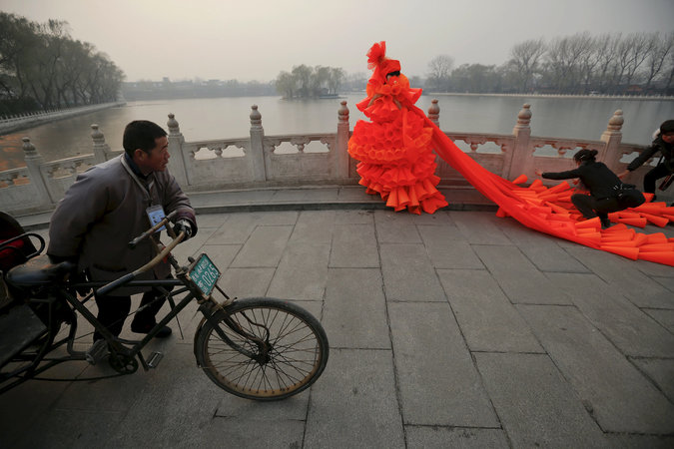
The artist Kong Ning wore a costume made of hundreds of plastic trumpets in Beijing on Monday to call attention to the hazardous smog. Credit Damir Sagolj/Reuters
BEIJING — Officials in the Chinese capital declared for the first time on Monday evening that the thick smog blanketing the city was bad enough to require a red alert, the highest level of alarm. It was the first time a code red had been sounded since Beijing announced an emergency air pollution response system with multicolored warnings in 2013.

Across the city, residents braced for the onset of another “airpocalypse” — the term that some English speakers here use for the most toxic bouts of air pollution.
If carried out properly, the temporary restrictions would affect many of Beijing’s more than 20 million residents. From 7 a.m. on Tuesday to noon on Thursday, schools will be required to close; cars will be allowed to drive only on alternate days, depending on their license plate numbers; and fireworks and outdoor barbecuing will be banned (grilled kebabs are a hugely popular street food in the city). In addition, government agencies will have to keep 30 percent of their automobiles off the streets.
By REUTERS 00:33 Smog Blankets Beijing

http://www.nytimes.com/2015/12/08/world/asia/beijing-pollution-red-alert.html?hp&action=click&pgtype=Homepage&clickSource=story-heading&module=second-column-region&region=top-news&WT.nav=top-news

Smog Blankets Beijing
Pollution has cloaked Beijing's skyline with a heavy veil of smog.
By REUTERS on Publish Date December 7, 2015. Watch in Times Video »
An official signal of the announcement came around 6:30 p.m. Monday, when Xinhua, the state news agency, posted on its English-language Twitter account: “Beijing issues first red alert for heavy smog. Odd-even car ban imposed; schools suspended.” The post included a photograph of the Bird’s Nest, the iconic stadium built for the 2008 Summer Olympics, shrouded in charcoal-gray smog and barely visible.
Around the same time, an official website of the Beijing government posted advisories on how to respond to the alarm.
One big question was whether officials would strictly enforce the regulations immediately, especially given the late notice on Monday. Many residents were left scrambling to plan for the next morning: what to do with children not going to school; how to get to their jobs if they could not drive; and whether they should even go to work.
The city government did not explain the timing of its announcement. Thick smog had already settled over Beijing by Sunday afternoon, with pollution reaching what the United States government labels “very unhealthy,” when everyone may experience the effects of toxic air and should avoid unnecessary outdoor activity. On Monday, even before the red alert, announcements in Beijing subway stations warned that a spell of toxic air was hitting the city and would last until Wednesday.
As much as anything, the red alert could be the Beijing government’s response to withering criticism it received from many residents last week who wondered why it had issued only an orange alert, the second highest, during the most recent “airpocalypse.” On Dec. 1, a blog post by Zhang Kai of Greenpeace East Asia asked: “What will it take for Beijing to call a Red Alert on pollution?”
Starting Nov. 28, an expanse of toxic air smothered northern China. Pollution in Beijing reached hazardous levels the next day and surged well beyond those levels on Nov. 30, when the air in some parts of the city contained deadly particulate matter called PM 2.5 that was nearly 40 times the limit recommended by the World Health Organization. It was the worst pollution of the year. The smog did not begin dissipating until late on Dec. 1, when strong winds blew across the city.
Under the system announced in 2013, Beijing is supposed to issue an alert at least 24 hours before the onset of bad smog. Officials can predict pollution levels based on wind and weather forecasts.
A red alert should go into effect if there is a prediction that the air quality index will stay above 200 for more than 72 hours. The United States government rates above 200 as “very unhealthy,” and 301 to 500 as “hazardous.” At 7 p.m. Monday, the Beijing municipal reading was 253.
The red alert was an upgrade from an orange alert issued on Saturday. By then, official Chinese news reports had already said a period of bad smog would start on Monday. Orange means outdoor construction should be halted, as well as the operations of companies that emit heavy pollution.
Chinese cities, especially northern ones, have some of the world’s worst air pollution. Most of it comes from industrial coal burning, and some from motor vehicles. The leaders in Beijing can ensure clear skies when they want by ordering shutdowns of factories, but they have done so only during international summit meetings here and signature events like the military parade on Sept. 3 for the victory over Japan in World War II.
At international climate change talks, including the ones now underway in Paris, Chinese officials have promised to curb coal use in order to address both air pollution and carbon dioxide emissions.
“This week in Paris, China is rightfully getting credit for its policies to tackle climate change,” said Alex Wang, a law professor at the University of California, Los Angeles, who studies Chinese environmental policy. “But the extraordinary air pollution in Beijing right now demonstrates just how much remains to be done to make these policies work in practice.”

NYT

Beijing, With Red Alert for Smog in Full Force, Closes Schools and Limits Traffic
By EDWARD WONGDEC. 8, 2015
Photo
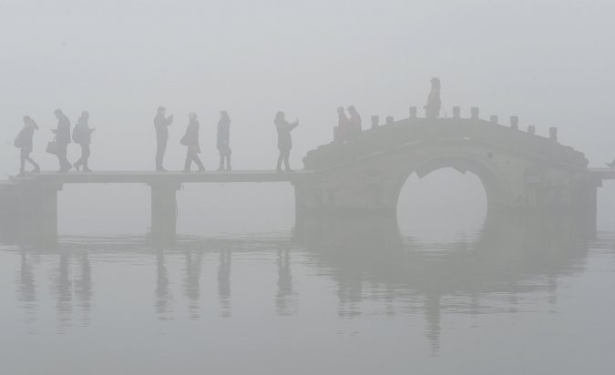
Heavy smog surrounding the West Lake in Hangzhou in Zhejiang Province in China on Tuesday. Because of industrial coal burning, Chinese cities regularly have among the world's worst air quality. Credit China Daily, via Reuters
BEIJING — Emergency measures adopted for Beijing’s first “red alert” over air pollution left millions of schoolchildren cooped up at home, forced motorists off the roads and shut down factories across the region on Tuesday, but they failed to dispel the toxic air that shrouded the Chinese capital in a soupy, metallic haze.

Beijing announced Monday night that from Tuesday morning to noon on Thursday, it was putting in place measures that included closing schools, limiting the number of cars on the road based on their license plate numbers, and banning fireworks and barbecues. Factories and construction sites closed.
Yet at 4 p.m. Tuesday, walking through Beijing was like strolling through a coal mine, and the municipal air quality index read 308, rated “hazardous” by United States standards — a situation in which people should not set foot outdoors. Because of industrial coal burning, Chinese cities regularly have air of that quality, among the world’s worst.

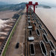

Chinese Report on Climate Change Depicts Somber ScenariosNOV. 29, 2015

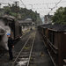

China Burns Much More Coal Than Reported, Complicating Climate TalksNOV. 3, 2015

Study Links Polluted Air in China to 1.6 Million Deaths a YearAUG. 13, 2015

“I have to watch my son because there is no kindergarten today,” said Kan Tingting, 35, a manager of a cafe who had to stay home with her 3-year-old. “What bothers me the most is that my son may have a very negative view of nature. He loves nature much less than he would in a normal environment. I don’t want him to grow up thinking nature is ugly.”
News Clips: Asia Pacific By THE ASSOCIATED PRESS 00:44 Beijing Residents React to Smog Alert
Continue reading the main story Video

Beijing Residents React to Smog Alert
Residents of the Chinese capital on Tuesday expressed mixed emotions about the air pollution that is blanketing this metropolis.
By THE ASSOCIATED PRESS on Publish Date December 8, 2015. Photo by Damir Sagolj/Reuters. Watch in Times Video »
Ms. Kan said that two of her Korean co-workers had fallen ill on Tuesday — one with a skin allergy and the other with a burning throat — but that Chinese colleagues who had made it to the cafe near Chaoyang Park seemed fine.
“If you ask me, I think it should be a red alert every day,” she said. “I have a car, too, but I think the license plate odd-even number restriction should be every day. All the factories should move away.”
Leaving Beijing is tempting, but not possible, she added. “If not for my work, I’d move away in a heartbeat,” she said. “ I used to live in Australia, so I could move there. Or anywhere in southern China is better than the north.”
The current spell of bad air in Beijing began on Sunday, and by Monday morning, the quality had already deteriorated to what the United States labels a “very unhealthy” level, when everyone can be affected. Still, it was well below the toxic bout that hit the city in the final weekend of November. That was the worst stretch of pollution this year, and municipal officials were roundly criticized for declaring only an orange alert at that time rather than going to code red. The sudden announcement Monday night may have been their attempt to make up for the oversight.
“The issuing of a ‘red’ pollution alert means, first and foremost, that the Beijing authorities are taking air quality, and related health issues, very seriously,” Dr. Bernhard Schwartländer, the representative of the World Health Organization in China, said in a written statement. The group helped lead a 2010 study whose data showed outdoor air pollution contributed to 1.2 million premature deaths in China in 2010, nearly 40 percent of the global total.
Greenpeace East Asia also praised Beijing for raising the alarm, after having criticized it a week earlier for its lack of action. “The red alert is a welcome sign of a different attitude from the Beijing government,” said Dong Liansai, a climate and energy campaigner. “However, this, the latest of a series of airpocalypses to hit Beijing, is also a firm reminder of just how much more needs to be done to ensure safe air for all.”
The announcement on Monday took the city’s 20 million residents by surprise. Parents checked with groups on smartphone messaging apps to see if schools were indeed shutting down. Some workers said they would have no option but to drive to the office, despite half of all cars being ordered not to drive each day.
“There is no other way for me to go to work besides driving,” said Zhao Lin, 36, a technology salesman. “I have to drive for more than an hour each way to commute to work every day.”
“I’m not supposed to drive tomorrow because my car has an even number license plate, but I have to,” he added. “They can fine me or dock me points. I have no choice. I think they can’t see my license plate in this smog anyway.”
Continue reading the main story

Today’s Headlines: Asia Edition
Get news and analysis from Asia and around the world delivered to your inbox every day in the Asian morning.
Mr. Zhao said he had left his 5-year-old son at home with his 65-year-old mother, who was in poor health. Neither would be going outside, he said.
“Instead of shutting down the schools, why don’t they just put air purifiers in the classrooms?” he said. “We pay the kindergartens to watch the children, and then we have to watch them when the air is bad? Do we get a refund for the three days without kindergarten?”
Since 2013, when an intense round of pollution slammed northern China, Beijing has had a color-coded emergency response plan. That plan was strengthened with new measures in March. Despite all that, Beijing had never sounded a red alert, and residents had wondered why. Did city officials or the top Communist Party leaders worry they would lose face? Did they fear the economic losses that might result?
“They probably didn’t declare a red alert last week because they didn’t want to slow down the economy,” said Wang Bei, a university lecturer who was at home with a 10-year-old son. “Shutting down factories is not ideal for the economy, but health should come first.”
“Air pollution is a huge problem that we ignored early on, while we concentrated on economic development,” she added. “Now we are paying the price for that. It only takes a second for someone to fall gravely ill, but it takes a long time to recover. Now China is that ill person trying to recover from air pollution.”
Ms. Wang said that she regularly checked a phone app to monitor the air quality and that she and her son wore masks outdoors and turned on purifiers at home. But she said she was worried about the invisible effects on her son’s health. “I wonder if this bad air is going to give him irreversible damage, 10 or 20 years down the road,” she said.
On one street, a young salesman, Liu Jia, sat on a bench, puffing on a cigarette. Half the pedestrians around him were wearing masks.
“They say the air quality has improved, but to me it feels about the same,” he said. “I know that smoking is bad, worse than the smog, but my work is too stressful.”
“I can choose to smoke a cigarette,” he said, then looked up. “But there’s no choice in this.”
Above him, the sky was the color of ash.

NYT

Companies in South China See Silver Lining in Beijing’s Smog
Sinosphere
By JANE PERLEZ and YUFAN HUANG DEC. 22, 2015
Photo
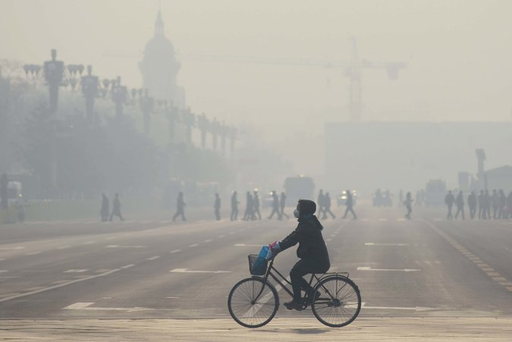
Beijing on Monday, the third day of a four-day red alert for hazardous air pollution. Credit Wang Zhao/Agence France-Presse — Getty Images
BEIJING — The online ads sound alluring: Come to the sunny south of China and forget the smog of Beijing, they say. Enjoy the laid-back lifestyle; abandon unhealthy Beijing!

As Beijing residents endured heavy smog on Tuesday, the last day of a four-day red alert for hazardous air pollution, companies in southern China have been advertising the attractions of their sun-filled, tree-lined cities, all in a bid to lure smart, educated and ambitious employees from the north.
Amy Li, a human resources adviser at Umeox, a technology company in Shenzhen that makes smartwatches, said the clean air at the technology park where her firm is was a big bonus in her recruiting drive.
“You’ll never need to wear a mask here,” Ms. Li said. “Our company is surrounded by green plants, and everything is clean and neat.”
Continue reading the main story

Related Coverage

In Beijing, a Day Off School for Smog Is No Fun for Anyone

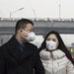

Sinosphere: Amid China’s Smog Worries, One More: Counterfeit Masks

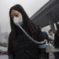

News Analysis: Polluted Skies Heighten Challenge for Chinese Government

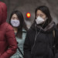
video

Chinese Families Try to Get Clean Air

Study Links Polluted Air in China to 1.6 Million Deaths a Year

No one is suggesting that the air in Beijing is the catalyst for a major brain drain from capital to southern cities — at least not yet. Nor does there seem to be a migration of older Beijing residents who want to swap the smog for sunshine in the way that American retirees flock to Florida.
But as patience frays over the inconvenience of red alerts, and worries mount over the risks to long-term well-being, leaving can seem like an enticing solution. On Tuesday afternoon, the air quality index in Beijing was 506, according to the United States Embassy, 20 times the safe limit set by the World Health Organization.
On Tuesday, the restrictive measures of Beijing’s second red alert this month were in effect: Schools were closed, and cars were only allowed to drive on alternate days, depending on their license plate numbers. Hundreds of factories were ordered to suspend production.
A real estate company in Shenzhen, JJS Home, needs new sales people and is pitching the clean sea air as a big attraction for prospective employees from the polluted north.
“It’s obvious that young people pay more attention to their health than their parents’ generation,” said Chen Jie, a human resources manager at JJS Home. “It’s sunny all the time here in the middle of winter. We wore T-shirts last weekend, while Beijing felt so gloomy.”
So far, an online ad on a recruiting website has brought modest results, Mr. Chen said. Of the roughly 20 new hires who have joined the company each week over the last few months, only a handful have come from Beijing. Partly, he said, that was because people from nearby provinces could more easily move to Shenzhen.
But ads trumpeting jobs in the sunny south freely tap into feelings of winter blues and claustrophobia in Beijing.
“I feel so depressed when I open the window everyday and can’t even see the building across the street because of all the smog,” said Ya Hanxiang, 24, a magazine editor. “Why do I have to live here? I feel like I’m living in a basement.”
The contrast between Mr. Ya’s view of Beijing and the description of the coastal province of Shandong in an ad for a small technology company, Mengba 100, on the social media website Douban could not be more stark.
“Had enough of the sand storms? Are you becoming like dried meat as you suffer in the smog? Now you have a choice: Come to Jinan, the capital of Shandong, with mountains and lakes,” reads a promotion aimed at computer engineers.
Liu Hao, 27, the product manager at Mengba 100, who left Beijing two years ago, said he wrote the ad to appeal to people like himself.
“When I was in Beijing, I was sick for months from bronchitis caused by the bad air,” Mr. Liu said. “Now, someday when I have a kid, I’ll be able to take him to the river or woods just a few minutes’ drive away.”

Graphic

Second Red Alert for Beijing: Air Pollution Worsens
Beijing issued its second-ever red alert for dangerously bad air quality on Friday morning, just a week after its first one. The current alert is for hazardous levels starting on Saturday and end at midnight on Tuesday.
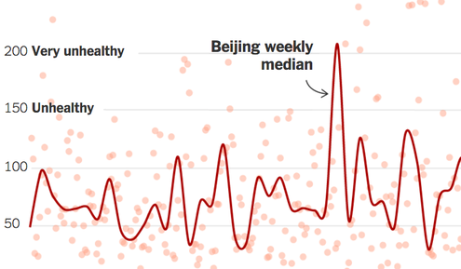
OPEN Graphic

