**Chinese Military Spending Data**

Chinese military budget is about 2X published figures

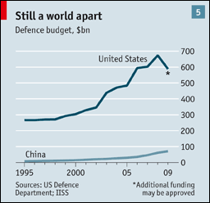

**U.S. and China**

**Comparative Military Spending**

**1990-2012**

**(constant 2011 billions $US)**

**1990 1995 2000 2005 2008 2010 2012**

U.S. 527.1 411.7 394.2 580.0 649.0 720.4 668.8

China 19.8 23.1 37.0 71.5 106.8 136.5 157.6

China as % of U.S. 3.75 5.61 9.38 12.33 16.45 18.94 23.56

Source: <http://www.sipri.org/research/armaments/milex/milex_database>

## 2012 Defense ExpenditureII (budget authority in billions of current U.S. dollars)

|  |  |
| --- | --- |
| **Country or Region** | **2012 Spending** |
| United States (including war and nuclear) | 645.7 |
| Asia | 314.9 |
| Europe | 280.1 |
| Middle East and North Africa | 166.4 |
| Russia and Eurasia | 69.3 |
| Latin America and The Caribbean | 68.8 |
| Sub-Saharan Africa | 19.2 |
| Canada | 18.4 |
| **Global Total** | **1,582.8** |

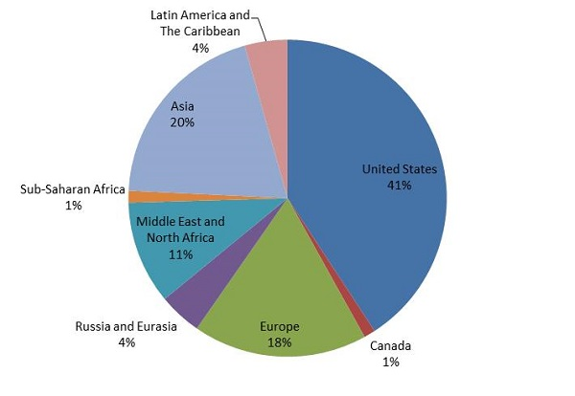

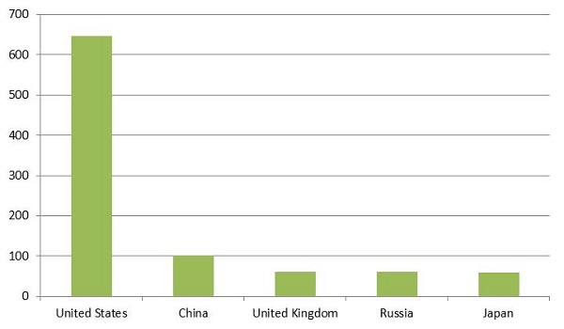

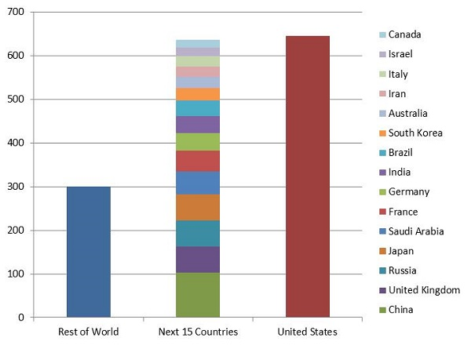

## Countries of Interest (budget authority in billions of current U.S. dollars)

|  |  |  |
| --- | --- | --- |
| **Country** | **2012 Spending** | **Percent of GDP** |
| United States (including war and nuclear) | 645.7 | 4.12 |
| Canada | 18.4 | 1.04 |
| China | 102.4 | 1.24 |
| Russia | 59.9 | 3.06 |
| United Kingdom | 64.1 | 2.63 |
| France | 48.1 | 1.86 |
| Germany | 40.4 | 1.20 |
| Japan | 59.4 | 0.99 |
| India | 38.5 | 1.98 |
| Italy | 23.6 | 1.19 |
| Brazil | 35.3 | 1.45 |
| Australia | 25.1 | 1.63 |
| Saudi Arabia | 52.5 | 7.99 |
| South Korea | 29.0 | 2.52 |
| Israel | 19.4 | 7.85 |
| Taiwan | 10.3 | 2.21 |
| Iran | 23.9 | 4.95 |
| North Korea | ** | ** |
| Pakistan | 5.9 | 2.55 |
| Venezuela | 6.1 | 1.80 |
| Iraq | 14.7 | 11.28 |
| Afghanistan | 2.1 | 10.54 |
| Oman | 6.7 | 8.42 |
| Jordan | 1.8 | 5.6 |

IU.S. figure includes funding for the Pentagon base budget, Department of Energy-administered nuclear weapons activities, and the war in Afghanistan. Data from Congressional Research Service, Office of Management and Budget, and International Institute for Strategic Studies.

IIUnfortunately, there is no such thing as an agreed-upon international definition for “defense expenditure.” Many countries count spending differently and, in some cases, transparency is an issue.  
The analysis above uses data from The Military Balance 2013, the authoritative reference almanac produced annually by the International Institute for Strategic Studies. Defense spending estimates for China and Russia, both of which regularly underreport their annual military budgets, have been reported using a methodology known as Purchasing Power Parity (PPP). The Military Balance typically uses market exchange rates to convert countries’ defense spending figures into U.S. dollars. In the case of China and Russia, however, the market exchange rates fail to fully reflect the purchasing power of the yuan and the ruble, respectively. To compensate for this, The Military Balance 2013 uses PPP. This allows for a more balanced calculation of the numbers. All of the figures for China and Russia in the analysis above use PPP figures, which are significantly higher than both officially reported and market exchange rate figures.  
**The bottom line is that this analysis uses the highest possible defense spending estimates for China and Russia.**

Source: <http://armscontrolcenter.org/issues/securityspending/articles/2012_topline_global_defense_spending/>

