POL 319
US-China
China energy

Lester and Steinfeld

Real problem for China is a governance crisis – an inability to manage the nation effectively.

Explosion of number and diversity of actors pressing or decisions on energy.
Capability of government agencies to decide is inadequate.

Most energy decisions are made on an ad hoc basis by actors with a narrow view of choices and no understanding of the big picture.

Energy usage and production are growing at a staggering rate:

Add the UK power system each year

Most new energy as with existing is provided by coal-fire power plants

¼ of all power plants are “illegal” = focus on growth, local control over capital sources, and tolerance of entrepreneurs in government = illegal power plants

Illegal power plants = lack of coherent national energy policy

Manufacturing firms build their own diesel power plants

Payment of pollution fees to SEPA to keep polluting = growth over environment

Coal, oil, natural gas, nuclear – what don’t they even mention in 2005?

Leading and lagging environmental regions

The Chinese political system doesn’t work much better than in the US on energy issues

Basic realities of China Energy
Summary
- The trajectory of China’s energy use is negative
- Energy use will get much worse before it gets better
- Threatens global growth and Chinese competitiveness
- Potential for global conflict is high
- China’s energy use is unsustainable

2001 year of change in China’s energy situation:

- As recently as 2001, China was able to meet most of its energy needs from its own resources.
- Prior to 2001, China’s rapid GDP growth was accompanied by much lower growth rates in energy consumption.
- Reform, TVEs, competition, new technology, profit motive all help reverse the very bad energy intensity of Chinese production during the Maoist era.
- Until the mid 1990s China was able to meet its energy needs and export energy.

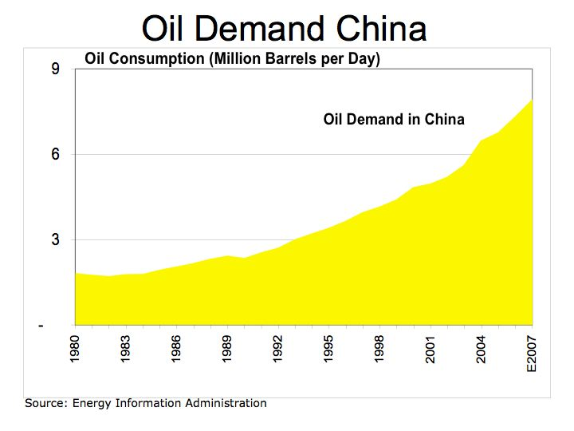

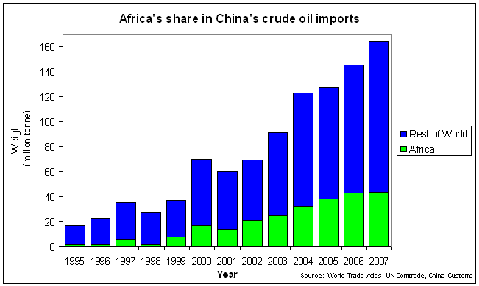

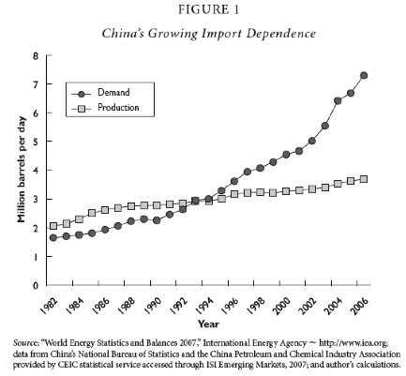

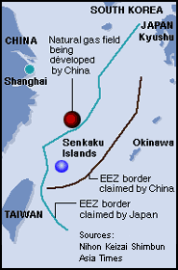

Global Economic Impact of China’s Energy Use

- China is having and will continue to have enormous effects on the rest of the world as a result of its energy situation.
- Magnitude and volatility of demand in global markets
- Volatility comes from cat and mouse game between Chinese firms and government
over retail prices

- Absolute and marginal effects: 1/3 of growth in global energy
demand from 1999-2006 comes from China
- Shift from exporter to net importer of coal

International Political Economy of Energy and Resource Supplies to China

Oil
- 45% from Middle East, 11% from Iran alone
- 28% from Africa (Sudan)
- Expanding relationships with Australia, Brazil, Venezuela, and Canada
- Oil supplies come through the Malacca Straits, kept open by US navy
- CNOOC attempts to buy Unocal in 2005 with loans from state-owned banks
- Chinese tied aid as basis for gaining oil concessions (Anglola)
Global Oil Reserves
Country Reserves (Billions barrels)

Saudi Arabia 264

Iran 137

Iraq 115

Kuwait 101

United Arab Emirates 98

Venezuela 80

Russia 74

Kazakhstan 40

Libya 39

Nigeria 36

Mexico 14

China 16

Canada 16

United States 30

Proved reserves are estimated quantities that analysis of geologic and engineering data demonstrates with reasonable certainty are recoverable under existing economic and operating conditions.
Estimates dated January 1, 2007

Almost three-quarters of the world's 1.2 trillion barrels of proven oil reserves—those that can be recovered from known oil fields using existing technology—are located in just seven countries, according to BP. Saudi Arabia's share at the end of last year was more than a fifth of the total. Iran, Iraq, Kuwait and the United Arab Emirates together accounted for over a third. Venezuela and Russia also have big reserves. If last year's production rates were sustained, global oil reserves would run out in just over 40 years' time. America and China would have little over a decade of oil production left before their reserves were exhausted. By contrast, Kuwait's oil fields would last for more than a century.

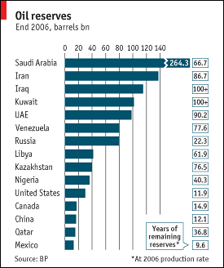

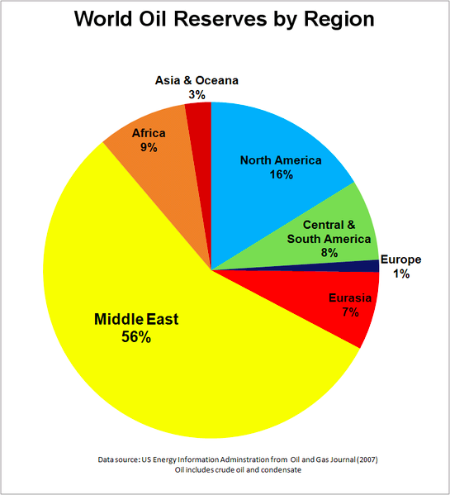
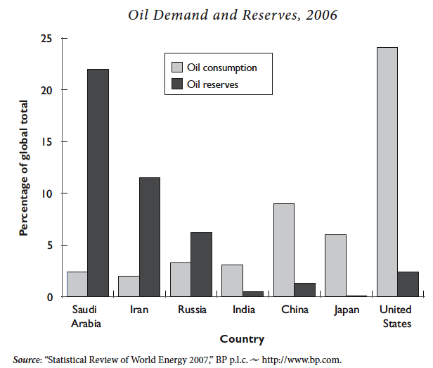

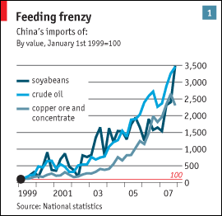
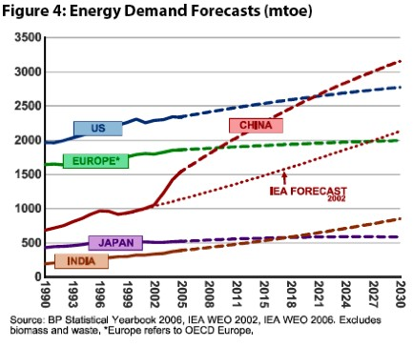

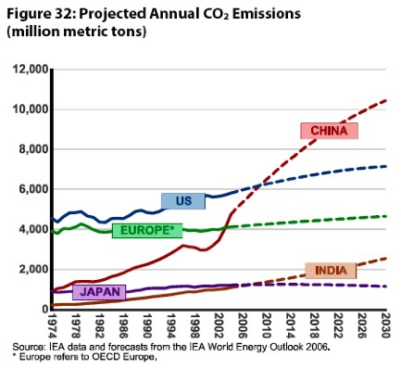
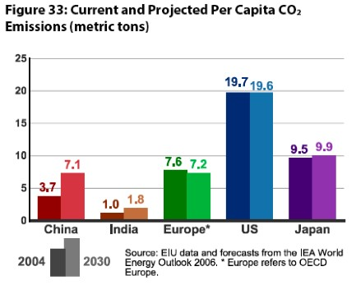

What are the implications of China’s resource situation?

- Huge potential for conflict with other nations. We are entering an era of rising physical needs and increasing scarcity. Scarcity = insecurity.
- Relative gains considerations feed into and flow from insecurity.
- Breakdown of liberal system of resource markets: US operation in Iraq as first step to resource spheres of influence.
- There are enormous and mostly negative political, strategic, military and economic implications of China’s global reach in the search for resources.
- Dislocation of global markets – huge increase in relative prices for resources
- Struggle among nations to avoid relative decline in dynamically changing environment.
- The Economist predicts a much more positive outcome. Why?
- Potential Solutions:
  - End subsidies in China and create incentives for energy efficiency
  - Shift to subsidies for alternative energy production in US and China
  - Mandatory environmental and efficiency standards for autos
  - Cooperation in oil production and distribution – avoid energy spheres

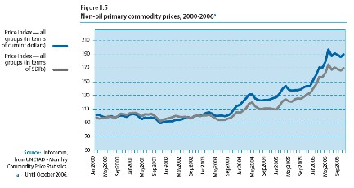
Source: Rosen and Houser, China Energy, May 2007, 6.

Global environmental effects

- China is the world’s largest emitter of SO2: acid rain, reduced visibility, and respiratory problems.
- Results in considerable tension with Korea and Japan. Hong Kong air quality threatens its competitiveness.
- Effects are felt at lower levels on US west coast.
- China surpassed the US in 2007 as the world's largest emitter of CO2.
- Even in 2030 China will be lower in per capita production of CO2.

Global Environmental Negotiations

- The US has an even larger global energy footprint.
- Negotiations between the US and China on energy issues will very likely be caught up in the political, economic and strategic rivalry between them.
- As a consequence, these negotiations will revolve around estimates of relative gains and not the absolute gains they and the world will reap from effective management of these global problems.
- Leaders will increasingly come to focus on how much each gains relative to the other and less on the mutual gains each can get from stable oil prices, secure sea lanes and a stable international environment.
- Though cooperation to achieve these gains is possible and clearly the desirable outcome, the competitive environment over resources and the scarcity of those resources will hasten a focus on relative gains.

Future Projections:
- Projections of future global energy needs see China equaling the US in energy demand by about 2020.
- This has very serious implications for the entire global economy, the global environment and for international politics and global security.
- China is already the largest contributor to global warming and this position will get much worse.
- Chinese competitiveness as a producer of manufactured goods is threatened
  - Long energy intensive supply chains and logistic systems
  - Cost of moving a 40 foot container from Shanghai to New York in 2000 was $3000; today it is $8000; at $200 barrel for oil price is $15000

Next several charts from
China’s energy economy: A survey of the literature
Hengyun Ma, Les Oxley, John Gibson
Economic Systems 34 (2010) 105–132
Chienergyover.pdf

US-China Energy Use % Global Share
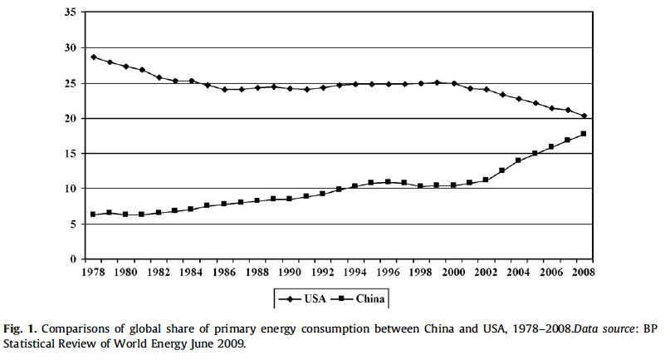

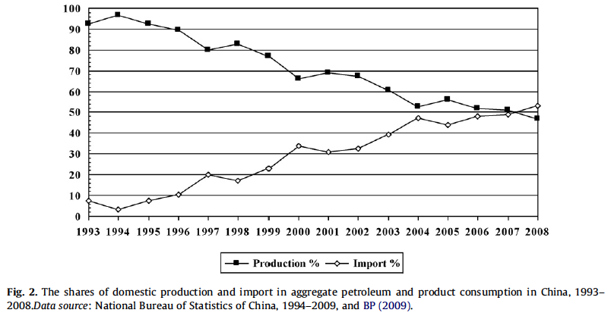

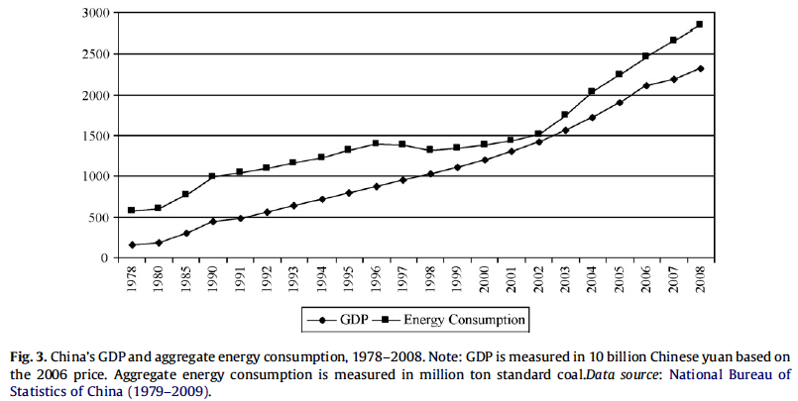

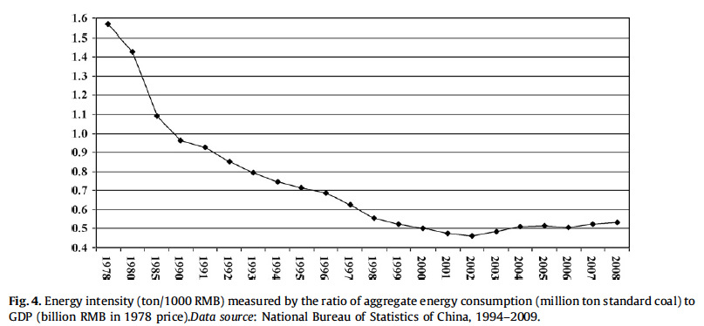

Houser, The Roots of Chinese Oil Investment Abroad

Enterprise reform, price liberalization, and the introduction of management incentives and competition have greatly fostered the modernization and marketization of China’s petroleum industry. These factors have also blurred the relationship between the oil companies and the government that owns and regulates them.
• Though Beijing actively encouraged overseas investment in the past, the companies are taking the lead today, shaping policy to suit economic interests.
• The international competitiveness of Chinese firms stems less from overt government support than from a higher risk threshold and a willingness to accept lower returns on investment.
• Because little of the oil Chinese companies produce abroad comes home and human and political costs of supporting the firms’ activities overseas are growing, leaders in Beijing are actively debating the merits of China’s “going out” strategy.

The U.S. would benefit more by focusing on the incentives facing individual firms than by focusing on policy pronouncements from Beijing.
• “Equity agreements” signed by Chinese oil companies look largely the same as those signed by international oil companies. These agreements, however, do not impact U.S. energy security regardless of whether the oil is shipped to China or sold on the open market.
• Rather than seeking to prevent Chinese firms from competing in the international oil market, the U.S. may find it more beneficial to encourage the companies’ continued reform so that they more closely resemble the international oil majors.
• The U.S. will find some policymakers in China interested in seeing such reform take place. Yet for China to comfortably depend on the open market, the U.S. will have to demonstrate that it is a reliable partner in ensuring the security of the market for all participants.

less is known about the structure and evolution of the oil and gas industry within China, the incentives and constraints facing NOC management, and the relationship between the companies, the government, and the policymaking process. Awareness of the domestic market and policy context in which China’s NOCs operate is essential for understanding what drives these companies to invest overseas, the targets of such investments, and how the investments are carried out.

This article makes four main points. First, enterprise reform, price liberalization, and the introduction of management incentives and competition have greatly encouraged the modernization and marketization of China’s petroleum industry; yet at the same time these factors have also blurred the relationship between the oil companies and the government that owns and regulates them.
Second, though Beijing actively encouraged overseas investment in the past, the companies are taking the lead today and are shaping policy to suit economic interests.
Third, Chinese firms’ competitiveness overseas stems less from overt government support than from a higher risk threshold and willingness to accept lower returns on investment.
Fourth, given that little of the oil Chinese NOCs produce abroad comes home, and that the cost of supporting the firms’ activities overseas in terms of human lives and political influence is growing, leaders in Beijing have begun actively debating the merits of a “going out” strategy.

CNPC is the fifth largest oil company in the world—larger than Exxon, BP, Chevron, or Shell (see Table 1). Although Sinopec is larger than CNPC in annual revenue, owing to a large refining and marketing business, Sinopec’s upstream exploration and production portfolio is considerably smaller than CNPC’s. CNOOC is a distant third to Sinopec and CNPC in terms of revenue and employees but pumps almost as much crude oil as Sinopec through the company’s offshore operations

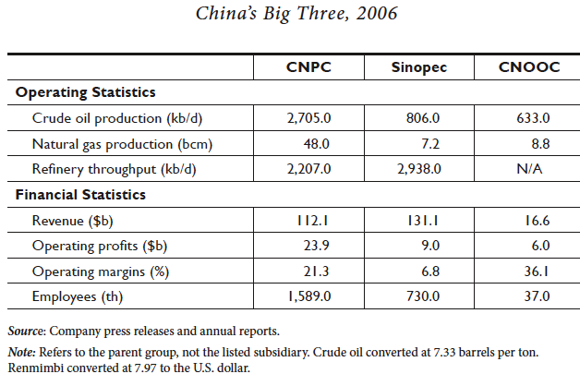

Chinese oil firms are exposed to the pressures of global prices and have become major pressure points for raising domestic prices.

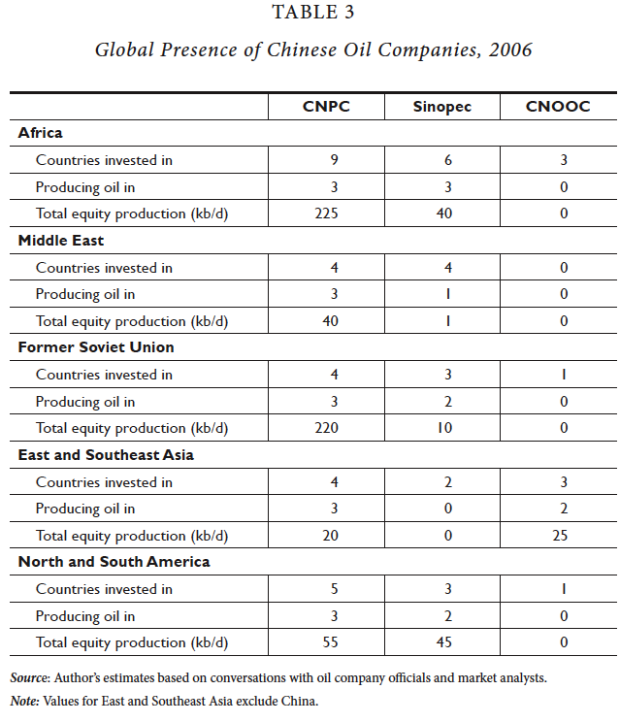

The lack of offshore drilling capabilities also means that Chinese firms are forced to operate in areas of greater political risk than their IOC peers. Without the technical prowess to bid on big blocks in deep water, the Chinese NOCs must settle for smaller-scale onshore operations, which are vulnerable to such hazards as kidnappings and attacks. To gain access to large concessions within their technical range, the NOCs have sought out countries where the IOCs are either legally barred or refuse to operate (e.g., Sudan, Iran, and Syria).

Much of the discourse in Washington surrounding Chinese overseas oil investment has focused on the perceived preference of Chinese NOCs to sign equity agreements with host countries. These contracts, which entitle the Chinese firm to a defined share of the field’s output as compensation for the company’s investment, are the same contracts signed by IOCs operating in those regions. The concern is that while IOCs such as Shell or Chevron will likely sell their production on the open market, a Chinese NOC will only sell its oil to refineries back home, thus removing oil from the total global supply available to everyone. Yet the observed behavior of Chinese firms, which have sophisticated trading operations with offices in London, New York, and Singapore, appears little different than the IOCs. Furthermore, even if every drop of oil a Chinese company produced overseas was shipped back to China, there would be no impact on the amount of oil available on the open market. Every barrel China buys from Sudan is one barrel the country does not need to buy from Saudi Arabia, meaning one more Saudi barrel is available to the United States, Europe, or Japan.

China's Global Hunt for Energy
David Zweig and Bi Jianhai.

Although China's new energy demands need not be a source of serious conflict with the West in the long term, at the moment, Beijing and Washington feel especially uneasy about the situation. While China struggles to manage its growing pains, the United States, as the world's hegemon, must somehow make room for the rising giant; otherwise, war will become a serious possibility. According to the power transition theory, to maintain its dominance, a hegemon will be tempted to declare war on its challengers while it still has a power advantage. Thus, easing the way for the United States and China -- and other states -- to find a new equilibrium will require careful management, especially of their mutual perceptions.

Interstate competition is natural, of course, but it need not be elevated to the level of conflict. And concerns over China's impressive rise, while understandable, should not detract from the vast room for cooperation that the country's new energy needs allow. After all, the United States and China share an interest in viable oil prices, secure sea-lanes, and a stable international environment, all of which can help sustain their economic prosperity and that of the rest of the world. Washington and Beijing share a common interest in securing open sea-lanes to ensure the unhindered passage of cargo ships. That both governments want stability in the Malacca and Taiwan straits does not pit them against each other -- just the opposite. Moreover, developing an oceangoing navy to defend far-off sea-lanes is an arduous and expensive project, which will take Beijing decades to complete. In the meantime, China must cooperate with the United States to maintain its sea-passage security, in particular the security of its energy shipping lanes. This should not be a problem, so long as China and the United States avoid war over Taiwan.

Should we care that China is engaged in a full court diplomatic press around the world to secure access to resources, especially oil? Should we care that the money to support his effort has come from the US via trade deficits?

Sino–American Energy Cooperation
JUNE TEUFEL DREYER
In an exceptionally blunt speech in September 2005, US Deputy Secretary of State Robert Zoellick accused the PRC of exhibiting increasing signs of mercantilism in seeking to lock up energy supplies and advised its government to take concrete steps to address what he called a cauldron of anxiety in the US and other parts of the world about Chinese intentions. The path to energy security, said Zoellick, was not through arousing anxieties.

With competitive impulses outweighing cooperative impulses, China has sought to
ensure its energy requirements in many different ways: introducing energy efficiencies; using alternate sources of power; constructing pipelines, since existing maritime routes for oil and gas could be blocked in time of war; building the People’s Liberation Army’s naval arm (PLAN) into a true bluewater force that can protect tankers bound for China; and adding to the number of countries that supply the PRC with energy.

What are the sources of conflict in international politics?

Evil nations
Security dilemma
Deep concerns over relative gains

Why does cooperation happen?

Costs of conflict are very high
Mutual gains
Political structures support focus on mutual gain

Forums for US-China cooperation on energy

cooperation already exists and has for some time. Major conduits through
which this occurs include:
. the US–China Energy Policy Dialogue;
partnership between the Department of Energy (DOE) and China’s National Development Reform Commission (NDRC

. the US–China Oil and Gas Industry Forum;
Founded in 1998 to facilitate Chinese familiarity with western business practices as
well as open the PRC market to American and western investment, the Oil and Gas
Forum has held six formal meetings in the intervening years. Co-hosted on the US
side by the Departments of Energy and Commerce with China’s NDRC

. the US–China Economic Development and Reform Dialogue;
Initiated in 2003 by the US Department of State with the NDRC, its discussions have
included market approaches to energy security as well as broader topics such as
agriculture, investment, and telecommunications

. the US–China Defense Consultative Talks.
Begun in December 1997, the seventh meeting of this dialogue in April 2005 featured an in-depth discussion between then-Undersecretary of Defense Douglas Feith and
Deputy Chief of the PLA General Staff Xiong Guangkai on global energy security
issues

