January 20th 2015

EIU

# One belt, one road

**The government is pushing forward a combination of long-term initiatives designed to increase China's global economic and leadership roles. Dubbed by some foreign observers a "Chinese Marshall Plan", the emerging strategy mimics the post-second world war US model of gaining influence through trade and development assistance. Yet China's version is likely to create only a loose affiliation, with neighbouring countries looking to hedge their bets by simultaneously deepening ties with other powers.**

China's version of the Marshall Plan has evolved through a series of vague rhetorical analogies that have gradually come together under a unified policy title. In September and October of 2013, China's president, Xi Jinping, began floating the ideas of a "Silk Road Economic Belt" and a "[21st Century Maritime Silk Road](http://country.eiu.com/article.aspx?articleid=522497036&Country=Malaysia&topic=Politics&subtopic=Forecast" \t "_blank)". These were eventually succeeded by a combination of the two concepts: "One Belt, One Road".

The basic idea behind the phrase is to promote infrastructure development in Asia (and possibly beyond), thereby enabling deeper economic cooperation. Through this strategy China can simultaneously increase its influence while also indirectly supporting its domestic economy by boosting trade and creating business opportunities overseas for Chinese companies. Some also view this as a means of using up surplus domestic industrial capacity, and draw parallels to the way the Marshall Plan kept US firms busy after World War II.

During the Asia-Pacific Economic Co-operation (APEC) summit in November, Mr Xi began to sketch out more concrete numbers for the strategy, unveiling a US$40bn infrastructure fund that will help to connect Chinese provinces to foreign markets. Alongside and complementary to the "One Belt, One Road" policy, China's government has also laid the groundwork for the Asian Infrastructure Investment Bank (AIIB). This would be used to promote the construction of transport and communication infrastructure in poorer Asian countries. The AIIB has run into resistance from the US and Japan, as it would seemingly compete with their influence through the World Bank and Asian Development Bank (ADB).

An eclectic route

The specifics of the One Belt One Road policy remain vague. A map published by China's state-owned Xinhua news agency shows 14 "stops" on the land-based silk road through Central Asia, and 14 on its maritime counterpart. However, ten of the total are in Chinese cities, showing that the policy can also be leveraged by domestic parties to promote favoured investment projects. On the land-based route, the non-Chinese cities listed include Almaty (in Kazakhstan), Bishkek (the Kyrgyz Republic), Samarkand (Uzbekistan), Dushanbe (Tajikistan), Tehran (Iran), Istanbul (Turkey), Moscow (Russia), Duisburg (Germany), Rotterdam (Netherlands) and Venice (Italy). The maritime road also incorporates Athens (Greece), Nairobi (Kenya), Colombo (Sri Lanka), Chittagong (Bangladesh), Kuala Lumpur (Malaysia), Jakarta (Indonesia) and Hanoi (Vietnam).

This list of cities is revealing. It is notable, for example, that the land route does not seem to tally with the plan to develop infrastructure to speed the shipment of products from inland Chinese cities like Chongqing to mainland Europe via Russia. Elsewhere, Chinese government sources have bracketed this initiative under the "silk road" rubric. Similarly, the maritime route does not encompass places like [Gwadar in Pakistan](http://country.eiu.com/article.aspx?articleid=662481250" \t "_blank) or [Kyaukpyu](http://country.eiu.com/article.aspx?articleid=1380492722" \t "_blank) in Myanmar where Chinese investments have sparked fears that the country may be trying to build a "string of pearls", ports to project its naval power into the Indian Ocean.

These absences suggest that the One Belt, One Road policy is still vaguely defined. It seems like an effort to try and put a strategic spin on what are, at heart, still a hodgepodge of bilateral and regional initiatives. This is not to diminish the scale of the plans involved. Even before the US$40bn infrastructure fund was unveiled, deals [signed in Central Asia](http://country.eiu.com/article.aspx?articleid=650971449&Country=Kyrgyz%20Republic&topic=Politics&subtopic=Regional+policy&subsubtopic=Regional+development+policy" \t "_blank) and elsewhere had involved China putting vast sums of money behind investments. It is also possible that a more coherent approach over the One Belt, One Road policy may emerge over time: it clearly remains a work in progress.

A generous but mistrusted neighbour

While the Marshall Plan engendered goodwill for the US that served to strengthen its strategic influence, it is unclear that China will enjoy the same sort of diplomatic dividend from its efforts. Many Asian countries are happy to accept money from China, but mistrust of the country's strategic objectives is likely to undercut the deeper co-operation that some policymakers envisage. China has fuelled its neighbours' suspicions by taking aggressive stances on territorial disputes in recent years, repeatedly dangling the possibility of military solutions to overlapping land claims with Japan, the Philippines, Vietnam and India. Central Asian states are fearful of replacing economic dominance from Russia with a Chinese version—China's huge population also causes some nervousness over the potential for Chinese immigration in the region.

Even as they enjoy the benefits of the One Belt, One Road policy, many governments will seek to offset their deepening economic dependence on China by strengthening ties with other powers, in particular the US. In terms of soft power, the US remains far more influential than China in Asia. In some countries this is based on shared values, but geographic distance and the sense that the US is a known actor also play a part. Although Asian governments may perceive the US as occasionally meddlesome, its strategic objectives are usually seen as relatively defined and limited. China's rise, by comparison, is more of an unknown.

Thinking for the long term

In the medium term, the Chinese government's ability to sustain the financial largesse that has underpinned its One Belt, One Road diplomacy may be increasingly constrained. Following their experiences in countries like [Venezuela](http://country.eiu.com/article.aspx?articleid=1262644510&Country=Venezuela&topic=Politics&subtopic=Forecast&subsubtopic=International+relations&u=1&pid=1392663923&oid=1392663923&uid=1" \t "_blank), Chinese banks are already becoming more cautious about their exposure in overseas markets.

Meanwhile, China's experiences in Myanmar and [Sri Lanka](http://country.eiu.com/article.aspx?articleid=942646478&Country=Sri%20Lanka&topic=Politics&subtopic=Forecast&subsubtopic=Election+watch&u=1&pid=302554014&oid=302554014&uid=1" \t "_blank) have shown that even where economic links have strengthened bilateral relations, political developments can swiftly undermine links that took years to build up. As domestic fiscal pressures increase in the coming years, the government will only become even more cautious about how it uses its money abroad.

Nonetheless, if the One Belt, One Road policy succeeds even partly in boosting levels of infrastructure development across Central Asia and along the maritime silk road it will have had an important impact. In the longer term, better links will help to support economic growth and trade in these regions, and thus to reduce political tensions. For China, that would be a great strategic result.

NYT

[Story Behind the Story](http://www.nytimes.com/times-insider/category/story-behind-the-story/?module=BlogCategory&version=Blog%20Post&action=Click&pgtype=Blogs&region=Header)

**As China’s Economic Power Increases, Questions Arise**

*By*

*[Keith Bradsher](http://www.nytimes.com/times-insider/author/keith-bradsher/" \o "More Posts by Keith Bradsher)*

July 24, 2015 2:10 pm July 24, 2015 2:10 pm

Photo

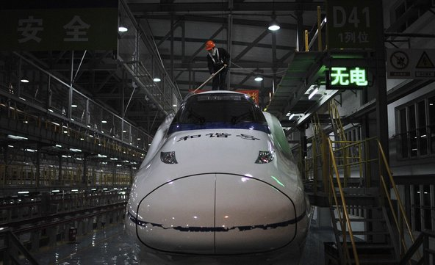

A worker cleans a bullet train at a high speed railway maintenance station during the travel rush period that happens around Chinese Lunar New Year.Credit Jianan Yu/Reuters

HONG KONG — I was waiting for a train in a remote town in southwest China last year when a young man marched up to me and barked out a question: Did I understand and accept that China is a great power?

It was a telling moment.

Had I been waiting at the same train station 10 years, five years, maybe two years earlier, I would have had to catch a slow-moving service that dropped me at Chongqing an hour and a half later. And the young man probably would have been almost deferential to a tall Westerner, and maybe asked whether I liked his hometown. Instead, I was about to catch a bullet train that dropped me at my destination in just 36 minutes. And his bold question underscored the pride Chinese people take in their country’s recent, quick growth, a pride that has fostered a new assertiveness toward China’s neighbors and the West.

Lately I’ve been spending time in small towns in other parts of the world, asking myself and the people I interview similar questions: What does China’s growth mean for them? And how are their lives changing as China turns into an international economic and financial powerhouse with a stake in practically every country?

These questions are far removed from those I asked when I began reporting on China’s economy years ago.

The New York Times transferred me from Detroit to Hong Kong in 2002, and I began visiting manufacturing facilities all over China. The country’s international ascent did not seem assured.

At a car factory in Harbin in northeastern China, I saw the latest, most expensive Japanese and German robots bolted to the floor in what was clearly an impractical layout. When I insisted on going through a door at the back, I found a vast number of workers equipped mostly with hand tools who were putting together cars on an antiquated assembly line.

Now China is the world’s largest car producer; with output that has increased tenfold since I arrived in Asia, and the country’s factories are among the most modern. China’s high-speed rail network is the envy of the world, with full trains leaving as often as every five minutes to take passengers distances that would take three times longer if attempted on United States highways.

China’s prosperity has trickled down to blue-collar workers to an extent seldom appreciated in the West.

When I started visiting mainland Chinese factories near Hong Kong in 2002, workers still lived eight to a room on bunk beds in dormitories with a single window fan, conditions that I still see on reporting trips elsewhere in Asia. Often workers wore the same dull cotton jackets and smocks that their parents wore on the farms they had left, and that they expected to return to one day.

By 2010, when I covered strikes against Japanese-owned factories in southeastern China, I found workers with their own rooms in shared apartments, and even renting studio apartments by themselves, equipped with air-conditioners and DVD players. Their tattered cotton jackets have been replaced by denim, tastefully torn in the right places, with glossy jackets and many-hued tattoos.

Since then, blue-collar wages have surged faster than food prices or rent, though very few earn enough to afford China’s stratospheric apartment prices. The air and water pollution in Chinese factory towns now rank among the worst in the world.

Rapid economic growth has not produced the political liberalization many scholars in the West had predicted. During my early trips to factory towns across China, I noted broad enthusiasm for the United States. But in the years since, attitudes toward the West seem to have hardened, particularly outside of cosmopolitan cities like Beijing or Shanghai.

China is clearly entering an important phase in its evolution. So the timing seemed right for a [series of articles](http://www.nytimes.com/2015/07/26/business/international/chinas-global-ambitions-with-loans-and-strings-attached.html?hp&action=click&pgtype=Homepage&module=a-lede-package-region&region=top-news&WT.nav=top-news&_r=0) on China’s growing financial and economic importance and its implications for the world, working with a range of colleagues around the world.

America’s policy of “constructive engagement” with China is based partly on the idea that close economic ties might help produce a less authoritarian, less confrontational China. The policy has also been based partly on the worry that if China suffered an economic meltdown, political chaos could ensue.

New questions are starting to surface. What if China replaces the West as the dominant lender and investor in projects around the globe? What does it mean if the main source of foreign investment is a country whose diplomats passionately defend the principle that state leaders around the world have the right to do whatever they want — sometimes including widespread human rights abuse — within their own borders? Will China, having suffered heavy environmental damage during its own industrialization, inflict similar damage on other countries?

Chinese investments in Ecuador and the Ecuadorean oil industry provide a good lens through which to explore the question. Ecuador is obviously a lot closer to the United States than China. It is also a sizable exporter of oil, a commodity of geopolitical interest for readers and statesmen alike. And with natural wonders ranging from the Amazon to the Galápagos Islands, Ecuador is an attractive destination for Americans.

Cliff Krauss, my partner for the first installment of the series of stories about China, brought unique skills to the assignment. He is not only our long-serving Houston bureau chief and chief energy writer, he previously spent many years covering Latin America. Cliff began interviewing American experts and was soon on his way to Ecuador, crisscrossing the country from the jungles of the Amazon and the Chinese embassy in Quito to the fishing port of Manta and the broad plateau where Chinese companies may build a vast oil refinery.

I contacted energy experts in Hong Kong and mainland China and started traveling from my base in Hong Kong to New York, Washington and elsewhere to look for further examples of China’s ever-growing economic and financial influence.

As the year progressed, China’s importance seemed to increase. A succession of American allies broke ranks with the Obama administration in the spring and signed up instead to join the Asian Infrastructure Investment Bank. The International Monetary Fund seems increasingly likely to designate the Chinese renminbi as a reserve currency. China’s central bank has begun taking a series of steps to ease controls on overseas investments by the country’s companies.

Two years ago I was at a high-speed train station in Changsha in south-central China; I was surprised to learn that the next 10 bullet trains to Guangzhou, each carrying up to 1,300 people and departing every five minutes, were already sold out, even though it was not a holiday. Many of those at the station were migrant workers, not affluent businesspeople, and they were very proud of China and what it has become.

The question is whether the rest of the world will welcome that speed, drive and determination when it shows up on its doorstep in the form of Chinese foreign investment and overseas lending.

*Keith Bradsher is the Hong Kong bureau chief of The New York Times and a senior writer covering Asian economics and business.*

[**International Business**](http://www.nytimes.com/pages/business/international/index.html) **| The China Factor**

**China’s Global Ambitions, With Loans and Strings Attached**

The country has invested billions in Ecuador and elsewhere, using its economic clout to win diplomatic allies and secure natural resources around the world.

By [CLIFFORD KRAUSS](http://topics.nytimes.com/top/reference/timestopics/people/k/clifford_krauss/index.html) and [KEITH BRADSHER](http://topics.nytimes.com/top/reference/timestopics/people/b/keith_bradsher/index.html)JULY 24, 2015

[点击查看本文中文版](http://cn.nytimes.com/world/20150722/c22chinalend)|[Leer en español](http://www.nytimes.com/2015/07/26/universal/es/con-prestamos-y-exigencias-china-expande-su-influencia-en-ecuador-y-el-resto-de-america-latina.html)

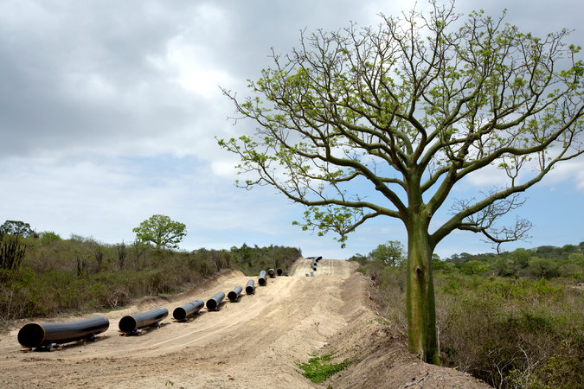

Water pipes set aside near where Ecuador wants a Chinese oil company to build a giant refinery, outside the port of Manta. China has invested heavily in overseas oil projects. Credit Ivan Kashinsky for The New York Times

EL CHACO, Ecuador — Where the Andean foothills dip into the Amazon jungle, nearly 1,000 Chinese engineers and workers have been pouring concrete for a dam and a 15-mile underground tunnel. The $2.2 billion project will feed river water to eight giant Chinese turbines designed to produce enough electricity to light more than a third of Ecuador.

Near the port of Manta on the Pacific Ocean, Chinese banks are in talks to lend $7 billion for the construction of an [oil](http://topics.nytimes.com/top/news/business/energy-environment/oil-petroleum-and-gasoline/index.html?inline=nyt-classifier) refinery, which could make Ecuador a global player in gasoline, diesel and other petroleum products.

Across the country in villages and towns, Chinese money is going to build roads, highways, bridges, hospitals, even a network of surveillance cameras stretching to the Galápagos Islands. State-owned Chinese banks have already put nearly $11 billion into the country, and the Ecuadorean government is asking for more.

Ecuador, with just 16 million people, has little presence on the global stage. But China’s rapidly expanding footprint here speaks volumes about the changing world order, as Beijing surges forward and Washington gradually loses ground.

**[Interactive Graphic](http://www.nytimes.com/interactive/2015/07/24/business/international/the-world-according-to-china-investment-maps.html)**

**[The World According to China](http://www.nytimes.com/interactive/2015/07/24/business/international/the-world-according-to-china-investment-maps.html)**

[China’s enormous overseas spending has helped it displace the United States and Europe as the leading financial power in large parts of the developing world.](http://www.nytimes.com/interactive/2015/07/24/business/international/the-world-according-to-china-investment-maps.html)

[[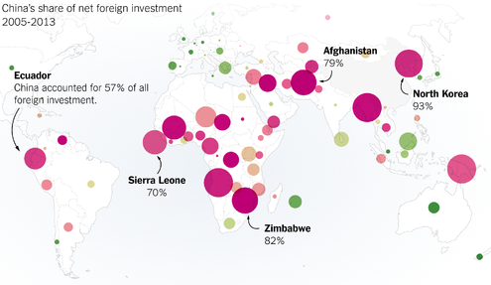](http://www.nytimes.com/interactive/2015/07/24/business/international/the-world-according-to-china-investment-maps.html)](http://www.nytimes.com/interactive/2015/07/24/business/international/the-world-according-to-china-investment-maps.html)

[OPEN Interactive Graphic](http://www.nytimes.com/interactive/2015/07/24/business/international/the-world-according-to-china-investment-maps.html)

While China has been important to the world economy for decades, the country is now wielding its financial heft with the confidence and purpose of a global superpower. With the center of financial gravity shifting, China is aggressively asserting its economic clout to win diplomatic allies, invest its vast wealth, promote its currency and secure much-needed natural resources.

It represents a new phase in China’s evolution. As the country’s wealth has swelled and its needs have evolved, President Xi Jinping and the rest of the leadership have pushed to extend China’s reach on a global scale.

China’s currency, the renminbi, is expected to be anointed soon as a global reserve currency, putting it in an elite category with the dollar, the euro, the pound and the yen. China’s state-owned development bank has surpassed the World Bank in international lending. And its effort to create an internationally funded institution to finance transportation and other infrastructure has drawn the support of 57 countries, including several of the United States’ closest allies, despite opposition from the Obama administration.

Even the current stock market slump is unlikely to shake the country’s resolve. China has nearly $4 trillion in foreign currency reserves, which it is determined to invest overseas to earn a profit and exert its influence.

China’s growing economic power coincides with an increasingly assertive foreign policy. It is building aircraft carriers, nuclear submarines and stealth jets. In a contested sea, China is turning reefs and atolls near the southern Philippines into artificial islands, with at least one airstrip able to handle the largest military planes. The United States has challenged the move, conducting surveillance flights in the area and discussing plans to send warships.

China represents “a civilization and history that awakens admiration to those who know it,” President [Rafael Correa](http://topics.nytimes.com/top/reference/timestopics/people/c/rafael_correa/index.html?inline=nyt-per) of Ecuador proclaimed on Twitter, as his jet landed in Beijing for a meeting with officials in January.

China’s leaders portray the overseas investments as symbiotic. “The current industrial cooperation between China and Latin America arrives at the right moment,” Prime Minister Li Keqiang said in a visit to Chile in late May. “China has equipment manufacturing capacity and integrated technology with competitive prices, while Latin America has the demand for infrastructure expansion and industrial upgrading.”

Photo

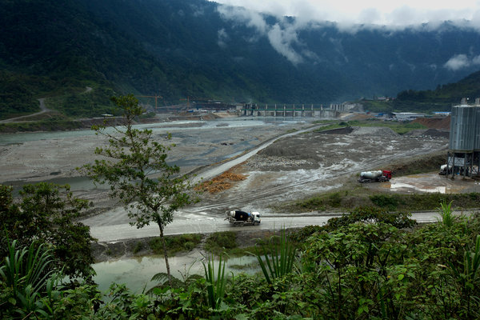

Nearly 1,000 Chinese engineers and workers have been pouring concrete for the dam and a 15-mile underground tunnel that is part of the $2.2 billion hydroelectric plant project. Credit Ivan Kashinsky for The New York Times

But the show of financial strength also makes China — and the world — more vulnerable. Long an engine of global growth, China is taking on new risks by exposing itself to shaky political regimes, volatile emerging markets and other economic forces beyond its control.

Any major problems could weigh on China’s growth, particularly at a time when it is already slowing. The country’s stock market troubles this summer are only adding to the pressure, as the government moves aggressively to stabilize the situation.

While China has substantial funds to withstand serious financial shocks, its overall health matters. When China swoons, the effects are felt worldwide, by the companies, industries and economies that depend on the country’s growth.

In many cases, China is going where the West is reluctant to tread, either for financial or political reasons — or both. After getting hit with Western sanctions over the Ukraine crisis, Russia, which is on the verge of a recession, deepened ties with China. The list of borrowers in Africa and the Middle East reads like a who’s who of troubled regimes and economies that may have trouble repaying Chinese loans, including Yemen, Syria, Sierra Leone and Zimbabwe.

With its elevated status, China is forcing countries to play by its financial rules, which can be onerous. Many developing countries, in exchange for loans, pay steep interest rates and give up the rights to their natural resources for years. China has a lock on close to 90 percent of Ecuador’s oil exports, which mostly goes to paying off its loans.

“The problem is we are trying to replace American imperialism with Chinese imperialism,” said Alberto Acosta, who served as President Correa’s energy minister during his first term. “The Chinese are shopping across the world, transforming their financial resources into mineral resources and investments. They come with financing, technology and technicians, but also high interest rates.”

China also has a shaky record when it comes to worker safety, environmental standards and corporate governance. While China’s surging investments have created jobs in many countries, development experts worry that Beijing is exporting its worst practices.

**The China Factor**

Articles in this series explore how China is exerting its financial heft and economic influence around the world.

Chinese mining and manufacturing operations, like many American and European companies in previous decades, have been accused of abusing workers overseas. China’s coal-fired power plants and industrial factories are adding to pollution problems in developing nations.

Issues have already surfaced in Ecuador.

A few miles from the site of the [hydroelectric](http://topics.nytimes.com/top/reference/timestopics/subjects/h/hydroelectric_power/index.html?inline=nyt-classifier) plant, the Coca River vaults down a 480-foot waterfall and cascades through steep canyons toward the Amazon. It is the tallest waterfall in Ecuador and popular with tourists.

When the dam is complete and the water is diverted to the plant, the San Rafael falls will slow to a trickle for part of the year. With [climate change](http://topics.nytimes.com/top/news/science/topics/globalwarming/index.html?inline=nyt-classifier) already shrinking the Andean glacier that feeds the river, experts debate whether the site will have enough water to generate even half the electricity predicted.

Ecuadoreans on the Chinese-run project have repeatedly protested about wages, health care, food and general working conditions. “The Chinese are arrogant,” said Oscar Cedeno, a 20-year-old construction worker. “They think they are superior to us.”

Last December, an underground river burst into a tunnel at the site. The high-pressure water flooded the powerhouse, killing 14 workers. It was one of a series of serious accidents at Chinese projects in Ecuador, several of them fatal.

**The Rise of China**

When the research arm of China’s cabinet scheduled an economic development conference this spring, the global financial and corporate elite came to Beijing. The heads of major banks and pharmaceutical, auto and oil companies mingled with top Chinese officials.

Photo

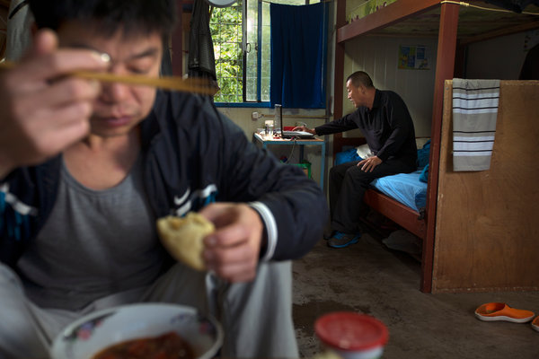

Chinese men, in Ecuador for the Coca Codo Sinclair hydroelectric project, in their room in a camp for workers. Credit Ivan Kashinsky for The New York Times

Some had large investments in the country and wanted to protect their access to the domestic market. Others came to court business, as Beijing channeled more of its money overseas.

At the event, the managing director of the International Monetary Fund, Christine Lagarde, commended China’s efforts to engage globally through investment and trade, as well as to enact economic reforms. It “is good for China and good for the world — their fates are intertwined,” she said in her keynote address.

China’s pull is strong.

It is the world’s largest buyer of oil, which gives China substantial sway over petropolitics. It is also increasingly the trading partner of choice for many countries, taking the mantle from Western nations. China’s foreign direct investment — the money it spends overseas annually on land, factories and other business operations — is second only to the United States’, having passed Japan last year.

Chinese companies are at the center of a worldwide construction boom, mostly financed by Chinese banks. They are building power plants in Serbia, glass and cement factories in Ethiopia, low-income housing in Venezuela and natural gas pipelines in Uzbekistan.

The evolution has been swift. When China started to open its economy in the late 1970s, Beijing had to court companies and investors.

One of the first multinationals to enter was the American Motors Corporation, which built a factory in Beijing. The project was initially aimed at producing Jeeps for export to Australia, rather than building cars for Chinese consumers.

Photo



At night, some of the Chinese workers at the Coca Codo Sinclair hydroelectric plant walk to the local brothel (prostitution is legal in Ecuador) and sit at separate tables from the Ecuadorean workers. Credit Ivan Kashinsky for The New York Times

“We didn’t devote a lot of our boardroom discussions to it,” said Gerald Meyers, then the chief executive of the carmaker. “We were really trying to scrape out a living in our domestic market.”

Today, China produces two million cars a month, far more than any other country. It mirrors the broader transformation of the economy from an insular agrarian society to the world’s largest manufacturer.

While the change has showered wealth on China, it has also brought new demands, like a voracious thirst for energy to power its economy. The confluence of trends has compelled China to look beyond its borders to invest those riches and to satisfy its needs.

Oil has been on the leading edge of this investment push. Energy projects and stakes have accounted for two-fifths of China’s $630 billion of overseas investments in the last decade, according to Derek Scissors, an analyst at the American Enterprise Institute.

China is playing both defense and offense. With an increased dependence on foreign oil, China’s leadership has followed the United States and other large economies by seeking to own more overseas oil fields — or at least the crude they produce — to ensure a stable supply. In recent years, state-controlled Chinese oil companies have acquired big stakes in oil operations in Cameroon, Canada, Kazakhstan, Kyrgyzstan, Iraq, Nigeria, São Tomé and Príncipe, Sudan, Uganda, the United States and Venezuela.

“When utilizing foreign resources and markets, we need to consider it from the height of national strategy,” Prime Minister Li said in 2009, when he was a vice premier. “If the resources mainly come from one country or from one place with frequent turmoil, national economic safety will be under shadow when an emergency happens.”

**Road to Dependence**

For President Correa of Ecuador, China represents a break with his country’s past — and his own.

Photo



A few miles from the site of a hydroelectric plant, the Coca River vaults down a 480-foot waterfall, the tallest in Ecuador. When the dam is complete and the water is diverted to the plant, the falls will slow to a trickle for part of the year. Credit Ivan Kashinsky for The New York Times

His father was imprisoned in the United States for cocaine smuggling and later committed suicide. At the University of Illinois at Urbana-Champaign, Mr. Correa focused his doctoral thesis on the shortcomings of economic policies backed by Washington and Western banks.

As a politician, he embraced Venezuela’s socialist revolution. During his 2006 campaign, Mr. Correa joked that the Venezuelan president Hugo Chávez’s comparison of President George W. Bush with Satan was disrespectful to the devil.

In an early move as president, Mr. Correa expelled the Americans from a military base in Manta, an important launching pad for the Pentagon’s war on drugs. “We can negotiate with the United States over a base in Manta if they let us put a military base in Miami,” President Correa said at the time.

Next, he severed financial ties. In late 2008, Mr. Correa called much of his country’s debt, largely owned by Western investors, “immoral and illegitimate” and stopped paying, setting off a default.

At that point, Ecuador was in a bind. The global financial crisis was taking hold and oil prices collapsed. Ecuador and Petroecuador, its state-owned oil company, started running low on money.

Shut out from borrowing in traditional markets, Ecuador turned to China to fill the void. [PetroChina](http://topics.nytimes.com/top/news/business/companies/petrochina-company-ltd/index.html?inline=nyt-org), the government-backed oil company, lent Petroecuador $1 billion in August 2009 for two years at 7.25 percent interest. Within a year, more Chinese money began to flow for hydroelectric and other infrastructure projects.

“What Ecuador wants are sources of capital with fewer political strings attached, and that goes back to the personal history of Rafael Correa, who holds the United States directly or indirectly responsible for his father’s death and suffering,” said R. Evan Ellis, professor of Latin American studies at the United States Army War College Strategic Studies Institute. “But there is also a desire to get away from the dependence on the fiscal and political conditions of the I.M.F., World Bank and the West.”

**Spreading Its Wealth**

China has lent nearly $11 billion to Ecuador, much of which has gone for hydroelectric, bridge, road and other infrastructure projects.

Major Chinese-backed

projects in Ecuador

The Coca Codo Sinclair hydroelectric facility, which is being built by Sinohydro for $2.2 billion, is the largest Chinese construction project in Ecuador. Other such projects include Sopladora, in Morona Santiago province, built by Gezhouba, and Toachi Pilatón, financed by a Russian consortium, but built by the China International Water & Electric Corp.

A 1.25 mile, four-lane bridge over the Babahoyo River was built by the Guangxi Road & Bridge Engineering Corp. at a cost of over $100 million. It opened in 2011.

WATERWORKS

A $55.6 million project to redirect the flow of the Bulubulu, Cañar and Naranjal rivers was completed this year. It was built by a consortium of Chinese firms — Gezhouba, Hydrochina and China CAMC Engineering.

OIL DRILLING

The Chinese oil companies CNPC and Sinopec, as the Andes Petroleum consortium, run various oil projects in the Amazonian province of Sucumbios. In Orellana and Pastaza provinces, PetroOriental and Andes Petroleum manage concessions.

ROADS

China’s Sinohydro is reconstructing and modernizing several roads in Azuay and Morona Santiago provinces.

MINING

A Chinese joint venture, CRCC-Tongguan Investment, paid $100 million to the Ecuadorean government in 2012 for the rights to the Mirador Copper Mine, with a commitment to invest $1.4 billion over five years. Its Ecuadorean subsidiary, EcuaCorriente, also holds copper and gold properties further north, in Morona Santiago province.

WIND POWER

The wind farm at Villonaco, which generates 16.5 megawatts of power, began operations in 2013. It was built by the Chinese company, Xinjiang Goldwind.

The Ecuadorean foreign minister calls the shift to China a “diversification of its foreign relations,” rather than a substitute for the United States or Europe. “We have decided that the most convenient and healthy thing for us,” said the foreign minister, Ricardo Patiño, is “to have friendly, mutually beneficial relations of respect with all countries.”

The Chinese money, though, comes with its own conditions. Along with steep interest payments, Ecuador is largely required to use Chinese companies and technologies on the projects.

International rules limit how the United States and other industrialized countries can tie their loans to such agreements. But China, which is still considered a developing country despite being the world’s largest manufacturer, doesn’t have to follow those standards.

It is one reason that China’s effort to build an international development fund, the Asian Infrastructure Investment Bank, has faced criticism in the United States. Washington is worried that China will create its own rules, with lower expectations for transparency, governance and the environment.

While China has sought to quell those fears over the infrastructure fund, its portfolio of projects around the world imposes tough terms and sometimes lax standards. Since 2005, the country has landed $471 billion in construction contracts, many tied to broader lending agreements.

In Ecuador, a consortium of Chinese companies is overseeing a flood control and irrigation project in the southern Ecuador province of Cañar. A Chinese engineering company built a $100 million, four-lane bridge to span the Babahoyo River near the coast.

Such deals typically favor the Chinese.

Photo



On the beach in Manta, a port city in Ecuador. After Ecuador was shut out from borrowing in traditional markets, the country turned to China to fill the void. Credit Ivan Kashinsky for The New York Times

PetroChina and Sinopec, another state-controlled Chinese company, together pump about 25 percent of the 560,000 barrels a day produced in Ecuador. Along with taking the bulk of oil exports, the Chinese companies also collect $25 to $50 in fees from Ecuador for each barrel they pump.

China’s terms are putting countries in precarious positions.

In Ecuador, oil represents roughly 40 percent of the government’s revenue, according to the United States Energy Department. And those earnings are suddenly plunging along with the price of oil. With crude at around $50 a barrel, Ecuador doesn’t have much left to repay its loans.

“Of course we have concerns over their ability to repay the debts — China isn’t silly,” said Lin Boqiang, the director of the Energy Economics Research Center at Xiamen University in China’s Fujian province and a government policy planner. “But the gist is resources will ultimately become valuable assets.”

If Ecuador or other countries can’t cover their debts, their obligations to China may rise. A senior Chinese banker, who spoke only on the condition of anonymity for diplomatic reasons, said Beijing would most likely restructure some loans in places like Ecuador.

To do so, Chinese authorities want to extend the length of the loans instead of writing off part of the principal. That means countries will have to hand over their natural resources for additional years, limiting their governments’ abilities to borrow money and pursue other development opportunities.

China has significant leverage to make sure borrowers pay. As the dominant manufacturer for a long list of goods, Beijing can credibly threaten to cut off shipments to countries that do not repay their loans, the senior Chinese banker said.

Photo

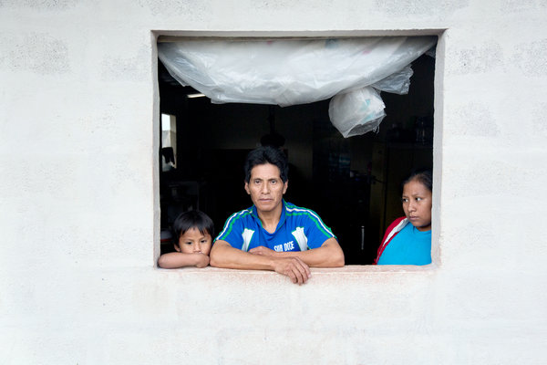

José Tixi, who works at the hydroelectric plant project, with his family in their home in San Luis. Ecuadoreans on the Chinese-run project have repeatedly protested about the working conditions. Credit Ivan Kashinsky for The New York Times

With its economy stumbling, Ecuador asked China at the start of the year for an additional $7.5 billion in financing to fill the growing government budget deficit and buy Chinese goods. Since then, the situation has only deteriorated. In recent weeks, thousands of protesters have poured into the streets of Quito and Guayaquil to challenge various government policies and proposals, some of which Mr. Correa has recently withdrawn.

“China is becoming the new company store for developing oil-, gas- and mineral-producing countries,” said David Goldwyn, who was the State Department’s special envoy for international energy affairs during President Obama’s first term. “They are entitled to secure reliable sources of oil, but what we need to worry about is the way they are encouraging oil-producing countries to mortgage their long-term future through oil-backed loans.”

A pall of acrimony surrounds the Coca Codo Sinclair hydroelectric plant, Ecuador’s largest construction project.

Few of the Chinese workers speak Spanish, and they live separately from their Ecuadorean counterparts. When the workers leave their camp in the village of San Luis at noon for lunch, they walk down the main street in separate groups. At night, they also walk in separate groups up the hill to the local brothel. (Prostitution is legal in Ecuador.) The workers sit at separate tables drinking bottles of the Ecuadorean beer, Pilsener.

When the Chinese and Ecuadorean workers return to camp, typically drunk, there have been shoving matches. Once a Chinese manager threw a tray at an Ecuadorean worker at mealtime.

“You make a little mistake, and they say something like, ‘Get out of here,’ ” said Gustavo Taipe, an Ecuadorean welder. “They want to be the strongmen.”

## Weapons technology

### Who’s afraid of America?

# The military playing field is more even than it has been for many years. That is a big problem for the West

Jun 13th 2015 | [From the print edition](http://www.economist.com/printedition/2015-06-13)

* [imekeeper](http://www.economist.com/news/international/21654066-military-playing-field-more-even-it-has-been-many-years-big?zid=309&ah=80dcf288b8561b012f603b9fd9577f0e)

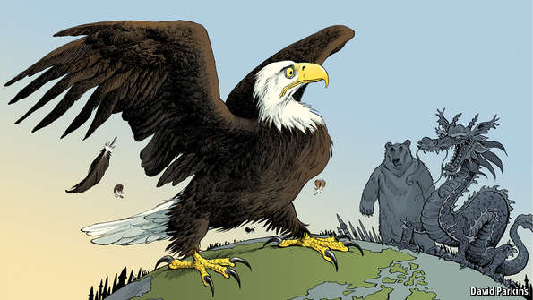

SINCE the end of the cold war one simple geopolitical rule has endured: do not take on America. The country’s armed forces have been so well resourced and so technologically superior that it would be utterly foolish for any state to mount a direct challenge to the superpower or its allies. This rule still holds—but it is no longer quite as compelling as it once was. Although America still possesses by far the most capable armed forces in the world, the technological advantage that guarantees it can defeat any conceivable adversary is eroding rapidly.

“We are entering an era where American dominance on the seas, in the skies, and in space—not to mention cyberspace—can no longer be taken for granted,” admitted Chuck Hagel, the outgoing secretary of defence, last year. He argued that America urgently needed to develop a new generation of military technologies, lest another country come to feel capable of challenging it. His warning was timely.

The others are certainly growing more assertive. China is increasingly keen to press its territorial claims in the western Pacific. Russia is intent on re-establishing its influence in what it regards as its “near abroad”, as it has shown in Ukraine. Less powerful but more reckless states such as North Korea and Iran might also become more inclined to make mischief if they believe they can inflict so much damage on the American forces that seek to punish them that Washington will think twice about doing so.

Repeating history

The effort that Mr Hagel called for is known as the “third offset strategy”, because it is the third time since the second world war that America has sought technological breakthroughs to offset the advantages of potential foes and reassure its friends. The first such moment occurred in the early 1950s, when the Soviet Union was fielding far larger conventional forces in Europe than America and its allies could hope to repel. The answer was to extend America’s lead in nuclear weapons to counter the Soviet numerical advantage—a strategy known as the “New Look”.

A second offset strategy was conceived in the mid-1970s. American military planners, reeling from the psychological defeat of the Vietnam war, recognised that the Soviet Union had managed to build an equally terrifying nuclear arsenal. They had to find another way to restore credible deterrence in Europe. Daringly, America responded by investing in a family of untried technologies aimed at destroying enemy forces well behind the front line. Precision-guided missiles, the networked battlefield, reconnaissance satellites, the Global Positioning System (GPS) and radar-beating “stealth” aircraft were among the fruits of that research.

Bob Work, the deputy secretary of defence charged with overseeing the new offset strategy, says that by the mid-1980s Soviet generals who studied the results of early demonstrations of the operational concept that became known as Air-Land Battle realised what they were up against. “We were an aggressive first mover,” Mr Work says. “We had picked an area that we knew our most likely adversary couldn’t copy.” The impact of this “revolution in military affairs” was hammered home in 1991 during the first Gulf war. Iraqi military bunkers were reduced to rubble and Soviet-style armoured formations became sitting ducks. Watchful Chinese strategists, who were as shocked as their Soviet counterparts had been, were determined to learn from it.

The large lead that America enjoyed then has dwindled. Although the Pentagon has greatly refined and improved the technologies that were used in the first Gulf war, these technologies have also proliferated and become far cheaper. Colossal computational power, rapid data processing, sophisticated sensors and bandwidth—some of the components of the second offset—are all now widely available.

And America has been distracted. During 13 years of counter-insurgency and stabilisation missions in Afghanistan and Iraq, the Pentagon was more focused on churning out mine-resistant armoured cars and surveillance drones than on the kind of game-changing innovation needed to keep well ahead of military competitors. America’s combat aircraft are 28 years old, on average. Only now is the fleet being recapitalised with the expensive and only semi-stealthy F-35 Joint Strike Fighter.

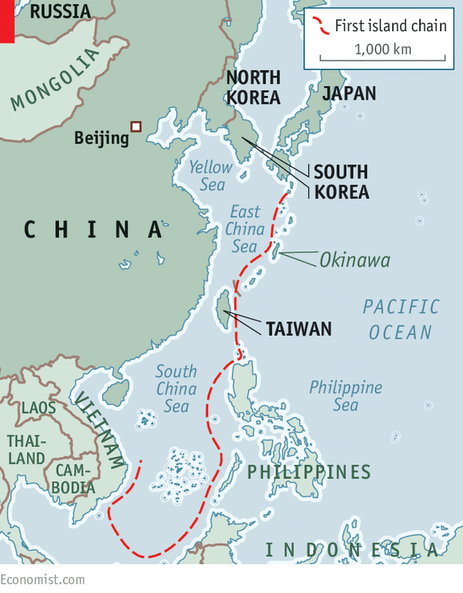

China, in particular, has seized the opportunity to catch up. With a defence budget that tends to grow by more than 10% a year, it has invested in an arsenal of precision short- to medium-range ballistic and cruise missiles, submarines equipped with wake-homing torpedoes and long-range anti-ship missiles, electronic warfare, anti-satellite weapons, modern fighter jets, integrated air defences and sophisticated command, control and communications systems.

The Chinese call their objective “winning a local war in high-tech conditions”. In effect, China aims to make it too dangerous for American aircraft-carriers to operate within the so-called first island chain (thus pushing them out beyond the combat range of their tactical aircraft) and to threaten American bases in Okinawa and South Korea. American strategists call it “anti-access/area denial”, or A2/AD.

Damage, not defeat

The concern for America’s allies in the region is that, as China’s military clout grows, the risks entailed in defending them from bullying or a sudden aggressive act—a grab of disputed islands to claim mineral rights, say, or a threat to Taiwan’s sovereignty—will become greater than an American president could bear. Some countries might then decide to throw in their lot with the regional hegemon.

Although China is moving exceptionally quickly, Russia too is modernising its forces after more than a decade of neglect. Increasingly, it can deploy similar systems. Iran and North Korea are building A2/AD capabilities too, albeit on a smaller scale than China. Even non-state actors such as Hizbullah in Lebanon and Islamic State in Syria and Iraq are acquiring some of the capabilities that until recently were the preserve of military powers.

Hence the need to come up with a third offset strategy. But the economic, political and technical circumstances are very different from the ones that prevailed in the 1950s or the 1970s. America needs to develop new military technologies that will impose large costs on its adversaries, even as budget caps ordered by Congress are squeezing its own defence spending.

The programme needs to overcome at least five critical vulnerabilities. The first is that carriers and other surface vessels can now be tracked and hit by missiles at ranges from the enemy’s shore which could prevent the use of their cruise missiles or their tactical aircraft without in-flight refuelling by lumbering tankers that can be picked off by hostile fighters. The second is that defending close-in regional air bases from a surprise attack in the opening stages of a conflict is increasingly hard. Third, aircraft operating at the limits of their combat range would struggle to identify and target mobile missile launchers. Fourth, modern air defences can shoot down non-stealthy aircraft at long distances. Finally, the satellites America requires for surveillance and intelligence are no longer safe from attack.

It is an alarming list. Yet America has considerable advantages, argues Robert Martinage of the Centre for Strategic and Budgetary Assessments, an influential Washington think-tank that has consistently drawn attention to the need to counter Chinese A2/AD capabilities. Those advantages include unmanned systems, stealthy aircraft, undersea warfare and the complex systems engineering that is required to make everything work together.

Over the next decade or so, America will aim to field unmanned combat aircraft that are stealthy enough to penetrate the best air defences and have the range and endurance to pursue mobile targets. Because they have no human pilots, fewer are needed for training. Since they do not need to rest, they can fly more missions back to back. And small, cheaper American drones might be used to swarm enemy air defences.

Drones are widespread these days, but America has nearly two decades of experience operating them. And the new ones will be nothing like the vulnerable Predators and Reapers that have been used to kill terrorists in Yemen and Waziristan. Evolving from prototypes like the navy’s “flying wing” X-47B and the air force’s RQ-180, they will be designed to survive in the most hostile environments. The more autonomous they are, the less they will have to rely on the control systems that enemies will try to disrupt—though autonomy also raises knotty ethical and legal issues.

Out of sight

Some of the same technologies could be introduced to unmanned underwater vehicles. These could be used to clear mines, hunt enemy submarines in shallow waters, for spying and for resupplying manned submarines, for example, with additional missiles. They can stay dormant for long periods before being activated for reconnaissance or strike missions. Big technical challenges will have to be overcome: Mr Martinage points out that the vehicles will require high-density energy packs and deep undersea communications.

Contracts will be awarded this summer for a long-range strike bomber, the first new bomber since the exotic and expensive B-2 began service two decades ago. The B-3, of which about 100 are likely to be ordered, will also have a stealthy, flying-wing design. This time, costs will be kept down by using proven technologies, but with a modular approach to allow for upgrades to be simply plugged in when necessary to counter improving air defences. Targets for the B-3, perhaps supported by unmanned aircraft, will include mobile missile launchers and command bunkers.

If surface vessels, particularly aircraft-carriers, are to remain relevant, they will need to be able to defend themselves against sustained attack from precision-guided missiles. The navy’s Aegis anti-ballistic missile-defence system is capable but expensive: each one costs $20m or so. If several of them were fired to destroy an incoming Chinese DF-21D anti-ship ballistic missile, the cost for the defenders might be ten times as much as for the attackers.

If carriers are to stay in the game, the navy will have to reverse that ratio. Hopes are being placed in two technologies: electromagnetic rail guns, which fire projectiles using electricity instead of chemical propellants at 4,500mph to the edge of space, and so-called directed-energy weapons, most likely powerful lasers. The rail guns are being developed to counter ballistic missile warheads; the lasers could protect against hypersonic cruise missiles. In trials, shots from the lasers cost only a few cents. The navy has told defence contractors that it wants to have operational rail guns within ten years.

[[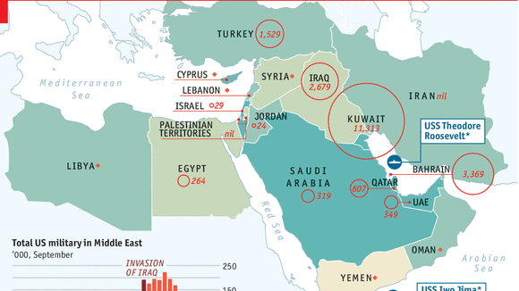](http://www.economist.com/blogs/graphicdetail/2015/06/daily-chart-8)](http://www.economist.com/blogs/graphicdetail/2015/06/daily-chart-8)

[Absentee America: Dwindling US presence in the Middle East](http://www.economist.com/blogs/graphicdetail/2015/06/daily-chart-8)

Defending against salvoes of incoming missiles will remain tricky and depend on other technological improvements, such as compact long-range radars that can track multiple targets. Finding ways to protect communications networks, including space-based ones, against attack is another priority. Satellites can be blinded by lasers or disabled by exploding missiles. One option would be to use more robust technologies to transmit data—such as chains of high-altitude, long-endurance drones operating in relays.

The technical challenges and potential costs involved in all this are large. And they will have to be tackled in fresh ways. Rather than staying within the closed loop of military R&D departments and the defence industry, much of the research the Pentagon needs is being done by consumer technology companies in Silicon Valley and elsewhere. Artificial intelligence, machine learning, algorithms, big-data processing, 3D printing, compact high-density power systems and tiny sensors of the kind found in smartphones will all be crucial. That raises the risk of a culture clash: though both are hot for innovation, the Pentagon operates rather differently from the consumer tech industry, to put it mildly.

The second offset strategy succeeded partly because of political will. Congress and the White House walked in step, with continuity from one administration to the next. The new offset strategy, too, appears to have widespread support. Congress is keen. Mr Hagel’s successor as defence secretary, Ash Carter, has spent three decades at the leading edge of science and weapons technology.

But Washington is far more confrontational than it was a few decades ago. Bipartisan agreement is hard to find and even harder to sustain. Stand-offs over the budget have made it exceedingly difficult for the Pentagon to plan ahead. Research and development spending, which accounts for about 10% of the defence budget (see chart) will have to be not just protected but increased.

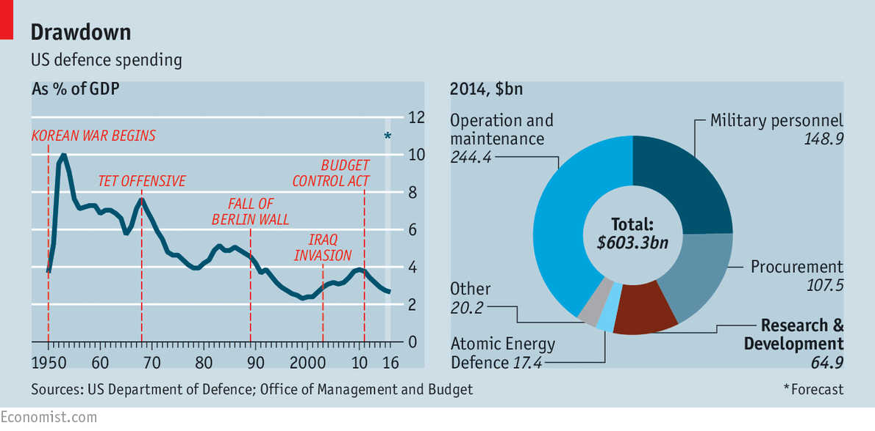

If defence spending remains tight, as seems likely, the money for breakthrough technologies will have to be found from somewhere. That means Congress allowing the Pentagon to make the savings it wants. The most pressing task is to reform military pay and benefits, which are eating up an ever-bigger slice of the defence budget despite falls in the number of Americans in uniform. Closing unwanted bases would also help. So would reforming the way the Pentagon buys things.

To get its hands on the technologies it needs, the military establishment and the armed forces themselves may have to take an axe to cherished programmes. One possibility would be to scale back plans to buy nearly 2,500 F-35 fighter jets, which have too short a range for many situations, and use the money to buy unmanned combat aircraft and a bigger fleet of long-range strike bombers. The navy might have to give up on two of its fabulously expensive carrier groups in recognition of their growing vulnerability in favour of investments in submarines, both manned and unmanned. None of this will be easy. The men who command air forces tend to be former fast-jet pilots still in love with their steeds; the sailors who run navies are attached to the muscular power that only big surface ships can display. The army, too, will have to shrink.

Third time unlucky?

Even if all these obstacles are overcome, it is unlikely that a third offset strategy will secure Western military dominance for as long as the first two did. Technology spreads much more quickly these days, partly thanks to the internet, which the Pentagon helped to create and which now helps rival powers steal America’s military secrets. Technological change of all kinds has become speedier, too, thanks to fierce competition in fashion-conscious consumer markets.

The second offset strategy benefited from some unusual circumstances that left America as the world’s unchallenged hyperpower after the end of the cold war. That world has vanished. In the military-technological struggle to come, the contest will be relentless and the victories probably more fleeting.

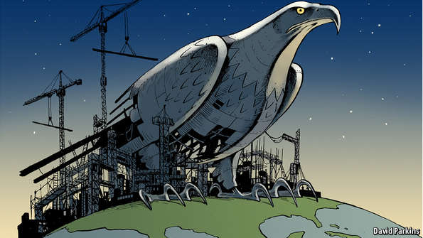

It would help if America’s allies weighed in. They should come up with innovations of their own—or at least invest in the capabilities required to be a useful military partner by adapting to changes in how the Pentagon invests and plans to fight. Few have even begun to think about this. In Britain, for example, politicians and general are arguing about whether defence spending should be allowed to fall below 2% of GDP rather than about how the money should be spent.

Finally, a warning. Despite the success of the second offset strategy, it never fully dealt with the possibility that a losing power might resort to nuclear weapons. The logic of nuclear deterrence, it was assumed (or hoped), would survive an intense conventional conflict. The cheerleaders for a new offset strategy rarely mention nuclear weapons.

Yet if a foe comes to believe it might win what the great strategist Thomas Schelling called “a competition in risk-taking”—an idea that Vladimir Putin, Russia’s president, actively encourages—the rational response to the other side’s technological superiority might be nuclear brinkmanship. As Elbridge Colby of the Centre for a New American Security argues: “The more successful the offset strategy is in extending US conventional advantages, the more attractive US adversaries will find strategies of nuclear escalation.” The enemy always gets a vote.