**Asia's balance of power**

**China’s military rise**

**There are ways to reduce the threat to stability that an emerging superpower poses**

Apr 7th 2012 | from the print edition

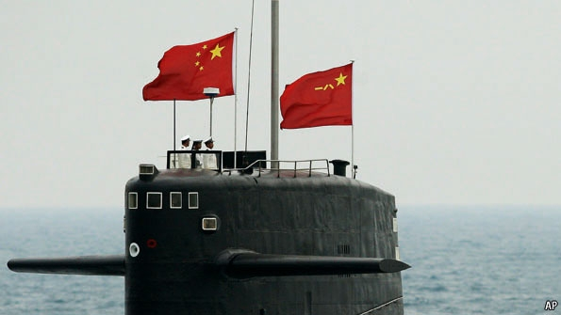

NO MATTER how often China has emphasised the idea of a peaceful rise, the pace and nature of its military modernisation inevitably cause alarm. As America and the big European powers reduce their defence spending, China looks likely to maintain the past decade’s increases of about 12% a year. Even though its defence budget is less than a quarter the size of America’s today, China’s generals are ambitious. The country is on course to become the world’s largest military spender in just 20 years or so (see [article](http://www.economist.com/node/21552193" \t "_self)).

Much of its effort is aimed at deterring America from intervening in a future crisis over Taiwan. China is investing heavily in “asymmetric capabilities” designed to blunt America’s once-overwhelming capacity to project power in the region. This “anti-access/area denial” approach includes thousands of accurate land-based ballistic and cruise missiles, modern jets with anti-ship missiles, a fleet of submarines (both conventionally and nuclear-powered), long-range radars and surveillance satellites, and cyber and space weapons intended to “blind” American forces. Most talked about is a new ballistic missile said to be able to put a manoeuvrable warhead onto the deck of an aircraft-carrier 2,700km (1,700 miles) out at sea.

China says all this is defensive, but its tactical doctrines emphasise striking first if it must. Accordingly, China aims to be able to launch disabling attacks on American bases in the western Pacific and push America’s carrier groups beyond what it calls the “first island chain”, sealing off the Yellow Sea, South China Sea and East China Sea inside an arc running from the Aleutians in the north to Borneo in the south. Were Taiwan to attempt formal secession from the mainland, China could launch a series of pre-emptive strikes to delay American intervention and raise its cost prohibitively.

This has already had an effect on China’s neighbours, who fear that it will draw them into its sphere of influence. Japan, South Korea, India and even Australia are quietly spending more on defence, especially on their navies. Barack Obama’s new “pivot” towards Asia includes a clear signal that America will still guarantee its allies’ security. This week a contingent of 200 US marines arrived in Darwin, while India took formal charge of a nuclear submarine, leased from Russia.

**En garde**

The prospect of an Asian arms race is genuinely frightening, but prudent concern about China’s build-up must not lapse into hysteria. For the moment at least, China is far less formidable than hawks on both sides claim. Its armed forces have had no real combat experience for more than 30 years, whereas America’s have been fighting, and learning, constantly. The capacity of the People’s Liberation Army (PLA) for complex joint operations in a hostile environment is untested. China’s formidable missile and submarine forces would pose a threat to American carrier groups near its coast, but not farther out to sea for some time at least. Blue-water operations for China’s navy are limited to anti-piracy patrolling in the Indian Ocean and the rescue of Chinese workers from war-torn Libya. Two or three small aircraft-carriers may soon be deployed, but learning to use them will take many years. Nobody knows if the “carrier-killer” missile can be made to work.

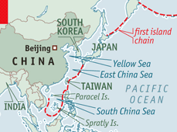

As for China’s longer-term intentions, the West should acknowledge that it is hardly unnatural for a rising power to aspire to have armed forces that reflect its growing economic clout. China consistently devotes a bit over 2% of GDP to defence—about the same as Britain and France and half of what America spends. That share may fall if Chinese growth slows or the government faces demands for more social spending. China might well use force to stop Taiwan from formally seceding. Yet, apart from claims over the virtually uninhabited Spratly and Paracel Islands, China is not expansionist: it already has its empire. Its policy of non-interference in the affairs of other states constrains what it can do itself.

The trouble is that China’s intentions are so unpredictable. On the one hand China is increasingly willing to engage with global institutions. Unlike the old Soviet Union, it has a stake in the liberal world economic order, and no interest in exporting a competing ideology. The Communist Party’s legitimacy depends on being able to honour its promise of prosperity. A cold war with the West would undermine that. On the other hand, China engages with the rest of the world on its own terms, suspicious of institutions it believes are run to serve Western interests. And its assertiveness, particularly in maritime territorial disputes, has grown with its might. The dangers of military miscalculation are too high for comfort.

**How to avoid accidents**

It is in China’s interests to build confidence with its neighbours, reduce mutual strategic distrust with America and demonstrate its willingness to abide by global norms. A good start would be to submit territorial disputes over islands in the East and South China Seas to international arbitration. Another step would be to strengthen promising regional bodies such as the East Asian Summit and ASEAN Plus Three. Above all, Chinese generals should talk far more with American ones. At present, despite much Pentagon prompting, contacts between the two armed forces are limited, tightly controlled by the PLA and ritually frozen by politicians whenever they want to “punish” America—usually because of a tiff over Taiwan.

America’s response should mix military strength with diplomatic subtlety. It must retain the ability to project force in Asia: to do otherwise would feed Chinese hawks’ belief that America is a declining power which can be shouldered aside. But it can do more to counter China’s paranoia. To his credit, Mr Obama has sought to lower tensions over Taiwan and made it clear that he does not want to contain China (far less encircle it as Chinese nationalists fear). America must resist the temptation to make every security issue a test of China’s good faith. There are bound to be disagreements between the superpowers; and if China cannot pursue its own interests within the liberal world order, it will become more awkward and potentially belligerent. That is when things could get nasty.

**Military might**

Apr 15th 2013, 14:17 by Economist.com

**Which countries spend most on their military?**

GLOBAL defence spending fell by 0.5% to $1.75 trillion last year. This is the first annual decline since 1998, according to new data from the Stockholm International Peace Research Institute, a think-tank. Although America still spends the biggest chunk of the world total, and 69% more in real terms than it did in 2001, its share has fallen below 40% for the first time since 1991. Indeed, since the recession in 2008, spending has fallen by 10% in 20 of the 37 countries in western and central Europe. By contrast Russia increased spending by 16% in 2012 and further rises are planned to 2015. Russia and America each spent the equivalent of 4.4% of GDP, considerably higher than the global average of 2.5%, but much lower than that of Saudia Arabia, at 8.9%. Over the past decade China's military budget has risen by 175%, the largest increase of any of the countries shown in the chart, though this still represents only around 2% of GDP.

