Hong Kong

Global House Prices

http://www.economist.com/blogs/dailychart/2011/11/global-house-prices?zid=306&ah=1b164dbd43b0cb27ba0d4c3b12a5e227

Unfurling umbrellas
All latest updates

A new force emerges in Hong Kong’s politics

Participants in huge pro-democracy protests a year ago make a mark in neighbourhood elections
Nov 24th 2015 | Hong Kong | China
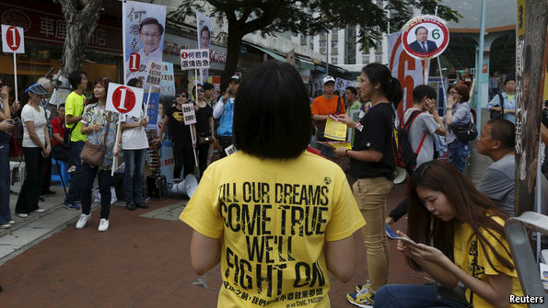
A YEAR ago thousands of demonstrators staged more than 11 weeks of sit-ins on busy streets in Hong Kong in the most sustained street campaign for democratic reform ever mounted in the territory. In the first election since then, held on November 22nd, a record 47% of the 3.1m people eligible to vote did so, to choose representatives to serve in District Councils which advise the government on a wide range of issues, especially matters relating to public services. The results showed that the territory remains deeply divided over last year’s upheaval. Hong Kong’s hugely unpopular chief executive, Leung Chun-ying, will take little comfort.
The councils, which have 431 seats (68 of them were uncontested), are the lowest tier of elected representation in Hong Kong. But despite their marginal role in the running of the territory (they have small budgets which they can spend on local events, such as festivals), elections to them are still closely watched as an indicator of political sentiment: they are freely contested, without the kind of gerrymandering that skews the outcomes of other elections in the territory in favour of pro-government candidates. Previously, some District Council seats were filled by government appointees. Not this time, however. As usual, the campaign turned into a shouting match between pro-democracy politicians and those sympathetic towards Hong Kong’s government and its backers in Beijing.
Related topics
- Beijing
- Hong Kong
The results were mixed. Despite the organisational skills their opponents usually display at this level of politics, the pro-democracy camp made a few, but striking, gains. About 50 participants in last year’s “umbrella movement”, as the sit-ins were dubbed (demonstrators used umbrellas to protect themselves from tear gas and pepper spray), were among the 935 people who campaigned for seats. These “umbrella soldiers”, as such activists are often described, secured at least eight seats.
Among those they defeated were two prominent incumbents, Elizabeth Quat and Christopher Chung, who are members of the largest political party, the pro-government Democratic Alliance for the Betterment and Progress of Hong Kong (DAB). The two also have seats in the Legislative Council (Legco)—the DAB may struggle to retain these in Legco polls next year.
The DAB’s losses, however, may also be a sign of dissatisfaction with the party within the pro-government camp. Some of the DAB’s usual backers were angered by a botched walkout from Legco staged by DAB members in June. That action resulted in a crushing defeat for government-backed political reforms which leaders in Beijing had been touting as a fulfilment of their promise to grant “universal suffrage” in the territory, but which pro-democracy activists viewed as a sham.
Overall, candidates supportive of the Communist Party in Beijing still did well. Of the 363 seats contested, they secured 191, up from 160. The Democratic Party, the largest pro-democracy group, won 43 seats, four fewer than it held before. A former chairman of the party, Albert Ho, and its vice chairman, Andrew Wan, were among those defeated. Mr Ho faced five contenders, who sometimes joined forces to jeer at him through loudhailers when he made speeches to voters.
The results mean that District Councils will remain under the control of pro-government politicians. But they also showed that the pro-democracy movement remains a force to be reckoned with. Where a single pro-democracy candidate faced a single pro-government opponent, about 55% of the votes went to the pro-democracy contender.
If this is replicated in next year’s Legco election, the pro-democracy camp will have a good chance of keeping control of at least one-third of its seats—enough to give them a veto over any future effort by the government to secure political reform on the Communist Party’s terms. In 2017 there will be a tightly controlled competition for the post of chief executive (designed to prevent pro-democracy candidates from getting anywhere near the finishing post). Umbrella activists will use that selection process as another opportunity to show their strength—possibly again on the streets. They have yet to prove, however, that the public is strongly behind them.

Hong Kong’s politics

A snub to the party

Legislators veto China’s plans for political change
Jun 20th 2015 | HONG KONG | From the print edition

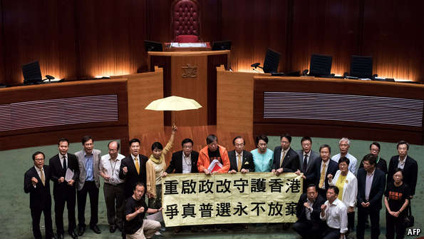
POLITICAL bodies in China rarely defy the will of the Communist Party. On June 18th, however, the legislature in Hong Kong (known as Legco) vetoed the party’s plans for what had been touted as momentous political reform in the former colony. Twenty-eight of the body’s 70 members voted against the proposal, calling it a sham. But that leaves Hong Kong no closer to achieving democracy. And as noisy demonstrations by rival groups outside the debating chamber suggested, public opinion is deeply divided.
The outcome of the vote was no surprise: pro-democracy legislators had long denounced the proposal, which called for the introduction of “universal suffrage” in the next elections for the territory’s chief executive, in 2017. Their objection was that the only candidates allowed to stand would be a maximum of three people, all of them nominated and chosen by a 1,200-member committee stacked with supporters of the party drawn from Hong Kong’s business and political elite.
In this section
- A snub to the party
- After Zhou, who?
- Pet food
Reprints
The only surprise was a bizarre walkout staged by pro-establishment lawmakers just before the vote. This meant that the plan was defeated far more soundly than expected, with only eight voting in favour of it. Voting rules required support from at least two-thirds of members for the package to pass. Though expected, the outcome is an embarrassment for the leadership in Beijing. It had badly wanted to be seen to be fulfilling the commitment it gave in its mini-constitution for post-colonial Hong Kong, known as the Basic Law, which says that the territory may eventually enjoy universal suffrage. China never offered Western-style democracy in Hong Kong, but thought it could allow one-person-one-vote while maintaining sufficient control over the process to ensure that a critic of the party would never be elected.
The leadership in Beijing had made it clear there was no other offer. That means the next elections will be held according to the existing rules: a similar kind of committee will choose the chief executive, but without a public vote. This leaves pro-democracy politicians in a quandary. Polls had suggested that public opinion is roughly evenly split between those who wanted legislators to vote down the plan, and those who believed that it would be better to accept it, even if it is flawed. If the outcome of the vote is greater tension between radical activists in Hong Kong and leaders in Beijing who are unwilling to make any concessions on voting procedures, then democrats risk losing support among moderates who fear turmoil. The possibility of growing street unrest became evident late last year when pro-democracy demonstrators staged unprecedented sit-ins on major roads for 79 days.
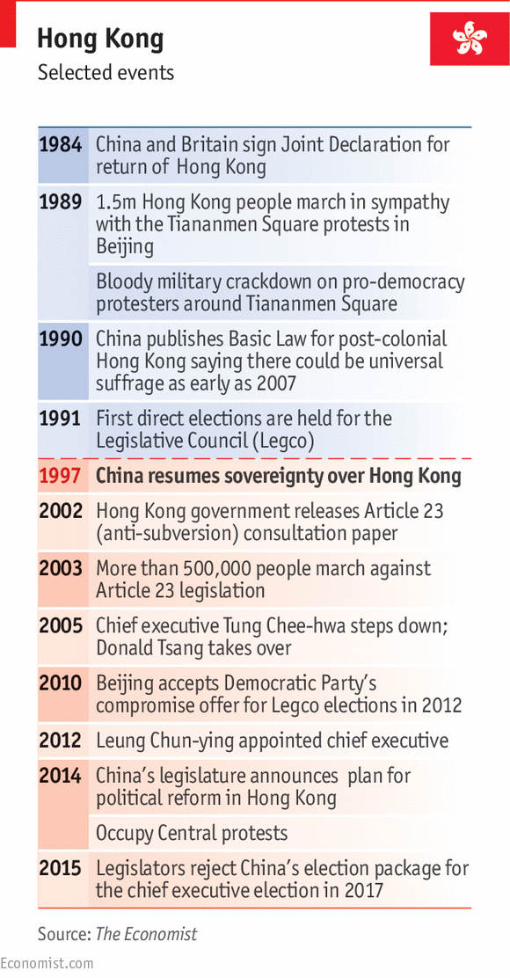
Democrats hope that elections to Legco next year will vindicate their stance. But Michael DeGolyer of Baptist University says they may be disappointed. It is possible, he says, that they will lose seats because of voters’ worries about the political impasse. That may deprive the democrats of their veto power, and make it easier to introduce changes in the voting system according to the party’s wishes. “They built this trap for themselves and then walked into it,” Mr DeGolyer says. Democratic politicians are unrepentant. “Perhaps we are naive, but at least we have a conscience,” says Lee Cheuk-yan, a veteran legislator (pictured above, in an orange jacket, with fellow legislators—their banner calls for genuine elections).
Democrats like Mr Lee see their struggle as part of a broader campaign for democracy in the country as a whole. Younger activists, however, believe the two issues should be separated, and that it is time to adopt a more militant stance in the pursuit of democracy in Hong Kong—even if that means sometimes breaking the law, albeit peacefully. Political frustration is causing some to reconsider their feelings for the mainland and its culture. This was evident earlier this month when Hong Kong’s football team played fellow minnows, the Maldives and Bhutan, in qualifying matches at home for the World Cup. As China’s national anthem, “March of the Volunteers”, struck up at both games, some Hong Kongers in the crowd began to boo. At the Maldives game, many also raised their middle fingers.
China is in no mood for a serious reassessment of its stance on democratic reform. Since taking power in 2012 President Xi Jinping has stepped up efforts to stifle dissent on the mainland. He does not want to make concessions in Hong Kong that might encourage pro-democracy activists on the other side of the border. Dozens of mainlanders who expressed sympathy with last year’s Occupy Central protests were detained or given warnings by mainland police.
In 2017, when Hong Kong is next due to choose its leader, Mr Xi will be engrossed in preparations for sweeping changes in the central leadership later that year. The last thing he wants adding to his headaches is any uncertainty about the outcome in Hong Kong. The current chief executive, Leung Chun-ying, may not be popular at home. But for now he has the support of Mr Xi, whose vote is the only one in China that really counts.

Hong Kong politics

X marks the spot

A struggle looms in Hong Kong’s legislature over political reform
Apr 25th 2015 | HONG KONG | From the print edition

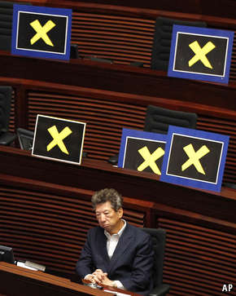Missing faces
AFTER pro-democracy protests in Hong Kong late last year that blocked several main streets for weeks, neither the territory’s leaders nor their backers in Beijing are in any mood to make concessions. On April 22nd the Hong Kong government revealed how it would like to conduct elections in 2017 for the territory’s chief executive, as the most senior official is known. The proposal faithfully echoed the views of mainland Communist Party officials, whose disdain for a free vote had triggered the recent unrest. For the first time, Hong Kong residents will all be allowed to cast a vote for their leader. But the only candidates will be ones approved by a committee stacked with the party’s supporters.
Pro-democracy legislators were quick to show their contempt for the government’s plan. Most of them walked out of the Legislative Council (Legco) when the proposals were announced. The politicians left placards with yellow “X” symbols (see picture): yellow being the adoptive colour of last year’s protests and “X” signifying their intention to vote against the proposals when they are submitted for approval, probably in mid-June. Some carried umbrellas, another symbol of the recent unrest. The current chief executive, Leung Chun-ying, has warned that if they do reject the plan, the next chief executive will be chosen by the same method as last time, which involved no public vote at all.
Senior government officials have prepared a publicity blitz in an effort to sway opinion in their favour. Pro-democracy protesters have threatened to disrupt the officials’ public appearances. Opinion polls show the public is divided. Some polls say that about 60% of respondents want Legco to adopt the government’s proposals. Others say a similar proportion believes that rejecting the plan would be fine. Albert Ho, a Democratic Party legislator, has pledged to step down after the vote in order to trigger a by-election that he would like to turn into, in effect, a referendum on the package. It is far from clear whether he would succeed in securing a convincing show of public support for his cause.
But the real struggle will be in Legco, where the government has to win over four legislators in order to prevent a veto by the 27-strong pro-democracy bloc (the proposals need the support of two-thirds of Legco’s 70 members to pass). Many pan-democrats, as the bloc’s members are commonly known, insist that the public be allowed to nominate candidates. As Hong Kong officials keep noting, the government in Beijing has ruled this out. The pan-democrats also object to the government’s proposal that those who make it onto the final shortlist of candidates would need the support of half of the 1,200 members of the electoral committee. That would all but rule out the inclusion of pro-democracy candidates: most of the committee’s members are establishment figures who would take their cue from officials in Beijing.
Despite their stated resolve to stand united against the proposals, the pan-democrats will face considerable pressure in the coming weeks. Officials’ warnings that political reform will be frozen if the measures fail to pass will give some of them pause. It would mean that reforms in the election of Legco members, which officials have said may be introduced in 2020, would also be shelved (and in any case it remains unclear what these would involve). The government will try assiduously to court pan-democrat waverers. It worries about failing to carry out the Communist Party’s wishes, which are for the creation of a new political model: “universal suffrage”, under the party’s firm control.

Hong Kong’s economy

A motherland’s embrace

The former colony’s economy is bound ever more closely to China’s
Jun 13th 2015 | HONG KONG | From the print edition
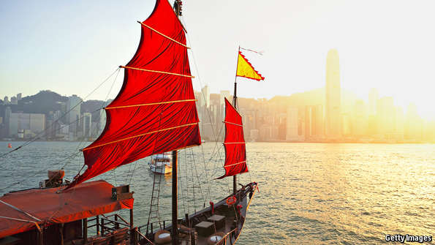
HALF a year on from pro-democracy protests that gripped Hong Kong for weeks, the city’s economy is—depending on your perspective—beginning to suffer the fallout or sailing along as if nothing much happened. A tale of two property markets sheds light on this. At one end of the spectrum are retail spaces. Hammered since the unrest by a slowdown in the growth of visits from the mainland, shop rents are expected to fall by as much as 20% this year. At the other end are offices. Buoyed by a series of new financial links with the mainland, vacancies in Hong Kong’s forest of glass-and-steel towers are at their lowest since the onset of the global financial crisis. The common thread is evident: more than at any point since the end of British rule in 1997, Hong Kong’s economic fate depends on mainland China.
That Hong Kong should be so interwoven with the rest of China might not seem surprising. It is, after all, a city of 7m people controlled by a country of 1.3 billion. But, as well as being administered under a separate political system, Hong Kong has long maintained a measure of economic distance from the mainland. Its currency is still pegged to the dollar, not the yuan, so it is American interest rates rather than Chinese ones that determine the cost of mortgages. As an entrepot for global trade, Hong Kong’s growth has hinged more on American and European demand for foreign goods than on the mainland’s relatively smaller appetite for imports. At least as of 2012 the American economy, not the Chinese, had a bigger impact on the ups and downs of Hong Kong’s business cycle, say researchers at the IMF.
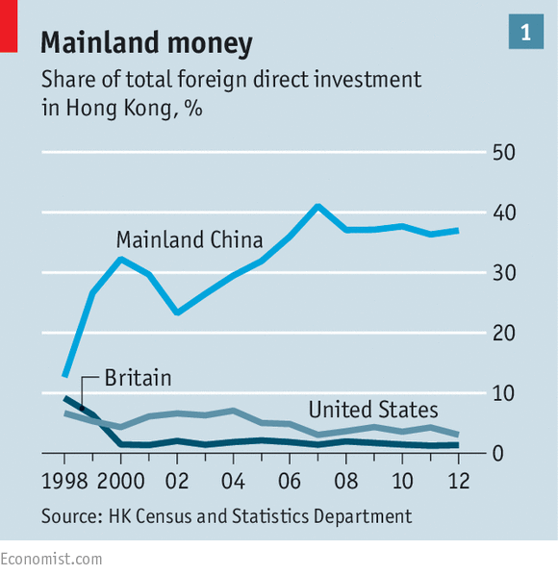
Over time, however, Hong Kong’s economy has been drawn deeper into China’s orbit. Most obvious is the influx both of mainland cash and visitors. The interior’s share of total foreign direct investment in Hong Kong has risen from barely a tenth in the late 1990s to nearly two-fifths today (see chart 1). If mainland companies registered in the British Virgin Islands and the Caymans were added, the tally would be even higher. CBRE, a consultancy, says occupancy by mainland firms of prime offices in major business districts rose from 12% in 2008 to 19% last year.
On the streets and in the subways, the patter of the Mandarin dialect spoken by many mainland tourists is ubiquitous. The number of mainland visitors to Hong Kong rose more than tenfold from 4.4m in 2001 to 47m last year (see chart 2), making up more than three-quarters of all foreign arrivals. A large number of these are “parallel traders” who flock to Hong Kong to haul boxes of basic necessities such as toothpaste and nappies back to the mainland, to sell for a markup. Yet many are also workers in the upper echelons of business and finance.
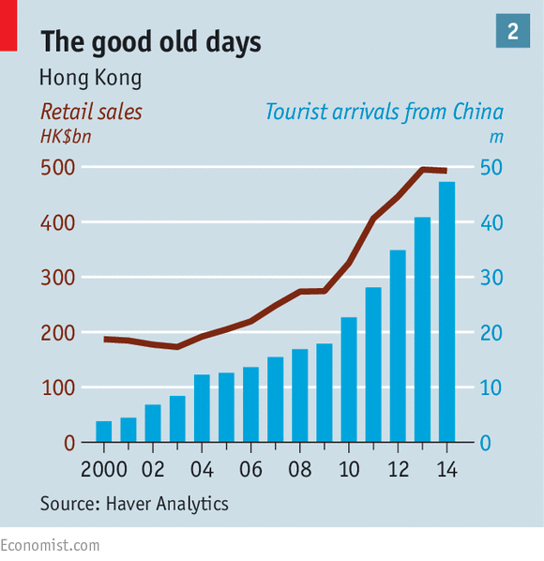
In the build-up to and during the pro-democracy rallies and smaller but nastier protests against parallel traders, many wondered whether Hong Kong’s economy would suffer. The Hong Kong offices of the “Big Four” global accounting companies—Deloitte, Ernst & Young, PWC and KPMG—warned that plans by demonstrators to “occupy” Central, the main business area, could cause “inestimable” economic losses because of disruption to the stock exchange and financial services. Some feared that Chinese tourists would shun Hong Kong because of anti-mainland sentiment in the city.
This second concern had some validity. After rising by an annual average of 21% over the previous five years, visits by mainlanders are up just 6% so far this year. With new rules that will halt day trips by parallel traders, limiting them to weekly access, the slowdown will become more marked.
Some retailers are suffering. Landmark North, a mall near the mainland border, targets shoppers from inland. Though located in a relatively poor area, its stores offer luxury goods. Transport back to the mainland for those laden with bags is an easy half-hour by bus or train. Lately, though, it has been short on a key part of the mix: customers. This is a citywide problem. Sales of jewellery and watches are down 16% this year—hence the forecasts of lower rents on retail properties. In some central locations, coffee shops and pharmacies have already replaced jewellers and high-end clothes shops.
But retailers’ woes started well before protesters began staging sit-ins on busy streets last year. The mainland’s economic slowdown and its fierce anti-corruption campaign have drained its appetite for expensive products. Luxury sales have been weak since late 2013; last year they fell by 13%. The decline in tourism growth is also easily misconstrued. With the yen and the won steadily weakening against the Hong Kong dollar over the past year, trips to Japan and South Korea look much more appealing to mainland travellers—though a recent outbreak in South Korea of Middle East Respiratory Syndrome may dampen tourists’ enthusiasm for that country, at least for a while (see article).
As for Hong Kong’s role as a global business and financial centre, last year’s sit-ins had even less discernible impact. Indeed, the Chinese government has moved to enhance that role. In November, during the unrest, Shanghai opened its closely guarded stockmarket to any foreigner with a Hong Kong brokerage account. Last month the mainland announced that mutual funds domiciled on its side or in Hong Kong could be sold in each other’s markets, giving a boost to Hong Kong’s asset-management industry. The mainland has also strengthened Hong Kong as the main offshore centre for trading the yuan by making it easier for cash to flow between the territory and mainland currency markets.
Just as important as financial links between Hong Kong and China are their improving physical connections. Two mammoth infrastructure projects, drawn up years before the protests, are on course for completion in the next few years, after a series of delays. A high-speed train will link Hong Kong to the neighbouring city of Shenzhen, while a 50km (30-mile) bridge will connect it to the interior.
Big companies are betting on the success of this integration. In a presentation this week, Stuart Gulliver, the chief executive of HSBC, a bank, said Hong Kong and the mainland area of the Pearl River Delta region would effectively combine as a single mega-city by 2025, forming the world’s biggest “banking city cluster”. Some analysts think it only a matter of time before HSBC shifts its headquarters to Hong Kong from London. Such talk is a sign that, for all the Big Four’s fretting last year, global finance still has confidence in Hong Kong—thanks, not least, to its ever-tighter embrace with the mainland.

Hong Kong and Taiwan

Losing hearts and minds

Dissatisfaction with China in Hong Kong and Taiwan shows up on the streets and at the polls. The causes are strikingly similar
Dec 6th 2014 | BEIJING, HONG KONG AND TAIPEI | From the print edition

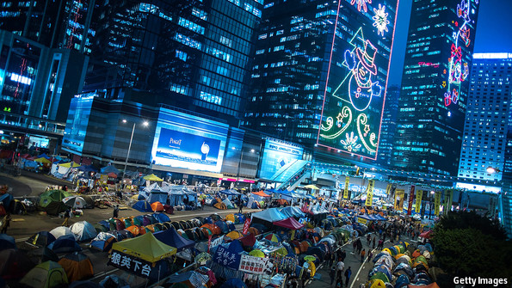
THE Communist Party’s strategy for bringing the self-governing people of Taiwan into its fold has long been tricky seduction. Ply them with money and favours (and tourists from the mainland) if they play along, and with threats of cutting them off if they don’t. Let them see how happy and prosperous the people of nearby Hong Kong are under Chinese rule.
That strategy is faltering. China is not winning hearts and minds in either Taiwan or Hong Kong. On November 29th voters in regional and municipal elections in Taiwan delivered a drubbing to the ruling Kuomintang party (KMT), which under President Ma Ying-jeou has forged closer economic links with Communist leaders in Beijing but has failed to soothe widespread dissatisfaction with the economy. More than 60% of the 23m people of Taiwan will now be governed by mayors who belong to or are supported by the Democratic Progressive Party (DPP), which opposes union with China. Mr Ma is now an unpopular lame duck serving his second (and final) four-year term, and the DPP has the early advantage in the presidential election due to be held in early 2016.
The electoral rout of the KMT is even more worrying to Chinese leaders seen in the context of Hong Kong, where protesters have been demanding more democratic elections than promised for 2017, when the position of chief executive comes up for a popular vote. After two months of huge demonstrations, the protests seem to be near an end following violent clashes between police and demonstrators. Leaders of one protest group, Occupy Central with Love and Peace, have called for protesters to go home. Two encampments, one of them outside the government’s headquarters, remain. But Hong Kong’s leaders have wisely waited for public opinion to sour. On December 1st Joshua Wong, an 18-year-old from the student group Scholarism, turned to a new tactic: a hunger strike. Three founders of the protest movement, however, turned themselves in to the police. They were released without charge.
Anti-mainland sentiments still run high. A poll in October by Chinese University of Hong Kong found just 8.9% of respondents identifying themselves solely as “Chinese”, the lowest figure recorded in the survey—and way down on 32.1% in 1997, the year of Hong Kong’s handover. Nearly two-thirds identified themselves as a combination of Hong Konger and Chinese, but another 26.8% said they were just Hong Kongers, the highest share since 1998.
Polling tells a similar story in Taiwan. In a survey in June by National Chengchi University, 60.4% of respondents said they identified as Taiwanese, a record high and up from less than 50% when Mr Ma was first elected in 2008. Only 32.7% identified themselves as “both Taiwanese and Chinese”, a new low.
China insists the problems posed by Hong Kong and Taiwan are separate. There is some truth in this. Voters in Taiwan, dissatisfied with the economy, have been aching to repudiate Mr Ma’s party at the polls. In Hong Kong young people have been increasingly chafing over Chinese rule. There have been bits of cross-pollination between youth movements in both places, but with little impact on events in either. (Chinese officials, for their part, blame “hostile foreign forces” from America and Britain for fomenting unrest; a committee of British parliamentarians has been denied entry to Hong Kong on the grounds that they had unfriendly intentions.)
Yet many grievances of young people in both places are strikingly similar. They are unhappy with growing inequality of wealth and are wary of integration with the mainland. Well-connected mainlanders are increasingly seen as interloping competitors for jobs. Investors from the mainland (and, in the case of Taiwan, rich Taiwanese who live on the mainland) bid up property prices. Rising numbers of tourists from the mainland have raised consumer prices (the torrent continued to increase in Hong Kong even during the protests, to 4m visitors from the mainland in October, up from 3.4m in the same month a year ago).
And in both Hong Kong and Taiwan there is a sense that the economic embrace of the mainland has enriched only the elite—the tycoons who are seen to be controlling Hong Kong and rich Taiwanese entrepreneurs who back eventual unification. Young people find it difficult to find work in either place: unemployment for 20-24-year-olds in Taiwan is around 14%, and the jobs they find pay little, as wages have stagnated.
A turning point in Taiwan came early this year, when young Taiwanese were at the forefront of an occupation of the legislature that lasted for more than three weeks. The protest, known as the “Sunflower Movement”, aimed to stop the legislature ratifying a cross-strait deal that would have allowed greater liberalisation of trade in services. The pact ignited fears that an influx of Chinese businesses would overwhelm Taiwanese competitors and flood Taiwan with cheap Chinese labour. It has since been stuck in Taiwan’s legislature without being ratified.
There seems little hope of more cross-strait dealmaking now. The results in the elections for 11,130 mayors, councillors and town chiefs represented “a total collapse of people’s confidence in the government and the ruling party”, says Jason Hu, who was voted out as mayor of the central city of Taichung. The KMT, which controlled four of the six main municipalities of Taiwan before the polls, emerged as victor in just one—losing even the capital, Taipei, long a KMT stronghold.
China’s president, Xi Jinping, will not have been too shocked. He knew after the Sunflower debacle that he had work to do to build better relations with Taiwan. In June Zhang Zhijun, the director of China’s Taiwan Affairs Office, became the first ministerial-level Communist official to visit Taiwan since 1949, when Chiang Kai-shek fled to the island at the end of the Chinese civil war. Mr Zhang also took the unusual step of meeting a prominent member of the typically despised DPP. There was an air of magnanimity not seen in cross-strait relations in years.
But will China adjust its approach to Taiwan, or to Hong Kong? In the wake of the election even KMT supporters seem less keen on economic co-operation with the mainland. Media in China shrug off Taiwan’s elections as “the chaos of democratic politics”, but have no suggestions for making voters happier. Perhaps it would help if citizens in both places got more of what they wanted. In Taiwan the DPP plans to deliver just that, with such things as virtually free health care for the elderly, welfare for the underprivileged and lots of social housing. (Hong Kong’s leader, Leung Chun-ying, won no sympathy for fretting aloud that “numerical” democracy would tilt policies towards the poor.)
There are signs of recognition in Beijing that the roots of discontent in Hong Kong must be addressed. On December 2nd an editorial in Global Times, a newspaper in Beijing, said that Hong Kong should manage its own problems. “The mainland shouldn’t be tempted to quell the unrest with troops too easily,” the newspaper said. “It can only bring temporary peace, but the deep-rooted cause will still linger.”

Family Business in Asia

Special report: Family companies

Typology

United by diversity

The four main types of family business
Apr 18th 2015 | From the print edition

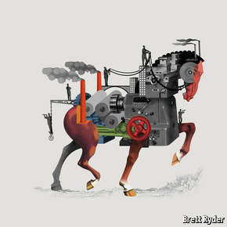
FAMILY COMPANIES COME in many guises. In a paper published last year Soumodip Sarkar, of the University of Evora, and two colleagues identified 200 different definitions. Some people use the term as a synonym for a small company, for others it means a closely held company. This special report will define family companies as those with families as either owners or managers or a combination of the two. They must involve more than one family member, and there has to be a succession, or a planned succession, from one generation to another. In a new book, “The Family Business Map”, Morten Bennedsen, of INSEAD, and Joseph Fan, of the Chinese University of Hong Kong, explain that this basic model comes in four main flavours.
In a classical family company the family exercises both ownership and control, as exemplified by members of the Hénokiens Association, an international club of 44 family businesses that combine family ownership and management and are at least 200 years old. They include 14 Italian companies, 12 French, five Japanese, four German, three Swiss, one British and one Austrian. The British have gone one better with a Tercentenarian Club of companies, owned and controlled by the same family for over 300 years.
As firms get bigger, this combination of ownership and control becomes harder to maintain, but a few manage to hold on to both. Lakshmi Mittal, scion of an Indian steel dynasty, owns 41% of the shares of Arcelor Mittal, the world’s largest steelmaker, and acts as both chairman and CEO. Charles and David Koch between them own 84% of the shares of Koch Industries, a company with revenues of $115 billion. Charles Koch is the CEO and David his loyal lieutenant.
In the second model, the family owns a controlling stake in the company but hands over the running of it to professional managers. The Walton family owns around half of Walmart but does not run it on a day-to-day basis. Passive ownership can be risky for families. The Cadburys retreated from direct management of their chocolate empire and progressively diluted their family control, so when Kraft, a giant American food company, made a hostile bid for the company in 2010, all they could do was protest.
Some families seize their patrimony back from professional managers. Li & Fung, a Hong Kong-based trading group, saw the family’s control slip away after the company was listed on the Hong Kong stockmarket in 1974. But in the mid-1980s William and Victor Fung reasserted family control by borrowing to buy out other owners and then relisting the company on the stockmarket in 1992.
Third, and more surprising, in some family companies the family retains very little ownership but continues to play a managerial role. This model is fairly common in Japan. The Toyodas and Suzukis have only small shareholdings in the companies that bear their names, but Suzukis have managed the company for generations. Toyota appointed Akio Toyoda CEO and president in 2009 when the company had been forced to recall 4.2m cars after a safety scare. The eight families that in 1917 founded Kikkoman, a soy-sauce company, own just 20% of it now, but the post of CEO continues to rotate among them.
In a fourth type of family firm the family turns itself into a venture-capital fund to give its younger members a start in life. The Mulliez family owns one of France’s leading retail groups, Auchan, and younger members have used family money to found many other companies, including Decathlon (sports), Pizza Pai and Flunch (catering), Leroy Merlin (do-it-yourself) and Boulanger (electrical appliances). These businesses are all owned by a holding company, Cimovam, that employs 366,000 people.
Many family companies are hybrids, alternating between giving managerial roles to family members and bringing in hired guns. Barings flip-flopped between family and non-family CEOs before the bank went under in 1995. Since Henry Ford died in 1947, three members of his family have been CEOs.
The prevalence of the hybrid form argues against the idea that families tend to move from being owner-managers to passive shareholders. That seems to have been the dominant model in the Anglo-Saxon world, but not elsewhere. Julian Franks of the London Business School and his colleagues studied more than 30,000 firms across Europe and found that older firms in France, Germany and Italy are in fact more likely to be family-controlled than younger ones.

Special report: Family companies

Asia

Asian values

In the world’s most dynamic region, family companies occupy the commanding heights of capitalism
Apr 18th 2015 | From the print edition

THE BUSINESS CAPITAL of the Philippines is a part of Manila called Makati. But it might be called Ayala, after the country’s most powerful company, which seems to dominate it. Ayala’s 35-storey headquarters stands in the heart of Makati, in Ayala Triangle just off Ayala Avenue. Its tenants include the Philippines Stock Exchange as well as a roster of the world’s big banks. The local museum is called the Ayala Museum (and houses a stunning collection of pre-colonial gold). Even the headquarters of the Bank of the Philippine Islands (BPI), which challenges the Ayala Tower for dominance of the skyline, is not really a rival: BPI is the financial arm of the vast Ayala empire.
Ayala has six divisions: property (Ayala Land), banking, mobile phones, utilities, call-centres and electronics. But this list understates the company’s ambitions. Ayala Land is in the business of turning plots of Philippine land into parcels of the American dream (and lifting their market value sky-high).
The Ayala empire has been run by the Ayala-Zóbel dynasty for the past 181 years. The family started out in agriculture, then diversified into everything from construction to phones. The Zóbels have professionalised and focused the company in recent years. The six main businesses have been listed on the stock exchange and put in the hands of professional CEOs, but the family remains at the heart of the firm. Two brothers from its sixth generation, Jamie Augusto and Fernando, run the holding company that sets the strategy. Three children from the eighth generation are working their way up the corporate hierarchy.
Jamie Augusto has a glowing vision of the company as the driver of his country’s modernisation. It has always taken a leading role in this, from building infrastructure to supporting corporate philanthropy; the Ayala Foundation is one of the country’s largest. But in recent years it has increasingly focused on the mass market in an effort at “nation-building”. Jamie Augusto, an alumnus of Harvard Business School, says this change of direction has been influenced by eminent management gurus. C.K. Prahalad urged companies to look for the “fortune at the bottom of the pyramid” and Michael Porter advised them to embrace “shared value”. But it would be just as accurate to credit the influence of Globe, the family’s communications business: you cannot build a mobile-phone empire without considering the poor.
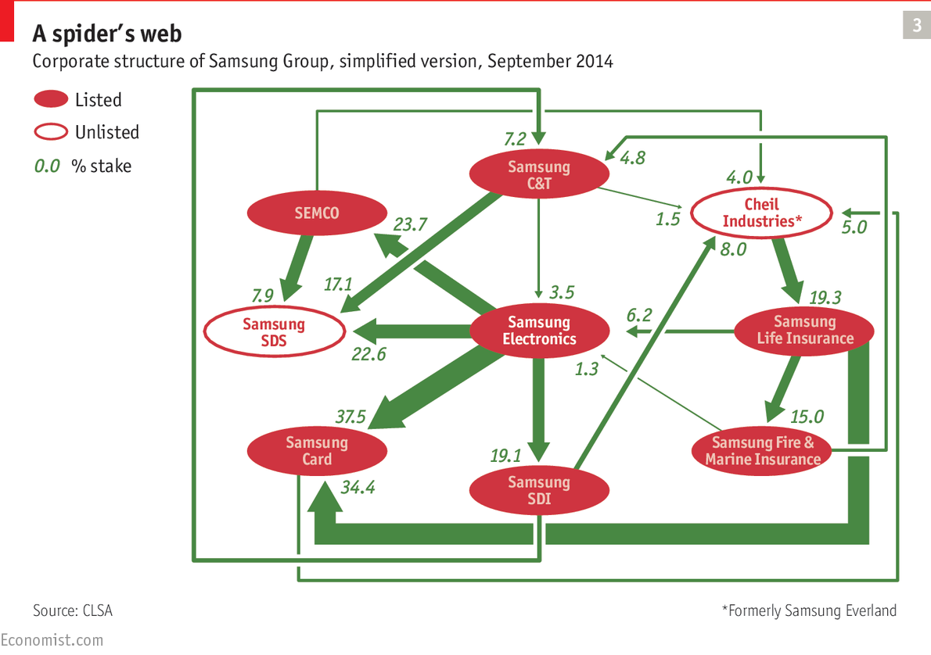
It is hard to know what to make of this vision of the family company as nation-builder. On the one hand Ayala is an unelected body with an interest in keeping new businesses out of the market. On the other, it is an efficient organisation that has had to compete with other conglomerates, some of them run by overseas Chinese, notably Henry Sy’s SM Group. Whatever their faults, these conglomerates do a better job of providing services than does the Philippine state, with its noxious mixture of incompetence and rent-seeking.
Ayala Land provides Makati with much of its public infrastructure in the form of walkways and parks. In 1997, when Ayala took over Manila Water, the taps in the utility’s headquarters did not work. Today it offers a reliable water supply to more than 8m customers. The company is good at long-term thinking and co-ordinating activities across a broad range of industries. In one of Ayala Land’s projects, Nuvali, it is building not just houses but also schools and churches for the people who work in the company’s factories and call-centres.
The commanding heights of the world’s fastest-growing region, Asia, are dominated by great business families. At first glance companies such as Samsung and Hutchison Whampoa may look like regular public companies, but closer examination quickly reveals a family dynasty and a family saga. The partial exception to this rule is China, where state-owned enterprises (SOEs) still dominate. But even there the country’s own brand of family capitalism flourishes wherever the state allows it to.
Family companies were at the heart of the development of capitalism in Asia. Family names acted as a guarantee of honesty for fellow businesspeople and quality for consumers. Family ties allowed businesspeople to operate across countries and regions. Some families such as the Tatas added further lustre to their name by standing up to the colonial oppressors. Indians love to tell the (probably apocryphal) story of how Jamsetji Tata built the Taj Palace, the grandest hotel in Mumbai, because he was refused entry to a European-owned hotel.
For some observers these family companies are turning into eye-catching relics as specialised firms move in and contracts are enforced by lawyers. The great patriarchs who once presided over these dynasties are being replaced by professional managers who could just as easily work in London or New York as in Hong Kong or Mumbai. Many hereditary businesspeople share these doubts. Anand Mahindra, the boss of Mahindra Group, a conglomerate that has been run by a member of the Mahindra family for three generations, is uncomfortable with talk of family capitalism. Family companies are mostly stuffed with family members “99% of whom should not be there”, he says.
But the numbers tell a different story. Asian countries are far more family-oriented than Western ones, and well over half the largest business groups in South-East Asia and India are controlled by families. Family companies continue to draw on time-honoured advantages such as their good names and deep connections, and continue to reinforce their positions through judicious marriages.
Family companies can also draw on new advantages, such as modern management techniques and their connections with Western companies. The local princes and princesses are almost invariably educated at famous Western business schools (to which they make generous donations) and then polished in well-known Western companies such as McKinsey and J.P. Morgan.
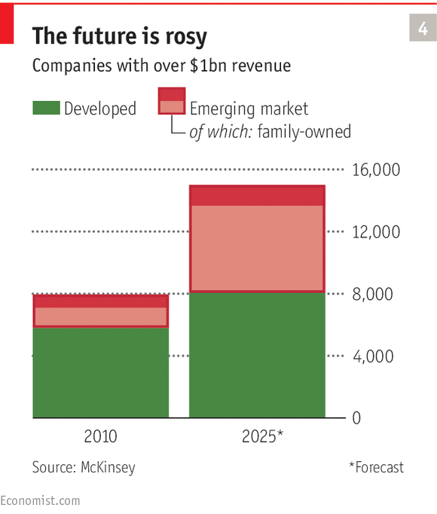
Vikram Bhalla, of the Boston Consulting Group, points to an even more important competitive advantage of Asian family businesses: their entrepreneurial zeal. They are more likely than public companies to make big bets and take big risks, and better than lone entrepreneurs at making things happen because they can mobilise far more resources. Being able to take a long-term view and co-ordinate activities across a wide range of sectors allows them to shape entire industries.
Which is yours?
Mr Bhalla divides Asian family companies into five main categories. The first is family-driven conglomerates, formed as the company repeatedly expands into new areas to provide jobs for the children. Boys tend to get “hard” industries such as construction whereas girls are given “soft” sectors such as hotels. The second is splitters, the opposite of the first: the family undergoes a strategic split to avoid (or disentangle) family conflicts. This can work smoothly, but is more often messy. The Birla family has repeatedly divided its empire amid furious arguments. The third group is institution-builders: the family hands over the day-to-day management of its businesses to professional CEOs and consolidates family power in holding companies. Anand Mahindra rules his group from his holding company. He likens himself to a “private-equity player” who chooses where to invest in the “Mahindra federation”.
The fourth category is joint families, in which several family members manage a company together. The main example of this is Asian Paints, which is flourishing under the joint control of three brothers. The fifth is serial entrepreneurs. Here the business platform is the family rather than the company: it moves from one industry to another but continues to use its name and connections to power its business dealings. The Piramals are a good example. Having started life in textiles, they shifted to pharmaceuticals, then used the profits from a judicious sale of their generic-drugs business to America’s Abbott Laboratories to go into big data and financial services.
But even such typologies risk understating the role of families in Asian business. Most of them are far more deferential to their patriarchs than their equivalents in the West, even in the face of dubious business decisions. They are also far more all-enveloping, even if they seem completely Westernised. Ajay Piramal, chairman of the Piramal Group, is a habitué of Davos; his wife, Swati, a doctor, is a member of Harvard University’s Board of Overseers; his two children were educated at “all the brand-name universities and business schools”. But the entire Piramal clan, numbering 40 in all, lives together as a huge extended family, discussing business and family affairs over every meal. “We go to Harvard,” says Mrs Piramal, “but we also wear saris.”
Perhaps the best place to learn the secrets of Asian capitalism is not the business sections of the newspapers but the gossip pages of glossy magazines. The stories of family feuds and scheming mistresses that can be found there are far more likely to change the balance of corporate power than the latest hostile takeover. As in family businesses the world over, the most important dramas are to do with succession. Many of the great patriarchs who created modern Asian capitalism have been useless at succession planning. They hold on to power until they have one foot in the grave. Talking about succession, they reckon, “is almost like putting a curse on someone”, in the words of Yupana Wiwattanakantang, of the National University of Singapore Business School. Sir Run Run Shaw, the chairman of Television Broadcasting Limited, waited until he was 103 to announce his retirement, handing his position to his 79-year-old wife. Joseph Fan of the Chinese University of Hong Kong studied succession in 250 family firms in Hong Kong, Taiwan and Singapore and found that on average the firms lost 60% of their value in the period spanning five years before succession and three years afterwards. Many lost a great deal more.
Again, feuds are commonplace. One of the highest-profile ones was the bitter dispute between Mukesh and Anil Ambani over their conglomerate, Reliance, after their father, Dhirubhai, died without leaving a will. Mukesh has proved the more talented of the two, celebrating his relative success by building a 27storey house in Mumbai for his family.
The tale of the Kwok family is even more colourful. Kwok Tak-Seng built up his company, Sun Hung Kai, to become the second-largest business group in Hong Kong and then left it to his wife and three sons, Walter, Raymond and Thomas. This quartet got on well until Walter was kidnapped and held in a wooden cage for a few days until a ransom was paid. The aftershocks of the kidnapping tore the family apart. Walter accused his brothers of quibbling over the size of the ransom, the rest of the family tried to oust him from his role as chairman of the family trust, and the fight continued for years.
Asian family politics are further complicated by Chinese patriarchs’ tendency to have several families. Stanley Ho’s gambling empire has repeatedly been convulsed by fights over inheritance between different branches of his family (he has had four wives). Given that the company once accounted for 40% of the Macau economy, these quarrels have aroused keen local interest. And since Wang Yung-ching’s death in 2008, his Formosa Plastics group has been rocked by rows among the nine offspring he had with his three wives.
Fixing family capitalism
As the patriarchs who built Asian capitalism after the second world war retire or die, Asia is seeing one of the biggest transfers of wealth in history. Some families are learning how to prepare their companies for a different age, preserving a measure of family power while also modernising their patrimonies.
The retiring generation has given its children two things that they need to succeed in this new world: personal wealth and a privileged education. But they are also wired into the old world of “Asian values”. Victor Chu, the boss of First Eastern Investment Group, is one of the rising generation of middlemen-cum-dealmakers. He earned his reputation in Japan by founding Peach Aviation, a low-cost carrier. (“He may not have his own plane but he does have his own airline,” quips a friend.) But his real talent lies in connections: he spends his life introducing Western companies to the East and vice versa.
The best example of a successful transition is Asia’s richest man, Li Ka-shing. When he put together his property and trading empire, Cheung Kong, political and family connections were vital. He had a genius for establishing monopolies through licences and building businesses with astonishing speed. But he has been preparing his empire for a different world for decades. He chose the cleverer of his two sons, Victor, to succeed him and set up his other son, Richard, in a different business to head off any quarrels. He has consolidated his empire into a more formal structure, with Hutchison Whampoa at its heart, and is moving its centre of gravity from Hong Kong to the global stage.
The Zóbels of Ayala fame also look likely to be around for generations to come. They have made use of all the tools of sensible family government and are training up the next generation of Zóbels in the family business. In a society given to flashiness, they come over as relatively modest. That helps at a time when the gap between the new business aristocracy and the poor is opening ever wider.

Special report: Family companies

Making it work

The family way

Distinctive problems call for tailor-made solutions
Apr 18th 2015 | From the print edition

JAPANESE BUSINESSES HAVE come up with a logical solution to the problem of disappointing heirs: find better ones. The easiest way to do this is to persuade your daughter to marry a talented man. (“You can’t choose your sons,” goes a Japanese adage, “but you can choose your sons-in-law.”) Another way is to adopt a star employee as a son. For best effect these two techniques can be combined: adopted sons can be persuaded to marry their stepsisters. A study of leading Japanese companies since the second world war found that about 10% of “family successions” in business families involved a son-in-law or an adopted son. Kajima Construction has been run by non-blood heirs for three generations. Suzuki Motors, too, has had a run of non-blood heirs. Osamu Suzuki, who was himself adopted into the family, chose his son-in-law as his successor, though the proposed heir then died. The use of adoption not only allows business families to draft in talent from outside. It also puts competitive pressures on biological heirs by raising the possibility that they will be moved aside.
The Japanese solution is unlikely to travel. But across the world family companies have been producing distinctive solutions to their distinctive problems, and they are getting better at it. That is partly because they have a growing body of family-company lore to draw upon. One grandee of a storied Western company active in the East says that China’s new billionaires are constantly asking him about the secrets of his company’s longevity. Partly, too, it is because the management-theory industry is at last beginning to take family companies seriously.
The secret of the pyramids
The biggest challenge for family companies is how to preserve family control while competing with public companies that can draw on public capital markets. One solution is to stick to a tiny global niche; many Mittelstand companies credit their success with refusing to compete “where the elephants play”. A second strategy is to form a close relationship with a local bank. This was once popular with Quaker families in Britain and is still the norm in much of continental Europe. But the most successful technique is to structure your company so that you can separate the right to a return (income) from the right to a say in how the company is run (control).
The most popular way to do this is by pyramiding. Yoshisuke Aikawa, the founder of the Nissan group in pre-war Japan, saw pyramids as the ideal solution to what he called “the capitalist quandary”. If a capitalist uses only his own or his family’s money, his scale of operations will be too small. If he taps into public equity markets, he risks losing control. Pyramids provide him with the best of both worlds—secure control and unlimited access to public capital. The family controls the company that sits at the top of the pyramid, which has a controlling stake (say 51%) in the company at the next level, and so on down the pyramid. This system allows families to maintain the maximum amount of power for their investment (and, as they see it, gives passive investors the maximum amount of profit from the managerial abilities of talented families). Sweden’s Wallenberg family and Italy’s Agnelli family both control large swathes of their country’s economies through pyramid structures.
A second technique is to issue dual-class shares, with the upper class carrying superior voting rights. This is widely practised in the media world. The most enthusiastic pyramiders also use dual-class shares: the Wallenbergs provide 40% of the capital for their investment vehicle, Investor, but control 80% of the votes. There are lots of variations on this two-class option: voting caps on non-family shareholders; cross-shareholdings giving families holdings in each other’s companies; golden shares that carry specific rights, such as blocking the sale of the company; and staggered boards that cannot be changed when the majority shareholding changes hands.
A third way of separating income from control is to put the ownership of the company into a trust or a foundation. Many of the world’s biggest companies, including the New York Times, Walmart and Ford, are owned by family trusts. Many of the most successful business families in Germany and northern Europe have handed their companies to foundations in order to manage their tax bills, including Bertelsmann, Heineken, Carlsberg, Robert Bosch, Novo Nordisk and Maersk. Trusts and foundations not only allow families to keep control of a company indefinitely, they let them exercise self-discipline: seats on the foundations can be reserved for the most talented and hardest-working members of the family.
Critics say these techniques offend against the principles of good corporate governance. Powerful families can use pyramids to transfer money between companies under their control and employ dual-class shares to disenfranchise other investors. Two decades ago the tide seemed to have turned against these devices. But founders of tech companies are keen on them, claiming that they provide protection against short-termism. The decision by Alibaba, a huge Chinese e-commerce company, to list on the New York Stock Exchange (which allows dual-class shares) rather than the Hong Kong one (which does not) has created strong pressure to reverse the bans.
The most important skill for any family business is managing the family itself
Another big challenge for family companies is how to professionalise their management without losing their family roots. Ideally, this is done by training family members to become accomplished professionals. Brown-Forman, a maker of spirits such as Jack Daniel’s and Southern Comfort, ascribes its success over the past 140 years to a policy of “planned nepotism”. Many family companies throw a dauphin in at the deep end and see if he can swim. John Elkann, the chairman of Fiat (and a member of The Economist’s board), worked incognito at a number of different family-related businesses before stepping up to the top job. All members of the Mulliez family who want to have a career in one of its companies or get involved in its venture fund have to undergo a strict apprenticeship. The De Kuyper family, which makes spirits, has an independent supervisory board responsible for selecting family members who want to work in the company. They must have gained a university degree and held a job in an unrelated firm for five years.
Some families choose outside managers to run the day-to-day operations of their companies but keep a careful eye on them from the boardroom. The Freudenberg Group, a classic German Mittelstand company, has been run by Freudenbergs for eight generations and has deep roots in its home town of Weinheim. But the Freudenbergs have retreated into a supervisory role and chosen an American-Iranian, Mohsen Sohi, to mastermind the rapid globalisation of their company.
Estée Lauder, a large cosmetics firm, has chosen a middle way. The company is enveloped in family tradition: much of the 41st floor of the General Motors Building in New York where it has its headquarters is given over to the eponymous founder’s perfectly preserved office and a reproduction of her sitting room in her Palm Beach house. But in 2009 William Lauder decided to step down as CEO and bring in Fabrizio Freda, a senior executive at Procter & Gamble. At the time the company was badly adrift, and William found the job exhausting. “Being CEO of a company is a sentence,” he likes to say. “Being CEO of a family company is a life sentence because your largest shareholders have your home phone number and don’t hesitate to phone any time of day or night.” Mr Freda’s professionalism has worked wonders: the share price has increased by about 145% since he took over and its market capitalisation has soared from $6.5 billion to $30.8 billion. But William Lauder remains closely engaged: he and Mr Freda have offices opposite each other, and in a joint interview with your correspondent they often finished each other’s sentences.
Keeping the peace
The most important skill for any family business is managing the family itself. Professional managers have to succeed at only one thing: managing the company they work for. Family managers have to succeed at managing both their companies and their families. The second is a precondition for the first.
Sensible families approach both tasks with the same rigour. They draw up family constitutions to work out the division of power and responsibilities. They appoint family offices to run the family’s affairs. They hold regular family councils and retreats, create private websites and publish family histories to foster a sense of collective pride.
Sweden’s Bonnier family, which focuses on publishing and media, is ruled by a general assembly of 76 family members, some of whom are responsible for a holding company (which presides over the family’s businesses) and others for a foundation (which runs the family mansion as well as several subsidiary foundations). The family holds regular get-togethers to induct younger Bonniers into its traditions and reinforce mutual bonds. Germany’s Haniel family, too, works hard to encourage its 650 family members to behave as responsible owners and organises many events to enable them to meet.
Michele Ferrero, Ferrero Rocher’s long-time boss, who died earlier this year at the age of 89, was in some ways the archetypical family businessman of the post-war generation. He only ever gave a single interview to the press and refused to ask consultants or bankers for advice, convinced that he knew his business better than anyone else. It is impossible to argue with the success of his chocolate business, yet most leaders of today’s family firms belong to a very different world. They need to use new techniques to survive in a world of technological disruption and globalisation.
Family companies have become increasingly willing to use public-relations companies and law firms. They are also more prepared to draw on professional advice from consultancies and business schools. McKinsey and BCG are currently competing to produce cutting-edge research on family businesses. Switzerland’s IMD business school focuses heavily on family companies, and Harvard Business School puts on a popular executive-education course especially for them.
Wealthy families increasingly look at themselves as collective enterprises with different branches, including family philanthropy as well as core businesses. They are also becoming more businesslike in running their private affairs. The richest among them have traditionally employed family offices to look after their personal finances, staffed by wealth managers, accountants, lawyers and assistants. Today a new breed of multi-family offices is extending this service much lower down the wealth scale. These offices are increasingly extending their influence into new areas. Britain’s Salamanca Group started out providing security for wealthy clients from the Middle East; now it offers families advice on everything from how to get their children into the best British public schools or managing their property portfolios to protecting their family businesses from cyber-crime.

Why Hong Kong remains vital to China’s economy
Sep 30th 2014, 23:50 by S.R. | BEIJING

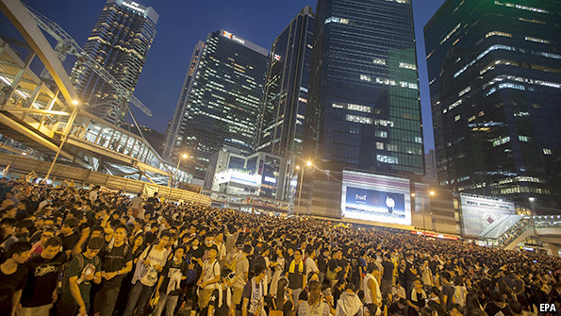
AS PROTESTS grip Hong Kong and worries mount about how China might respond, one of the most unsettling questions for the city’s residents is whether its fate matters much to the rest of the country. Hong Kong has long served as the bridge between China and the world, conveying trade and investment flows both ways. That role has diminished in recent years as China has opened its borders and plugged itself directly into the global economy. Hong Kong's leaders warn that the current unrest will only result in Chinese businesses bypassing it even more. Judging by size, they have a point: Hong Kong is clearly less important than in the past. Its GDP has shrunk from 16% of China’s in 1997, the year it was returned to Chinese control, to 3% today. That has led many inside China and abroad to conclude that Hong Kong is fading towards economic irrelevance. Is it?
Not so fast. The focus on size alone is too simplistic. With China’s development over the past two decades, growth has spread around the country—no one city can dominate GDP when there are now nearly 200 cities with populations of more than 1m people and rapidly rising incomes. But in the financial sphere Hong Kong has remained indispensable to China. And in several dimensions its position has actually been consolidated, not eroded, in recent years. Hong Kong has proved to be more reliable than the mainland as a source of equity financing. Since 2012, Chinese companies have raised $43 billion in initial public offerings in the Hong Kong market, versus just $25 billion on mainland exchanges, according to Dealogic. More than anywhere else in the world, Hong Kong has also provided Chinese companies with access to global capital markets for bond and loan financing. What’s more, Hong Kong is the key hub for investment in and out of China. It accounted for two-thirds of foreign direct investment into China last year, up from 30% in 2005.
Although much of this money is simply passing through Hong Kong, foreign companies also use the city as their staging post for investing in China as it offers them something that no mainland city does: a stable investment environment, protected by fair, transparent courts that enforce long-established rule of law. And it is not just foreign companies and investors that turn to Hong Kong. Over the past five years, the Chinese government has made the city a testing ground for a range of financial reforms: the yuan’s path towards acceptance as a global currency began in Hong Kong in 2009 with an experiment in trade settlement; Hong Kong is also home to the biggest “dim sum” bond market—yuan-denominated debt that is issued overseas; and a soon-to-be-launched programme that will for the first time allow any foreign investor to buy China-listed shares will be conducted via the Hong Kong stock exchange. Hong Kong has been only too willing to host these experiments believing, rightly, that they are crucial to its survival as a thriving financial centre.
In short, China has benefited greatly from Hong Kong’s unique status. It is a city that is sealed off from the mainland but closely connected to it; a territory that is fully integrated into the global economy but ultimately controlled by the Communist Party in Beijing. Even with its unique status, however, there is no question where the balance of power lies in Hong Kong’s relationship with China: about half of Hong Kong’s exports end up in China; one-fifth of its bank assets are loans to Chinese customers; and tourism and retail spending, mostly from China, account for 10% of Hong Kong's GDP. In the opposite direction, the Chinese economy’s direct exposure to Hong Kong is vanishingly small. But it would be a grave mistake to conclude that Hong Kong therefore does not matter to China. If China were to do anything that jeopardised their special relationship, Hong Kong would suffer most; but China would also pay a heavy price.
Dig deeper:
The risk of Hong Kong's unrest spilling over into mainland China may continue to rise (September 2014)
Daily chart: China’s censorship of the Hong Kong protests on social media (September 2014)
Essay: China wants the respect it enjoyed in centuries past. But it does not know how to achieve it (August 2014)

Democracy for Hong Kong

Unyielding
Sep 2nd 2014, 8:20 by J.C. | HONG KONG

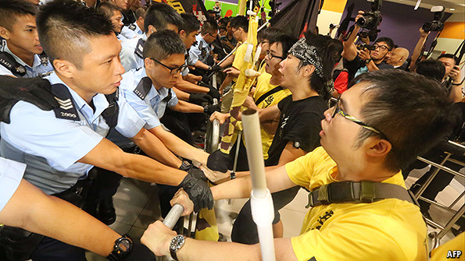
PRO-DEMOCRACY activists announced the start of a “new era of civil disobedience” on the night of August 31st, after China’s top legislature laid down restrictive guidelines on the kind of elections that are allowed in Hong Kong, a semi-autonomous territory. Officials in Beijing had promised to allow the election of Hong Kong’s next leader, in 2017, through universal suffrage. With the announcement China has clarified that there is a catch, and it's a big one: the government sees itself as being under no obligation to allow open nominations for the election’s candidates. Before the announcement, Chen Zuoer, one of the officials who helped negotiate Hong Kong's handover to mainland China back in 1997, had warned that "blood will be shed" if pro-democracy activists refuse to back down.
In a show of defiance, an alliance of activists who support fully open elections held a rally on Sunday night to declare that they would launch waves of protests, culminating in the occupation of the city’s main financial district. Their movement has been many months in the making; they call it “Occupy Central with Love and Peace”. It was first proposed nearly two years ago by Benny Tai, an associate law professor at the University of Hong Kong, in anticipation of a disappointing official interpretation of “universal suffrage”—just like the one that the central government has now given them.
Police arrested at least 22 people during protests that began on Sunday night and carried on into Monday morning. The student-union president at the Chinese University of Hong Kong has announced a strike; students there will have a rally of their own on September 4th around a replica of the “Goddess of Democracy” statue that became famous for its appearance in Tiananmen Square in 1989. Other universities are expected to announce strikes of their own in the next few days.
Many of the participants at Sunday’s rally despair at convincing the bureaucrats in Beijing to change their position—but they feel they need to put up a fight anyway. “Normal protests are no longer useful,” in the words of Agnes Chow Ting, a student protester. She led a failed attempt after the rally to “ambush” a delegation of officials from the central government.
Such actions may attract international attention but they are indeed unlikely to sway decision-makers in Beijing. Li Fei, a deputy secretary-general of the National People’s Congress Standing Committee, told local politicians on September 1st that the committee believes Hong Kong’s police will be capable of handling any disturbance that might be caused by “a small group of people seeking to undermine Hong Kong", as he characterises the Occupy movement.
Hong Kong's current chief executive, Leung Chun-ying, was picked for the role in 2012 by a 1,200-member “election committee”. A reliable majority of that committee were Hong Kongers who will ever be glad to demonstrate loyalty to their counterparts in Beijing.
The new reform package, which was endorsed unanimously by the National People’s Congress Standing Committee, is supposed to give meaning to the commitment to universal suffrage, which was guaranteed to Hong Kongers at the time of its handover to China. It turns out to be suffrage only of the crudest sort: allowing each adult citizen of Hong Kong a vote in the general election for the next chief executive, but not necessarily much of a choice. A committee with a make-up much like the so-called election committee is to be used to screen the candidates standing for the 2017 election. Each nominee must obtain more than half the votes of the rechristened “nomination committee” before being able to stand. This should make it impossible for any candidate who did not meet the approval of the Standing Committee to make it to the popular vote—never mind winning.
With leaflets and posters, the local government has been urging residents to seize the chance to embrace this form of universal suffrage in 2017. According to some prominent legal scholars in mainland China, a “less perfect” version of democracy is better than none at all. Universal suffrage is written into the city’s mini-constitution, the Basic Law, but there is no set timeline for its delivery. If its meaning cannot be agreed upon in time for the 2017 election, the next elections will be run according to the existing framework, wherein a closed committee chooses the chief executive all by itself, and appointed interest groups elect half the legislature.
The central government’s reform package requires the approval of two-thirds of Hong Kong’s local legislature before it can be implemented. A kink in the plan is that more than a third of the current assembly supports at least some of the demands of the pro-democracy protesters. Beijing’s officials will need to persuade at least five of those lawmakers to approve the package. The trouble for them is that 25 of those 27 members of the legislature have already signed an agreement to veto the proposal. “The veto is almost a certainty. We cannot accept fake democracy,” says Claudia Mo, a legislator with the Civic Party. “But after that there is no possibility of change and we can only soldier on.”
A sense of gloom has settled over the city. Democrats, moderates and pro-establishment figures alike predict that universal suffrage—in whatever guise—will be delayed. With that, they can expect political stagnation for the foreseeable future. It is not an indefinite future however. The Sino-British declaration of 1984, signed between Margaret Thatcher and Zhao Ziyang, was clearer in guaranteeing Hong Kong its state of semi-autonomy. That is supposed to last a period of 50 years, ending in 2047.

Democracy in China

The struggle for Hong Kong

The territory’s citizens must not give up demanding full democracy—for their sake and for China’s
Sep 6th 2014 | From the print edition

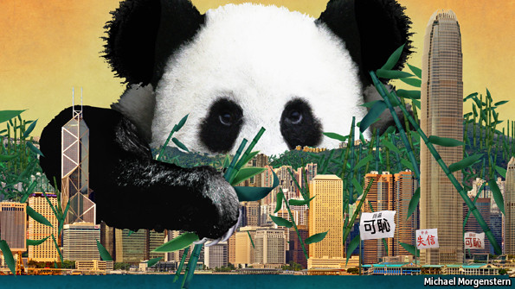
CHINESE officials have called it a “leap forward” for democracy in Hong Kong. Yet their announcement on August 31st of plans to allow, for the first time, every Hong Kong citizen to vote for the territory’s leader has met only anger and indifference. Joy was conspicuously absent. This is not because Hong Kong’s citizens care little for the right to vote, but because China has made it abundantly clear that the next election for Hong Kong’s chief executive, due in 2017, will be rigged. The only candidates allowed to stand will be those approved by the Communist Party in Beijing, half a continent away.
At its worst, this risks provoking a disaster which even China cannot want. Democrats are planning protests. It is unclear how many people will join in, but the fear is that the territory’s long history of peaceful campaigning for political reform will give way to skirmishes with police, mass arrests and possibly even intervention by the People’s Liberation Army. That would disrupt one of Asia’s wealthiest and most orderly economies, and set China against the West. But even if, as is likely, such a calamity is avoided, this leap sideways is a huge missed opportunity not just for Hong Kong but also for the mainland. A chance to experiment with the sort of local democracy that might have benefited all of China has been missed.
One country, one-and-a-half systems
China’s announcement marks the end of an era. No longer is it possible to argue that the development of democracy in Hong Kong can forge ahead even in the absence of political reform in Beijing (see article). The arrangements, set out by China’s party-controlled parliament, the National People’s Congress, were needed because of a pledge to grant the territory a “high degree of autonomy” and eventually “universal suffrage” when it took over from Britain in 1997. To most people, that meant having the right to choose their leader themselves.
China has stuck to the letter of its promise, but not the spirit. In 2012 the chief executive was appointed by a 1,200-strong committee stacked with the party’s yes-men from among Hong Kong’s business and political elite. The proposal for 2017 is that a similar committee will select candidates who will then be presented to all Hong Kong’s voters for election. In theory the committee could allow through candidates of many political stripes. In practice, pessimism is more than justified. Only two or three candidates will be allowed, and each must win the support of at least half of the committee. Under this arrangement, democracy will mean little more in Hong Kong than it does elsewhere in China, where every adult citizen can vote for local legislators—as long as the party approves.
This is bad for Hong Kong. The territory’s four leaders since the handover in 1997 were all chosen in Beijing and rubber-stamped into office. All of them, including the incumbent Leung Chun-ying, proved highly unpopular. Under a government in thrall to Beijing, the press has been subdued by intimidation and by pressure from advertisers. The judiciary fears that it may face a test of loyalty to the mainland. Some Hong Kongers complain that even the postal service is compromised—it refused to deliver leaflets urging civil disobedience.
The story may not be over. Activists in Hong Kong have vowed to launch a campaign of civil disobedience which they call, disarmingly, “Occupy Central with Love and Peace”, but whose declared mission is to paralyse the territory’s main financial district with sit-ins. This would be the first large-scale flouting of the law by the pro-democracy camp.
The activists’ aim is correct and their courage impressive, but their tactics may be mistaken. If the unrest gets out of control and troops are deployed, it would be a calamity for Hong Kong—and would probably set back the activists’ cause. Better to stick to what the democrats have always done best: staging the kind of peaceful protests that have made the territory a model of rational political discourse in a part of the world where it is often sorely lacking. And there is another form of peaceful protest available: Hong Kong’s legislators can reject China’s proposals, even though that would mean reverting to the equally undemocratic system used in 2012. Only a few dozen democrats now sit in the electoral college. They should, in future, boycott it. There is no point in propagating a falsehood.
If Hong Kong’s people keep marching without damaging the territory’s economy, China may well simply shrug. But not necessarily. It was thanks in part to a huge and orderly protest in 2003 that Hong Kong’s puppet government shelved plans to introduce an anti-subversion bill and that the hapless chief executive, Tung Chee-hwa, stepped down. Rather than break the law, Hong Kong’s democrats would do better to wield the weapon of embarrassment.
He’s blown it
But it is not only in Hong Kong that China’s decision to strangle the territory’s democratic aspirations will be felt. China’s government has alienated opinion in Taiwan, which it dreams of bringing under its umbrella in the same way. The party appears to have concluded that the damage done to the prospects of union with Taiwan is less important than the threat that one of its opponents might win an election in Hong Kong and stoke demands across China for political reform. The territory would also become independent in all but name. That, the government worries, would encourage separatists around China’s periphery, from Tibet to Xinjiang.
But discontent is growing all over China, and Beijing cannot just sit on it. The huge new middle class is becoming increasingly frustrated with its powerlessness over issues such as education, health care, the environment and property rights. In terms of their day-to-day worries, mainlanders have a lot in common with Hong Kong’s citizens. China’s government is going to have to work out a way of satisfying their aspirations for more control over their lives. Hong Kong would have been a good place to start.
Xi Jinping, the party chief and president, had the opportunity to use Hong Kong as a test-bed for political change in China. Had he taken this opportunity, he might have gone down in history as a true reformer. Instead, he has squandered it.

