**Economist**

**India and China**

**Himalayan obstacles**

Apr 18th 2014, 11:10 by Banyan | SINGAPORE

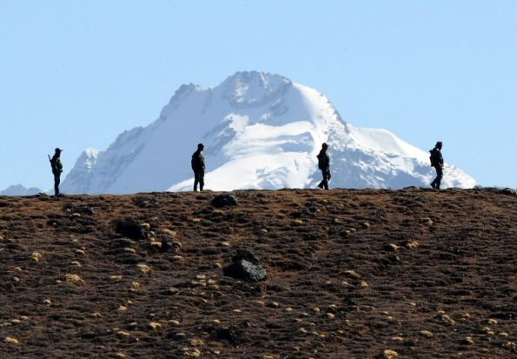

ODDLY, for a democratic country in the midst of an election, India this week held its sixth [“strategic dialogue”](http://timesofindia.indiatimes.com/india/India-China-hold-sixth-strategic-dialogue-to-review-ties/articleshow/33738149.cms" \t "_blank) with China. The talks in Beijing, between the two countries’ most senior diplomats, at least show how keen their foreign ministries are keen to maintain the long, slow rapprochement they have been pursuing for nearly three decades. They are still working to heal the scar in the relationship left by a brief but bloody border war in 1962.

It was also odd that a Chinese spokesperson said that the Indian side at the talks had said that [the outcome of the election will not change India’s China policy](http://www.fmprc.gov.cn/mfa_eng/xwfw_665399/s2510_665401/t1147430.shtml" \t "_blank). The favourite to be India’s next prime minister is Narendra Modi, of the opposition Bharatiya Janata Party, or BJP. He would presumably not be pleased if civil servants were committing him to following in the footsteps of his predecessors from the Congress party.

Like Shinzo Abe in Japan, or Vladimir Putin in Russia, Mr Modi appeals to voters in part as a patriot, who will brook no disrespect for his country’s standing. So when the campaign trail took him in February to the north-eastern state of Arunachal Pradesh, over which China claims sovereignty, [Mr Modi was forthright](http://in.reuters.com/article/2014/03/30/india-election-policy-modi-idINDEEA2T00620140330" \t "_blank): “I swear in the name of the soil that I will protect this country,” he told a rally.

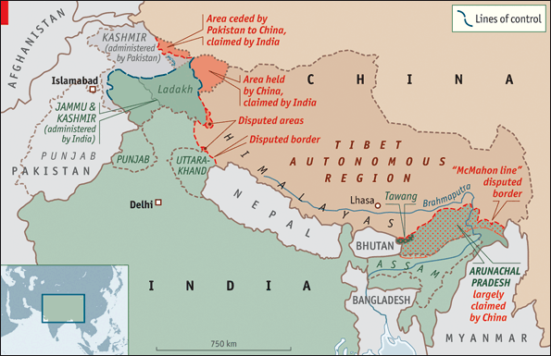

Since China, too, is these days aggressively assertive of its territorial claims, the prospects for a settlement of the long-running dispute under a government led by Mr Modi seem remote. They are. But in fact Mr Modi may be better placed to reach a deal with China than is the present government.

Indeed, as Kanti Bajpai, of the Lee Kuan Yew School in Singapore, points out, Mr Modi is by some measures on better terms with China than he is with America. In 2005 [he was refused an American visa](http://india.blogs.nytimes.com/2014/03/31/congressional-report-strengthens-case-for-future-u-s-visa-for-modi/?_php=true&_type=blogs&_r=0" \t "_blank) because of allegations about his complicity in riots in 2002 in Gujarat, the state of which he is still chief minister. He has twice been to China, courting Chinese investment into Gujarat.

He has two advantages over the incumbent prime minister, Manmohan Singh, in dealing with China. One is his reputation as a hardline defender of Indian rights, in contrast to Mr Singh, mocked by his opponents as a mild-mannered weakling.

The second is that Mr Modi’s Bharatiya Janata Party, the BJP, has less reason to be traumatised by the humiliation India suffered in 1962. Congress was in government then, and the prime minister was Jawaharlal Nehru, great-grandfather of Rahul Gandhi, Congress’s figurehead in this campaign.

The BJP has even sought to capitalise on this history during the campaign. In March an Australian writer, Neville Maxwell, published on the internet a big chunk of the “Henderson Brooks report”, an internal investigation into the Indian conduct of the war, commissioned by the Indian government and named after one of its co-authors.

Mr Maxwell covered the war for the *Times* of London and in 1970 published a revisionist history of it, “[India’s China War](http://www.amazon.com/Indias-China-War-N-Maxwell/dp/0394470516?&ref_=custrec_signin_redirect_same_page" \t "_blank)”, based in part, it is now clear, on this report. The book convincingly challenged the conventional wisdom in India and the West that it was a war of unprovoked Chinese aggression, and argued that much of the fault lay with Indian policy.

The report is still classified as top secret, and the government still refuses to release it. But one of Mr Modi’s BJP colleagues, Arun Jaitley, has [called for it to be published](http://www.bjp.org/en/media-resources/public-forum/interview-and-articless/article-shri-arun-jaitley-on-the-henderson-brooks-report" \t "_blank). He asked whether it is still classified because the war was “a Nehruvian blunder”. The suggestion is that it paints Mr Nehru, and hence by implication his party, Congress, and his dynasty, which is still leading it into the latest election, in a bad light.

The BJP itself refrained from publishing the report when it was in power, as recently as 2004, perhaps because it blames not so much Mr Nehru personally, as the army high command and intelligence services, who are portrayed as myopic, deluded and incompetent. It also undermines what remains the official version of events: that the war was provoked by an aggressive China to reinforce an illegitimate land-grab, against all the best endeavours of the idealistic and betrayed Nehru, who coveted nothing more than solidarity between Indian and Chinese “brothers”.

In fact, by 1962, brotherhood had already been tested by the uprising in Tibet in 1959, and the hospitality India afforded the Dalai Lama and 80,000 other Tibetans who fled into exile. Also, India had noticed that two years earlier China had built a road across the Aksai Chin, an area India claimed as part of its Ladakh region of Kashmir.

Keeping control of that strategically important road, linking its frontier regions of Tibet and Xinjiang, has always seemed one of China’s main war aims. But Henderson Brooks made plain that the conflict was provoked in part by a botched “forward policy” adopted by India to position small garrisons along the disputed borders in both the Aksai Chin, where an area the size of Switzerland is contested, and in the eastern sector, where territory three times larger—what is now Arunachal Pradesh—is at stake.

China overran Indian forces in both places. But, having made its point, it abruptly declared a ceasefire after a month and  withdrew, restoring the pre-war status quo. Since then it has been threatened at times by skirmishes or incursions, most recently in April 2013, when Chinese troops intruded [well into Indian-held Ladakh](http://www.economist.com/news/asia/21588367-manmohan-singhs-foreign-policy-undercut-domestic-weakness-eastern-promise%20for%20three%20weeks:" \t "_blank). But since 1988, when the two countries agreed to get on with improving relations in other spheres, they have been inching painfully towards a solution.

The two sides are working to demarcate the de facto border—more than 3,000km long. China has never recognised the “McMahon Line” that India inherited as the frontier in the eastern sector from a treaty signed between a Scot representing the British raj and an independent Tibet. **And both understand the “package deal” that could be done: in essence, the two sides simply keep what they have.**

Two big obstacles stand in the way. The first is that China no longer seems content with what it has. Of 14 sections of the border where agreement is elusive, one seems to matter very much: around [Tawang in Arunachal Pradesh](http://www.economist.com/blogs/banyan/2012/10/indias-remote-north-east). It was there that the 1962 war started. It is also the site of an important Tibetan monastery.  Facing uncertainty in Tibet when the present Dalai Lama (the 14th) dies, China now seems intent on incorporating Tawang, the birthplace of the sixth Dalai Lama, and, it argues, central to Tibetan Buddhism.

The second obstacle is the political difficulty both countries would have in persuading public opinion that big, if notional, territorial concessions were justified. China’s leader, Xi Jinping, may feel secure enough in his power to do so. But for India it would mean flouting [a parliamentary resolution](http://www.observerindia.com/cms/sites/orfonline/modules/occasionalpaper/attachments/op_33_1337324255608.pdf%20) passed after the defeat in 1962 that “India will recover each inch of territory lost to the Chinese”.

Nobody expects India ever to mount an invasion of the Aksai Chin. But formally giving up the claim is something no Indian prime minister could contemplate—unless he was absolutely sure that no one would impugn him as weak, unpatriotic or pro-China. Narendra Modi might fit that bill. But reaching a formal settlement with China is probably a long way down his list of policy priorities.