**The Hindustan Times**

**India must involve itself in the China-Pakistan One Belt, One Road initiative to stay in the game**

[columns](http://www.hindustantimes.com/columns/) Updated: Mar 01, 2017 15:21 IST

rinath Raghavan

Srinath Raghavan

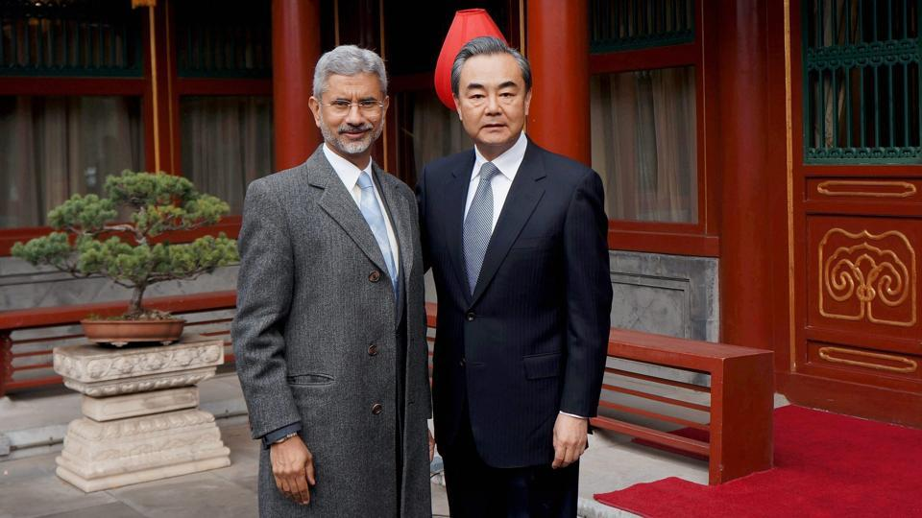

**Foreign secretary S Jaishankar with Chinese foreign minister Wang Yi , Beijing, February 22, 2017(PTI)**

The recently held strategic dialogue between India and China provides a useful reality check on the state of the play. Over the past year, the relationship had reached an impasse owing to China’s unwillingness to support India’s entry into the Nuclear Suppliers’ Group and to allow Masood Azhar of Jaish-e-Mohammed to be placed on the United Nations Security Council’s terror list.

In both cases India had insisted that these were litmus tests of its ties with China. New Delhi’s stance stemmed from an under-estimation of the growing importance of Pakistan to China and from an over-estimation of its own clout. If the former underscored the inability of the government to get the measure of China-Pakistan convergence, the latter flowed from the curious belief that international influence was mostly about talking ourselves up.

The meeting between the Indian foreign secretary and his Chinese counterpart has evidently not yielded much on either of these issues. Yet, New Delhi has sought to bracket them and emphasise the avenues of cooperation with Beijing. Given the disparity in power between the two countries, it was always faintly ridiculous for India to believe that it could stare down the Chinese. In its new co-operative mood, too, New Delhi should keep this underlying asymmetry of power fully in view .

The backdrop to the meeting, as the foreign secretary observed, was the “flux” in the international system. The advent of Donald Trump has called into question the continuation of a stable, open international economic order — one that benefited both China and India. In this context, it was desirable to aim at “a more stable, substantive, forward looking India-China relationship”. Both the diagnosis and the prescription are well taken. At the same time, it is important to recognise that the changing global context will impinge upon China and India rather differently .

The prospect of a trade war sparked off by Trump’s imposition of tariffs is surely a major cause for concern to the Chinese leadership. But they also know that United States does not hold all the chips. For one thing, China can retaliate against American exports on a range of things from aircraft to soya bean. More importantly, American tariffs will undercut global value chains and the accompanying deep integration of regulatory systems — commercial laws, taxation, intellectual property rights — fostered assiduously by the US in the past.

While this will hurt China in the short run, it also provided Beijing an opening to reorient economic integration in Asia under its leadership and on more congenial terms.

The collapse of the Trans-Pacific Partnership and the rolling out of the One Belt, One Road (OBOR) initiative have already provided Beijing the perfect setting in which to pursue a more ambitious agenda of Asian connectivity and integration. Chinese economists have also mooted ideas to channel a greater portion of Asian savings into investments in Asia — instead of persisting with the current pattern of effectively sending those savings to the US and allowing American banks and financial institutions to reinvest them in Asia. All this will take time and enormous effort, but the Chinese are well poised.

|  |
| --- |
| Ads by ZINC |
|  |

Politically, too, Beijing will stand to gain from Trump’s attitude towards longstanding partners in Asia. If an ally like Australia — which stood by the US even during the Vietnam War — came in for rough treatment, what are the odds that others are going to have smooth relationship with the Trump administration? To be sure, many of these countries will continue to be concerned about China but the emergence of countervailing coalitions may become difficult.

Unlike Beijing, New Delhi does not have many cards to play. Despite repeated expressions of interest, India’s record in fostering economic integration even in the subcontinent is underwhelming. Further, New Delhi has firmly refused to sign up to the Chinese OBOR initiative. The two sides did, however, discuss the possibility of cooperating on developmental activities in Afghanistan. Again, while this is welcome, New Delhi should recognise that Beijing does not really need to work with it in Afghanistan.

Over the past year and a half, the Chinese have been active in diplomatic efforts to bring the Taliban to the negotiating table. Apart from Pakistan and Afghanistan, they have worked with the US and Russia to facilitate these negotiations. Most recently, the Chinese have acknowledged that they have undertaken joint counter-terrorist operations with Afghan forces. All this is a sharp departure from Beijing’s earlier, tentative policy towards Afghanistan. In the light of growing Chinese activism as well as their deepening ties with Pakistan, it is unlikely that India-China “cooperation” in Afghanistan will amount to very much.

Instead of pursuing such chimeras, New Delhi should reconsider its position on the One Belt, One Road initiative. At the latest meeting, the foreign secretary reiterated India’s refusal to participate on the grounds that the China-Pakistan Economic Corridor violates India’s sovereignty over Kashmir. What matters, however, is not our motivations or desires but the outcomes of the Chinese initiative and their implications for India. Riding the high horse is unlikely to get us very far.

New Delhi is also put off by the fact that Beijing has not been adequately consultative in its approach. But petulance should not drive our policy. The reality is that the Asian economic order is set to undergo far-reaching changes. By refusing to take a realistic tack, India is effectively depriving itself of an opportunity to shape the transforming landscape of Asia.

***Srinath Raghavan is senior fellow, Centre for Policy Research, New Delhi***