India

Modi’s many tasks

Narendra Modi has grand ambitions for his country, and self-confidence to match. But he has yet to show how he will deliver, says Adam Roberts
May 23rd 2015 | From the print edition

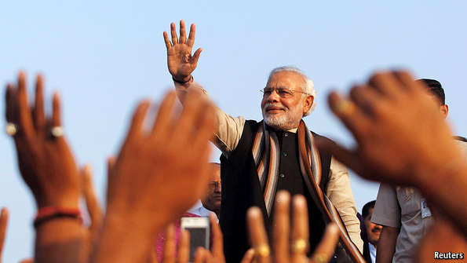
YOU WOULDN’T KNOW by looking at scruffy Vadnagar that it has a famous son. Tourists occasionally visit the walled part of the Gujarati town for its ornate wooden doors and balconies. A pair of stone gateways hints at a history stretching over two millennia. The town claims a mention in the Mahabharata, a saga of ancient India.

The railway station is single-track. Next to it, where the celebrity’s father once ran a tea stall, is a motorbike-repair shop. Over the road is his modest, whitewashed former school. Only in a street nearby, beyond a Sufi shrine, do you find hints of the great man. Neighbours all introduce themselves with the same surname: Modi, Modi, Modi.
Most of them recall something of the childhood of Narendra Modi, such as when he brought home a baby crocodile from a lake. They speak with respect more than fondness. He rarely helped his father with the tea stall. Friends from the school recall that he liked theatre and insisted on taking the part of a king. From childhood his passion was politics, and he soon joined the Hindu nationalist Rashtriya Swayamsevak Sangh (RSS) movement. A fellow RSS member recounts a playground scrap with Muslim rivals. A neighbour attended his teenage wedding. An unwilling groom, he soon fled town, leaving his wife behind. He rarely goes back.
This report is about the country of which Mr Modi became prime minister a year ago, and its nearly 1.3 billion people. Vadnagar is a useful starting point for understanding India today and making sense of his plans for the next 10-15 years. Even that time scale implies ambition. Elected politicians usually look no more than five years ahead. But this 64-year-old has never lost an election, and after the landslide victory in May 2014 that propelled him into the top job he made a triumphal speech insisting that “ten years is all that is needed” to modernise India. By 2022, the 75th anniversary of India’s independence, it will be clear that this is “India’s century”, he says. Sit with him and you come away impressed by an intensely driven outsider determined to leave his mark on national affairs. He can sound arrogant, vainglorious or hubristic. More than any Indian prime minister since Indira Gandhi, he personally embodies power. Last year’s parliamentary election pitted his Bharatiya Janata Party (BJP) against the incumbent Congress Party, plus regional parties, in 543 constituencies. It became a presidential contest in which Mr Modi, an energetic campaigner and charismatic speaker, steamrollered rivals. Congress, weakened by years of corruption scandals, poor leadership and slowing economic growth, failed to put up much of a fight. The media mostly fawned.
A Modi election delivered a Modi government. He appointed nonentities to many ministerial posts and is keeping the more impressive ones on a tight leash. It was Mr Modi, rather than Arun Jaitley, the finance minister, who crafted many details of the budget delivered in February.
During 70-odd interviews conducted for this report, including many with enthusiastic supporters, it was notable how often (and unbidden) words like “megalomaniac” and “authoritarian” were used to describe him. But Mr Modi’s ego seems easily big enough to leave him untroubled by such views. For a visit in January by America’s president, Barack Obama, he wore an expensive-looking navy blue suit with pinstripes made up of his name, repeated hundreds of times, stitched in gold thread.
One of the ways he has made his presence felt is by cutting bureaucrats down to size. He sacked the heads of the finance, home and foreign ministries soon after coming to office. That may have been necessary, since many civil servants have resisted reforms, but his style has spread dismay. He dominates his government but has struggled to silence members of the RSS as well as Hindu-nationalist-inclined members of his own administration who try to spread religious discord.
This report will explain how he uses the power he has accumulated, and how India is changing on his watch. It should be noted, however, that the country was already in the throes of considerable structural upheaval before he took over, including broad demographic change. Southern Indians are relatively old, urban, educated and middle-class and have ever fewer children. Similarly, Indians living on the west coast are becoming more like people in South-East Asia, both socially and economically. Largely because of those changes in the south and the west, India’s total population should reach replacement levels of fertility (an average of 2.1 children per couple) before 2020. That will be a historic turning-point, though there is so much momentum elsewhere that the population will keep on growing for quite a while, peaking at about 1.64 billion in 2065.
Welcome to IndiaPopulation gain, 2015 estimateSource: UN; The Economist4 in the past 8 seconds
Much of that growth will be in the north. In landlocked states like Uttar Pradesh and Bihar (which between them have over 300m people, almost as many as America) people remain mostly poor, rural and ill-educated, and have larger families. Their problems are similar to Africa’s. Public hygiene is poor and many treatable diseases linger. The economy relies heavily on rain-fed farming, and electricity is in short supply. Women, girls and female fetuses are discriminated against. Add religious clashes and the menace of Maoist revolutionaries in rural pockets, and it is no wonder that southerners can sound exasperated by their northern kin.
But there are common trends too, most of them uplifting. One is a steady stream of people moving off the fields. Over the next 40 years about 11m extra people a year are expected to push into Indian towns and cities. As a consequence, demand for non-agricultural work is growing. By one estimate, India needs to create 10m additional jobs a year to employ a youthful and increasingly literate population.
The virtues of impatience
Indians everywhere are becoming more demanding. Consumers expect better phones and internet connections, a chance to own a scooter or take a holiday. They want education, hospitals and reliable power. A vocal minority worries about a toxic environment, complaining of rivers like sewers and urban air thick with deadly particles from bad fuel.
Voters are now holding politicians responsible for things they can control, such as corruption or economic prospects, and even those they can’t, such as rainfall that damages crops and puts up the price of onions. Voting by religion or caste has not yet disappeared. But the young, urban and educated treat their politicians as they might a phone supplier: if the service is disappointing, they switch.
That impatience is a wonderful thing. Politicians are now pressed to deliver or get ejected, even sent to jail if found to be corrupt. Voters increasingly expect them not just to dole out a few freebies but to create conditions for their lives to become materially richer. They can see that many other countries are better off than theirs. Talk of a $2 trillion economy sounds good, but income per person in 2014 was still only $1,627, according to the IMF. (National statistics, shown on our map, use a different basis and put it at $1,364.) And inequality is rising. Credit Suisse last year counted 182,000 dollar millionaires in India. A far wider circle than that needs to prosper.
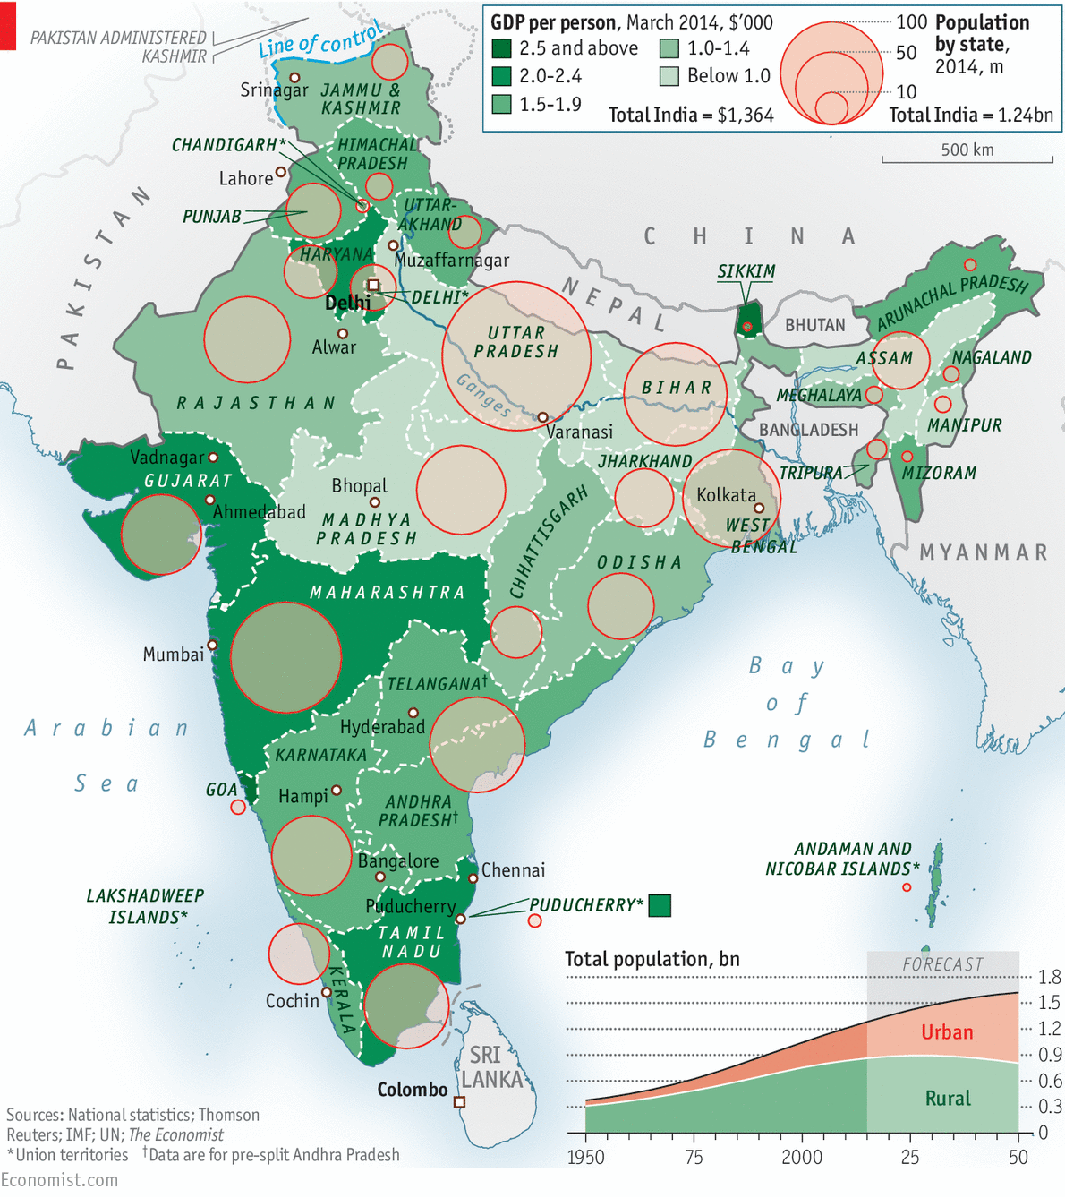
INTERACTIVE: Compare other indicators across India's states here
A year is time enough to ask how Mr Modi is beginning to shape the country. The first thing to note is that he is doing what he knows, applying the methods that worked for him in Gujarat, where he ruled for a dozen years. To his mind, effective political leaders are much like chief executives. He models himself on Singapore’s business-minded first prime minister, the late Lee Kuan Yew. In conversation, he praises the Singaporean for his “enormous work”. Like Mr Lee, he sets goals with dates attached, decides how they are to be implemented and monitors progress. At times he micromanages.
The taskmaster
Given Mr Modi’s predilection for tasks, The Economist has compiled a list of 30-odd official pledges announced in the past year to outline his government’s ambitions. A selection appears in the table above; the full list is available online. All have deadlines attached to them. Around half the tasks are meant to be completed by the next election, in 2019. Others are for later, so it will be some time before Mr Modi’s mission can be declared a success or a failure.
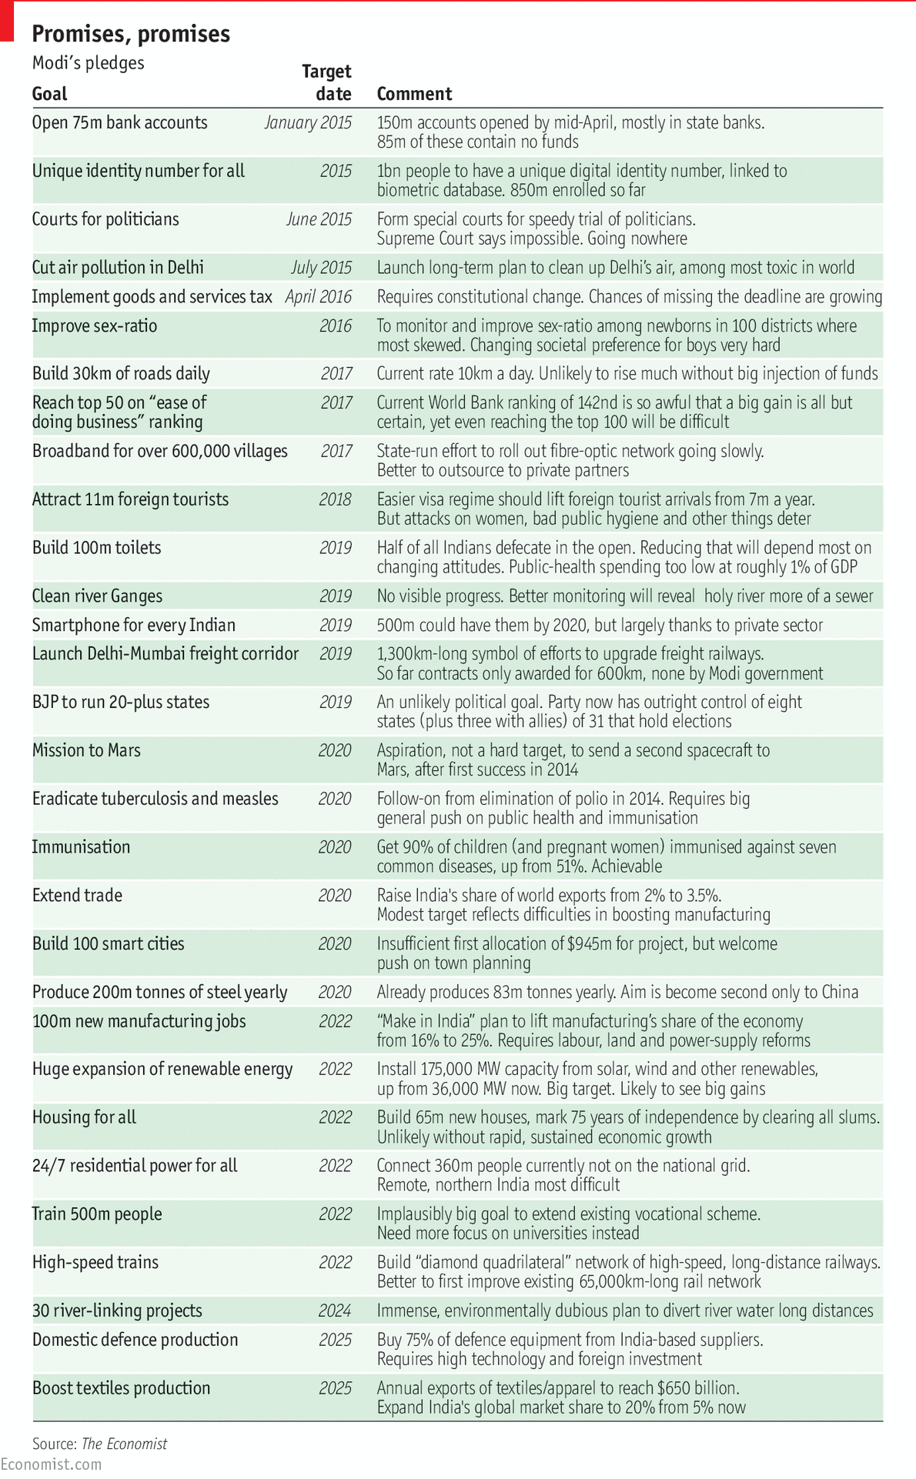
He occasionally praises small government, but the list contains a striking number of big tasks for the state. Half of the goals involve grand, state-heavy expansion, including a commitment for state banks to open millions of new accounts, as well as building 30km (19 miles) of new roads every day between now and 2017, 100m toilets by 2019 and 100 new “smart cities” by 2020.
Only a few tasks are about streamlining officialdom or creating conditions for private businesses to thrive. These include a plan for a national goods and services tax, meant to be introduced by next April but likely to be delayed; getting ranked in the top 50 of the World Bank’s “ease of doing business” index by 2017; and relaxing the visa regime to attract 11m foreign visitors a year by 2018. A more liberalising government might have aimed to sell off dozens of state-run firms (as an earlier BJP government did) or pressed for an easing of labour laws across the country.
Mr Modi is interested in concrete things like infrastructure and defence hardware, leaving more intangible matters like education, health and the environment to others. Public spending on health suffered cuts in this year’s national budget, even though the country’s health-care system is vastly underfunded. On the plus side, the government has set targets for improving the skewed child sex ratio, eradicating tuberculosis and measles and immunising 90% of children against a host of diseases.
Education is not receiving enough attention. India’s abundance of young workers is not automatically an advantage: what the country needs is people with better skills at every level of organised employment. Mr Modi’s list includes a dizzying target to provide vocational training for 500m people by 2022, but he has said almost nothing about improving higher education. He should aim for more competition and investment in that field.
Mr Modi understands projects. “He ran a government of events in Gujarat; it was exhausting,” says a man who knew him well in Ahmedabad. Setting out a list of specific tasks to be ticked off can be a good idea, but it is an operating mode more appropriate for a chief minister than for a transformative prime minister. The most successful leaders create the right conditions so that others can achieve ambitious goals. Mr Modi’s government needs to push broad reform, not just individual targets. The main constraint to that is usually politics. That is the area where change under Mr Modi has been perhaps the most radical.

Special report: India

Politics

How to run a continent

Mr Modi is accumulating power at the centre, but also devolving a fair amount to the states
May 23rd 2015 | From the print edition

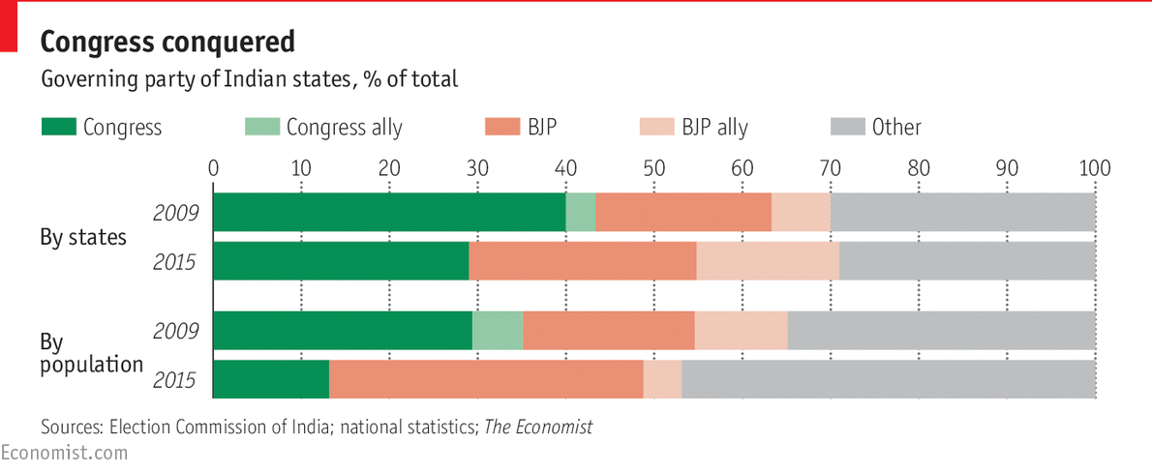
INDIA IS A continent masquerading as a country. Like America, it is a federation that divides power between the centre in Delhi and 31 states with their own elected assemblies and rulers (five more “union” territories are run from the centre). It has a national parliamentary system where the lower house matters more but the upper one has veto powers. And it is saddled with a bureaucracy that can stifle reformist politicians, though it also has an assertive judiciary, pushy media and lots of activists.
Until recently one institution looked chronically weak: the prime minister. The previous incumbent, Manmohan Singh, was timid and allowed his boss in the Congress Party, Sonia Gandhi, to wield power behind the scenes. “The truth is, nobody was in charge,” says a former cabinet minister. Now Mr Modi dominates, drawing strength from his emphatic national election victory in May last year. His Bharatiya Janata Party (BJP) won 282 of 543 seats in the lower house, the first overall majority ever for a party other than Congress.
The “Modi wave” of electoral success had started earlier, and continued later, with strong performances in several states beginning in December 2013 and carrying on for a year. On its own, the BJP now runs eight sizeable states with one-third of India’s population. Add in states governed with or by allies, and that tally rises to 13 states and 41% of the population.
Congress, long the chief national force, has been the main loser: it now controls nine (mostly small) states with only 12% of the population. It could well also lose elections in Assam and Kerala next year, leaving it to govern barely 7% of India’s people. Karnataka may well go the same way in 2018, all but eliminating the party in important states. Mr Modi talks of creating a “Congress-free India”.
Congress’s structural decline began in the states, but was partly concealed by its successful decade at the national level that ended last year. Eventually the rot from below worked its way up: one reason for its national defeat last year was the loss of its main power base in Andhra Pradesh (AP). So far the party has recovered none of its standing.
The general election was a catastrophe, with the party getting just 44 MPs, but it is still not sure exactly what went wrong. Jyotiraditya Scindia, a young Congress leader, asks ruefully, “What didn’t go wrong?” Jairam Ramesh, a more senior figure, worries that Congress is on the verge of irrelevance.
Part of the answer is poor leadership. Rahul Gandhi, scion of the Nehru-Gandhi dynasty, is poised to take over, but regularly proves himself incapable. He retreated from public life for nearly two months of this spring’s important budget session of parliament, going abroad to “introspect”. That would have been a sacking offence for most politicians, but his mother, Mrs Gandhi, wants him to run the family business. Ramachandra Guha, a historian in Bangalore, says that the party is “definitely finished” and that “everyone knows that Rahul is a dud.” Mr Gandhi’s more charismatic sister, Priyanka, is sometimes mentioned as a better bet; she is decisive and assertive, reminding many of her grandmother, Indira Gandhi. But her husband, Robert Vadra, has had to fend off allegations of corruption, which have cast a shadow on her.
For now Congress’s main strength lies in retaining control of the upper house of parliament, where it can block bills sent by Mr Modi. But a third of its members are replaced every two years, with new ones appointed in proportion to the parties’ strength in relevant state assemblies, so the BJP’s heft in the upper house will steadily increase. Eventually Mr Modi’s party should control both houses and be able to pass bolder laws, though that could take two years or more. In 2017 the prime minister will also have a say in who becomes president, a mostly ceremonial post that occasionally matters. So even if Mr Modi loses popularity, he may become more powerful.
But it is a firm law of Indian politics that if things appear to be going swimmingly, a potential disaster is already lurking. In February the BJP was thrashed in polls in Delhi, winning just three of 70 seats. An upstart movement, the Aam Aadmi (Common Man) Party, led by an anti-corruption activist, Arvind Kejriwal, won a landslide victory. The result owed something to special circumstances, but probably reflected a wider perception that Mr Modi had frittered too much time on travelling abroad and not delivered on promised economic improvements. “He lost because of arrogance,” says a friend of nearly three decades. In fact the BJP’s share of the vote, at 32%, hardly declined. The decisive factor was that all other voters, including former Congress ones, united behind Mr Kejriwal.
The question is whether such a defeat could be repeated in more important states. A test looms in Bihar (population 102m), with an election that will probably be held in October. The BJP had hoped it could win this, yet Bihar’s chief minister, Nitish Kumar, who runs a regional party, has joined other regional party leaders in an anti-BJP front. That unity may not be easy to sustain, but if it works in Bihar, then other states could follow.
Against that, the prime minister’s camp has enjoyed a fairly smooth ride in the media so far. India’s press and its screechy TV stations have not been particularly hostile. Mr Modi anyway likes to bypass them. He has not appointed a press spokesman, preferring one-way communication with his 12m followers on Twitter. But he does give the occasional interview, including one to The Economist for this report.
Longer-term trends seem to be working in the BJP’s favour. The electorate is increasingly urban, educated, connected and hungry for jobs, and therefore less interested in welfare pledges from Congress and more responsive to Mr Modi’s aspirational talk (though Mr Kejriwal’s populist promises of cheap power and water also ring a bell). Mr Modi’s organisation on the ground looks strong, too, drawing on an army of Hindu nationalist volunteers. In April the BJP claimed its hundred-millionth member, though not everyone believes that number.
Conversely, rural voters might turn against Mr Modi, and regional figures like Bihar’s Mr Kumar could pose more of a threat. Their collective popularity, unlike that of Congress, is stable. At every general election since 1996 regional parties together have won roughly half the total vote, a pattern repeated last year.
Gonna be a devolution
Intriguingly, just as Mr Modi is accumulating power nationally, he is overseeing the devolution of some of it to the states, prompted, he explains, by his recent experience as chief minister. One of his early decisions as prime minister was to scrap Delhi’s Planning Commission, a relic of Soviet-style centrist policymaking. It created rigid national schemes in fields such as education, rural jobs and urban renewal which required the states that implemented them to put up significant funds. The states felt disempowered.
The commission has now been replaced with a less powerful think-tank, Niti Aayog, leaving the states with more discretion over what they spend. They will also have more money, thanks partly to a new rule that entitles them to all funds from the sale by auction of natural resources. Favoured states have been urged to experiment with liberalising their economic policies. Rajasthan, Madhya Pradesh and a few others are making a start by easing labour laws.
The process has been dubbed “competitive federalism”: states are meant to compete for capital and talent (a process China has managed without the federalism). Arvind Subramanian, the government’s chief economic adviser, calls it a “real watershed”. Individual states, he points out, are often better run than central government. Mr Modi says that “a one-size-fits-all approach does not work in India.”
Even more important, Mr Modi signed up to proposals by India’s 14th Finance Commission that gives state governments 42% of central tax receipts, up from 32%. Mr Subramanian says that, taking into account all tax receipts, the states now control 62% of the total. Though they have lost some funds that used to be doled out by the old Planning Commission, they have more autonomy than before. Jayant Sinha, the junior finance minister, sees a “very big change for state-centre relations”. Chandrababu Naidu, chief minister of southern AP, notices a welcome shift. Baijayant “Jay” Panda, an MP from Odisha, a small eastern state, says that “states have different needs, so the shift of discretionary spending is huge.”
A well-connected businessman thinks Mr Modi has shown “a genuine instinct that India can’t be run from Delhi, it’s his really big idea.” But Mr Modi also has a strong motive for courting state leaders just now. He plans to change the constitution to push through a nationwide tax reform, bringing in a goods and services tax (GST). That will require support from two-thirds of both houses of parliament, as well as backing from most states. Proposals for a GST, a form of sales tax, have been lingering for years. Its introduction would mark a welcome political and economic shift, removing barriers, freeing internal trade and spurring state competition. Onno Ruhl, who heads the World Bank’s office in India, calls it “an excellent test of how to challenge vested interests”. But it is sensitive because it will deny states their most important direct source of revenue. States currently get some funds from the centre but also raise money by taxing fuel, alcohol and other goods at their discretion.

Religious tensions

Hindus to the fore

Religious pluralism is looking less secure
May 23rd 2015 | From the print edition
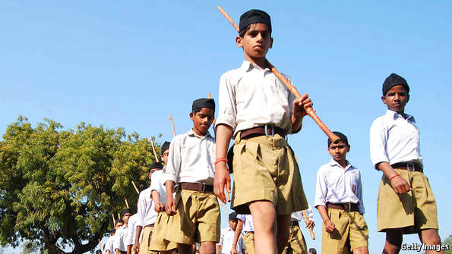Prepared for leadership
UNDER A MANGO tree in Varanasi two dozen men parade in white shirts, black caps and khaki shorts, a uniform modelled on Baden-Powell’s Scouts. They salute a flag, completing a shakha, a morning meeting of the Rashtriya Swayamsevak Sangh (RSS). Resurgent Hindu nationalists have perhaps 5m members nationwide, their numbers lifted by Mr Modi’s success. The rank and file adore the muscular leader who was a long-term pracharak, an RSS preacher-monk.
The group used to talk about its cultural and social aims. Now leaders are quite frank about political motives: last year millions of RSS volunteers brought out voters for the BJP, trumpeting the nationalist slogan, “One India, great India”. Among the men this morning (women are not welcome) is Indresh Kumar, in a bulging blue waistcoat. He oversees the RSS’s relations with Muslims, Christians and other minorities. Data from the 2011 census, when finally released, will show that about 20% of Indians are non-Hindu, up slightly on a decade earlier.
Mr Kumar says that “society should be harmonious, above caste or religion.” The big worry about Mr Modi is his history of allowing, and exploiting, disharmony. In Gujarat pogroms on his watch in 2002 killed over 1,000, two-thirds from the small Muslim population, as police stood by. After that Mr Modi campaigned for election by stirring more hostility to Muslims, saying they had too many children. Gujarat has otherwise remained calm, but is more polarised than most of India.
Religious violence is rarely spontaneous: politicians stir it up to exploit it. It flared in late 2013 in Muzaffarnagar, Uttar Pradesh. Jat-Hindu landowners and Muslims clashed, killing over 40 and displacing tens of thousands. Yet last year Mr Modi appointed a BJP figure who had been accused of a role in the clashes, Sanjeev Baliyan, as a junior minister. The Election Commission banned Mr Modi’s closest confidant, Amit Shah, from public campaigning after he had urged Jats in Muzaffarnagar to seek “revenge” at the ballot box. Mr Shah is now the BJP’s president.
Various Hindu nationalist groups, collectively known as the Sangh Parivar, are throwing their weight around. Mohan Bhagwat, the RSS chief, says that anyone from Hindustan must admit to being Hindu and that Christians, including Mother Teresa, who worked with Kolkata’s poor, are aggressive missionaries. Hindu nationalists rant about “Love Jihad”, accusing Muslim men of seducing and converting Hindu women, but that is nothing new. Leaders from the Sangh tell Hindu women to have at least four, ideally ten, children, to keep up the numbers. A campaign called ghar wapsi (homecoming) aims to convert non-Hindus to their supposedly original Hindu identity. In April Hindu extremists in Maharashtra said non-Hindus should be sterilised or denied the vote.
Most of this is nasty talk, not taken seriously, but worryingly it is echoed by people in government. A junior minister in November told a rally in Delhi that non-Hindus were “bastards”. She kept her job. Smriti Irani, the education minister, said schools should stay open on Christmas Day. The home minister, Rajnath Singh, one of many (like Mr Modi) from the RSS, wants a nationwide ban on eating beef.
The prime minister himself has said nothing offensive, but has conspicuously failed to speak out against his colleagues’ hate speech. That may be because he will want the RSS’s help again in future elections. “He cannot afford to be more mild than this, he will lose,” says an old acquaintance. Some suspect that, in private, he agrees with the thugs. He did give one notable speech on religious tolerance and co-operation in February, but only after the BJP lost badly in Delhi and Barack Obama, who had just visited, had cautioned against society “splintering” on religious lines.
There is no sign of that, and other parties have also presided over religious clashes. As Ramachandra Guha, the historian in Bangalore, puts it: “We shouldn’t be apocalyptic, we are not going the way of Pakistan. But religious pluralism is hard-won, and you can never be fully secure.”

The economy

Uncurl the body

India needs to learn to trust markets more
May 23rd 2015 | From the print edition

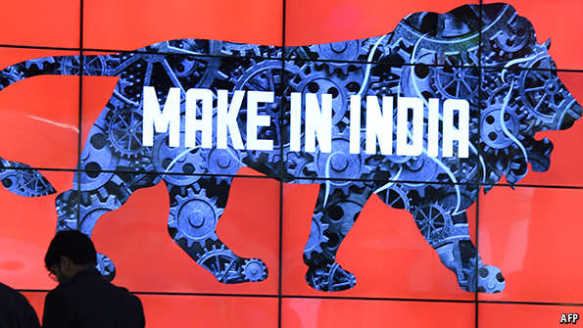Let’s hear it roar
THE SCREAMS BEGIN most mornings at 9am. Elderly men and women in a Delhi park hold their arms in the air and shriek, then laugh. After years of observing the pensioners from his office window, your correspondent one day joins them. “Open your lungs,” the team leader instructs. “Laughter is good exercise for the internal organs, the lungs, the heart.” A woman as old as independent India (it turns 68 in August) explains: “We are not young in age, so we get stiff and need to uncurl the body.”
India needs to clear its own internal blockages. In the language of laughter, it has tended to respond with discreet giggles: a series of incremental changes. Its economy did enjoy a boom in the early years of this century, with high investment and rapid growth, in spite of decades of over-regulation, state domination of many sectors, including banks, and a lingering scepticism about markets. But now it needs to uncurl the economic body properly with much bolder reforms. Many had hoped Mr Modi would set these in motion, but so far he has done little, even though his whopping mandate would allow him to push through any measure he wants.
He has paid too little attention to the economy. The two budgets he has overseen so far have lacked an unambiguous thrust for growth, despite some welcome initiatives. Nor did he appoint a strong figure with reformist credentials as finance minister. He might have chosen Arun Shourie, a former privatisation minister who sold many state-run firms, but instead he picked a deferential loyalist lawyer, Arun Jaitley.
Mr Modi is not at heart a liberaliser. In Gujarat he proved himself as a rigorous manager who excelled at implementing projects to boost investment. He got public-sector firms to run better. He is pro-business, but not necessarily in favour of more market. He is attracted to East Asia’s development model, with a powerful role for the state. Gurcharan Das, an astute and supportive observer and author of a book on reforming India’s economy, calls him a moderniser more than a reformer. Another man, who worked closely with him in Gujarat, notes that “he galvanises government machinery, he doesn’t reform it.”
When Mr Modi was voted in, he lifted confidence merely by ejecting the previous government, which had been mired in corruption and famous for indecision. Macroeconomic conditions also started to improve around the same time, notably with a sharp fall in inflation. Austerity policies introduced under the previous government were kept going, which helped reduce the big fiscal deficit. Since 2013 monetary policy has been run by a respected central-bank governor, Raghuram Rajan. As a big oil importer, India got lucky when crude prices slumped—a “$50 billion gift” to the economy, as Mr Rajan has said.
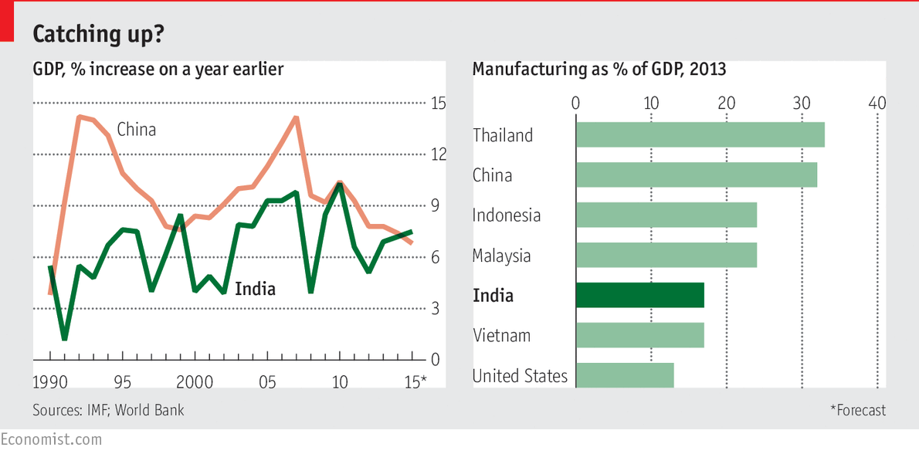
As a result, short-term prospects look promising, certainly brighter than in most emerging markets, or in India itself a couple of years ago. The central bank is trimming rates (though banks have been slow to pass on the cuts), and India is setting up its first inflation-targeting regime. Exports have done badly, but thanks to cheaper oil and lower import costs the current-account deficit is no longer scary. The rupee is stable. In January government statisticians released a new series of GDP figures which seemed to suggest that the economy has been growing by 7.5%, up from around 5-6% in recent years and faster than China’s.
Slow going
Yet other indicators do not support that rosy assessment. Industrial production is anaemic, credit and investment are barely growing, construction is slow, few jobs are being created and consumer demand is limp. On the ground, not much is moving. In April Ratan Tata, the former boss of Tata, India’s biggest conglomerate, had to chide the grumblers not to be “disillusioned so fast” with Mr Modi.
It would be easier to believe talk of rapid growth if there were a stronger story of reforms to tell. Defenders of the government say other things matter more: reducing the fiscal deficit, making government more efficient, improving the business climate. Jayant Sinha, the junior finance minister, admits that the economic mood is flat, but says that restoring “the balance of the macroeconomy [is] a major accomplishment.” The combined impact of many smallish steps, he predicts, will “really transform the economy”.
He denies that India is emulating East Asian-style state capitalism, pointing to efforts to give the market a bigger role. State-run defence firms are notoriously incompetent, so the private sector is being invited in. A cap on foreign investment in the sector has been lifted from 26% to 49% of any joint venture (though so far foreigners have made no new big investments). Similarly, in March parliament finally agreed to raise the cap on foreign investment in the insurance industry, also to 49%. In railways, private firms will be given a bigger role, and restrictions on foreign capital have mostly been lifted.
That just about sums up the economic story so far. The previous BJP-led government, from 1998 to 2004, was bolder, even though it had to keep coalition partners happy, and had a privatisation ministry headed by Mr Shourie (who is unlikely to be invited to join the government after saying of Mr Modi in December that “when all is said and done, more is said than done”). The present government has adopted Congress’s approach of divesting only slices of massive state companies, raising revenue but not changing their ownership or management.
Now and then Mr Modi suggests that the economy should involve “minimum government”, but does not spell out what he means. He could have announced plans for the outright sale of state-owned steel or oil firms or banks by now, but “basically he doesn’t want to sell,” says a businessman in Ahmedabad. Asked in a private conversation last year why he was not setting an example by selling Air India, the low-flying national carrier, Mr Modi said he had no wish to battle unions as he began ten years in office.
Mr Sinha argues that the state is in fact pulling back. The scrapping of subsidies on diesel, begun under the previous government, has been completed. The power ministry has auctioned off most coal-mining licences issued in the past two decades after the Supreme Court cancelled them because of corruption. That raised over two trillion rupees ($32 billion). The winning bidders, including private firms, can now dig more coal.
But note what has not happened. The government could have considered breaking up Coal India, a state firm that mines the lion’s share of the country’s coal. If you ask Piyush Goyal, the power minister, whether Coal India could go down that route, or even be privatised, he rolls his eyes and says there is no need to be ideological.
It is a similar tale for India’s troubled banks. Many are state-run and have endured decades of political meddling. Ideally some of them should be recapitalised and made independent, and the worst of them should be closed. They are lumbered with big old loans from previous splurges by infrastructure investors, many of them with political connections, on projects that are going nowhere. The government counts 1,400 stalled projects worth $80 billion. That helps explain why there is little new investment: credit growth has been slowing since November 2013.
Adding to the pressure, in a few years banks will have to comply with new global rules, Basel 3, to hold more capital. But instead of recapitalising them or getting them ready for private buyers, the government is determined to restart those stalled projects, which may prove slow going. It is also telling state banks to promote financial inclusion. Earlier this year it ordered 75m new bank accounts to be opened, enticing customers with free insurance and overdrafts. In fact state-run banks have set up double that figure, though many of them were for people who already had accounts and lots of the new ones are dormant.
Mr Modi’s government is missing a rare chance to launch some bold reforms, along with an opportunity to educate the public about why reforms are to be welcomed, not feared. Time is short because in another year or two minds will begin to turn to the 2019 election.
Just possibly, critics will be mollified if Mr Modi gets one big thing right. Everyone agrees that India needs a bigger manufacturing sector to create lots of new jobs. Currently manufacturing accounts for only 16% of the economy, much less than in other Asian countries. The government has set a target to lift the share to 25% by 2022, and launched a nifty website and an official slogan, “Make in India”. But for that target to be achieved, at least four big reforms are needed.
One is to ease strict labour laws. Even a government official calls India’s the worst in the world, both cumbersome and contradictory. “You can’t apply 100% of Indian labour laws without instantaneously violating 10% of them,” grumbles a businessman, noting that most new jobs in India are of the informal kind.
Mr Modi should have led from the front, explaining that overly strict regulations (for example, on firing workers) stand in the way of creating formal jobs. Instead he has subcontracted the task to willing state governments in Rajasthan, Tamil Nadu and Gujarat, which are among the main manufacturing states. But that is second-best to encouraging the whole country to reform faster.
A second area is tax reform, where progress has been mostly disappointing. Indian governments have long had a bad habit of levying taxes retrospectively, and the current one has failed to demonstrate that this has been abandoned, so planning investments remains difficult. Nor has the government simplified or cut corporate or income taxes. To its credit, it is pushing a goods and services tax to replace separate levies raised by the states with just one imposed centrally. It will not be perfect, but it will create a single market that should allow manufacturers to serve the whole country from one place. Mr Jaitley says this reform could add two percentage points to India’s growth.
Fixing the power supply is a third urgent need. Those coal auctions could help, though breaking Coal India’s dominance would have been better. Much will depend on getting the railways to deliver the coal to power plants (see article) and fulfilling a pledge greatly to expand solar, wind and hydropower generation, as well as cranking up nuclear power. But even if all that is done, there will still be distribution problems: many manufacturers continue to use generators because the grid is unreliable or absent. State-run distribution firms are often useless.
The fourth, contentious, area for reform is land. Some manufacturers fret about a lack of space for factories. Others worry that the government will not be able to get hold of land quickly enough to build lots of new roads, railways and other infrastructure. One painful legacy from the previous administration is the first new law on buying land since 1894. It enshrines a slow process and gives farmers strong rights to ward off compulsory purchases. In December Mr Modi’s government came up with an ordinance (a temporary law to be confirmed by parliament later) on land, but it was badly drafted and infuriated farmers, many of whom have been ripped off by developers conniving with officials and politicians. “He is pushing a land bill that is fatally flawed,” laments an expert. The government has made more changes, but for now the bill is stuck in parliament.
Climate change
Even if all these reforms succeed, there is no guarantee that faster growth and lots of jobs will follow, because India’s business climate is notoriously awful. But politicians can do a lot to change that. A senior bureaucrat in the commerce ministry, Amitabh Kant, has listed 98 tasks that state governments must complete by July to make the country a more appealing place in which to do business. The central government will then name the best- and worst-performing states to spur competition for investment.
Mr Kant tells some good stories. In a previous job he dreamt up “Incredible India”, a tourism campaign that won many plaudits (though India still lures only 7m foreign visitors a year). He is the driving force behind the “Make in India” campaign. Now he is busy trying to snip red tape for investors.
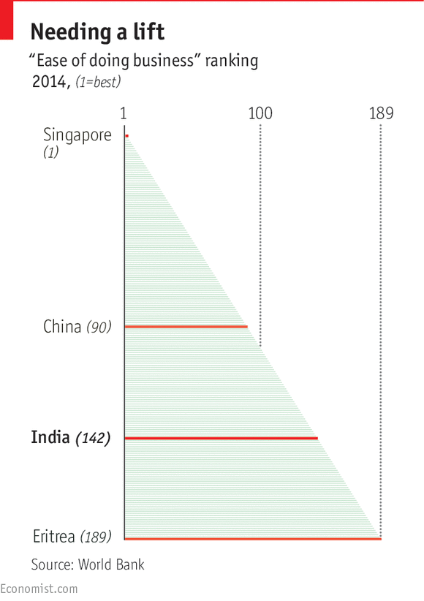
As a benchmark, the government is using the World Bank’s ease of doing business index, which ranks India a dire 142nd out of 189 countries, behind countries such as Yemen, Sierra Leone and Ethiopia (see chart). One of India’s worst problems is getting contracts enforced: it takes an average of 1,420 days to settle a court case. Other headaches include the lack of a proper bankruptcy law and archaic rules for setting up a business, getting permits and shipping goods across borders.
Mr Kant says things are getting better. A small indication was the scrapping in April of the last foolish restrictions that allowed only small businesses to produce items like wooden furniture, locks, candles, matches, bangles and pickles. Mr Modi said late last year that India will advance to the top 50 in the rankings within two years. Even if it doesn’t, at least it is now trying. In order to improve its image, it is all but gaming the World Bank system, putting intense efforts into reforms in Mumbai and Delhi, the only two Indian cities surveyed for the index.
The finance minister promises to introduce a bankruptcy law, and red tape is becoming less tangled, even if it is not disappearing altogether. Instead of 14 forms for a permit to move goods across borders, would-be exporters now have to fill in only three. In Maharashtra, the state that includes Mumbai, it used to take 67 days and seven administrative steps for a firm to get an electricity connection. This is supposed to have come down to three weeks and three steps, but much depends on implementation. The manager of a factory in Rajasthan complains that getting a good electrical connection has taken him two years when officially it should have happened in months.
Onno Ruhl, the World Bank’s representative in Delhi, thinks that aiming for the top 50 is “very ambitious, but not as crazy as it sounds”. Mr Modi has plans for introducing far more technology in government so that all form-filling, visa-issuing and other official interactions are carried out online (see article). Some authorities are already setting an example: a study of 17 Indian cities in 2009 suggested that if the whole country were to adopt the best practices seen in different states, the national ranking would leap by 50 places.
The World Bank’s index does not capture everything that bothers investors. Particular bugbears include a poor work culture (which shows up in things like absenteeism) and skills shortages. In Rajasthan, Kajaria, the country’s most successfultilemaker, complains that it took two years to get permission to put up a new $15m factory near Alwar because suitable land was so hard to find. In any case, a ranking may matter less than market conditions, consumer demand and growth prospects. Foreign direct investment at least is up: Mr Kant says that in the financial year just completed it is likely to run to $45 billion.
Yet a puzzle persists. If India had wanted to present itself as more business-friendly, it could have already notched up some easy gains by cutting corporation tax from 30% (higher than in most countries) and simplifying a tax code riddled with exemptions that allows authorities to gouge companies at will. Mr Jaitley, the finance minister, talks of both but has done neither. Mr Kant’s imperatives are welcome, but they can offer no categorical guarantee that investors will respond.

New cities: Let there be concrete

India’s future is urban
May 23rd 2015 | From the print edition
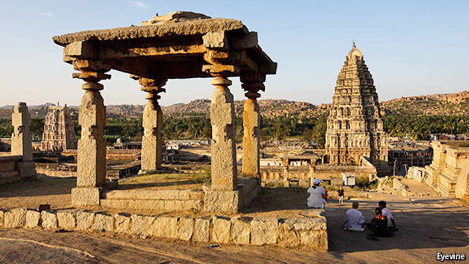
INDIANS ONCE KNEW how to build great cities. Take the ruins of Hampi (pictured), a site in southern India that rivals Angkor Wat in magnificence but gets only 47,000 foreign visitors a year, compared with the 2.3m who flock to the Cambodian attraction. Built in the 15th century, Hampi was crammed with splendid temples and mosques, mighty stables for elephants, markets for diamond traders and a granite chariot. Intricate sculptures illustrating the Kama Sutra adorn the walls of many buildings. One palace even had a flush toilet. By contrast, around half of Indians today, including many city-dwellers, still defecate in the open.
Modern Indian cities are mostly ill-planned, crowded, polluted and jammed with traffic. Rural voters still outnumber urban ones by about two to one, and there are no powerful mayors. Apart from a few pampered places such as New Delhi, politicians were mostly indifferent to cities. That is changing as people like Mr Modi respond to their growing clout. He promises to build 100 smart cities by 2020, generating millions of jobs.
The first, GIFT City, is now rising on 886 acres (358 hectares) of semi-desert near Ahmedabad, in Gujarat. Two glass towers, 28 storeys high, adorn a barren landscape. From the top you see spidery roads, a modern waste-treatment plant and a half-built school. Developers broke ground three years ago, and by 2024 there should be 110 towers, a metro, 25,000 apartments, hospitals, hotels and an artificial lake. The hope is that there will also be 1m jobs, many in financial services. An area prone to earthquakes and intense heat may not be ideal, but developers point to efficient air-conditioning.
Not everyone is enthusiastic. “GIFT is humbug,” proclaims Gujarat’s opposition leader, Shankersinh Vaghela. A town planner calls it “ridiculous, a London Docklands-style project in the middle of nowhere.” He says it is flashy, politically led and follows the Chinese model of construction (a Chinese company is in fact involved). Mr Modi enjoyed touring China in the past and visited it again this month. He is impatient to show how fast India is developing. Thanks to his personal interest, GIFT is certain to succeed: state-owned banks are filling those towers “to be in the good books of Mr Modi”, says the planner.
Locations for all 100 cities have been tentatively named and states will experiment with plans for them, bidding for central funds ($945m is budgeted for this year). Not all of these will materialise, and the concept may be redefined to include improvements to existing cities. The prospects would be better if municipal corporations were stronger. Varanasi, for example, a city that has been in continuous use for over 5,000 years, today verges on dysfunction. A warren of old buildings and narrow streets on the banks of the Ganges, it needs the most basic things, such as working sewerage and transport systems.
The grandest new city is being planned by the chief minister of Andhra Pradesh, Chandrababu Naidu. He calls India a “sleeping giant, with huge untapped potential”. Hyderabad flourished under his rule in the 1990s as the IT industry moved in. Last year his state split and Hyderabad was hived off. Mr Naidu, his eyes sparkling with excitement, says he “will build a city, a world-class capital, a really smart city…it is a one-chance-in-a-lifetime opportunity.”
His creation, Vijayawada, one of the 100 on Mr Modi’s list, will house 22m people near the eastern coast. Given a dense population with strong property rights, acquiring the necessary 50,000 acres is proving difficult. Mr Naidu will reward original owners of farmland by returning smaller plots of more valuable urban property to them. He says that central government must pay for the construction work first; private developers will follow. Perhaps the master plan should include a few Kama Sutra sculptures.

Railways

A better lifeline

The best way to modernise the railways would be to break the state monopoly
May 23rd 2015 | From the print edition

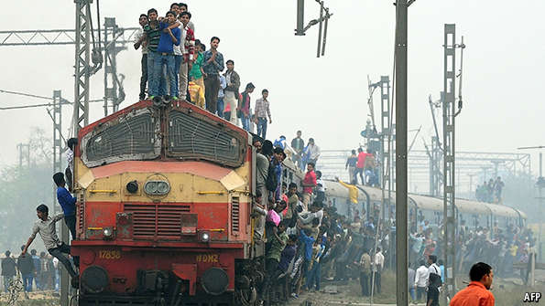In need of private input
A WHIRL OF activity fills the dimly lit carriage. Passengers jostle and rip open paper bags containing linen for their bunks. It is a relief to leave the stench of Bangalore station, where tracks double as latrines. The Hospet overnight service departs a few minutes late, trundles along for 400km (250 miles) and arrives on time at dawn.
Like all Indian trains, it is crammed. Its cabins are worn and a bit grubby, the toilets holes in the floor. It is also cheap. A nine-hour trip on the best, air-conditioned berths costs 3,200 rupees ($50) for a family of four. Ticket prices were frozen by populist politicians who long ran the network, and only recently started to rise modestly.
The railways are a huge business: each day 19,000 trains carry 23m people and 3m tonnes of freight. But the state-owned monopoly is badly run. A former cabinet minister points to overstaffing, factionalism and bureaucracy.
A comparison with China is instructive. In 1990 that country had less track than India, but since then China’s rail network has grown by well over half, to 112,000km, whereas India’s has remained much the same, at 65,000km. As a share of GDP, China invests three times as much in its railways as India does. Spending per person is 11 times higher.
India’s politicians levied high freight charges to subsidise cheap rides for passengers. That diverted goods to less efficient, more polluting, overcrowded roads. Now rail carries just 30% of India’s freight, compared with 65% in the 1970s. Delivering coal to power plants is a crucial task for railways in both countries. In India this is a third costlier than in China, and a third slower—one reason for so many power cuts.
In a test of its efforts at state-directed modernisation, the new government wants to fix this. An official estimate suggests that for every rupee that the output of the railways goes up, the economy as a whole will be lifted by 3.3 rupees as other industries benefit from improved efficiency. Suresh Prabhu, the capable railways minister, plans a capital-spending splurge of $140 billion over five years. He plans to introduce market mechanisms where possible. To stimulate competition, he is creating 20 state-run corporations and perhaps 60 special-purpose vehicles that will be given autonomy to run parts of the network. Private (including foreign) partners can take part in much of this. Eventually units that run schools and hospitals and produce bottled water could be sold off. But outright privatisation of the country’s oldest government institution is not envisaged. The industry’s 1.3m employees and strong unions would not wear it.
In an early experiment, beginning in Bhopal, private investors will get the chance to overhaul decrepit railway stations. Thanks to better management, punctuality, revenues, safety, catering and hygiene are also improving. Traffic is up by 15% this year, says Mr Prabhu, and will rise steeply next year.
Adding tracks is harder. In the long-promised Delhi-Mumbai freight corridor, which is meant to open by 2019, the previous government managed to award only 600km of a 1,500km line to contractors.
“What matters is to be market-friendly, completely transparent,” says Mr Prabhu. Crucially, he needs to make it impossible for any successor to return to the old political meddling, when employment and tracks were handed out (and sold) to cronies. Some powers currently held by the minister will soon be devolved to an independent regulator. “I am rushing to give my powers away,” says Mr Prabhu, “so no populist politician would again want to have this job.”

Government and technology

Playing leapfrog

The wonders of smart systems
May 23rd 2015 | From the print edition

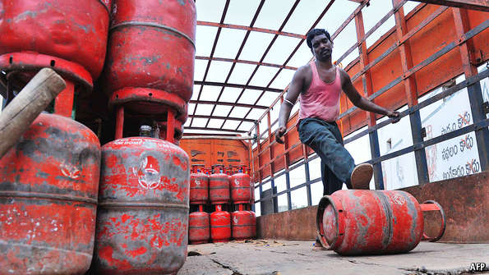No more dodgy cooking-gas deals
“THE BEST THING about India is we don’t have to replace anything,” says Sachin Bansal. He founded Flipkart, an online marketplace, with $8,000 in 2007. When it lists later this year, India’s answer to Amazon is likely to be valued at $15 billion. That is because Indians are learning to leapfrog, says Mr Bansal. Many will never see a supermarket, but will go straight from shopping in local kirana (neighbourhood) shops to ordering online. He expects his firm, eventually, to create jobs for 2m.
He is speaking at a dinner in Bangalore, where other guests make similar claims. Some 900m Indians have access to mobile phones. Smartphone use is likely to go up from around 200m now to 500m by 2020. Bhavish Aggarwal, who founded OlaCabs in 2011, says his smartphone-based taxi service has 150,000 drivers, mostly first-time entrepreneurs. It is several times bigger than the Indian branch of Uber. He believes that many Indians, like himself, will skip over having a car of their own.
Advertisers are also leapfrogging. Naveen Tewari and Abhay Singhal are two founders of InMobi, an online firm that serves ads to billions of people globally and is growing fast. They say India, and especially Bangalore, is learning how to succeed with digital startups. It has plenty of engineers, youngsters good at programming, creative types and centres of excellence in the shape of the Indian Institutes of Technology (IITs). Places like Bangalore are already IT hubs: in Karnataka, the surrounding state, perhaps 1m work in the industry.
Mr Tewari is excited by a new generation of tech businesses, many of them smartphone-based, launched by youngsters who have been through the IITs. He has invested in 19 such startups. Bangalore also benefits from close ties, through the Indian diaspora, to California’s Bay Area.
If business can thrive like this in India, why not government? Nandan Nilekani, the host of the dinner, is all in favour. He co-founded Infosys, a big IT firm, and now wants technology to deliver more public and social gains. For example, he is working on a project called “Ekstep” to spread literacy and numeracy in schools and beyond, using games on smartphones.
Karnataka’s government wants residents eventually to interact by smartphone with hundreds of services from its 60 departments. In December it launched Mobile One, a phone application, for checking property records, birth certificates, car-registration documents and more. The state also runs intercity bus services, utilities and other services, so residents can now book tickets and pay electricity bills or taxes on the phone, or check in with doctors or dentists.
Residents are also encouraged to report local problems through the app. If you spot a pothole or a pile of rubbish in Bangalore, you can alert city officials by uploading a geo-tagged photograph. (Lahore, in Pakistan, has a similar service to get standing water removed, to discourage mosquitoes and dengue.)
Official enthusiasm for online transactions is growing fast. Mr Modi, who turned techno-obsessive when he travelled among the Indian diaspora in America, now uses electronic tablets, not paper, in cabinet meetings. “Digital India is a big programme,” he says. He launched MyGov.in, a national scheme to crowdsource policy ideas from the public. He is convinced government in Gujarat became less corrupt when land records were put online and bids for official tenders went digital and thus more transparent.
“He is driven, he has tasted blood by using technology in so many ways in government,” says an official. In last year’s general election he used holograms to address several rallies simultaneously. A national fibre-optic network is meant to reach all 600,000 villages and their schools by 2017, though that deadline is likely to be missed.
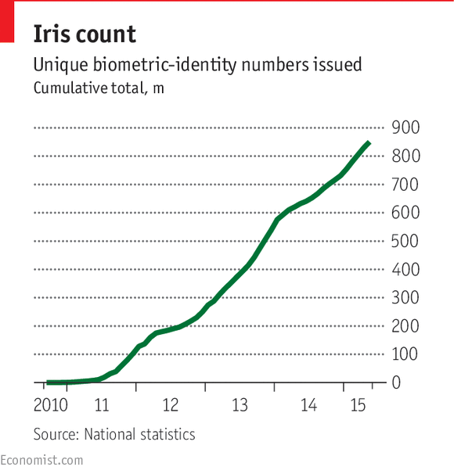
Last July Mr Modi decided to support Aadhaar, a unique identity system launched and run by Mr Nilekani for the previous government. The world’s biggest biometric database has so far created a reliable digital identity for 850m people (see chart). The target is to hit 1 billion this summer.
This framework will support many official applications, which are beginning to be launched. Jharkhand, a small northern state, is using it to deal with an old problem: skiving bureaucrats. State employees now check in and out by having their irises scanned. Their attendance is plotted, live, on a website. Ram Sewak Sharma, who set up the scheme, says habitual offenders are easy to identify and attendance is up. He oversees all technology projects for national government and has introduced the system for the 121,000 national civil servants in Delhi, too. Eventually it could cover all state employees in India, a total of some 18m people.
Here’s looking at you
Back in Jharkhand the unique identity number is also used for monitoring distribution of subsidised food rations. A website lists every recipient, how much food each person has got in each transaction and from which supplier. This makes it harder for suppliers or ration shops to steal, which is how an estimated 40% of the supplies used to disappear. Such monitoring could cut waste dramatically.
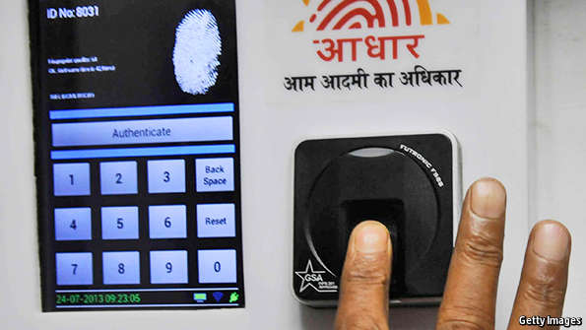
Aadhaar, the world’s biggest biometric database, has created a digital identity for 850m people
State-run banks have recently opened 150m new accounts, many bearing the owners’ Aadhaar numbers. They will serve as the basis for replacing subsidies in kind with cash transfers. Neeraj Mittal, an official in Delhi, is running the first project. Now that subsidies on cooking-gas canisters for 140m households have been abolished, he explains, suppliers no longer have an incentive to divert cheap gas to commercial users. Canisters are sold at market prices, and residents get cash subsidies paid to them directly. This has created the world’s largest cash-transfer programme, launched in April, with over 3m transactions a day. Last year the government spent $7.5 billion on the cooking-gas subsidy. Some 10-20% of that was obtained fraudulently. Since Aadhaar helps remove “ghost” beneficiaries, it could save perhaps $1.5 billion. Revealingly, sales of commercial gas are up by 30% since last November—because restaurants can no longer buy cheap cooking gas diverted from domestic use.
Thanks to Aadhaar, these reliable “pipes” now linking government to beneficiaries’ bank accounts can be used for all sorts of welfare benefits, including scholarships. The hope is that in time they will act as a conduit for much bigger payments to replace price subsidies for items like paraffin, fertiliser and food, again reducing theft.
Aadhaar could also help create a more formal financial system. Less than 3% of Indians, some 36m, pay income tax, though many more should be doing so. Aadhaar and reliable digital identification, plus new bank accounts, could lift the numbers. One day you may need to provide your unique number when buying a house or transferring large sums of money. Playing leapfrog might replace games of hide-and-seek with the taxman.

Foreign policy

High visibility

India is reaching out to the world
May 23rd 2015 | From the print edition

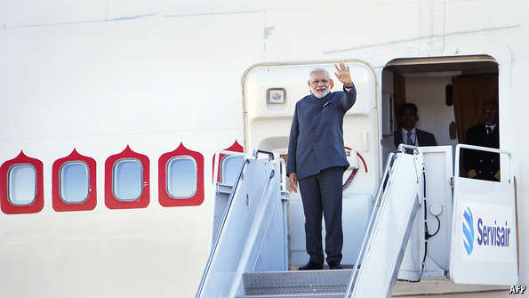Fifty leaders and counting
“FOREIGN POLICY IS fun, to an extent it is theatre,” says Shivshankar Menon, who was India’s national security adviser until last year. He recalls a prime minister who so enjoyed talking about foreign policy that he let meetings on the subject run for three times their scheduled length.
Narendra Modi obviously loves it too. As Gujarat’s chief minister he showed unusual interest in other countries, visiting Japan, China and Britain, and hosting investor jamborees. As prime minister he has put more energy into foreign policy than anything else.
By giving so much attention to foreign affairs, Mr Modi has sidelined his foreign minister, Sushma Swaraj. By now he has spent 52 days of his first year abroad, visiting America, Japan, Brazil and Germany, among other countries. Many trips were overdue. It had been 28 years since an Indian prime minister had last paid a bilateral call on Sri Lanka or Australia; for Canada, the gap was 42 years.India’s top diplomat, Subrahmanyam Jaishankar, says this is about more than appearances. India, he explains, now aspires to be a “leading power, not just a balancing power”. That means it has become less self-effacing, abandoning talk of a “no-frills” foreign policy of non-alignment. India is also hoping to boost its share of world trade from 2% to 3.5% by 2020. Mr Modi is playing his part. He has established warm relations with Japan’s Shinzo Abe and Australia’s Tony Abbott. In his first year, he says, he has met 50 national leaders for direct talks.
An immediate goal, of being seen to play an important international role, has been achieved. “India is back in the news,” says Tanvi Madan, of the Brookings Institution, a think-tank. Mr Menon claims his successors are mostly continuing with the country’s previous policy, “but they present it more forcefully.” Making a greater impact requires more manpower, including a bigger diplomatic corps. India has long been famous for having a mere 800 diplomats. The foreign ministry claims it actually has 2,500, but that figure results from a new way of counting them, not extra recruitment.
A more determined approach is showing up in two areas. One is the immediate neighbourhood. Mr Jaishankar says that “you cannot be a leading power if your neighbourhood is not with you, you need it to root for you.” So India is promoting cross-border trade and a regional electricity grid (some of its neighbours have massive hydropower potential), creating infrastructure on its borders, relaxing visas and doling out aid. After last month’s devastating earthquake in Nepal, India was quick to take a leading role in the relief effort. It wants to end the perception that it meddles and bullies, though rumours still swirled that it helped sway Sri Lanka’s election in January.
Old enemies, new friends
The obvious problem is Pakistan. India has a “SAARC-minus-one” strategy of integrating South Asia’s economies over the next decade, working with the South Asian Association for Regional Co-operation but isolating Pakistan. So far Mr Modi’s handling of the old rival has not been coherent: he welcomed Nawaz Sharif, its prime minister, to his inauguration in May last year, then used a pretext to cancel talks between the two countries’ foreign secretaries. Relations deteriorated as the bloodiest border clashes in 11 years broke out in October, but this relationship looks unlikely to shift much for better or worse.
The second new emphasis in foreign policy concerns ties with America and the West generally. In Mr Menon’s day India was already drifting westwards as memories of the cold war faded, economic ties strengthened and Pakistan’s relations with the West became more strained. But India hedged, keen to avoid confrontation with China.
Under Mr Modi the westward tilt has become more explicit. That was partly China’s doing. During a visit to India by Xi Jinping, the Chinese leader, Chinese soldiers crossed a disputed border and camped in Himalayan territory that India considers its own, humiliating a man who had boasted he would secure the frontier. Later, China twice sent a military submarine to Colombo, Sri Lanka’s capital. Mr Modi took offence.
In January Barack Obama was the chief guest at India’s Republic Day celebrations. The countries issued a joint security statement on stability in Asia, calling for freedom of navigation in and over the South China Sea, where China is needling its neighbours. The same visit delivered what Mr Obama called a “breakthrough in understanding” over the liability of suppliers to any civil-nuclear power plants. Details remain fuzzy, but heavy American investment in energy would deepen ties.
Defence is another area ripe for co-operation. India is opening its defence industry to foreign, most likely Western, investors. In July 2014 a cap on foreign investment in domestic defence projects was increased to 49%, though investors may not be tempted to put money in until the government starts buying more defence kit. Bizarrely, on a trip to France in April Mr Modi announced an order for 36 Rafale fighter jets to be made in France, undercutting his own procurement strategy.
Even so, India’s co-operation with the West will become closer as it buys less military hardware from Russia (and as Russia becomes friendlier with Pakistan). That co-operation extends even into space: last September India got a spacecraft to orbit around Mars, with some navigational help from NASA. India’s public seems to approve. Surveys by the Pew Research Centre show that it generally favours the West. In a poll in 2014, 55% of Indians said they liked America. One reason is that many millions of them have relatives who live, study and work there.

The diaspora

The worldwide web

India should make more of a valuable asset abroad
May 23rd 2015 | From the print edition

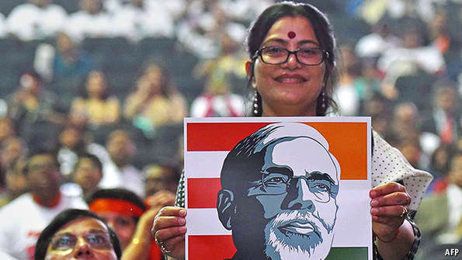
PART OF THE secret of China’s success in the past four decades or so has been the clever use of its diaspora. Chinese manufacturers in Hong Kong who had long supplied American partners moved to the mainland and set up factories. Chinese nationals who succeeded abroad brought home trusted contacts, networks, experience, standards, technology and capital.
India could do with more of that. Over 27m people of Indian origin, including some temporary migrants, live overseas, many of them in the Gulf. They remit $70 billion a year to their home country, more than any other group of expats. That adds up to 3.5% of India’s GDP, outstripping foreign direct investment.
The biggest potential lies with the diaspora in the West. Mr Modi seems to be aware of that. He has been courting it on visits to America, Australia, Germany and Canada, holding big rallies. Indians abroad heavily backed him in last year’s election, sending millions of dollars as well as people to help. Even in remote corners of Uttar Pradesh, your correspondent bumped into jovial volunteers with American accents.
Indians in America are the most promising. They are increasingly prominent in tech companies, on Wall Street and in government, especially in the state department. Around 1% of America’s population, over 3.3m people, are “Asian Indians”. Perhaps 150,000 more arrive each year, and 90% of them stay permanently. Devesh Kapur, who has studied them, talks of a “flood”. He says over half of all Indian-born people in America arrived there after 2000.
On the usual measures of success they outstrip all other minorities, including Jewish-Americans. They are educated and rich. In 2012 some 42% held first or higher degrees; average family income was over $100,000, roughly double that of white Americans (see chart). Over two-thirds of them hold high-status jobs. They have done so well that many migrants from Pakistan or Bangladesh like to call themselves Indian, hoping that some of the stardust will rub off on them.
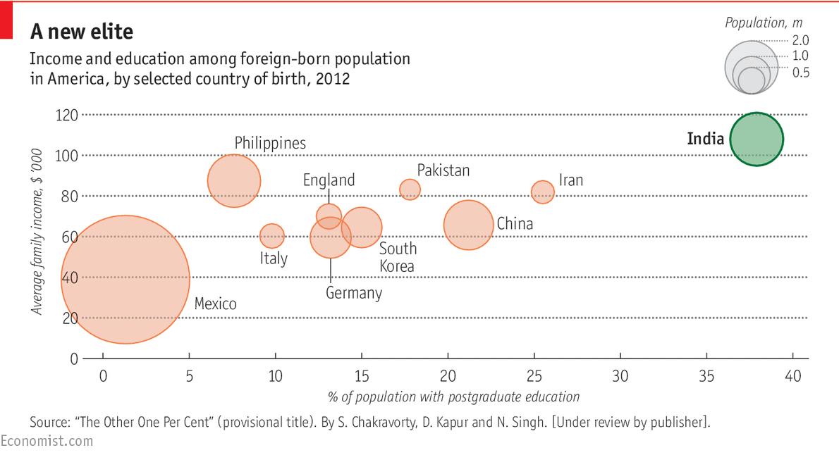
The stereotype of Indians as keeping shops or running motels in their adopted country is thus outdated. An IT professional from Andhra Pradesh would be far more typical. Since the turn of the century America has slurped in highly skilled graduates as fast as India can produce them. America’s H-1B employment visa for skilled professionals tells the story. In a book under review by a publisher, provisionally entitled “The Other One Per Cent”, Mr Kapur and his co-authors note that between 1997 and 2013 half of those visas went to Indians. Since 2009 the share has been more than two-thirds. Some 30,000 Indians a year also arrive in America to study, and many stay to work.
Exporting all that talent could hurt India, which lacks skilled workers. Mr Kapur says that some 91,000 Indian-born people with PhDs are now living in America. This suggests that India is failing to create the right conditions to retain high-fliers. But it is also an opportunity to deepen its ties with the West.
This has proved useful before. The 1990s boom in IT created a $100 billion industry in India as staff of Indian origin working in Western companies persuaded their bosses that they had the contacts and cultural understanding to be able to set up in their home country. Indians returning from work or study in America helped found big IT companies like Wipro and Infosys. The same diaspora could act as a bridge for other entrepreneurs now. And a wealthy diaspora should be a big source of tourism and capital, notes Sanjay Puri, chairman of USINPAC, the main political lobby for Indian-Americans in Washington.
Mr Puri points to plans for an infrastructure bond to be sold to members of the diaspora. One model for this could be a bond for building Cochin airport, in Kerala, to which nearly 10,000 Indians abroad contributed. “A highly successful community is looking to engage back again,” says Mr Puri.
Although most of the diaspora are social conservatives, they typically back the Democrats
The Indian diaspora also influences American domestic politics (Indians talk of emulating the Jewish-Israeli lobby). Its members are becoming bigger donors, and although most of them are social conservatives, they typically back the Democrats because Republican Christian evangelism makes them uncomfortable. Shivshankar Menon, the former national security adviser, credits the diaspora with lobbying America’s Congress to approve a civil nuclear agreement with India a decade ago.
The diaspora will not fix India’s problems, but it should help to reinforce success. An Indian who has done extremely well from making garments in China, Bangladesh and Vietnam says that for the moment he would not dream of setting up in his home country because he worries about the quality of manufacturing and the work culture there. But if things were to change, he would be ready to move quickly.

Modi’s next steps

Now for the serious stuff

India’s leader needs to offer a vision of what he wants to achieve, and let others help him
May 23rd 2015 | From the print edition

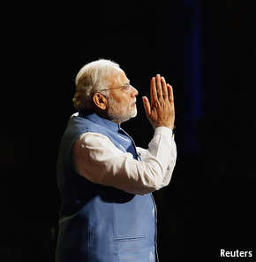
NARENDRA MODI would like to believe he has broken the mould as India’s leader. He is personally powerful and keener on a big international role for his country than his predecessors were. As he says, “there are huge global expectations for India.” Showing more openness than earlier leaders, he agreed to be interviewed on the eve of his first anniversary in power.
In conversation he is thoughtful, sincere and well briefed. He is driven (staff say he takes no holidays) and can be charming, though he is also intensely self-regarding. For example, he explains his many foreign trips as necessary for the “international community to get an opportunity to assess me directly”.
There are several broad concerns about his record so far. Though he seeks economic growth and national strength, he has not yet shown a clear vision for bringing these about; nor has he appointed the right ministers to deliver sweeping change. He is not speaking up enough for a noisy liberal democracy and the need to protect religious minorities, and he is not showing sufficient tolerance of criticism.
Ask about his vision, and he talks of jobs: “My government is committed to the poor of the country so I need to enhance employment opportunities.” He mentions a new ministry to promote skills, plans for roads and rail, and hopes to boost manufacturing. All of that is sensible but not inspiring. One way forward might be to trust markets more; another might be to invest more in human capital, public health and a world-class university system. But Mr Modi mentions none of these.
Thus he comes over as a cautious policymaker, which is surprising for a fiercely ambitious politician who got an overwhelming mandate a year ago. He seeks grand outcomes, saying India must compete with other emerging markets, secure a greater share of global trade, be “an engine of international growth”. Yet he does not spell out how these goals are to be achieved.
Perhaps, deep down, he is a pro-market reformer who for political reasons dare not speak out. Ask him about his timid approach to selling state assets, for example, and he retorts that recent coal auctions constitute the “biggest divestment in India’s entire history”. As evidence of reform, he claims that his government has done more than any other to untangle impossible labour-market rules. But he is careful also to talk of protecting the “dignity of labour”. The biggest economic reform his government is planning is the introduction of a goods and services tax, in effect an internal trade deal.
However capable Mr Modi may be, he cannot run everything, and he has not done enough to promote other talented individuals. In the course of a long conversation he never once refers to any of his ministers. He tends to say things like “I have created a ministry” or “my government is acting”. When speaking about world affairs, he focuses on his personal rapport with other leaders. He seems to think he is the government.
The ruling BJP is not stuffed with gifted leaders, but there are some. And Mr Modi could draw on people beyond politics. The previous government deserves credit for the creation of Aadhaar, the biometric-identity scheme, by Nandan Nilekani, a former businessman. Similar talent from the private sector could be brought in by Mr Modi.
Trust me, but why?
Yet if Mr Modi wants outsiders to join his government, they need to be able to trust his politics. He needs to speak out for moderation and tolerance and confront the “nutty underbelly” of Hindu nationalists, as one figure in government put it. Even his supporters concede that he has been too silent on religious affairs. All he will say on this is that he is “absolutely committed to the integrity and harmony of India” and that he respects “only one holy book”, the constitution—a line this correspondent first heard from him in 2012. This failure to talk more convincingly about religious tolerance raises suspicions over his own beliefs. He concedes that “perhaps the kind of words that people want to listen to do not come out from my mouth.”
Critics also note that his government is turning increasingly hostile to those it dislikes. In April it, in effect, suspended nearly 9,000 non-government groups. Organisations such as the Ford Foundation, which Mr Modi considers objectionable, find they have less scope for action. Greenpeace’s bank accounts were frozen last month. America’s ambassador to India, Richard Verma, notes that all this has “chilling effects” on democracy.
Mr Modi has made some steady, if not yet spectacular, progress in office so far, but he needs a clearer vision for economic reform, a broader range of talent within his government and a more convincing message of moderation. If he can produce them, the boy who left Vadnagar all those years ago could still become a truly transformative force.

Sources:
Books:
"The Other One Percent; Indians in America". By Sanjoy Chakravorty, Devesh Kapur and Nirvikar Singh. [under review by publisher].
"Getting India Back on Track; An Action Agenda for Reform". Edited by Bibek Debroy, Ashley J. Tellis, Reece Trevor.

"Why Growth Matters: How Economic Growth in India Reduced Poverty and the Lessons for Other Developing Countries". By Jagdish Bhagwati and Arvind Panagariya. Public Affairs.

"An Uncertain Glory: India and its Contradictions". By Amartya Sen and Jean Drèze. Allen Lane.

"India Grows at Night: A Liberal Case for a Strong State". By Gurcharan Das. Penguin Global.

"Forged in Crisis; India and the United States since 1947". By Rudra Chaudhuri. Harper Collins.

Reports:

Report of the Fourteenth Finance Commission 24th February, 2015
Economic Survey 2014-15
Global Wealth Report 2014
Interim Report of the Committee for Mobilization of Resources for Major Railway Projects and Restructuring of Railway Ministry and Railway Board
Doing Business 2015 data for India
India Development Update: Towards a Higher Growth Path April 2015

Websites:
http://mospi.nic.in/Mospi_New/site/home.aspx
http://planningcommission.nic.in/data/datatable/data_2312/
DatabookDec2014%20212.pdf
http://censusindia.gov.in/
https://portal.uidai.gov.in/uidwebportal/dashboard.do
From the print edition: Special report

