**India**

**Can India become a great power?**

**India’s lack of a strategic culture hobbles its ambition to be a force in the world**

Mar 30th 2013 |[From the print edition](http://www.economist.com/printedition/2013-03-27)

NOBODY doubts that China has joined the ranks of the great powers: the idea of a G2 with America is mooted, albeit prematurely. India is often spoken of in the same breath as China because of its billion-plus population, economic promise, value as a trading partner and growing military capabilities. All five permanent members of the United Nations Security Council support—however grudgingly—India’s claim to join them. But whereas China’s rise is a given, India is still widely seen as a nearly-power that cannot quite get its act together.

That is a pity, for as a great power, India would have much to offer. Although poorer and less economically dynamic than China, India has soft power in abundance. It is committed to democratic institutions, the rule of law and human rights. As a victim of jihadist violence, it is in the front rank of the fight against terrorism. It has a huge and talented diaspora. It may not want to be co-opted by the West but it shares many Western values. It is confident and culturally rich. If it had a permanent Security Council seat (which it has earned by being one of the most consistent contributors to UN peacekeeping operations) it would not instinctively excuse and defend brutal regimes. Unlike China and Russia, it has few skeletons in its cupboard. With its enormous coastline and respected navy (rated by its American counterpart, with which it often holds exercises, as up to NATO standard) India is well-placed to provide security in a critical part of the global commons.

The modest power

Yet India’s huge potential to be a force for stability and an upholder of the rules-based international system is far from being realised. One big reason is that the country lacks the culture to pursue an active security policy. Despite a rapidly rising defence budget, forecast to be the world’s fourth-largest by 2020, India’s politicians and bureaucrats show little interest in grand strategy (see [article](http://www.economist.com/news/briefing/21574458-india-poised-become-one-four-largest-military-powers-world-end)). The foreign service is ridiculously feeble—India’s 1.2 billion people are represented by about the same number of diplomats as Singapore’s 5m. The leadership of the armed forces and the political-bureaucratic establishment operate in different worlds. The defence ministry is chronically short of military expertise.

These weaknesses partly reflect a pragmatic desire to make economic development at home the priority. India has also wisely kept generals out of politics (a lesson ignored elsewhere in Asia, not least by Pakistan, with usually parlous results). But Nehruvian ideology also plays a role. At home, India mercifully gave up Fabian economics in the 1990s (and reaped the rewards). But diplomatically, 66 years after the British left, it still clings to the post-independence creeds of semi-pacifism and “non-alignment”: the West is not to be trusted.

India’s tradition of strategic restraint has in some ways served the country well. Having little to show for several limited wars with Pakistan and one with China, India tends to respond to provocations with caution. It has long-running territorial disputes with both its big neighbours, but it usually tries not to inflame them (although it censors any maps which accurately depict where the border lies, something its press shamefully tolerates). India does not go looking for trouble, and that has generally been to its advantage.

Indispensable India

But the lack of a strategic culture comes at a cost. Pakistan is dangerous and unstable, bristling with nuclear weapons, torn apart by jihadist violence and vulnerable to an army command threatened by radical junior officers. Yet India does not think coherently about how to cope. The government hopes that increased trade will improve relations, even as the army plans for a blitzkrieg-style attack across the border. It needs to work harder at healing the running sore of Kashmir and supporting Pakistan’s civilian government. Right now, for instance, Pakistan is going through what should be its first transition from one elected civilian government to the next. India’s prime minister, Manmohan Singh, should support this process by arranging to visit the country’s next leader.

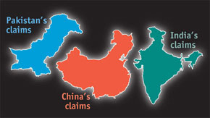Our **[interactive map](http://www.economist.com/blogs/dailychart/2011/05/indian_pakistani_and_chinese_border_disputes" \o " (opens in a new window) " \t "_blank)** demonstrates how the territorial claims of India, Pakistan and China would change the shape of South Asia

China, which is increasingly willing and able to project military power, including in the Indian Ocean, poses a threat of a different kind. Nobody can be sure how China will use its military and economic clout to further its own interests and, perhaps, put India’s at risk. But India, like China’s other near neighbours, has every reason to be nervous. The country is particularly vulnerable to any interruption in energy supplies (India has 17% of the world’s population but just 0.8% of its known oil and gas reserves).

India should start to shape its own destiny and the fate of its region. It needs to take strategy more seriously and build a foreign service that is fitting for a great power—one that is at least three times bigger. It needs a more professional defence ministry and a unified defence staff that can work with the country’s political leadership. It needs to let private and foreign firms into its moribund state-run defence industry. And it needs a well-funded navy that can become both a provider of maritime security along some of the world’s busiest sea-lanes and an expression of India’s willingness to shoulder the responsibilities of a great power.

Most of all, though, India needs to give up its outdated philosophy of non-alignment. Since the nuclear deal with America in 2005, it has shifted towards the west—it tends to vote America’s way in the UN, it has cut its purchases of Iranian oil, it collaborates with NATO in Afghanistan and co-ordinates with the West in dealing with regional problems such as repression in Sri Lanka and transition in Myanmar—but has done so surreptitiously. Making its shift more explicit, by signing up with Western-backed security alliances, would be good for the region, and the world. It would promote democracy in Asia and help bind China into international norms. That might not be in India’s short-term interest, for it would risk antagonising China. But looking beyond short-term self-interest is the kind of thing a great power does.

That India can become a great power is not in doubt. The real question is whether it wants to.

## India as a great power

### Know your own strength

# India is poised to become one of the four largest military powers in the world by the end of the decade. It needs to think about what that means

Mar 30th 2013 | DELHI |[From the print edition](http://www.economist.com/printedition/2013-03-27)

* <http://www.economist.com/news/briefing/21574458-india-poised-become-one-four-largest-military-powers-world-end>

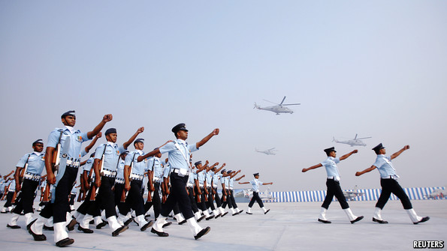

UNLIKE many other Asian countries—and in stark contrast to neighbouring Pakistan—India has never been run by its generals. The upper ranks of the powerful civil service of the colonial Raj were largely Hindu, while Muslims were disproportionately represented in the army. On gaining independence the Indian political elite, which had a strong pacifist bent, was determined to keep the generals in their place. In this it has happily succeeded.

But there have been costs. One is that India exhibits a striking lack of what might be called a strategic culture. It has fought a number of limited wars—one with China, which it lost, and several with Pakistan, which it mostly won, if not always convincingly—and it faces a range of threats, including jihadist terrorism and a persistent Maoist insurgency. Yet its political class shows little sign of knowing or caring how the country’s military clout should be deployed.

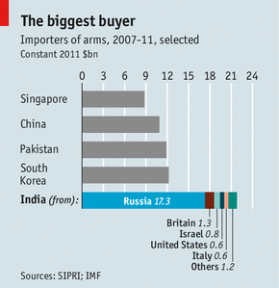

That clout is growing fast. For the past five years India has been the world’s largest importer of weapons (see chart). A deal for $12 billion or more to buy 126 Rafale fighters from France is slowly drawing towards completion. India has more active military personnel than any Asian country other than China, and its defence budget has risen to $46.8 billion. Today it is the world’s seventh-largest military spender; IHS Jane’s, a consultancy, reckons that by 2020 it will have overtaken Japan, France and Britain to come in fourth. It has a nuclear stockpile of 80 or more warheads to which it could easily add more, and ballistic missiles that can deliver some of them to any point in Pakistan. It has recently tested a missile with a range of 5,000km (3,100 miles), which would reach most of China.

Which way to face?

Apart from the always-vocal press and New Delhi’s lively think-tanks, India and its leaders show little interest in military or strategic issues. Strategic defence reviews like those that take place in America, Britain and France, informed by serving officers and civil servants but led by politicians, are unknown in India. The armed forces regard the Ministry of Defence as woefully ignorant on military matters, with few of the skills needed to provide support in areas such as logistics and procurement (they also resent its control over senior promotions). Civil servants pass through the ministry rather than making careers there. The Ministry of External Affairs, which should be crucial to informing the country’s strategic vision, is puny. Singapore, with a population of 5m, has a foreign service about the same size as India’s. China’s is eight times larger.

The main threats facing India are clear: an unstable, fading but dangerous Pakistan; a swaggering and intimidating China. One invokes feelings of superiority close to contempt, the other inferiority and envy. In terms of India’s regional status and future prospects as a “great power”, China matters most; but the vexatious relationship with Pakistan still dominates military thinking.

A recent attempt to thaw relations between the two countries is having some success. But tension along the “line of control” that separates the two sides in the absence of an agreed border in Kashmir can flare up at any time. To complicate things, China and Pakistan are close, and China is not above encouraging its grateful ally to be a thorn in India’s side. Pakistan also uses jihadist terrorists to conduct a proxy war against India “under its nuclear umbrella”, as exasperated Indians put it. The attack on India’s parliament in 2001 by Jaish-e-Mohammed, a terrorist group with close links to Pakistan’s intelligence service, brought the two countries to the brink of war. The memory of the 2008 commando raid on Mumbai by Lashkar-e-Taiba, another terrorist organisation, is still raw.

Pakistan’s nuclear capabilities are a constant concern. Its arsenal of warheads, developed with Chinese assistance, is at least as large as India’s and probably larger. It has missiles of mainly Chinese design that can reach most Indian cities and, unlike India, it does not have a “no first use” policy. Indeed, to offset the growing superiority of India’s conventional forces, it is developing nuclear weapons for the battlefield that may be placed under the control of commanders in the field.

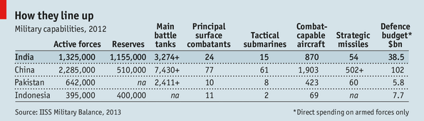

Much bigger and richer, India has tended to win its wars with Pakistan. Its plans for doing so again, if it feels provoked, are worrying. For much of the past decade the army has been working on a doctrine known as “Cold Start” that would see rapid armoured thrusts into Pakistan with close air support. The idea is to inflict damage on Pakistan’s forces at a mere 72 hours’ notice, seizing territory quickly enough not to incur a nuclear response. At a tactical level, this assumes a capacity for high-tech combined-arms warfare that India may not possess. At the strategic level it supposes that Pakistan will hesitate before unleashing nukes, and it sits ill with the Indian tradition of strategic restraint. Civilian officials and politicians unconvincingly deny that Cold Start even exists.

Bharat Karnad of the Centre for Policy Research, a think-tank, believes Pakistan’s main danger to India is as a failed state, not a military adversary. He sees Cold Start as a “blind alley” which wastes military and financial resources that should be used to deter the “proto-hegemon”, China. Others agree. In 2009 A.K. Antony, the defence minister, told the armed forces that they should consider China rather than Pakistan the main threat to India’s security and deploy themselves accordingly. But not much happened. Mr Karnad sees feeble civilian strategic direction combining with the army’s innate conservatism to stop India doing what it needs to.

The “line of actual control” between China and India in Arunachal Pradesh, which the Chinese refer to as South Tibet, is not as tense as the one in Kashmir. Talks between the two countries aimed at resolving the border issue have been going on for ten years and 15 rounds. In official statements both sides stress that the dispute does not preclude partnership in pursuit of other goals.

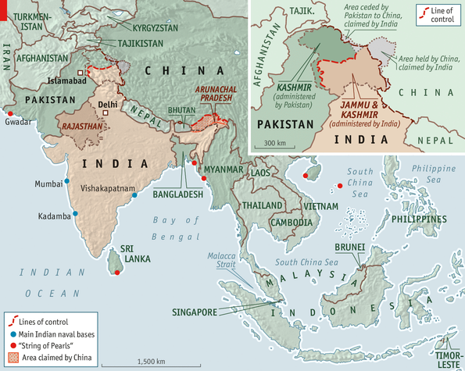

But it is hard to ignore the pace of military investment on the Chinese side of the line. Brigadier Gurmeet Kanwal of the Centre for Land Warfare Studies points to the construction of new railways, 58,000km of all-weather roads, five air bases, supply hubs and communication posts. China would be able to strike with power and speed if it decided to seize the Indian-controlled territory which it claims as its own, says Mr Karnad. He thinks the Indian army, habituated to “passive-reactive” planning when it comes to the Chinese, has deprived itself of the means to mount a counter-offensive.

Unable to match Chinese might on land, an alternative could be to respond at sea. Such a riposte was floated in a semi-official strategy document called “Nonalignment 2.0”, promoted last year by some former national security advisers and blessed by the current one, Shivshankar Menon. India’s naval advantage might allow it, for example, to impede oil traffic heading for China through the Malacca Strait.

China and India are both rapidly developing their navies from coastal defence forces into instruments that can project power further afield; within this decade, they expect to have three operational carrier groups each. Some Indian strategists believe that, as China extends its reach into the Indian Ocean to safeguard its access to natural resources, the countries’ navies are as likely to clash as their armies.

Two if by sea

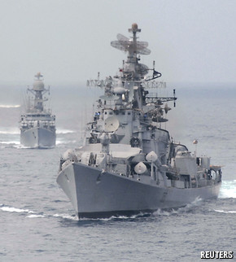An ocean needs a navy

China’s navy is expanding at a clip that India cannot match—by 2020 it is expected to have 73 major warships and 78 submarines, 12 of them nuclear—but India’s sailors are highly competent. They have been operating an aircraft-carrier since the 1960s, whereas China is only now getting into the game. India fears China’s development of facilities at ports in Pakistan, Sri Lanka, Bangladesh and Myanmar—a so-called “string of pearls” around the ocean that bears India’s name; Mr Antony called the announcement in February that a Chinese company would run the Pakistani port of Gwadar a “matter of concern”. China sees a threat in India’s developing naval relationships with Vietnam, South Korea, Japan and, most of all, America. India now conducts more naval exercises with America than with any other country.

India’s navy has experience, geography and some powerful friends on its side. However, it is still the poor relation to India’s other armed services, with only 19% of the defence budget compared with 25% for the air force and 50% for the army.

The air force also receives the lion’s share of the capital-equipment budget—double the amount given to the navy. It is buying the Rafales from France and upgrading its older, mainly Russian, fighters with new weapons and radars. A joint venture between Hindustan Aeronautics Limited (HAL) and Russia’s Sukhoi is developing a “fifth generation” strike fighter to rival America’s F-35. As well as indulging its pilots’ need for speed, though, the air force is placing a new emphasis on “enablers”. It is negotiating the purchase of six Airbus A330 military tankers and five new airborne early-warning and control aircraft. It has also addressed weaknesses in heavy lift by buying ten giant Boeing C-17 transports, with the prospect of more to come. Less clear is the priority the air force gives to the army’s requirements for close air support over its more traditional role of air defence, particularly after losing a squabble over who operates combat helicopters.

With the army training for a blitzkrieg against Pakistan and the navy preparing to confront Chinese blue-water adventurism, it is easy to get the impression that each service is planning for its own war without much thought to the requirements of the other two. Lip-service is paid to co-operation in planning, doctrine and operations, but this “jointness” is mostly aspirational. India lacks a chief of the defence staff of the kind most countries have. The government, ever-suspicious of the armed forces, appears not to want a single point of military advice. Nor do the service chiefs, jealous of their own autonomy.

The absence of a strategic culture and the distrust between civilian-run ministries and the armed forces has undermined military effectiveness in another way—by contributing to a procurement system even more dysfunctional than those of other countries. The defence industrial sector, dominated by the sprawling Defence Research and Development Organisation (DRDO), remains stuck in state control and the country’s protectionist past. According to a recent defence-ministry audit, only 29% of the products developed by the DRDO in the past 17 years have entered service with the armed forces. The organisation is a byword for late-arriving and expensive flops.

The cost of developing a heavy tank, the Arjun, exceeded the original estimates by 20 times. But according to Ajai Shukla, a former officer who now writes on defence for the Business Standard, the army wants to stick with its elderly Russian T-72s and newer T-90s, fearing that the Arjun, as well as being overweight, may be unreliable. A programme to build a light combat aircraft to replace the Mirages and MiG-21s of an earlier generation started more than quarter of a century ago. But the Tejas aircraft that resulted has still not entered service.

There are signs of slow change. These include interest in allowing partnerships between India’s small but growing private-sector defence firms and foreign companies, which should stimulate technology transfer. But the deal to buy the Rafale has hit difficulties because, though Dassault would prefer to team up with private-sector firms such as Tata and Reliance, the government wants it to work with stodgy HAL. Even if Dassault had a free choice of partners, though, it is not clear that Indian industry could handle the amount of work the contract seeks to set aside for it.

Richard Bitzinger, a former RAND Corporation analyst now at the S. Rajaratnam School of International Studies in Singapore, sums up the problem in a recent study for the Zurich-based International Relations and Security Network. If India does not stop coddling its existing state-run military-industrial complex, he says, it will never be capable of supplying its armed forces with the modern equipment they require. Without a concerted reform effort, a good part of the $200 billion India is due to spend on weaponry over the next 15 years looks likely to be wasted.

Our **[interactive map](http://www.economist.com/blogs/dailychart/2011/05/indian_pakistani_and_chinese_border_disputes" \o " (opens in a new window) " \t "_blank)** demonstrates how the territorial claims of India, Pakistan and China would change the shape of South Asia

Disputed borders are both a cause and a symptom of tensions between big neighbours in South Asia. When the colonial power, Britain, withdrew from India it left a dangerous legacy of carelessly or arbitrarily drawn borders. Tensions between India and China flare on occasion, especially along India's far north-eastern border, along the state of Arunachal Pradesh. In recent years Chinese officials have taken to calling part of the same area “South Tibet”, to Indian fury, as that seems to imply a Chinese claim to the territory. A failure to agree the precise border, and then to demarcate it, ensures that future disagreements may flare again.   
  
Pakistan, too, is beset by difficult borders. Afghanistan, to the north, has long been a hostile neighbour. This is largely because Afghanistan refuses to recognise the frontier—known as the Durand line—between the countries, drawn by the British.  
  
Most contentious of all, however, are the borders in Kashmir, where Pakistan, India and China all have competing claims. By the time of independence, in 1947, it was clear that many Indian Muslims were determined to break off from Hindu-majority India. It fell to a British civil servant, who knew nothing of the region, to draw a line of partition between territory that would become Pakistan and India. Pakistan was given Muslim dominated areas in the far north west, plus territory in the east (which itself got independence as Bangladesh in 1971). The rulers of some disputed areas, notably Kashmir, were told to choose which country to join.  
  
While Kashmir's Hindu rulers prevaricated, hoping somehow to become an independent country, Pakistan's leaders decided to force the issue. Since Kashmir was (and is) a Muslim majority territory, Pakistan felt justified in seeing Pushtun warlords charge in from the north-west of Pakistan, late in 1947, to seize control of Kashmir. In response India, apparently invited by Kashmir's rulers, deployed its national army and stopped the invaders taking Srinagar, Kashmir's capital, located in the Kashmir valley, the most coveted part of the territory. The resulting line of control, by and large, remains the de-facto international frontier within Kashmir and, in effect, is accepted by Paksitan and India. Huge numbers of Indian and Pakistani soldiers remain in Kashmir today as both countries profess to be the rightful authority for the rest of Kashmir.  
  
Complicating matters, China has also extended its influence, and control, over portions of Kashmir, largely with the support of Pakistan, an ally.

*The interactive map above allows you to view the various territorial claims from each country's perspective.*

The tiger and the eagle

The money it will spend abroad also carries risks. Big foreign deals lend themselves to corruption. Investigations into accusations of bribery can delay delivery of urgently needed kit for years. The latest “scandal” of this sort surrounds a $750m order for helicopters from Italy’s Finmeccanica. The firm denies any wrongdoing, but the deal has been put on hold.

Britain, France, Israel and, above all, Russia (which still accounts for more than half of India’s military imports), look poised to be beneficiaries of the coming binge. America will get big contracts, too. But despite a ground-breaking civil nuclear deal in 2005 and the subsequent warming of relations, America is still regarded as a less politically reliable partner in Delhi. The distrust stems partly from previous arms embargoes, partly from America’s former closeness to Pakistan, partly from India’s concerns about being the junior partner in a relationship with the world’s pre-eminent superpower.

The dilemma over how close to get to America is particularly acute when it comes to China. America and India appear to share similar objectives. Neither wants the Indian Ocean to become a Chinese “lake”. But India does not want to provoke China into thinking that it is ganging up with America. And it worries that the complex relationship between America and China, while often scratchy, is of such vital importance that, in a crisis, America would dump India rather than face down China. An Indian navy ordered to close down China’s oil supplies would not be able to do so if its American friends were set against it.

India’s search for the status appropriate to its ever-increasing economic muscle remains faltering and uncertain. Its problems with Pakistan are not of the sort that can be solved militarily. Mr Karnad argues that India, from a position of strength, should build better relations with Pakistan through some unilateral gestures, for example cutting back the size of the armoured forces massed in the deserts of Rajasthan and withdrawing its short-range missiles. General Ashfaq Parvez Kayani, head of Pakistan’s army, has declared internal terrorism to be a greater danger to his country than India. That may also offer an opportunity.

China’s confidence in its new military power is unnerving to India. But if a condescending China in its pomp is galling, one in economic trouble or political turmoil and pandering to xenophobic popular opinion would be worse. Japan and South Korea have the reassurance of formal alliances with America. India does not. It is building new relationships with its neighbours to the east through military co-operation and trade deals. But it is reluctant to form or join more robust institutional security frameworks.

Instead of clear strategic thinking, India shuffles along, impeded by its caution and bureaucratic inertia. The symbol of these failings is India’s reluctance to reform a defence-industrial base that wastes huge amounts of money, supplies the armed forces with substandard kit and leaves the country dependent on foreigners for military modernisation.

Since independence India has got away with having a weak strategic culture. Its undersized military ambitions have kept it out of most scrapes and allowed it to concentrate on other things instead. But as China bulks up, India’s strategic shortcomings are becoming a liability. And they are an obstacle to India’s dreams of becoming a true 21st-century power.

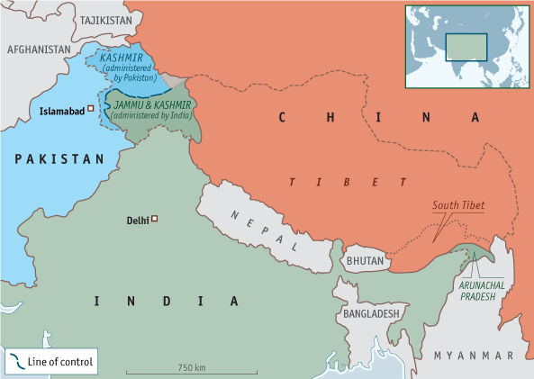

Pakistan’s territorial claims

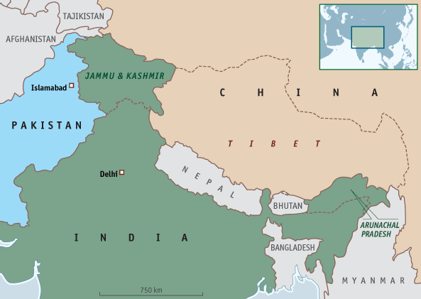

India’s territorial claims



China’s territorial claims

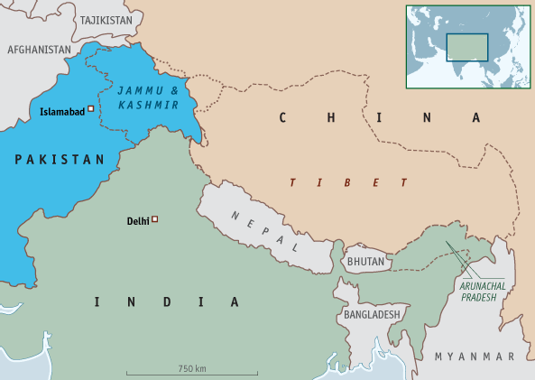

Current boundaries

The Economist

## India’s armed forces

### Guns and ghee

# India is wise to speak softly, but it could do with a bigger stick

Sep 24th 2016 | DELHI | [From the print edition](http://www.economist.com/printedition/2016-09-22)

<http://www.economist.com/news/asia/21707562-india-wise-speak-softly-it-could-do-bigger-stick-guns-and-ghee?fsrc=permar|image3>

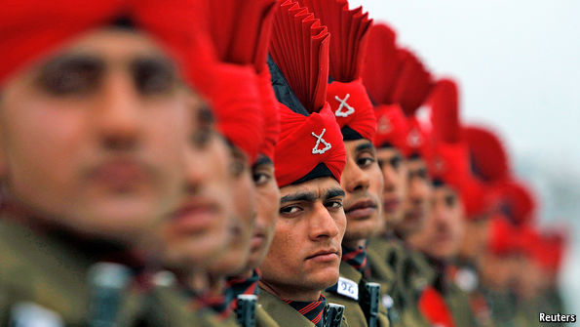

TO MANY Indians, their country’s strategic position looks alarming. Its two biggest neighbours are China and Pakistan. It has fought wars with both, and border issues still fester. Both are nuclear-armed, and are allies with one another to boot. China, a rising superpower with five times India’s GDP, is quietly encroaching on India’s traditional sphere of influence, tying a “string of pearls” of alliances around the subcontinent. Relatively weak but safe behind its nuclear shield, Pakistan harbours Islamist guerrillas who have repeatedly struck Indian targets; regional security wonks have long feared that another such incident might spark a conflagration.

So when four heavily armed infiltrators attacked an Indian army base on September 18th, killing 18 soldiers before being shot dead themselves, jitters inevitably spread. The base nestles in mountains close to the “line of control”, as the border between the Indian and Pakistani-administered parts of the disputed territory of Kashmir is known. Indian officials reflexively blamed Pakistan; politicians and pundits vied in demanding a punchy response. “Every Pakistan post through which infiltration takes place should be reduced to rubble by artillery fire,” blustered a retired brigadier who now mans a think-tank in New Delhi, India’s capital.

Yet despite electoral promises to be tough on Pakistan, the Hindu-nationalist government of Narendra Modi has trodden as softly as its predecessors. On September 21st it summoned Pakistan’s envoy for a wrist-slap, citing evidence that the attackers had indeed slipped across the border, and noting that India has stopped 17 such incursions since the beginning of the year. Much to the chagrin of India’s armchair warriors, such polite reprimands are likely to be the limit of India’s response.

|  |
| --- |
|  |
|  |

There are good reasons for this. India gains diplomatic stature by behaving more responsibly than Pakistan. It is keenly aware of the danger of nuclear escalation, and of the risks of brinkmanship to its economy. Indian intelligence agencies also understand that they face an unusual adversary in Pakistan: such is its political frailty that any Indian belligerence tends to strengthen exactly the elements in Pakistan’s power structure that are most inimical to India’s own interests.

But there is another, less obvious reason for reticence. India is not as strong militarily as the numbers might suggest. Puzzlingly, given how its international ambitions are growing along with its economy, and how alarming its strategic position looks, India has proved strangely unable to build serious military muscle.

India’s armed forces look good on paper. It fields the world’s second-biggest standing army, after China, with long fighting experience in a variety of terrains and situations (see chart). It has topped the list of global arms importers since 2010, sucking in a formidable array of top-of-the-line weaponry, including Russian warplanes, Israeli missiles, American transport aircraft and French submarines. State-owned Indian firms churn out some impressive gear, too, including fighter jets, cruise missiles and the 40,000-tonne aircraft-carrier under construction in a shipyard in Kochi, in the south of the country.

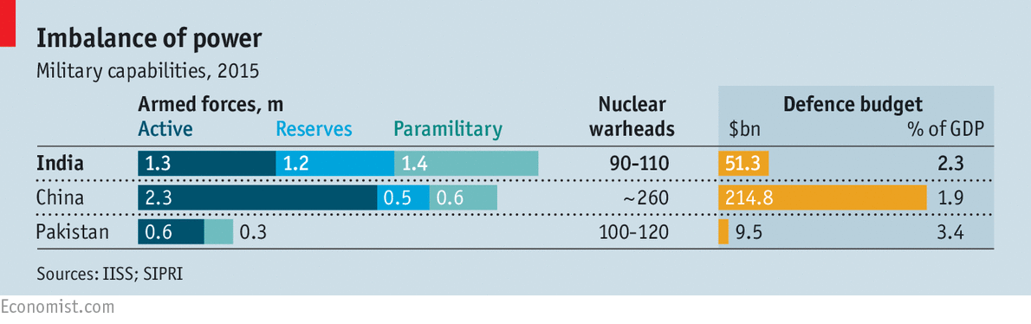

Yet there are serious chinks in India’s armour. Much of its weaponry is, in fact, outdated or ill maintained. “Our air defence is in a shocking state,” says Ajai Shukla, a commentator on military affairs. “What’s in place is mostly 1970s vintage, and it may take ten years to install the fancy new gear.” On paper, India’s air force is the world’s fourth largest, with around 2,000 aircraft in service. But an internal report seen in 2014 by IHS Jane’s, a defence publication, revealed that only 60% were typically fit to fly. A report earlier this year by a government accounting agency estimated that the “serviceability” of the 45 MiG 29K jets that are the pride of the Indian navy’s air arm ranged between 16% and 38%. They were intended to fly from the carrier currently under construction, which was ordered more than 15 years ago and was meant to have been launched in 2010. According to the government’s auditors the ship, after some 1,150 modifications, now looks unlikely to sail before 2023.

Such delays are far from unusual. India’s army, for instance, has been seeking a new standard assault rifle since 1982; torn between demands for local production and the temptation of fancy imports, and between doctrines calling for heavier firepower or more versatility, it has flip-flopped ever since. India’s air force has spent 16 years perusing fighter aircraft to replace ageing Soviet-era models. By demanding over-ambitious specifications, bargain prices, hard-to-meet local-content quotas and so on, it has left foreign manufacturers “banging heads against the wall”, in the words of one Indian military analyst. Four years ago France appeared to have clinched a deal to sell 126 of its Rafale fighters. The order has since been whittled to 36, but is at least about to be finalised.

India’s military is also scandal-prone. Corruption has been a problem in the past, and observers rightly wonder how guerrillas manage to penetrate heavily guarded bases repeatedly. Lately the Indian public has been treated to legal battles between generals over promotions, loud disputes over pay and orders for officers to lose weight. In July a military transport plane vanished into the Bay of Bengal with 29 people aboard; no trace of it has been found. In August an Australian newspaper leaked extensive technical details of India’s new French submarines.

The deeper problem with India’s military is structural. The three services are each reasonably competent, say security experts; the trouble is that they function as separate fiefdoms. “No service talks to the others, and the civilians in the Ministry of Defence don’t talk to them,” says Mr Shukla. Bizarrely, there are no military men inside the ministry at all. Like India’s other ministries, defence is run by rotating civil servants and political appointees more focused on ballot boxes than ballistics. “They seem to think a general practitioner can perform surgery,” says Abhijit Iyer-Mitra, who has worked as a consultant for the ministry. Despite their growing brawn, India’s armed forces still lack a brain.