NYT

Indian Leader Narendra Modi, Once Unwelcome in U.S., Gets Rock Star Reception
By SHREEYA SINHASEPT. 27, 2014
Photo
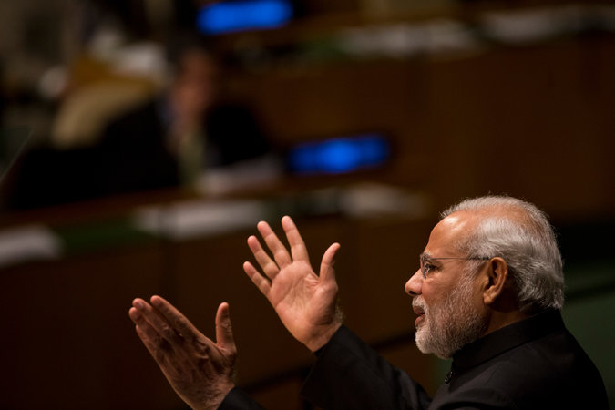
Prime Minister Narendra Modi of India addressed the United Nations General Assembly on Saturday. Credit Todd Heisler/The New York Times
The Indians who draw crowds of adoring fans are usually tall and sultry, with washboard abs and elaborate outfits, Bollywood stars like Shah Rukh Khan — described by some as the Brad Pitt of India — or Priyanka Chopra, the bombshell actress, singer and model.
But this time it is a teetotaler and bachelor who has boasted of his 56-inch chest and wears a simple cotton shirt.
Narendra Modi, India’s new prime minister, will receive a rally fit for a rock star at Madison Square Garden on Sunday. His rags-to-riches story mirrors the rise of Gujarat, the Indian state that he governed and that gave him and his Bharatiya Janata Party a landslide victory in India’s general election in May. His new profile has also allowed him to return to the United States for the first time in more than two decades; the State Department had revoked his visa in 2005 over his alleged role in deadly religious riots in Gujarat three years earlier.
For Mr. Modi and his supporters, the visit, which includes a speech before the United Nations General Assembly and a meeting with President Obama, is also a moment to connect with members of the broad Indian diaspora in the United States, many of whom watched with embarrassment from afar as India’s economic engine sputtered and corruption scandals plagued Mr. Modi’s rivals in the Indian National Congress party, which has governed India for most of its postcolonial history.

The Times asked Indian-Americans what Mr. Modi's trip to the U.S. means to them.
Manisha Verma, who lives in San Jose, Calif., has family from Ranchi, Jharkhand.
“Modi's upcoming trip brings a ray of hope for American Indians like me who face a conflicting reality of being part of one of the most successful and prosperous communities in the United States, and yet we carry the legacy of a poor third-world country and face biases in our adopted homeland. Modi brings hope of change in India which will help Indians have better self-esteem and image in the United States.”
Arun Gupta, who lives in New York, has family from Amritsar, Punjab.
“It's a visit by a head of state of a second-tier power that Washington is courting in terms of economic and political opportunities not the least of which is as a counterweight to China. In other words, it's business as usual.”
Vivek Pai, who lives in New York, has family from Bangalore, Karnataka.
“Today, thanks to the political expressions of 550 million Indians in the largest democratic electoral exercise in human history, the U.S. is being forced to eat the humble pie and welcome Mr. Modi as the leader of India. The greatest military and economic power on Earth had to bow to the democratic wishes of a half billion people. That represents the greatest triumph of democratic ideals during our times.”
Sheetal Ranjan, who lives in Teaneck, N.J., has family from Jodhpur, Rajasthan.
“It means that the U.S. now looks at India as a pivotal strategic partner in the world. And I am glad to be living in a nation where my origins are of value.”
Nikhil Desai, who lives in San Francisco, has family from Ahmedabad, Gujarat.
“Modi has not satisfactorily addressed the failure by his government to prevent the riots in Gujarat; presumably he has not done so because of his complicity in those events. His actions need to be scrutinized at the international level - his trip to the U.S. will likely suggest that the U.S. is with open-arms embracing Modi and won't press further into the charges.”
Sant Gupta, who lives in Lorton, Va., has family from New Delhi.
“Mr. Modi's trip will jump start the process of restoring respect and in fact admiration for Indian civilization, history, heritage and acceptance.”
Tenaz H. Dubash, who lives in New York, has family from Delhi.
“I have mixed feelings about Mr. Modi's trip to the U.S. His treatment of the minorities in Gujarat was deplorable. He is supposed to have a stellar grip on economic issues. Hopefully he can deliver economically while working tirelessly to make sure that India remains a secular democracy where all minorities are protected.”
Kayhan Irank, who lives in Jackson Heights, N.Y., has family from Mumbai.
“It means that America and Indian-Americans are actively denying the genocide that took place in Gujarat and are re-writing history regarding Modi's role in carrying it out.”
Saad Mohammad, who lives in Evanston, Ill., has family from Bareilly, Uttar Pradesh.
“I am appalled that the U.S. government is sponsoring this criminal who has been complicit in pogroms. There are still hundreds of millions throughout India and millions in the diaspora that refuse to go along with the Modi and BJP agenda.”
Asokan Vengassery Krishnan, who lives in Philadelphia, has family from Thiruvananthapuram, Kerala.
“The Modi visit is expected to strengthen the ties between the most powerful and the largest democratic nations. It will also be a sweet revenge for Modi who was long being treated as a pariah by the U.S. In turn, it is also the victory of the Indian identity and might in a post-colonial, post-Cold War era. Modi will prove that India has a dignified role to play in the new world order.”
Rama Krishna Ambati, who lives in Victor, N.Y., has family from Guntur, Andhra Pradesh.
“I believe India has so much potential but has been waiting for a dynamic leader to lead the nation. It happened now.”
Raghu C. Mudumbai, M.D., who lives in Seattle, has family from Hyderabad, Andhra Pradesh.
“Mr. Modi's trip lays the ground work for Indian-American relations over the next 10 years at a time when the world economy continues to recover, when democratic nations seek the proper balance between security and protection of its citizens (and learn from each others experience), and when the world's largest democracy and the world's most powerful democracy seek to define their place in the new world order.”

“Prime Minister Modi’s message will be refreshing — what role Indian-Americans can play promoting a relationship between two great stories,” said Dr. Bharat Barai, a longtime friend of Mr. Modi’s who helped arrange his visit.
Many Indians in the United States see Mr. Modi as India’s savior: a strong leader who has pledged to cut through red tape, stamp out corruption, revive India’s economy and restore pride.
Of the more than 1,700 Indians living in the United States who responded to a New York Times questionnaire, a majority expressed excitement and hope about Mr. Modi’s visit, saying they expected him to resurrect the narrative of India as a rising global power and strengthen relations between the two countries.
“Modi’s trip will jump-start the process of restoring respect and admiration for Indian civilization,” wrote one respondent, Sant Gupta, 66, of Virginia.
Tapping into a level of interest they never expected, Dr. Barai and the group organizing the $1.5 million event, the Indian American Community Foundation, have mobilized more than 400 organizations and individuals. Bollywood stars offered their talents, but organizers wanted to keep the focus on Indian-Americans. The hosts will be last year’s Miss America winner, Nina Davuluri, and a PBS anchor, Hari Sreenivasan. Anjali Ranadivé, the daughter of Vivek Ranadivé, owner of the Sacramento Kings basketball team, will sing the American national anthem, while L. Subramaniam, a violinist, and Kavita Krishnamurthy, a classical singer, will perform the Indian anthem.
The prime minister’s office told Dr. Barai and the other organizers, “Just don’t have a Bollywood night there.”
The event will include an acrobatic and laser show, a speed-painted portrait of Mr. Modi and a hologram re-creating the seminal speech of Mr. Modi’s guru, Swami Vivekananda, who became the ambassador of Hinduism to the United States when he spoke at the World’s Parliament of Religions in 1893. Mr. Modi was honoring him when he visited the United States in 1993, and Dr. Barai recalled how embarrassed Mr. Modi was by his meager possessions during that visit. “I know you only do laundry in America once a week,” Mr. Modi said. “But I only have two pairs of clothes.” Now, his shirts are a fashion symbol.

The Times asked Indian-Americans how they think Mr. Modi's trip will influence U.S.-India relations.
Mohin Patel, who lives in Edison, N.J., has family from Thasara, Gujarat.
“I can see the excitement Prime Minister Modi has generated among the Indian communities in the U.S. and around the world. He has actually brought the factions among the Indian communities together to act as one voice, that in itself is going to make a huge impact. Also many Indian business men and women who are doing business in the U.S. are going to see positive changes in getting business done in India.”
Rajiv Varma, who lives in Houston, has family from Kanpur, Uttar Pradesh.
“With a strong leader like Mr. Modi at the helm, it will become more difficult for the U.S. to push India around.”
Saad Mohammad, who lives in Evanston, Ill., has family from Bareilly, Uttar Pradesh.
“It will further oppress those targeted by Modi and BJP by cementing in these tyrants minds that their actions have no international consequences.”
Rumit Patel, who lives in Edison, N.J., has family from Anand, Gujarat.
“It will mark a stepping stone to U.S.-India ties and it will mean the world's biggest democracies are coming together to form stronger allies.”
Arun S, who lives in Washington, has family from Chennai, Tamil Nadu.
“Washington politicians should use this opportunity to seal several deals with India (including economic and security deals) which could make India a huge geopolitical ally in Asia. These deals could be mutually beneficial for both countries.”
Nilay Kumar, who lives in Brookline, Mass., has family from Patna, Bihar.
“He has singlehandedly changed the course of India's ties with Nepal and Japan (both of which he visited in the last two months). He has an enormous support among the Indian diaspora in the United States, many of whom are very influential people. Modi is pro business and the U.S. needs access to a billion-strong market. There is a natural alignment of interests here.”
Sheetal Ranjan, who lives in Teaneck, N.J., has family from Jodhpur, Rajasthan.
“For once, we have a visionary national leader who has a keen eye for trade. The U.S. needs India and Modi can make that partnership happen.”
Nihal Mariwala, who lives in New York, has family from Mumbai.
“We are both the world's most vibrant, diverse and exciting nations. The relative inactivity and tension in our historic ties have always disappointed me, and I am hopeful that this visit will help unlock a lot of latent potential.”
“It’s also milestone for us as a community,” said Anand Shah, a spokesman for the organizers.
Only about half of the 30,000 people who applied for free tickets will get to see Mr. Modi. Free lunches will be provided around the corner for guests, though Mr. Modi himself will be observing a nine-day religious fast. A majority of those attending are from the Northeast.
“I am die-hard fan of Narendra Modiji and have been following him since last 12 years,” a software engineer from Atlanta wrote in an email to Dr. Barai, using a term of respect for the prime minister. He said he had bought a plane ticket to New York before learning that he had not got a ticket to the Modi event.
The Indian diaspora is as complex as India itself: a kaleidoscope of religious and ethnic groups, a growing middle class, skilled laborers, poor migrants and pockets of the wealthy elite. The Indian government estimates the diaspora, including immigrants and their descendants, at 20 million, with large concentrations in 22 countries.
India has the largest number of people living outside its borders of any nation, according to the Pew Research Center. Indian-Americans make up the third-largest Asian-American group in the United States, and lead these groups in terms of income and education.
“India has defense and economic ties with other countries,” said Tanvi Madan, director of the India Project at the Brookings Institution, but the large number of Indians living in the United States “is what makes the relationship different.”
By the mid-1990s, the Indian community in the United States was fairly large and rich, made up of skilled migrants of the 1960s and '70s and young men seeking higher education in the mid-1980s, according to Ashutosh Varshney, a political scientist at Brown University.
“This diaspora was embarrassed about India’s poverty and economic performance,” he said. “There’s a diasporic desire to see India economically rise again, which also drives the fascination with Mr. Modi.”
After India’s economy was overhauled in the 1990s, its technology sector began to boom and it began approaching China’s double-digit growth rates. But the global downturn of 2008-09 laid bare its chronic problems, including antiquated infrastructure, wasteful spending and rising food prices.
“The trip provides a great opportunity to resurrect the India growth story in the West,” Soumyadeep Ghosh, a computer scientist from Princeton, wrote in his response to the Times questionnaire. “Something that would lead to better opportunities for India and its people.”
Respondents to The Times also raised concerns about resurfacing tensions with Pakistan and China’s growing might. Some also said they felt a greater connection to India because of Mr. Modi‘s election. A. Chaturvedi, 23, of Chicago wrote that it “has renewed my pride in being Indian and made me consider moving back home once again.”
Had Mr. Modi not been elected, it is unlikely that he would be able to even set foot in America. Many Western countries besides the United States revoked his visas over his handling of the 2002 Hindu-Muslim riots, which left more than 1,000 people dead, most of them Muslims. A United States federal court issued a summons on Thursday in a lawsuit over the riots, but it is not likely to affect Mr. Modi’s visit, as he enjoys immunity as a head of state.
Mr. Modi, a Hindu nationalist, has been a divisive figure in India, and although he has not made inflammatory statements since his election, some respondents raised concerns about his religious tolerance.
Zahir Janmohamed, who was among those who worked to deny Mr. Modi a visa, said, “Questions about Modi’s failure to protect his own citizens are still relevant.”
And Kayhan Irank of Jackson Heights, Queens, said Mr. Modi’s ascendance “definitely strains my relationships with some elders and relatives who are less interested in justice for those who were killed and displaced over the facade of India as a major economic player.”

Defying Expectations in India, Modi Begins Key Trip to U.S.
By ELLEN BARRYSEPT. 25, 2014
Photo
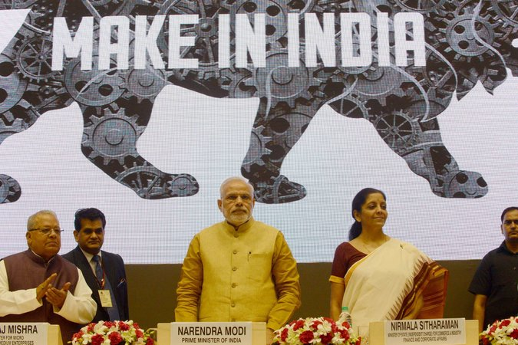
Prime Minister Narendra Modi, in New Delhi on Thursday, opened a campaign to attract more global businesses to India. Credit Raveendran/Agence France-Presse — Getty Images
NEW DELHI — Almost as soon as Narendra Modi became prime minister of India, whispers began circulating of mysterious phone calls from his office, upbraiding startled officials for infractions like inappropriate clothing or chummy-looking public meetings with tycoons.
The message was received. Mr. Modi, who is famously austere in his own habits, intends to impose discipline.
The United States will get a taste of Mr. Modi’s style starting Friday. Booked for back-to-back high-pressure appearances during five days in New York and Washington, Mr. Modi, 64, has also announced that he will maintain a strict religious fast for the duration of the visit, which coincides with the Hindu festival of Navratri, consuming only tea and lemonade with honey.
The visit is a big moment for Mr. Modi, who offers himself as a metaphor for the India he wants to build — ambitious, confident and impatient with slackness of any kind.

Rarely has any world leader come full circle the way Mr. Modi has: Denied a United States visa for nearly a decade as punishment for his handling of religious riots that broke out in the state he then led, Mr. Modi flies into New York as an immensely popular leader and a sought-after strategic partner, viewed as uniquely capable of balancing the might of a rising China.

The Times asked Indian-Americans if they supported Mr. Modi in the past election.
Nikhil Desai, who lives in San Francisco, has family from Ahmedabad, Gujarat.
“Despite the weaknesses within the opposing parties, Modi has yet to be held accountable for a very dark period in India's troubled history. I know there are many who supported him — only because of the belief that the alternatives are worse. But how can one support a leader who hasn't cleared himself of what amounts to crimes against humanity?”
Ashok K, who lives in New Jersey, has family from Surat, Gujarat.
“India needs strong leadership, development and growth and there is no better person in India now than Mr. Modi.”
Surya Kapa, who lives in Jersey City, has family from Bangalore, Karnataka.
“Yes, he signified a change in the status quo and much needed change for the better.”
Vijay Kumar, who lives in Princeton, N.J., has family from Jagadhri, Haryana.
“I haven't forgiven him for his role in 2002 Gujarat riots. I think the country is taking a big risk in putting him in this job of prime minister of India.”
Nishant Bhajaria, who lives in Portland, Ore., has family from Mumbai.
“I did, with reservations as big as the U.S. national debt. Mr. Modi's party has tasted power before but failed to deliver on their volcanic promises. His party, much like the modern-day GOP, is a mix of crackpots and sensible conservatives who understand the limits of power. The BJP, all said and done, is better than the alternative.”
Kartik Sreepada, who lives in Kansas City, Mo., has family from Hyderabad, Andhra Pradesh.
“I lukewarmly supported him because India needs serious economic reform to remedy its underperformance, but his attitude towards Muslims will continue to concern me especially in relation to Pakistan.”
Bhanu Gouda, who lives in Laurel, Md., has family from Hyderabad, Telangana.
“I did support Modi for he is both smart and diligent. Not to mention his charisma. In a country which is infested by corruption, he comes out as a clean leader for the most part.”
Arun Gupta, who lives in New York, has family from Amritsar, Punjab.
“I completely oppose Modi, the BJP, and everything it stands for. The BJP is a quasi-fascist party that stokes Hindu chauvinism to burnish its nationalist credentials even as it promotes economic liberalization that mainly benefits the elite and foreign investors.”
Nihal Mariwala, who lives in New York, has family from Mumbai.
“I vehemently opposed his election. However, in the last few months, Mr. Modi's foreign policy steps have been more than exemplary given India's relative inactivity in the preceding 10 years. While I am still not convinced, Mr. Modi's enthusiasm, decisiveness and charisma have started to charm me.”

In the four months since he has taken office, Mr. Modi has disappointed those who were hoping for an Indian Margaret Thatcher, proving to be cautious and incremental in his use of economic policy. Instead, he has set about changing the architecture of the state, diluting the powers of ministries and concentrating them in his office. Mr. Modi is building a machine for governing, one he intends to operate for a long time.
It is not yet clear whether he can pull it off. To succeed, Mr. Modi must bring about fundamental changes in India’s economy and steer a stable course in a country prone to incendiary conflicts. Policy experts, surveying still-unfilled positions in his government, wonder whether Mr. Modi will be able to trust outsiders enough to bring in talent. And critics say his concentrated power will make it more difficult for his own officials to question him.
M. J. Akbar, a spokesman for Mr. Modi’s Bharatiya Janata Party, dismissed those worries, saying Mr. Modi’s early moves aimed at “setting the rules for his own government” and putting an end to a bureaucratic culture so loose that officials “used to tweet and send SMS’s in the middle of a cabinet meeting.”
The prime minister, Mr. Akbar said, “is just a tough guy. Delhi hasn’t seen a tough guy in a long time.”
On the day Mr. Modi was endorsed as prime minister, he stood before Parliament and seemed close to tears, promising to focus his attention on “rural areas, farmers, untouchables, the weak and the pained,” because “our weakest, our poorest have sent us here.”
This was a new tone for Mr. Modi. His reputation had preceded him to New Delhi: His rise through his own party proved him a ruthless political operator, capable of deftly sidelining well-established older leaders. An angry presence during the campaign, he had been championed by right-wing economists as someone prepared to slash away at the country’s gargantuan subsidy programs.
Since taking office, though, Mr. Modi has presented a softer face to the country, guided by a populist’s unerring instinct for his audience. In his major addresses, delivered without notes and in earthy, colloquial Hindi, he has spoken as a kindly moral instructor, focusing on such humble causes as the need to build toilets. Last week, perhaps responding to calls to move more quickly on reforms, Mr. Modi said he naturally gravitated to practical matters.
“There have been discussions about vision, about big vision and grand vision,” he said, in comments published by The Indian Express. “I only want to say that I am a small person, and I think about small people. By thinking small for small people I am trying to make them grow. Nobody was thinking about these small people.”

The Times asked Indian-Americans how Mr. Modi has influenced their connection to India.
Soumyadeep (Deep) Ghosh, who lives in Princeton, N.J., has family from Pune, Maharashtra.
“Mr. Modi and his party's view of a entrepreneurial economy high on technology-based solutions is important for a computer scientist like me. The steps his government has taken to remove red tape and improve the ease of doing business has allowed me to seriously think of a future where I go back to India to follow my own entrepreneurial ambitions.”
Vivek Pai, who lives in New York, has family from Bangalore, Karnataka.
“For the first time in my life, I view India with a hopefulness that goes beyond just GDP growth. Mr. Modi has focused his rhetoric not just on economic growth but basic civic sensibility that has been lacking for too long. For the first time, I believe that people like me, who are young and educated, may have a role in shaping the national discourse.”
Nilay Kumar, who lives in Brookline, Mass., has family from Patna, Bihar.
“He has made me prouder to be an Indian. I was sick and depressed of seeing a dysfunctional government and country that did one thing best, appeasing sections of the society at the cost of our nation. Modi will not have any of that while in office.”
Kayhan Irank, who lives in Jackson Heights, N.Y., has family from Mumbai.
“[Modi's new position] definitely strains my relationships with some elders and relatives who are less interested in justice for those who were killed and displaced over the facade of India as a major economic player.”
Vijay Kumar, who lives in Princeton, N.J., has family from Jagadhri, Haryana.
“My relationship is way beyond Modi. Politicians come and go in a democracy; countries and relationships live on.”
Rumit Patel, who lives in Edison, N.J., has family from Anand, Gujarat.
“With previous governments I have sort of lost hope with India. Now looking at progress in Gujarat I'm hoping that mojo for India will come back again and really looking forward for stronger India.”
Bhanu Gouda, who lives in Laurel, Md., has family from Hyderabad, Telangana.
“I am living in the United states for the last 16 plus years. I am out of touch with the current affairs of India. Modi's election created an interest to read more about India, watch news related to India.”
Sangeeta Shukla, who lives in Fairfax, Va., has family from Ahmedabad, Gujarat.
“I wouldn't say Modi influences my connection to India. Instead, I would say that he represents me to the whole world. His sincerity and his commitment to give India a better future inspires me as an individual to make an effort, in any and every way possible, to serve my country.”
Sant Gupta, who lives in Lorton, Va., has family from New Delhi.
“I feel proud to be of Indian heritage with renewed desire to help India the best I can. He will unleash its potential and channel its intellect and energy for a better India; the whole world will be benefit from India's rise.”
Mohin Patel, who lives in Edison, N.J., has family from Thasara, Gujarat.
“Following his campaign and seeing the passion and national pride he has stirred up in the nation and abroad, I couldn't help but feel proud of my heritage. No longer did I see India with a begging bowl but a proud nation that has a great history and so much to offer to the world.”
Kartik Sreepada, who lives in Kansas City, Mo., has family from Hyderabad, Andhra Pradesh.
“His election has made me more interested in the current affairs of India because he brings hope.”
Arun Gupta, who lives in New York, has family from Amritsar, Punjab.
“India is a huge country with a rich history, an incredible diversity of communities, peoples, and beliefs, and great social complexities. Who is in office does not change my affection for India.”

His bristles have mainly shown in the arena of foreign affairs. Last week, Mr. Modi was faced with a snap decision during a rare visit by the Chinese president, an event he hosted on his birthday, choreographed to cast the two leaders as potential partners. Chinese officials had dangled an investment package of as much as $100 billion, but as the two men sat down to dinner, Chinese and Indian troops were facing off against each other in the highlands of Ladakh, Kashmir, near the disputed border between the two nations.
With little time to decide, Mr. Modi took the unusual step of publicly prodding his Chinese guest over the border issue at a news conference, a moment that cast a shadow over the message of deepening trade.
Speaking of India in a recent interview with CNN, Mr. Modi made it clear that his goal was a historic restoration. “This is a country that once upon a time was called the golden bird,” he said. “We have fallen from where we were before. But now we have the chance to rise again.”
Mr. Modi’s toughness is certainly visible in New Delhi, a city where power has long been distributed among a constellation of heavyweight ministers, editors and business tycoons.
That balance has begun to change. Nearly every week during his early months in office, a new rumor began to circulate, each with the subtext that Mr. Modi and his team were keeping a close watch on officials, including members of his own cabinet. One described a minister who received a call from the prime minister’s office on a Friday, was told the exact number of unapproved files sitting on his desk, and was so unnerved that he worked all weekend to clear the files, one after another.
Party insiders would not confirm or deny these reports but acknowledged that officials were under scrutiny. “That officials are being monitored? Yes. Is their behavior being monitored? Yes,” said Akhilesh Mishra, a Bharatiya Janata Party activist who was a strategist for the parliamentary campaign. The reports, he said, come from “a vast network of people, people who give a feedback mechanism.”
Week by week, Mr. Modi has built up the prime minister’s office into a dominant force in government. First, cabinet officials were discouraged from speaking to the news media without permission. Ministers were barred from hiring personal staff members without approval.
And unlike his predecessors, Mr. Modi is said to be making many appointments himself. Senior officials, speaking on the condition of anonymity, complained to The Hindustan Times that the government had begun to circulate the agenda for cabinet meetings just hours before they were to begin, making it nearly impossible for them to fully participate in policy making.
Photo
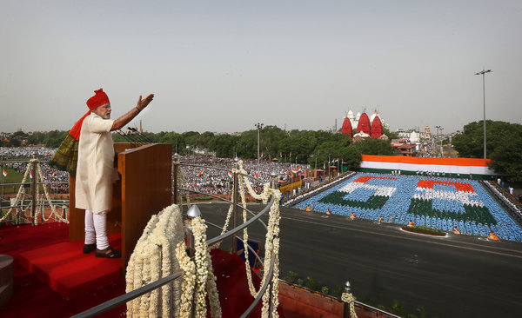
Prime Minister Narendra Modi of India spoke during the nation's Independence Day celebrations last month in New Delhi. Credit Manish Swarup/Associated Press Continue reading the main story
“Even in Indira Gandhi’s time, you had advisers who were very powerful, they were larger than life and capable of giving input,” said Siddharth Varadarajan, a journalist and senior fellow at Shiv Nadar University. “Here you have a prime minister whose strength is reminiscent of Indira Gandhi’s, but I think it goes beyond that, because you’d at least have that layer of advisers.”
Journalists now have virtually no opportunity to ask questions of top officials. As the Editors Guild of India complained in a letter published Tuesday, much of the bureaucracy has gone silent, and journalists have found themselves scrambling to get even basic information from the prime minister’s office, which has yet to appoint a contact person for the news media.
India’s business titans are another group facing an unfamiliar new landscape. Long accustomed to maintaining personal, informal contacts with officials in the ministries that grant crucial approvals, they must now fall in line with a new protocol: Meetings are to be formal, held in government offices, and presumed to be under the scrutiny of the prime minister’s apparatus.
This is, on one hand, a way of ensuring that payoffs are not offered or received. It also gives corporate leaders the sense that they are being kept at arm’s length, at least for the moment, said one executive from a large Indian company, who spoke on the condition of anonymity.
“Is Modi taking the demonstrative step of being wary of industry?” the executive said. “If that’s just messaging, it’s also risky, because you are almost sending the message that industry is the cause of corruption. If he actually believes it, that’s terrible. Even if it’s just signaling, that’s bad enough.”
Mr. Modi’s supporters say his centralization of authority has begun to yield results: Ministries that previously worked as independent fiefs have fallen in line, and long-delayed projects have begun to move. India’s economy is showing signs of a revival, growing at an annualized rate of 5.7 percent in the first quarter of the year, after languishing under 5 percent for nearly two years.
But Mr. Modi’s time to make decisions is limited, and a backlog is said to be piling up. A surprising number of senior positions remain unfilled — notably, that of defense minister, despite this government’s keen focus on defense. Arun Jaitley, a lawmaker close to Mr. Modi, is temporarily serving as both finance minister and defense minister.
In some cases, the difficulty may be in identifying outside experts who are fully trusted by Mr. Modi’s team. But that, said an analyst who consulted with the Bharatiya Janata Party’s parliamentary campaign, is hardly surprising — Mr. Modi has never depended much on any one aide or adviser.
“He is his own master completely,” the analyst said, speaking on the condition of anonymity. “He has no problem seeking advice or talking to people. In terms of trust, I don’t think 100 percent he trusts anybody.”

Nikkei Asian Review

When Obama Meets Modi: The Superpower and the Global Swing State
- BY Daniel Twining
- SEPTEMBER 28, 2014 - 02:31 PM

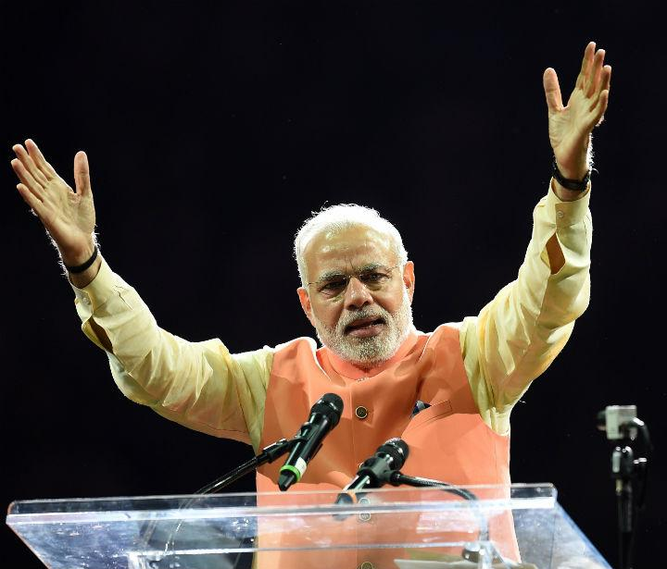
Share +
245 Shares
As U.S. President Barack Obama prepares to meet Indian Prime Minister Narendra Modi in late September, in the wake of Chinese President Xi Jinping's grand tour of South Asia, the world will be watching for clues about the future strategic triangle between its three biggest nations.
A China-India axis would tilt the balance of power against the United States, calling into question the future of its alliances with nations like Japan, and the ability of the U.S. to lead globally. By contrast, a U.S.-India partnership would make it more difficult for China to challenge American leadership in Asia and the world. An international order anchored by strong democracies would be fundamentally different from one led by an authoritarian superpower.
Both Obama and Xi will therefore cultivate Modi's India as the key global "swing state" -- just as prime ministers Shinzo Abe of Japan and Tony Abbott of Australia have recently done. When Modi visited Tokyo in early September, Abe announced a "special" strategic partnership and an impressive $35 billion in new Japanese investments in India. Abbott, on an official visit to New Delhi, announced that Australia would strengthen military ties and supply India with uranium for its civil nuclear reactors.
Not to be outdone, Xi committed to $20 billion in new investments during his visit to India from Sept. 17 to Sept. 19, clearly attempting to reverse the momentum of New Delhi's growing strategic ties to Tokyo, Washington, and Canberra. As one Chinese observer put it: "China is eager to win India over and ensure that it will not gravitate rapidly to the emerging anti-China coalition" led by the U.S. and Japan.
Fortunately, while Modi wants to import Chinese economic dynamism into India, he has also made clear that India will push back against what he calls China's "18th century expansionist mindset." On the day that Modi welcomed Xi to India, reports surfaced of a major Chinese border incursion into Indian-controlled territory. The summit was overshadowed by this military standoff.
On his recent trip to Tokyo, Modi compared China's vistarvad, or expansionism, to his hope for vikasvad, or development. He followed up during Xi's visit to New Delhi with the sternest warning by any Indian leader in decades that China should back off from its armed revisionism along their disputed frontier and settle the issue peacefully. India's new government has ordered its forces to "interdict" Chinese troops in disputed areas along the border.
Balance-of-power logic alone cannot explain recent India-China frictions, in part because each country is implicated in the other's domestic politics. New Delhi is complicit in China's domestic insecurity by virtue of India's strong support for Tibet, including hosting its government-in-exile. In India, Xi was met by waves of pro-Tibetan protestors angry about China's crackdown there. For its part, China has stepped up claims to what it calls southern Tibet -- otherwise known as the Indian state of Arunachal Pradesh. China also supports a Pakistani "deep state" that has produced waves of terrorism against India, and endorses Pakistan's claim to Indian-controlled Kashmir.
There was a period in 2009 to 2012, as Indian leaders grew disillusioned with Obama's foreign policy, when senior officials in New Delhi spoke internally of maintaining "equidistance" between Washington and Beijing. Diplomatically, India hedged its bets against both China and America during this period. But the policy did not work. China stepped up its hostile behavior against India even as it pursued gunboat diplomacy against Japan and Southeast Asian nations.
By 2013, a former senior Indian official who had served during the period of the Delhi-Beijing rapprochement was clear: "Equidistance is dead; of course India will tilt towards the United States." With an eye on the threat posed by India's northern neighbor, Modi has increased defense spending by 15 percent. He has signaled his determination to revitalize India's economic growth not only to advance domestic welfare, but to provide the resources to propel the country's military modernization.
New Delhi's approach to China will be influenced by America's approach. Modi has indicated his openness to a strategic alliance between the world's largest democracies. But if U.S. policy towards China is too accommodating -- or if America is simply less present as Obama backs away from his "pivot to Asia" -- Indian calculations naturally will be affected. By contrast, if U.S. power and purpose appear resurgent, Washington will be a more attractive partner to New Delhi, reinforcing common interests in defeating terrorism, stabilizing Asia, and growing the world economy.
As one Indian strategist put it: "We didn't seek a strategic partnership with America because we thought you'd go into decline but because we expected you to remain strong -- and to lead." President Obama should heed this message when he meets India's prim
NYT

Premier Outlines Goals for India on Eve of a Visit With Obama
By SOMINI SENGUPTASEPT. 28, 2014
Photo
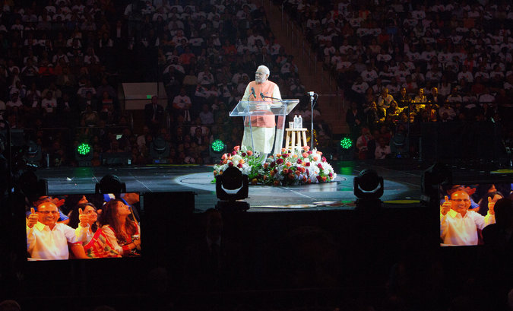
Over 19,000 people at Madison Square Garden in New York chanted and roared for Narendra Modi, who was elected in May. Some wore white Modi T-shirts over their clothes. Credit Ruth Fremson/The New York Times
Narendra Modi, the prime minister of India, sold himself on Sunday as a onetime tea vendor who wanted to lift India to glory by cleaning up the country, clearing the way for business and preparing its young citizens to be the work force of an aging world. His speech at Madison Square Garden telegraphed a wish list on the eve of his first meeting with President Obama, while also deftly rallying an influential diaspora to his side.
Mr. Modi addressed a wildly enthusiastic audience that was largely made up of Indian-Americans, and played skillfully to their sentiments. He reminded the crowd of the taunts they had heard for years that India was a land of snake charmers, and he offered lavish praise for their success in the United States.
His remarks were directed equally at the folks back home, where Mr. Modi won a sweeping electoral victory in May, and at American officials and investors he is wooing.

In an hourlong speech that was signature Modi, complete with rhetorical flourishes, soaring arms, and a good deal of snarkiness, the prime minister made fun of those who say he lacks “big vision.”

The Times asked Indian-Americans what Mr. Modi's trip to the U.S. means to them.
Manisha Verma, who lives in San Jose, Calif., has family from Ranchi, Jharkhand.
“Modi's upcoming trip brings a ray of hope for American Indians like me who face a conflicting reality of being part of one of the most successful and prosperous communities in the United States, and yet we carry the legacy of a poor third-world country and face biases in our adopted homeland. Modi brings hope of change in India which will help Indians have better self-esteem and image in the United States.”
Arun Gupta, who lives in New York, has family from Amritsar, Punjab.
“It's a visit by a head of state of a second-tier power that Washington is courting in terms of economic and political opportunities not the least of which is as a counterweight to China. In other words, it's business as usual.”
Vivek Pai, who lives in New York, has family from Bangalore, Karnataka.
“Today, thanks to the political expressions of 550 million Indians in the largest democratic electoral exercise in human history, the U.S. is being forced to eat the humble pie and welcome Mr. Modi as the leader of India. The greatest military and economic power on Earth had to bow to the democratic wishes of a half billion people. That represents the greatest triumph of democratic ideals during our times.”
Sheetal Ranjan, who lives in Teaneck, N.J., has family from Jodhpur, Rajasthan.
“It means that the U.S. now looks at India as a pivotal strategic partner in the world. And I am glad to be living in a nation where my origins are of value.”
Nikhil Desai, who lives in San Francisco, has family from Ahmedabad, Gujarat.
“Modi has not satisfactorily addressed the failure by his government to prevent the riots in Gujarat; presumably he has not done so because of his complicity in those events. His actions need to be scrutinized at the international level - his trip to the U.S. will likely suggest that the U.S. is with open-arms embracing Modi and won't press further into the charges.”
Sant Gupta, who lives in Lorton, Va., has family from New Delhi.
“Mr. Modi's trip will jump start the process of restoring respect and in fact admiration for Indian civilization, history, heritage and acceptance.”
Tenaz H. Dubash, who lives in New York, has family from Delhi.
“I have mixed feelings about Mr. Modi's trip to the U.S. His treatment of the minorities in Gujarat was deplorable. He is supposed to have a stellar grip on economic issues. Hopefully he can deliver economically while working tirelessly to make sure that India remains a secular democracy where all minorities are protected.”
Kayhan Irank, who lives in Jackson Heights, N.Y., has family from Mumbai.
“It means that America and Indian-Americans are actively denying the genocide that took place in Gujarat and are re-writing history regarding Modi's role in carrying it out.”
Saad Mohammad, who lives in Evanston, Ill., has family from Bareilly, Uttar Pradesh.
“I am appalled that the U.S. government is sponsoring this criminal who has been complicit in pogroms. There are still hundreds of millions throughout India and millions in the diaspora that refuse to go along with the Modi and BJP agenda.”
Asokan Vengassery Krishnan, who lives in Philadelphia, has family from Thiruvananthapuram, Kerala.
“The Modi visit is expected to strengthen the ties between the most powerful and the largest democratic nations. It will also be a sweet revenge for Modi who was long being treated as a pariah by the U.S. In turn, it is also the victory of the Indian identity and might in a post-colonial, post-Cold War era. Modi will prove that India has a dignified role to play in the new world order.”
Rama Krishna Ambati, who lives in Victor, N.Y., has family from Guntur, Andhra Pradesh.
“I believe India has so much potential but has been waiting for a dynamic leader to lead the nation. It happened now.”
Raghu C. Mudumbai, M.D., who lives in Seattle, has family from Hyderabad, Andhra Pradesh.
“Mr. Modi's trip lays the ground work for Indian-American relations over the next 10 years at a time when the world economy continues to recover, when democratic nations seek the proper balance between security and protection of its citizens (and learn from each others experience), and when the world's largest democracy and the world's most powerful democracy seek to define their place in the new world order.”

“I tell them, ‘My friends, I came here selling tea,’ ” he said, and paused, as the audience leapt to its feet and clapped. “I’m a small man. My mind is busy doing small things.”
Mr. Modi is visiting at a time when India and the United States are each seeking big things from the other. Theirs was supposed to be what Mr. Obama once called the defining “partnership” of the 21st century. The relationship has withered since then, though, and both Washington and Delhi are trying urgently now to repair it, showering each other with the diplomatic equivalent of Champagne and roses during Mr. Modi’s five-day visit to America.
He has met with two mayors and three governors, and more than two dozen members of Congress attended his event at the Garden. He is scheduled to meet on Monday with 11 chief executives from companies like Boeing, Google and Goldman Sachs, and then to speak at the Council on Foreign Relations.
An intimate dinner is planned with Mr. Obama on Monday (though Mr. Modi’s aides have let it be known that he is fasting for a Hindu festival called Navratri), as well as lunch on Tuesday at the State Department and tea with Speaker John A. Boehner. His itinerary also includes a meeting with Hillary Rodham Clinton.
Mr. Modi is here to sell a new New India, with himself as the man who can be trusted to deliver on its promise. But it remains to be seen whether he is willing or able to bridge India’s wide differences with the United States on tax policy, climate change, outsourcing, intellectual property rights and other issues. Nor has India proved to be a trusted partner (India avoids the word “ally”) on American foreign policy priorities, including the conflict in Syria.
R. Nicholas Burns, who was a top State Department official in the administration of George W. Bush, put the question this way: “Can we reset, reboot, revive — use your word — this relationship? We have to.”
An administration official cast Mr. Modi’s visit as a chance to “reinvigorate” relations. Speaking on the condition of anonymity, the official said the new government in Delhi offered a fresh chance, not least because Mr. Modi’s Bharatiya Janata Party won enough seats in Parliament to govern alone, without coalition partners. “We think this will be a pivotal moment and an opportunity for us to define how we can work together,” the official said.
Mr. Modi seems eager to establish something of a brain trust among influential Indian-Americans. He met Saturday evening with a dozen of them, including venture capitalists, technology executives, a college president and a former aide to Mrs. Clinton.
“You guys have achieved a lot here,” the prime minister told the group, according to one of the attendees. “I want to duplicate your success. What do we do to duplicate that success?”
On Sunday evening, he spoke to 700 Indian-Americans at a dinner at the Pierre Hotel. He said he did not need their dollars; he wanted every Indian-American to send five non-Indian friends to visit the country. Tourism, he said, can generate income for cabbies, auto-rickshaw drivers — “even tea sellers.”
Mr. Modi is keen to attract business deals that will create jobs in India, one of his main campaign promises in a nation where every month a million people turn 18 and join the labor force. For their part, American officials and executives want Mr. Modi to remove many of the obstacles that foreign companies face in doing business in India.
“The biggest thing the prime minister can do is to re-establish trust,” said Ajay Banga, chief executive of MasterCard, who has championed the cause of American business in India.
Stephen Ezell of the Information Technology and Innovation Foundation said that Mr. Modi seemed to be the most business-friendly prime minister in India’s recent history, but that he had yet to take action on matters like trade policy and taxes. “If he is truly going to deliver on that vision, then he is going to have to make some very difficult decisions,” Mr. Ezell said.
Mr. Modi received resounding applause on Sunday for a promise to clear away red tape facing new businesses.
The stated purpose of Mr. Modi’s trip was to address the United Nations General Assembly, but every stop he has made in New York has been tailored to send messages to specific audiences. One of his first was at the 9/11 Memorial in Lower Manhattan, signaling India’s commitment to combating extremist groups. He has not said whether India supports the American-led airstrikes against insurgents in Iraq and Syria, but that issue is certain to come up in his meetings in Washington, administration officials have said.
India has not taken a side in the war in Syria, and it continues to do business with Iran. But in steps that American officials have noted, Mr. Modi has improved ties with Japan, cautioned China against expansionism and signaled that he can be trusted as a friend to the United States in fighting terrorism. He met with the Israeli prime minister, Benjamin Netanyahu, on the sidelines of the General Assembly.
Both publicly and privately, Mr. Modi has listed his own priorities for India: building toilets, expanding Internet broadband access in the countryside, training young people for work and cleaning up the Ganges, a holy river in Hindu scripture.
“He is projecting an image of India that we haven’t seen in a while — that is, an India as a global player,” said Vishakha Desai, a former president of the Asia Society, who attended the Madison Square Garden speech on Sunday.
Mr. Modi’s emphasis on prosperity and cleanliness appealed to Rohit Sehgal of Secaucus, N.J. He said he hoped the changes Mr. Modi was promising would get his daughter’s generation to stop complaining about the roads and the garbage in India. “I want my daughter to want to go back to her country,” he said.
Not everyone was impressed. Outside the arena, a small group of protesters held banners denouncing Mr. Modi, who was chief minister of Gujarat in 2002 when sectarian rioting racked the state. He could not get a visa to visit the United States for nearly 10 years because of accusations that he had done too little to stop the violence.
Rekha Malhotra, 43, a popular disc jockey who was among the protesters, said she had turned down passes that she had been offered to see Mr. Modi speak. “I said thanks but no thanks — I’ll be outside,” she explained.
Sherry Hundal, 46, said she had come from Denville, N.J., to raise her voice against the prime minister. “I’m glad to be on the right side of history,” she said.

K@W

The U.S. Welcomes Modi, but Will Renewed Investment in India Follow?
Sep 30, 2014
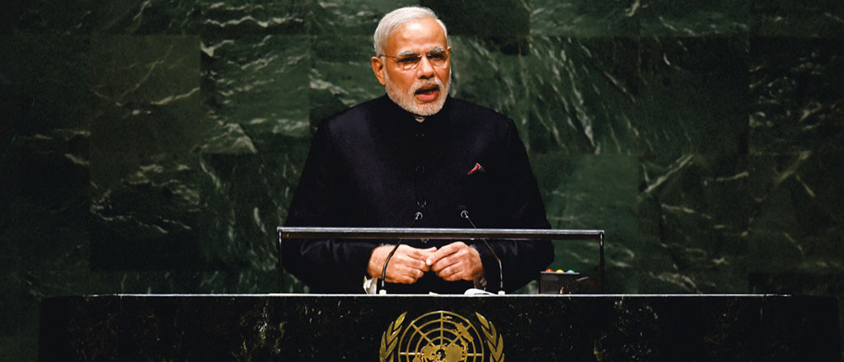
00:00
As Indian Prime Minister Narendra Modi’s U.S. visit comes to an end, he carries back promises of renewed partnerships between the two countries’ governments and businesses. In what has been billed as a “rock star-like” tour, Modi packed 36 events into five days, including meetings with some 300 business executives, and talks at the United Nations, Madison Square Garden and Central Park in New York City. He managed all that while observing a nine-day fast (drinking only lemon juice and water) to mark the Hindu Navratri festival that is underway.
Unlike many other high-profile foreign jaunts by heads of state, Modi’s visit did not result in a long list of specific investment commitments from U.S. companies, partnership announcements or other business deals. But Modi used his trip to showcase India as an investment destination, and as a market for U.S. companies to sell into, according to Wharton marketing professor Jagmohan Raju and Devesh Kapur, director of Penn’s Center for the Advanced Study of India (CASI). The two discussed the takeaways from Modi’s visit on the Knowledge@Wharton show on Wharton Business Radio on SiriusXM channel 111. (Listen to the podcast at the top of this page.)
Kapur said Modi’s visit is significant because Asia will play a key role in the global economy in the 21st century; India will be a big part of that growth story, along with China. He also noted that U.S.-India trade is now worth about $100 billion and could grow “multiple-fold” over the next 20 years. Raju added that India has a large consumer market, which makes it more important as a business investment destination. “History has taught us that power goes wherever the buying power goes Twitter ,”he said. “The buying power is likely to shift to India.”
Kapur noted that Modi sought to put to rest apprehensions and concerns that U.S. firms may have had about India’s stance on intellectual property rights and its tax regime. He also pointed out that even as the business community is enthusiastic about Modi’s plans, the Prime Minister will face an uphill road as India has to “reinvigorate its public institutions”and faces “severe challenges” in human capital. Raju “agreed to disagree,” saying that Kapur had underestimated Modi’s leadership potential. “As business people, we know how much difference a leader can make, and has made, in countries across the world,” Raju said.
Sizing up the gains of Modi’s visit, Raju noted, “There are country level agreements and business level agreements —[Modi] is trying to do both.” That said, he added that“much of the value of the visit will come from the business side, and Mr. Modi is making sure that that happens.” Kapur added that a key objective of Modi’s visit was to rebuild trust, especially as the relationship between the two countries has weakened somewhat in recent years.
“History has taught us that power goes wherever the buying power goes. The buying power is likely to shift to India.” –Jagmohan Raju
Modi began the business leg of his visit on Monday, at a breakfast meeting he hosted for 11 CEOs. At that meeting, he promised a more welcoming business environment in India, and identified infrastructure, skills development and tourism as areas in which he would like them to invest. The CEOs at that meeting included Google chairman Eric Schmidt, Citigroup CEO Michael Corbat, PepsiCo CEO Indra Nooyi, MasterCard CEO Ajay Banga, Warburg Pincus co-CEO Charles Kaye and Merck chairman and CEO Kenneth Frazier. Modi later had one-on-one meetings with the CEOs of General Electric, IBM, Goldman Sachs, Boeing, BlackRock and KKR.
Ahead of the Modi visit, media outlets reported that U.S. companies were eyeing $3.5 billion worth of defense and aerospace deals in India, and that firms including Google, IBM and Adobe had expressed interest in Modi’s plans for smart cities and a “Digital India”program with an outlay of Rs. 100,000 crores (approximately $17 billion) over the next five years. Among other objectives, the Digital India program aims to bring high speed Internet connectivity to all of India’s 600,000 villages.
Mixed Results
Modi drew a mixed response in his overtures to U.S. business. Caterpillar CEO Doug Oberhelman, who attended the Monday breakfast meeting with Modi, told Reuters that he was “genuinely quite impressed.” But the Reuters report also said Modi “alarmed some foes of government tinkering with business last week when he said in India, multinational soft drink giants PepsiCo Inc. and Coca-Cola Co. should help increase sales by Indian farmers by adding fresh fruit juices to their fizzy drinks.” Business groups have highlighted India’s trade barriers and its opposition to the World Trade Organization’s agreement on climate change as other concerns that could be an impediment to making investments there.
Modi also scored what The Washington Post called “a rare second day of attention”from President Barack Obama, highlighting the White House’s desire “to give a warm welcome to a man who was once barred from even entering the U.S.” Modi was denied a U.S. visa following widespread criticism over his handling of communal riots in the state of Gujarat in 2002 when he was its chief minister. Some 800 Muslims and 250 Hindus were killed in the riots, according to official records.
“There are country level agreements and business level agreements —[Modi] is trying to do both.” –Jagmohan Raju
In a joint op-ed published in The Washington Post on Tuesday, Obama and Modi wrote, “The true potential of our relationship has yet to be fully realized. The advent of a new government in India is a natural opportunity to broaden and deepen our relationship.” They added: “While India benefits from the growth generated by U.S. investment and technical partnerships, the United States benefits from a stronger, more prosperous India.”
The two leaders also spoke of collaboration in clean energy, climate change, medicine and efforts to improve sanitation and hygiene in India. They signed off the op-ed with“Forward together we go —chalein saath saath [meaning: “We will walk together” in Hindi].”

NYT

Narendra Modi, Indian Premier, Courts Silicon Valley to Try to Ease Nation’s Poverty
By VINDU GOELSEPT. 27, 2015
Photo
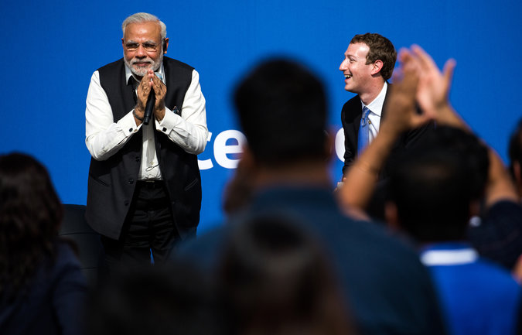
India's Prime Minister Narendra Modi and Mark Zuckerberg, chief of Facebook, at its headquarters in Menlo Park, Calif. Credit Max Whittaker for The New York Times

MENLO PARK, Calif. — Narendra Modi and Mark Zuckerberg have much in common.
Mr. Modi, the prime minister of India, oversees a nation of 1.25 billion people. Mr. Zuckerberg, the chief executive of Facebook, runs a social network with 1.5 billion active users. Both see themselves as global leaders pushing for broad social change, and both routinely use social media to communicate with their many millions of fans.
On Sunday, the two men engaged in a mutual admiration session at Facebook’s Silicon Valley headquarters, with Mr. Modi fielding preselected questions from a crowd of Facebook employees and guests invited by the Indian Embassy.
Mr. Modi praised social networks like Facebook, Twitter and even China’s Weibo as useful tools for governing and diplomacy.
“The strength of social media is it can tell government where they are going wrong,” Mr. Modi said. “We used to have elections every five years. Now we have them every five minutes.”
Mr. Modi’s visit to Facebook came halfway through his weekend tour of Silicon Valley, where he has been meeting with technology executives and seeking their ideas and assistance in bringing India fully into the digital world.
Silicon Valley has been eager to assist. India is the world’s fastest-growing major economy, and use of the Internet and smartphones is growing rapidly, providing new markets for American companies.
In addition, tens of thousands of Silicon Valley technology workers are of Indian descent and eager to give something back to their country of origin.
The prime minister, an avid user of Twitter and Facebook, sees technology as a way to lift India out of poverty.
“In this digital age, we have an opportunity to transform the lives of people in ways that were hard to imagine just a couple of decades ago,” Mr. Modi said in San Jose on Saturday in a dinnertime speech to about 500 technology leaders, including the chief executives of Microsoft, Google, Adobe and Uber.
Naren Gupta, a founder of the Silicon Valley investment firm Nexus Venture Partners, who helped organize Mr. Modi’s visit, said the prime minister wants tech companies to help him bring about that transformation.
“Innovation is a state of mind, and he is saying, help him bring that state of mind to India,” Mr. Gupta said. “Big changes are pretty much impossible to make. What you need to do in a democracy is take a thousand little steps.”
Mr. Modi’s message of partnership with American technology companies has been carefully choreographed to appeal to his constituents back in India, a country that is rapidly discovering the Internet and the start-up culture. The prime minister’s Bharatiya Janata Party has encountered setbacks in its legislative agenda and will soon face state elections.
A group of academics raised concerns about the free speech and privacy policies of Mr. Modi’s government in an open letter before his visit. Outside Facebook headquarters, Sikh separatists also protested his visit.
On Saturday, Mr. Modi stopped by Tesla Motors, the electric-car maker, and held private meetings with three of the technology world’s most powerful executives: Timothy D. Cook of Apple, Sundar Pichai of Google and Satya Nadella of Microsoft.
At the subsequent dinner, the tight connections between American companies and the Indian government were apparent.
Mr. Modi announced that Google had agreed to provide free public Wi-Fi in hundreds of Indian railroad stations, which are major transit and social hubs for their communities.
Recalling his childhood in India, Mr. Nadella pledged that Microsoft would help India bring wireless Internet to its 500,000 villages, but offered no details. “What opportunities can we unlock, what changes can we spark?” he said.
Qualcomm, a chip maker with thousands of employees in India, promised $150 million to finance Indian start-ups.
After the Facebook visit on Sunday, Mr. Modi planned to visit Google and Stanford University, and to drop by a meeting of Indian tech entrepreneurs. In the evening, he was scheduled to address a sold-out crowd of about 18,000 people, mostly Indo-Americans, at an arena in San Jose.

The Economist

Banyan

Narendra Modi takes on Xi Jinping China in a soft-power battle in America

A battle between Winnie the Pooh and a bear-hugger
Sep 29th 2015 | From the print edition

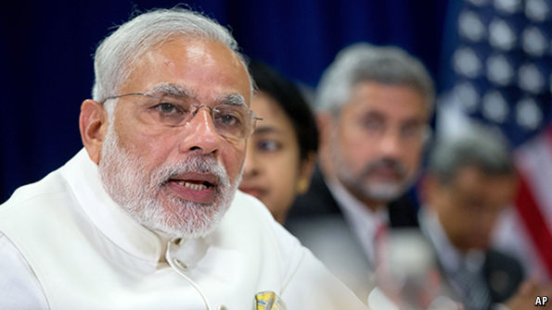
“ANYTHING Xi can do, I can do better,” seemed to be the mantra of Narendra Modi, India’s prime minister, as he toured America in late September, hot on the heels of China’s president, Xi Jinping. Both started on the west coast, seeking to charm the bosses of technology firms: both made speeches at the United Nations; and both met President Barack Obama. Above all, both sought to burnish their images with their own people at home and with Americans. Mr Modi perhaps wanted to show America how important a friend he can be; Mr Xi to prove that he is not yet an enemy. By those criteria, Mr Modi had the more successful American journey. But it also served as a reminder of how far India lags China in global clout.
Mr Modi’s tour was tacked on to his attendance at the UN’s summit on sustainable development. By contrast, Mr Xi’s was much the grander affair. He was making his first formal state visit, with the full panoply of White House pomp. China’s official press compared its importance to the famous goodwill tour made by Deng Xiaoping in 1979, the first visit by a Chinese leader after the two countries established diplomatic relations. The same press also tried hard to present a cuddly image of Mr Xi, after the bad publicity China has received under his rule for its bullying of neighbours and its worsening repression at home. The People’s Daily, the Communist Party mouthpiece, produced a video of foreign students in China gushing about “Uncle Xi”: “wise and resolute”, “handsome”, “super-charismatic”, “a little bit cute”, “Winnie the Pooh”, etc, etc. It appeared not to be a joke.
Perhaps recalling the splash Deng made by donning a ten-gallon hat, Mr Xi went out of his way to embrace American culture. As is his habit on foreign trips, in a speech to business leaders he reeled off a reading list of notable national authors, adding a personal touch by recalling how he once had a mojito at a bar in Cuba frequented by Ernest Hemingway. Unusually, he even noted reports of a power struggle at the top of the Communist Party, if only to deny them by reference to “House of Cards”, an American television series about political skulduggery in Washington.
During his visit Mr Xi also said many of the things his hosts wanted to hear. He said he opposed Chinese cyber-theft from American firms. He respected the freedom of navigation in the South China Sea and said China would not turn the artificial islands it has built there into military bases. He was committed to economic reform and rejected any further devaluation of the yuan. And he said China was determined to do its bit to combat climate change, on which he and Mr Obama issued a fresh joint statement following one they agreed on in Beijing a year ago. Meanwhile, on the eve of the state visit the two countries’ defence ministries signed an agreement elaborating their procedures for avoiding accidental clashes between military aircraft.
Yet despite all these demonstrations of a flourishing bilateral relationship Mr Xi failed to dispel American mistrust. After all, the apparent rapport he and Mr Obama established at their informal summit in California in 2013 led to no moderation in Chinese behaviour in the South China Sea or over cyber-security. On the contrary, in American eyes, China has grown more aggressive on both counts.
Of course, similar mistrust might be appropriate for Mr Modi’s promises to turn India into a business-friendly, wired economy free of red tape. In America Mr Modi, like Mr Xi, had to counter impressions that his early zeal for economic reform had run into the sands of vested interests and institutional inertia. And unlike the Western-suited Mr Xi, with his glamorous wife in tow and banging on about his bookshelves stuffed with Mark Twain and Thomas Paine, Mr Modi is not a man you could share a chicken bucket and a beer with. He is, well, un-American—favouring Indian clothes, celibate, teetotal, vegetarian and with a political history that, a decade ago, meant he was refused an American visa. Moreover, intense American efforts over the past decade to deepen relations with India are constantly frustrated by wrangling over nitty-gritty irritations—in creating a commercial-liability regime that will allow American firms to get involved in India’s nuclear-power industry, over visas for an army of Indian software engineers in Silicon Valley, and in finalising an investment treaty.
It’s hard, being a soft power
Yet in the contest for popularity in America Mr Modi is beating Mr Xi hands down. He makes full use of three big advantages. First, he is a politician who has risen through a democratic system, with all the skills getting elected requires, including a willingness to flaunt emotions in public. He and Mr Obama greet each other with bear hugs. It is hard to imagine Mr Xi in such a clinch, or weeping as Mr Modi did when in a public forum he told Mark Zuckerberg, the founder of Facebook, about his mother. Second, Mr Modi enjoys the support of a large and influential community of Indian-Americans, enthusiastic lobbyists for India. It is almost impossible to imagine Mr Xi working similar crowds of Chinese-Americans. It is not just that many Chinese in America have chosen not to live under communist rule; to show enthusiasm for the party’s leaders would be to be excoriated as a fifth column. Lastly, India is not China. The more China appears a threat to American interests, the more important India appears as a counterbalance. The bigger the worries about China’s economy, the more hopes are invested in India’s.

