**POL 319**

**US-India-China**

**Notes for 8/28/2014**

Basic Dates

**China**

**Qing Dynasty**

**1644-1912**

**Opium War – 1840-41**

**Sino-Japanese War 1894-95**

**US Open Door Policy in China**

**War and Revolution**

**1912-1949**

**US support for Nationalists**

**Communist Party – 1949 – present**

**Sino-Soviet Treaty, 1950**

**US-China war in Korea, 1950-1953**

**Sino-Soviet Treaty collapses into bitter conflict, 1960**

**1961-1971, radical ideological isolation**

**1972, Global strategic realignment**

**1978 – Deng Xiaoping opens China to global capitalism**

**Mao Zedong – 1949-1976**

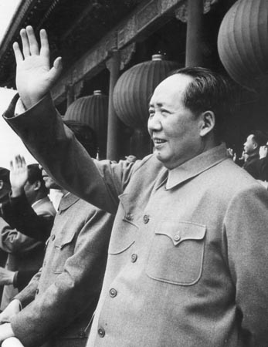

**India**

**Mughal Empire – 1526-1707**

**East India Company Raj – 1757-1858**

**Indian Revolt – 1857**

**British Government Raj – 1858-1947**

**Congress Party**

**Jawaharlal Nehru – 1947-1964**

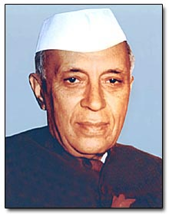

**Indira Gandhi – 1966-1977; 1980-1984**



**Major dates and events**

**Independence, 1947**

**Conflict with Pakistan**

**Partition fails to separate Hindu and Muslim**

**Kashmir (Muslim majority) ruler chose to join with India**

**1947-48 India-Pakistan war results in division of Kashmir**

**Economic strategy of rejecting capitalism, industrialize through self reliance**

**Protectionism and state socialism**

**Development without revolution**

**Tilt toward Soviet Union in Cold War**

**Sino-Indian War, 1962**

**Consequences of India’s defeat:**

**End of idealism and rise of power-based realism in foreign policy**

**China becomes a large focal point for India**

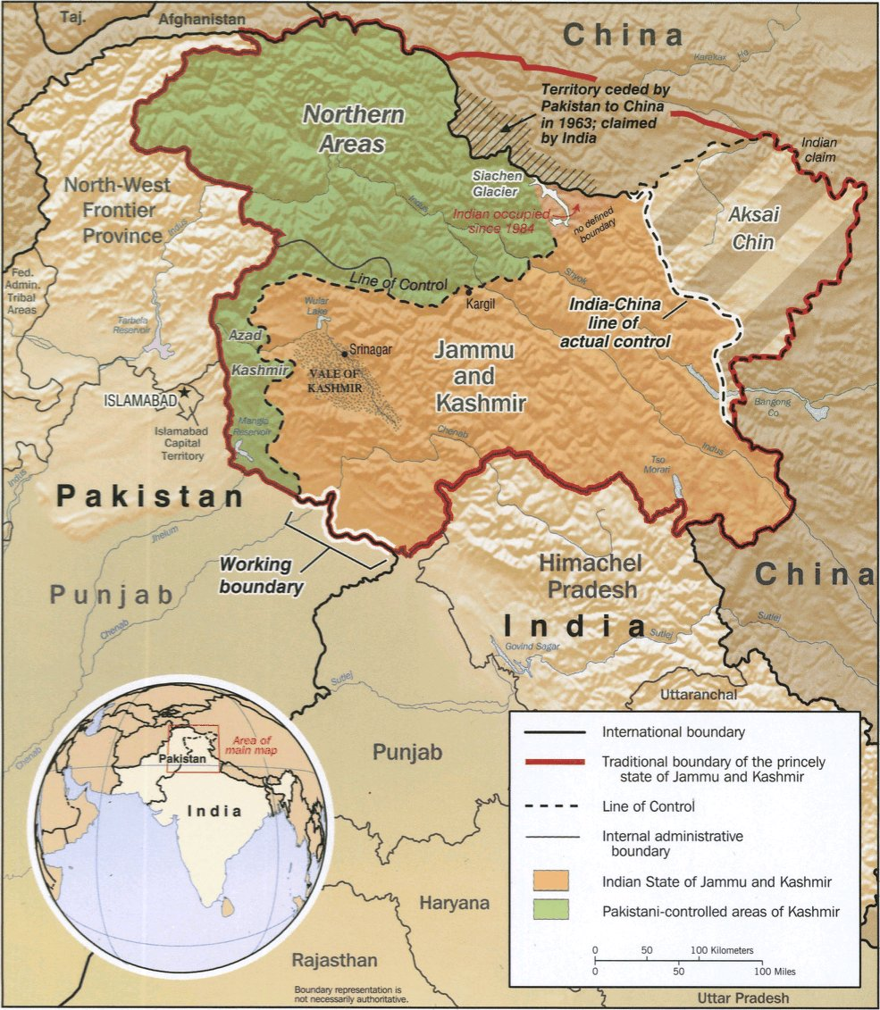

Wars Between India and Pakistan

1965

1971

1999

Three Waves of Economic Reform

1981

1991

2003

Rapid growth brings India closer to great power status

**International Relations and the Study of US-India-China Relations**

Dominant set of ideas for the study of international affairs is Realism and Neorealism:

Two other important sets of ideas are Liberalism/Neoliberalism

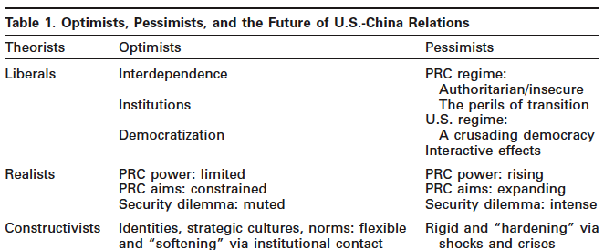

**Realism/Neorealism**

Mechanism affecting state behavior is anarchy, the absence of any global government:

States must rely on themselves for security

States must pay very close attention to the power capabilities of other states

States cannot determine with confidence the intentions of other states

Defensive buildup and offensive buildup look the same

States must assume the worst about how other states will use power

Only offsetting power can deter power – close attention to the balance of power

Best security position is one of hegemony

Security dilemma: increasing the security of one nation decreases the security of other nations

War is much more likely during periods of shifting balance of power

“What is the best way to maximize my country’s security in a world where another state might have significant offensive military capability as well as offensive intentions, and where there is no higher body I can turn to for help if that other state threatens my country?”

“I believe there is a straightforward answer to this question and that all great powers know it and act accordingly. The best way for any state to ensure its survival is to be much more powerful than all the other states in the system, because the weaker states are unlikely to attack it for fear they will be soundly defeated.”

“How should we expect China to conduct itself, as it grows more powerful? And how should we expect the United States and China’s neighbors to react to a strong China?

I expect China to act the way the United States has acted over its long history. Specifically, I believe that China will try to dominate the Asia-Pacific region much as the United States dominates the Western Hemisphere. For good strategic reasons, China will seek to maximize the power gap between itself and potentially dangerous neighbors like India, Japan, and Russia. China will want to make sure that it is so powerful that no state in Asia has the wherewithal to threaten it.”

“China can also be expected to try to push the United States out of the Asia-Pacific region, much the way the United States pushed the European great powers out of the Western Hemisphere in the 19th century. We should expect China to come up with its own version of the Monroe Doctrine, as Imperial Japan did in the 1930s. In fact, we are already seeing inklings of that policy. Consider that in March, Chinese officials told two high-ranking American policymakers that the United States was no longer allowed to interfere in the South China Sea, which China views as a ‘core interest’ like Taiwan and Tibet.”

“And what is the likely American response if China attempts to dominate Asia? It is crystal clear from the historical record that the United States does not tolerate peer competitors. As it demonstrated over the course of the 20th century, it is determined to remain the world’s only regional hegemon. Therefore, the United States can be expected to go to great lengths to con- tain China and ultimately weaken it to the point where it is no longer a threat to rule the roost in Asia. In essence, the United States is likely to act toward China similar to the way it behaved toward the Soviet Union during the Cold War.  
  
China’s neighbors in the Asia-Pacific region are certain to fear its rise as well, and they too will do whatever they can to prevent it from achieving regional hegemony. Indeed, there is already substantial evidence that coun- tries like India, Japan, and Russia, as well as smaller powers like Singapore, South Korea, and Vietnam, are worried about China’s ascendancy and are looking for ways to contain it. India and Japan, for example, signed a ‘Joint Security Declaration’ in October 2008, in good part because they are worried about China’s growing power.24 India and the United States, which had testy relations at best during the Cold War, have become good friends over the past decade, in large part because they both fear China.”

“Most of China’s neighbors will eventually join an American-led balancing coalition designed to check China’s rise, much the way Britain, France, Germany, Italy, Japan, and even China, joined forces with the United States to contain the Soviet Union during the Cold War.”

“China, which is not only deeply integrated into the world economy, but is also actively engaged with Western elites of all kinds. For those who believe that economic interdependence produces peace, this is good news.29 However, it is bad news for those who think that these ties are often a major source of friction between great powers.30 My view is that economic interdependence does not have a significant effect on geopolitics one way or the other. After all, the major European powers were all highly interdependent and prospering in 1914 when First World War broke out.”