SHA 315
China Business and Economy
US-China Finance

Reagan Political Economy – 1981-2009
Globalization

- The Global Financial Crisis is a result of a combination of poorly governed globalization, inherently unstable financial markets and poor economic policies.
- The Global Financial Crisis has exposed deep competitive weaknesses in the US. economy that China and Asia have exploited for years.
- The Global Financial Crisis has damaged the US economy.
- The ability of the US to fix economic problems and rebalance with China is in doubt.
- A multi-polar global economy involves large governance challenges, many focused on China.
- The Global Financial Crisis exposes structural conflict between liberal capitalism and state capitalism.
- Unless both the US and China are able to rebalance and the US is able to rebuild competitive position, US-China relations may be entering an era of increasing conflict.

Financial Crises

Financial crises are frequent in past 30 years – every three years

Financial crises can provide indicators of significant imbalances and unsustainable systems of economic structures

Bretton Woods Crisis – 1971-1973
Fixed exchange rates are unsustainable
Results in rapid and large expansion of global markets

Developing Nations Debt Crises of 1979, 1982, 1994, 1997-1998
Too many loans for unproductive investments into nations with fixed exchange rates – investment mania
Radical adjustment imposed by IMF – economic rebalancing

Dot Com Stock Market Collapse
Too much investment into firms with no profits – investment mania
Recession and much slower growth

GFC can also illuminate deep weaknesses in economic systems – lack of sustainability is source of financial collapse

GFC 2008-2010
Too much markets; too little governance
Too much deficits; too much consumption; too little productivity
Too much inequality in income in US
Too much reliance on China and Asia
China exploits US weaknesses

Strategy and Outcomes of Reagan Political Economy (Bush, Clinton and Bush)

Cut tax rates for highest income earners – votes and contributions, saving, investment, growth

Raise government spending – promised cuts do not occur = large budget deficits

Savings rate falls after 1984; maintain investment level via foreign borrowing

High US interest rates = rising $US = rising and large trade deficit

US manufacturing decline – shift US economy from manufacturing to services
Maintain high consumption of goods
Encourage manufacturing to shift to emerging economies (Asia)
Increase trade deficit

Radical deregulation of finance
End inspection of lending practices
Lower reserve requirements
Markets can measure risk in firms
Manage risk with derivatives
Ignore systemic risk – doesn’t exist

Real effort to fix trade and budget deficits is hard and expensive

US resorts to a strategy of making the surplus nations adjust to our needs:

Attacks on Japan: political effort to pretend to do something about manufacturing (VER; Plaza Agreement, managed trade)

US promises to reduce budget deficit – always fails except under Clinton

Clinton - geoeconomics

US strategy includes regional free trade agreements – NAFTA

Aggressive managed trade with Japan

Uruguay Round – WTO

Aggressive push to open foreign economies to US finance

Success in moving budget deficit to surplus and increasing US savings

Reagan – Bush – Clinton

Relatively high growth

Increasing inequality – growth focused on wealthy and knowledge workers

Growth 1982-1987 – fiscal stimulus

Growth 1990-2000 technology revolution; finance

Growth 2001 – 2008 finance plus home appreciation plus more debt

None of US strategies reduces trade deficit

Weakening US manufacturing – US cannot compete at assembly; cannot upgrade to higher skilled manufacturing

Bottom 60% sees no growth in income 1981-2009 – savings falls to zero – borrow on house equity to consume

Low savings plus high consumption = trade deficit

Asian nations plus OPEC provide funds to US to finance budget deficit
China assumes this role after 2000

US Economy and Structural Change: US and Globalization, 1980-2008
Dollar as Reserve Currency – supply global liquidity
De-industrialize – Asia/China must be source of much manufacturing
US political and economic elites accept the decline of US manufacturing as inevitable and beneficial
US will become knowledge economy and service economy
Allow free markets to make the structural shift from manufacturing to knowledge/services
Several large tax reductions to the wealthiest Americans leads to increasing fiscal deficits
--
US finance capitalism is major beneficiary of this strategy
Industrial policy for finance – lower regulations; push opening of foreign markets to US investment; promote liberal ideology; provide market support in times of crisis
Economic growth resumes in mid-1980s; bolstered by IT revolution and rising incomes of the rich
Rise of Casino Finance – when investment opportunities decline
--
US manufacturing is replaced by inexpensive goods produced in Japan, Korea, Taiwan, Singapore, then China
US FDI rises in 1990s to China and Asia
Finance industry makes large profits on:
Manufacturing consolidation;
FDI and global lending; selling US bonds
Casino finance
Vast fortunes and profits are made – reinforce commitment to this system
China 1992 – 2007 surge in FDI and creation of global manufacturing system
--
2001-2008 –
Surge in US fiscal and trade deficits
Long-term secular decline in US savings rates; rising rates of consumption
Loss of manufacturing and failure to invest in workers = growing inequality in US – rich get much richer; middle class stagnates and declines
Rising house prices become a source of maintaining consumption
Surge in China FDI, exports, accumulation of foreign assets
--
2001-2008
Importance of maintaining consumption in face of stagnating incomes
Use rising debt levels – credit cards, auto loans, home equity loans
Easy credit leads to home speculation
Exotic derivatives on home mortgages are bought with borrowed money - Collateralized Debt Obligations
Contraction of credit in 2005 – home prices decline, interest rates rise, CDOs weaken, bank losses mount, Global Financial Crisis

Debt – Savings – Consumption

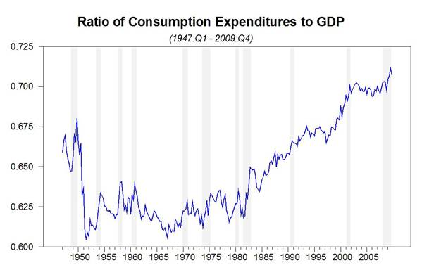
Source: US Dept, of Commerce Bureau of Economic Analysis
http://www.bea.gov/

Personal Savings in the US in the same period fell from 10% of income to nearly zero. http://www.bea.gov/national/nipaweb/PrintGraph.asp?Freq=Year

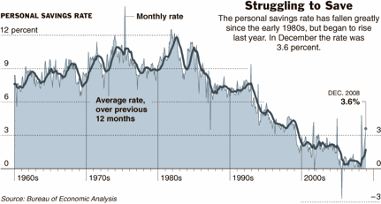

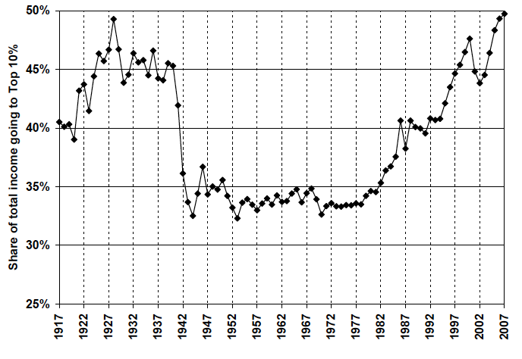
Share of Total US Income by Top 10% of Earners, 1917-2007
Source: Emmanuel Saez, “Striking It Richer: The Evolution of Top Incomes in the United

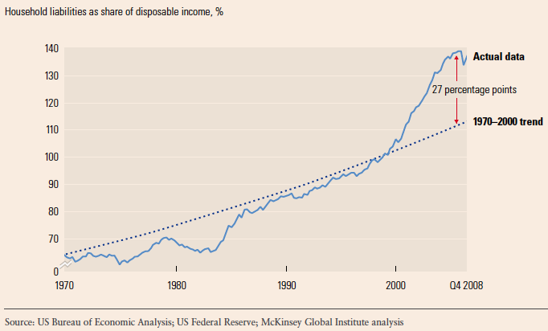
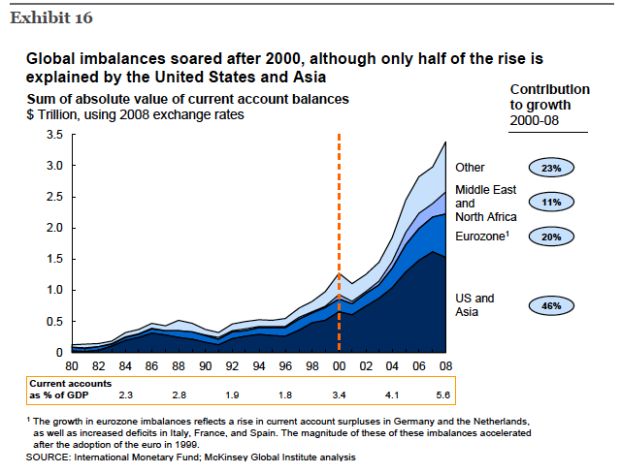

Global Imbalances from US Current Account, 1999-2008

Year | US Current Account – Total  (millions US $) |  | US-Asia Current Account  (millions US $) |  | US-China Current Account  (millions US $) | US-China % Total | US-Asia % of Total
1999 | -301630 |  | -216071 |  | -72743 | 24.1 | 71.6
2000 | -417426 |  | -246690 |  | -88043 | 21.1 | 59.1
2001 | -398270 |  | -225945 |  | -88658 | 22.3 | 56.7
2002 | -459151 |  | -249558 |  | -109899 | 23.9 | 54.3
2003 | -521519 |  | -260713 |  | -131825 | 25.3 | 50.0
2004 | -631130 |  | -325465 |  | -172343 | 27.3 | 51.6
2005 | -748683 |  | -377908 |  | -219196 | 29.3 | 50.5
2006 | -803547 |  | -437434 |  | -259490 | 32.3 | 54.4
2007 | -726573 |  | -452594 |  | -293105 | 40.3 | 62.3
2008 | -706068 |  | -430534 |  | -308474 | 43.7 | 61.0
Source: Author’s calculations, Bureau of Economic Affairs, http://www.bea.gov/international/bp_web/simple.cfm?anon=71&table_id=10&area_id=35

Chinese Foreign Assets
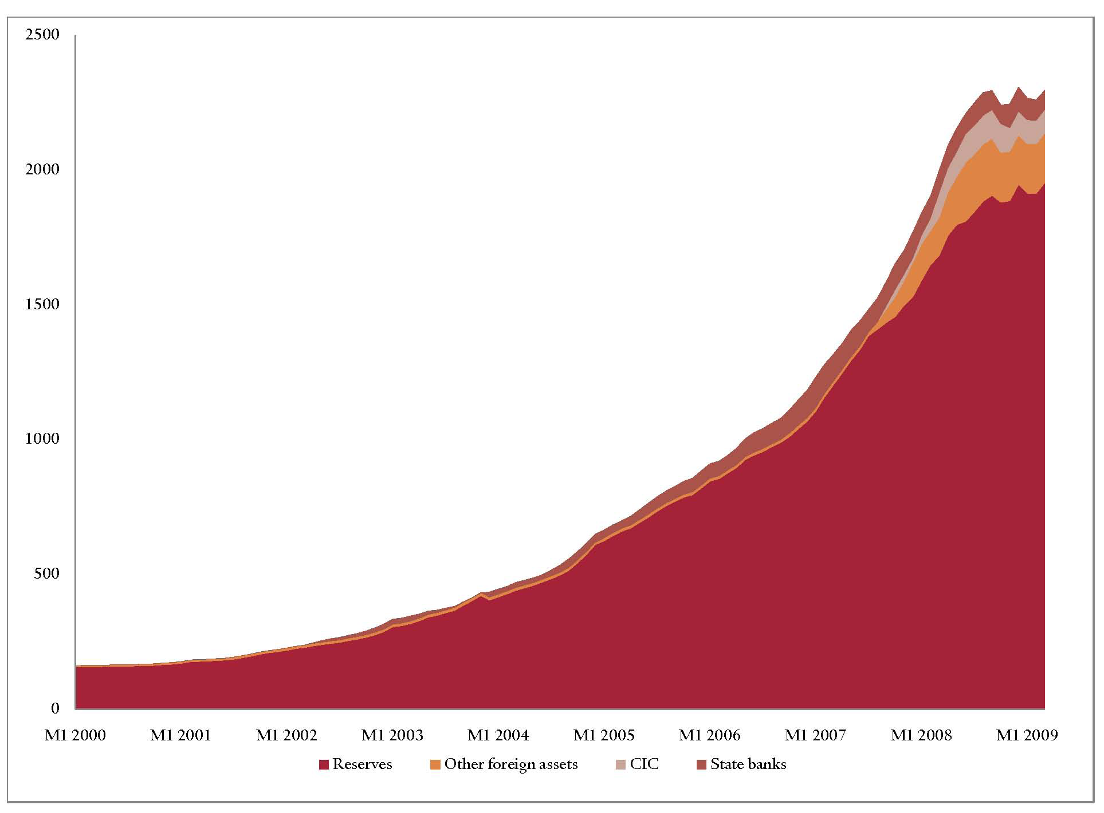
Source: Brad Setser and Arpana Pandley, “China’s $1.5 Trillion Bet: Understanding China’s External Portfolio,” Council on Foreign Relations Working Paper, May 2009, 3.

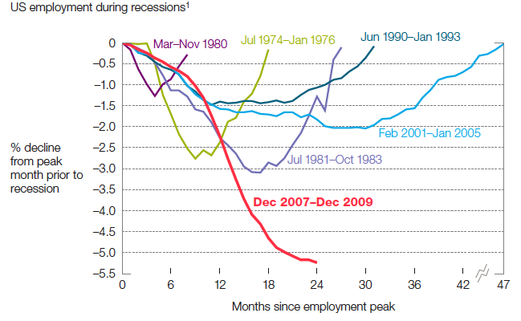

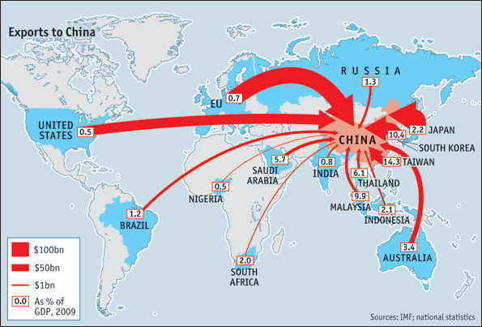

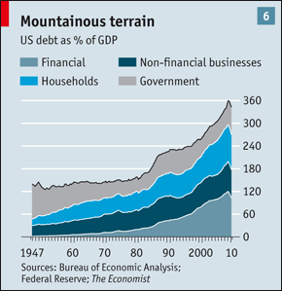

US position today

Massive budget deficit; rising but still very low savings rates (2009-2010)
Improving trade deficit (temporary?)
Needs large GDP growth to reduce unemployment – how?
US must lower standard of living to rebalance Reagan policies

Dependence on China

What are the global power implications of the US China economic relationships?

How will the economic relationship affect the political and strategic relationship?

Alternative perspective on managing interdependence

TWO GAMES IN A SYSTEM OF DEEP INTERDEPENDENCE

1) MANAGING INTERDEPENDENCE – DOMINANT GAME
2) STRUGGLE FOR POWER – SECONDARY GAME

Deep levels of economic interdependence cannot be understood through the traditional categories and relationships and theories of international relations. Notions of deterrence and compellence don’t make a lot sense. And are much less relevant to analysis. Traditional IR involves preserving physical security and forcing behavior on others they would not otherwise adopt. Behind all actions in traditional IR lies the possibility of war.

In systems of deep economic interdependence, the role of states is to manage fragile systems involving many powerful non-state actors (firms) with outcomes that can involve large win-win or win lose or lose-lose outcomes. Though relative gains can be involved, failure here involves large loses for both that are unacceptable. The goal is to manage outcomes for win-win results that may be asymmetrically and differentially distributed. Further, states can engage in efforts to adjust domestically and to adjust the policies of others so as to achieve the win-win results. Only very rarely does interdependence involve efforts to coerce a win-lose outcome. Instead, deep interdependence involves efforts mutually to define win-win outcomes. Behind all actions in deep interdependence lies alteration of the terms of interdependence, which at worst lies the option of exit by one or both parties.

What are US options and China’s options in dealing with its position of economic interdependence with the US?

Adjustment Outcomes Matrix

China adjusts China does not adjust
US
Both increase competitive  Imbalances decline  Basis for win-win coop  US growth returns to 3-4%  US GINI declines  China GINI declines | Imbalances decline  US compete increases  China fails to upgrade firms  Global coop declines  China is free rider  US-China conflict rises
Imbalances increase  China compete increases  Force China to adjust  US economy in LT decline  US is free rider  Global coop declines  US-China conflict rises | Imbalances remain  Promote more conflict  US protectionism  Global coop collapses  Spheres of influence  Spirals of conflict
adjusts

US does
not adjust

China’s Options

Maintain status quo in face of no US economic adjustment
Benefits – exports continue to rise if US economy recovers
Sustain the investment-based economic growth giving CCP continuing large role in economic direction
Negatives – imbalances remain continued need to finance US government and consumer – role as manufacturer and banker continues
US failure to adjust = decline in growth
Risk of additional financial instability
China’s overall freedom of action is constrained by deep interdependence with US

Domestic Structural Adjustment

Raise consumption rate and lower savings rate

Consumption rate of 50% of GDP in ten years

Reduce Investment as % of GDP

Rebalance capital account surplus with US

US Options

Adjust
Obama supports a plan that can fix US problems:

Cut consumption and raise savings

Shared sacrifice: raise taxes on rich AND cut benefits to middle class

Focused national investments on raising competitiveness – invest in workers

Republicans oppose all except cuts to SS and Medicare

No Adjust
Blame China and attempt to force revaluation of RMB

Play same hegemony/reserve currency game as in the past: US forces others to accept a dollar devaluation instead of making adjustment to US competitiveness

Endless political paralysis weakens the US government and society

US economy stagnates with high unemployment

Competitive groups win and non-competitive lose – inequality rises

Astonishing system of political economy:

Political economic elites get vast increase in incomes and wealth
Large increase in inequality
No sacrifices by wealthy
No US sacrifices for competitiveness
Use US power to force everyone else to adjust their economies as a condition of access to the US market
Use up wealth and power today at the expense of tomorrow

Drezner on Financial Coercion

Gao Xiqing, the head of the China Investment Corporation (CIC), recently warned, “[The U.S.
economy is] built on the support, the gratuitous support, of a lot of countries. So why don’t you come over and . . . I won’t say kowtow, but at least, be nice to the countries that lend you money.” Whenever sovereign creditors appear to lose their appetite for dollar-denominated assets, it becomes front-page news.

“Political might is often linked to financial might, and a debtor’s capacity to project military power hinges on the support of its creditors.” As the United States continues to run large deficits, many other commentators believe that its power is another bubble that will soon pop.

This article appraises the ability of creditor states to convert their financial power into political power, drawing from the existing literature on economic statecraft.

It concludes that the power of credit between great powers has been exaggerated in policy circles. Amassing capital can empower states in two ways: first, by enhancing their ability to resist pressure from other actors and, second, by increasing their ability to pressure others. As states become creditors, they experience an undeniable increase in their autonomy. Capital accumulation strengthens the ability of creditor states to resist pressure from other actors. When capital exporters try to use their financial power to compel other powerful actors into policy shifts, however, they run into greater difficulties. As the economic statecraft literature suggests, the ability to coerce is circumscribed.

When targeted at small or weak states, financial statecraft can be useful; when targeted at great powers, such coercion rarely works. There are hard limits on the ability of creditors to impose costs on a target government. Expectations of future conflict have a dampening effect on a great power’s willingness to concede. For creditors to acquire the necessary power to exert financial leverage,
they must become enmeshed in the fortunes of the debtor state. More often than not, the attempt to use financial power to exercise political leverage against great powers has failed. Looking at recent history, what is surprising is not the rising power of creditors, but rather how hamstrung they
have been in using their financial muscle. To date, China has translated its large capital surplus into minor but not major foreign policy gains. To paraphrase John Maynard Keynes, when the United States owes China tens of billions, that is America’s problem. When it owes trillions, that is China’s
problem.

If financial power does not work in altering target government policies on economic policies, then
linkage strategies are far less likely to affect the foreign and security policies of the target government.

Dependence on foreign creditors alters the distribution of power through two theoretical pathways: deterrence and compellence. In a deterrence scenario, lenders use their financial holdings to ward off pressure from debtor countries; in a compellence scenario, lenders threaten to use financial statecraft to extract concessions from the debtor states. Creditors should be well equipped to deter debtor nations from using coercion on other policy disputes. Even if creditors never explicitly brandish the threat to stop exporting capital, that possibility should constrain the ability of debtor countries to ratchet up tensions in a policy dispute. Countries possessing sufficient levels of reserves
should therefore have greater autonomy of action and be better placed to rebuff foreign policy pressures from the debtor state.

Beyond deterrence, creditor nations could use their holdings as a tool of compellence. Leverage could be exercised most crudely through the threat of investment withdrawal.

Not everyone is concerned about the specter of financial statecraft hanging over the United States. Another school of thought argues that the size of capital and trade flows creates mutual interdependence rather than asymmetric dependence, making it difficult for China to credibly threaten or use its financial leverage.

The scholarly literature concludes that financial sanctions work only under a limited set of conditions. The first necessary condition is that the debtor state cannot access alternative sources of credit. If debtors can find other lines of credit—through public or private sources, domestic or foreign investors—then the material impact of financial statecraft is severely circumscribed.

If the target state is in such desperate straits that no other actor is willing to bear the risk of extending credit, then financial statecraft can be a powerful form of leverage. The other condition is that the primary creditor is able to gain institutionalized multilateral cooperation in the execution of any kind of coercive threat. The greater the number of actors that agree to sanction, the greater the opportunity costs of finding alternative sources of credit. Institutionalized cooperation significantly increases the likelihood of sanctions success. In sum, for financial leverage to yield tangible concessions, the target state must be unable to find alternative creditors, lack the capability to inflict costs on the sanctioning country in response to coercive pressure, anticipate few conflicts with the coercing state over time, and try to maintain a fixed exchange rate regime.

The United States is also well placed to impose significant costs on the Chinese economy if Beijing were to try to use its currency reserves to execute the nuclear option. If China scaled back its purchase of U.S. assets, the dollar would inevitably depreciate against the renminbi. Any dollar depreciation triggers capital losses in China’s external investment portfolio. A 10 percent
appreciation of the renminbi translates into a book loss of 3 percent of China’s GDP in its foreign exchange reserves.

The importance of the American market to Chinese exporters—and the threat of trade retaliation in the face of Chinese financial statecraft—highlights the mutual dependency of the two economies. This interdependence makes it difficult for China to credibly threaten any substantial
exercise of financial muscle.

‘Flowers and criticism’: The political
economy of the renminbi debate
Paul Bowles and Baotai Wang1

The exception to this pattern of the burden of adjustment falling
most heavily on deficit countries has been the United States. It has been
able to use its superpower status and its position as the supplier of the
international reserve currency to escape severe domestic adjustments of
the expenditure reducing type in the face of a poor trading performance.
The United States has been able to rely on expenditure switching to a
much greater extent by forcing other countries to allow a devaluation of
the dollar, a move which the United States is uniquely able to absorb since
it borrows in its own currency; the United States has ‘no fear of floating’
since it repays debt in its own currency. The United States stimulates its
own exports through depreciation but minimizes the need for expenditure
reducing measures. Rather, other countries are asked to accept that their
dollar reserves are worth less and their economies are less competitive.
It is for this reason that political pressure is typically needed to persuade
other countries to allow the dollar to depreciate against their currencies.
This much was evident in the decision of the Nixon administration to
remove convertibility in 1971 and to devalue the dollar in 1973. Faced
with a weak dollar as a result of a trade deficit and domestic inflation,
Treasury Secretary at the time, John Connolly, famously remarked that
‘the dollar is our currency and your problem’.

by forcing an appreciation on Japan as a result of its
‘financial hegemonism’, the United States was able to obtain ten years of
economic prosperity.Now,he argues, China is being faced with pressures to
revalue as a result of thenewfinancial hegemonism of the United States and
Japan.

Seen in this light, the renminbi debate
has been in large part about how much of the adjustment to this ‘problem’
will be undertaken by a change in US policies and how much by a change
in policies in China and other countries.
The current impasse can be seen as a game of ‘problem assignment’;
whoever blinks first will have to assume responsibility for the problem and
bear the associated costs.

