WSJ

The Coming Chinese Crackup

The endgame of communist rule in China has begun, and Xi Jinping’s ruthless measures are only bringing the country closer to a breaking point
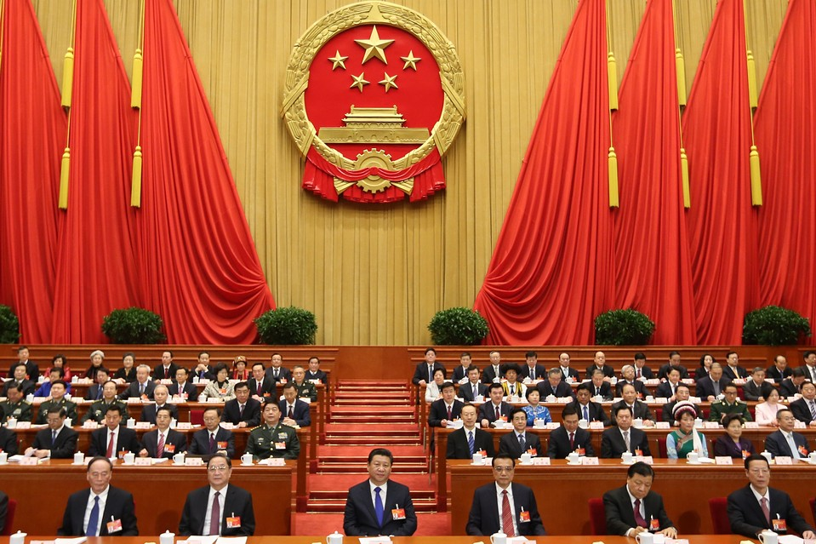ENLARGE
Chinese President Xi Jinping, front center, and other Chinese leaders attend the opening meeting on Thursday of the third session of the National People’s Congress at the Great Hall of the People in Beijing. Photo: Xinhua/Zuma Press
By
David Shambaugh
March 6, 2015 11:26 a.m. ET
488 COMMENTS
On Thursday, the National People’s Congress convened in Beijing in what has become a familiar annual ritual. Some 3,000 “elected” delegates from all over the country—ranging from colorfully clad ethnic minorities to urbane billionaires—will meet for a week to discuss the state of the nation and to engage in the pretense of political participation.
Some see this impressive gathering as a sign of the strength of the Chinese political system—but it masks serious weaknesses. Chinese politics has always had a theatrical veneer, with staged events like the congress intended to project the power and stability of the Chinese Communist Party, or CCP. Officials and citizens alike know that they are supposed to conform to these rituals, participating cheerfully and parroting back official slogans. This behavior is known in Chinese as biaotai, “declaring where one stands,” but it is little more than an act of symbolic compliance.

Related Reading
- China’s New Boss
- Will China Crush the Hong Kong Protests?
Despite appearances, China’s political system is badly broken, and nobody knows it better than the Communist Party itself. China’s strongman leader, Xi Jinping, is hoping that a crackdown on dissent and corruption will shore up the party’s rule. He is determined to avoid becoming the Mikhail Gorbachev of China, presiding over the party’s collapse. But instead of being the antithesis of Mr. Gorbachev, Mr. Xi may well wind up having the same effect. His despotism is severely stressing China’s system and society—and bringing it closer to a breaking point.
Predicting the demise of authoritarian regimes is a risky business. Few Western experts forecast the collapse of the Soviet Union before it occurred in 1991; the CIA missed it entirely. The downfall of Eastern Europe’s communist states two years earlier was similarly scorned as the wishful thinking of anticommunists—until it happened. The post-Soviet “color revolutions” in Georgia, Ukraine and Kyrgyzstan from 2003 to 2005, as well as the 2011 Arab Spring uprisings, all burst forth unanticipated.
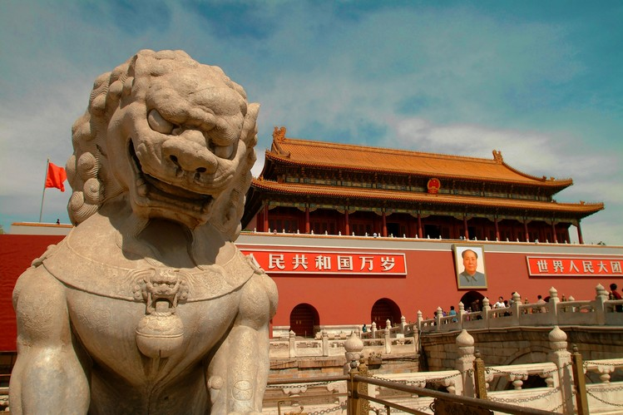ENLARGE
The Gate of Heavenly Peace in Beijing’s Tiananmen Square, the site of pro-democracy demonstrations in 1989. Photo: National Geographic/Getty Images
China-watchers have been on high alert for telltale signs of regime decay and decline ever since the regime’s near-death experience in Tiananmen Square in 1989. Since then, several seasoned Sinologists have risked their professional reputations by asserting that the collapse of CCP rule was inevitable. Others were more cautious—myself included. But times change in China, and so must our analyses.
The endgame of Chinese communist rule has now begun, I believe, and it has progressed further than many think. We don’t know what the pathway from now until the end will look like, of course. It will probably be highly unstable and unsettled. But until the system begins to unravel in some obvious way, those inside of it will play along—thus contributing to the facade of stability.
Advertisement
Communist rule in China is unlikely to end quietly. A single event is unlikely to trigger a peaceful implosion of the regime. Its demise is likely to be protracted, messy and violent. I wouldn’t rule out the possibility that Mr. Xi will be deposed in a power struggle or coup d’état. With his aggressive anticorruption campaign—a focus of this week’s National People’s Congress—he is overplaying a weak hand and deeply aggravating key party, state, military and commercial constituencies.
The Chinese have a proverb, waiying, neiruan—hard on the outside, soft on the inside. Mr. Xi is a genuinely tough ruler. He exudes conviction and personal confidence. But this hard personality belies a party and political system that is extremely fragile on the inside.
Consider five telling indications of the regime’s vulnerability and the party’s systemic weaknesses.
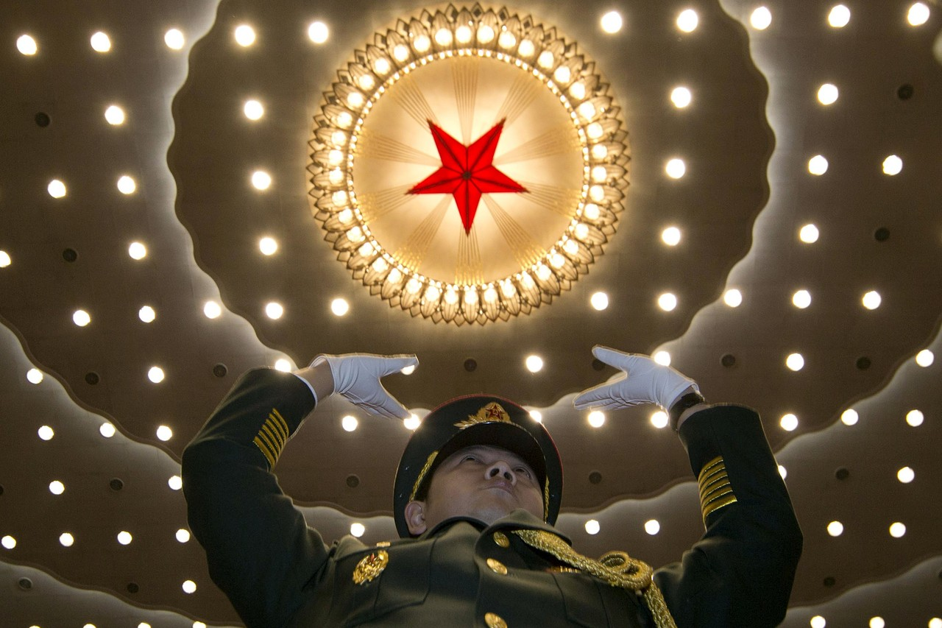ENLARGE
A military band conductor during the opening session of the National People’s Congress on Thursday at the Great Hall of the People in Beijing. Photo: Associated Press
First, China’s economic elites have one foot out the door, and they are ready to flee en masse if the system really begins to crumble. In 2014, Shanghai’s Hurun Research Institute, which studies China’s wealthy, found that 64% of the “high net worth individuals” whom it polled—393 millionaires and billionaires—were either emigrating or planning to do so. Rich Chinese are sending their children to study abroad in record numbers (in itself, an indictment of the quality of the Chinese higher-education system).
Just this week, the Journal reported, federal agents searched several Southern California locations that U.S. authorities allege are linked to “multimillion-dollar birth-tourism businesses that enabled thousands of Chinese women to travel here and return home with infants born as U.S. citizens.” Wealthy Chinese are also buying property abroad at record levels and prices, and they are parking their financial assets overseas, often in well-shielded tax havens and shell companies.
Meanwhile, Beijing is trying to extradite back to China a large number of alleged financial fugitives living abroad. When a country’s elites—many of them party members—flee in such large numbers, it is a telling sign of lack of confidence in the regime and the country’s future.
Second, since taking office in 2012, Mr. Xi has greatly intensified the political repression that has blanketed China since 2009. The targets include the press, social media, film, arts and literature, religious groups, the Internet, intellectuals, Tibetans and Uighurs, dissidents, lawyers, NGOs, university students and textbooks. The Central Committee sent a draconian order known as Document No. 9 down through the party hierarchy in 2013, ordering all units to ferret out any seeming endorsement of the West’s “universal values”—including constitutional democracy, civil society, a free press and neoliberal economics.
A more secure and confident government would not institute such a severe crackdown. It is a symptom of the party leadership’s deep anxiety and insecurity.
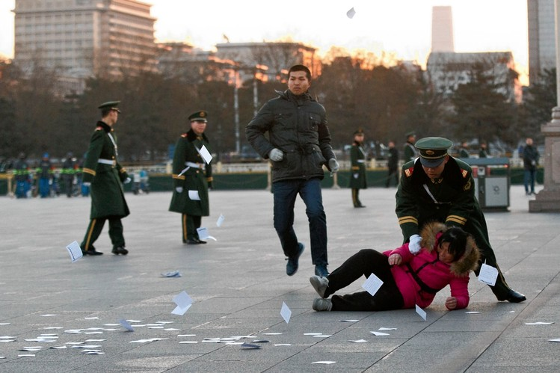ENLARGE
A protester is pushed to the ground by a paramilitary policeman March 5, 2014, in Beijing before the opening of the National People’s Congress nearby. Photo: Associated Press
Third, even many regime loyalists are just going through the motions. It is hard to miss the theater of false pretense that has permeated the Chinese body politic for the past few years. Last summer, I was one of a handful of foreigners (and the only American) who attended a conference about the “China Dream,” Mr. Xi’s signature concept, at a party-affiliated think tank in Beijing. We sat through two days of mind-numbing, nonstop presentations by two dozen party scholars—but their faces were frozen, their body language was wooden, and their boredom was palpable. They feigned compliance with the party and their leader’s latest mantra. But it was evident that the propaganda had lost its power, and the emperor had no clothes.
In December, I was back in Beijing for a conference at the Central Party School, the party’s highest institution of doctrinal instruction, and once again, the country’s top officials and foreign policy experts recited their stock slogans verbatim. During lunch one day, I went to the campus bookstore—always an important stop so that I can update myself on what China’s leading cadres are being taught. Tomes on the store’s shelves ranged from Lenin’s “Selected Works” to Condoleezza Rice’s memoirs, and a table at the entrance was piled high with copies of a pamphlet by Mr. Xi on his campaign to promote the “mass line”—that is, the party’s connection to the masses. “How is this selling?” I asked the clerk. “Oh, it’s not,” she replied. “We give it away.” The size of the stack suggested it was hardly a hot item.
Fourth, the corruption that riddles the party-state and the military also pervades Chinese society as a whole. Mr. Xi’s anticorruption campaign is more sustained and severe than any previous one, but no campaign can eliminate the problem. It is stubbornly rooted in the single-party system, patron-client networks, an economy utterly lacking in transparency, a state-controlled media and the absence of the rule of law.
Moreover, Mr. Xi’s campaign is turning out to be at least as much a selective purge as an antigraft campaign. Many of its targets to date have been political clients and allies of former Chinese leader Jiang Zemin. Now 88, Mr. Jiang is still the godfather figure of Chinese politics. Going after Mr. Jiang’s patronage network while he is still alive is highly risky for Mr. Xi, particularly since Mr. Xi doesn’t seem to have brought along his own coterie of loyal clients to promote into positions of power. Another problem: Mr. Xi, a child of China’s first-generation revolutionary elites, is one of the party’s “princelings,” and his political ties largely extend to other princelings. This silver-spoon generation is widely reviled in Chinese society at large.
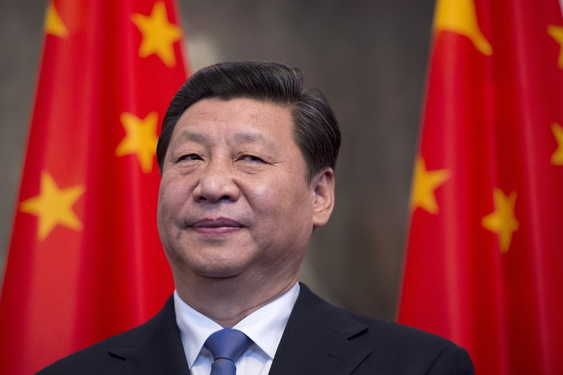ENLARGE
Mr. Xi at the Schloss Bellevue presidential residency during his visit to fellow export powerhouse Germany in Berlin on March 28, 2014. Photo: Agence France-Presse/Getty Images
Finally, China’s economy—for all the Western views of it as an unstoppable juggernaut—is stuck in a series of systemic traps from which there is no easy exit. In November 2013, Mr. Xi presided over the party’s Third Plenum, which unveiled a huge package of proposed economic reforms, but so far, they are sputtering on the launchpad. Yes, consumer spending has been rising, red tape has been reduced, and some fiscal reforms have been introduced, but overall, Mr. Xi’s ambitious goals have been stillborn. The reform package challenges powerful, deeply entrenched interest groups—such as state-owned enterprises and local party cadres—and they are plainly blocking its implementation.
These five increasingly evident cracks in the regime’s control can be fixed only through political reform. Until and unless China relaxes its draconian political controls, it will never become an innovative society and a “knowledge economy”—a main goal of the Third Plenum reforms. The political system has become the primary impediment to China’s needed social and economic reforms. If Mr. Xi and party leaders don’t relax their grip, they may be summoning precisely the fate they hope to avoid.
In the decades since the collapse of the Soviet Union, the upper reaches of China’s leadership have been obsessed with the fall of its fellow communist giant. Hundreds of Chinese postmortem analyses have dissected the causes of the Soviet disintegration.
Mr. Xi’s real “China Dream” has been to avoid the Soviet nightmare. Just a few months into his tenure, he gave a telling internal speech ruing the Soviet Union’s demise and bemoaning Mr. Gorbachev’s betrayals, arguing that Moscow had lacked a “real man” to stand up to its reformist last leader. Mr. Xi’s wave of repression today is meant to be the opposite of Mr. Gorbachev’s perestroika and glasnost. Instead of opening up, Mr. Xi is doubling down on controls over dissenters, the economy and even rivals within the party.
But reaction and repression aren’t Mr. Xi’s only option. His predecessors, Jiang Zemin and Hu Jintao, drew very different lessons from the Soviet collapse. From 2000 to 2008, they instituted policies intended to open up the system with carefully limited political reforms.
They strengthened local party committees and experimented with voting for multicandidate party secretaries. They recruited more businesspeople and intellectuals into the party. They expanded party consultation with nonparty groups and made the Politburo’s proceedings more transparent. They improved feedback mechanisms within the party, implemented more meritocratic criteria for evaluation and promotion, and created a system of mandatory midcareer training for all 45 million state and party cadres. They enforced retirement requirements and rotated officials and military officers between job assignments every couple of years.
In effect, for a while Mr. Jiang and Mr. Hu sought to manage change, not to resist it. But Mr. Xi wants none of this. Since 2009 (when even the heretofore open-minded Mr. Hu changed course and started to clamp down), an increasingly anxious regime has rolled back every single one of these political reforms (with the exception of the cadre-training system). These reforms were masterminded by Mr. Jiang’s political acolyte and former vice president, Zeng Qinghong, who retired in 2008 and is now under suspicion in Mr. Xi’s anticorruption campaign—another symbol of Mr. Xi’s hostility to the measures that might ease the ills of a crumbling system.
Some experts think that Mr. Xi’s harsh tactics may actually presage a more open and reformist direction later in his term. I don’t buy it. This leader and regime see politics in zero-sum terms: Relaxing control, in their view, is a sure step toward the demise of the system and their own downfall. They also take the conspiratorial view that the U.S. is actively working to subvert Communist Party rule. None of this suggests that sweeping reforms are just around the corner.
We cannot predict when Chinese communism will collapse, but it is hard not to conclude that we are witnessing its final phase. The CCP is the world’s second-longest ruling regime (behind only North Korea), and no party can rule forever.
Looking ahead, China-watchers should keep their eyes on the regime’s instruments of control and on those assigned to use those instruments. Large numbers of citizens and party members alike are already voting with their feet and leaving the country or displaying their insincerity by pretending to comply with party dictates.
We should watch for the day when the regime’s propaganda agents and its internal security apparatus start becoming lax in enforcing the party’s writ—or when they begin to identify with dissidents, like the East German Stasi agent in the film “The Lives of Others” who came to sympathize with the targets of his spying. When human empathy starts to win out over ossified authority, the endgame of Chinese communism will really have begun.
Dr. Shambaugh is a professor of international affairs and the director of the China Policy Program at George Washington University and a nonresident senior fellow at the Brookings Institution. His books include “China’s Communist Party: Atrophy and Adaptation” and, most recently, “China Goes Global: The Partial Power.”

The New Yorker

Profiles April 6, 2015 Issue

Born Red

How Xi Jinping, an unremarkable provincial administrator, became China’s most authoritarian leader since Mao.

By Evan Osnos

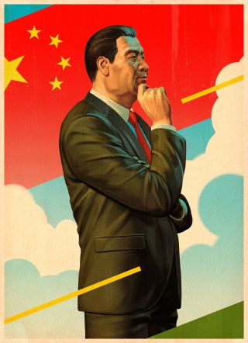When Xi was fourteen, Red Guards warned, “We can execute you a hundred times.” He joined the Communist Party at twenty. Credit Illustration by Tavis Coburn
In anticipation of New Year’s Eve, 2014, Xi Jinping, the President of China and the General Secretary of the Chinese Communist Party, permitted a camera crew to come into his office and record a message to the people. As a teen-ager, Xi had been sent to work on a farm; he was so delicate that other laborers rated him a six on a ten-point scale, “not even as high as the women,” he said later, with some embarrassment. Now, at sixty-one, Xi was five feet eleven, taller than any Chinese leader in nearly four decades, with a rich baritone and a confident heft. When he received a guest, he stood still, long arms slack, hair pomaded, a portrait of take-it-or-leave-it composure that induced his visitor to cross the room in pursuit of a handshake.
Xi’s predecessor, Hu Jintao, read his annual New Year’s greeting from a lectern in an antiseptic reception hall. Xi, who took office in November, 2012, has associated himself with an earthier generation of Communists, a military caste that emphasized “hard work and plain living.” He delivered his New Year’s message at his desk. Behind him, bookshelves held photographs that depicted him as Commander-in-Chief and family man. In one picture, he was wearing Army fatigues and a fur hat, visiting soldiers in a snowfield; in another, he was strolling with his wife and daughter, and escorting his father, Xi Zhongxun, a hallowed revolutionary, in a wheelchair. The shelves also held matching sets of books. Xi’s classroom education was interrupted for nearly a decade by the Cultural Revolution, and he has the autodidact’s habit of announcing his literary credentials. He often quotes from Chinese classics, and in an interview with the Russian press last year he volunteered that he had read Krylov, Pushkin, Gogol, Lermontov, Turgenev, Dostoyevsky, Nekrasov, Chernyshevsky, Tolstoy, Chekhov, and Sholokhov. When he visited France, he mentioned that he had read Montesquieu, Voltaire, Rousseau, Diderot, Saint-Simon, Fourier, Sartre, and twelve others. In his New Year’s remarks, Xi oscillated between socialist slogans (“Wave high the sword against corruption”) and catchphrases from Chinese social media (“I would like to click the thumbs-up button for our great people”). He vowed to fight poverty, improve the rule of law, and hold fast to history. When he listed the achievements of the past year, he praised the creation of a holiday dedicated to the Second World War: “Victory Day of the Chinese People’s War of Resistance Against Japanese Aggression.”
Xi is the sixth man to rule the People’s Republic of China, and the first who was born after the revolution, in 1949. He sits atop a pyramid of eighty-seven million members of the Communist Party, an organization larger than the population of Germany. The Party no longer reaches into every corner of Chinese life, as it did in the nineteen-seventies, but Xi nevertheless presides over an economy that, by one measure, recently surpassed the American economy in size; he holds ultimate authority over every general, judge, editor, and state-company C.E.O. As Lenin ordained, in 1902, “For the center . . . to actually direct the orchestra, it needs to know who plays violin and where, who plays a false note and why.”
Xi’s New Year’s message was broadcast on state television and radio channels at 6:30 p.m., just before the evening news. A few hours later, the news veered sharply out of his control. In Shanghai, a large holiday crowd had gathered to celebrate on the Bund, the promenade beside the Huangpu River, with splendid views of the skyline. The crowd was growing faster than the space could handle. Around 11:30 p.m., the police sent hundreds of extra officers to keep order, but it was too late; a stairway was jammed, and people shouted and pushed. A stampede ensued. In all, thirty-six people suffocated or were trampled to death.
The disaster occurred in one of China’s most modern and prosperous places, and the public was appalled. In the days that followed, the Shanghai government held a memorial for the victims, and encouraged people to move on; Internet censors struck down discussion of who was responsible; police interrogated Web users who posted criticisms of the state. When relatives of the victims visited the site of the stampede, police watched them closely, and then erected metal barriers to render it unreachable. Caixin, an investigative media organization, revealed that, during the stampede, local officials in charge of the neighborhood were enjoying a banquet of sushi and sake, at the government’s expense, in a private room at the Empty Cicada, a luxury restaurant nearby. This was awkward news, because one of the President’s first diktats had been “Eight Rules” for public servants, to eliminate extravagance and corruption. Among other things, the campaign called on officials to confine themselves to “four dishes and one soup.” (Eventually, eleven officials were punished for misusing funds and for failing to prevent a risk to the public.)
A few weeks after the incident in Shanghai, I paid a call on a longtime editor in Beijing, whose job gives him a view into the workings of the Party. When I arrived at his apartment, his kids were in raucous control of the living room, so we retreated to his bedroom to talk. When I asked him how President Xi was doing, he mentioned the banquet at the Empty Cicada. He thought it pointed to a problem that is much deeper than a few high-living bureaucrats. “The central government issued an order absolutely forbidding them to dine out on public funds. And they did it anyway!” he said. “What this tells you is that local officials are finding their ways of responding to change. There is a saying: ‘When a rule is imposed up high, there is a way to get around it below.’ ” The struggle between an emperor and his bureaucracy follows a classic pattern in Chinese politics, and it rarely ends well for the emperor. But the editor was betting on Xi. “He’s not afraid of Heaven or Earth. And he is, as we say, round on the outside and square on the inside; he looks flexible, but inside he is very hard.”
Before Xi took power, he was described, in China and abroad, as an unremarkable provincial administrator, a fan of American pop culture (“The Godfather,” “Saving Private Ryan”) who cared more about business than about politics, and was selected mainly because he had alienated fewer peers than his competitors. It was an incomplete portrait. He had spent more than three decades in public life, but Chinese politics had exposed him to limited scrutiny. At a press conference, a local reporter once asked Xi to rate his performance: “Would you give yourself a score of a hundred—or a score of ninety?” (Neither, Xi said; a high number would look “boastful,” and a low number would reflect “low self-esteem.”)
But, a quarter of the way through his ten-year term, he has emerged as the most authoritarian leader since Chairman Mao. In the name of protection and purity, he has investigated tens of thousands of his countrymen, on charges ranging from corruption to leaking state secrets and inciting the overthrow of the state. He has acquired or created ten titles for himself, including not only head of state and head of the military but also leader of the Party’s most powerful committees—on foreign policy, Taiwan, and the economy. He has installed himself as the head of new bodies overseeing the Internet, government restructuring, national security, and military reform, and he has effectively taken over the courts, the police, and the secret police. “He’s at the center of everything,” Gary Locke, the former American Ambassador to Beijing, told me.
In the Chinese Communist Party, you campaign after you get the job, not before, and in building public support and honing a message Xi has revealed a powerful desire for transformation. He calls on China to pursue the Chinese Dream: the “great rejuvenation of the nation,” a mixture of prosperity, unity, and strength. He has proposed at least sixty social and economic changes, ranging from relaxing the one-child policy to eliminating camps for “reëducation through labor” and curtailing state monopolies. He has sought prestige abroad; on his first foreign trip (to Moscow), he was accompanied by his wife, a celebrity soprano named Peng Liyuan, who inspired lavish coverage of China’s first modern Presidential couple. Peng soon appeared on Vanity Fair’s Best-Dressed List.
After Mao, China encouraged the image of a “collective Presidency” over the importance of individual leaders. Xi has revised that approach, and his government, using old and new tools, has enlarged his image. In the spirit of Mao’s Little Red Book, publishers have produced eight volumes of Xi’s speeches and writings; the most recent, titled “The Remarks of Xi Jinping,” dissects his utterances, ranks his favorite phrases, and explains his cultural references. A study of the People’s Daily found that, by his second anniversary in office, Xi was appearing in the paper more than twice as often as his predecessor at the same point. He stars in a series of cartoons aimed at young people, beginning with “How to Make a Leader,” which describes him, despite his family pedigree, as a symbol of meritocracy—“one of the secrets of the China miracle.” The state news agency has taken the unprecedented step of adopting a nickname for the General Secretary: Xi Dada—roughly, Big Uncle Xi. In January, the Ministry of Defense released oil paintings depicting him in heroic poses; thousands of art students applying to the Beijing University of Technology had been judged on their ability to sketch his likeness. The Beijing Evening News reported that one applicant admired the President so much that “she had to work hard to stop her hands from trembling.”
To outsiders, Xi has been a fitful subject. Bookstores in Hong Kong, which are insulated from mainland control, offer portraits of varying quality—the most reliable include “The New Biography of Xi Jinping,” by Liang Jian, and “China’s Future,” by Wu Ming—but most are written at a remove, under pseudonyms. The clearest account of Xi’s life and influences comes from his own words and decisions, scattered throughout a long climb to power.
Kevin Rudd, the former Prime Minister of Australia, a Mandarin speaker who has talked with Xi at length over the years, told me, “What he says is what he thinks. My experience of him is that there’s not a lot of artifice.”
In a leadership known for grooming colorless apparatchiks, Xi projects an image of manly vigor. He mocks “eggheads” and praises the “team spirit of a group of dogs eating a lion.” In a meeting in March, 2013, he told the Russian President, Vladimir Putin, “We are similar in character,” though Xi is less inclined toward bare-chested machismo. Xi admires Song Jiang, a fictional outlaw from “Water Margin,” a fourteenth-century Chinese classic, for his ability to “unite capable people.” Neither brilliant nor handsome, Song Jiang led a band of heroic rebels. In a famous passage, he speaks of the Xunyang River: “I shall have my revenge some day / And dye red with blood the Xunyang’s flow.”
Xi describes his essential project as a rescue: he must save the People’s Republic and the Communist Party before they are swamped by corruption; environmental pollution; unrest in Hong Kong, Xinjiang, and other regions; and the pressures imposed by an economy that is growing more slowly than at any time since 1990 (though still at about seven per cent, the fastest pace of any major country). “The tasks our Party faces in reform, development, and stability are more onerous than ever, and the conflicts, dangers, and challenges are more numerous than ever,” Xi told the Politburo, in October. In 2014, the government arrested nearly a thousand members of civil society, more than in any year since the mid-nineteen-nineties, following the Tiananmen Square massacre, according to Chinese Human Rights Defenders, a Hong Kong-based advocacy group.
Xi unambiguously opposes American democratic notions. In 2011 and 2012, he spent several days with Vice-President Joe Biden, his official counterpart at the time, in China and the United States. Biden told me that Xi asked him why the U.S. put “so much emphasis on human rights.” Biden replied to Xi, “No President of the United States could represent the United States were he not committed to human rights,” and went on, “If you don’t understand this, you can’t deal with us. President Barack Obama would not be able to stay in power if he did not speak of it. So look at it as a political imperative. It doesn’t make us better or worse. It’s who we are. You make your decisions. We’ll make ours.”
In Xi’s early months, supporters in the West speculated that he wanted to silence hard-line critics, and would open up later, perhaps in his second term, which begins in 2017. That view has largely disappeared. Henry Paulson, the former Treasury Secretary, whose upcoming book, “Dealing with China,” describes a decade of contact with Xi, told me, “He has been very forthright and candid—privately and publicly—about the fact that the Chinese are rejecting Western values and multiparty democracy.” He added, “To Westerners, it seems very incongruous to be, on the one hand, so committed to fostering more competition and market-driven flexibility in the economy and, on the other hand, to be seeking more control in the political sphere, the media, and the Internet. But that’s the key: he sees a strong Party as essential to stability, and the only institution that’s strong enough to help him accomplish his other goals.”
In his determination to gain control and protect the Party, Xi may have generated a different kind of threat: he has pried apart internal fault lines and shaken the equilibrium that for a generation marked the nation’s rise. Before Xi took power, top officials presumed that they were protected. Yu Hua, the novelist, told me, “As China grew, what really came to matter were the ‘unwritten rules.’ When the real rules weren’t specific enough or clear enough, when policies and laws lagged behind reality, you always relied on the unwritten rules.” They dictated everything from how much to tip a surgeon to how far an N.G.O. could go before it was suppressed. “The unwritten rules have been broken,” Yu said. “This is how it should be, of course, but laws haven’t arrived yet.”
The Communist Party dedicated itself to a classless society but organized itself in a rigid hierarchy, and Xi started life near the top. He was born in Beijing in 1953, the third of four children. His father, Xi Zhongxun, China’s propaganda minister at the time, had been fomenting revolution since the age of fourteen, when he and his classmates tried to poison a teacher whom they considered a counterrevolutionary. He was sent to jail, where he joined the Communist Party, and eventually he became a high-ranking commander, which plunged him into the Party’s internal feuds. In 1935, a rival faction accused Xi of disloyalty and ordered him to be buried alive, but Mao defused the crisis. At a Party meeting in February, 1952, Mao stated that the “suppression of counterrevolutionaries” required, on average, the execution of one person for every one thousand to two thousand citizens. Xi Zhongxun endorsed “severe suppression and punishment,” but in his area “killing was relatively lower,” according to his official biography.
Xi Jinping grew up with his father’s stories. “He talked about how he joined the revolution, and he’d say, ‘You will certainly make revolution in the future,’ ” Xi recalled in a 2004 interview with the Xi’an Evening News, a state-run paper. “He’d explain what revolution is. We heard so much of this that our ears got calluses.” In six decades of politics, his father had seen or deployed every tactic. At dinner with the elder Xi in 1980, David Lampton, a China specialist at the School of Advanced International Studies at Johns Hopkins, marvelled that he could toast dozens of guests, over glasses of Maotai, with no visible effects. “It became apparent that he was drinking water,” Lampton said.

When Xi Jinping was five, his father was promoted to Vice-Premier, and the son often visited him at Zhongnanhai, the secluded compound for top leaders. Xi was admitted to the exclusive August 1st School, named for the date of a famous Communist victory. The school, which occupied the former palace of a Qing Dynasty prince, was nicknamed the lingxiu yaolan—the “cradle of leaders.” The students formed a small, close-knit élite; they lived in the same compounds, summered at the same retreats, and shared a sense of noblesse oblige. For centuries before the People’s Republic, an evolving list of élite clans combined wealth and politics. Some sons handled business; others pursued high office. Winners changed over time, and, when Communist leaders prevailed, in 1949, they acquired the mantle. “The common language used to describe this was that they had ‘won over tianxia’—‘all under Heaven,’ ” Yang Guobin, a sociologist at the University of Pennsylvania, told me. “They believed they had a natural claim to leadership. They owned it. And their children thought, naturally, they themselves would be, and should be, the future owners.” As the historian Mi Hedu observes in his 1993 book, “The Red Guard Generation,” students at the August 1st School “compared one another on the basis of whose father had a higher rank, whose father rode in a better car. Some would say, ‘Obey whoever’s father has the highest position.’ ” When the Cultural Revolution began, in 1966, Beijing students who were zilaihong (“born red”) promoted a slogan: “If the father is a hero, the son is also a hero; if the father is a reactionary, the son is a bastard.” Red Guards sought to cleanse the capital of opposition, to make it “as pure and clean as crystal,” they said. From late August to late September, 1966, nearly two thousand people were killed in Beijing, and at least forty-nine hundred historical sites were damaged or destroyed, according to Yiching Wu, the author of “The Cultural Revolution at the Margins.”
But Xi Jinping did not fit cleanly into the role of either aggressor or victim. In 1962, his father was accused of supporting a novel that Mao opposed, and was sent to work in a factory; his mother, Qi Xin, was assigned to hard labor on a farm. In January, 1967, after Mao encouraged students to target “class enemies,” a group of young people dragged Xi Zhongxun before a crowd. Among other charges, he was accused of having gazed at West Berlin through binoculars during a visit to East Germany years earlier. He was detained in a military garrison, where he passed the years by walking in circles, he said later—ten thousand laps, and then ten thousand walking backward. The son was too young to be an official Red Guard, and his father’s status made him undesirable. Moreover, being born red was becoming a liability. Élite academies were accused of being xiao baota—“little treasure pagodas”—and shut down. Xi and the sons of other targeted officials stayed together, getting into street fights and swiping books from shuttered libraries. Later, Xi described that period as a dystopian collapse of control. He was detained “three or four times” by groups of Red Guards, and forced to denounce his father. In 2000, he told the journalist Yang Xiaohuai about being captured by a group loyal to the wife of the head of China’s secret police:
I was only fourteen. The Red Guards asked, “How serious do you yourself think your crimes are?”
“You can estimate it yourselves. Is it enough to execute me?”
“We can execute you a hundred times.”
To my mind there was no difference between being executed a hundred times or once, so why be afraid of a hundred times? The Red Guards wanted to scare me, saying that now I was to feel the democratic dictatorship of the people, and that I only had five minutes left. But in the end, they told me, instead, to read quotations from Chairman Mao every day until late at night.
In December, 1968, in a bid to regain control, Mao ordered the Red Guards and other students to the countryside, to be “reëducated by the poor and lower-middle-class peasants.” Élite families sent their children to regions that had allies or family, and Xi went to his father’s old stronghold in Shaanxi. He was assigned to Liangjiahe, a village flanked by yellow cliffs. “The intensity of the labor shocked me,” Xi recalled in a 2004 television interview. To avoid work, he took up smoking—nobody bothered a man smoking—and lingered in the bathroom. After three months, he fled to Beijing, but he was arrested and returned to the village. In what later became the centerpiece of his official narrative, Xi was reborn. A recent state-news-service article offers the mythology: “Xi lived in a cave dwelling with villagers, slept on a kang, a traditional Chinese bed made of bricks and clay, endured flea bites, carried manure, built dams and repaired roads.” It leaves out some brutal details. At one point, he received a letter informing him that his older half-sister Xi Heping had died. The Australian journalist John Garnaut, the author of an upcoming book on the rise of Xi and his cohort, said, “It was suicide. Close associates have said to me, on the record, that after a decade of persecution she hanged herself from a shower rail.”
Xi chose to join the Communist Party’s Youth League. Because of his father’s status, his application was rejected seven times, by his count. After Xi befriended a local official, he was accepted. In January, 1974, he gained full Party membership and became secretary of the village. His drive to join the Party baffled some of his peers. A longtime friend who became a professor later told an American diplomat that he felt “betrayed” by Xi’s ambition to “join the system.” According to a U.S. diplomatic cable recounting his views, many in Xi’s élite cohort were desperate to escape politics; they dated, drank, and read Western literature. They were “trying to catch up for lost years by having fun,” the professor said. He eventually concluded that Xi was “exceptionally ambitious,” and knew that he would “not be special” outside China, so he “chose to survive by becoming redder than the red.” After all, Yang Guobin told me, referring to the sons of the former leaders, “the sense of ownership did not die. A sense of pride and superiority persisted, and there was some confidence that their fathers’ adversity would be temporary and sooner or later they would make a comeback. That’s exactly what happened.”
The following year, Xi enrolled at Tsinghua University as a “worker-peasant-soldier” student (applicants who were admitted on the basis of political merit rather than test scores). That spring, Xi Zhongxun was rehabilitated, after sixteen years of persecution. When the family reunited, he could not recognize his grown sons. His faith never wavered. In November, 1976, he wrote to Hua Guofeng, the head of the Party, asking for reassignment, in order to “devote the rest of my life to the Party and strive to do more for the people.” He signed it, “Xi Zhongxun, a Follower of Chairman Mao and a Party Member Who Has Not Regained Admission to Regular Party Activities.”
Xi Jinping’s pedigree had exposed him to a brutal politics—purges, retribution, rehabilitation—and he drew blunt lessons from it. In a 2000 interview with the journalist Chen Peng, of the Beijing-based Chinese Times, Xi said, “People who have little experience with power, those who have been far away from it, tend to regard these things as mysterious and novel. But I look past the superficial things: the power and the flowers and the glory and the applause. I see the detention houses, the fickleness of human relationships. I understand politics on a deeper level.” The Cultural Revolution and his years in Yan’an, the region where he was sent as a teen-ager, had created him. “Yan’an is the starting point of my life,” he said in 2007. “Many of the fundamental ideas and qualities I have today were formed in Yan’an.” Rudd, the former Australian Prime Minister, told me, “The bottom line in any understanding of who Xi Jinping is must begin with his dedication to the Party as an institution—despite the fact that through his personal life, and his political life, he has experienced the best of the Party and the worst of the Party.”
Xi’s siblings scattered: his brother and a sister went into business in Hong Kong, the other sister reportedly settled in Canada. But Xi stayed and, year by year, invested more deeply in the Party. After graduating, in 1979, he took a coveted job as an aide to Geng Biao, a senior defense official whom Xi’s father called “my closest comrade-in-arms” from the revolution. Xi wore a military uniform and made valuable connections at Party headquarters. Not long after college, he married Ke Xiaoming, the cosmopolitan daughter of China’s Ambassador to Britain. But they fought “almost every day,” according to the professor, who lived across the hall. He told the diplomat that the couple divorced when Ke decided to move to England and Xi stayed behind.
China’s revolutionaries were aging, and the Party needed to groom new leaders. Xi told the professor that going to the provinces was the “only path to central power.” Staying at Party headquarters in Beijing would narrow his network and invite resentment from lesser-born peers. In 1982, shortly before Xi turned thirty, he asked to be sent back to the countryside, and was assigned to a horse-cart county in Hebei Province. He wanted to be the county secretary—the boss—but the provincial chief resented privileged offspring from Party headquarters and made Xi the No. 2. It was the Chinese equivalent of trading an executive suite at the Pentagon for a mid-level post in rural Virginia.
Within a year, though, Xi was promoted, and he honed his political skills. He gave perks to retired cadres who could shape his reputation; he arranged for them to receive priority at doctors’ offices; when he bought the county’s first imported car, he donated it to the “veteran-cadre office,” and used an old jeep for himself. He retained his green Army-issue trousers to convey humility, and he learned the value of political theatrics: at times, “if you don’t bang on the table, it’s not frightening enough, and people won’t take it seriously,” he told a Chinese interviewer in 2003. He experimented with market economics, by allowing farmers to use more land for raising animals instead of growing grain for the state, and he pushed splashy local projects, including the construction of a television studio based on the classic novel “A Dream of Red Mansions.”
In 1985, he spent two weeks in Iowa as part of an agricultural delegation. In the town of Muscatine, he stayed with Eleanor and Thomas Dvorchak. “The boys had gone off to college, so there were some spare bedrooms,” Eleanor told me. Xi slept in a room with football-themed wallpaper and “Star Trek” action figures. “He was looking out the window, and it seemed like he was saying, ‘Oh, my God,’ and I thought, What’s so unusual? It’s just a split-level,” she said. Xi did not introduce himself as a Communist Party secretary; his business card identified him as the head of the Shijiazhuang Feed Association. In 2012, on a trip to the U.S. before becoming top leader, he returned to Muscatine, to see Dvorchak and others, trailed by the world press. She said, “No one in their right mind would ever think that that guy who stayed in my house would become the President. I don’t care what country you’re talking about.”
By 1985, Xi was ready for another promotion, but the provincial Party head blocked him again, so he moved to the southern province of Fujian, where one of his father’s friends was the Party secretary, and could help him. Not long after he arrived, he met Liao Wanlong, a Taiwanese businessman, who recalled, “He was tall and stocky, and he looked a little dopey.” Liao, who has visited Xi repeatedly in the decades since, told me, “He appeared to be guileless, honest. He came from the north and he didn’t understand the south well.” Liao went on, “He would speak only if he really had something to say, and he didn’t make casual promises. He would think everything through before opening his mouth. He rarely talked about his family, because he had a difficult past and a disappointing marriage.” Xi didn’t have a questing mind, but he excelled at managing his image and his relationships; he was now meeting foreign investors, so he stopped wearing Army fatigues and adopted a wardrobe of Western suits. Liao said, “Not everyone could get an audience with him; he would screen those who wanted to meet him. He was a good judge of people.”
The following year, when Xi was thirty-three, a friend introduced him to Peng Liyuan, who, at twenty-four, was already one of China’s most famous opera and folk singers. Xi told her that he didn’t watch television, she recalled in a 2007 interview. “What kind of songs do you sing?” he asked. Peng thought that he looked “uncultured and much older than his age,” but he asked her questions about singing technique, which she took as a sign of intelligence. Xi later said that he decided within forty minutes to ask her to marry him. They married the following year, and in 1989, after the crackdown on student demonstrators, Peng was among the military singers who were sent to Tiananmen Square to serenade the troops. (Images of that scene, along with information about Peng’s private life and her commercial dealings, have been largely expunged from the Web.) In 1992, they had a daughter. As it became clear that Xi would be a top leader, Peng gave up the diva gowns and elaborate hairdos in favor of pants suits and the occasional military uniform. Fans still mobbed her, while he stood patiently to the side, but for the most part she stopped performing and turned her attention to activism around H.I.V., tobacco control, and women’s education. For years, Xi and Peng spent most of their time apart. But, in the flurry of attention around Big Uncle Xi, the state-run media has promoted a pop song entitled “Xi Dada Loves Peng Mama,” which includes the line “Men should learn from Xi and women should learn from Peng.”
The posting to the south put Xi closer to his father. Since 1978, his father had served in neighboring Guangdong, home to China’s experiments with the free market, and the elder Xi had become a zealous believer in economic reform as the answer to poverty. It was a risky position: at a Politburo meeting in 1987, the Old Guard attacked the liberal standard-bearer, Hu Yaobang. Xi’s father was the only senior official who spoke in his defense. “What are you guys doing here? Don’t repeat what Mao did to us,” he said, according to Richard Baum’s 1994 chronicle of élite politics, “Burying Mao.” But Xi lost and was stripped of power for the last time. He was allowed to live in comfortable obscurity until his death, in 2002, and is remembered fondly as “a man of principle, not of strategy,” as the editor in Beijing put it to me.
His son avoided overly controversial reforms as he rose through the ranks. “My approach is to heat a pot with a small, continuous fire, pouring in cold water to keep it from boiling over,” he said. In 1989, a local propaganda official, Kang Yanping, submitted a proposal for a TV miniseries promoting political reform, but Xi replied with skepticism. According to “China’s Future,” he asked, “Is there a source for the opinion? Is it a reasonable point?” The show, which Xi predicted would leave people “discouraged,” was not produced. He also paid special attention to cultivating local military units; he upgraded equipment, raised subsidies for soldiers’ living expenses, and found jobs for retiring officers. He liked to say, “To meet the Army’s needs, nothing is excessive.”
Xi prosecuted corruption at some moments and ignored it at others. A Chinese executive told the U.S. Embassy in Beijing that Xi was considered “Mr. Clean” for turning down a bribe, and yet, for the many years that Xi worked in Fujian, the Yuanhua Group, one of China’s largest corrupt enterprises, continued smuggling billions of dollars’ worth of oil, cars, cigarettes, and appliances into China, with the help of the Fujian military and police. Xi also found a way to live with Chen Kai, a local tycoon who ran casinos and brothels in the center of town, protected by the police chief. Later, Chen was arrested, tried, and sentenced to death, and fifty government officials were prosecuted for accepting bribes from him. Xi was never linked to the cases, but they left a stain on his tenure. “Sometimes I have posted colleagues wrongly,” he said in 2000. “Some were posted wrongly because I thought they were better than they actually were, others because I thought they were worse than they actually were.”
Xi proved adept at navigating internal feuds and alliances. After he took over the economically vibrant province of Zhejiang, in 2002, he created policies intended to promote private businesses. He encouraged taxi services to buy from Geely, the car company that later bought Volvo. He soothed conservatives, in part by reciting socialist incantations. “The private economy has become an exotic flower in the garden of socialism with Chinese characteristics,” he declared. In 2007, he encountered a prime opportunity to show his political skills: a corruption scandal in Shanghai was implicating associates of Jiang Zemin, the powerful former President, who served from 1989 to 2002. Xi was sent to Shanghai to take over. He projected toughness to the public without alienating Jiang. He rejected the villa that had been arranged for him, announcing that it would be better used as a retirement home for veteran comrades.
His timing was fortunate: a few months later, senior Party officials were choosing the next generation of top leaders. Xi was expected to lose to Li Keqiang, a comrade who had no revolutionary family pedigree, and had postgraduate degrees in law and economics from Peking University. Since 2002, the highest ranks of Chinese politics had been dominated by men who elbowed their way in on the basis of academic or technocratic merit. President Hu’s father ran a tea shop, and the Premier, Wen Jiabao, was the son of a teacher, but Chen Yun, the late economic czar, had advised his peers that born reds, now known as “second-generation reds,” or princelings, would make more reliable stewards of the Party’s future. One princeling told a Western diplomat, “The feeling among us is: ‘Hu Jintao, Wen Jiabao, your fathers were selling shoelaces while our fathers were dying for this revolution.’ ” In private, some princelings referred to the President and the Premier as huoji—“hired hands.” In October, 2007, Xi was unveiled as the likely heir apparent. It was not entirely a compliment. “Party leaders prefer weak successors, so they can rule behind the scenes,” Ho Pin, the founder of Mingjing News, an overseas Chinese site, said. Xi’s rise had been so abrupt, in the eyes of the general public, that people joked, “Who is Xi Jinping? He’s Peng Liyuan’s husband.”
Xi was tested by a pageant of dysfunction that erupted in the run-up to his début as General Secretary, in 2012. In February, Wang Lijun, a former police chief, tried to defect to the U.S. and accused the family of his former patron, Bo Xilai, the Party secretary of Chongqing, of murder and embezzlement. Party leaders feared that Bo might protect himself with the security services at his command, disrupt the transition of power, and tear the Party apart. In September, Ling Jihua, the chief of staff of the outgoing President, was abruptly demoted, and he was later accused of trying to cover up the death of his son, who had crashed a black Ferrari while accompanied by two women.
Beset by crises, Xi suddenly disappeared. On September 4, 2012, he cancelled a meeting with Secretary of State Hillary Clinton and visits with other dignitaries. As the days passed, lurid rumors emerged, ranging from a grave illness to an assassination attempt. When he reappeared, on September 19th, he told American officials that he had injured his back. Analysts of Chinese politics still raise the subject of Xi’s disappearance in the belief that a fuller explanation of why he vanished might illuminate the depth, or fragility, of his support. In dozens of conversations this winter, scholars, officials, journalists, and executives told me that they suspect he did have a health problem, and also reasons to exploit it. They speculate that Xi, in effect, went on strike; he wanted to install key allies, and remove opponents, before taking power, but Party elders ordered him to wait. A former intelligence official told me, “Xi basically says, ‘O.K., fuck you, let’s see you find someone else for this job. I’m going to disappear for two weeks and miss the Secretary of State.’ And that’s what he did. It caused a stir, and they went running and said, ‘Whoa, whoa, whoa.’ ” The handoff went ahead as planned. On November 15, 2012, Xi became General Secretary.
Xi headed a Politburo Standing Committee of seven men: four were considered princelings by birth or marriage, a larger ratio than in any Politburo in the history of the People’s Republic. Western politicians often note that Xi has the habits of a retail pol: comfort on the rope line, gentle questions for every visitor, homey anecdotes. On a trip to Los Angeles, he told students that he likes to swim, read, and watch sports on television, but rarely has time. “To borrow a title from an American film, it’s like ‘Mission: Impossible,’ ” he said. But Chinese observers tend to mention something else: his guizuqi, or “air of nobility.” It can come off as a reassuring link to the past or, at times, as a distance from his peers. In a meeting at the Great Hall of the People last year, Party officials were chatting and glad-handing during a lengthy break, but Xi never budged. “It went on for hours, and he sat there, staring straight ahead,” a foreign attendee told me. “He never wandered down from the podium to say, ‘How’s it going in Ningxia?’ ”
Xi believed that there was a grave threat to China from within. According to U.S. diplomats, Xi’s friend the professor described Xi as “repulsed by the all-encompassing commercialization of Chinese society, with its attendant nouveaux riches, official corruption, loss of values, dignity, and self-respect, and such ‘moral evils’ as drugs and prostitution.” If he ever became China’s top leader, the professor had predicted, “he would likely aggressively attempt to address these evils, perhaps at the expense of the new moneyed class.” Though princelings and their siblings had profited comfortably from China’s rise (Xi’s sister Qi Qiaoqiao is reported to have large corporate and real-estate assets), the revolutionary families considered their gains appropriate, and they blamed the hired hands for allowing corruption and extravagance, which stirred up public rage and threatened the Party’s future.
The first step to a solution was to reëstablish control. The “collective Presidency,” which spread power across the Standing Committee, had constrained Hu Jintao so thoroughly that he was nicknamed the Woman with Bound Feet. Xi surrounded himself with a shadow cabinet that was defined less by a single ideology than by school ties and political reliability. Members included Liu He, a childhood playmate who had become a reform-minded economist, and Liu Yuan, a hawkish general and the son of former President Liu Shaoqi. The most important was Wang Qishan, a friend for decades, who was placed in charge of the Central Commission on Discipline and Inspection, the agency that launched the vast anticorruption campaign.
The Party had long cultivated an image of virtuous unanimity. But, during the next two years, Wang’s investigators, who were granted broad powers to detain and interrogate, attacked agencies that might counter Xi’s authority, accusing them of conspiracies and abuses. They brought corruption charges against officials at the state-planning and state-assets commissions, which protect the privileges of large government-run monopolies. They arrested China’s security chief, Zhou Yongkang, a former oil baron with the jowls of an Easter Island statue, who had built the police and military into a personal kingdom that received more funding each year for domestic spying and policing than it did for foreign defense. They reached into the ranks of the military, where flamboyant corruption was not only upsetting the public—pedestrians had learned to watch out for luxury sedans with military license plates, which careered around Beijing with impunity—but also undermining China’s national defense. When police searched homes belonging to the family of Lieutenant General Gu Junshan, a senior logistics chief, they removed four truckloads of wine, art, cash, and other luxuries. According to a diplomat in Beijing, Gu’s furnishings included a gold replica of China’s first aircraft carrier. “When questioned about it, he said it was a sign of patriotism,” the diplomat said.
By the end of 2014, the Party had announced the punishment of more than a hundred thousand officials on corruption charges. Many foreign observers asked if Xi’s crusade was truly intended to stamp out corruption or if it was a tool to attack his enemies. It was not simply one or the other: corruption had become so threatening to the Party’s legitimacy that only the most isolated leader could have avoided forcing it back to a more manageable level, but railing against corruption was also a proven instrument for political consolidation, and at the highest levels Xi has deployed it largely against his opponents. Geremie Barme, the historian who heads the Australian Centre on China in the World, analyzed the forty-eight most high-profile arrests, and discovered that none of them were second-generation reds. “I don’t call it an anticorruption campaign,” a Western diplomat told me. “This is grinding trench warfare.”
Shortly after taking over, Xi asked, “Why did the Soviet Communist Party collapse?” and declared, “It’s a profound lesson for us.” Chinese scholars had studied that puzzle from dozens of angles, but Xi wanted more. “In 2009, he commissioned a long study of the Soviet Union from somebody who works in the policy-research office,” the diplomat in Beijing told me. “It concluded that the rot started under Brezhnev. In the paper, the guy cited a joke: Brezhnev brings his mother to Moscow. He proudly shows her the state apartments at the Kremlin, his Zil limousine, and the life of luxury he now lives. ‘Well, what do you think, Mama,’ says Brezhnev. ‘You’ll never have to worry about a thing, ever again.’ ‘I’m so proud of you, Leonid Ilyich,’ says Mama, ‘but what happens if the Communists find out?’ Xi loved the story.” Xi reserved special scorn for Gorbachev, for failing to defend the Party against its opponents, and told his colleagues, “Nobody was man enough to stand up and resist.”
The year after Xi took office, cadres were required to watch a six-part documentary on the Soviet Union’s collapse, which showed violent scenes of unrest and described an American conspiracy to topple Communism through “peaceful evolution”: the steady infiltration of subversive Western political ideas. Ever since the early aughts, when “color revolutions” erupted in the former Soviet bloc, Chinese Communists have cited the risk of contagion as a reason to constrict political life. That fear was heightened by a surge of unrest in Tibet in 2008, in Xinjiang in 2009, and across the Arab world in 2011. Last September, when pro-democracy protests erupted in Hong Kong, an opinion piece in the Global Times, a state-run daily, accused the National Endowment for Democracy and the C.I.A. of being “black hands” behind the unrest, intent on “stimulating Taiwanese independence, Xinjiang independence, and Tibetan independence.” (The U.S. denied involvement.)
Xi’s government has no place for loyal opposition. When he launched the anticorruption campaign, activists—such as the lawyer Xu Zhiyong, who had served as a local legislator in Beijing—joined in, calling on officials to disclose their incomes. But Xu and many others were arrested. (He was later sentenced to four years in prison for “gathering crowds to disrupt public order.”) One of Xu’s former colleagues, Teng Biao, told me, “For the government, ‘peaceful evolution’ was not just a slogan. It was real. The influence of Western states was becoming more obvious and more powerful.” Teng was at a conference in Germany soon after Xu and another colleague were arrested. “People advised me not to return to China, or I’d be arrested, too,” Teng said. He is now a visiting scholar at Harvard Law School.
A prominent editor in Beijing told me that Chinese philanthropists have been warned, “You can’t give money to this N.G.O. or that N.G.O.—basically all N.G.O.s.” In December, the Committee to Protect Journalists counted forty-four reporters in Chinese jails, more than in any other country. Well-known human-rights lawyers—Pu Zhiqiang, Ding Jiaxi, Xia Lin—have been jailed. Earlier this month, Human Rights Watch called this the harshest suppression of dissent in a decade.
Although Vladimir Putin has suffocated Russian civil society and neutered the press, Moscow stores still carry books that are critical of him, and a few long-suffering blogs still find ways to attack him. Xi is less tolerant. In February, 2014, Yiu Mantin, a seventy-nine-year-old editor at Hong Kong’s Morning Bell Press, who had planned to release a biography critical of Xi, by the exiled writer Yu Jie, was arrested during a visit to the mainland. He had received a phone call warning him not to proceed with publication. He was sentenced to ten years in prison, on charges of smuggling seven cans of paint.
For years, Chinese intellectuals distinguished between words and actions: Western political ideas could be discussed in China as long as nobody tried to enact them. In 2011, China’s education minister, Yuan Guiren, extolled the benefits of exchanges with foreign countries. “Whether they’re rich or poor, socialist or capitalist, as long as they’re beneficial to our development we can learn from all of them,” he told the Jinghua Times, a state newspaper. But in January Yuan told a conference, “Young teachers and students are key targets of infiltration by enemy forces.” He said, “We must, by no means, allow into our classrooms material that propagates Western values.” An article on the Web site of Seeking Truth, an official Party journal, warned against professors who “blacken China’s name,” and it singled out the law professor He Weifang by name. When I spoke to He, a few days later, he said, “I’ve always been unpopular with conservatives, but recently the situation has become more serious. The political standpoint of this new slate of leaders isn’t like that of the Hu or Jiang era. They’re more restraining. They’re not as willing to permit an active discussion.”
Sealing China off from Western ideas poses some practical problems. The Party has announced “rule of law” reforms intended to strengthen top-down control over the legal system and shield courts from local interference. The professor said, “Many colleagues working on civil law and that sort of thing have a large portion of their lectures about German law or French law. So, if you want to stop Western values from spreading in Chinese universities, one thing you’d have to do is close down the law schools and make sure they never exist again.” Xi, for his part, sees no contradiction, because preservation of the Party comes before preservation of the law. In January, he said that China must “nurture a legal corps loyal to the Party, loyal to the country, loyal to the people, and loyal to the law.” Echoing Mao, he added, “Insure that the handle of the knife is firmly in the hand of the Party and the people.”
Xi’s wariness of Western influence is reflected in his foreign policy. On a personal level, he expresses warm memories of Iowa, and he sent his daughter, Xi Mingze, to Harvard. (She graduated last year, under a pseudonym, and has returned to China.) But Xi has also expressed an essentialist view of national characteristics such that, in his telling, China’s history and social makeup render it unfit for multiparty democracy or a monarchy or any other non-Communist system. “We considered them, tried them, but none worked,” he told an audience at the College of Europe, in Bruges, last spring. Adopting an alternative, he said, “might even lead to catastrophic consequences.” On his watch, state-run media have accentuated the threat of “peaceful evolution,” and have accused American companies, including Microsoft, Cisco, and Intel, of being “warriors” for the U.S. government.
As for a broad diplomatic vision, Chinese leaders since Deng Xiaoping have adhered to a principle known as “Hide your strength, bide your time.” Xi has effectively replaced that concept with declarations of China’s arrival. In Paris last year, he invoked Napoleon’s remark that China was “a sleeping lion,” and said that the lion “has already awakened, but this is a peaceful, pleasant, and civilized lion.” He told the Politburo in December that he intends to “make China’s voice heard, and inject more Chinese elements into international rules.” As alternatives to the Washington-based World Bank and International Monetary Fund, Xi’s government has established the New Development Bank, the Silk Road infrastructure fund, and the Asia Infrastructure Investment Bank, which, together, intend to amass two hundred and forty billion dollars in capital. Xi has been far bolder than his predecessors in asserting Chinese control over airspace and land, sending an oil rig into contested waters, and erecting buildings, helipads, and other facilities on reefs that are claimed by multiple nations. He has also taken advantage of Putin’s growing economic isolation; Xi has met with Putin more than with any other foreign leader, and, last May, as Russia faced new sanctions over the annexation of Crimea, Xi and Putin agreed on a four-hundred-billion-dollar deal to supply gas to China at rates that favor Beijing. According to the prominent editor, Xi has told people that he was impressed by Putin’s seizure of Crimea—“He got a large piece of land and resources” and boosted his poll numbers at home. But, as war in Ukraine has dragged on, Xi has become less complimentary of Putin.
No diplomatic relationship matters more to China’s future than its dealings with the United States, and Xi has urged the U.S. to adopt a “new type of great-power relationship”—to regard China as an equal and to acknowledge its claims to contested islands and other interests. (The Obama Administration has declined to adopt the phrase.) Xi and Obama have met, at length, five times. American officials describe the relationship as occasionally candid but not close. They have “brutally frank exchanges on difficult issues, and it doesn’t upset the apple cart,” a senior Administration official told me. “So it’s different from the era of Hu Jintao, where there was very little exchange.” Hu almost never departed from his notes, and American counterparts wondered how much he believed his talking points. “Xi is reading what I’m confident Xi believes,” the official said, though their engagements remain stilted: “There’s still a cadence that is very difficult to extract yourself from in these exchanges. . . . We want to have a conversation.”
For years, American military leaders worried that there was a growing risk of an accidental clash between China and the U.S., in part because Beijing protested U.S. policies by declining meetings between senior commanders. In 2011, Mike Mullen, then the Chairman of the Joint Chiefs, visited Xi in Beijing, and appealed to his military experience, telling him, as he recalled to me, “I just need you to stop cutting off military relationships as step one, every time you get ticked off.” That has improved. In Beijing last November, Xi and Obama spent five hours at dinner and meetings and announced coöperation on climate change, a high-tech free-trade deal that China had previously resisted, and two military agreements to encourage communication between forces operating near each other in the South China and East China Seas. Mullen, who has met Xi again since their initial encounter, is encouraged: “They still get ticked off, they take steps, but they don’t cut it off.”
As China ejects Western ideas, Xi is trying to fill that void with an affirmative set of ideas to offer at home and abroad. Recently, I rode the No. 1 subway line eastbound, beneath the Avenue of Eternal Peace—under Party headquarters, the Central Propaganda Department, and the Ministries of Commerce and Public Security—and got off the train at the Second Ring Road, where the old City Wall once stood. Near the station, at a Starbucks, I met Zhang Lifan, a well-known historian. At sixty-four, he defies the usual rumpled stereotype of the liberal intelligentsia; he is tall, with elegant hints of gray hair, and he wore a black mandarin-collar jacket and a winter cap covered in smooth black fur. Zhang grew up around politics; his father, a banker before the revolution, served as a minister in the early years of Mao’s government. I asked him what message Xi hoped to promote from China around the world. He said, “Ever since Mao’s day, and the beginning of reform and opening up, we all talk about a ‘crisis of faith,’ ” the sense that rapid growth and political turmoil have cut China off from its moral history. “He is trying to solve that problem, so that there can be another new ideology.”
Zhang writes about politics, and he is occasionally visited by police who remind him to avoid sensitive subjects. “Sometimes, they will pass by and say it through the closed front door,” Zhang said. He commented, “They tried to stop me from coming today. They followed me here.” He indicated a slim young man in a windbreaker, watching us from a nearby table. In remote areas, where police are unaccustomed to the presence of foreigners, authorities often try to prevent people from meeting reporters. But, in a decade of writing about China, this was the first time I’d encountered that situation in the capital. I suggested we postpone our discussion. He shook his head. In a stage whisper, he said, “What I say and what I write are the same. There’s no difference.”
The most surprising thing about the era of Xi Jinping is the decision to close off the margins—those minor mutinies and indulgences that used to be tolerated as a way to avoid driving China’s most prosperous and well-educated citizens abroad. For years, the government tacitly allowed people to gain access to virtual private networks, or V.P.N.s, which allow users to reach Web sites that are blocked in China. The risks seemed manageable; most Chinese users had less interest in politics than in reaching a celebrity’s Instagram feed (Instagram, like Facebook, Twitter, Bloomberg, Reuters, and the Times, is blocked). Keeping them open, the theory went, allowed sophisticated users to get what they wanted or needed—for instance, researchers accessing Google Scholar, or businesses doing transactions—while preventing the masses from employing technology that worries the Party. But on January 23rd, while I was in Beijing, the government abruptly blocked the V.P.N.s, and state media reiterated that they were illegal. Overnight, it became radically more difficult to reach anything on the Internet outside China. Before the comments were shut down on the Web site Computer News, twelve thousand people left their views. “What are you afraid of?” one asked. “Big step toward becoming a new North Korea,” another wrote. Another wrote: “One more advertisement for emigration.”
A decade ago, the Chinese Internet was alive with debate, confession, humor, and discovery. Month by month, it is becoming more sterilized and self-contained. To the degree that China’s connection to the outside world matters, the digital links are deteriorating. Voice-over-Internet calls, viral videos, podcasts—the minor accessories of contemporary digital life—are less reachable abroad than they were a year ago. It’s an astonishing thing to observe in a rising superpower. How many countries in 2015 have an Internet connection to the world that is worse than it was a year ago?
The General Secretary, in his capacity as Big Uncle Xi, has taken to offering advice on nonpolitical matters: last fall, he lamented an overly “sensual” trend in society. (In response, Chinese auto executives stopped having lightly clad models lounge around vehicles at car shows.) In January, he urged people to get more sleep, “however enthusiastic you may be about the job,” saying that he goes to bed before midnight. Online, people joked that it seemed implausible: since taking office, Xi has acquired heavy bags under his eyes and a look of near-constant irritation.
For a generation, the Communist Party forged a political consensus built on economic growth and legal ambiguity. Liberal activists and corrupt bureaucrats learned to skirt (or flout) legal boundaries, because the Party objected only intermittently. Today, Xi has indicated that consensus, beyond the Party élite, is superfluous—or, at least, less reliable than a hard boundary between enemies and friends.
It is difficult to know precisely how much support Xi enjoys. Private pollsters are not allowed to explicitly measure his public support, but Victor Yuan, the president of Horizon Research Consultancy Group, a Beijing polling firm, told me, “We’ve done some indirect research, and his support seems to be around eighty per cent. It comes from two areas: one is the anticorruption policy and the other is foreign policy. The area where it’s unclear is the economy. People say they’ll have to wait and see.”
China’s economy is likely to be Xi’s greatest obstacle. After economic growth of, on average, nearly ten per cent a year, for more than three decades, the Party expected growth to slow to a sustainable pace of around seven per cent, but it could fall more sharply. China remains the world’s largest manufacturer, with four trillion dollars in foreign-exchange reserves (a sum equivalent to the world’s fourth-largest economy). In November, 2013, the Party announced plans to reinvigorate competition by expanding the role of private banks, allowing the market (instead of bureaucrats) to decide where water, oil, and other precious resources are directed, and forcing state firms to give up larger dividends and compete with private businesses. Last spring, China abolished registered-capital and other requirements for new companies, and in November it allowed foreign investors to trade shares directly on the Shanghai stock market for the first time. “A fair judgment is that Xi’s government has achieved more progress, in more areas, in the past eighteen months than the Hu government did in its entire second term,” Arthur Kroeber, a longtime Beijing-based economist at Gavekal Dragonomics, a research firm, told me. And yet, Kroeber added, “my confidence level is only slightly above fifty per cent” that the reforms will be enough to head off a recession.
The risks to China’s economy have rarely been more visible. The workforce is aging more quickly than in other countries (because of the one-child policy), and businesses are borrowing money more rapidly than they are earning it. David Kelly, a co-founder of China Policy, a Beijing-based research and advisory firm, said, “The turning point in the economy really was about four, five years ago, and now you see the classical problem of the declining productivity of capital. For every dollar you invest, you’re getting far less bang for your buck.” The growth of demand for energy and raw materials has slowed, more houses and malls are empty, and nervous Chinese savers are sending money overseas, to protect it in the event of a crisis. Some factories have not paid wages, and in the last quarter of 2014 workers held strikes, or other forms of protest, at three times the rate of the same period a year earlier.
Xi’s ability to avoid an economic crisis depends partly on whether he has the political strength to prevail over state firms, local governments, and other powerful interests. In his meetings with Rudd, the former Australian Prime Minister, Xi mentioned his father’s frustrated attempts to achieve market-oriented reforms. “Xi Jinping is legitimately proud of his father,” Rudd said, adding, “His father had a record of real achievement and was, frankly, a person who paid a huge political and personal price for being a dedicated Party man and a dedicated economic reformer.”
Historically, the Party has never perceived a contradiction between political crackdown and economic reform. In 2005, Premier Wen Jiabao met with a delegation from the U.S. Congress, and one member, citing a professor who had recently been fired for political reasons, asked the Premier why. Wen was baffled by the inquiry; the professor was a “small problem,” he said. “I don’t know the person you spoke of, but as Premier I have 1.3 billion people on my mind.”
To maintain economic growth, China is straining to promote innovation, but by enforcing a political chill on Chinese campuses Xi risks suppressing precisely the disruptive thinking that the country needs for the future. At times, politics prevails over rational calculations. In 2014, after China had spent years investing in science and technology, the share of its economy devoted to research and development surpassed Europe’s. But, when the government announced the recipients of grants for social-science research, seven of the top ten projects were dedicated to analyzing Xi’s speeches (officially known as “General Secretary Xi’s Series of Important Speeches”) or his signature slogan: the Chinese Dream.
The era of Xi Jinping has defied the assumption that China’s fitful opening to the world is too critical and productive to stall. The Party today perceives an array of threats that, in the view of He Weifang, the law professor, will only increase in the years ahead. Before the Web, the professor said, “there really weren’t very many people who were able to access information from outside, so in Deng Xiaoping’s era the Party could afford to be a lot more open.” But now, if the Internet were unrestricted, “I believe it would bring in things that the leaders would consider very dangerous.”
Like many others I met this winter, He Weifang worries that the Party is narrowing the range of acceptable adaptation to the point that it risks uncontrollable change. I asked him what he thinks the Party will be like in ten or fifteen years. “I think, as intellectuals, we must do everything we can to promote a peaceful transformation of the Party—to encourage it to become a ‘leftist party’ in the European sense, a kind of social-democratic party.” That, he said, would help its members better respect a true system of law and political competition, including freedom of the press and freedom of thought. “If they refuse even these basic changes, then I believe China will undergo another revolution.”
It is a dramatic prediction—and an oddly commonplace one these days. Zhang Lifan, the historian I saw at Starbucks, said, in full view of his minder, “In front of a lot of princeling friends, I’ve said that, if the Communist Party can’t take sufficient political reform in five or ten years, it could miss the chance entirely. As scholars, we always say it’s better to have reform than revolution, but in Chinese history this cycle repeats itself. Mao said we have to get rid of the cycle, but right now we’re still in it. This is very worrying.”
Two months after the events of New Year’s Eve, the Party again confronted a collision between its instinct for control and the complexity of Chinese society. For years, the government had downplayed the severity of environmental pollution, describing it as an unavoidable cost of growth. But, year by year, the middle class was becoming less accommodating; in polls, urban citizens described pollution as their leading concern, and, using smartphones, they compared daily pollution levels to the standards set by the World Health Organization. After a surge of smog in 2013, the government intensified efforts to consolidate power plants, close small polluters, and tighten state control. Last year, it declared a “war against pollution,” but conceded that Beijing will not likely achieve healthy air before 2030. In a moment of candor, the mayor pronounced the city “unlivable.”
In February, Chinese video sites posted a privately funded documentary, titled “Under the Dome,” in which Chai Jing, a former state-television reporter, described her growing alarm at the risks that air pollution poses to her infant daughter. It was a sophisticated production: Chai, in fashionable faded jeans and a white blouse, delivered a fast-paced, TED-style talk to a rapt studio audience, unspooling grim statistics and scenes in which bureaucrats admitted that powerful companies and agencies had rendered them incapable of protecting public health. In spirit, the film was consistent with the official “war on corruption,” and state-run media responded with a coördinated array of flattering coverage.
The film raced across social media, and by the end of the first week it had been viewed two hundred million times—a level usually reserved for pop-music videos rather than dense, two-hour documentaries. The following weekend, the authorities ordered video sites to withdraw the film, and news organizations took down their coverage. As quickly as it had appeared, the film vanished from the Chinese Web—a phenomenon undone.
In the era of Xi Jinping, the public had proved, again, to be an unpredictable partner. It was a lesson that Xi absorbed long ago. “The people elevated me to this position so that I’d listen to them and benefit them,” he said in 2000. “But, in the face of all these opinions and comments, I had to learn to enjoy having my errors pointed out to me, but not to be swayed too much by that. Just because so-and-so says something, I’m not going to start weighing every cost and benefit. I’m not going to lose my appetite over it.” ♦

