This is the second part of a compilation on the South China Sea. It begins with the legal ruling against China in the Hague on July 12, 2016

Dr. Thomas Lairson

Jindal Global University

Rollins College

US Alliance Relationships in East Asia

http://www.brookings.edu/research/papers/2016/07/asia-pacific-alliances-us-commitments?hs_u=tlairson@rollins.edu&utm_campaign=Center+for+Northeast+Asian+Policy+Studies&utm_source=hs_email&utm_medium=email&utm_content=31787974&_hsenc=p2ANqtz-8k_DOYXMe92D0vD8YM9hMkd8XM9yMYKDyK5PClI2xqlhyfd_2oJEtQHranE33mNOKW-mlBI-wFe8hldrP0GFI4H2knQg&_hsmi=31787974

AMTI Detail on Islands

http://amti.csis.org/island-tracker/

Maps

http://amti.csis.org/atlas/

Dialogue between Kerry and Xi on SCS

http://www.nytimes.com/video/world/asia/100000004454952/china-us-xi-jinping-john-kerry.html?version=meter+at+0&contentId=&mediaId=&referrer=&priority=true&action=click&contentCollection=International%20Business&module=RelatedCoverage&region=EndOfArticle&pgtype=article

China’s Island Building

http://www.nytimes.com/interactive/2015/07/30/world/asia/what-china-has-been-building-in-the-south-china-sea.html?hp&action=click&pgtype=Homepage&module=photo-spot-region&region=top-news&WT.nav=top-news&_r=0

Map @ http://www.nytimes.com/interactive/2014/02/25/world/asia/claims-south-china-sea.html

NYT

Beijing’s South China Sea Claims Rejected by Hague Tribunal
点击查看本文中文版 Read in Chinese
By JANE PERLEZJULY 12, 2016
Photo
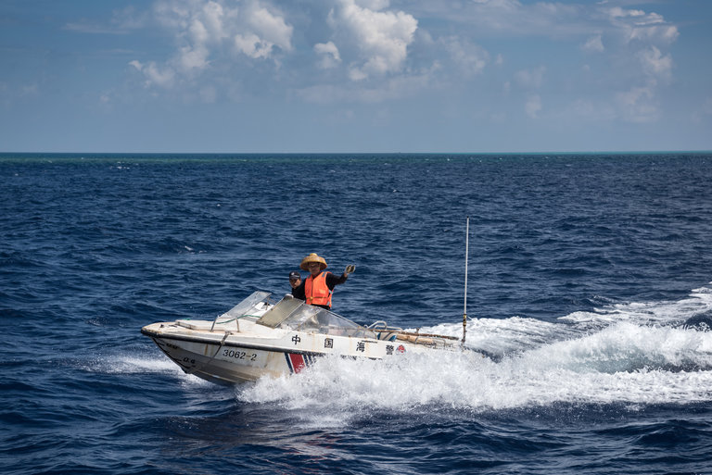
A member of the Chinese Coast Guard ordering a boat to leave the area of Scarborough Shoal, seen as green water in the background, in June. Credit Sergey Ponomarev for The New York Times
BEIJING — An international tribunal in The Hague delivered a sweeping rebuke on Tuesday of China’s behavior in the South China Sea, including the construction of artificial islands, and found that its expansive claim to sovereignty over the waters had no legal basis.
The tribunal also said that Beijing had violated international law by causing “severe harm to the coral reef environment” and by failing to prevent Chinese fishermen from harvesting endangered sea turtles and other species “on a substantial scale.”
The landmark case, brought by the Philippines, was seen as an important crossroads in China’s rise as a global power. It is the first time the Chinese government has been summoned before the international justice system, and the decision against it could provide leverage to other neighboring countries that have their own disputes with Beijing in the South China Sea.
“It’s an overwhelming victory. We won on every significant point,” said the Philippines’ chief counsel in the case, Paul S. Reichler. “This is a remarkable victory for the Philippines.”
But while the decision is legally binding, there is no mechanism for enforcing it, and China, which refused to participate in the tribunal’s proceedings, reiterated on Tuesday that it would not abide by it. “The award is invalid and has no binding force,” the Foreign Ministry said in a statement. “China does not accept or recognize it.”
The foreign secretary of the Philippines, Perfecto Yasay, said Manila welcomed the decision as “significant” and called on “all those concerned to exercise restraint and sobriety.”
Many in the region have been concerned that China would react by accelerating efforts to assert control over the South China Sea, which includes vital trade routes and fishing waters as well as potential oil and mineral deposits.

Document

Hague Announces Decision on South China Sea
An international tribunal in The Hague decided that China's expansive claim to sovereignty over the waters had no legal basis.
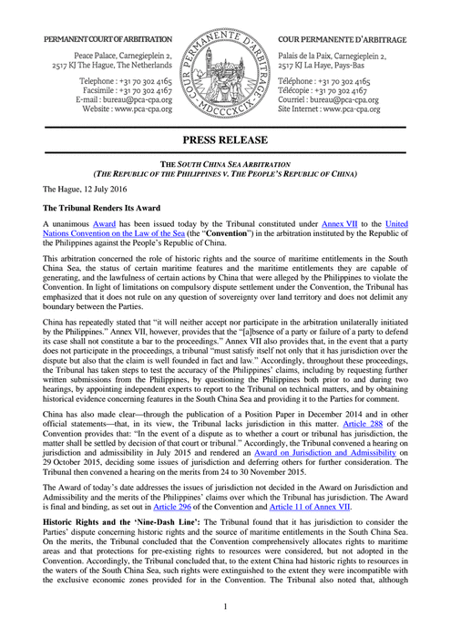
OPEN Document

The Philippines filed its case in 2013, after China seized a reef over which both countries claim sovereignty. There has been speculation that Beijing might respond to the decision by building an artificial island at the reef, Scarborough Shoal, a move that could set off a conflict with the Philippines and its treaty ally, the United States.

Related Coverage

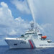

Philippines v. China: Q. and A. on South China Sea Case JULY 10, 2016

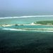

China Promoting Tourism for Disputed Paracel Islands MAY 28, 2016



China, Denying Close Encounter With American Plane, Points Finger at U.S. MAY 19, 2016



Benigno Aquino Says U.S. Must Act if China Moves on Reef in South China Sea MAY 19, 2016

The key issue before the panel was the legality of China’s claim to waters within a “nine dash line” that appears on official Chinese maps and encircles as much as 90 percent of the South China Sea, an area the size of Mexico. Beijing cites historical evidence to support the claim.
But the tribunal sided with the Philippines, which had asked the judges to find the nine-dash claim to be in violation of the United Nations Convention on the Law of the Sea. The treaty details rules for drawing zones of control over the world’s oceans based on distances to coastlines.
The tribunal said that while China and other countries have used the islands in the sea in the past, Beijing had never exercised exclusive authority over the waters. Thus there was “no legal basis for China to claim historic rights to resources” in the waters within the nine-dash line.
The panel also concluded that several disputed rocks and reefs in the South China Sea were too small for China to use to claim the waters around them. As a result, it found, China was engaged in unlawful behavior inside Philippine waters, including activities that had aggravated the dispute.
The tribunal cited interference with fishing and oil exploration, “irreparable” damage to the environment and the construction of a large artificial island in Philippine waters. China has built a military airstrip, naval berths and sports fields on the island, known as Mischief Reef, but the panel said that it was in Philippine waters.
The rejection of the nine-dash line could encourage other countries to file complaints against China and strengthen their negotiating position in any talks with Beijing. Brunei, Indonesia, Malaysia, Taiwan and Vietnam all claim portions of the South China Sea inside the line.
The five judges and legal experts ruled unanimously, and the decision was so lopsided in favor of the Philippines that there were fears in Washington about how angrily the Chinese leadership would react. Some experts on China cautioned that a modest reaction from the United States would be wise.

Our Boat Was Intercepted by China
China has been blocking fishermen from a reef near the Philippines for four years, in another flash point in the dispute over the South China Sea.
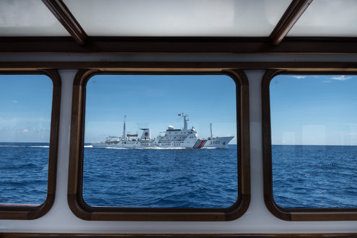

“Xi Jinping cannot be humiliated over this,” said Bonnie S. Glaser, a senior adviser for Asia at the Center for Strategic and International Studies in Washington, referring to the Chinese president. “Xi Jinping has lost face here, and it will be difficult for China to do nothing.
“I expect a very tough reaction from China since it has lost on almost every point. There is virtually nothing that it has won.”
China had boycotted the tribunal, saying that it had no jurisdiction in the case. Because the sovereignty of reefs and islands in the sea is disputed, Beijing asserted, the tribunal could not decide on competing claims to the surrounding waters. The treaty covers only maritime disputes, not land disputes.
In a tough speech in Washington last week, a former senior Chinese official, Dai Bingguo, said that the findings would amount to no more than “waste paper” and that China would not back down from its activities in the South China Sea even in the face of a fleet of American aircraft carriers.
The issue has powerful ramifications for China’s domestic politics, as an integral part of the ruling Communist Party’s narrative is that after long periods of humiliation at the hands of bigger powers, China has regained its former greatness.
The party contends that the disputed areas in the waterway have been China’s since ancient times, and any test of the credibility of that narrative is seen in Beijing as a challenge to party rule.
Some commentators in China have said in recent days that military maneuvers in the South China Sea should not be ruled out as an immediate response to the tribunal’s finding. “Whether it will be significant or large scale I cannot say,” said Shi Yinhong, a professor of international relations at Renmin University in Beijing.
China is hosting the Group of 20 summit meeting in September, a major international forum that it wants to proceed without the distraction of conflict. But Mr. Shi said he was not sure the government “has that kind of patience” to wait until after the gathering before taking some sort of action in the South China Sea.

Interactive Feature

What China Has Been Building in the South China Sea
China has been feverishly piling sand onto reefs in the South China Sea, creating seven new islets in the region and straining already taut geopolitical tensions.
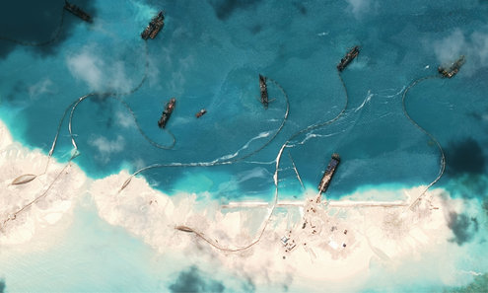
OPEN Interactive Feature

Still, some in China have counseled moderation in recent days.
In a surprising opinion article on the India Today website over the weekend, a professor of international relations at Fudan University in Shanghai, Shen Dingli, wrote that Beijing needed to “revise its stance” and “employ a more effective approach” that maintained China’s “long-held ‘smiling’ image.”
The new president of the Philippines, Rodrigo Duterte, has signaled that he would be more accommodating toward China than his predecessor, Benigno S. Aquino III, and he was reported to have met last week with the Chinese ambassador in Manila, Zhao Jianhua.
The case before the tribunal was filed at the initiative of Mr. Aquino, whose term ended on June 30. Soon after the case was filed, China began building artificial islands in the Spratly archipelago, parts of which are also claimed by the Philippines, in a move that many saw as a demonstration of contempt for the international court system.
Mr. Yasay of the Philippines said over the weekend that it would consider talks with China over the dispute. But he said negotiations would have to be in line with the Convention on the Law of the Sea, which China and the Philippines have ratified.
Experts in international law said that negotiations could be the most positive outcome of the case.
Such analysts point to a case in 1986, in which the United States ignored the International Court of Justice in a ruling that declared the Reagan administration’s mining of the harbors of Nicaragua to be illegal. Washington had not ratified the Convention on the Law of the Sea, and it still has not.
But the unanimous ruling 30 years ago by the judges in The Hague emboldened congressional critics to cut funds for the administration’s campaign against the Sandinista government in Nicaragua, and it galvanized countries in Central America to seek a settlement of the conflict.
The tribunal decision on the Philippines case has no enforcement mechanism: There is no international maritime police force, and China will not vacate or dismantle the artificial islands it has built on top of atolls in the Spratly archipelago. That makes the legal arguments important, the analysts said.
“In a way the tribunal will not solve the South China Sea issue but will heavily influence future negotiations,” said Markus Gehring, a lecturer in law at Cambridge University. “The tribunal rulings will move the goal posts towards the Philippines and the smaller countries.”

WP

Asia & Pacific

Beijing’s claims to South China Sea rejected by international tribunal
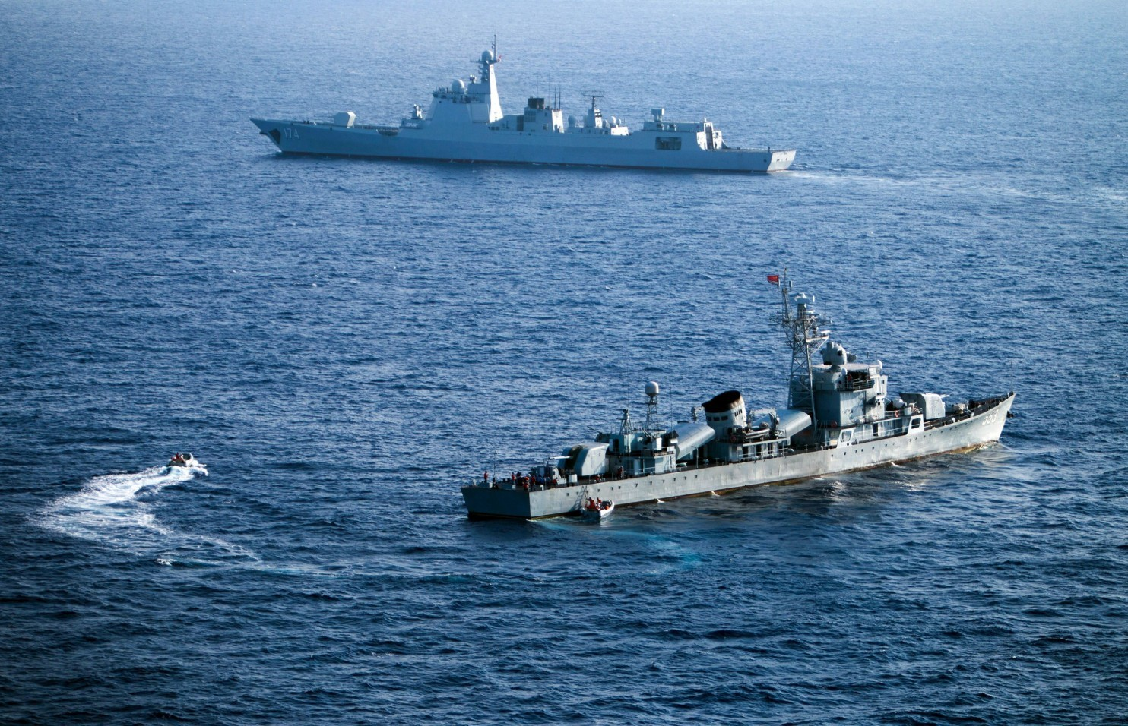
Crew members of China's South Sea Fleet taking part in a drill in the Xisha Islands, or the Paracel Islands in the South China Sea in May. (Str/AFP/Getty Images)
By Simon Denyer and Emily Rauhala July 12 at 9:14 AM
BEIJING — An international tribunal ruled Tuesday that China has no legal basis to claim historic rights to the South China Sea — a major blow to Beijing that could further inflame tensions.
China immediately rejected the decision by the Permanent Court of Arbitration in The Hague, but it was hailed as a landmark victory for those challenging Beijing’s reach into waters with key strategic and commercial significance.
The State Department called on China to abide by the ruling and urged nations bordering the South China Sea to avoid “provocative statements or actions.”
China insists it has full rights over the sea and has moved ahead with construction of island sites that the West and others worry could have military dimensions and disrupt important shipping routes.
The tribunal also ruled that China had violated the Philippines’ sovereign rights by constructing artificial islands there and had caused “permanent irreparable harm to the coral reef ecosystem.”
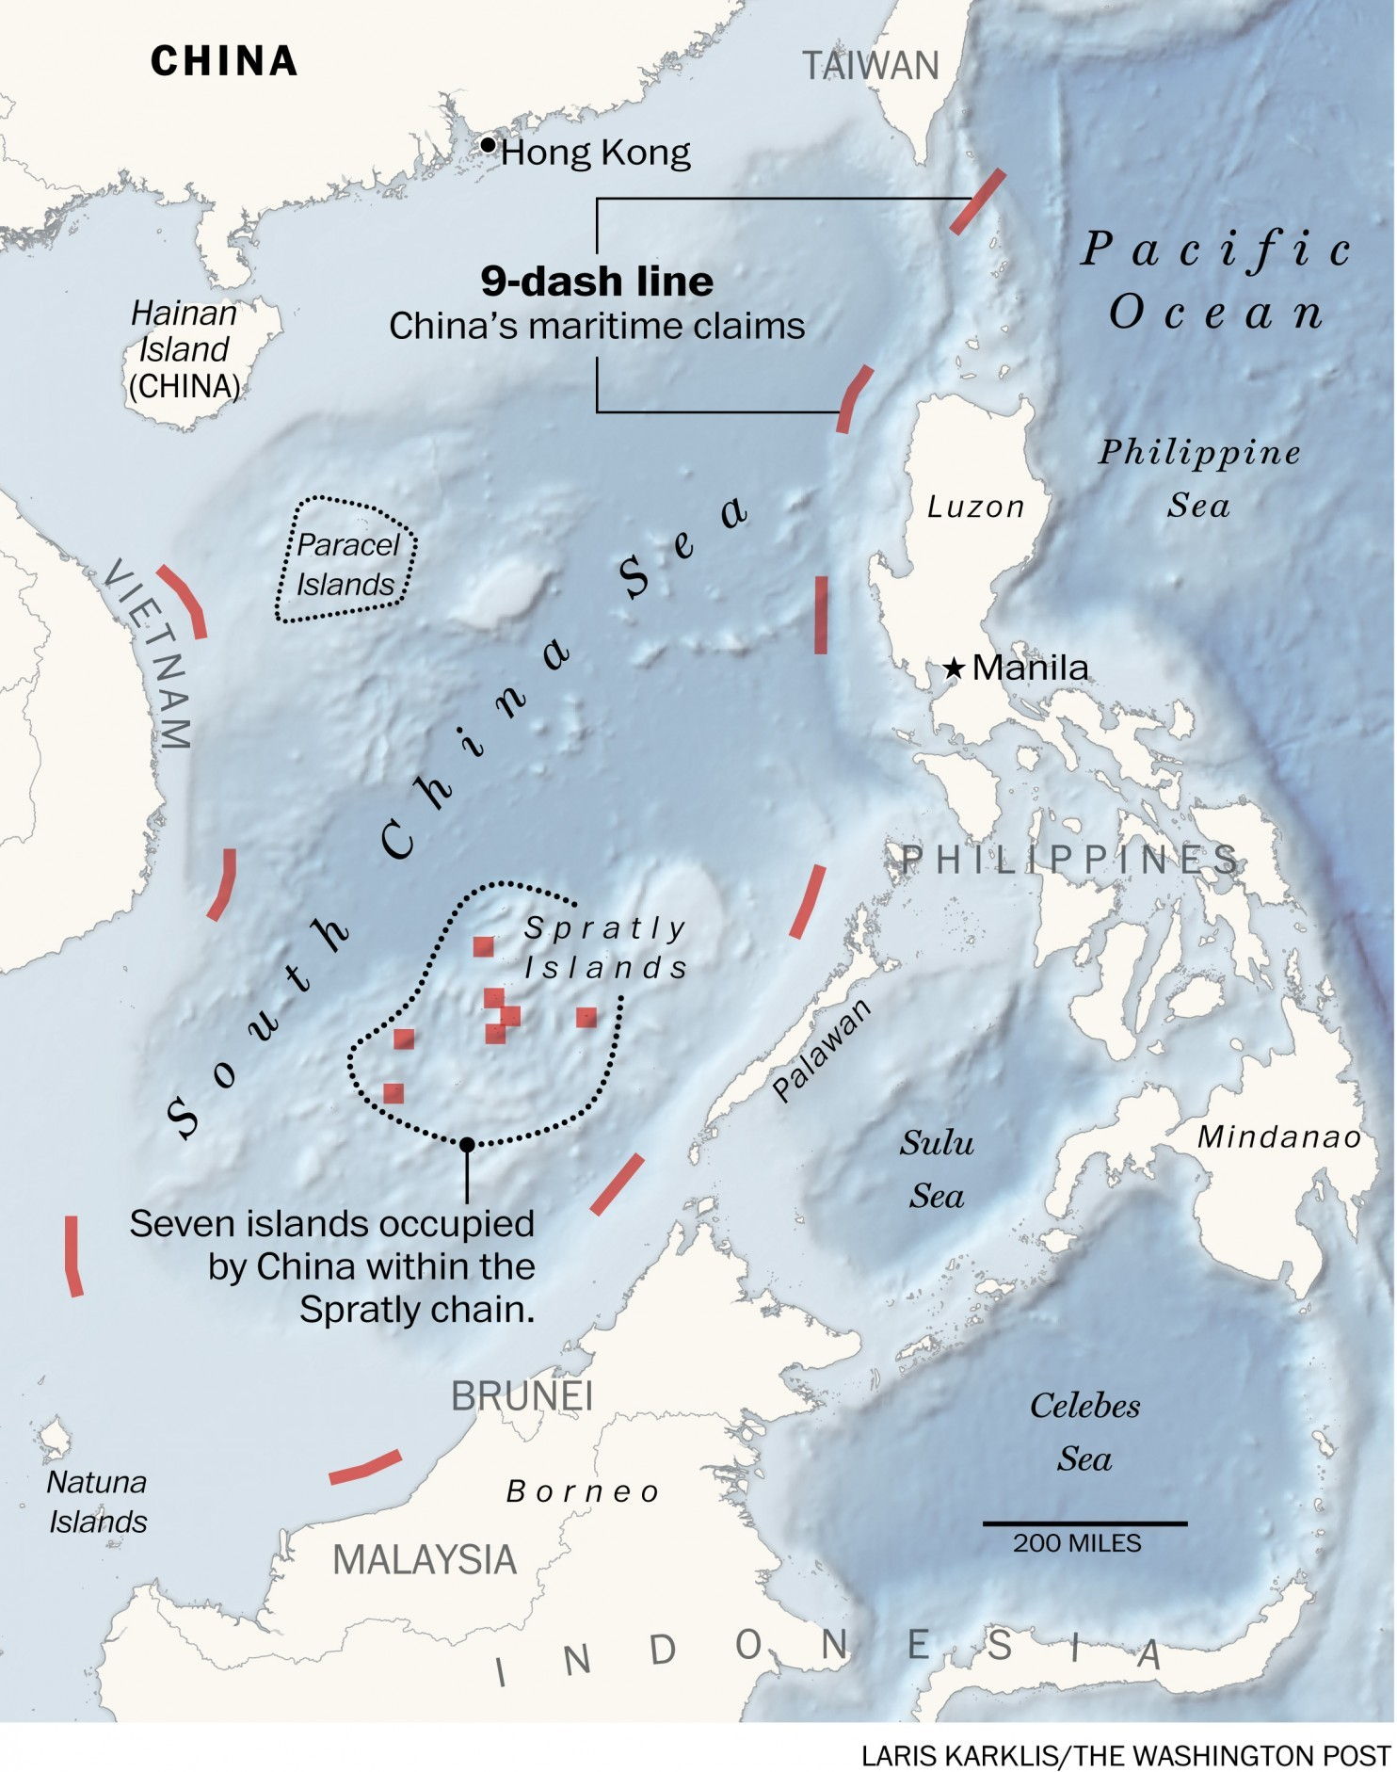
[How big disputes reach most powerful court no one’s ever heard of]
China has repeatedly made it clear it will not accept, recognize or implement the ruling on the South China Sea, the hotly contested waterway that contains some of the world’s busiest shipping routes.
In a statement, the Foreign Ministry said China “solemnly declares that the award is null and void and has no binding force.” It said that “China's territorial sovereignty and maritime rights and interests in the South China Sea shall under no circumstances be affected by those awards.”
But the verdict, which strongly favored the Philippines against China, will nevertheless undermine Beijing’s claim to sovereignty within what it calls the “nine-dash line,” which it draws around most of the South China Sea.
In a statement, the Philippines’ secretary of foreign affairs, Perfecto Yasay Jr., welcomed the ruling, calling it a “milestone.” But he also urged “restraint and sobriety” among all concerned.
[China believes it is the real victim in the South China Sea dispute]
“The verdict is the best-case scenario that few thought possible,” said Richard Javad Heydarian, an assistant professor of political science at Manila’s De La Salle University.

Why China is militarizing the South China Sea
Play Video2:37
China has laid claim to a number of islands in the South China Sea, building airbases on tiny spits of land while installing powerful radar and missile launchers. Here's why. (Jason Aldag, Julie Vitkovskaya/The Washington Post / Satellite photos courtesy of CSIS)
“It is a clean sweep for the Philippines, with the tribunal rejecting China's nine-dashed line and historical rights claim as well as censuring its aggressive activities in the area and, among others, the ecological damage caused by its reclamation activity.”
The State Department said it was still studying the decision but that it “hopes and expects” both China and the Philippines will abide by the ruling.
“In the aftermath of this important decision, we urge all claimants to avoid provocative statements or actions,” said State Department spokesman John Kirby. “This decision can and should serve as a new opportunity to renew efforts to address maritime disputes peacefully.”
At the International Crisis Group, senior China analyst Yanmei Xie called the verdict “as unfavorable to China as it can be.” She said it “significantly limits” the maritime rights that China can legally claim and declares many of its activities illegal.
In Washington, Bonnie Glaser, senior adviser for Asia at the Center for Strategic and International Studies, said the Philippines won “a major victory,” with judges ruling in its favor on almost every point. “China's reaction is likely to be extremely tough. Fasten your seat belts,” she said.
In China, Chen Xiangmiao, an assistant research fellow at National Institute for South China Sea Studies, said he was “totally surprised” by the decision, especially on the nine-dash line.
“The nine-dash line is the foundation of China's claim to sovereignty activities in South China Sea, which has been smashed by the ruling,” he said. “Without this foundation, China has less territory to claim in the South China Sea. However, it’s hard to say how much the ruling will restrain China, given the reaction from the Chinese government.”
[5 stories you need to read to understand the South China Sea ruling]
The Philippines took China to the Permanent Court of Arbitration (PCA) in The Hague in January 2013 after the Chinese navy seized control of Scarborough Shoal, a largely submerged chain of reefs and rocks set amid rich fishing grounds off the main Philippine island of Luzon.
The ruling could lead to more friction between China and the United States.
Washington has been leading international calls for China to respect the tribunal’s decision, and the issue has become a key test of its ability to maintain the leading U.S. role in Asian security in the face of China’s rising power.
Beijing refused to participate in the arbitration process and instead launched a global propaganda campaign to make its case. Foreign Minister Wang Yi was quoted as telling his counterpart, Secretary of State John F. Kerry, last week that the process was a “farce.” His ministry said it was delusional to think China would bow to diplomatic pressure to accept the ruling.
Some $5 trillion in commerce, roughly one-third of global trade, flows through the South China Sea every year, while its fisheries account for 12 percent of the global catch, and significant oil and gas reserves are thought to exist under the sea floor. The waters are some of the most fiercely disputed in the world, with claims to various parts staked by Brunei, Malaysia, Vietnam and Taiwan, in addition to China and the Philippines.
China’s nine-dash line, a version of which first appeared on its maps in 1947, encompasses the vast majority of the South China Sea, and Beijing uses it to claim sovereignty over almost all the islands, reefs and rocks in the sea.
Beijing says its sovereignty claims date back hundreds of years and are “indisputable.” In the past two years, it has undertaken a massive land-reclamation process in the sea, turning seven reefs and rocks into nascent military outposts, with several airstrips and radar installations under construction.
But the tribunal backed the Philippines’ submission that none of those features are islands — as defined by the 1982 United Nations Convention on the Law of the Sea (UNCLOS).
Only natural (rather than artificially constructed) islands that can sustain human habitation qualify for both 12 nautical miles of territorial waters and 200-nautical mile Exclusive Economic Zones (EEZs) under UNCLOS.
In other words, the ruling drastically undermines China’s claim to the waters surrounding the island bases it is in the process of building.
The tribunal found that “certain sea areas are within the exclusive economic zone of the Philippines, because those areas are not overlapped by any possible entitlement of China.” It went on to say that China had violated the Philippines' sovereign rights by interfering with its fishing and petroleum exploration, building artificial islands and failing to prevent Chinese fishermen from fishing there.
It also ruled that Chinese authorities were aware that Chinese fishermen had “harvested endangered sea turtles, coral and giant clams on a substantial scale” in the South China Sea and had not fulfilled Beijing’s obligation under the Law of the Sea to prevent such activities.
China says the tribunal lacked the jurisdiction to rule on Manila’s various submissions, and says it has abused its powers.
In Washington last week, former senior official Dai Bingguo derided the ruling as “nothing more than a scrap of paper,” a refrain echoed by state media here. China also argues that the Philippines had previously agreed to resolve the dispute bilaterally.
But its legal case is undermined by a key provision in UNCLOS, which states that the tribunal alone can decide if it has the jurisdiction to rule on issues before it. In October last year, the tribunal decided it indeed had jurisdiction to rule on several key issues brought by Manila. The tribunal’s decision is legally binding, but it lacks any mechanism to enforce its rulings.
In rejecting the decision, Beijing is certainly not alone. No permanent member of the U.N. Security Council has ever complied with a ruling by the PCA on the Law of the Sea, wrote Graham Allison, director of the Harvard Kennedy School's Belfer Center for Science and International Affairs. “In fact, none of the five permanent members of the U.N. Security Council have ever accepted any international court's ruling when (in their view) it infringed on their sovereignty or national security interests,” Allison wrote in The Diplomat.
The United States has never ratified UNCLOS, and rejected a 1986 verdict at the International Court of Justice ordering it to pay reparations to Nicaragua for mining its harbors, he noted.
Nevertheless, the case is an important indication of China's willingness to submit itself to international law as its clout grows, and a sign of what kind of global power it wants to become.
This is a breathtaking indictment of China's position in the South China Sea,” said David Welch, CIGI Chair of Global Security at the Balsillie School of International Affairs, in Waterloo, Ontario. “It will be very difficult for Beijing to pretend that the tribunal's finding does not matter legally, politically, or practically. How China reacts over the next days and weeks will essentially determine its international standing for decades.”
Despite its efforts to dismiss and discredit the process, Beijing is far from indifferent about the result, analysts said.
What happens next will depend on how it and the other key players — the Philippines and the United States, as well as Vietnam — react.
The United States has already conducted several “freedom of navigation” exercises in the South China Sea, sending warships within 12 nautical miles of islands, reefs and rocks controlled by China and other claimants. It is also rebuilding military ties with the Philippines. China cites this as evidence that President Obama’s actions — not its island-building – are responsible for militarizing the region.
Last week, the U.S. Navy said it had also sent destroyers to patrol close to some of the islands and reefs held by China, although those ships stayed just outside the 12-nautical-mile zone. Washington might decide to step up its patrols after the ruling.
China, meanwhile, could attempt to reinforce its de facto control by declaring an Air Defense Identification Zone (ADIZ) over the South China Sea, under which any incoming aircraft would be required to declare their presence to Chinese
[Chinese jets intercept U.S. recon plane, almost colliding over South China Sea]
authorities. Another option might be to build a new military base on Scarborough Shoal.
“It must be made clear that China needs to exercise restraint and resist taking further actions that would exacerbate tensions,” said Paul Haenle, director of the Carnegie-Tsinghua Center in Beijing.
“But it is also important that the Philippines, the U.S. and others are level and restrained in their responses as well. There is no need for triumphalism or gloating that could provoke greater nationalist sentiment in China.”
Indeed, there are good reasons for all sides to react cautiously.
China hosts a summit of the Group of 20 major economies in September, and is unlikely to want the meeting to take place amid an intense dispute over the South China Sea.
It is also likely to want time to gauge the reaction from Manila, where newly elected President Rodrigo Duterte has sent mixed signals over the issue.
Early in his presidential campaign, Duterte, a long-time mayor with limited foreign policy experience, implied he might be willing to soften his stance on China in return for Chinese infrastructure spending. Later, in a play to nationalist sentiment, he promised to ride a water scooter to Scarborough Shoal to plant the Philippine flag.
Since his inauguration, he has struck a more cautious tone. His challenge will be to appear strong at home to satisfy national pride, without further angering Beijing
Gu Jinglu, Xu Yangjingjing and Xu Jing in Beijing, Michael Goe Delizo in Manila and Carol Morello in Washington contributed to this report.

WP

Asia & Pacific

U.S. ‘hypocrisy’ and Chinese cash strengthen Beijing’s hand in South China Sea

Activists protest in front of the Chinese Consular Office in Manila on June 10. They shouted slogans against China’s reclamation and construction activities in the South China Sea. (Noel Celis/AFP/Getty Images)
By Simon Denyer June 19
BEIJING — The latest was Kenya. Before that: Lesotho, Vanuatu and Afghanistan.
The list of countries backing Beijing’s stance in the South China Sea just keeps growing — China’s Foreign Ministry boasted last week that nearly 60 had swung behind the country’s rejection of international arbitration in a case brought by the Philippines.
The numbers are questionable, and the idea of gaining the support of distant, landlocked Niger in a dispute about the South China Sea could seem faintly ludicrous.
Yet China’s frantic efforts to rally support ahead of a ruling from an international tribunal in The Hague may not be as meaningless as they might seem. Cold, hard Chinese cash and what many see as American double standards are undermining efforts to build a unified global response to Beijing’s land reclamation activities in the disputed waters and employ international law to help resolve the issue.
The lure of Chinese money is having an impact in the Philippines, where President-elect Rodrigo Duterte has made wildly contradictory comments on the issue but has suggested some openness to bilateral negotiations — if China builds railways there.

Carter: China risks erecting 'Great Wall of self-isolation'
Play Video1:36
U.S. Defence Secretary Ash Carter urges China to join a "principled security network" for Asia during a regional security summit. (Reuters)
https://www.washingtonpost.com/world/asia_pacific/us-hypocrisy-and-chinese-cash-strengthen-beijings-hand-in-south-china-sea/2016/06/18/6907943a-330a-11e6-ab9d-1da2b0f24f93_story.html?tid=a_inl
A farcical display of disunity from the Association of Southeast Asian Nations was another case in point. On Tuesday, China sensed a mild rebuke when ASEAN appeared to issue a statement expressing “serious concerns” over rising tensions in the South China Sea, urging restraint in land reclamation and full respect for international law.
Within hours, the statement had been retracted for “urgent amendments.” No revised statement ever emerged.
Beijing, experts said, was riled because the statement was issued at a meeting held in China and at a sensitive time in the run-up to the arbitration ruling, expected anytime in the next three months. It was withdrawn after China lobbied close ally Laos, an official at the talks told Bloomberg News.
Ian Storey, a senior fellow at the ISEAS-Yusof Ishak Institute in Singapore, called it another “embarrassing” episode of ASEAN disunity.
“China didn’t create the disunity in ASEAN, but it does exploit the divisions and uses its economic clout to try to get its way,” Storey said. “China didn’t want ASEAN to in any way support the arbitration process.”
The Philippines took China to court in 2013 after the Chinese navy seized control of Scarborough Shoal, set amid rich fishing grounds off the main Philippine island of Luzon. Among other things, it wants the court to rule on whether China’s “nine-dash line” — under which it claims most of the South China Sea — is consistent with international law.
China vehemently rejects arbitration and says it will ignore the court’s rulings. It argues that the Philippines had previously agreed to settle the dispute bilaterally and that the court has no jurisdiction over issues of territorial sovereignty.
Julian Ku, a professor of constitutional law at Hofstra University, says Beijing has “a very weak” case. The court, he points out, has already spent a year considering the question of jurisdiction and ruled that it does have the authority to consider many of the issues raised by the Philippines.
“While I have expressed strong criticism of the Philippines’ use of arbitration (and the U.S. role in supporting it) from a strategic perspective, I don’t have any such criticism of their legal arguments,” Ku wrote in a blog post. “China’s claim that it can legally ignore the pending arbitral award is not only wrong, it is legally insupportable.”
The weakness of China’s legal case may explain the vehemence of some of its propaganda. Officials portray China as the victim of a “vicious” and deceptive legal case. They accuse the United States of militarizing the region through President Obama’s strategic rebalance to Asia and encouraging Asian nations to seek confrontation with China.
“The U.S. cannot tolerate others challenging its global hegemony,” China’s ambassador to ASEAN, Xu Bu, wrote in the Straits Times, calling Washington “dictatorial and overbearing.”
But legality is only part of the argument, since the court is not in a position to enforce any rulings. In the end, the matter will be settled militarily, in the chess game of global power relations or in some notional court of global public opinion.
And this is where American double standards come in. Despite efforts by the Bush and Obama administrations, the Senate has never ratified the United Nations Convention on the Law of the Sea (UNCLOS).
So when the United States, the European Union and Japan urge China to respect a “rules-based” international system, the admonishments often come across here as insincere.
Japan, experts point out, has ignored a 2014 ruling from the International Court of Justice (ICJ) against its whaling operations, and the United States ignored a 1986 ICJ ruling against the Reagan administration’s support for contra rebels in Nicaragua.
“More importantly, because the United States has never ratified UNCLOS, countries that have maritime disputes with it are unable to take it to legal arbitration,” said Storey, arguing that the issue has become “even more glaringly apparent” in the run-up to the ruling.
Although the U.S. government says it follows UNCLOS as “customary international law,” its failure to submit itself formally to its provisions rankles many nations — especially China.
“China is trying to emulate components of American exceptionalism that place the U.S. above other nations and international law,” said Yanmei Xie, a senior analyst at the International Crisis Group. “The U.S. not ratifying UNCLOS just proves China’s point.”
Wang Dong, an associate professor in the School of International Studies at Peking University, underlined China’s frustration with American “hypocrisy.”
“Big powers rarely subject themselves to international law,” he said. “That’s the reality we have to face.”
Aside from Russia, experts note that none of China’s supporters are major maritime powers, and some question Beijing’s tally. The Center for Strategic and International Studies (CSIS) says that only eight countries have explicitly supported China’s position, while Cambodia, Slovenia and Fiji have disavowed China’s description of their views.
“The 60-country claim is complete nonsense,” said Gregory Poling, head of the Asia Maritime Transparency Initiative at CSIS. “The vast majority have made very vague comments — in support of peaceful resolution or that negotiations are the best way to deal with conflict — and China takes that and says, ‘See, they side with us in the arbitration.’ ”
Nevertheless, China’s ability to get poorer countries on its side could be important if the issue ever comes up at the United Nations.
“China can also portray this as the West against the Third World, of the developed world bullying the developing world,” Xie said. “The narrative matters.”
But however the arbitration panel rules — and however Manila reacts — China won’t be giving an inch on its territorial claims in the South China Sea. A move to declare an Air Defense Identification Zone — under which foreign planes would be asked to inform Chinese authorities before entering airspace above the South China Sea — would be seen as provocative and seems unlikely for now, but Beijing won’t be letting up in its drive to expand its military presence in the South China Sea, experts say. That spells more tension with the United States.
Emily Rauhala and Xu Jing contributed to this report.

AMTI

Support for Legal action
http://amti.csis.org/arbitration-support-tracker/

Arbitration Support Tracker

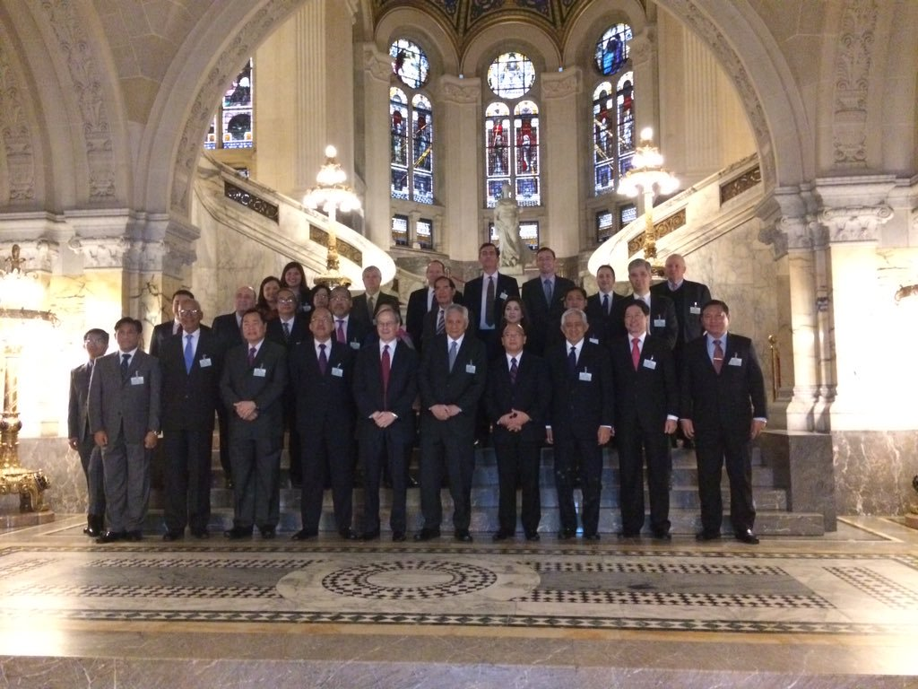
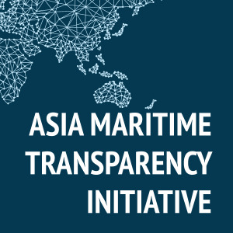

AMTI Leadership
June 16, 2016
Arbitration, China, Philippines, South China Sea
A final ruling is expected soon from a tribunal at the Permanent Court of Arbitration in The Hague hearing Manila’s case against Beijing’s claims in the South China Sea. How many countries recognize the decision as legally binding on both parties and call for it to be respected will determine its ultimate value, as international pressure is the court’s only enforcement mechanism. In an effort to deflect that pressure, Chinese officials and state media have been trumpeting the number of countries that have voiced support for Beijing’s position that the tribunal lacks jurisdiction in the case and the ruling is therefore invalid. China’s Ministry of Foreign Affairs claims that number has climbed to 60, but has not provided a list of the countries or, in most cases, evidence for their support.
AMTI has scoured publicly available, official statements in an effort to determine the real positions taken by countries. To-date, we have identified 50 countries that appear to be included in China’s list of supporters. Of those, 7 have publicly confirmed their support, 3 have denied Beijing’s claim of support, and 40 have remained publicly silent or have issued statements that are considerably vaguer than indicated by China. In contrast, 10 countries plus the European Union have said that the arbitral award will be legally binding and have called on both China and the Philippines to respect it.
Support for China’s position is defined here as an explicit public statement that 1) the arbitral tribunal lacks jurisdiction or legitimacy; 2) the right of states to choose their own method of dispute resolution should be respected (and therefore compulsory dispute mechanisms such as the tribunal are invalid); or 3) the right of states to exempt certain types of disputes from compulsory settlement as provided for by article 298 of the UN Convention on the Law of the Sea should be respected (which China claims invalidates the arbitral proceedings because they actually touch upon boundary delimitation, from which it has exempted itself).
AMTI will endeavor to keep this list constantly updated. If you believe we have overlooked or misinterpreted the statements of any countries, please email AMTI@csis.org.
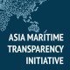
About AMTI Leadership
Dr. Michael Green is senior vice president for Asia and Japan Chair at the Center for Strategic and International Studies (CSIS) and Executive Advisor to AMTI. Gregory Poling is Director of AMTI and Fellow with the Asia Program at CSIS.

AMTI

Judgment Day: The South China Sea Tribunal Issues Its Ruling









Gregory Poling, Michael Green, Murray Hiebert, Chris Johnson, Amy Searight and Bonnie Glaser
July 11, 2016
AMTI Update, Arbitration, China, International Law, Philippines
Today an arbitral tribunal at the Permanent Court of Arbitration in The Hague issued a long-awaited ruling in Manila’s case against Beijing’s claims in the South China Sea. The five-judge tribunal was established under the compulsory dispute settlement provisions of the United Nations Convention on the Law of the Sea (UNCLOS), and despite China’s refusal to participate in the proceedings, its ruling is final and legally binding.
For a closer look at the tribunal’s ruling and the areas it leaves legally disputed in the South China Sea, visit the Asia Maritime Transparency Initiative’s new interactive map.

Q1: What did the court rule?
A1: The judges issued a unanimous decision in favor of the Philippines on the overwhelming majority of the claims it made against China. They invalidated Beijing’s claims to ill-defined historic rights throughout the nine-dash line, finding that any claims it makes in the South China Sea must be made based on maritime entitlements from land features. The tribunal ruled that any other historic rights China might once have claimed in what are now the exclusive economic zones (EEZ) or continental shelves of other countries were invalidated by its ratification of UNCLOS. On the question of specific maritime entitlements over disputed features, the court found that Scarborough Shoal is a rock entitled only to a 12-nautical-mile territorial sea. The judges cannot rule on sovereignty over that shoal, but ruled that China has violated the traditional fishing rights of Filipinos by not allowing them to fish at the shoal. Notably the tribunal said it would have found the same regarding Chinese fishermen if they were prevented access to the shoal by the Philippines.
In the Spratly Islands, the court surprised many observers by ruling on the legal status of every feature raised by the Philippines. It found that none of the Spratlys, including the largest natural features—Itu Aba, Thitu Island, Spratly Island, Northeast Cay, and Southwest Cay—are legally islands because they cannot sustain a stable human community or independent economic life. As such, they are entitled only to territorial seas, not EEZs or continental shelves. Of the seven Spratlys occupied by China, the court agreed with the Philippines that Johnson Reef, Cuarteron Reef, and Fiery Cross Reef are rocks, while Hughes Reef and Mischief Reef are below water at high-tide and therefore generate no maritime entitlements of their own. It disagreed with the Philippines on the question of Gaven Reef, finding that it is a rock, not a low-tide elevation, as well as on Kennan Reef (which China does not occupy but was introduced into the case). Additionally, the court ruled that Second Thomas Shoal and Reed Bank are submerged and belong to the Philippine continental shelf.
Taken together, these decisions effectively invalidate any Chinese claim within the nine-dash line to more than the disputed islets themselves and the territorial seas they generate (excepting around the Paracels farther north). In addition, the judges ruled that China violated its responsibilities under UNCLOS by engaging in widespread environmental destruction via its construction of artificial islands; violated Philippine sovereign rights by interfering with oil and gas exploration at Reed Bank; and illegally constructed a facility on Mischief Reef, which sits on the Philippine continental shelf. The only questions on which the tribunal found that it lacks jurisdiction were those involving China’s blockade and other harassment of Philippine troops upon the BRP Sierra Madre at Second Thomas Shoal. Those questions fell within the exception to arbitration relating to military matters, which China claimed under article 298 of UNCLOS.

Read the full opinion from The Hague
http://amti.csis.org/arbitration-ruling-analysis/

Q2: What comes next?
A2: China has been clear that it will not accept any decision from the court, and there is no enforcement mechanism for the ruling. However, China will suffer considerable reputational cost from the ruling and this could help convince Beijing over the medium-to-long term to bring its claims into accordance with international law and treat fairly with Manila and the other claimants. Recognizing this, the Philippines and partners like Japan and the United States will not only be issuing their own statements calling on both parties to abide by the ruling, but they will urge as many other nations as possible to do the same.
Historically, major powers have often resisted the rulings of international tribunals, only to eventually find a politically acceptable means to accommodate them. Whether or not Beijing will follow that pattern is an open question, and so this will be an important test case of whether a strong international consensus can be sustained vis-à-vis Chinese rejection of international law and whether Beijing will in the end accommodate the expectations of its neighbors.
Beijing recognizes that international solidarity will be the real determinant of whether the case has long-term impact, and has been working to rally countries behind a counter-narrative of China as the victim. Despite Chinese government claims to the contrary, this effort has had limited success. CSIS’s Asia Maritime Transparency Initiative has documented that, on the eve of the ruling, just eight nations had sided with China, calling the tribunal’s proceedings illegitimate, while 40 had voiced support for the outcome as legally binding.
How many more will speak up now that a decision has been reached? And how many will continue to do so in bilateral meetings, international forums, and UN General Assembly votes for the years it might take to convince China of the costs it is incurring? All eyes will be on whether the Philippines’ closest neighbors in the Association of Southeast Asian Nations, who have varying degrees of ties with China, will be able to develop a common statement on the court’s ruling. Ultimately, the success of Manila’s legal effort depends not on the immediate aftermath of this ruling, but on whether the Philippines and likeminded countries including the United States can sustain enough reputational pressure to eventually convince Beijing to seek a face-saving way out.

Q3: How might China react in the near-term?
A3: China’s reaction will depend how much room Beijing decides it still has to maneuver in the wake of the ruling, as well as the reactions of the Philippines, the United States, and others. China may not make any immediate moves other than publicly rejecting the tribunal’s ruling. As host of the G-20 Summit in early September and an offer by the Philippines’ new president Rodrigo Duterte for talks on de-escalation and resource sharing, Beijing may respond with restraint for the time being. If so, this would be an important opportunity for dialogue.
But in light of today’s sweeping ruling against several of the core arguments that undergird China’s approach to dealing with the South China Sea, Beijing may feel compelled to demonstrate that it is undeterred in the face of what some in the senior leadership are sure to see as a concerted U.S. and allied campaign to undermine China’s sovereignty claims. Doing so would serve as retaliation against Manila for its refusal to drop the case, could dissuade others like Vietnam and Indonesia from following in the Philippines’ footsteps, and would send a message that China will not be bound by the ruling. These steps are more likely to occur several months from now, after the G20, but could come sooner.
One act of retaliation could be island building at Scarborough Shoal. Beijing already resolved to undertake land reclamation at Scarborough in March but was deterred by strong signaling from Washington, including the extended operations of the USS John C. Stennis aircraft carrier in the area, patrols near the shoal by A-10 Warthogs deployed to Clark Air Base, and direct warnings from President Barack Obama and Defense Secretary Ashton Carter. Scarborough Shoal’s location—just 185 nautical miles from Manila and situated near the entrance to the Luzon Strait separating the Philippines and Taiwan—makes the establishment of a Chinese military base there strategically unacceptable to both Washington and Manila. Reclamation would also carry enormous diplomatic and economic costs, and would be difficult, albeit not impossible, to prevent if China determines to make the attempt.
An even more escalatory, though perhaps less likely, Chinese reaction could be the imposition of a blockade of the Philippine marines stationed aboard the derelict BRP Sierra Madre at Second Thomas Shoal. Chinese ships prevented resupply of those marines for several months in early 2014, forcing the Philippines to drop supplies by air. Eventually a Philippine civilian ship carrying international and domestic journalists ran the blockade and the Chinese ships backed off. A new blockade could lead to violence, thereby drawing the U.S. military into a direct response under the requirements of its mutual defense treaty with the Philippines.
Other possible retaliations include moving up the timeline on actions that Beijing has already determined to undertake. China could deploy the first rotation of fighter jets to its facilities on Fiery Cross, Subi, and Mischief reefs. The runways at all three have been built to accommodate fighters, and, at least at Fiery Cross, hangars have been constructed to house them. Beijing could also decide to declare archipelagic baselines around the Spratlys Islands—something that it has explicitly reserved the right to do since establishing baselines around its mainland and the Paracel Islands in 1996. Doing so would be a serious threat to freedom of navigation, since it would amount to a declaration that the waters within the Spratly group were China’s internal waters, closed to all surface and air traffic by any other nation. It would also be a direct contravention of today’s court ruling.
The deployment of air assets and drawing of straight baselines around the Spratlys would also be the likely precursors to another major escalation: the declaration of an Air Defense Identification Zone (ADIZ) over the South China Sea. As occurred when China declared an ADIZ over the East China Sea in 2013, the militaries of the United States and Japan, along with most claimant states and others like Australia, would rapidly violate the zone. But most, if not all, civilian air traffic would comply with China’s demands. This would not only heighten the risks of air-to-air incidents between militaries, but would represent another attempt to establish de facto, if not de jure, control over civilian activities throughout the South China Sea.
These are only some of the possible escalatory activities that China could undertake in response to today’s ruling. But they all indicate that while the tribunal’s decision could prove useful in managing the South China Sea disputes in the long run, the short-term result is likely to be heightened tensions.

About Gregory Poling
Gregory B. Poling is director of the Asia Maritime Transparency Initiative and a fellow with the Sumitro Chair for Southeast Asia Studies at CSIS. He oversees research on U.S. foreign policy in the Asia Pacific, with a particular focus on the maritime domain and the countries of Southeast Asia. His research interests include the South China Sea disputes, democratization in Southeast Asia, and Asian multilateralism.

About Michael Green
Michael Jonathan Green is senior vice president for Asia and Japan Chair at CSIS and an associate professor at the Edmund A. Walsh School of Foreign Service at Georgetown University. He served on the staff of the National Security Council (NSC) from 2001 through 2005, first as director for Asian affairs, and then as special assistant to the president for national security affairs and senior director for Asia.

About Murray Hiebert
Murray Hiebert serves as senior fellow and deputy director of the Sumitro Chair for Southeast Asia Studies at CSIS in Washington, DC. He earlier worked as a journalist in Asia for the Wall Street Journal and the Far Eastern Economic Review.

About Chris Johnson
Christopher Johnson is a senior adviser and holds the Freeman Chair in China Studies at the Center for Strategic and International Studies (CSIS). He served in the U.S. government’s intelligence and foreign affairs communities for nearly two decades, during which he worked as a senior China analyst for the Central Intelligence Agency (CIA) and as intelligence liaison for two secretaries of state and their deputies.

About Amy Searight
Dr. Amy Searight serves as senior adviser and director of the Southeast Asia Program at the Center for Strategic and International Studies (CSIS) in Washington, D.C. Dr. Searight has wealth of experience on Asia policy—spanning defense, diplomacy, development, and economics — in both government and academia. Most recently, she served in the Department of Defense (DOD) as deputy assistant secretary of defense for South and Southeast Asia, from 2014 to 2016.

About Bonnie Glaser
Bonnie S. Glaser is a senior adviser for Asia and the director of the China Power Project at CSIS, where she works on issues related to Chinese foreign and security policy. She is concomitantly a non-resident fellow with the Lowy Institute in Sydney, a senior associate with CSIS Pacific Forum and a consultant for the U.S. government on East Asia.

NYT

Testing the Rule of Law in the South China Sea
By THE EDITORIAL BOARDJULY 12, 2016
Photo

Credit Bianca Bagnarelli
How China reacts to the sweeping legal defeat over its claims to the South China Sea will tell the world a lot about its approach to international law, the use — measured or otherwise — of its enormous power, and its global ambitions. So far, the signs are troubling. Beijing has defiantly rejected an international arbitration court’s jurisdiction over a case brought by the Philippines and insisted it will not accept Tuesday’s pathbreaking judgment.
The unanimous ruling, by a five-judge tribunal in The Hague, was more favorable toward the Philippines and broader in scope than experts had predicted. It said that under the United Nations Convention on the Law of the Sea, China had no legal basis to claim historic rights over most of the waterway, which is rich in resources and carries $5 trillion in annual trade.
The panel also faulted China for its aggressive attempts to establish sovereignty by shipping tons of dirt to transform small reefs and rocks into artificial islands with airstrips and other military structures. China’s neighbors fear that it intends to use these outposts to restrict navigation and the rights of others to fish and explore for oil and gas.
The Philippines filed the case in 2013 after China took control of a reef known as Scarborough Shoal. The case accused Beijing of interfering with fishing, endangering ships and failing to protect marine life. Manila also asked the tribunal to reject China’s claims to sovereignty within a so-called nine-dash line that encompasses much of the South China Sea and appears on official Chinese maps.
The judges ruled for the Philippines on most claims in its complaint: China had indeed violated international law by causing “irreparable harm” to the marine environment, endangering ships and interfering with Philippine fishing and oil exploration. Further, China had illegally built an artificial island on Mischief Reef, complete with a military airstrip, in waters belonging to the Philippines.
The Law of the Sea treaty sets rules for establishing zones of control over the oceans based on distances to coastlines. In addition to China and the Philippines, Malaysia, Vietnam, Brunei, Indonesia and Taiwan all claim parts of the South China Sea. The tribunal is authorized to deal with maritime disputes, not the underlying land claims to the islands, reefs and rocks that are also contested. The decision is the first international ruling on the disputed maritime issues in the South China Sea.
There are serious concerns about what will happen next. The tribunal has no authority to enforce its ruling, and China, which boycotted the legal process, threatens to use force to protect the maritime interests the court has now declared illegal.
What this means in practice is not clear. Given China’s stake in peaceful trade with the rest of the world, it would be foolish for President Xi Jinping to take provocative actions that could inflame regional tensions and conceivably lead to a military confrontation with its neighbors or the United States. Retaliatory measures — further island-building at Scarborough Shoal, for instance, or declaring an air defense zone over large portions of the South China Sea — would be risky.
In fact, the ruling offers a fresh opportunity to address maritime disputes in a peaceful manner. China’s ambassador to the United States, Cui Tiankai, condemned Tuesday’s ruling but said Beijing remains open to negotiations. Nations in the region have often gone wobbly in the face of pressure from Beijing. At this critical moment, despite competing interests of their own, they need to join the Philippines in endorsing the tribunal decision and then proceed, if necessary, with their own arbitration cases.
The United States, which is neutral on the various claims, can help ensure a peaceful, lawful path forward. The Obama administration has said that disputes should be resolved according to international law, a position it now reaffirms. It has built closer security relations with Asian nations and responded to China’s assertiveness in the South China Sea with increased naval patrols. This combination of diplomacy and pressure is sound, but the hard part is getting the balance right.

NYT

Beijing Protests South China Sea Ruling With Modest Show of Strength
By JANE PERLEZJULY 13, 2016
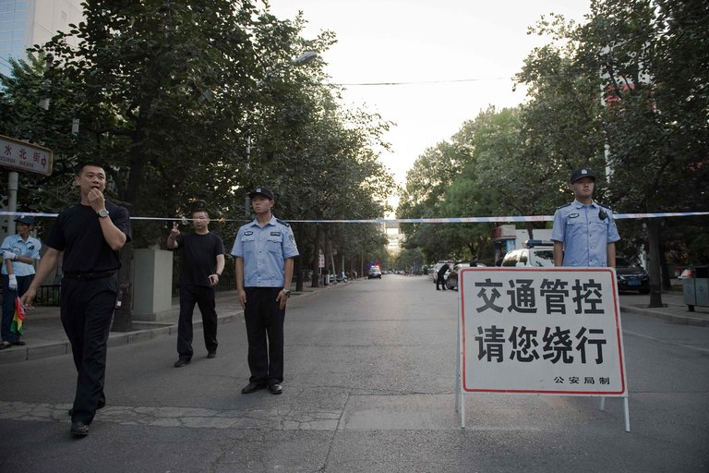
Chinese police officers blocked the road leading to the Philippine Embassy in Beijing on Tuesday and Wednesday. Credit Nicolas Asfouri/Agence France-Presse — Getty Images
BEIJING — A day after an international tribunal rejected China’s claims in the South China Sea, Beijing excoriated the panel and sent two civilian planes to artificial islands it occupies in the waterway to demonstrate control.
But the government stopped short on Wednesday of sending warships to the area, and there were signs of limits to how far it was prepared to go in whipping up anger against the Philippines, which won almost all the arguments in the case it brought against China in The Hague.
The lack of protests around the Philippine Embassy in Beijing signaled that China was preparing at some point to negotiate with the new president, Rodrigo Duterte, who has been friendlier toward Beijing than his predecessor, Benigno S. Aquino III, who initiated the case.
In repudiating China’s sweeping claims over the South China Sea, the tribunal handed the government a credibility problem not only abroad but also at home — where the population has been treated to a steady diet of Chinese invincibility over the waterway.
Chinese news media were full of declarations on Wednesday that Beijing, which had refused to participate in the proceedings, would not abide by what it called an illegal ruling. Under the law of the sea treaty that China has ratified, the decision is legally binding, but there is no mechanism to enforce it.
The most damning aspect of the report was the finding that China had no historical rights over the sea. There was no evidence, the panel concluded, that China had ever exercised exclusive control of the waterway.
One of the enduring lessons Chinese schoolchildren are taught is that the South China Sea has belonged to China since ancient times, a nostrum that President Xi Jinping repeated to state media several hours after the decision was made public.
To drive home the point, Mr. Xi’s portrait was shown in a particularly prominent position — on the front page of Wednesday’s edition of the English-language state-run newspaper, China Daily, above the paper’s name.
A map of China with the “nine-dash line” marking its territory appeared in many state media outlets, with the caption “not one dot less.” The line encircles about 90 percent of the South China Sea, an area as big as Mexico.
To demonstrate that China’s occupation of two artificial islands in the Spratly archipelago remained intact, the government sent civilian planes on Wednesday to two reefs that were at the center of the arbitration: Subi Reef and Mischief Reef, in the Spratly archipelago.
The tribunal ruled that under the law the two reefs, which were built into islands by mammoth dredging operations, were too small for China to claim economic control of the waters around them. It also said that Mischief Reef was in Philippine waters.
China’s national broadcaster, CCTV, showed footage of the civilian planes and their crew standing in the sunshine on the runways. There appeared to be no passengers on the aircraft, emblazoned with the logos of Southern Airlines and Hainan Airlines.
Photo
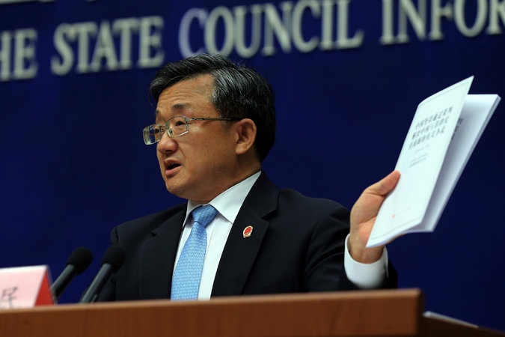
Liu Zhenmin, the deputy foreign minister of China, lashed out Wednesday at the judges and experts who decided the case, calling them biased and anti-Asian at a news conference in Beijing. Credit China Daily/Reuters
In another sign intended to show the Chinese public that the government’s control of the sea remained untouched, the People’s Liberation Army newspaper announced the launch of a new advanced missile destroyer. The navy will soon receive a “massive number” of destroyers that would protect China’s maritime interests, CCTV said.
A fierce attack on the credentials of the tribunal itself was led by the deputy foreign minister, Liu Zhenmin, who lashed out at the judges and experts who decided the case, calling them biased and anti-Asian.
“Do they know about Asia?” he asked at a news conference on Wednesday. “Do they know about Asia’s culture? Do they know about the South China Sea issue?”
He continued: “Do they understand the complex regional politics in Asia? Do they realize the history of the South China Sea? How on earth could they deliver a just award.”
The panel consisted of five legal experts on the law of the sea from France, Germany, Poland, the Netherlands and Ghana.
One of Mr. Liu’s complaints was that four members of the panel were appointed by Judge Shunji Yanai, a former Japanese ambassador to the United States, and a lawyer who was the president of the International Tribunal on the Law of the Sea in 2013 when the Philippines started the case.
Normally in a case that is to be heard by a five-member panel, each side chooses two members and the sea tribunal chooses one, experts on the treaty said.
In the South China Sea case, the Philippines appointed one judge from Germany.
In an effort to not have a disproportionate number of members appointed by its side, the Philippines asked Mr. Yensai to appoint the remaining four, said Markus Gehring, a law-of-the-sea expert and lecturer in law at the University of Cambridge.
Mr. Liu cast aspersions on Mr. Yanai saying he was an ally of the Japanese prime minister, Shinzo Abe, a conservative politician whom the Chinese government often criticize. “This tribunal is totally rigged by him,” Mr. Liu said.
The deputy foreign minister also attacked the tribunal over the fees for their services, which had been paid by the Philippines. “They make money, who owns them? Who are paying them? Philippines or another country?”
In both commercial and international arbitration cases, including law of the sea matters, it was normal practice for the two sides to pay for the fees of the arbitrators, and other expenses such as court reporters, and information technology, Mr. Gehring said.
China declined to pay its costs for the case, so the Philippines did, the Permanent Court of Arbitration in The Hague, which administered the case between the Philippines and China, noted on its website.
“The Permanent Court of Arbitration’s bills to the parties had to be paid,” said Paul S. Reichler, the chief counsel for the Philippines. “Because China ignored them, the Philippines had no choice but to pay China’s share as well. That is what happens when one of the parties refuses to pay its share, and the other party wants the arbitration to proceed.”
He called the five jurists among the “most honorable and distinguished” in the world.
“The suggestion that these five arbitrators ruled in the Philippines’ favor because they knew that the Philippines paid the costs — to the Permanent Court of Arbitration, not to them personally — is vicious and mendacious.”

The Economist

Hard court
All latest updates

A UN-appointed tribunal dismisses China’s claims in the South China Sea

The region, and America, will now anxiously await China’s response
Jul 12th 2016 | China

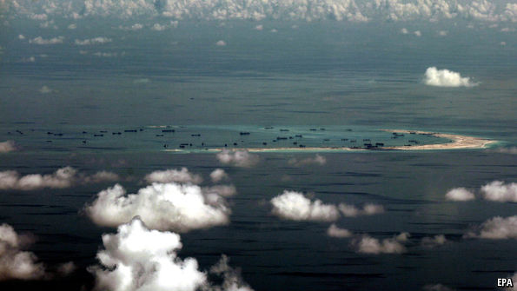
CHINA’S efforts to assert vast and ambiguous territorial claims in the South China Sea—including a crash programme to turn several rocks and reefs into military bases and other facilities—have been causing growing tension in the region for years. Nearby countries and America have tried unsuccessfully to persuade China to back off. Now a UN-designated court in The Hague has delivered a ruling that declares invalid China’s claim to historic rights over almost all of the South China Sea, as well as islands within it. China had refused to take part in the court’s proceedings, describing them as illegal. It will now be furious.
The judgement by the Permanent Court of Arbitration had long been expected to contradict China’s assertions and uphold the complaints raised by the Philippines when it lodged the case (with strong American backing) in January 2013. Apparently with this in mind, China had stepped up its building of artificial islands, hoping that by establishing firmer footholds on them it would be impossible for any claimant to push it back without risking confrontation. The construction of what an American admiral called a “great wall of sand” has angered other contestants for rights in the sea, especially the Philippines and Vietnam (Malaysia, Brunei and Taiwan are also in the fray). The court’s ruling will further convince China that it was right to move quickly. It will hold firm to what it has got.
Advertisement
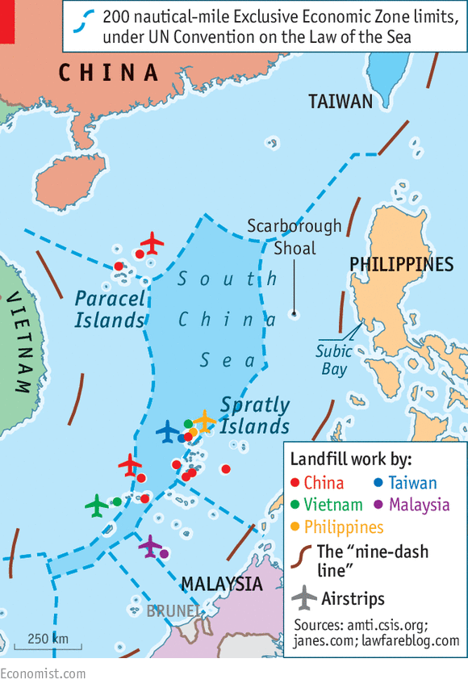
In a summary of its conclusions, the court said there was no evidence that China had in the past exercised exclusive control over the South China Sea or its resources. Hence, it said, there was “no legal basis for China to claim historic rights” to resources within the “nine-dash line”, as the U-shaped outline used by China to sketch its claims there is often called (see chart). The line stretches as far as 2,000km (1,200 miles) from China’s shores. Under the UN Convention on the Law of the Sea, the court said, historic rights to resources could not trump exclusive economic zones awarded by that convention.
China has never clarified what it means by the nine-dash line: whether it regards the seas within as its sovereign territory, or whether it is used to enclose clusters of islands that it claims. But even if the claim is just to islands, then the court’s ruling has considerably undermined that. The tribunal said that none of the Spratly Islands, where China’s island-building efforts have been concentrated, were features that could sustain human life. They could therefore not qualify for 200 nautical-mile exclusive economic zones around them. The court said China had thus violated the “sovereign rights” of the Philippines by stopping it from fishing and exploring for oil in parts of the Spratlys that lie within the Philippines’ exclusive economic zone.
There was a further blow to China’s pride: the court ruled that China’s island-building efforts in the Spratlys had caused “severe harm to the coral reef environment”. It said the Chinese authorities “had not fulfilled their obligations” to stop Chinese fishermen from harvesting endangered species there, including sea turtles, coral and giant clams “on a substantial scale”.
The region, and America, will now anxiously await China’s response. Furious rhetoric is inevitable; more serious would be any action aimed at reinforcing China’s claims. One such might be the declaration of an Air Defence Identification Zone over the South China Sea, like the one it imposed over the East China Sea in 2013 in response to an escalating spat with Japan over ownership of a group of islands there. China requires all aircraft transiting that zone to report their presence to its authorities. America’s military aircraft (and Japanese airliners) have ignored the one in the East China Sea and would be certain to do the same if one were imposed in the South China Sea, as China is thought to be mulling. That would add to an already substantial risk that the two countries’ military planes might end up in dangerous confrontation.
Another possibility is that China might start building on Scarborough Shoal, a feature north-east of the Spratlys which it wrested from the Philippines in 2012. The court ruled that the Philippines, as well as China, had traditional fishing rights around the shoal and that China had interfered with those rights. Any attempt by China to establish an outpost on the shoal would be seen by the Philippines, and by its ally America, as a serious ratcheting up of tensions.
At least in the short term, there are reasons why China might be cautious. It is involved in high-level meetings on trade and investment this week with leaders from Europe and other Asian countries in Beijing and Ulan Bator, the capital of Mongolia. China will also be hosting a meeting of G20 leaders in September. It will not want such events to be disturbed by recriminations over China’s response to the court’s verdict. But having made such an issue of China’s maritime claims since he took over as China’s leader in 2012, Xi Jinping will find it hard to play them down. The South China Sea, which China says it wants to become a “sea of peace, friendship and co-operation”, will remain far from it.

Daily chart

The South China Sea
Jul 12th 2016, 12:56 by THE DATA TEAM

The South China Sea
- Exclusive Economic Zones
- Reef building
- Oil and gas reserves
- 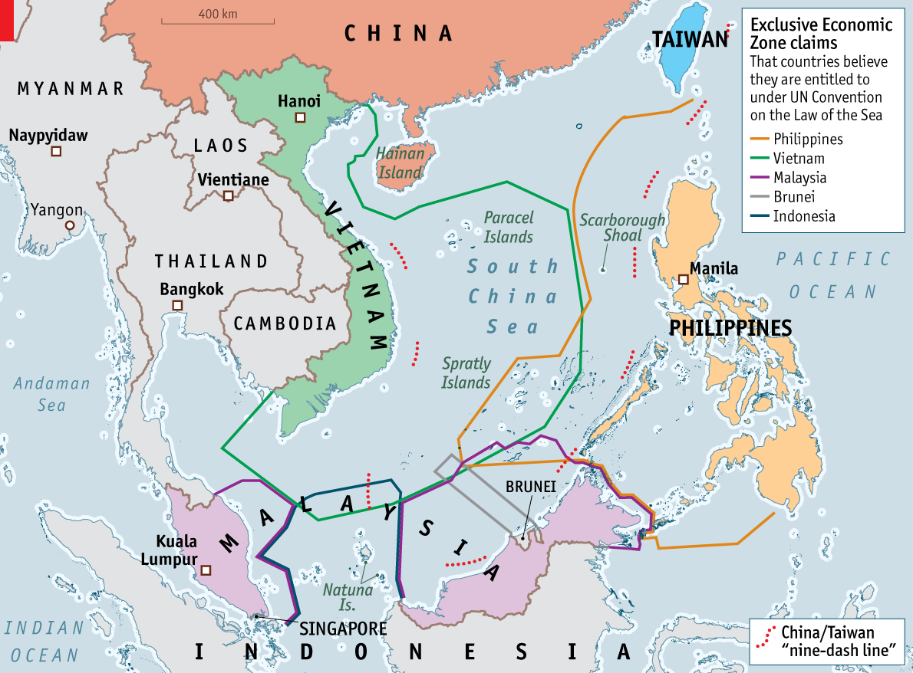

- 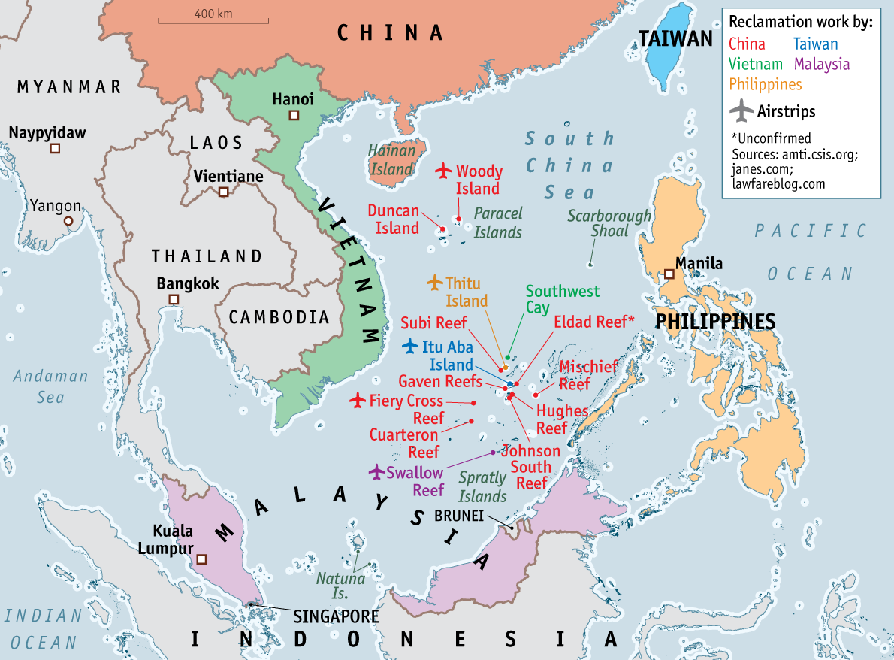

- 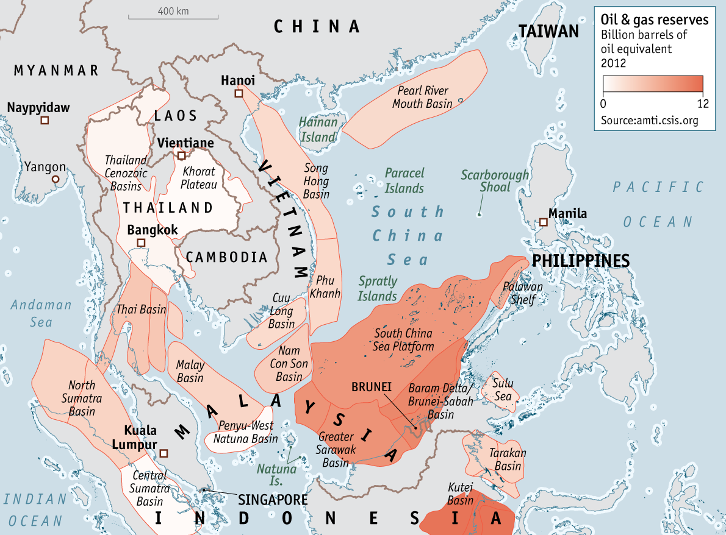
THE South China Sea has long been one of the world’s most coveted waterways. Seven different countries—counting Taiwan, which is itself claimed by China—assert sovereignty over overlapping portions of its waters. The last time waxing and waning tension spilled over into serious conflict was in 1988, when Vietnam lost over 70 lives in a skirmish with China in the Spratly archipelago. But the stakes of any potential relapse into violence are higher than ever now that America is involved.
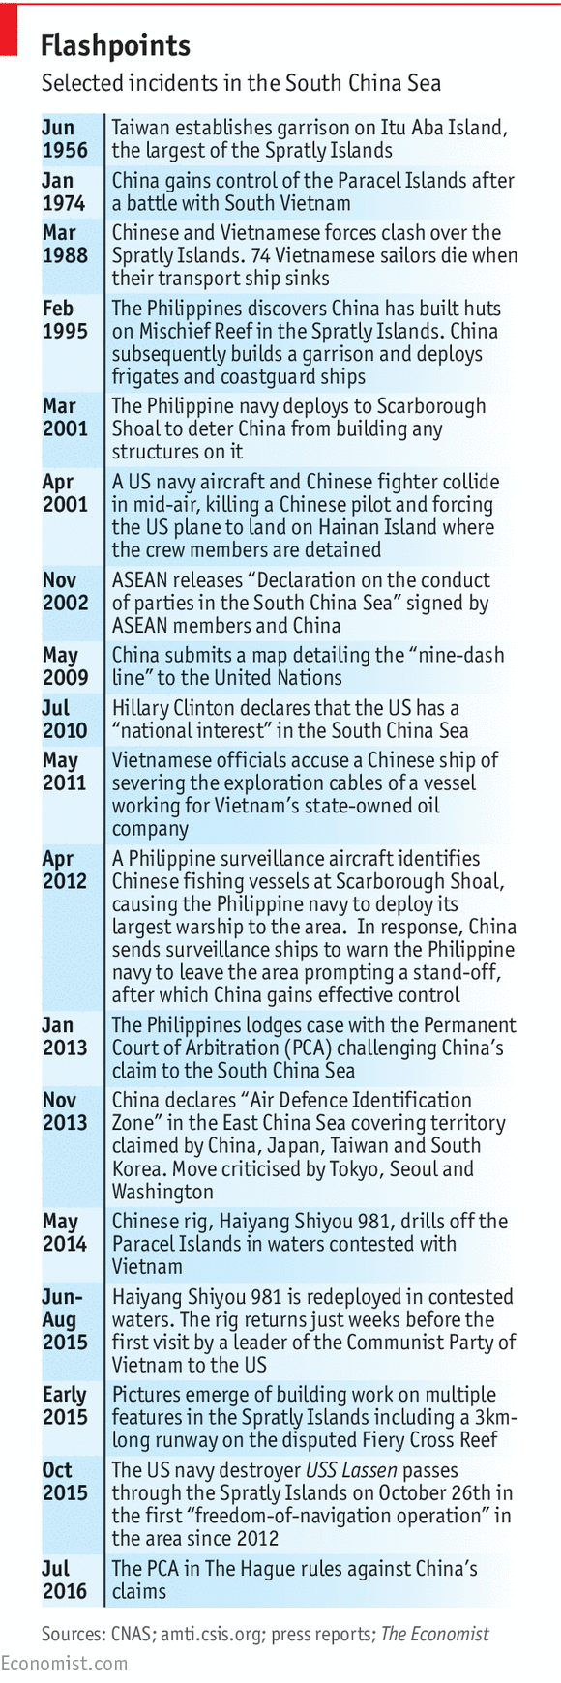
Chinese maps feature a “nine-dash line” encircling almost all of the sea inside its borders. Malaysia, Brunei, Vietnam and the Philippines all contest parts of that area, as does Taiwan, whose claims in the sea mirror China’s. In addition, although Indonesia is not a party to any of the disputes over tiny islands, rocks and reefs, it says the nine-dash line cuts through the “exclusive economic zone” granted to it by the UN Law of the Sea. Like those of other countries, its fishermen complain about Chinese incursions. And every government in the region takes an interest in the sea’s purported hydrocarbon riches. In 2013 the Philippines filed a case with the Permanent Court of Arbitration (PCA) in The Hague, asking the tribunal to reject China’s claim. On July 12th 2016 the court released a summary of its ruling saying that there was “no legal basis for China to claim historic rights to resources within the sea areas falling within the ‘nine-dash line’”.
China has said it will ignore the PCA’s ruling, denying that the court has any jurisdiction over what it sees as an issue of sovereignty. But the United States will not allow China to do so unmolested. Although America is formally neutral on the territorial disputes between the littoral states, it says it has a national interest in maintaining freedom of navigation in the sea, through which one-third of the world’s maritime trade passes. China accuses America of stoking discord between it and its neighbours, and of encouraging them to defy it, while America and most South-East Asian countries see China as the main source of tension. Despite an agreement with the Association of South-East Asian Nations in 2002 to avoid provocations, in the past three years China has been engaged in a frenetic building spree, creating seven artificial islands on top of disputed rocks and reefs. Many assume they will one day become military bases.
The United States has already angered China by sending warships close to Chinese-claimed features in the sea on “freedom-of-navigation operations”. Currently, two American aircraft-carrier groups are stationed in the region, apparently to deter China from taking any provocative steps now the PCA’s decision has gone against it. China, for its part, has been staging naval drills near the Paracel islands to the north of the sea. Further escalation could be likely if China does more than ignore the ruling, and starts building on yet another contested shoal, or declares an Air Defence Identification Zone over a sea it seems to regard as a Chinese lake.
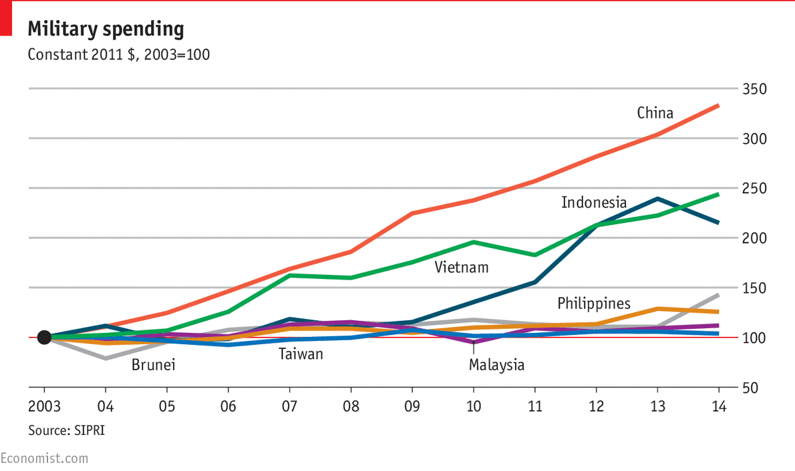

Brookings
Jonathan D. Pollack | July 12, 2016 5:15pm

How will China respond to the South China Sea ruling?
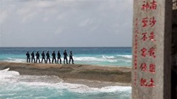
In a long-awaited ruling prepared under the United Nations Convention on the Law of the Sea (UNCLOS), an arbitration panel has handed an unequivocal victory to the Philippines in its case against China, which it first filed in early 2013. The arbitration panel deemed invalid virtually all of Beijing’s asserted claims to various islands, rocks, reefs, and shoals in the South China Sea, determining that Chinese claims directly violated the provisions of UNCLOS, which China signed in 1982.
From the outset of Manila’s initiation of the arbitration process, Beijing has refused to participate. However, it did issue a position statement of its own in late 2014, claiming that the arbitration panel violated various UNCLOS provisions and additional agreements signed by the two governments. As the arbitration neared its conclusion, China released a steady stream of editorials and commentaries, claiming that the ruling sought “to deny China’s territorial sovereignty and maritime rights and interests in the South China Sea.”
Beijing has repeatedly stated that “it does not accept any means of third party dispute settlement or any solution imposed on China.” At the same time, UNCLOS has no enforcement mechanism for carrying out the panel’s judgments. But Beijing’s repeated efforts at shaming and stonewalling have imposed an undoubted cost on its political standing in the region. Moreover, China’s signing of UNCLOS obligated Beijing to compulsory third party determination, though it is not the only power contesting this commitment.
Beijing’s repeated efforts at shaming and stonewalling have imposed an undoubted cost on its political standing in the region.
The fundamental weakness of China’s policy defense was its reliance on various “historic claims” to most of the maritime expanses of the South China Sea, including areas that directly encroached on the sovereign territory of various neighboring states. Its claims have frequently been encapsulated in the nine-dash line, an ill-defined geographic demarcation initially appearing in a map prepared by cartographers in the Republic of China in 1947 (i.e., prior to the victory of the Chinese Communist Party in 1949). But China’s sweeping claims to “unequivocal sovereignty” failed to address the multiple layers of ambiguity and conflicting judgments found in various policy documents released by Beijing.
Moreover, the arbitration panel emphasized from the outset that its authority did not extend to determinations over sovereignty. Rather, its mandate (distilled from a list of 15 claims in Manila’s original brief) focused on Chinese claims to the continental shelf and to exclusive economic zones extending from land features, reefs, and rocks over which China claimed indisputable sovereignty. The Philippines also contested Chinese activities that infringed on the rights of Filipino fishermen, Beijing’s construction of artificial islands, and the operation of Chinese law enforcement vessels in various shoals.
Even if Beijing persists in its angry defiance of the arbitration panel’s findings and continues to contest their legitimacy, the sweeping character of the rulings (in a document exceeding 500 pages in length) is impossible to deny. UNCLOS specifically states that land features not deemed an island are entitled only to a 12-mile territorial sea, not to an exclusive economic zone or to a continental shelf. In an especially controversial finding, the panel concluded that Itu Aba (known in Chinese as Taiping Island and the largest land feature in the Spratly Island group and controlled by Taiwan) was not an island; this has been strongly contested by Taipei as well as by Beijing.
The biggest looming issues will focus on how China opts to respond.
The biggest looming issues will focus on how China opts to respond in words and deeds. The arbitration proceeding has triggered strongly nationalistic responses from leaders and experts in China, with many alleging a hidden U.S. hand in the arbitration. American political and military support for the Philippines and other claimants and heightened U.S. air and maritime activities in the South China Sea—all justified as ensuring freedom of navigation in the vital waterways of the region—engenders additional angry responses from the Chinese leadership.
Beijing continues to insist that it is prepared to enter into bilateral negotiations with Manila over various disputed claims. But with China claiming indisputable sovereignty over various contested features and possessing maritime capabilities that vastly exceed those of any other claimants, will it be prepared to demonstrate flexibility, restrain its responses, and give any credence to the diligent labors of the arbitration panel? Can Beijing envision quiet diplomacy, either with the United States or with regional claimants, as opposed to seeing itself as the endlessly aggrieved party? If Beijing doesn’t exercise restraint and instead takes steps that heighten the risks, these could readily pose new threats to the regional maritime order that cannot possibly be in anyone’s interest.
- 
Jonathan D. Pollack
Interim SK-Korea Foundation Chair in Korea Studies, Foreign Policy, Center for East Asia Policy Studies
Senior Fellow, Foreign Policy, John L. Thornton China Center
Jonathan D. Pollack is the Interim SK-Korea Foundation Chair in Korea Studies in the Center for East Asia Policy Studies and a senior fellow in the John L. Thornton China Center at the Brookings Institution. A specialist on East Asian international politics and security, he has published extensively on Chinese political-military strategy, U.S.-China relations, the political and security dynamics of the Korean Peninsula and U.S. strategy and policy in Asia and the Pacific. His latest publication, "No Exit: North Korea, Nuclear Weapons, and International Security", was published in May 2011 by Routledge for the International Institute for Strategic Studies

Richard C. Bush III | July 13, 2016 11:40am

The South China Sea ruling and China’s grand strategy
- More Topics
- China
- Asia and the Pacific
- South Asia
- Southeast Asia
- Global Governance
- chinese foreign policy
- chinese military
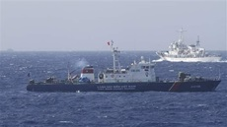
The International Tribunal on the Law of the Sea has ruled on the case that the Philippines brought in 2013, challenging China's claims and behavior in the South China Sea. International lawyers and the policy commentariat has judged the ruling as a sweeping victory for the Philippines and a significant loss for China, which refused to acknowledge the tribunal's jurisdiction or to take part in the proceedings.
The question going forward is how China will respond. Will it double down on the aggressive and coercive activities of the past six years, behavior that has put most of its East Asian neighbors on guard? Will it continue to interpret the Law of the Sea in self-serving ways that very few countries accept? Or, might China recognize that its South China Sea strategy has been an utter failure and that its best response is to take a more restrained and neighborly approach?

What got us here?
Critical as the next weeks and months will be, it is also useful to take a look back and examine recent events in the broad context of Chinese foreign and security policy over the last four decades. The premise of that reform policy, initiated in the late 1970s and early 1980s, was that a weak China could best ensure its security by engaging and accommodating the international community, in order to gradually build up all aspects of its national power. The most clear-cut feature of this strategy was to join the global economy: China accepted the leadership of the IMF and World Bank; opened the Chinese economy to international trade and investment; carved out critical roles in global supply chains; accepted the liberalization disciplines of the World Trade Organization; and, more recently, began to provide public goods to other developing economies. Not everyone has benefitted from China's economic engagement, but on balance it has been a signal success.
China's reformist leaders also recognized the value of taking an accommodating stance toward its East Asian neighborhood, of which the United States is a part. One side of accommodation was to execute a skillful diplomacy designed to reduce tensions and avoid conflict unless Beijing's fundamental interests were under threat. Accommodation's other side was to delay the modernization of the Chinese military and exercise restraint in the use of those capabilities that it did create. This made sense because China both lacked the power to challenge the United States and Japan militarily and needed the help of those and other countries to grow economically.
That approach changed in the early 2000s, when Beijing judged that it would only be secure if it expanded its eastern and southern strategic perimeters into the East and South China Seas. That judgment had its own logic, which maritime territorial disputes and reports of maritime energy and mineral resources only intensified. Thus began a program to build the capabilities to project power into the maritime domain and then use them to press its claims. That campaign created frictions with its neighbors. An increasingly overbearing diplomacy didn't help China's reputation either.

It’s your move, China
Another part of China's grand strategy has been to integrate itself in the system of international institutions, law, norms, and regimes—both global and regional. This step did not signify a fundamental acceptance of the international order that had emerged and evolved after World War II. Rather, it reflected a belief that China could and should use institutions, law, norms, and regimes to protect China's interests against hegemonic behavior by others, particularly the United States. (Conversely, the "West" believed that binding Beijing to "its" order would restrain Chinese bad behavior.)
The tribunal’s decision on the Philippines case was a clear blow to China's long-standing strategy to use international law to advance or protect its interests, prompting feelings of buyer's remorse. The hardy perennial that China has been the victim of humiliation at the hands of Western countries will only add to the resentful reaction. Of course, China rejects the widely-held view that it is bound by the ruling even though it did not participate in the case. Also, this is a court with no enforcement powers, so Beijing could simply ignore the ruling and use its military and law enforcement assets to continue its past pattern of aggressive and coercive actions—essentially increasing the salience of its military power. That course of action would only further push the test of wills between it and Washington, even though neither benefits from a downward spiral of increased competition and conflict.
Beijing could simply ignore the ruling...That course of action would only further push the test of wills between it and Washington, even though neither benefits from a downward spiral of increased competition and conflict.
China could go even further than simply doubling down. Contrary to the tribunal's ruling, it could treat the Spratly Islands as islands under international law; define them as a single unit for purposes of defining maritime boundaries; accordingly draw straight baselines around them; then declare for itself an exclusive economic zone that covered most of the waters of the South China Sea; and finally, over time, challenge the rights of other countries to freedom of navigation and the exploitation of natural resources. For the lay-reader, what is important here is that none of these actions would accord with the widely accepted principles of the Law of the Sea. (Ultimately, China might someday insist to the countries of East Asia that it will no longer tolerate their relying on China for economic prosperity and depending on the United States for security.)
On the other hand, China could conduct a serious assessment of how it has exercised its diplomatic, coercive, and legal power over the last half-decade. Is China really more secure after alienating its East Asian neighbors through heavy-handed diplomacy, stimulating a very public coercive counter-response from the United States (too public in my view), and suffered a significant defeat in the international court of law? Might a tactical retreat at this stage, including a recommitment to international law and institutions, better serve China's strategic interests than more domineering behavior?
A key principle of Chinese diplomatic statecraft beginning in the 1980s was taoguang yanghui, a phrase that basically means to exercise restraint as one steadily builds one's power. The Chinese national security establishment has forgotten that principle as it conducted its recent policy towards the South China Sea. It would do well to revive it.
- 
Richard C. Bush III
Director, Center for East Asia Policy Studies
Senior Fellow, Foreign Policy, John L. Thornton China Center
@richardbushiii
Richard Bush’s two-decade public service career spans Congress, the intelligence community, and the U.S. State Department. He currently focuses on China-Taiwan relations, U.S.-China relations, the Korean peninsula, and Japan’s security.

Joseph Chinyong Liow | July 12, 2016 3:00pm

What does the South China Sea ruling mean, and what’s next?
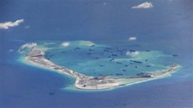
The much-awaited rulings of the Permanent Court of Arbitration in The Hague—in response to the Philippines’ 2013 submission over the maritime entitlements and status of features encompassed in China’s expansive South China Sea claims—were released this morning. Taken together, the rulings were clear, crisp, comprehensive, and nothing short of a categorical rejection of Chinese claims.
Among other things, the court ruled China’s nine-dash line claim to the South China Sea invalid because of Beijing’s earlier ratification of the United Nations Convention on the Law of the Sea (UNCLOS). In a move that surprised many observers, the court also ventured a ruling on the status of every feature in the Spratly Islands, clarifying that none of them were islands and hence do not generate an exclusive economic zone (EEZ). Significantly, it ruled that Mischief Reef, which China has occupied since 1995, and Second Thomas Shoal, where China has blockaded Philippine marines garrisoned on an old vessel that was deliberately run aground there, to be within the EEZ of the Philippines.

In the neighborhood
Now that the rulings have been made, what are the implications and way forward for concerned states?
For the Philippines, the legal victory presents a paradoxical challenge for the new government. Prior to the ruling, newly-elected President Rodrigo Duterte indicated on several occasions that he was prepared to depart from his predecessor’s more hardline position on the South China Sea to engage Beijing in dialogue and possibly even joint development. He even hinted that he would tone down Manila’s claim in exchange for infrastructure investment. Given that the ruling decisively turns things in Manila’s favor, it remains to be seen whether the populist Duterte administration would be able to sell the idea of joint development of what are effectively Philippine resources without risking a popular backlash. This will be difficult but not necessarily impossible, given that the Philippines would likely still require logistical and infrastructural support of some form or other for such development projects.
Since the submission of the Philippine case in 2013, China has taken the position of “no recognition, no participation, no acceptance, and no execution,” as described by Chinese professor Shen Dingli. Beijing continues to adhere to this position, and is likely to dig in its heels given the comprehensive nature of the court’s rejection of China’s claims. This, in turn, will feed the conspiracy theories swirling around Beijing that the court is nothing but a conspiracy against China.
[T]he rulings are likely to occasion intense internal discussions and debates within the Chinese leadership as to how best to proceed.
Not surprisingly, in defiance of the ruling, China continues to insist on straight baselines and EEZs in the Spratlys. Away from the glare of the media however, the rulings are likely to occasion intense internal discussions and debates within the Chinese leadership as to how best to proceed. Many analysts have the not-unfounded concern that hawkish perspectives will prevail in this debate, at least in the short term—fed by the deep sensibilities to issues of security and sovereignty, and a (misplaced) sense of injustice. This would doubtless put regional stability at risk. Instead, China should do its part to bring the Code of Conduct it has been discussing with ASEAN to a conclusion as a demonstration of its commitment to regional order and stability, and the peaceful settlement of disputes. Beijing should also continue to engage concerned states in dialogue, but these dialogues cannot be conducted on the premise of Chinese “unalienable ownership” of and “legitimate entitlements” in the South China Sea.
ASEAN will be hosting several ministerial meetings later this month, and the ruling will doubtless be raised in some form or other, certainly in closed-door discussions. For ASEAN, the key question is whether the organization can and will cobble together a coherent, consensus position in response to the ruling, and how substantive the response will be (they should at least make mention of the importance of international law to which all ASEAN states subscribe). For now though, it is too early to tell.

U.S. policy
As an Asia-Pacific country, the United States has set great stock in the principle of freedom of navigation, and has articulated this as a national interest with regards to the South China Sea. There are however, three challenges for the United States as it proceeds to refine its policy in the region:
- First, going by the attention it has commanded in Washington, it appears that the South China Sea issue has already become the definitive point of reference of America’s Southeast Asia policy. Southeast Asian states, on the other hand, have expressed their desire precisely that the South China Sea issue should not overshadow or dominate the regional agenda. Hence, even as the United States continues to be present and engaged on South China Sea issues in the region, equal attention, if not more, should be afforded to broaden the scope of their engagement.
- Second, in pushing back Chinese assertiveness in the South China Sea, the United States must be careful not to inadvertently contribute to the militarization of the region. There is talk about the deployment of a second carrier group to the region, and the U.S.S. John C. Stennis and U.S.S. Ronald Reagan are already patrolling the Philippine Sea. On the one hand, this is presumed to enhance the deterrent effect of the American presence in the region. Yet on the other hand, Washington should be mindful of the fact that China’s South China Sea claim is also informed by a deep sense of vulnerability, especially to the military activities that the United States conducts in its vicinity.
- Finally, in its desire to reassure the region, the United States has sought to strengthen its relations with regional partners and allies. This is necessary, and it is welcomed. At the same time however, Washington should also ensure that this strengthening and deepening of relations is undergirded by an alignment of interests and shared outlooks. This cannot, and should not, be assumed.
- 
Joseph Chinyong Liow
Senior Fellow, Foreign Policy, Center for East Asia Policy Studies
Lee Kuan Yew Chair in Southeast Asia Studies
Joseph Chinyong Liow is the inaugural holder of the Lee Kuan Yew Chair in Southeast Asia Studies and senior fellow at the Brookings Center for East Asia Policy Studies. Liow’s research interests encompass Muslim politics in Southeast Asia and the international politics of the Asia-Pacific region. He is the author of "Islam, Reform, and Education in Southern Thailand: Tradition and Transformation" (2009), "Piety and Politics: Islamism in Contemporary Malaysia" (2009), "The Politics of Indonesia-Malaysia Relations: One Kin, Two Nations" (2005), and "Dictionary of the Modern Politics of Southeast Asia," fourth edition (2014).

NYT

Asia Pacific

China Begins Air Patrols Over Disputed Area of the South China Sea
点击查看本文中文版 Read in Chinese
By MICHAEL FORSYTHEJULY 18, 2016
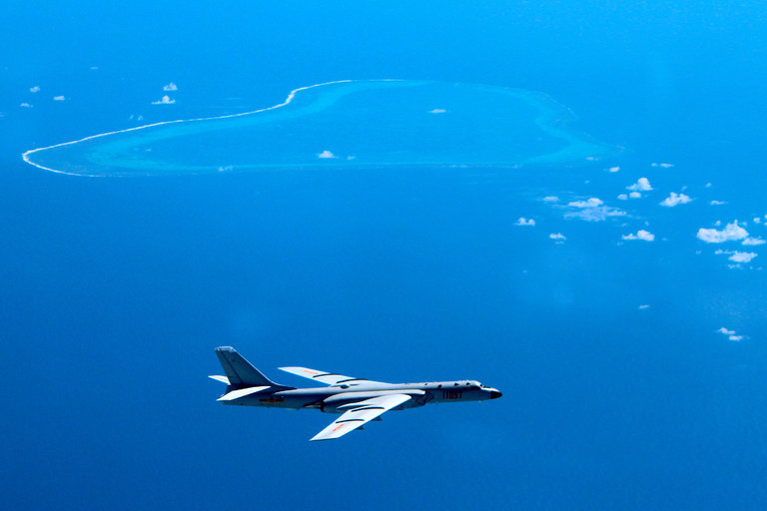
A Chinese H-6K bomber patrolling over the South China Sea in an undated photo released by Xinhua, the state news agency. Credit Liu Rui/Xinhua, via Associated Press
HONG KONG — China said Monday that it had begun what would become regular military air patrols over disputed islands and shoals of the South China Sea, highlighting its claim to the vast area a week after an international tribunal said Beijing’s assertion of sovereignty over the waters had no legal basis.
China’s air force flew a “combat air patrol” over the South China Sea “recently,” Xinhua, the official news agency, reported, citing Shen Jinke, an air force spokesman. The patrol consisted of bombers, fighters, “scouts” and tankers and would become “regular practice,” Mr. Shen said, according to Xinhua.
The announcement of the air patrols, plus a separate statement that China would conduct military exercises in the South China Sea off the coast of Hainan Island, came as Adm. John M. Richardson, the chief of United States naval operations, was in Beijing to discuss the South China Sea and other issues that arose after the tribunal rebuked China’s claims over the waters on July 12.
The landmark decision rejected China’s assertion that it enjoys historical rights over a huge area of the South China Sea encompassed by a “nine-dash line.” China had argued that the tribunal had no jurisdiction in the matter.
China’s announcement of military exercises and patrols as a response to the ruling had been expected by analysts. But Beijing also moved to contain any public anger over the tribunal’s decision. Demonstrators in China called for boycotts at about a dozen KFC outlets on Monday to protest the United States’ role in the South China Sea dispute. But the protests were small compared with previous nationalist outpourings in China, and the state news media warned demonstrators not to disturb social order. The angry mobs of people rallying outside embassies in the Chinese capital, a regular feature in the past when China wanted to vent its grievances, never materialized.
Flying combat aircraft over international waters is also a more mild response than other measures China could have taken, like initiating reclamation work on the disputed Scarborough Shoal or setting up a so-called air defense identification zone in the South China Sea, in which China would require that aircraft entering the zone identify themselves or face a military response, said Euan Graham, the director of the International Security Program at the Lowy Institute in Sydney, Australia.
“I think China is licking its wounds and taking stock,” Mr. Graham said by telephone. “The real unknown is how this will play out internally.”
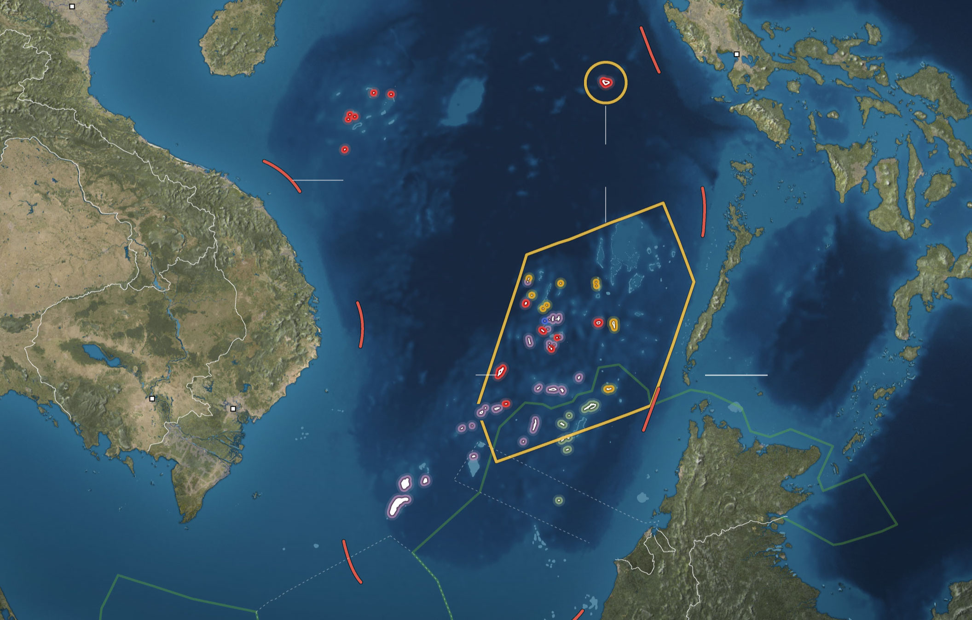
Hanoi
China
Manila
Vietnam claims the Paracel and the Spratly Islands.
Hainan
South China Sea
Paracel Islands
Philippines
Claimed by the Philippines
China has long marked its claim with a “nine-dash line” that skirts the coasts of other countries.
Visayas
Thailand
Palawan
Vietnam
Sulu Sea
Cambodia
Spratly Islands
Fiery Cross Reef
100 Miles
Ho Chi Minh City
Phnom Penh
Celebes Sea
Claimed by Brunei
Malaysia
Islands are colored by occupying country: China, the Philippines, Malaysia, Vietnam or Taiwan. Lines in the same colors show the extent of territorial claims.
Claimed by Malaysia
Brunei
Indonesia
Sulawesi
Claimed by Indonesia
Borneo
On Monday, Admiral Richardson’s Chinese counterpart, Adm. Wu Shengli, said China would continue construction in the South China Sea. In the past two years, China has reclaimed thousands of acres on seven features in the Spratly Islands, an area where Malaysia, the Philippines, Taiwan and Vietnam also have claims, building ports, large airstrips and radar installations.
“We will never stop our construction on the Nansha Islands halfway,” Xinhua, in a separate report, quoted Admiral Wu as saying, using the Chinese name for the Spratly chain. “The Nansha Islands are China’s inherent territory, and our necessary construction on the islands is reasonable, justified and lawful.”
Significantly, the Xinhua report on the air patrols said the flights encompassed Scarborough Shoal, a fishing ground far to the north of the Spratlys off the coast of Luzon Island in the Philippines. China seized control of the shoal in 2012, using coast guard vessels to bar Filipino fishermen. A photograph released by Xinhua showed a Chinese bomber flying near the shoal.
“It is an aerial version of showing the flag,” Mr. Graham said, adding that air patrols were far less provocative than reclamation work, which would probably inflame tensions with both the Philippines and the United States.
The Xinhua article did not say when the air patrol took place and did not provide any details, other than saying that the bombers were H-6K aircraft, a modification of a 1950s-era Soviet design that carries cruise missiles.
Bonnie S. Glaser, a senior adviser for Asia at the Center for Strategic and International Studies in Washington, said that a more telling test of China’s posture after the decision last week may come when the United States Navy resumes so-called freedom of navigation operations in the South China Sea, which often involve testing Chinese claims by ordering American ships to transit within 12 nautical miles of Chinese-claimed features.
While Admiral Wu reminded Admiral Richardson about China’s position on the South China Sea, his remarks, coming only days after one of the most stinging rebukes to Beijing’s foreign policy in years, were moderated with calls for more cooperation between the world’s two biggest navies.
Highlighting agreements between the United States and China that sought to govern encounters between the two militaries in the air and at sea to help prevent accidental clashes, Admiral Wu said that cooperation is “the only correct option,” Xinhua reported.

NYT

New Photos Cast Doubt on China’s Vow Not to Militarize Disputed Islands
By DAVID E. SANGER and RICK GLADSTONEAUG. 8, 2016
When President Xi Jinping of China visited President Obama at the White House last September, he startled many with reassuring words about his intentions for the Spratly Islands, a contested area where the Chinese government has been piling dredged sand and concrete atop reefs for the past few years and building housing and runways on them.
“China does not intend to pursue militarization,” Mr. Xi said, referring to the area as the Nansha Islands, a Chinese name for what most of the rest of the world calls the Spratlys in the South China Sea.
China not to pursue confrontation in South China Sea Video by New China TV
The most recent satellite photographs suggest a different plan. The photos, collected and scrutinized by the Center for Strategic and International Studies, a Washington-based research organization, show the construction of what appear to be reinforced aircraft hangars at Fiery Cross, Subi and Mischief Reefs, all part of the disputed territories.
There were no military aircraft seen at the time the photos were taken. But a summary of the center’s analysis suggests that the hangars on all three islets have room for “any fighter-jet in the People’s Liberation Army Air Force.”
A larger type of hangar on the islets can accommodate China’s H-6 bomber and H-6U refueling tanker, a Y-8 transport aircraft and a KJ200 Airborne Warning and Control System plane, the center said in its analysis.
Continue reading the main story
Continue reading the main story
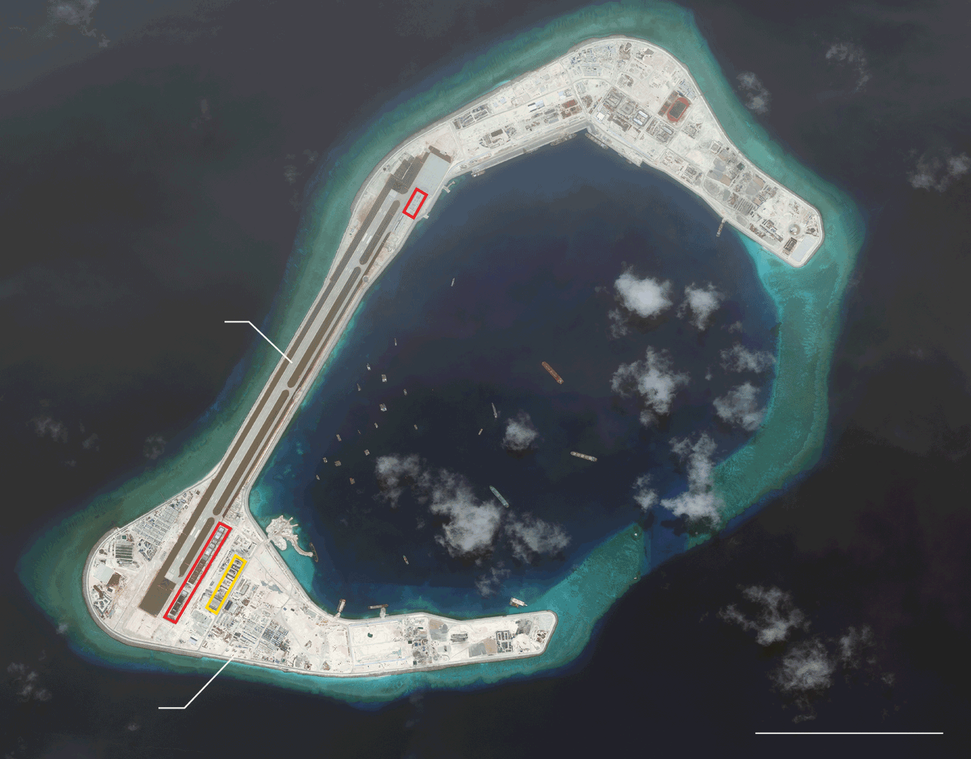
Subi Reef
July 24, 2016
Runways

South China Sea
Towers
4,000 Feet
Hangars large enough to hold: Fighter jets Bombers, tankers or transport planes
By The New York Times | Source: Center for Strategic and International Studies/Asia Maritime Transparency Initiative/DigitalGlobe
While China may assert that the structures are for civilian aircraft or other nonmilitary functions, the center says its satellite photos strongly suggest otherwise. Besides their size — the smallest hangars are 60 to 70 feet wide, more than enough to accommodate China’s largest fighter jets — all show signs of structural strengthening.
“They are far thicker than you would build for any civilian purpose,” Gregory B. Poling, director of the center’s Asia Maritime Transparency Initiative, said on Monday in a telephone interview. “They’re reinforced to take a strike.”
Continue reading the main story
Continue reading the main story
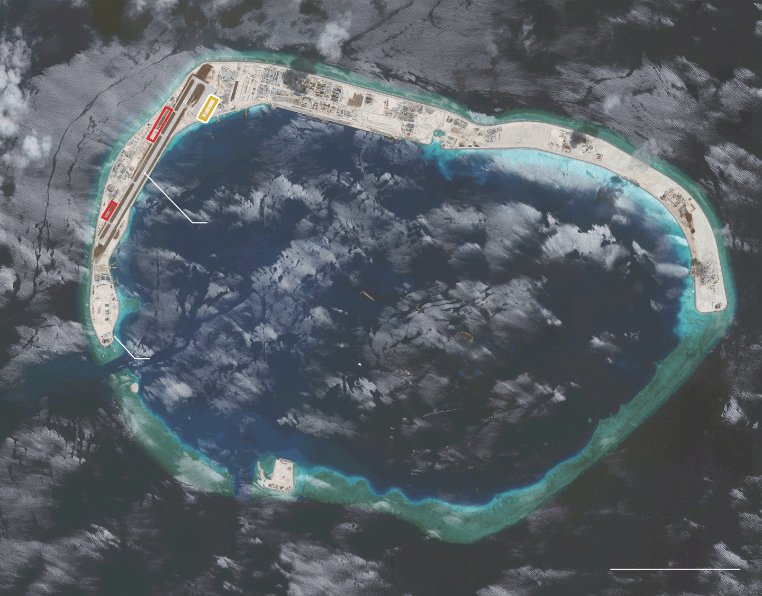
Runways
Mischief Reef
July 22, 2016
Towers
South China Sea
5,000 Feet
Hangars large enough to hold: Fighter jets Bombers, tankers or transport planes
By The New York Times | Source: Center for Strategic and International Studies/Asia Maritime Transparency Initiative/DigitalGlobe
The largest hangars, 200 feet wide, are “more than enough for strategic bombers and refuelers,” Mr. Poling said.
Continue reading the main story
Continue reading the main story
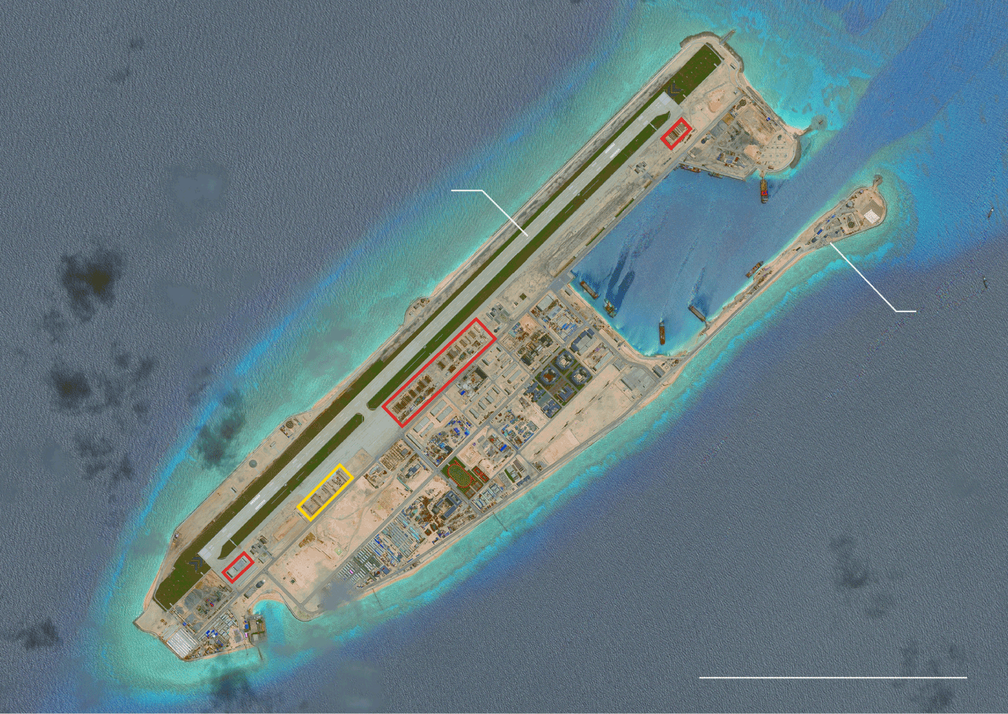
Fiery Cross Reef
June 3, 2016
Runways
Towers
South China Sea
4,000 Feet
Hangars large enough to hold: Fighter jets Bombers, tankers or transport planes
By The New York Times | Source: Center for Strategic and International Studies/Asia Maritime Transparency Initiative/DigitalGlobe
If those planes were deployed, they would greatly complicate China’s disputes with the Philippines and other nations, and add a level of military risk to the United States’s “freedom of navigation” patrols through the area.
Even before the hangars appeared, it was clear to independent military analysts that China’s intention was to use the islands to flex military might in the area.
“We knew from the day they started building those runways,” Mr. Poling said. For China to assert a more benign purpose, he said, would be “like saying you’re building a mansion, but only living on the first floor.”
Evidence of the military hangars emerged a month after an international tribunal at The Hague sharply rebuked China over its behavior in the South China Sea, including its assertion of expansive sovereignty and construction of artificial islands.
The tribunal’s ruling was a response to a landmark case brought by the Philippines, which called it an “overwhelming victory.” Infuriated, China said it would ignore the ruling.
Some analysts cautioned that the hangars were not a response to the ruling and had likely been under construction for some time.
“The foundations may have been laid months ago,” said M. Taylor Fravel, a political science professor at the Massachusetts Institute of Technology and a member of its Security Studies Program.
Mr. Fravel said the hangars are not necessarily inconsistent with the Chinese president’s assertions.
“China has given itself the option to use these reefs as military facilities, but has not decided yet to what degree it is going to use them,” he said. “It creates the option for a robust defense of those places or even a power projection.”

The Diplomat

Australian Intelligence: China Poised to Take 'Decisive and Provocative' Action in the South China Sea
U.S. and Australian intelligence agencies voice concern about China’s recent moves in the South China Sea.

By Carl Thayer
April 15, 2016

Two recent developments suggest that China is preparing to take preemptive action in the South China Sea in advance of the ruling by the Arbitral Tribunal at the Permanent Count of Arbitration (PCA) in The Hague on claims against it brought by the Philippines. (That ruling is expected in late-May or June.)
These developments include beefing up air defenses on Woody Island in the Paracels, and, moreover, leaked intelligence assessments that China may be planning major construction activities at Scarborough Shoal.
Satellite imagery taken on April 7 revealed that China recently deployed two additional Shenyang J-11 multirole jet fighters and the Active Electronically Scanned Array or AESA system to Woody Island. Pentagon officials estimate that China has about ten military aircraft stationed there, including J-11s and Xian JH-7s. The J-11 is an air superiority fighter, similar to the Russian Su-27, with a range of 3,530 km, according to the journal Air Force Technology. The JH-7 is a fighter bomber.
In February this year China placed eight batteries of the HQ-9 surface-to-air missile system on Woody island; four are currently operational. These missiles have a range of nearly 220 km. Now that China has deployed the AESA fire control radar it will be able to more accurately monitor aircraft movements around Woody Island. The AESA system tracks multiple targets at the same time and gathers data on the target’s range, altitude, direction and speed in order to direct the HQ-9 missiles.
There are three likely explanations for China’s action.
First, China is reacting to the activation of the Enhanced Defense Cooperation Agreement between the Philippines and the United States. In March the Philippines released the names of four air bases and one army base that will be open to the rotation of U.S. military personnel, planes and equipment. Also in March the Philippines and the U.S. began conducting joint naval patrols in the South China Sea. Joint air patrols are expected to commence this month.
China also is angered at the current Balikatan (Shoulder-to-Shoulder) military exercises underway in the Philippines involving U.S., Australian, and other military forces and the accompanying visit by U.S. Defense Secretary Ashton Carter to the Philippines. After the conclusion of Balikatan six military aircraft (including five Warthog ground-attack planes) and three helicopters will remain at Clark Air Force Base along with 200 pilots and crew.
Second, China also may be reacting to recent reports that the next U.S. Freedom of Navigation Operational Patrol in the South China Sea will take place shortly, following a first operation in the Spratlys in October 2015 and another in the Paracels in January 2016.
Third, China likely is responding to the G7’s adoption of a special statement on maritime security. This statement declared:
We express our strong opposition to any intimidating, coercive or provocative unilateral actions that could alter the status quo and increase tensions, and urge all states to refrain from such actions as land reclamations including large scale ones, building of outposts, as well as their use for military purposes and to act in accordance with international law including the principles of freedoms of navigation and overflight.
China strongly condemned the G-7 statement.
In the longer term, China’s deployment of fighter aircraft and fire control radar to the Paracels demonstrates its capability to deploy small numbers of modern jet aircraft, surface-to-air missiles, and fire control radar at short notice to airstrips elsewhere in the South China Sea and that the United States can take no action to prevent it from doing so. China also is sending a signal to the United States that the risks have gone up if the United States continues to conduct aerial reconnaissance of sensitive Chinese military installations and fly over People’s Liberation Army Navy (PLAN) warships in the South China Sea.
U.S. intelligence sources confirmed last month that China had drawn up plans for a new phase of militarization involving Scarborough Shoal. The Australian media has reported similar concerns by Australian intelligence and analytical agencies, presumably Australia’s Defense Intelligence Organization and the Office of National Assessments, that China is poised to take “decisive and provocative action” in the Spratly Islands. These sources report that China may dynamite Scarborough Shoal to build an artificial island to house military facilities or declare an Air Defense Identification Zone (ADIZ). China declared an ADIZ in the East China Sea in November 2013.
If these reports are accurate, China is likely to erect small permanent structures on Scarborough Shoal and station personnel on them. China would justify its actions under the guise of providing public goods such as weather reports and safety of navigation. By acting quickly China would leave the United States and the Philippines flat footed. This would lay the ground work for further expansion in the future.
Once the Arbitral Tribunal makes its finding public, China is likely to mount an international campaign challenging the legitimacy of the Tribunal. Australia got a foretaste of China’s likely propaganda offensive when leaders of the Australian Chinese community convened a forum on April 9 in Sydney. The Diplomat received a translated copy of an official statement released by Australian Chinese community leaders. It stated that:
…the Australian political elite should have a sober understanding of these matters and should treat carefully on sensitive matters like the South China Sea. They should not send irrational and mistaken signals to the international community.
The statement also called on Australian political circles to “make appropriate preparations for a possible ‘crisis situation.’”
The meeting by Australia-Chinese community leaders took place on the eve of Malcolm Turnbull’s first visit to Beijing as prime minister. Prior to Turnbull’s departure the media reported that he would raise his concerns over the South China Sea privately to Premier Li Keqiang and President Xi Jinping in Beijing.
Turnbull was greeted on arrival in Shanghai with a news report in the China Daily that quoted a member of the Chinese Academy of Social Sciences as stating that the South China Sea dispute “will cast a shadow on the promising (economic) cooperation if such a tendency keeps developing.” This was viewed as a veiled warning that Australia’s economic interests could be harmed by its South China Sea policy. Earlier in March, Turnbull characterized China’s South China Sea policy as “counterproductive.”
If China converted Scarborough Shoal into an artificial island and constructed an airfield and harbor, it would have the basic infrastructure to prevent the Philippines from operating in the waters of the Spratly islands, leaving Pag-asa island and Second Thomas Shoal exposed.
If China placed long-range radar, fire control radar, surface-to-air missiles, and anti-ship cruise missiles on its artificial islands, including Scarborough Shoal, it would be in a much better position to monitor the movements of U.S. Seventh Fleet vessels using Subic Bay, for example.
The U.S. Navy and other regional navies would be placed at risk in a crisis situation in the South China Sea. China would have excellent maritime domain awareness and be able to respond to the intrusion of foreign military ships and aircraft once it completed the construction of airfields, protected hangars, and fuel storage facilities.
China’s J-11 multirole air superiority fighters could take off from Woody Island to conduct combat air patrols. They could extend their patrol time by landing and refueling on an airfield on one of the artificial islands.
China has constructed and continues to construct helipads on its occupied features. This would enable China to monitor U.S. submarines through the deployment of aerial reconnaissance aircraft and anti-submarine warfare helicopters.
If China undertakes “decisive and provocative” action by shoring up its position on Scarborough Shoal, it would present a fait accompli to findings of the Arbitral Tribunal. The Tribunal has no power of enforcement. China’s pre-emptive actions would likely derail any concerted action by the international community to exert diplomatic pressure on China to respect international law by accepting the findings of the Arbitral Tribunal. Concerns about international law would be sidelined by China’s newest phase of militarization.

Banyan

Full steam

If long-standing tensions ease in the South China Sea, China will ensure they rise elsewhere
Aug 20th 2016 | From the print edition

WITH all respect to the endearing Fu Yuanhui, the Olympic swimmer whose goofy post-race interviews have made her a global star, the Chinese are creatures of the land, not the water. On the beaches of Sanya on the southern island of Hainan, China’s new Hawaii, crowds of holidaymakers in tropical shirts dabble awkwardly at the water’s edge; few actually plunge into the sea. In the Sanya market a fishmonger explains a national aversion to deep water more bluntly: the Chinese, she says, simply don’t have sea legs. Refusing to go afloat herself, she buys her fish from the boat people living in the harbour, an ethnic subgroup whose generations have come into the world afloat and gone out the same way. Tanka, as these people are called in southern China, have historically faced discrimination. Even the name, “egg people”, has the force of an insult in Chinese (they call themselves “on-the-water people”).
So it is striking how large water now looms in China’s diplomatic calculations and in the region’s geopolitics, nowhere more so than in the South China Sea that Sanya looks out on. It is there that the gunboat diplomacy which China has employed in recent years to back expansive maritime claims has stirred nervousness among South-East Asian neighbours—and created fears of a collision with America.
Sanya is part of the story. An expanding deepwater naval base there is intended to project China’s power far into the South China Sea and to support a new archipelago of artificial islands that China has built on reefs and atolls a long way from Chinese shores. Three of these bases in the Spratly islands have military-length runways, and recent satellite pictures show the construction of concrete bunkers, presumably for fighter jets. Back in Sanya, a base for nuclear submarines cuts into the mountainside. Even Hainan’s lowly fishermen play a part. Formed into waterborne “people’s militias”, their vessels have grabbed fishing grounds far from home by chasing off their counterparts from neighbouring countries, such as the Philippines and Vietnam.
Last month an international tribunal in The Hague issued a ruling in a case brought by the Philippines that challenged, among other things, China’s “indisputable historical claim” in the South China Sea. In a damning rebuke, the tribunal dismissed China’s assertion of sovereignty over a vast area within a “nine-dash” line that encompasses nearly all of the sea.
China reacted with fury. The nine-dash line has long been a matter of national pride. A recent letter to The Economist from the foreign ministry asserts that there are “ample historical documents and literature” to show that China was “the first country to discover, name, develop and exercise continuous and effective jurisdiction over the South China Sea islands”. Bunkum. As Bill Hayton points out in his book, “The South China Sea”, the first Chinese official ever to set foot on one of the Spratlys was a Nationalist naval officer in 1946, the year after Japan’s defeat and loss of control of the sea; he did so from an American ship crewed by Chinese sailors trained in Miami. As for the story of the nine-dash line, it begins only a decade earlier with a Chinese government naming commission. China was not the first to name the islands; the commission borrowed and translated wholesale from British charts and pilots.
Yet no Chinese official could ever admit this. The nine-dash line has for decades graced maps of China in every schoolroom in the land—part of what one academic has described as a cartography of humiliation: a narrative about what China lost in the past to imperialist depredations and what it rightly owns today.
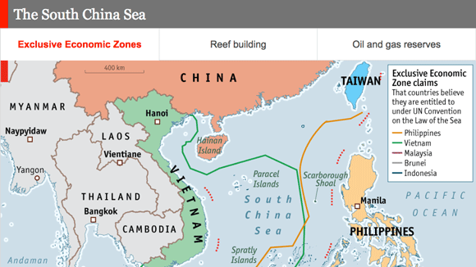
In graphics: A guide to the South China Sea
So what happens next? To some, laying bare China’s claims will only raise the stakes. When a Singaporean author and former diplomat, Kishore Mahbubani, predicted earlier this month that tensions would not lead to military conflict between China and America, the auditorium broke into applause—as much for the boldness of his assertion as in the hope that he may be right. Some predict that China will take advantage of what is left of Barack Obama’s presidency to start building on the disputed Scarborough Shoal, from which Chinese ships dislodged the Philippine navy in 2012. America has suggested that such a move would constitute a red line. But, fairly or not, Mr Obama does not have the reputation of an energetic enforcer of red lines.
China will not necessarily act provocatively. Challenging America, backed as it is by much of South-East Asia, carries risks. Besides, despite its legal setback, China’s military position in the South China Sea is stronger than ever—even without a base on Scarborough Shoal. The trip to Hong Kong last week of a former president of the Philippines, Fidel Ramos, to meet senior Chinese officials and try to improve roiled relations, had the air of a vassal’s visit. The imperial power could now be magnanimous, allowing Philippine fishermen to fish where they always have.
There are other seas full of fish
A pause, perhaps, but far from the end of the matter. Indeed, even if tensions ease in the South China Sea, they are rising again in the East China Sea, around the Senkaku islands which Japan controls but which China claims (and calls the Diaoyu). In recent weeks, fleets of Chinese fishing boats have crowded into the waters around the uninhabited islands, backed by Chinese fisheries-protection vessels, part of the coastguard. The incursions are the most intense since China began challenging Japan for control of the islands four years ago. Japan has protested at both the onslaught and a military radar found on a nearby Chinese oil rig.
China’s latest actions may be to please a nationalistic audience back home. They may be to warn a new, right-wing cabinet in Japan against visiting Tokyo’s militaristic Yasukuni shrine around the anniversary of the end of the second world war. (No member has.) Or they may simply be to show who calls the tune in East Asia these days—now it’s Japan’s turn to dance.

Daily chart

The South China Sea
Jul 12th 2016, 12:56 by THE DATA TEAM

The South China Sea
Exclusive Economic Zones

Reef Building

- Oil and gas reserves
THE South China Sea has long been one of the world’s most coveted waterways. Seven different countries—counting Taiwan, which is itself claimed by China—assert sovereignty over overlapping portions of its waters. The last time waxing and waning tension spilled over into serious conflict was in 1988, when Vietnam lost over 70 lives in a skirmish with China in the Spratly archipelago. But the stakes of any potential relapse into violence are higher than ever now that America is involved.
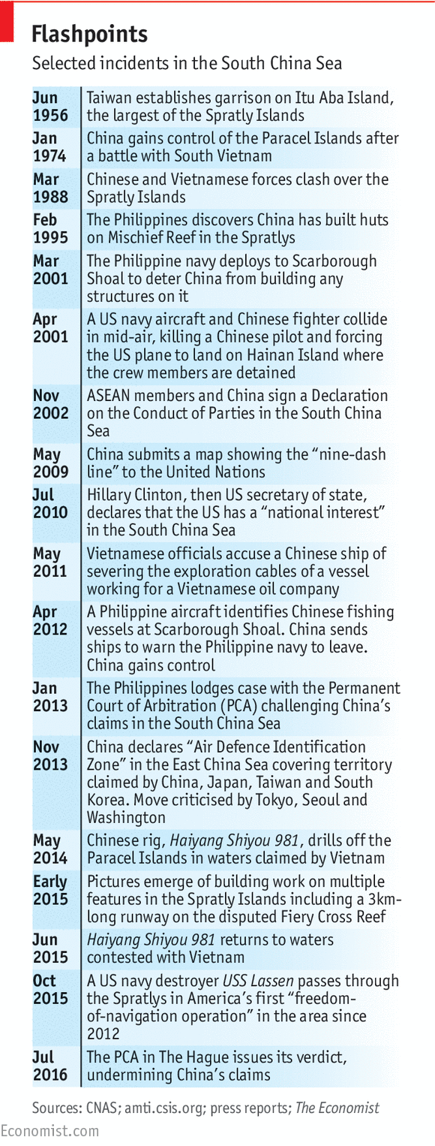
Chinese maps feature a “nine-dash line” encircling almost all of the sea inside its borders. Malaysia, Brunei, Vietnam and the Philippines all contest parts of that area, as does Taiwan, whose claims in the sea mirror China’s. In addition, although Indonesia is not a party to any of the disputes over tiny islands, rocks and reefs, it says the nine-dash line cuts through the “exclusive economic zone” granted to it by the UN Law of the Sea. Like those of other countries, its fishermen complain about Chinese incursions. And every government in the region takes an interest in the sea’s purported hydrocarbon riches. In 2013 the Philippines filed a case with the Permanent Court of Arbitration (PCA) in The Hague, asking the tribunal to reject China’s claim. On July 12th 2016 the court released a summary of its ruling saying that there was “no legal basis for China to claim historic rights to resources within the sea areas falling within the ‘nine-dash line’”.
China has said it will ignore the PCA’s ruling, denying that the court has any jurisdiction over what it sees as an issue of sovereignty. But the United States will not allow China to do so unmolested. Although America is formally neutral on the territorial disputes between the littoral states, it says it has a national interest in maintaining freedom of navigation in the sea, through which one-third of the world’s maritime trade passes. China accuses America of stoking discord between it and its neighbours, and of encouraging them to defy it, while America and most South-East Asian countries see China as the main source of tension. Despite an agreement with the Association of South-East Asian Nations in 2002 to avoid provocations, in the past three years China has been engaged in a frenetic building spree, creating seven artificial islands on top of disputed rocks and reefs. Many assume they will one day become military bases.
The United States has already angered China by sending warships close to Chinese-claimed features in the sea on “freedom-of-navigation operations”. Currently, two American aircraft-carrier groups are stationed in the region, apparently to deter China from taking any provocative steps now the PCA’s decision has gone against it. China, for its part, has been staging naval drills near the Paracel islands to the north of the sea. Further escalation could be likely if China does more than ignore the ruling, and starts building on yet another contested shoal, or declares an Air Defence Identification Zone over a sea it seems to regard as a Chinese lake.

Brookings

Assessing the rule of law after the South China Sea arbitration: Will the G-20 be a turning point in China’s behavior?
Lynn Kuok Thursday, September 1, 2016
China will be hosting the G-20 summit on September 4 and 5. Its deputy foreign minister has said that it wants to avoid sensitive issues, and focus on economic development at the world’s premier forum for international economic cooperation. Indeed, some argue that China has moderated its response to the July 12 arbitral tribunal ruling on the South China Sea so that the issue does not cast a pall over the summit.
China’s stated aim notwithstanding, the South China Sea is almost certainly going to be raised at bilateral meetings surrounding the G-20. It will also be raised in Laos where the U.S.-ASEAN and the East Asia summits will be held the following week. According to a White House press statement, President Barack Obama will “coordinate with the region’s leaders on efforts to advance a rules-based international order” at the East Asia Summit.

Author

Lynn Kuok

Nonresident Fellow - Foreign Policy, Center for East Asia Policy Studies
Almost two months after the tribunal’s ruling, it is worth taking stock of where the rule of law stands. How has China’s conduct measured up to the ruling?
Immediately after the award was issued, China declared it null and void and of no binding force. It also continues to insist that any negotiations with the Philippines cannot mention the ruling.
Beijing’s actions, however, have been relatively restrained. It has not taken additional, escalatory steps, such as creating a new base on Scarborough Shoal just off the Philippines island of Luzon. It has also not declared an air defense identification zone (ADIZ) over the South China Sea.
These actions would not necessarily be unlawful, though they would significantly raise tensions. The tribunal did not rule on sovereignty over Scarborough Shoal or any other feature in the South China Sea. Many countries, including the United States, employ ADIZs with the aim of protecting national security. State practice varies, but given that freedom of overflight in international airspace cannot be circumscribed, any ADIZ can only be applied to aircraft intending or signaling an intention to enter national airspace, which it would otherwise have no right to do.
Some who accuse China of openly flouting the award cite Beijing’s failure to renounce the dashed line, its continued presence on occupied features, and its island-building and construction activities.
However, the tribunal did not say that the dashed line per se was illegal. It only ruled that insofar as it was a claim to historic rights, this would be inconsistent with the convention.
Further, the tribunal did not touch on whether China’s occupation of land features, as well as its island-building and construction activities, were in and of themselves unlawful since this would depend on the issue of sovereignty.
It confined itself to ruling that Beijing’s island-building and construction activities were unlawful because they violated environmental obligations under the convention, aggravated and extended the ongoing dispute before the tribunal, and had the effect of tampering with evidence.

Related
- 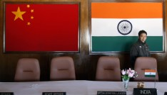

India’s Relations with China: The Good, the Bad and the (Potentially) Ugly
- 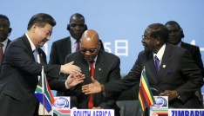

Rising Sino-Japanese competition in Africa
- 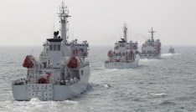

Tides of change: Taiwan’s evolving position in the South China Sea

Where the tribunal found that China’s construction activities were unlawful was at Mischief Reef, a feature China occupied in the mid-1990s, given that such activities were conducted without the Philippines’ authorization. The tribunal found that Mischief Reef was in its natural state a low-tide elevation that is part of the Philippines’ exclusive economic zone (EEZ) and continental shelf.
There have been unconfirmed reports of Beijing speeding up construction activities on Mischief Reef. If true, this would be problematic given the tribunal’s clear finding that it lies within the Philippines’ jurisdiction.
Also problematic are reports of Chinese vessels harassing Philippines fishing vessels around Scarborough Shoal. The tribunal ruled that both China and the Philippines have traditional fishing rights in its territorial sea.
The international community appears to have taken the pragmatic position that there is some room for ambiguity at the margins, but not for a wholesale repudiation of the tribunal’s decision. Thus far, it seems that Beijing has kept its actions within that gray zone.
Things to look out for in assessing China’s conduct after the summit are as follows. First, how China responds if the Philippines begins oil and gas exploration work at Reed Bank, one of the areas in the South China Sea with significant hydrocarbon resource potential. The tribunal found that Reed Bank is an entirely submerged reef formation forming part of the Philippines EEZ and continental shelf.
Second, whether Beijing itself begins exploration at Reed Bank.
Third, whether Beijing makes any moves against Second Thomas Shoal, a feature on which Manila intentionally grounded a vessel in 1999 to prevent China from occupying it. Like Mischief Reef, the tribunal found that Second Thomas Shoal is a low-tide elevation that is part of the Philippines EEZ and continental shelf, and within the Philippines’ exclusive jurisdiction.
Fourth, whether China draws straight baselines around the features in the Spratlys, as it did around the Paracels located in the northern part of the South China Sea in 1996. In a Ministry of Foreign Affairs statement issued on the same date as the tribunal ruling, Beijing appeared to be laying the groundwork for this by stating that “China has internal waters, territorial sea and contiguous zone, based on Nanhai Zhudao [the South China Sea Islands].” Given the tribunal’s ruling that the Spratlys cannot generate maritime zones collectively as a unit, drawing straight baselines around them would be a clear breach of the ruling.
Fifth, whether China declares an ADIZ above the South China Sea. This would not necessarily be unlawful, though it would heighten tensions. China can signal the sincerity of its desire to manage the dispute peacefully by avoiding this act.
How the rule of law fares will also depend on how other states behave. If all states treat the award as authoritative, it will be difficult for China to assert control outside of a 12 nautical mile (nm) zone from the islands it occupies. States should exercise the right of innocent passage within the territorial seas of features in the Spratlys identified as rocks by the tribunal, and high sea freedoms around features identified as low-tide elevations or submerged features. Exercising high sea freedoms through the Spratlys can signal to Beijing that if it wishes to take the escalatory step of declaring unlawful straight baselines around them, it will not be able to defend the waters within them as internal waters without risking confrontation.
Quite apart from holding China to account, states who believe in a rules-based system should also begin to implement the tribunal’s decision in respect of their own claims and activities, especially with regard to the status and entitlement of features, as well as the environmental obligations the ruling clarifies. While the ruling is not binding on non-parties to the dispute, it is an authoritative interpretation of the convention.
On balance, the award has strengthened the rule of law by clarifying provisions in the convention, as well as the areas of overlapping claims—now limited to the 12 nm belts of territorial sea around the disputed islands. This provides the basis for negotiations between claimants to take place.
The underlying issue of sovereignty over islands is unlikely to be resolved in the near- to medium-term, though the award has reduced the significance of who has a better claim to sovereignty by its finding that all features in the Spratlys are at most islands entitled to a 12 nm territorial sea (“rocks”). But this should not stop negotiations to share resources, manage fishing, and protect the marine environment. Negotiations to expand agreements to prevent incidents at sea should also be pursued as an urgent priority.
In all these endeavors, the law plays an important role in providing a backdrop to and framework for peaceful negotiations. It is in the interests of all states, including China, to preserve the rules-based order founded on the generally accepted provisions in the convention. One hopes that China’s relatively moderate response to the tribunal’s ruling thus far has been motivated by a realization that its reputation as a law-abiding power and good relations with its neighbors and the United States are at least as important as, if not decidedly more so than, the narrow goal of being regarded as a good G-20 host.

The Economist

Banyan

Full steam

If long-standing tensions ease in the South China Sea, China will ensure they rise elsewhere
Aug 20th 2016 | From the print edition

WITH all respect to the endearing Fu Yuanhui, the Olympic swimmer whose goofy post-race interviews have made her a global star, the Chinese are creatures of the land, not the water. On the beaches of Sanya on the southern island of Hainan, China’s new Hawaii, crowds of holidaymakers in tropical shirts dabble awkwardly at the water’s edge; few actually plunge into the sea. In the Sanya market a fishmonger explains a national aversion to deep water more bluntly: the Chinese, she says, simply don’t have sea legs. Refusing to go afloat herself, she buys her fish from the boat people living in the harbour, an ethnic subgroup whose generations have come into the world afloat and gone out the same way. Tanka, as these people are called in southern China, have historically faced discrimination. Even the name, “egg people”, has the force of an insult in Chinese (they call themselves “on-the-water people”).
So it is striking how large water now looms in China’s diplomatic calculations and in the region’s geopolitics, nowhere more so than in the South China Sea that Sanya looks out on. It is there that the gunboat diplomacy which China has employed in recent years to back expansive maritime claims has stirred nervousness among South-East Asian neighbours—and created fears of a collision with America.
Sanya is part of the story. An expanding deepwater naval base there is intended to project China’s power far into the South China Sea and to support a new archipelago of artificial islands that China has built on reefs and atolls a long way from Chinese shores. Three of these bases in the Spratly islands have military-length runways, and recent satellite pictures show the construction of concrete bunkers, presumably for fighter jets. Back in Sanya, a base for nuclear submarines cuts into the mountainside. Even Hainan’s lowly fishermen play a part. Formed into waterborne “people’s militias”, their vessels have grabbed fishing grounds far from home by chasing off their counterparts from neighbouring countries, such as the Philippines and Vietnam.
Exclusive Economic Zone
Last month an international tribunal in The Hague issued a ruling in a case brought by the Philippines that challenged, among other things, China’s “indisputable historical claim” in the South China Sea. In a damning rebuke, the tribunal dismissed China’s assertion of sovereignty over a vast area within a “nine-dash” line that encompasses nearly all of the sea.
China reacted with fury. The nine-dash line has long been a matter of national pride. A recent letter to The Economist from the foreign ministry asserts that there are “ample historical documents and literature” to show that China was “the first country to discover, name, develop and exercise continuous and effective jurisdiction over the South China Sea islands”. Bunkum. As Bill Hayton points out in his book, “The South China Sea”, the first Chinese official ever to set foot on one of the Spratlys was a Nationalist naval officer in 1946, the year after Japan’s defeat and loss of control of the sea; he did so from an American ship crewed by Chinese sailors trained in Miami. As for the story of the nine-dash line, it begins only a decade earlier with a Chinese government naming commission. China was not the first to name the islands; the commission borrowed and translated wholesale from British charts and pilots.
Reef Building

Yet no Chinese official could ever admit this. The nine-dash line has for decades graced maps of China in every schoolroom in the land—part of what one academic has described as a cartography of humiliation: a narrative about what China lost in the past to imperialist depredations and what it rightly owns today.
So what happens next? To some, laying bare China’s claims will only raise the stakes. When a Singaporean author and former diplomat, Kishore Mahbubani, predicted earlier this month that tensions would not lead to military conflict between China and America, the auditorium broke into applause—as much for the boldness of his assertion as in the hope that he may be right. Some predict that China will take advantage of what is left of Barack Obama’s presidency to start building on the disputed Scarborough Shoal, from which Chinese ships dislodged the Philippine navy in 2012. America has suggested that such a move would constitute a red line. But, fairly or not, Mr Obama does not have the reputation of an energetic enforcer of red lines.
China will not necessarily act provocatively. Challenging America, backed as it is by much of South-East Asia, carries risks. Besides, despite its legal setback, China’s military position in the South China Sea is stronger than ever—even without a base on Scarborough Shoal. The trip to Hong Kong last week of a former president of the Philippines, Fidel Ramos, to meet senior Chinese officials and try to improve roiled relations, had the air of a vassal’s visit. The imperial power could now be magnanimous, allowing Philippine fishermen to fish where they always have.
There are other seas full of fish
A pause, perhaps, but far from the end of the matter. Indeed, even if tensions ease in the South China Sea, they are rising again in the East China Sea, around the Senkaku islands which Japan controls but which China claims (and calls the Diaoyu). In recent weeks, fleets of Chinese fishing boats have crowded into the waters around the uninhabited islands, backed by Chinese fisheries-protection vessels, part of the coastguard. The incursions are the most intense since China began challenging Japan for control of the islands four years ago. Japan has protested at both the onslaught and a military radar found on a nearby Chinese oil rig.
China’s latest actions may be to please a nationalistic audience back home. They may be to warn a new, right-wing cabinet in Japan against visiting Tokyo’s militaristic Yasukuni shrine around the anniversary of the end of the second world war. (No member has.) Or they may simply be to show who calls the tune in East Asia these days—now it’s Japan’s turn to dance.
Oil and Gas Reserves

India Strategic Studies

7 August 2016

How the US Misjudged the South China Sea, Part II
By Xue Li and Xu Yanzhuo
August 05, 2016
http://thediplomat.com/2016/08/how-the-us-misjudged-the-south-china-sea-part-ii/

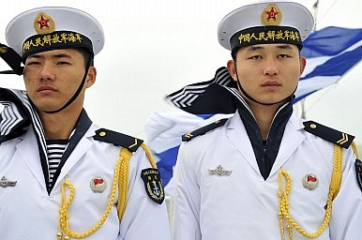In Part I, we looked at U.S. actions and strategy in the South China Sea (SCS), and how U.S. policy so far has failed to achieve its desired result. The main reason for this is that U.S. strategy is based on a misunderstanding of China’s actions and goals in the SCS. In Part II, we examine China’s stance in the SCS and its response to U.S. actions.

After a series of tough approaches by the United States toward China, will China respond by further tightening control over the SCS (for example, by establishing an air defense identification zone)? By constructing massive military buildings on occupied reefs? By claiming a 200 nm exclusive economic zone (EEZ) around artificial reefs? Or by announcing that the nine-dash line is a maritime boundary and expelling the U.S. presence? It seems Washington must prevent these outcomes by all necessary means.

These questions are difficult; no one can promise these things won’t happen. Since foreign policy decisions are not always made on the basis of assured information, we will seek to answer these questions according to China’s foreign policy philosophy.

An Analysis of China’s Stance

We would argue President Xi Jinping’s personal experiences and his knowledge of China’s historical lessons determine that China must continue its peaceful rise. It is impossible for China to develop in a non-peaceful environment. Since the “reform and opening up” began close to 40 years ago, China’s rapid growth, together with a deep involvement in international society, have made the country a major beneficiary of the current system. Today, continuing this approach will further benefit China.

Additionally, in human history a rising power and established power have always escalated toward war — the so-called Thucydides Trap. Creating an alternative order not only is impossible to achieve through peaceful means, but would also be too unpredictable for China, and would definitely harm China’s development. Even if Beijing succeeded in establishing a China-dominated international system, it would be extremely difficult for China to maintain the current necessary growth within this framework. Practically speaking, it is better for China to maintain the existing international order than to take on the great risk and high cost of revising it. It is better for China to develop and achieve the “two centenary goals” within the current system. Beyond that, it is better to leave the more long-term questions for the next generation.

Moreover, China still has a large gap with the United States in many aspects; it is far behind challenging Washington’s dominant role. Although China has a history of being a hegemon for 2,000 years, it is a late comer to modern international society. In the future, China might overtake the U.S. in terms of GDP and national defense expenditures, yet in terms of comprehensive national power, science, technology, education, international influence, and military alliances, China is unable to catch up with or to serve as an alternative to the United States.

In short, China is unlikely to replace the United States’ dominant role worldwide. The Chinese government has a clear understanding of this. With this judgement in mind, it has taken the following steps. Domestically, it seeks to increase the legitimacy of the Communist Party of China (CPC), enhance governance capabilities, promote the establishment of a service-oriented government in order to maintain social stability, restructure the economy, promote sustainable development, and improve social welfare. Externally, it supports and maintains the existing international system and even dedicates China’s efforts to improving the system by creating functional mechanisms and enhancing the role of emerging economies. Take the Asian Infrastructure Investment Bank (AIIB) as an example — China has operated the bank in cooperation and collaboration with the existing global and regional programs.

Some analysts have implied that China has a secret plan to create a new international order by peaceful or non-peaceful means. Even though we can’t claim access to military secrets, based on China’s current military power and technology, it is impossible for China to pose an alternative to the United States when it comes to world security. While serving in the largest think tank in China, we have not found any information on, much less a program or plan to create, a China-centered international system.

Some analysts have argued that China’s supposed rejection of the current system is revealed in its response to the recent SCS arbitration case brought by the Philippines. It’s worth noting, however, that China is not opposed to international judicial and arbitration in general, yet it selectively accepts such measures — as do all other powers. The United States has not sent its disputes of Arctic waterways in North America with Canada to arbitration by a third party; it maintains the status quo while dealing with the disputes directly. In fact, the U.S. has not ratified UNCLOS because it is believed to be unfavorable to American interests, and the other four permanent Security Council members have all made exception declarations.

Most famously, Nicaragua instituted a case against the United States in the International Court of Justice due to Washington’s support for Contras in their rebellion against the Nicaraguan government, including the use of mines in Nicaragua’s harbors. The ICJ ruled clearly in favor of Nicaragua. The Reagan administration, however, refused to participate in the proceedings and argued that the Court did not have jurisdiction. Later, the U.S. withdrew from compulsory jurisdiction in 1986 and now accepts the Court’s jurisdiction only on a case-by-case basis. This is how the United States shows respect to international law.

An Analysis of China’s Activities

How then should we understand China’s recent activities in the SCS, particularly its large scale land reclamation in the Spratly Islands? Theoretically, there are two possible explanations. The first is that China wants to expand its holdings and is thus poised to take even more provocative steps; the second is that China merely wants to set up a proportional presence in the SCS so that it can negotiate the disputes on a reasonable basis. Researchers and military officials from ASEAN, the EU, Japan and the United States mainly focus on the first explanation. However, we would argue China is unlikely to take further actions — whether militarizing the SCS or declaring the nine-dash line a maritime boundary — because doing so would work against its interests.

First, the One Belt, One Road (OBOR) strategy is a top-level design introduced by the new government to guide its foreign relations. It will be the paramount strategy through Xi’s administration. And Sino-ASEAN relation is key to the 21st Century Maritime Silk Road.

China has always valued its relations with ASEAN. Since the 1990s, it has considered ASEAN as an important multilateral diplomatic platform. Xi’s government further prioritizes such peripheral diplomacy and has advocated for a China-ASEAN community of common destiny. This diplomatic emphasis means China’s SCS policy cannot undermine the overall agenda. It is said that ASEAN countries tend to rely on China economically, yet depend on the U.S. for national security. Viewed strictly in terms of trade volume, ASEAN countries may be dependent on China, yet regarding technology and value-added trade, ASEAN countries can hardly be said to rely on China. Meanwhile, the United States has strengthened its economic links with ASEAN through the Trans-Pacific Partnership (TPP). In this case, if China sought to militarize the SCS, it will definitely harm to China-ASEAN relationship and further to push these countries to side with the United States.

Second, Chinese officials have repeated the dual-use nature of facilities in the Spratly Islands; the few military facilities are deployed only for necessary defense. In fact, the deployment essentially is no different from what ASEAN claimants have done for years. Meanwhile, Xi and Foreign Minister Wang Yi have both warned the United States not to misjudge the situation in the SCS. Xi even clearly assured Obama that China will not militarize the SCS.

Third, the announcement of nine-dash line as maritime boundary would contradict the Convention on the High Seas ratified in 1958 as well as China’s declaration of territorial baselines in the Paracel Islands. Further, if China treated the nine-dash line as a maritime boundary, the navigation of hundred thousands of ships will be impeded, which would essentially mean that China is declaring itself against the world for very little benefits.

Finally, any of these actions would engender a fight against the United States in a situation where most of countries are siding with Washington.

In short, China’s land reclamation activities in the Spratly Islands were not done solely because the government has the capability; it was done because it was necessary. China’s capabilities in the SCS go far beyond the current scale of its actions; it is capable of greatly increasing the number of occupied maritime features, or of conducting reclamation on features other than the reefs it currently occupies. With this in mind, based on its power and presence, China’s current activities are very restrained.

Among all the claimants, China is the only state that has not explored any oil and gas in the waters near the Spratlys. Up until 2013, it was also the only country that had not conducted land reclamation. Since the Declaration on the Conduct of Parties in the South China Sea (DOC) was signed in 2002, ASEAN claimants have never stopped changing the status quo. Instead, they continued to explore new oil and gas fields, build new facilities, develop resettlement, or carry out land reclamation. They either responded negatively to China’s call for “joint development” or refused China’s proposals by denying the disputed areas or setting unreasonable conditions, such as demanding that China offer financial investment. China, Vietnam, and the Philippines finally agreed to conduct trilateral Joint Maritime Seismic Understanding (JMSU) in a disputed area from 2005 to 2008, but the plan fell through due to the Philippines’ domestic obstacles. The failure of cooperation taught Beijing that without a strong presence in the Spratly Islands, it is impossible to promote the resolution of the disputes.

Meanwhile, there is not any tangible joint development program among ASEAN claimants themselves in the overlapping area in the Spratly Islands, nor have the other claimants finalized mutual maritime demarcation. Their conflicts and disputes have merely been temporarily covered up with China’s.

China is not very ambitious in the SCS, nor does it seek to control the whole water through military means. Even though some Chinese analysis has suggested taking full control by claiming the nine-dash line as a maritime boundary line, the government is unlikely to follow this advice. Such an approach is not only incompatible with China’s long-term interests, but also harms China’s OBOR strategy and peripheral diplomacy. China chooses instead to take advantage of the resources in the SCS by maintaining peace and stability.

When it comes to the SCS, China is learning to become a great power and is searching to balance its national interests and a resolution acceptable to ASEAN claimants. The disputes are extremely complicated; clearly, introducing more and more external states will not simplify the problem. The practical way forward is to establish consensus, to share benefits in some functional aspects, and to narrow differences in this process. Therefore, China advocates promoting tangible cooperation under the DOC framework, and would like to provide financial, technical, and personnel support. Some analyses that concentrate on China’s tough activities ignore the insights of these actions (nor do they recognize China’s long-term restraint).

The Prospects of the Nine-Dash Line

Some believe that the nine-dash line will collapse under the U.S. “combo punches” explained in Part I. Even if China will not give up the claim, it will largely hurt China’s international reputation. Considering its loss, some analysts hope that China might give up the nine-dash line. Such a prediction does not fully understand Chinese traditions and contemporary political culture. European culture values honor and dignity; similarly Eastern culture emphasizes face and harmony, which are reflected in the the “ASEAN way.” Though the SCS is not China’s core interest, humiliating a rising power is not wise for a hegemon to do. Such a move might have consequences far beyond the SCS. China is unlikely to change its policy of “no first use” of nuclear weapons, but it is possible that China might abandon its minimum nuclear deterrence strategy. Imagine a China that possesses more than 1,000 intercontinental ballistic missiles — what consequences would that have?

The Philippines’ arbitration case will likely do only limited damage to China in the long run, yet it has caused high diplomatic pressure in the short term. After all, it was China’s first arbitral case in decades, which launched with U.S. support, no less. Apart from applying external diplomatic pressure, the United States also undermines China’s claims in the SCS through muscular patrols. These activities continuously humiliate China. The Chinese navy is stronger than the ASEAN countries’ navies combined, but it never threatened these countries in such a way. The Chinese government has already been pushed into a difficult situation. Further aggressive actions will only make it even harder for China to soften its policy, and will force Chinese government to react strongly.

U.S. Defense Secretary Ashton Carter is probably an old hand of George Kennan’s philosophy, but is he familiar with Confucius and Mohism? U.S. military activities in the SCS have harmed China in an unnecessary way and silenced the moderates’ voice in China, while stimulating Chinese nationalism. It creates tremendous internal and external pressure for Beijing, thus forcing the country to respond aggressively. In this case, it is inevitable for China to deploy military facilities and conduct military exercises in the SCS; otherwise, the government cannot dilute the increasing domestic nationalism. As Ouyang Yujing, director general of the Department of Boundary and Ocean Affairs of China’s Foreign Ministry, has said, the relationship between China and the United States is like a spring. The more pressure from U.S., the larger the rebound from China.

Even if it is hard to predict China’s future actions, consider the historical precedent. Since 1949, China has demarcated borders with 12 out of 14 neighboring countries. All of the concessions were made in line with a friendly bilateral relationship; none of the demarcations have been finished under great diplomatic pressure. Chinese traditional culture may explain this diplomatic philosophy of high dignity and low visibility. In terms of diplomacy, China tends to compromise in a good environment yet respond aggressively under high pressure. Moreover, China did not make any concessions when its comprehensive national power is much weaker; it is unlikely to compromise today. Additionally, Xi may be the strongest Chinese leader since Mao. Faced with U.S. pressure and humiliation, China would only choose to fight back.

Summary and Suggestions

Probably misinformed by a military focus and a lack of understanding of Chinese philosophy, the Obama administration misjudged in the SCS. “Combo punches” are only effective to a certain extent; overreacting and unnecessary pushing will have the opposite effect.

China is rebuilding its identity and interests, especially its maritime interests. China and the U.S. have common maritime interests. China’s maritime strategy mainly lies in cooperating with the U.S., jointly protecting global maritime security, and improving current maritime mechanisms. After all, the SCS is only part of the broader bilateral relationship.

The Obama administration has less than six months left to make a difference. It is necessary and possible for Obama to make more of an effort to dial down the disputes, such as instructing senior officials in the Pacific and Pentagon spokespeople to be cautious and responsible in their speeches. What’s more, as great powers, both China and the U.S. have a responsibility to communicate and negotiate in a more decent and mild way and to clarify misunderstandings. Only once the U.S. and China have found consensus can the tension in the SCS cool down.

Encouragingly, after the Philippines’ arbitration case concluded, it seems that China and the U.S. are indeed trying to cool down tensions. If this trend continues, a hopeful future for the SCS could become a diplomatic legacy for the Obama administration. If there is another return to strong words and muscular deeds, however, the U.S. approach will surely backfire.

Dr. Xue Li is Director of Department of International Strategy at the Institute of World Economics and Politics, Chinese Academy of Social Sciences. Xu Yanzhuo received her doctorate from Durham University (U.K.) in December 2014 and studies international responsibility, the South China Sea disputes, and Chinese foreign policy.
Posted by Strategic Studies at 00:25

The Diplomat
http://thediplomat.com/tag/taiping-island/

5 Takeaways: A Closer Look at the Historic South China Sea Arbitration Award
Reading the historic award in Philippines v. China raises several interesting questions.

By Ankit Panda
July 13, 2016

We’re hardly 12 hours out from the release of today’s historic award by a five-judge tribunal in The Hague on maritime entitlements in the South China Sea. The Tribunal, among other things, ruled China’s nine-dash line claim invalid and ruled in the Philippines’ favor on almost all counts. You can read my summary and early analysis of the award in a previous article here at The Diplomat. While I’m far from finished with the 500-page document, I do want to highlight some notable takeaways from my early reading of the award. (Readers may have caught some of these impressions on Twitter already, but it’s always good to avail of the longer form permitted here.)
Taiwan’s island isn’t an island. One of the big bang outcomes of the arbitration is the ruling on Itu Aba, the largest feature in the Spratlys occupied by Taiwan. Itu Aba had been a complicating factor in this whole dispute. While the case involved a filing by the Philippines against China, Taiwan possessed a feature at the center of the Spratly imbroglio that could have potentially been ruled an island under Article 121.3 of the United Nations Convention on the Law of the Sea, generating a full 200 nautical mile exclusive economic zone (EEZ). This didn’t happen and Itu Aba is just a rock, like so many of the other features involved in the award.
My colleague Shannon has written about why the result is so deeply disappointing for the Taiwanese, but there’s a broader fallout that’s worth considering too. If Itu Aba isn’t an island on the account that it doesn’t support a “stable community of people,” it raises questions about other EEZ-generated possessions, like Wake and Midway Islands for the United States and Japan’s Okinotori claim (which I’ve discussed recently). The U.S. hasn’t ratified UNCLOS while Japan has. Meanwhile, the results of this award are binding on China and the Philippines, but will serve as a notable precedent in potential other cases of generously understood “islands.”
Enjoying this article? Click here to subscribe for full access. Just $5 a month.
Let’s talk about Mischief Reef. In its ruling, the Tribunal decided that Mischief Reef, along with Second Thomas Shoal, is part of the Philippines’ continental shelf and falls within Manila’s EEZ. (Paragraph 647 outlines this in more detail.) As a low-tide elevation, it receives no special consideration for a territorial sea. As some readers may be aware, Mischief Reef also happens to be the site of one of China’s artificial islands. In paragraph 1177, the Tribunal remarkably notes that “China has effectively created a fait accompli” at Mischief Reef.
The Tribunal’s observation is correct. Mischief Reef now contains an illegally constructed Chinese dual-use facility on the Philippines continental shelf that a) cannot be reverted to its pre-artificial island state, and b) is highly unlikely to change hands. If Manila and Beijing do enter bilateral talks as per the Duterte government’s recent signals, this fact will loom as an awkward elephant in the room.
Finally, way back in October 2015, after the first U.S. freedom of navigation operation (FONOP) near Subi Reef, I made the incorrect prediction that Washington would opt to conduct a FONOP near Mischief Reef, which was enticing as it likely had far fewer constraints, permitting a high seas-assertion FONOP instead of an innocent passage operation like the first three we’ve seen. The ITLOS award effectively confirms what I’d suggested about the feature, but it also makes it an acute flash point given U.S. commitments to the Philippines under the Mutual Defense Treaty.
Slice it any way, it seems likely that Mischief Reef, through China’s island-building, has been sealed in as a long-term flash point in the South China Sea.
China’s island-building made the Tribunal’s job a lot harder than it needed to be. Remember, when the Aquino administration in the Philippines decided to file an Annex VII compulsory arbitration under UNCLOS back in 2013, after the 2012 stand-off over Scarborough Shoal, the present seven Chinese artificial islands didn’t exist (though the features were Chinese possessions). China began building them up shortly thereafter, but the arbitration was always a motivating factor.
In its award Tuesday, the Tribunal notes as much: “China has undermined the integrity of these proceedings and rendered the task before the Tribunal more difficult.” The Tribunal effectively alleges that Beijing obstructed the swift carriage of an investigation. Reading pages 131 to 260 of the decision, it’s apparent, for instance, how much work went into ascertaining the pre-reclamation status of some of the features that the Tribunal ended up ruling on. Given Chinese land reclamation and island-building activities, the Court resorted to pre-2013 hydrographic and navigational data from a variety of sources to make its decision easier (going back to early 20th century sources in some cases).
China’s non-participation in the case was always going to be an issue, but the award makes it clear just how deleterious Beijing’s activities in the Spratlys were to the Tribunal’s work.
China’s “own goals” in the South China Sea. Several paragraphs in the Tribunal’s award expose episodes of China shooting itself in the foot. For instance, there’s the Tribunal’s statement in paragraph 1164 that it would have found itself lacking jurisdiction over the seven artificial island-bearing features had China stated that they had military applications. Instead, the Tribunal “will not find activities to be military in nature when China itself has consistently resisted such classification and affirmed the opposite at the highest level.” Remember Xi Jinping’s pledge in the White House Rose Garden that the Nansha Islands (the Chinese name for the Spratlys) would not be militarized? Turns out that turned what could have been a less embarrassing verdict into a virtual calamity for China.
Other areas in the award–for instance, paragraph 209, on petroleum block assignment–highlight simple lapses in China’s conceptual framing of its position. In the aforementioned paragraph, the Tribunal points out that had China eschewed framing its entitlement to continental shelf rights in terms of the language of “historic rights” and used language consistent with UNCLOS, it may have had some luck with the Tribunal. Instead, the judges found that “the framing of China’s objections strongly indicates that China considers its rights with respect to petroleum resources to stem from historic rights,” which were declared invalid elsewhere.
One final example of the Tribunal underlining an “own goal” by China is in its reading of the nine-dash line itself. Paragraph 213 notes that China’s declaration of baselines in the Paracels and around Hainan contradicts its ambiguous claim to a territorial sea or internal waters within the area claimed by the nine-dash line. “China would presumably not have done so if the waters both within and beyond 12 nautical miles of those islands already formed part of China’s territorial sea (or internal waters) by virtue of a claim to historic rights through the ‘nine-dash line,'” it notes.
One wonders if China could have fared better on these counts if it had actively participated in the arbitration process, instead of refusing to participate and leaving its position up to the Tribunal’s interpretation based on a lone position paper, public statements, and past declarations.
Reduced bargaining space. One final takeaway from today’s award is somewhat counter-intuitive. The Philippines may have won a favorable award on nearly all 15 of its submissions, but that leaves the space for bilateral negotiation and “off ramping” with China limited. With Itu Aba a mere rock and the Spratlys reduced to a small collection of rocks with territorial seas and some LTEs, there’s little the Philippines can concede that would not involve the capitulation of something the ITLOS Tribunal has clarified is legitimately Manila’s under international law. For instance, concessions over Mischief Reef or Second Thomas Shoal (where the stranded BRP Sierra Madre sits) are out of the question unless Duterte wants to either face constitutional scrutiny under Article XII, Section 2 of the Philippines constitution or public outcry.
The one open door–somewhat poetically–is Scarborough Shoal, the disputed feature that led Manila to the court in the first place. (After the award, Scarborough is a disputed feature, albeit within the Philippines’ EEZ.) The Tribunal’s award leaves some space for the two sides to come to an agreement on joint resource exploitation. For this to work–in my personal read of the diplomatic situation–China would have to be both literally and figuratively the bigger country and make the first concession. (Chinese Coast Guard currently hold the chips for Scarborough Shoal, chasing away Chinese fishermen and sailors.) Manila isn’t in a position to make the first concession. Another option may be some form of energy exploitation bargain at Reed Bank, but that too has its complications, as Jeremy Maxie explores in The Diplomat.
Given China’s reaction to the award and the fact that, despite its legal propriety, the verdict will be read as another “national humiliation” in a long string of embarrassments, I don’t see Beijing taking the opening.
- Raisina Debates
- Oct 29 2016

What Duterte’s comments mean for the South China Sea dispute, and the Indian position
- Arun Mohan Sukumar
Haikou (Hainan Province): In announcing his country’s “separation from the United States”, has the Philippines president Rodrigo Duterte radically altered the nature of the South China Sea dispute? Not quite. The US effort to influence its outcome has, nevertheless, come a full circle. Duterte’s remarks indicate that the political costs of the SCS dispute to the parties outweigh potential benefits from the legal imprimatur that comes from an arbitral award. The president’s proposal for the Philippines’ “military” and “economic” separation from the US, made during his state visit to Beijing, are unlikely to change political realities in Asia. Far from tipping the balance of power in the region, it is unclear whether Filipinos themselves will endorse a break in ties with Washington D.C that their president has sought. But the “greased cartridge” reason for Duterte’s remarks is the simmering tension in the region brought to bear by the SCS arbitral award. Indeed, many analysts here in China see Duterte’s intervention as “pragmatic”, meant mostly as course correction after the ITLOS arbitral tribunal rubbished many of China’s “historic” claims on the South China Sea. Three outcomes are likely to follow from the Beijing-Manila detente:
- Duterte’s remarks signal he is willing to put the SCS arbitral award on the slow burner, and seek a political resolution to the dispute, which reduces pressure on China to escalate its rhetoric. They are also likely to dissuade Beijing from taking dramatic measures, such as suspending its obligations under the UN Convention on the Law of the Sea. After the ITLOS tribunal based in the Hague ruled in July that the “nine-dash-line” had no historical or legal basis, the sharpest criticism of Beijing’s position has come from the United States and Japan. Japan may not push China into a corner, given the verdict’s own implications for the Xiaoyu/ Senkaku island dispute. Without the support of key allies, the Obama administration’s room to criticise Beijing too will be limited. Duterte’s remarks will be interpreted in China as an attempt to negotiate the SCS dispute on his own terms — not necessarily in favour of Beijing, but to project his image regionally as an independent interlocutor.
- The Duterte regime’s proposed “separation” from the US is unlikely to diminish the latter’s influence in the region. The United States remains the preponderant military power in Asia, and while there is uncertainty about the future of economic re-engineering currently under way through the AIIB-OBOR-RCEP trifecta, it is premature to judge their outcomes as favourable to China alone. Future trading configurations are likely to create captive markets for China, but its greater integration with Central and South East Asian markets will also constrain Beijing’s political ability to adopt unilateral measures. What Duterte’s comments reflect is a reluctance among smaller countries in the region to get caught in the cross-hairs of the US-China struggle for power in Asia. Take the US’ closest partners in the region: Japan, South Korea, Singapore and the Philippines. They are all likely to pursue independent relations with Beijing: resurgent sentiments of nationalism in Japan and Philippines will continue to motivate bilateral ties with China; the necessity to manage North Korea will drive the Seoul-Beijing dynamic; and Singapore will engage China with a view to ensure plurilateral Free Trade Agreements do not disrupt those already in place. In short, the rise of China in Asia will be managed not by the United States, but by regional powers pursuing largely independent foreign policies.
- With Duterte likely to make similar, dramatic interventions in the future, the region will feel an acute need for a stable and independent arbiter of relations, projecting the ASEAN into ever greater prominence. Within the ASEAN too, the push and pull among perceived ‘pro’ and ‘anti’ China camps will intensify, making consensus on political issues — already difficult to achieve — almost elusive. The China-ASEAN declaration of conduct on the South China Sea is no closer to being realised than it was before Duterte’s statement last week, but it may prompt Beijing to work bilaterally with littoral states for a resolution of maritime boundaries. In any event, these decisions will need ASEAN’s stamp of approval, which may be a good outcome given the unequal bargaining position that China enjoys against individual countries.
Where does this leave India? New Delhi’s position on the South China Sea dispute, and in particular the ITLOS award, is a factor of its bilateral relationship with Beijing. Were China to continue obstructing India’s entry into the Nuclear Suppliers Group, or tighten its strategic embrace of Pakistan, it is likely India will sharpen its tone on the SCS dispute as well. Foreign Secretary Jaishankar’s remarks at the Indian Ocean Conference hosted by the India Foundation in September— moving the Indian line forward from the Ministry of External Affairs’ initial response to the arbitral award — reflect this approach. Duterte’s statements, however, complicate matters for India. No longer can New Delhi expect the United States or US allies to effectively sustain pressure on China over the SCS dispute. Consequently, should the South China Sea become less of a flashpoint, it will ironically limit India’s ability to use the dispute as a bargaining chip. India’s longstanding and continued endorsement of the “centrality” of ASEAN in regional matters holds it in good stead, given the rising profile of the organisation. Ultimately, a political resolution of the South China Sea dispute works to India’s favour, because it will reflect the limits of Chinese power in the region, and encourage smaller powers to push for shared arrangements in Asia’s governance architecture.

NYT

Asia Pacific

Philippines’ Deal With China Pokes a Hole in U.S. Strategy
By JANE PERLEZNOV. 2, 2016
Photo
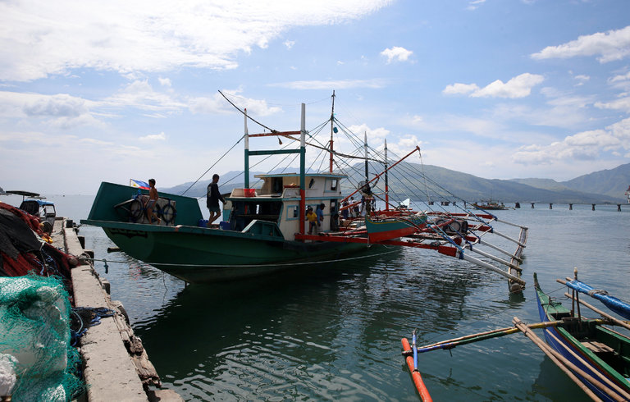
A fishing boat returning to the Philippine city of Subic from Scarborough Shoal on Tuesday. The Philippines has persuaded China to allow its fishermen access to the shoal, signaling a softening of its alliance with the United States. Credit Erik De Castro/Reuters
BEIJING — For years, the United States and its allies have struggled to contain China’s ambitions in the South China Sea, even as China steadily seeded the waters with artificial islands and military installations.
Now, by cutting its own deal with China, the Philippines has suddenly changed the calculus, persuading the Chinese to let its fishermen operate around a disputed shoal but setting a worrying precedent for the United States and its hopes of using regional alliances to preserve its place as the dominant power in the Pacific.
What had been a fairly united front against China’s expanding maritime claims, stretching from Japan to Malaysia, now has a gap in the southeast corner where the Philippines lies, and could soon have another at the southwestern end, where Malaysia is making noises about shifting its alliances.
In both cases, resentment over what is seen as American interference in unrelated problems — a wave of extrajudicial killings in the Philippines and a huge financial scandal in Malaysia — may have contributed to the shift.
The Philippine president, Rodrigo Duterte, is angry with the United States over its criticism of his lethal antidrug program, in which 2,000 people have been killed, mostly by the police.
In Washington, the ranking Democrat on the Senate Foreign Relations Committee, Benjamin L. Cardin of Maryland, has vowed to block any sale of assault rifles to the Philippine police, Senate aides confirmed Tuesday. While President Obama has criticized extrajudicial killings in the Philippines, blocking weapons sales would be the first concrete American sanction, and would probably only drive the Philippines further from the United States.
Malaysia’s prime minister, Najib Razak, is angry over a money-laundering investigation into what the United States Justice Department says is more than $1 billion looted from a Malaysian government fund by Mr. Najib’s relatives, friends and associates. Mr. Najib is in Beijing this week shopping for military hardware.
“Nobody wants the U.S. to leave the region to China,” said Bilahari Kausikan, ambassador at large for Singapore. “But China is using its economic leverage, its geographic position and its lack of interest in human rights to try and change the balance of influence in a region where the vagaries of American politics are now on stark display.”
The deal between China and the Philippines became apparent over the last week with reports that China had begun to allow Philippine fishermen to operate in contested waters in the South China Sea for the first time in four years, rewarding Mr. Duterte for his friendship with Beijing and his coolness toward the United States.
The deal is an informal one, and so far has not been committed to writing, but it seems to give both parties what they want while sidestepping the more contentious issue of sovereignty over Scarborough Shoal, the contested fishing grounds claimed by both China and the Philippines.
Photo
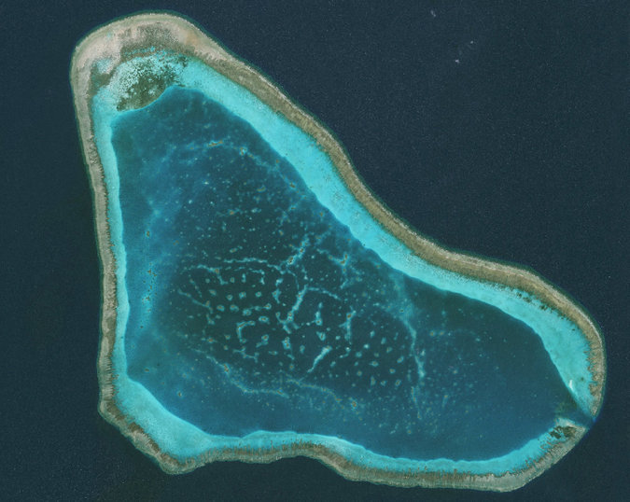
A satellite image of Scarborough Shoal, in the South China Sea, last year. The Chinese still control the area around it. Credit DigitalGlobe, via Getty Images
China has not renounced its claim over the shoal, nor has the Philippines conceded China’s claim. But the Philippines’ main interest in the territory is fish, and it appears to have gotten that, a victory for Mr. Duterte and his popular defense of his country’s important fishing industry.
For China, the concession not only shifts an important American ally into its good graces but also brings it at least partly into compliance with a ruling by a tribunal in The Hague on the dispute.
The July ruling, which China rejects, denied Beijing’s claim over most of the South China Sea. China’s Foreign Ministry said on Monday that it remained opposed to the ruling and that the loosening of its four-year blockade of the shoal was a special “arrangement” for Mr. Duterte and “has nothing to do with the so-called award.”
Nonetheless, in allowing Philippine fishermen back into the waters around the shoal, China, whether it admits as much or not, was complying with the part of the ruling that dealt with the blockade, according to Paul S. Reichler, the Philippines’ chief counsel in the case.
“China has suddenly decided to act in a manner that, in fact, complies with one aspect of the award,” he said. “It is a welcome step in the right direction.”
Because the tribunal did not consider the question of sovereign rights, he said, China is not out of bounds in continuing to claim sovereignty over the shoal, nor would the Philippines be, if it did the same.
“Beijing has played a clever diplomatic hand,” said Ashley Townshend, a research fellow at the United States Studies Center at the University of Sydney in Australia. “It’s secured a public relations win by lifting the blockade, without forgoing its sovereignty claims over the shoal or even removing its coast guard vessels.”
For Mr. Duterte, who has vowed to scale back relations with the United States, including possibly denying American forces access to five military bases in the Philippines, the deal on Scarborough Shoal came with little cost.
A Philippine official, Representative Harry Roque, who accompanied Mr. Duterte on his trip to Beijing two weeks ago, told The Philippine Daily Inquirer that the Chinese had wanted a written document that said the fishermen would be “allowed” or “permitted” to return to Scarborough Shoal, wording that would imply China’s control of the area.
Such wording was “unacceptable,” Mr. Roque said, and so the deal was not put in writing or formally announced.
Photo
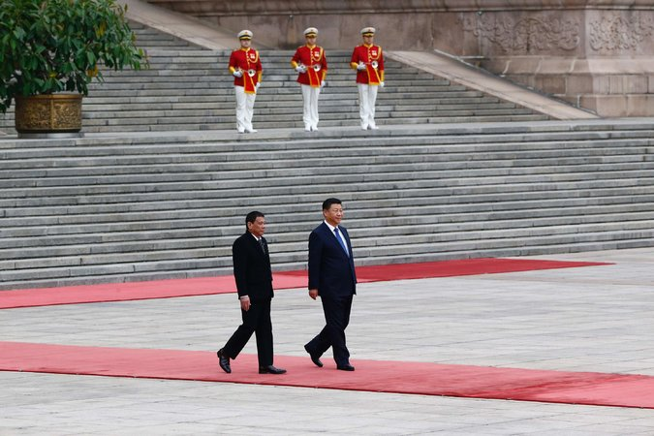
President Rodrigo Duterte of the Philippines, left, with his Chinese counterpart, Xi Jinping, in Beijing last month. Credit Thomas Peter/Agence France-Presse — Getty Images
For China there was also little cost. The Chinese still control the area around Scarborough Shoal, and it would be tough for the Philippine government to negotiate a full withdrawal of the Chinese from the shoal, an area China has considered turning into an artificial island to create a military base.
Still, China has lost a point of leverage, Mr. Townshend said. “Having now lifted the blockade and drawn global attention to the issue, it will be very difficult for Beijing to reinstate the blockade without incurring serious reputational damage and undermining its political rapprochement with Manila,” he said.
The United States, a bystander to the deal, gave it a kind of provisional approval.
Deputy Secretary of State Antony J. Blinken, saying that he had only read reports, said it would be a “positive development” because it showed that China “is acting consistently with the arbitration ruling.”
Even if it portends a potential strategic loss, the agreement also helped reach a goal that the United States has long sought: lowering tensions in an important area of the South China Sea.
For Mr. Duterte, the deal caps a two-week period in which he has shown himself to be a “shrewd political animal,” as Mr. Kausikan, the Singaporean ambassador, put it.
In Beijing, Mr. Duterte signed $24 billion in infrastructure projects and loans. He left Tokyo last week with the promise of two new vessels for the poorly equipped Philippine Coast Guard and, according to Philippine news reports, $19 billion in investment and loan pledges.
He also won tacit support in both capitals for his campaign against drugs. Like the Chinese leadership, Prime Minister Shinzo Abe of Japan did not raise the issue of extrajudicial killings and human rights violations.
How long Mr. Duterte can ride out his good relations with China and keep up his threats against the United States is an open question.
At a cabinet meeting next week, Mr. Duterte will hear a report from the Philippine Defense Ministry on whether to continue to allow the United States access to the military bases, including one at Palawan, close to Scarborough Shoal.
Mr. Duterte has threatened to cancel the 2014 accord that gives Americans access to the bases, a decision that Beijing would welcome. Termination of the agreement requires a one-year notice by the Philippine government to the United States.
But the Philippine public remains pro-American and skeptical of China, opinion polls show.
“I think Filipinos are happy to see the fishermen back in their fishing grounds, but I doubt if this meant that there is a significant increase in the 33 percent of Filipinos favorable to China,” said Patricio N. Abinales, a professor of Asian studies at the University of Hawaii.

The National Interest

The decision could make certain land disputes even worse.
M. Taylor Fravel
July 13, 2016

On July 12, the tribunal hearing the case issued its ruling that can only be described as a huge win for the Philippines. Digesting all 507 pages of the award will take time, allowing only for preliminary judgments to be made. Below, I discuss several strategic implications.
The Scope of Lawful Maritime Claims in the South China Sea
In assessing the Philippine submissions, the tribunal greatly reduced the scope of maritime entitlements that states can claim in the South China Sea. First, the tribunal concluded that China cannot lawfully, under the UN Convention on the Law of the Sea, claim historic rights to resources within the nine-dash line that appears on Chinese maps. Although China has not clarified the nine-dashed line or even explained officially what it means, the tribunal indicated that one potential explanation, as a claim to historic rights, was inconsistent with the convention. The tribunal reasoned that whatever historic rights or high-seas freedoms China enjoyed were “extinguished” when it acceded to the convention.
Second, the tribunal interpreted Article 121 of the convention, which outlines the “regime of islands.” In particular, the tribunal offered a four-part test for determining what constitutes an “island” and not a rock. This matters greatly because under the convention islands are entitled to a two-hundred-nautical-mile Exclusive Economic Zone, while a mere rock is entitled only to a twelve-nautical-mile territorial sea. The tribunal ruled that none of the naturally formed land features satisfied its four-part test and that no “islands” exist in the Spratlys from which China, or any other claimant state, can claim a two-hundred-nautical-mile EEZ.
Taken together, these two elements of the tribunal’s award greatly restrict what maritime zones China can claim. In fact, China can claim only a twelve-nautical-mile sea around those naturally formed land features in the Spratlys that would be deemed to be rocks or above high tide. According to the tribunal, any claim to either historic rights or to an EEZ would be inconsistent with the convention, and unlawful. In so doing, the tribunal decreased the value of claiming sovereignty over offshore islands by limiting the economic value that they create. If a land feature cannot generate a two-hundred-nautical-mile EEZ, giving states the exclusive right to resources in the water column and seabed, then the value at stake in these disputes has also declined.
The Meaning of an “Island”
Whether intended or not, the tribunal’s ruling on lawful claims to maritime zones in the South China Sea has much broader implications for all parties to UNCLOS. By offering an interpretation of what constitutes an “island” that can generate a two-hundred-nautical-mile EEZ, the tribunal created a international legal precedent about what constitutes a lawful EEZ claim from naturally formed land features.
That is, the tribunal has not only limited China’s lawful claims in the South China Sea under the convention. It has also potentially limited the lawful claims that other states can make from land features that would fail the test offered by the tribunal. Many states claim a two-hundred-nautical-mile EEZ from land features that would clearly be rocks and not islands according to the tribunal’s ruling. Japan, for example, claims a two-hundred-nautical-mile EEZ from Okinotorishima, a coral reef that consists of three rocks that are above high tide. The United States, too, claims EEZs from similar features, such as Kingman Reef in Micronesia. Under the precedent established by the tribunal, these features may not be entitled to the EEZ that states claim from them. In this way, the tribunal’s ruling has much broader implications for how all states interpret lawful claims under the convention.
The Endurance of Territorial Disputes in the South China Sea
The final strategic implication is that the tribunal’s award could not address the fundamental issue at stake in the South China Sea, which are the competing claims to territorial sovereignty over the Spratly Islands. The reason is simple: as a tribunal constituted under UNCLOS, it can only consider questions relating to the interpretation of the convention, such as the kinds of maritime zones states can claim. Because the treaty specifically omits territorial disputes, the tribunal lacks jurisdiction to adjudicate on the claims between China and the other claimants in the South China Sea over the sovereignty of the Spratlys.
Ironically, perhaps, by reducing what states can lawfully claim from the land features in the Spratlys, the tribunal’s ruling may have the unintended effect of intensifying the dispute over these land features even though the tribunal sought to minimize their importance.
M. Taylor Fravel is an associate professor of political science at MIT and the author of Strong Borders, Secure Nation: Cooperation and Conflict in China’s Territorial Disputes. He can be followed on Twitter @fravel.
Image: The U.S. and Royal Malaysian Navy vessels KD Lekir, guided-missile frigate USS Ford and KD Sri Inderapura sail in formation. Wikimedia Commons/U.S. Navy

SCMP

South China Sea
Home
Background
The Hague case
Analysis
Video
Interactive

What will guide China’s response to the South China Sea tribunal ruling?
M. Taylor Fravel says Beijing is likely to study the specifics of the Permanent Court of Arbitration decision and carefully watch the reactions of others, including the US, before deciding how it should act
PUBLISHED : Friday, 08 July, 2016, 4:11pm
UPDATED : Friday, 08 July, 2016, 7:32pm
29 Oct 2016
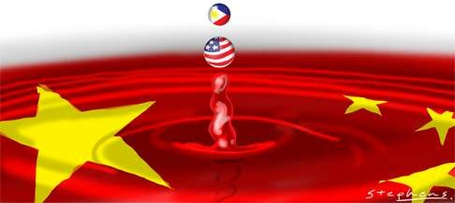
Next week, a tribunal in The Hague hearing the arbitration case that the Philippines brought against China will deliver its verdict. It is likely to rule in favour of the Philippines on at least some of the submissions before it. Despite its commitments under the UN Convention on the Law of the Sea, China has refused to participate or recognise the legitimacy of the arbitration process.
How Beijing will respond to any adverse ruling animates conversations in Washington, DC and capitals around Asia. The mainstream view is that China is likely to undertake some significant action, to demonstrate that it rejects the tribunal’s decision as well as to punish the Philippines and deter other states from pursuing similar cases. The two most discussed actions include initiating land reclamation at Scarborough Shoal or declaring an air defence identification zone over the South China Sea.

UN chief appeals for peace as US and China step up patrols in South China Sea
Yet, how China will respond is probably the product of more complex calculations in Beijing.
As Paul Gewirtz has recently noted, the tribunal itself will not resolve all the issues at stake in the South China Sea disputes over sovereignty and maritime jurisdiction. First, it cannot rule on the most fundamental issue – the sovereignty over the islands, rocks and reefs that make up the contested Spratly Islands. As the Law of the Sea is an international treaty that created a regime for governing the oceans, the tribunal can only consider questions relating to the interpretation of the treaty and the zones of maritime jurisdiction it created. Because the treaty specifically omits territorial disputes, the tribunal lacks jurisdiction to adjudicate on the claims between China and the Philippines over the sovereignty of the islands.
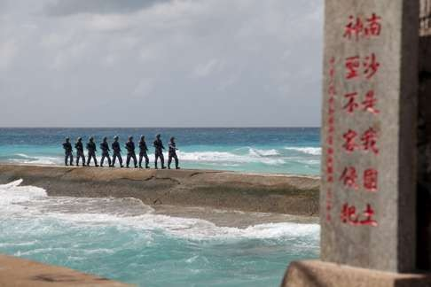

A UN ruling against China won’t help resolve the South China Sea dispute with the Philippines
Second, the tribunal’s award will avoid any question of maritime delimitation or boundaries. The reason is procedural: under Article 298, the treaty allows states to exclude maritime boundary delimitations from the convention’s compulsory dispute resolution. Given that China issued such a reservation in 2006, the tribunal cannot consider any question of possible maritime delimitation.
Taken together, the tribunal cannot determine who owns what land features in the South China Sea, or where maritime boundaries should be drawn. Instead, it will focus on how to interpret the convention in light of the facts pertaining to the case.
Given these limits, the first factor that will shape China’s response is the content of the award. The Philippines asked the tribunal to rule on 15 unique submissions. As a result, the content of the award is likely to be mixed and complex, perhaps without definitive answers on some issues.
The Philippine submissions cover a range of issues, including the maritime entitlements of specific land features in the Spratly Islands currently occupied by China, fishing around Scarborough Shoal, and, above all, the legality of China’s infamous “nine-dash line” and any possible claims to historic rights that China may claim within the line.
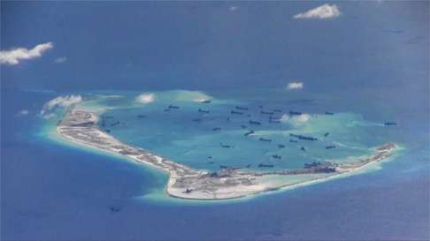

Is Beijing courting disaster by shunning South China Sea tribunal?
In October 2015, the tribunal ruled it had jurisdiction over seven of the 15 submissions and reserved the determination of jurisdiction of another seven to the merit phase (and asked for clarification of the last claim). Moreover, in the seven submissions where the tribunal determined it had jurisdiction, it conditioned that in two instances based on the absence of any dispute over maritime delimitation. If the largest land feature in the Spratlys, Itu Aba, is deemed to be an island that can generate a 200 nautical mile exclusive economic zone and continental shelf, then a possible maritime delimitation dispute would exist over Mischief Reef, Second Thomas Shoal, Subi Reef and Mckennan Reef, and prevent the tribunal from ruling on these submissions.
As a result, the tribunal will produce 15 distinct decisions. The award itself is likely to be lengthy and detailed. The tribunal will need to explain its legal reasoning and understanding of the facts for each submission.
The complexity of the award, and the possibility for a mixed decision, means China would face less pressure to react strongly with actions on the water
The complexity of the award, and the possibility for a mixed decision that combines elements favourable and unfavourable to the Philippines, means China would face less pressure to react strongly with actions on the water. For example, the tribunal could find China has no basis for “historic rights” within the nine-dash line while at the same time not providing a definitive definition of the line. Because China has not officially defined the line, such a ruling may not warrant a strong Chinese reaction.
The second factor shaping China’s response is how other states will respond. Under the Law of the Sea treaty, the judgment of arbitral proceedings is binding on the parties. This holds even if one party has chosen not to participate. At the same time, it is not enforceable.
Thus, the Philippines and other interested states such as the US will be faced with a decision on whether to try to compel China to accept the award. On the one hand, they could simply use the tribunal’s interpretation of the treaty to determine how they formulate their own claims or actions in the South China Sea. For example, if the tribunal rules that certain land features are not entitled to a territorial sea, the US may conduct a freedom of navigation operation within 12 nautical miles of such features. On the other hand, they could take actions in disputed waters subject to the arbitration to uphold favourable elements of the award, which in essence would amount to enforcement. The Philippines, for example, could decide to resume fishing activities inside Scarborough Shoal and request an American escort.
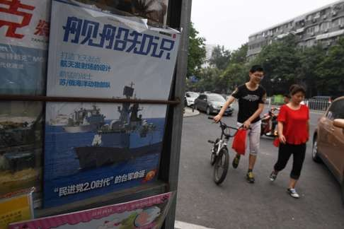

China warns US against infringing on its sovereignty ahead of ruling on territorial claims in South China Sea
The steady drumbeat of China’s public diplomacy rejecting the tribunal reflects its hope that other states will not seek to compel China to accept any adverse findings. Therefore, China is most likely to calibrate its actions not only in light of the content of the award but also in response to efforts by other states to compel it to accept the findings.
Earlier this week, Dai Bingguo ( 戴秉國 ), China’s point man for foreign affairs under Hu Jintao (胡錦濤), made this explicit. During a conference in Washington, DC, he said “no country should implement the award in any form, much less force China into implementation”. The key implication here is that China will take firm action. China is likely to focus on how the Philippines responds and whether new president Rodrigo Duterte engages China diplomatically. For its part, China should not put any preconditions on the initiation of negotiations, such as requiring Manila to renounce the tribunal’s award.
At a minimum, the US will provide rhetorical support for the award. Arbitration is a clear example of peaceful dispute resolution, which plays a key role in US policy towards South China Sea disputes. But a mixed and complicated award means all states with an interest in supporting the outcome will need to study it in detail before determining how to proceed.

What to expect from Asean statement on Hague court’s South China Sea rulings
A third and final factor shaping China’s response is the regional diplomatic calendar. The Asean Regional Forum will be held later this month, while the East Asia Summit is in early September and the Asia-Pacific Economic Cooperation meeting in November. Land reclamation at Scarborough Shoal or establishment of an air defence identification zone in the South China Sea would guarantee that the disputes dominate regional discussions and likely increase security cooperation between the US and other claimants, an outcome China very much wants to avoid.
How China will actually respond to the tribunal’s award, of course, is uncertain. Apart from continued public diplomatic efforts to delegitimise the tribunal, whether China takes bold action on the waters of the South China Sea is likely to depend on the content of the award and how other stakeholders respond themselves, especially the Philippines and the US.
M. Taylor Fravel is associate professor of political science and a member of the security studies programme at MIT

NYT

Asia Pacific | News Analysis

Muted U.S. Response to China’s Seizure of Drone Worries Asian Allies
By JANE PERLEZDEC. 18, 2016
BEIJING — Only a day before a small Chinese boat sidled up to a United States Navy research vessel in waters off the Philippines and audaciously seized an underwater drone from American sailors, the commander of United States military operations in the region told an audience in Australia that America had a winning military formula.
“Capability times resolve times signaling equals deterrence,” Adm. Harry B. Harris Jr. told a blue-chip crowd of diplomats and analysts at the prestigious Lowy Institute in Sydney, the leading city in America’s closest ally in the region.
In the eyes of America’s friends in Asia, the brazen maneuver to launch an operation against an American Navy vessel in international waters in the South China Sea about 50 miles from the Philippines, another close American ally, has raised questions about one of the admiral’s crucial words. It was also seen by some as a taunt to President-elect Donald J. Trump, who has challenged the One China policy on Taiwan and has vowed to deal forcefully with Beijing in trade and other issues.
“The weak link is the resolve, and the Chinese are testing that, as well as baiting Trump,” said Euan Graham, the director of international security at the Lowy Institute. “Capability, yes. Signaling, yes, with sending F-22 fighter jets to Australia. But the very muted response means the equation falls down on resolve.”
Continue reading the main story

Related Coverage

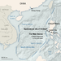

China Agrees to Return Seized Drone, Ending Standoff, Pentagon Says DEC. 17, 2016

U.S. Demands Return of Drone Seized by Chinese Warship DEC. 16, 2016

ADVERTISEMENT
Continue reading the main story
Across Asia, diplomats and analysts said they were perplexed at the inability of the Obama administration to devise a strong response to China’s challenge. It did not even dispatch an American destroyer to the spot near Subic Bay, a former American Navy base that is still frequented by American ships, some noted.
After discussions at the National Security Council on how to deal with the issue, the Obama administration demanded the return of the drone. On Saturday, China said it would comply with the request but did not indicate when or how the equipment would be sent back.
The end result, analysts said, is that China will be emboldened by having carried out an act that amounted to hybrid warfare, falling just short of provoking conflict, and suffering few noticeable consequences.
“Allies and observers will find it hard not to conclude this represents another diminishment of American authority in the region,” said Douglas H. Paal, the vice president for studies at the Carnegie Endowment for International Peace.
Significantly, the Chinese grabbed the drone not only in international waters but outside even the “nine-dash line” that China uses as a marker for its claims in the South China Sea. In so doing, analysts said, Beijing was making the point that the entire sea was its preserve, even though it is entirely legal for the United States to conduct military operations in waters within 200 miles of the Philippines, an area known as an exclusive economic zone.
In the last dozen years, China has steadily showed off its growing military prowess to the countries around the South China Sea, which carries trillions of dollars of world trade and which China values for its strategic access to the Western Pacific and the Indian Ocean.
As China has built up its navy and its submarine fleet in the last decade, it has also emphasized what it calls its “inherent” right to dominate the regional seas, and to challenge the presence of the United States, its allies and partners in Asia.
The drone episode, which occurred on Thursday and was first broadcast by CNN despite efforts by the Obama administration to settle it quietly, was of a different nature and just as disquieting as past confrontations with China that involved bigger ships and more dangerous maneuvers, analysts said.
In 2001, soon after President George W. Bush came to office, an American spy aircraft, an EP-3, was forced to land on Hainan Island after colliding with a Chinese fighter jet. The Chinese stripped the plane of its assets and returned it broken down to its parts and packed in boxes.
In 2009, two months after President Obama took office, Chinese vessels swarmed a United States Navy reconnaissance ship, the Impeccable, in what the Pentagon said were dangerous and unprofessional maneuvers.
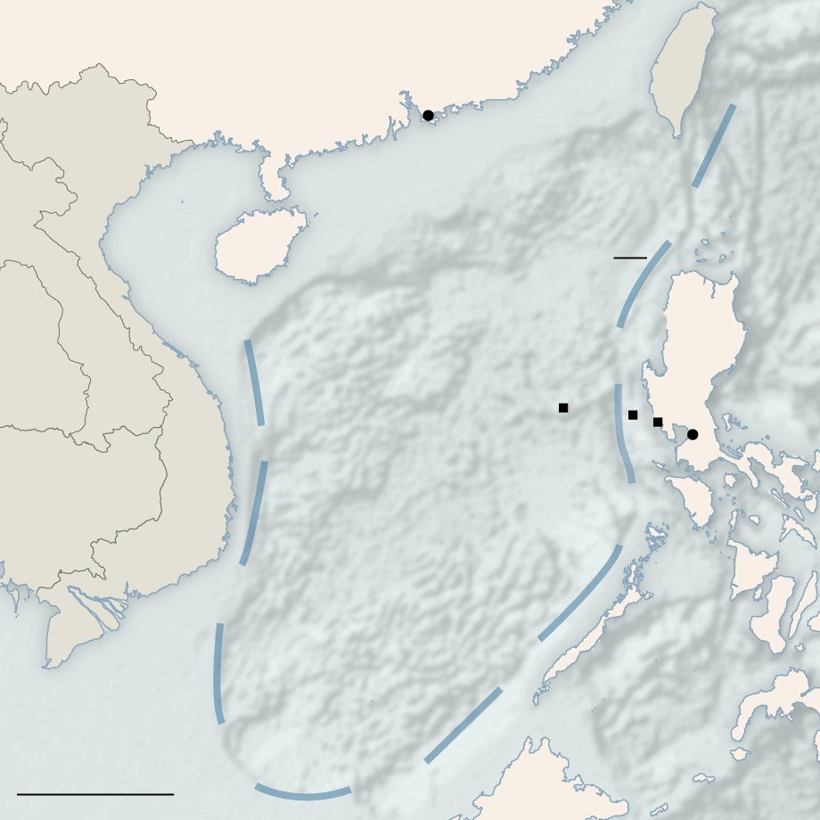
CHINA
TAIWAN
VIETNAM
Hong Kong
Gulf of
Tonkin
Hainan
The “Nine Dash Line”

China’s historical
territorial claim
PHILIPPINES
Paracel Islands
LAOS
THAILAND
Scarborough Shoal
Subic Bay
Approximate site of incident
Manila
CAMBODIA
Spratly Islands
South China Sea
Sulu
Sea
300 Miles
By The New York Times
This time, China chose a more unconventional method to challenge the United States and hastened the timetable, challenging a president-elect rather than a newly installed president as it has in the past.
The drone itself, known as an unmanned underwater vehicle, was not a particularly important piece of equipment. Such drones are deployed to gather military oceanographic data and are available over the counter for about $150,000, the Pentagon said. Data from the drone would no doubt be used to help track China’s growing submarine fleet, naval experts said.
More important than the equipment was the principle of freedom of navigation in international waters, and whether China was in the process of imposing its own rules in the South China Sea — more than 800 miles away from its coastline, said Alexander Vuving, a specialist on Vietnam at the Asia-Pacific Center for Security Studies in Hawaii.
“This is China showing that it is in the process of setting the rules in the South China Sea, imposing its own view in the South China Sea and saying the South China Sea should be its own backyard,” Mr. Vuving said.
“If China can get away with this incident with impunity,” he added, “this will send a chilling message to countries in the region.”
Some leaders, like President Rodrigo Duterte of the Philippines, will feel validated in a pivot away from the United States toward China, Mr. Vuving said. “Others, like the Vietnamese, will have to seriously rethink their regional outlook.”
Vietnam — always fearful of China, its neighbor to the north, but also careful not to alienate Beijing — has tried in the last few years to draw closer to the United States, while still maintaining a careful distance.
In 2011, as China became more assertive in the South China Sea, Vietnam accused China of instructing three high-speed patrol boats to cut the cables of a Vietnamese oil and gas survey ship.
The authoritarian Vietnamese government was so furious that it allowed anti-Chinese demonstrations in Hanoi.
In 2014, China moved a billion-dollar oil rig to waters close to the Paracel Islands that both Vietnam and China claim, and then blasted a flotilla of Vietnamese ships with water cannon.
Since then, China has hardened its position, sometimes referring to the South China Sea a “core interest” in which there is no room for compromise, though others in the region call it bullying by the Chinese president, Xi Jinping.
Under that vision, China would be in control from the waters of Indonesia to Brunei, Malaysia, the Philippines and up to Japan.
In the East China Sea, China and Japan are at odds over an uninhabited island chain, known as the Senkaku in Japan and the Diaoyu in China. In June, China sent a warship for the first time into the waters around the islands, further escalating tensions.
Japan has been more outspoken than other Asian countries in its support for the Obama administration’s objections to China’s construction of military facilities on seven artificial islands in the South China Sea.
But in Tokyo, the government was watching the outcome of the drone episode with some anxiety. So far, Washington’s restrained response has not been reassuring.

NYT

Asia Pacific

China Agrees to Return Seized Drone, Ending Standoff, Pentagon Says
点击查看本文中文版
By JANE PERLEZ and MATTHEW ROSENBERGDEC. 17, 2016
Photo
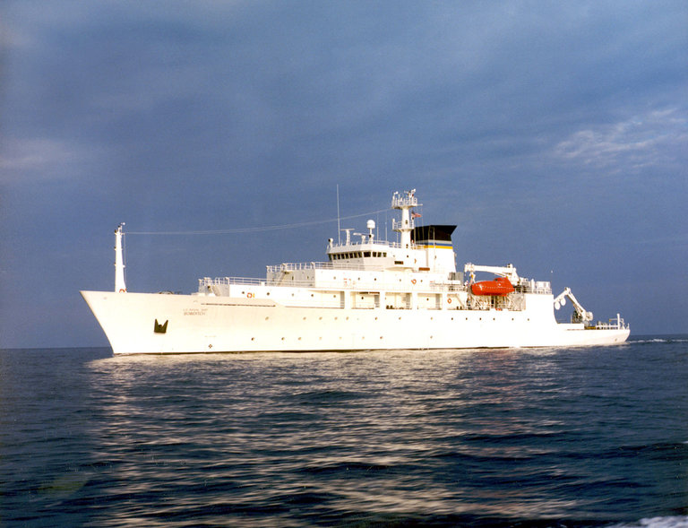
The drone was launched by the Bowditch, an American ship, on Thursday. Credit United States Navy
BEIJING — The Pentagon on Saturday said that Beijing had agreed to return an underwater drone seized by China in international waters, an indication that the two countries were moving to resolve an unusual incident that risked sharpening tensions in the run-up to the inauguration of President-elect Donald J. Trump.
“Through direct engagement with Chinese authorities, we have secured an understanding that the Chinese will return the U.U.V. to the United States,” said Peter Cook, the Pentagon press secretary, using initials to refer to the Navy’s unmanned underwater vehicle.
Mr. Cook said the deal had been reached after the United States “registered our objection to China’s unlawful seizure of a U.S. unmanned underwater vehicle operating in international waters in the South China Sea.”
The Chinese authorities told American officials that they planned to return the drone, but the two sides were still working out where, when and precisely how the device would be handed back, said two Defense Department officials, both of whom would talk about the negotiations with China only on the condition of anonymity. One of the officials said the Pentagon expected the matter to be resolved in the coming days without further acrimony.
Continue reading the main story

Related Coverage

U.S. Demands Return of Drone Seized by Chinese Warship DEC. 16, 2016

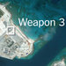

China Suggests It Has Placed Weapons on Disputed Spratly Islands in South China Sea DEC. 15, 2016

Xi Again Defends China’s Claim to South China Sea Islands NOV. 7, 2015

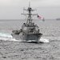

NEWS ANALYSIS

White House Moves to Reassure Allies With South China Sea Patrol, but Quietly OCT. 27, 2015

ADVERTISEMENT
Continue reading the main story
The Pentagon statement came hours after China warned that the highly charged episode would not be resolved easily.
In a statement late Saturday, the Chinese Defense Ministry said it was in talks with the United States but criticized Washington for what it called an “inappropriate” exaggeration of the dispute. The American reaction, it said, is “not conducive to solving the problem smoothly.”
“We hereby express regrets for that,” it said.
Although the ministry said the drone would be returned to the United States in a “proper way,” the statement stopped short of saying when or how the device, which Chinese and American analysts say was most likely used to gather intelligence about Chinese submarine activity in contested waters, would be returned, or if it would be handed back intact.
President-elect Donald J. Trump entered the fray Saturday morning, accusing China on Twitter of acting improperly. “China steals United States Navy research drone in international waters — rips it out of water and takes it to China in unprecedented act,” he said.
The overseas edition of The People’s Daily, the Communist Party’s flagship newspaper, said on its social media account Saturday night that the Chinese capture of the drone was legal because rules about drone activities had not been clearly written. “This is the gray area,” the newspaper said. “If the U.S. military can send the drone, surely China can seize it.”
In its statement, the Defense Ministry scolded the United States over what it called its longstanding practice of conducting “close-in reconnaissance and military surveys” in waters claimed by China. The Chinese government has often complained to senior American officials, including President Obama, that the United States repeatedly intrudes by air and ship into waters close to China. The ministry’s statement reiterated the complaint, saying “China firmly opposes it and urges the U.S. side to stop such operations.”
A Chinese naval vessel seized the drone, which had been launched on Thursday from an American ship, the Bowditch, in waters off the Philippines. The American crew was in the process of retrieving the device when a small boat dispatched from the Chinese vessel took it as the American sailors looked on.
CHINA
TAIWAN
VIETNAM
Hong Kong
Gulf of
Tonkin
Hainan
The “Nine Dash Line”

China’s historical
territorial claim
PHILIPPINES
Paracel Islands
LAOS
THAILAND
Scarborough Shoal
Subic Bay
Approximate site of incident
Manila
CAMBODIA
Spratly Islands
South China Sea
Sulu
Sea
300 Miles
By The New York Times
The action came two weeks after Mr. Trump angered Beijing by speaking by phone to the leader of Taiwan, and almost a week after he criticized China for building military bastions in the South China Sea. American officials were trying to determine whether the seizure was a response to Mr. Trump or whether it was just one more escalatory step in China’s long-term plan to try to push the United States Navy out of the South China Sea, one of the world’s busiest commercial and military waterways.
The Pentagon formally protested the capture of the drone, saying it was stolen American military property. The Pentagon said the drone had been carrying out scientific research, and asked China to return it. American experts, however, said the drone might have been designed to help follow China’s submarine buildup, a critical part of the country’s growing naval strength as it seeks unfettered control of the South China Sea and unimpeded access to the Pacific and Indian oceans.
A retired Chinese rear admiral, Yang Yi, speaking earlier at a conference sponsored by a state-run newspaper, The Global Times, said the Americans had invited the Chinese sailors to take the drone by sailing in the waters close to the Scarborough Shoal, fishing grounds that are claimed by China and the Philippines.
The Americans “deliver these things to our home,” and it would be more than natural for Chinese sailors to seize the drone and examine it, Admiral Yang said.
“If Trump and the American government dare to take actions to challenge the bottom line of China’s policy and core interests,” he said, “we must drop any expectations about him and give him a bloody nose.”
Reached by telephone, the president of a state-affiliated think tank, Wu Shicun, said the United States had most likely been conducting intelligence reconnaissance to detect Chinese submarine routes in the South China Sea. Mr. Wu, who heads the National Institute for South China Sea Studies and advises the government on maritime matters, described the drone “as a new way for the United States to conduct intelligence gathering.”
“Previously the United States conducted surveillance with warships in the nearby waters of China, or by aircraft,” he said. “Now the unmanned underwater vehicle is a new approach.” The Chinese were justified in taking the unmanned underwater vehicle, he said.
The episode occurred in seas about 50 miles northwest of Subic Bay, a major port of the Philippines and a former United States Navy base, the Pentagon said. That means the Bowditch was within 200 miles of Scarborough Shoal, American analysts said.
The American vessel appeared to be outside the perimeter of the “nine-dash line,” said Mira Rapp-Hooper, a senior fellow at the Center for a New American Security. China drew the line in the late 1940s as it laid claim to about 90 percent of the South China Sea.
“China has no legal basis to take actions like these on the high seas, but doing so outside Beijing’s ambiguous claim line is particularly egregious and will make the incident especially hard to justify,” Ms. Rapp-Hooper said.
The president of the Philippines, Rodrigo Duterte, who is nurturing warm ties with China and has warned he may break longstanding military relations with the United States, took a conciliatory approach over the Chinese action.
“I will not impose anything on China,” he said at a news conference in Manila on Saturday. “Why? Because politics in Southeast Asia is changing.” This was a reference to his tilt away from the United States, a treaty ally, since taking office in June. He referred to China as “the kindest soul of all.”
Photo
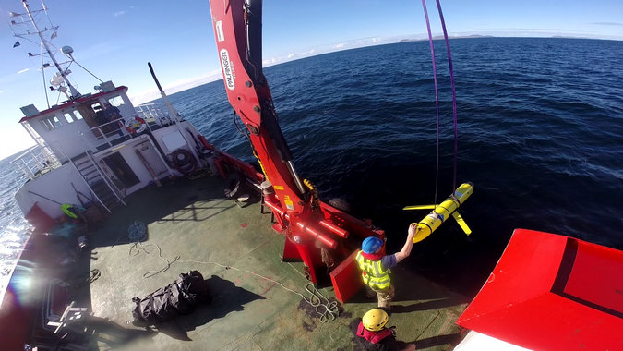
The drone was seized by Chinese sailors off the Philippines. Credit Cmdr Santiago Carrizosa/United States Navy
The Philippines also took a forgiving attitude after the release of satellite images on Wednesday by the Center for Strategic and International Studies that appeared to show that China has installed weapons on the seven artificial islands it has built in the Spratly archipelago, not far from the Philippines in the South China Sea.
“There is nothing that we can do about that now, whether or not it is being done for purposes of further militarizing these facilities that they have put up,” the foreign secretary, Perfecto Yasay Jr., said, reflecting the weak state of the Philippines military. “We cannot stop China at this point in time and say, ‘Do not put that up.’ ”
By seizing the drone so close to the Philippines, China may have been trying to further weaken the already frayed United States alliance with Manila, American experts said.
The conciliatory reaction by the Philippines, even as the United States was making stern demands on Beijing, would complicate Washington’s efforts to convince China that its actions were unacceptable, a senior American military official said on Saturday.
In an important ruling in July, an international tribunal in The Hague decided against China, saying that the Scarborough Shoal was entitled only to a 12-mile territorial zone, not 200 miles as the Chinese assert. China has refused to recognize the ruling.
Mr. Duterte on Saturday said he was ignoring the Hague ruling even though the case had been brought by the previous Philippines government. “In the play of politics now, I will set aside the arbitral ruling,” he said.
The drone incident, according to a Pentagon account, began when a Chinese Navy vessel that was shadowing the Bowditch — a common practice in the South China Sea — pulled up not far from the ship. It then dispatched a small boat to seize the drone as the American crew was recovering it from the water. The Pentagon described the vehicle as an unclassified “ocean glider” system used to gather military oceanographic data such as salinity, water temperature and sound speed.
An American naval expert did not disagree with Mr. Wu’s notion of what the Americans were probably doing. “Warfare and surveillance in the age of drones has not yet developed an agreed-upon set of rules,” said Lyle J. Goldstein, an associate professor at the China Maritime Studies Institute at the United States Naval War College, in Rhode Island.
“This is increasingly a major problem as both China and the U.S. are deploying ever more air and naval drones into the contested waters and airspace of the Western Pacific,” he said.
The seizure may have been just another way for Beijing to provoke the United States in a gray zone, just under the threshold of actual hostilities, Mr. Goldstein said. He said it was a time for “cooler heads to prevail,” to halt a cycle of escalation that “cannot end well for either side.”
In some respects, the seizure was not a surprise but just another step in China’s increased harassment of the American Navy in the South China Sea, several American naval experts said.
In March 2009, soon after President Obama took office, five Chinese ships swarmed an American surveillance vessel, the Impeccable, 75 miles off Hainan island, the southernmost province of China. The Impeccable was towing sonar equipment designed for anti-submarine warfare, and the Chinese ships got as close as 25 feet from the ship in what the Pentagon called “illegal and dangerous” maneuvers.

Brookings

Southeast Asia View

Op-Ed

“America first” cannot mean “America alone”: Engaging Southeast Asia
Lynn Kuok Thursday, December 15, 2016
Southeast Asia watchers have been waiting for President-elect Trump’s nomination for Secretary of State to complete the first sketch on what Mr. Trump’s policy towards the region might be. His pick of retired Marine General James Mattis as Secretary of Defense signaled a more robust approach to the South China Sea, though this might be somewhat at odds with what appears to be Mr. Trump’s own thoughts on the matter. The selection of retired Lt. Gen. Michael Thomas Flynn raised concerns about what his outspoken comments on Islam might mean for Southeast Asia’s majority- and even minority-Muslim countries. What does Mr. Trump’s latest pick add to the broad brushstrokes of this picture?

Author

Lynn Kuok

Nonresident Fellow - Foreign Policy, Center for East Asia Policy Studies
@LynnKuok
ExxonMobil chief executive Rex Tillerson is widely reported to be a strong proponent of free trade and close to President Putin of Russia. Some will no doubt regard his nomination as in keeping with an administration that envisions greater cooperation with Russia and a harder stance on China. But not a whole lot is known of Mr. Tillerson’s foreign policy views, especially as it pertains to Southeast Asia.
Mr. Tillerson likely has some familiarity with the region. ExxonMobil has a presence in Indonesia, Malaysia, Singapore, Thailand and Vietnam. ExxonMobil owns and operates the Singapore Refinery and Singapore Chemical Plant, which is the company’s largest integrated manufacturing site in the world. Mr. Tillerson has visited the city-state many times and met its prime minister.
Mr. Tillerson is also likely to be no stranger to the South China Sea dispute. In 2009, Exxon acquired the rights to explore off the coast of Vietnam. Hanoi considers this area part of its exclusive economic zone, but Beijing was unhappy with Exxon drilling there.
Still, Mr. Tillerson’s approach towards the region and how it will impact Mr. Trump’s largely inchoate thinking on it remains to be seen. While Mr. Trump has made putting “America first” the lodestar of his presidency, what this means in practice is unclear. Certainly, as a statement of objective it is neither novel nor objectionable that the United States puts its national interests first—this is what all countries seek to do.

U.S. INTERESTS IN SOUTHEAST ASIA
The Obama administration recognized Southeast Asia’s economic and strategic importance to the United States, and sought to broaden and deepen engagement with the region.
Some of the world’s busiest shipping lanes are located in the region. The 10 Association of Southeast Asian Nations (ASEAN) member states collectively comprise the third largest economy in Asia and the seventh largest in the world. The region is young and dynamic. More than 65 percent of its 632 million people are below the age of 35.
Sustained engagement with ASEAN increases Washington’s flexibility and influence.
Given rivalry between intra- and extra-regional powers, ASEAN stands at the heart of any viable security architecture in the wider region. Sustained engagement with ASEAN, which shares an interest in sustaining a rules-based order in the Asia-Pacific, increases Washington’s flexibility and influence. It also takes the edge off direct Sino-U.S. competition.
President Obama’s pivot to Asia was in fact a pivot to Southeast Asia. He leaves behind an enduring framework for engaging the region. Under Obama, the United States joined the East Asia Summit, which is hosted by ASEAN. It also set up the U.S.-ASEAN summit, which culminated, at least symbolically, in the Sunnylands meeting in the United States earlier this year.
Will a Trump administration, with Mr. Tillerson at its diplomatic helm, build on this strong foundation? Countries in Southeast Asia have three main concerns about the next four years.

WITHDRAWAL FROM THE TPP: A BLOW TO U.S. ECONOMIC AND STRATEGIC GOALS
First, U.S. withdrawal from the Trans Pacific Partnership (TPP). Four ASEAN countries (Brunei, Malaysia, Singapore and Vietnam) are members of the high-standard multilateral trade deal; others had expressed a desire to join. U.S. withdrawal will deal a blow to the agreement and to U.S. economic and strategic objectives. It will bring about a more empowered China.
Rejecting the TPP sends a signal that U.S. engagement with the region is narrow and, in any event, cannot be counted upon.
In Southeast Asia, economics is security. Rejecting the TPP sends a signal that U.S. engagement with the region is narrow and, in any event, cannot be counted upon. Many countries, including Malaysia and Vietnam, signed on to the TPP at considerable political cost, making the sting of a U.S. withdrawal all the greater. Regional newspapers are already reporting on new life being breathed into the Regional Cooperation Economic Partnership (RCEP), a trade deal China spearheaded in 2011 with considerably lower standards.

PIVOT TO PIROUETTE: REDUCED OR HAPHAZARD ENGAGEMENT WITH SOUTHEAST ASIA
ASEAN and its member states are also concerned about where the region will stand in the next administration’s list of priorities. Even a move from pivot to pirouette, that is, from focused to sporadic engagement, will hurt U.S. interests.
Veteran observers of the region maintain that Mr. Trump is likely to have little patience for ASEAN. It is associated more with droning meetings and doddering processes, than immediate and tangible rewards. Will Mr. Tillerson’s background in the oil industry, with its decades-long horizons before a return on investment, display greater equanimity?

Related
- 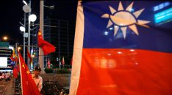

An open letter to Donald Trump on the One-China policy
- 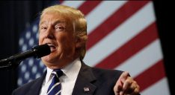

Trump’s team of rivals, riven by distrust
- 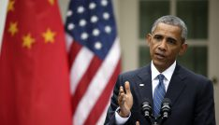

Assessing U.S.-China relations under the Obama administration
Further, there are questions over the extent to which a Trump administration will countenance the simultaneous balancing and hedging that almost all ASEAN countries, including claimants in the South China Sea, undertake. The current administration may not like it, but understands that it is to be expected from China’s smaller neighbors. The avoidance of hard coalitions also helps to decrease the propensity for conflict.
At the end of the day, the extent of balancing and hedging that takes place depends on demonstrable U.S. commitment and Chinese behavior. As a rising and more assertive China heightens anxieties in Southeast Asia, countries are thinking about how best to position themselves. Neglecting the region will hurt the United States’ position and standing.

WEAK OR INEFFECTUAL DEFENSE OF INTERESTS AND PRINCIPLES: THE SOUTH CHINA SEA AS LITMUS TEST
The South China Sea is an important litmus test of U.S. commitment. Many countries in Southeast Asia are worried about a weak or ineffectual defense of interests and principles, though some are more vocal than others.
Mr. Trump has done little to allay anxieties. He suggested that he would use trade as a tool to get the Chinese to stop “ambitious” behavior that “totally disregard[s]” the United States. The last thing the region wants is a trade war.
At the same time, Mr. Trump appeared to distance the United States from the issue by stating that other countries are affected “far greater” and the South China Sea is “very far away”.
His words buy into Beijing’s narrative that the dispute only concerns claimants. Yet, non-claimants, including the United States, have critical interests in the peaceful settlement of disputes, adherence to the rule of law, and freedom of navigation. The dispute and how it plays out also sets the tone for the broader Sino-U.S. relationship and whether might or right governs relations between states.
Mr. Trump’s statement that China has “already built” in the South China Sea also appears to too readily concede the strategic landscape. The battle for the South China Sea is one of peacetime control over its waters and the airspace above them. It will be won or lost over responses to Beijing’s “grey zone” activities and creeping assertions of control over wide expanses of water and air.
The president-elect’s policy advisers have boldly claimed that a Trump administration will increase the navy from the current 274 ships to 350 ships. But more ships do not, in and of themselves, a strategy make (though it will be a boost to the defense industry). It still leaves open the question of where and for what purposes these ships will be deployed.

Related Books
In this respect, General Mattis will be a trusted hand. In 2015, he gave testimony before the Senate Armed Services Committee questioning if the U.S. shipbuilding budget was sufficient, and stating that while efforts in the Pacific to keep positive relations with China are “well and good”, “these efforts must be paralleled by a policy to build the counterbalance if China continues to expand its bullying role in the South China Sea and elsewhere.” He emphasized both diplomacy and the credible threat of force in calling for the counterbalance to “deny China veto power over territorial, security and economic conditions in the Pacific, [thereby] building support for our diplomatic efforts to maintain stability and economic prosperity so critical to our economy.”
Regular assertions of maritime rights vested under international law will limit the extent of control China asserts from the features it occupies. This would not be a militarization of the region, nor a use of force, as Beijing claims. Indeed, failure to exercise these rights risks their loss in law and in practice.
The United States can also dissuade further activism by clearly communicating U.S. interests in the South China Sea. How the dispute pans out will affect Sino-U.S. relations and, more broadly, whether might or right governs relations between states.
Contrary to Mr. Trump’s claims, predictability in international relations is not always a bad thing. Privately communicating behavior which will be considered unacceptable will help to deter such conduct.

WHAT’S AT STAKE: THE STRATEGIC LANDSCAPE IN ASIA
If the United States withdraws from the TPP, neglects ASEAN and its member states, and is weak or ineffectual in its defense of interests and principles, this feeds into the Chinese narrative of an unreliable America, and could fundamentally alter the strategic landscape in Asia.
Some analysts argue that institutional checks and balances in the United States will limit the damage a president Trump can do. Yet, a stable and prosperous world-order based on respect for international law must also be about creating positive conditions for peace and prosperity. If the United States wants to affect the strategic evolution of Asia, it cannot come and go.
The next administration must engage Southeast Asia early on to assuage anxiety and put the relationship on a surer footing.
The next administration must engage Southeast Asia early on to assuage anxiety and put the relationship on a surer footing. It must also ensure that engagement is broad, deep and consistent. If the United States must withdraw from the TPP, it should first at least work out and signal the broad outline of what its presence means for the region both economically and in the security realm.
Engagement must be based on respect for the countries of Southeast Asia. This means understanding their legitimate concerns and constraints. Anti-Muslim rhetoric would be deeply problematic, not least because it jeopardizes the ability of governments in the region to forge strong ties with the United States. Two important ASEAN states, Indonesia and Malaysia, are majority Muslim. Stalwart partners of the United States like Singapore have a significant minority Muslim population.
Mr. Trump’s goal of putting “America first” cannot be achieved by an “America alone” policy. It must be built on the strong foundation of a network of allies, partners and friends, including in Southeast Asia. If confirmed, countries in the region will be watching to see whether Mr. Tillerson’s promise to focus on “strengthening…alliances” and “pursuing shared national interests” extends to their part of the world.

NYT

China Deploys Aircraft Carrier to Disputed South China Sea
By JAVIER C. HERNÁNDEZDEC. 27, 2016
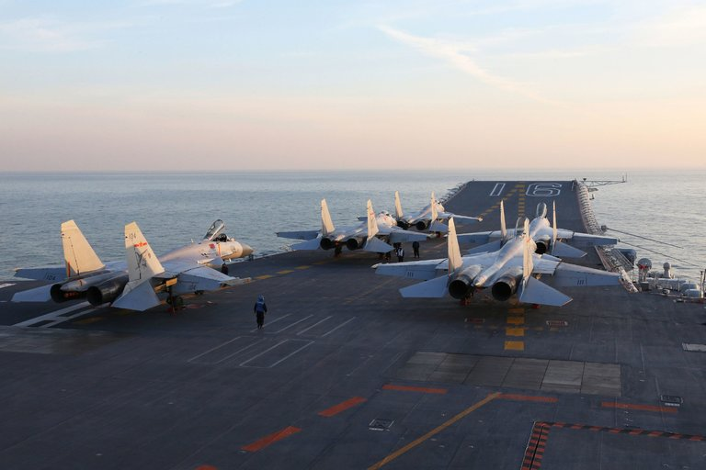
Fighter jets on the deck of China’s Liaoning aircraft carrier during military drills in the Bohai Sea, off China’s northeast coast, this month. Credit Agence France-Presse — Getty Images
BEIJING — The Chinese military, in a move analysts described as a challenge to President-elect Donald J. Trump’s strident criticism of China, has deployed an aircraft carrier to patrol the contested South China Sea, officials said on Tuesday.
The ship, which is known as the Liaoning and is China’s first and only aircraft carrier, was spotted leading five other Chinese warships this week in patrols near the coasts of Taiwan and Japan. China claims the South China Sea as its own despite objections from neighboring countries and the United States.
Chinese military experts called the deployment of the Liaoning a long-overdue challenge to American military dominance in the Pacific. Several said the move appeared aimed at testing Mr. Trump, who has antagonized Beijing with acerbic words and actions on issues like Taiwan, trade and North Korea.
“The message is: ‘If you test our bottom line, we’ll play that game too,’” said Ni Lexiong, a naval expert at Shanghai University of Political Science and Law.
The decision by Beijing to deploy the carrier group seemed likely to complicate an increasingly fractious relationship between China and the United States.
Nowhere are those tensions more on display than in the South China Sea, where American forces have resisted China’s efforts to build artificial islands and military outposts as part of its efforts to assert greater control over the sea, a major commercial waterway.
In the weeks since Mr. Trump’s election, Beijing has increased pressure on the United States, placing weapons on disputed islands and seizing an underwater United States Navy drone from international waters.
Chinese officials appear to be emboldened by Mr. Trump’s pledge to focus on domestic issues and his ambivalence toward the One China principle, an understanding between the United States and China that has underpinned relations for decades.
“The mission is to signal to neighbors that Beijing will set the security table in East Asian waters, and that not even President Donald Trump can reverse that trend,” Patrick M. Cronin, a senior director at the Center for a New American Security, a Washington think tank, said in an email.
Chinese officials played down the significance of the Liaoning’s journey, saying the ships were taking part in annual training exercises.
“The Liaoning aircraft carrier is entitled to the freedom of navigation and overflight under international law,” Hua Chunying, a spokeswoman for the Ministry of Foreign Affairs, said at a news conference on Monday. “We hope that all parties will respect this.”
Photo
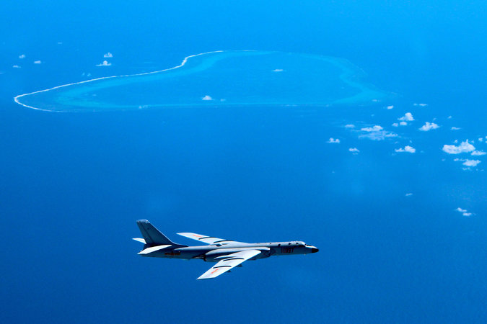
A Chinese H-6K bomber patrolling the islands and reefs of the South China Sea. Credit Liu Rui/Xinhua, via Associated Press
Officials in Taiwan and Japan said that the warships were spotted patrolling their coasts over the past several days. Taiwanese officials said the Liaoning came within 90 nautical miles of the southern tip of the island before entering the South China Sea. Japanese officials said the ships were seen near the shores of Okinawa, in the Pacific Ocean.
Many people in China cheered the deployment of the Liaoning, a discarded vessel bought from Ukraine in 1998 and refurbished by the Chinese Navy.
While the Liaoning lacks the capabilities of its American counterparts, it is a symbol of national pride for the government, which is in the midst of an effort to vastly upgrade its military capacity to meet its ambition of projecting strength far from Beijing. Officials have announced plans for a second aircraft carrier and other high-tech weapons.
Some commentators in China seized the moment to call on officials to send the Liaoning closer to American shores.
“Aircraft carriers are strategic tools which should be used to show China’s strength to the world and shape the outside world’s attitude toward China,” an editorial in Global Times, a state-run newspaper that often adopts a nationalistic tone, said on Sunday. “As China’s only aircraft carrier fleet now, it should have the ability and courage to sail further.”
The Department of Defense declined to directly address China’s movements in the South China Sea.
“We continue to observe a range of ongoing Chinese military activity in the region,” Cmdr. Gary Ross, a spokesman for the Pentagon, said in a statement on Tuesday. “The United States recognizes the rights, freedoms and lawful uses of the sea and airspace guaranteed to all countries in accordance with international law.”
In Taiwan, officials called for caution. Many residents worry that China is seeking to punish Taiwan for Mr. Trump’s actions. He surprised officials in Beijing when he took a call from President Tsai Ing-wen of Taiwan, breaking from decades of diplomatic practice. More recently, he suggested he might abandon the One China principle, prompting sharp rebukes from Beijing.
In a speech on Tuesday, Taiwan’s defense minister, Feng Shih-kuan, spoke about the dangers facing the island and urged more training for Taiwanese soldiers. “The threat of our enemies is growing day by day,” he said, according to Reuters.
As China looks to expand its power in the South China Sea, some experts argue that it risks antagonizing nearby countries, potentially pushing them to form stronger alliances with the United States.
“As China’s military power grows, the fear is that so, too, will its appetite for regional hegemony,” said Mr. Cronin of the Center for a New American Security. “Thus China’s coercion will impose yet new costs on Beijing.”
Still, others note China’s ability to win allies in the region through its economic might, and they point to the shifting allegiances of countries like the Philippines, an American ally that has warmed up to Beijing in recent months.
Xu Guangyu, a retired major general in the People’s Liberation Army, said China’s decision to deploy aircraft carriers in faraway waters and to expand its military were natural developments for a country of China’s stature.
“People in other countries should rest assured that China will not interfere in other country’s affairs like the U.S.,” he said.

NYT

China Sends Aircraft Carrier Into Taiwan Strait
By MICHAEL FORSYTHE and CHRIS BUCKLEYJAN. 10, 2017
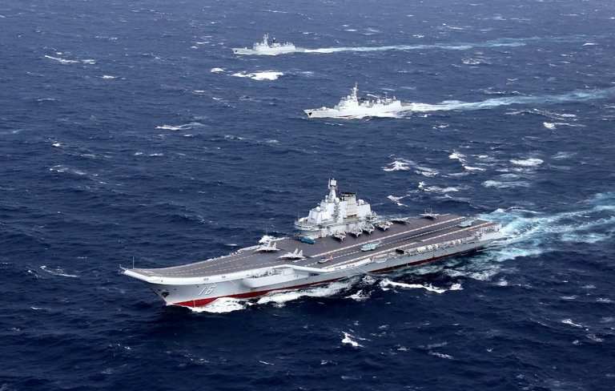
China’s lone aircraft carrier, the Liaoning, with accompanying ships during a drill in the South China Sea in December. Credit China Stringer Network, via Reuters
HONG KONG — China sent its sole aircraft carrier into the Taiwan Strait on Wednesday morning, Taiwan officials said, a defiant move that signals China’s growing naval strength and may foreshadow an early foreign policy challenge for President-elect Donald J. Trump when he takes office in nine days.
The transit of the aircraft carrier, the Liaoning, which had been conducting exercises in the South China Sea, comes amid rising tensions between Taiwan and China, and after Mr. Trump broke decades of protocol by speaking on the phone with Taiwan’s president, Tsai Ing-wen, after his election victory. Ms. Tsai leads a political party that has traditionally supported Taiwan’s formal independence from China.
“It’s a show of force, and I think it is intended in part to intimidate, and that’s worrisome from the U.S. and Taiwan’s point of view because we don’t know how much more they are going to ratchet up these pressures and tensions,” said Bonnie S. Glaser, senior adviser for Asia at the Center for Strategic and International Studies in Washington. “If the Trump administration does see this as a test of U.S. resolve, I suspect they’ll push back pretty forcefully.”
Taiwan scrambled F-16 fighter jets and a P-3C anti-submarine plane in response, and its navy dispatched a frigate to monitor the Liaoning’s movement, Taiwan’s official Central News Agency reported. Ms. Tsai, who is visiting Nicaragua, made two calls to Taiwan seeking updates on the Liaoning’s transit, the Central News Agency reported, citing Alex Huang, the president’s spokesman.
It was the third time in three days that air forces in the region had scrambled jets in response to Chinese military activity, after Japan and South Korea deployed fighters on Monday. Those actions occurred when a squadron of six Chinese bombers and two other aircraft flew over the waters that separate Japan and South Korea and over the Sea of Japan.
China was using the aircraft carrier to send a symbolic warning to both Taiwan and the incoming Trump administration, said Ni Lexiong, a naval affairs researcher at the Shanghai University of Political Science and Law.
“It’s all connected,” Mr. Ni said in a telephone interview. “Since Trump won the election, his words and actions have touched China’s bottom line. I think this was directed at America and the Taiwanese authorities. The aircraft carrier was on training exercises after all, but on the other hand, choosing this route to return was a response to their provocations.”
But Ms. Glaser said the action could have been planned well in advance as part of the vessel’s exercises in the South China Sea.
Liu Zhenmin, a Chinese vice foreign minister, said on Wednesday that the Taiwan Strait was an international waterway and that it was normal for the Liaoning to pass though it. The passage would not have any effect on cross-strait relations, he said in remarks carried in the Chinese news media.
Mark C. Toner, a State Department spokesman, told reporters in Washington in response to a question about the Liaoning’s passage through the strait that the United States “wouldn’t have a problem” with countries sailing their vessels in international waters so long as it was done in accordance with international law.
It also was not the first time the Liaoning had sailed through the strait: It passed through in November 2013 on its way to the South China Sea after having been commissioned only the year before.
In that instance, the carrier kept to the western half of the strait, closer to mainland China. In a statement on Wednesday morning, Taiwan’s Defense Ministry said that the Liaoning was also staying to the west of the strait’s middle and urged citizens to remain calm. A transit on the eastern side, closer to Taiwan, would be viewed as much more provocative.
Taiwan, considered by Beijing to be Chinese territory, has been ruled separately since 1949, when the forces of the Nationalist leader Chiang Kai-shek fled to the island following their defeat on the mainland by the Communists. China views any assertion of Taiwan’s separateness from the mainland, such as Ms. Tsai’s call with Mr. Trump, as an affront to its claim of sovereignty.
Since 1979, the United States has recognized the government in Beijing and broke off formal diplomatic ties to Taiwan as part of the One China policy. In the wake of the Trump-Tsai phone call, China warned the incoming president against making changes to that policy after he takes office on Jan. 20.
Euan Graham, the director of the International Security Program at the Lowy Institute in Sydney, Australia, said that for the Chinese, traveling through the strait was a logical way to move from one area of fleet operations to another along its long coastline. In order for warships based in northern ports, like the Liaoning, to return home from southern waters, they must either pass close to Japanese islands or transit the Taiwan Strait. “Geography forces a very binary choice,” he said.
Mr. Graham said it was important to see how the Liaoning conducted its passage. If it had aircraft on deck and was conducting flight operations, that would be seen as more provocative than if it passed through the strait with the aircraft in its hangar bay, he said.
The Liaoning, commissioned in 2012 and built from a Soviet hull, is China’s first aircraft carrier. In past decades, the United States has shown its resolve to defend Taiwan by sailing carriers through the Taiwan Strait. In 1995, the aircraft carrier Nimitz transited the strait amid heightened tensions after Beijing conducted missile exercises in the waters.
China’s military decision-making is highly secretive, but it would seem inconceivable for the Liaoning to pass through such contested waters without approval from the president, Xi Jinping, who is also the chairman of the Central Military Commission, which controls the military. And the Chinese military media has described the aircraft carrier as embodying Mr. Xi’s plans for a stronger navy, capable of projecting force far beyond China’s territorial waters.
Last Thursday, the front page of People’s Liberation Army Daily, the official newspaper of the Chinese military, featured a report about the aircraft carrier’s latest journey under the headline, “We’re sailing under the leader’s attentive gaze,” a clear tribute to Mr. Xi.
Although the passage of the Liaoning sent an emphatic political message, China’s aircraft carrier program is still in its fledgling stage.
The Liaoning, refashioned from an unfinished hull bought from Ukraine, displaces about 60,000 tons. That is much smaller than the American Navy’s Nimitz-class aircraft carriers, which have a displacement of 97,000 tons.
In contrast with China’s one carrier, the American Navy has 10 operational aircraft carriers and one more, the Gerald R. Ford, which will soon be commissioned.
China is building a second aircraft carrier in Dalian, a northeastern port city, and experts estimate that the second carrier, similar in design to the Liaoning but perhaps a bit larger, will be ready to launch this year or next. After that, the Chinese Navy appears likely to start building larger carriers.
Ma Xiaoguang, a spokesman for the Taiwan Affairs Office in Beijing, said in a news conference on Wednesday that the Liaoning’s passage was part of the ship’s scheduled training in the western Pacific, which had begun on Dec. 24.
Mr. Ma also said that the Taiwan-China relationship in the coming year would face “increasing uncertainty, looming risks and challenges.”
He added that Taiwan’s government and “independence forces” there had “seriously threatened the peace and stability of the Taiwan Strait,” accusing them of engaging in separatist activities and warning that China would “resolutely safeguard its national sovereignty and territorial integrity.”
The aircraft carrier’s passage was part of a cluster of recent acts by the Chinese military that have raised regional hackles.
Last month, a Chinese warship seized an underwater drone belonging to the United States Navy about 50 miles northwest of Subic Bay in the Philippines. The drone was returned after the Obama administration publicly chided China over the seizure. On Monday, Japan said it had sent fighter jets into the air after Chinese bombers and surveillance planes flew over the East China Sea and the Sea of Japan.
“When China was militarily weaker, Japan considered that area to be its backyard,” said Mr. Ni, the naval researcher. “This was a way of telling Japan that if there ever is conflict, the location of any future battle space won’t be decided by you and America. We have the initiative. So Japan, don’t think of meddling further afield in Taiwan or the South China Sea.”
NYT

Taiwan Responds After China Sends Carrier to Taiwan Strait
点击查看本文中文版
By MICHAEL FORSYTHE and CHRIS BUCKLEYJAN. 10, 2017
China’s lone aircraft carrier, the Liaoning, with accompanying ships during a drill in the South China Sea in December. Credit China Stringer Network, via Reuters
HONG KONG — Taiwan scrambled F-16 fighter jets and dispatched a frigate to the Taiwan Strait on Wednesday after China sent its sole aircraft carrier into the waterway, Taiwan’s official Central News Agency reported.
The transit of the aircraft carrier, the Liaoning, came amid rising tensions between Taiwan and China after President-elect Donald J. Trump broke decades of protocol by speaking on the phone with Taiwan’s president, Tsai Ing-wen, after his election victory. Ms. Tsai leads a political party that has traditionally supported Taiwan’s formal independence from China.
Ms. Tsai, who is visiting Central America this week, made two calls to officials in Taiwan seeking updates on the Liaoning’s transit, the Central News Agency reported, citing Alex Huang, the president’s spokesman. China’s decision to send the carrier through the waterway that separates it from Taiwan reflects an early foreign policy challenge for Mr. Trump.
“It’s a show of force, and I think it is intended in part to intimidate, and that’s worrisome from the U.S. and Taiwan’s point of view because we don’t know how much more they are going to ratchet up these pressures and tensions,” said Bonnie S. Glaser, senior adviser for Asia at the Center for Strategic and International Studies in Washington. “If the Trump administration does see this as a test of U.S. resolve, I suspect they’ll push back pretty forcefully.”
China sent the carrier, which had been conducting exercises in the South China Sea, into the Taiwan Strait on Wednesday morning. Taiwan’s response was the third time in three days that air forces in the region had scrambled jets in response to Chinese military activity, after Japan and South Korea deployed fighters on Monday. Those actions occurred when a squadron of six Chinese bombers and two other aircraft flew over the waters that separate Japan and South Korea and over the Sea of Japan.
Taiwan, considered by Beijing to be Chinese territory, has been governed separately since 1949, when the forces of the Nationalist leader Chiang Kai-shek fled to the island after their defeat on the mainland by the Communists. China views any assertion of Taiwan’s separateness from the mainland — like Ms. Tsai’s call with Mr. Trump — as an affront to its claim of sovereignty.
Since 1979, the United States has recognized the government in Beijing and broke off formal diplomatic ties to Taiwan as part of the One China policy. In the wake of the Trump-Tsai call, China warned the incoming president against making changes to that policy after he takes office on Jan. 20.
Liu Zhenmin, a Chinese vice foreign minister, said on Wednesday that the Taiwan Strait was an international waterway and that it was normal for the Liaoning to pass though it. The passage would not have any effect on cross-strait relations, he said in remarks carried in the Chinese news media.
Mark C. Toner, a State Department spokesman, told reporters in Washington in response to a question about the Liaoning’s passage through the strait that the United States “wouldn’t have a problem” with countries sailing their vessels in international waters as long as it was done in accordance with international law.
It also was not the first time the Liaoning had sailed through the strait: It passed through in November 2013 on its way to the South China Sea after having been commissioned only the year before.
In that instance, the carrier kept to the western half of the strait, closer to mainland China. In a statement on Wednesday morning, Taiwan’s Defense Ministry said that the Liaoning was also staying to the west of the strait’s middle and urged citizens to remain calm. A transit on the eastern side, closer to Taiwan, would be viewed as much more provocative.
Euan Graham, the director of the International Security Program at the Lowy Institute in Sydney, Australia, said that for the Chinese, traveling through the strait was a logical way to move from one area of fleet operations to another along its long coastline. In order for warships based in northern ports, like the Liaoning, to return home from southern waters, they must either pass close to Japanese islands or transit the Taiwan Strait. “Geography forces a very binary choice,” he said.
Mr. Graham said it was important to see how the Liaoning conducted its passage. If it had aircraft on deck and was conducting flight operations, that would be seen as more provocative than if it passed through the strait with the aircraft in its hangar bay, he said.
The Liaoning, commissioned in 2012 and built from a Soviet hull, is China’s first aircraft carrier. In past decades, the United States has shown its resolve to defend Taiwan by sailing carriers through the Taiwan Strait. In 1995, the aircraft carrier Nimitz transited the strait amid heightened tensions after Beijing conducted missile exercises in the waters.
China’s military decision-making is highly secretive, but it would seem inconceivable for the Liaoning to pass through such contested waters without approval from the president, Xi Jinping, who is also the chairman of the Central Military Commission, which controls the military. And the Chinese military media has described the aircraft carrier as embodying Mr. Xi’s plans for a stronger navy, capable of projecting force far beyond China’s territorial waters.
Last Thursday, the front page of People’s Liberation Army Daily, the official newspaper of the Chinese military, featured a report about the aircraft carrier’s latest journey under the headline, “We’re sailing under the leader’s attentive gaze,” a clear tribute to Mr. Xi.
Ma Xiaoguang, a spokesman for the Taiwan Affairs Office in Beijing, said in a news conference on Wednesday that the Liaoning’s passage was part of the ship’s scheduled training in the western Pacific, which had begun on Dec. 24.
Mr. Ma also said that the Taiwan-China relationship in the coming year would face “increasing uncertainty, looming risks and challenges.”
He added that Taiwan’s government and “independence forces” there had “seriously threatened the peace and stability of the Taiwan Strait,” accusing them of engaging in separatist activities and warning that China would “resolutely safeguard its national sovereignty and territorial integrity.”
The aircraft carrier’s passage was part of a cluster of recent acts by the Chinese military that have raised hackles in the region.
Last month, a Chinese warship seized an underwater drone belonging to the United States Navy about 50 miles northwest of Subic Bay in the Philippines. The drone was returned after the Obama administration publicly chided China over the seizure. On Monday, Japan said it had sent fighter jets into the air after Chinese bombers and surveillance planes flew over the East China Sea and the Sea of Japan.
“When China was militarily weaker, Japan considered that area to be its backyard,” said Ni Lexiong, a naval affairs researcher at the Shanghai University of Political Science and Law. “This was a way of telling Japan that if there ever is conflict, the location of any future battle space won’t be decided by you and America. We have the initiative. So Japan, don’t think of meddling further afield in Taiwan or the South China Sea.”

NYT

Rex Tillerson’s South China Sea Remarks Foreshadow Possible Foreign Policy Crisis
By MICHAEL FORSYTHEJAN. 12, 2017
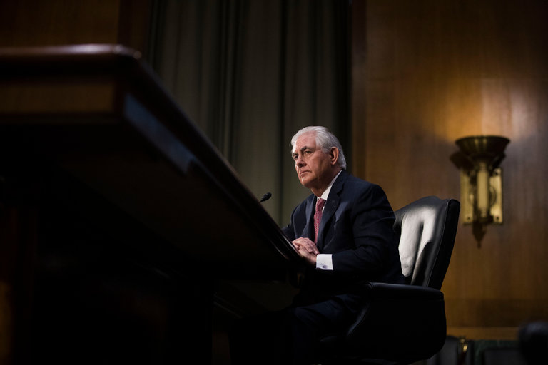
Rex W. Tillerson, the nominee for secretary of state, told senators on Wednesday that China’s actions in the South China Sea were “akin to Russia’s taking of Crimea.” Credit Doug Mills/The New York Times
HONG KONG — Rex W. Tillerson’s call for China to be denied access to its artificial islands in the South China Sea, made Wednesday during his confirmation hearing for secretary of state, set the stage for a possible crisis between the world’s two biggest economies should his comments become official American policy.
Mr. Tillerson told members of the Senate Foreign Relations Committee on Wednesday that China’s multibillion-dollar island-building campaign in the oil-and-gas rich sea was illegal and “akin to Russia’s taking of Crimea.”
“We’re going to have to send China a clear signal that, first, the island-building stops,” Mr. Tillerson told the senators. “And second, your access to those islands also is not going to be allowed.”
Should those words be translated into action after Donald J. Trump assumes the presidency on Jan. 20, it would be a remarkable change in the American approach to Beijing’s island-building in the South China Sea, which is transforming the area into what one Washington think tank said would by 2030 become “virtually a Chinese lake.” China asserts sovereignty over most of the South China Sea despite competing claims by countries including Vietnam and the Philippines and an international ruling rejecting most of Beijing’s assertions.
The Obama administration has challenged what it calls China’s “excessive maritime claims” in the sea by sailing warships close to the artificial islands, some of which feature deep harbors and runways capable of handling jumbo jets. But that has not stopped China from continuing its buildup, which now includes military installations such as radar stations on more than 3,000 acres of artificial land built on reefs and shoals.
Mr. Tillerson’s comments, with the possible implication that the United States might use its armed forces to deny the Chinese access to the islands, garnered reactions including confusion, disbelief and warlike threats from analysts in China.
“This is a signal, now that Trump is set to take office, that he wants to have a tough stand on China,” said Yang Chengjun, a retired senior colonel and military expert, who said that China’s potential war-fighting capability was greater than America’s. “China does not stir up troubles but we are not afraid of them when they come.”
Lu Kang, a spokesman for the Chinese Foreign Ministry, declined to answer a reporter’s question about what Beijing might do if the United States Navy moved to deny China access to the islands, saying it was a “hypothetical question.”
But his reaction also highlighted the confusion sown by the testimony, because Mr. Tillerson did not explain how the United States could block China from the islands.
Photo
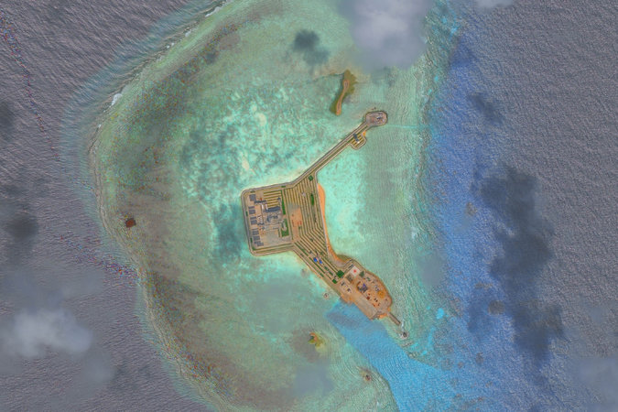
One of China’s artificial islands in the Gaven Reefs in the South China Sea. Credit DigitalGlobe, via Getty Images
“I can’t predict what Mr. Tillerson is thinking specifically, and on the other hand, it is impossible for me to make any prediction about China’s policy, based on your assumptions of what he said,” Mr. Lu said.
That confusion was shared by one of China’s most prominent experts on the South China Sea, who also questioned the legality of any American effort to block access to the islands.
“Is this a warning? Or will this be a policy option?” said Zhu Feng, executive director of the China Center for Collaborative Studies of the South China Sea at Nanjing University. “If this is a policy option, this will not be able to block China’s access to these constructed islands. There is no legal basis.”
Mr. Trump’s transition team did not respond to emailed questions asking for details on Mr. Tillerson’s remarks, and whether they represented the intended policy of the United States after Mr. Trump assumes the presidency.
What is also not clear is the extent to which Mr. Tillerson’s tough stance on the South China Sea springs from his extensive experience in the region during his time as chief executive of Exxon Mobil, when his company became embroiled in bitter territorial disputes over the extensive oil and gas reserves beneath the seafloor.
During his tenure, the company forged close ties to the Vietnamese government, signing an agreement in 2009 with a state-owned firm to drill for oil and gas in two areas in the South China Sea. The agreement with PetroVietnam was signed quietly, according to a leaked United States diplomatic cable, because it conflicted with Chinese territorial claims.
While Exxon Mobil has some operations in China, including a stake in a petrochemical plant in the country’s south, it has a very small presence in the country’s huge retail market for gasoline, which is dominated by state-owned Chinese companies. In contrast, its agreements with Vietnam are potentially huge, given that the South China Sea may contain 11 billion barrels of oil and 190 trillion cubic feet of natural gas, according to the United States Energy Information Administration.
A spokeswoman for Exxon Mobil in Singapore did not return a phone call asking for comment about the company’s operations in Vietnam. The Vietnamese Foreign Ministry did not reply to a request for comment about Mr. Tillerson’s remarks.
But his statements have put further strains on one of the world’s most important bilateral relationships. Policy directions set by President Richard M. Nixon more than 40 years ago have remained relatively steady under the Republican and Democratic administrations that followed. But Mr. Trump’s talk of enacting new tariffs on Chinese goods and his willingness to break decades of protocol by taking a phone call from Taiwan’s president have called those policies into question.
“How much farther will the Trump administration go?” said Mr. Zhu of Nanjing University. “When it comes to South China Sea, we’ll have to wait and see.”

NYT

Philippines Sends Defense Chief to Disputed South China Sea Island
By FELIPE VILLAMORAPRIL 21, 2017
Continue reading the main story Share This Page
- Share
- Tweet
- Email
- More
- Save
Photo
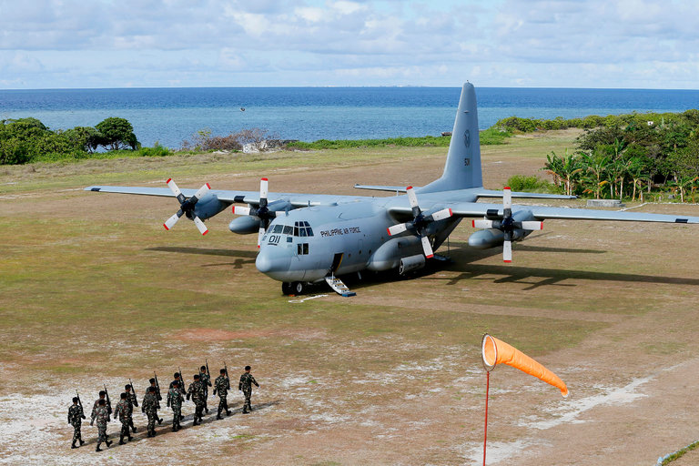
A Philippine military transport plane on Pag-asa Island, also known as Thitu, in the South China Sea on Friday. Credit Bullit Marquez/Associated Press
MANILA — The Philippines sent its top military officials on Friday to an island it occupies in the disputed South China Sea to reinforce the country’s claim.
Even before the military C-130 transport aircraft reached Pag-asa Island, also known as Thitu, the Chinese challenged the flight at least four times on radio as it passed through the region. China claims the island, as do Vietnam and Taiwan.
Defense Secretary Delfin Lorenzana, who led the trip, sought to play down the challenge from the Chinese, saying it was their “protocol” to question aircraft flying over what they regarded as their airspace. “No untoward incident happened,” he added.
Pag-asa is part of the Spratly Islands, an archipelago of about 14 islets and dozens of reefs and shoals. It is believed to lie atop vast reserves of natural deposits, and the varying claims are a point of conflict for the region.
Photo

The Philippine defense secretary, Delfin Lorenzana, during a visit to the island on Friday. Credit Ted Aljibe/Agence France-Presse — Getty Images
China claims the vast majority of the South China Sea, and it has been bolstering its presence there by expanding shoals into artificial islands and building military and other facilities. The Philippines has contested many of China’s claims, but President Rodrigo Duterte has taken a more conciliatory stance since taking office last year.
This month, however, Mr. Duterte appeared to antagonize China by ordering the military to deploy to islands claimed by the Philippines. Mr. Lorenzana soon walked back those comments, however.
Mr. Duterte also recently said he would go to Pag-asa on the Philippines’ independence day in June to plant the country’s flag, but he later said he would not do so.
Mr. Lorenzana said on Friday that he went to Pag-asa to check the island’s facilities, saying that the runway needed repairs and that docks should be upgraded. He said a “beaching ramp” was to be built on the island before the typhoon season starts in July.
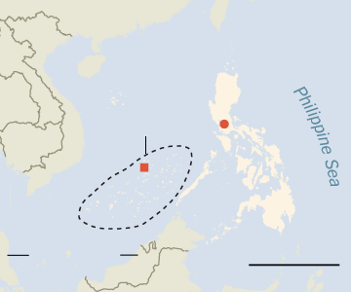
CHINA
Pacific
Ocean
VIETNAM
South
China Sea
Manila
SPRATLY IS.
Pag-asa
PHILIPPINES
Celebes Sea
MALAYSIA
500 mileS
By The New York Times
Apart from fixing the runway, the government has also earmarked $32 million for a fishing port, a power and desalination plant, a radio station and an ice plant. A marine research sanctuary is also being planned, as the government hopes to turn the area into a tourist attraction, Mr. Lorenzana said.
Mr. Lorenzana said he expected China to protest his trip and the development plans. “That protest is automatic. We both claim the region,” he said. “If they build in other areas in the region, we also protest.”
Pag-asa is considered an island municipality, attached to the island province of Palawan. It is occupied by troops and governed by an elected official, who also joined Mr. Lorenzana’s trip.
The trip coincided with a report that a group of Filipino fishermen had been fired on by the Chinese Coast Guard last month while sailing near the Union Banks atoll, also in the disputed region.
The Philippine Coast Guard said fishermen had reported that a Chinese Coast Guard speedboat had fired at them seven times after it dropped anchor in the area on March 27. The Chinese Embassy in Manila did not respond to requests for comment about the report.

American Interest

Published on: July 22, 2016
South China Sea Change
India’s Response to the South China Sea Verdict Mohan Malik

The ruling couldn’t have been better for New Delhi, but where India goes next depends on China’s response.
The verdict by the Permanent Court of Arbitration (PCA) rejecting China’s ownership claims to 80 percent of the South China Sea (an area almost the size of India) was greeted with much satisfaction and glee in New Delhi. This was the first time that the entire basis of China’s “historical claims” (for example, the “nine-dash line”) was ruled to be invalid under international law by an international tribunal. The ruling not only has important implications for countries with unresolved territorial disputes with China but also impinges on India’s relations with Japan, the United States, ASEAN countries, and the international order. Coming as it did close on the heels of Beijing’s successful blocking—citing legal procedures—of New Delhi’s bids to gain entry into the Nuclear Suppliers Group (NSG) and to have the Pakistani terrorist Masood Azhar banned by the United Nations Security Council (UNSC), the verdict was seen as a “damning indictment” of China’s flouting of the United Nations Convention on the Law of the Sea (UNCLOS) and Security Council resolutions against terrorism that Beijing had itself signed and supported.
Chiding China
The Indian government’s official reaction was prompt and measured, with the Ministry of External Affairs (MEA) issuing a statement on the day of the award that called on all parties to show the “utmost respect” for the UNCLOS. By stressing that “India supports freedom of navigation and over-flight, and unimpeded commerce, based on the principles of international law, as reflected notably in the UNCLOS,” the MEA statement was seen as chiding China. Emphasizing India’s specific national interest in the issue, it added: “States should resolve disputes through peaceful means without threat or use of force and exercise self-restraint in the conduct of activities that could complicate or escalate disputes affecting peace and stability.” The demand for “utmost respect,” the assertion of India’s vital interest in maintaining “freedom of navigation and overflight rights under UNCLOS” and aversion to “activities that complicate or escalate disputes”—all implied strong criticism of Beijing’s intention to reject the tribunal’s verdict and continue as before.
As expected, China strongly condemned the verdict, declaring it null and void, and questioned the legality of the tribunal itself. Its response contrasted sharply with India’s graceful acceptance of a similar arbitration between it and Bangladesh two years ago, even though the verdict went in favor of its smaller neighbor. However, it was not India that reminded China and the world about the adverse maritime-delimitation arbitration it had accepted with Bangladesh but U.S. Assistant Secretary of Defense for East Asia Abraham Denmark. On the eve of the verdict, Denmark called on China to follow India’s example of resolving its maritime boundary dispute with Bangladesh by accepting the ruling of a tribunal appointed by the PCA. However, an enraged China vehemently denounced U.S. advice to follow India’s example claiming that there was “no comparison” between the two cases.
At the same time, China’s desperation to dispel the widespread perception of its global isolation led state-run media and diplomats to make outlandish claims about the support of sixty countries, including India. China’s Charge d’Affaires to India, Liu Jinsong, insisted disingenuously that India’s position on the South China Sea was “quite similar” to China’s own, as India had signed a “common position” statement on the issue in April 2016 in Moscow. The Russia-India-China trilateral joint communiqué by three foreign ministers did resemble the language used by Chinese foreign ministry statements: It called for all disputes in the South China Sea (SCS) to “be addressed through negotiations and agreements between the parties concerned. In this regard, the Ministers called for full respect of all provisions of UNCLOS, as well as the Declaration on the Conduct of Parties in the South China Sea (DOC) and the Guidelines for the implementation of the DOC.” However, while Chinese officials deliberately highlighted the first sentence, Indian officialdom and media took comfort from the second sentence, which placed limits on the first. Apparently, faced with the challenge of balancing India’s interests between the Russia-India-China continental trilateral and the U.S.-Japan-India maritime trilateral, the “please-all” joint communiqué was an act of diplomatic tap-dancing by New Delhi. Despite Beijing’s claims of substantial global support, only ten countries—nearly all of them landlocked, poor, corrupt, and dependent on Chinese largesse—openly lent support to China’s stance that it was “complying with the international law by rejecting the illegal tribunal’s verdict.”
Much to Beijing’s chagrin, a joint statement issued by Indian and Japanese Defense Ministers following the annual Indo-Japanese Defense Ministerial Meeting two days later on July 14 again urged parties to “show utmost respect for the UNCLOS” and expressed the two countries’ “concern over recent developments” (Chinese actions such as the landing of planes on artificial islands and the tirade against the tribunal judges, coupled with threats to declare an air defense identification zone over the SCS). The language closely resembled separate statements issued by India’s MEA and Japan’s Ministry of Foreign Affairs on July 12. It was the second time that a joint Indo-Japanese statement mentioned the SCS territorial disputes and brought into sharp focus the evolving geopolitical alignments in Asia. In December 2015, a joint statement by Indian Prime Minister Narendra Modi and Japanese Prime Minister Shinzo Abe had called all parties to “avoid unilateral actions” in the South China Sea “that could lead to tensions in the region.” Tokyo and New Delhi also agreed to deepen their overall military cooperation by setting up a Maritime Strategic Dialogue and conducting the India-U.S.-Japan trilateral maritime exercise, Exercise Malabar, annually.
The China-India Geopolitical Rivalry
The growing Sino-Indian discord over the South China Sea adds to numerous stresses and strains in their bilateral relationship, still scarred by a border war of 1962 and unresolved territorial disputes in the Himalayas. With their growing economies and expanding geopolitical horizons, Asia’s giants now compete for forward presence and influence, especially as they scramble for energy resources. Since 2008, China has sent nearly two dozen naval expeditions to the Indian Ocean, ostensibly to counter piracy but implicitly to project power in the region. Given their unresolved disputes, China’s role as the largest arms supplier to India’s neighbors, and patrols by Chinese nuclear submarines in the Indian Ocean (which New Delhi considers its strategic backyard), India is understandably maneuvering for advantage in those spheres of influence that overlap with China. New Delhi has reached out to Asian neighbors but also to faraway countries in Beijing’s increasingly expansive shadow, most notably beleaguered Vietnam, the Philippines and Japan. India, much like Vietnam, has long perceived China as an irredentist and expansionist power. As noted strategic affairs analyst Brahma Chellaney observed recently, “China is not just aiming for uncontested control in the South China Sea; it is also working relentlessly to challenge the territorial status quo in the East China Sea and the Himalayas.” However, instead of launching “an old-fashioned invasion—an approach that could trigger a direct confrontation with the United States—China is creating new facts on the ground by confounding, bullying, and bribing adversaries.”
Since 55 percent of India’s trade passes through the SCS, the Indian Navy has of late come to prioritize energy security and sea-lane protection. Since 2007, Beijing has been protesting a Vietnamese-Indian energy exploration project in the disputed waters of the South China Sea, and there have even been reports of Chinese warships confronting Indian naval vessels in the region. Ignoring Beijing’s warnings, India has publicly supported Vietnam and the Philippines, in particular in their disputes with Beijing, and continues to cooperate with Hanoi on hydrocarbon exploration in the South China Sea. In bilateral declarations with Manila, New Delhi has acknowledged the region as part of the West Philippines Sea and refused to endorse the Chinese discourse on the South China Sea. So India is clawing for influence, just as China is.
As part of its “Act East” policy that dovetails with the “U.S. rebalance” and Japan’s “Proactive Contribution to Peace,” India has increased coordination, both military and diplomatic, with East and Southeast nations that also see China as a threat. New Delhi is currently negotiating the sale of the BrahMos cruise missile to Vietnam and frigates and patrol craft to the Philippines, while also forging military-to-military ties and economic and trade links with Indonesia, Malaysia, Thailand, and Singapore. At a time when ASEAN stands divided, India is placing itself at the center of regional relationships with Mongolia, Vietnam, the Philippines, Australia, Indonesia and Thailand as part of security architecture that would balance a rising China and enhance the safety and security of the global commons. In their high-level joint statements, both the United States and India have repeatedly declared their support for freedom of navigation and overflight, signaling that the Modi government is not shy about explicitly aligning U.S. and Indian strategic aims in the Indo-Pacific to counter China’s expansionist moves.
For its part, China is increasingly uncomfortable with the prospect of India playing a greater role in the Indian and Pacific Oceans. Beijing disapproves of India’s joint naval exercises with the United States, Japan, Vietnam, and Singapore in the East and South China Seas. Beijing has let it be known that would not tolerate another maritime power operating in the South China Sea—which its officials have described as a “core interest” in relation to state sovereignty, territorial integrity, and national security, and thus inextricably linked to the Communist regime’s domestic legitimacy and survival. Control over the South China Sea is also vitally important to the success of Xi Jinping’s Maritime Silk Road strategy.
Debating Gains, Costs and Options
Indian policymakers and commentators often accuse China of double standards. They emphasize that the UNCLOS is not an “unequal treaty” imposed on Beijing by external powers. For years China participated as an equal in negotiating the UNCLOS and consented to the dispute-settlement procedures therein when it became a party to the treaty. What’s more, China makes full use of naval rights and freedoms under the UNCLOS in seas and oceans where it is not a littoral state yet seeks a major role, such as in the Indian Ocean and the Arctic Sea, but it denies the same rights and freedoms to other countries closer to home in the East and South China seas.
India’s old China hands also note a striking similarity between the tactics adopted by Beijing to extend its land frontiers in the Himalayas and those it uses to advance its maritime boundary in the South China Sea. Just as the People’s Liberation Army (PLA) periodically sends border patrols in the garb of villagers, yak graziers, and road-construction engineering teams to the Indo-Tibetan border to change the facts on the ground, coast guard, fishermen, and maritime militias have been dispatched to expand China’s maritime frontier in the South China Sea.
Beijing engages in verbal trickery as well. Though from a legal standpoint, the usage of the nomenclature “South China Sea” does not amount to recognition of historical Chinese sovereignty, Chinese admirals and generals claim with a straight face that “the South China Sea, as the name indicates, is China’s sea” (Rear Admiral Yuan Yubai, Sep 2015), but “the Indian Ocean is not India’s ocean” (Captain Zhao Yi, Sep 2015; Gen Zhao Nanqi, 1993)—a particularly galling claim for New Delhi. Although Beijing claims about 80 percent of the South China Sea as its “historic waters” (and has now elevated this claim to a “core interest” akin with its claims on Taiwan and Tibet), China has, historically speaking, about as much right to claim the South China Sea for its exclusive use as Mexico has to claim the Gulf of Mexico, or Iran the Persian Gulf, or India the Indian Ocean. In other words, none at all.
The continued reinterpretation of history to advance contemporary political, territorial, and maritime claims, coupled with the Communist leadership’s ability to turn “nationalistic eruptions” on and off like a tap during moments of tension with the United States, Japan, Vietnam, the Philippines, and India makes it difficult for Beijing to reassure neighbors that its “peaceful rise” is anything like peaceful. Though Chinese leaders and diplomats still chant the mantra of “peaceful rise,” their body language tells everyone to get out of their way.
Against this backdrop, India could not have hoped for a better PCA ruling. The verdict is a welcome development for India’s burgeoning economic and strategic interests (especially oil exploration off Vietnam) as the tribunal declared the South China Sea to be international waters. Strategically, the ruling provides legal and diplomatic cover for increased Indian naval engagement (including freedom of navigation operations and joint exercises) with other Southeast Asian countries in the South China Sea. A clear victory for the Philippines is also a shot in the arm for other claimants like Malaysia, Indonesia, Vietnam, and Brunei should they choose to bring their cases to the PCA. Indian strategists believe that China’s attempts to split ASEAN would polarize the region resulting in “China versus the Rest.” The ruling should give India greater maneuverability to act as a balancing power or as a possible counterweight to China in the Indo-Pacific. Given China’s bases (Djibouti and Gwadar) and increasing naval forays in the Indian Ocean, the Indian Navy wants to stake out a presence in the South China Sea, mainly to counter China’s in the Indian Ocean. Not only that, the court ruling’s denunciation of Xi Jinping’s South China Sea policy raises questions about his judgement and leadership and could weaken Xi’s hold on power at the next Party congress. In addition, it could unravel Xi’s ambitious Maritime Silk Road through the Indian Ocean—another net gain for India.
The tribunal’s award could be beneficial for India in other ways, too. China’s disregard for international law puts Beijing, which had earlier blockaded New Delhi’s NSG bid by citing the law, on the back foot. India, by contrast, stands on a higher moral ground for having obeyed the PCA’s award to Bangladesh on a similar issue. This development should bolster India’s case for NSG membership and undermine China’s efforts to rally countries like South Africa, Brazil, Ireland, and New Zealand against India in the next plenary meeting.
More importantly, some Indian strategic analysts believe that the tribunal award, which demolished China’s historical claims regarding the “nine-dash line,” could also undermine China’s claims to Arunachal Pradesh. India, for one, has never bought Beijing’s historical argument on Tibet. If historical claims had any validity, then Mongolia could claim all of Asia simply because it once conquered the lands of the continent. The tribunal also concluded that, if China had historical rights to resources in the waters of the South China Sea, such rights were extinguished to the extent they were incompatible with the exclusive economic zones provided for in the UNCLOS. If one were to apply the same logic to the Sino-Indian boundary dispute, the PCA verdict would seem to bolster India’s case vis-à-vis China. As one Indian China expert, Srikanth Kondapalli, points out: “In 1914, the Simla Conference, which resulted in the MacMahon Line, was initialed by Chen Yifan of the Nationalist government. While the document was not expanded into a treaty later (due to differences over the Sino-Tibetan boundary, not the Indo-Tibetan border), according to international law, initialing implies the freezing of negotiations.” So, Kondapalli argues against extending China’s historical argument “to cover Arunachal Pradesh, which can, at best be described as a semi-legal case.” The international tribunal would concur: law trumps history.
Many Indian strategic analysts, still smarting from China’s obstructionist posture in international forums, want Beijing to stew in its own juice, and favor their government’s adoption of a tit-for-tat policy. Just as non-proliferation rules cannot be bent for New Delhi, they maintain, UNCLOS rules must not be bent for Beijing. The PCA ruling “establishes international legal order of seas and oceans and all parties must respect it.” For them, China’s rejection of the verdict is all the more galling when compared with India’s acceptance of an adverse UNCLOS ruling on the disputed maritime boundary issue with Bangladesh.
Most believe that Xi’s China values territorial gains more than reputation costs. China’s growing economic strength, military might, and hyper-nationalism at home are spurring actions abroad that bring it into increasingly dangerous conflicts. For example, former Indian National Security Adviser S. S. Menon does not see the Chinese “backing down” any time soon and expects its “aggressive expansionism in the near future” to continue. In that case, Beijing’s belligerence would usher in the formation of a U.S.-led maritime coalition to maintain freedom of navigation and overflight in the Pacific.
On the other hand, some of India’s China experts and former diplomats stress the need to dial down tensions, help China find the middle path through diplomacy and negotiation, and enable Beijing to step back and uphold the rules-based system. China-watcher Kondapalli wants his country “to pursue a policy of mediation between China and the Southeast Asian countries for regional security.” Others caution against unnecessarily antagonizing or provoking China. Says former Foreign Secretary Kanwal Sibal: “China’s land threat to India and the strengthening of the China-Pakistan axis are much more serious for us than its maritime claims.” For retired Commodore C. Uday Bhaskar, an angry or petulant China that turns its back on mediation or international arbitration, and lashes out at its weaker neighbors is not a desirable outcome. He thinks that “India has more to lose than gain by ratcheting up tensions especially at a time when the Chinese could be probably be feeling hemmed in and isolated,” because “India after all does have vital interests in maintaining a peaceful and stable relationship with China given the extent of trade links, disparity in economic standing, existing border disputes, etc.” Having said that, nearly everyone wonders if the region’s future will be defined by adherence to international laws and norms or whether it will be determined by money and might.
Alternative Futures
The Hague ruling marks a definitive moment in the evolution of maritime law and Asia’s geopolitical order. The court case is over, but the dispute is not. The South China Sea, through which more than $5.3 trillion of maritime trade passes each year, is now the arena of a geopolitical poker game that will determine the future of regional order: Pax Sinica or Pax Americana. Washington seems as determined to preserve the U.S.-led liberal international order as Beijing is to change and modify it.
The PCA ruling forces China to decide what kind of a power it aspires to be—one that upholds existing laws and norms or one that flouts them in naked pursuit of power, territory, and hegemony. Whether a major power becomes a great power or not is also determined by the reactions or acquiescence of others. The support of Gambia, Sudan, Pakistan, Laos, or Cambodia will definitely not make China a great power. So, the choice is clear: Beijing can either dial down tensions or double down on its disputes. China’s choices will shape Asia’s future. Should Beijing adopt a moderate foreign policy course and re-commit itself to international law and norms, the Asian security environment will improve. All Asian countries want to benefit from economic ties with China, but none want the return of a Sino-centric tributary order.
Faced with an aggressive China, Asia’s major maritime and democratic powers—India, Japan, and Australia—will work in a more synchronized manner in a quadrilateral grouping with the United States. They will be backed by middle powers (South Korea, Vietnam, the Philippines, Malaysia, and Indonesia) which are increasingly worried about Chinese maritime behavior. They will cooperate closely with each other to promote and defend a rules-based order that does not advantage big and powerful nations at the expense of small and weak states. Over time, various bilateral, trilateral (such as Japan-Vietnam-the Philippines, the United States-Japan-India, Australia-Indonesia-India, India-Japan-Vietnam), and informal multilateral efforts to constrain China could coalesce into a maritime coalition or the “Indo-Pacific Maritime Partnership” (an “Asian NATO” by another name). If the Chinese dragon is seen as running rampant in lands and seas around India, a weak Indian tilt toward the United States would turn into a firm alignment against China.

The Quint
https://www.thequint.com/india/2016/07/13/south-china-sea-ruling-a-shot-in-the-arm-for-india-experts

India
- Home
- City
- India
- World
- Business
- Tech
- Cricket
- Sports
- Entertainment
- TV
- Life & Style
- Travel
- Blogs
- Photos
- Videos
- ePaper
- Times Now
- Live TV
- Property
- All Sections
- News Home
»
- India

South China Sea ruling a shot in the arm for India, a damning indictment of Beijing, say experts
Indrani Bagchi | TNN | Jul 12, 2016, 10.50 PM IST

Highlights
- The tribunal said China has no "historical rights" over South China Sea
- Tribunal said "none of the Spratly islands grant China an exclusive economic zone"
- China has said it will not be bound by any ruling

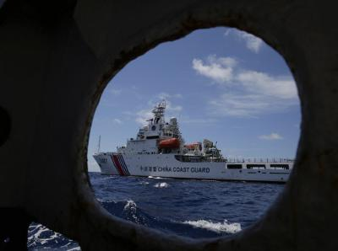
NEW DELHI: The verdict of The Hague, rejecting China's claims to economic rights across large swathes of the South China Sea , is a damning indictment of Beijing. Its significance also lies in its stunning clarity - it leaves China with absolutely no room for re-interpretation.
For India, it was a sweet verdict, because it was recently stifled by China at the Nuclear Suppliers Group. So the verdict by the UN-appointed international court of arbitration was greeted with much satisfaction by New Delhi.
China said it neither accepts nor recognizes the tribunal's verdict
India's comment after the verdict was measured, but it was chiding China, for sure.
"Sea lanes of communication passing through the South China Sea are critical for peace, stability, prosperity and development. As a State Party to the UNCLOS (United Nations Convention on the Law of the Sea), India urges all parties to show utmost respect for the UNCLOS, which establishes the international legal order of the seas and oceans" the external affairs ministry said in a statement.
Simultaneously, India's statement was also a reminder that India took an adverse UNCLOS ruling on the chin to resolve a maritime boundary issue with Bangladesh two years ago.
The MEA stated, "India supports freedom of navigation and over flight, and unimpeded commerce, based on the principles of international law, as reflected notably in the UNCLOS. India believes that States should resolve disputes through peaceful means without threat or use of force and exercise self-restraint in the conduct of activities that could complicate or escalate disputes affecting peace and stability."
It was a strong criticism of China's decision to disregard the award and continue as before. As expected, when China rejected the ruling it cited 2,000 years of history.
"China's territorial sovereignty and maritime rights and interests in the South China Sea shall under no circumstances be affected by those awards."
Shyam Saran, former foreign secretary said, "It's a damning indictment. Of course they can up the ante. But what does it do to them? They would appear as a rogue state if they fail to abide by international law."
Former NSA, Shivshankar Menon said he expects China to continue its aggressive expansionism in the South China Sea in the near future. "They cannot be seen to be backing down."
Victory not just for Philippines
Dr Mohan Malik, professor of Asian security in Asia-Pacific Center for Security Studies Hawaii, said the verdict would be beneficial for India, too, not just for the Philippines.
"The verdict is a welcome development for India's economic (especially oil exploration in the South China Sea off Vietnam) and strategic interests. It provides legal and diplomatic cover for increased Indian naval engagement with other south-east Asian countries," he said.
The Hague's verdict could be a shot in the arm for other claimants like Malaysia, Indonesia, Vietnam etc. But Indian strategists believe the ASEAN would become more polarised than ever. This could give India greater acceptability as a balancing power.
Malik said the award would be beneficial for India in other ways too. "It will bolster India's case for NSG membership and weaken China's opposition and efforts to rally countries like South Africa, Brazil, Ireland and New Zealand against India in the next plenary meeting."
The most important part of the tribunal's award is the unequivocal quashing of Chinese claims of its territory on the famed 'nine-dash line.'
"Tribunal concluded that, to the extent China had historic rights to resources in the waters of the South China Sea, such rights were extinguished to the extent they were incompatible with the exclusive economic zones provided for in the Convention....
The tribunal concluded that there was no legal basis for China to claim historic rights to resources within the sea areas falling within the 'nine-dash line'.
- Check Out Unbelievable List of Safest 2017 MinivansMinivans - Sponsored Ads
- Discover the Thrilling Features of the New Acura TLXAcura

The tribunal ruled China-occupied Spratly Islands could not "generate extended maritime zones" quashing China's claim that possession of these islands would give Beijing 200 nautical mile EEZ.

The court rapped China for violating "Philippines' sovereign rights in its exclusive economic zone" adding "Chinese law enforcement vessels had unlawfully created a serious risk of collision when they physically obstructed Philippine vessels."

China, the court ruled, "had caused severe harm to the coral reef environment and violated its obligation to preserve and protect fragile ecosystems and the habitat of depleted, threatened, or endangered species."

In a damning conclusion, it said "China's recent large-scale land reclamation and construction of artificial islands was incompatible with the obligations on a State during dispute resolution proceedings, insofar as China has inflicted irreparable harm to the marine environment, built a large artificial island in the Philippines' exclusive economic zone, and destroyed evidence of the natural condition of features in the South China Sea that formed part of the Parties' dispute."

World Affairs

Spring 2016

Balancing Act: The China-India-U.S. Triangle
Mohan Malik
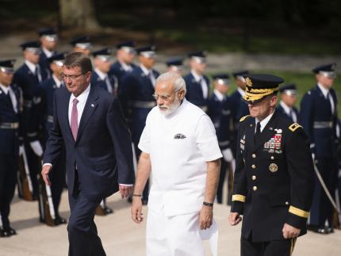
Addressing a security conference in India in March 2016, Admiral Harry Harris, Commander of U.S. Pacific Command, noted “with admiration India’s peaceful resolution of disputes with neighbors in the waters of the Indian Ocean,” while criticizing China for seeking “to bully smaller nations through intimidation and coercion.” It was more than a straw in the wind. Harris also called on India to join the United States, Japan, and Australia to deal with common security challenges in the Indo-Asia-Pacific region via the Quadrilateral Security Dialogue (or Quad). Although each values its economic ties with China, Washington, Tokyo, Canberra, and New Delhi, all share a common interest in ensuring that the Indo-Pacific region is not dominated by China and the overall balance of power remains favorable to the liberal democracies.
Many believe that Beijing would have been far less aggressive in its “island building” and the other challenges to the status quo in the Pacific norms if the Quad had already been in place. But Harris called for the new initiative in the spirit of better late than never. With media reporting the first-ever trilateral naval exercise planned by the U.S., Indian, and Japanese navies in the South China Sea, the Admiral hoped that in the not too distant future, American and Indian navy vessels steaming together will become “a common and welcome sight” throughout Indo-Asia-Pacific waters. Not surprisingly, China reacted fast and furiously to the prospect of a more robust Indo-U.S. entente, warning both to stand back.

The Origins of the Triangle
It was in 1971 that President Richard Nixon’s courting of Mao’s China amid the looming India–Pakistan war of December 1971 pushed the “non-aligned” India firmly into the Soviet camp. In the 1990s, President Bill Clinton’s attempts to establish a U.S.–China condominium to “cap, freeze and roll back” India’s nuclear program made New Delhi go nuclear and ballistic. Historically, the state of the Sino-U.S. relationship has always heavily influenced India’s foreign policy orientation.
The central appeal of the change proposed in the Quad initiative is that over the years of sometimes chilly relations with the United States, India is the only Asian power that has been committed to balancing China since 1962, after the People’s Liberation Army (PLA) marched into Tibet and converted the traditional Indo-Tibetan frontier into the disputed Sino-Indian boundary. Today, in one of those slow motion realignments that enliven history, India’s traditional security concerns—Pakistan (in the form of militant Islam) and China (irredentism and revisionism)—have finally become Washington’s immediate and long-term security concerns as well. The threat of terrorism and the need to contain Chinese regional muscularity, along with growing economic synergy in the high-tech sector, transformed U.S. ties with India. So, in 2002, three decades after Nixon’s opening with China led “non-aligned” India to ally with the USSR and eventually go nuclear, President George W. Bush let India’s Premier A. B. Vajpayee know that the times were changing: “A strong India can help provide the balance of power in the entire Asian region.” India’s economic rise was seen as serving Washington’s long-term interests by ensuring that there would be countervailing powers in Asia—China, Japan, and India—able to prevent the domination of the region by any one power.
The Bush administration lifted decades-old sanctions against India imposed over its nuclear weapons program and concluded defense (2005) and nuclear (2008) cooperation agreements. His successor, President Barack Obama described the U.S.–India relationship as the “indispensable partnership of the 21st century,” while his Secretary of Defense called “India the linchpin of the US rebalance strategy.” President Obama’s talks with Prime Minister Narendra Modi during his 2015 India visit revealed that American and Indian views of China’s challenge to the global order are now “strikingly similar.”

Powers Shifts: Changing Triangular Dynamics
Power shifts have brought into sharp focus the significance of the U.S.–China–India triangular relationship in the early twenty-first century. As China reaches out for trade, investment, resources, markets, and bases, Beijing is also using its burgeoning military-industrial complex to court, arm, and aid its friends and allies to protect its overseas interests, assets, and nationals. The fact that countries with resources, markets, and strategically located naval bases usually tend to be the largest recipients of Chinese largesse is indicative of Beijing’s search for potential allies. Beijing’s long-term strategy is to re-establish its dominance in Asia and regain territories it claims as its own. Post-2008 global financial crisis, China has turned up the volume, transitioning from “hide and bide” to “seize and lead.” Rhetoric aside, Beijing’s “New Type of Great Power Relations” concept seeks U.S. recognition of China’s primacy in Asia in a geopolitical deal that limits Washington’s regional role and presence, relegates traditional U.S. allies (especially Japan) to the sidelines, and settles disputes on China’s terms.
Short of a major economic meltdown, China’s ability to project power is estimated to grow rapidly between now and 2025. China plans to build a blue-water navy that will include four aircraft carriers, the world’s largest submarine fleet, and missile capability that would deny the U.S. navy the ability to operate inside the “first island chain” (from southern Japan through Taiwan and the Philippines to the South China Sea) and effectively counter regional competitors, Japan and India. Indeed, despite regular “feel-good” high-level summits and numerous “rules of the road” agreements, air and naval encounters between the U.S. and Chinese surveillance and reconnaissance aircraft and vessels will continue because these are messages from Beijing that the days of the Pacific Ocean as an “American lake” are now over. And now, this message is meant for Tokyo, Seoul, Hanoi, Manila, Jakarta, Canberra, and New Delhi, too. Beijing sees the U.S. military alliances and forward presence as the biggest hurdle in inducing Asians to accommodate and acquiesce to Chinese power. Chinese strategic thinkers argue that some resistance to China’s rise is to be expected, but they believe resistance will give way to accommodation followed by reconciliation on China’s terms—sooner rather than later. This increases the pressure on convincing neighboring countries that the overall balance of power has shifted in Beijing’s favor and their long-term interests lie in cutting bilateral deals with China instead of yearning for Uncle Sam.
While Chinese leaders and diplomats still chant the mantra of “peaceful rise,” their body language makes it clear that they expect everyone to get out of their way. China is as determined to change the U.S.-led liberal international order as the United States seeks to preserve it. President Xi Jinping’s “One Belt One Road” strategy seeks to secure China’s continental and maritime interests by simultaneously dominating the Eurasian Heartland and exploiting natural resources for future economic growth and naval development. The South China Sea, through which more than $5.3 trillion of maritime trade passes each year, is now the arena of a geopolitical poker game that will determine whether the regional future is a Pax Sinica or Pax Americana. The long-term growth of Chinese supremacy in Asia is also contingent on having weaker and pliant states on China’s periphery. These goals invariably pit China not only against the United States and Japan, but also against India.
But just as China will not play second fiddle to the United States, India will not play second fiddle to China. Because India was never part of the Sinic world order, but a civilization-empire in and of itself, it remains genetically ill-disposed to compliantly sliding into China’s orbit. In its view, China has risen, India is still rising. At present, China’s economy and defense budget are four to five times larger than India’s. By 2025, India is projected to displace China as the world’s most populous country with a growing economy. Both want the same things at the same time on the same continent and its adjoining maritime domain. They are also two fierce competitors that according to former Chinese ambassador Zhang Yan, have now entered a period of “Cold Peace.” Just as the Chinese view the United States as a hegemonic power and accuse Washington of pursuing a policy of containment, Indians see China as an expansionist and hegemonic power and accuse Beijing of using every opportunity to contain India while publicly professing support for friendly ties. Despite growing economic ties, Beijing’s conflicts with India (over the unresolved border, Tibet, Pakistan, naval, nuclear, and geopolitical rivalries) are deep-seated. Through a combination of trade, aid, resource extraction, and infrastructure development, arms sales, and bases, Beijing is seeking to extend its strategic perimeter in southern Asia and the Indian Ocean region. China’s “Malacca paranoia” is matched by India’s “Hormuz dilemma.” If China’s navy is going south, India’s navy is going east. At a minimum, New Delhi wants to use its strategic ties with Washington to bolster India’s position in its dealings with China and in mitigating the dangers posed by its old adversary, Pakistan.
Apprehension about China has buried New Delhi’s Cold War-era opposition to U.S. forward presence, now viewed as “invaluable in balancing China’s power and outreach.” For its part, Washington strategy documents talk of India’s positive role as a “net security provider in the Indian Ocean and beyond.” Simply by being itself—democratic, secular, powerful, prosperous, and successful—India frustrates China’s attempts to establish a Sino-centric regional order. While Washington cultivates India as a rising Asian power, Beijing has deep mistrust of India’s strategic ambitions, seeing its southern rival as a potential peer competitor that must be contained. As the Sino-American security competition increases, India slides into the geopolitical sweet spot of a “swing state” earlier occupied by China during the old Cold War when it joined the United States to balance against the USSR.
Significantly, Narendra Modi is the first Indian Prime Minister who has not uttered the “N” word—“non-alignment”—even once since coming to power in 2014. A “Modified India” has moved away from this Nehruvian notion to skillfully play the balance of power game as a “leading power.” Because of unresolved territorial disputes, China’s role as the largest arms supplier to India’s neighbors, and patrols by Chinese nuclear submarines in the Bay of Bengal, which India considers its strategic backyard, “non-alignment” is no longer an option. In their high-level joint statements, both the United States and India have repeatedly declared their support for freedom of navigation and overflight, signaling that the Modi government is not shy about explicitly aligning U.S. and Indian strategic aims in the Indo-Pacific to counter China’s expansionist moves.
India now seeks American economic and technological assistance to give momentum to its rise as a major power and its new role in maintaining maritime preeminence over the Indian Ocean region. Most of the $14 billion worth weapons and technology (C-130Js, C-17s, light howitzer artillery, UAVs (unmanned aerial vehicles), P-8 maritime surveillance aircraft, jet engine, and aircraft carrier technologies) that India has purchased from the United States over the last decade directly augments its capabilities vis-à-vis China on the Himalayan border and in the Indian Ocean. The Defense Trade and Technology Initiative (DTTI) concluded in 2012 aims to transition the defense transactions from a buyer–seller operation to a co-development and co-producer model. The conclusion of Logistics Support Agreement would enhance operational capability and interoperability allowing aircraft and ships to land and make port calls, for example, in the Andaman Islands in the future.

Russia, Japan, and Southeast Asia
Although Moscow still remains India’s major partner in strategically sensitive technology projects ranging from missiles, aircraft carriers, and nuclear submarines to fighter aircraft, stronger U.S.–India strategic ties could fray old Russia–India bonds. Russia and India no longer see eye to eye on China. Moscow has downgraded New Delhi from an “exclusive” to a “preferred” partner, and now sells its most advanced weapons to China and Pakistan. As a result, Chinese–Russian strategic and energy ties today are far more substantive than Russian–Indian ties. Russia and China increasingly coordinate their stance on global issues and routinely conduct joint military exercises. Much to India’s chagrin, Moscow now plays second fiddle to China in Beijing-backed multilateral institutions that promote China’s interests and projects (e.g., the Silk Road Economic Belt). For New Delhi, the diplomatic challenge lies in balancing India’s interests between the Russia–India–China continental trilateral and the U.S.–Japan–India maritime trilateral.
With Russia’s future uncertain, Prime Minister Modi wants Japan to replace Moscow as India’s preferred security partner in Asia in the twenty-first century. Both India and Japan have unsettled territorial disputes with China that erupt occasionally. Neither is in a position to deal with an increasingly aggressive China alone. Given their geographical location southwest and northeast of China and the impact of Chinese power and ambitions on them, India and Japan are well placed to ensure power equilibrium and safeguard vital sea lanes. India is now the largest recipient of Japan’s overseas development assistance. Tokyo is actively participating in “Make-in-India” manufacturing programs as India is seeking technology to boost its defense-industrial base. Japan’s promise of $35 billion in investment in railroads and industrial corridors, as well as a possible deal for amphibious aircraft add ballast to a partnership based on democratic values and market economy. Both are coordinating to build East–West connectivity linking South Asia with Southeast Asia to counter China-financed North–South railroad projects. Conceivably, India and Japan could cut a deal in not too distant future on granting privileged access to each other’s ports (e.g., Andamans and Okinawa) for forward deployment of their respective military assets in the Pacific and Indian oceans to safeguard freedom of the Global Commons.
In addition, “Modified India” has reached out to neighbors but also to far-away countries in the shadow of Beijing’s increasingly expansive territorial ambitions, most notably beleaguered Vietnam and the Philippines. Under its “Look East” (now revamped as “Act East”) policy that dovetails with the “U.S. rebalance” and Japan’s “Proactive Contribution to Peace,” India is placing itself at the center of regional relationships with Mongolia, Vietnam, the Philippines, Australia, Indonesia, and Thailand as part of a security architecture that would balance a rising China. Ignoring Beijing’s warnings, India has publicly supported Vietnam and Philippines, in particular in their disputes with Beijing, and continues to cooperate with Hanoi on hydrocarbon exploration in the South China Sea.

Discord over Accord
But although U.S.–India relations have come a long way, there are still residual differences and doubts. New Delhi has long regarded U.S.–Pakistani military ties as sustaining Beijing’s strategy to keep India off balance. Disputes over trade barriers and intellectual property, H1Bvisas, and market access hold back business ties. (The United States does about $100 billion in trade with India a year, a fraction of the $560 billion it does with China.) Mitigating the effects of disagreement on such issues to promote bilateral cooperation has not been easy. Moreover, Washington is used to relationships where it has the dominant voice. But India’s historic quest for strategic autonomy, its self-identity as a great civilization, and great power ambitions of its own mean that it will not be the kind of junior partner the United States cultivated during the Cold War. Unlike Britain, Germany, and Japan in the 1950s, India is a rising, not receding, great power.
New Delhi would prefer to avoid any formal alignment with Washington partly because of concern that such an alignment will prompt the Chinese to tighten their embrace of India’s smaller neighbors, which, in turn, will exacerbate India’s security dilemma. “In economy, politics and security,” an article in Global Times recently noted, “China is far more capable of making trouble for India than the reverse.” Reacting to the proposal to form an informal strategic quadrangle with Japan, Australia, India, and the United States, Shen Dingli, an influential Chinese analyst, told the New York Times a few weeks ago that India would not join such a network for fear of Chinese retaliation: “China actually has many ways to hurt India. China could send an aircraft carrier to the Gwadar port in Pakistan. China had turned down the Pakistan offer to have military stationed in the country. If India forces China to do that, of course we can put a navy at your doorstep.”
Convinced that the U.S.–India security relationship is largely directed against China, Beijing is simultaneously wooing and coercing India to prevent Washington and New Delhi from coming too close for China’s comfort. During President Xi Jinping’s India visit in 2015, China promised $20 billion worth of investments and more under its Silk Road fund over five years.
And there also remains in New Delhi an undercurrent of suspicion that Washington is a fickle and not-so-reliable partner and that U.S. priorities and policies vis-à-vis China might change in the future to the detriment of India’s national interests. Indian strategists often point out that the United States and China were allies before and during the Second World War and in the second phase of the Cold War from 1971 to 1989. Beijing has played on this fear. Claiming that “China is familiar with the US mentality,” Liu Di recently expressed confidence that Washington would eventually “make concessions to China on the South China Sea issue, putting Japan [and others] out of business.”
The worst-case scenario from India’s perspective is the emergence of U.S.–China condominium in which China remains hostile to India and the United States is unavailable as a balancing power. The Obama administration’s silence on the Sino-Indian border dispute as Beijing ratcheted up tensions in 2008–2009 and his administration’s cancellation of a joint army drill in Arunachal state for fear of antagonizing China still rankles India’s policymakers. Indians worry that Washington may not come to India’s rescue in times of crisis should a combination of disputes—related to Tibet, Pakistan, disputed Himalayan borders, and energy exploration in the South China Sea—snowball into an armed confrontation. Ruling out India’s participation in joint patrols with the United States (but not joint naval exercises) in the South China Sea, former Foreign Secretary Kanwal Sibal said that “China’s land threat to India and the strengthening of the China-Pakistan axis are much more serious for us than its maritime claims.”
On the U.S. side, many believe that India’s claim to global power is at this point tenuous and over-hyped. The material basis of Indian power is neither strong nor secure due to successive governments’ dismal failure to undertake drastic economic reforms in land, labor, taxation, and capital. Unlike Deng Xiaoping, no Indian leader has traveled the length and breadth of the country to sell the gospel of modernization, industrialization, and urbanization. Unless India can sustain a high economic growth of 7 to 9 percent for a decade or two, it cannot match China’s economic clout nor fulfill the role of a regional security provider. Seeing India as both unable and unwilling to share the burden of managing the global commons and acknowledging that the U.S. share of global economic output is declining, some American policymakers want Washington to cut its losses and cut a deal with Beijing for shared hegemony. They believe that an alignment with India would present far more costs and risks to the United States than benefits. And that a strategic alignment would imply an American commitment to Indian security against China and Pakistan that Washington would not be able to fulfill. Just as India’s policy toward China cannot be reduced to a single issue or the pursuit of a single objective, U.S. policies toward both China and India require flexible, nuanced, and differentiated strategies.

Alternative Futures—2030
China’s and India’s futures depend largely on economic growth, political unity, and the future evolution of Taiwan and Pakistan. A mix of shared economic interests, on one hand, and competitive and conflicting strategic interests, on the other hand, suggests a variety of alternative geopolitical futures with significant implications of each for the United States in 2030.
A possible but unlikely future would be one in which the United States pulled back strategically from Asia as China rose to global leadership. More plausible is that buoyed by technological breakthrough in 3D manufacturing and the vast shale gas reserves, future economic growth could come from the United States as Chinese economy undergoes a serious downturn. Far from reducing its footprint or walking away from the Asia-Pacific region, Washington would continue to practice “power-balancing” strategy as it has vital economic and strategic interests at stake in the region. Faced with an aggressive China, Asia’s major maritime and democratic powers—Japan, Australia, and India—will work in a more synchronized manner in a quadrilateral grouping with the United States. They will be backed by middle powers (South Korea, Vietnam, the Philippines, Indonesia, and Malaysia) which are increasingly voicing their concerns about Chinese maritime behavior. They will closely cooperate with each other to promote and defend a rules-based order that does not advantage big and powerful nations at the expense of small and weak states. Over time, various bilateral, trilateral (e.g., Japan–Vietnam–the Philippines, the United States–Japan–India, Australia–Indonesia–India, India–Japan–Vietnam), and informal multilateral efforts to constrain China could coalesce into a maritime coalition or the “Indo-Pacific Maritime Partnership” (i.e., an “Asian NATO” by another name).
Since India remains the weakest link in the emerging coalition, its domestic policies and external orientation will be a key determinant in how effective this new diplomatic relationship becomes. In the “Modi Restoration” scenario, India is able to sustain a high growth rate of 8% for a decade or more that ushers in industrialization and urbanization. Japan and the West develop a growing stake in continued Indian economic reforms and success as they contribute to global growth and maintain a favorable balance of power in Asia. As the world’s most populous country with a powerful military, a confident India plays the role of a “leading power” alongside the United States, China, and Japan. Militarily, India tilts toward the United States and Japan but maintains strong economic relations with China.
However, if India continues to “muddle through” with halfhearted economic reforms producing a low growth rate of 4 to 5 percent with high unemployment, insurgencies, and fractured politics, the power gap with China will widen, and India will enter a period of greater strategic vulnerability. In the worst case scenario, a sequence of catastrophes (e.g., a two-front war or a nuclear conflict, another partition caused by the growing Muslim population, or the success of jihadi and Maoist terrorism in unraveling the Indian Union) weakens India severely, making Indian leaders much more deferential in their dealings with China.
Or, under another extreme but not impossible scenario, if the U.S. economy goes into free fall, culminating in the end of the U.S. forward military presence in the Pacific, and if Japan slides into China’s orbit following the return of Taiwan to China’s fold, in that event, New Delhi’s faith in the U.S.–Japanese alliance as a heat shield for India’s rise would evaporate. Without great power backing and left to fend for itself on multiple fronts, New Delhi would want to steer clear of any aggravation or even competition with Beijing. An isolated India—having fallen so far behind China in relative power terms—would decide to bandwagon with, rather than balance against, the superpower on its doorstep. Beijing would not then need to worry about the “India challenge” any longer. In short, “the Modi Restoration” would be the best-case scenario for Washington but a “weak and divided India” would be the best case scenario for Beijing.

Conclusion
The U.S.–China–India triangular relationship is a strategic Rubik’s Cube. All three need each other. For China, its economic relationship with the United States is vitally important as its biggest export market. For India, its ties with the United States facilitate its rise as a major power and augment its position in Asia. For its part, Washington does not want a single power to dominate the Asian continent and its adjoining waters and supports the rise of several powers, India chief among them, with the United States acting as an “engaged offshore power balancer.” For China, the United States is the principal strategic adversary; for India, it is China. India’s deterrence capabilities are China-centric, while those of China’s are U.S.-centric. The U.S. interests require it to cooperate with China on some issues and with India on others, and sometimes with both. How China and India manage their differences on their border dispute, trade imbalance, Tibet, Pakistan, regional integration, and the UN Security Council reforms will have significant implications on the United States’ place in Asia.
In the triangular power balance game, Beijing fears India’s participation in the U.S.–Japanese containment of China. Conversely, India fears a Sino-U.S. alignment that would allow Beijing to curb the growth of Indian power or lead to U.S. acknowledgment of the South Asia/Indian Ocean region as China’s sphere of influence. All three countries benefit from a degree of competition but lose if competition turns into overt rivalry and confrontation. Strained U.S.–China relations make India the “swing state” in the triangle but tense India–China relations would put the United States in a pivotal position. Whether India enters into a soft or hard alignment with the United States (and Japan) will be determined by Beijing’s willingness to accommodate India’s rise and aspirations. A major rupture in the U.S.–Chinese or Indian–Chinese relations alone will crystallize fluid relationships into rigid alignments. A strong, prosperous India would checkmate China and prolong U.S. primacy underpinned by shared values and interests. In contrast, a weaker, subdued, and isolated India would hasten the arrival of a Sino-centric regional order.
Although at present, the weakest side in the triangle, New Delhi will determine its future. Abandoning “non-alignment,” Modi’s India is weaving a web of strategic relationships to signal Beijing that India can become part of an anti-Chinese coalition should China threaten its security. In the meantime, a pro-United States, pro-Japan tilt in India’s national security strategy—in reaction to China’s power and ambitions— will be a defining characteristic of Asian geopolitics. If the Chinese dragon is seen as running rampant in lands and seas around India, a weak Indian tilt toward the United States would turn into a firm alignment against China. Should Beijing adopt a moderate foreign policy course and commit itself to multilateral efforts to resolve disputes and foster regional stability, American–Chinese and Chinese–Indian relations will improve. All Asian countries want to benefit from economic ties with China, but none want to live under the shadow of the Dragon.

Mohan Malik is a professor in Asian security at Asia-Pacific Center for Security Studies, Honolulu, and is the editor of Maritime Cooperation in the Indo-Pacific Region (Rowman & Littlefield, 2014) and author of China and India: Great Power Rivals (Lynne Rienner Publishers, 2011). The views expressed here are his own.


Top of Form
May/June 2013

Historical Fiction: China’s South China Sea Claims
Mohan Malik
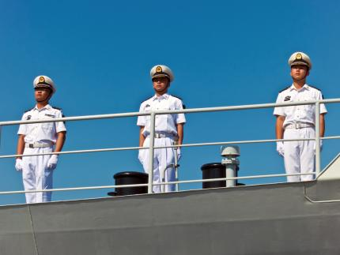
The Spratly Islands—not so long ago known primarily as a rich fishing ground—have turned into an international flashpoint as Chinese leaders insist with increasing truculence that the islands, rocks, and reefs have been, in the words of Premier Wen Jiabao, “China’s historical territory since ancient times.” Normally, the overlapping territorial claims to sovereignty and maritime boundaries ought to be resolved through a combination of customary international law, adjudication before the International Court of Justice or the International Tribunal for the Law of the Sea, or arbitration under Annex VII of the United Nations Convention on the Law of the Sea (UNCLOS). While China has ratified UNCLOS, the treaty by and large rejects “historically based” claims, which are precisely the type Beijing periodically asserts. On September 4, 2012, China’s foreign minister, Yang Jiechi, told US Secretary of State Hillary Clinton that there is “plenty of historical and jurisprudence evidence to show that China has sovereignty over the islands in the South China Sea and the adjacent waters.”
As far as the “jurisprudence evidence” is concerned, the vast majority of international legal experts have concluded that China’s claim to historic title over the South China Sea, implying full sovereign authority and consent for other states to transit, is invalid. The historical evidence, if anything, is even less persuasive. There are several contradictions in China’s use of history to justify its claims to islands and reefs in the South China Sea, not least of which is its polemical assertion of parallels with imperialist expansion by the United States and European powers in the eighteenth and nineteenth centuries. Justifying China’s attempts to expand its maritime frontiers by claiming islands and reefs far from its shores, Jia Qingguo, professor at Beijing University’s School of International Studies, argues that China is merely following the example set by the West. “The United States has Guam in Asia which is very far away from the US and the French have islands in the South Pacific, so it is nothing new,” Jia told AFP recently.
China’s claim to the Spratlys on the basis of history runs aground on the fact that the region’s past empires did not exercise sovereignty. In pre-modern Asia, empires were characterized by undefined, unprotected, and often changing frontiers. The notion of suzerainty prevailed. Unlike a nation-state, the frontiers of Chinese empires were neither carefully drawn nor policed but were more like circles or zones, tapering off from the center of civilization to the undefined periphery of alien barbarians. More importantly, in its territorial disputes with neighboring India, Burma, and Vietnam, Beijing always took the position that its land boundaries were never defined, demarcated, and delimited. But now, when it comes to islands, shoals, and reefs in the South China Sea, Beijing claims otherwise. In other words, China’s claim that its land boundaries were historically never defined and delimited stands in sharp contrast with the stance that China’s maritime boundaries were always clearly defined and delimited. Herein lies a basic contradiction in the Chinese stand on land and maritime boundaries which is untenable. Actually, it is the mid-twentieth-century attempts to convert the undefined frontiers of ancient civilizations and kingdoms enjoying suzerainty into clearly defined, delimited, and demarcated boundaries of modern nation-states exercising sovereignty that lie at the center of China’s territorial and maritime disputes with neighboring countries. Put simply, sovereignty is a post-imperial notion ascribed to nation-states, not ancient empires.

China’s present borders largely reflect the frontiers established during the spectacular episode of eighteenth-century Qing (Manchu) expansionism, which over time hardened into fixed national boundaries following the imposition of the Westphalian nation-state system over Asia in the nineteenth and twentieth centuries. Official Chinese history today often distorts this complex history, however, claiming that Mongols, Tibetans, Manchus, and Hans were all Chinese, when in fact the Great Wall was built by the Chinese dynasties to keep out the northern Mongol and Manchu tribes that repeatedly overran Han China; the wall actually represented the Han Chinese empire’s outer security perimeter. While most historians see the onslaught of the Mongol hordes led by Genghis Khan in the early 1200s as an apocalyptic event that threatened the very survival of ancient civilizations in India, Persia, and other nations (China chief among them), the Chinese have consciously promoted the myth that he was actually “Chinese,” and therefore all areas that the Mongols (the Yuan dynasty) had once occupied or conquered (such as Tibet and much of Central and Inner Asia) belong to China. China’s claims on Taiwan and in the South China Sea are also based on the grounds that both were parts of the Manchu empire. (Actually, in the Manchu or Qing dynasty maps, it is Hainan Island, not the Paracel and Spratly Islands, that is depicted as China’s southern-most border.) In this version of history, any territory conquered by “Chinese” in the past remains immutably so, no matter when the conquest may have occurred.
Such writing and rewriting of history from a nationalistic perspective to promote national unity and regime legitimacy has been accorded the highest priority by China’s rulers, both Nationalists and Communists. The Chinese Communist Party leadership consciously conducts itself as the heir to China’s imperial legacy, often employing the symbolism and rhetoric of empire. From primary-school textbooks to television historical dramas, the state-controlled information system has force-fed generations of Chinese a diet of imperial China’s grandeur. As the Australian Sinologist Geremie Barmé points out, “For decades Chinese education and propaganda have emphasized the role of history in the fate of the Chinese nation-state . . . While Marxism-Leninism and Mao Thought have been abandoned in all but name, the role of history in China’s future remains steadfast.” So much so that history has been refined as an instrument of statecraft (also known as “cartographic aggression”) by state-controlled research institutions, media, and education bodies.
China uses folklore, myths, and legends, as well as history, to bolster greater territorial and maritime claims. Chinese textbooks preach the notion of the Middle Kingdom as being the oldest and most advanced civilization that was at the very center of the universe, surrounded by lesser, partially Sinicized states in East and Southeast Asia that must constantly bow and pay their respects. China’s version of history often deliberately blurs the distinction between what was no more than hegemonic influence, tributary relationships, suzerainty, and actual control. Subscribing to the notion that those who have mastered the past control their present and chart their own futures, Beijing has always placed a very high value on “the history card” (often a revisionist interpretation of history) in its diplomatic efforts to achieve foreign policy objectives, especially to extract territorial and diplomatic concessions from other countries. Almost every contiguous state has, at one time or another, felt the force of Chinese arms—Mongolia, Tibet, Burma, Korea, Russia, India, Vietnam, the Philippines, and Taiwan—and been a subject of China’s revisionist history. As Martin Jacques notes in When China Rules the World, “Imperial Sinocentrism shapes and underpins modern Chinese nationalism.”

If the idea of national sovereignty goes back to seventeenth-century Europe and the system that originated with the Treaty of Westphalia, the idea of maritime sovereignty is largely a mid-twentieth-century American concoction China has seized upon to extend its maritime frontiers. As Jacques notes, “The idea of maritime sovereignty is a relatively recent invention, dating from 1945 when the United States declared that it intended to exercise sovereignty over its territorial waters.” In fact, the UN’s Law of the Sea agreement represented the most prominent international effort to apply the land-based notion of sovereignty to the maritime domain worldwide—although, importantly, it rejects the idea of justification by historical right. Thus although Beijing claims around eighty percent of the South China Sea as its “historic waters” (and is now seeking to elevate this claim to a “core interest” akin with its claims on Taiwan and Tibet), China has, historically speaking, about as much right to claim the South China Sea as Mexico has to claim the Gulf of Mexico for its exclusive use, or Iran the Persian Gulf, or India the Indian Ocean.
Ancient empires either won control over territories through aggression, annexation, or assimilation or lost them to rivals who possessed superior firepower or statecraft. Territorial expansion and contraction was the norm, determined by the strength or weakness of a kingdom or empire. The very idea of “sacred lands” is ahistorical because control of territory was based on who grabbed or stole what last from whom. The frontiers of the Qin, Han, Tang, Song, and Ming dynasties waxed and waned throughout history. A strong and powerful imperial China, much like czarist Russia, was expansionist in Inner Asia and Indochina as opportunity arose and strength allowed. The gradual expansion over the centuries under the non-Chinese Mongol and Manchu dynasties extended imperial China’s control over Tibet and parts of Central Asia (now Xinjiang), Taiwan, and Southeast Asia. Modern China is, in fact, an “empire-state” masquerading as a nation-state.
If China’s claims are justified on the basis of history, then so are the historical claims of Vietnamese and Filipinos based on their histories. Students of Asian history know, for instance, that Malay peoples related to today’s Filipinos have a better claim to Taiwan than Beijing does. Taiwan was originally settled by people of Malay-Polynesian descent—ancestors of the present-day aborigine groups—who populated the low-lying coastal plains. In the words of noted Asia-watcher Philip Bowring, writing last year in the South China Morning Post, “The fact that China has a long record of written history does not invalidate other nations’ histories as illustrated by artifacts, language, lineage and genetic affinities, the evidence of trade and travel.” Unless one subscribes to the notion of Chinese exceptionalism, imperial China’s “historical claims” are as valid as those of other kingdoms and empires in Southeast and South Asia. China laying claim to the Mongol and Manchu empires’ colonial possessions would be equivalent to India laying claim to Afghanistan, Bangladesh, Burma, Malaysia (Srivijaya), Nepal, Pakistan, and Sri Lanka on the grounds that they were all parts of either the Maurya, Chola, or the Moghul and the British Indian empires.
China’s claims in the South China Sea are also a major shift from its longstanding geopolitical orientation to continental power. In claiming a strong maritime tradition, China makes much of the early-fifteenth-century expeditions of Zheng He to the Indian Ocean and Africa. But, as Bowring points out, “Chinese were actually latecomers to navigation beyond coastal waters. For centuries, the masters of the oceans were the Malayo-Polynesian peoples who colonized much of the world, from Taiwan to New Zealand and Hawaii to the south and east, and to Madagascar in the west. Bronze vessels were being traded with Palawan, just south of Scarborough, at the time of Confucius. When Chinese Buddhist pilgrims like Faxian went to Sri Lanka and India in the fifth century, they went in ships owned and operated by Malay peoples. Ships from what is now the Philippines traded with Funan, a state in what is now southern Vietnam, a thousand years before the Yuan dynasty.”
And finally, China’s so-called “historic claims” to the South China Sea are actually not “centuries old.” They only go back to 1947, when Chiang Kai-shek’s nationalist government drew the so-called “eleven-dash line” on Chinese maps of the South China Sea, enclosing the Spratly Islands and other chains that the ruling Kuomintang party declared were now under Chinese sovereignty. Chiang himself, saying he saw German fascism as a model for China, was fascinated by the Nazi concept of an expanded Lebensraum (“living space”) for the Chinese nation. He did not have the opportunity to be expansionist himself because the Japanese put him on the defensive, but cartographers of the nationalist regime drew the U-shape of eleven dashes in an attempt to enlarge China’s “living space” in the South China Sea. Following the victory of the Chinese Communist Party in the civil war in 1949, the People’s Republic of China adopted this cartographic coup, revising Chiang’s notion into a “nine-dash line” after erasing two dashes in the Gulf of Tonkin in 1953.

Since the end of the Second World War, China has been redrawing its maps, redefining borders, manufacturing historical evidence, using force to create new territorial realities, renaming islands, and seeking to impose its version of history on the waters of the region. The passage of domestic legislation in 1992, “Law on the Territorial Waters and Their Contiguous Areas,” which claimed four-fifths of the South China Sea, was followed by armed skirmishes with the Philippines and Vietnamese navies throughout the 1990s. More recently, the dispatch of large numbers of Chinese fishing boats and maritime surveillance vessels to the disputed waters in what is tantamount to a “people’s war on the high seas” has further heightened tensions. To quote commentator Sujit Dutta, “China’s unmitigated irredentism [is] based on the . . . theory that the periphery must be occupied in order to secure the core. [This] is an essentially imperial notion that was internalized by the Chinese nationalists—both Kuomintang and Communist. The [current] regime’s attempts to reach its imagined geographical frontiers often with little historical basis have had and continue to have highly destabilizing strategic consequences.”
One reason Southeast Asians find it difficult to accept Chinese territorial claims is that they carry with them an assertion of Han racial superiority over other Asian races and empires. Says Jay Batongbacal of the University of the Philippines law school: “Intuitively, acceptance of the nine-dash line is a corresponding denial of the very identity and history of the ancestors of the Vietnamese, Filipinos, and Malays; it is practically a modern revival of China’s denigration of non-Chinese as ‘barbarians’ not entitled to equal respect and dignity as peoples.”
Empires and kingdoms never exercised sovereignty. If historical claims had any validity then Mongolia could claim all of Asia simply because it once conquered the lands of the continent. There is absolutely no historical basis to support either of the dash-line claims, especially considering that the territories of Chinese empires were never as carefully delimited as nation-states, but rather existed as zones of influence tapering away from a civilized center. This is the position contemporary China took starting in the 1960s, while negotiating its land boundaries with several of its neighboring countries. But this is not the position it takes today in the cartographic, diplomatic, and low-intensity military skirmishes to define its maritime borders. The continued reinterpretation of history to advance contemporary political, territorial, and maritime claims, coupled with the Communist leadership’s ability to turn “nationalistic eruptions” on and off like a tap during moments of tension with the United States, Japan, South Korea, India, Vietnam, and the Philippines, makes it difficult for Beijing to reassure neighbors that its “peaceful rise” is wholly peaceful. Since there are six claimants to various atolls, islands, rocks, and oil deposits in the South China Sea, the Spratly Islands disputes are, by definition, multilateral disputes requiring international arbitration. But Beijing has insisted that these disputes are bilateral in order to place its opponents between the anvil of its revisionist history and the hammer of its growing military power.
Mohan Malik is a professor in Asian security at Asia-Pacific Center for Security Studies, in Honolulu. The views expressed are his own. His most recent book is China and India: Great Power Rivals. He wishes to thank Drs. Justin Nankivell, Carlyle Thayer, Denny Roy, and David Fouse for their comments on this article.

Top of Form
July/August 2012

China and India Today: Diplomats Jostle, Militaries Prepare
Mohan Malik

Just as the Indian subcontinental plate has a tendency to constantly rub and push against the Eurasian tectonic plate, causing friction and volatility in the entire Himalayan mountain range, India’s bilateral relationship with China is also a subtle, unseen, but ongoing and deeply felt collision, the affects of which have left a convoluted lineage. Tensions between the two powers have come to influence everything from their military and security decisionmaking to their economic and diplomatic maneuvering, with implications for wary neighbors and faraway allies alike. The relationship is complicated by layers of rivalry, mistrust, and occasional cooperation, not to mention actual geographical disputes.
Distant neighbors buffered by Tibet and the Himalayas for millennia, China and India became next-door neighbors with contested frontiers and disputed histories in 1950, following the occupation of Tibet by Mao’s People’s Liberation Army (PLA). While the rest of the world started taking note of China’s rise during the last decade of the twentieth century, India has been warily watching China’s rise ever since a territorial dispute erupted in a brief but full-scale war in 1962, followed by skirmishes in 1967 and 1987.
Several rounds of talks held since 1981 have failed to resolve the disputed claims. During his last visit to India, in 2010, Chinese Premier Wen Jiabao dashed any hopes of early border settlement, stating that it would take a very long time to settle the boundary issue—a situation that in many ways works to Beijing’s advantage. An unsettled border provides China the strategic leverage to keep India uncertain about its intentions, and nervous about its capabilities, while exposing India’s vulnerabilities and weaknesses, and encouraging New Delhi’s “good behavior” on issues of vital concern. Besides, as the ongoing unrest and growing incidents of self-immolations by Buddhist monks in Tibet show, Beijing has not yet succeeded in pacifying and Sinicizing Tibet, as it has Inner Mongolia. The net result is that the 2,520-mile Sino-Indian frontier, one of the longest inter-state boundaries in the world, remains China’s only undefined land border. It is also becoming heavily militarized, as tensions rise over China’s aggressive patrolling on the line of actual control (LAC) and its military drills, using live ammunition, for a potential air and land campaign to capture high-altitude mountain passes in Tibet.

Over the last decade, the Chinese have put in place a sophisticated military infrastructure in the Tibet Autonomous Region (TAR) adjoining India: five fully operational air bases, several helipads, an extensive rail network, and thirty thousand miles of roads—giving them the ability to rapidly deploy thirty divisions (fifteen thousand soldiers each) along the border, a three-to-one advantage over India. China has not only increased its military presence in Tibet but is also ramping up its nuclear arsenal. In addition, the PLA’s strategic options against India are set to multiply as Chinese land and rail links with Pakistan, Nepal, Burma, and Bangladesh improve.
Developments on the disputed Himalayan borders are central to India’s internal debate about the credibility of its strategic deterrent and whether to test nuclear weapons again. Being the weaker power, India is far more concerned about the overall military balance tilting to its disadvantage. India sees China everywhere because of Beijing’s “hexiao gongda” policy in South Asia: “uniting with the small”—Pakistan, Bangladesh, Nepal, Burma, and Sri Lanka—“to counter the big”—India. When combined with Chinese nuclear and missile transfers to Pakistan and building of port facilities around India’s periphery, and a dramatic increase in the PLA’s incursions and transgressions across the LAC, the official Indian perception of China has undergone a dramatic shift since 2006, with China now being widely seen as posing a major security threat in the short to medium term rather than over the long term. The Indian military, long preoccupied with war-fighting scenarios against Pakistan, has consequently turned its attention to the China border, and unveiled a massive force modernization program, to cost $100 billion over the next decade, that includes the construction of several strategic roads and the expansion of rail networks, helipads, and airfields all along the LAC. Other measures range from raising a new mountain strike corps and doubling force levels in the eastern sector by one hundred thousand troops to the deployment of Sukhoi Su-30MKI aircraft, spy drones, helicopters, and ballistic and cruise missile squadrons to defend its northeastern state of Arunachal Pradesh, territory three times the size of Taiwan that the Chinese invaded in 1962 and now claim sovereignty over as “Southern Tibet.”
Propelled by incidents related to border disputes, Chinese opposition to the US-India nuclear energy deal, India’s angst over the growing trade deficit due to perceived Chinese unfair trade practices, potential Chinese plans to dam the Brahmaputra River, and the “war talk” in the official Chinese media in the 2007 to 2009 period (reminding India not to forget “the lessons of 1962”), mutual distrust between the Indian and Chinese peoples is growing. Clearly, China’s extraordinary economic performance over the last three decades has changed the dynamics of the relationship. China and India had similar average incomes in the late 1970s, but thirty years later they find themselves at completely different stages of development. China’s economic reforms—launched in 1978, nearly thirteen years before India’s in 1991—changed their subsequent growth trajectories by putting China far ahead of India in all socioeconomic indices. Both China’s gross domestic product and military expenditure are now three times the size of India’s; recent surveys conducted by Pew Global Research show a growth in popular distrust, with just twenty-five percent of Indians holding a favorable view of China in 2011, down from thirty-four percent in 2010 and fifty-seven percent in 2005. Likewise, just twenty-seven percent of Chinese hold a favorable view of India in 2011, down from thirty-two percent in 2010, with studies of Internet content showing a large degree of “hostility and contempt for India.”
Nor is there much effort to keep these emotions submerged. Reacting to the test launch in mid-April of a long-range Agni-V ballistic missile, dubbed the “China killer” by India’s news media, a Chinese daily wryly noted that “India stands no chance in an overall arms race with China,” because “China’s nuclear power is stronger and more reliable.” The unequal strategic equation, in particular the Chinese perception of India as a land of irreconcilable socioreligious cleavages with an inherently unstable polity and weak leadership that is easily contained through proxies, aggravates tensions between the two. In 2008, an official reassessment of China’s capabilities and intentions led the Indian military to adopt a “two-front war” doctrine against what is identified as a “collusive threat” posed by two closely aligned nuclear-armed neighbors, Pakistan and China. This doctrine validates the long-held belief of India’s strategic community that China is following a protracted strategy of containing India’s rise.
India is also responding by strengthening its strategic links with Afghanistan, Tajikistan, Mongolia, Vietnam, and Burma—countries on China’s periphery. In testimony to the US Senate in February, James Clapper, the director of national intelligence, noted that “the Indian military is strengthening its forces in preparation to fight a limited conflict along the disputed border, and is working to balance Chinese power projection in the Indian Ocean.” That “balance” includes a strategic tilt toward the United States that has also had a damaging effect on Sino-Indian relations.
Although leaders from both countries often repeat the ritualized denials of conflict and emphasize burgeoning trade ties, such platitudes cannot obliterate the trust deficit. Few if any of China’s strategic thinkers seem to hold positive views of India for China’s future, and vice versa. Chinese strategists keep a wary eye on India’s “great power dreams,” its military spending and weapons acquisitions, and the developments in India’s naval and nuclear doctrines. A dominant theme in Chinese commentary in the last decade is that India’s growing strength—backed by the United States—could tip Asia’s balance of power away from Beijing.

Not surprisingly, bilateral relations between Asia’s giants remain, in the words of Zhang Yan, China’s ambassador to India, “very fragile, very easy to be damaged, and very difficult to repair.” Both have massive manpower resources, a scientific and industrial base, and million-plus militaries. For the first time in more than fifty years, both are moving upward simultaneously on their relative power trajectories. As the pivotal power in South Asia, India perceives itself much as China has traditionally perceived itself in relation to East Asia. Both desire a peaceful security environment to focus on economic development and avoid overt rivalry or conflict. Still, the volatile agents of nationalism, history, ambition, strength, and size produce a mysterious chemistry. Neither power is comfortable with the rise of the other. Both seek to envelop neighbors with their national economies. Both are nuclear and space powers with growing ambitions. Both yearn for a multipolar world that will provide them the space for growth and freedom of action. Both vie for leadership positions in global and regional organizations and have attempted to establish a sort of Monroe Doctrine in their respective neighborhoods—without much success.
And both remain suspicious of each other’s long-term agenda and intentions. Each perceives the other as pursuing hegemony and entertaining imperial ambitions. Both are non–status quo powers: China in terms of territory, power, and influence; India in terms of status, power, and influence. Both seek to expand their power and influence in and beyond their regions at each other’s expense. China’s “Malacca paranoia” is matched by India’s “Hormuz dilemma.” If China’s navy is going south to the Indian Ocean, India’s navy is going east to the Pacific Ocean. Both suffer from a siege mentality born out of their elites’ acute consciousness of the divisive tendencies that make their countries’ present political unity so fragile. After all, much of Chinese and Indian history is made up of long periods of internal disunity and turmoil, when centrifugal forces brought down even the most powerful empires. Each has its vulnerabilities—regional conflicts, poverty, and religious divisions for India; the contradiction between a market economy and Leninist politics for China. Both are plagued with domestic linguistic, ethno-religious, and politico-economic fault lines that could be their undoing if not managed properly.
In other words, China and India are locked in a classic security dilemma: one country sees its actions as defensive, but the same actions appear aggressive to the other. Beijing fears that an unrestrained Indian power—particularly one that is backed by the West and Japan—would not only threaten China’s security along its restive southwestern frontiers (Tibet and Xinjiang) but also obstruct China’s expansion southwards. Faced with exponential growth in China’s power and influence, India feels the need to take counterbalancing measures and launch strategic initiatives to emerge as a great power, but these are perceived as challenging and threatening in China.
China’s use of regional and international organizations to institutionalize its power while either denying India access to these organizations or marginalizing India within them has added a new competitive dynamic to the relationship. In the past decade, India has found itself ranged against China at the UN Security Council, East Asia Summit, the Asia-Pacific Economic Cooperation, the Nuclear Suppliers Group, and the Asian Development Bank. In 2009, China vetoed a development plan for India by the latter in the disputed Arunachal Pradesh, thereby internationalizing a bilateral territorial dispute. In a tit-for-tat response, New Delhi has kept Beijing out of India-led multilateral frameworks such as the Bay of Bengal Initiative for Multi-Sectoral Technical and Economic Cooperation, the India-Brazil-South Africa Dialogue, and the Mekong–Ganga Cooperation forums, and rejected China’s request to be included as observer or associate member into the 33-member Indian Ocean Naval Symposium, started by India in 2008.

Resource scarcity has added a maritime dimension to this geopolitical rivalry. As China’s and India’s energy dependence on the Middle East and Africa increases, both are actively seeking to forge closer defense and security ties with resource supplier nations (e.g., Saudi Arabia and Iran), and to develop appropriate naval capabilities to dominate the sea lanes through which the bulk of their commerce flows. Since seventy-seven percent of China’s oil comes from the Middle East and Africa, Beijing has increased its activities in the Indian Ocean region by investing in littoral states’ economies, building ports and infrastructure, providing weaponry, and acquiring energy resources. Nearly ninety percent of Chinese arms sales go to countries located in the Indian Ocean region. Beijing is investing heavily in developing the Gwadar deep-sea port in Pakistan, and naval bases in Sri Lanka, Bangladesh, and Myanmar. Whether one calls it a “string of pearls” or a series of places at which China’s navy can base or simply be resupplied, that navy is setting up support infrastructure in strategic locations along the same sea lanes of communication that could neutralize India’s geographical advantage in the Indian Ocean region. A recent commentary from the official Xinhua news outlet called for setting up three lines of navy supply bases in the northern Indian Ocean, the western Indian Ocean, and the southern Indian Ocean. It stated: “China needs to establish overseas strategic support stations for adding ship fuel, re-supply of necessities, staff break time, repairs of equipment, and weapons in Pakistan, Sri Lanka, and Myanmar, which will be the core support bases in the North Indian Ocean supply line; Djibouti, Yemen, Oman, Kenya, Tanzania, and Mozambique, which will be the core support bases in the West Indian Ocean supply line; and Seychelles and Madagascar, which will be the core support bases in the South Indian Ocean supply line.”
For its part, New Delhi is pursuing the same strategy as Beijing and creating its own web of relationships with the littoral states, both bilaterally and multilaterally, through the Indian Ocean Naval Symposium, to ensure that if the military need arises, the necessary support infrastructure and network will be in place. India has also stepped up defense cooperation with Oman and Israel in the west, while upgrading military ties with the Maldives, Madagascar, and Myanmar in the Indian Ocean, and with Singapore, Indonesia, Thailand, Vietnam, Taiwan, the Philippines, Australia, Japan, and the United States in the east. In December 2006, Admiral Sureesh Mehta, then India’s naval chief, expanded the conceptual construct of India’s “greater strategic neighborhood” to include potential sources of oil and gas imports located across the globe—from Venezuela to the Sakhalin Islands in Russia. The Indian navy currently has a stronger naval presence on the Indian Ocean than does China. It is strengthening its port infrastructure with new southern ports, which allow greater projection into the ocean. Taking a leaf out of China’s book, the new focus is to develop anti-access and area-denial capabilities that will thwart any Chinese attempt at encirclement or sea-access denial.
In short, maritime competition is intensifying as Indian and Chinese navies show the flag in the Pacific and Indian oceans with greater frequency. This rivalry could spill into the open after a couple of decades, when one Indian aircraft carrier will be deployed in the Pacific Ocean and one Chinese aircraft carrier in the Indian Ocean—ostensibly to safeguard their respective trade and energy routes.

In turn, India’s “Look East” policy is a manifestation of its own strategic intent to compete for influence in the wider Asia-Pacific region. Just as China will not concede India’s primacy in South Asia and the Indian Ocean region, India seems unwilling to accept Southeast and East Asia as China’s sphere of influence. Just as China’s rise is viewed positively in the South Asian region among the small countries surrounding India with which New Delhi has had difficult relations, India’s rise is viewed in positive-sum terms among China’s neighbors throughout East and Southeast Asia. Over the last two decades, India has sought to enhance its economic and security ties with those Northeast and Southeast Asian nations (Mongolia, South Korea, Japan, Taiwan, Vietnam, Singapore, Thailand, Indonesia, and Australia) that worry about China more than any other major power. As China’s growing strength creates uneasiness in the region, India’s balancing role is welcome within the Association of Southeast Asian Nations (ASEAN) in order to influence China’s behavior in cooperative directions. While the Southeast Asian leaders seek to deter China from utilizing its growing strength for coercive purposes and to maintain regional autonomy, Indian strategic analysts favor an Indian naval presence in the South China Sea and the Pacific Ocean to counter Chinese naval presence in the Indian Ocean. On maritime security, Southeast Asians seem more willing to cooperate with India than China, especially in the Strait of Malacca.
A key element of India’s Pacific outreach has been regular naval exercises, port calls, security dialogues, and more than a dozen defense cooperation agreements. India has welcomed Vietnam’s offer of berthing rights in Na Trang Port in the South China Sea, and news reports suggest that India might offer BrahMos cruise missiles and other military hardware at “friendship prices” to Vietnam. The conclusion of free-trade agreements with Singapore, South Korea, Malaysia, Japan, and the ASEAN, coupled with New Delhi’s participation in multilateral forums such as the East Asia Summit and the ASEAN Plus Eight defense ministers’ meetings, have also reinforced strategic ties. India’s determination to strengthen its strategic partnership with Japan and Vietnam, commitment to pursue joint oil exploration with Hanoi in the South China Sea waters in the face of Chinese opposition, and an emphasis on the freedom of navigation are signs of India maneuvering to be seen as a counterweight to Chinese power in East Asia. New Delhi is also scaling up defense ties with Tokyo, Seoul, and Canberra.
The US-India partnership is also emerging as an important component of India’s strategy to balance China’s power. India seeks US economic and technological assistance. It helps this relationship that India’s longtime security concerns—China and Pakistan—also now happen to be the United States’ long-term and immediate strategic concerns as well. Both the Bush and Obama administrations have encouraged India’s involvement in a wider Asian security system to balance a rising China and declining Japan. Apparently, US weakness—real or perceived—invites Chinese assertiveness. Since the United States does not wish to see Asia dominated by a single hegemonic power or a coalition of states, India’s economic rise is seen as serving Washington’s long-term interests by ensuring that there be countervailing powers in Asia—China, Japan, and India, with the United States continuing to act as an “engaged offshore power balancer.”
The “India factor” is increasingly entering the ongoing US policy debate over China. Asia-Pacific is now the Indo-Pacific, a term underlining the centrality of India in the new calculus of regional power. The 2010 US Quadrennial Defense Review talked of India’s positive role as a “net security provider in the Indian Ocean and beyond.” India’s “Look East” policy, which envisions high-level engagement with “China-wary” nations (South Korea, Japan, Taiwan, Vietnam, Thailand, Indonesia, and Australia), dovetails with the US policy of establishing closer ties with countries beyond Washington’s traditional treaty partners to maintain US predominance. The US-Indian strategic engagement, coupled with India’s expanding naval and nuclear capabilities and huge economic potential, have made India loom larger on China’s radar screen. An editorial in a Shanghai daily last November lamented the fact that “India will not allow itself to stay quietly between the US and China. It wants to play triangle affairs with the duo, and will do anything it can to maximize its benefit out of it. Therefore, China will find it hard to buy India over.” The Chinese fear that the Indian-American cooperation in defense, high-tech R&D, nuclear, space, and maritime spheres would prolong US hegemony and prevent the establishment of a post-American, Sino-centric hierarchical regional order in Asia. This tightening relationship, and the possibility that what is presently a tilt on India’s part could turn into a full-fledged alignment, is a major reason for recent deterioration in Chinese-Indian relations.

Although these relations remain unstable and competitive, both have sought to reduce tensions. Despite border disputes, denial of market access, and harsh words against the Dalai Lama, leaders in both countries understand the dangers of allowing problems to overwhelm the relationship. Burgeoning economic ties between the world’s two fastest-growing economies have become the most salient aspect of their bilateral relationship. Trade flows have risen rapidly, from a paltry $350 million in 1993 to $70 billion in 2012, and could surpass $100 billion by 2015. Several joint ventures in power generation, consumer goods, steel, chemicals, minerals, mining, transport, infrastructure, info-tech, and telecommunication are in the works. Intensifying trade, commerce, and tourism could eventually raise the stakes for China in its relationship with India. On the positive side, both share common interests in maintaining regional stability (for example, combating Islamist fundamentalists), exploiting economic opportunities, and maintaining access to energy sources, capital, and markets.
Despite ever-increasing trade volumes, however, there is as yet no strategic congruence between China and India. As in the case of Sino-US and Sino-Japanese ties, Sino-Indian competitive tendencies, rooted in geopolitics and nationalism, are unlikely to be easily offset even by growing economic and trade links. In fact, the economic relationship is heavily skewed. The bulk of Indian exports to China consist of iron ore and other raw materials, while India imports mostly manufactured goods from China—a classic example of the dependency model. Most Indians see China as predatory in trade. New Delhi has lodged the largest number of anti-dumping cases against Beijing in the World Trade Organization. India is keener on pursuing mutual economic dependencies with Japan, South Korea, and Southeast Asian nations through increased trade, investment, infrastructure development, and aid to bolster economic and political ties across Asia that will counter Chinese power.
Even as a range of economic and transnational issues draw them closer together, the combination of internal issues of stability (Tibet and Kashmir), disputes over territory, competition over resources (oil, gas, and water), overseas markets and bases, external overlapping spheres of influence, rival alliance relationships, and ever-widening geopolitical horizons forestall the chances for a genuine Sino-Indian accommodation. Given the broad range of negative attitudes and perceptions each country has for the other, it is indeed remarkable that China and India have been able to keep diplomatic relations from fraying. How long this situation can last is more and more uncertain as each country is increasingly active in what would once have been seen as the other’s “backyard” and both engage in strategic maneuvers to checkmate each other.
Just as China has become more assertive vis-à-vis the United States, Indian policy toward China is becoming tougher. India’s evolving Asia strategy reflects the desire for an arc of partnerships with China’s key neighbors—in Southeast Asia and further east along the Asia-Pacific rim—and the United States that would help neutralize the continuing Chinese military assistance and activity around its own territory and develop counter-leverages of its own vis-à-vis China to keep Beijing sober.
At this point, the two heavyweights circle each other warily, very much aware that their feints and jabs could turn into a future slugging match.
Mohan Malik is a professor at the Asia-Pacific Center for Security Studies, in Honolulu, and author of China and India: Great Power Rivals.
The National Interest

America and China's Dangerous Game of Geopolitical Poker
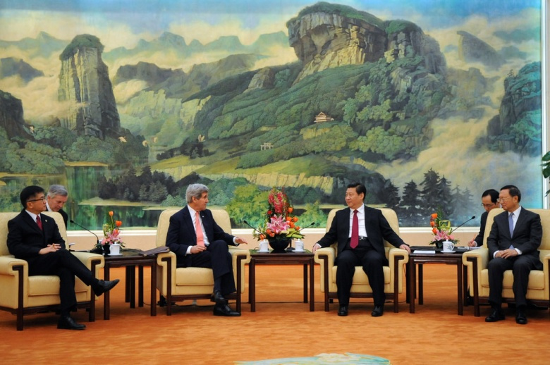
Place your bets. The stakes could not be any higher.
Mohan Malik
June 18, 2014
Coming close on the heels of President Barack Obama’s “reassurance trip” to China’s East Asian neighbors in April 2014, Beijing’s deployment of an oil rig protected by over eighty naval vessels in the South China Sea is a deliberate and calculated provocation. China’s move though fits a pattern of advancing territorial claims on its periphery through coercion, intimidation and the threat of force through what I call “paramilitary operations short of war” (POSOW). China’s drilling rig is also a political statement of Beijing’s resolve and capability to control and exploit the South China Sea and deny it to others—and this message is meant as much for Washington as for Tokyo, Hanoi, Manila, Jakarta, and New Delhi. While exploring oil in the disputed waters, the $1 billion oil rig is supposedly drilling a big hole in Washington’s “pivot strategy” insofar as it undermines Washington’s credibility as regional security anchor or security guarantor. In essence, it makes mockery of President Obama’s security assurances to regional countries against Chinese coercive tactics aimed at changing facts on the ground. Beijing calculates that neither the mighty United States nor China’s weak and small neighbors would respond with force to counter Chinese incremental efforts to turn the South China Sea (SCS) into a “Chinese lake.”
The key reason for China’s aggressive posturing on the seas is the tectonic shift in Beijing’s strategic environment that occurred following the collapse of the Soviet Union in 1991. For the first time in its long history, China no longer faces any threat whatsoever on its northern frontiers and this geopolitical development of the millennium largely explains Chinese military’s expansionist moves on its eastern seaboard and southwestern frontiers. It is worth recalling that the successive Chinese dynasties built the Great Wall to keep out the troublesome northern Mongol and Manchu tribes that repeatedly overran Han China. In 1433, faced with increasingly bold raids made by Mongols and a growing threat from other Central Asian peoples to its land borders in the northwest, China’s Ming rulers halted Admiral Zheng He’s expensive ocean voyages so as to concentrate their resources on securing the Middle Kingdom’s land borders. From the eighteenth to twentieth centuries, threats first from the ever-expanding Czarist Russia and then the Soviet Union kept the focus of Chinese military planners on their northern frontiers.
Despite Moscow’s geopolitical concerns about Chinese encroachments in Russia’s Far East and the loss of Central Asia to China’s growing influence, President Putin—faced with isolation by Europe and the United States following Russia’s annexation of Crimea and continuing unrest in eastern Ukraine—seems to have accepted unpalatable terms from China to clinch a massive gas pipeline deal that will diversify Russian energy export markets away from Europe, and make China Russia’s major ally. On a range of issues, Russia, along with China, is challenging the post–World War II international order. Even though China has backed Russia neither on Georgia nor on Crimea, Putin believes the ties between Moscow and Beijing are at their “peak.” If a “Sino-Russian alliance” is being resurrected, then in a complete reversal of roles from the early Cold War era, China—not an economically and demographically shrinking Russia—is the stronger partner in this alliance. As in the past, entanglements in the West have once again led Russia to make concessions in the East. Beijing’s game plan is to make Russia economically dependent on China just as the West has become addicted to the cheap Chinese manufactured goods.
Not surprisingly, media is awash with reports of a “new Sino-Russian strategic alliance threatening to dominate Eurasia heartland,” thereby signaling a “nightmare of Mackinderesque proportions for Washington.” Some envision a Beijing-Moscow-Tehran axis based on energy, trade and security across Eurasia. Though Russia’s pivot to Asia is motivated by turbulence on the western front and comes from a position of relative weakness, Washington nonetheless faces challenges by revisionist states seeking to revise regional balances of power in ways detrimental to U.S. and its allies’ interests.
Thus, the public perception of Asia out of balance is widespread. America’s war-weariness in times of fiscal constraints is apparently emboldening China and Russia. The Obama Administration’s efforts to “rebalance” the U.S. role in the Asia-Pacific were influenced by public perceptions of strategic imbalance and rapidly changing geopolitical equations. The struggle for dominance over “contested commons” (maritime, cyber and outer space) is intensifying. Strategic concerns loom large as China’s growing ambition, power and reach run up against the interests of old, established powers. Despite official claims to the contrary, China is behaving just as other rising powers have behaved in history: it is laying down new markers, drawing new lines in the land, air, water, sand and snow all around its periphery, seeking to expand its territorial and maritime frontiers, forming and reforming institutions, and coercing others to fall in line. For Beijing, history—the Chinese Communist Party’s version of history— trumps international law and norms. The Asia-Pacific region is thus on the threshold of change—the known and unknown; challenges and uncertainties abound. This article outlines major strategic shifts that will shape China’s strategic future and Asia’s geopolitical landscape.
Asia’s rising powers versus Europe’s retiring powers
Power in the international system is relative and ever shifting. Over the past three decades, China has demonstrated tremendous ability to plan and mobilize national resources to implement goal-oriented, timely action strategies in economic, diplomatic, and military arenas. The global impact of China’s success will be “Chigantic” (amend the Oxford Dictionary). If China can sustain its growth, China’s gross domestic product (GDP), military and R&D spending could rival those of the United States, albeit not in terms of quality but quantity. China has the potential to emerge as a peer competitor far more powerful than the Soviet Union.
No rising power is ever a status quo power. Rising powers tend to be both risk-takers, impatient, and paranoid powers. They flex their muscles and test the resolve of old, established powers. They seek to benefit from the weakness in resolve—not capabilities—of the established powers by employing asymmetric strategies to chip away at their hegemony. Post-2008 financial crisis, China has transitioned from “hide and bide” policy to “seizing opportunities, taking lead and showing off capabilities to shape others’ choices in China’s favor.” The post–World War II international order has depended on three factors: U.S. alliances, uncontested American maritime dominance and a stable balance of power. All these are under challenge by China’s growing power and purpose. For, China—the biggest beneficiary of the post–World War II order—no longer sees U.S. primacy as serving its interests. One Chinese military officer observed: “American forward presence and alliances constrain China’s future growth and goals in the region.” Beijing dubs U.S. alliances “relics of the Cold War” which must be dismantled to restore what it calls “natural power balance in the region” (translation: a Sino-centric hierarchical order of premodern Asia). It is not in China’s DNA to play second fiddle to any other power. Moscow learnt the hard way in the 1950s. Now it’s the turn of those Americans who have long talked of co-opting China as a junior partner. Moreover, regimes that do not share power or abide by the rule of law in domestic politics do not abide by the rule of law in international politics or share power in world politics.
China’s Asia strategy is to undermine the United States’ credibility as regional security guarantor. Beijing’s diplomatic rhetoric notwithstanding, the “New Type of Great Power Relations” seeks U.S. recognition of China’s primacy in Asia in a geopolitical deal that limits Washington’s regional role and presence, and relegates traditional U.S. allies (esp. Japan) to the sidelines. This push and shove will continue for decades because the Chinese believe that “the U.S. is in irreversible decline, and growing weaker as China grows stronger.” From Beijing’s perspective, the main issue is how to manage, and profit from, America’s decline. The challenge, from Washington’s perspective, is how to manage China’s rise within the U.S.-led order without diluting American role and presence. Who emerges at the top in this poker game will ultimately determine the future of world order. It is against this backdrop that the Obama administration officials have been visiting Asian capitals to reassure U.S. friends and allies about security commitments, and reaffirm Washington’s determination to rebalancing to Asia.
Significantly, China is not rising in a vacuum. Under Shinzo Abe’s leadership, Japan is keen to become a “normal nation.” India has been economically and strategically rebalancing toward the Asia-Pacific for nearly two decades under its “Look East” policy. With the victory of Narendra Modi-led BJP government in May 2014 elections, India may well be back in the reckoning. Since Beijing will not abandon its policy of engaging India economically while strangulating it geopolitically, a revitalized India will form the southern anchor of an Asian balance of power and frustrate efforts to establish Chinese supremacy. Small and middle powers (Singapore, South Korea, Indonesia, Vietnam, the Philippines, and Australia) are also maneuvering for balance and advantage. Indonesia and Vietnam, in particular, are upgrading their naval power, as territorial disputes in the South China Sea escalate. For its part, Russia is using its vast energy resources to stage a comeback on the world stage. Though it predates the Ukraine crisis, the Russian pivot to Asia is set to deepen given Western isolation under sanctions, Gazprom’s thirty-year gas deal worth $400 billion with China, and growing demand for Russian weaponry and energy by China’s neighbors. Russia is unlikely to slide into China’s junior partner’s role without resistance. It is indeed a very complex and crowded geopolitical space out there.
These Asia-Pacific powers are today where Germany, France, Britain, and Italy were at the beginning of the twentieth century. They are looking outward globally in search of markets, resources and bases, jockeying for power and influence, outmaneuvering and outbidding each other in different parts of the world, and forming natural-resources-based partnerships characterized by hedging strategies. The major power competition is between China and the United States, but in the maritime and continental domains, it is between China and Japan and between China and India. The logic of geopolitics—i.e., Japan’s and India’s worries about their place in a Sino-centric Asia—will forge a closer bond under the Abe-Modi leadership. It will intensify Beijing’s strategic competition with both Tokyo and New Delhi.
Much like Europe in the late nineteenth and early twentieth centuries, the Asia-Pacific of the early twenty-first century is thus home to several rising, contending powers and some fragile or failing states. As new powers rise in Asia, new strategic balances are emerging as partnerships and alliances among states shift. Simply put, the Asia-Pacific of the early twenty-first century bears more resemblance to Europe of the late nineteenth and early twentieth centuries, not Europe of the old, retiring powers of the twenty-first century. Russia’s moves against Ukraine may have unnerved European powers but there is no sign of a major strategic push back by European countries against Moscow. That is certainly not the case in Asia. For the first time in modern history, Asians are now spending more on defense than Europeans.
China’s “Geopolitical Discomfort”
This is the decade of power transitions in Asia. For small and weak states in China’s neighborhood, this is the decade of living dangerously. Among regional countries, China arouses unease because of its size, history, proximity, power, and, more importantly, because the memories of “the Middle Kingdom syndrome” or tributary state system have not dimmed. Historically, there has never been a time when China has coexisted on equal terms with another power of similar or lesser stature. As in the past, a rich and powerful China demands obeisance and deference from other countries. What has changed is that Beijing’s economic interests have now displaced ideological fervor of the past. In Asian capitals, there are hardly any takers of “China’s peaceful rise” or of “noninterference in internal affairs” rhetoric (ask North Korea, Cambodia, Laos, Indonesia, Myanmar, Nepal or Sri Lanka).
The growing economic ties between China and its Asian neighbors have created a sense of dependency and despondency. While China’s neighbors do not oppose China’s power and prosperity, they do not welcome their own loss of strategic autonomy in foreign-policy making. With the exception of a few (notably Pakistan), most Asian countries (including North Korea) show little or no desire to live in a China-led or China-dominated Asia. Instead, they seek to preserve existing security alliances and pursue sophisticated diplomatic and hedging strategies designed to give them more freedom of action.
Territorial integrity is the core interest of all—weak or strong, big or small. The mounting tensions between China and its neighbors from India to Japan over land and maritime disputes have geopolitical implications. China’s unresolved land and maritime disputes and the “Middle Kingdom syndrome” work to Beijing’s disadvantage, and to Washington’s advantage. Referring to heightened tensions over territorial disputes, China’s Defense Minister, General Chang Wanquan, told U.S Secretary of Defense Chuck Hagel in April 2014 that Beijing would make “no compromise, no concession, [and] no treaty” in the fight for what he called his country’s “territorial sovereignty.” Chang warned Hagel: “The Chinese military can assemble as soon as summoned, fight any battle, and win.” The Chinese are genuinely aghast at the defiance and insolence displayed by their smaller and weaker neighbors.
Beijing’s aggressive posturing since 2007 on land and maritime disputes all along its periphery has driven China’s neighbors into Washington’s embrace. So, one could argue that much like everything else these days, Washington’s “pivot” or “rebalance” strategy is also “Made-in-China.” China’s unresolved territorial disputes with neighbors are creating allegiances where they never existed before. Examples include Canberra-Tokyo, Manila-Hanoi, Manila-Tokyo, Tokyo-Hanoi, Hanoi-New Delhi and Tokyo-New Delhi strategic partnerships. The target of everyone’s balancing in Asia is China, not Russia or the United States. In fact, those balancing China (India, Vietnam, the Philippines, and Indonesia to name a few) are being armed by both Russian and American weaponry.
Historically, the rise of a continental power has always led to the formation of a coalition of maritime powers to counterbalance it. This is particularly so if that continental power happens to have an authoritarian regime nursing historical grievances with active territorial disputes and/or happens to be a polarizing power. China is no exception to this rule. Being a distant hegemon, the United States remains the balancing power of choice for most countries on China’s periphery. All want to benefit from economic ties with China, but none want the region dominated by Beijing or their policy options constrained by China. Put simply, there is no desire to replace the fading American hegemony with Chinese hegemony.
Much as Beijing would like to restore China’s primacy that prevailed in premodern Asia, structural changes in Asian geopolitics over the last 200 years rule out a return to the Sino-centric hierarchical tributary state system of the past. Geography defines a country’s role and power. A major reason the United States is a global superpower is its unique geography. China does not have Canada and Mexico on its borders, but large powerful states—Russia, Japan, Vietnam, Indonesia, Australia, and India—that will do everything to counterbalance China’s growing power for historical, civilizational, geopolitical and geoeconomic reasons. This gap or disconnect between China’s ambitions in Asia and the changed geopolitics which works against the restoration of Chinese supremacy is what the Chinese ruefully call the “containment of China.” Objectively speaking, this is China’s “geopolitical discomfort,” not “containment.”
The ol’ “new” Great Game
Economic expansion creates overseas interests, fuels grandiose geopolitical ambitions and inevitably leads to military expansion. It was the search for natural resources to fuel industrial growth; markets to dump manufactured goods; and bases (coaling stations) to protect both that led to the colonization of Asia, Africa and Latin America by industrializing European powers in the 18th and 19th centuries. These three—resources, markets and bases—usually go together. Trade, markets, resource extraction, port and infrastructure development are also the key ingredients of China’s foreign policy today. For resources, markets, and diplomatic space, China is pivoting to the West (toward Africa, the Middle East, Russia, Southwest and Central Asia). As in the past, the “new” great game is essentially about having pliant and friendly regimes in resource supplier nations and port access.
Global dominance by a single power is passé
Global dominance by a single power is passé. No single power can dominate in the future, no matter how much soft and hard power it has. What kind of a power you are actually matters more than how powerful you are. The Chinese seem convinced that once their country acquires “comprehensive national power,” everything will fall into its proper place and everybody will fall in line. However, the acquisition of “comprehensive national power” alone will not make China a global power. Major powers become great powers with the support of small and middle powers. In terms of number of allies (58) and potential partners (41) worldwide, the United States still remains an unrivalled superpower. The support of small and middle powers, or lack of it, makes all the difference between great power dominance and defeat. During the Cold War, China and Egypt were two middle powers and “swing states.” When China and Egypt shifted their support from the Soviet Union to the United States, they became pivotal players in the Asian and Middle Eastern balance of power respectively. That tilted the scales against the Soviet Union and the rest is history. In a geopolitical replay, Washington is courting the new “swing states”: India, Indonesia and Vietnam.
Mackinder matters as much as Mahan
Asia’s geopolitical center of gravity is shifting inland, with implications for the maritime powers. Mahan matters but so do Mackinder, Spykman, Kautilya and Sun Zi. Notwithstanding the focus on maritime rivalries, new economic hubs, institutions, transport corridors, high-speed railways, expressways and pipelines networks are changing the geopolitics of Eurasia. During the Cold War, much of the economic growth took place within the U.S. hub-and-spokes alliance network in maritime Asia. Post–Cold War, economic growth has taken place in China, India, and continental Southeast Asia, outside of the U.S. Pacific alliance network.
China, much like Britain and Russia in the past, is now employing modern transportation technology, high-speed railways and expressways to redraw the geopolitical map of Eurasia. As part of its “Go West” strategy, Beijing is spending hundreds of billions to create its “economic hub-and-spokes system” in continental Asia via pipelines, highways, railway networks linking China with Central, Southwest and Southeast Asia. These spokes or arteries will bring in raw materials and energy resources and export Chinese manufactured goods to those regions and beyond. However, not enough attention is being paid to Eurasia because three centuries of Anglo-American maritime dominance seem to have caused a certain degree of “land-blindness” among policy makers.
Technology is the great equalizer
Technology is a game changer. Just as no one could foresee in 1990 how Internet will change everything, the rapid diffusion of disruptive technologies, such as 3D/4D printing, biotechnology, robotics, quantum computing etc. will be a game changer. What would a revolution in manufacturing based on 3D/4D printing mean for Made-in-China? Tomorrow’s technological breakthroughs will create new winners and losers.
Geopolitics and geology are closely interlinked. Just when China and the rest were writing off America as a declining power, the country finds itself on the cusp of achieving energy self-sufficiency, thanks to a breakthrough in fracking technology. The shale revolution could help the United States rejuvenate itself and prolong American dominance of the international order. The energy boom in the U.S. and Canada—if exploited fully has the potential to change the power dynamics among great powers and revitalize U.S. alliances. It could turn yesterday’s winners into tomorrow’s losers. Just as the “old” Middle East is “moving East” to forge closer energy ties with China and India, the “new Middle East” (comprising Canada and the United States) could be “looking West” to sell tight oil and gas to Japan, India, South Korea and Southeast Asian countries. The shale oil and gas bonanza would not only enhance American diplomatic leverage, but also make the world oil market more diversified, more stable for oil prices and reduce consumers’ overdependence on the volatile Middle East and Putin’s Russia.
The Future of Asian Geopolitics
These strategic trends will shape the future of Asian geopolitics. Power asymmetry among major powers means that each will form flexible ad hoc partnerships with the others as they compete, collide, coalesce and collude with each other when their objectives coincide. China is, of course, the most important piece of the geopolitical puzzle. No country threatens China today as it is presently constituted. As the largest (in terms of territory) and the most powerful (economically and militarily) country in Asia, should Beijing agree to freeze and accept territorial status quo along its land and maritime boundaries, it could unravel the Cold War-era alliances and undermine the raison d’etre of U.S. forward presence.
Since the prospects of the PLA accepting the territorial status quo seem nil, the question then facing the United States is how to sustain a robust balance of power that deters intimidation and aggression and reassures friends and allies faced with an overconfident and powerful China determined to establish its dominance on the continent and its adjoining waters. Peace and stability will prevail if major powers work for a multipolar Asia with inclusive multilateral institutions and dispute resolution mechanisms. However, competition, rivalry, and even conflict will result should bipolarity reemerge or should Beijing seek to reestablish a Sino-centric hierarchical order wherein the Middle Kingdom behaves in a hegemonic manner expecting obeisance and tribute from its neighbors.
Mohan Malik is a professor in Asian Security at Asia-Pacific Center for Security Studies, Honolulu and editor of Maritime Security in the Indo-Pacific (Rowman & Littlefield, forthcoming Oct. 2014) and author of China and India: Great Power Rivals (Lynne Rienner Publishers, 2011). These are author’s personal views.

The Diplomat

China and Strategic Imbalance
‘This is the decade of power transitions in Asia.’
By Mohan Malik
July 14, 2014

The recent Shangri-la meeting in Singapore saw some sharp exchanges between Chinese and other participants. Beijing’s deployment of an oil rig protected by more than 80 naval vessels in the South China Sea four days after President Barack Obama’s “reassurance trip” to China’s East Asian neighbors in April 2014 was widely seen as a deliberate and calculated provocation.
Yet China’s move fits a pattern of advancing territorial claims on its periphery through coercion, intimidation, and the threat of force through what may be called “paramilitary operations short of war” (POSOW). China’s drilling rig is also a political statement of Beijing’s resolve and capability to control and exploit the South China Sea and deny it to others – and this message is meant as much for Washington as for Tokyo, Hanoi, Manila, Jakarta, and New Delhi. While exploring oil in the disputed waters, the $1 billion oil rig is supposedly drilling a big hole in Washington’s “pivot strategy” insofar as it undermines Washington’s credibility as regional security anchor or security guarantor. In essence, it makes a mockery of Obama’s security assurances to regional countries against Chinese coercive tactics aimed at changing facts on the ground. Beijing calculates that neither the mighty United States nor China’s weak and small neighbors would respond with force to counter Chinese incremental efforts to turn the South China Sea (SCS) into a “Chinese lake.” China is known for doing things in small steps and piecemeal, quietly, patiently, eventually bringing the pieces together “when the conditions are ripe.”
The key reason for China’s aggressive posturing on the seas is the tectonic shift in Beijing’s strategic environment that occurred following the collapse of the Soviet Union in 1991. For the first time in its long history, China no longer faces any threat whatsoever on its northern frontiers and this immense geopolitical development largely explains Chinese military’s expansionist moves on its eastern seaboard and southwestern frontiers. It is worth recalling that the successive Chinese dynasties built the Great Wall to keep out the troublesome northern Mongol and Manchu tribes that repeatedly overran Han China. In 1433, faced with increasingly bold raids made by Mongols and a growing threat from other Central Asian peoples to its land borders in the northwest, China’s Ming rulers halted Admiral Zheng He’s expensive ocean voyages so as to concentrate their resources on securing the Middle Kingdom’s land borders. From the 18th to 20th centuries, threats first from the ever-expanding Czarist Russia and then the Soviet Union kept the focus of Chinese military planners on their northern frontiers. Except for a very brief period of bonhomie in the 1950s, Beijing was preoccupied throughout the Cold War with the threat from the north until the Soviet collapse in 1991.
Despite Moscow’s geopolitical concerns about Chinese encroachments in Russia’s Far East and the loss of Central Asia to China’s growing influence, President Vladimir Putin – faced with isolation by Europe and the United States following Russia’s annexation of Crimea and continuing unrest in eastern Ukraine – has accepted unpalatable terms from China to clinch a massive gas pipeline deal that will diversify Russian energy export markets away from Europe, and make China Russia’s major ally. On a whole range of issues, Russia, along with China, is challenging the postwar international order. Even though China has backed Russia neither on Georgia nor on Crimea, Putin believes the ties between Moscow and Beijing are at their “peak.” If a “Sino-Russian alliance” is being resurrected, then in a complete reversal of roles from the early Cold War era, China – not an economically and demographically shrinking Russia – is the stronger partner in this alliance. As in the past, entanglements in the West have once again led Russia to make concessions in the East. Beijing’s game plan is to make Russia economically dependent on China just as the West has become addicted to the cheap Chinese manufactured goods. India will need to re-calibrate ties with a Russia that plays a second fiddle to China and joins Beijing in arming Pakistan.
Not surprisingly, media is awash with reports of a “new Sino-Russian strategic alliance threatening to dominate [the Eurasia] heartland,” thereby signaling a “nightmare of Mackinderesque proportions for Washington.” Some envision a Beijing-Moscow-Teheran axis based on energy, trade and security across the Eurasia. Though Russia’s pivot to Asia is motivated by turbulence on the western front and comes from a position of relative weakness, Washington is nonetheless being increasingly challenged by states seeking to revise regional balances of power.
Thus, the public perception of Asia out of balance is widespread. America’s war-weariness in times of fiscal constraints is apparently emboldening revisionist powers China and Russia. The Obama Administration’s efforts to “rebalance” the U.S. role in the Asia-Pacific were
influenced by public perceptions of strategic imbalance and rapidly changing geopolitical equations. The struggle for dominance over “contested commons” (maritime, cyber and outer space) is intensifying. Strategic concerns loom large as China’s growing ambition, power and reach run up against the interests of old, established powers.
The Diplomat’s Zackary Keck and Chen Dingding have started a debate on whether China will be a different kind of a global hegemon or behave just like the United States and other hegemonic powers in the past. Chinese leaders, of course, leave no opportunity to eschew any hegemonic aspirations or superpower behavior. Yet, official claims to the contrary notwithstanding, China is behaving just as other rising powers have behaved in history: it is laying down new markers, drawing new lines in the land, air, water, sand and snow all around its periphery, seeking to expand its territorial and maritime frontiers, forming and reforming institutions, and coercing others to fall in line. Map-making seems to be a growth industry in China. Beijing’s international behavior (i.e., its “exercise of power”) is not and won’t be different from other great powers’. The Asia-Pacific region is thus on the threshold of change – the known and unknown; challenges and uncertainties abound. I argue that seven major strategic shifts will determine China’s strategic behavior and Asia’s geopolitical landscape in the years and decades to come.
Rising Versus Retiring Powers
Power in the international system is relative and ever-shifting. Over the past three decades, China has demonstrated tremendous ability to plan and mobilize national resources to implement goal-oriented, timely action strategies in economic, diplomatic, and military arenas. The global impact of China’s success will be “Chigantic” (amend the Oxford Dictionary). If China can sustain its growth, China’s gross domestic product (GDP), military, and R&D spending could rival those of the United States, albeit not in terms of quality but quantity. China has the potential to emerge as a peer competitor far more powerful than the Soviet Union.
No rising power is ever a status quo power. Power is, by nature, expansionist. It is actually intoxicating. In 2009, the bestseller in China was a book called Unhappy China. When the world is their oyster, why would China be so unhappy, one might ask. Historically, rising powers are highly suspicious, paranoid powers: they think others are out to get them, and stop their march to glory. Expecting too much too soon, they overreact. That sometimes leads to their unraveling. Think Japan and Germany. Rising powers also tend to be risk-takers and impatient powers. They flex their muscles and test the resolve of old, established powers. They seek to benefit from the weakness in resolve – not capabilities – of the established powers by employing asymmetric strategies to chip away at their hegemony.
Post-2008 financial crisis, China has transitioned from “hide and bide” policy to “seizing opportunities, taking lead and showing off capabilities to shape others’ choices in China’s favor.” The postwar international order has depended on three factors: U.S. alliances, uncontested American maritime dominance, and a stable, unmolested balance of power. All these are now being challenged by China’s growing power and purpose. For, China – the biggest beneficiary of the postwar order – no longer sees U.S. primacy as serving its interests. One Chinese military officer observed: “American forward presence and alliances constrain China’s future growth and goals in the region.” Beijing dubs U.S. alliances “relics of the Cold War” which must be dismantled to restore what it calls “natural power balance in the region” (translation: a Sino-centric hierarchical order of pre-modern Asia). It is not in China’s DNA to play second fiddle to any other power. Moscow learned this the hard way in the 1950s. Now it’s the turn of those Americans who have long dreamt of co-opting China as a junior partner. Many would argue that regimes that do not share power or abide by the rule of law in domestic politics do not abide by the rule of law in international politics or share power in world politics.
China’s Asia strategy is to undermine the United States’ credibility as regional security guarantor. Beijing’s diplomatic rhetoric notwithstanding, the “New Type of Great Power Relations” seeks U.S. recognition of China’s primacy in Asia in a geopolitical deal that limits Washington’s regional role and presence, and relegates traditional U.S. allies (especially Japan) to the sidelines. This push and shove will continue for decades because the Chinese see the U.S. as “in irreversible decline, and growing weaker as China grows stronger.” From Beijing’s perspective, the main issue is how to manage, and profit from, America’s decline. The challenge, from Washington’s perspective, is how to manage China’s rise within the U.S.-led order without diluting American role and presence. Who emerges at the top in this poker game will ultimately determine the future of world order. It is against this backdrop that the Obama administration officials have been visiting Asian capitals to reassure U.S. friends and allies about security commitments, and reaffirm Washington’s determination to rebalancing to Asia.
Significantly, China is not rising in a vacuum. Under Shinzo Abe’s leadership, Japan is becoming a “normal nation” with the lifting of restrictions on collective self-defense and arms transfers. India has been economically and strategically rebalancing toward the Asia-Pacific for nearly two decades under its “Look East” policy. With the victory of Narendra Modi-led BJP government in May 2014 elections, India may well be back in the reckoning. Since Beijing will not abandon its policy of engaging India economically while strangulating it geopolitically, a revitalized India will form the southern anchor of an Asian balance of power and frustrate Chinese efforts to establish supremacy. Small and middle powers (Singapore, South Korea, Indonesia, Vietnam, the Philippines, and Australia) are also maneuvering for balance and advantage. Indonesia and Vietnam, in particular, are upgrading their naval power, as territorial disputes in the South China Sea escalate. For its part, Russia is using its vast energy resources to stage a comeback on the world stage. Though it pre-dates the Ukraine crisis, the Russian pivot to Asia is set to deepen given Western isolation under sanctions, Gazprom’s 30-year gas deal worth $400 billion with China, and growing demand for Russian weaponry and energy by China’s neighbors. Russia is unlikely to slide into the role of “China’s Canada” without resistance. It is indeed a very complex and crowded geopolitical space out there.
These Asia-Pacific powers are today where Germany, France, Britain, and Italy were at the beginning of the 20th century. They are looking outward globally in search of markets, resources and bases, jockeying for power and influence, outmaneuvering and outbidding each other in different parts of the world, and forming natural resources-based partnerships characterized by hedging strategies. The major power competition is between China and the United States, but in the maritime and continental domains, it is between China and Japan and between China and India. Indian and Chinese navies are showing the flag in the Pacific and Indian oceans with greater frequency. The logic of geopolitics – that is, Japan’s and India’s worries about their place in a Sino-centric Asia – will forge a closer bond under the Abe-Modi leadership. It will intensify Beijing’s strategic competition with both Tokyo and New Delhi.
Much like Europe in the late 19th and early 20th centuries, the Asia-Pacific of the early 21st century is thus home to several rising, contending powers and some fragile or failing states. As new powers rise in Asia, new strategic balances are emerging as partnerships and alliances among states shift. Simply put, the Asia-Pacific of the early 21st century bears more resemblance to Europe of the late 19th and early 20th centuries, not Europe of the old, retiring powers of the 21st century. Russia’s moves against Ukraine may have unnerved European powers but there is no sign of a major strategic pushback by European countries against Moscow. That is certainly not the case in Asia. For the first time in modern history, Asians are now spending more on defense than Europeans. The rise of nationalist leaders in Japan, the Philippines and India is in part because of their predecessors’ perceived failure to deal strongly with Chinese transgressions.
“Geopolitical Discomfort,” not Containment
This is the decade of power transitions in Asia. For small and weak states in China’s neighborhood, this is the decade of living dangerously. Among regional countries, China arouses unease because of its size, history, proximity, power, and, more importantly, because memories of “the Middle Kingdom syndrome” or tributary state system have not dimmed. Historically, there has never been a time when China has coexisted on equal terms with another power of similar or lesser stature. As in the past, a rich and powerful China demands obeisance and deference from other countries. What has changed is that Beijing’s economic interests have now displaced the ideological fervor of the past. In Asian capitals, there are hardly any takers of “China’s peaceful rise” (ask Mongolia, Japan, Vietnam, the Philippines or India) or of “non-interference in internal affairs” rhetoric (ask North Korea, Cambodia, Laos, Malaysia, Indonesia, Myanmar, Nepal or Sri Lanka).
The growing economic ties between China and its Asian neighbors have created a sense of dependency and despondency. While China’s neighbors do not oppose China’s power and prosperity, they do not welcome their own loss of strategic autonomy in foreign policymaking. With the exception of a few (notably Pakistan), most Asian countries (including North Korea) show little or no desire to live in a China-led or China-dominated Asia. Instead, they seek to preserve existing security alliances and pursue sophisticated diplomatic and hedging strategies designed to give them more freedom of action. Given China’s centrality in Asian geopolitics, “hedging,” or old-fashioned “balancing” vis-à-vis China is becoming the most preferred option, without giving up on the many benefits of engaging Beijing. To this end, each major power is rebalancing its posture and strategy. The U.S. “rebalance,” India’s “Look East,” ASEAN’s “Look West,” Australia’s “Look North” policies, and Japan’s defense cooperation with Australia, the Philippines, Vietnam and India are signs of the times.
Territorial integrity is the core interest of all nations: weak or strong, big or small. The mounting tensions between China and its neighbors from India to Japan over land and maritime disputes have geopolitical implications. China’s unresolved land and maritime disputes and the “Middle Kingdom syndrome” work to Beijing’s disadvantage, and to Washington’s advantage. Referring to heightened tensions over territorial disputes, China’s Defense Minister, General Chang Wanquan, told U.S Secretary of Defense Chuck Hagel in April 2014 that Beijing would make “no compromise, no concession, [and] no trading” in the fight for what he called his country’s “territorial sovereignty.” Chang warned Hagel: “The Chinese military can assemble as soon as summoned, fight any battle, and win.” The Chinese are genuinely aghast at the defiance and insolence displayed by their smaller and weaker neighbors. Beijing expects its neighbors to respect China’s core interests by placing them over and above their national interests – a sort of tributary relationship that acknowledges China as the lord of Asia. In this context, the U.S. military support is seen as the biggest hurdle in inducing Asians to accommodate and acquiesce to Chinese power.
Beijing’s aggressive posturing since 2007 on land and maritime disputes all along its periphery has driven China’s neighbors into Washington’s embrace. So, I would argue that much like everything else these days, Washington’s “pivot” or “rebalance” strategy is also “made-in-China.” China’s unresolved territorial disputes with neighbors are creating allegiances where they never existed before. Examples include Canberra-Tokyo, Manila-Hanoi, Manila-Tokyo, Tokyo-Hanoi, Hanoi-New Delhi, and Tokyo-New Delhi strategic partnerships. The target of everyone’s balancing in Asia is China, not Russia or the United States. In fact, those balancing China (India, Vietnam, the Philippines, and Indonesia to name a few) are being armed by both Russian and American weaponry.
Historically, the rise of a continental power has always led to the formation of a coalition of maritime powers to counterbalance it. This is particularly so if that continental power happens to have an authoritarian regime nursing historical grievances with active territorial disputes and/or happens to be a polarizing power. China is no exception to this rule. Being a distant hegemon, the United States remains the balancing power of choice for most countries on China’s periphery. All want to benefit from economic ties with China, but none want the region dominated by Beijing or their policy options constrained by China. Put simply, there is no desire to replace the fading American hegemony with Chinese hegemony.
Much as Beijing would like to restore China’s primacy that prevailed in pre-modern Asia, China’s territorial expansion and structural changes in Asian geopolitics over the last 300 years rule out a return to the Sino-centric hierarchical tributary state system of the past. Since geography defines a country’s role and power, there is no turning back the clock. A major reason the United States is a global superpower is its unique geography. China does not have Canada and Mexico on its borders, but large powerful states – Russia, Japan, Vietnam, Indonesia, Australia and India – that will do everything to counterbalance China’s growing power for historical, civilizational, geopolitical, and geo-economic reasons. This gap or disconnect between China’s ambitions in Asia and the changed geopolitics which works against the restoration of Chinese supremacy is what the Chinese ruefully call the “containment of China.” Objectively speaking, this is China’s “geopolitical discomfort,” not “containment.” For containment, in the classic George Kennan’s multidimensional concept (economic, diplomatic, military and political), is largely counter-productive in a globalized economy. Managing China’s rise and molding its behavior is the biggest diplomatic challenge facing the region and the world in the coming years.
The Old ‘New’ Great Game
Economic expansion creates overseas interests, fuels grandiose geopolitical ambitions, and inevitably leads to military expansion. It was the search for natural resources to fuel industrial growth; markets to dump manufactured goods; and bases (coaling stations) to protect both that led to the colonization of Asia, Africa and Latin America by industrializing European powers in the 18th and 19th centuries. These three – resources, markets and bases – usually go together. Trade, markets, resource extraction, port and infrastructure development are also the key ingredients of China’s foreign policy today. China is pivoting to the West (toward Africa, the Middle East, Russia, Southwest and Central Asia) for resources, markets, and diplomatic space. As in the past, the “new” great game is essentially about having pliant and friendly regimes in resource supplier nations and port access. The game of world politics does not change much, only players do.
Global Dominance Is Passé
No single power can dominate in the future, no matter how much soft and hard power it has. Nor can G-2 manage the world. What kind of a power you are actually matters more than how powerful you are. The Chinese seem convinced that once their country acquires “comprehensive national power,” everything will fall into its proper place and everybody will fall in line. However, the acquisition of “comprehensive national power” alone will not make China a global superpower. Major powers become great powers with the support of small and middle powers. In terms of number of allies (58) and potential partners (41) worldwide, the United States still remains an unrivalled superpower. The support of small and middle powers, or lack of it, makes all the difference between great power dominance and defeat. You cannot be a leader if you don’t have followers. During the Cold War, China and Egypt were two middle powers and “swing states.” When China and Egypt shifted their support from the Soviet Union to the United States, they became pivotal players in the Asian and Middle Eastern balance of power respectively. That tilted the scales against the Soviet Union and the rest is history. In a geopolitical replay, Washington is courting the new “swing states” India, Indonesia and Vietnam to balance China.
Mackinder Matters as Much as Mahan
Asia’s geopolitical center of gravity is shifting inland, with implications for the maritime powers. Mahan matters but so do Mackinder, Spykman, Kautilya and Sun Zi. Notwithstanding the focus on maritime rivalries, new economic hubs, institutions, transport corridors, high-speed railways, expressways, and pipelines networks are changing the geopolitics of Eurasia. During the Cold War, much of the economic growth took place within the U.S. hub-and-spokes alliance network in maritime Asia. Post-Cold War, economic growth has taken place in China, India, and continental Southeast Asia, outside of the U.S. Pacific alliance network.
China, much like Britain and Russia in the past, is now employing modern transportation technology, high-speed railways, expressways, pipeline networks to re-draw the geopolitical map of Eurasia. As part of its “Go West” strategy, Beijing is spending hundreds of billions to create its “economic hub-and-spokes system” in continental Asia via pipelines, highways, railway networks linking China with Central, Southwest and Southeast Asia. These spokes or arteries will bring in raw materials and energy resources and export Chinese manufactured goods to those regions and beyond. However, not enough attention is being paid to Eurasia because three centuries of Anglo-American maritime dominance seem to have caused a certain degree of “land-blindness” among policymakers.
Technology: the Great Equalizer
Technology is a game changer. In war and peace, technology shapes relations among nations. Technology determines hierarchy in international relations. Few economists predicted the rise of China as an economic powerhouse. Why? Because economists cannot foresee the impact of technologies of the future. Just as no one could foresee in 1990 how Internet will change everything, the rapid diffusion of disruptive technologies such as 3D/4D printing, advances in biotechnology, robotics, and quantum computing will be a game changer. What would a revolution in manufacturing based on 3D/4D printing mean for made-in-China? Tomorrow’s technological breakthroughs will create new winners and losers and offer new opportunities and challenges.
Geopolitics and geology are closely interlinked. Just when China and the rest were writing off America as a declining power, the country finds itself on the cusp of achieving energy self-sufficiency, thanks to a breakthrough in fracking technology. The shale revolution could help the United States rejuvenate itself and prolong American dominance of the international order. The energy boom in the U.S. and Canada – if exploited fully – has the potential to change the power dynamics among great powers and revitalize U.S. alliances. It could turn yesterday’s winners into tomorrow’s losers. Just as the “old” Middle East is “moving East” to forge closer energy ties with China and India, the “new Middle East” (comprising Canada and the United States) could be “looking West” to sell tight oil and gas to Japan, India, South Korea, and Southeast Asian countries. The shale oil and gas bonanza would not only enhance American diplomatic leverage, it will also make the world oil market more diversified and more stable for oil prices, and will reduce consumers’ over-dependence on the volatile Middle East, the OPEC cartel, and Putin’s Russia.
The Future of Asian Geopolitics
These strategic trends will shape the future of Asian geopolitics, in particular the interactions among the United States, China, Russia, Japan and India. Power asymmetry among major powers means that each will form flexible ad hoc partnerships with the others where their interests converge, mobilize the support of one against the other when their interests collide, and checkmate the other two from forming an alignment against it as they compete, coalesce and collude with each other when their objectives coincide. China is, of course, the most important piece of the geopolitical puzzle. No country threatens China today as it is presently constituted. As the largest (in terms of territory) and the most powerful (economically and militarily) country in Asia, should Beijing agree to freeze and accept territorial status quo all along its land and maritime boundaries, it could unravel the Cold War-era U.S. alliances and undermine the raison d’être of the U.S. forward presence. But don’t put your money on that: as one Chinese strategist (essentially echoing Defense Minister General Chang) said: “Giving up claims to ‘lands lost to others’…It’s unthinkable. It’s inconceivable.”
Since the prospects of the PLA accepting the territorial status quo are nil, the question then facing the United States and its friends is how to sustain a robust balance of power that deters intimidation and aggression and reassures friends and allies faced with an increasingly confident and powerful China determined to establish its dominance on the Asian continent and its adjoining waters. Peace and stability will prevail if major powers work for a multipolar Asia with inclusive multilateral institutions and dispute resolution mechanisms. However, competition, rivalry, and even conflict will result should bipolarity re-emerge or should Beijing seek to re-establish a unipolar Sino-centric hierarchical order wherein the Middle Kingdom behaves in a hegemonic manner expecting obeisance and tribute from its neighbors.
Last but not least, nothing is inevitable in life and politics – domestic or world. The future is not a straight line. It is full of crossroads, shocks, setbacks, surprises, discontinuities, non-linearity and reverses. The Soviet Union and Japan illustrate that nothing is inevitable about the rise of China. Historically, rising powers, expecting too much too soon, have often shown an uncanny knack for being their own worst enemies. Contrary to what International Relations textbooks teach us, a country’s foreign policy is not a cold calculation of costs and benefits or pros and cons alone. It’s a mix of five “Ps”: passion, power, profit, pride and prejudice. That is what makes the task of predicting China’s future or the future of world politics so difficult. The risk of miscalculation lies in the Chinese military overestimating its strength and the rest of the world underestimating Beijing’s ambitions, power and purpose.
Mohan Malik is a Professor in Asian Security at Asia-Pacific Center for Security Studies, Honolulu and editor of Maritime Security in the Indo-Pacific (Rowman & Littlefield, forthcoming October 2014) and author of China and India: Great Power Rivals (Lynne Rienner Publishers, 2011). A shorter version of this paper “China’s Dangerous Game of Geopolitical Poker” was published in The National Interest (June 18, 2014). These are author’s personal views.

NYT

U.S. Warship Sails Near Island Claimed by Beijing in South China Sea
点击查看本文中文版
By JANE PERLEZMAY 24, 2017
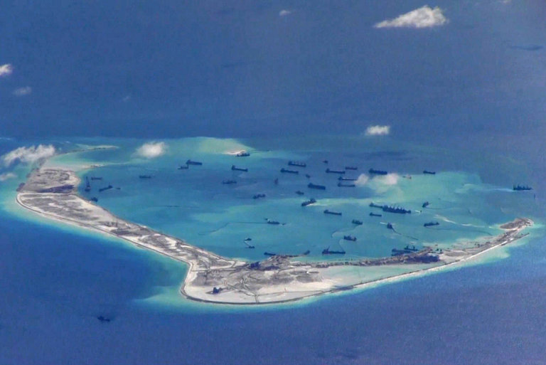
Chinese ships dredging around Mischief Reef in the Spratly Islands in the South China Sea in 2015. Beijing has placed weapons and runways for fighter jets on the islands. Credit U.S. Navy, via Reuters
BEIJING — A United States Navy warship sailed within 12 nautical miles of an artificial island claimed by China in the South China Sea on Wednesday, an operation that showed a new firmness by the Trump administration in its dealings with Beijing.
The warship, the guided missile destroyer Dewey, passed near Mischief Reef in the Spratly Islands, not far from the Philippines, American military officials said.
The operation may tamp down concerns among allies of the United States that the Trump administration has been unwilling to confront China’s territorial claims in the South China Sea as it seeks Beijing’s cooperation on issues like halting North Korea’s nuclear program.
Until the operation on Wednesday, the Pentagon had turned down requests from the United States Pacific Command in Hawaii, under the command of Adm. Harry B. Harris Jr., for such maneuvers. It was the first freedom of navigation operation since President Trump took office.

Related Coverage

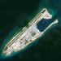

Trump’s Mixed Signals on South China Sea Worry Asian Allies MAY 10, 2017

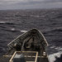

Trump’s Turn Toward China Curtails Navy Patrols in Disputed Zones MAY 2, 2017



Duterte Says Xi Warned Philippines of War Over South China Sea MAY 19, 2017

The United States does not recognize China’s claims of sovereignty over the 12 nautical miles surrounding the artificial islands, the conventional limit for territorial waters.
A Pentagon official involved in the operation said the American warship did a “man overboard” rescue drill while passing by the island. The particular exercise was intended to show China that the United States would operate anywhere on the high seas in accordance with international law, the official said.
Mr. Trump was initially reluctant to confront China’s territorial claims once he became president, despite his criticism during the campaign of the Obama administration’s handling of the issue. In an interview with The New York Times in March 2016, Mr. Trump said that Beijing had built in the South China Sea “a military fortress, the likes of which perhaps the world has not seen.”
A Chinese Foreign Ministry spokesman said Thursday that Chinese vessels around the Spratly Islands “identified and warned” the American warship to leave.
Lu Kang, the spokesman, said at a regular briefing Thursday that Beijing was “strongly dissatisfied” with the operation, particularly at a moment when the situation in the South China Sea was “cooling down.” That was an apparent reference to the recent start of direct talks between China and the Philippines, an American ally, over the status of islands both countries claim.
Separately, China’s department of defense accused the United States of spoiling what it called “an important period of development” in the relations between American and Chinese forces.
“This behavior by the United States military is a show of force to promote the militarization in the region, and would very easily lead to accidents on the sea and in the air,” Sr. Col. Ren Guoqiang said in statement.
In the wake of Wednesday’s maneuver, allies will be watching to see how consistent the Trump administration is on the South China Sea, analysts said.
“One operation won’t allay fears about Trump’s transactional approach toward China and its apparent disinterest in defending international and legal rights,” said Euan Graham, an analyst with the Lowy Institute in Australia.
Satellite images suggest that China has placed military hardware like antiaircraft and antimissile systems on the islands it has constructed in the South China Sea.
Maj. Jamie Davis, a Pentagon spokesman, declined to discuss any current maneuvers but said the military was continuing with its freedom of navigation operations, known as Fonops.
“We are continuing regular Fonops, as we have routinely done in the past and will continue to do in the future,” he said in a statement. “All operations are conducted in accordance with international law and demonstrate that the United States will fly, sail and operate wherever international law allows.”
“We have a comprehensive freedom of navigation operations program that seeks to challenge excessive maritime claims in order to preserve the rights, freedoms and uses of the sea and airspace guaranteed to all nations under international law,” he added.
The naval operation on Wednesday was interpreted by the United States’ allies in the region as a welcome sign of American engagement in the South China Sea.
Even so, Australia, whose economy is highly dependent on exports to China, has declined to participate in the United States-led military operations, arguing that China now controls the Spratly Islands, where it has placed weapons and runways for fighter jets.
“Australia is extremely reluctant to participate in freedom of navigation operations that involve flying over or sailing through the 12 nautical miles around the islands,” said Alan Dupont, a former Australian military intelligence official.
“The Australian government feels it would be provocative and upset China,” Mr. Dupont said. “It feels it would be counterproductive now that China has militarized the islands.”

The Diplomat

Is the Focus on FONOPs Muddying Strategic Discourse on the South China Sea?
It is proving extremely difficult for Washington to convince Beijing of its seriousness in the South China Sea.

By Robert Farley
June 17, 2017

At Lawfare, Peter Dutton and Isaac Kardon argue that the focus on Freedom of Navigation Operations (FONOPs) in the South China Sea has come to obscure the basic strategic issues, rather than illuminate them. Dutton and Kardon suggest that the U.S. government and the U.S. Navy ought to reconsider the use of FONOPs as a political tool, and instead concentrate on the broader goal of sailing whenever, and wherever, it feels itself legally entitled to sail.
Over the past weeks, the U.S. Navy and a considerable portion of the U.S. strategic analyst community have staked out the position that whether a U.S. destroyer conducts a “man overboard” drill in the vicinity of a Chinese installation has strategic relevance. The analytic community was previously gripped by the question of why the United States had conducted no FONOPs since the beginning of the Trump administration; before that, it pondered whether a FONOP without a “man overboard” drill constituted a sufficiently robust response to the growth of Chinese naval power and the assertiveness of China’s territorial claims in the South China Sea.
The notion of the utility of FONOPs is built around the idea that the Chinese are hypersensitive to U.S. messages regarding SCS installations, and that the Chinese will read such messages in the way that we intend; in other words, the Chinese are listening, and there is no meaningful noise to muddle what we’re saying. Of the first assumption there is considerable evidence; Chinese officials do seem to pay a great deal of attention to U.S. vessels when they conduct freedom of navigation missions in the South China Sea. Of the second, there is considerably less evidence.
At the very best, conveying critical strategic messages through military action is fraught with difficulty and contradiction. What does the action mean? How will the target interpret the action? Will the target believe the action represents a credible commitment, or cheap bluster? Literal bookshelves of foreign policy work has been produced on these questions, but have failed to resolve the basic conundrum; the messages we want to send are only rarely the messages that others hear.
FONOPs taken; FONOPs not taken; FONOPs misconducted; FONOPs conducted at the behest of one element of the U.S. foreign policy hierarchy rather than some other element; FONOPs as indicative of the policy of one administration rather than another. In sum, Dutton and Kardon make clear that FONOPs make nothing clear; they are inadequate to conveying precision-guided messages to the Chinese military and diplomatic establishment. FONOPs impose no practical constraints on China’s development of new installations in the SCS. They send no obvious message about conditions under which the United States might go to war. They are as likely to confuse potential allies as they are to confuse the Chinese.
The United States has taken on an enormously difficult task in the South China Sea. It needs to convince China that it cares as much about quasi-island-features in the South China Sea as China does, and that it is willing to take expensive risks in order to prevent China’s expansion of these features. Given that the U.S. has no territorial claims of its own, and that the U.S. has struggled to develop a compelling economic argument regarding the relevance of these features, it is proving extremely difficult for Washington to convince Beijing of its seriousness. FONOPs are the tool that the United States has happened upon, but they are altogether inadequate to the task.

Is the Focus on FONOPs Muddying Strategic Discourse on the South China Sea?
It is proving extremely difficult for Washington to convince Beijing of its seriousness in the South China Sea.
By Robert Farley
June 17, 2017
At Lawfare, Peter Dutton and Isaac Kardon argue that the focus on Freedom of Navigation Operations (FONOPs) in the South China Sea has come to obscure the basic strategic issues, rather than illuminate them. Dutton and Kardon suggest that the U.S. government and the U.S. Navy ought to reconsider the use of FONOPs as a political tool, and instead concentrate on the broader goal of sailing whenever, and wherever, it feels itself legally entitled to sail.
Over the past weeks, the U.S. Navy and a considerable portion of the U.S. strategic analyst community have staked out the position that whether a U.S. destroyer conducts a “man overboard” drill in the vicinity of a Chinese installation has strategic relevance. The analytic community was previously gripped by the question of why the United States had conducted no FONOPs since the beginning of the Trump administration; before that, it pondered whether a FONOP without a “man overboard” drill constituted a sufficiently robust response to the growth of Chinese naval power and the assertiveness of China’s territorial claims in the South China Sea.
The notion of the utility of FONOPs is built around the idea that the Chinese are hypersensitive to U.S. messages regarding SCS installations, and that the Chinese will read such messages in the way that we intend; in other words, the Chinese are listening, and there is no meaningful noise to muddle what we’re saying. Of the first assumption there is considerable evidence; Chinese officials do seem to pay a great deal of attention to U.S. vessels when they conduct freedom of navigation missions in the South China Sea. Of the second, there is considerably less evidence.
At the very best, conveying critical strategic messages through military action is fraught with difficulty and contradiction. What does the action mean? How will the target interpret the action? Will the target believe the action represents a credible commitment, or cheap bluster? Literal bookshelves of foreign policy work has been produced on these questions, but have failed to resolve the basic conundrum; the messages we want to send are only rarely the messages that others hear.
FONOPs taken; FONOPs not taken; FONOPs misconducted; FONOPs conducted at the behest of one element of the U.S. foreign policy hierarchy rather than some other element; FONOPs as indicative of the policy of one administration rather than another. In sum, Dutton and Kardon make clear that FONOPs make nothing clear; they are inadequate to conveying precision-guided messages to the Chinese military and diplomatic establishment. FONOPs impose no practical constraints on China’s development of new installations in the SCS. They send no obvious message about conditions under which the United States might go to war. They are as likely to confuse potential allies as they are to confuse the Chinese.
The United States has taken on an enormously difficult task in the South China Sea. It needs to convince China that it cares as much about quasi-island-features in the South China Sea as China does, and that it is willing to take expensive risks in order to prevent China’s expansion of these features. Given that the U.S. has no territorial claims of its own, and that the U.S. has struggled to develop a compelling economic argument regarding the relevance of these features, it is proving extremely difficult for Washington to convince Beijing of its seriousness. FONOPs are the tool that the United States has happened upon, but they are altogether inadequate to the task.

The Economist

Shoals apart

China and ASEAN declare progress in the South China Sea

But a new agreement is less than it seems
May 27th 2017 | SINGAPORE

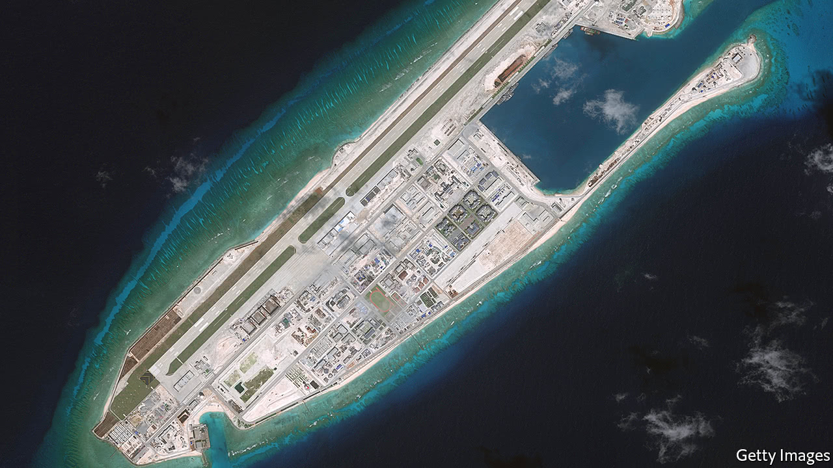A reef with Chinese characteristics
TO CALL negotiations between China and the ten-country Association of South-East Asian Nations (ASEAN) over rival claims in the South China Sea “drawn out” would be a gross understatement. At the centre of the matter is an unsquareable circle: the competing claims of China and several South-East Asian countries. Nobody wants to go to war; nobody wants to be accused of backing down.
Still, at a meeting of senior Chinese and ASEAN officials on May 18th, something happened: the two sides agreed on a “framework” for a code of conduct. An official from Singapore (which currently co-ordinates ASEAN-China relations) called the agreement a sign of “steady progress”.
ASEAN members called for a legally binding code of conduct as far back as 1996. In 2002, ASEAN and China signed a “declaration of conduct”, which recognised that a fully fledged code would be nice to have; it also committed both sides to peaceful dispute resolution and “self-restraint” in doing anything that could “escalate disputes [or] affect peace and stability”.
Since then, code-of-conduct negotiations have proceeded glacially. And in 2013 China embarked on a vast effort to build up seven reefs and rocks into islands suited for military use (see picture). Last July, after China received an unfavourable ruling on its maritime claims in a case brought by the Philippines to a tribunal in The Hague, China agreed to expedite the talks.
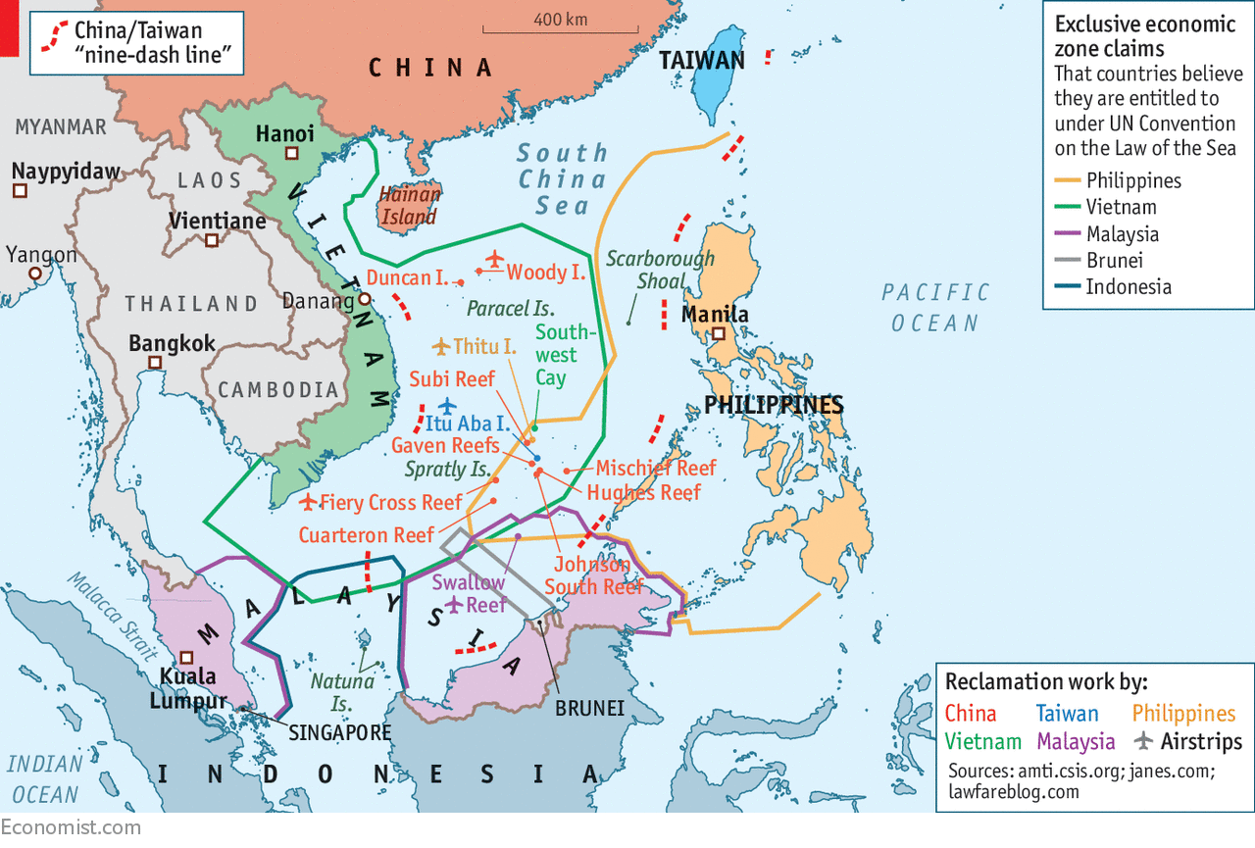
The draft framework will be presented to ASEAN and Chinese foreign ministers at a conference in August. This will then form the basis for the thorny negotiations to follow. The text has not (yet) been leaked. But its most salient feature may be what it appears to lack: any hint of enforcement mechanisms or consequences for violations. China has long rejected a legally binding agreement—or indeed any arrangement that could limit its actions in the South China Sea.
The result, explains Ian Storey, of the ISEAS-Yusof Ishak Institute, a think-tank in Singapore, is a framework “that makes China look co-operative…without having to do anything that might constrain its freedom of action”. ASEAN, meanwhile, gets the appearance of progress. “The ASEAN secretariat is a bureaucracy, and bureaucrats like process,” explains Mr Storey.
But a toothless agreement need not augur further Chinese aggression. And why should it? Under Rodrigo Duterte the Philippines has turned from China’s chief regional rival into an ally. The two countries recently reiterated their desire in principle for joint exploration for resources, something Manila had resisted for fear it would validate China’s expansionary claims. Other countries seem resigned, in fact if not in principle, to its island-building.
On May 24th America carried out its first freedom-of-navigation operation (sending warships through international waters) since the election of Donald Trump. But he seems less willing than his predecessor to enforce a rules-based order; his transactional mercantilism will reassure China. Extended talks on a code of conduct probably mean that China will be free to consolidate its gains with minimal interference from rivals near or far.

The Diplomat

Asia Reassurance Initiative Act: A Republican Vision for Engaging Southeast Asia
Can the Asia Reassurance Initiative Act find strategic ballast?
By Carl Thayer
July 19, 2017

On July 18, Senator Cory Gardner (R-CO) delivered the keynote address at the seventh international conference on the South China Sea hosted by the Center for Strategic and International Studies in Washington, DC.
Gardner is the chairman of the Senate Foreign Relations Committee’s Subcommittee on East Asia, the Pacific, and International Cyber Security. Under Gardner’s leadership, the Subcommittee has held three hearings to gather information and analysis to support his legislative initiative, the Asia Reassurance Initiative Act (ARIA). The first hearing, held in late March, focused on growing security challenges such as North Korea, the South China Sea, and terrorism in Southeast Asia. The theme of the second hearing, held in May, examined the importance of U.S. economic leadership in Asia. The third hearing, held in July, considered promoting democracy, human rights, and the rule of law in the Asia-Pacific.
Gardner’s keynote address is a welcome sign that legislators in Washington are thinking seriously about U.S. policy in Southeast Asia under the Trump administration. Gardner proposed three major goals for U.S. policy. They are a good starting point but a coherent U.S. strategy toward the Indo-Pacific region still remains elusive.
Gardner opened his address by offering assurance to the United States’ “jittery allies after years of neglect.” This swipe at the Obama administration was not entirely accurate.
Under President Barack Obama, U.S. alliance relations with the Philippines were raised to new levels of interaction through the Enhanced Defense Cooperation Agreement, including U.S. rotational access to bases and facilities in the Philippines. Singapore, a strategic partner, permitted the United States to station two more Littoral Combat Ships for patrols in the South China Sea.
U.S.-Vietnam defense cooperation was stepped up through a Joint Vision Statement on Defense Relations signed in 2015 and the lifting of the International Trafficking in Arms Regulations, otherwise known as the arms embargo, during Obama’s visit to Hanoi in May 2016.
The Obama administration was also active in bringing protracted negotiations on a Trans-Pacific Partnership (TPP) to a successful conclusion.
The main failure of the Obama administration was not to stand up strongly enough when it became clear that China was implementing a master plan to dominate the South China Sea through the construction of seven artificial islands. As Admiral Harry Harris noted in testimony to the Senate Armed Services Committee on May 1, the artificial islands “support long-range weapons emplacements, fighter aircraft hangars, radar towers and barracks for their troops. China’s militarization of the South China Sea is real.”
Gardner’s keynote address was divided into four parts. He opened by identifying the “coming nuclear crisis on the Korean peninsula” as “the most urgent challenge for U.S. policy in the region.” He reinforced Trump’s China-centric approach by noting “the road to peacefully stopping Pyongyang undoubtedly lies through Beijing.” The senator advocated a policy of “maximum pressure,” including the invocation of further sanctions against commercial entities that do business with North Korea.
Gardner concluded this section by arguing that “Beijing must be made to choose whether it wants to work with the United States as a responsible leader to stop Pyongyang – or bear consequences of keeping him [Kim Jong-un] in power.”
In the next section of his keynote address, Gardner turned his attention to maritime security and escalating tensions in the South China Sea. Here he missed an opportunity to link the North Korean crisis with the South China Sea, the focus of the CSIS conference.
How should the United States approach these two interrelated security challenges? Gardner called for a “consistent and assertive diplomatic engagement with China” on the South China Sea in contrast to his more robust approach to China on the North Korean issue. China’s inaction with North Korea contributed to the present crisis. And China actions in the South China Sea have raised tensions and challenged U.S. national interests.
What is needed is a strategic policy framework for dealing with China on both issues. Without a comprehensive strategy regional states are less likely to be assured that the Trump administration won’t pursue a transactional approach, rewarding China for pressure on North Korea by going soft on China in the South China Sea.
In his discussion of the South China Sea, Gardner, like the Obama administration, used the term “land reclamation” to describe China’s construction of artificial islands. This description is inaccurate and misleading. It is inaccurate because it suggests that China is restoring a land feature to its previous condition. None of the Chinese-occupied features was an island that lost soil due to erosion by wind or waves. China’s artificial islands were constructed by destroying coral reefs and gouging the seabed for fill.
Gardner’s discussion of the South China Sea was all the more remarkable for its omission of any mention of the Association of Southeast Asian Nations (ASEAN). ASEAN not only seeks centrality in the region’s security architecture but it is currently engaged in discussions with China on a Code of Conduct for the South China Sea. It is clear from past U.S. diplomatic initiatives that if the Unites States pursues policies that get ahead of ASEAN, or fails to consult with ASEAN members first, these policies will remain dead in the water.
Most of Gardner’s prescriptions repeat policies that were part and parcel of Obama’s rebalance to the Asia-Pacific. The senator calls for engaging with allies. As noted, U.S. alliance relations were robust under Obama. Gardner proposes assisting the Philippines with maritime domain awareness; this was a central component of U.S. assistance under Obama. The essential point is that Gardner did not address is how to stop and reverse the growing estrangement in alliance relations initiated by Philippine President Rodrigo Duterte. Later in his presentation, Gardner mentions human rights but there is no mention of the extra-judicial killing of suspected drug traffickers in the Philippines promoted by Duterte.
Gardner, like the Obama administration, advocates conducting freedom of navigation operation (FONOP) patrols. FONOPs are designed to challenge China’s (and other countries’) excessive maritime claims, but these patrols are largely irrelevant because the United States is not addressing the central issue. China has not promulgated baselines around any of its artificial islands in the Spratlys. These are a prerequisite to determining a 12 nautical mile (nm) territorial sea. The United States is splitting legal hairs when it sails within 12 nm of an artificial island.
The central issue is China’s challenge to FONOPs on the grounds that they threaten China’s security. China routinely warns off military aircraft for entering a “military alert zone.” This is an expansive claim with no basis in international law. However, if China interferes with U.S. FONOPs, the United States would be unable to use the United Nations Convention on the Law of the Sea (UNCLOS) for legal redress, as Washington has never ratified the convention. Gardner’s keynote does not mention whether he supports the early ratification of UNCLOS.
Gardner called for U.S. allies such as Australia, Japan, and the United Kingdom to join U.S. FONOPs. This is a good suggestion for two reasons. First, as maritime powers the United States and its allies should challenge China’s imposition of a “military alert zone” over the Spratlys. Second, if China attempted to interfere with freedom of navigation patrols by Australian or Japanese warships operating with the U.S. Navy, for example, these countries could take legal action under UNCLOS because they have ratified the treaty.
Gardner also argues that negotiations for a Code of Conduct “must start with the Hague ruling, which invalidated the so-called ‘nine-dash line.’” This is a decision that ASEAN should make. The United States could backstop ASEAN by conducting FONOPs and overflights across the South China Sea and the Spratlys in particular to demonstrate that Washington does not recognize the nine-dash line claim. This would be a modification of the current official rational for freedom of navigation missions. The purpose of challenging China’s nine-dash line should be made explicit.
Gardner is on sound ground in advocating that “urgent steps” must be taken “to rebuild our military, so we can enhance our defense posture in the region.”
Gardner’s third section addressed the threat of “the rising tide of Islamic extremism in Southeast Asia.” He correctly advocates a significant increase in “military, intelligence, and counterterrorism cooperation with the governments of the region.” He presciently observes:
When U.S. leadership wanes, or even the perception of U.S. leadership is waning, it undoubtedly empowers bad actors and constrains the political space for many nations to make choices that comport with U.S. values and interests.
Gardner concluded his keynote by proposing a new legislative initiative, the Asia Reassurance Initiative Act (ARIA). U.S. reassurance is needed not because of Obama’s “flawed ‘Asia rebalance’ policy” as the senator argued, but because of candidate Trump’s transactional approach to foreign policy, his criticism of U.S. allies Japan and South Korea during the presidential election campaign, and his withdrawal from the TPP on his first day as president.
ARIA has three components: strengthening U.S. security commitments to its allies; promoting economic engagement and securing a U.S. market access in the Asia-Pacific; and promoting democracy, human rights, and transparency. Gardner left unexplained how these three goals will be integrated into a coherent strategy. But they are important first steps and should be given bipartisan support. ARIA should include a fourth goal – the expeditious completion of the Trump administration’s belated U.S. National Security Strategy mandated by Congress.

