**TPP**

**Text of TPP**

[**https://ustr.gov/trade-agreements/free-trade-agreements/trans-pacific-partnership/tpp-full-text**](https://ustr.gov/trade-agreements/free-trade-agreements/trans-pacific-partnership/tpp-full-text)

**TPP and Free Trade in Asia**

[**http://www.keia.org/event/future-free-trade-east-asia**](http://www.keia.org/event/future-free-trade-east-asia)

**FT 11/08/11**

**Trans-Pacific Partnership: Far-reaching agreement could form powerful new trade bloc**

By David Pilling

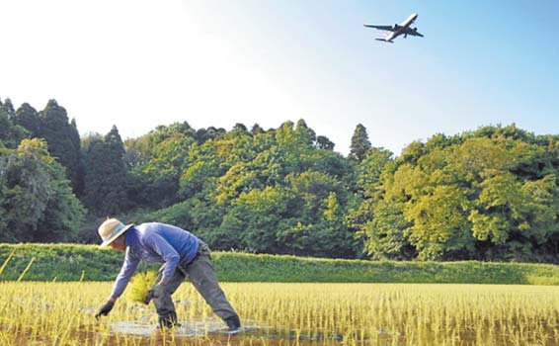

TPPing point: the ruling Democratic party of Japan faces trouble over fears that signing up to the partnership would threaten the country's farming industry

Just what the global trading system needs: another acronym. The TPP, or Trans-Pacific Partnership to give it its full title, is a proposed trade agreement between, to put it politely, a disparate collection of nations.

The TPP is intended to build on an existing arrangement, the Trans-Pacific Strategic Economic Partnership, of which Singapore, Brunei, Chile and New Zealand are already members. But the new TPP has taken on a life of its own.

Spearheaded by the US, other countries to show early interest in joining the founding members are Australia, Malaysia, Peru and Vietnam. Japan is also agonising over whether to throw its lot in with the grouping, though, predictably, the proposal has antagonised its farmers.

On the face of it, the countries involved in negotiations, which recently concluded their ninth round in Lima, are a motley crew. In addition to the world’s largest economy, they include two smallish Andean nations, two developed economies in Australasia, a rich city state, a small oil-rich kingdom and a poor communist country. China is notable by its absence.

Yet, at least in theory, the nine negotiating partners are all committed to signing what has been called a “state-of-the-art” trade agreement that would go further than existing arrangements. The idea is for the TPP to be a structure on to which other nations, including possibly South Korea, and eventually even China, could be bolted.

Ronald Kirk, the US trade representative, launched the initiative domestically in late 2009, saying the putative deal “provides the opportunity to develop a new model for US trade negotiations and a new regional approach that focuses more on jobs, enhances US competitiveness and ensures that the benefits of our trade agreements are shared by all Americans”.

This is not, in other words, intended to be just another deal that is good for multinational companies but of uncertain benefit to US workers.

Last month, Thomas Donohue, chief executive of the US chamber of commerce, fleshed out his own vision, saying: “This must be an agreement with high standards. These standards will set the bar on regulatory coherence, investment and intellectual property.”

Simon Tay, chairman of the Singapore Institute of International Affairs, says talk of the agreement has energised the wider Asia-Pacific Economic Co-operation group (Apec), which meets in Hawaii this week.

The nine governments are discussing “deep commitments that go beyond tariff reduction and pass existing World Trade Organization standards”.

So what is so special about the TPP? Iwan Azis, head of the Asian Development Bank’s regional integration office, says the agreement is intended to deal with what he calls “behind the border” issues. These include areas of what could be deemed domestic policy, such as government procurement, which go beyond the normal scope of trade agreements.

Other areas likely to be covered include rules governing the conduct of state-owned enterprises, which sometimes benefit from cheap financing or government protection. China, in particular, is often criticised for seeking to ensure the success of national champions.

The TPP would also include labour, environmental and intellectual property standards. Finally, it is supposed to help bring benefits to small and medium-sized companies from trade integration.

“As a concept, this is definitely something big,” says Mr Azis of the ADB. “This is so comprehensive, it is like a Grade A agreement. But when it comes to realisation, we have to be a little less optimistic about how this is going to proceed.”

Indeed, the path to a comprehensive TPP will not be easy. The negotiating partners have already struggled. As a result, Barack Obama, the US president, is unlikely to announce anything beyond the broadest of principles at the Apec summit.

Negotiations are stuck on several points. Some participants, for example, are wary that standards designed to protect the intellectual property of the pharmaceutical industry could restrict poor countries’ access to life-saving medicines.

Malaysia, which has a sizeable state sector, is worried about what entry to the TPP might mean. It is unlikely to move forward decisively until elections are held sometime next year.

There are even concerns that the US, whose government has a controlling stake in General Motors, not to mention the US Postal Service, could fall foul of some of the agreement’s stipulations.

The controversy that the TPP has caused in Japan is also a harbinger of difficulties ahead. [Opponents have threatened to leave](http://www.ft.com/cms/s/0/e8258cf0-007d-11e1-ba33-00144feabdc0.html#axzz1d3z06utp) the ruling Democratic Party of Japan over fears that signing up would threaten the country’s farming industry. Japan produces just 40 per cent of its calorific intake and many officials are opposed to becoming even more dependent on foreign food.

Japan’s angst could be repeated elsewhere. Many trade agreements put sensitive issues to one side. But if the TPP is to be genuinely more all-embracing, it will also be that much harder to conclude.

Ironically, one of the attractions of the TPP for Japan – the absence of China – is also one of the agreement’s biggest potential pitfalls. Akihisa Nagashima, a special adviser to Yoshihiko Noda, Japan’s prime minister, has said the TPP would “create a strategic environment, where China would see Japan as a formidable neighbour that cannot be pushed around”.

But China is now at the very centre of an Asian supply chain that is itself at the heart of the global manufacturing industry. “Any agreement that does not include China will not be so relevant,” says Mr Azis.

If the TPP smacks of “an anyone-but-China club”, it is likely to be highly divisive in a region where Beijing is becoming more dominant, politically as well as economically. Commentary in the Chinese press often casts the TPP as an “aggressive” US-led ploy to “squeeze China out”.

There is, undoubtedly, an element of seeking to wrest back global trade for nations perceived to play by the rules. But there is also a deeply pragmatic driving force behind the TPP.

The US has watched intra-Asian trade balloon, while trade between Asia and other emerging countries, from Brazil to South Africa, has flourished.

The TPP is an attempt to regain the initiative by opening up Asia-Pacific markets more fully to US business. Mr Kirk has said that “a declining US market share in Asia-Pacific countries means fewer US jobs”.

Everything now depends on the willingness of negotiating partners to follow through.

Joining TPP will require give as well as take. But making sacrifices and pooling one’s interests for the sake of a higher common goal is never easy. Just ask the Greek prime minister.

# Sidney Herald

# Beware the limits of latest free trade deal

##### Russell Marks

November 15, 2011

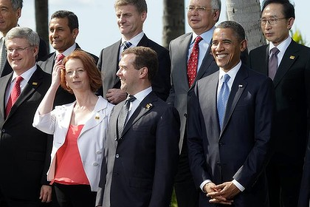

Prime Minister JUlia Gillard, Russian President Dmitry Medvedev and US President Barack Obama and Russian at APEC this week. The annoucement of a Trans-Pacific Partnership in trade is not all good news for Australia. Despite claims to the contrary by Prime Minister Julia Gillard, the nine-country Trans-Pacific Partnership announced this week is not good news for Australia.

Multilateral and bilateral free trade treaties form a major plank of what has variously been called neo-liberal economic policy or "economic rationalism". This is based on the theory that the regulation of the economy by governments almost always results in inefficiencies and productivity losses, which in turn lead to higher consumer prices and slower rates of economic growth. One major aim of free trade agreements is to compel governments to remove themselves from their role as regulators, and to allow "market forces" to determine what is produced and consumed where, by whom and at what price.

It's a neat idea, in theory. And it must have something going for it, considering that it's been ascendant in government policy circles for the better part of 30 years. The trouble is that over the course of those 30 years, there are numerous instances of the idea having failed when it's been put into practice. Many of the fundamental tenets of neo-liberalism were discredited in 2008, when the consequences of the global deregulation of the financial sector became apparent.

Advertisement: Story continues below

The discrediting of neo-liberal ideas has occurred not least in the arena of international trade. It has become increasingly apparent that what free trade agreements do best is restrict governments from regulating the economy for public interest policy reasons, such as public health and the protection of the environment and local industry.

Australia has recent experience of the detrimental consequences of signing a free trade deal with a much larger "partner". In 2004, neo-liberal ideologues in the Howard government engineered a bilateral free trade agreement with the US. Ostensibly, this was to allow Australian exporters greater access to American agricultural markets. However, the powerful agricultural lobby in the US was effective in preventing any real access. Famously, not one grain of Queensland sugar has seen entry into US markets. In the first three years of the operation of the AUSFTA, the Department of Foreign Affairs and Trade's [**own figures**](http://www.dfat.gov.au/publications/stats-pubs/trade-and-investment-between-australia-and-the-us.pdf) show that Australia's trade deficit with the US more than doubled.

Neo-liberal ideas are also referred to as "the Washington Consensus", given the location of many of the major institutions – the International Monetary Fund, the World Bank and the US Treasury – which prescribe rationalist solutions for crisis-ridden developing economies. "Washington Consensus" is an apt term. Historically, the US has used its relative economic and political power to secure "free trade" deals that benefit it at the expense of its trading "partners". This can most clearly be seen in America's attempts to reclassify other governments' public interest policies as forms of economic protectionism, which must be abandoned under the rules of "free trade" agreements.

In its negotiations over the AUSFTA during 2003-04, the office of the United States Trade Representative focused in particular on Australia's Pharmaceutical Benefits Scheme (which provides heavily subsidised access for patients to listed medicines under patent), its process of blood procurement (which for health and security reasons is not open to international competition) and its laws mandating minimum levels of local broadcast content on television. The USTR sees these policies as "protectionist" and [**wants them abandoned**](http://www.ustr.gov/sites/default/files/uploads/reports/2010/NTE/2010-NTE-Australia-final.pdf), regardless of Australia's arguments that they are in our national interest.

There has been very little media coverage of the Trans-Pacific Partnership negotiations. The TPP aims to build on a four-nation treaty originally signed by New Zealand, Singapore, Chile and Brunei. In September 2008, the new Obama administration announced that it would be seeking to join what was then called the P-4. Within two months, the governments of Vietnam, Peru and Australia announced that they would also join in negotiations, which formally started on March 15, 2010.

When the Rudd government committed Australia to the TPP negotiations (in the same year that he [**publicly declared**](http://www.themonthly.com.au/monthly-essays-kevin-rudd-global-financial-crisis--1421) that neo-liberalism was "little more than personal greed dressed up as an economic philosophy"), many outside DFAT scratched their heads. Yesterday morning, Gillard [**told ABC radio**](http://www.abc.net.au/am/content/2011/s3363730.htm) that "freer trade with our growing region means Australian jobs". But at what cost?

Why, exactly, is the Australian government pursuing a TPP deal? It already has bilateral agreements with four of the negotiating countries – New Zealand, Chile, Singapore and the US – and with the 10-country ASEAN bloc. Australia claims that the TPP will result in greater access to Pacific markets for exporters. But it is highly unlikely that the US, in a presidential election year, will allow much further access to its own domestic markets, especially given that it is still facing 9 per cent unemployment and is at risk of a double-dip recession. It is also likely that the US will make a further push for the deregulation of Australia's PBS, local content requirements and blood procurement system.

The New Zealand-born former British Labour MP Bryan Gould, who [**has been warning**](http://www.scoop.co.nz/stories/BU1102/S00169/bryan-gould-named-patron-of-network-to-fight-tppa.htm) New Zealand against signing up to any free trade deal involving the US, [**argues**](http://www.allenandunwin.com/default.aspx?page=94&book=9781742376271) that "free trade areas" effectively become single economies.

Australians should be aware that any Pacific-wide free trade area would inevitably drive wages down as part of the need to compete with Asian and South American industries. With this in mind, the neo-liberal "jobs at any cost" rationalisation of our own Labor Prime Minister has a very hollow ring.

**Dr Russell Marks is a lecturer in Australian politics at La Trobe University.**  
Read more: <http://www.smh.com.au/opinion/politics/beware-the-limits-of-latest-free-trade-deal-20111115-1ngax.html#ixzz1eRfGqB5a>

# NYT

# Administration Is Seen as Retreating on Environment in Talks on Pacific Trade

By CORAL DAVENPORTJAN. 15, 2014

WASHINGTON — The Obama administration is retreating from previous demands of strong international environmental protections in order to reach agreement on a sweeping Pacific trade deal that is a pillar of President Obama’s strategic shift to Asia, [according to documents obtained by WikiLeaks](https://wikileaks.org/tpp-enviro/pressrelease.html), environmentalists and people close to the contentious trade talks.

The negotiations over the Trans-Pacific Partnership, which would be one of the world’s biggest trade agreements, have exposed deep rifts over environmental policy between the United States and 11 other Pacific Rim nations. As it stands now, the documents, viewed by The New York Times, show that the disputes could undo key global environmental protections.

The environmental chapter of the trade deal has been among the most highly disputed elements of negotiations in the pact. Participants in the talks, which have dragged on for three years, had hoped to complete the deal by the end of 2013.

Environmentalists said that the draft appears to signal that the United States will retreat on a variety of environmental protections — including legally binding pollution control requirements and logging regulations and a ban on harvesting sharks’ fins — to advance a trade deal that is a top priority for Mr. Obama.

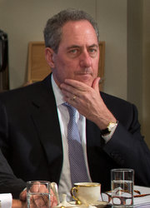

Launch media viewer

Michael Froman, the United States trade representative, said, “We’re pushing hard.” Stephen Crowley/The New York Times

Ilana Solomon, the director of the Sierra Club’s Responsible Trade Program, said the draft omits crucial language ensuring that increased trade will not lead to further environmental destruction.

“It rolls back key standards set by Congress to ensure that the environment chapters are legally enforceable, in the same way the commercial parts of free-trade agreements are,” Ms. Solomon said. The Sierra Club, the Natural Resources Defense Council and the World Wildlife Fund have been following the negotiations closely and are expected to release a report on Wednesday criticizing the draft.

American officials countered that they had put forward strong environmental proposals in the pact.

“It is an uphill battle, but we’re pushing hard,” said Michael Froman, the United States trade representative. “We have worked closely with the environmental community from the start and have made our commitment clear.” Mr. Froman said he continued to pursue a robust, enforceable environmental standard that he said would be stronger than those in previous free-trade agreements.

The draft documents are dated Nov. 24 and there has been one meeting since then.

The documents consist of the environmental chapter as well as a [“Report from the Chairs,”](http://wikileaks.org/tpp-enviro-chairsreport/#start) which offers an unusual behind-the-scenes look into the divisive trade negotiations, until now shrouded in secrecy. The report indicates that the United States has been pushing for tough environmental provisions, particularly legally binding language that would provide for sanctions against participating countries for environmental violations. The United States is also insisting that the nations follow existing global environmental treaties.

But many of those proposals [are opposed by most or all of the other Pacific Rim nations](http://www.wikileaks.org/Second-release-of-secret-Trans.html) working on the deal, including Australia, New Zealand, Canada, Mexico, Chile, Japan, Singapore, Malaysia, Brunei, Vietnam and Peru. Developing Asian countries, in particular, have long resisted outside efforts to enforce strong environmental controls, arguing that they could hurt their growing economies.

The report appears to indicate that the United States is losing many of those fights, and bluntly notes the rifts: “While the chair sought to accommodate all the concerns and red lines that were identified by parties regarding the issues in the text, many of the red lines for some parties were in direct opposition to the red lines expressed by other parties.”

As of now, the draft environmental chapter does not require the nations to follow legally binding environmental provisions or other global environmental treaties. The text notes only, for example, that pollution controls could vary depending on a country’s “domestic circumstances and capabilities.”

In addition, the draft does not contain clear requirements for a ban on shark finning, which is the practice of capturing sharks and cutting off their fins — commonly used in shark-fin soup — and throwing back the sharks to die. The dish is a delicacy in many of the Asian negotiating countries. At this point the draft says that the countries “may include” bans “as appropriate” on such practices.

Earlier pacts like the North American Free Trade Agreement included only appendices, which called for cooperation on environmental issues but not legally binding terms or requirements. Environmentalists derided them as “green window dressing.”

But in May 2007, President George W. Bush struck an environmental deal with Democrats in the Senate and the House as he sought to move a free-trade agreement with Peru through Congress. In what became known as the May 10 Agreement, Democrats got Mr. Bush to agree that all American free-trade deals would include a chapter with environmental provisions, phrased in the same legally binding language as chapters on labor, agriculture and intellectual property. The Democrats also insisted that the chapter require nations to recognize existing global environmental treaties.

Since then, every American free-trade deal has included that strong language, although all have been between the United States and only one other country. It appears to be much tougher to negotiate environmental provisions in a 12-nation agreement.

“Bilateral negotiations are a very different thing,” said Jennifer Haverkamp, the former head of the United States trade representative’s environmental office. “Here, if the U.S. is the only one pushing for this, it’s a real uphill battle to get others to agree if they don’t like it.”

But business groups say the deal may need to ease up. “There are some governments with developing economies that will need more time and leeway,” said Cal Cohen, president of the Emergency Committee for American Trade, a group of about 100 executives and trade associations that lobbies the United States trade negotiator on the deal. “When you think about the evolution of labor provisions, you realize how many centuries the development of high standards took.”

Since the trade talks began, lawmakers and advocacy groups have assailed the negotiators for keeping the process secret, and WikiLeaks has been among the most critical voices. The environment chapter is the third in a series of Trans-Pacific Partnership documents released by WikiLeaks. In November, the group [posted the draft chapter on intellectual property](https://wikileaks.org/tpp/). In December, the site posted documents detailing disagreements between the negotiating parties on other issues. The site is expected to release more documents as the negotiations unfold.

NYT

March 15, 2014, 5:06 pm

# On the Wrong Side of Globalization

By [JOSEPH E. STIGLITZ](http://opinionator.blogs.nytimes.com/author/joseph-e-stiglitz/)

Trade agreements are a subject that can cause the eyes to glaze over, but we should all be paying attention. Right now, there are trade proposals in the works that threaten to put most Americans on the wrong side of globalization.

The conflicting views about the agreements are actually [tearing at the fabric of the Democratic Party](http://www.nytimes.com/2014/02/15/us/politics/biden-remark-casts-doubt-on-pillar-of-us-trade-agenda.html?action=click&module=Search&region=searchResults%230&version=&url=http%3A%2F%2Fquery.nytimes.com%2Fsearch%2Fsitesearch%2F%23%2Fdemocrats%2Btpp%2F" \t "_blank), though you wouldn’t know it from President Obama’s rhetoric. In his State of the Union address, for example, he blandly referred to “new trade partnerships” that would “create more jobs.” Most immediately at issue is the Trans-Pacific Partnership, or TPP, which would bring together 12 countries along the Pacific Rim in what would be the largest free trade area in the world.

Negotiations for the TPP began in 2010, for the purpose, [according to the United States Trade Representative](http://www.ustr.gov/about-us/press-office/fact-sheets/2011/november/outlines-trans-pacific-partnership-agreement" \t "_blank), of increasing trade and investment, through lowering tariffs and other trade barriers among participating countries. But the TPP negotiations have been taking place in secret, forcing us to rely on [leaked drafts](https://wikileaks.org/Second-release-of-secret-Trans.html" \t "_blank) to guess at the proposed provisions. At the same time, Congress [introduced a bill](http://www.slate.com/blogs/future_tense/2014/01/10/tpp_negotiations_bill_would_allow_the_white_house_to_fast_track_the_controversial.html" \t "_blank) this year that would grant the White House filibuster-proof fast-track authority, under which Congress simply approves or rejects whatever trade agreement is put before it, without revisions or amendments.

Controversy has erupted, and justifiably so. Based on the leaks — and the history of arrangements in past trade pacts — it is easy to infer the shape of the whole TPP, and it doesn’t look good. There is a real risk that it will benefit the wealthiest sliver of the American and global elite at the expense of everyone else. The fact that such a plan is under consideration at all is testament to how deeply inequality reverberates through our economic policies.

Worse, agreements like the TPP are only one aspect of a larger problem: our gross mismanagement of globalization.

Let’s tackle the history first. In general, trade deals today are markedly different from those made in the decades following World War II, when negotiations focused on lowering tariffs. As tariffs came down on all sides, trade expanded, and each country could develop the sectors in which it had strengths and as a result, standards of living would rise. Some jobs would be lost, but new jobs would be created.

Today, the purpose of trade agreements is different. Tariffs around the world are already low. The focus has shifted to “nontariff barriers,” and the most important of these — for the corporate interests pushing agreements — are regulations. Huge multinational corporations complain that inconsistent regulations make business costly. But most of the regulations, even if they are imperfect, are there for a reason: to protect workers, consumers, the economy and the environment.

What’s more, those regulations were often put in place by governments responding to the democratic demands of their citizens. Trade agreements’ new boosters euphemistically claim that they are simply after regulatory harmonization, a clean-sounding phrase that implies an innocent plan to promote efficiency. One could, of course, get regulatory harmonization by strengthening regulations to the highest standards everywhere. But when corporations call for harmonization, what they really mean is a race to the bottom.

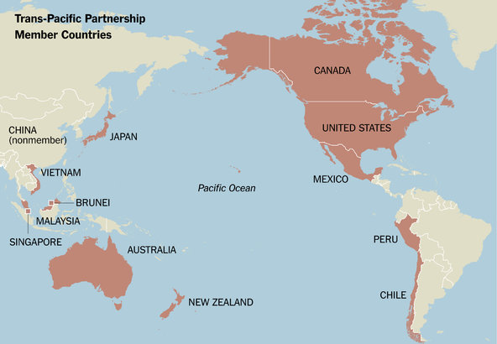

When agreements like the TPP govern international trade — when every country has agreed to similarly minimal regulations — multinational corporations can return to the practices that were common before the Clean Air and Clean Water Acts became law (in 1970 and 1972, respectively) and before the latest financial crisis hit. Corporations everywhere may well agree that getting rid of regulations would be good for corporate profits. Trade negotiators might be persuaded that these trade agreements would be good for trade and corporate profits. But there would be some big losers — namely, the rest of us.

These high stakes are why it is especially risky to let trade negotiations proceed in secret. All over the world, trade ministries are captured by corporate and financial interests. And when negotiations are secret, there is no way that the democratic process can exert the checks and balances required to put limits on the negative effects of these agreements.

The secrecy might be enough to cause significant controversy for the TPP. What we know of its particulars only makes it more unpalatable. One of the worst is that it allows corporations to seek restitution in an international tribunal, not only for unjust expropriation, but also for alleged diminution of their potential profits as a result of regulation. This is not a theoretical problem. Philip Morris has already tried this tactic against Uruguay, claiming that its antismoking regulations, which have won accolades from the World Health Organization, unfairly hurt profits, violating a bilateral trade treaty between Switzerland and Uruguay. In this sense, recent trade agreements are reminiscent of the Opium Wars, in which Western powers successfully demanded that China keep itself open to opium because they saw it as vital in correcting what otherwise would be a large trade imbalance.

Provisions already incorporated in other trade agreements are being used elsewhere to undermine environmental and other regulations. Developing countries pay a high price for signing on to these provisions, but the evidence that they get more investment in return is scant and controversial. And though these countries are the most obvious victims, the same issue could become a problem for the United States, as well. American corporations could conceivably create a subsidiary in some Pacific Rim country, invest in the United States through that subsidiary, and then take action against the United States government — getting rights as a “foreign” company that they would not have had as an American company. Again, this is not just a theoretical possibility: There is already some evidence that companies are choosing how to funnel their money into different countries on the basis of where their legal position in relation to the government is strongest.

There are other noxious provisions. America has been fighting to lower the cost of health care. But the TPP would make the introduction of generic drugs more difficult, and thus raise the price of medicines. In the poorest countries, this is not just about moving money into corporate coffers: thousands would die unnecessarily. Of course, those who do research have to be compensated. That’s why we have a patent system. But the patent system is supposed to carefully balance the benefits of intellectual protection with another worthy goal: making access to knowledge more available. [I’ve written](http://opinionator.blogs.nytimes.com/2013/07/14/how-intellectual-property-reinforces-inequality/" \t "_blank) before about how the system has been abused by those seeking patents for the genes that predispose women to breast cancer. The Supreme Court ended up rejecting those patents, but not before many women suffered unnecessarily. Trade agreements provide even [more opportunities](http://opinionator.blogs.nytimes.com/2013/07/14/how-intellectual-property-reinforces-inequality/" \t "_blank) for patent abuse.

The worries mount. One way of reading the leaked negotiation documents suggests that the TPP would make it easier for American banks to sell risky derivatives around the world, perhaps setting us up for the same kind of crisis that led to the Great Recession.

In spite of all this, there are those who passionately support the TPP and agreements like it, including many economists. What makes this support possible is bogus, debunked economic theory, which has remained in circulation mostly because it serves the interests of the wealthiest.

Free trade was a central tenet of economics in the discipline’s early years. Yes, there are winners and losers, the theory went, but the winners can always compensate the losers, so that free trade (or even freer trade) is a win-win. This conclusion, unfortunately, is based on numerous assumptions, many of which are simply wrong.

The older theories, for instance, simply ignored risk, and assumed that workers could move seamlessly between jobs. It was assumed that the economy was at full employment, so that workers displaced by globalization would quickly move from low-productivity sectors (which had thrived simply because foreign competition was kept at bay through tariffs and other trade restrictions) to high-productivity sectors. But when there is a high level of unemployment, and especially when a large percentage of the unemployed have been out of work long-term (as is the case now), there can’t be such complacency.

Today, there are 20 million Americans who would like a full-time job but can’t get one. Millions have stopped looking. So there is a real risk that individuals moved from low productivity-employment in a protected sector will end up zero-productivity members of the vast ranks of the unemployed. This hurts even those who keep their jobs, as higher unemployment puts downward pressure on wages.

We can argue over why our economy isn’t performing the way it’s supposed to — whether it’s because of a lack of aggregate demand, or because our banks, more interested in speculation and market manipulation than lending, are not providing adequate funds to small and medium-size enterprises. But whatever the reasons, the reality is that these trade agreements do risk increasing unemployment.

One of the reasons that we are in such bad shape is that we have mismanaged globalization. Our economic policies encourage the outsourcing of jobs: Goods produced abroad with cheap labor can be cheaply brought back into the United States. So American workers understand that they have to compete with those abroad, and their bargaining power is weakened. This is one of the reasons that the real median income of full-time male workers is [lower than it was](http://www.nytimes.com/2014/01/30/opinion/obamas-free-trade-conundrum.html?action=click&module=Search&region=searchResults%230&version=&url=http%3A%2F%2Fquery.nytimes.com%2Fsearch%2Fsitesearch%2F%3Faction%3Dclick%26region%3DMasthead%26pgtype%3DHomepage%26module%3DSearchSubmit%26contentCollection%3DHomepage%26t%3Dqry653%23%2Fbonior+tpp&_r=1" \t "_blank) 40 years ago.

American politics today compounds these problems. Even in the best of circumstances, the old free trade theory said only that the winners could compensate the losers, not that they would. And they haven’t — quite the opposite. Advocates of trade agreements often say that for America to be competitive, not only will wages have to be cut, but so will taxes and expenditures, especially on programs that are of benefit to ordinary citizens. We should accept the short-term pain, they say, because in the long run, all will benefit. But as John Maynard Keynes famously said in another context, “in the long run we are all dead.” In this case, there is little evidence that the trade agreements will lead to faster or more profound growth.

Critics of the TPP are so numerous because both the process and the theory that undergird it are bankrupt. Opposition has blossomed not just in the United States, but also in Asia, where the talks have stalled.

By leading a full-on rejection of fast-track authority for the TPP, the Senate majority leader, Harry Reid, seems to have given us all a little respite. Those who see trade agreements as enriching corporations at the expense of the 99 percent seem to have won this skirmish. But there is a broader war to ensure that trade policy — and globalization more generally — is designed so as to increase the standards of living of most Americans. The outcome of that war remains uncertain.

In this series, I have repeatedly made two points: The first is that the high level of inequality in the United States today, and its enormous increase during the past 30 years, is the cumulative result of an array of policies, programs and laws. Given that the president himself has emphasized that inequality should be the country’s top priority, every new policy, program or law should be examined from the perspective of its impact on inequality. Agreements like the TPP have contributed in important ways to this inequality. Corporations may profit, and it is even possible, though far from assured, that gross domestic product as conventionally measured will increase. But the well-being of ordinary citizens is likely to take a hit.

And this brings me to the second point that I have repeatedly emphasized: Trickle-down economics is a myth. Enriching corporations — as the TPP would — will not necessarily help those in the middle, let alone those at the bottom.

# CSIS Trade and Obama’s Visit to Asia

* 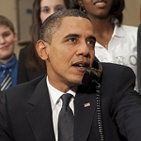

By [Scott Miller](https://csis.org/expert/scott-miller), Paul Nadeau

Apr 21, 2014

This week, U.S. president Barack Obama will travel to Asia, beginning with Japan and followed by South Korea, Malaysia, and the Philippines. The visit comes as Asian leaders are increasingly worried about the Obama administration’s dedication to the Asian “pivot.” The administration’s tepid response to the crisis in Ukraine has intensified these questions, but the visit will give President Obama an ideal opportunity to reassure our partners that the United States has staying power in Asia. Because the [Trans-Pacific Partnership is the vehicle that will functionally bind the Asia-Pacific region](http://csis.org/publication/tpp-more-trade-agreement), a commitment to move forward on TPP will provide a tangible reassurance.

**Q1: What is the current status of TPP?**

**A1:** Negotiations are continuing and chief negotiators will meet in Vietnam on May 12-15. U.S. Trade Representative Michael Froman and his Japanese counterpart, TPP minister Akira Amari, have met in Tokyo and Washington in the past few weeks, and acting deputy USTR Wendy Cutler has done the same with her Japanese colleagues, describing the progress as “slow but steady.” Even so, the remaining issues to cover such as market access for services and agricultural products, non-tariff barriers, and more, are not only complicated but are politically contentious for each leader.  
 **Q2: What can the United States and Japan do to get to a final agreement?**

**A2:** TPP is a new experience for Japan which to this point has focused on smaller, more limited free trade agreements than a high-standard, comprehensive agreement like TPP, making Japan an outlier among large economies. One of their biggest difficulties has been in exempting Japan’s agricultural sector from the free trade regime, not least because the sector is politically powerful and resistant to liberalization. TPP gives Prime Minister Abe an opportunity to open up this sector but the political fight will be daunting and is just one of the challenges that Prime Minister Abe faces as energy costs increase and consumers deal with a new value-added tax.

For the United States, trade promotion authority (TPA) has stalled in the run-up to the mid-term elections. In order to succeed post-election, President Obama needs to sell his domestic audience on TPP, preparing the ground now as a precursor to making a push when he tries to get the legislation in late 2014 or early 2015. USTR Froman’s [remarks at the Center for American Progress](http://www.americanprogress.org/events/2014/02/12/84107/remarks-from-u-s-trade-representative-michael-froman/) did a good job of explaining how trade has evolved since NAFTA and this is a message that the administration must continue to carry, especially if trade debates are on hold until after the elections. Getting trade agreements through Congress is difficult but not impossible—in 2011 the House and Senate considered and passed three free trade agreements (Colombia, Panama, and South Korea) in less than 48 hours. Granted, TPP is a much larger proposition, but that only means that the sale needs to be made more assertively. In short, President Obama could secure TPP if the administration gave it the effort that President Clinton gave NAFTA in 1993-94.

Asian leaders understand the constraints that an election year imposes as well as beltway insiders, but privately they are extremely anxious about the administration’s commitment to getting TPP through Congress. Some Japanese observers have voiced gentle frustration with the United States, believing that Abe is carrying all the risk while Congress and the administration avoid “speed bumps” before the November elections.

**Q3: What can be expected from this week’s meeting?**

**A3:** At this point the focus should be less about the agreement itself and more about the steps that the parties are taking to get to an agreement, both among themselves and with their domestic constituencies. President Obama can assure his hosts that he is committed to TPP and will take tangible steps to achieve it, and Prime Minister Abe can assure the President that Japan will commit to meaningful reforms to achieve the goal of a high-standard TPP.  
After a series of foreign policy setbacks in Europe and the Middle East, successful progress on TPP would bring the President closer to a significant victory on economic integration and establishing rules for trade liberalization and would also demonstrate that the Asian pivot is supported by concrete policy. To get to that goal, President Obama needs to assure his Asian counterparts that he is serious about TPP and that the pivot is on course. Anything less and he will have undermined his own strategic priorities.

Scott Miller holds the Scholl Chair in International Business at the Center for Strategic and International Studies in Washington, D.C. Paul Nadeau is program manager and research associate with the Scholl Chair at CSIS.

**Critical Questions is produced by the Center for Strategic and International Studies (CSIS), a private, tax-exempt institution focusing on international public policy issues. Its research is nonpartisan and nonproprietary. CSIS does not take specific policy positions. Accordingly, all views, positions, and conclusions expressed in this publication should be understood to be solely those of the author(s).**

**© 2014 by the Center for Strategic and International Studies. All rights reserved.**

CSIS

# TPP Is More than a Trade Agreement

* 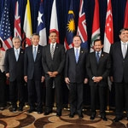

By [Scott Miller](http://csis.org/expert/scott-miller), Paul Nadeau

Jan 31, 2014

Senate Majority Leader Harry Reid made news this week when he said that “everyone would be well advised not to push (Trade Promotion Authority, TPA) right now.” Because trade agreements negotiated by the United States practically require TPA to be concluded, Senator Reid’s comments were described as “putting the brakes” on the President’s trade agenda until after the midterm elections in November.

Senator Reid’s comments should not have been surprising or even troubling. When asked if he would bring TPA to the Senate floor, Reid replied with “We’ll see,” leaving the possibility on the table. That trade critics are pleased with Senator Reid’s comments and that business groups are not isn’t news. President Obama expressed support for trade agreements during the State of the Union address, but not much more than a name-check and not enough to provide political cover to Democrats who might consider supporting TPA. With Senate Minority Leader Mitch McConnell and other Republicans openly advocating TPA, the issue was probably due to get some push-back from Democrats. Tactically, this makes sense because no Democrat in a contested seat (and Senator Reid has many to protect) for the November elections stands to gain from TPA or the deals that it would accelerate, chiefly the Trans-Pacific Partnership (TPP).

Who gains the most now from TPA and the resulting TPP agreement? The White House. This isn’t because of the immediate economic benefits to the United States, or because it provides a template for future large-scale, comprehensive trade agreements, or because the President has advanced the most ambitious trade agenda since the early 1990s.

The White House needs TPA because the TPP is the “pivot to Asia.” The military realignment is important, but the repositioning is mostly relative, driven by drawdowns in Iraq and Afghanistan. The Pivot is a political and economic realignment that aims to improve cooperation and integration among the United States and East Asia. Then-secretary of state Hillary Clinton said this explicitly in her Foreign Policy article, “[America’s Pacific Century](http://www.foreignpolicy.com/articles/2011/10/11/americas_pacific_century),” when she wrote “[O]pen markets in Asia provide the United States with unprecedented opportunities for investment, trade, and access to cutting-edge technology. Our economic recovery at home will depend on exports and the ability of American firms to tap into the vast and growing consumer base of Asia.” Military presence was only one out of the six courses of action that Secretary Clinton used to define the Asia Pivot, while the TPP is arguably the key ingredient of three (deepening America's relationships with rising powers, including China; engaging with regional multilateral institutions; expanding trade and investment). If solving the financial crisis and passing health care reform were President Obama’s key domestic policy victories, then the Asia Pivot is primed to be the area where he beneficially changes the course of U.S. foreign policy (the discussions with Iran are still too nascent to determine how far reaching they will become).

Today, there are tensions among Asia’s large powers, and the United States is likely the single entity that can influence the situation. The United States and Asia need each other and TPP is the vehicle that can functionally, economically, and politically help bind them together. The Members of Congress and staff that have drafted the TPA bill have put admirable effort into legislation. Trade negotiators working on TPP have been equally tireless. But TPP, and Asia, cannot wait forever. Many in Asia are already concerned that the Pivot was only superficial and that United States is already moving on. If TPA and TPP remain framed as a trade issue, with all of the political baggage that comes with that, the Administration risks putting TPP on ice for 2014.

Alternatively, the Administration can influence perceptions by framing the TPP as a strategic goal that will be the cornerstone of the Asia Pivot. This would reassure U.S. partners in Asia and answer domestic critics who argue that the Pivot lacks substance. Moreover, it would give the President an achievable goal in advance of his April trip to Asia.

Many have had their say on TPA this week. What matters now is what the President does. We hope he will start by reminding policymakers what’s at stake.  
Scott Miller holds the Scholl Chair in International Business at the Center for Strategic and International Studies in Washington, D.C. Paul Nadeau is program manager and research associate with the Scholl Chair at CSIS.

# NYT

# Deal on Trade Pact Gives Obama Authority but Builds in a Delay

By [JONATHAN WEISMAN](http://topics.nytimes.com/top/reference/timestopics/people/w/jonathan_weisman/index.html) and [MICHAEL D. SHEAR](http://topics.nytimes.com/top/reference/timestopics/people/s/michael_d_shear/index.html)APRIL 21, 2015

Photo

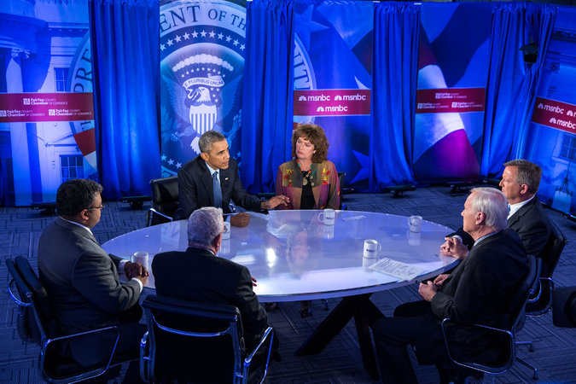

President Obama took part in a panel discussion on free trade, broadcast on MSNBC’s “Hardball With Chris Matthews” on Tuesday, to counter critics of the proposed Trans-Pacific Partnership. Credit Pete Souza/White House

WASHINGTON — Republican lawmakers and the White House have agreed to subject any trade deal negotiated by [President Obama](http://topics.nytimes.com/top/reference/timestopics/people/o/barack_obama/index.html?inline=nyt-per) to a monthslong review by Congress and the public, a concession aimed at winning the support of Democrats who view trade agreements as a threat to American workers.

That provision, expected to be formally approved Wednesday by the Senate Finance Committee, would give Mr. Obama the “fast-track” authority he has been seeking to negotiate the Trans-Pacific Partnership with a dozen Pacific Rim nations, potentially expanding markets for American companies. But the compromise will almost certainly push a major trade accord with Asia into the presidential election season, a politically charged prospect that trade supporters had hoped to avoid.

## Related Coverage

* [[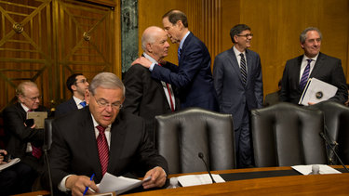](http://www.nytimes.com/2015/04/17/business/obama-trade-legislation-fast-track-authority-trans-pacific-partnership.html)Credit Stephen Crowley/The New York Times](http://www.nytimes.com/2015/04/17/business/obama-trade-legislation-fast-track-authority-trans-pacific-partnership.html)

## [Deal Reached on Fast-Track Authority for Obama on Trade AccordAPRIL 16, 2015](http://www.nytimes.com/2015/04/17/business/obama-trade-legislation-fast-track-authority-trans-pacific-partnership.html)

* [[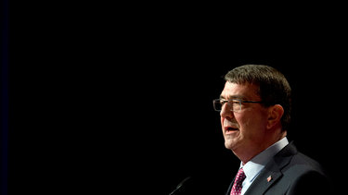](http://www.nytimes.com/2015/04/07/us/politics/defense-secretary-supports-trade-deal-with-asia.html)Credit Manuel Balce Ceneta/Associated Press](http://www.nytimes.com/2015/04/07/us/politics/defense-secretary-supports-trade-deal-with-asia.html)

## [U.S. Defense Secretary Supports Trade Deal With AsiaAPRIL 6, 2015](http://www.nytimes.com/2015/04/07/us/politics/defense-secretary-supports-trade-deal-with-asia.html)

As a result of the delays built into the legislation, final consideration of the trade pact could fall to the next president, just as the North American Free Trade Agreement, completed by President George H. W. Bush, was passed under his successor, Bill Clinton.

“What I hope it will do is have people say, ‘They’re changing the playbook on trade,’ ” said Senator Ron Wyden of Oregon, the ranking Democrat on the Finance Committee, who demanded the open comment period after facing intense pressure from liberal and labor groups. “I’m very much aware there isn’t going to be any kumbaya moment here. I’m probably more aware of that than practically anybody in the United States at this point.”

Mr. Obama made an energetic case for free trade in [an interview broadcast Tuesday night](http://www.msnbc.com/hardball/watch/president-obama-defends-tpp-deal-431711811768) and predicted that Congress would soon give him the fast-track authority to complete the Asia-Pacific trade deal, the largest trade accord since Nafta went into effect in 1994.

“I would not be doing this trade deal if I did not think it was good for the middle class,” Mr. Obama said in the interview. “And when you hear folks make a lot of suggestions about how bad this trade deal is, when you dig into the facts they are wrong.”

Mr. Obama made his comments, meant to counter lawmakers in his own party who oppose the deal, on Tuesday during the taping of a panel discussion on free trade hosted by Chris Matthews, the host of the MSNBC program “Hardball.”

But in agreeing to the terms of the legislation granting him trade promotion authority, Mr. Obama has probably made the job of actually approving such a trade accord far more difficult. Trade promotion authority gives Congress the right to accept or reject a trade deal but not amend or [filibuster](http://topics.nytimes.com/top/reference/timestopics/subjects/f/filibusters_and_debate_curbs/index.html?inline=nyt-classifier) it. But the new bill before both the Senate Finance and House Ways and Means committees this week lays out new requirements for openness and review. The president would have to notify Congress of the accord’s completion 90 days before he intends to sign it, a delay similar to past requirements. But in a new twist, the full agreement would have to be made public for 60 days before the president gives his final assent and sends it to Congress. Congress could not begin considering it for 30 days after that.

That extra time means that Congress probably will not consider the Trans-Pacific Partnership until at least October, the thick of the presidential primary debate season and just as White House hopefuls are preparing for the first primary voting.

“It’s like 180 days that the T.P.P. has to lay out there,” said Senator John Cornyn of Texas, the Senate’s No. 2 Republican.

Mr. Wyden defended the addition of the waiting period and said it was a reason that Congress should act quickly to approve the legislation.

“In the vicinity of four months, the American people will be able to sit at a town hall meeting and read what’s in T.P.P. and ask questions about it,” he said. “That’s one of the reasons to move now.”

Supporters remained sanguine ahead of the Finance Committee’s formal drafting of the trade promotion bill.

“Most people, if they look at it, think it’s pretty darned important,” Senator Orrin Hatch, Republican of Utah and the committee’s chairman, said of the Pacific accord. “Sooner or later we’re going to have to look at it.”

Mr. Obama did his best to brush back opposition in his party from the liberal wing now associated with Senator Elizabeth Warren, Democrat of Massachusetts.

“I love Elizabeth,” Mr. Obama told Mr. Matthews during the interview. “We’re allies on a whole host of issues. But she’s wrong on this.”

But the measure remains a political hot potato. Hillary Rodham Clinton, campaigning in New Hampshire, dodged a direct question of whether she supported giving Mr. Obama trade promotion authority.

“Any trade deal has to produce jobs and raise wages and increase prosperity and protect our security,” she said. “We have to do our part in making sure we have the capabilities and the skills to be competitive.”

Senator Harry Reid of Nevada, the Democratic leader, declared “not only no but hell no” to trade promotion authority.

If anything, the demands placed on the administration’s negotiators by the legislation are likely to become more onerous. Senators Rob Portman, Republican of Ohio, and Debbie Stabenow, Democrat of Michigan, are expected to introduce an amendment in the Finance Committee on Wednesday requiring the Pacific deal to include enforceable language to ensure that foreign competitors do not manipulate currency exchange rates to keep their exports cheap and American exports more expensive.

That measure has the strong support of the automotive industry, as well as key senators like Charles E. Schumer, Democrat of New York, and Lindsey Graham, Republican of South Carolina.

The Economist

## The United States, Japan and trade

### Don’t treat trade as a weapon

# An Asian-Pacific trade deal looks within reach, but politicians should stop seeing it as a way to contain China

Apr 25th 2015 | [From the print edition](http://www.economist.com/printedition/2015-04-23)

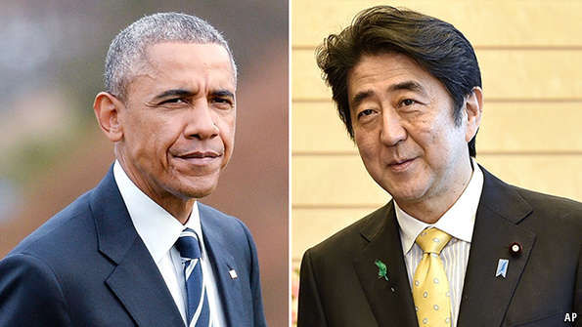

GOOD news out of Washington is rare. Last week congressional leaders agreed on a bipartisan bill which, if passed, would for the first time in years give the president “fast-track” authority when negotiating trade deals. The bill would be a boost for the prospects of a huge trade deal, the Trans-Pacific Partnership (TPP), binding America with 11 economies (including Japan but not China) around the Pacific rim. Now, as if on cue, come welcome signals about the TPP itself. As Japan’s prime minister, Shinzo Abe, prepared to head to Washington for a much-anticipated trip including an invitation to address a joint session of Congress (see [article](http://www.economist.com/news/asia/21649538-bilateral-alliance-has-served-well-decades-needs-makeover-base-issues" \t "_blank)), he claimed that America and Japan were close to agreement over their bilateral terms—on which the whole TPP deal hinges.

Yet there are two big caveats. First, fast track, formally known as Trade Promotion Authority, may still fall foul of Congress. Second, Japan may not make any serious cuts to tariffs that protect its farmers. Those outcomes are more likely because the Obama administration and the Japanese government have made a similar mistake: both have been too quick to cast the TPP as a weapon in the containment of China.

Flanked by Japan and America, the TPP would link countries which make up 40% of global GDP. It could boost world output by $220 billion a year by 2025. It is supposed to reform difficult areas such as intellectual property, state-owned firms and environmental and labour standards. It would join economies—from Vietnam to Australia—that lie at different ends of the spectrum of development.

But the TPP will not happen without fast track, which forces Congress into a yes/no vote on any pending trade deal and so avoids the risk that it will be amended into oblivion. And the passage of fast track faces a lot of scepticism from Democrats (see [article](http://www.economist.com/news/united-states/21649613-america-inches-towards-big-trade-deal-asia-barack-obama-faces-showdown" \t "_blank)). Some are implacably opposed. Others want America to have a bigger arsenal with which to fight against unfair traders. Driven by a conviction that China artificially holds its currency down and destroys American jobs, Charles Schumer, a powerful senator from New York, is determined that fast track should include a provision that would make sure a trade deal included sanctions on currency manipulation.

Attaching a currency-manipulation clause to trade deals is a poor idea, both because the practice is hard to define and because the addition of such clauses makes reaching an agreement less likely. But since the Obama administration has pitched TPP as a counterbalance to an assertive China, Mr Schumer’s demands are harder to ignore.

Give trade a chance

The same mistaken logic looks set to cause problems in Japan. Mr Abe committed his country to joining the TPP on strategic grounds—as a counterweight to China—rather than because he is a born admirer of free trade. When he entered negotiations, some of his backers thought that, by playing the China card, Japan would be spared from making real concessions: that America would care more about a pact that excluded China than about prising open Japan’s most protected markets, particularly rice. Even now, Japan seems to want to keep tariffs high. The best it may offer is to allow in a fixed quota of tariff-free rice from the TPP’s other members, America included.

If the China-containment logic leads to a minimalist agreement, then the economic gains from TPP will be slim. TPP’s real value is to set high new standards for world trade, and that demands the boldest possible agreement. And in the long run the world gains most if China joins. The rhetoric makes trade negotiations sound like a contest. In fact, it is a battle where the more you give away the more you win.

## The politics of trade

### Fighting the secret plot to make the world richer

# As America inches towards a big trade deal with Asia, Barack Obama faces a showdown with his party

Apr 25th 2015 | [From the print edition](http://www.economist.com/printedition/2015-04-23)

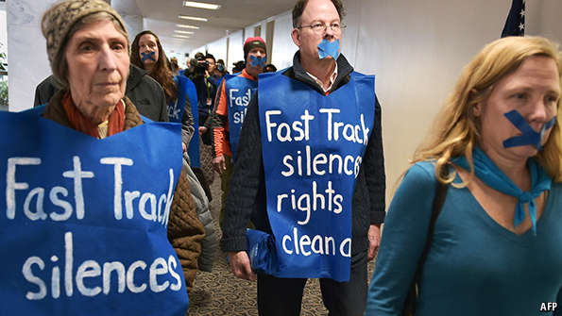

PRESIDENT BARACK OBAMA is itching to sign one of the biggest trade deals in American history. The Trans-Pacific Partnership (TPP) would link 11 economies of the Pacific rim—including Japan and Singapore—with America. These 12 countries together account for 40% of world GDP and one-third of trade (see chart 1). As well as dismantling tariff barriers, the TPP is meant to tackle tough issues such as intellectual property, labour and environmental standards. American trade negotiators predict that by 2025 the TPP will make the world $220 billion a year richer.

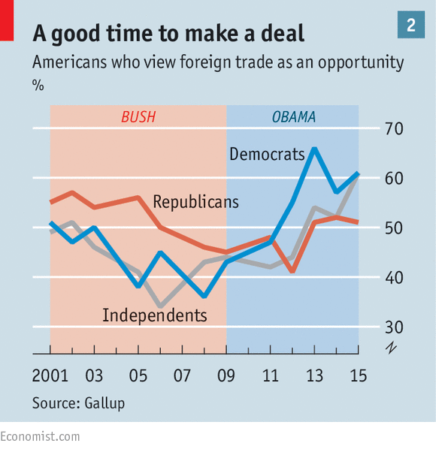

Many Democrats, however, fiercely oppose it. Sandy Levin, a Democratic congressman, growls that he is “out to defeat” Mr Obama’s plans. Hillary Clinton has conspicuously withheld her endorsement. Labour unions hate the TPP. If it passes, it will be because Republicans in Congress, for once, back Mr Obama.

The geopolitical aspects of the deal are hardly controversial. Friendly ties with Asian allies are obviously important. China has been flexing its military muscles over disputed islands and is trying to build up regional influence with projects such as the Asian Infrastructure Investment Bank, of which America is not a part. The TPP could help America retain its sway in Asia, boosters argue. If the 12 TPP countries plump for common trade standards (for instance, mutual recognition of regulatory approval processes in medical services), then those rules—not China’s—could function in effect as global ones, given the fat chunk of world GDP they would govern.

Congressional Republicans and Mr Obama argue that by boosting exports, the deal would make America richer. Jason Furman, the chairman of the president’s Council of Economic Advisers, says that by 2025 the TPP would raise American incomes by 0.4% per year. Public support for foreign trade is high. Gallup finds that 58% of Americans see it mostly as an opportunity—a figure that has risen 17 percentage points since the recession—and only 33% see it as a threat. Republicans’ views have not changed much, but the proportion of Democratic voters who see trade positively has shot up from 36% to 61% since 2008 (see chart 2). This may be because Democrats are more likely to be in jobs that benefit from globalisation, or it may simply be because there is now a Democrat in the White House pushing trade deals instead of a Republican.

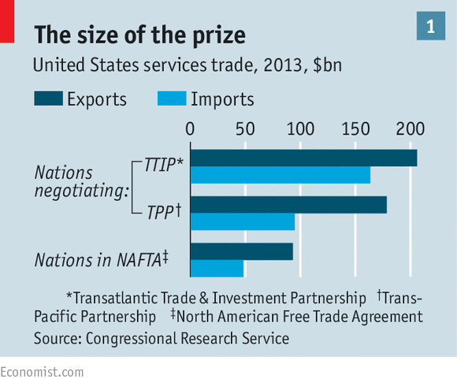

Nonetheless, opposition to the deal is strong. Democratic politicians are much less trade-friendly than Democratic voters or the country as a whole. Many fret that imports from low-cost countries such as Vietnam will hurt American workers in industries such as carmaking and textiles.

This is not a foolish worry. Globalisation has filled people’s shopping trolleys with cheaper, better goods: the US Chamber of Commerce estimates that imports boost the average American family’s purchasing power by $10,000 a year. However, trade has probably also held down blue-collar workers’ wages in rich countries. A new paper, from Ann Harrison of the University of Pennsylvania and colleagues finds that if there had been no imports, median real wages in America in 2008 would have been 3% higher than they actually were. For workers in menial tasks, they would have been 15% higher. Another paper found that a quarter of the employment decline in American manufacturing from 1990 to 2007 was caused by competition from Chinese imports.

Yet it is difficult to blame trade deals for this. America has no free-trade agreement with India, yet imports of goods from there have more than doubled over the past decade. Though many Democrats see NAFTA, a deal with Canada and Mexico that Bill Clinton signed in 1993, as a disaster for America’s workers, the consensus among economists is that it did not have much effect on the labour market. The effects of the latest deal are unlikely to be very different. What is more, thanks to pressure from Democrats, any trade deal would also include extra “trade-adjustment assistance”: ie, help for those whose jobs may be threatened by it.

Barack Obama, corporate shill?

This will not reassure everyone. The TPP is big—there are nearly 30 chapters—and since large chunks of the negotiations are kept secret, many worry that American workers, human rights and the environment will soon be at the mercy of the “global corporate agenda” that Mr Obama somehow represents. Many of these concerns are overblown. In TPP negotiations America is pursuing provisions similar to the “May 10th Agreement”, a deal which included workers’ rights and has appeared in other American trade pacts.

Other parts of the TPP will irk greens. In recent months America seems to have softened its language on the environment, possibly to win over poorer trading partners. Mr Levin complains that the TPP “does not address whether or how climate-change issues should be handled”.

The TPP might not be so controversial if talks were conducted openly. Jeffrey Schott of the Peterson Institute, a think-tank, argues that although negotiators need input from those who will be affected—including businesses and trade unions—making the negotiations public might make it difficult to balance the demands of competing interest groups. However, secrecy may now be so strict that it ends up irritating everyone. In an attempt to make the plan stick, senior Democrats say that a final trade agreement must be subject to public consultation before Congress votes.

Many Democrats also grumble that the TPP says little about “currency manipulation”, by which countries deliberately hold down their currencies to boost exports. According to a paper from the Peterson Institute, currency manipulation may be responsible for half of America’s “excess unemployment” (joblessness above what economists call “full employment”). Among the countries the paper designates as “currency manipulators” are Japan and Singapore. Some simple, even lax, rules on currency manipulation would appease many of the sceptics, though such manipulation is fiendishly hard to define.

Economists worry that cluttering up trade pacts with rules about labour, greenery and currencies dilutes the benefits of free trade and gives its opponents extra tools to block the deals entirely. However, there is scant chance of getting any deal through Congress without such sweeteners. On April 16th congressional leaders settled on a bill to give Mr Obama “Trade Promotion Authority” (TPA), also known as “fast track”. This is very important: if the bill passes, it would allow the president to negotiate a deal and then submit it to Congress for a yes-or-no vote, with no amendments. Without this power, it is hard for Mr Obama to make credible promises, since Congress could shred them later. Past deals have nearly always been negotiated using fast track, which expired in 2007.

Mr Obama’s ability to conclude TPP and an even bigger proposed pact with Europe, the Transatlantic Trade and Investment Partnership, hinges on him getting fast-track authority. Most Republicans in Congress, where they hold a majority in both chambers, are likely to support him—they believe in free trade and are keen to show that they can govern. But both TPA and TPP will need a few Democratic votes to pass. And with so many Democrats in Congress, not to mention darlings of the left such as Elizabeth Warren, either anti-trade or seeking to build a post-Obama identity, that is far from assured.

NYT

### [The Opinion Pages](http://www.nytimes.com/pages/opinion/index.html) | Editorial

# Trade Wars in Congress

By [THE EDITORIAL BOARD](http://www.nytimes.com/interactive/opinion/editorialboard.html)MAY 12, 2015

Photo

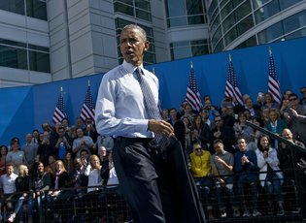

President Obama after a speech on trade policy last week at Nike headquarters in Beaverton, Ore. Credit Brendan Smialowski/Agence France-Presse — Getty Images

Congress is considering a [trade bill](http://www.nytimes.com/2015/05/11/us/politics/obama-pushing-skeptical-legislators-hard-on-pacific-trade-deal.html?ref=business) that is pitting President Obama against many members of his own party and some Republicans. Though the two sides have major differences, a compromise is still possible and would be good for the American economy.

Mr. Obama is pushing for a bill that sets negotiating objectives for trade agreements and binds Congressional lawmakers to casting up-or-down votes on those deals for up to six years. This “fast-track” process would be used for two big pacts being negotiated now: the [Trans-Pacific Partnership](http://www.nytimes.com/2014/12/31/business/obamas-trade-chief-undaunted-by-odds-pushes-for-trans-pacific-partnership.html) with 11 countries, including Australia, New Zealand, Canada, Japan and Mexico, and the [Transatlantic Trade and Investment Partnership](http://www.nytimes.com/2013/06/13/business/global/to-create-jobs-europe-pushes-for-trade-deal-with-us.html) with the European Union. Mr. Obama argues that foreign negotiators will not put their best offer on the table if Congress can easily amend deals after they have been signed.

On Tuesday, the Senate is expected to take up the bill, which is opposed by some liberal Democrats who believe such trade agreements hurt American workers and by Republicans who do not want to give the president a victory. Getting support in the House might be even harder.

The important thing to remember about the Pacific and European trade deals is that they are not primarily about lowering customs duties and quotas. While these deals would reduce those barriers to trade, they would have much of their impact by getting countries to adopt similar regulations in areas like labor standards, environmental protection, how governments treat foreign investors and patent and copyright law.

Done right, the Pacific trade deal, which is [nearing completion](http://www.nytimes.com/2015/04/29/world/no-deal-but-progress-on-trans-pacific-trade-obama-and-shinzo-abe-say-after-meeting.html?_r=0), could help reduce environmental destruction and improve the lives of workers in countries like Brunei, Peru, Chile and Vietnam, which are part of the negotiations. That agreement would also strengthen American alliances in Asia because it includes Malaysia and Singapore. Administration officials say other countries like South Korea and Thailand might want to join the pact in the future.

Some provisions that are expected to be part of the deal could raise problems. For example, some public interest groups fear that the deal could force developing countries to adopt strict patent regulations that could make many medicines unaffordable to poor people.

Other critics like Senator [Elizabeth Warren](http://www.washingtonpost.com/blogs/plum-line/wp/2015/05/11/elizabeth-warren-fires-back-at-obama-heres-what-theyre-really-fighting-about/), Democrat of Massachusetts, are worried that provisions in the trade agreement that prohibit governments from discriminating against foreign companies might be used by international banks to challenge American financial regulations. [Mr. Obama has called](https://www.yahoo.com/politics/why-obama-is-happy-to-fight-elizabeth-warren-on-118537612596.html) Ms. Warren’s fears “hypothetical” and “speculative;” the administration says the fast-track bill contains language that would prevent the use of trade measures to change American laws.

Many lawmakers want the administration to include an enforceable provision against [currency manipulation](http://levin.house.gov/press-release/evin-currency-manipulation-obligations-tpp-would-not-disrupt-us-monetary-policy) in the Pacific trade deal. This is a concern because countries like China, Japan and South Korea have, at various times, artificially depressed the value of their currencies to boost exports, which has hurt American businesses and led to manufacturing job losses.

There are ways Mr. Obama can address these legitimate concerns. For example, he and lawmakers should be able to write amendments to the bill that clearly explain that trade pacts that could undercut financial and other regulations would not receive fast-track consideration. This is important because the bill in the Senate would be effective well after Mr. Obama has left office.

On currency manipulation, the administration has acknowledged that the Pacific pact should address this issue. But it has provided few details about how the agreement might prevent or discourage countries from using this tactic.

Most Americans support increased trade and business ties with other countries. But half also believe that trade destroys jobs, according to a 2014 [Pew Research report](http://www.pewglobal.org/2014/09/16/faith-and-skepticism-about-trade-foreign-investment/). Last week in a [speech](https://www.whitehouse.gov/the-press-office/2015/05/08/remarks-president-trade) at the offices of Nike, Mr. Obama said the agreements he is negotiating would be good for American workers and the economy. He still needs to convince lawmakers in Congress.

NYT

# As Obama Plays China Card on Trade, Chinese Pursue Their Own Deals

By [DAVID E. SANGER](http://topics.nytimes.com/top/reference/timestopics/people/s/david_e_sanger/index.html) and [EDWARD WONG](http://topics.nytimes.com/top/reference/timestopics/people/w/edward_wong/index.html)MAY 12, 2015

WASHINGTON — President Obama has toured Nike’s headquarters and busy American ports in recent weeks to try to convince Democrats that rejecting the Trans-Pacific Partnership, a 12-nation trade deal that he envisions as a crucial part of a legacy of national economic revival, will undercut American power.

“If we don’t write the rules for trade around the world, guess what?” Mr. Obama warned at the headquarters of the sporting goods giant, whose wares he uses when he works out. “China will.”

[[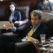](http://www.nytimes.com/2015/05/12/business/fight-over-china-currency-policies-threatens-vote-on-trade-bill.html)](http://www.nytimes.com/2015/05/12/business/fight-over-china-currency-policies-threatens-vote-on-trade-bill.html)

## [Fight Over China Currency Policies Threatens Vote on Trade BillMAY 11, 2015](http://www.nytimes.com/2015/05/12/business/fight-over-china-currency-policies-threatens-vote-on-trade-bill.html)

## [Xi Jinping of China and Shinzo Abe of Japan Meet Amid Slight Thaw in TiesAPRIL 22, 2015](http://www.nytimes.com/2015/04/23/world/asia/xi-jinping-of-china-and-shinzo-abe-of-japan-meet-in-indonesia.html)

[[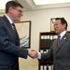](http://www.nytimes.com/2015/04/18/business/international/at-global-economic-gathering-concerns-that-us-is-ceding-its-leadership-role.html)](http://www.nytimes.com/2015/04/18/business/international/at-global-economic-gathering-concerns-that-us-is-ceding-its-leadership-role.html)

## [At Global Economic Gathering, U.S. Primacy Is Seen as EbbingAPRIL 17, 2015](http://www.nytimes.com/2015/04/18/business/international/at-global-economic-gathering-concerns-that-us-is-ceding-its-leadership-role.html)

Xi Jinping, the Chinese president and head of the Communist Party, is making a parallel pitch — but rooted in a very different strategy for gaining global influence. Mr. Xi has essentially shrugged off the question of whether his nation, the world’s second-largest economy, will join the pact. Instead, he has picked off American allies like Britain, Germany and South Korea to join, against the administration’s wishes, the Asian Infrastructure Investment Bank, a project started by China in part to keep its own state-owned firms busy building roads, dams and power plants around Asia.

China is at the same time setting up other trade pacts around the region so it can use its cash and enormous market leverage to strike deals more advantageous to its interests. Mr. Xi was in Kazakhstan this month plugging his “One Belt, One Road” initiative of construction from Europe to Central Asia to the seas around China.

It is a subtle form of competition, but one that many in the Obama administration see as the most important geopolitical power struggle in the world today.

“It’s not a black-and-white contest between us and China, even though the president has presented it that way to sell it to Democrats,” said Michael J. Green, a Georgetown University professor who charts the progress of the contest. “The Pacific Partnership puts pressure on the Chinese to up their game. We are somewhere between direct competition over who will make the rules and a competitive liberalization that will eventually create some common rules around the world.”

America’s strategy since the 1990s, when Bill Clinton wooed Republican votes to get China into the World Trade Organization, has been a straightforward one: Entice China into institutions that operate according to Western standards of trade rules, labor practices and the protection of intellectual property, gradually changing the way a rising power rises. Mr. Clinton made that case in visits to Beijing, arguing that if China opened its doors to trade, new ideas and the Internet would inevitably pressure its leaders toward democracy and freer expression.

It was a view that, in retrospect, overestimated American influence and underestimated the degree to which the Chinese believed they could amend the global order to suit their own economic interests. So while Mr. Obama plays the China card to sell the accord in the United States, the Chinese are pursuing their own course.

China has been excluded from the negotiations on the trade deal because it has been unwilling to sign on, so far, to the wide-ranging reforms of its economy required of all members. It could join later on — and Chinese officials have left open that possibility, as have nations like South Korea. But for now, China seems in no rush. Just as it created an infrastructure bank to suit its own ambitions, it is assembling trade agreements whose rules it can write by virtue of the huge size of its market.

“The Chinese government’s response is to build the free-trade agreements that it can influence,” said Li Daokui, a professor at the School of Economics and Management at Tsinghua University in Beijing. “I would say it was a mistake for the U.S. not to include China. If China had been allowed to join at the beginning, the landscape would be entirely different.”

Mr. Li said that if China had been part of the negotiations at the start, it might not have pushed so hard across the region for its own trade agreements, and “everything would be much simpler.”

Perhaps for Mr. Xi. For Mr. Obama, it might have been even more complex. The domestic politics of this deal are difficult enough without China as a potential signatory, as shown by his failure to prevail in an important vote in the Senate on Tuesday to get the authority he needs to negotiate the trade agreement. (Administration officials insisted it was a temporary and tactical setback.)

Kevin Rudd, the former Australian prime minister, has spent the last year at Harvard and at the Asia Society studying the long-term future between China and the West. He concluded in a recently published report that in both China and the United States there was a rush “to believe that the two countries are now locked into some sort of irreversible and increasingly fractious zero-sum game.” Instead, he found the relationship was still “functioning reasonably effectively,” but noted that Mr. Xi had changed strategy.

“He has ended former paramount leader Deng Xiaoping’s foreign policy orthodoxy over the past 35 years of ‘hide your strength, bide your time, never take the lead,’ in favor of a more vigorous, activist and assertive international policy to advance Chinese interests both in the region and beyond,” he wrote in Foreign Policy.

Shi Yinhong, a professor of international relations at Renmin University, said Chinese leaders were well aware of how important approval of the trade agreement, also known as the TPP, is for Mr. Obama as he tries what he has often called a “rebalancing” toward Asia.

“The Chinese government knows the TPP is a major attempt by the U.S. to win back economic leadership in the region,” Mr. Shi said. “China also knows the Asia Pacific region is such a wide region, so you can have two stages. One is led by the U.S., which is pushing the TPP. The other is dominated by China.”

Mr. Shi said China was not worried about the TPP because Asia was a vast enough region to allow for multiple trade agreements. “This is far from a zero-sum game,” he said. “In the future, both countries will find places of cooperation as well as competition.”

American officials say the Chinese view has evolved. “They have come around to seeing that they are going to have to live in a TPP world, a world with higher standards and increased competition for investment,” Michael B. Froman, the United States trade representative, who is negotiating the deal, said in an interview. “We are already seeing that investors are deciding to move to TPP countries where they will have a stable labor system,” protections for intellectual property and the freedom to move data into and out of the country without government restraints, which are part of the deal being negotiated. “That’s going to force China to raise their game, too.”

Listen to the debate on Capitol Hill and it sounds a lot like the 1990s — discussion of manufacturing jobs being sent to China, fears that American sovereignty will be ignored in trade disputes, revived arguments about North American Free Trade Agreement, which was passed more than two decades ago.

In Beijing, things sound very different. Last month, a Foreign Ministry spokesman, Hong Lei, was asked about the TPP at a regularly scheduled news conference. He responded that the TPP was one component that could help build a [larger free-trade area across Asia](http://www.chinadaily.com.cn/world/2014apec/2014-11/07/content_18885318.htm), a plan that China laid out last year. That plan, he said, “will generate far more economic gains than all existing regional free-trade arrangements once it is completed.”

K@W

# A Battle Rages over the TPP to Re-write Global Rules

May 18, 2015

* [Law and Public Policy](http://knowledge.wharton.upenn.edu/category/law-and-public-policy/)
* [Asia-Pacific](http://knowledge.wharton.upenn.edu/region/asia-pacific/)
* [China](http://knowledge.wharton.upenn.edu/region/china/)
* [Global Focus](http://knowledge.wharton.upenn.edu/region/global-focus/)
* [North America](http://knowledge.wharton.upenn.edu/region/north-america/)

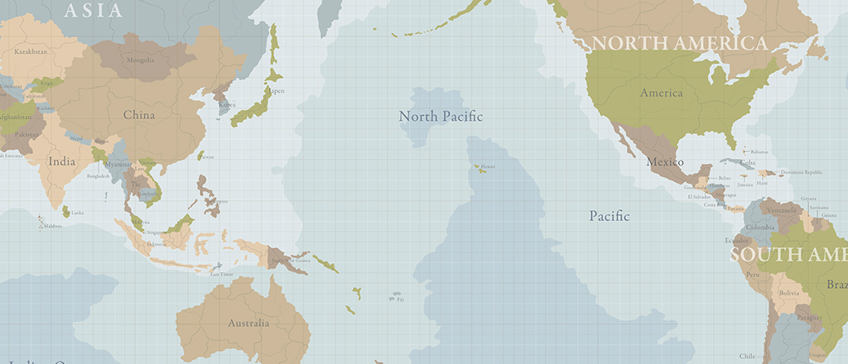

Twenty-one years after the enactment of the North American Free Trade Agreement (NAFTA), the debate over free trade has risen to the top of the U.S. political agenda once again, this time in the form of the looming Trans-Pacific Partnership (TPP), a 12-nation trade bloc that would bring the United States and 11 other Pacific Rim nations together in a wide-ranging pact that would establish the rules for international trade, investment and foreign investment during the coming decade and beyond. Total trade between the U.S. and the other TPP countries exceeded $1.7 trillion in goods and $260 billion in services in 2012, making the TPP the largest free-trade agreement in world history.

Like NAFTA, which brought together three neighboring nations — the U.S., Canada and Mexico — the TPP has become a divisive political issue, not only among the general public, but within both the Democratic and Republican parties. There are questions about what kind of impact the TPP would have on the U.S. economy, and on the competitiveness of U.S. multinationals in the years ahead, in addition to concerns related to job growth, and U.S.-China trade and political relations. For example, Public Citizen, a left-leaning advocacy group, stirred opposition to the TPP recently with this message: “In one fell swoop, this secretive deal” could “offshore American jobs and increase income inequality, jack up the cost of medicines, expose the U.S. to unsafe food and products, and empower corporations to attack our environmental and health safeguards.”

By contrast, supporters say the TPP goes well beyond making additional cuts in tariff and duties to include the implementation of higher standards for the protection of labor rights, intellectual property, foreign investment and other barriers that thwart further trade in high-value services in which the U.S. has a competitive advantage. Its provisions would likely cost the U.S. economy some additional jobs in certain areas, supporters say, but generate large numbers of new jobs by boosting exports of U.S. high-value goods, and attracting further investment by foreign manufacturers and service providers in the United States.

At the root of this fundamental disagreement is the unique nature of the TPP. Wharton management professor [Mauro Guillen](http://knowledge.wharton.upenn.edu/faculty/guillen/), who is also director of [The Lauder Institute](http://lauder.wharton.upenn.edu/), notes that the TPP is a “very different kind of pact” from NAFTA. Tariffs don’t have a big role to play in the TPP because the U.S. has already instituted bilateral agreements with a number of countries in Latin America and the Pacific. “The issues of the day have shifted toward services; and all of these other ‘soft’ institutions or issues in the sense that they are intangible” such as intellectual property, Guillen notes.

“It’s not clear that the substance has been decided, or that anyone understands how outstanding issues have been resolved.”–Marshall Meyer

**A Rorschach Test**

Supporters of the TPP argue that by opening opportunities for more companies to engage in foreign trade, the agreement will boost incomes for substantial numbers of middle-income workers. According to the U.S. Business Coalition for TPP, companies engaged in international trade pay salaries that average 15% to 20% more than those firms that are not as engaged. The trade group argues that “global trade already supports millions of jobs for middle class families” and the “passage of additional free trade agreements, like TPP, provides the opportunity to provide over 10 million trade-connected jobs over the next decade.”

On the other hand, the TPP’s critics argue that the agreement will actually rob the U.S. economy of millions of middle-class jobs in coming decades, thanks to the new opportunities that it will open for non-U.S. firms to enter markets in the U.S. They also argue that the Obama Administration is being unreasonable in requiring that Congress grant the President what is known formally as “trade promotion authority” (TPA) — or “fast track,” in common parlance. Thanks to TPA, during both the Clinton and George W. Bush administrations, the U.S. Congress was not allowed to make any further amendments to any free-trade agreements negotiated by the executive branch. Congress had only the authority to vote a simple up or down (yes or no) on each deal, a process that accelerated the passage of those bills. That practice would simply be revived for the TPP, supporters note.

Many critics of the TPP are blinded by their ideological opposition to all free trade agreements, not just the TPP, says Rob Mulligan, senior vice president for policy and government affairs at the United States Council for International Business (USCIB), the American affiliate of the International Chamber of Commerce (ICC). Regarding left-leaning critiques who say the TPP doesn’t do enough to protect labor and the environment, Mulligan says, “The Obama Administration has made an effort to address a lot of these concerns that have been made in the past. And yet that doesn’t seem to be enough. Now there are complaints that this has all been done in secrecy, which is a disingenuous argument. Labor unions have been on all the advisory boards that the business community is on. And the members of Congress get access to information; they get briefings regularly.”

According to Marshall Meyer, a Wharton management professor, the current flap over TPP is more about fast-track authority than the substance of the agreement. “It’s not clear that the substance has been decided, or that anyone understands how outstanding issues have been resolved.” Thus, he adds, the TPP has become “something of a Rorschach test — a ‘flak catcher’ to use Tom Wolfe’s phrase — onto which people project their anxieties.”

#### Sponsored Content:

Meyer says he keeps telling his friends on the liberal side of the Democratic Party that “[the TPP] is good for workers.” But “they can’t grasp that.” They know that the U.S. Chamber of Commerce is very clear about its support for the TPP, he adds, and feel, in effect, that “‘if business wants it, we don’t want it.'”

**Rules of Engagement**

Penn Law professor Jacques DeLisle, who is also director of Penn’s [Center for East Asian Studies](http://www.ceas.sas.upenn.edu/), agrees that reactions to the TPP are, in effect, a Rorschach test on attitudes regarding trade. DeLisle adds that the argument in favor of the TPP is based in part on the classical theory of free trade, which holds that removing barriers to free trade is a good thing. However, he adds, “there is [also] a measure of Realpolitik” in the TPP — “a geopolitical argument that is fairly confrontational.” This notion is that the success or failure of [the TPP will “go a long way toward determining who writes the fundamental rules of the global economy in the coming decades — the United States or China](https://twitter.com/intent/tweet?original_referer=http%3A%2F%2Fknowledge.wharton.upenn.edu%2Farticle%2Fwhy-the-trans-pacific-partnership-is-a-battle-to-re-write-global-economic-rules%2F&url=http%3A%2F%2Fknlg.net%2F1JUatm4&source=tweetbutton&text=Why%20the%20TPP%27s%20success%20or%20failure%20will%20determine%20who%20%27writes%20the%20fundamental%20rules%20of%20the%20global%20economy.%27" \t "_blank)*[Twitter](https://twitter.com/intent/tweet?original_referer=http%3A%2F%2Fknowledge.wharton.upenn.edu%2Farticle%2Fwhy-the-trans-pacific-partnership-is-a-battle-to-re-write-global-economic-rules%2F&url=http%3A%2F%2Fknlg.net%2F1JUatm4&source=tweetbutton&text=Why%20the%20TPP%27s%20success%20or%20failure%20will%20determine%20who%20%27writes%20the%20fundamental%20rules%20of%20the%20global%20economy.%27" \t "_blank)*.”

Another major argument in favor of the TPP is that it would be the first free-trade pact between the United States and Japan — the world’s third-largest economy, measured by nominal GDP, despite the ascension of China in recent decades. “While the economic argument behind the TPP is central, it is also about strengthening ties between the U.S. and Japan, which has never been involved in a free-trade agreement with the United States,” DeLisle notes. “It is a sucker’s bet for the United States to underwrite the costs of security” in the Asia-Pacific region “while many of the economic gains in the region go to China.” That could well become the case if the TPP fails, and China gets to write the trade rules of the future.

“There is [also] a measure of Realpolitik” in the TPP — “a geopolitical argument that is fairly confrontational.”–Jacques DeLisle

In such a case, notes DeLisle, there could be a “tug of war for who will be at the center of gravity” — the TPP versus the Regional Comprehensive Economic Partnership (RCEP), a proposed free trade agreement between the ten members of the Association of Southeast Asian Nations (ASEAN), and the six nations that have existing free trade agreements with ASEAN — China, India, Japan, Australia, South Korea and New Zealand. Negotiations for RCEP were formally launched in 2012.

Beyond strengthening U.S. ties with Japan, the TPP also promises to bring stronger and closer ties between the U.S. and its other friends in the region, such as Australia, New Zealand and Singapore. DeLisle notes that these countries are more likely to believe that the U.S. won’t disappear from the region — in terms of playing a role in regional security — if the U.S. shows itself to be fully committed to strengthening its economic ties in the region, via the TPP. DeLisle says that there has been some skepticism in the Asia-Pacific region regarding the U.S. government’s talk about “re-pivoting” toward Asia, and some understanding that the U.S. is “resource-constrained” because of costly wars in Iraq and Afghanistan.

Guillen adds that it is “in the best interest of the United States to push the agenda” of trade in intellectual property and services so central to the TPP “because the United States continues to be the world’s leading technological power.” He adds that, in the long run, this will ultimately benefit everyone — including Japan and even China — “because China is very quickly becoming a technological powerhouse.”

**The Impact on Jobs**

What impact would the TPP have on jobs? Analysts at Wharton and elsewhere agree that the low-end jobs that largely disappeared from the United States following the implementation of NAFTA are never going to return to the U.S., TPP or no TPP. But how much impact might the TPP have on job growth in higher-skilled labor categories?

“It is undeniable that whenever you make a change in a trading regime — whenever you change the rules of trade either for greater trade or more restrictions on trade — there are always winners and losers in the short run,” Guillen notes. “NAFTA was no exception — so the issue [with the TPP] is, what happens in the long run? In the long run, we know that free trade is good, and the important political issue is how do you make sure that whoever loses has the resources to overcome that particular situation?”

Guillen adds that if the TPP is enacted, “everyone is going to benefit” in the long run, including consumers who gain access to foreign goods at lower prices, improving their purchasing power. In the shorter run, however, the key is whether “we can take care of those people who suffer as the result of free trade,” rather than “let the winners hijack the entire process.”

Guillen cautions against forgetting that free trade agreements like NAFTA and TPP are not just about free trade but about protectionism. “These agreements are always a mix of free trade within the bloc and more protectionism relative to third countries.” In the case of NAFTA, what the U.S. got was, essentially, low-end jobs moving to Mexico from the U.S. It was a loss for U.S. workers, but a gain for U.S. consumers because they could get products at lower prices. “But it was also a loss for the Japanese and the European manufacturers who, in the wake of the establishment of NAFTA, had to establish factories in the United States in order to overcome the additional hurdles,” Guillen points out.

Will the TPP have a similar protectionist impact on manufacturers outside the new 12-nation bloc of member states? “I don’t think the impact will be as large as the one from NAFTA because this agreement is not going to be as comprehensive,” Guillen says. “[Moreover,] the migration of jobs from one country to another is going to happen anyway. You are just changing the timing.” With or without TPP, “low-end jobs in China are either [moving] to the interior of the country, where wages are lower, or moving to Vietnam or Bangladesh or to some other place. That’s going to happen regardless of whether the TPP moves forward or not.”

Much as in the case of NAFTA, many of the TPP’s proponents and detractors are making exaggerated claims either about its marvelous virtues — or its horrendous defects. However, DeLisle argues that “the economic analysis is that the impact [of the TPP] on growth will be not very large.” Whereas NAFTA furthered the economic integration of three neighboring countries that already had intimate ties on multiple levels, the TPP will bring together countries that are far more distant from one another. Moreover, as DeLisle points out, “A lot of the countries in the TPP are already involved in free trade agreements with the U.S.,” including Australia, Canada, Chile, Mexico, Peru, Singapore and South Korea. All the more reason why the participation of Japan — which has never before signed a free-trade pact with the U.S. — is so critical to boosting the TPP’s potential impact on the global economy, he adds.

“It is undeniable that whenever you make a change in a trading regime — whenever you change the rules of trade either for greater trade or more restrictions on trade — there are always winners and losers in the short run.”–Mauro Guillen

**The Secrecy Question**

Mulligan says that it is “a bit disingenuous” to argue that the TPP negotiations have been too secretive. “It is hard to negotiate if all of your positions are public, and all of the other side’s positions are public…. I am not sure that some of the people in Congress who are complaining do all of their negotiations in public. But they also have access. I haven’t seen the language [of the text]; I have sat in on briefings that the government has provided. They provide those briefings to NGOs and to unions — [and] the unions have cleared advisors who are able to see the language. There are members of Congress who are able to see the language to the extent that it is not finalized. When it is finalized, there will be access to the final documents before Congress acts on it.” He adds: “There is a 90 day notice, and then 60 days before they vote on it. It will be many months before this will be pushed through.”

Almost all trade experts agree that “fast-track” authority is required if the TPP is to be negotiated wisely. Although not a trade expert himself, Meyer says his “instinct” is that this view is correct. The TPP text, he notes, “is so complex; it is hammered out over years, and if you start tinkering with one part of it, you have to go back to all your negotiators.” Guillen agrees that it would be “really hard” to achieve Congressional approval in the absence of “fast track” authority. On the other hand, he adds, “I don’t think that the Republican Congress wants to give the President fast-track authority on anything.”

To win stronger support from anti-trade Democrats, might President Obama opt to make some sort of concession regarding one or more details of the TPP text? Guillen recalls that “when the NAFTA negotiations were going on, the Democrats were also split. It was [President Bill] Clinton who made the final concessions to the more pro-labor wing of the Democratic Party,” which involved adding provisions regarding the protection of labor and environmental rights to the text of the agreement.

Given the complexities of the TPP, a far more multilateral agreement, might Obama be willing — or able — to make such a concession to win support from stubbornly anti-trade Democrats? Since the TPP already incorporates many protections that were intended to win over labor unionists and environmentalists, what might such a concession involve? Guillen says that a concession “may be necessary, but who knows what that may be?”

The Economist

## Free exchange

### A weighting game

# Pacific trade talks expose the limits of economic modelling

May 30th 2015 | [From the print edition](http://www.economist.com/printedition/2015-05-30)

* [imekeeper](http://www.economist.com/cge15)

THE Trans-Pacific Partnership (TPP), a putative trade agreement, would ease commerce between America, Japan and ten other countries that between them account for two-fifths of global GDP. But how beneficial would it be to these economies? Advocates claim it would boost their output by nearly $300 billion in a decade. Critics say it would make little or no difference.

The disagreement reflects the difficulty of gauging the impact of free-trade agreements. Almost all economists accept the benefits of free trade as laid out in the early 1800s by David Ricardo. Countries do well when they focus on what they are relatively good at producing. But Ricardo looked at only two countries making two products, at a time when few non-tariff barriers such as safety standards existed. This renders his elegant model about as useful for analysing contemporary free-trade deals as a horse and carriage are for predicting the trajectory of an aircraft.

Instead, most economists use what is known as computable general equilibrium (CGE) analysis. CGE models are built on top of a database that seeks to describe economies in full, factoring in incomes, profits and more. Researchers line things up so that the model yields the same output as a real benchmark year. Once that is achieved, they “shock” the model, adjusting trade barriers to see how outcomes shift, both immediately and over time.

There is much to recommend CGE. It is the only trade model broad enough to encompass services, investment and regulations, all of which lie at heart of the TPP debate. It also generates predictions that policymakers want: which sectors will do well and how incomes will change. But CGE has big drawbacks. First, it is dependent on data, which can be very patchy in some areas. Second, faulty assumptions can quickly lead forecasts astray.

Studies of TPP illustrate these strengths and weaknesses. The [most influential](http://aacs.ccny.cuny.edu/2014conference/Papers/Michael%20Plummer.pdf" \t "_blank), by Peter Petri, Michael Plummer and Fan Zhai, for the East-West Centre, a research institute, forecasts that the deal would raise the GDP of the 12 signatories by $285 billion, or 0.9%, by 2025. It is their numbers that America’s government cites when it says TPP will make the country $77 billion richer. Their model tries to avoid some of the common failings of CGE. Their assumptions are transparent, include a range of scenarios and are often conservative—for example, they expect only slow and partial implementation. That makes the results more credible.

Yet subjective elements of the model have a huge impact. The authors use a new approach to predict that more firms will become exporters as the costs of trade decrease. That may be an improvement over previous theories, which assumed a constant number of exporters, but this one tweak greatly changes results: it makes the benefits some 70% bigger, according to [a study](http://papers.ssrn.com/sol3/Papers.cfm?abstract_id=2550935" \t "_blank) for Canada’s C.D. Howe Institute by Dan Ciuriak and Jingliang Xiao.

Some assumptions are also debatable. The researchers calculate that increased protection of intellectual property (IP) is beneficial for all countries. A [review of studies](http://www.ipekpp.com/admin/upload_files/Report_3_54_Quantifying_7053194685.pdf" \t "_blank) of TPP funded by the British government, by Badri Narayanan, Mr Ciuriak and Harsha Vardhana Singh, questions that. Stronger protection for IP should spur more investment by producers. But it can also raise costs for consumers beyond what is necessary to encourage innovation and slow the spread of technology to developing nations.

That also points to one of the many blind spots in CGE models. Most use figures from [Purdue University’s Global Trade Analysis Project](https://www.gtap.agecon.purdue.edu" \t "_blank), the best database available. But since it was initially developed for agriculture, it is skewed. It has separate categories for raw milk and dairy products, but lumps pharmaceuticals into one overarching category for chemicals—a problem for models since TPP deals extensively with drugmakers’ IP. Given the uncertainty, Messrs Ciuriak and Xiao exclude any impact from enhanced protection of IP. They also use a more conventional model for exports. They calculate that TPP will raise the GDP of the 12 countries by just $74 billion by 2035, a mere 0.21% higher than baseline forecasts. Others see an even smaller impact. In a [paper](http://www.adbi.org/files/2013.07.11.wp428.trans.pacific.partnership.east.asian.regionalism.pdf" \t "_blank) for the Asian Development Bank Institute, Inkyo Cheong forecasts that America’s GDP will be entirely unchanged by TPP.

Why bother?

That raises the question of whether TPP is worth pursuing at all. As complex as the CGE studies are, they are just models, peering into the future through a haze of assumptions. It is thus important to buttress them with studies of completed deals. The Asia-Pacific region is an ideal laboratory because it went from five free-trade agreements in 1990 to more than 200 in 2015. A [new Asia-Pacific Economic Cooperation study](http://publications.apec.org/publication-detail.php?pub_id=1631" \t "_blank) finds that, in the five years after an agreement, participants’ exports increased on average by nearly 50% relative to the five prior years. The researchers then control for factors such as GDP and distance, isolating free-trade deals as a variable. Those with the biggest impact share certain features: they have more members, bring together developed and developing economies, and aim at non-tariff barriers as well as tariffs.

This suggests that the gains to be had from freeing trade, even if diminishing, are far from exhausted. But that does not necessarily make TPP the right way forward. Almost all studies agree that its principal limitation is size: it is not big enough. Specifically, the exclusion of China is costly. The Petri study concludes that a more inclusive Pacific free-trade deal with weaker rules on state-owned firms and intellectual property would lift income gains for the original 12 TPP members, including America, to $760 billion—more than double the boost from TPP. Such precise CGE forecasts ought to be taken with a pinch of salt. But the moral is clear enough. The objective should be to bring more countries into the tent, not to push for overly strict rules.

# Obama’s Push for Trade Deal Faces Bipartisan Peril in House

By [JONATHAN WEISMAN](http://topics.nytimes.com/top/reference/timestopics/people/w/jonathan_weisman/index.html)MAY 31, 2015

Photo

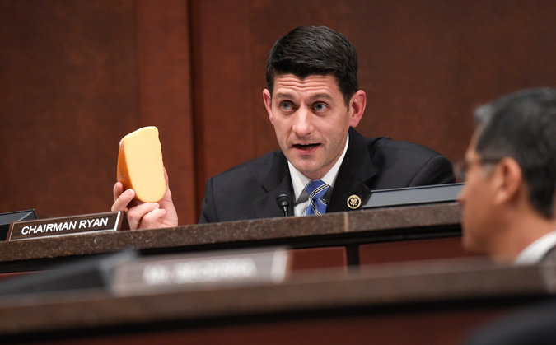

“We’re not quite there, but we’re getting close,” said Representative Paul D. Ryan of Wisconsin, chairman of the House Ways and Means Committee and co-author of the trade legislation. Credit Susan Walsh/Associated Press

WASHINGTON — The bruising battle over [President Obama](http://topics.nytimes.com/top/reference/timestopics/people/o/barack_obama/index.html?inline=nyt-per)’s push for the power to negotiate two potentially far-reaching trade pacts will shift this week to the House, where the White House faces entrenched opposition from Democrats and the stirring of rebellion from the Republicans’ right flank.

Advocates of the trade bill from both parties say they are gaining strength since it passed the Senate just before the Memorial Day break. But that 62-to-37 vote — while bipartisan — was not the overwhelming victory House supporters had hoped for.

And those advocates concede they do not yet have the votes to hand the White House trade promotion authority, which would allow Mr. Obama to complete the Trans-Pacific Partnership trade accord, knowing Congress could vote for or against it but not amend or [filibuster](http://topics.nytimes.com/top/reference/timestopics/subjects/f/filibusters_and_debate_curbs/index.html?inline=nyt-classifier) it. (Another trade deal, involving Europe, is also being negotiated but is not expected to be completed until after Mr. Obama leaves office.)

Only 17 Democrats out of 188 have come out in favor of so-called fast-track authority — and many of them are being hounded by labor and environmental groups to change their minds. Opponents of the trade deal say just seven Democrats remain truly undecided.

Representative Nancy Pelosi of California, the minority leader, who has yet to declare her position, has told House Speaker John A. Boehner of Ohio that he will have to produce 200 Republican votes to win the 217 he needs. In other words, she is not promising a single new convert.

“We’re not quite there, but we’re getting close,” said Representative Paul D. Ryan of Wisconsin, chairman of the House Ways and Means Committee and co-author of the trade legislation. But Mr. Obama, he added, “needs to deliver some votes. It’s just that clear.”

The president needs the authority to finish up the Pacific accord, the largest trade deal in a generation, linking 12 nations — including Canada and Chile in the Americas, and Japan and Australia across the Pacific — in a pact that would not just further cut generally low tariffs on goods but also put in place investment rules for roughly 40 percent of the global economy. The White House says, moreover, that the deal is an essential element in America’s strategic posture in Asia vis-à-vis the rising power of China.

Most congressional Democrats are skeptical. They argue that since the North American Free Trade Agreement was approved in 1993, such accords have only hastened the flow of manufacturing jobs overseas and pressured wages downward through international competition. Corporations, their executives and shareholders have prospered, but globalization has helped hollow out the middle class, many Democrats say.

By contrast, most Republicans conceptually [side with President Obama](https://www.whitehouse.gov/sites/default/files/docs/cea_trade_report_final_non-embargoed_v2.pdf), contending that the forces of globalization are inevitable and that trade deals like the T.P.P. will help open foreign markets to American goods and services. They support the White House’s effort to forge deals that protect intellectual property from theft and promote investor rights through strong international rules, which are seen as crucial to expanding opportunities for a wide range of American industries, including aircraft, entertainment, pharmaceuticals and insurance.

But in the current hyperpartisan atmosphere of Washington, concept does not necessarily translate to votes. Many of the most conservative Republicans simply do not want to give this president anything.

Representative Dave Brat, a Virginia Republican who was an economics professor before he [upset](http://www.nytimes.com/2014/06/12/us/politics/david-brat-waged-solo-fight-against-eric-cantor.html?_r=0) the former House majority leader Eric Cantor last year, said trade was good and tariffs were bad. But he is still furious that Mr. Obama tried to use an executive order to stop the deportation of hundreds of thousands of immigrants in the United States illegally.

“We just got through with an end-run around the Constitution,” he said, fuming. “I’m leaning heavy no.”

Representative Gary Palmer of Alabama, another conservative Republican freshman, said he liked the idea of the Trans-Pacific Partnership. But, he added, “If the president won’t abide by the Constitution, what gives you any confidence he’ll abide by T.P.P.?”

Representative John C. Fleming, Republican of Louisiana, echoed those fears. “As a rule, conservatives are free-traders. I’m a free-trader,” he said. “But we have a president who for every inch of authority we give, he takes a mile.”

Even Donald Trump has waded into the debate, blasting Congress for empowering the president and insufficiently addressing the issue of currency manipulation by some of America’s trading partners.

“Free trade only works if you have smart leaders and great negotiators,” he said in an unsolicited telephone interview on Friday. “We’re checkers players against grandmaster negotiators.”

Republican leaders say such voices represent a fringe in the party. After all, trade promotion has been embraced by longstanding conservative voices like the anti-tax gadfly Grover Norquist and the editorial page of The Wall Street Journal. But they cannot afford to lose much of that fringe, given the firm Democratic position.

With organized labor, environmental groups and liberal advocacy organizations like MoveOn.org opposed to the bill, Democratic leaders say they are in no position to deliver votes for Republican leaders, even if their own standard-bearer in the White House is adamantly behind the measure as well. The A.F.L.-C.I.O. began running [attack ads](https://www.youtube.com/watch?v=Tq5_1UlDi3A) against one Democrat, Representative Ami Bera of California, who came out for trade promotion authority and who has twice used union muscle to eke out narrow victories in his swing district. Less pointed [pressure ads](https://www.youtube.com/watch?v=LtQPg-ZRfWo&feature=youtu.be) are going up in 17 other Democratic districts.

“It doesn’t make any sense for our members to make a career-changing vote” to let Republican members off the hook, a senior Democratic leadership aide said.

That has Republicans — and the president — in a bind. Representative Jim Jordan, Republican of Ohio and leader of the conservative House Freedom Caucus, said that as written, the trade promotion legislation lets Congress “turn off” fast-track approval if a trade deal comes back having failed to meet the standards demanded in the bill.

But in reality, he said, the process for shutting down fast-track is so byzantine, it is nearly impossible to do. Such a resolution would first have to go through the House Ways and Means Committee and Senate Finance Committee, which tend to be pro-trade, before it could be considered by the House and Senate. Mr. Jordan and a handful of like-minded colleagues plan to amend the trade bill to make it easier for Congress to halt fast-track.

“I understand economics. I understand comparative advantage. I understand livestock producers in Ohio who want to sell pork in Japan,” said an exasperated Mr. Jordan, whose vote could influence a dozen or more conservatives. “But I’ve got a real problem here.”

Mr. Ryan, the manager of the bill, said there was no way he could allow such an amendment. That would make the House’s trade bill different from the Senate’s, prompt a negotiating conference between the chambers and force both to have to vote all over again.

“If we go to conference, that would kill T.P.A.,” Mr. Ryan said, referring to fast-track authority.

That could mean it will be up to the president. Representative Gregory W. Meeks, Democrat of New York and one of Mr. Obama’s main vote getters, said port-city Democrats and Congressional Black Caucus members could make all the difference.

Republican leaders have told wavering conservatives that trade promotion is not about trusting President Obama. It is about putting strict guidelines and demands on trade negotiations upfront. Besides, they say, the trade promotion authority bill would last three years, with an option for a three-year extension, well beyond this president’s final term.

Mr. Meeks’s explanation to African-American lawmakers is the opposite: Conservatives, out of spite, are trying to deny the first black president the same trade authority every modern president but Richard M. Nixon has enjoyed.

“There are some folks who aren’t doing things on merits,” Mr. Meeks said. “It’s to deny this president.”

That pitch is running into a wall of union leaders and liberal activists who want Democrats to stand firm. Activists delivered cotton swabs to Mr. Bera’s office over the break to tell him to clean out his ears. They delivered screws to the office of Representative Mike Quigley, a pro-trade Democrat from Illinois, supposedly representing jobs lost because of unfair trade practices. Signs have sprouted up around the Portland, Ore., district of Representative Earl Blumenauer, a Democrat, criticizing his support of the bill.

“These are tough, tough debates, the passion, the politics,” said Representative Ron Kind, Democrat of Wisconsin, who has tried to round up more votes for the president. “Outside of an authorization of military force, votes probably don’t get tougher than trade.”

NYT

# U.S. Shifts Stance on Drug Pricing in Pacific Trade Pact Talks, Document Reveals

By [JONATHAN WEISMAN](http://topics.nytimes.com/top/reference/timestopics/people/w/jonathan_weisman/index.html)JUNE 10, 2015

WASHINGTON — Facing resistance from its Pacific trading partners, the Obama administration is no longer demanding protection for pharmaceutical prices under the 12-nation Trans-Pacific Partnership, according to a newly leaked “transparency” annex of the proposed trade accord.

But American negotiators are still pressing participating governments to open up the process that sets reimbursement rates for drugs and medical devices. Public health professionals, generic drugmakers and activists opposed to the trade deal, which is still being negotiated, contend that it will empower big pharmaceutical firms to command higher reimbursement rates in the United States and abroad, at the expense of consumers.

They also say that it could expose international markets to the direct consumer appeals that Americans have experienced.

“It was very clear to everyone except the U.S. that the initial proposal wasn’t about transparency; it was about getting market access for the pharmaceutical industry by giving them greater access to and influence over decision-making processes around pricing and reimbursement,” said Deborah Gleeson, a lecturer at the School of Psychology and Public Health at La Trobe University in Australia, who has seen the leaked document. And even though it has been toned down, she said, “I think it’s a shame that the annex is still being considered at all for the T.P.P.”

The pharmaceutical and medical device annex is the latest document obtained by The New York Times in collaboration with the watchdog group WikiLeaks, and it was released [ahead of the House vote](http://www.nytimes.com/2015/06/01/business/obamas-push-for-trade-deal-faces-bipartisan-peril-in-house.html) on whether to give [President Obama](http://topics.nytimes.com/top/reference/timestopics/people/o/barack_obama/index.html?inline=nyt-per) expanded powers to complete the Trans-Pacific Partnership. The Senate [has already approved](http://www.nytimes.com/2015/05/23/business/senate-vote-is-a-victory-for-obama-on-trade-but-a-tougher-test-awaits.html) legislation giving the president “trade promotion authority,” or fast-track power to complete trade deals that cannot be amended or filibustered by Congress. A House vote on final passage of the bill, which could come as early as Friday, appears extremely close.

The Pacific accord, the largest since the North American Free Trade Agreement two decades ago, would link countries stretching from Canada and Chile to Japan and Australia into a new regimen of trade rules that would cover 40 percent of the global economy.

## Trans-Pacific Partnership Countries

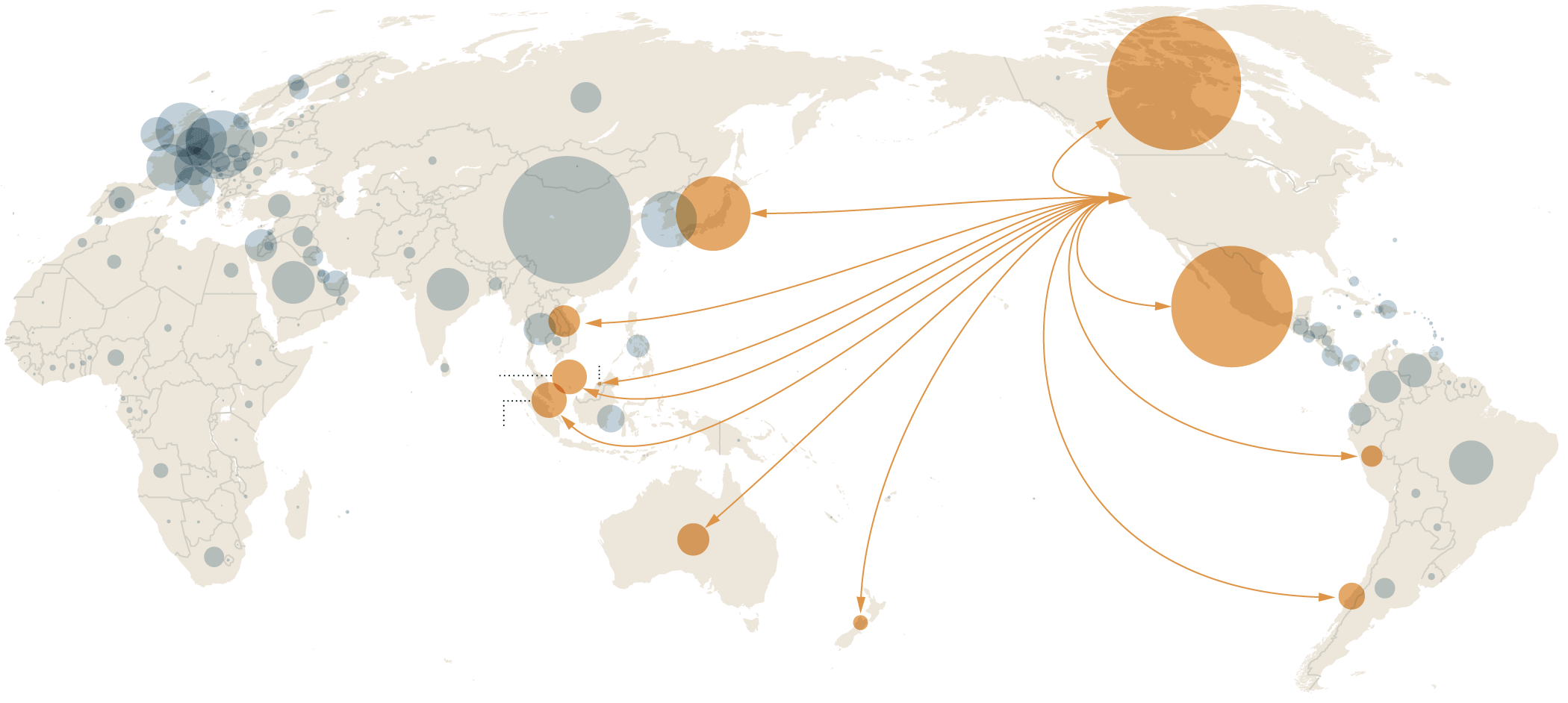

**Total Goods Trade with the US in 2014 (imports + exports in billions $US)**

Canada $658

Japan $201

Mexico $534

Vietnam $36

Brunei $0.6

Malaysia $44

Singapore $47

Peru $16

Australia $37

Chile $26

New Zealand $8

Census Bureau

By The New York Times

## Related Coverage

[[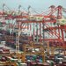](http://www.nytimes.com/2015/05/12/business/unpacking-the-trans-pacific-partnership-trade-deal.html)](http://www.nytimes.com/2015/05/12/business/unpacking-the-trans-pacific-partnership-trade-deal.html)

## [The Trans-Pacific Partnership Trade Deal: What It Would MeanMAY 11, 2015](http://www.nytimes.com/2015/05/12/business/unpacking-the-trans-pacific-partnership-trade-deal.html)

[[](http://www.nytimes.com/2015/06/01/business/obamas-push-for-trade-deal-faces-bipartisan-peril-in-house.html)](http://www.nytimes.com/2015/06/01/business/obamas-push-for-trade-deal-faces-bipartisan-peril-in-house.html)

## [Obama’s Trade Deal Faces Bipartisan Peril in the HouseMAY 31, 2015](http://www.nytimes.com/2015/06/01/business/obamas-push-for-trade-deal-faces-bipartisan-peril-in-house.html)

[[](http://www.nytimes.com/2015/06/10/business/international/transatlantic-trade-deal-pact-europe-eu-us-germany.html)](http://www.nytimes.com/2015/06/10/business/international/transatlantic-trade-deal-pact-europe-eu-us-germany.html)

## [In Germany, Grass-Roots Opposition to a European-U.S. Trade DealJUNE 9, 2015](http://www.nytimes.com/2015/06/10/business/international/transatlantic-trade-deal-pact-europe-eu-us-germany.html)

Opponents of both the Pacific deal and the legislation to grant trade promotion authority have long targeted the pharmaceutical issue. Foreign governments and health care activists have accused pharmaceutical giants, mostly based in the United States, of protecting profits over public health, especially in poor countries where neither the government nor consumers can afford to pay rates anywhere close to those charged in the West.

That fight re-emerged in the Pacific trade negotiations, which involve countries with strong cost-containment policies, like New Zealand, as well as poor countries like Peru and Vietnam.

The agreement “will increase the cost of medicines worldwide, starting with the 12 countries that are negotiating the Trans-Pacific Partnership,” said Judit Rius Sanjuan, a lawyer at Doctors Without Borders, a humanitarian organization that provides medical care in more than 60 countries.

Drug companies, however, say they need to be able to charge fair prices to compensate for the billions of dollars and decades of research that go into their medicines.

Jay Taylor, vice president for international affairs for the Pharmaceutical Research and Manufacturers of America, said penetrating the opaque process for getting a drug considered for a national health system, listed as available and properly priced is central to free trade for drug makers. “It is market access,” he said.

That is particularly true for the Pacific accord, he said, because one of the countries, New Zealand, has a powerful system for holding down drug costs — and keeping drug makers in the dark. New Zealand’s health system has been held up as a model for the Pacific region, a prospect the pharmaceutical industry does not relish.

“There are no clear timelines for review, no sense of what a complete dossier is to get a fair review,” Mr. Taylor said. “It’s a question of basic due process.”

Negotiators from the United States appear to be pushing a similar agenda in separate negotiations with the European Union, according to a copy of an internal European report viewed on Wednesday by The New York Times.

“The U.S. reiterated its interest to include transparency provisions on pricing and reimbursement within the TTIP similar to the ones E.U. and U.S. have with Korea,” said the report, dated May 8 and written by the European Commission, on the status of talks with the United States on a planned Transatlantic Trade and Investment Partnership, also known as TTIP.

The report was made available by a person who shared the information on the condition of anonymity because of the sensitivity of the document.

### [Document](http://www.nytimes.com/interactive/2015/06/10/business/international/document-annex-of-proposed-pacific-trade-accord.html)

## [Annex of Proposed Pacific Trade Accord](http://www.nytimes.com/interactive/2015/06/10/business/international/document-annex-of-proposed-pacific-trade-accord.html)

[The Obama Administration is shifting its stance on drug pricing in the Trans-Pacific Partnership talks, according to a newly leaked “transparency” annex of the proposed trade accord.](http://www.nytimes.com/interactive/2015/06/10/business/international/document-annex-of-proposed-pacific-trade-accord.html)

[[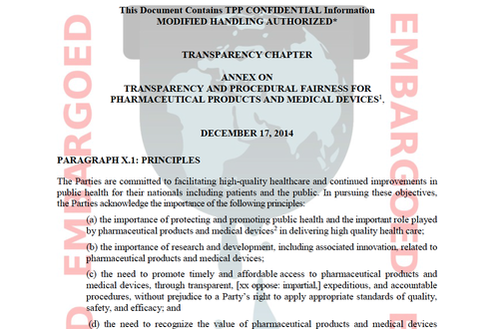](http://www.nytimes.com/interactive/2015/06/10/business/international/document-annex-of-proposed-pacific-trade-accord.html)](http://www.nytimes.com/interactive/2015/06/10/business/international/document-annex-of-proposed-pacific-trade-accord.html)

[OPEN Document](http://www.nytimes.com/interactive/2015/06/10/business/international/document-annex-of-proposed-pacific-trade-accord.html)

That leak, and others, had made threat of higher drug prices a major concern for some European critics of a trade deal with the United States, said John Hilary, the executive director of War on Want, a group based in Britain that fights global poverty.

The European Commission has previously said that the pharmaceutical aspects of trade talks with the United States mostly focus on simplifying inspections of manufacturing plans, and on exchanging information to make it easier whether to approve medicines and to develop new ones.

In a public fact-sheet, the commission has acknowledged that some citizens “fear E.U. governments would lose their right to decide” drug costs. But it said that fear was unfounded.

Pharmaceutical firms and their trade associations have filed by far more lobbying disclosure forms on the Pacific trade negotiations than any other industry, according to the watchdog [Sunlight Foundation](http://sunlightfoundation.com/blog/2014/03/13/tpp-lobby/). More broadly, the pharmaceutical and health product industries have been active political players in the United States for decades. They have been the [biggest spenders on lobbying](https://www.opensecrets.org/lobby/top.php?indexType=i), and drug company deal-making with the Obama administration and in Congress was instrumental in securing passage of the Affordable Care Act.

Public health professionals say pharmaceutical industry lobbying is meant to diminish the power of government health programs that trim reimbursement rates to the global pharmaceutical giants. The newly leaked annex, dated Dec. 17, 2014, explicitly lists [Medicare](http://topics.nytimes.com/top/news/health/diseasesconditionsandhealthtopics/medicare/index.html?inline=nyt-classifier) and the Centers for Medicare and Medicaid Services as falling under its strictures.

That may embolden critics.

“The leak is just the latest glaring example of why fast-tracking the T.P.P. would undermine the health of Americans and the other countries and cost our government more, all to the benefit of pharma’s profits,” said Lori Wallach, director of Public Citizen’s Global Trade Watch and one of the most prominent voices in the coalition working to scuttle trade promotion authority.

Officials at the United States Trade Representative’s office, while declining to comment on a leak they would not acknowledge, say rules in the Pacific accord would have no impact on the United States because Medicare and [Medicaid](http://topics.nytimes.com/top/news/health/diseasesconditionsandhealthtopics/medicaid/index.html?inline=nyt-classifier) already adhere to them. The U.S.T.R. worked with the Centers for Medicare and Medicaid Services and the Health and Human Services Department to develop the proposals.

“Already, transparency and procedural fairness are integral parts of the U.S. legal system and as such are principles reflected in U.S. trade agreements,” the U.S.T.R. said in a statement.

While the leaked annex may fall short of what pharmaceutical companies wanted, it also offers them new opportunities to challenge the decisions of trading partners on which drugs they will offer their citizens through government health care programs and the rates at which they will reimburse drug sellers.

Photo



Heather Bresch, chief executive of the generic drug maker Mylan, said that the proposed trade accord would help brand-name pharmaceuticals. Credit Jeff Swensen for The New York Times

A version of the Trans-Pacific Partnership annex that leaked in 2011 made explicit reference to “competitive market-derived prices,” promising drug companies the chance to appeal rates deemed insufficient. Those are gone, “a victory for the non-U.S. partners to some extent,” Ms. Gleeson, the Australian expert, said.

But Pacific accord negotiators do appear ready to grant pharmaceutical and medical device makers more power to influence participating governments. The 12 countries involved, and any others that might join later, would have to disclose rules and guidelines for deciding which medical products would be made available through government programs and at what rate providers would be reimbursed.

Drug companies and medical device makers would have to be given “timely opportunities to provide comments at relevant points in the decision-making process.” And governments would have to offer a review process “that may be invoked at the request of an applicant directly affected” by the decisions of national health care authorities.

In the United States, pharmaceutical companies and Medicare have fought for years over which drugs are listed for reimbursement, especially when Medicare lists generic drugs over name brands. While advocates of the trade deal, including President Obama, say opening markets to competition should lower prices for consumers, generic drug makers say the Trans-Pacific Trade Partnership could raise costs instead.

Heather Bresch, the chief executive of [Mylan](http://topics.nytimes.com/top/news/business/companies/mylan_laboratories/index.html?inline=nyt-org), one of the largest generic-drug makers, said that the brand-name pharmaceutical industry was “establishing, through U.S. trade policy, an international system designed to maximize its monopolies.”

The annex also tackles restrictions in many countries on direct marketing to consumers, mandating that drug companies be allowed to “disseminate to health professionals and consumers through the manufacturer’s Internet site” in each country “truthful and not misleading information” on products approved for sale in that country. It does, however, say such dissemination must reflect each country’s “laws, regulations, and procedures.”

By explicitly listing the Centers for Medicare and Medicaid Services, the annex makes it clear the United States is not immune to Trans-Pacific Partnership rules. Japan, Australia and New Zealand may not have pharmaceutical companies as powerful as the United States’ but under the accord, United States subsidiaries located in Pacific trade partners could use the accord’s dispute resolution process to tackle perceived violations by Medicare officials.

The annex makes clear that disputes over pharmaceutical listing procedures would not be subject to government-to-government dispute resolution, the World Trade Organization and retaliatory tariffs.

Instead, disputes would be resolved through the [Investor-State Dispute Settlement](http://www.nytimes.com/2015/03/26/business/trans-pacific-partnership-seen-as-door-for-foreign-suits-against-us.html) process, which involves three-lawyer extrajudicial tribunals organized under rules set by the United Nations or World Bank.

That could be significant, both for current Medicare practices and future efforts to lower cost, said Peter Maybarduk of Public Citizen’s Global Access to Medicines project. Drug makers have limited access to Centers for Medicare and Medicaid Services policy makers as they decide which drugs to list and how much to reimburse. The Trans-Pacific Partnership could change that.

It could also hinder efforts by many Democrats to change federal law precluding the government from negotiating drug prices directly with pharmaceutical makers. To make that work, the Centers for Medicare and Medicaid Services would need a “national formulary” — a government list of accepted medications. But each decision is subject to review and appeal, which would make it far more difficult, Mr. Maybarduk said.

# Business Leaders React With Dismay to Defeat of Trade Bill

By [NELSON D. SCHWARTZ](http://topics.nytimes.com/top/reference/timestopics/people/s/nelson_d_schwartz/index.html), [PATRICIA COHEN](http://topics.nytimes.com/top/reference/timestopics/people/c/patricia_cohen/index.html) and [KATIE THOMAS](http://topics.nytimes.com/top/reference/timestopics/people/t/katie_thomas/index.html)JUNE 12, 2015

Photo

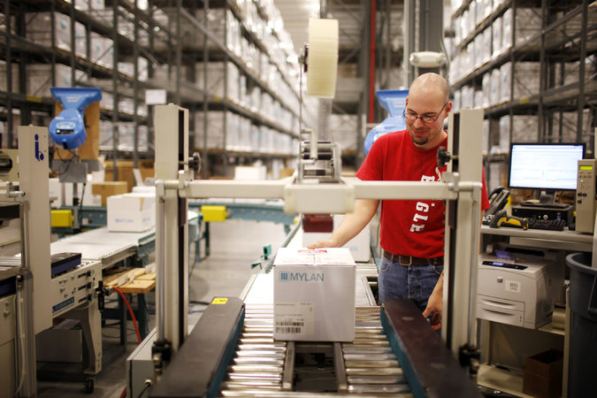

A Mylan pharmaceuticals processing station in Greensboro, N.C. Credit Travis Dove for The New York Times

As big a setback as Friday’s vote on Capitol Hill was for President Obama’s efforts to advance his trade agenda, it was an even bigger rebuff for the leaders of American business.

While there are deep divisions over trade policy among Democrats, and to some extent among Republicans as well, corporate America has been nearly unified in its support of a deal that would lower various barriers to trade and investment between the United States and 11 other Pacific Rim nations.

Though many sought to put the best face on the vote, business groups and chief executives were quick to voice their displeasure with the House’s rejection of aid to workers harmed by imports, which could doom prospects for eventual approval of a wider trade pact.

“This is disappointing and discouraging,” said Todd J. Teske, chief executive of Briggs & Stratton, a 107-year-old manufacturer based in Wauwatosa, Wis. “We do business around the world, and free and fair trade allows the U.S. and our company to be competitive globally.”

In a classic strange-bedfellows-in-Washington moment, big-business lobbies swung into action Friday afternoon in a concerted effort to save a signature initiative of President Obama, a leader with whom they have rarely seen eye to eye.

“Manufacturers will not back down in this fight for expanded trade, for the future of our industry and our country,” the National Association of Manufacturers said in a statement.

Manufacturers have been among the most vocal supporters of what is formally known as the Trans-Pacific Partnership, or T.P.P., but officials from other sectors also made their frustration plain on Friday. David French, senior vice president for the [National Retail Federation](http://www.nrf.com/), called the vote “a victory for those with a narrow agenda that puts petty politics ahead of people, while jeopardizing the futures of millions of men and women in America.”

“It is nothing short of astounding that in the 21st century anyone would think it is in our country’s best interest to sit back and let foreign governments dictate our role in a global marketplace,” he added.

After the vote, many trade associations representing consumer electronics, semiconductor manufacturers and Silicon Valley firms, as well as individual companies like the computer chip maker Intel, issued statements cheering on the president and urging Congress to reconsider its opposition to the piece of the legislation dealing with assistance to workers.

Friday’s showdown on Capitol Hill makes the odds of a trade agreement before President Obama leaves the White House much longer, but some experts insist the fight is far from over.

“I’m still hopeful,” said Gary Hufbauer, a senior researcher with the Peterson Institute for International Economics, who characterized the vote on Friday as a vehicle for Democrats to show their displeasure with aspects of the pact. “This was a way of them stomping their feet, but in the end I think the president will get his way.”

Bill Lane, director of global government affairs for Caterpillar, echoed Mr. Hufbauer’s view that the door was not completely shut. “Even though the process is temporarily stalled, we are optimistic,” he said.

Mark Grayson, a spokesman for the Pharmaceutical Research and Manufacturers of America, an industry trade group, said that the group was hopeful “that the House will pass the bill so it can get to the president’s desk.”

He declined to comment on the group’s position on the overall pact, saying it was still being negotiated. But he made clear that the pharmaceutical industry was hoping for what he called “strong” intellectual property provisions to be included in the trade pact.

He dismissed concerns that the pact could limit access to generic drugs, noting that the overwhelming majority of prescriptions filled in the United States were for generic medications, despite strong intellectual property laws in this country.

Generic drug industry officials hailed the vote, however.

Heather Bresch, the chief executive of Mylan, a generic drug maker, applauded the defeat on Friday by the House, saying it would give her more time to lobby against the trade pact.

She and other leaders in the generic drug industry have argued that the pact goes too far in protecting the patents of the brand-name drug industry and would block access to generic drugs around the world.

“I think it’s scary and dangerous that the president is looking for this kind of authority on a trade bill that I think has serious flaws in it,” she said. “It’s setting the global generic industry back 30 years.”

“I’m thankful for this reconsideration, and I’m going to use this window to try and educate and let our voice be heard,” she said.

Although certainly a minority, a few business groups oppose the trade pact. Unions, environmental groups and many liberals are also opposed. Many critics cited the job losses that followed the signing of North American Free Trade Agreement more than two decades ago.

There was also some applause for the defeat from groups like the American Sustainable Business Council, a network of progressive business organizations.

“The T.P.P. would give multinational corporations unprecedented power to evade safeguards that protect consumers, workers and the environment. It would hurt smaller, innovative businesses,” said David Levine, the group’s co-founder.

While most economists generally support the White House’s trade agenda, some on the left have kept up a steady drumbeat, warning that it has been structured primarily to advance the interests of Wall Street and major corporations doing business abroad.

“The more you learned about the T.P.P., the less it sounded like a simple free trade deal and the more it sounded like a handshake between businesses and investors on all sides of the border,” said Jared Bernstein, a senior fellow at the Center on Budget and Policy Priorities.

Mr. Bernstein, who served as the chief economist to Vice President Joseph R. Biden Jr. from 2009 to 2011, argued that voters were also suspicious about the benefits of trade agreements.

“Many constituents were deeply uncomfortable,” he said. “Members from districts where there’s nervousness not just about trade deals but about the impact of globalization on jobs and wages had a hard time saying yes.”

Many manufacturing giants have been pushing hard to create a broad set of trade rules across major Pacific Rim nations (not including China, however), in part because they already have a major presence in the region. These include companies like General Electric, Honeywell and Cummins. But even a company like Briggs & Stratton, which exports less than 10 percent of what it makes to Asia, stands strongly behind the pact being negotiated.

If sales of the gasoline engines for outdoor power equipment that his company makes — along with Snapper lawn mowers, Simplicity tractors and other products — are to grow in the future, Mr. Teske, the company’s chief executive, said, new customers in Asia are vital.

About 85 percent of Briggs & Stratton’s products are manufactured in the United States, with factories in Missouri, Kentucky, Nebraska and other states, Mr. Teske said, noting that his work force is efficient enough to be competitive with rival manufacturers in low-wage countries.

“If we become isolated as a country,” Mr. Teske said, “that’s not to our advantage.”

### [Asia Pacific](http://www.nytimes.com/pages/world/asia/index.html)

# Failure of Obama’s Trade Deal Could Hurt U.S. Influence in Asia

By JONATHAN SOBLEJUNE 16, 2015

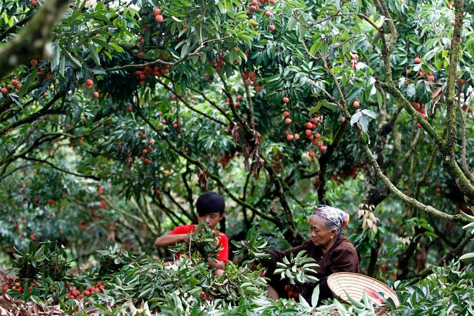

Workers harvesting lychees in Luc Ngan, Vietnam. President Obama argues that a Pacific Rim trade pact would require the Vietnamese government to improve employee safety. Credit Luong Thai Linh/European Pressphoto Agency

TOKYO — With President Obama’s trade agenda in jeopardy in Congress, the nations of Asia are weighing the potential impact of a failed deal on local jobs and exports, but also something else: American influence in the region.

For many here, the defeat of a sweeping trade and investment pact being negotiated between the United States and 11 other Pacific Rim nations would weaken Washington’s already strained claim to leadership in Asia and undermine a commitment by Mr. Obama to devote more attention and resources to a group of countries contending with the growing power of China.

Congress rejected legislation on Friday that is crucial to completing the trade deal, the Trans-Pacific Partnership, throwing its future — and its potential to bind together countries friendly to American interests — in doubt.

“If this collapses, Pacific Rim countries will be aghast,” said Shunpei Takemori, a professor at Keio University in Japan, the largest economy in the would-be trade zone after the United States. “China is pushing, and if the U.S. just stands aside, it would be a tragedy.”

The White House and its Republican free-trade allies in Congress are searching for ways to revive a bill that would extend aid to workers displaced by global trade agreements. By rejecting that measure on Friday, Mr. Obama’s fellow Democrats in the House effectively scuttled legislation granting him the power to negotiate trade deals that cannot be amended or filibustered by Congress.

Without such trade promotion authority, analysts in the region said, it may be impossible for Mr. Obama to persuade governments to make the concessions needed to close a deal that would affect 40 percent of the global economy.

The death of the Trans-Pacific Partnership would be a new setback for American economic diplomacy in Asia after a failed attempt to thwart a Chinese state-run infrastructure investment fund that some see as a competitor to American-dominated institutions like the World Bank. The Obama administration has also struggled to respond to blunter assertions of Chinese power, such as Beijing’s efforts to strengthen its territorial claims by building islands out of reefs in the South China Sea.

“If you don’t do this deal, what are your levers of power?” Singapore’s foreign minister, K. Shanmugam, said in Washington on Monday. “The choice is a very stark one: Do you want to be part of the region, or do you want to be out of the region?”

He argued that “trade is strategy” and that without economic leverage, the United States was left with only military clout in Asia, “and that’s not the lever you want to use.”

“It’s absolutely vital to get it done,” he added, referring to the bill’s passage.

In Japan, Prime Minister Shinzo Abe has presented the imperiled trade pact as key to his nation’s ambitions, and he has pushed back with unusual vigor for a Japanese leader against the country’s influential farm lobby, which has long opposed lower barriers to imports of rice and other agricultural products. He has made the case that Japan needs trade liberalization to bolster its stagnant economy, but his arguments have been as much about diplomacy as economics.

“It is also about our security,” he said of the proposed trade deal in a speech during a joint session of Congress in April. “Long term, its strategic value is awesome.”

Ichiro Fujisaki, a former Japanese ambassador to the United States, described the Trans-Pacific Partnership as “economic glue to cement ties with like-minded countries,” including emerging economies, such as Vietnam, that are only partly integrated into the global economic order shaped by the United States.

“It’s an important time for rule-making in Asia, and T.P.P. is central to establishing the right rules,” Mr. Fujisaki said. “I trust that Congress will ultimately understand that.”

China is conspicuously absent from the list of 12 countries negotiating the agreement. The group comprises Australia, Brunei, Canada, Chile, Mexico, New Zealand and Peru, as well as Japan, Malaysia, Singapore, the United States and Vietnam. But the Chinese government has taken pains not to criticize the deal, and has even suggested it may eventually ask to join.

For now, the pact’s wide-ranging rules on intellectual property, investor protections and workers’ rights are seen as a step too far for the ruling Communist Party.

“China knows that T.P.P. is one of the pillars of U.S. rebalancing strategy in the Asia Pacific, and it is trying to create a club that excludes China,” said Song Guoyou, a professor at the Center for American Studies in Fudan University in Shanghai. The collapse of the deal, he added, would be “a huge blow to Obama’s effort to build an integrated trade system” in the Asia-Pacific region.

Professor Song said the United States should work with China to offer a “more ambitious and more inclusive” agreement, and he held up as an alternative the separate, less comprehensive regional trade deal that China is negotiating with countries in Southeast Asia as well as Japan, South Korea and other nations.

Negotiations over that pact could gain momentum if the agreement fails, as could potential bilateral deals, including one proposed between Japan and the European Union that Tokyo deferred while it focused on the trade deal.

South Korea, a crucial American ally and one of China’s top trading partners, has expressed interest in joining the Trans-Pacific Partnership talks, but its enthusiasm has been muted. Some have accused the government of trying to use the Chinese proposal to secure better terms from the United States. A bilateral trade agreement with the United States that came into force in 2012 set off large, prolonged protests, and the South Korean government has been wary of entering another grueling round of politically charged trade talks with Washington.

In terms of tangible economic benefits, the stakes are higher for some nations than for others. Countries like Australia and Singapore already have highly open markets and bilateral trade deals with many of their important trading partners, meaning the potential for additional gains is relatively small, experts said.

At the other extreme is Vietnam, the only Communist country in the group and perhaps its most incongruous member. Vietnam has played an outsize role in the debate over the deal in the United States, with Mr. Obama arguing that the Vietnamese government would be required to improve worker safety and allow the establishment of independent labor unions, something it currently forbids. Opponents of the pact countered that provisions on labor standards in trade deals were too difficult to enforce to make a difference.

The region’s smaller economies are increasingly bound to China’s. China is the largest trading partner for countries in the Association of Southeast Asian Nations, for instance, accounting for 14 percent of the bloc’s external trade last year, almost twice as much as the group’s second-largest partner, the United States.

In Japan, the failure of the Trans-Pacific Partnership would relieve pressure on Mr. Abe to open up the agricultural sector and other protected industries.

Japanese trade negotiators had sought to preserve import barriers on some of the nation’s most politically sensitive farm products, including rice — a battle that had been the biggest obstacle to a deal until the House Democrats revolted. Japan was nonetheless preparing for painful concessions.

A collapse in the talks could thus offer a political silver lining for Mr. Abe, who could avoid angering farmers and the rural members of his party who depend on their votes.

“He has tackled some structural reform, but it has been rather piecemeal,” Professor Takemori of Keio said. “The agricultural lobby would have been furious.”

# The Trans-Pacific Partnership and a President’s Legacy

By [PETER BAKER](http://topics.nytimes.com/top/reference/timestopics/people/b/peter_baker/index.html)JUNE 14, 2015

Photo

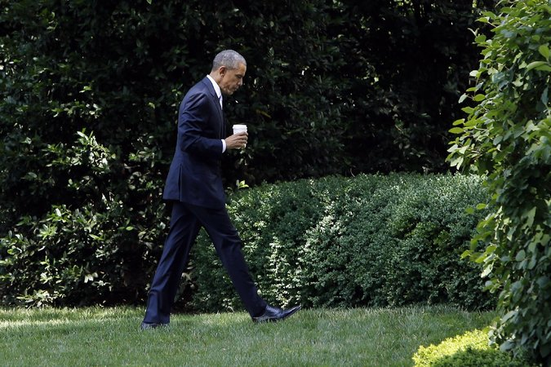

President Obama returning to the White House on Friday after meeting with House Democrats to push for trade legislation in Washington. Credit Jonathan Ernst/Reuters

WASHINGTON — For more than six years, the short walk from the Oval Office downstairs to the Situation Room has all too often meant bad news or grim choices. Whether it was war in the Middle East, Russian aggression in Ukraine or the hunt for terrorists around the globe, [President Obama](http://topics.nytimes.com/top/reference/timestopics/people/o/barack_obama/index.html?inline=nyt-per)’s foreign policy has felt consumed by guns and drones.

So the 12-nation trade deal Mr. Obama has been negotiating in Asia took on special meaning for a president eager to change the world. It was a way to leave behind a positive legacy abroad, one that could be measured, he hoped, by the number of lives improved rather than by the number of bodies left behind. And if the Pacific really is the future, Mr. Obama wanted to position the United States to lead the way.

As it turned out, the biggest challenge to securing that legacy has been at home, and not overseas, as Mr. Obama’s fellow Democrats last week [shot down legislation](http://www.nytimes.com/2015/06/13/us/politics/obamas-trade-bills-face-tough-battle-against-house-democrats.html) crucial to finalizing the trade agreement on the grounds that it would hurt rather than help America. Unless he can convince scores of Democrats to change their votes in the coming days, the centerpiece of his much-touted re-engagement with Asia will slip away along with one of the last chances he has to leave his imprint on the world before leaving office.

“If the president cannot get” trade promotion authority “through Congress, it is a disaster for his Asia policy,” said Michael J. Green, a former Asia adviser to President George W. Bush and now at Georgetown University and the Center for Strategic and International Studies. “The administration will be dismissed as lame duck at a time when China is flexing its muscles.”

Moreover, Mr. Green and other analysts said, a failure to follow through on the trade deal would lead to Japan, Vietnam and other putative partners reversing course on economic reforms or tariff concessions required to join the multilateral trade zone with the United States, known as the Trans-Pacific Partnership, or T.P.P. And momentum may shift to economic institutions and agreements that do not include the United States, including the new [Asian Infrastructure Investment Bank](http://www.nytimes.com/2015/04/03/world/asia/china-asian-infrastructure-investment-bank.html) that China is creating over American resistance.

“Domestically we tend to view trade through a political prism by way of winners and losers,” said Jon Huntsman, a Republican former governor of Utah who served as Mr. Obama’s ambassador to China before mounting a campaign to challenge his re-election in 2012. “In Asia, it’s seen as directly tied to our leadership and commitment to the region. A failed T.P.P. would create an influence vacuum that others, primarily China, would fill.”

The trade agreement, about a decade in the making, would stitch together the United States with 11 other nations along the Pacific Rim, including Canada, Mexico, Japan, Vietnam, Malaysia and Australia, creating a free-trade zone for about 40 percent of the world’s economy. It would lower tariffs, while setting rules for resolving trade disputes, setting patents and protecting intellectual property. China is not part of the group.

Mr. Obama, congressional Republicans and business groups argue that it will unlock foreign markets to American goods and level the playing field by forcing Asian competitors to improve labor and environmental standards. But House Democrats, labor unions and environmental groups argue that it will benefit big corporations, further bleed American manufacturing jobs and fail to adequately enforce the workplace standards it promises.

The administration tried making a foreign policy argument over the last few weeks, maintaining that if the United States does not seal the trade pact, it will be leaving the field to China, which has been exerting its clout in recent years, whether by investing in energy supplies in Africa and the Middle East or by asserting claims over disputed waters and islands.

But some on the left argue that the administration is using China to scare lawmakers and exaggerating the competition. “I just don’t buy this China boogeyman stuff,” said Jared Bernstein, a senior fellow at the Center on Budget and Policy Priorities and a former economic adviser to Vice President Joseph R. Biden Jr. “If anything, I see China as being more inward looking, devoting less resources to mercantile-type trade and more to internal investment, consumption and developing human capital.”

Supporters of the trade pact hope to hold a new vote this week on the part of the trade package rejected by the House on Friday but will need to secure 90 more votes. Representative Paul D. Ryan, the Wisconsin Republican who has worked with the White House to secure trade negotiating authority, said on Sunday that if Mr. Obama wanted to avoid being a “very lame-duck president,” he would have to win over members of his own party.

“I think that this can be salvaged because I think people are going to realize just how big the consequences are for American leadership,” Mr. Ryan said on “Fox News Sunday.”

But there was little indication over the weekend that many minds had been changed on the political left. “We need to regroup and come up with a trade policy which demands that corporate America start investing in this country rather than in countries all over the world,” Senator Bernie Sanders of Vermont, a candidate for the Democratic presidential nomination, said on “Face the Nation” on CBS.

There's obviously a reason none of us have seen more than glimpses of the paperwork behind this. There's obviously a reason no one in...

The Pacific trade pact was meant to be one of three major foreign policy achievements Mr. Obama wanted to secure before leaving office; all three are on the line this summer. He faces a June 30 deadline to seal an agreement with Iran to scale back its [nuclear program](http://topics.nytimes.com/top/news/international/countriesandterritories/iran/nuclear_program/index.html?inline=nyt-classifier) and he hopes to follow through on his reconciliation with Cuba by formally restoring diplomatic relations.

Those three initiatives take on even more significance for Mr. Obama as he confronts the reality that he is likely to turn over the White House to his successor without having defeated the Islamic State in Syria and Iraq or resolved the conflict with Russia over Ukraine. He still plans to leave office as the president who ended the American war in Afghanistan, but the security situation there remains fluid.

Amid all those wartime issues, the Asia initiative was to be the long-term investment that would pay off years later. The White House has deployed more military forces to the region and made it a focus. But the trade pact was to be the most tangible element of the policy.

The trade talks have reached a decisive turning point. Negotiators have drafted the bulk of the agreement but other countries are holding back to see if Mr. Obama wins the authority he needs from Congress before completing the pact. With Asia on his mind, Mr. Obama recently hosted Prime Minister Shinzo Abe of Japan and he now plans to welcome President Xi Jinping of China to the White House in coming weeks, a meeting that will be colored by his failure to achieve his trade goal should he not turn House Democrats around.

“There is no Asia pivot without an economic component, and that component is tied up in T.P.P.,” said Walter Lohman, director of the Asian studies program at the Heritage Foundation. The challenge for Mr. Obama, he added, is that no matter how important the trade pact may be to his foreign policy, Congress will consider it through an economic lens. “Geopolitics gets it very few votes.”

Peter A. Petri, a professor of international finance at Brandeis University, said he just returned from a trip to Asia. “Many people there are dismayed by our political impasse,” he said. “They simply don’t understand or want an America that is defensive and distant.” He said that was actually true of China as well, despite the competitiveness between the two countries.

“The pivot makes no sense without American economic partnerships,” he added, “and taking economics out of the relationship would leave only zero-sum strategic competition.”

## Congressional business

### Tangling on trade

# A rebellion in the House shows how far apart the president and his party are

Jun 20th 2015 | WASHINGTON, DC | [From the print edition](http://www.economist.com/printedition/2015-06-20)

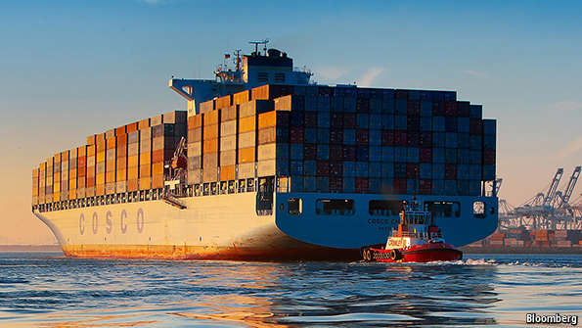

“WHATEVER the deal is with other countries, we want a better deal for America’s workers.” With that incisive bit of analysis Nancy Pelosi, the minority leader of the House of Representatives, postponed Barack Obama’s hopes of securing the authority he needs to negotiate a trade deal with a dozen Pacific countries, and then another with the EU. Mr Obama now finds himself in the unfamiliar position of relying on the two most senior Republicans in Congress, John Boehner in the House and Mitch McConnell in the Senate, to rescue him. If they are unable to do so then Mr Obama’s foreign policy, which is forever proclaiming its pivot to Asia, will merely resemble a plank.

Failure to move forward on the deals would create more than enough blame to go around the capital. It would also suggest that in the past two decades it has got easier for groups pursuing minority interests to stop the federal government working.

Understanding how Mr Obama finds himself in this position entails getting to grips with the acronyms that populate trade policy, as well as with arcane parliamentary manoeuvres. To negotiate with other countries, the president needs Trade-Promotion Authority (TPA), which allows his administration to make agreements without the people on the other side of the table worrying that Congress will pick them apart at some later date. People involved with negotiating the Pacific deal say that other countries will not put their best offers forward until they know the president’s representatives have this authority. Republicans have been prepared to put aside their mistrust of Mr Obama and give him TPA. Most Democrats, by contrast, would rather their fingerprints were not found on trade deals.

To get TPA through the Senate, the Republican majority leader, Mitch McConnell, combined it with something Democrats do like, namely the spending of federal dollars on retraining workers who have lost their jobs as a result of globalisation. This is where the second acronym, TAA (Trade Adjustment Assistance), comes in. The combined bill then went to the House, where Democrats, who are in the minority, were powerless to prevent the president from getting his negotiating authority. They did, however, manage to block the other half of the bill. Republicans looking to trim government spending were happy to help. Democrats thus managed to delay the whole package, at the cost of voting down a retraining fund which they would ordinarily have supported.

Viewed from afar, it might be tempting to conclude that this all means America has changed its mind about trade, or about the benefits of global capitalism. This is not the case: polling by Gallup suggests that more Americans see foreign trade as an opportunity than as a threat than at any time during the past two decades. When those views are broken down by party affiliation, the results are surprising. Though Republicans are the party of trade in Congress, Democrats are more likely to have a positive view of trade, by a margin of ten points (see chart). Why, then, did their representatives in the House decide to kill it?

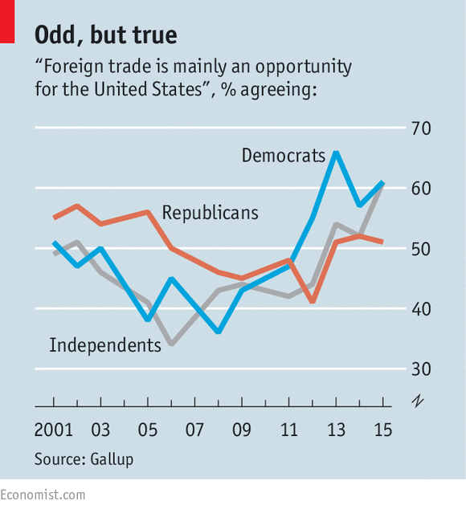

Trade bills tend to pit the president, who must weigh up the impact of any deal on America’s economy and its standing in the world, against the House, where members are more concerned with the risk of job losses in their districts. One way of reconciling these interests in the past has been for the president to help congressmen secure earmarks, as Bill Clinton did in 1993 to pass the North Atlantic Free Trade Agreement (NAFTA). This kind of bribery is no longer available to party leaders and whips in Congress, leaving the president more reliant on his power to charm.

It is possible that with some more arm-twisting in person Mr Obama could have got his way, but the idea that his administration has been a casual observer is mistaken. Michael Froman, the administration’s chief negotiator on trade, and his staff have held 1,700 meetings on Capitol Hill, most of them with Democrats. In the event Mr Froman managed to get the backing of 28 House Democrats for trade promotion, compared with 102 who voted for NAFTA in 1993. Most of those 102, though, represented districts crowded with conservative voters, who urged their congressmen to adopt more centrist positions. Many of these seats have since been lost or redistricted away, leaving behind a Democratic rump in the House which is to the left of the party’s median voter on trade.

Alongside the demise of earmarks and blue-dog Democrats, trade politics has been complicated by the increased sway outside groups hold over congressmen. Such is the size of the Republican majority in the House that it ought to have been easy to secure TPA for the president. Yet the Club for Growth, which lobbies for a smaller state, suggested to Republican congressmen that they should vote against the fund for retraining workers, even though that would have brought the trade deals the club purports to favour.

On the other side of the aisle, groups that seek to influence the Democrats have begun to imitate their ideological opposites. Though the importance of unions has declined in most American workplaces, Congress is not one of them. The AFL-CIO, the largest of the lot, organised a grassroots movement against the Pacific deal that made use of phone banks to bombard House Democrats with calls from angry constituents—the same technique that Republican-leaning groups used to put pressure on House Republicans to support the government shutdown in 2013.

For House Democrats, foreign trade has come to stand for everything the party dislikes about the changes that have swept through America’s economy in the past half-century, from the closing of factories to increased inequality. That the Pacific deal is not primarily about tariffs and does not include China does not seem to make any difference. Hillary Clinton, with her acute sense of what the party’s core supporters are willing to put up with, has opposed the president on the issue. No doubt Mrs Clinton recalls a similar argument on trade in 2008, when Mr Obama the candidate attacked her for having lived in the White House when NAFTA was passed. On top of all the other things that are working against him, Mr Obama’s scepticism about past trade deals is making it harder for him to sell his own.

Brookings

<http://www.brookings.edu/blogs/order-from-chaos/posts/2015/03/13-geopolitical-importance-transpacific-partnership>

Mireya Solís | March 13, 2015 12:25pm

# The geopolitical importance of the Trans-Pacific Partnership: At stake, a liberal economic order

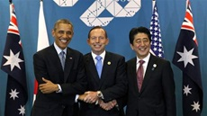

The return of geopolitics is all around us. Civil wars in the Middle East and Russian aggression in Ukraine properly dominate the headlines. But more quietly, a potentially more consequential strategic defeat looms for the United States: the Trans-Pacific Partnership (TPP) may fail. Why should we care that some trade pact we have barely heard of collapses into ignominy? Quite simply: the negotiation’s failure would have devastating consequences for U.S. leadership, for the deepening of key partnerships in strategic regions, for the promotion of market reforms in emerging economies, and for the future of the trade agenda. Consider the following:

**The United States would lose the ability to make the rules in international trade.**The World Trade Organization (WTO) has been unable to update the multilateral rules on trade and investment for the past 20 years. In the meantime, global supply chains have profoundly altered patterns of international production and trade. Deep free trade agreements (FTAs) like TPP seek to provide new rules that match the [realities of 21st century trade](https://ideas.repec.org/p/zbw/wtowps/ersd201108.html" \t "_blank). They focus on the liberalization of services that are critical to the efficient management of dispersed production chains (telecommunications, transportation, etc.), the protection of foreign investments and intellectual property rights, and avoiding predatory market behavior of state-owned enterprises. With the stagnation of the WTO, we have moved to a system of decentralized competition where different clusters of countries seek to define the standards for economic integration. As President Obama has warned, if we don’t write the rules on trade, China will. Moreover, we will have no way to encourage China to move away from its mercantilistic practices.

**The rebalance to Asia will stall.** TPP is the second leg (after a reorientation of military resources) of the policy of rebalancing to Asia. As such, its fate will determine whether this strategy advances or just limps along. If TPP fails, doubts about the staying power of the United States will once again rear their ugly head. The signature U.S. policy to remain vitally connected to the world’s most dynamic economic region will come to naught. Let’s not forget that prior to the advent of TPP, the United States appeared poised to be marginalized from the process of regionalism in Asia.

**The U.S.-Japan alliance will lose a critical pillar.** Trade has in the past been a divisive issue for the two allies. If TPP fails, it will demonstrate that the United States and Japan cannot move past frictions over market access in agriculture and automobiles to work in areas such as internationalization of financial services, protection of intellectual property, and governance of the internet economy that are central to the 21st century economy.

**The international trade agenda will hit a dead end.** If TPP fails, the most significant trade agenda in a generation will come to a grinding halt. At that point, how can the trade agenda move forward? The WTO is not institutionally fit to advance a deep integration agenda. If a group of 12 countries that have self-selected are unable to wrap up an agreement, what other alternatives are there? The collapse of the TPP talks will greatly undermine the chances of success of the transatlantic trade negotiations and the East Asian trade deals are unlikely to generate deep integration commitments.

## The time for a TPP deal is now

The window of opportunity to cinch a TPP deal is closing fast. With the 2016 U.S. presidential election on the horizon, a number of important milestones must be achieved this year in a very tight sequence: adoption of Trade Promotion Authority (TPA) legislation, a breakthrough in U.S.-Japan market access deal, an agreement in principle among all TPP partners, and a vote on the final trade deal.

First and foremost, we need to pass TPA in the Congress. Every week that goes by without movement on TPA reduces the prospect that trade policy could be the one area immune to the dysfunctional political climate in Washington. And, quite simply, without TPA, there is no TPP. It is a commonplace observation that passage of TPA is not required to see a vote on a trade agreement. But this is a technical argument, when we need to understand the essential role of TPA as a political device to give complex trade agreements a chance at successful negotiation and ratification.

At home, TPA reassures Congress of having a meaningful role in setting the trajectory and objectives of U.S. policy. Far from an abdication of authority, TPA allows Congress to retain responsibility for laying out trade policy objectives, remain appraised of the progress in the negotiations, and act as the ultimate arbiter in deciding the fate of a trade deal.

Internationally, TPA reassures negotiating parties that the carefully calibrated package of reciprocal concessions will not unravel at the ratification stage. Granted, TPA is an imperfect credibility mechanism since it has in the past not stopped Congress from demanding renegotiations. But without the modicum of credibility that TPA provides, it will not be possible for the United States to obtain a good deal, either because TPP countries are genuinely concerned about future “asks” or because they have the perfect cover to avoid politically painful concessions on sensitive issues. Either way, the lack of TPA weakens the hands of American trade negotiators.

## If TPP fails, who is to blame?

Passing TPP would be a geopolitical and economic boon for America. These benefits need not and will not come at the expense of workers or the regulatory sovereignty of countries. On the contrary, under deep FTAs, countries retain their right to regulate. Rather, the aim of the agreement is to increase international competitiveness in order to create better quality jobs.

If TPP nonetheless fails, the next question will naturally be who is to blame? Congress should be mindful that by failing to deliver on TPA, it risks becoming the weak link in the U.S.-led endeavor to craft a liberal economic order.

* [](http://www.brookings.edu/blogs/experts/solism)

[Mireya Solís](http://www.brookings.edu/blogs/experts/solism)

Senior Fellow, [Foreign Policy](http://www.brookings.edu/about/programs/foreign-policy), [Center for East Asia Policy Studies](http://www.brookings.edu/about/centers/east-asia-policy-studies)

Philip Knight Chair in Japan Studies

[@solis\_msolis](https://twitter.com/solis_msolis)

Mireya Solís is the Philip Knight Chair in Japan Studies and senior fellow at the Brookings [Center for East Asia Policy Studies](http://www.brookings.edu/about/centers/east-asia-policy-studies" \t "_blank). An expert in Japan’s foreign economic policies, Solís earned a Ph.D. in government and an M.A. in East Asian studies from Harvard University, and a B.A. in international relations from El Colegio de México. Her main research interests include Japanese politics, political economy and foreign policy; international and comparative political economy; international relations; and government-business relations. She also has interests in broader issues in U.S.-Japan relations and East Asian multilateralism.

### [Business Day](http://www.nytimes.com/pages/business/index.html)

# The Trans-Pacific Partnership Trade Deal Explained

By KEVIN GRANVILLEMAY 11, 2015

Photo

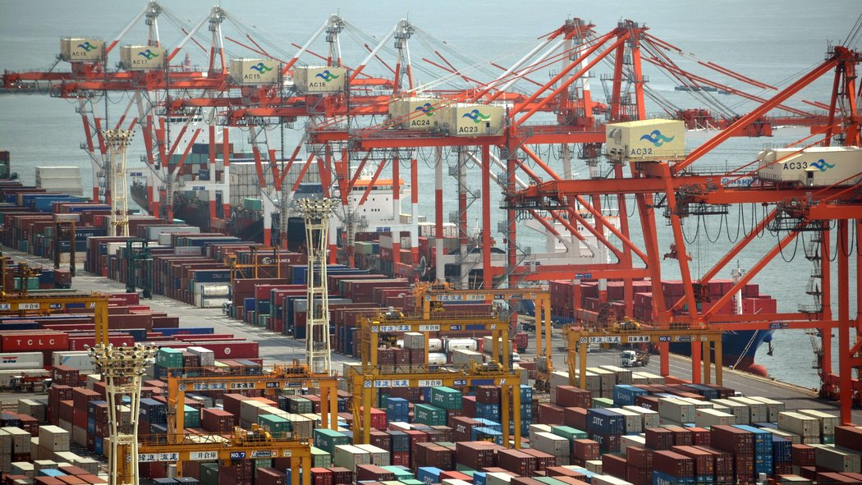

A container wharf in Tokyo. Credit Kazuhiro Nogi/Agence France-Presse — Getty Images

***Updated: July 31***

Like a huge container ship pushing its way into port, the trade pact known as the Trans-Pacific Partnership has dropped anchor in Washington. The document is weighty and secret, stretching to perhaps 30 chapters. It took 10 years of talks to take shape, and it would set new terms for trade and business investment among the United States and 11 other Pacific Rim nations — a far-flung group with an annual [gross domestic product](http://topics.nytimes.com/top/reference/timestopics/subjects/u/united_states_economy/gross_domestic_product/index.html?inline=nyt-classifier) of nearly $28 trillion that represents roughly 40 percent of global G.D.P. and one-third of world trade.

Trade officials are meeting in Hawaii this week to complete the negotiations. They have already overcome a substantial hurdle by reaching an agreement to [protect endangered ecosystems](http://www.nytimes.com/2015/08/01/business/tpp-trade-talks-us-pacific-nations.html).

But [President Obama](http://topics.nytimes.com/top/reference/timestopics/people/o/barack_obama/index.html?inline=nyt-per) would then need to convince Congress — his fellow Democrats, in particular — to approve the trade deal. In June, he successfully overcame opposition from Democrats to win trade promotion authority: the power to negotiate trade deals that cannot be amended or filibustered by Congress.

The debate in Congress would put all the elements of the trade pact under scrutiny. It would be the final step for United States adoption of the Trans-Pacific Partnership, the most ambitious trade deal since the North American Free Trade Agreement in the 1990s.

#### Why the Pact Is So Divisive

Supporters say it would be [a boon for all the nations involved](https://ustr.gov/tpp), that it would “unlock opportunities” and “address vital 21st-century issues within the global economy,” and that it is written in a way to encourage more countries, possibly even China, to sign on. Passage in Congress is one of President Obama’s final goals in office, but he faces stiff opposition from nearly all of his fellow Democrats.

Opponents in the United States see the pact as [mostly a giveaway to business](http://www.citizen.org/TPP), encouraging further export of manufacturing jobs to low-wage nations while limiting competition and encouraging higher prices for pharmaceuticals and other high-value products by spreading American standards for patent protections to other countries. A provision allowing multinational corporations to challenge regulations and court rulings before special tribunals [is drawing intense opposition](http://www.nytimes.com/2015/03/26/business/trans-pacific-partnership-seen-as-door-for-foreign-suits-against-us.html).

#### Why This, Why Now?

The pact is a major component of President Obama’s “pivot” to Asia. It is seen as a way to bind Pacific trading partners closer to the United States while raising a challenge to Asia’s rising power, China, which has pointedly been excluded from the deal, at least for now.

It is seen as a means to address a number of festering issues that have become stumbling blocks as global trade has soared, including e-commerce, financial services and cross-border Internet communications.

There are also traditional trade issues involved. The United States is eager to establish formal trade agreements with five of the nations involved — Japan, Malaysia, Brunei, New Zealand and Vietnam — and strengthen Nafta, its current agreement with Canada and Mexico.

Moreover, as attempts at global trade deals have faltered (such as the World Trade Organization’s Doha round), the Trans-Pacific Partnership is billed as an “open architecture” document written to ease adoption by additional Asian nations, and to provide a potential template to other initiatives underway, like the Transatlantic Trade and Investment Partnership.

#### What Are Some of the Issues on the Table?

**Tariffs and Quotas** Long used to protect domestic industries from cheaper goods from overseas, tariffs on imports were once a standard, robust feature of trade policy, and generated much of the revenue for the United States Treasury in the 19th century. After the Depression and World War II, the United States led a movement toward freer trade.

SEE: <http://www.nytimes.com/2015/05/12/business/unpacking-the-trans-pacific-partnership-trade-deal.html?hpw&rref=business&action=click&pgtype=Homepage&module=well-region&region=bottom-well&WT.nav=bottom-well>

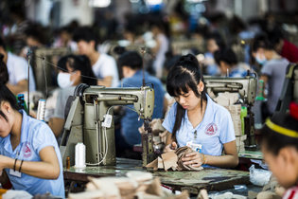

A shoe factory in Vietnam. The United States imposes tariffs on imported shoes. Credit Aaron Joel Santos for The New York Times

Today, the United States and most developed countries have few tariffs, but some remain. The United States, for example, protects the domestic sugar market from lower-priced global suppliers and imposes tariffs on imported shoes, while Japan has steep surcharges on agricultural products including rice, beef and dairy. The pact is an attempt to create a Pacific Rim free-trade zone.

**Environmental, Labor and Intellectual Property Standards** United States negotiators stress that the Pacific agreement would seek to level the playing field by imposing rigorous labor and environmental standards on trading partners, and supervision of intellectual property rights.

**Data Flows** The United States wants the Pacific trade pact to address a number of issues that have arisen since previous agreements were negotiated. One is that countries agree not to block cross-border transfers of data over the Internet, and not require that servers be located in the country in order to conduct business in that country. This proposal has drawn concerns from some countries, Australia among them, that it could conflict with privacy laws and regulations against personal data stored offshore.

**Services** A big aim of the Pacific pact is enhancing opportunities for service industries, which account for most of the private jobs in the American economy. The United States has a competitive advantage in a range of services, including finance, engineering, software, education, legal and information technology. Although services are not subject to tariffs, nationality requirements and restrictions on investing are used by many developing countries to protect local businesses.

**State-Owned Businesses** United States negotiators have discussed the need to address favoritism often granted to state-owned business — those directly or indirectly owned by the government. Although Vietnam and Malaysia have many such corporations, the United States has some too (the Postal Service and Fannie Mae, for example). The final agreement may include terms that seek to insure some competitive neutrality while keeping the door open to China’s future acceptance of the pact.

#### Why All the Secrecy?

The office of the United States Trade Representative [has said that](https://ustr.gov/about-us/policy-offices/press-office/fact-sheets/2012/june/transparency-and-the-tpp) “negotiators need to communicate with each other with a high degree of candor, creativity and mutual trust. To create the conditions necessary to successfully reach agreements in complex trade and investment negotiations, governments routinely keep their proposals and communications with each other confidential.”

But previous trade agreements were shared more openly and, despite the secrecy efforts, portions of the document have been leaking out, through WikiLeaks and other organizations.

#### Why Isn’t China In on the Talks?

China has never expressed interest in joining the negotiations, but in the past has viewed the pact with concern, seeing a potential threat as the United States tries to tighten its relationship with Asian trading partners. But lately, as the talks have accelerated, senior Chinese officials [have sounded more accepting of the potential deal](http://www.nytimes.com/2015/04/29/business/international/once-concerned-china-is-quiet-about-trans-pacific-trade-deal.html), and have even hinted that they might want to participate at some point. At the same time, the deal provides China some cover as it pursues its own trade agreements in the region, such as the Silk Road initiative in Central Asia.

United States officials, while making clear that they see the pact as part of an effort to counter China’s influence in the region, say they are hopeful that the pact’s “open architecture” eventually prompts China to join, along with other important economic powers like South Korea.

#### The Shadow of Nafta, and the Debate in Washington

Photo

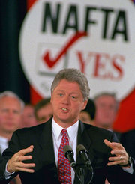

President Bill Clinton won congressional backing for Nafta, but most lawmakers in his own party voted against it. Credit Doug Mills/Associated Press

Nafta, signed by President Bill Clinton in 1993, helped lead to a boom in trade among the United States, Mexico and Canada. All three countries exported more goods and services to the other two, cross-border investments grew, and the United States economy has added millions of jobs since then. But of course not all those trends were attributable to Nafta, and the benefits were not equal: The United States had a small trade surplus with Mexico when the pact was signed, but that quickly became a trade deficit that has widened to more than $50 billion a year. Critics of Nafta also point out that job growth in the United States does not account for the loss of jobs to Mexico or Canada; the A.F.L.-C.I.O. contends about 700,000 United States jobs have been lost or displaced because of Nafta.

Nafta was a [significant victory for President Clinton](http://www.nytimes.com/1993/11/19/us/the-free-trade-accord-how-clinton-won-56-long-days-of-coordinated-persuasion.html) after a difficult congressional battle, where he won support from just enough fellow Democrats to ensure passage. The votes were 234 to 200 in the House, and 61 to 38 in the Senate.

President Obama may yet win that kind of outcome. Working with Republican leadership in the House and Senate, [he gained final approval for trade promotion authority](http://www.nytimes.com/2015/06/25/business/trade-pact-senate-vote-obama.html), a critical step that allows the White House to present the trade package to Congress for a straight up-or-down vote, without amendments.

But the tortuous legislative process [further soured relations](http://www.nytimes.com/2015/06/25/business/obama-bolsters-his-leverage-with-trade-victory-but-at-a-cost.html) with many fellow Democrats, as well as unions and progressive groups, who vehemently oppose the Trans-Pacific Partnership. Many Democrats said the president would have to address their concerns over labor and environmental standards and investor protections when he returns to Congress seeking approval of the trade deal.

### [International Business](http://www.nytimes.com/pages/business/international/index.html)

# Trans-Pacific Partnership’s Potential Impact Weighed in Asia and U.S.

By [KEITH BRADSHER](http://topics.nytimes.com/top/reference/timestopics/people/b/keith_bradsher/index.html)JULY 8, 2015

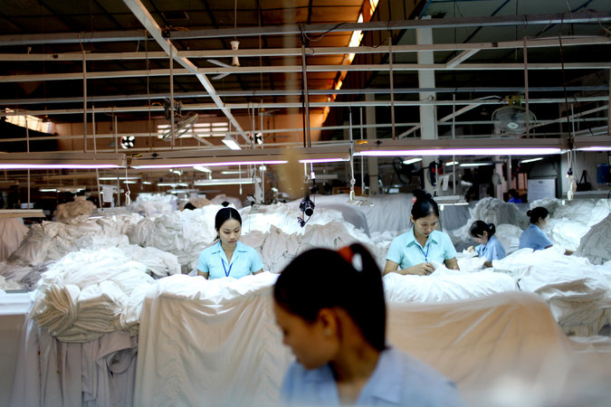

Workers sort through shirts headed for the Kingdom of Saudi Arabia on the assembly line of the Dai Viet Garment factory in Ho Chi Minh City, Vietnam. Credit Justin Mott for The New York Times

HONG KONG — Willie Fung, a leader in the world’s bra industry, knows just what he will do if negotiators from the United States and 11 Pacific Rim nations complete a Trans-Pacific Partnership trade agreement this summer.

He says he will catch a flight to Vietnam to look at possible locations for a new brassiere factory. Mr. Fung’s company, Top Form, has built factories in China, Thailand, Cambodia and Myanmar, countries that are not part of the planned trade deal. That makes him worry that they may become less competitive if Vietnam qualifies for extra-low tariffs and the United States eases access in other ways to its vast market.

As the trade talks move toward conclusion, Mr. Fung said, garment industry tycoons here in Hong Kong “ask ourselves the question, ‘What does it mean to us?’ ”

After a bitter fight, the House and Senate approved legislation last month to allow President Obama and his successor to submit the Pacific pact and a potential agreement with Europe to Congress for an up-or-down vote with no [filibusters](http://topics.nytimes.com/top/reference/timestopics/subjects/f/filibusters_and_debate_curbs/index.html?inline=nyt-classifier) or amendments permitted.

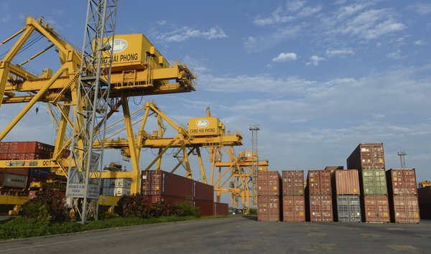

A shipping container yard in the northeastern coastal city of Hai Phong, Vietnam. Credit Agence France-Presse — Getty Images

The draft text of the agreement has not been released, but emerging details suggest that it could have a substantial effect on a variety of industries.

Banks from rich countries like the United States and Japan would have the right to be treated more like local banks in less affluent countries, including Peru, Malaysia and Vietnam. Japan would be required to let in more American farm goods. Makers of pharmaceuticals would have an extra tool to protect their patents abroad, limiting competition from less expensive generic drugs. Auto parts would move more smoothly around the Pacific, with fewer taxes.

The Obama administration has been pushing the trade pact as a way to write new rules not just for the 12 nations involved but also as an umbrella to someday cover many other countries — above all, China.

One set of provisions requires that state-owned enterprises become less secretive and receive fewer government subsidies in the form of low-rate loans, cheap or free land and other assistance. The clause is initially aimed at Vietnam — as well as Malaysia and Singapore to some extent — but it offers a signpost for the direction in which the United States wants China to move.

Some Asian economists, particularly those from China, are skeptical that the Trans-Pacific Partnership will have a profound effect on commerce in the region. He Weiwen, a former Chinese Commerce Ministry official who is now a director of the influential China-United States-[European Union](http://topics.nytimes.com/top/reference/timestopics/organizations/e/european_union/index.html?inline=nyt-org) Study Center at the China Association of International Trade in Beijing, said the potential expansion of trade from a possible China-led pact covering all of East Asia could be up to three times greater.

One shortcoming of the Trans-Pacific Partnership is that it has only one major consumer market, the United States, while the rest of the trading partners are essentially producers with limited demand for imported goods, said Terence Chong, who is the executive director of the Institute of Global Economics and Finance at the Chinese University of Hong Kong and is also a senior economist at Nanjing University in east-central China.

“There are not enough markets for the whole thing to develop — you need China as a market and producer,” he said. “You need more members; now it has only 12, but it may need 20.”

Such criticisms have not dissuaded the Obama administration from pushing ahead. One goal of the pact is to set streamlined rules on technical issues like standardizing the online processing of customs documents, a measure that could not only expedite shipments but also reduce the opportunities for bribing customs officials.

“The real impact, I think, is going to be on trade facilitation,” said Richard Vuylsteke, the president of the American Chamber of Commerce in Hong Kong.

The member countries of the new pact already have a series of bilateral free trade agreements and regional trade agreements that cover large chunks of their trade with each other. The two big exceptions are Japan, which has gone out of its way to protect its farmers, and Vietnam, which is embracing capitalism while remaining tightly controlled politically by its Communist Party.

But perhaps the single biggest driving force is geopolitical.

China has been making increasingly assertive claims of sovereignty over islands and seas close to Japan and Vietnam. That has left both countries willing to open their markets wider to trade with the United States, as a way to move further under the American security umbrella.

Vietnam in particular is trying to draw closer to the United States. Nguyen Phu Trong, the general secretary of Vietnam’s Communist Party and most powerful leader of the country, met with President Obama at the White House on Tuesday in the first such visit by a general secretary from his party.

Photo

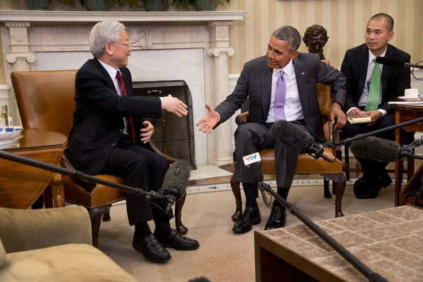

President Obama and Secretary Nguyen Phu Trong of Vietnam after a meeting in the Oval Office. The secretary said he shared Mr. Obama's concerns about maritime disputes in South China Sea. Credit Stephen Crowley/The New York Times

While the Trans-Pacific Partnership has 12 members, the trade agreement “is in large part a Japan story and a Vietnam story,” said Peter Petri, an international trade economist at Brandeis University outside Boston.

American executives are often criticized for being oblivious to foreign markets even as business leaders overseas pay close attention to international trade. But one unlikely outcome of the contentious debate in Washington is that many American executives are now focused on the pact, even as it has attracted far less attention among their Asian counterparts.

John G. Rice, General Electric’s vice chairman for global operations, said that if the Pacific trade deal were not completed and approved, and if the Export-Import Bank were not reauthorized by Congress, the combination of the two events “would serve to move the U.S. to the back seat when it comes to global trade, and in the front seat you’re going to see a number of countries, including China.”

The bra industry offers one specific sign of what some of the shifting trade patterns from a successful Trans-Pacific Partnership might mean.

As it turns out, a move of bra manufacturing from China and some of its Southeast Asian neighbors to Vietnam could have a modestly beneficial effect on textile makers in the United States. That is because the partnership is virtually certain to include a “yarn forward” rule, specialists said. Such a rule, already found in the [North American Free Trade Agreement](http://topics.nytimes.com/top/reference/timestopics/subjects/n/north_american_free_trade_agreement/index.html?inline=nyt-org), says that to qualify for low or zero tariffs while crossing borders within the regional trade pact, garments must be made from fabric woven in a member country, and that fabric must be made from yarn made in a member country.

Vietnam has low-cost labor but virtually no fabric production or yarn production, said Mr. Fung, who is the chairman of the Hong Kong Garment Manufacturers Association. The United States is the only country in the proposed trade zone with a cotton yarn industry or a cotton fabric industry of any size, and one of several countries in the pact with sizable production of synthetic fabric.

Freight costs to bring fabric from the United States to Asia are extremely low, largely because current trade flows across the Pacific lopsidedly consist of goods traveling from China to the United States. To avoid having shipping containers come back to Asia empty, freight companies accept very low rates for exporters in the United States who want to send cargo to Asia.

Foreign companies may eventually set up yarn and fabric factories in Vietnam. But this could take many years. The country has almost no one with the technical skills needed to operate and maintain the computerized equipment for these highly automated industries.

The Asian fabric industry is also dominated by mainland Chinese and Taiwanese companies, and they are worried about potential political risks if they establish operations in Vietnam.

When China set up an oil drilling rig early last year off the coast of central Vietnam, in waters claimed by both countries, industrial parks in Vietnam were [convulsed by rioting](http://www.nytimes.com/2014/05/16/world/asia/anti-chinese-violence-turns-deadly-and-spreads-in-vietnam.html) that led to the burning of hundreds of businesses owned by mainland Chinese and Taiwanese companies alike. That violence has left such companies wary of further investment.

“There’s just an unease from what has happened in the past,” said Bradley Gordon, a lawyer based in Phnom Penh.

Low freight rates and preferential trade terms mean that American fabric is likely to be highly competitive in Vietnam until new factories eventually emerge there, Mr. Fung said. Top Form, which he led for decades before retiring last November, and where he remains an influential director, buys most of its fabric from China, but it also buys some from the United States. And Top Form, like many such companies, has been looking for ways to reduce its dependence on mainland China as wages there have soared.

So garment makers may set up operations in Vietnam for shipments to the United States, while buying substantial quantities of American fabric to supply their factories, Mr. Fung said. And fabric is a big part of the overall cost.

“If I sell a $10 bra to the United States,” Mr. Fung said, “$5.50 of the cost is the fabric.”

## The Trans-Pacific Partnership

### Into the home stretch

# For all its flaws, the biggest trade deal in years is good news for the world

Jul 25th 2015 | PENANG, MALAYSIA | [From the print edition](http://www.economist.com/printedition/2015-07-25)

* [imekeeper](http://www.economist.com/news/finance-and-economics/21659716-all-its-flaws-biggest-trade-deal-years-good-news-world)

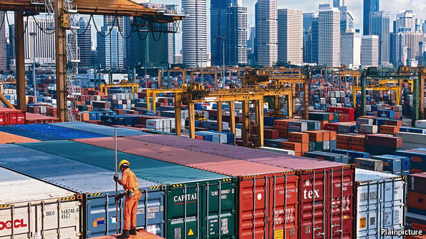

FIVE years of trade negotiations, 29 chapters of dense rules and hundreds of tariff lines culminate, in one corner of Asia, in whirring spools of white fabric. Negotiators are still wrangling over the text that aims to establish a new Pacific trade zone, tying together 12 countries from America to Vietnam. But Penfabric, a textile company in Penang, north-western Malaysia, is not waiting around. In one of its mills, bright yellow flags distinguish rolls of high-end fabric from cheaper cloth. Lately, these flags have started to multiply. “We need to be in tune with what America wants,” says H. S. Teh, Penfabric’s managing director.

The zone, dubbed the Trans-Pacific Partnership (TPP), is the most important free-trade agreement in years. If completed, it will be the largest regional trade deal ever, with its members accounting for nearly 40% of the world economy. The countries leading the negotiations want to set a new standard for what trade agreements cover. They are taking on the morass of regulations, such as local-content rules determining how much of a product must be made from local inputs, that have replaced tariffs as the main obstacle to the free flow of goods across borders. After repeated failures to seal big global deals—the World Trade Organisation (WTO) has turned its focus to specific industries rather than comprehensive agreements (see [article](http://www.economist.com/news/finance-and-economics/21659715-world-trade-organisation-draws-close-its-first-deal-nearly-two" \t "_blank))—the TPP actually has a good chance at success. A meeting of trade ministers in Maui from July 28th to 31st is expected to put the final touches on the deal.

Gauging the exact benefits of the TPP is tricky, not least because the trade talks are still confidential. Critics have bemoaned the lack of disclosure but conducting negotiations in the open would have been a sure way to undermine them. Governments will have several months to review the final deal before deciding whether to give their assent.

Even when the details are known, it will still be hard to assess the impact. The most authoritative study, published by the Peterson Institute for International Economics, reckons the TPP will enlarge the economies of the 12 member states by $285 billion by 2025. But, as with any economic model, reality is more complex. Benefits could be smaller if exemptions on tariffs blunt its impact—Japan, for one, is still trying to protect its “sacred” food, such as rice, wheat and beef, from imports. But through knock-on effects—if, say, Vietnamese industry becomes more efficient—the gains could also be larger.

Trying to pin down the exact value of the deal misses the point, though. First, the TPP is not at its final destination. It is supposed to expand, drawing in more countries. The Philippines, South Korea, Taiwan and Thailand have expressed interest in joining. The hope is that it will eventually also attract China. If the initial 12-country zone is expanded to 17, the benefits could be much bigger (see chart). Second, TPP is not mainly about cutting tariffs (these are already low after years of trade liberalisation) but rather about setting new rules for global commerce.

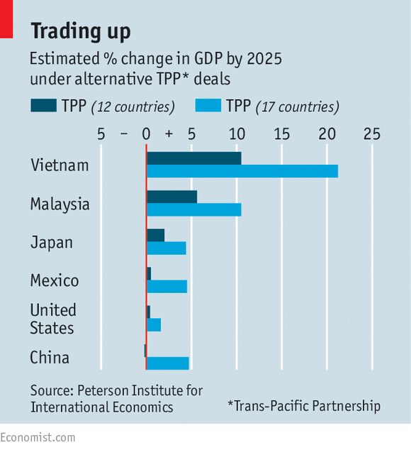

By leaving China out, America has, to a certain extent, rigged the talks in its favour. Much as state-owned companies in Malaysia or Vietnam want to defend their fiefdoms, they do not have the clout to push back as strongly as their peers in China might have done. But if the TPP gets under way and proves successful, China may yet be compelled to join, or at least to agree to pacts with similar standards. “If China doesn’t promote its own ideas for trade, it will be influenced by those of others,” says Zhou Mi, a researcher in a think-tank under China’s commerce ministry.

The rules that America is pushing have faced criticisms, some valid, some not. Particularly controversial has been a demand from big pharmaceutical firms for a 12-year freeze on sharing data on a group of new medicines called “biologics”, which they say is necessary to spur more innovation. Groups such as Médecins Sans Frontières say that this would go too far and hinder the development of the cheaper alternatives needed for poorer countries. People familiar with the negotiations say the data-exclusivity term is likely to be pared back, perhaps to seven years.

Other rules are more welcome. Some economists have noted the TPP’s focus on intellectual property and its mechanism allowing investors to sue states, and concluded that it is more a political agenda than a free-trade agreement. But such provisions are not unique to TPP. And its boldness in tackling the rules gumming up the gears of global trade is laudable. Firms that straddle borders know that local-content rules can be just as distortionary as tariffs. “In South-East Asia, you basically have to build cars in the country in which you want to sell them,” says Matt Hobbs, vice-president of government relations at General Motors International.

[[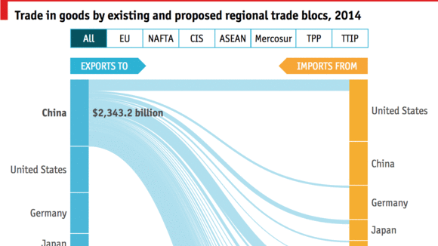](http://www.economist.com/blogs/graphicdetail/2015/06/global-trade-graphics)](http://www.economist.com/blogs/graphicdetail/2015/06/global-trade-graphics)

[Why countries are so keen to agree new trade deals](http://www.economist.com/blogs/graphicdetail/2015/06/global-trade-graphics)

The TPP talks have dragged on since 2010 and there could be drama yet in the final weeks. Some think Canada could quit the group if its dairy farmers are not insulated. Malaysia might be pushed out because of American concerns about human trafficking. In America, Congress could scupper the deal, though goodies for beef farmers, carmakers and drug companies should tip the balance in favour. Japan will also face domestic blowback if it opens its door to agricultural trade. But as a hub of innovation, it has a strong interest in TPP. It has been a crucial ally for America in demanding more rigorous trade rules, says Matthew Goodman of the Centre for Strategic and International Studies.

The China syndrome

Ultimately, for TPP to really make a mark, it has to be bigger. Leaving out China is an expedient to get the deal done but, if kept that way, it would be a huge gap. China is the world’s biggest manufacturer. Any Asian trade zone without it faces one of two sorry fates. Either, because of China’s centrality to Asian supply chains, the deal is so riddled with exemptions that it becomes worthless. Or, if the zone gains traction, the effect is to divert trade away from the most efficient Chinese companies and hurt the global economy.

The TPP is likely to face both problems. In textiles, for instance, Vietnamese and Malaysian mills expect to be allowed to continue to source fabric from countries such as China or India that those inside the trade zone cannot produce. This exemption may be vast. Meanwhile, Vietnamese and Malaysian garment makers admit the exclusion of Chinese finished goods will help shelter them from their toughest competition—hardly the ideal of free trade.

In other areas, though, TPP could make waves of a good kind. Rules to protect labour rights, strengthen environmental safeguards and limit subsidies to state-owned companies should go further than any previous trade deal. Officials in China, who previously viewed TPP as a gambit to isolate it, now drop hints about wanting to join the club. “It won’t be the gold-standard deal they’ve been talking about, and they will be lucky to get a silver. Perhaps it will be a bronze,” says Jayant Menon of the Asian Development Bank. With other ambitious trade talks gathering dust, however, even a bronze would glitter.

[Graphic detail](http://www.economist.com/blogs/graphicdetail)

## Charts, maps and infographics

# Global trade, in graphics

### Why everyone is so keen to agree new trade deals

Jun 24th 2015, 13:40 by The Data Team

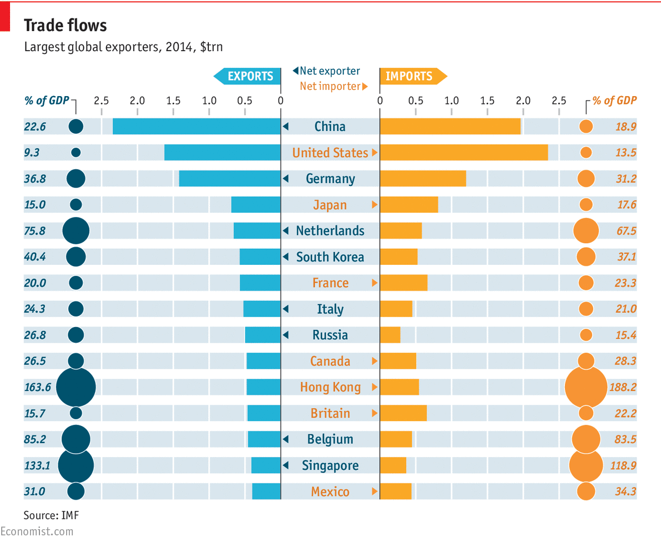

GLOBAL trade talks would be great if only they worked. Multilateral deals mean common standards and lower barriers for all, but the Doha round, launched by the World Trade Organisation in 2001, is dead in all but name, having seemingly drawn to a close after the [negotiation](http://www.economist.com/news/finance-and-economics/21591625-global-trade-talks-yield-deal-first-time-almost-20-years-unaccustomed) of an uninspiring set of reforms in Bali in 2013. Growth in global trade volumes has slowed in recent years, and the cause of liberalisation is increasingly advanced by [regional trade agreements](http://www.economist.com/news/finance-and-economics/21646772-regional-trade-deals-arent-good-global-ones-they-are-still) (RTAs). The number of RTAs has risen from around 70 in 1990 to just under 300 today. The chart at the bottom shows some of the biggest. At the moment, two RTAs (with confusingly similar initials) hog the headlines. The Trans-Pacific Partnership (TPP) would link 11 economies of the Pacific rim—including Japan and Singapore—with America. These 12 countries together account for 40% of world GDP and one-third of trade. Meanwhile, the Transatlantic Trade and Investment Partnership (TTIP) is an ambitious planned trade deal between America and the EU.

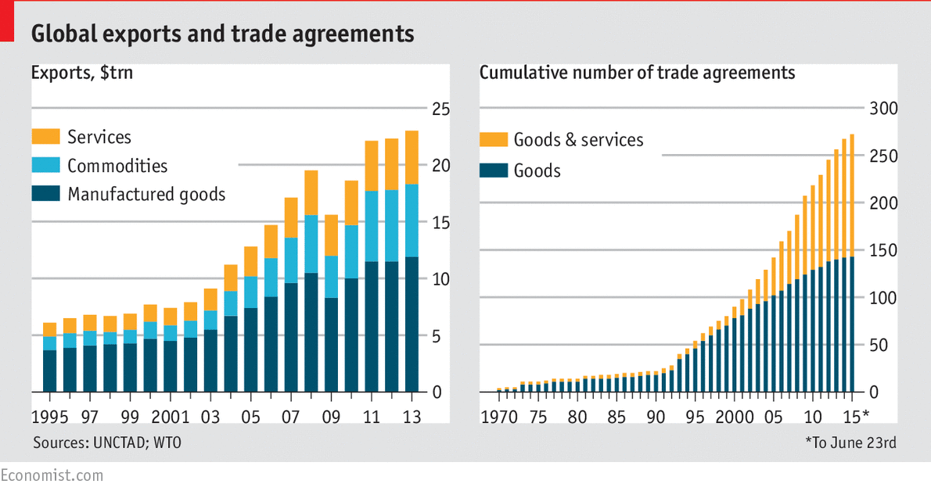

These new deals not only involve fewer countries, but tend to have a different focus to previous trade deals. The focus of TPP, for instance, is less on dismantling tariff barriers and more on tackling tough issues such as intellectual property, labour and environmental standards. This reflects the fact that traditional tariffs are already low after decades of trade liberalisation. What's more, services form a bigger part of global GDP than ever before; making trade easier would boost incomes across the world. American trade negotiators predict that by 2025 the TPP will make the world $220 billion a year richer, adding roughly 1% to GDP. TTIP has a similar focus. This deal focuses on regulatory and other non-tariff barriers, since levies on most products traded across the Atlantic are already close to zero (exceptions include running shoes and fancy chocolate). Negotiators dream of a world in which pharmaceuticals are subject to the same testing regimes, standards on everything from car design to chemical labelling are harmonised or mutually recognised. The potential benefits are hard to estimate, but one reasonable guess is that TTIP could raise America’s GDP by 0.4% and the EU’s by slightly more.

Audio and Video content on Economist.com requires a browser that can handle iFrames.

See trade chart at <http://www.economist.com/blogs/graphicdetail/2015/06/global-trade-graphics>

Nonetheless, opposition is strong. As trade deals wade into complex regulatory waters, it is far harder to [gauge their impact](http://www.economist.com/cge15?zid=295&ah=0bca374e65f2354d553956ea65f756e0). Even some economists who have long been strong proponents of free trade argue that the boost to growth from the new deals will be small. In the case of TPP, Barack Obama, the American president, has [struggled to convince](http://www.economist.com/blogs/economist-explains/2015/05/economist-explains-1) his own party of the benefits. Many Democratic politicians fret that imports from low-cost countries such as Vietnam will hurt American workers in industries such as carmaking and textiles. It looks as though Mr Obama has won his battle; on June 24th the Senate voted to give Mr Obama the authority he needs to finish off the negotiations.

Resistance to TTIP is of a different hue. The deal, cry some, will permit American multinationals to undercut tough European standards, or to buy up parts of Britain’s National Health Service. Opposition is rather strong in Germany, not previously a bastion of anti-trade activists. Germans have focused on Chlorhühnchen (chlorine-soaked chicken), an example of the horrors that TTIP’s opponents say would be forced down European throats if doors were opened to American products. For now, haters of American poultry need not worry. TTIP talks are floundering. It is less of a priority for the Obama administration than the TPP; and Europe has other things to worry about. At times, RTAs seem no easier to negotiate than grand global agreements.

## Free exchange

### A weighting game

# Pacific trade talks expose the limits of economic modelling

May 30th 2015 | [From the print edition](http://www.economist.com/printedition/2015-05-30)

THE Trans-Pacific Partnership (TPP), a putative trade agreement, would ease commerce between America, Japan and ten other countries that between them account for two-fifths of global GDP. But how beneficial would it be to these economies? Advocates claim it would boost their output by nearly $300 billion in a decade. Critics say it would make little or no difference.

The disagreement reflects the difficulty of gauging the impact of free-trade agreements. Almost all economists accept the benefits of free trade as laid out in the early 1800s by David Ricardo. Countries do well when they focus on what they are relatively good at producing. But Ricardo looked at only two countries making two products, at a time when few non-tariff barriers such as safety standards existed. This renders his elegant model about as useful for analysing contemporary free-trade deals as a horse and carriage are for predicting the trajectory of an aircraft.

Instead, most economists use what is known as computable general equilibrium (CGE) analysis. CGE models are built on top of a database that seeks to describe economies in full, factoring in incomes, profits and more. Researchers line things up so that the model yields the same output as a real benchmark year. Once that is achieved, they “shock” the model, adjusting trade barriers to see how outcomes shift, both immediately and over time.

There is much to recommend CGE. It is the only trade model broad enough to encompass services, investment and regulations, all of which lie at heart of the TPP debate. It also generates predictions that policymakers want: which sectors will do well and how incomes will change. But CGE has big drawbacks. First, it is dependent on data, which can be very patchy in some areas. Second, faulty assumptions can quickly lead forecasts astray.

Studies of TPP illustrate these strengths and weaknesses. The [most influential](http://aacs.ccny.cuny.edu/2014conference/Papers/Michael%20Plummer.pdf" \t "_blank), by Peter Petri, Michael Plummer and Fan Zhai, for the East-West Centre, a research institute, forecasts that the deal would raise the GDP of the 12 signatories by $285 billion, or 0.9%, by 2025. It is their numbers that America’s government cites when it says TPP will make the country $77 billion richer. Their model tries to avoid some of the common failings of CGE. Their assumptions are transparent, include a range of scenarios and are often conservative—for example, they expect only slow and partial implementation. That makes the results more credible.

Yet subjective elements of the model have a huge impact. The authors use a new approach to predict that more firms will become exporters as the costs of trade decrease. That may be an improvement over previous theories, which assumed a constant number of exporters, but this one tweak greatly changes results: it makes the benefits some 70% bigger, according to [a study](http://papers.ssrn.com/sol3/Papers.cfm?abstract_id=2550935" \t "_blank) for Canada’s C.D. Howe Institute by Dan Ciuriak and Jingliang Xiao.

Some assumptions are also debatable. The researchers calculate that increased protection of intellectual property (IP) is beneficial for all countries. A [review of studies](http://www.ipekpp.com/admin/upload_files/Report_3_54_Quantifying_7053194685.pdf" \t "_blank) of TPP funded by the British government, by Badri Narayanan, Mr Ciuriak and Harsha Vardhana Singh, questions that. Stronger protection for IP should spur more investment by producers. But it can also raise costs for consumers beyond what is necessary to encourage innovation and slow the spread of technology to developing nations.

That also points to one of the many blind spots in CGE models. Most use figures from [Purdue University’s Global Trade Analysis Project](https://www.gtap.agecon.purdue.edu" \t "_blank), the best database available. But since it was initially developed for agriculture, it is skewed. It has separate categories for raw milk and dairy products, but lumps pharmaceuticals into one overarching category for chemicals—a problem for models since TPP deals extensively with drugmakers’ IP. Given the uncertainty, Messrs Ciuriak and Xiao exclude any impact from enhanced protection of IP. They also use a more conventional model for exports. They calculate that TPP will raise the GDP of the 12 countries by just $74 billion by 2035, a mere 0.21% higher than baseline forecasts. Others see an even smaller impact. In a [paper](http://www.adbi.org/files/2013.07.11.wp428.trans.pacific.partnership.east.asian.regionalism.pdf" \t "_blank) for the Asian Development Bank Institute, Inkyo Cheong forecasts that America’s GDP will be entirely unchanged by TPP.

Why bother?

That raises the question of whether TPP is worth pursuing at all. As complex as the CGE studies are, they are just models, peering into the future through a haze of assumptions. It is thus important to buttress them with studies of completed deals. The Asia-Pacific region is an ideal laboratory because it went from five free-trade agreements in 1990 to more than 200 in 2015. A [new Asia-Pacific Economic Cooperation study](http://publications.apec.org/publication-detail.php?pub_id=1631" \t "_blank) finds that, in the five years after an agreement, participants’ exports increased on average by nearly 50% relative to the five prior years. The researchers then control for factors such as GDP and distance, isolating free-trade deals as a variable. Those with the biggest impact share certain features: they have more members, bring together developed and developing economies, and aim at non-tariff barriers as well as tariffs.

This suggests that the gains to be had from freeing trade, even if diminishing, are far from exhausted. But that does not necessarily make TPP the right way forward. Almost all studies agree that its principal limitation is size: it is not big enough. Specifically, the exclusion of China is costly. The Petri study concludes that a more inclusive Pacific free-trade deal with weaker rules on state-owned firms and intellectual property would lift income gains for the original 12 TPP members, including America, to $760 billion—more than double the boost from TPP. Such precise CGE forecasts ought to be taken with a pinch of salt. But the moral is clear enough. The objective should be to bring more countries into the tent, not to push for overly strict rules.

## Trade deals

### Bargaining chips

# The World Trade Organisation draws close to its first deal for nearly two decades

Jul 25th 2015 | [From the print edition](http://www.economist.com/printedition/2015-07-25)

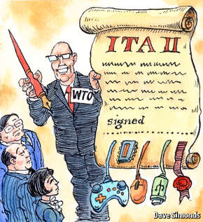

“WHEN you’ve already settled the price of the car, there’s no point quibbling over whether the gas tank is full.” Thus did Roberto Azevedo, director-general of the World Trade Organisation, urge WTO ambassadors this week to conclude the second Information Technology Agreement (ITA-II). They duly agreed to eliminate import tariffs on 201 new electronics products, such as high-end semiconductors, medical equipment and game consoles.

The 54 countries involved cover 90% of the trade in such goods, which in turn amounts to 10% of all world trade. The deal extends the product list of the original ITA, in 1996, which included floppy disks and tape recorders, to include modern technologies such as the flash drives for smartphones. A final agreement was expected on July 24th.

ITA-II is the first big WTO trade deal since the original ITA and has been haggled over for three years. The slowness of progress was largely due to China, Japan, Taiwan and South Korea fighting over the inclusion of goods produced by infant industries they had been protecting from international competition. India stayed away from the talks altogether, citing the impact that the first ITA had on its fledgling electronics sector. China left early on, worried that South Korean flat-screen TVs and Japanese car radios would outcompete its domestic firms.

The final push for ITA-II came last November, when China agreed its own bilateral extension of the ITA with America, spurring the rest of the WTO to finish its deal. China, which has rejoined the deal, has been building up its domestic computer-chip industry for at least 15 years. In 2013 it imported more than $230 billion-worth of materials for its semiconductor industry—more than it spent on oil.

The deal is likely to save $13.8 billion a year in tariff payments on the $1.3 trillion global trade in electronic goods, says the WTO. Removing tariffs will open up new markets, particularly China, which has the highest levies on such goods. Tariffs on semiconductors, used in electronic circuits, are as high as 25% in some countries. Although the precise effects of the deal have not yet been studied, it will increase trade in electronics between East Asia, Europe and North America. All three regions both import and export large amounts of electronics—the EU exports €82 billion ($90 billion) and imports €68 billion.

Few African or South American countries participated in the negotiations, but the WTO believes that all will benefit. More trade should be good news for a global electronics supply chain that buys materials and labour from around the world. As tariffs fall on inputs like semiconductors, the rest of the developing world ought to enjoy cheaper finished electronic goods, which could very well speed innovation at home. High-tech industries played a big part in the South Korean and Taiwanese development miracles. These took place behind tariff barriers, however. Whether those developing countries that adopt ITA-II can advance without such shelter is unclear.

NYT

### [Business Day](http://www.nytimes.com/pages/business/index.html)

# Trans-Pacific Partnership Trade Deal Is Reached

By [JACKIE CALMES](http://topics.nytimes.com/top/reference/timestopics/people/c/jackie_calmes/index.html)

OCT. 5, 2015

Photo

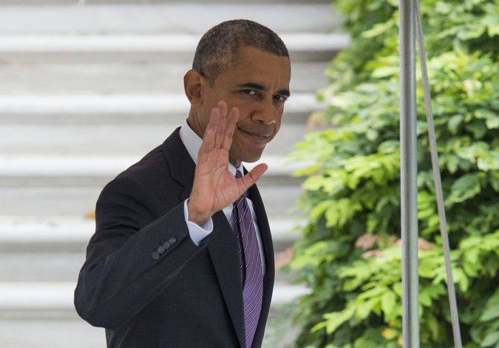

President Obama spent recent days contacting world leaders to seal the trade deal. Credit Molly Riley/Agence France-Presse — Getty Images

ATLANTA — The United States and 11 other Pacific Rim nations on Monday agreed to the largest regional trade accord in history, a potentially precedent-setting model for global commerce and worker standards that would tie together 40 percent of the world’s economy, from Canada and Chile to Japan and Australia.

The Trans-Pacific Partnership still faces months of debate in Congress and will inject a new flash point into both parties’ presidential contests.

But the accord — a product of nearly eight years of negotiations, including five days of round-the-clock sessions here — is a potentially legacy-making achievement for President Obama, and the capstone for his foreign policy “pivot” toward closer relations with fast-growing eastern Asia, after years of American preoccupation with the Middle East and North Africa.

Mr. Obama spent recent days contacting world leaders to seal the deal. Administration officials have repeatedly pressed their contention that the partnership would build a bulwark against China’s economic influence, and allow the United States and its allies — not Beijing — to set the standards for Pacific commerce.

The Pacific accord would phase out thousands of import tariffs as well as other barriers to international trade. It also would establish uniform rules on corporations’ intellectual property, open the Internet even in communist Vietnam and crack down on wildlife trafficking and environmental abuses.

Several potentially deal-breaking disputes kept the ministers talking through the weekend and forced them repeatedly to reschedule the promised Sunday announcement of the deal into the evening and beyond. Final compromises covered commercial protections for drug makers’ advanced medicines, more open markets for dairy products and sugar, and a slow phaseout — over two to three decades — of the tariffs on Japan’s autos sold in North America.

Yet the trade agreement almost certainly will encounter stiff opposition.

Its full 30-chapter text will not be available for perhaps a month, but labor unions, environmentalists and liberal activists are poised to argue that the agreement favors big business over workers and environmental protection. Donald Trump has repeatedly castigated the Pacific trade accord as “a bad deal,” injecting conservative populism into the debate and emboldening some congressional Republicans who fear for local interests like sugar and rice, and many conservatives who oppose Mr. Obama at every turn.

## Trans-Pacific Partnership Countries



Canada

$658

United States

Japan

$201

Mexico

Vietnam $36

$534

Brunei $0.6

Malaysia $44

Singapore

$47

Peru

$16

Australia

$37

Chile

$26

Total goods traded with the United States in 2014

New Zealand

$8

Imports plus exports, not including services, in billions of dollars

## Related Coverage

[[](http://www.nytimes.com/2015/10/05/business/us-and-11-nations-close-to-accord-on-trade-pact.html)](http://www.nytimes.com/2015/10/05/business/us-and-11-nations-close-to-accord-on-trade-pact.html)

## [As Pacific Trade Negotiators Haggle, U.S. Officials Remain HopefulOCT. 4, 2015](http://www.nytimes.com/2015/10/05/business/us-and-11-nations-close-to-accord-on-trade-pact.html)

Long before an accord was reached, it was being condemned by both Mr. Trump, the Republican presidential front-runner, and Senator Bernie Sanders of Vermont, who is challenging Hillary Rodham Clinton for the Democrats’ nomination. Other candidates also have been critical. Mrs. Clinton, who as secretary of state promoted the trade talks, has expressed enough wariness as she has campaigned among unions and other audiences on the left that her support is now in doubt.

Still, in Congress the outcome for ratifying the agreement “will be affected by what’s in it, and that’s the way it should be,” said Representative Sander Levin of Michigan, in an interview here before the deal came together. He was the one lawmaker to come to Atlanta to monitor final talks.

Mr. Levin, the ranking Democrat on the House Ways and Means Committee, which has jurisdiction for trade, has supported some trade pacts but was skeptical of this one. He is concerned about unfair competition from Japan for his state’s automakers and union workers. In particular, Mr. Levin objected that language addressing Japan’s devaluation of its currency, which reduces the cost of its auto exports, would not be in the trade agreement but rather in a side agreement that would be hard to enforce against currency scofflaws.

The Office of the United States Trade Representative said the partnership eventually would end more than 18,000 tariffs that the participating countries have placed on United States exports, including autos, machinery, information technology and consumer goods, chemicals and agricultural products ranging from avocados in California to wheat, pork and beef from the Plains states.

Japan’s other barriers, like regulations and design criteria that effectively keep out American-made cars and light trucks, would come down.

While many opponents object that the trade pact will kill jobs or send them overseas, the administration contends that the United States has more to gain from freer trade with the Pacific nations. Eighty percent of those nations’ exports to the United States are already duty-free, officials say, while American products face assorted barriers in those countries that would end.

Also, the administration contends that increased United States sales abroad would create jobs in export industries, which generally pay more than jobs in domestic-only businesses.

The parties to the accord also include New Zealand, Mexico, Peru, Malaysia, Singapore and Brunei.

The accord for the first time would require state-owned businesses like those in Vietnam and Malaysia to comply with commercial trade rules and labor and environmental standards. Michael B. Froman, the United States trade representative, called the labor and environmental rules the strongest ever in a trade agreement and a model for future pacts, although some environmental groups and most unions remained implacably opposed. The worker standards commit all parties to the International Labor Organization’s principles for collective bargaining, a minimum wage and safe workplaces, and against [child labor](http://topics.nytimes.com/top/reference/timestopics/subjects/c/child_labor/index.html?inline=nyt-classifier), forced labor and excessive hours.

Unions and human rights groups have been skeptical at best that Vietnam, Malaysia and Brunei will improve labor conditions, or that Malaysia will stop human trafficking of poor workers from Myanmar and Southeast Asia. The United States reached separate agreements with the three nations on enforcing labor standards, which would allow American tariffs to be restored if a nation is found in violation after a dispute-settlement process.

On the environment, the accord has provisions against wildlife trafficking, illegal or unsustainable logging and fishing, and protections for a range of marine species and animals including elephants and rhinoceroses.

For the first time in a trade agreement there are provisions to help small businesses without the resources of big corporations to deal with trade barriers and red tape. A committee would be created to assist smaller companies.

The agreement also would overhaul special tribunals that handle trade disputes between businesses and participating nations. The changes, which also are expected to set a precedent for future trade pacts, respond to widespread criticisms that the Investor-State Dispute Settlement panels favor businesses and interfere with nations’ efforts to pass rules safeguarding public health and safety.

Among new provisions, a code of conduct would govern lawyers selected for arbitration panels. And tobacco companies would be excluded, to end the practice of using the panels to sue countries that pass antismoking laws. On Sunday, Matthew Myers, president of the Campaign for Tobacco-Free Kids, hailed the provision as “historic.”

In a concession likely to be problematic with leading Republicans, the United States agreed that brand-name pharmaceutical companies would have a period shorter than the current 12 years to keep secret their data on producing so-called biologics, which are advanced medicines made from living organisms. Senator Orrin G. Hatch of Utah, chairman of the Senate Finance Committee, which has jurisdiction over trade, has threatened to withdraw his support for the accord if United States negotiators agree to loosening pharmaceutical industry protections against American law.

But arrayed against the United States, which said the protection was a necessary incentive for drug makers to innovate, were virtually every other country at the table, led by Australia. The generic drug industry and nonprofit health groups also strenuously opposed the United States’ position, pressing for access to the data within five years to speed lower priced “biosimilars” to market. The compromise is a hybrid that protects companies’ data for five years to eight years.

Only once that intellectual property issue was settled did several nations, including Canada, New Zealand and the United States, turn to the arcane details of further opening their dairy markets.

Months of final drafting, analyses and debate lie ahead. Mr. Obama cannot sign the accord until Congress has its 90 days to review the pact’s details.

The difficulty the president confronts was foreshadowed earlier this year by his narrow victory in winning “fast track” trade promotion authority from Congress. That authority guarantees that trade pacts will get expedited consideration in Congress — a yes-or-no vote without amendments or [filibusters](http://topics.nytimes.com/top/reference/timestopics/subjects/f/filibusters_and_debate_curbs/index.html?inline=nyt-classifier).

Passage of fast-track power eased Mr. Obama’s ability to conclude the Pacific accord as well as to continue negotiating a separate, more difficult trade pact with Europe. Other nations might balk at making a trade deal with the United States, the argument goes, if the terms could be effectively rewritten in Congress.

# Environmentalists Praise Wildlife Measures in Trans-Pacific Trade Pact

By [RON NIXON](http://topics.nytimes.com/top/reference/timestopics/people/n/ron_nixon/index.html) and CORAL DAVENPORTOCT. 5, 2015

Photo

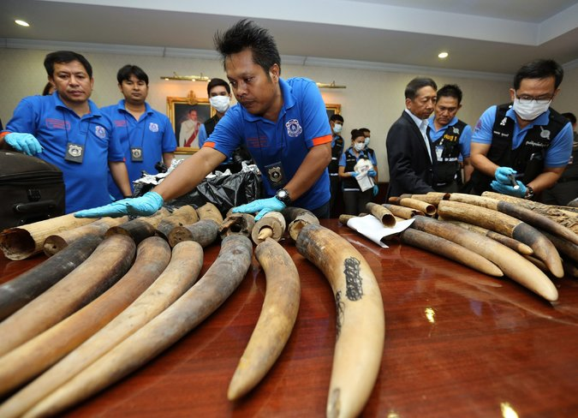

Confiscated elephant tusks in Thailand. Environmentalists said the trade pact could help  diminish the illegal trade in certain plants and animals. Credit Narong Sangnak/European Pressphoto Agency

WASHINGTON — Environmentalists praised wildlife protections included in the sweeping Trans-Pacific Partnership trade deal announced Monday, calling them groundbreaking.

They said the pact would strengthen international environmental enforcement agreements and could go a long way to diminish the illegal trade in certain plants and animals.

Those measures represent a major breakthrough on one of the most divisive issues in the contentious trade negotiations, as well as a significant victory for the Obama administration, which had pushed for strong environmental provisions against the objections of most other countries taking part in the 12-nation deal.

“The provisions in the Trans-Pacific Partnership go beyond what we have seen in other trade agreements,” said David McCauley, senior vice president for policy and government affairs at the World Wildlife Federation, which was among several advocacy groups that had worked closely with the administration on the final language. “We see this as a very big deal.”

Environmentalists had criticized the Obama administration after a [draft of the environmental chapter](http://www.nytimes.com/2014/01/15/us/politics/administration-is-seen-as-retreating-on-environment-in-talks-on-pacific-trade.html) of the trade agreement, made public in January 2014, appeared to signal that the United States was retreating on a variety of environmental measures in order to advance a trade deal that has been a top priority for President Obama.

In particular, the draft showed that Michael Froman, the United States trade representative, had pushed for but failed to achieve a requirement that the pact’s signers abide by existing environmental treaties, which have few enforcement provisions.

But the final deal includes that requirement along with new methods of enforcement. It also places new limits on wildlife trafficking and subsidies for illegal fishing.

The United States and several of the Asian countries participating in the trade deal are sources and crucial markets for illegal animal parts like African rhinoceros horns, ivory and tiger bones. In Asia, some exotic animal parts end up as meals or in medicine shops, where they are sold as cures for various ailments including impotence. In Western countries, some smuggled items, like lion heads, end up in living rooms as trophies.

Worldwide, the illegal trade is estimated at about $20 billion a year by Interpol, the international police agency.

The agreement complements the [Convention on International Trade in Endangered Species of Wild Fauna and Flora](https://www.cites.org/), also known as Cites. The Cites agreement provides a list of animals and plants for which international trade is banned or restricted, and it is the world’s primary treaty to protect wildlife, with roughly 175 countries as members.

Under provisions in the Trans-Pacific Partnership, countries would be required to enforce laws and regulations to protect wildlife covered under the Cites agreement from illegal smuggling, or risk economic sanctions.

The agreement goes further by requiring countries to take action to protect any wildlife, even if it is not covered under Cites, if the wildlife has been illegally taken from any country.

United States law enforcement officials say that smugglers have often considered themselves safe from prosecution after their goods left the countries of origin, because the destination countries typically did not pursue investigations.

By contrast, the wildlife provisions of the trade agreement require cooperation among law enforcement agencies across international borders and require that the agencies share information to help investigate international criminal gangs involved in wildlife trafficking.

The trade agreement also includes what some environmental groups and trade officials call historic measures to protect against overfishing, which causes losses estimated at $10 billion to $23 billion a year because of depleted stocks.

Under the agreement, countries would agree to prohibit some subsidies that they provide to their fishing fleets. United States trade officials said the measure was a major concession for several countries that have large fishing industries.

Environmental advocacy groups, while praising the wildlife language in the Trans-Pacific Partnership, said that the impact would be only as good as participants’ willingness to enforce it.

“There has to be vigilance in monitoring the agreements and making sure that countries live up to their end of the bargain,” said Glenn Prickett, chief external affairs officer for the Nature Conservancy.

WP

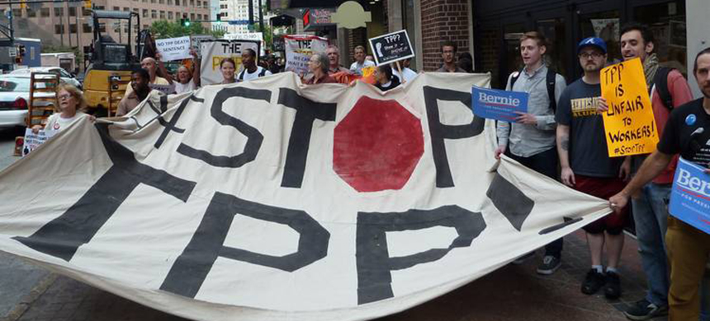  
Protesters in Atlanta on Thursday called for the Trans-Pacific Partnership to be rejected. (photo: Paul Handley/AFP/Getty Images)

[o to original article](http://www.washingtonpost.com/business/economy/deal-reached-on-pacific-rim-trade-pact/2015/10/05/7c567f00-6b56-11e5-b31c-d80d62b53e28_story.html)

# TPP Finalized

By David Nakamura, Washington Post

05 October 15

http://readersupportednews.org/images/stories/alphabet/rsn-T.jpghe United States, Japan and 10 other Pacific Rim nations reached agreement Monday on the largest free-trade accord in a generation, an ambitious effort led by the Obama administration to knit together economies across a vast region.

The deal capped more than five years of arduous negotiations on a project central to President Obama’s economic agenda and potentially hand him a [legacy-defining victory](http://www.washingtonpost.com/politics/us-11-nations-go-down-to-the-wire-on-historic-pacific-rim-trade-accord/2015/10/04/37de3462-69c1-11e5-9223-70cb36460919_story.html" \t "_blank) late in his presidency.

U.S. Trade Representative Michael B. Froman described the pact as “historic agreement” that addresses economic and international trade “challenges faced in the 21st century.”

The deal “helps define the rules of the road for the Asian-Pacific region” for decades ahead, he told journalists.

Negotiators spent a feverish week of talks to find consensus on terms for the Trans-Pacific Partnership (TPP). On Sunday, plans to publicly announce a deal were delayed several times as the parties wrangled over the technical details related to market access for dairy products and new-generation biologic medicines.

“We achieved something that some people thought was unachievable,” said Canada’s envoy in the talks, Trade Minister Ed Fast.

Those are just two sections of a sprawling, multiple-chapter pact that addresses tariff reductions for agriculture and automobiles as well as intellectual-property rights for pharmaceutical drugs and movies, the free flow of information on the Internet, wildlife conservation, online commerce and dispute settlements for multinational corporations.

During the crunch-time talks, the sense of urgency was elevated by political elections in Canada this month and the United States next year. Opponents of the deal have staged demonstrations inside and outside a Westin hotel in Atlanta, where the negotiators are meeting.

The Obama administration has cast the accord as a historic effort to establish new rules of international commerce among a dozen nations at a time when evolving technologies are disrupting old industries and creating new ones. The 12 TPP nations — the others are Australia, Brunei, Chile, Malaysia, Mexico, New Zealand, Peru, Singapore and Vietnam — account for a combined 40 percent of the world’s gross domestic product.

Obama, who announced in 2011 that his administration would take a leading role in the negotiations, stands to realize a major victory with just over a year left in office. Initially skeptical of large trade deals when he entered the White House, Obama came to [embrace the Pacific Rim pact](http://www.washingtonpost.com/politics/obamas-evolution-on-trade-will-put-him-at-war-with-his-party/2015/04/15/dabd42f4-ccc8-11e4-a2a7-9517a3a70506_story.html" \t "_blank) as a way to bolster his strategy of rebalancing U.S. foreign policy toward Asia and maintaining an economic edge in the face of China’s growing clout.

“We can promote growth through trade that meets a higher standard,” Obama said in a speech at the United Nations in New York last week. “And that’s what we’re doing through the Trans-Pacific Partnership — a trade agreement that encompasses nearly 40 percent of the global economy, an agreement that will open markets while protecting the rights of workers and protecting the environment that enables development to be sustained.”

The president personally intervened in the final days of talks, having phone conversations with several leaders, including Australian Prime Minister Malcolm Turnbull. The final sticking points in Atlanta centered on the length of market protections for an emerging class of pharmaceuticals, tariffs for dairy products and rules governing how to classify where automobiles are manufactured.

Even if the deal is completed, Obama’s work is not yet done, however. Though he won new “fast-track” trade powers from Congress in the spring to help smooth negotiations, the president still must get the final pact ratified by a vote in Congress, which probably will take place early next year.

Lawmakers will not be allowed to amend or filibuster the TPP deal, but the vote will come during the presidential primary nominating contests. Candidates from both parties have lambasted U.S. trade policies as contributing to a reordering of the American economy that has led to a growing income gap.

Opponents of the deal, including labor unions, environmental groups and liberal Democrats, have pledged to mount a final campaign to block the accord on Capitol Hill. They have criticized the TPP as a regulatory framework aimed at protecting the interests of large multinational corporations while doing little to protect worker rights and the environment. U.S. officials have said that there are chapters in the agreement with enforceable provisions to do just that.

On Sunday morning, a handful of protesters unfurled a large banner reading “#StopTPP!” They chanted “TPP is corporate greed. Affordable medicine is what we need” before being removed from the lobby of the Westin hotel.

The Obama administration “is pursuing policies under extreme secrecy,” said Ilana Solomon, director of responsible trade for the Sierra Club, which has concerns about the environmental provisions in the deal. “The entire TPP has been negotiated behind closed doors. .?.?. The lack of dialogue is abysmal.”

The TPP represents the largest U.S. trade pact since the North American Free Trade Agreement with Canada and Mexico in 1993. The accord has its roots in the mid-2000s, when Brunei, Chile, New Zealand and Singapore began discussing a tiny regional trade pact.

The United States first declared an interest in joining the talks in the final year of the George W. Bush administration, and the negotiations grew to encompass eight nations. But Obama put a halt on U.S. efforts after taking office in 2009, amid a global recession.

A year later, Obama notified Congress of his administration’s intent to reenter the talks, and the White House’s support helped draw in additional countries, including Japan, the world’s third-largest economy, whose entry in 2013 helped boost the global scale of the pact.

In all, the 12 nations held more than three dozen negotiating sessions over the past five years.

Obama’s decision to make a concerted push to close the deal this year put the White House in a rare partnership with Republican leaders to push the fast-track powers through Congress in the spring. That effort angered much of his liberal base, but the legislation was approved in June after fierce political wrangling, passing with broad GOP support and a fraction of Democrats.

Under the terms of the fast-track legislation, Obama must wait 90 days after the TPP agreement is completed before he signs it and sends it to Congress for a vote, and the text of the accord must be made public for at least 60 of those days.

# What Changes Lie Ahead From the Trans-Pacific Partnership Pact

By [KEITH BRADSHER](http://topics.nytimes.com/top/reference/timestopics/people/b/keith_bradsher/index.html) and [ANDREW POLLACK](http://topics.nytimes.com/top/reference/timestopics/people/p/andrew_pollack/index.html)OCT. 5, 2015

Photo



A cow at a dairy farm in Upton, Quebec. Credit Mathieu Belanger/Reuters

Dairy farmers in Pennsylvania. Auto-parts workers in the Midwest. Pharmaceutical companies concentrated around New Jersey. These pivotal groups, not to mention consumers across the country, are among those that can expect a wide range of changes in the years ahead from the [newly concluded Trans-Pacific Partnership](http://www.nytimes.com/2015/10/06/business/trans-pacific-partnership-trade-deal-is-reached.html?_r=0) trade deal.

By lowering trade barriers among the United States and 11 nations scattered around the Pacific Rim from Japan to Chile, the pact is intended to help countries specialize in producing and exporting whatever goods and services they can make most efficiently, while importing the rest. In the long run, that could help decrease some of the prices consumers see in stores.

But the details of the agreement are a complex hodgepodge of [new rules](http://www.nytimes.com/2015/10/06/business/international/the-trans-pacific-partnership-trade-deal-explained.html), some of them intended to protect the way business is conducted by a number of powerful industries, while others will open the door to new markets. For American dairy farmers, the agreement means new opportunities to start selling milk to Canada, a nearly closed market now. For cattle ranchers in the Midwest, the pact means a gradual reduction over the next 15 years in steep Japanese tariffs on beef imports that have protected Japan’s famous producers of tender but costly Wagyu beef.

Photo

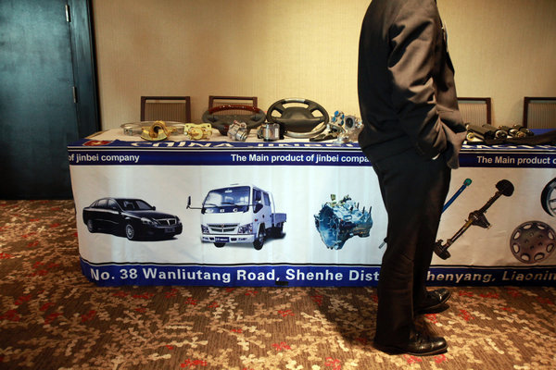

A Chinese auto parts maker's table at a networking event in Michigan in 2012. Credit Fabrizio Costantini for The New York Times

In some cases, notably pharmaceuticals, the agreement seems to have not entirely pleased either the drug industry nor its many critics in the United States and around the world.

One of the final sticking points to getting a deal was agreeing on a standard for protecting drug-company patents. In the end, negotiators agreed to a five-year minimum period in each country of market exclusivity, plus further years for regulatory approvals, for drugs made using biotechnology before they face competition from cheaper imitations known as biosimilars.

The pharmaceutical and biotechnology industries had pushed for 12 years, the same period granted in the 2010 Affordable Care Act. The 12-year standard will remain in effect for the American market, but the pharmaceutical industry wanted that for all the countries in the pact.

“We are disappointed that the ministers failed to secure 12 years of data protection for biologic medicines, which represent the next wave of innovation in our industry,” John Castellani, president of the Pharmaceutical Research and Manufacturers of America, said in a statement Monday. “This term was not a random number, but the result of a long debate in Congress, which determined that this period of time captured the appropriate balance that stimulated research but gave access to biosimilars in a timely manner.”

Critics of the pharmaceutical industry, while welcoming the shortening of the exclusivity period, said that the trade agreement as a whole would still impede access to affordable medicines, particularly for the less-developed countries in the pact.

“They’ve been able to eliminate a number of harmful rules from the agreement, and that will save many lives,” said Peter Maybarduk, director of the access-to-medicines program at the public-interest group Public Citizen. “The agreement could have been much worse.”

Still, Mr. Maybarduk said the agreement as a whole imposed new patent and market exclusivity rules on countries that now do not have them.

“For us, any T.P.P. is making things worse,” he said. “The industry will have many more tools with which to defend its monopoly business model.”

For steel makers, auto-parts manufacturers, garment companies and solar panel producers, as well as their hundreds of thousands of workers, the question is whether the gradual reduction of import tariffs and other trade barriers will unintentionally provide a back door for more Chinese goods to enter the United States.

The agreement has elaborate “rules of origin” that determine which goods will qualify for duty-free treatment. In the auto industry, for example, 45 percent of the value of each car or light truck will need to be produced in a Trans-Pacific Partnership member country for the vehicle to be charged little or no duty by customs officials. By comparison, the North American Free Trade Agreement used a different methodology that effectively required 53 percent to 55 percent of the components by net cost to be produced in North America. So the new agreement has the effect of allowing slightly more components to come from outside the trade region, most likely from China.

The [Trans-Pacific Partnership](http://www.nytimes.com/2015/10/06/business/trans-pacific-partnership-trade-deal-is-reached.html?_r=0) provisions have prompted labor leaders and companies that are vulnerable to import competition to warn that the other half of the components might be coming from China. “It’s complete devastation of the auto supply chain,” Leo Gerard, the international president of the United Steelworkers, said in a telephone interview. “If you look at the autos these days, they’re assembled from parts from all over the place.”

The Obama administration contends that the system will be tightly enforced to make sure that the minimum content standards will be met. “Importers will be able to claim preferential tariff treatment as long as they have the documentation to support their claim,” the Office of the United States Trade Representative said in a statement.

Administration trade officials also pointed out that the United States’ separate free-trade pact with South Korea, a country not in the Trans-Pacific Partnership, set a minimum requirement of only 35 percent.

Chinese auto parts are already pouring into the United States in large volumes anyway, as Detroit automakers increasingly use them in their factories.

Photo

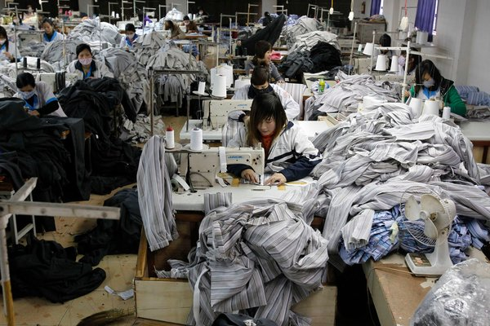

Factory workers sewing for the Viet Huy garment company in Hanoi, Vietnam. Credit Kham/Reuters

Much depends on the precise legal language and formulas used to calculate the rules of origin for each product, and the fine print of the pact will not be released for a month. “The details will be critical,” said Tim Brightbill, a trade-law partner at the Wiley Rein law firm in Washington who represents American steel and solar panel manufacturers.

Food safety is another issue. Critics contend that it will become easier for contaminated seafood to enter the United States with less inspection from big seafood exporters like Vietnam. Lori Wallach, the director of Public Citizen’s Global Trade Watch, said that while the precise details of the pact had not yet been released, it raised the potential for outbreaks of disease that could hurt public confidence in all seafood, including products of the American fisheries industry.

The Obama administration has repeatedly denied that the pact will affect [food safety](http://topics.nytimes.com/top/reference/timestopics/subjects/f/food_safety/index.html?inline=nyt-classifier). Gavin Gibbons, a spokesman for the National Fisheries Institute, an industry trade group, said that the pact would not undermine the reliability of import inspections.

From the start, the pact has been as much about geopolitics as about commerce. The Obama administration has promoted it as a way to strengthen trade relationships with American allies as tensions have increased with China. At the same time, American trade officials have also suggested that it could be a model for an eventual free-trade pact with China itself.

China bristled at the Trans-Pacific Partnership when the Obama administration began pushing for the plan three years ago. President Xi Jinping of China asked President Obama in 2012 to keep him informed about the details. But initial Chinese worries about commercial encirclement have been replaced in Beijing by considerable curiosity about whether the pact can serve as a model for China’s planned trade deals with its neighbors.

China has emerged as the largest foreign investor in many Asian countries as well as the biggest exporter to them, and that has given China a stake in greater openness.

“I don’t think China is that much concerned about the T.P.P.,” said He Weiwen, a former Chinese commerce ministry official who is now the co-director of the influential China-U.S./E.U. Study Center at the China Association of International Trade in Beijing. “China will learn more and apply whatever is appropriate.”

The conclusion of the Trans-Pacific Partnership negotiations may also leave American negotiators with more time to focus on another Chinese priority, a bilateral investment treaty, Mr. He added. The planned agreement would provide greater legal protections for China’s fast-growing investments in the United States as well as more protections for American investments in China.

NYT

# The Trans-Pacific Partnership Trade Accord Explained

By KEVIN GRANVILLEOCT. 5, 2015

Photo

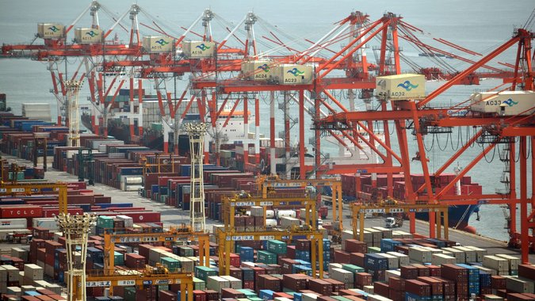

A container wharf in Tokyo. Credit Kazuhiro Nogi/Agence France-Presse — Getty Images

The largest regional trade accord in history, the Trans-Pacific Partnership would set new terms for trade and business investment among the United States and 11 other Pacific Rim nations — a far-flung group with an annual [gross domestic product](http://topics.nytimes.com/top/reference/timestopics/subjects/u/united_states_economy/gross_domestic_product/index.html?inline=nyt-classifier) of nearly $28 trillion that represents roughly 40 percent of global G.D.P. and one-third of world trade.

[The agreement reached by trade ministers on Monday](http://www.nytimes.com/2015/10/06/business/trans-pacific-partnership-trade-deal-is-reached.html) in Atlanta, the result of five days of round-the-clock talks, came after a dispiriting failure to reach consensus in Hawaii in late July.

The product of 10 years of negotiations, the agreement is a hallmark victory for [President Obama](http://topics.nytimes.com/top/reference/timestopics/people/o/barack_obama/index.html?inline=nyt-per) who has pushed for a foreign-policy “pivot” to the Pacific rim. But the Trans-Pacific Partnership now takes center stage on Capitol Hill, where it remains politically divisive.

In June, [Mr. Obama successfully overcame opposition from Democrats to win trade promotion authority](http://www.nytimes.com/2015/06/25/business/obama-bolsters-his-leverage-with-trade-victory-but-at-a-cost.html): the power to negotiate trade deals that cannot be amended or filibustered by Congress. He must now convince Congress — his fellow Democrats, in particular — to approve the trade deal. Lawmakers have 90 days to review the pact’s details.

The debate in Congress will put all the elements of the trade pact under scrutiny. It would be the final step for United States adoption of the Trans-Pacific Partnership, the most ambitious trade deal since the North American Free Trade Agreement in the 1990s.

#### Why Has the Pact Been So Divisive?

Supporters say it would be [a boon for all the nations involved](https://ustr.gov/tpp), that it would “unlock opportunities” and “address vital 21st-century issues within the global economy,” and that it is written in a way to encourage more countries, possibly even China, to sign on. Passage in Congress is one of President Obama’s final goals in office, but he faces stiff opposition from nearly all of his fellow Democrats.

Opponents in the United States see the pact as [mostly a giveaway to business](http://www.citizen.org/TPP), encouraging further export of manufacturing jobs to low-wage nations while limiting competition and encouraging higher prices for pharmaceuticals and other high-value products by spreading American standards for patent protections to other countries. A provision allowing multinational corporations to challenge regulations and court rulings before special tribunals [is drawing intense opposition](http://www.nytimes.com/2015/03/26/business/trans-pacific-partnership-seen-as-door-for-foreign-suits-against-us.html).

#### Why This, Why Now?

The pact is a major component of President Obama’s “pivot” to Asia. It is seen as a way to bind Pacific trading partners closer to the United States while raising a challenge to Asia’s rising power, China, which has pointedly been excluded from the deal, at least for now.

It is seen as a means to address a number of festering issues that have become stumbling blocks as global trade has soared, including e-commerce, financial services and cross-border Internet communications.

There are also traditional trade issues involved. The United States is eager to establish formal trade agreements with five of the nations involved — Japan, Malaysia, Brunei, New Zealand and Vietnam — and strengthen Nafta, its current agreement with Canada and Mexico.

Moreover, as efforts at global trade deals have faltered (such as the World Trade Organization’s Doha round), the Trans-Pacific Partnership is billed as an “open architecture” document written to ease adoption by additional Asian nations, and to provide a potential template to other initiatives underway, like the Transatlantic Trade and Investment Partnership.

#### What Are Some of the Issues Addressed by the Pact?

**Tariffs and Quotas** Long used to protect domestic industries from cheaper goods from overseas, tariffs on imports were once a standard, robust feature of trade policy, and generated much of the revenue for the United States Treasury in the 19th century. After the Depression and World War II, the United States led a movement toward freer trade.

Photo

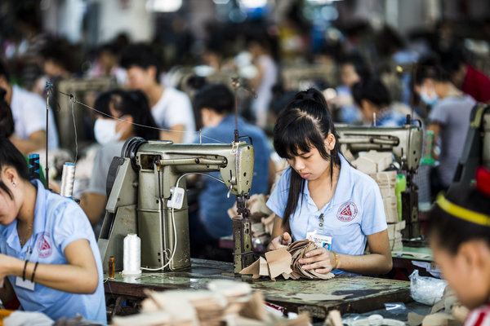

A shoe factory in Vietnam. The United States imposes tariffs on imported shoes. Credit Aaron Joel Santos for The New York Times

Today, the United States and most developed countries have few tariffs, but some remain. The United States, for example, protects the domestic sugar market from lower-priced global suppliers and imposes tariffs on imported shoes, while Japan has steep surcharges on agricultural products including rice, beef and dairy. The pact is an effort to create a Pacific Rim free-trade zone.

**Environmental, Labor and Intellectual Property Standards** United States negotiators stress that the Pacific agreement seeks to level the playing field by imposing rigorous labor and environmental standards on trading partners, and supervision of intellectual property rights.

**Data Flows** The Pacific trade pact to address a number of issues that have arisen since previous agreements were negotiated. One is that countries agree not to block cross-border transfers of data over the Internet, and not require that servers be located in the country in order to conduct business in that country. This proposal has drawn concerns from some countries, Australia among them, that it could conflict with privacy laws and regulations against personal data stored offshore.

**Services** A big aim of the Pacific pact is enhancing opportunities for service industries, which account for most of the private jobs in the American economy. The United States has a competitive advantage in a range of services, including finance, engineering, software, education, legal and information technology. Although services are not subject to tariffs, nationality requirements and restrictions on investing are used by many developing countries to protect local businesses.

**State-Operated Businesses** United States negotiators have discussed the need to address favoritism often granted to state-owned business — those directly or indirectly owned by the government. Although Vietnam and Malaysia have many such corporations, the United States has some too (the Postal Service and Fannie Mae, for example). The final agreement may include terms that seek to insure some competitive neutrality while keeping the door open to China’s future acceptance of the pact.

#### Why Hasn’t China Been In on the Talks?

China has never expressed interest in joining the negotiations, but in the past has viewed the pact with concern, seeing a potential threat as the United States tries to tighten its relationship with Asian trading partners. But lately, as the talks have accelerated, senior Chinese officials [have sounded more accepting of the potential deal](http://www.nytimes.com/2015/04/29/business/international/once-concerned-china-is-quiet-about-trans-pacific-trade-deal.html), and have even hinted that they might want to participate at some point. At the same time, the deal provides China some cover as it pursues its own trade agreements in the region, such as the Silk Road initiative in Central Asia.

United States officials, while making clear that they see the pact as part of an effort to counter China’s influence in the region, say they are hopeful that the pact’s “open architecture” eventually prompts China to join, along with other important economic powers like South Korea.

#### The Shadow of Nafta, and the Debate in Washington

Photo

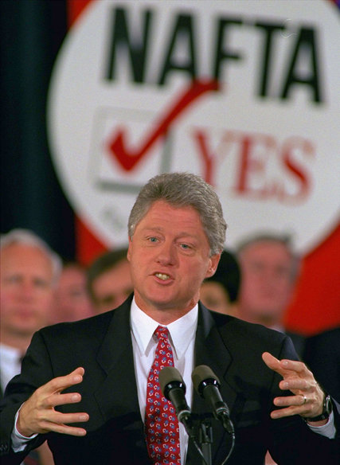

President Bill Clinton won congressional backing for Nafta, but most lawmakers in his own party voted against it. Credit Doug Mills/Associated Press

Nafta, signed by President Bill Clinton in 1993, helped lead to a boom in trade among the United States, Mexico and Canada. All three countries exported more goods and services to the other two, cross-border investments grew, and the United States economy has added millions of jobs since then. But of course not all those trends were attributable to Nafta, and the benefits were not equal: The United States had a small trade surplus with Mexico when the pact was signed, but that quickly became a trade deficit that has widened to more than $50 billion a year.

Critics of Nafta also point out that job growth in the United States does not account for the loss of jobs to Mexico or Canada; the A.F.L.-C.I.O. contends about 700,000 United States jobs have been lost or displaced because of Nafta.

Nafta was a [significant victory for President Clinton](http://www.nytimes.com/1993/11/19/us/the-free-trade-accord-how-clinton-won-56-long-days-of-coordinated-persuasion.html) after a difficult congressional battle, where he won support from just enough fellow Democrats to ensure passage. The votes were 234 to 200 in the House, and 61 to 38 in the Senate.

President Obama may yet win that kind of outcome. Working with Republican leadership in the House and Senate, [he gained final approval for trade promotion authority](http://www.nytimes.com/2015/06/25/business/trade-pact-senate-vote-obama.html), a critical step that allows the White House to present the trade package to Congress for a straight up-or-down vote, without amendments.

But the tortuous legislative process [further soured relations](http://www.nytimes.com/2015/06/25/business/obama-bolsters-his-leverage-with-trade-victory-but-at-a-cost.html) with many fellow Democrats, as well as unions and progressive groups, who vehemently oppose the Trans-Pacific Partnership. Many Democrats said the president would have to address their concerns over labor and environmental standards and investor protections when he returns to Congress seeking approval of the trade deal.

NYT

# U.S. Allies See Trans-Pacific Partnership as a Check on China

By [JANE PERLEZ](http://topics.nytimes.com/top/reference/timestopics/people/p/jane_perlez/index.html)OCT. 6, 2015

Photo

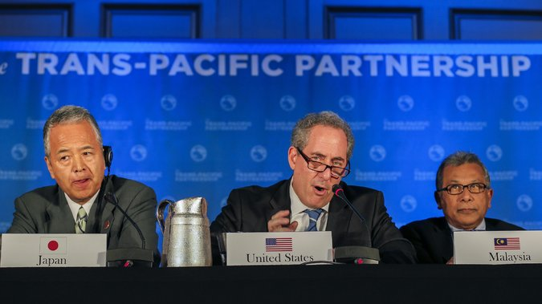

Michael Froman, the United States trade representative, center, with some of the trade ministers from member countries of the Trans-Pacific Partnership announcing the pact in Atlanta on Monday. Credit Erik S. Lesser/European Pressphoto Agency

BEIJING — The Trans-Pacific Partnership trade deal was welcomed on Tuesday as a win for the United States in its contest with [China](http://topics.nytimes.com/top/news/international/countriesandterritories/china/index.html?inline=nyt-geo) for clout in Asia, as America’s allies expressed optimism about the impact of the 12-nation accord on a region worried about its dependence on the slowing Chinese economy.

The pact still must win approval in Congress, and analysts said the economic effects may be less sweeping than Washington predicts. But the mere fact that President Obama delivered on his pledge to close the deal came as a relief to allies in Asia. It was seen as a counterweight to China’s efforts to expand its influence not just in trade but in other areas, including its island-building in the disputed South China Sea and the establishment of a new regional development bank to compete with Western-led institutions.

“The TPP may not be the game-changer the Americans say it will be, but if the TPP failed, it would certainly have been a blow to U.S. credibility, and its conclusion is to be welcomed,” said Bilahari Kausikan, a former permanent secretary of Singapore’s Foreign Ministry. Yet, he cautioned: “This is not going to erode what China does.”

The victory for the United States comes as China’s position in Asia has been thrown off balance by questions about the condition of its economy, which is expanding at its slowest pace in a quarter century and has sent tremors across the region. Even with the slowdown, though, the Chinese economy is growing faster than those of most industrial nations, and China enjoys deepening economic ties with almost all countries in the region.

The trade agreement is unlikely to change that, but it is an important symbol of America’s staying power in Asia, some experts said. “It does at least temporarily halt the seemingly inexorable waning of U.S. influence and the corresponding rise of Chinese influence in the Asian region,” said Eswar S. Prasad, a professor of international economics at Cornell University and former head of the China division at the International Monetary Fund.

Since 2011, when President Obama told the Australian Parliament that the United States would play a “larger and long-term role” in shaping the Asian region, its allies have been waiting for results. For a while, the much-extolled “pivot” to Asia seemed to be mostly a verbal one — and one intended to antagonize China, by proposing to bolster America’s military presence and creating a trade zone that kept China out.

Even as Washington talked about a new focus on Asia, China’s economic ties with America’s friends in the region steadily expanded. Many Asian countries now have trade agreements with China that were completed since the announcement of the “pivot,” and count China as their biggest trading partner. Australia, for example, [signed a trade agreement](http://www.abc.net.au/news/2015-06-17/australia-and-china-sign-free-trade-agreement/6552940) with China in June, although it has yet to pass through Parliament.

China was seen to be winning in other ways, too. While its strategic capabilities in East Asia did not yet rival those of the United States, the financial picture was changing rapidly, with China becoming the major lender in the region, the Inter-American Dialogue, a policy group in Washington, said in [a July report](http://www.thedialogue.org/wp-content/uploads/2015/07/CLA-TPP-Report-final-web.pdf).

“The China Development Bank and the Export-Import Bank of China now provide more loans to the region than the World Bank and the Asia Development Bank combined,” the report said. Indeed, although the TPP is seen mainly as an enterprise that aims to knit the United States and Asia closer together, four of its 12 members are in Latin America: Chile, Colombia, Mexico and Peru.

In terms of trade competition with China in Asia, the deal would advantage American firms over Chinese firms “only very slightly,” since there is very little overlap in the range of goods each country exports to Asian members of the accord, said Nicholas Lardy, a China expert at the Peterson Institute for International Economics in Washington.

## Related Trade Deal Coverage

[[](http://www.nytimes.com/2015/08/03/business/chinese-textile-mills-are-now-hiring-in-places-where-cotton-was-king.html)](http://www.nytimes.com/2015/08/03/business/chinese-textile-mills-are-now-hiring-in-places-where-cotton-was-king.html)

## [Chinese Textile Manufacturers Bring Jobs Back to AmericaAug. 03, 2015](http://www.nytimes.com/2015/08/03/business/chinese-textile-mills-are-now-hiring-in-places-where-cotton-was-king.html)

[[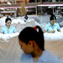](http://www.nytimes.com/2015/07/09/business/international/trans-pacific-partnerships-potential-impact-weighed-in-asia-and-us.html)](http://www.nytimes.com/2015/07/09/business/international/trans-pacific-partnerships-potential-impact-weighed-in-asia-and-us.html)

## [Gauging Impact of Pacific DealJuly 09, 2015](http://www.nytimes.com/2015/07/09/business/international/trans-pacific-partnerships-potential-impact-weighed-in-asia-and-us.html)

The stakes for the Obama administration to conclude the negotiations became higher in Asia after the United States defense secretary, Ashton B. Carter, [said in April](http://www.abc.net.au/news/2015-04-07/us-defence-secretary-backs-trans-pacific-partnership/6375274) that the trade pact was “as important to me as another aircraft carrier.” His comments were interpreted as an effort to play down the Asia “pivot” as a predominantly military project, an image that some countries worried served to exacerbate an arms race with China.

In China, where the government’s initial opposition to the trade pact has softened recently, the Ministry of Commerce issued a statement on Tuesday saying that the accord was “one of the important free trade agreements in the Asia-Pacific region.” Early in the negotiations, Beijing criticized the pact as an American effort to contain China, an argument that is still frequently heard from Chinese analysts.

“Initial Chinese hostility toward TPP has moderated dramatically,” Mr. Lardy said. But if China contemplated becoming a member, as some reform-minded Chinese economists have suggested, the government would need to work harder at economic reform in order to meet the pact’s standards, Mr. Lardy said.

In a surprising statement in Japan, Prime Minister Shinzo Abe, whose relations with China have been poor, suggested China should become a member of the pact. “If China joined TPP in the future,” Mr. Abe said, “it would contribute greatly to our country’s security and the stability of the Asia-Pacific region, and that would have an extremely large strategic significance.”

But Peter Drysdale, emeritus professor of economics at the Australian National University in Canberra, said it was almost certain that China would stay outside the TPP, and therefore work even harder at cementing its economic ties in East Asia through other means.

“Even with growth two or three percentage points lower than its current rate, there’s not a major business anywhere in the region, including in Japan, that doesn’t have to factor China in,” Mr. Drysdale said. “With China out of TPP for the foreseeable future, the incentive for China and its East Asian partners to ramp up their economic ties will be more powerful.”

Australia’s prime minister, Malcolm Turnbull, greeted the deal with enthusiasm, saying it offered “unprecedented new opportunities” for new markets in Asia and Latin America, as Australia faced the end of its mining boom. Mr. Turnbull, a proponent of close ties with Beijing, did not mention China in his comments.

Mr. Abe also hailed the accord, saying, “The curtain is finally rising on a new Asian century.” Japan was a latecomer to the negotiations, joining only in 2013, and demands by its influential farm lobby that it keep in place tariffs on rice, beef, milk and other agricultural products proved to be one of several major stumbling blocks.

Mr. Abe championed the deal against considerable domestic opposition, including from many members of his own conservative party, large numbers of whom represent rural constituencies. But Japan’s Parliament was widely expected to approve the accord.

Although the conclusion of the negotiations were broadly welcomed among America’s friends in Asia, the United States should not view Asian nations as wanting to decide between Washington and Beijing, Mr. Kausikan said.

“No one sees the TPP as an alternative to China,” he said. “The U.S. is important, and China is important. We’re capable of doing things simultaneously. China is a huge economic factor that cannot be wished away.”

# U.S. Allies See Trans-Pacific Partnership as a Check on China

By [JANE PERLEZ](http://topics.nytimes.com/top/reference/timestopics/people/p/jane_perlez/index.html)OCT. 6, 2015

BEIJING — The Trans-Pacific Partnership trade deal was welcomed on Tuesday as a win for the United States in its contest with [China](http://topics.nytimes.com/top/news/international/countriesandterritories/china/index.html?inline=nyt-geo) for clout in Asia, as America’s allies expressed optimism about the impact of the 12-nation accord on a region worried about its dependence on the slowing Chinese economy.

The pact still must win approval in Congress, and analysts said the economic effects may be less sweeping than Washington predicts. But the mere fact that President Obama delivered on his pledge to close the deal came as a relief to allies in Asia. It was seen as a counterweight to China’s efforts to expand its influence not just in trade but in other areas, including its island-building in the disputed South China Sea and the establishment of a new regional development bank to compete with Western-led institutions.

“The TPP may not be the game-changer the Americans say it will be, but if the TPP failed, it would certainly have been a blow to U.S. credibility, and its conclusion is to be welcomed,” said Bilahari Kausikan, a former permanent secretary of Singapore’s Foreign Ministry. Yet, he cautioned: “This is not going to erode what China does.”

The victory for the United States comes as China’s position in Asia has been thrown off balance by questions about the condition of its economy, which is expanding at its slowest pace in a quarter century and has sent tremors across the region. Even with the slowdown, though, the Chinese economy is growing faster than those of most industrial nations, and China enjoys deepening economic ties with almost all countries in the region.

The trade agreement is unlikely to change that, but it is an important symbol of America’s staying power in Asia, some experts said. “It does at least temporarily halt the seemingly inexorable waning of U.S. influence and the corresponding rise of Chinese influence in the Asian region,” said Eswar S. Prasad, a professor of international economics at Cornell University and former head of the China division at the International Monetary Fund.

Since 2011, when President Obama told the Australian Parliament that the United States would play a “larger and long-term role” in shaping the Asian region, its allies have been waiting for results. For a while, the much-extolled “pivot” to Asia seemed to be mostly a verbal one — and one intended to antagonize China, by proposing to bolster America’s military presence and creating a trade zone that kept China out.

Even as Washington talked about a new focus on Asia, China’s economic ties with America’s friends in the region steadily expanded. Many Asian countries now have trade agreements with China that were completed since the announcement of the “pivot,” and count China as their biggest trading partner. Australia, for example, [signed a trade agreement](http://www.abc.net.au/news/2015-06-17/australia-and-china-sign-free-trade-agreement/6552940) with China in June, although it has yet to pass through Parliament.

China was seen to be winning in other ways, too. While its strategic capabilities in East Asia did not yet rival those of the United States, the financial picture was changing rapidly, with China becoming the major lender in the region, the Inter-American Dialogue, a policy group in Washington, said in [a July report](http://www.thedialogue.org/wp-content/uploads/2015/07/CLA-TPP-Report-final-web.pdf).

“The China Development Bank and the Export-Import Bank of China now provide more loans to the region than the World Bank and the Asia Development Bank combined,” the report said. Indeed, although the TPP is seen mainly as an enterprise that aims to knit the United States and Asia closer together, four of its 12 members are in Latin America: Chile, Colombia, Mexico and Peru.

In terms of trade competition with China in Asia, the deal would advantage American firms over Chinese firms “only very slightly,” since there is very little overlap in the range of goods each country exports to Asian members of the accord, said Nicholas Lardy, a China expert at the Peterson Institute for International Economics in Washington.

NYT

# In Pacific Trade Deal, Vietnam Agrees to U.S. Terms on Labor Rights

By [JACKIE CALMES](http://topics.nytimes.com/top/reference/timestopics/people/c/jackie_calmes/index.html)NOV. 5, 2015

Photo

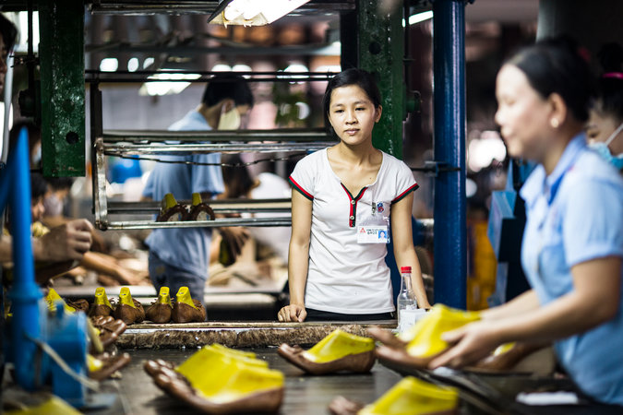

Workers assembling women's shoes at a factory in southern Vietnam. Credit Aaron Joel Santos for The New York Times

[Continue reading the main story](http://www.nytimes.com/2015/11/06/business/international/trans-pacific-trade-deal-tpp-vietnam-labor-rights.html?hp&action=click&pgtype=Homepage&module=first-column-region&region=top-news&WT.nav=top-news&_r=0#story-continues-1)

WASHINGTON — The Communist government in [Vietnam](http://topics.nytimes.com/top/news/international/countriesandterritories/vietnam/index.html?inline=nyt-geo) has agreed to American terms to grant potentially far-reaching labor rights to the country’s workers, including the freedom to unionize and to strike, in return for expanded trade between the former adversaries, according to the newly released text of a vast Pacific trade agreement.

Those terms were [disclosed early Thursday](https://ustr.gov/trade-agreements/free-trade-agreements/trans-pacific-partnership/TPP-Full-Text), along with all 30 chapters and side agreements that make up the Trans-Pacific Partnership, a pact reached a month ago by12 Pacific Rim nations that would be the largest regional trade accord in history. The agreement would end most tariffs and other trade barriers among countries that account for 40 percent of the global economy.

With the release of the text, Congress begins months of review and then debate. Votes for approval in the House and Senate next spring, amid a presidential contest in which the trade pact is an issue in both parties, are likely to be close.

For President Obama, the effort to sell the potentially legacy-making agreement may be the last big battle of his tenure. He will have to rely mostly on Republican votes, while holding on to support from the few Democratic allies willing to confront organized labor and other liberal groups that are skeptical about trade globalization.

“We have a whole-of-government, whole-of-White House effort underway,” said Michael B. Froman, Mr. Obama’s trade representative, who has negotiated the voluminous agreement since 2009.

In recent weeks, Mr. Froman and other cabinet members have met with lawmakers in Congress, and Mr. Obama has hosted both supportive Democrats and displeased pharmaceutical executives at the White House. The president’s campaign will ramp up now that the agreement’s text is finally in hand.

The White House posted the text of the deal on Medium, a social media sharing website, and Mr. Obama described the agreement as a “new type of trade deal that puts American workers first.”

In a statement from the White House Thursday morning, Mr. Obama bragged about the deal’s high labor standards, its reduction of tariffs and its benefits for American workers.

“It eliminates 18,000 taxes that various countries put on American goods,” Mr. Obama said. “That will boost Made-in-America exports abroad while supporting higher-paying jobs right here at home. And that’s going to help our economy grow.”

Mr. Obama said the full text of the agreement should help to build support for the deal in Congress.

“When it comes to Asia, one of the world’s fastest-growing regions, the rule book is up for grabs. And if we don’t pass this agreement — if America doesn’t write those rules — then countries like China will,” the president said. “And that would only threaten American jobs and workers and undermine American leadership around the world.”

Opponents of the trade accord — on the political left and the [Tea Party](http://topics.nytimes.com/top/reference/timestopics/subjects/t/tea_party_movement/index.html?inline=nyt-classifier) right, as well as some business leaders — will also step up their efforts after holding their fire pending the release of the full agreement. Lawmakers who have withheld judgment will come under renewed pressure to take sides.

“Now it will be homework time for members of Congress to be actively engaged and to take the time to study up on these provisions to determine if the agreement does make sense for their collective districts, states and, ultimately, for our country,” said Representative Ron Kind of Wisconsin, a leader among the 28 House Democrats who indicated tentative support for the trade pact by voting during the summer to give Mr. Obama so-called fast-track authority for expedited congressional consideration.

The Obama administration is hoping that the accord’s labor protections, along with separate bilateral labor and human rights agreements between the United States and Vietnam, Malaysia and Brunei, will help persuade some Democrats to back the deal. The administration is especially eager to promote the agreement with Vietnam.

“Without reservation, I think this is the best opportunity we’ve had in years to encourage deep institutional reform in Vietnam that will advance human rights, and it will only happen if T.P.P. is approved,” Tom Malinowski, the assistant secretary of state for democracy, human rights and labor, said in an interview.

While most trade agreements “have been a leap of faith when it comes to human rights,” Mr. Malinowski said, “these are highly specific commitments that Vietnam has made to change laws.” Vietnam will not get the economic benefits of closer trade with the United States, as provided in the broader 12-nation pact, unless it abides by the two countries’ separate agreement, he said.

That bilateral agreement would require Vietnam to change laws or enact new ones to allow workers to form unions independent of the government, and they would be empowered to strike not only over wages and hours but also over working conditions and rights.

The grass-roots unions would not have to join Vietnam’s government-sanctioned labor confederation, but they could affiliate with each other and seek assistance from any “international worker organization,” like the A.F.L.-C.I.O., for help and training. The agreement also calls for Vietnam’s government to educate workers and employers about the labor changes.

Trade between the United States and Vietnam has grown significantly since formal trade relations began in 2001, and so has American investment in Vietnam.

According to a State Department report this year, Vietnam exported nearly $30 billion worth of goods to the United States in 2013, and the United States exported $5.5 billion worth of goods and services to Vietnam in 2014. Administration officials said the Trans-Pacific Partnership would open markets in Vietnam — and in other member nations — to more American-made goods.

The other nations that are parties to the trade partnership, besides the United States, Vietnam, Malaysia and Brunei, are Japan, Canada, Mexico, Australia, New Zealand, Peru, Chile and Singapore.

The United States will monitor Vietnam’s compliance with the labor requirements, under their separate agreement, and an independent panel of three labor experts — one each from the United States, Vietnam and the International Labor Organization — will also conduct reviews. Five years after the agreement takes effect, the United States could withhold trade benefits if it is determined that Vietnam has not met its obligations.

Some labor and human rights groups, however, said they were not sold on the Vietnam agreement, based on what they had learned before the text’s release.

John Sifton, the Asia advocacy director for Human Rights Watch, said that while the bilateral agreement was enforceable in theory, “it is not enforceable in practice.”

The record of the Office of the United States Trade Representative, he said, does not suggest that it would enforce the terms. What is needed, he added, is for workers to have the same right that corporations have under this trade agreement and others: to take complaints directly to a dispute settlement panel.

“Are trade unionists who actually produce all the capital that we’re talking about here allowed to bring complaints against a country for violations?” he asked. “No, of course not.”

But Human Rights Watch and other left-leaning advocacy groups are more incensed that separate provisions of the overall agreement protect for several years the patents of brand-name drug companies for so-called biologics, which are state-of-the-art drugs made from living organisms that have promise for treating cancers.

While drug companies and their Republican allies in Congress wanted 12 years of patent protection before the data must be released for producing generic versions, the public advocacy groups have deplored the five- to eight-year process that the trade agreement outlined.

“This agreement is going to kill people, literally,” Mr. Sifton said. “As a direct result of that, health care systems will not be able to provide lifesaving medicines for all people who need them.”

For the first time in a trade accord, the Pacific partners agreed to language in a “joint declaration” that commits them to avoid manipulating their currencies for trade advantage, to report interventions in foreign exchange markets and to meet at least once a year to air any concerns or complaints.

But the declaration, which is not part of the official trade text, is unlikely to placate members of Congress, many of them Democrats, who say that Japan and other nations underprice their exports by manipulating the value of their currencies.

Nonetheless, a senior Treasury official, who asked not to be identified because he was speaking before the text’s official release, said of the joint declaration, “I think this will be seen by people as a meaningful step in terms of holding countries accountable for their currency practices” and guarding against the unfair use of exchange rates “to drive a better advantage with regard to trade.”

# NYT

# Labor Reform in Vietnam, Tied to Pacific Trade Deal, Depends on Hanoi’s Follow-Up

By [KEITH BRADSHER](http://topics.nytimes.com/top/reference/timestopics/people/b/keith_bradsher/index.html)NOV. 5, 2015

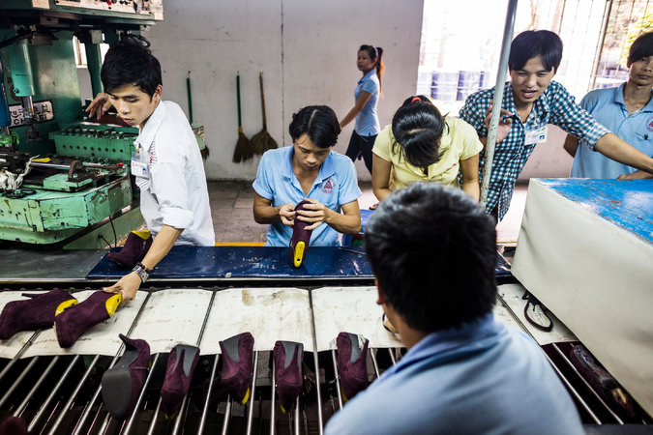

Factory workers in southern Vietnam. The side agreement to the Trans-Pacific Partnership calls for the country to pass legislation that would expand labor rights. Credit Aaron Joel Santos for The New York Times

HONG KONG — A pact between Washington and Hanoi to strengthen labor unions in [Vietnam](http://topics.nytimes.com/top/news/international/countriesandterritories/vietnam/index.html?inline=nyt-geo) could give workers greater bargaining power, but the impact will depend on how Vietnam carries out the agreement, longtime Vietnamese government advisers and other experts said on Thursday.

The [side agreement](https://ustr.gov/sites/default/files/TPP-Final-Text-Labour-US-VN-Plan-for-Enhancement-of-Trade-and-Labor-Relations.pdf) to the Trans-Pacific Partnership calls for Vietnam to pass legislation that would legalize independent unions, allow them to go on strike and let them seek help from foreign labor organizations like the A.F.L.-C.I.O.

The overall trade agreement faces a [contentious debate](http://www.nytimes.com/2015/11/06/business/international/trans-pacific-trade-deal-tpp-vietnam-labor-rights.html) in the United States Congress. The Obama administration is aiming to win over Democrats who have expressed concern about the potential for free trade to shift jobs to countries where unions and workers’ rights are weak.

Vietnam’s Constitution actually enshrines the right of workers to strike and engage in organized protests, said Le Dang Doanh, a prominent economist and a former top official at a government research organization in Hanoi. But until now, Vietnam has adopted few laws to codify and protect those rights.

Consequently, the labor accord “is a very positive step for Vietnam,” said Mr. Doanh, a longtime advocate of market reforms who has advised his country’s top leadership through its gradual relaxation of many government controls over the economy in the past quarter-century.

Pham Chi Lan, the former secretary general of the Vietnam Chamber of Commerce and Industry and a former senior adviser in the office of the prime minister, also portrayed the agreement as an important concession. “This is a big compromise, for Vietnam to agree to do this,” she said.

But Tony Foster, the managing partner of the Hanoi and Ho Chi Minh City offices of Freshfields Bruckhaus Deringer, a big global law firm, said that the labor provisions of the Trans-Pacific Partnership had been expected, and that it was unclear how much change they would bring to Vietnam.

The central question, he said, will be the extent to which the trade agreement actually increases the influence and independence of labor unions.

“The devil is really going to be in the details on a lot of this stuff — I’m sure people are going to be parsing it very carefully to determine what will really be required,” Mr. Foster said in a telephone interview from Hanoi. “It will be a balancing act for the government, and I’m sure they will comply, more or less.”

Multinationals have shown much more interest this autumn in investing in Vietnam, and the anticipated labor provisions of the trade accord have caused little concern among companies, he added.

For the past decade, factories in Vietnam have faced numerous wildcat strikes each spring, sometimes involving thousands of workers at a single location. The strikes tend to occur close to the Tet festival and are often the result of workers’ dissatisfaction with the annual bonuses that factories pay then.

Vietnam has administrative regulations for holding a strike with government protection, but they are so bureaucratic that workers seldom follow them. The Vietnamese government has tolerated wildcat strikes as a way for workers to let off steam and to demand raises, particularly during the period of high inflation in Vietnam that accompanied and followed the global financial crisis in 2008 and 2009.

Unlike some countries that have been under authoritarian rule, like Indonesia before the fall of President Suharto in 1998, Vietnam does not have a large underground labor movement that might quickly benefit from legalization. Vietnam’s tolerance of wildcat strikes may have discouraged the formation of such a broader movement.

Labor-affiliated institutes in Germany and Australia have had offices in Vietnam for many years to work with the government-affiliated union and encourage it to press harder on behalf of workers. American labor groups have been less active until now in Vietnam, partly because of the lingering history of the Vietnam War, which has made American involvement in Vietnamese domestic issues more delicate.

Two Vietnamese government officials, contacted in Hanoi after the accord’s text was made public on Thursday, had no immediate comment. But Le Dinh Quang, the deputy head of the labor relationships department at the government-controlled Vietnam General Confederation of Labor, welcomed the agreement.

“That is a very big challenge for us, but due to national benefit, the integration with the world and also the rights and benefit of labor, we have to find solutions” to apply the agreement, he said in a telephone interview. “We understand that this would be very good for workers in Vietnam.”