**[International Business](http://www.nytimes.com/pages/business/international/index.html)**

**Micron Technology Is Said to Be Takeover Target of Chinese Company**

By PAUL MOZURJULY 14, 2015

Photo

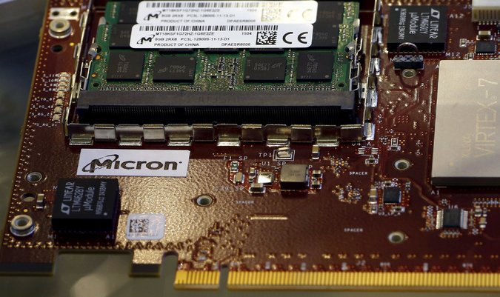

The memory chips made by the Micron, which is based in Idaho, sit in data centers and servers that process the flow of information across the globe. Credit Kai Pfaffenbach/Reuters

HONG KONG — It is either the first step in the largest takeover of an American company by a Chinese one or a fresh chapter in the emerging technological cold war between the two countries.

Tsinghua Unigroup, a state-owned company that is China’s top microchip maker, is preparing a plan to bid $23 billion for [Micron Technology](http://topics.nytimes.com/top/news/business/companies/micron_technology_inc/index.html?inline=nyt-org), the United States maker of memory chips, according to a person briefed on the matter. The bid would dwarf the price of the closest such deal, the $4.8 billion paid by Shuanghui International Holdings of China to take over the American pork producer Smithfield Foods in 2013.

Yet obstacles abound to any takeover of Micron by Tsinghua Unigroup. In a report released on Tuesday, Credit Suisse said the deal was “highly unlikely to get past U.S. regulators who are increasingly viewing semiconductors as a strategic industry.” Credit Suisse said a trade war was brewing between the United States and China over the production of chips, which serve as the brains of the billions of computers, phones and other devices across the world.

The political difficulties that could hurt the deal highlight a growing wariness by both China and the United States of technology produced by the other, and illustrate how critical to security advanced consumer technologies have become. The memory chips made by Micron, which is based in Idaho, sit in data centers that process the flow of information across the globe. The loss of the ability to make advanced memory chips — Micron is the last major maker in the United States — could affect American security, according to some analysts.

When reached over the phone for comment, Tsinghua Unigroup’s chairman, Zhao Weiguo, said, “I can only say we are interested in working with Micron.”

“Micron does not comment on rumor or speculation,” a company spokesman, Daniel Francisco, wrote in an email.

The person briefed on the deal said Tsinghua Unigroup was targeting Micron in part because it makes memory chips, a segment that has relatively fewer security concerns than the production of microchips. Much of the memory chip industry has been commodified by Asian companies like Samsung and SK Hynix. And because memory chips are responsible for storing data, instead of increasing processing speeds, their technologies are generally considered less sensitive.

**Top 10 China-U.S. Acquisitions**

A plan to bid for Micron Technology would be the largest takeover of an American company by a Chinese one.

|  |
| --- |
| **RANK** | **ACQUIRER IN CHINA** | **TARGET IN THE UNITED STATES** | **DATE** | **TARGET'S INDUSTRY** | **DEAL VALUE, IN BILLIONS** |
| **1** | **Tsinghua Unigroup** * | **Micron Technology** | **2015** | **Microchips** | **$23** |
| 2 | Shuanghui Int'l | Smithfield Foods | 2013 | Pork | $4.8 |
| 3 | Dalian Wanda | AMC Entertainment | 2012 | Motion Pictures | $2.6 |
| 4 | SIPC | Devon Energy assets | 2012 | Oil & Gas | $2.5 |
| 5 | Anbang Insurance | Waldorf Astoria | 2014 | Hotels | $2.0 |
| 6 | Investment group ** | OmniVision Technologies | 2014 | Semiconductors | $1.8 |
| 7 | Sinochem Petroleum USA | Pioneer Natural Resources assets | 2013 | Oil & Gas | $1.7 |
| 8 | China Investment | AES | 2009 | Power | $1.6 |
| 9 | Lenovo | IBM (personal computing) | 2004 | Computers | $1.3 |
| 10 | China Huaneng | InterGen | 2010 | Power | $1.2 |

* Potential bid ** Pending bid

Another problem could be the size of the bid. Nam Hyung Kim, a memory analyst at the research group Arete, said it was too low and could indicate that the Chinese company was simply feeling out prices for companies that produce chips and memory.

“I’m not sure they are even serious” about the price, he said.

“Yesterday a major shareholder said the company should be worth more than $40 billion,” Mr. Kim said, referring to a note distributed on Monday by David Einhorn, the activist investor who heads Greenlight Capital and has built up a stake in Micron. “Given that, and the fact that Micron has good technology with a strong fundamental outlook, the price is way too low for them to even consider, from my view.”

Still, Tsinghua Unigroup has little to lose if the bid fails. Simply by proposing a deal, the company stands to gain status at home as a Chinese company willing to explore deals abroad. If the deal was shot down by American regulators, it would enable Beijing to claim that United States policies are restrictive to Chinese investment — undercutting complaints by the United States about Chinese blocks against American technology companies’ operations in China.

As a part of the Chinese government’s push to build a domestic semiconductor industry, a Tsinghua Unigroup acquisition of Micron would provide access to highly advanced semiconductor manufacturing equipment that could speed the country’s ability to produce smaller and more advanced chips, according to Willy C. Shih, a professor of technology and operations management at Harvard Business School.

He said the move would help China improve its ability to produce memory chips. Otherwise, the country would need years of investment to catch up with industry leaders, like Samsung.

“The question is, if you’re China and you want to have this capability, one of the ways to do it is to buy it,” Mr. Shih said. “Tsinghua Unigroup has the cash because it’s basically government money, so that’s one way to do it.”

Ye Ming, a spokesman for Tsinghua Unigroup, said on Tuesday that the company had no official announcement. The news was first reported by The Wall Street Journal.

If it materializes, the plan would be the strongest indication yet of the aggressiveness with which Beijing is pushing to build China’s semiconductor industry. Partly because of export restrictions on the sophisticated tools and machines required to produce semiconductors, China’s companies have lagged the global leaders. In 2013, China imported $232 billion worth of semiconductor materials, more than it spent on petroleum.

To address the imbalance, Beijing has vowed to spend big. Vice Premier Ma Kai heads a group with the task of making China’s chip industry a global leader by 2030, and he is equipped with about $170 billion in government money to spend over the next decade, according to a report last year by McKinsey & Company.

The push has also raised security concerns. Leaks by the former National Security Agency contractor Edward J. Snowden revealed how the United States used hardware produced outside China to snoop on the Chinese. On the other side, the United States government expressed consternation that chips imported from China and placed in military equipment could open it to hacking.

Over the last two years, Tsinghua Unigroup has emerged as a leader in China’s semiconductor effort. As a subsidiary of Tsinghua Holdings, which controls companies spun off from China’s top universities, it is closely connected to the government. Tsinghua Holdings once counted the son of Hu Jintao, the former Chinese president, as its party secretary, a position responsible for communicating and cooperating with the Chinese Communist Party.

All of that means the bid for Micron is likely to stir up scrutiny from American regulators, and in particular could prompt a review by the Committee on Foreign Investment in the United States, which reviews company acquisitions that could pose a threat to American security. Even though the technology is not directly related to the military, the deal might receive scrutiny because it would effectively eliminate the last major American company to make memory chips.

“I think the U.S. should be concerned,” said Mr. Shih, the Harvard professor. “One could say that maybe the Chinese want to keep Micron in Idaho. If they buy them, they’ll likely be wanting to move the tech to China. So to me it just represents the loss of another U.S. capability.”

The huge bid is also unusually aggressive for a Chinese state-run company, and analysts say it may shine a spotlight on how China uses a state-backed industrial policy to increase the technological capabilities of its companies.

In September, President Xi Jinping, who has taken a personal interest in cybersecurity by acting as chairman of a crucial Communist Party group planning policy on the matter, will visit the United States on his first visit as the Chinese leader.