The Economist

**Great-power politics**

**The new game**

**American dominance is being challenged**

Oct 17th 2015 | [From the print edition](http://www.economist.com/printedition/2015-10-17)

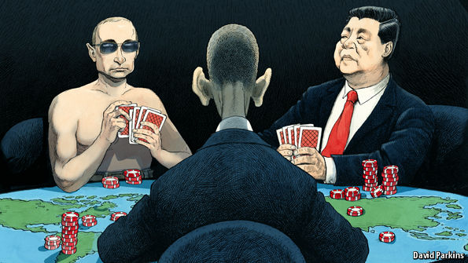

A CONTINENT separates the blood-soaked battlefields of Syria from the reefs and shoals that litter the South China Sea. In their different ways, however, both places are witnessing the most significant shift in great-power relations since the collapse of the Soviet Union.

In Syria, for the first time since the cold war, Russia has deployed its forces far from home to quell a revolution and support a client regime. In the waters between Vietnam and the Philippines, America will soon signal that it does not recognise China’s territorial claims over a host of outcrops and reefs by exercising its right to sail within the 12-mile maritime limit that a sovereign state controls.

For the past 25 years America has utterly dominated great-power politics. Increasingly, it lives in a contested world. The new game with Russia and China that is unfolding in Syria and the South China Sea is a taste of the struggle ahead.

Facts on the ground

As ever, that struggle is being fought partly in terms of raw power. Vladimir Putin has intervened in Syria to tamp down jihadism and to bolster his own standing at home. But he also means to show that, unlike America, Russia can be trusted to get things done in the Middle East and win friends by, for example, offering Iraq an alternative to the United States (see [article](http://www.economist.com/news/middle-east-and-africa/21674697-russia-sticks-first-toe-iraq-putin-champion-shias" \t "_blank)). Lest anyone presume with John McCain, an American senator, that Russia is just “a gas station masquerading as a country”, Mr Putin intends to prove that Russia possesses resolve, as well as crack troops and cruise missiles.

The struggle is also over legitimacy. Mr Putin wants to discredit America’s stewardship of the international order. America argues that popular discontent and the Syrian regime’s abuses of human rights disqualify the president, Bashar al-Assad, from power. Mr Putin wants to play down human rights, which he sees as a licence for the West to interfere in sovereign countries—including, if he ever had to impose a brutal crackdown, in Russia itself.

Power and legitimacy are no less at play in the South China Sea, a thoroughfare for much of the world’s seaborne trade. Many of its islands, reefs and sandbanks are subject to overlapping claims. Yet China insists that its case should prevail, and is imposing its own claim by using landfill and by putting down airstrips and garrisons.

This is partly an assertion of rapidly growing naval might: China is creating islands because it can. Occupying them fits into its strategy of dominating the seas well beyond its coast. Twenty years ago American warships sailed there with impunity; today they find themselves in potentially hostile waters (see [article](http://www.economist.com/news/international/21674648-china-no-longer-accepts-america-should-be-asia-pacifics-dominant-naval-power-who-rules" \t "_blank)). But a principle is at stake, too. America does not take a view on who owns the islands, but it does insist that China should establish its claims through negotiation or international arbitration. China is asserting that in its region, for the island disputes as in other things, it now sets the rules.

Nobody should wonder that America’s pre-eminence is being contested. After the Soviet collapse the absolute global supremacy of the United States sometimes began to seem normal. In fact, its dominance reached such heights only because Russia was reeling and China was still emerging from the chaos and depredations that had so diminished it in the 20th century. Even today, America remains the only country able to project power right across the globe. (As we have recently argued, its sway over the financial system is still growing.)

There is nevertheless reason to worry. The reassertion of Russian power spells trouble. It has already led to the annexation of Crimea and the invasion of eastern Ukraine—both breaches of the very same international law that Mr Putin says he upholds in Syria (see [article](http://www.economist.com/news/europe/21674772-selling-europes-trade-agreement-america-strategic-has-problems-ttip-spear" \t "_blank)). Barack Obama, America’s president, takes comfort from Russia’s weak economy and the emigration of some of its best people. But a declining nuclear-armed former superpower can cause a lot of harm.

Relations between China and America are more important—and even harder to manage. For the sake of peace and prosperity, the two must be able to work together. And yet their dealings are inevitably plagued by rivalry and mistrust. Because every transaction risks becoming a test of which one calls the shots, antagonism is never far below the surface.

**American foreign policy has not yet adjusted to this contested world. For the past three presidents, policy has chiefly involved the export of American values—although, to the countries on the receiving end, that sometimes felt like an imposition. The idea was that countries would inevitably gravitate towards democracy, markets and human rights. Optimists thought that even China was heading in that direction.**

Still worth it

That notion has suffered, first in Iraq and Afghanistan and now the wider Middle East. Liberation has not brought stability. Democracy has not taken root. Mr Obama has seemed to conclude that America should pull back. In Libya he led from behind; in Syria he has held off. As a result, he has ceded Russia the initiative in the Middle East for the first time since the 1970s.

All those, like this newspaper, who still see democracy and markets as the route to peace and prosperity hope that America will be more willing to lead. Mr Obama’s wish that other countries should share responsibility for the system of international law and human rights will work only if his country sets the agenda and takes the initiative—as it did with Iran’s nuclear programme. The new game will involve tough diplomacy and the occasional judicious application of force.

**America still has resources other powers lack. Foremost is its web of alliances, including NATO. Whereas Mr Obama sometimes behaves as if alliances are transactional, they need solid foundations. America’s military power is unmatched, but it is hindered by pork-barrel politics and automatic cuts mandated by Congress. These spring from the biggest brake on American leadership: dysfunctional politics in Washington. That is not just a poor advertisement for democracy; it also stymies America’s interest. In the new game it is something that the United States—and the world—can ill afford.**

## Russia and Iraq

### Putin, champion of the Shias

# Russia sticks a first toe into Iraq

Oct 17th 2015 | BAGHDAD | [From the print edition](http://www.economist.com/printedition/2015-10-17)

* [imekeeper](http://www.economist.com/news/middle-east-and-africa/21674697-russia-sticks-first-toe-iraq-putin-champion-shias)

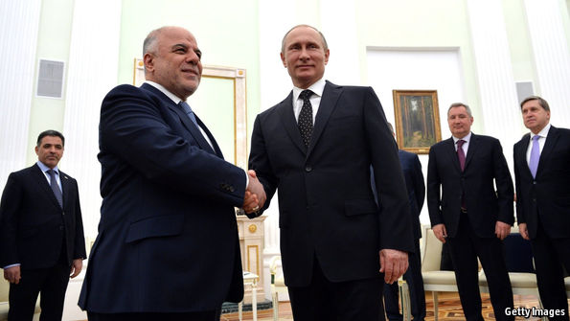

AT CHECKPOINTS across the country, Iraq’s many and various security forces cheer Russia’s arrival as an answer to their failure to turn the tide after 16 months battling the jihadists of Islamic State (IS) in north-western Iraq. “The US and its coalition did nothing,” says a policeman, back from a month on the front. “Finally we’ll have a real coalition with the clout to contend with IS.”

Late last month, Iraq signed an intelligence-sharing agreement with Russia which infuriated the Americans. Days later Russia’s generals established an operations room with America’s two regional foes, Iran and Syria, inside Baghdad’s Green Zone, which houses America’s embassy. Then Russia fired missiles from the Caspian Sea through Iraqi airspace en route to Syria. Haider al-Abadi, the Iraqi prime minister (pictured, left, with Vladimir Putin), has appealed to Russia to expand its air campaign from Syria to include IS targets in Iraq. His forces also proudly show off their Russian tanks. Some officials even talk of giving the Russians an airbase. “We want a full-blown military alliance,” says a senior security official.

America has reacted with consternation to the notion that, after it has expended hundreds of billions of dollars and thousands of lives, Russia might regain the hold on Iraq it last exercised at the height of the cold war. Until now Mr Abadi, the prime minister America shoehorned into place last year, has been dutiful. Iranian military overflights destined for Syria have dwindled from 20 a day to a handful, says a Western diplomat in Baghdad. But his threat to reach out to the Russians, coupled with his failure to do anything significant to implement a promised anti-corruption drive, has prompted some Western powers to start looking for alternative leaders.

Filling a vacuum

Mr Abadi’s men argue that beggars cannot be choosers. Iraq spends a quarter of its budget fighting IS, despite a government deficit made worse by falling oil prices. A bond issue marketed overseas earlier this year failed to attract punters, despite offering an interest rate of 11%. And while America insists it remains on course to “degrade and destroy” IS (in Barack Obama’s words), the Iraqis suspect it has merely set its sights on containing the caliphate rather than rolling it back. That would amount to a permanent division of their country.

From a position of weakness, Mr Abadi is trying to play America’s coalition off against the putative Russian one. American aid has fallen by over 80% since the surge of troops it sent in against IS’s precursors, al-Qaeda in Iraq, in 2007; and the government’s limited resources mean that it delivers weapons to its forces late and in a trickle. “We were expecting the international coalition, the Americans, to bring massive air power to protect our forces,” Mr Abadi has said. “We haven’t received that.”

The gamble may be paying off. The threat of an enhanced Russian role seems to have stirred America into action. In recent days the coalition has intensified its strikes on Baiji and Ramadi, providing air cover as Iraqi forces have girded themselves for a fresh push against IS lines. Never before has IS faced such multiple offensives, says an American official.

But there are also dangers. The region’s sectarian problems risk getting worse and broadening. Iraq’s cartoonists now portray Mr Putin as a Shia tribal hero, giving the region’s Shia powers (currently led by Iran) a global reach. Meanwhile, Sunni powers still look grudgingly to America, despite Mr Obama’s nuclear deal with Iran. After months of waiting, some of Syria’s rebels have at last received an American arms drop (ostensibly to fight IS, not the Syrian regime). In Iraq, America is again arming and training thousands of tribesmen, adding a Sunni flank to the Iranian-dominated fight against IS. On the street and in parliament, some Sunnis have denounced Russia’s return to Iraq’s stage as vehemently as Shias have championed it. One cartoonist summed up IS’s response: “Bring back America’s bombs and spare us Russia’s!”

Not all Sunnis and Shias are so entrenched, however. Militiamen loyal to Muqtada al-Sadr, a powerful Shia cleric, insist they will fight Russians as fiercely as they once fought Americans. And Sunnis hopeful of returning to Mosul, Iraq’s second city now in IS’s hands, doubt Mr Obama is up to the job. To retake Mosul, we’ll need the Russians,” says Mishaan al-Jabbouri, a Sunni politician and tribal leader who was briefly Mosul’s mayor.

## Sea power

### Who rules the waves?

# China no longer accepts that America should be Asia-Pacific’s dominant naval power

Oct 17th 2015 | [From the print edition](http://www.economist.com/printedition/2015-10-17)

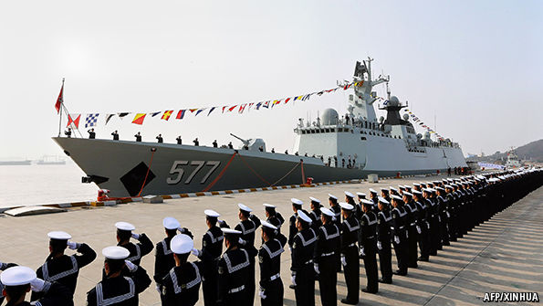

IN THE next few days, out of sight of much of the world, the American navy will test the growing naval power of China. It will do so by conducting patrols within the putative 12-mile territorial zone around artificial islands that China is building in the disputed Spratly archipelago. Not since 2012 has America’s navy asserted its right under international rules to sail so close to features claimed by China. The return to such “freedom of navigation” patrolling comes after a visit to Washington by Xi Jinping, China’s president, that failed to allay concerns about the aggressive island-building in the South China Sea.

China will protest, but for now that is probably all it will do. The manoeuvres are a clear assertion of America’s sea power, which remains supreme—but no longer unchallenged. The very notion of “sea power” has a 19th-century ring to it, summoning up Nelson, imperial ambition and gunboat diplomacy. Yet the great exponent of sea power, the American naval strategist Alfred Thayer Mahan, who died in 1914, is still read with attention by political leaders and their military advisers today. “Control of the sea,” he wrote in 1890, “by maritime commerce and naval supremacy, means predominant influence in the world; because, however great the wealth product of the land, nothing facilitates the necessary exchanges as does the sea.”

Sea power of both the hard, naval kind and the softer kind that involves trade and exploitation of the ocean’s resources is as vital as ever. Bits and bytes move digitally, and people by air. Physical goods, though, still overwhelmingly go by sea: a whopping 90% of global trade by weight and volume. But the sea’s freedom and connectivity are not inevitable. They rely on a rules-based international system to which almost all states subscribe for their own benefit, but which in recent decades only America, in partnership with close allies, has had the means and will to police.

Since the second world war, America’s hegemonic power to maintain access to the global maritime commons has been challenged only once, and briefly. In the 1970s the Soviet Union developed an impressive-looking blue-water navy—but at a cost so huge that some historians regard it as among the factors that brought the Soviet system to collapse less than two decades later. When the cold war ended, most of that expensively acquired fleet was left to rust, abandoned in its Arctic bases.

That may now be changing. On October 7th Russia ostentatiously fired 26 cruise missiles from warships in the Caspian Sea at targets in Syria (it denied American claims that some fell in Iran). Vladimir Putin, Russia’s president, milked the propaganda value: “It is one thing for the experts to be aware that Russia supposedly has these weapons, and another thing for them to see for the first time that they really do exist.” Western military planners must now contend with Russia’s demonstrated ability to hit much of Europe with low-flying cruise missiles from its own waters.

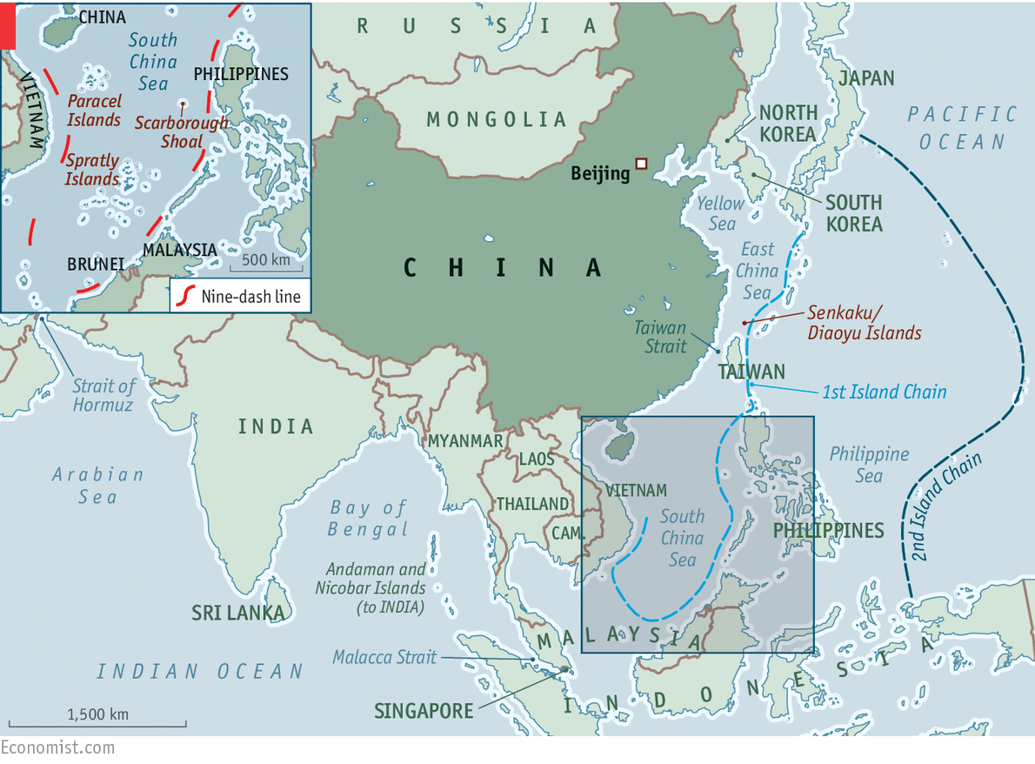

But by far the more serious naval challenger is China. From modest beginnings it has created a navy that has grown from a purely coastal outfit to a potent force in its “near-seas”, ie, within the first island chain from Japan to the Philippines (see map). It is now evolving again, into something even more ambitious. Over the past decade, long-distance operations by the People’s Liberation Army Navy (PLAN) have become more frequent and technically demanding. As well as maintaining a permanent counter-piracy flotilla in the Indian Ocean, China conducts naval exercises far out in the western Pacific. Last month a group of five Chinese naval vessels passed close to the Aleutian Islands after a Russian-Chinese military exercise.

The sea’s the thing

In May China issued a military white paper that formalised the addition of what it calls “open-seas protection” to the PLAN’s “offshore-waters defence” role. A strategy that used to put local sea control first now emphasises China’s expanding economic and diplomatic influence. The primacy China once gave its land forces has ended.

The traditional mentality that land outweighs the sea must be abandoned, and great importance has to be attached to managing the seas and oceans and protecting maritime rights and interests. It is necessary for China to develop a modern maritime force structure commensurate with its national security.

Taiwan remains at the centre of these military concerns. China seeks to develop not only the means to recover the renegade province (as it sees it), by military means if necessary, but also to fend off Taiwan’s main protector, America. China has not forgotten its humiliation in 1996 when America sent two carrier battle groups, one through the Taiwan Strait, to deter Chinese missile tests aimed at intimidating the Taiwanese government. America’s then-defence secretary, William Perry, crowed that, although China was a great military power, “the strongest military power in the western Pacific is the United States.”

China is determined to change the balance. It has invested heavily in everything from shore-based anti-ship missiles to submarines, modern maritime patrol and fighter aircraft, to try to keep America beyond the first and, ultimately, second island chains. China is also seeking the ability to patrol the choke points that give access to the Indian Ocean, through which most of its oil imports enter. About 40% comes through the Strait of Hormuz and over 80% through the Malacca Strait. Among the goals it appears to have set itself are to protect economically vital sea lanes; to constitute a dominating presence in the South and East China Seas; and to be able to intervene wherever its expanding presence abroad, whether in terms of investment or of people, may be threatened.

In August the Pentagon announced a new Asia-Pacific Maritime Security Strategy. It stresses three objectives: to “safeguard the freedom of the seas; deter conflict and coercion; and promote adherence to international law and standards”. It confirmed that America was on schedule to “rebalance” its resources by deploying at least 60% of its naval and air forces to the Asia-Pacific by 2020, a target announced in 2012. Ray Mabus, the navy secretary, has asked Congress for an 8% increase in his budget, to $161 billion for the next fiscal year; he wants the navy to grow from 273 ships to at least 300. Some Republicans say that 350 is the right number.

Is America right to be worried? The way China is going about becoming a global maritime power differs somewhat from the Soviet Union’s great period of naval expansion. Apart from the powerful Soviet submarine fleet, the main purpose of which was strategic nuclear strike and stopping American reinforcements crossing the Atlantic to come to Europe’s aid, the Soviet navy was mostly concerned with expressing great-power status and extending Soviet influence around the world through “presence” missions that impressed allies and deterred enemies.

Power plays

These matter to China, too: a central element of what Mr Xi calls the “China dream” is its transformation into a military power that can cut a dash on the world stage. When large naval vessels exercise or enter port far from home they can be used to influence and coerce. It is understandable that a country of China’s size, history and economic clout should want some of that. Nor is it strange that China should want to prevent a possible adversary (ie, America) from operating with impunity near its own shores.

What makes China’s rise as a sea power troubling for the countries that rely on America to maintain the rules-based international order and the freedom of the seas are its behaviour and where it lies. The Indian Ocean, South China Sea and East China Sea are vital transit routes for the world economy. Eight out of ten of the world’s busiest container ports are in the region. Two-thirds of the world’s oil shipments travel across the Indian Ocean on their way to the Pacific, with 15m barrels passing through the Malacca Strait daily. Almost 30% of maritime trade goes across the South China Sea, $1.2 trillion of which is bound for America. That sea accounts for over 10% of world fisheries production and is thought to have oil and natural-gas deposits beneath its floor.

Much of this is contested, with China the biggest and most aggressive of the claimants. In the South China Sea Beijing’s territorial disputes include the Paracel Islands (with Taiwan and Vietnam); the Spratlys (with Taiwan, Vietnam, the Philippines, Malaysia and Brunei) and Scarborough Shoal (with the Philippines and Taiwan). China vaguely claims sovereignty within its so-called nine-dash line over more than 90% of the South China Sea (see map). The claim was inherited from the Kuomintang government that fled to Taiwan in 1949; whether this applies only to the islands and reefs, or to all the waters within it, has never been properly explained. In the East China Sea a dispute with Japan over the Senkaku Islands (which Japan controls) rumbles on, though the mutual circling of coastguard vessels has become more ritualised of late.

America takes no position on these disputes, insisting only that they should be resolved through international arbitration rather than force, and that all sovereignty claims should be based on natural land features. Yet China is using its growing sea power coercively, carrying out invasive patrols, encroaching on other claimants’ waters and, most recently, creating five artificial islands in vast land-reclamation projects on previously submerged features (which, under the UN Convention on the Law of the Sea, do not grant entitlement to the 12-mile territorial waters). These are being equipped as advanced listening posts and three are getting runways and hangars, meaning they can rapidly be put to military use.

China is not the first to build in the area. But in less than two years it has reclaimed nearly 20 times as much artificial land as rival claimants together have in the past 40. Its bases would be easy for America to neutralise; but, short of war, they allow China to project military power much farther than hitherto. No wonder America’s national security adviser, Susan Rice, recently vowed that American forces will “sail, fly and operate anywhere that international law permits”, and that those “freedom of navigation” patrols would resume.

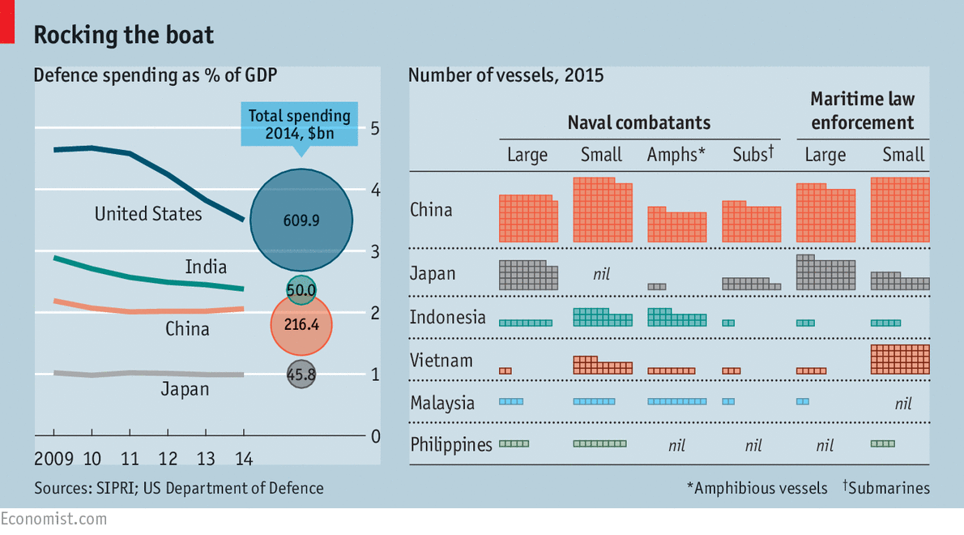

The Pentagon document notes that the PLAN now has the largest number of vessels in Asia, with more than 300 warships, submarines, amphibious ships and patrol craft. Indonesia, Japan, Malaysia, the Philippines and Vietnam can muster only about 200 between them, many of those older and less powerful than China’s (see table). This preponderance is hardly less daunting when it comes to maritime law-enforcement vessels: it has 205 compared with 147 operated by those five countries, which it often uses to stake its territorial claims while more lethal naval forces lurk over the horizon. Although nearly all the countries in dispute with China are trying to buy or build new ships, the capability gap continues to widen.

On the horizon

China could therefore threaten, if so minded, the rules and norms governing maritime boundaries and resources, freedom of navigation and the peaceful resolution of disputes. Would America be ready to face that challenge? Those who fear that America’s ultimate retreat is inevitable are almost certainly wrong. Although growing fast, China’s entire (official) defence budget is not much more than that of America’s navy alone. America has ten nuclear-powered supercarriers, one of which is permanently based in Japan. China has just one, a small, refurbished Soviet-era affair, and two more under construction. All three of America’s latest Zumwalt-class stealth destroyers (pictured), the world’s most advanced surface warships, will be deployed in the Asia-Pacific region along with other new ships and aircraft. Chinese military experts believe that the PLAN will take another 30 years to match the efficiency of the American navy.

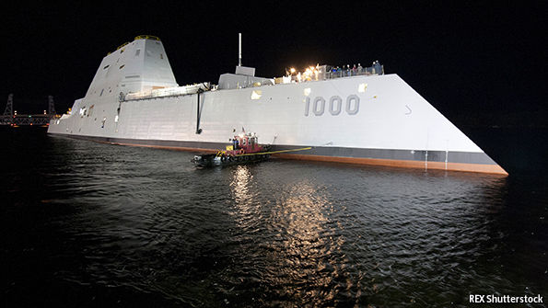Stealthily present

America also has the advantage of having other navies to work with and alongside, both in the region and globally. Japan’s Maritime Self-Defence Force lacks power-projection, but is regarded as the fifth-best navy in the world and is used to exercising with the American navy. The relaxation of national-security laws last month, allowing the Japanese navy to co-operate much more closely with allies on a greater range of missions, went down badly in Beijing. And Japan is working hard with regional neighbours who are in territorial disputes with China. It has made soft loans to the Philippines and Vietnam for new patrol vessels and older destroyers.

The Indian navy is another powerful ally. As concern about China has grown, it has started to drill with Western navies, who rate its competence highly. The annual Malabar exercise with the American navy now also includes ships from Australia, Singapore and, this year for the first time, Japan. The newish government of Narendra Modi is aiming for a 200-ship navy by 2027, with three carrier task groups and nuclear-powered submarines.

Catching up with the PLAN is impossible, but the Indian navy is determined to stop the Indian Ocean becoming a “Chinese lake”. Indian strategists have long believed that China is establishing a network of civilian port facilities and underwriting littoral infrastructure projects to boost its vessels’ ability to operate in waters which the Indian government thinks should be under its dominion. China now often sends its nuclear-powered submarines into the Indian Ocean.

China has benefited as much as any other country from the hegemonic power of the American navy to preserve peace in the Asia-Pacific region. This has helped its remarkable growth. Yet it seems determined to challenge that order. It is understandable that China should want to make it riskier for the American navy to operate close to its own littoral. And for a country that wants a “new type of great power relationship”, relying on America to police the seas is demeaning, though the notion that America and its allies are threatening to blockade the sea lanes of communication that are the arteries of China’s, and the world’s, trade is fanciful in any scenario short of war. But should it ever come to war over, say, a Chinese invasion of Taiwan, China will want to deny America the ability to come to Taiwan’s aid, or at least delay it. The flip-side is that by developing a navy which intimidates its neighbours, China is driving them ever more closely into America’s embrace.

Moreover, being a strong but still second-best sea power can result in disastrous miscalculation. Germany challenged British naval supremacy early in the 20th century by provoking ruinously expensive competition in battleship construction. But it was still powerless to break Britain’s blockade during the first world war. As for Japan, six months after its surprise attack on Pearl Harbour during the second world war, it lost the decisive battle of Midway and with it a large part of the fleet it had built with such hubris.

There is nothing wrong with China regarding a powerful blue-water navy as essential to its prestige and self-image, particularly if it eventually concludes that it should be used to reinforce international rules rather than undermine them. The worry is that China itself may not know what it will do, and that the temptation to use it for more than flag-waving, diplomatic signalling and discreet bullying will become hard to resist. As Mahan observed: “The history of sea power is largely, though by no means solely, a narrative of contests between nations, of mutual rivalries, of violence frequently culminating in war.” It does not have to be like that, but America must prepare for the worst.

# The Atlantic

# Putin's Grandest Dream: Could His 'Eurasian Union' Work?

* [EurasiaNet](http://www.theatlantic.com/author/eurasianet/)
* Mar 18, 2012
* [Global](http://www.theatlantic.com/international/)

*The reelected president wants integrate the region under Moscow's leadership, but he's not the first Russian leader to over-reach.*

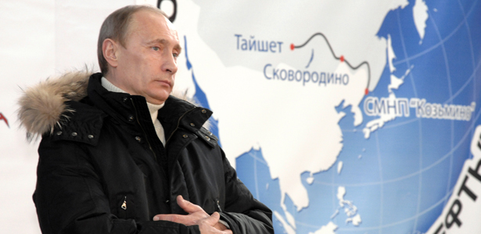

*Putin in Russia's far east / Reuters*

Now that Vladimir Putin has dispensed with the formalities of reclaiming presidential authority, Kremlinologists can focus on the more substantive question of how Russia's paramount leader intends to define his third term. In particular, many are wondering how he will proceed with his pet project -- the creation of a Eurasian Union.

Russia-led Eurasian integration is perhaps the [last](http://www.eurasianet.org/node/65088" \o "" \t ") "big idea" in Putin's ideological arsenal that he can draw on to prop up its eroding legitimacy. Even so, the Russian blueprint for integrating post-Soviet Eurasia seems now less feasible than ever before.

The protests of the past few months in Russia show that the political and economic system developed by Putin - authoritarian in nature and wrapped in a veneer of democracy - is suffering from a crisis of confidence. Open-minded Russians, especially moderately affluent members of the middle class in Moscow and other cities, want a genuine say in the political process. Meanwhile, the ideological clichés and images used in the past by the Putin administration to rally supporters - slogans like "order and stability vs. the chaos of the 1990s," "Russia as the energy super power," and "resurgent Russia gets off its knees" - have [lost](http://www.eurasianet.org/node/64975" \o "" \t ") much of their luster.

The concept of regional hegemony, in the form of a Eurasian economic union, would seem just the tonic to reinvigorate a jaded population. And from a geopolitical viewpoint, Putin's Kremlin needs to join forces with formerly Soviet republics in order to be better positioned to economically compete with the United States, European Union and China.

The idea of an economic union has particular appeal for Putinists, as it contains the potential to "right the wrongs" of the Soviet collapse in 1991, placing Eurasia's peoples back on track to fulfill their "historical destiny." It is noteworthy that Putin's Eurasian vision was first unveiled in his programmatic [article](http://www.eurasianet.org/node/64291" \o "" \t ") headlined "A New Integration Project for Eurasia: The Future Starts Today," published in the Izvestia daily last October.

Re-integrating the former "Soviet Eurasia" under Moscow's leadership may seem simple in Putin's concept paper, but reality is far more complex. Several powerful constraints will hinder the Kremlin's ability to maneuver.

Some Russian policymakers constantly invoke the EU template. Yet, the experience of European integration is hardly relevant for post-Soviet lands, where Russia dwarfs all other potential partners. Given its economic potential and military might, Russia would be a "natural leader" of any union. At the same time, Russia's outsized presence creates a perception problem. Other, smaller potential members would understandably be [wary](http://www.eurasianet.org/node/64422" \o "" \t ") of an economic union becoming a vehicle for the reduction of their political sovereignty at the Kremlin's expense. Russian leaders occasionally feed such concerns by evoking images of Russia as a benevolent hegemon.

Of course, even the most inexperienced political scientist knows that benevolence is not a word in the Kremlin's political lexicon.

The second constraint stems from the very nature of the socio-political systems in Russia and other would-be members of an economic union. Such systems tend to prioritize the preservation of political power over the general well-being of the population. Supporting authoritarian-style systems in what Russia's policy elite sees as its geopolitical sphere of influence is perceived as a sine qua non for this elite's ultimate long-term survival.

Ironically, it is precisely Moscow's preference to prop up post-Soviet authoritarian rulers that puts a brake on any potential integration process because authoritarian power is seen as indivisible in the former Soviet sphere, and not transferable to a supra-national body. This conundrum is perhaps best illustrated by Russia's prickly relationship with Belarus: the two countries are technically unified, but hardly interact in a unified fashion.

Ultimately, Putin's hopes for a Eurasian Union are doomed simply because Russia appears to be unable to prevent the [erosion](http://www.eurasianet.org/node/65118" \o "" \t ") of its economic position in the post-Soviet space. Russia's geopolitical competitors have managed to dramatically increase their strategic and economic footprints in the region. Most importantly, Russia seems to have lost its stranglehold over Turkmenistan's vast [gas reserves](http://www.eurasianet.org/node/64609" \o "" \t "), with China increasingly becoming Ashgabat's principal trading partner.

Lately Russia has been seeking to cast itself as a potential "norm-maker," pretending to act as a counterweight to the EU. However, Kremlin ideologists never spell out in what sense Russia's "specific" set of values differs from Europe's. So far, Russia has failed to present an alternative socio-political model that could be attractive to societies in post-Soviet lands.

Putin's Eurasianist vision is an ideology that is deficient in practical ideas. Thus, as it proceeds with its Eurasian union plans, the Kremlin stands a good chance of being consumed by what might be called Tsar Paul complex. Students of Russian history might recall that Tsar Paul in the late 18th became fixated with the idea of establishing a Russian naval presence in the Mediterranean Sea. The idea back then had its strategic merits, but, as experience showed, Paul and his dream were completely divorced from reality.