**Vietnam and America**

**Power plays**

**Vietnam’s new friendship with America reflects political drama at home**

Jul 4th 2015 | HANOI | [From the print edition](http://www.economist.com/printedition/2015-07-04)

* [imekeeper](http://www.economist.com/news/asia/21656714-vietnams-new-friendship-america-reflects-political-drama-home-power-plays)

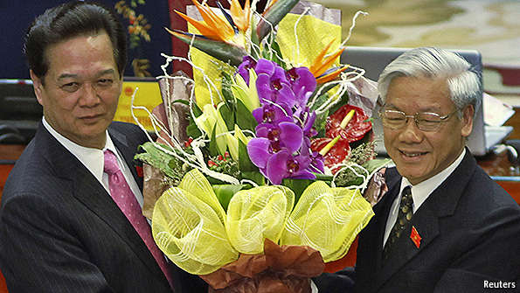

SHOULD all go to plan, America’s government will soon host an unlikely guest. Nguyen Phu Trong’s visit to Washington—perhaps as soon as July 6th—will be the first by a serving chief of America’s old enemy, the Communist Party of Vietnam (CPV). In theory Mr Trong is the most senior politician in his country (though not, in practice, the most powerful). His trip marks an upturn in relations between America and Vietnam, just as the latter’s dealings with China have soured. But where the new friendship leads will in part depend on the result of struggles in Vietnam. A party congress in a few months’ time could have a big impact on Vietnam’s policies at home and abroad.

America and Vietnam have had diplomatic ties for two decades, but growing cuddliness is a recent trend. America frets about Vietnam’s atrocious human-rights record, even if it may be improving (on June 27th Vietnam released a high-profile political prisoner, Le Quoc Quan, a human-rights lawyer—the latest of several high-profile dissidents to be freed). Yet it appreciates Vietnam’s enthusiasm for the American-led Trans-Pacific Partnership (TPP)—a proposed regional trade pact that would not, at least initially, include China. America is thought to be particularly keen to find a way for its naval ships to dock more freely at Cam Ranh Bay, a base on Vietnam’s southern coast.

For Vietnam the relationship is more urgent, and the stakes much higher. Last spring a state-owned Chinese company moved an oil-drilling rig into contested waters close to the Vietnamese coast, sparking anti-Chinese riots in parts of Vietnam’s central and southern provinces. Spooked by this assertiveness—and by a gaping trade deficit with its moody northern neighbour (see chart)—Vietnam has been seeking new friends. Last October it convinced America partially to lift a long-standing ban on arms sales to Vietnam. But this strategy still worries some conservatives in the CPV, who fear inflaming China further and who believe that America may be quietly trying to undermine the party.

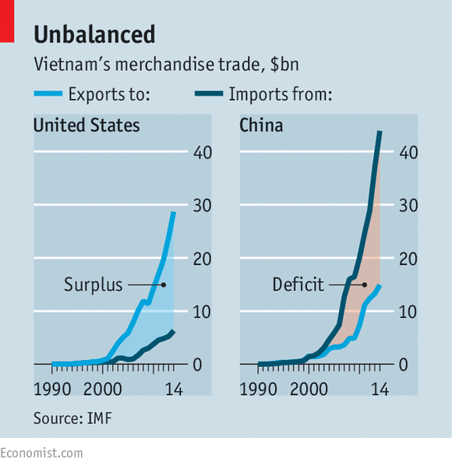

American officials paint Mr Trong’s visit as an exercise in “trust-building” between two countries still plagued by deep and troubled memories of their war, which ended 40 years ago. Mr Trong, however, may be thinking as much about burnishing the party’s credentials at home. Many ordinary Vietnamese worry that the CPV is too close to China’s Communist Party. His meeting with President Barack Obama may help to allay their suspicions that he and his ally, President Truong Tan Sang, have been soft on the Chinese.

Mr Trong may not be on the scene for much longer. He may well end up retiring after the party’s next five-yearly congress, which may take place in January or February. There, Vietnam’s three highest roles—party chief, president and prime minister, among whom power loosely circulates—will be dished out to three members of the 16-seat Politburo. Forecasting the result is difficult. But with public opinion tilting firmly against China, party factions seen to advocate a tougher line against the Chinese—and a friendlier one towards America, Japan, India and South Korea—look most likely to emerge as winners.

Their leader is Nguyen Tan Dung (pictured, above left, with Mr Trong) a self-styled economic reformer and the prime minister since 2006. Despite a poor record in fighting corruption, his government seems open to ideas from Western-educated Vietnamese. Mr Dung seems more eager than other leaders to promote reforms needed to boost feeble productivity growth, not least by pressing on with the part-privatisation of Vietnam’s many state firms—changes which the TPP would probably require. On June 26th the government said it planned to relax limits on ownership by foreigners in several industries.

In part through patronage, Mr Dung has greatly expanded his power: prime ministers are normally much weaker in Communist systems. His ties with provincial party heads and the bosses of state firms have enabled him to dominate the party’s 175-member Central Committee. But this does not necessarily mean Mr Dung will emerge victorious at the coming congress. Enemies will be looking for weaknesses, of which he has shown a few. Mr Dung suffered embarrassment in 2010 following a loan default by Vinashin, a state-owned shipping firm which was meant to be an exemplar of his reform agenda. In 2012 he narrowly survived a campaign by rivals in the Politburo to oust him. Yet he is still widely regarded as the country’s most capable and charismatic politician. China’s aggressive behaviour in the South China Sea, where the two countries are in bitter dispute over maritime boundaries, has strengthened his position by giving him a chance to assert his nationalist credentials.

Mr Dung has already served two terms as prime minister and is forbidden to seek a third. But he is thought to fancy the role of general secretary (Mr Trong’s job, at present). Winning that would probably allow Mr Dung to install one of two allies as prime minister: Nguyen Xuan Phuc, a deputy prime minister, or Nguyen Thi Kim Ngan, a deputy chairwoman of the country’s legislature, the National Assembly. Mr Dung’s camp may still face a challenger, however. President Sang may choose to keep his job, or he may retire and find an ally to replace him (Phung Quang Thanh, the defence minister, and Tran Dai Quang, who controls the police, are possibilities.)

But there is also speculation that Mr Dung may try to take on the posts of general secretary and president and toss a concession to his opponents by offering the premiership to a politician close to Mr Sang. That would mark a “major transition” in Vietnamese politics, says a foreign analyst. It would, ironically, make Vietnam’s political system more like China’s, where Xi Jinping enjoys unrivalled influence as both the country’s president and chief of the Communist Party.

Such a grab for power would make some in the party feel queasy. Mr Dung’s ambition and strong personality have long seemed in conflict with the CPV’s slow, consensus-based processes. But many think that perilous times call for decisive leadership. On June 25th a Chinese maritime authority announced that the state-affiliated oil rig that was moved close to Vietnam last year was again being positioned nearby (though this time just inside waters that are generally considered Chinese). The announcement is probably a sign that China is unhappy with Mr Trong’s decision to visit America; the rig’s next movements—towards or away from Vietnamese territory—will show how much displeasure China feels.

NYT

# Obama Hosts a Top Official From Vietnam at Oval Office

By JULIE HIRSCHFELD DAVISJULY 7, 2015

News Clips

#### Obama Hosts Vietnam Communist Leader

President Obama met with Nguyen Phu Trong, the head of Vietnam’s Communist Party, at the White House and praised the progress made in relations between the U.S. and Vietnam.

By Associated Press on Publish Date July 7, 2015. Photo by Stephen Crowley/The New York Times.

WASHINGTON — [President Obama](http://topics.nytimes.com/top/reference/timestopics/people/o/barack_obama/index.html?inline=nyt-per) said Tuesday that the United States and [Vietnam](http://topics.nytimes.com/top/news/international/countriesandterritories/vietnam/index.html?inline=nyt-geo) had moved beyond their “difficult history” and would move ahead on trade and security cooperation that could benefit both countries. He warmly welcomed the head of the nation’s Communist Party to the White House and spoke of a future visit to Vietnam.

Mr. Obama’s meeting with the Vietnamese official, Nguyen Phu Trong, was timed to mark the 20th anniversary of normalized relations between the onetime war enemies. It came 40 years after the fall of Saigon and reflected a deepening of the reconciliation between the United States and Vietnam.

It was also another opportunity for Mr. Obama, who announced last week that he was ready to restart diplomatic relations with another Cold War rival, Cuba, to showcase his determination to deal with adversaries through diplomacy rather than estrangement.

“I got an invitation to Vietnam, and I think this is indicative of the remarkable progress that’s taken place in the relationship between our two countries over the last 20 years,” Mr. Obama said in the Oval Office, sitting beside Mr. Trong. “I certainly do look forward to visiting your beautiful country sometime in the future.”

The warm words fell short of an official pledge to visit Vietnam during Mr. Obama’s presidency, and administration officials acknowledged privately that the vagueness was intentional.

Mr. Obama has made completion of the Trans-Pacific Partnership, a vast trade agreement spanning the Pacific Rim, a top priority for the remainder of his term, and ironing out differences with Vietnam — including its record of trampling on worker rights — is crucial to doing so.

Although Mr. Obama is scheduled to travel to Asia this fall for summit meetings, American officials are reluctant to commit him to a stop in Vietnam until it is clear that those gaps can be bridged.

“We discussed the Trans-Pacific Partnership, or T.P.P., and the enormous potential of a high-standards trade agreement that raises labor standards, raises environmental standards, and could potentially create significant job growth and prosperity for both the Vietnamese and the American people,” Mr. Obama said.

At the same time, Mr. Obama may have been reluctant to accept a direct invitation from Mr. Trong, who is not a head of state but the leader of Vietnam’s one-party government.

A group of Republican and Democratic members of Congress wrote to Mr. Obama this week asking him to send “a clear message to Hanoi authorities that respect for human rights is essential for a closer economic and security relationship.” They criticized the “authoritarian one-party system” over which Mr. Trong presides, and called the human rights situation in Vietnam “deplorable.”

Both Mr. Obama and Mr. Trong acknowledged the issue during their meeting.

“We discussed candidly some of our differences around issues of human rights, for example, and freedom of religion,” Mr. Obama said. “But what I’m confident about is that the diplomatic dialogue and practical steps that we are taking together will benefit both countries, that these tensions can be resolved in an effective fashion.”

Mr. Trong said the two men had talked about trade and human rights “in a constructive and candid manner.”

“There has been a bad, difficult chapter in our history,” Mr. Trong said, “but we have been able to rise above the past to overcome differences, to promote our shared interests, and look toward a future in order to build the comprehensive partnership that we have today. As I mentioned to the president in our meeting, the past cannot be changed, but the future depends on our action, and it is our responsibility to ensure a bright future.”

The United States and Vietnam have been pressed together in recent years by mutual wariness about a rising [China](http://topics.nytimes.com/top/news/international/countriesandterritories/china/index.html?inline=nyt-geo). In a joint statement they issued after their meeting on Tuesday, Mr. Obama and Mr. Trong expressed concerns about developments in the South China Sea, where China and Vietnam have clashed over territorial claims.

After the White House meeting, at a luncheon at the State Department, Vice President Joseph R. Biden Jr. marveled at the historic significance of Mr. Trong’s visit, saying he had first run for the Senate as a 29-year-old bent on ending the war in Vietnam.

### [The Opinion Pages](http://www.nytimes.com/pages/opinion/index.html) | Editorial

# Common Ground for Vietnam and the U.S.

By [THE EDITORIAL BOARD](http://www.nytimes.com/interactive/opinion/editorialboard.html)JULY 7, 2015

Photo



Credit Adam Maida

Forty-plus years after the Americans withdrew from Vietnam, and 20 years after the two countries re-established diplomatic relations, President Obama took the relationship to a new level on Tuesday by [hosting Nguyen Phu Trong](http://www.nytimes.com/2015/07/08/world/asia/obama-hosts-a-top-official-from-vietnam-at-oval-office.html), the head of Vietnam’s Communist Party, at the White House.

Because Mr. Trong doesn’t hold an official government post, diplomatic protocol did not necessarily call for a meeting with Mr. Obama. But, in spite of serious differences over human rights and labor rights, it made sense for Mr. Obama to bend the rules because Mr. Trong is Vietnam’s highest-ranking political leader and, along with other influential conservatives in that nation’s ruling party, has been the most resistant to closer relations with America.

The meeting showed Mr. Obama’s strong commitment to building deeper partnerships in Asia. The intent is to balance China’s growing economic, military and political clout and guarantee regional stability. Despite longstanding ties between Vietnam and China, many Vietnamese are anxious about China’s increasing assertiveness, especially in the South China Sea. In what Hanoi perceived as a challenge to its sovereignty, China last year temporarily parked an oil rig in waters claimed by Vietnam.

There are other reasons closer ties should be of mutual interest for Washington and Hanoi. Mr. Obama is trying to conclude a sweeping trade agreement, the Trans-Pacific Partnership, [as early as this month](http://www.nytimes.com/2015/07/07/business/international/trade-deal-negotiators-see-a-wrap-in-late-july.html) and Vietnam is among the dozen countries that are part of that negotiation. Some of the most difficult TPP-related disputes involve Vietnam. The deal would require it to curb the state’s role in business and improve labor and environmental standards in exchange for easier access to American markets for clothing and shoes. Within the last two years, Vietnam has become the United States’ largest trading partner in Southeast Asia, with two-way trade totaling $35 billion last year. That trade is projected to grow to $57 billion by 2020.

In June, the two countries agreed to expand [defense trade](http://www.defensenews.com/story/defense/policy-budget/budget/2015/06/01/us-vietnam-joint-vision-statement-signed-in-hanoi/28291963/), including possible coproduction of new technologies and equipment, joint operations between their navies and cooperation in global peacekeeping. There is also talk about once again giving the United States access to Vietnam’s ports.

In seeking closer ties with Vietnam, Mr. Obama has come under fire from [human rights groups](http://www.wsj.com/articles/obama-greets-vietnams-communist-party-chief-at-white-house-1436289002) and some Democrats in Congress who criticized Vietnam’s unfair labor practices and low wages. Such complaints are valid. Although the number of political prisoners has declined in recent years and Vietnam [ratified](http://cogitasia.com/vietnam-party-chiefs-historic-visit-to-washington-establishing-strategic-trust/) the United Nations convention against torture in 2013, more than 100 Vietnamese are still imprisoned on political charges, and dissent is suppressed.

Mr. Obama did not avoid these issues on Tuesday. Standing with Mr. Trong after the talks, Mr. Obama spoke publicly about the political differences — Vietnam is an [authoritarian](http://www.state.gov/j/drl/rls/hrrpt/2014/eap/236490.htm) one-party Communist state — and said they candidly discussed human rights and freedom of religion, although there was no mention of concrete progress.

Mr. Obama should continue to press Vietnam to open up its political system and allow its citizens greater freedoms, like letting workers organize or join independent unions of their choice. Tangible movement in such areas should be required before the United States lifts its ban on providing lethal weapons to Vietnam — like guns mounted on coast defense patrol boats — or before Mr. Obama sets a date to make an official visit to Mr. Trong’s country.

### [International Business](http://www.nytimes.com/pages/business/international/index.html)

# Trans-Pacific Partnership’s Potential Impact Weighed in Asia and U.S.

By [KEITH BRADSHER](http://topics.nytimes.com/top/reference/timestopics/people/b/keith_bradsher/index.html)JULY 8, 2015

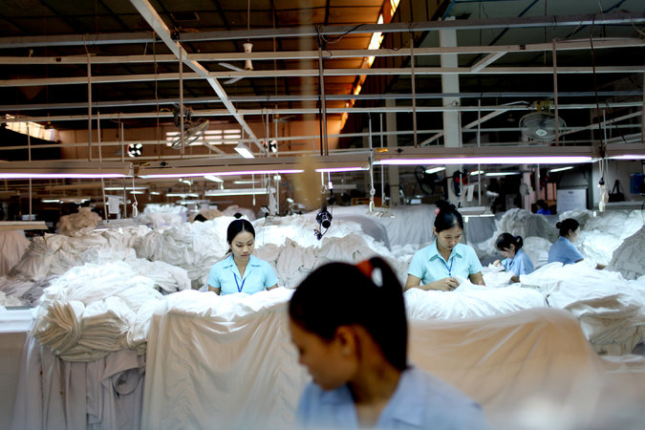

Workers sort through shirts headed for the Kingdom of Saudi Arabia on the assembly line of the Dai Viet Garment factory in Ho Chi Minh City, Vietnam. Credit Justin Mott for The New York Times

HONG KONG — Willie Fung, a leader in the world’s bra industry, knows just what he will do if negotiators from the United States and 11 Pacific Rim nations complete a Trans-Pacific Partnership trade agreement this summer.

He says he will catch a flight to Vietnam to look at possible locations for a new brassiere factory. Mr. Fung’s company, Top Form, has built factories in China, Thailand, Cambodia and Myanmar, countries that are not part of the planned trade deal. That makes him worry that they may become less competitive if Vietnam qualifies for extra-low tariffs and the United States eases access in other ways to its vast market.

As the trade talks move toward conclusion, Mr. Fung said, garment industry tycoons here in Hong Kong “ask ourselves the question, ‘What does it mean to us?’ ”

After a bitter fight, the House and Senate approved legislation last month to allow President Obama and his successor to submit the Pacific pact and a potential agreement with Europe to Congress for an up-or-down vote with no [filibusters](http://topics.nytimes.com/top/reference/timestopics/subjects/f/filibusters_and_debate_curbs/index.html?inline=nyt-classifier) or amendments permitted.

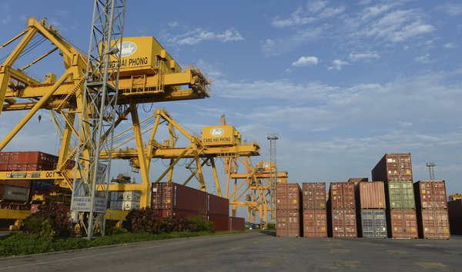

A shipping container yard in the northeastern coastal city of Hai Phong, Vietnam. Credit Agence France-Presse — Getty Images

The draft text of the agreement has not been released, but emerging details suggest that it could have a substantial effect on a variety of industries.

Banks from rich countries like the United States and Japan would have the right to be treated more like local banks in less affluent countries, including Peru, Malaysia and Vietnam. Japan would be required to let in more American farm goods. Makers of pharmaceuticals would have an extra tool to protect their patents abroad, limiting competition from less expensive generic drugs. Auto parts would move more smoothly around the Pacific, with fewer taxes.

The Obama administration has been pushing the trade pact as a way to write new rules not just for the 12 nations involved but also as an umbrella to someday cover many other countries — above all, China.

One set of provisions requires that state-owned enterprises become less secretive and receive fewer government subsidies in the form of low-rate loans, cheap or free land and other assistance. The clause is initially aimed at Vietnam — as well as Malaysia and Singapore to some extent — but it offers a signpost for the direction in which the United States wants China to move.

Some Asian economists, particularly those from China, are skeptical that the Trans-Pacific Partnership will have a profound effect on commerce in the region. He Weiwen, a former Chinese Commerce Ministry official who is now a director of the influential China-United States-[European Union](http://topics.nytimes.com/top/reference/timestopics/organizations/e/european_union/index.html?inline=nyt-org) Study Center at the China Association of International Trade in Beijing, said the potential expansion of trade from a possible China-led pact covering all of East Asia could be up to three times greater.

One shortcoming of the Trans-Pacific Partnership is that it has only one major consumer market, the United States, while the rest of the trading partners are essentially producers with limited demand for imported goods, said Terence Chong, who is the executive director of the Institute of Global Economics and Finance at the Chinese University of Hong Kong and is also a senior economist at Nanjing University in east-central China.

“There are not enough markets for the whole thing to develop — you need China as a market and producer,” he said. “You need more members; now it has only 12, but it may need 20.”

Such criticisms have not dissuaded the Obama administration from pushing ahead. One goal of the pact is to set streamlined rules on technical issues like standardizing the online processing of customs documents, a measure that could not only expedite shipments but also reduce the opportunities for bribing customs officials.

“The real impact, I think, is going to be on trade facilitation,” said Richard Vuylsteke, the president of the American Chamber of Commerce in Hong Kong.

The member countries of the new pact already have a series of bilateral free trade agreements and regional trade agreements that cover large chunks of their trade with each other. The two big exceptions are Japan, which has gone out of its way to protect its farmers, and Vietnam, which is embracing capitalism while remaining tightly controlled politically by its Communist Party.

But perhaps the single biggest driving force is geopolitical.

China has been making increasingly assertive claims of sovereignty over islands and seas close to Japan and Vietnam. That has left both countries willing to open their markets wider to trade with the United States, as a way to move further under the American security umbrella.

Vietnam in particular is trying to draw closer to the United States. Nguyen Phu Trong, the general secretary of Vietnam’s Communist Party and most powerful leader of the country, met with President Obama at the White House on Tuesday in the first such visit by a general secretary from his party.

Photo

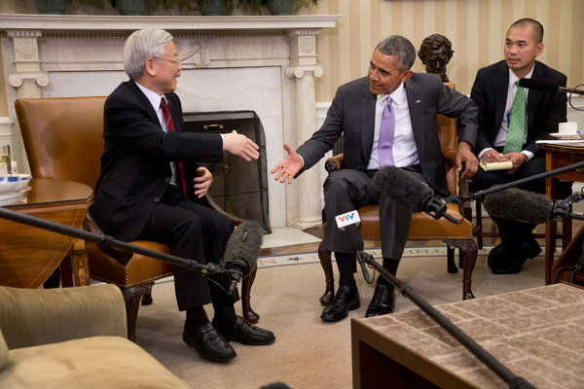

President Obama and Secretary Nguyen Phu Trong of Vietnam after a meeting in the Oval Office. The secretary said he shared Mr. Obama's concerns about maritime disputes in South China Sea. Credit Stephen Crowley/The New York Times

While the Trans-Pacific Partnership has 12 members, the trade agreement “is in large part a Japan story and a Vietnam story,” said Peter Petri, an international trade economist at Brandeis University outside Boston.

American executives are often criticized for being oblivious to foreign markets even as business leaders overseas pay close attention to international trade. But one unlikely outcome of the contentious debate in Washington is that many American executives are now focused on the pact, even as it has attracted far less attention among their Asian counterparts.

John G. Rice, General Electric’s vice chairman for global operations, said that if the Pacific trade deal were not completed and approved, and if the Export-Import Bank were not reauthorized by Congress, the combination of the two events “would serve to move the U.S. to the back seat when it comes to global trade, and in the front seat you’re going to see a number of countries, including China.”

The bra industry offers one specific sign of what some of the shifting trade patterns from a successful Trans-Pacific Partnership might mean.

As it turns out, a move of bra manufacturing from China and some of its Southeast Asian neighbors to Vietnam could have a modestly beneficial effect on textile makers in the United States. That is because the partnership is virtually certain to include a “yarn forward” rule, specialists said. Such a rule, already found in the [North American Free Trade Agreement](http://topics.nytimes.com/top/reference/timestopics/subjects/n/north_american_free_trade_agreement/index.html?inline=nyt-org), says that to qualify for low or zero tariffs while crossing borders within the regional trade pact, garments must be made from fabric woven in a member country, and that fabric must be made from yarn made in a member country.

Vietnam has low-cost labor but virtually no fabric production or yarn production, said Mr. Fung, who is the chairman of the Hong Kong Garment Manufacturers Association. The United States is the only country in the proposed trade zone with a cotton yarn industry or a cotton fabric industry of any size, and one of several countries in the pact with sizable production of synthetic fabric.

Freight costs to bring fabric from the United States to Asia are extremely low, largely because current trade flows across the Pacific lopsidedly consist of goods traveling from China to the United States. To avoid having shipping containers come back to Asia empty, freight companies accept very low rates for exporters in the United States who want to send cargo to Asia.

Foreign companies may eventually set up yarn and fabric factories in Vietnam. But this could take many years. The country has almost no one with the technical skills needed to operate and maintain the computerized equipment for these highly automated industries.

The Asian fabric industry is also dominated by mainland Chinese and Taiwanese companies, and they are worried about potential political risks if they establish operations in Vietnam.

When China set up an oil drilling rig early last year off the coast of central Vietnam, in waters claimed by both countries, industrial parks in Vietnam were [convulsed by rioting](http://www.nytimes.com/2014/05/16/world/asia/anti-chinese-violence-turns-deadly-and-spreads-in-vietnam.html) that led to the burning of hundreds of businesses owned by mainland Chinese and Taiwanese companies alike. That violence has left such companies wary of further investment.

“There’s just an unease from what has happened in the past,” said Bradley Gordon, a lawyer based in Phnom Penh.

Low freight rates and preferential trade terms mean that American fabric is likely to be highly competitive in Vietnam until new factories eventually emerge there, Mr. Fung said. Top Form, which he led for decades before retiring last November, and where he remains an influential director, buys most of its fabric from China, but it also buys some from the United States. And Top Form, like many such companies, has been looking for ways to reduce its dependence on mainland China as wages there have soared.

So garment makers may set up operations in Vietnam for shipments to the United States, while buying substantial quantities of American fabric to supply their factories, Mr. Fung said. And fabric is a big part of the overall cost.

“If I sell a $10 bra to the United States,” Mr. Fung said, “$5.50 of the cost is the fabric.”

# The Diplomat

# The Practicalities of US Military Sales to Vietnam

Despite converging strategic and economic interests, expect a slow start to U.S. military sales to Vietnam.

By Eric Tegler

August 05, 2015

During his early July visit to Washington DC, Nguyen Phu Trong, general secretary of Vietnam’s Communist Party, did at least two highly symbolic things.

He spent over an hour – more time than scheduled – meeting with President Barack Obama at the White House. The following day, in a speech he gave at the Center for Strategic and International Studies he said, “A fast changing world requires ourselves (sic) to be exposed to new ways of thinking and new ways of action.”

A few extra minutes with the president and musing about change might not seem like much when set against the shear novelty of the Vietnamese Communist Party secretary general actually visiting D.C., but these examples speak to the pragmatism which will make the once unthinkable sale of American weapons systems to Vietnam a reality. What’s driving it?

The obvious answer is China. But it’s not the only answer. Consider that, as Trong pointed out, the United States — not China — is Vietnam’s largest trading partner. In 2014, that trade amounted to $36 billion. In this context, prospective American foreign military sales (FMS) to Vietnam are merely an expansion of the two countries’ existing trade relationship.

As Vietnam’s largest single-country export market ($19.7 billion worth in the first half of 2015), the United States might reasonably expect the trade balance to even slightly as Vietnam’s economy grows. The country has outperformed America in expansionary terms with average GDP growth at 6.15 percent from 2000-2015. Economic growth surely benefits Vietnamese defense spending but only at the margin, since the nation’s defense budget remains at less than two percent of GDP.

Of course, China cannot be dismissed. Vietnam runs a hefty trade deficit with its gigantic neighbor — through June 2015 China exported $24.22 billion in goods and services to Vietnam, an increase of 23.2 per cent over the first half of 2014.

Trong recently summed up his country’s geographic and strategic reality, saying, “China is a big neighbor. So whether we like it or not, we still have to live close to that country. We don’t have the right to select a neighbor.”

Vietnam eyes China warily, however. As noted Asian affairs expert, Carl Thayer puts it, “They acknowledge China’s supremacy but aim to have Vietnam’s autonomy respected.”

Thayer, emeritus professor at the University of New South Wales at the Australian Defense Force Academy, has visited Vietnam twice this year and was returning from Hanoi when he spoke with *The Diplomat*. He explains Vietnam’s relations with China and the United States as part of its post-Cold War historical pattern of foreign policy diversification.

“Vietnam presents itself as irresistibly attractive to Great Powers,” Thayer says. “Yet it’s careful not to be taken into the orbit of any one. It tries to manipulate them so all feel compelled to center on Vietnam for fear of losing out.”

While China is Vietnam’s preeminent strategic partner, Russia, India, and Japan follow in that order. The U.S. has only signed a “comprehensive agreement” with Vietnam, placing it a tier below. Thayer maintains that this layered, multi-lateral foreign policy is key to understanding Vietnam’s approach to U.S. relations and arms agreements. In so many words, strategic partners (notably Russia, which has a virtual monopoly) get first crack at selling Vietnam weapons systems.

Recent Russian sales of *Kilo* submarines, *Gepard*-Class frigates and Club-S submarine-to-surface missiles affirm the acquisition hierarchy, as does Vietnamese interest in Indian/Russian BrahMos cruise missiles. China too, sells extensively in the Southeast Asian marketplace. But recent events and a demographic shift within Vietnam itself are increasing the likelihood that it will take advantage of the partial lifting of the ban on American arms sales.

“I think the desire in the U.S. to put the ghosts of the past behind it is combining with hard national interests on both sides, partly in response to perceived Chinese coercion,”   Gregory Poling of the Center for Strategic and International Studies opines.

The coercion of which Poling speaks stems from China’s 2014 deployment of the Haiyang Shiyou 981 (HD-981) oil rig in the South China Sea near Vietnam. The incident reinforced anti-Chinese feeling within Vietnam and put China-friendly Communist Party conservatives on the defensive.

“What the rig did was open a window of time in which it was not politically okay to argue against more rapprochement with the U.S. or others,” Poling points out. “It created a months-long period where the pro-Beijing crowd in Hanoi were sidelined.”

Carl Thayer agrees that a level of “strategic trust” was lost between the Party elites in Vietnam and China. That trust was already low among newer generations of Vietnamese.

“Anti-China feeling is extraordinarily widespread among the educated youth of Vietnam,” Thayer says flatly. “Once you get below 50 years of age, people are quite angry over the South China Sea.”

The redeployment of the rig to waters slightly farther from Vietnam by the China National Offshore Oil Cooperation this June certainly hasn’t impressed ordinary Vietnamese. Its symbolism — coming just weeks before the general secretary’s first visit to Washington — was clear.

A new generation of Party and political leaders is set to assume power in Vietnam, where the mandatory retirement age of 65 will see its more conservative elites exit stage right. That generation will be more favorably disposed to the United States, but its pragmatism toward China will promote slow change in arms-sourcing.

Practicalities will also mean slow going, Gregory Poling cautions. So byzantine is the U.S. system for accessing FMS, that for a nation with no experience (not only with the U.S., but with NATO-compatible procurement) Vietnam will have to be taught how to go about deciding what it wants and making the requests. The first acquisitions will likely be maritime systems. The Vietnamese Coast Guard is the region’s third largest after Japan, ahead of neighbors like Malaysia and the Philippines.

Lockheed Martin and Boeing reps recently visited Vietnam, raising the possibility of coastal radar or communications systems sales. Thayer sees potential consideration for a range of systems from a stripped-down P-3 Orion to helicopters and C3I systems. Poling views aircraft and ships as second-generation type of acquisitions and cautions that Vietnam has acquired radar systems from Israel in the last couple of years. He adds that even if the U.S. can offer higher quality systems at a competitive price, the challenge of integrating new logistics and training to accommodate them may dissuade the Vietnamese.

“The problems become apparent when you look at neighbors like Malaysia who have split their equipment between Russian and NATO-compatible. It’s hugely inefficient and very costly,” Poling says.

However the forces driving the Vietnamese to counter-balance China (which has yet to complain publicly about the prospect of U.S. arms sales) may lead to a more sophisticated defense acquisition relationship with the United States, Thayer asserts:

“It could well be that aside from just buying [weapons systems] off the shelf, Vietnam is looking for a long term working relationship with American defense industry to help develop, transfer technology and co-produce.”

None of it will happen overnight (Gregory Poling puts the first arms sales deal in 2016 at the earliest) and any acquisition will unfold within the context of the Party’s five-year planning.

Still, the confluence of Vietnamese and American strategic and economic interests is, in effect, inspiring “the new ways of thinking and new ways of action” Secretary Trong referenced.

Eric Tegler is a regular contributor to Aviation Week & Space Technology, Popular Mechanics, Wired, and Faircount Media Defense on political, government, and military affairs.

# Vietnam Faces Last-Minute Maneuvering for Communist Party Leadership

By MIKE IVESJAN. 18, 2016

Photo

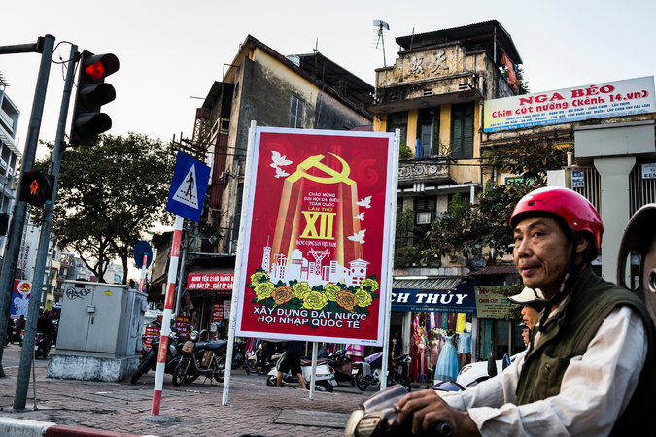

A banner in Hanoi, Vietnam, for the party congress set to begin Wednesday. Credit Aaron Joel Santos for The New York Times

Advertisement

[Continue reading the main story](http://www.nytimes.com/2016/01/19/world/asia/vietnam-communist-party-congress.html?emc=edit_ae_20160118&nl=todaysheadlines-asia&nlid=64888777#story-continues-1)

[Continue reading the main story](http://www.nytimes.com/2016/01/19/world/asia/vietnam-communist-party-congress.html?emc=edit_ae_20160118&nl=todaysheadlines-asia&nlid=64888777#story-continues-1) Share This Page

* [Email](javascript:;)
* [Share](javascript:;)
* [Tweet](javascript:;)
* [Save](javascript:;)
* [more](javascript:;)

[Continue reading the main story](http://www.nytimes.com/2016/01/19/world/asia/vietnam-communist-party-congress.html?emc=edit_ae_20160118&nl=todaysheadlines-asia&nlid=64888777#story-continues-1)

HANOI, Vietnam — Soon after becoming the American ambassador to [Vietnam](http://topics.nytimes.com/top/news/international/countriesandterritories/vietnam/index.html?inline=nyt-geo) in 2007, Michael W. Michalak approached Nguyen Tan Dung, the country’s new prime minister, at a gala dinner and mentioned that human rights were among the American government’s highest priorities in Vietnam.

“You could see his face just freeze,” Mr. Michalak, now the senior vice president of the U.S.-Asean Business Council, recalled with a chuckle. Mr. Michalak quickly told Mr. Dung that he wanted to toast his health and make a friendly suggestion: The caterers should serve American beef at the next such diplomatic event.

“He just cracked up, and we started drinking vodka,” Mr. Michalak said. “And ever since then, at every one of these dinners, he always would make sure to have a shot of vodka with me.”

On Wednesday, Vietnam’s ruling Communist Party is to convene its national congress, which meets every five years to select the country’s top leaders. And Mr. Dung, a charismatic prime minister who favors closer ties with the United States, is battling to succeed Nguyen Phu Trong, a conservative apparatchik looking to stay on in the party’s top job of general secretary, according to several analysts, diplomats and business leaders.

Photo

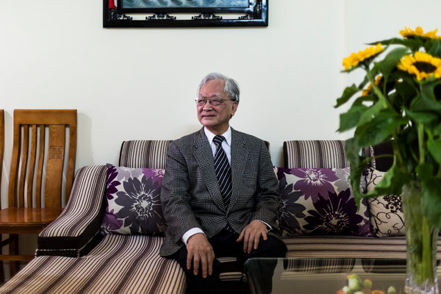

Bui Kien Thanh, an American-educated businessman who has advised Nguyen Tan Dung and other Vietnamese prime ministers on economic policy. Credit Aaron Joel Santos for The New York Times

The outcome of these congresses is usually settled months in advance, but a protracted spat between factions loyal to Mr. Dung and Mr. Trong has resulted in last-minute maneuvering. Whoever comes out on top could determine the future of Vietnam’s carefully calibrated strategic balance between China, its ideological ally and main trading partner, and the United States, which the party elite increasingly considers an important counterweight against growing Chinese influence in the region.

Mr. Dung, who is finishing his second term as prime minister, won praise among Vietnamese for [denouncing China’s decision](http://www.nytimes.com/2014/05/12/world/asia/vietnam.html) to move an oil rig into disputed waters near Vietnam’s coast in May 2014, and he is considered a champion of market-oriented policies who has developed warm personal relationships with top American officials.

By contrast, Mr. Trong, the party’s general secretary since 2011, appeared reluctant to criticize China in the [oil rig dispute](http://www.nytimes.com/2014/06/19/world/asia/china-vietnam-meet-on-territorial-dispute.html), and he is seen as a more forceful proponent of the state’s role in the economy and defender of the party’s monopoly on power. But he also steered Vietnam into the Trans-Pacific Partnership, an American-led trade agreement among a dozen Pacific Rim nations that excludes China.

“If the conservative faction emerges the winner at this party congress, the U.S. may find that it would need to do even more trust-building with Hanoi” than it has done lately, said Phuong Nguyen, an associate fellow at the Center for Strategic and International Studies in Washington.

“Trade and investment ties are expected to still forge ahead if the T.P.P. is ratified,” she said, but she predicted that it would be more difficult for Washington to expand military ties with Vietnam if Mr. Trong’s faction were to prevail.

At 66, Mr. Dung is five years younger than Mr. Trong. But according to a longstanding rule, the age limit for a member of the Politburo to start a new term is 65. The leadership can grant an exception, however, and Mr. Dung has been angling for one so he can succeed Mr. Trong as the party’s general secretary, several Vietnamese political observers have said in recent months.

That prospect, once considered almost inevitable, has come to seem less likely in recent days as Mr. Trong and his supporters have sought to force Mr. Dung into retirement, analysts said. The apparent turnaround has caused concern among Vietnam’s urban intellectuals, many of whom view Mr. Dung as the best hope for further integration into the global economy and curbing Chinese influence in the region.

“Dung doesn’t have many allies in the Politburo, and it’s very hard for him to change the status quo, so we are worrying,” said a Vietnamese academic at a state-affiliated institution, who spoke on the condition of anonymity to discuss a sensitive political matter.

While Mr. Trong’s supporters are said to have the upper hand in the elite, 16-member Politburo, they are worried that Mr. Dung, an unusually dynamic prime minister, has undercut the party leadership by strengthening government institutions and building a vast patronage network among provincial party bosses and in the 175-member Central Committee.

One chain of events that has been discussed in recent days is that the party’s top four leaders, including Mr. Dung and Mr. Trong, will retire and cede power to a younger crop of Politburo members, apparently in a victory for Mr. Trong’s camp. Some analysts said Mr. Trong may even remain in his post for another year or two to keep a lid on tensions inside the party elite.

It is not entirely clear how the leadership shuffle will affect Vietnam’s warming relationship with the United States, or its efforts to assert its economic independence and sovereignty over parts of the South China Sea without angering China.

In May 2014, the Chinese oil rig episode set off street protests in some cities that were initially tolerated — some said encouraged — by the government, and then riots at industrial parks in central and southern provinces. Mr. Dung, unlike other party leaders, responded to the Chinese move with denunciations of Beijing’s territorial ambitions that appealed to Vietnamese patriotism.

Relations between the Communist neighbors have since recovered somewhat, and Mr. Dung shook hands with President Xi Jinping of China when he visited Hanoi in November. But many Vietnamese object to China’s island-building projects in disputed waters, viewing them as reminders of Chinese imperial conquests of Vietnam. They also resent China’s economic influence here, in the form of growing trade, tourism and infrastructure projects.

At the beginning of January, Vietnam formally accused China of violating its sovereignty, as well as a recent confidence-building pact, after Beijing [landed a plane](http://www.reuters.com/article/us-vietnam-china-protests-idUSKBN0UG0FA20160103) on one of the artificial islands built by the Chinese.

Photo

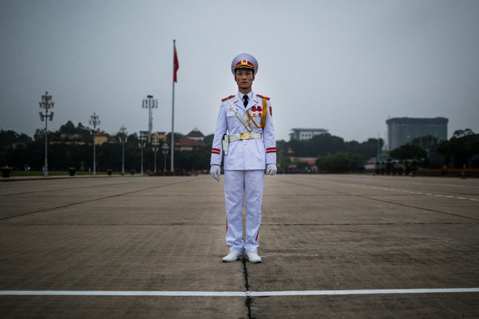

A soldier standing guard at the Ho Chi Minh Mausoleum, across the street from Parliament in Hanoi. Credit Aaron Joel Santos for The New York Times

Mr. Dung’s economic record has been marred by scandals at state-owned enterprises and a bout of debilitating inflation. Yet he is still widely seen as the party’s strongest proponent of opening the Vietnamese economy to more foreign investment and competition, and of Vietnam’s membership in the T.P.P.

“Until now, none of our leaders did much to internationalize Vietnam, but Dung is different — he stands out,” said Nguyen Viet Ha, who runs a chemical-trading company in Hanoi. “Before, we depended on China a bit more, and now we’re a bit more independent and have access to Western technology.”

Bui Kien Thanh, an American-educated businessman who has advised Mr. Dung and other prime ministers on economic policy, acknowledged that such policies had left Mr. Dung open to criticism. “A lot of people say Nguyen Tan Dung is an American ally and so on, but that is only talk,” he said. “Nguyen Tan Dung sees very well that economic opening cannot go without good relations with the U.S.”

Other analysts and business leaders said relations with the United States would remain on an upward swing even if Mr. Dung were forced to retire. Mr. Trong’s visit to the White House in July — the first by a Vietnamese Communist Party boss — was a clear sign of a growing consensus across party factions that better relations with the United States is in Vietnam’s national interest, they said.

Mr. Michalak, the former American ambassador, said Vietnam’s relationship with China had “dropped down a few degrees” since the oil rig dispute. “I don’t think that’s going to change anytime soon no matter what government gets in” at the congress, he added.

The United States, meanwhile, eased a longstanding ban on the sale of lethal arms to the country in October 2014, saying there have been incremental improvements in Vietnam’s human rights record.

But human rights activists have pushed back against that narrative, and many said they expect no improvement in civil liberties as a result of the leadership transition.

[Le Cong Dinh](http://www.nytimes.com/2010/01/21/world/asia/21vietnam.html), a prominent human rights lawyer now under house arrest in Ho Chi Minh City, said in a New Year’s Eve message on Facebook to his supporters that he was “totally indifferent” to the outcome of the nine-day party congress. “They haven’t proven what they’ve done or will do for our nation, aside from running back and forth for the sake of their and their comrades’ ‘chairs’ and ‘rice pots,’ ” he wrote, using slang for jobs and income.

NYT

# Shift in Vietnam’s Leadership as Party Boss Apologizes

By [SETH MYDANS](http://topics.nytimes.com/top/reference/timestopics/people/m/seth_mydans/index.html)JAN. 19, 2011

HANOI, Vietnam — The ruling Communist Party ended a major congress Wednesday with the announcement of several changes in the country’s hierarchy, and what amounted to an apology by the party’s chief for the performance of the nation’s leaders over the past five years.

“I myself, to some extent, haven’t met the expectations of the people and the Communist members,” said the outgoing general secretary, Nong Duc Manh, in closing remarks to the assembled congress.

“And I honor the reports that you heard over the days that pointed out our shortcomings in the leadership, for the party’s Central Committee, and I also take my responsibility,” he added.

As his successor as party leader, the congress named Nguyen Phu Trong, 66, who has been an unusually assertive chairman of [Vietnam](http://topics.nytimes.com/top/news/international/countriesandterritories/vietnam/index.html?inline=nyt-geo)’s National Assembly.

Prime Minister Nguyen Tan Dung, 61, was expected to keep his job, although he had come under criticism for his economic policies and a recent scandal involving the near collapse of a major state-owned shipping company. That appointment, widely reported in Hanoi, would need to be confirmed at a session of the National Assembly to be held soon.

Vietnam’s economy continues to expand rapidly, with growth this year of about 7 percent of gross domestic product. Yet double-digit inflation has driven up the prices of food and basic commodities, and it is suffering deficits in current accounts, trade and the budget.

Carlyle Thayer, an analyst in Australia who closely follows the workings of the Vietnamese Communist Party and government, said there would be both old and new faces in the ruling Politburo.

“Of the outgoing 15-member Politburo, six members were dropped and nine retained. This is a retention rate of 60%. The Politburo is being expanded to 17, so there will be 8 new members (47 percent),” he wrote in an e-mailed analysis.

This is not the first time Mr. Manh, 70, has issued a mea culpa at a party congress. Five years ago, he concluded his first term in office with a bleak portrayal of the state of the nation.

The question now is how much will and power the party has to act on the problems that it acknowledges and to implement its policies in a system hemmed in with personal and political agendas and permeated with corruption.

According to Mr. Thayer, who works at the Australian Defense Force Academy at the University of New South Wales in Sydney, Vietnam’s most important domestic issue is a decision on whether to continue to pursue high economic growth or to concentrate on structural problems. “If Vietnam can’t start paying its debts and defaults and ratings go south, isn’t it better to rein it in?” he said in a telephone interview.

NYT

# Vietnam’s Communist Party Gives Old-Guard Leader a New 5-Year Term

By MIKE IVESJAN. 27, 2016

Photo

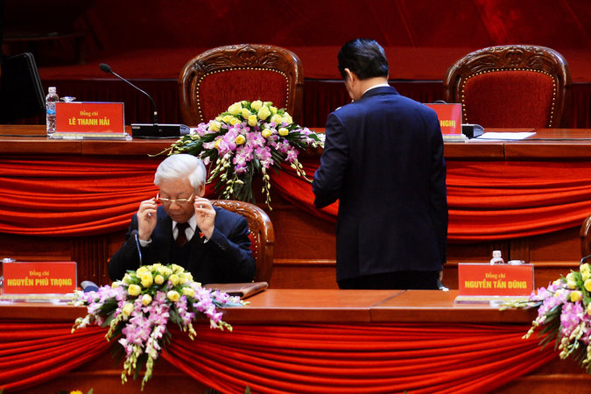

General Secretary Nguyen Phu Trong of Vietnam, left, with Prime Minister Nguyen Tan Dung at the Communist Party’s national congress in Hanoi, a day before Mr. Trong’s reappointment. Credit Hoang Dinh Nam/Agence France-Presse — Getty Images

HANOI, Vietnam — The Communist Party of Vietnam has chosen the incumbent general secretary as the country’s top leader for a second five-year term, the official [Vietnam](http://topics.nytimes.com/top/news/international/countriesandterritories/vietnam/index.html?inline=nyt-geo) News Agency reported Wednesday.

The reappointment of Nguyen Phu Trong, 71, could slow the pace of Vietnam’s shift to a more open, market-oriented economy, but it is unlikely to alter its strategic balance in relations with China and the United States, analysts said.

Mr. Trong is a leader of the party’s old guard, which was trained in Soviet-style economics and has long seen neighboring China, Vietnam’s top trading partner, as a critical strategic and ideological ally. Notably, Mr. Trong appeared reluctant to criticize China when it [deployed an oil rig in disputed waters](http://www.nytimes.com/2014/06/19/world/asia/china-vietnam-meet-on-territorial-dispute.html) in 2014.

## [Shift in Vietnam’s Leadership as Party Boss ApologizesJAN. 19, 2011](http://www.nytimes.com/2011/01/20/world/asia/20viet.html)

But his visit to the White House last July underlined a growing view among party elites that developing better relations with the United States is in Vietnam’s national interest, and an essential counterweight to China’s influence in the region. Mr. Trong steered Vietnam into the Trans-Pacific Partnership, an American-led trade agreement among a dozen Pacific Rim nations that excludes China.

Vu Xuan Nguyet Hong, a former vice president of Vietnam’s Central Institute for Economic Management, said the party’s 19-member Politburo, which has more power than any single politician, was in broad agreement on the need for both domestic economic changes and better relations with the United States.

“The reforms and renovation toward the market economy will continue,” and Vietnam’s relations with the United States will improve at a steady speed, she said.

But Mr. Trong’s reappointment will send the United States-friendly prime minister, Nguyen Tan Dung, a rival who had [reportedly sought the general secretary job](http://www.nytimes.com/2016/01/19/world/asia/vietnam-communist-party-congress.html?_r=0), into not-so-early retirement later this year.

As prime minister, Mr. Dung has overseen a wave of foreign investment and cultivated warm relations with top American officials, diplomats and analysts said. He has also spoken out more forcefully than other party leaders against China’s assertive claims to territory in the South China Sea and won support from ordinary Vietnamese who believe the country needs to escape China’s orbit as a way of securing its economic independence.

When China towed a giant oil rig into contested waters of the South China Sea near Vietnam’s central coast [in May 2014](http://www.nytimes.com/2014/05/09/world/asia/china-and-vietnam.html), anti-China demonstrations erupted in Vietnamese cities, and rare riots broke out in several industrial zones. The United States later eased a longstanding ban on lethal weapons sales to Vietnam, although Russia still supplies the vast majority of Vietnam’s military equipment.

Mr. Dung, 66, is technically barred from serving another term under party rules because he is over 65 and has already served two terms as prime minister. Mr. Trong is also ineligible because he is over the age limit, but the party has apparently granted him a special exemption, for a second time.

Several analysts predicted that the pace of Vietnam’s already sluggish economic liberalization may slow further after Mr. Dung retires this year, in part because he has a better understanding than Mr. Trong of how to communicate with foreign investors and has been more eager to shake off the party’s Marxist-Leninist ideological mantle.

Tuong Vu, a political scientist at the University of Oregon, said Mr. Trong would probably be more receptive to hard-line party apparatchiks who argue against opening the country’s state-dominated agricultural and service sectors to foreign competitors and against a draft law that would codify rights for nongovernmental associations in Vietnam.

Both changes are seen as critical to bringing Vietnam into compliance with the Trans-Pacific Partnership. If approved by its member legislatures, that deal will require Vietnam to further open its economy to foreign competition and make concessions on labor rights, on intellectual property and in other areas.

“All factions agree on a need to have more trade and investment,” Professor Vu said in a telephone interview. “But the Trong faction would resist any concessions, whereas the Dung faction would try to make the gesture of reform to keep money coming in.”

Sami Kteily, executive chairman of PEB Steel, a construction company in Ho Chi Minh City, said that the country’s membership in several recent trade agreements underlined its commitment to being an active member of the global economy.

“I think it will be business as usual,” he said. “Vietnam is a country of institutions and policies not determined by one person.”

Frederick Burke, managing partner for Vietnam at the American law firm Baker & McKenzie, said that the smooth leadership transition at this week’s party congress was encouraging because it highlighted the country’s political stability and respect for the rule of law.

“For people who live here, that’s what you want,” he said. “You don’t want a virtual civil war going on.”

In recent weeks there has been a flurry of political gossip and speculation on Vietnamese-language blogs and Facebook threads — some of it fueled by reports in the foreign news media — about an intraparty turf war between reformist and conservative party factions.

But Mr. Burke said that there was far more consensus within the Communist Party than the news media or some political observers suggest and that Mr. Trong had never shown regressive or conservative tendencies as a leader.

“People are trying to make up a stage play, but the script is actually different from the reality,” he said.