The Economist

**China**

**What China wants**

**After a bad couple of centuries, China is itching to regain its place in the world. How should America respond?**

Aug 23rd 2014 | [From the print edition](http://www.economist.com/printedition/2014-08-23)

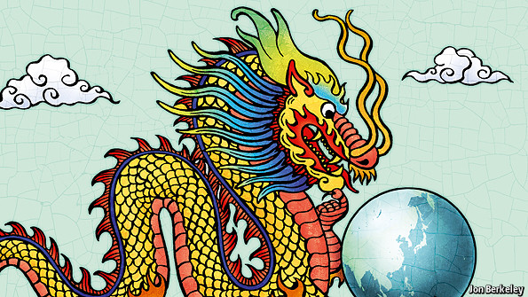

AN ALARMING assumption is taking hold in some quarters of both Beijing and Washington, DC. Within a few years, China’s economy will overtake America’s in size (on a purchasing-power basis, it is already on the cusp of doing so). Its armed forces, though still dwarfed by those of the United States, are growing fast in strength; in any war in East Asia, they would have the home advantage. Thus, some people have concluded, rivalry between China and America has become inevitable and will be followed by confrontation—even conflict.

Diplomacy’s task in the coming decades will be to ensure that such a catastrophe never takes place. The question is how?

Primacy inter pares

Some Western hawks see a China threat wherever they look: China’s state-owned businesses stealing a march in Africa; its government covering for autocrats in UN votes; its insatiable appetite for resources plundering the environment. Fortunately, there is scant evidence to support the idea of a global Chinese effort to upend the international order. China’s desires have an historical, even emotional, dimension. But in much of the world China seeks to work within existing norms, not to overturn them.

In Africa its business dealings are transactional and more often led by entrepreneurs than by the state. Elsewhere, a once-reactive diplomacy is growing more sophisticated—and helpful. China is the biggest contributor to peacekeeping missions among the UN Security Council’s permanent five, and it takes part in anti-piracy patrols off the Horn of Africa. In some areas China is working hard to lessen its environmental footprint, for instance through vast afforestation schemes and clean-coal technologies.

The big exception is in East and North-East Asia—one of the greatest concentrations of people, dynamism and wealth on Earth. There, both its rhetoric and its actions suggest that China is unhappy with *Pax Americana*. For centuries China lay at the centre of things, the sun around which other Asian kingdoms turned. First Western ravages in the middle of the 19th century and then China’s defeat by Japan at the end of it put paid to Chinese centrality. Today an American-led order in the western Pacific perpetuates the humiliation, in the eyes of Chinese leaders. Soon, they believe, their country will be rich and powerful enough to seize back primacy in East Asia.

China’s sense of historical grievance explains a spate of recent belligerence. China has deployed ships and planes to contest Japan’s control of islands in the East China Sea, grabbed reefs claimed by the Philippines in the South China Sea and moved an oil rig into Vietnam’s claimed exclusive economic zone. All this has created alarm in the region. Some strategists say America can keep the peace only if it is firm in the face of Chinese expansionism. Others urge America to share power in East Asia before rivalries lead to a disaster.

America cannot walk away without grave consequences for the region and its own standing. Since the end of the second world war, American security has been the basis of Asian prosperity and an increasingly liberal order. It enabled Japan to rise from the ashes without alarming its neighbours. Indeed, China’s race to modernity could not have happened without it. Even Vietnam, America’s old foe, is clearer than ever that it wants America’s stabilising, reassuring presence.

Yet, if the liberal order is to survive, it must evolve. Denying the reality of China’s growing power would only encourage China to reject the world as it is. By contrast, if China can prosper within the system, it will reinforce it. That is why the United States needs to acknowledge one increasingly awkward aspect of its leadership: American advantage is hard-wired into the system in ways that a rising power might justifiably resent.

For a great power to find a new equilibrium with an emerging one is hard—because every adaptation looks like a retreat. Three principles should guide America.

First, it should only make promises that it is prepared to keep. On the one hand, America would be foolish to draw red lines around specks of reef in the South China Sea. On the other, if America is to count for anything, its allies need to know that they can depend on it. Although Taiwan is central to China’s sense of its own honour, America should leave Beijing in no doubt that it would come to the island’s defence.

Second, even in security, America must make room. China’s participation in America’s recent RIMPAC naval exercises off Hawaii was a start. China could be invited to join Asian exercises, including for disaster relief. And America should avoid a cold-war battle for the loyalty of regional powers.

Lastly, America will find it easier to include China in new projects than to give ground on old ones—and should make more effort to do so. It is nonsensical that America should be leading the formation of the region’s biggest free-trade area, the Trans-Pacific Partnership, without the inclusion of the region’s largest economy. And there is no reason to exclude China from co-operation in space. Even during the cold war American and Soviet astronauts worked together.

Let the dragon in

Why should China be satisfied with a bit more engagement when primacy is what it seeks? There is no guarantee that it will be. Just now the rhetoric coming out of Beijing is full of cold-war, Manichean imagery. Yet sensible Chinese understand that their country faces constraints—China needs Western markets, its neighbours are unwilling to accept its regional writ and for many more years the United States will be strong enough militarily and diplomatically to block it. And in the longer run, the hope is that the Chinese system will of itself adapt from one-party rule to some more liberal polity that, by its nature, is more comfortable with the world as it now is.

Drawing China into a strengthened regional framework would not be to cede primacy to it. Nor would it be to abandon a liberal order that has served Asia—and America—so well. It may, in the end, not work. But given the huge dangers of rivalry, it is essential now to try.

What China Wants

8/23/2014

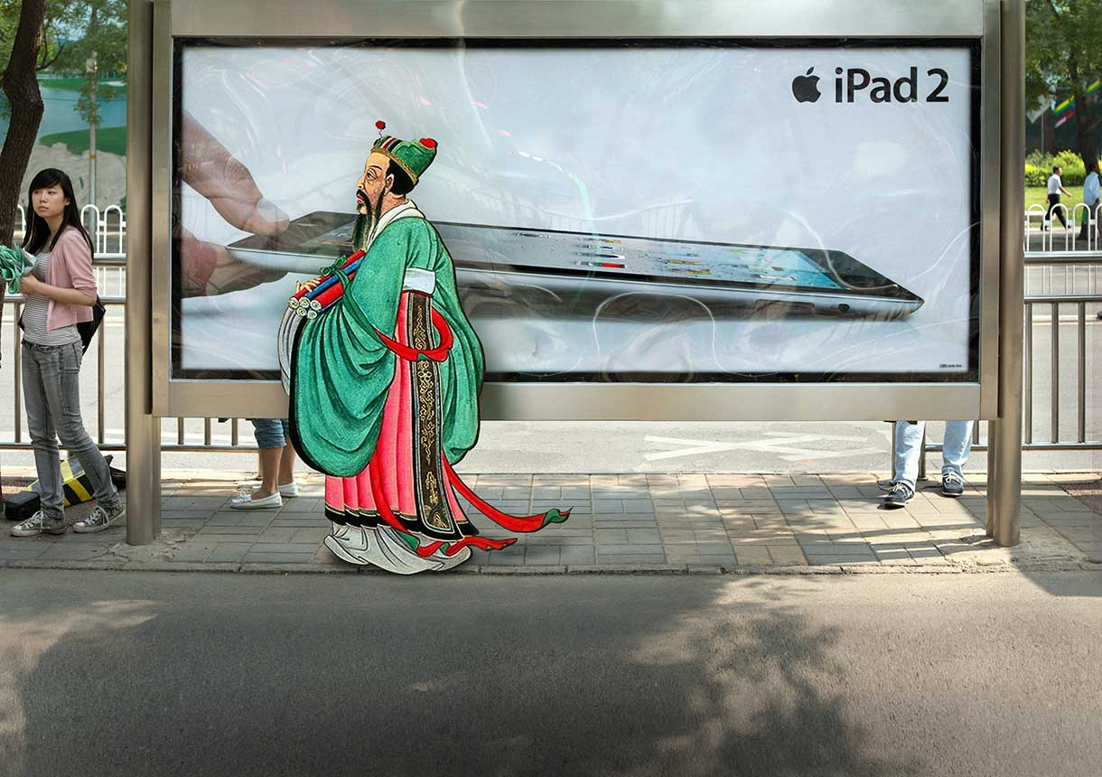

As China becomes, again, the world's largest economy, it wants the respect it enjoyed in centuries past. But it does not know how to achieve or deserve it

MATTHEW BOULTON, James Watt’s partner in the development of the steam engine and one of the 18th century’s greatest industrialists, was in no doubt about the importance of Britain’s first embassy to the court of the Chinese emperor. “I conceive”, he wrote to James Cobb, secretary of the East India Company, “the present occasion to be the most favourable that ever occurred for the introduction of our manufactures into the most extensive market in the world.”

In light of this great opportunity, he argued, George Macartney’s 1793 mission to Beijing should take a “very extensive selection of specimens of all the articles we make both for ornament and use.” By displaying such a selection to the emperor, court and people, Macartney’s embassy would learn what the Chinese wanted. Boulton’s Birmingham factories, along with those of his friends in other industries, would then set about producing those desiderata in unheard-of bulk, to everybody’s benefit.

That is not how things turned out. The emperor accepted Macartney’s gifts, and quite liked some of them—a model of the Royal Sovereign, a first-rate man o’ war, seemed particularly to catch his fancy—but understood the whole transaction as one of tribute, not trade. The court saw a visit from the representatives of King George as something similar in kind to the opportunities the emperor’s Ministry of Rituals provided for envoys from Korea and Vietnam to express their respect and devotion to the Ruler of All Under Heaven. (Dealings with the less sophisticated foreigners from inner Asia were the responsibility of the Office of Barbarian Affairs.)

"We have never valued ingenious articles, nor do we have the slightest need of your country’s manufactures"

The emperor was thus having none of Macartney’s scandalous suggestion that the Son of Heaven and King George should be perceived as equals. He professed himself happy that Britain’s tribute, though admittedly commonplace, should have come from supplicants so far away. But he did not see it as the beginning of a new trading relationship: “We have never valued ingenious articles, nor do we have the slightest need of your country’s manufactures…Curios and the boasted ingenuity of their devices I prize not.” Macartney’s request that more ports in China be opened to trade (the East India Company was limited to Guangzhou, then known as Canton) and that a warehouse be set up in Beijing itself was flatly refused. China at that time did not reject the outside world, as Japan did. It was engaged with barbarians on all fronts. It just failed to see that they had very much to offer.

In retrospect, a more active interest in extramural matters might have been advisable. China was unaware that an economic, technological and cultural revolution was taking place in Europe and being felt throughout the rest of the world. The subsequent rise of colonialist capitalism would prove the greatest challenge it would ever face. The Chinese empire Macartney visited had been (a few periods of collapse and invasion notwithstanding) the planet’s most populous political entity and richest economy for most of two millennia. In the following two centuries all of that would be reversed. China would be semi-colonised, humiliated, pauperised and torn by civil war and revolution.

Now, though, the country has become what Macartney was looking for: a relatively open market that very much wants to trade. To appropriate Boulton, the past two decades have seen the most favourable conditions that have ever occurred for the introduction of China’s manufactures into the most extensive markets in the world. That has brought China remarkable prosperity. In terms of purchasing power it is poised to retake its place as the biggest economy in the world. Still home to hundreds of millions mired in poverty, it is also a 21st-century nation of Norman Foster airports and shining solar farms. It has rolled a rover across the face of the moon, and it hopes to send people to follow it.

#### Video

### An embassy to China

### <http://www.economist.com/news/essays/21609649-china-becomes-again-worlds-largest-economy-it-wants-respect-it-enjoyed-centuries-past-it-does-not>

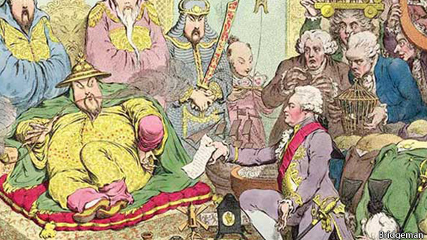

And now it is a nation that wants some things very much. In general, it knows what these things are. At home its people want continued growth, its leaders the stability that growth can buy. On the international stage people and Communist Party want a new deference and the influence that befits their nation’s stature. Thus China wants the current dispensation to stay the same—it wants the conditions that have helped it grow to endure—but at the same time it wants it turned into something else.

Finessing this need for things to change yet stay the same would be a tricky task in any circumstances. It is made harder by the fact that China’s Leninist leadership is already managing a huge contradiction between change and stasis at home as it tries to keep its grip on a society which has transformed itself socially almost as fast as it has grown economically. And it is made more dangerous by the fact that China is steeped in a belligerent form of nationalism and ruled over by men who respond to every perceived threat and slight with disproportionate self-assertion.

The post-perestroika collapse of the Soviet Union taught China’s leaders not just the dangers of political reform but also a profound distrust of America: would it undermine them next? Xi Jinping, the president, has since been spooked by the chaos unleashed in the Arab spring. It seems he wants to try to cleanse the party from within so it can continue to rule while refusing any notions of political plurality or an independent judiciary. That consolidation is influencing China’s foreign policy.

China is building airstrips on disputed islands in the South China Sea, moving oil rigs into disputed waters and redefining its airspace without any clear programme for turning such assertion into the acknowledged status it sees as its due. This troubles its neighbours, and it troubles America. Put together China’s desire to re-establish itself (without being fully clear about what that might entail) and America’s determination not to let that desire disrupt its interests and those of its allies (without being clear about how to respond) and you have the sort of ill-defined rivalry that can be very dangerous indeed. Shi Yinhong, of Renmin University in Beijing, one of China’s most eminent foreign-policy commentators, says that, five years ago, he was sure that China could rise peacefully, as it says it wants to. Now, he says, he is not so sure.

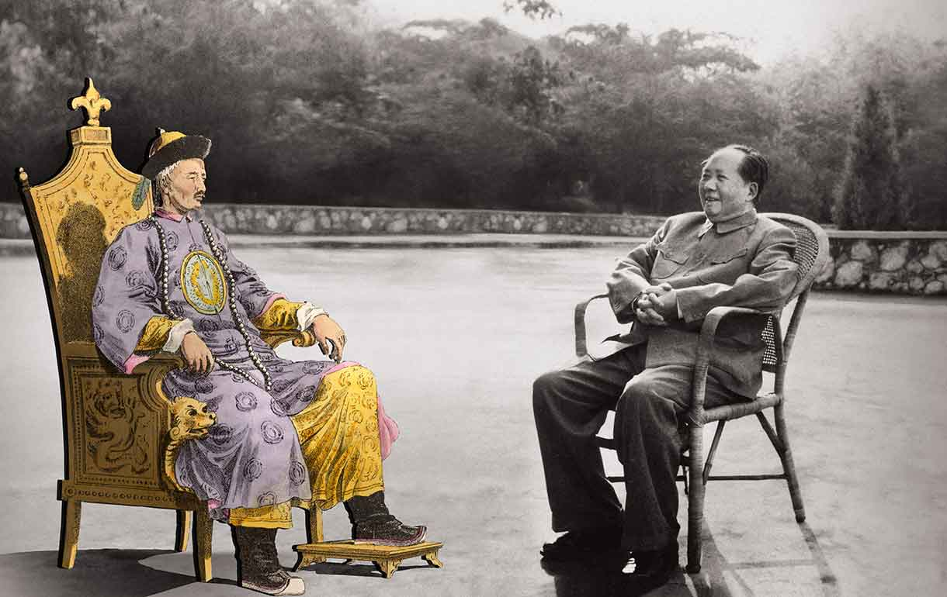

## The long fall

WHEN China was first unified in 221BC, Rome was fighting Carthage for dominion over the western Mediterranean. Rome would go on to rise further and, famously, fall. China collapsed, too, many times, but the model had been set that it must always reunite. By the end of the Han dynasty in 220AD its rulers had institutionalised the teachings of Confucius, which emphasised the value of social hierarchy and personal morality, as the basis for government. By the Tang dynasty in the 7th century—at about the time Muhammad returned to Mecca—China was one of the wealthiest and most illustrious civilisations on Earth. Its economic and military power dwarfed that of neighbouring peoples. Its cultural riches and Confucian moral order made that pre-eminence seem natural to all concerned. China was the model to emulate. Kyoto in Japan is laid out like 8th-century Chang’an (modern day Xi’an). The Koreans and Vietnamese adopted Chinese script. Confucian teaching became, and remains, the philosophical foundation of many Asian cultures. Just as it was right for the emperor to occupy the apex of China’s hierarchy, so it was meet for China to sit atop the world’s.

Macartney came to this paragon at the height of its Qing dynasty. In the middle of the 18th century the emperor had brought Tibet and Turkestan into the empire by means of intensive military campaigns and the genocidal elimination of the Dzungars, taking it to its greatest historical extent. Though everyday life for the peasants was grim, imperial life was magnificent. But for all the wealth and despite—or perhaps because of—his imperious dismissal, Macartney felt the state was not as sempiternal as its rulers would have it. It was, he wrote, a “crazy, first rate man o’ war”, able to overawe her neighbours “merely by her bulk and appearance”. He sensed something of its fragility and the problems to come. “She may drift sometime as a wreck and then be dashed to pieces on the shore.”

Revolutionaries came to believe culture was part of the problem

The structural reasons for China’s subsequent decline and the empire’s demise have been much discussed. Some point to what Mark Elvin, a historian, calls “the high-level equilibrium trap”; the country ran well enough, with cheap labour and efficient administration, that supply and demand could be easily matched in a way that left no incentive to invest in technological improvement. Others note that Europe benefited from competition and trade between states, which drove its capacity for weaponry and its appetites for new markets. As Kenneth Pomeranz, an American historian, has argued, access to cheap commodities from the Americas was a factor in driving industrialisation in Britain and Europe that China did not enjoy. So was the good luck of having coal deposits close to Europe’s centres of industry; China’s coal and its factories were separated by thousands of kilometres, a problem that remains trying today.

For some or all of these reasons, and probably others too, China did not industrialise in the way that the West did. Europe had learned of gunpowder from China in the Middle Ages, but by the 19th century Europeans were far better at using it to get their way. In the 1830s the British tried to prise open the China market with opium—something people could be made to want, and keep wanting, whatever their previous inclinations. The Chinese tried to stop the trade; the British forced a war upon them and won it. In the subsequent Treaty of Nanjing, concluded in 1842, Britain grabbed Hong Kong and forced China to open its doors. China descended into a spiral of denial, defeat and semi-colonisation. Perhaps most humiliating, in the 1890s enfeebled China was defeated in battle by the Japanese—a people whose culture had been founded on Chinese civilisation, but which was now transformed by eagerly adopted Western technology and ambition. China’s centrality in Asia had been usurped.

Much of what has taken place since—republican revolution in 1911, the rise and victory of Maoism in 1949 and now “socialism with Chinese characteristics”—has been a reaction to the loss of wealth, power and status, and a desire to regain the respect China’s leaders and people feel to be their country’s due.

The reformers and revolutionaries of the late 19th century came to believe that traditional Chinese culture was part of the problem. In an attempt not to be carved up by the colonial powers, they began to ditch much of China’s cultural heritage; to save themselves as a nation, many believed they had to destroy themselves as a culture. In 1905 the Confucian examination system that had been the focus of governmental training for two millennia was abandoned. The last emperor and the entire imperial system were overthrown in 1911. With no modern institutions to support it, the new republic soon collapsed into chaos.

China's long climb back

After Mao reunited China in 1949, the Communists stepped up the assault on Chinese culture yet further. China’s institutions, and the mindsets they created and embodied, were replaced wholesale by ideas from elsewhere. This was the equivalent of Europeans throwing out any vestiges of Roman law, Greek philosophy or Christian belief. Under Mao, Confucius became the enemy. And yet the sense of China as a great civilisation persisted, and persists to this day—leaving the country with a deep identity crisis that it is still struggling to resolve.

Along the way, China cast off the imperial view of the world as a source of tribute and embraced the one that in Europe had been introduced by the Peace of Westphalia: one of essentially equivalent sovereign states distinguished from each other by the quantities of wealth and power they disposed of, not by any qualitative hierarchy. China now has to see itself as a state among others. Yet it is at the same time, in the words of Lucian Pye, an American academic, “a civilisation pretending to be a state”. Its history, its size and the feeling of potency brought on by the remarkable growth of the past two decades push it to want to be something more, and to take back the place that foreigners stole from it. China’s people and leaders feel their nation’s time has come once again.

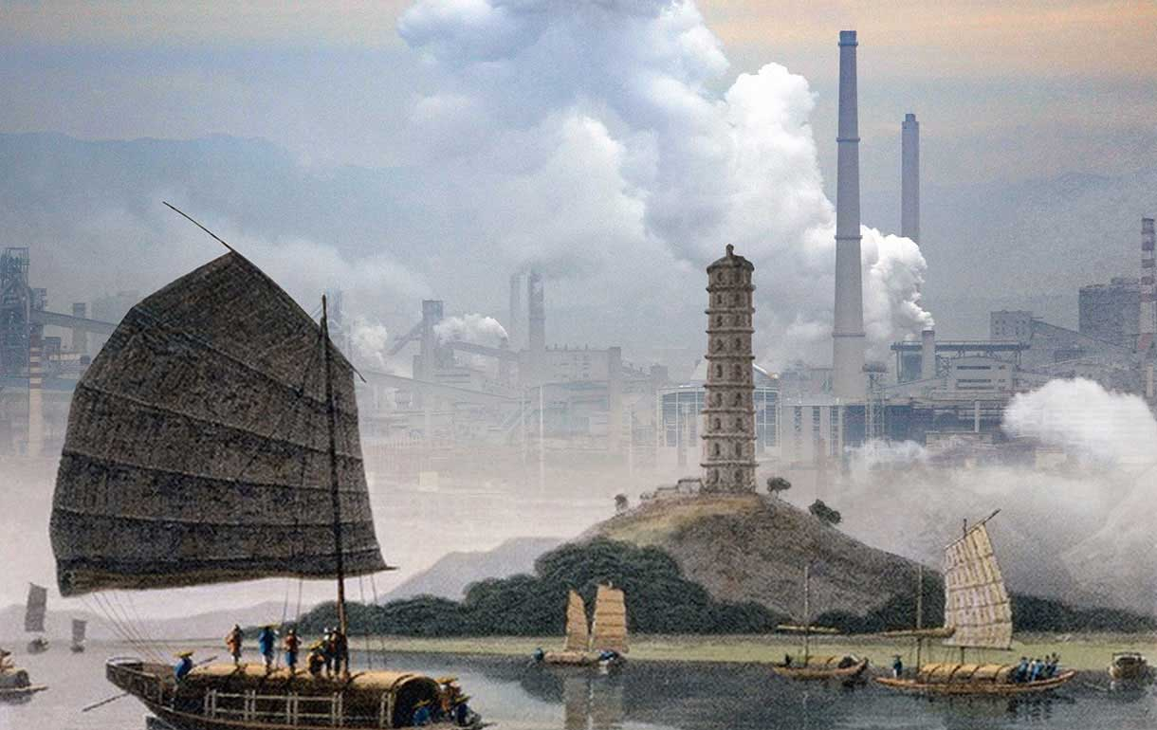

## Expanding the bounds

FOR all this ambition, China is not bent on global domination. It has little interest in polities beyond Asia, except in as much as they provide it with raw material and markets. Talk of China’s “neo-colonialism” in Africa, for instance, is much exaggerated. The country’s stock of direct investment there still lags far behind Britain’s and France’s and amounts to only a third of America’s. Though China’s influence is undoubtedly growing, its engagement is not imperial but transactional, says Deborah Brautigam, of Johns Hopkins University. When a Japanese company bought the Rockefeller Centre in the 1980s, “Americans thought they were buying all of Manhattan,” says Ms Brautigam. “The same is true of China in Africa. It’s all about perception.” In a forthcoming book, she investigates 20 media reports of land acquisitions by Chinese firms in Africa, claimed to total 5.5m hectares. She found the real figure to be just 63,400 hectares.

Chinese foremen have abused African workers, Chinese companies have run illegal mines and annoyingly undercut local traders with cheap Chinese goods. But these are the problems of bad business, not of grand strategy. Unlike Europe’s colonial powers of yesteryear, China has no strategic vision of keeping all others out of its bit of the continent, nor any hypocritical “civilising mission”. When it perceives it could have a problem with its image, it responds pragmatically: building hospitals, paying for malaria-prevention programmes, laying down railways. In Africa and Latin America it is focusing more on taking stakes in local companies, not just buying up land and resources. It is also making forays into the use of soft power through a number of Confucius Institutes all over the world that try—in frequently ham-fisted ways—to show that China and its culture are benign.

China is “neither a missionary culture nor a values superpower,” says Kerry Brown of the University of Sydney. “It is not trying to make other people into China.” The rhetoric of American foreign policy—and frequently its content, too—is shaped by claims to be the champion of democracy and liberty. The Communist Party is less committed to universal values. Alliances often grow out of shared values; if you don’t have them, friends are harder to find. Awe can be a respectable alternative to friendship, and China has begun to awe the world—but also to worry it.

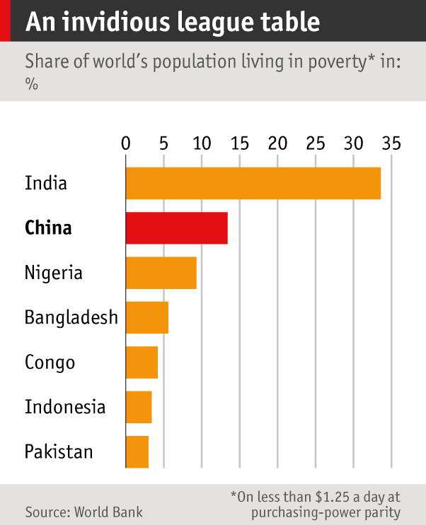

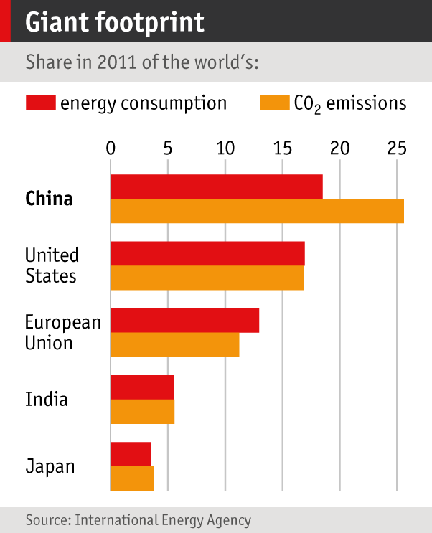

Clan-focused Confucianism and the fear bred by communism have persuaded the Chinese to mind their own business: sweep the snow from in front of your own house, goes the old saying, don’t worry about the frost on your neighbour’s roof. If it adopts similar attitudes to the world at large, that may be because China faces problems on a global scale within its own borders: it has more poor people than any other country save India. When 160m of your own citizens are living on less than $1.25 a day, and many people are beginning to complain more openly about your nation’s domestic problems, the development needs of Africans can seem less pressing.

Accordingly, there is a tension in Chinese foreign policy. The country wants to have as little involvement abroad as it can get away with, except for engagements that enhance its image as a great power. It will act abroad when its own interests are at stake, but not for the greater or general good. Its navy has started to take part in anti-piracy operations off the Horn of Africa and in UN peacekeeping in Africa. In 2011 it sent a ship to co-ordinate the evacuation of 36,000 Chinese workers from Libya. More such actions may follow as its companies get more deeply involved in the world, but only if they are seen as either low-cost or absolutely necessary. Acute awareness of its domestic weaknesses acts as a restraint, as does the damage China sees done by the militarisation of America’s foreign policy in recent years.

In a wide range of fields, what China is against is a lot clearer than what it is for. It vetoed the interventions Western powers sought in Syria and Darfur and has taken no position on the Russian annexation of Crimea (despite having a dim view of any sort of centrifugalism at home).  At the 2009 climate summit in Copenhagen China made sure no deal emerged that would even suggest it might have to slow its industrial growth. There and elsewhere it showed itself ready to block but not ready to build. As a former senior official in the Bush administration says of Chinese engagement at the G20, “They love to show up, but we’re still waiting for their first idea.”

The former official argues that the world needs more Chinese engagement and initiative, not less. Chinese leaders dislike the existing system of alliances, he says, but offer no alternative system of collective security. They talk about sharing hydrocarbon and fishery resources in the South and East China Seas, but have offered no concrete proposals. They condemn Western interference in the internal affairs of developing nations, but exacerbate corruption and poor governance in countries where they have a growing stake of their own.

Sweep the snow from in front of your own house, don’t worry about the frost on your neighbour’s roof

A lack of engagement is not unusual in a rising power. It took a world war to draw America irrevocably onto the world stage.  And the absence of an articulated agenda does not stop China wanting more standing. Despite being one of the five permanent members of the UN Security Council—a position it achieved as one of the victorious powers in the second world war—it is frustrated by what it sees as its lack of influence in international organisations and is leading the other large developing nations in pushing for a better deal.

The BRICS countries—Brazil, Russia, India, China and South Africa—make up 42% of the world’s population and 28% of the global economy (at PPP), but they have only 11% of the votes at the International Monetary Fund. In July China led the establishment of the Shanghai-based New Development Bank, of which all the BRICS countries are members and which looks like a fledgling alternative to the World Bank, leading to talk of a “Chinese Bretton Woods”. China has also set up an Asian Infrastructure Investment Bank to rival the Asian Development Bank.

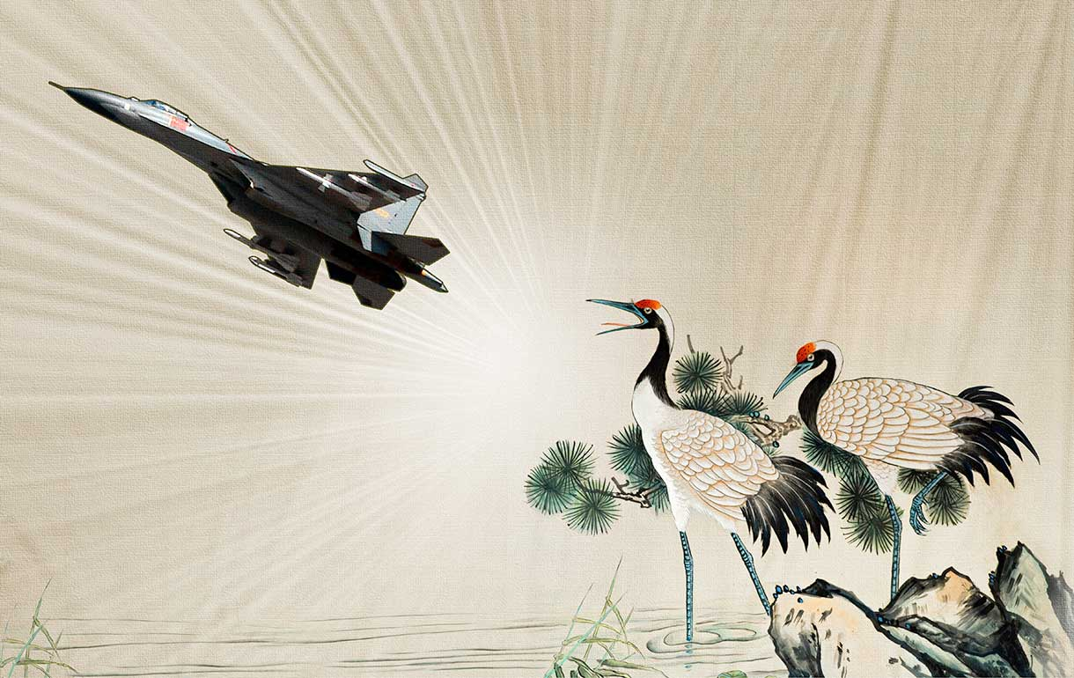

## Leviathan and its hooks

WITHIN Asia, it is Chinese activity, not Chinese inactivity, that has people worried, and their concern is understandable. Perhaps most provocative is China’s devotion to the “nine-dash line”, an ill-defined swish of the pen around the South China Sea. Within this perimeter, China claims all the dry land and, it appears, all the water and seabed too; by way of contrast, the rules of the United Nations Convention on the Law of the Sea (UNCLOS) would tend to see quite a lot of those things as subject to claims from other countries. Speaking in June at the Shangri-La Dialogue, an annual regional-security shindig in Singapore, Wang Guanzhong, a Chinese general, made it clear that although China respected UNCLOS, the convention could not apply retroactively: the nine-dash line was instituted in the 1940s and the islands of the South China Sea have been Chinese for 2,000 years.

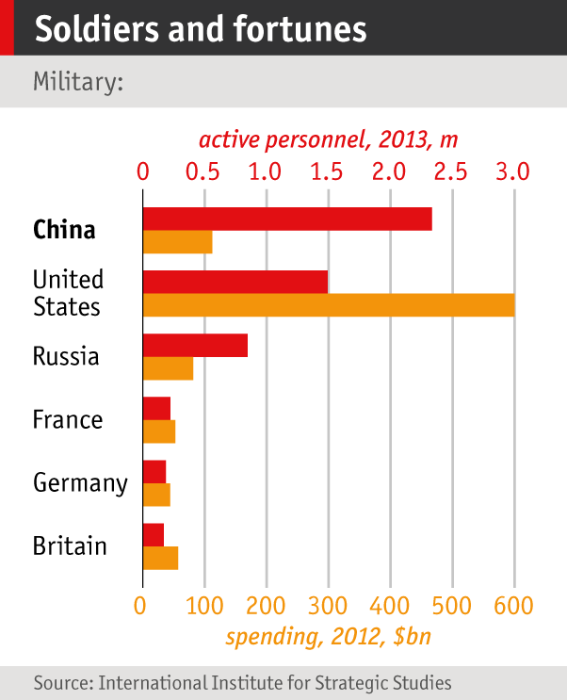

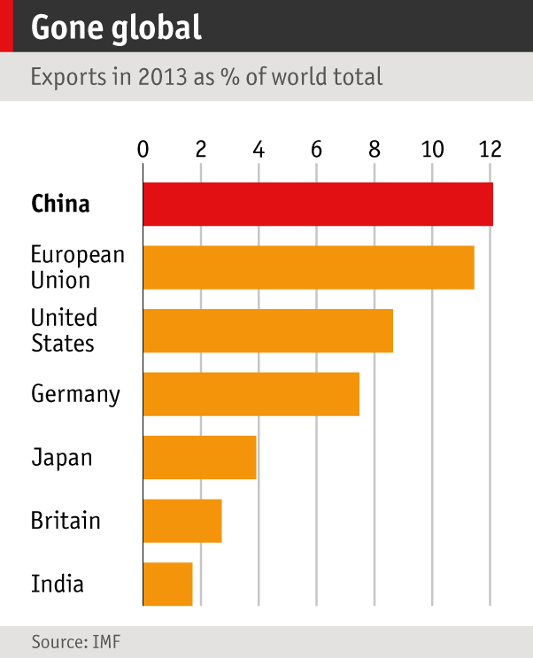

Others in China have been blunter. Wu Shicun, head of the National Institute for South China Seas Studies, based on the southern Chinese island of Hainan, recently pointed out that UNCLOS was developed under Western guidance and that, looking to the long term, “we should rebuild through various methods of regional co-operation a more reasonable, fairer and more just international maritime order that is guided by us.” Not surprisingly, this has caused concern in Washington. “How much of the temple do they actually want to tear down?” asks Douglas Paal, a former American official now at the Carnegie Endowment for International Peace.

Probably not all that much, for now. But “China gets it that being a great power is messy, and involves trampling on a few flowers,” says Lyle Goldstein of America’s Naval War College. “It is a price the Chinese are willing to pay.” Rules such as those which say the nine-dash line must be respected might be acceptable for the small fry. But as China’s then foreign minister, Yang Jiechi, vocally pointed out at a meeting of regional powers in Hanoi in 2010, “China is a big country and other countries are small countries and that is a fact.”

Militarily, this is indeed the case. China’s armed forces are, if not technologically first-rate, certainly large and impressive, not least because they include a nuclear-missile force. But some of Mr Yang’s small countries have a big friend. With troops and bases in Japan and South Korea, America has been the dominant power of the western Pacific for 70 years. Its regional presence has not declined much since it won the cold war a quarter of a century ago. On a trip to Asia in 2011 Barack Obama announced a “pivot” of his country’s policy away from the Middle East and towards Asia.

China’s leaders are convinced that America is determined to prevent their country from increasing its strategic and military influence in Asia—that it is trying to contain China as it once sought to contain and eventually crush the Soviet Union. The irony is that China is the only country that really believes the pivot is happening. South-East Asian nations express a fair amount of scepticism at the idea that America’s attention has been newly fixed on their region, and his opponents in America claim Mr Obama has done far too little to follow through on what he said in 2011.

That said, the recent Shangri-La Dialogue did nothing to dispel China’s fears. Japan’s prime minister, Shinzo Abe, offered to assist China’s neighbours with military hardware, and has been pushing, within the constraints of Japan’s pacifist post-war constitution, for a more robust defence policy in the region. In his first year in office Mr Abe visited every member of the Association of South-East Asian Nations. America’s secretary of defence, Chuck Hagel, endorsed Mr Abe’s ideas at Shangri-La, accusing China of “destabilising unilateral actions”.

"China gets it that being a great power is messy, and involves trampling on a few flowers"

China has been assertive in the South China Sea for decades, but there has been a distinct hardening of its position since Mr Xi came to power. Recent moves to dominate the seas within the “first island chain” that runs from Okinawa through Taiwan to the Spratlys (see map) have alienated almost all the country’s neighbours. “It would be hard to construct a foreign policy better designed to undermine China’s long-term interests,” argues Brad Glosserman of the Pacific Forum CSIS, a think-tank.

The moves are undoubtedly motivated in part by a desire to control the resources of the sea bed. But China itself does not see them as straightforward territorial expansionism. Chinese leaders believe their own rhetoric about the islands of the East and South China Seas having always been part of their territory–a territory that, since the death of Mao, they have chosen to define as almost the empire’s maximum extent under the Qing dynasty, rather than its more modest earlier size. And if they are expressing this territorial interest aggressively, they are behaving no worse—in their eyes, better—than the only other power they see as their match. The Chinese note that America is hardly an unsullied protector of that temple of the global international order; it enjoys the great-power prerogatives and dispensations they seek for their own nation. Disliking the restraints of international treaties perhaps even more than China does, America has not itself ratified UNCLOS. With a handful of allies it rode roughshod over the international legal system to invade Iraq.

#### Video

### Videographic: China’s territorial disputes

### VIDEO @

### <http://www.economist.com/news/essays/21609649-china-becomes-again-worlds-largest-economy-it-wants-respect-it-enjoyed-centuries-past-it-does-not>

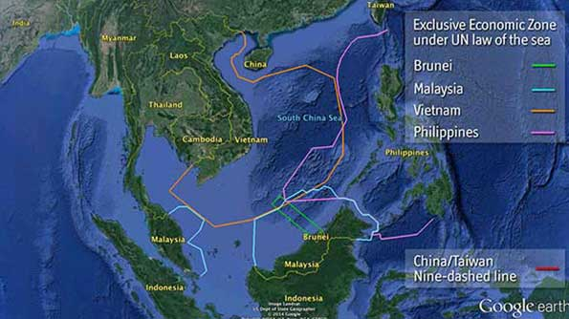

China might also note parallels between its ambitions and those of America’s in days gone by. Although America waited until the early 20th century to take on a global role, it defined an ambitious regional role a hundred years earlier. In 1823 James Monroe laid out as policy a refusal to countenance any interference in the Western hemisphere by European nations; all incursions would be treated as acts of aggression. Conceptually, what China wants in East Asia seems akin to a Monroe Doctrine: a decrease in the influence of external powers that would allow it untroubled regional dominance. The difference is that the 19th-century Americas did not have any home-grown powers to challenge the United States, and most of its nations were quite content with the idea of keeping European great powers out of the area. At least in its early years, they were the doctrine’s beneficiaries, not its subjects.

China is not completely uncompromising. Along its land borders it has let some disputes fade away and offered a bit of give and take. But this is in part because the South and East China Seas are seen as more strategically important. A key part of this strategic importance is the possibility that, eventually, the question of Taiwan’s sovereignty will come to a head; it is in effect protecting its flanks in case of a future clash with America on the matter. The ever-volatile situation in North Korea could also create a flashpoint between the two states.

When Mr Xi said, at his 2013 California summit with Mr Obama, that “the vast Pacific has enough space for two large countries like the United States and China,” it was an expression not so much of the possibility of peaceful coexistence that must surely come from being separated by 10,000km of water, as of the idea that the western Pacific was a legitimate Chinese sphere of influence.

And if Mr Xi’s words, repeated to America’s secretary of state, John Kerry, in Beijing in July, seemed to imply a symmetry between the countries, China knows that, in fact, it enjoys various asymmetric advantages. For one, it is a unitary actor. It can drive wedges between America and its allies in the region. Hugh White, an Australian academic, argued in a recent article that, by threatening other Asian countries with force, “China confronts America with the choice between deserting its friends and fighting China.”



China’s armed forces are much less proficient than America’s. But China enjoys the advantage of playing at home. America can dominate these seas only through naval and air operations. If Chinese anti-ship missiles present a serious threat to such operations they can greatly reduce America’s ability to project power, without putting China to the expense of developing a navy of its own remotely so capable. Thus the military forces of the two sides are not as unbalanced as one might think by simply counting carrier groups (of which China is building its first, whereas America has ten, four of them in the Pacific).

China also thinks there is an asymmetry of will. It sees a war-weary America as unlikely to spend blood and treasure defending uninhabited rocks of no direct strategic importance. America may speak loudly, but its big stick will remain unwielded. China’s people, on the other hand, their views shaped not just by propaganda but also by a nationalism that needs scant encouragement, look on the projection of power in the China seas very favourably. And its military-industrial complex yearns to be paid to build bigger, better sticks of its own. Even if party leaders wanted to succeed in their stated desire for a peaceful rise and to remain within international law, the way they have shaped the spirit of their country would not necessarily let them.

This is especially true when it comes to Japan, the country which took on the role of regional power in Asia when China was laid low in the 19th century, and with which relations would always be most vexed. The vitriolic propaganda against the Japanese in Chinese media scarcely needs official prompting; Chinese suffering under Japan’s cruel occupation is well remembered. Japan is a useful whipping boy to distract attention from the party’s inadequacies. China’s leaders have legitimate security concerns and a right to seek a larger international role for their nation but, obsessed with their own narrative of victimhood, they do not see that they themselves are becoming Asia’s bullies.

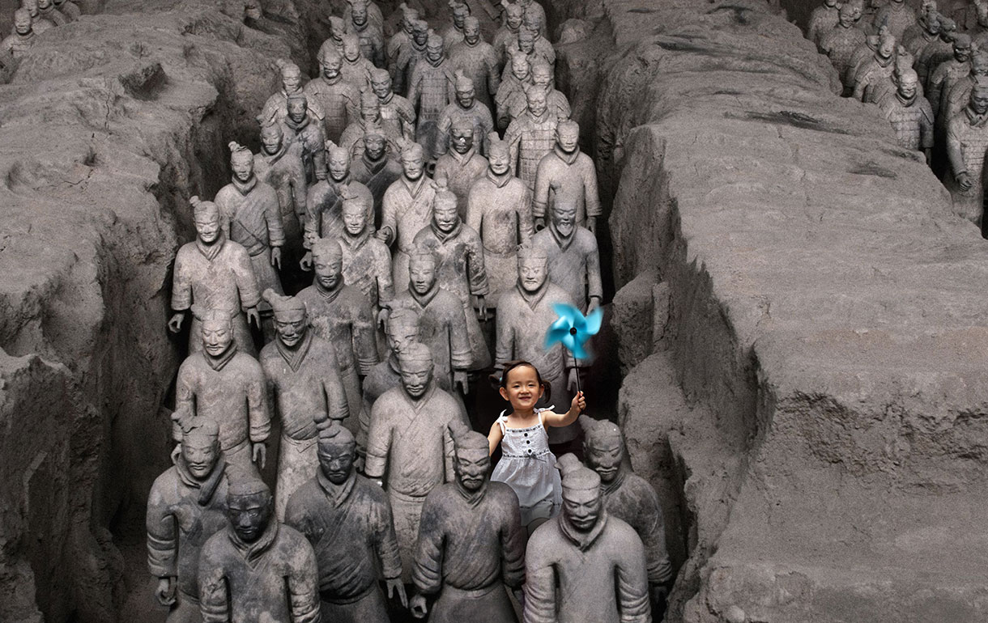

## The challenge of change

PUBLIC enthusiasm underlines the fact that China’s growing assertiveness is not purely a matter of relationships outside its borders. “Whenever I see a change in foreign policy, I always ask, ‘what’s going on domestically?’ ” says Joseph Fewsmith of Boston University. Mr Xi is purging rivals, clamping down on corruption and, many hope, pushing through tough economic and financial reforms; some foreign distraction might come in handy.

Consolidating power at home and throwing its weight around abroad are linked, but they do not mark a return to full-blown, go-home-Macartney imperial arrogance. The Chinese know that there are now things they want from beyond their borders—ideas as well as markets, raw materials and investment—and they have integrated remarkably well, if sometimes grudgingly, into many international organisations. From not understanding the Westphalian world view, China has grown into a devotee, seeing a way of looking at the world in which it thinks, as a big state among small states, that it enjoys natural advantages. It has accepted the equality of its rulers with foreign kings, though not necessarily the idea that there should be laws to bind all such princes.

The danger is that China will seek greater power in the world as a substitute for fundamental changes at home

However, those rulers have not accepted, and cannot accept, equality with those they rule at home. Maoist China created a strong state and a weak society. Now that strong state has to deal with an ever stronger society, too, in which individuals have new ways of expressing themselves about all sorts of things, including the need for more accountable government. China’s rulers believe the country cannot hold together without one-party rule as firm as an emperor’s (and they may be right); an increasing number of its people (and many foreign sinologists) believe it cannot become fully modern as long as one-party rule endures.

Both the aspirations of the enriched and the resentments of the oppressed are in play. In western regions, Muslim and Tibetan areas are constantly rocked by unrest. In the more prosperous east of the country, the post-Tiananmen deal—stay out of politics and you can do anything you want—is fraying, and public outrage at corruption, pollution and other problems grows more vociferous. Yet rather than allow more formal popular participation and move towards the rule of law, China’s leaders are allowing less participation as they crack down on free-thinkers, believing that carrying out real, structural reform is more dangerous than not doing so. In fact the opposite may be true. The deep fissures in the country will be increasingly hard to paper over with mere prosperity.

## When will China overtake the US in GDP?

The United States has long boasted both an unrivalled economy and unparalleled global clout. Its status as the world’s biggest military power remains secure. But its position as the world’s biggest economy is more precarious as China continues to grow.

## When will China overtake the US in GDP?

There are many ways to compare economies. Our chart looks at GDP in current dollars at market exchange rates. The timing of America’s economic eclipse thus depends on a number of things: its own growth, China’s growth, the evolution of prices in each country, and the exchange rate between them. If, for example, China’s prices rise faster than America’s, and its currency, the yuan, does not fall, then China’s economy will be worth more, relative to America’s, and it will overtake sooner.We invite you to generate your own forecasts.

### Your China and America GDP forecast

US

China

0204060801002000051015202530

You predict

China overtakes US in 2021

It is not just that seeking to placate the public at home with braggadocio overseas will make it harder still for China to garner allies and respect. There is a deeper problem. Many countries around the world admire, and would like to emulate, the undemocratic but effective way that China has managed its decades of growth. If China’s domestic politics look less stable, some of that admiration will wane. And even if things can be held together, for the time being, admiration for China does not translate into affection for it, or into a sense of common cause. Economically and militarily, China has come a long way towards regaining the centrality in Asia it enjoyed through much of history. Intellectually and morally, it has not. In the old days it held a “soft power” so strong, according to William Kirby of Harvard University, that “neighbours converted themselves” to it. Now, Mr Xi may know how to assert himself and how to be feared, at home and abroad. But without the ability to exert a greater power of attraction, too, such strength will always tend to destabilise.

If China could resolve its identity crisis and once again become an attractive civilisation rather than just an enviable development model, it would be much better placed to get the respect and influence it craves. But it is hard to see that happening unless the party gives more power to its people, and Mr Xi has made it clear that will not happen on his watch. The danger is that China will seek greater power in the world as a substitute for fundamental changes at home. If it fails to make those changes, its global power will continue to look hollow, unattractive and threatening, and its neighbours will continue to cling to the coat-tails of Uncle Sam.

China is no longer the “crazy, first-rate man o’ war” described by Macartney in 1793. In spite of its many problems, it is a sleeker, more modern ship. Over 200 years, through much pain and suffering, it has transformed the very core of its identity, changing itself from an inward- and backward-looking power to an outward- and forward-looking one. Since 1978, it has shown both flexibility and unwielding resolve in its continued pursuit of wealth and power. Now those goals are within reach and China stands on the verge of greatness. The next few decades may prove to be the most difficult of all.