**NYT**

# Cultural Revolution Shaped Xi Jinping, From Schoolboy to Survivor

[点击查看本文中文版](http://cn.nytimes.com/china/20150924/c24revolution/" \o "点击查看本文中文版" \t "_blank) [Read in Chinese](http://cn.nytimes.com/china/20150924/c24revolution/" \t "_blank)

By [CHRIS BUCKLEY](http://topics.nytimes.com/top/reference/timestopics/people/b/chris_buckley/index.html) and DIDI KIRSTEN TATLOWSEPT. 24, 2015

Photo

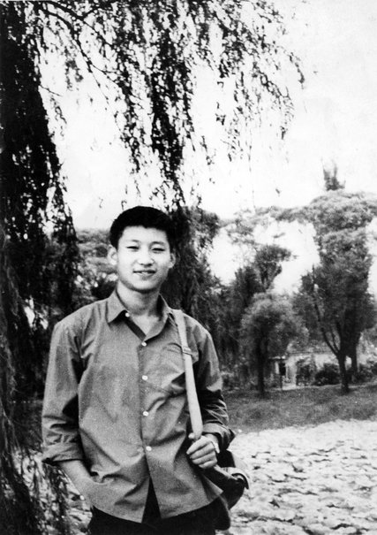

Xi Jinping during a visit to Beijing in 1972. He has rarely spoken publicly about his experiences as a teenager in the capital during the early years of the Cultural Revolution. Credit Xinhua Press, via Corbis

BEIJING — When the pandemonium of the Cultural Revolution erupted, he was a slight, softly spoken 13-year-old who loved classical Chinese poetry. Two years later, adrift in a city torn apart by warring Red Guards, [Xi Jinping](http://topics.nytimes.com/top/reference/timestopics/people/x/xi_jinping/index.html?inline=nyt-per) had hardened into a combative street survivor.

His father, a senior Communist Party official who had been purged a few years earlier, was seized and repeatedly beaten. Student militants ransacked his family’s home, forcing the family to flee, and one of his sisters died in the mayhem. Paraded before a crowd as an enemy of the revolution and denounced by his own mother, the future president of [China](http://topics.nytimes.com/top/news/international/countriesandterritories/china/index.html?inline=nyt-geo) was on the edge of being thrown into a prison for delinquent children of the party elite.

Visiting the United States this week, Mr. Xi, 62, has presented himself as a polished statesman, at ease hobnobbing with American capitalists in Seattle and attending a state dinner at the White House in his honor, set for Friday. Yet his first immersion in politics came on the streets of the Chinese capital during the most tumultuous era of Communist rule, when Mao Zedong exhorted students “to bombard the headquarters” of order.

“I always had a stubborn streak and wouldn’t put up with being bullied,” Mr. Xi [recalled in an interview in 2000](http://m2.people.cn/r/MV80XzE3OTc4NTFfMjAzXzE0MjA3OTE1OTk=), one of the few times he has spoken about his experience as a teenager in Beijing. “I riled the radicals, and they blamed me for everything that went wrong.”

Mr. Xi has often discussed the seven years he spent exiled to a rural village during the latter part of the Cultural Revolution, including in a speech in Seattle on Tuesday, casting that chapter of his life as an uplifting story of a city boy who discovers the suffering of ordinary Chinese in the countryside and resolves to make a difference.

But Mr. Xi has rarely spoken in public about his experiences from 1966 to 1968 at the tumultuous start of the Cultural Revolution, and his close contemporaries refuse to talk to foreign journalists about those years.

An examination of memoirs written by them and by members of Mr. Xi’s family, though, offers an unusually vivid look at how a shy, bookish youth, raised in the bosom of party privilege, was tested and changed by the chaos that unfolded after Mao’s decision to turn the masses against the party establishment.

Mr. Xi started his transformation in the equivalent of the seventh grade in the August 1 School, a cloistered boarding school largely reserved for children with parents in the senior ranks of the party and the military. When Cultural Revolution militants shut it down, he ended up at the No. 25 School, which was a hotbed of discontent with the party elite, said Qian Peizhen, chairwoman of the school’s alumni association.

## From Bookish Youth to Polished Statesman

##### Xi and the Cultural Revolution

###### 1967-1968

Normal classes have stopped, and life for many youths is consumed by rallies and, increasingly, fighting between rival Red Guard groups. Mr. Xi and his siblings fear for the life of their father, who had been seized by Red Guards. “Some said he had committed suicide or disappeared. Rumors abounded, but there was no news. Our family was enveloped in gloom,” Mr. Xi’s brother, Xi Yuanping, later recalled.

But as order broke down, Mr. Xi, like many youths, spent little time in class. Mr. Xi and a friend “would hang out all day,” Ms. Qian said. After fleeing their home, he, his mother and his siblings took refuge at the Central Party School, an academy for officials. “We grew up in a highly abnormal environment,” Li Xiaobing, a classmate at the August 1 School, [recalled on a school alumni website](http://xyh.bayims.cn/video/36.html).

The purges, zealotry and mass strife that Mao unleashed during the Cultural Revolution left a lasting mark on every Chinese leader who has succeeded him. But Mr. Xi stands out because he is the first party chief from the generation of the Red Guards — the youths who served as Mao’s shock troops — and because he fell so far before beginning his trek to power, from a family in the party elite to an unmoored life as a teenage political pariah.

Some of Mr. Xi’s critics argue that his experiences during the Cultural Revolution inform his authoritarian ways. But the imprint of that time was more complex than that, said Patricia M. Thornton, a professor at Oxford who is researching the Cultural Revolution and its legacy.

Mr. Xi’s generation venerated Mao, she said, but his family suffered in the violence that Mao unleashed, and Mr. Xi’s outlook is rooted in an elitist rejection of that turmoil.

International By JONAH M. KESSEL 3:46 Who Is Xi Jinping?

[Continue reading the main story](http://www.nytimes.com/2015/09/25/world/asia/xi-jinping-china-cultural-revolution.html?mabReward=CTM&moduleDetail=recommendations-2&action=click&contentCollection=Politics&region=Footer&module=WhatsNext&version=WhatsNext&contentID=WhatsNext&src=recg&pgtype=article#story-continues-5) Video

#### Who Is Xi Jinping?

President Xi Jinping of China arrived in the United States on Tuesday for a state visit at a crucial crossroads in the Sino-American relationship.

By JONAH M. KESSEL on Publish Date September 21, 2015. Photo by Wu Hong/European Pressphoto Agency. [Watch in Times Video »](http://www.nytimes.com/video/world/asia/100000003926677/who-is-xi-jinping.html?action=click&contentCollection=world&module=embedded&region=caption&pgtype=article)

“Xi got to see both sides of that time, which is one reason I think he’s such an interesting character,” she said, “but that’s also why he’s so difficult to read.”

Unlike some youths from elite backgrounds, Mr. Xi did not turn against the party or Mao, but learned to revere strict order and abhor challenges to hierarchy, said Yongyi Song, a historian and [librarian in Los Angeles](http://www.calstatela.edu/univ/ppa/journalist/dept/library) who has long studied the Cultural Revolution.

“He suffered much under Mao,” Mr. Song said, “but I think that actually increased his belief that those who are ‘born red,’ those children of the party elite, earned the right to inherit Mao’s place at the center.”

At the August 1 School, Mr. Xi and other students were expected to be exemplary servants of the socialist revolution. “We took the children to clean out latrines, and they did a really fine job,” a former teacher, Tang Yuhua, said in an [interview](http://xyh.bayims.cn/article/61.html) for the school alumni association. “The children of officials did what they were told.”

## [Reporter’s Notebook: Xi Jinping’s U.S. Visit](http://www.nytimes.com/interactive/projects/cp/reporters-notebook/xi-jinping-visit)

Jane Perlez, The New York Times’s chief diplomatic correspondent, will be following China's president, Xi Jinping, and documenting key moments of his first state visit to the United States.

[[](http://www.nytimes.com/interactive/projects/cp/reporters-notebook/xi-jinping-visit/chinas-president-hasa-facebook-page-but-no-one-in-china-can-see-it?action=click&contentCollection=xi-jinping-visit&module=g-series-graphic)](http://www.nytimes.com/interactive/projects/cp/reporters-notebook/xi-jinping-visit/chinas-president-hasa-facebook-page-but-no-one-in-china-can-see-it?action=click&contentCollection=xi-jinping-visit&module=g-series-graphic)

## [China's President Has a Facebook Page, But No One in China Can See It](http://www.nytimes.com/interactive/projects/cp/reporters-notebook/xi-jinping-visit/chinas-president-hasa-facebook-page-but-no-one-in-china-can-see-it?action=click&contentCollection=xi-jinping-visit&module=g-series-graphic)

[[](http://www.nytimes.com/interactive/projects/cp/reporters-notebook/xi-jinping-visit/a-chat-in-chinese-with-mark-zuckerberg-as-tech-giants-jostle-for-facetime?action=click&contentCollection=xi-jinping-visit&module=g-series-graphic)](http://www.nytimes.com/interactive/projects/cp/reporters-notebook/xi-jinping-visit/a-chat-in-chinese-with-mark-zuckerberg-as-tech-giants-jostle-for-facetime?action=click&contentCollection=xi-jinping-visit&module=g-series-graphic)

## [A Chat in Chinese with Mark Zuckerberg, as Tech Giants Jostle for Face Time](http://www.nytimes.com/interactive/projects/cp/reporters-notebook/xi-jinping-visit/a-chat-in-chinese-with-mark-zuckerberg-as-tech-giants-jostle-for-facetime?action=click&contentCollection=xi-jinping-visit&module=g-series-graphic)

[[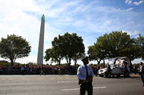](http://www.nytimes.com/interactive/projects/cp/reporters-notebook/xi-jinping-visit/china-pope-francis?action=click&contentCollection=xi-jinping-visit&module=g-series-graphic)](http://www.nytimes.com/interactive/projects/cp/reporters-notebook/xi-jinping-visit/china-pope-francis?action=click&contentCollection=xi-jinping-visit&module=g-series-graphic)

## [Not Wanting to Compete With Pope Francis, Xi Jinping Lingers in Seattle](http://www.nytimes.com/interactive/projects/cp/reporters-notebook/xi-jinping-visit/china-pope-francis?action=click&contentCollection=xi-jinping-visit&module=g-series-graphic)

[[](http://www.nytimes.com/interactive/projects/cp/reporters-notebook/xi-jinping-visit/seattle-tech-industry?action=click&contentCollection=xi-jinping-visit&module=g-series-graphic)](http://www.nytimes.com/interactive/projects/cp/reporters-notebook/xi-jinping-visit/seattle-tech-industry?action=click&contentCollection=xi-jinping-visit&module=g-series-graphic)

## [China’s Leader Tries Hard to Improve Relations With U.S. Tech Industry](http://www.nytimes.com/interactive/projects/cp/reporters-notebook/xi-jinping-visit/seattle-tech-industry?action=click&contentCollection=xi-jinping-visit&module=g-series-graphic)

[One of Mr. Xi’s teachers, Chen Qiuying](http://hun.wenweipo.com/?action-viewnews-itemid-502), recalled him as a studious, elaborately polite boy who was fond of Du Fu, an ancient Chinese poet. He had a “very steady, kind personality,” she said in an [interview](http://hun.wenweipo.com/?action-viewnews-itemid-502) published in Hong Kong.

But Mr. Xi and his brothers and sisters were vulnerable when the Cultural Revolution began because Mao had turned on their father, Xi Zhongxun, [a revolutionary veteran](http://sinosphere.blogs.nytimes.com/2013/10/15/china-venerates-a-revolutionary-the-father-of-its-new-leader/) and vice premier, four years earlier. He lost his post and was sent to work in a factory in central [China](http://topics.nytimes.com/top/news/international/countriesandterritories/china/index.html?inline=nyt-geo), while his wife, Qi Xin, kept her job as a party cadre in Beijing.

Many of the first Red Guards who embraced Mao’s call in August 1966 to purge society of ideological enemies and traitors were the children of party officials. But Mr. Xi could not join them because he was too young and had been tainted by his father’s fall.

Instead, he became a target of abuse, Ms. Chen said.

Photo

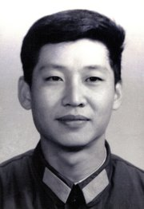

Mr. Xi in 1979. Credit Xinhua Press, via Corbis

“He told me of one incident, in which a primary school sports teacher with a very poor attitude bullied him when the wave of physical assaults in the Cultural Revolution was spreading,” she said. The sports teacher, she recalled, mocked him as “child of a black gang,” a term for toppled officials.

Radicals accused students at the school of betraying Mao by defending their parents and privileges. A journal published by Red Guards described the school as “a cradle for pampering the sons of senior cadres” that had “bred a successor class of the bourgeoisie.”

Violence was encouraged and widespread. In August and September of 1966, nearly 1,800 people died in attacks across Beijing, according to party estimates issued in 1980.

Mr. Xi lost an elder sister, Xi Heping, his father’s first daughter through an earlier marriage. [Official accounts](http://www.gapp.gov.cn/contents/2091/157500.shtml) say she was “persecuted to death,” leaving out details, but a historian familiar with the party elite who spoke on condition of anonymity said she probably had taken her own life under duress, as many targeted by the Red Guards did in those years.

Photo

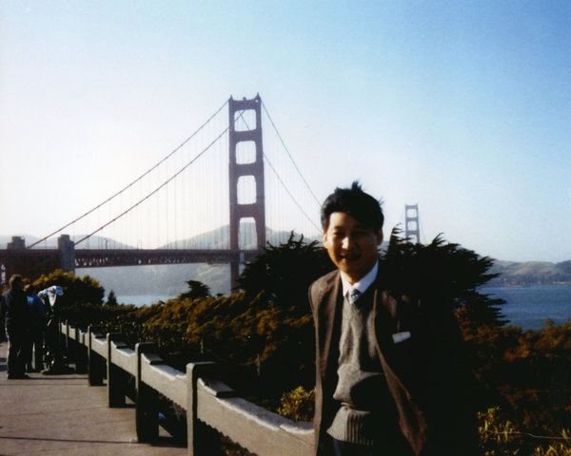

Mr. Xi visiting San Francisco in 1985. Credit Xinhua Press, via Corbis

Mr. Xi’s father, exiled in central China, was seized by Red Guards, who took him to Xi’an, a city in northwest China. There they paraded him around on a truck, beat and interrogated him, and made outlandish accusations that he had used a secret radio set in his home for clandestine foreign contacts.

As the Cultural Revolution spiraled into mayhem, Mr. Xi learned to fend for himself.

“We were the ‘blackest’ in the class, and the others all despised us,” recalled Nie Weiping, a classmate at the No. 25 School whose father had also been purged. “They wouldn’t come near us, and we also despised them.”

One day, he, Mr. Xi and another teenage friend with a purged father, Liu Weiping, were among a large group ambushed by radical Red Guards outside a school hall. “Hundreds of them came rushing out, waving clubs and yelling, and they beat whomever they saw,” Mr. Nie said [in a memoir](http://www.difangwenge.org/simple/?t10338.html).

[Continue reading the main story](http://www.nytimes.com/2015/09/25/world/asia/xi-jinping-china-cultural-revolution.html?mabReward=CTM&moduleDetail=recommendations-2&action=click&contentCollection=Politics&region=Footer&module=WhatsNext&version=WhatsNext&contentID=WhatsNext&src=recg&pgtype=article#story-continues-12)

[[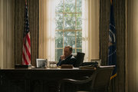](http://www.nytimes.com/interactive/2015/09/23/world/asia/xi-jinping-china-us-house-of-cards.html)](http://www.nytimes.com/interactive/2015/09/23/world/asia/xi-jinping-china-us-house-of-cards.html)

## [Xi Jinping on ‘House of Cards’ and Hemingway](http://www.nytimes.com/interactive/2015/09/23/world/asia/xi-jinping-china-us-house-of-cards.html)

“[Xi Jinping](http://topics.nytimes.com/top/reference/timestopics/people/x/xi_jinping/index.html?inline=nyt-per) and I moved fast and escaped,” he said, “but Liu Weiping ran a step slower, and almost suffered a concussion from a beating.”

In the interview published in 2000, when he was still a provincial official, Mr. Xi recalled being singled out and detained by the radicals because of his refusal to yield. “They all believed I was a leader,” he said.

“They asked me how bad I thought my crimes were,” he said. “I said that they should make a guess, was it enough to deserve being shot? They said it would be enough to be shot 100 times over. I thought, what was the difference between being shot once and 100 times?”

“Afterwards,” he added, “I recited the thoughts of Chairman Mao every day late into the night.”

Photo

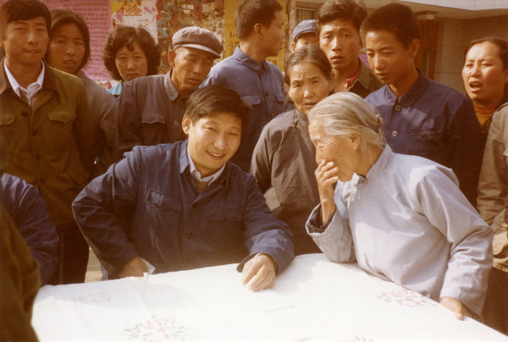

Xi Jinping, front left, meeting villagers as the Communist Party secretary in Zhengding County, in the north Chinese province of Hebei, in 1983. Credit Xinhua Press, via Corbis

At one point, militants paraded Mr. Xi and five adults on a stage before a rally, according to an [associate of Mr. Xi’s father, Yang Ping](http://www.21ccom.net/articles/rwcq/article_2013010474235.html), citing conversations with the father and family. Mr. Xi had to use both hands to hold up the cone-shaped metal hat he was made to wear.

“The mother had no choice but to go to the struggle session and sat below the stage,” Mr. Yang wrote. “When they yelled, ‘Down with Xi Jinping!’ on the stage, his mother was forced to raise her arm and shout the slogan along with everyone.”

By late 1968, Mr. Xi’s record of defiance was enough that he was ordered to a juvenile detention center for the children of purged officials. But he was spared imprisonment after Mao issued a call for urban youths to go to the countryside.

He did not see his father again until 1972, when Premier Zhou Enlai arranged a family reunion.

The father, battered and disoriented after years of isolation and interrogation, “looked at his two grown boys, and totally failed to recognize them,” according to his father’s biography, citing an interview with Mr. Xi. The older man wept, and Mr. Xi offered him a cigarette.

“He asked me, ‘How come you also smoke?’” Mr. Xi said. “I said: ‘I’m depressed. We’ve also made it through tough times over these years.’

“He went quiet for a moment and said, ‘I grant you approval to smoke.’”