Technology and Global Business
Dr. Thomas Lairson
Jindal Global University

Getting Started:

Just a warning: If you don’t like this course, be prepared to see the future accelerating off into the distance.

Interview with Elon Musk and Sam Altman (of Y Combinator [if you don’t know what this is, look it up])

http://www.vanityfair.com/news/2017/03/elon-musk-billion-dollar-crusade-to-stop-ai-space-x

This article is very interesting, if you want to study the subject of this course. If you don’t like this, you won’t like this course. Another example is this article focused on how cars and AI are changing a lot:

https://medium.com/future-crunch/carmageddon-is-coming-899c0f05a2a

One more indicator: Look at these two websites. If you find them interesting, you will like this course; if not, well….

http://data-informed.com/

Big Data Glossary
http://data-informed.com/glossary-of-big-data-terms/?utm_source=hs_automation&utm_medium=email&utm_content=24819178&_hsenc=p2ANqtz-87AKYRyTEwWnzmrk3VnjJMkYFqYyzHGDaZ8YNzSuvzxT052hZfMCc9QEf5V0I01jL1pZD7Dz5lUOJg6UrRQvPsQBV2vQ&_hsmi=24819178

If you want to keep going, here is a somewhat scary piece:

We Are All Kasparov

What Deep Blue tells Us About AI in 2017

When Deep Blue beat the world chess champion 20 years ago, we learned a huge lesson. Just not the one we thought.
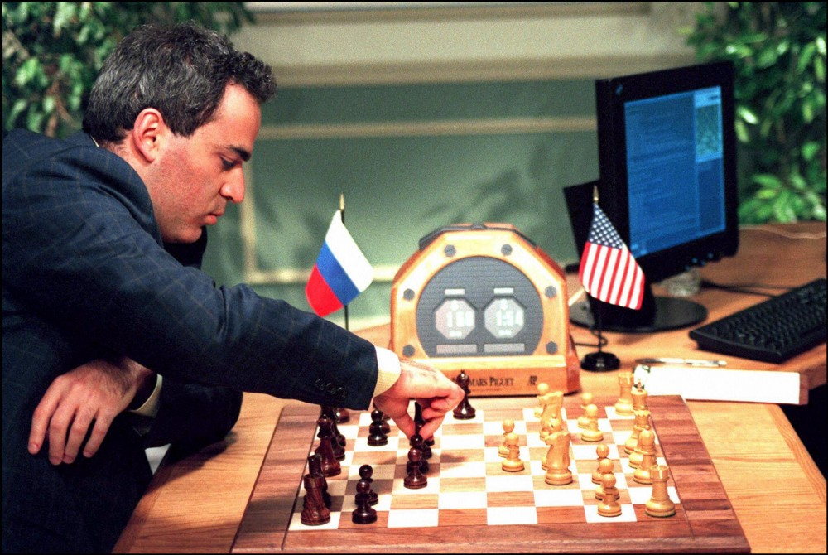
(Stan Honda / Getty Images)
Steven Levy (May 23, 2017)
Backchannel
The room where it happened was decked out like a faux study—a place where a couple of friends might engage in a friendly game of chess. But the people at the chessboard were professionals, and only one was paid to play chess. One was IBM computer scientist Murray Campbell, whose job it was to move pieces at the instructions of a computer he helped program. He sat with an air of detachment mixed with anticipation, like a passenger on public transit not sure where the bus will stop. The other was world champion chess player Garry Kasparov, whose concentration was intense enough to start a fire in a rainforest. His head hovered over the chessboard as if trying to identify which piece was threatening to betray him. His ankles shook. He was clearly under epic stress. Meanwhile, his putative opponent —a supercomputer housed elsewhere on the 35th floor of this midtown skyscraper — not only did not suffer stress, but did not even know what stress was.
I was in that room, for a few minutes at least, taking a turn at occupying one of its eight seats. It was February 1997, and I was covering the Kasparov-Deep Blue match—the historic contest where IBM’s computer would beat the world champion—for Newsweek. In my own tribe’s form of jousting, I had campaigned for the cover, despite the editor’s declaration that “we will never run a cover about chess.” I successfully argued that this was not about a game of chess, but rather about a much more epic contest between human and artificial intelligence. What clinched it was the cover line I suggested: “The Brain’s Last Stand.” It also helped that no celebrity died that week. So it was that Kasparov’s X-ray eyes and ultra-confident visage graced the newsstands of America, at a time when people actually paused at the newsstands to see what the weeklies put on their covers. And that “Brain’s Last Stand” line would come to be be invoked to this day. Even Kasparov, in a TED Talk last month, cited it twice.
I stand behind that provocation. Even though chess isn’t the toughest thing that computers will tackle for centuries, it stood as a handy symbol for human intelligence. No matter what human-like feat computers perform in the future, the Deep Blue match demands an indelible dot on all timelines of AI progress.
But that’s not the only reason why that six-game match in the Equitable Center is still so important. Two decades later, it’s clear that the significance of that outcome rests as much on how Kasparov was defeated. Though brute force computation and clever algorithms had created the winning positions against him, the champion was shattered by a well-planned psychological attack against him, executed by an IBM effort that leveraged its silicon advantages with human cunning. By the final session of the six-game match — one which began with the two opponents tied in points — Kasparov was a haunted ghost of himself. “I knew I didn’t have the energy for a complex flight,” he writes in his recent book, Deep Thinking, explaining why, early in the game, he made a risky move that effectively ended his chances for winning. The machine had gotten inside the human’s head.
And therein lies a parable.
Nine weeks or so before the match, I had lunch with Kasparov and C.J. Tan, the IBM scientist who managed the Deep Blue team. Both of those men maintained a veneer of cordiality that occasionally slipped to reveal the high stakes for each. Looking over the transcript 20 years later, a few things jump out at me. One was the confidence of each man. Tan had earlier remarked to a reporter that IBM was “not conducting a scientific experiment anymore,” and now he amended that to say, “It’s part of the experiment to how far the computer will go, and we’re doing everything we can to win.” Kasparov was annoyed that the prospect of an IBM victory was even mentioned. “I don’t think it’s an appropriate thing to discuss the situation if I lose,” said Kasparov. “I never lost in my life.”
The other interesting point was our discussion about the psychological aspects of the game. “I hope it will be as small as possible,” said Kasparov.
Today, those aspects seem to loom larger than the technological achievement of Deep Blue. It turns out that Tan’s remark about IBM doing everything it could to win included waging psychological warfare against its human opponent.
One tool was the element of surprise. Going into the match, Kasparov was frustrated that IBM had not shared printouts of Deep Blue’s practice games. He felt at a disadvantage because in a contest with any human, he would have a long history of match performance and would be able to tailor a strategy against that person’s tendencies and weaknesses. The best he could do against Deep Blue was to study the chess minds who helped IBM program its system—but the only grandmaster on staff was the American player Joel Benjamin, who was not top-ranked, and to Kasparov, not even worth researching. “I have better things to do in my life” than study Benjamin’s games, Kasparov told me. But he did suspect that IBM was secretly working with more experienced grandmasters. I asked Tan directly at our lunch if this was so, and the IBM-er replied, “No. Only Benjamin.”
But at the match, IBM revealed that formidable grandmaster Miguel Illescas was on its team, as well as two other grandmasters who were working in consulting roles. (In his book, Kasparov says he had known only that Illescas had played training matches against Deep Blue.) Kasparov had no way to prepare, and he was thrown off balance.
Our Machines Now Have Knowledge We’ll Never Understand
Artificial intelligence is making the limits of human knowledge painfully obvious.backchannel.com
That was far from the only trick that IBM would use. Here’s a small example Kasparov cites in his book. During a match, human players sometimes will play games with the timing of a move. For instance, they might have a firm plan in mind, and if it’s going their way, instead of making the next move in the cascade right away they might let some time tick off the clock, to feign uncertainty. IBM actually programmed in the equivalent. In a 2009 interview with a chess publication, Illescas revealed that sometimes when Deep Blue instantly knew its next move, it would wait minutes before acting. When a chess computer stalls like this, it typically signals that the machine is having difficulty, or even has crashed. When Kasparov made his best move, the machine would play immediately, trying to give Kasparov the impression he had fallen into a trap. “This has a psychological impact as the machine becomes unpredictable, which was our main goal,” said Illescas.
The turning point of the match came in Game Two. Kasparov had won the first game and was feeling pretty good. In the second, the match was close and hard fought. But on the 36th move, the computer did something that shook Kasparov to his bones. In a situation where virtually every top-level chess program would have attacked Kasparov’s exposed queen, Deep Blue made a much subtler and ultimately more effective move that shattered Kasparov’s image of what a computer was capable of doing. It seemed to Kasparov — and frankly, to a lot of observers as well — that Deep Blue had suddenly stopped playing like a computer (by resisting the catnip of the queen attack) and instead adopted a strategy that only the wisest human master might attempt. By underplaying Deep Blue’s capabilities to Kasparov, IBM had tricked the human into underestimating it. A few days later, he described it this way: “Suddenly [Deep Blue] played like a god for one moment.” From that moment Kasparov had no idea what — or who — he was playing against. In what he described as “a fatalistic depression,” he played on, and wound up resigning the game.
After Game Two, Kasparov was not only agitated by his loss but also suspicious at how the computer had made a move that was so…un-computer like. “It made me question everything,” he now writes. Getting the printouts that explained what the computer did — and proving that there was no human intervention — became an obsession for him. Before Game Five, in fact, he implied that he would not show up to play unless IBM submitted printouts, at least to a neutral party who could check that everything was kosher. IBM gave a small piece to a third party, but never shared the complete file.
Kasparov was not the same player after Game Two. He fought to draws in the next three games, but in addition to the added mental pressures of dealing with what he clearly believed was his opponent’s skullduggery, he was physically wearing down. Though both sides were tied going into the final match, Kasparov approached it with dread. Asked in the press conference after Game Five about a comment Illescas made that he was now afraid of Deep Blue, Kasparov said, “I’m not afraid to admit I’m afraid!” Quite a difference from his pre-match confidence.
Has DeepMind Really Passed Go?
Behind Google’s achievement is a tale of long-standing conflicts in the AI fieldbackchannel.com
Indeed, Game Six was a debacle. From where we journalists were sitting, Kasparov seemed disengaged from the start. Afterwards, he claimed that he “wasn’t in the mood of playing at all.” On his seventh move, on what should have been a routine opening-game move, he made a mistake so egregiously awful that there were cries of disbelief in the auditorium where spectators were gathered. It was almost like he was throwing the game. He played in a desultory fashion for a few moves, and then resigned in obvious disgust. In a chaotic post-game press conference, Kasparov alternated between rage and depression.
The master had been mastered.
After the match, I pushed very hard for a one-on-one with Kasparov. We met in a ballroom of the Plaza hotel, where his team had been staying. The space was empty except for a few generic dining chairs, the kind used at banquets. We sat knee-to-knee — like chess players, but of course no board separated us. Kasparov immediately repeated a demand he had made in the press conference: that IBM agree to a rematch, under more favorable conditions.
And of course, he railed about not seeing those full printouts. “There is no information,” he complained. “I’m not interested in segments! I’m interested in the whole printout! It’s their obligation!”
But even at that stage, he was clear why he had lost. “I never got over Game Two,” he said to me. “It was sitting in my mind.” And then he summed it up: “It was a single individual fighting one of the largest corporations in the world.”
Indeed, IBM’s stock jumped up after the match. The company never agreed to Kasparov’s demand for a rematch.
Today, Kasparov is no longer competing for chess titles. He is a political activist squaring off against a more formidable opponent than even IBM : Vladimir Putin. His new book is a departure into a chapter of his life that defines him more than he’d like. He now talks about how the future of chess lies in collaborations between human and machine players. In his recent TED Talk, he didn’t revert to his complaints about IBM in the Deep Blue match.
In his book, however, he can’t help but revisit it — the printouts, the tricks, the misdirection, the grandmasters. He does say that he no longer believes IBM cheated its way to victory. But then he trots out a detailed scenario, rooted in that same Illescas interview, in which IBM might have made changes on the eve of the final game that specifically targeted the move he made that ultimately undid him. He implies, vaguely, that IBM planted Russian-speaking security guards in his private space, which might explain that last-minute shift. Not that they cheated. But still.
I dwell on these suspicions, even ones that may border on paranoia, for a reason. Amazingly, when the Deep Blue match occurred, AI was in its “winter” peri0d. Now it is flowering. We hear of amazing machine learning accomplishments on a daily basis. But in 2017, we view them differently. We view them as inevitabilities.
The prime example is last year’s contest, during which DeepMind’s AlphaGo program thumped an 18-time world champion in a series of five games. Go is a much more challenging feat for a computer than chess. Yet AlphaGo did not need to resort to any of the tactics that IBM used to distract, deceive, and ultimately destroy Kasparov. The human champion, Lee Sedol, ended with respect for his opponent and awe for how far computer science had come. But though the match deservedly received attention, it was nowhere near as mythic as the Deep Blue match was. The ground has shifted. Given enough time, money, and machine learning, there’s no cognitive obstacle that machines will not surmount.
When I covered Kasparov-Deep Blue match, I thought the drama came from a battle between computer and human. But it was really a story of people, with brutal capitalist impulse, teaming up with AI to destroy the confidence and dignity of the greatest champion the world had seen. That leads me to believe it’s not Skynet that should worry us about AI, but rather the homo sapiens who build, implement, and employ those systems.
Don’t get me wrong. I’m still on board with the scientists who believe that advances in AI will make life better for all of us. Ultimately, using the power of computation for cognition is a great and historic human enterprise. But may I add a codicil to that declaration?
Always check the printouts.
One chart helps identify the nations involved in the global AI race

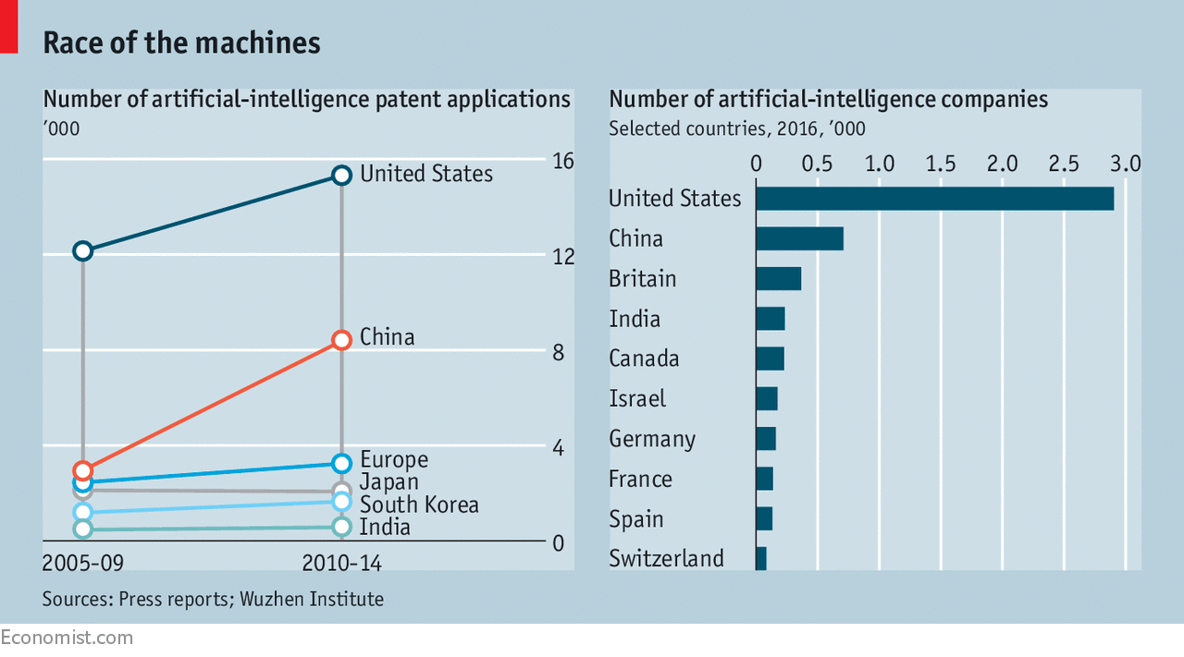

One more piece examines how AI is a different kind of technology:

Unsupervised Methods

Robbie Allen
Entrepreneur turned Ph.D Student @UNCCS focused on AI, Machine Learning & Natural Language. Founder & Chairman at @AInsights. https://unsupervisedmethods.com
Jun 12
https://unsupervisedmethods.com/why-artificial-intelligence-is-different-from-previous-technology-waves-764d7710df8b

Why Artificial Intelligence is Different from Previous Technology Waves
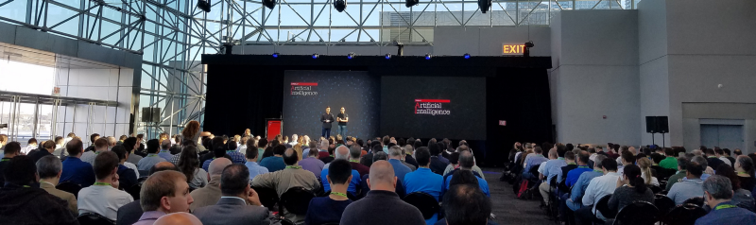
Packed house before my talk at the first O’Reilly Artificial Intelligence Conference in Sept 2016. I thought we achieved Peak AI Hype then, but it’s only continued to grow.
I’ve been around computing since my older brother got a Commodore 64 for Christmas in 1983. I took my first “business machines” class in high school in 1991, attended my first computer science class in 1994 (learning Pascal), and moved to Silicon Valley in 1997 after Cisco converted my internship into a permanent position. I worked in Cisco’s IT department for several years before moving to their engineering group where I designed networking protocols. I went to grad school at MIT in 2004 where I met the founders of several companies in Y Combinator’s first couple of batches and worked on Hubspot before it was Hubspot. After writing several books for O’Reilly and attending the first O’Reilly Web 2.0 and MIT Sloan Sports Analytics conferences, I started a “Web 2.0 for Sports” company called StatSheet.com in 2007, which in 2010 pivoted into the first Natural Language Generation (NLG) company called Automated Insights. I recently stepped back at Ai to become a Ph.D. student at UNC studying Artificial Intelligence.
All of that to say I’ve had a bird’s eye view to watch the incredible innovation that’s occurred over the past 30 years in technology. I’ve been lucky to be in the right place at the right time.
I’ve also seen my share of technology fads — I want my WebTV. Being a technology geek, I have a predisposition for shiny objects, and after managing over a hundred programmers in my career, it seems to be a trait many developers share. Being older now and having seen a variety of technology waves come and go (including one called Wave), it’s a little easier to apply pattern matching to the latest new thing that’s supposedly going to revolutionize our lives. I’ve become more skeptical of most new technologies as I see people get enamored with silver bullet thinking.
While I believe Artificial Intelligence is overhyped in many ways, I’m extremely bullish about its potential even when you factor in all the hype. There is a unique combination of factors that will make AI the most impactful technology in our lifetime. Yes, I have drunk the AI kool-aid, but I think it is for good reason.

Selling AI “before it was cool” was not cool
As Artificial Intelligence started to make a comeback again in 2011, I was cautiously optimistic. I started a company in 2010 with the initials AI (for Automated Insights) before AI was cool. My intuition was that it would be a slog for a couple years, but if Ray Kurzweil was even partially accurate about the rate at which AI would happen, positioning a company in the AI space in the early 2010's would end up working out — it did.
In 2012, trying to sell AI as a capability was difficult to say the least. Our company built a solution that automated the quantitative analysis and reporting process. That is, we automated what had only been done manually before with handwritten, data analysis reports. Since then we’ve automated everything from fantasy football recaps for Yahoo! to sales reports for one of the largest insurance companies. We automated earnings reports for the Associated Press and personalized workout recaps for bodybuilding.com. Trying to sell customers on “automated writing” in 2011 was how I imagine it felt to Henry Ford when he sold automobiles to people that had only seen horses: quizzical looks and disbelief that such a contraption was even possible — or necessary.
A short fours years later and things changed dramatically. The Gartner Hype Cycle (published since 1995) has been a consistent measure of the hype surrounding emerging technologies. Take a look at the 2016 report:
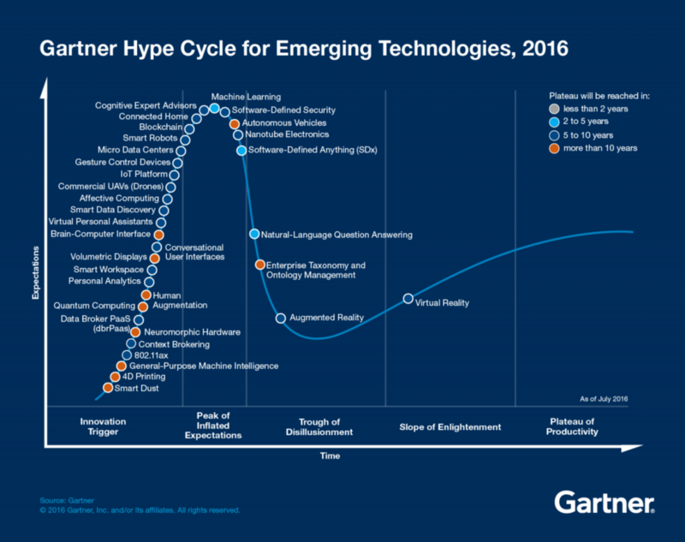
Source: Gartner
Several AI-related technologies make an appearance including Smart Robots, Autonomous Vehicles, Conversational User Interfaces, Natural Language Question-Answering, and of course, Machine Learning at the Peak of Inflated Expectations.
We went from a general disbelief in software being able to automate things that were strictly in the domain of humans to every startup having a token AI slide in their pitch decks. Before, I had to tone down the mention of “Artificial Intelligence” so we didn’t sound too geeky and scare people away, to now customers are disappointed if your solution isn’t completely magical. Before, the quickest way to end a conversation at a dinner party was to mention AI, and now my insurance agent tells me about this cool new “AI assistant” he’s using to schedule all his meetings.
Whether we’ve reached “Peak AI” or not, most people, including my retired mom, have heard about it. The big question remains: can it live up to the hype? How does AI compare with previous technologies regarding its potential? The answer is what gets me excited about the future.

The eight technology waves
I’ve identified eight broad technologies over the past 30 years that I think are useful for comparison purposes. I analyzed how quickly each technology evolved and the factors that either helped or impeded the rate of innovation. These eight are by no means the only technologies I could have chosen, but each one had a significant impact on the overall technology landscape during its peak. My intention is not to exhaustively go through every technology wave that’s ever occurred, but to provide a framework we can use to compare and contrast.
The eight I’m covering in this article include Desktop Operating Systems, Web Browsers, Networking, Social Networks, Mobile Apps, Internet of Things, Cloud Computing, and Artificial Intelligence.

Two key factors for Technology Potential
There are two factors that are very important determinants for how far and how fast a technology advances over time.
The first factor is the barrier to entry for a single developer to create something useful. If developers have the ability to create or tweak their own implementation, you get rapid dispersion of the technology and many improvements both big and small through the contributions of the developer crowd.
Operating Systems have a high barrier to entry because of the complexity of the software. Generally, you don’t see large numbers of developers spending time on the weekend trying to modify an operating system for some specialized purpose. On the flip side, Mobile Apps are easy to create and publish with limited skills (which has been both good and bad as I’ll explain).
The second factor is whether development on the core platform is centralized or decentralized. Does one company or organization serve as the gatekeeper for new versions of the core platform or can anyone contribute? In the Social Network space, development is completely centralized by the owners of the platforms (Twitter, Facebook, etc.) compared with Networking; the RFC process led to a widely distributed group of contributors.
A technology with a low barrier to entry and decentralized platform development has the greatest potential for future impact. None of the eight technologies possess both of those characteristics except Artificial Intelligence, but more on that later.
For the purpose of this article, I’m mainly interested in the potential for innovation, not how much innovation has or will occur. The two factors I mentioned aren’t required for a technology to have a huge impact. Cloud Computing has had a tremendous impact even though there are only a small handful of players in the space. But the future of Cloud Computing is almost entirely dependent on the companies that own the platforms. If the market consolidates or becomes less attractive over time for the major players, innovation will cease or diminish greatly, which was the story of the Web Browser in the early 2000's.
Below is how I’d rank the eight technologies across both factors. Just like Gartner’s Hype curve, the placement of each in the four quadrants was largely a subjective exercise based on my analysis. I’ll go into some detail on each technology, but first I’ll cover what each quadrant represents.
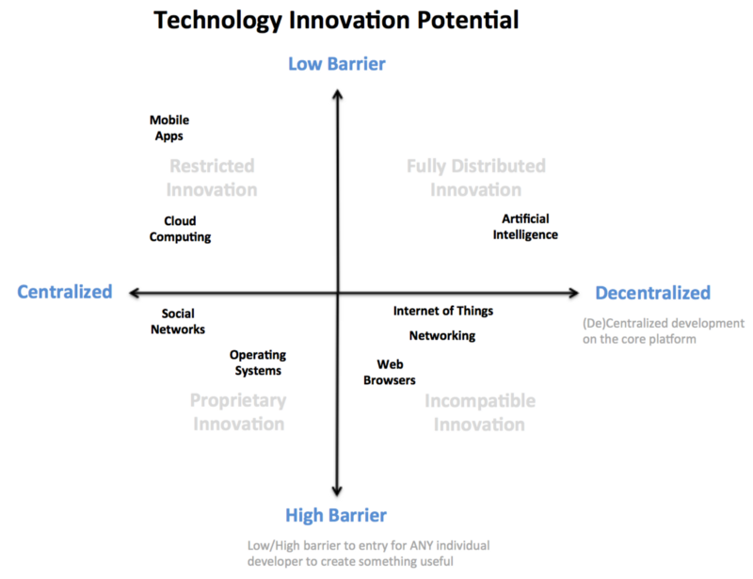
Low Barrier + Centralized Dev = Restricted Innovation
This scenario is pretty unusual because developers can easily create, but platform development is centralized. Innovation is restricted to the whims of the platform owner. Developers have to work within the confines of the platform with limited ability to influence overall direction because it is owned by a single authority. The app store model falls into this quadrant.
High Barrier + Centralized Dev = Proprietary Innovation
In this case, development can be done only by the platform owner. Developers have a high barrier to create and can’t contribute to the platform. This is the classic proprietary model, which has been dominant in product development.
High Barrier + Decentralized Dev = Incompatible Innovation
This quadrant often represents technologies that are based on open source or have open (and in many cases optional) standards, but either due to being based on hardware or very complex software, the barrier for developers to create is non-trivial. The result can be significant innovation, but with solutions that are not compatible as developers are free to incorporate the “standards” they choose.
Low Barrier + Decentralized Dev = Fully Distributed Innovation
This is optimal in terms of an environment that foster innovation. Not only can individual developers create because the barrier to entry is low, but they can also build their own platforms. AI is the only technology I’d put in this quadrant, and I’ll discuss the reasons for that in the next section.
Fully distributed innovation is difficult to scale over time because without any central coordination, you often end up with a fragmented ecosystem with many incompatible solutions. You can see this starting to occur within AI as certain frameworks become popular (e.g. Tensorflow and PyTorch).

Overview of the eight technologies
Next, I’m going to briefly describe the reasons I put each technology in a particular quadrant.

Desktop Operating Systems
The desktop operating systems have been dominated by a small number of players. IBM started in 1981 with their initial PC, Microsoft (and Sun to a lesser extent) in the 1990s, and Apple in the 2000s. Linux was in the mix too, but could never quite go mainstream on the desktop/laptop.
Operating systems are massive pieces of software, so there isn’t much that a single developer will do to improve and redistribute the core platform on their own. The complexity and breadth of code is a big reason for the high barrier to entry.
With the exception of Linux, the other popular desktop operating systems were proprietary. That means, for the most part, innovation in the OS has been centralized within the walls of big companies. Even in the case of Linux, having a benevolent dictator meant all big decisions were centrally managed. Big, monolithic software such as operating systems require centralized coordination at some level to ensure the end product is a fully integrated and stable solution.

Networking
Cisco’s IPO in 1990 was the beginning of an incredible run for networking companies over the next decade. A variety of companies were created and then were acquired or merged. Cisco, Lucent, and Nortel were the big players (and eventually Juniper) before the dot-com bust took the legs out of the industry from which it never fully recovered.
Internet protocols have had a decentralized development process with Request For Comments (RFCs) since the first RFC was published in 1969. There are standards bodies, such as the IETF, which can ratify RFCs as official standards. While defining protocols was decentralized, the core platforms that made use of these protocols (e.g. Cisco routers) were still proprietary and closed.
And since the major networking vendors had their own hardware, the barrier was high for an individual developer to contribute. While it was possible for an outsider to contribute to a protocol specification, only developers at the networking companies could add those protocols to their platforms.
I include Networking in this list not so much because it was a major technology wave, but because of their unique standardization process.

Web Browser
While the operating system wars were raging on, the most important application on the desktop also went through a similar battle. Whether it was Netscape and IE in the 1990s or Chrome, IE and Firefox today, the browser has always been a coveted application due to it being the front-end to the web.
While IE is the only major browser that is not open source or based on open source, the barrier to entry is still high. Like operating systems, modern web browsers have become very complex pieces of software. It’s not common for an average developer to fork a browser to customize it for their company’s use. Each browser provides varying support for extensions or plug-ins, but these tend to be pretty limited in terms of capabilities and are often brittle.
Given the open-source nature of some browsers, development on the core platform is decentralized, but in practice, changes are closely monitored. Given the wide user base for browsers, the browser owners have to scrutinize every change or risk sending out a flawed product to millions of users.

Mobile Apps
I could list “Mobile” or “Smartphones” here instead of Mobile Apps, but many of the same issues I described under Desktop Operating Systems would apply. Mobile Apps are a little more interesting for our purposes because of their low barrier to entry. When Apple came out with the App Store, it changed things forever in Mobile computing. Similar to web pages, but more feature rich, Mobile Apps ushered in a new era of consumer capabilities.
As far as a developer creating something useful, it doesn’t get much easier than a Mobile App. Some may argue that the barrier to entry is too low, so now the app stores are filled with junk. If it were a little harder to create, maybe the script kiddies and copycats of the world wouldn’t have contributed, but that’s the tradeoff with being open to all comers. A small percentage will create great apps, and the vast majority will not.

Social Networks
Whether it’s Facebook and Twitter or Foursquare and LinkedIn, the Social Networks have all been proprietary with limited standardization. There have been some open source attempts at Social Networks, but none have gained critical mass. That means virtually all the development in the Social Network space has come from a small number of companies.
Regarding a developer’s ability to create something useful, you can look at Social Networks in one of two ways, which is why I gave it a middle of the road score on barrier to entry. It is true that unless you are an employee of one of the Social Network companies, you won’t be able to contribute to their platform. On the other hand, Social networks are not nearly as complex as an operating system or web browser. The complexity comes in trying to scale Social Networks to millions (or billions) of users. A developer could cobble together a web app that resembled Facebook or Twitter in a weekend. Making them work for millions of users is a different story.
The other issue that makes Social Networks have a high barrier to entry is the required network effects before they become useful. If you don’t get a critical mass of users, the network has limited value. More than just making a mobile app, obtaining network effects is extremely difficult and not something a developer can easily build on her own.

Cloud Computing
Amazon, with Google and Microsoft following fast, has done an amazing job in ushering in a new age of Cloud Computing features and pricing with AWS. However, due to the significant hardware requirements, Cloud Computing is a very capital intensive business to be successful at scale. That generally leads to centralized development of the core platform where individual companies hold the keys to the kingdom, which is the case here (Amazon, Google, Microsoft, etc.)
Cloud Computing has been optimized to allow developers to create interesting things, so the barrier to create is low. Cloud Computing has enabled a lot of innovation, but that will only continue as long as Amazon, Google, and Microsoft deem the space worth investing in.

Internet of Things
It has been interesting to watch the Internet of Things (IoT) unfold over the last ten years as it gained and lost momentum a few times. Regarding my two factors, IoT is a mixed bag. As far as barrier to entry, most of the software (and even hardware) building blocks to build an IoT device are commonly available, but taking a commercial IoT device to market is a significant undertaking — just ask me about any of the failed Kickstarter projects in which I’ve invested.
IoT has benefited from some standardization, but it’s also a very fragmented space. It resembles the Networking environment I described earlier. Just because there are “standards” doesn’t mean companies have to use them. As a result, you likely have a variety of IoT devices in your home or office that use different standards or don’t work together.

Artificial Intelligence
I first realized something was different with the AI ecosystem when I started digging into the latest research on a variety of topics: LSTMs, GANs, CNNs, Seq-to-seq. There is so much new research coming out; it’s hard to keep up. Getting up-to-speed with the current state of the art and staying abreast of the latest research has been challenging, to say the least.
Looking at the two factors, first, the barrier to entry for a developer to do something interesting with AI is low. All the tools you need are freely available. The barriers are purely self-driven. To do something interesting you need a significant dataset (although there is some debate about how much you need) and the other is you need the mental bandwidth to understand how to build a useful model. It’s this last point that leaves me a little skeptical about the vast number of companies that claim they are doing interesting things with AI, specifically Machine Learning. Building an ML program isn’t like building a Mobile App. It’s more complicated, especially if you are doing anything interesting (although Amazon has simplified the process considerably).
Regarding the core platforms, it is still early days, and there aren’t heavyweight platforms that define the experience with AI like the other technologies I’ve covered. All of the machine learning and deep learning platforms like Tensorflow, PyTorch, Theano, and Keras are open-source and have vibrant communities.
The key that makes AI different than most other technologies is its strong research background. By default, the computer science field has been an open community marked by academic conferences where researchers present their latest findings. Many of the luminaries in the AI world hail from academia where publishing their research open was the norm. Instead of keeping innovation closed or waiting until the final moment once an idea has been fully baked and lots of code written, most research is based on a few months worth of work and limited code. The point is to get the ideas out to the community as quickly as possible so others can improve on them (and you get credit for the idea before someone else does).
The closest thing we’ve seen to this kind of ecosystem is the Internet standards bodies or open source movements I mentioned earlier, but AI is still different in important ways. When it comes to AI research, there is no governing body that approves new advances. The IETF and other organizations became notorious for playing favorites to the incumbents as well as being heavily political with the big powers in the industry forcing their representation so they can steer standards groups in particular ways. The closest thing to that in the research community is the paper submission process at the big academic conferences and awards for best paper. While those accolades are nice, they are not a necessary condition for your new idea to be picked up by the research crowd.
Even with Google, Facebook, Amazon, and Baidu scooping up Ph.D. students as quickly as they can, retraining their workforce on Machine Learning, and investing billions of dollars in the space, this is one of the few times in the past 30 years where a lot of that investment is helping push the whole industry forward instead of just a particular company’s agenda.

Confluence of circumstances
I often tell entrepreneurs that most startups fail too soon. They have to hang around long enough for the confluence of circumstances to line up in their favor. That’s what happened in my case. There was a domino effect of companies getting acquired that led to mine getting acquired for a great return. That said, this is the most troubling aspect of startup life for me — you can’t control everything that will make you successful. Market forces, technology shifts, economic conditions, etc. all have a significant impact on your company.
The same thing applies to technologies. Despite failed attempts in the past, the current AI boom came along at just the right time. There are a variety of circumstances that have contributed to its success including:
- The fully distributed innovation environment I’ve discussed has resulted in a very rapid rate of new capabilities throughout the AI field.
- After years of hype around Big Data starting in the mid-2000’s, by 2010 and 2011 many companies had finally started to develop Big Data infrastructures.
- After focusing years on the “what” instead of the “why,” companies wanted to realize value in their Big Data investments. The problem with Big Data is it’s not an end, but a means to an end. Pent-up demand to get something meaningful out of Big Data meant companies were open to new ways of making use of their data (enter AI stage left).
- Thanks in large part to the gaming world, optimized compute for AI (in the form of GPUs) have become readily available. GPUs perform matrix multiplication must faster than traditional CPUs, which means machine learning and deep learning models can perform much faster. Nvidia is happy.
- There is a low barrier to entry to develop AI solutions, but it requires a high level of technical knowledge. This is an important difference from Mobile Apps, which also have a low barrier to develop. Where App Stores are marred by numerous crappy apps, unless you are a serious developer with access to significant data, you won’t be able to do much with Machine Learning. As a result, the average AI app will be higher quality.

Will AI be Lebron James or Greg Oden?
In this article, I’ve described why the potential for future innovation with Artificial Intelligence is unlike anything we’ve seen among previous major technology waves. However, you can have all the potential in the world and not make full use of it. Just ask Tiger Woods.
The AI ecosystem will be resilient due to the fully distributed innovation model I’ve described, but there are a few external factors that could impede progress.
- Too focused on Deep Learning. A researcher from the Allen Institute for AI gave a talk at the O’Reilly AI conference last year and shared his concern that with all the attention Deep Learning has attracted, we may develop a local maximum on DL and not explore other methods that may be better suited to help achieve general AI.
- Not enough good Big Data. Despite the progress many companies have made at organizing their data, most still have a long way to go. At Automated Insights, we’ve seen the #1 impediment to successful projects is lack of enough quality data. Most companies think they have better data than they do.
- Humans! Easily the biggest impediment to adoption of next-generation automation and AI technologies will be ourselves. As a society, we will not fully embrace technologies that can save millions of lives like autonomous cars. The technology for Level 5 autonomous cars is within reach, but societal and political pressures will make it take considerably longer to get fully implemented.
- Surviving the Trough of Disillusionment. It would be interesting to ask the Gartner folks, but I’d be curious if they’ve seen in the last 20 years a technology get as hyped as quickly as AI. They use the same hype curve for all emerging technologies, but in reality, each one has different slope to their curve. Given just how much hype has surrounded AI, it may mean the Trough of Disillusionment could also be deeper and potentially harder to come out of. Will people get soured on AI when early results don’t come back as amazing as we hoped?
- AI platforms emerge that make development more centralized. Tensorflow has gained a lot of traction in the ML community. Could it become a more heavyweight platform that becomes the default framework every ML engineer has to use? Then we risk following a more centralized innovation pattern.
Ultimately, I believe Amara’s Law will hold true for AI:
We tend to overestimate the effect of a technology in the short run and underestimate the effect in the long run.
Many manual tasks I thought were untouchable just a year or two ago, I can see a path to making them more automated. It will be interesting to watch if there is a tipping point where the rate of innovation goes even quicker as we make additional breakthroughs.

Now, let’s shift to the business part of technology:

The Business of Technology

NYT

Is It Time to Break Up Google?
By JONATHAN TAPLINAPRIL 22, 2017
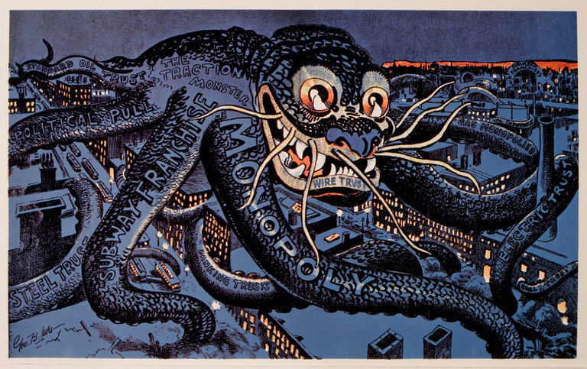
An antimonopoly cartoon from 1899, “The Menace of the Hour.” Credit Universal History Archive/UIG, via Getty Images
In just 10 years, the world’s five largest companies by market capitalization have all changed, save for one: Microsoft. Exxon Mobil, General Electric, Citigroup and Shell Oil are out and Apple, Alphabet (the parent company of Google), Amazon and Facebook have taken their place.
They’re all tech companies, and each dominates its corner of the industry: Google has an 88 percent market share in search advertising, Facebook (and its subsidiaries Instagram, WhatsApp and Messenger) owns 77 percent of mobile social traffic and Amazon has a 74 percent share in the e-book market. In classic economic terms, all three are monopolies.
We have been transported back to the early 20th century, when arguments about “the curse of bigness” were advanced by President Woodrow Wilson’s counselor, Louis Brandeis, before Wilson appointed him to the Supreme Court. Brandeis wanted to eliminate monopolies, because (in the words of his biographer Melvin Urofsky) “in a democratic society the existence of large centers of private power is dangerous to the continuing vitality of a free people.” We need look no further than the conduct of the largest banks in the 2008 financial crisis or the role that Facebook and Google play in the “fake news” business to know that Brandeis was right.
While Brandeis generally opposed regulation — which, he worried, inevitably led to the corruption of the regulator — and instead advocated breaking up “bigness,” he made an exception for “natural” monopolies, like telephone, water and power companies and railroads, where it made sense to have one or a few companies in control of an industry.
Could it be that these companies — and Google in particular — have become natural monopolies by supplying an entire market’s demand for a service, at a price lower than what would be offered by two competing firms? And if so, is it time to regulate them like public utilities?
Consider a historical analogy: the early days of telecommunications.
In 1895 a photograph of the business district of a large city might have shown 20 phone wires attached to most buildings. Each wire was owned by a different phone company, and none of them worked with the others. Without network effects, the networks themselves were almost useless.
The solution was for a single company, American Telephone and Telegraph, to consolidate the industry by buying up all the small operators and creating a single network — a natural monopoly. The government permitted it, but then regulated this monopoly through the Federal Communications Commission.
AT&T (also known as the Bell System) had its rates regulated, and was required to spend a fixed percentage of its profits on research and development. In 1925 AT&T set up Bell Labs as a separate subsidiary with the mandate to develop the next generation of communications technology, but also to do basic research in physics and other sciences. Over the next 50 years, the basics of the digital age — the transistor, the microchip, the solar cell, the microwave, the laser, cellular telephony — all came out of Bell Labs, along with eight Nobel Prizes.
In a 1956 consent decree in which the Justice Department allowed AT&T to maintain its phone monopoly, the government extracted a huge concession: All past patents were licensed (to any American company) royalty-free, and all future patents were to be licensed for a small fee. These licenses led to the creation of Texas Instruments, Motorola, Fairchild Semiconductor and many other start-ups.

Changes at the Top

2006
5 largest by market cap
$ billion US
Exxon Mobil 540
General Electric 463
Microsoft 355
Citigroup 331
Bank of America 290

2017 4/20 6/17
Apple 794 805
Alphabet (Google) 593 682
Microsoft 506 559
Amazon 429 479
Facebook 414 443
All figures in 2017 dollars; 2017 companies as of April 20 and June 7
Source: S&P Dow Jones Indices
By The New York Times
True, the internet never had the same problems of interoperability. And Google’s route to dominance is different from the Bell System’s. Nevertheless it still has all of the characteristics of a public utility.
We are going to have to decide fairly soon whether Google, Facebook and Amazon are the kinds of natural monopolies that need to be regulated, or whether we allow the status quo to continue, pretending that unfettered monoliths don’t inflict damage on our privacy and democracy.
It is impossible to deny that Facebook, Google and Amazon have stymied innovation on a broad scale. To begin with, the platforms of Google and Facebook are the point of access to all media for the majority of Americans. While profits at Google, Facebook and Amazon have soared, revenues in media businesses like newspaper publishing or the music business have, since 2001, fallen by 70 percent.
According to the Bureau of Labor Statistics, newspaper publishers lost over half their employees between 2001 and 2016. Billions of dollars have been reallocated from creators of content to owners of monopoly platforms. All content creators dependent on advertising must negotiate with Google or Facebook as aggregator, the sole lifeline between themselves and the vast internet cloud.
It’s not just newspapers that are hurting. In 2015 two Obama economic advisers, Peter Orszag and Jason Furman, published a paper arguing that the rise in “supernormal returns on capital” at firms with limited competition is leading to a rise in economic inequality. The M.I.T. economists Scott Stern and Jorge Guzman explained that in the presence of these giant firms, “it has become increasingly advantageous to be an incumbent, and less advantageous to be a new entrant.”
There are a few obvious regulations to start with. Monopoly is made by acquisition — Google buying AdMob and DoubleClick, Facebook buying Instagram and WhatsApp, Amazon buying, to name just a few, Audible, Twitch, Zappos and Alexa. At a minimum, these companies should not be allowed to acquire other major firms, like Spotify or Snapchat.
The second alternative is to regulate a company like Google as a public utility, requiring it to license out patents, for a nominal fee, for its search algorithms, advertising exchanges and other key innovations.
The third alternative is to remove the “safe harbor” clause in the 1998 Digital Millennium Copyright Act, which allows companies like Facebook and Google’s YouTube to free ride on the content produced by others. The reason there are 40,000 Islamic State videos on YouTube, many with ads that yield revenue for those who posted them, is that YouTube does not have to take responsibility for the content on its network. Facebook, Google and Twitter claim that policing their networks would be too onerous. But that’s preposterous: They already police their networks for pornography, and quite well.
Removing the safe harbor provision would also force social networks to pay for the content posted on their sites. A simple example: One million downloads of a song on iTunes would yield the performer and his record label about $900,000. One million streams of that same song on YouTube would earn them about $900.
I’m under no delusion that, with libertarian tech moguls like Peter Thiel in President Trump’s inner circle, antitrust regulation of the internet monopolies will be a priority. Ultimately we may have to wait four years, at which time the monopolies will be so dominant that the only remedy will be to break them up. Force Google to sell DoubleClick. Force Facebook to sell WhatsApp and Instagram.
Woodrow Wilson was right when he said in 1913, “If monopoly persists, monopoly will always sit at the helm of the government.” We ignore his words at our peril.
Jonathan Taplin is the director emeritus of the University of Southern California’s Annenberg Innovation Lab and the author of “Move Fast and Break Things: How Google, Facebook and Amazon Cornered Culture and Undermined Democracy.”
What are the implications of the changes between 2006 and 2017?

What is it like to work with an AI-based machine?
NYT

Meet the People Who Train the
Robots (to Do Their Own Jobs)
Before the machines become smart enough to replace
humans, as some people fear, they need to be taught.
By DAISUKE WAKABAYASHI APRIL 28, 2017
SAN FRANCISCO — What if part of your job became teaching a computer everything you know about doing someone’s job — perhaps your own?
Before the machines become smart enough to replace humans, as some people fear, the machines need teachers. Now, some companies are taking the first steps, deploying artificial intelligence in the workplace and asking their employees to train the A.I. to be more human.
We spoke with five people — a travel agent, a robotics expert, an engineer, a customer-service representative and a scriptwriter, of sorts — who have been put in this remarkable position. More than most, they understand the strengths (and weaknesses) of artificial intelligence and how the technology is changing the nature of work.
Here are their stories.
Credit Shiho Fukada for The New York Times

‘It made me feel competitive’
Rachel Neasham, travel agent
Ms. Neasham, one of 20 (human) agents at the Boston-based travel booking app Lola, knew that the company’s artificial intelligence computer system — its name is Harrison — would eventually take over parts of her job. Still, there was soul-searching when it was decided that Harrison would actually start recommending and booking hotels.
At an employee meeting late last year, the agents debated what it meant to be human, and what a human travel agent could do that a machine couldn’t. While Harrison could comb through dozens of hotel options in a blink, it couldn’t match the expertise of, for example, a human agent with years of experience booking family vacations to Disney World. The human can be more nimble — knowing, for instance, to advise a family that hopes to score an unobstructed photo with the children in front of the Cinderella Castle that they should book a breakfast reservation inside the park, before the gates open.
Ms. Neasham, 30, saw it as a race: Can human agents find new ways to be valuable as quickly as the A.I. improves at handling parts of their job? “It made me feel competitive, that I need to keep up and stay ahead of the A.I.,” Ms. Neasham said. On the other hand, she said, using Harrison to do some things “frees me up to do something creative.”
Ms. Neasham is no ordinary travel agent. When she left the Army after serving as a captain in Iraq and Afghanistan, she wanted to work at a start-up. She joined Lola as one of its first travel agents. Knowing that part of her job was to be a role model, basically, for Harrison, she felt a responsibility for Harrison to become a useful tool.
Founded in 2015 by Paul English, who also started the travel-search site Kayak, Lola was conceived as part automated chat service and part recommendation engine. Underlying it all was a type of artificial intelligence technology called machine learning.
Lola was set up so that agents like Ms. Neasham didn’t interact with the A.I. much, but it was watching and learning from every customer interaction. Over time, Lola discovered that Harrison wasn’t quite ready to take over communication with customers, but it had a knack for making lightning-fast hotel recommendations.
At first, Harrison would recommend hotels based on obvious customer preferences, like brands associated with loyalty programs. But then it started to find preferences that even the customers didn’t realize they had. Some people, for example, preferred a hotel on the corner of a street versus midblock.
And in a coming software change, Lola will ask lifestyle questions like “Do you use Snapchat?” to glean clues about hotel preferences. Snapchat users tend to be younger and may prefer modern but inexpensive hotels over more established brands like the Ritz-Carlton.
While Harrison may make the reservations, the human agents support customers during the trip. Once the room is booked, the humans, for example, can call the hotel to try to get room upgrades or recommend how to get the most out of a vacation.
“That’s something A.I. can’t do,” Ms. Neasham said.
Photo
Credit Hiroko Masuike/The New York Times

‘How do we elegantly recover?’
Diane Kim, interaction designer
Ms. Kim is adamant: Her assistant doesn’t use slang or emoji.
Her assistant, Andrew Ingram, also avoids small talk and doesn’t waste time on topics beside scheduling her meetings, she said.
Ms. Kim isn’t being tyrannical. She just knows her assistant better than most bosses, because she programmed him.
Ms. Kim, 22, works as an A.I. interaction designer at x.ai, a New York-based start-up offering an artificial intelligence assistant to help people schedule meetings. X.ai pitches clients on the idea that, through A.I., they get the benefits of a human assistant — saving the time and hassle of scheduling a meeting — at a fraction of the price.
It’s Ms. Kim’s job to craft responses for the company’s assistants, who are named Andrew and Amy Ingram, or A.I. for short, that feel natural enough that swapping emails with these computer systems feels no different than emailing with a human assistant.
Ms. Kim’s job — part playwright, part programmer and part linguist — didn’t exist before Alexa, Siri and other A.I. assistants. The job is like a translator of sorts. It is to help humans access the A.I.’s superhuman capabilities like 24/7 availability and infallible memory without getting tripped up by robotic or awkward language.
Even in the narrow parameters of scheduling meetings, it takes a lot of machine learning to break down emails for a computer. For example, setting a meeting for “Wednesday” is different than setting a meeting for “a Wednesday,” as in any Wednesday. X.ai breaks down emails to their component parts to understand intent.
The automated response is where Ms. Kim takes over. Her job is to imagine how a human assistant would arrange a meeting for the boss. For a specific task, she devises different situations — for example, what if the meeting had five attendees versus two — and then she creates a flow chart of how the email exchange would go.
The goal is to schedule a meeting in as few emails as possible. With that in mind, x.ai settled on a set of personality traits for its assistants: polite, professional, friendly and clear.
Sometimes, it’s hard to predict what will rub people the wrong way. Early on, the A.I. assistant sent emails to potential attendees saying that the assistant would be happy to put something on the boss’s “calendar,” but some people found that wording to be cold, and not always appropriately deferential to the other attendees.
X.ai changed the wording so that the A.I. assistant says it would be happy to “find a time” that works for all attendees.
Some people try to test the A.I. assistants with unusual requests. For example, people are curious what else the assistants can do and ask for help in booking hotels, flights or conference rooms (things they can’t do). Others ask Amy’s age, or Andrew’s birthday. “How do we elegantly recover when Amy or Andrew don’t know what to do?” Ms. Kim said.
X.ai doesn’t pretend the assistants are human. But Ms. Kim still gets satisfaction when people don’t realize that the assistants are robots. People ask them out on dates. They receive thank-you emails from happy customers even though, as robots, they don’t need gratitude.
“They’re shocked and surprised that they were talking to an A.I.,” she said.
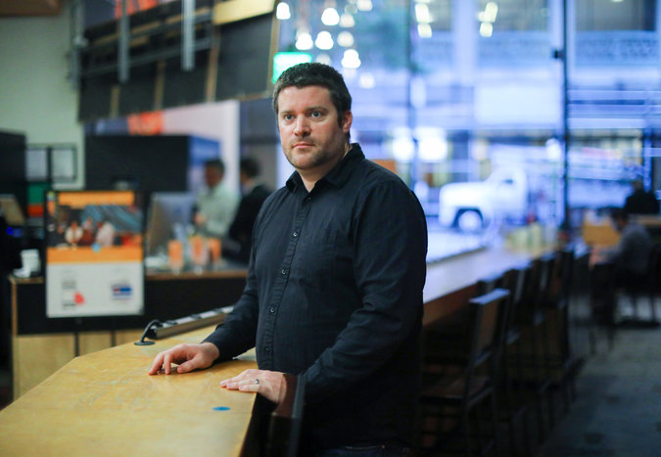
Credit Jim Wilson/The New York Times

‘A cesspool of legal language’
Dan Rubins, chief executive
Mr. Rubins has a lot of grievances with lawyers.
At his former job, he recalled the time when six corporate lawyers, each billing at hundreds of dollars an hour, were inspecting a contract looking for capitalization errors. It’s what prompted him to create Legal Robot, a start-up that uses artificial intelligence to translate legalese into plain English.
Having reviewed nearly a million legal documents, Legal Robot also flags anomalies (strange wording or clauses) in contracts. “Lawyers have had 400 years to innovate and change the profession, and they haven’t done it,” said Mr. Rubins, who is not a lawyer. “It’s time for some outside help.”
He said legal documents are well suited to machine learning because they are highly structured and repetitive. Legal Robot tapped a vast trove of contracts prepared by human lawyers in filings with the Securities and Exchange Commission — “a cesspool of legal language,” Mr. Rubins said — as well as past documents from law firms who wanted to help train Legal Robot’s systems.
After going through a large set of documents, the company’s machine learning systems start to recognize patterns indicating the words that tend to go together and those that do not. However, Mr. Rubins becomes worried when the A.I. is too confident about its results. That’s often a byproduct of training the computer on too narrow a set of contracts.
For example, Legal Robot trained its A.I. on thousands of employment contracts from a state that allows noncompete clauses, which restrict employees from switching to a rival company. That meant when the A.I. saw contracts from states where noncompetes aren’t enforceable, it nevertheless piped up to say the clause was missing. In other words, the A.I. was missing important context.
Mr. Rubins, 33, said the A.I. is good at identifying potentially vague word choices. He recently received a two-page nondisclosure agreement — it was reviewed by human lawyers — from another company containing the word “shall” 30 times. The A.I. pointed out that “shall” can be vague and advised that “will” or “may” are more clear, depending on the context.
Mr. Rubins doesn’t think A.I. will put lawyers out of business, but it may change how they work and make money. The less time they need to spend reviewing contracts, the more time they can spend on, say, advisory work or litigation.
“I really don’t think we’re going to get rid of lawyers,” he said. “Unfortunately, we still need them.”
Credit Jenn Ackerman for The New York Times

‘That was a ‘wow’ moment for me’
Sarah Seiwert, customer representative
It took two weeks for Ms. Seiwert to notice that her company’s A.I. computer system was starting to pick up on her work patterns.
Ms. Seiwert, 37, a customer representative at the online test-prep company Magoosh, answers student emails. When a question comes in, she searches a database of preapproved responses and finds the appropriate answer.
There are thousands of different responses. Finding the right answer isn’t as easy as it sounds.
When Magoosh implemented an A.I. system in February to help its customer service team work more efficiently, Ms. Seiwert noticed that it was reading the questions and suggesting responses.
If the suggestions were good, she would add a few niceties and send back a quick reply. But within two weeks, she noticed that even when she wasn’t responding directly to an email, but following up to one that she had sent earlier, the software was suggesting the proper response.
“That was a ‘wow’ moment for me,” said Ms. Seiwert, who works from a home office in Mankato, Minn. “It’s been studying and learning my patterns.”
As more customer service moves from phone calls to text-based conversations through chat or email, companies are looking to machine learning to help the human agents work faster. Magoosh is using software created by DigitalGenius, a London-based start-up.
When an email comes into Magoosh, the system reads the email, categorizes it and routes it to the appropriate employee. After a few months, some DigitalGenius customers start to automate responses for some common questions. Basically, this happens when the A.I. has seen enough examples of how human agents handled the request that it gains confidence that its answer will be correct.
Magoosh isn’t there yet. But Ms. Seiwert said the software has reduced Magoosh’s queue of customer requests by half, and it has made her team’s goal of responding to every customer within 24 hours more manageable.
Even though the A.I. is learning from the human agents, Ms. Seiwert said she doesn’t foresee a future where she’s out of a job. Too many questions still require a level of human intuition to know the appropriate answer. There are also times when rules need to be broken, like when customers ask for an extension on their account because of some circumstance beyond their control.
“I am not convinced that artificial intelligence is going to replace us,” she said. “You can’t program intuition, a gut instinct. So the A.I. might get very intelligent, but I hope as a human I continue to get intelligent and not stand at a standstill.”
Photo
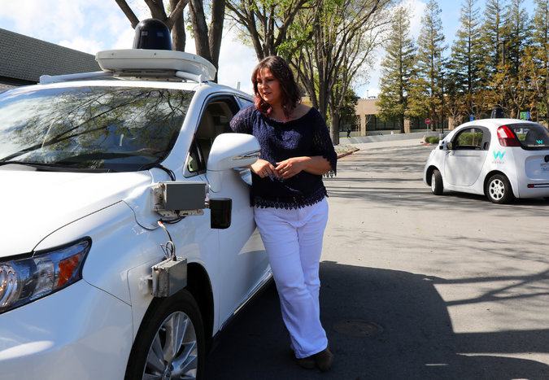
Credit Jim Wilson/The New York Times

The ‘cases we haven’t seen before’
Aleksandra Faust, software engineer
As a senior software engineer at the self-driving car company Waymo and a robotics expert, Ms. Faust grapples with an unpredictable world.
Formerly known as Google’s self-driving car project, Waymo wants to build autonomous vehicles that can react properly under all kinds of unusual circumstances. Not only when drivers run red lights, but also when a child crosses an intersection riding a hoverboard while walking a dog (which happened recently).
Waymo’s cars have driven two million miles in the real world and billions more in computer simulations. But it’s impossible to program for every event.
“There’s always going to be some cases that we haven’t seen before,” Ms. Faust said. “Based on the situations it’s seen, the A.I. helps the car react in situations it hasn’t seen.”
Safety is a concern, said Ms. Faust, 43, but so is comfort. Take the process of braking at a red light. When human drivers see a red light, they tend to slow down gradually before coming to a full stop. Waymo’s driverless car was hitting the brake too abruptly in a way that human drivers would do if they weren’t paying attention.
However, a sudden stop is dangerous because other drivers may not be paying attention. And it is jarring for the passengers.
Using real-world examples of how human drivers slow to a stop from different speeds, Ms. Faust’s team creates different models for the most natural way a car should brake depending on how fast it is going. “One thing we’ve learned about human driving is that it’s very, very complex,” said Ms. Faust, who joined Waymo two years ago when it was still part of Google’s research lab, X.

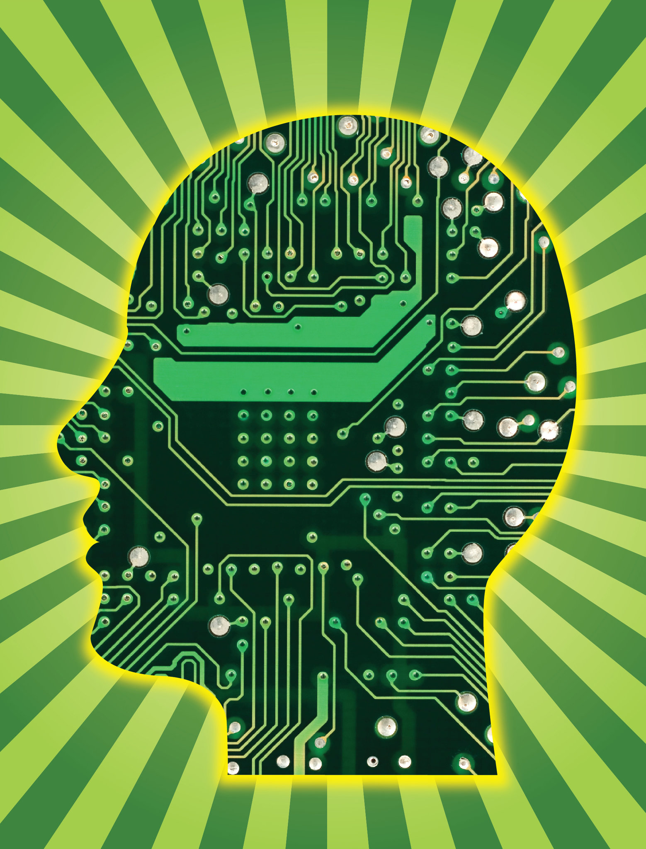

Is Unemployment in Your Future?

The Robot Economy: Ready or Not, Here It Comes
Sunday, May 07, 2017 By JP Sottile, Truthout | News Analysis

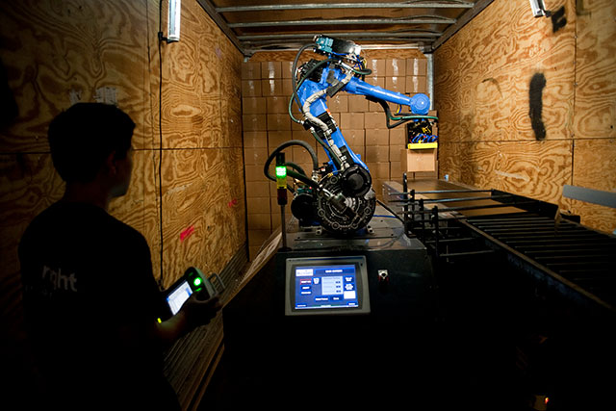Duc Tran, an automation engineer, observes the fully autonomous robotic truck loader during a test at the Wynright Robotics facility in Arlington, Texas, July 18, 2012. (Photo: Brandon Thibodeaux / The New York Times)
September 17th changed everything.
On that day in 2013, Oxford University published an innocuously titled academic paper by two mostly unknown economists. But "The Future of Employment" wasn't just another number-crunching exercise in opacity by a couple of dreary scientists. No, their bombshell report portended a coming robot apocalypse that could change the nature of human civilization, and perhaps even human beings themselves.
Thankfully, the forthcoming carnage described by Carl Benedikt Frey and Michael A. Osborne isn't a doomsday scenario where Skynet systematically wipes out humankind, or a darkly lit near-future where attractive Replicants violently struggle to make sense of their emerging emotions in a perpetually damp Los Angeles.
Instead, the economists previewed an all-too-real world where the second-richest man on the planet -- Amazon's Jeff Bezos -- gleefully parades around like Sigourney Weaver in a massive robotic exoskeleton built by Hankook Mirae Technology.
They presaged the impending doom from robots like Handle, the Michael Jordan-esque robot built by Boston Dynamics. Handle can leap like a superhero, can run a marathon in under three hours and, if Softbank CEO Masayoshi Son is right, will probably be smarter than you in just a few decades.
They foresaw a future with the likes of Gordon, the "first robotic barista in the U.S." Gordon can serve "about 120 coffees in an hour." They also predicted the likes of Otto, the self-driving big-rig designated by Uber to deliver truckloads of beer to thirsty consumers. And then there's Pepper, the empathic, "day-to-day" companion that is not just working in airports and banks, but being "adopted" into Japanese homes … and even "enrolling" in school.
The Future Is Now
This is the "next economy," and, ready or not, it is coming at the double-time speed of Moore's Law. This rapid acceleration of the Fourth Industrial Revolution is transforming "The Future of Employment's" apocalyptic premonition -- that 47 percent of all jobs in the United States may be lost to automation over the next two decades -- into a solemn epitaph for the rapidly fading era of manufacturing-based, consumption-driven economics.
Dire warnings have come from Bill Gates, Stephen Hawking, Elon Musk and, most dauntingly, from cybersecurity experts who recently warned of the threat of hacked robots violently turning against people and their pets in a souped-up scenario reminiscent of The Purge. However, long before a haywire Roomba or a disgruntled Pepper comes calling, millions of workers will struggle to fend off the brutal reality of unplanned obsolescence.
This is an economy where manufacturing jobs require a college degree, artificial intelligence replaces administrative workers, automated kiosks dislodge food service workers and driverless vehicles threaten the livelihoods of up to 10 million Americans who take the wheel for a living.
This is "Industry 4.0." It's an economy where Amazon's dirigible-based distribution center perpetually floats over cities, effortlessly deploying drones to deliver stuff built by robots or 3-D printers or both. F rankly, it's Amazon's jungle out there. Its plan to "disrupt " the grocery business with almost human-free stores is just the next phase of an ongoing, Amazon-led "retail apocalypse " that's driving human-staffed brick and mortar stores into extinction. Amazon also dominates the AI-assistant market with its self-teaching, suspiciously spooky personal assistant Alexa. And now Amazon's poised to pair its increasingly automated warehouses with a move to become the leader in the self-driving future of trucking and overland shipping.
Even low-paying farming jobs could be completely upended by robotic fruit pickers with the deft touch needed to harvest food in American and European fields. Robots are already replacing cheap migrant workers shut out by anti-immigrant policies. And new robot-staffed factories are producing modular houses, while robotic bricklayers promise to do to the construction trades what automation did to coal mining.
This is an economy where there's "an 83% chance that workers who earn $20 an hour or less could have their jobs replaced by robots in the next five years" and "those in the $40 an hour pay range face a 31% chance of having their jobs taken over by the machines," according to a 2016 report by then-President Obama's White House.
And it's not coincidental that this robot apocalypse comes at the very moment the epic economic growth we've enjoyed throughout the post-World War II era seems to be coming to an end. Peak demand in oil and "peak stuff" for consumer products may signal more than just growing energy efficiency and market saturation for cheap stuff. This may signal the spread of Japan-style economic stagnation around the developed world. This could be the end of the ecologically untenable assumption of limitless growth.
The End of the American Century
The post-war idea of never-ending growth emerged from the manufacturing boom that came with the "American Century." Perpetual government investment in the military-industrial complex created a baseline of well-paying, low and high-skilled jobs that helped raise the floor -- and consumer expectations -- for workers, while also sustaining huge corporations like Boeing, Westinghouse and General Electric. Military Keynesian was a reliable tide that lifted a lot of boats moored to an American dream of endless economic expansion. Sadly, it also conjured up a series of costly, nightmarish wars for those who paid the ultimate price both at home and abroad.
An often overlooked element, though, is the way automation helped maintain continued growth in productivity, even as wages lagged. As the Guardian recently noted, "As of 2015, a typical production worker in the US earned about 9% less than a comparable worker in 1973. Over the same 42 years, the American economy grew by more than 200%, or a staggering $11tn." This divergence between wages and productivity drove wealth inequality. But it also presented a problem for producers facing the declining purchasing power of their customers -- a.k.a. the workers not getting the wages they needed to drive, or at least sustain, continued growth in consumption.
To keep up, the manufacturing economy needed 1) a massive flood of consumer credit to create artificial purchasing power; 2) ever-lower prices on ever-more mass-produced goods so wage-stagnant workers could afford to consume the way they did when one good job per family made for a middle-class life.
To get there, jobs went to places like China. But one of the underappreciated drivers of this move to cheap labor was the coming of automation, which made American humans a far less efficient way to make things. BuzzFeed reported on a recent study by the National Bureau of Economic Research, which found that since 1990, each new robot installed in an American factory "reduced employment in the surrounding area by 6.2 workers." The only thing cheaper than replacing American humans with better technology was exploiting cheap labor markets in China and the developing world. But that's no longer true.
To wit, Oxford paired with Citibank in 2015 to produce a fuller picture of the global threat to jobs. In "Technology at Work," researchers found that 75 percent of the world's robots are "geographically concentrated" in just five countries -- "China, Germany, Japan, Korea, and the US." Of those, China is by far "the fastest growing market" with the "most significant room for future growth." In fact, they determined that "on average 57% of jobs are susceptible to automation," but the "number rises to 69% in India and 77% in China."
As if on cue, China's new "five-year plan" to be a global leader in robotics has already produced results. China leads the world in production of industrial robots, and robots are becoming a cheaper, more productive option to Chinese labor. That's the simple, 21st-century reality undermining the hollow promise to "Make America Great Again" by bringing back jobs from China. It's a great plan for growth … if you've got a time machine big enough for 320 million people.
Not only is China automating jobs at an ever-faster pace, but 3-D printing technology is radically altering the way everything gets made. Even as we begin to wrap our heads around a future filled with 3-D printed guns, researchers are moving on to 4-D printing techniques with evolving materials that can self-assemble, repair and even remake themselves at will.
Perhaps most tellingly, artificial intelligence is starting to lay waste to college-educated workers in non-manual jobs previously thought to be exempt from automation. Here are just some of white-collar casualties of the robot apocalypse:
* Goldman Sachs "employs" Marcus -- a fully automated lending platform that's part of an industry-wide AI-makeover displacing humans in equities "sales, trading, and research."
* Fukoku Mutual Life Insurance is turning over policy payouts to IBM's Watson Supercomputer, which has 6,000 corporate clients ranging from Hilton Hotels to Whirlpool and Visa.
* Coca-Cola's global senior digital director plans on using AI bots to crank out ads with "automated narratives" and AI is already creating commercial music and jingles.
* Jeff Bezos-owned Washington Post used Heliograf to pump out stories about the 2016 Rio Olympics before tweaking it to "cover" the 2016 Election campaign.
* The Smart Tissue Autonomous Robot (STAR) recently "outperformed" a human surgeon in a test of skill. This breakthrough augurs a near-future world where robots assist and perform a variety of surgical procedures.
Just like elsewhere, medical robots will ultimately prove they can do the job quickly, efficiently and without human burnout. The high price of doctors will be weighed against robots that perform thousands of surgeries without complaint or error, particularly since "self-taught" AI already outperforms humans in predicting heart attacks and matches them in diagnosing skin cancer. Like it is doing in manufacturing, this could mean a wholesale revolution in health care that lowers costs and increases access to highly specialized care. It's that level of relentless, Terminator-like efficiency that is disrupting the existing economic model of everything from retail and restaurants, to education and warfare.
What's Next?
The Fourth Industrial Revolution may be an era of human obsolescence for which the previous three Industrial Revolutions may not be a guide. That's because artificially created, human-modeled deep learning neural networks already generate cognitive processes so complex that even the scientists who created those networks cannot determine how, for instance, an autodidactic self-driving car makes the decisions it does when driving itself around New Jersey. In other words, we're not talking about industrial looms, steam engines or punch-cards. We're talking about cheaper, efficient, tireless and infinitely upgradeable workers that (or who?) are ready to take on nearly every human endeavor.
That's why tech leaders increasingly talk about the "New Collar" economy, where human beings not only work with intelligent machines, but also begin physically merging with machines in an effort to keep pace. While some see this coming singularity as a metaphysical event horizon for human consciousness, Elon Musk sees it as the only way we'll will be able to keep up with what is, in effect, a whole new class of forced labor … and he's got the start-up to prove it.
Sadly, forced labor may be the economic model most applicable to the next economy. As more and more jobs are turned over to AI, robots and algorithms, more and more wealth will accumulate in the hands of those already at the top of a steep pyramid. Like the pharaohs of old, these masters of the universe will profit as the cost of labor declines precipitously thanks to the robots they "employ."
As MIT Technology Review recently pointed out, this will generate windfalls for firms like Goldman Sachs where "pay of the average managing director … will probably get even bigger, as there are fewer lower-level people to share the profits with." Since they are in the business of leveraging money to make more money, they can thrive -- at least for a while -- in the whiz-bang, highly financialized world of high-speed, algorithmic market trades.
But it will also be an era when inequality hits not only human beings, but also companies. The tech world is filled with hi-tech unicorns like Uber that gallop to higher and higher valuation with just a fraction of the workforce (6,700) supported by Ford (201,000), Hertz (30,000) or one of the nation's leading trucking firms (18,000). Successful companies with the fewest employees and the most robots will complete the long process of "de-industrialization" often blamed on globalization. On the surface, outsourcing and offshoring look like the main disruptive forces opening up the income and wealth gaps. But they're really just the logical outcome of driving growth through increased productivity, instead of driving growth (and consumption) through increased wages and broader employment. Robots are simply the cheapest, most efficient and most productive phase of all.
However, the next economy doesn't have to be a doomsday scenario. It could be a sustainable economy where technology drives a stake into the heart of the hydrocarbons, drives down the cost on heath care and expands banking to underserved communities. The next economy could also see the "gig economy" transition to open-source, peer-to-peer, micro-entrepreneurial and microgrid-powered networks that eliminate economic middlemen. And the "Maker Movement" could inspire a "curated economy" of artisans, urban farmers and hyperlocal bartering that runs parallel to the robot-run, mass-produced economy. These human-made goods and services may be worth far more in a world where every mass-produced need is only a click and a hovering Amazon blimp away.
As our needs are increasingly met by hyper-efficient, AI-driven systems, the only acquisition that will truly matter is knowledge. And knowledge must become more than just a "means" to the end of getting that coveted or expected job out of high school or college -- because the means of production will no longer require human hands, human sweat or human tears. Perhaps that's why Alibaba's Jack Ma not only lamented a coming world of "pain" as the tech-driven economic disruption lays waste to the global economy, but also said education must be reformed to "raise children to be more creative and curious or they will be ill-prepared for the future." It's a future where knowledge -- and the creativity it sparks -- may have to be an end unto itself.
And while Musk is plotting for the day when augmented humans rise up to stop his vision of a Terminator-filled future, the true test will be how we as a society choose to manage -- or whether we simply continue to ignore -- the widening pain of displacement as we move from this economy to the next one. Either way, it's not only coming … it's already here.

JP Sottile
JP Sottile is a freelance journalist, published historian, radio co-host and documentary filmmaker (The Warning, 2008). His credits include a stint on the Newshour news desk, C-SPAN and as newsmagazine producer for ABC affiliate WJLA in Washington. His weekly show, "Inside the Headlines With The Newsvandal," co-hosted by James Moore, airs every Friday on KRUU-FM in Fairfield, Iowa. He blogs under the pseudonym "the Newsvandal."

Innovate or be Unemployable?

www.Steveblank.com

Innovation, Change, and the Rest of Your Life
I gave the Alumni Day talk at U.C. Santa Cruz and had a few things to say about innovation.
May 9, 2017
Even though I live just up the coast, I’ve never had the opportunity to start a talk by saying “Go Banana Slugs.”
I’m honored for the opportunity to speak here today.
We’re standing 15 air miles away from the epicenter of technology innovation. The home of some of the most valuable and fastest growing companies in the world.
I’ve spent my life in innovation, 8 startups in 21 years, and the last 15 years in academia teaching it.
I lived through the time when working in my first job in Ann Arbor Michigan we had to get out a map to find out that San Jose was not only in Puerto Rico but there was a city with that same name in California. And that’s where my plane ticket ought to take me to install some computer equipment.
39 years ago I got on that plane and never went back.
I’ve seen the Valley grow from Sunnyvale to Santa Clara to today where it stretches from San Jose to South of Market in San Francisco. I’ve watched the Valley go from Microwave Valley, to Defense Valley, to Silicon Valley, to Internet Valley. And to today, when its major product is simply innovation. And I’ve been lucky enough to watch innovation happen not only in hardware and software but in Life Sciences — in Therapeutics, Medical Devices, Diagnostics, and now Digital Health.
I’ve been asked to talk today about the future of Innovation — typically that involves giving you a list of hot technologies to pay attention to — technologies like machine learning. The applications that will pour out of this just one technology will transform every industry — from autonomous vehicles to automated radiology/oncology diagnostics.
Equally transformative on the life science side, CRISPR and CAS enable rapid editing of the genome, and that will change life sciences as radically as machine intelligence.
But today’s talk about the future of innovation is not about these technologies, or the applications or the new industries they will spawn.
In fact, it’s not about any specific new technologies.
The future of innovation is really about seven changes that have made innovation itself possible in a way that never existed before.
We’ve created a world where innovation is not just each hot new technology, but a perpetual motion machine.
So how did this happen? Where is it going?
Silicon Valley emerged by the serendipitous intersection of:
- Cold War research in microwaves and electronics at Stanford University,
- a Stanford Dean of Engineering who encouraged startup culture over pure academic research,
- Cold War military and intelligence funding driving microwave and military products for the defense industry in the 1950’s,
- a single Bell Labs researcher deciding to start his semiconductor company next to Stanford in the 1950’s which led to
- the wave of semiconductor startups in the 1960’s/70’s,
- the emergence of Venture Capital as a professional industry,
- the personal computer revolution in 1980’s,
- the rise of the Internet in the 1990’s and finally
- the wave of internet commerce applications in the first decade of the 21st century.
- The flood of risk capital into startups at a size and scale that was not only unimaginable at its start, but in the middle of the 20th century would have seemed laughable.
Up until the beginning of this century, the pattern for the Valley seemed to be clear. Each new wave of innovation — microwaves, defense, silicon, disk drives, PCs, Internet, therapeutics, — was like punctuated equilibrium. Just when you thought the wave had run its course into stasis, there emerged a sudden shift and radical change into a new family of technology.
But in the 20th Century there were barriers to entrepreneurship
In the last century, while startups continued to innovate in each new wave of technology, the rate of innovation was constrained by limitations we only now can understand. Startups in the past were constrained by:
- customers were initially the government and large companies and they adopted technology slowly,
- long technology development cycles (how long it takes to get from idea to product),
- disposable founders,
- the high cost of getting to first customers (how many dollars to build the product),
- the structure of the Venture Capital industry (there were a limited number of VC firms each needing to invest millions per startups),
- the failure rate of new ventures (startups had no formal rules and acted like smaller versions of large companies),
- the information and expertise about how to build startups (information was clustered in specific regions like Silicon Valley, Boston, New York, etc.), and there were no books, blogs, or YouTube videos about entrepreneurship.
What we’re now seeing is The Democratization of Entrepreneurship. What’s happening today is something more profound than a change in technology. What’s happening is that these seven limits to startups and innovation have been removed.
1st change: Consumer Internet and Genomics are Driving Innovation at scale. In the 1950’s and ‘60’s U.S. Defense and Intelligence organizations drove the pace of innovation in Silicon Valley by providing research and development dollars to universities, and defense companies built weapons systems that used the Valley’s first microwave devices and semiconductor components.
In the 1970’s, 80’s and 90’s, momentum shifted to the enterprise as large businesses supported innovation in PCs, communications hardware, and enterprise software. Government and the enterprise are now followers rather than leaders.
Today, for hardware and software it’s consumers — specifically consumer Internet companies — that are the drivers of innovation. When the product and channel are bits, adoption by 10’s and 100’s of millions and even billions of users can happen in years versus decades.
For life sciences it was the Genentech IPO in 1980 that proved to investors that life science startups could make them a ton of money.
2nd change: We’re now Compressing the Product Development Cycle. In the 20th century startups I was part of, the time to build a first product release was measured in years as we turned out the founder’s vision of what customers wanted. This meant building every possible feature the founding team envisioned into a monolithic “release” of the product.
Yet time after time, after the product shipped, startups would find that customers didn’t use or want most of the features. The founders were simply wrong about their assumptions about customer needs.
It turns out the term “visionary founder” was usually a synonym for someone who was hallucinating, and the effort that went into making all those unused features was wasted.
Today startups build products differently. Instead of building the maximum number of features, founders treat their vision as a series of untested hypotheses, then get out of the building and test a minimum feature set in the shortest period of time. This lets them deliver a series of minimal viable products to customers in a fraction of the time.
For products that are simply “bits” delivered over the web, a first product can be shipped in weeks rather than years.
3rd Change: Founders Need to Run the Company Longer. Today, we take for granted new mobile apps and consumer devices appearing seemingly overnight, reaching tens of millions of users — and just as quickly falling out of favor.
But in the 20th century, dominated by hardware, software, and life sciences, technology swings inside an existing market happened slowly — taking years, not months. And while new markets were created (i.e. the desktop PC market), they were relatively infrequent.
This meant that disposing of the founder, and the startup culture responsible for the initial innovation, didn’t hurt a company’s short-term or even mid-term prospects. So, almost like clockwork, 20th century startups fired the innovators/founders when they scaled. A company could go public on its initial wave of innovation, then coast on its current technology for years. In this business environment, hiring a new CEO who had experience growing a company around a single technical innovation was a rational decision for venture investors.
That’s no longer the case.
The pace of technology change in the second decade of the 21st century is relentless. It’s hard to think of a hardware/software or life science technology that dominates its space for years. That means new companies face continuous disruption before their investors can cash out.
To stay in business in the 21st century, startups must do three things their 20th century counterparts didn’t:
- A company is no longer built on a single innovation. It needs to be continuously innovating — and who best to do that? The founders.
- To continually innovate, companies need to operate at startup speed and cycle time much longer than their 20th century counterparts did. This requires retaining a startup culture for years — and who best to do that? The founders.
- Continuous innovation requires the imagination and courage to challenge the initial hypotheses of your current business model (channel, cost, customers, products, supply chain, etc.). This might mean competing with, and if necessary ,killing your own products. (Think of the relentless cycle of iPod then iPhone innovation.) Professional CEOs who excel at growing existing businesses find this extremely hard. Who best to do that? The founders.
4th Change: You can start a company on your laptop For Thousands Rather than Millions of Dollars. Startups traditionally required millions of dollars of funding just to get their first product to customers. A company developing software would have to buy computers and license software from other companies and hire the staff to run and maintain it. A hardware startup had to spend money building prototypes and equipping a factory to manufacture the product.
Today open source software has slashed the cost of software development from millions of dollars to thousands. My students think of computing power as a utility like I think of electricity.
Today, my students can get to more computing power via their laptop through Amazon Web Services than existed in the entire world when I started in Silicon Valley.
And for consumer hardware, no startup has to build their own factory as the costs are absorbed by offshore manufacturers. China has simply become the factory.
The cost of getting the first product out the door for an Internet commerce startup has dropped by a factor of a 100 or more in the last decade. Ironically, while the cost of getting the first product out the door has plummeted, it now can take 10’s or 100’s of millions of dollars to scale.
5th Change: The New Structure of how startups get funded. The plummeting cost of getting a first product to market, particularly for Internet startups, has shaken up the Venture Capital industry.
Venture Capital used to be a tight club clustered around formal firms located in Silicon Valley, Boston, and New York. While those firms are still there (and getting larger), the pool of money that invests risk capital in startups has expanded, and a new class of investors has emerged.
First, Venture Capital and angel investing is no longer a U.S. or Euro-centric phenomenon. Risk capital has emerged in China, India and other countries where risk taking, innovation and liquidity are encouraged, on a scale previously only seen in the U.S.
Second, new groups of VCs, super angels, smaller than the traditional multi-hundred-million-dollar VC fund, can make small investments necessary to get a consumer Internet startup launched. These angels make lots of early bets and double-down when early results appear. (And the results do appear years earlier than in a traditional startup.)
Third, Venture capital has now become Founder-friendly. A 20th century VC was likely to have an MBA or finance background. A few, like John Doerr at Kleiner Perkins and Don Valentine at Sequoia, had operating experience in a large tech company. But out of the dot-com rubble at the turn of the 21st century, new VCs entered the game — this time with startup experience.
The watershed moment was in 2009 when the co-founder of Netscape, Marc Andreessen, formed a venture firm and started to invest in founders with the goal to teach them how to be CEOs for the long term.
Andreessen realized that the game had changed. Continuous innovation was here to stay and only founders — not hired execs — could play and win.
Founder-friendly became a competitive advantage for his firm Andreessen Horowitz. In a seller’s market, other VCs adopted this “invest in the founder” strategy.
Fourth, in the last decade, corporate investors and hedge funds have jumped into later stage investing with a passion. Their need to get into high-profile deals has driven late-stage valuations into unicorn territory. A unicorn is a startup with a market capitalization north of a billion dollars.
What this means is that the emergence of incubators and super angels have dramatically expanded the sources of seed capital. VCs have now ceded more control to founders. Corporate investors and hedge funds have dramatically expanded the amount of money available. And the globalization of entrepreneurship means the worldwide pool of potential startups has increased at least 100-fold since the turn of this century. And today there are over 200 startups worth over a billion dollars.
6th Change: Starting a Company means you no longer Act Like A Big Company. Since the turn of the century, there’s been a radical shift in how startups thought of themselves. Until then, investors and entrepreneurs acted like startups were simply smaller versions of large companies. Everything a large company did, a startup should do — write a business plan; hire sales, marketing, engineering; spec all the product features on day one and build everything for a big first customer ship.
We now understand that this approach to building a startup is wrong. Not kind of wrong but going out of business wrong.
What used to happen is you’d build the product, have a great launch event, everyone high-five the VP of Marketing for great press, and then at the first board meeting ask the VP of Sales how he was doing versus the sales plan. The response was inevitably “great pipeline.” (Great pipeline means no real sales.)
This would continue for months, as customers weren’t behaving as per the business plan. Meanwhile, every other department in the company would be making their plan — meaning the company was burning cash without bringing in revenue. Finally the board would fire the VP of sales. This cycle would continue then you’d fire the VP of Marketing, then the CEO.
What we’ve learned is that while companies execute business models, startups search for a business model.
It means that unlike in big companies, startups are guessing about who their customers are, what features they want, where and how they want to buy the product, and how much they want to pay. We now understand that startups are just temporary organizations designed to search for a scalable and repeatable business models.
We now have specific management tools to grow startups. Entrepreneurs first map their assumptions and then test these hypotheses with customers out in the field (customer development). They use an iterative and incremental development methodology (agile development) to build the product. When founders discover their assumptions are wrong, as they inevitably will, the result isn’t a crisis, it’s a learning event called a pivot — and an opportunity to change the business model.
The result: startups now have tools that speed up the search for customers, reduce time to market and slash the cost of development. I’m glad to have been part of the team inventing the Lean Startup methodology.
7th Change: The last one and perhaps the most profound and one students graduating today don’t even recognize is this — Information is everywhere. In the 20th century learning the best practices of a startup CEO was limited by your coffee bandwidth. That is, you learned best practices from your board and by having coffee with other, more experienced CEOs.
Today, every founder can read all there is to know about running a startup online. Incubators and accelerators like Y-Combinator have institutionalized experiential training in best practices (product/market fit, pivots, agile development, etc.); provide experienced and hands-on mentorship; and offer a growing network of founding CEOs.
The result is that today’s CEOs have exponentially more information than their predecessors. This is ironically part of the problem. Reading about, hearing about, and learning about how to build a successful company is not the same as having done it. As we’ll see, information does not mean experience, maturity or wisdom.

The Entrepreneurial Singularity
The barriers to entrepreneurship are not just being removed. In each case, they’re being replaced by innovations that are speeding up each step, some by a factor of ten.
And while innovation is moving at Internet speed, it’s not limited to just Internet commerce startups. It has spread to the enterprise and ultimately every other business segment. We’re seeing the effect of Amazon on retailers. Malls are shutting down. Most students graduating today have no idea what a Blockbuster record/video store was. Many have never gotten their news from a physical newspaper.
If we are at the cusp of a revolution as important as the scientific and industrial revolutions, what does it mean? Revolutions are not obvious when they happen. When James Watt started the industrial revolution with the steam engine in 1775 no one said, “This is the day everything changes.” When Karl Benz drove around Mannheim in 1885, no one said, “There will be 500 million of these driving around in a century.” And certainly in 1958 when Noyce and Kilby invented the integrated circuit, the idea of a quintillion (10 to the 18th) transistors being produced each year seemed ludicrous.
It’s possible that we’ll look back to this decade as the beginning of our own revolution.
We may remember this as the time when scientific discoveries and technological breakthroughs were integrated into the fabric of society faster than they had ever been before. When the speed of how businesses operated changed forever.
We may remember it as the time when we reinvented the American economy and our Gross Domestic Product began to take off and the U.S. and the world reached a level of wealth never seen before. It may be the dawn of a new era for a new American economy built on entrepreneurship and innovation.
Here is a somewhat long piece. But it discusses perhaps our only hope for survival in a world of really smart AI:

Neuralink

http://waitbutwhy.com/2017/04/neuralink.html?utm_source=MIT+Technology+Review&utm_campaign=6713c2939b-The_Download&utm_medium=email&utm_term=0_997ed6f472-6713c2939b-153796881

And if you are not completely overwhelmed, a thoughtful piece by a Chinese entrepreneur about the social, economic and political consequences of the coming technological change:

https://www.nytimes.com/2017/06/24/opinion/sunday/artificial-intelligence-economic-inequality.html?_r=1

NYT

The Real Threat of Artificial Intelligence
点击查看本文中文版
Leer en español
By KAI-FU LEE JUNE 24, 2017
BEIJING — What worries you about the coming world of artificial intelligence?
Too often the answer to this question resembles the plot of a sci-fi thriller. People worry that developments in A.I. will bring about the “singularity” — that point in history when A.I. surpasses human intelligence, leading to an unimaginable revolution in human affairs. Or they wonder whether instead of our controlling artificial intelligence, it will control us, turning us, in effect, into cyborgs.
These are interesting issues to contemplate, but they are not pressing. They concern situations that may not arise for hundreds of years, if ever. At the moment, there is no known path from our best A.I. tools (like the Google computer program that recently beat the world’s best player of the game of Go) to “general” A.I. — self-aware computer programs that can engage in common-sense reasoning, attain knowledge in multiple domains, feel, express and understand emotions and so on.
This doesn’t mean we have nothing to worry about. On the contrary, the A.I. products that now exist are improving faster than most people realize and promise to radically transform our world, not always for the better. They are only tools, not a competing form of intelligence. But they will reshape what work means and how wealth is created, leading to unprecedented economic inequalities and even altering the global balance of power.
It is imperative that we turn our attention to these imminent challenges.
What is artificial intelligence today? Roughly speaking, it’s technology that takes in huge amounts of information from a specific domain (say, loan repayment histories) and uses it to make a decision in a specific case (whether to give an individual a loan) in the service of a specified goal (maximizing profits for the lender). Think of a spreadsheet on steroids, trained on big data. These tools can outperform human beings at a given task.
This kind of A.I. is spreading to thousands of domains (not just loans), and as it does, it will eliminate many jobs. Bank tellers, customer service representatives, telemarketers, stock and bond traders, even paralegals and radiologists will gradually be replaced by such software. Over time this technology will come to control semiautonomous and autonomous hardware like self-driving cars and robots, displacing factory workers, construction workers, drivers, delivery workers and many others.
Unlike the Industrial Revolution and the computer revolution, the A.I. revolution is not taking certain jobs (artisans, personal assistants who use paper and typewriters) and replacing them with other jobs (assembly-line workers, personal assistants conversant with computers). Instead, it is poised to bring about a wide-scale decimation of jobs — mostly lower-paying jobs, but some higher-paying ones, too.
This transformation will result in enormous profits for the companies that develop A.I., as well as for the companies that adopt it. Imagine how much money a company like Uber would make if it used only robot drivers. Imagine the profits if Apple could manufacture its products without human labor. Imagine the gains to a loan company that could issue 30 million loans a year with virtually no human involvement. (As it happens, my venture capital firm has invested in just such a loan company.)
We are thus facing two developments that do not sit easily together: enormous wealth concentrated in relatively few hands and enormous numbers of people out of work. What is to be done?
Part of the answer will involve educating or retraining people in tasks A.I. tools aren’t good at. Artificial intelligence is poorly suited for jobs involving creativity, planning and “cross-domain” thinking — for example, the work of a trial lawyer. But these skills are typically required by high-paying jobs that may be hard to retrain displaced workers to do. More promising are lower-paying jobs involving the “people skills” that A.I. lacks: social workers, bartenders, concierges — professions requiring nuanced human interaction. But here, too, there is a problem: How many bartenders does a society really need?
The solution to the problem of mass unemployment, I suspect, will involve “service jobs of love.” These are jobs that A.I. cannot do, that society needs and that give people a sense of purpose. Examples include accompanying an older person to visit a doctor, mentoring at an orphanage and serving as a sponsor at Alcoholics Anonymous — or, potentially soon, Virtual Reality Anonymous (for those addicted to their parallel lives in computer-generated simulations). The volunteer service jobs of today, in other words, may turn into the real jobs of the future.
Other volunteer jobs may be higher-paying and professional, such as compassionate medical service providers who serve as the “human interface” for A.I. programs that diagnose cancer. In all cases, people will be able to choose to work fewer hours than they do now.
Who will pay for these jobs? Here is where the enormous wealth concentrated in relatively few hands comes in. It strikes me as unavoidable that large chunks of the money created by A.I. will have to be transferred to those whose jobs have been displaced. This seems feasible only through Keynesian policies of increased government spending, presumably raised through taxation on wealthy companies.
As for what form that social welfare would take, I would argue for a conditional universal basic income: welfare offered to those who have a financial need, on the condition they either show an effort to receive training that would make them employable or commit to a certain number of hours of “service of love” voluntarism.
To fund this, tax rates will have to be high. The government will not only have to subsidize most people’s lives and work; it will also have to compensate for the loss of individual tax revenue previously collected from employed individuals.
This leads to the final and perhaps most consequential challenge of A.I. The Keynesian approach I have sketched out may be feasible in the United States and China, which will have enough successful A.I. businesses to fund welfare initiatives via taxes. But what about other countries?
They face two insurmountable problems. First, most of the money being made from artificial intelligence will go to the United States and China. A.I. is an industry in which strength begets strength: The more data you have, the better your product; the better your product, the more data you can collect; the more data you can collect, the more talent you can attract; the more talent you can attract, the better your product. It’s a virtuous circle, and the United States and China have already amassed the talent, market share and data to set it in motion.
For example, the Chinese speech-recognition company iFlytek and several Chinese face-recognition companies such as Megvii and SenseTime have become industry leaders, as measured by market capitalization. The United States is spearheading the development of autonomous vehicles, led by companies like Google, Tesla and Uber. As for the consumer internet market, seven American or Chinese companies — Google, Facebook, Microsoft, Amazon, Baidu, Alibaba and Tencent — are making extensive use of A.I. and expanding operations to other countries, essentially owning those A.I. markets. It seems American businesses will dominate in developed markets and some developing markets, while Chinese companies will win in most developing markets.
The other challenge for many countries that are not China or the United States is that their populations are increasing, especially in the developing world. While a large, growing population can be an economic asset (as in China and India in recent decades), in the age of A.I. it will be an economic liability because it will comprise mostly displaced workers, not productive ones.
So if most countries will not be able to tax ultra-profitable A.I. companies to subsidize their workers, what options will they have? I foresee only one: Unless they wish to plunge their people into poverty, they will be forced to negotiate with whichever country supplies most of their A.I. software — China or the United States — to essentially become that country’s economic dependent, taking in welfare subsidies in exchange for letting the “parent” nation’s A.I. companies continue to profit from the dependent country’s users. Such economic arrangements would reshape today’s geopolitical alliances.
One way or another, we are going to have to start thinking about how to minimize the looming A.I.-fueled gap between the haves and the have-nots, both within and between nations. Or to put the matter more optimistically: A.I. is presenting us with an opportunity to rethink economic inequality on a global scale. These challenges are too far-ranging in their effects for any nation to isolate itself from the rest of the world.
Kai-Fu Lee is the chairman and chief executive of Sinovation Ventures, a venture capital firm, and the president of its Artificial Intelligence Institute.

