INB 201
Global Business technology
Dr. Lairson
Virtual Reality

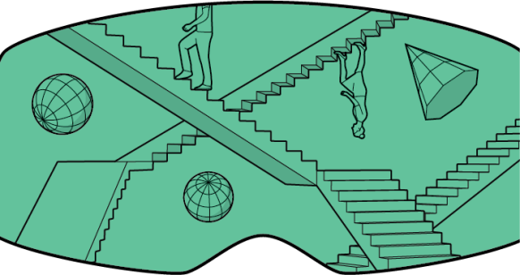
Virtual Reality
VR places the user in another location entirely. Whether that location is computer-generated or captured by video, it entirely occludes the user’s natural surroundings.
Augmented Reality
In augmented reality—like Google Glass or the Yelp app’s Monocle feature on mobile devices—the visible natural world is overlaid with a layer of digital content.
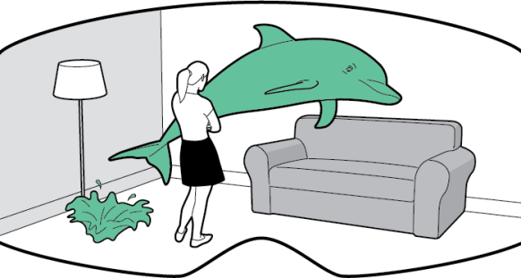
Mixed Reality
In technologies like Magic Leap’s, virtual objects are integrated into—and responsive to—the natural world. A virtual ball under your desk, for example, would be blocked from view unless you bent down to look at it. In theory, MR could become VR in a dark room.

How has virtual reality developed since February 2016?

Microsoft wants back in the game, and it is using a little science fiction to get there.
The company has seemed adrift in recent years. But on Wednesday, it unveiled an unexpected new headset that allows interaction with holographic images, enabling people to play video games, build 3-D models and hold immersive videoconferences with colleagues.
With the device, HoloLens, Microsoft is entering an increasingly crowded area, with giant competitors, in the world of virtual and augmented reality. Whether Microsoft can outmaneuver those companies, like Facebook and Google, is far from guaranteed.

Apple recently acquired an augmented reality start-up called Flyby Media and hired Doug Bowman, who ran the Center for Human-Computer Interaction at Virginia Tech and who has researched topics such as immersion in virtual environments.
An Apple spokesman confirmed the Flyby deal and said, “Apple buys smaller technology companies from time to time, and we generally do not discuss our purpose or plans.”

Virtual and augmented reality are growing fields in the technology industry. Supporters like Mark Zuckerberg, Facebook’s chief executive, have said virtual reality is the next big platform after mobile. The technology, which can make users feel transported by immersing them in different environments, has the potential to transform games, movies, social networks and work. Almost $4 billion has been invested in virtual reality start-ups since 2010, according to PitchBook, a research firm.
Apple has not, until recently, been publicly enthusiastic about virtual reality. While it has made tiny acquisitions in the field, it has not made a deal as large as Facebook’s Oculus purchase and has not brought any hardware to market.
Now rivals are delivering products to consumers. In addition to Google’s Cardboard, an inexpensive product that has been on the market for months, Facebook plans to ship its $599 Rift headset in March. Facebook’s partner Samsung is already selling a more rudimentary $99 headset, the Gear VR.
Apple has filed dozens of virtual reality-related patents in the past, including one in 2008 for a head-mounted display apparatus. The patent illustration shows a large pair of glasses that can hold an iPhone, and it looks much like Google’s Cardboard.

Magic Leap, a secretive augmented reality start-up based in Dania Beach, Fla., announced on Tuesday that it had raised a $793 million round of venture financing, valuing the company at $3.7 billion, excluding the new funds.
The round comes during a race to discover and create the next breakout platform for consumers, which many of the world’s largest tech companies think will be some form of virtual reality.
“Here at Magic Leap, we are creating a new world where digital and physical realities seamlessly blend together to enable amazing new experiences,” Rony Abovitz, founder and chief executive of Magic Leap, said in a statement. “This investment will accelerate bringing our new Mixed Reality Lightfield experience to everyone.”
This most recent round was led by Alibaba, the large Chinese e-commerce company, with participation from new investors including J.P. Morgan Investment Management, Morgan Stanley Investment Management and T. Rowe Price Associates. Magic Leap has raised more than $1 billion in funding to date.

Many believe that the technology Abovitz is working on—along with a handful of competing virtual reality rigs—could usher in the next big change in how we use computers. (Abovitz calls it “cinematic reality—a complete shift in visual computing.”) The ability to place sensors everywhere and process the volume of data they produce, coupled with advances in computer vision, makes it possible to create better immersive environments (as we saw with the debut of the Oculus Rift last year) and believable layers of digital images on top of the physical world (demo’d earlier this year by Microsoft with its Project HoloLens). Facebook and Microsoft have chosen to make their headset prototypes available as they engineer them, inviting outside developers to experiment with creating software for them. But Magic Leap, which claims to be using a different technology to achieve its effect, is keeping its efforts secret, releasing only the occasional short concept video to tease enthusiasts.

But while Oculus wants to transport you to a virtual world for fun and games, Magic Leap wants to bring the fun and games to the world you’re already in. And in order for its fantasy monsters to appear on your desk alongside real pencils, Magic Leap had to come up with an alternative to stereoscopic 3-D—something that doesn’t disrupt the way you normally see things. Essentially, it has developed an itty-bitty projector that shines light into your eyes—light that blends in extremely well with the light you’re receiving from the real world.
That’s no doubt why Google took the lead in an astonishingly large $542 million investment round in Magic Leap last October. Whatever it is cooking up has a good chance of being one of the next big things in computing, and Google would be crazy to risk missing out. The investment looked especially prescient in January, when Microsoft revealed plans to release a sleek-looking headset this year. HoloLens, which lets you interact with holograms, sounds as if it’s very similar to what Magic Leap is working on.
To judge from a look I get at a design prototype—a realistic-looking piece of hardware that’s completely nonfunctional—the company appears to be aiming to fit its technology into a chunky pair of sports sunglasses wired to a square pack that fits into your pocket. A somewhat similar image in a patent application Magic Leap filed in January suggests as much, too. The company won’t say for sure, though; Abovitz confirms that the headset will be a glasses-like wearable device, but I have to twist his arm to get him to agree to use even that hazy phrasing on the record.

Virtual real estate
Halstead says it will introduce three-dimensional displays and virtual-reality headsets to its offices this year, and the brokerage isn’t alone. Greenland Forest City Partners and Douglas Elliman Real Estate are also hoping to add virtual-reality technology in the coming months, as are individual brokers looking for a competitive edge. Digital design firms charge tens of thousands of dollars to create virtual customizable spaces for high-end buyers.
This technology is expected to transform the real estate industry and, some say, make house-hunting more efficient. It can help to reduce the stress of relocating to a new city or buying from abroad and also allow buyers to visualize properties in development.

Virtual reality videos show the water views that will be available from the Turnberry Ocean Club Residences in Florida

Virtual reality videos show how a development in Prospect Heights, Brooklyn, will fit into the surrounding green space.
“Imagine that you’re sending a check for $30 million and you have nothing to see,” Mr. Navarro said. “Our work is the closest you can get without having to build it. You feel the size. You get the textures.” His drones don’t just take photos but also capture video. So if there’s a lot of street noise, “I can’t lie to you,” he said.
The virtual apartments created by Mr. Navarro cost nearly $100,000 to make and take months to build. They can be viewed with an Oculus headset, Mr. Navarro said, but most clients don’t use this option. When presenting images of the 54-story Turnberry Ocean Club Residences in Sunny Isles Beach, Fla., to the developer, Turnberry Associates, Mr. Navarro used a giant video wall to let the company’s executives virtually walk around the building without goggles. “We didn’t want the guy coming to write a $70 million check to get dizzy on us,” he said.
Mr. Leone of Halstead says virtual reality could eventually eliminate the need for open houses. “If you can see the homes remotely and be more educated before you actually make a trip, you’ll make the process easier,” he said.
At Douglas Elliman, Mr. Hummel said it would be better to put large-screen curved TVs in select offices until the headset technology “comes of age.” He says the goggles might be better suited to international buyers so they can evaluate a property “before taking an expensive plane ride.”

Headset race

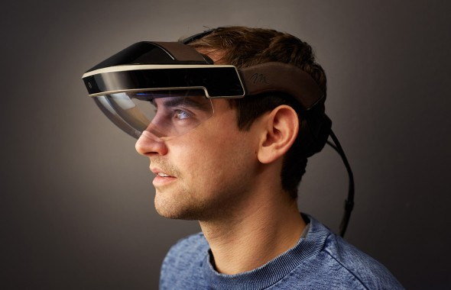Meta’s latest augmented-reality headset, Meta 2, weighs about a pound and a half and lets you touch and move digital images that appear to be in front of you in the real world.

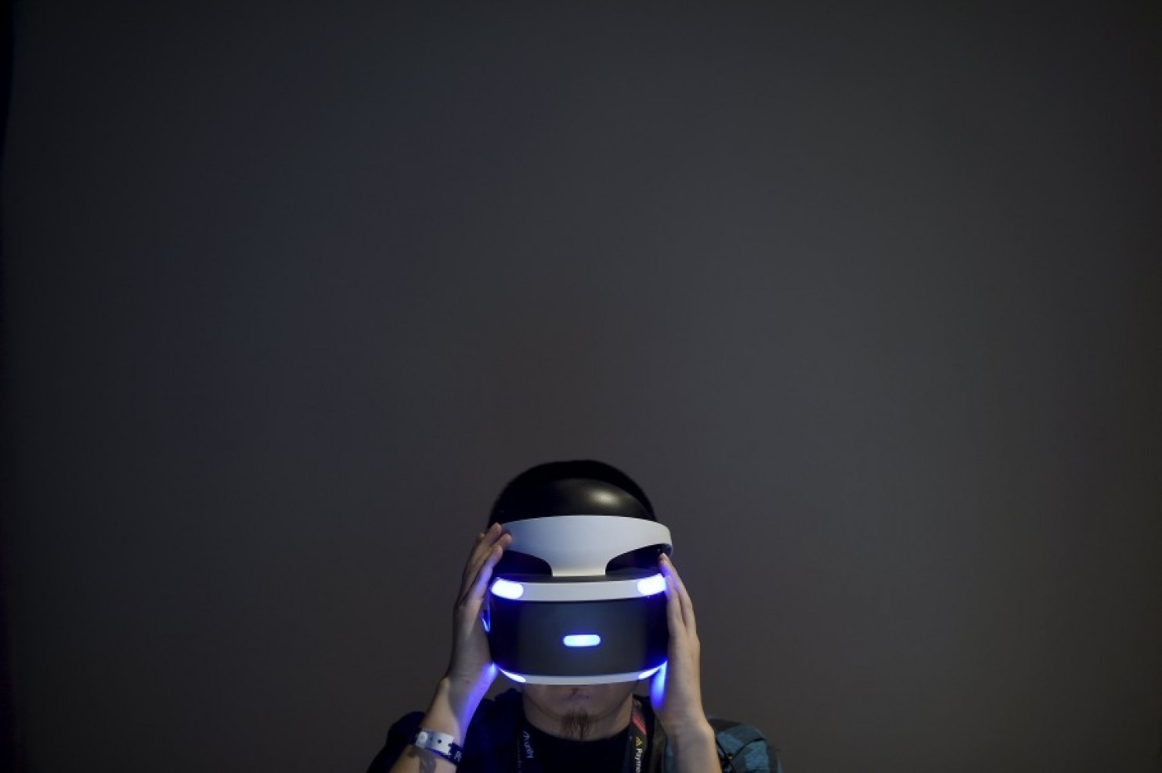
A man demonstrates Sony's PlayStation VR during an event in San Francisco on Tuesday.

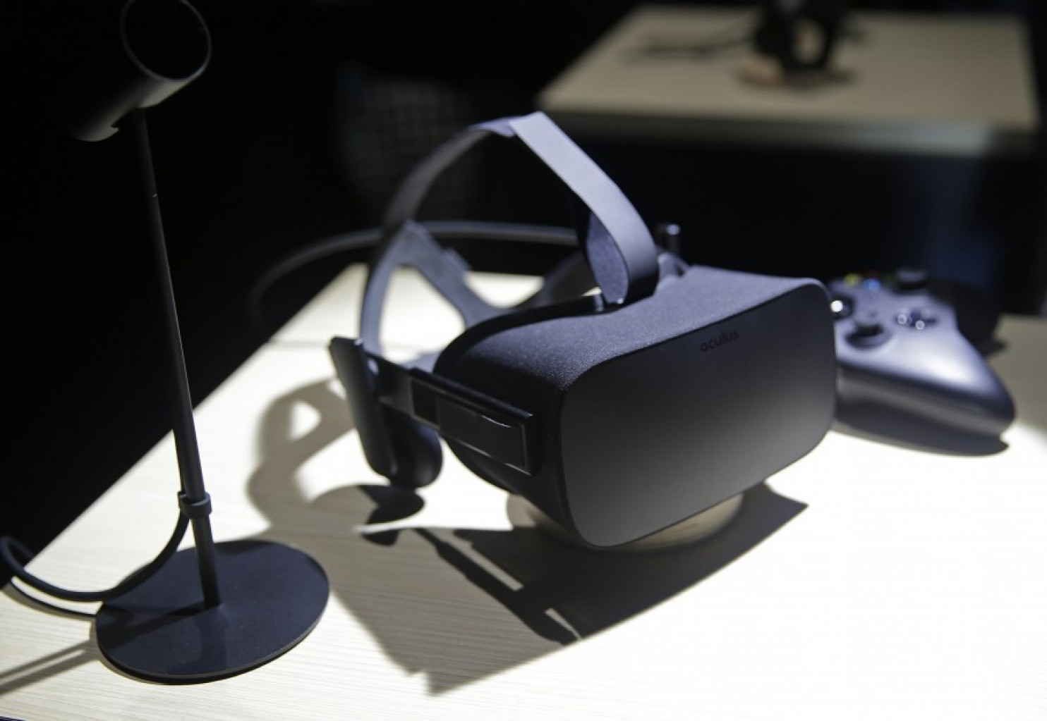

The Oculus Rift virtual reality headset.

Oculus Rift

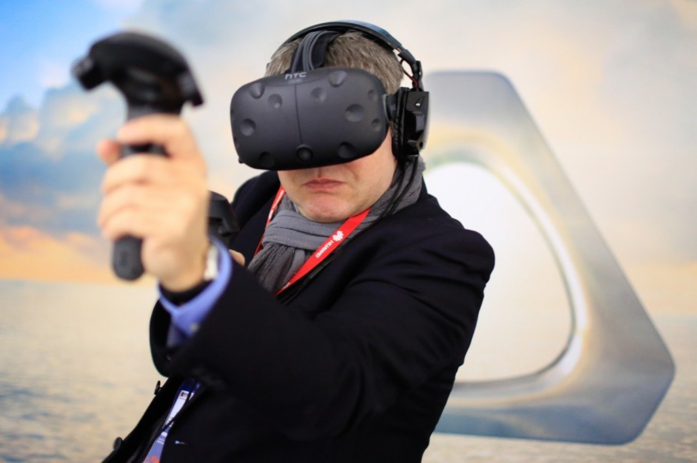

Video @ http://www.wired.com/2016/04/magic-leap-vr/

