Special report: Tech startups

Tech startups

A Cambrian moment

Cheap and ubiquitous building blocks for digital products and services have caused an explosion in startups. Ludwig Siegele weighs its significance
Jan 18th 2014 | From the print edition
ABOUT 540M YEARS ago something amazing happened on planet Earth: life forms began to multiply, leading to what is known as the “Cambrian explosion”. Until then sponges and other simple creatures had the planet largely to themselves, but within a few million years the animal kingdom became much more varied.
This special report will argue that something similar is now happening in the virtual realm: an entrepreneurial explosion. Digital startups are bubbling up in an astonishing variety of services and products, penetrating every nook and cranny of the economy. They are reshaping entire industries and even changing the very notion of the firm. “Software is eating the world,” says Marc Andreessen, a Silicon Valley venture capitalist.
This digital feeding frenzy has given rise to a global movement. Most big cities, from Berlin and London to Singapore and Amman, now have a sizeable startup colony (“ecosystem”). Between them they are home to hundreds of startup schools (“accelerators”) and thousands of co-working spaces where caffeinated folk in their 20s and 30s toil hunched over their laptops. All these ecosystems are highly interconnected, which explains why internet entrepreneurs are a global crowd. Like medieval journeymen, they travel from city to city, laptop not hammer in hand. A few of them spend a semester with “Unreasonable at Sea”, an accelerator on a boat which cruises the world while its passengers code. “Anyone who writes code can become an entrepreneur—anywhere in the world,” says Simon Levene, a venture capitalist in London.
Here we go again, you may think: yet another dotcom bubble that is bound to pop. Indeed, the number of pure software startups may have peaked already. And many new offerings are simply iterations on existing ones. Nobody really needs yet another photo-sharing app, just as nobody needed another site for pet paraphernalia in the first internet boom in the late 1990s. The danger is that once again too much money is being pumped into startups, warns Mr Andreessen, who as co-founder of Netscape saw the bubble from close by: “When things popped last time it took ten years to reset the psychology.” And even without another internet bust, more than 90% of startups will crash and burn.
But this time is also different, in an important way. Today’s entrepreneurial boom is based on more solid foundations than the 1990s internet bubble, which makes it more likely to continue for the foreseeable future. One explanation for the Cambrian explosion of 540m years ago is that at that time the basic building blocks of life had just been perfected, allowing more complex organisms to be assembled more rapidly. Similarly, the basic building blocks for digital services and products—the “technologies of startup production”, in the words of Josh Lerner of Harvard Business School—have become so evolved, cheap and ubiquitous that they can be easily combined and recombined.

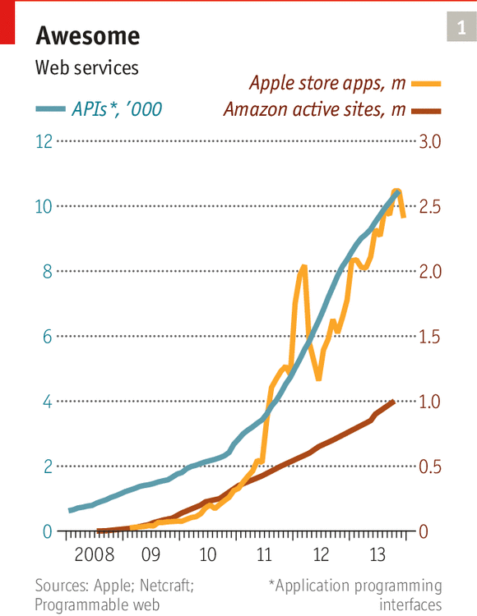
Some of these building blocks are snippets of code that can be copied free from the internet, along with easy-to-learn programming frameworks (such as Ruby on Rails). Others are services for finding developers (eLance, oDesk), sharing code (GitHub) and testing usability (UserTesting.com). Yet others are “application programming interfaces” (APIs), digital plugs that are multiplying rapidly (see chart 1). They allow one service to use another, for instance voice calls (Twilio), maps (Google) and payments (PayPal). The most important are “platforms”—services that can host startups’ offerings (Amazon’s cloud computing), distribute them (Apple’s App Store) and market them (Facebook, Twitter). And then there is the internet, the mother of all platforms, which is now fast, universal and wireless.
Startups are best thought of as experiments on top of such platforms, testing what can be automated in business and other walks of life. Some will work out, many will not. Hal Varian, Google’s chief economist, calls this “combinatorial innovation”. In a way, these startups are doing what humans have always done: apply known techniques to new problems. The late Claude Lévi-Strauss, a French anthropologist, described the process as bricolage (tinkering).
Technology has fuelled the entrepreneurial explosion in other ways, too. Many consumers have got used to trying innovative services from firms with strange names (which, unavoidably, will abound in this special report). And thanks to the web, information about how to do a startup has become more accessible and more uniform. Global standards are emerging for all things startup, from programming tools to term sheets for investments, dress code and vocabulary, making it easy for entrepreneurs and developers to move around the world.
Invent yourself a job
Economic and social shifts have provided added momentum for startups. The prolonged economic crisis that began in 2008 has caused many millennials—people born since the early 1980s—to abandon hope of finding a conventional job, so it makes sense for them to strike out on their own or join a startup.
A lot of millennials are not particularly keen on getting a “real” job anyway. According to a recent survey of 12,000 people aged between 18 and 30 in 27 countries, more than two-thirds see opportunities in becoming an entrepreneur. That signals a cultural shift. “Young people see how entrepreneurship is doing great things in other places and want to give it a try,” notes Jonathan Ortmans of the Ewing Marion Kauffman Foundation, which organises an annual Global Entrepreneurship Week.
Lastly, startups are a big part of a new movement back to the city. Young people increasingly turn away from suburbia and move to hip urban districts, which become breeding grounds for new firms. Even Silicon Valley’s centre of gravity is no longer along Highway 101 but in San Francisco south of Market Street.
Describing what sorts of businesses these startups engage in would at best provide a snapshot of a fast-moving target. In essence, software (which is at the heart of these startups) is eating away at the structures established in the analogue age. LinkedIn, a social network, for instance, has fundamentally changed the recruitment business. Airbnb, a website on which private owners offer rooms and flats for short-term rent, is disrupting the hotel industry. And Uber, a service that connects would-be passengers with drivers, is doing the same for the taxi business.
So instead of outlining what these startups do, this special report will explain how they operate, how they are nurtured in accelerators and other such organisations, how they are financed and how they collaborate with others. It is a story of technological change creating a set of new institutions which governments around the world are increasingly supporting.
Startups run on hype; things are always “awesome” and people “super-excited”. But this world has its dark side as well. Failure can be devastating. Being an entrepreneur often means having no private life, getting little sleep and living on noodles, which may be one reason why few women are interested. More ominously, startups may destroy more jobs than they create, at least in the shorter term.
Yet this report will argue that the world of startups today offers a preview of how large swathes of the economy will be organised tomorrow. The prevailing model will be platforms with small, innovative firms operating on top of them. This pattern is already emerging in such sectors as banking, telecommunications, electricity and even government. As Archimedes, the leading scientist of classical antiquity, once said: “Give me a place to stand on, and I will move the Earth.”

Creating a business

Testing, testing

Launching a startup has become fairly easy, but what follows is back-breaking work
Jan 18th 2014 | From the print edition
“WE EVEN HAD to host the servers in our own office.” Naval Ravikant laughs as he describes how in 1999 he and some friends founded his first startup, Epinions, a website for consumer reviews. They had to raise $8m in venture capital, buy computers from Sun Microsystems, license database software from Oracle and hire eight programmers. It took nearly six months to get a first version of the site up and running.
By comparison, setting up Mr Ravikant’s latest venture, AngelList, a social network for startups and investors (see article), was a doddle. The cost was in the tens of thousands of dollars, which he put up himself. Hosting and computing power was available, for a small fee, via the internet. Most of the software needed was free. The biggest expense was the salary of the two developers, but thanks to nifty programming tools they were able to do the job in a few weeks.
Mr Ravikant is not the only serial entrepreneur with such a tale to tell. Since the start of the first dotcom boom in the mid-1990s, launching startups has become dirt cheap, which has radically changed their nature. What was once a big bet on a business plan has become a series of small experiments, an ongoing exploration. This shift has given rise to a whole new set of management practices.
Not all newly created firms qualify as startups. Steve Blank, a noted expert in the field, defines them as companies looking for a business model that allows for fast, profitable growth. The aim is to become a “micro-multinational”, a firm that is global without being large. Many of them are simply small businesses that use digital technology. A growing number are “social enterprises”—firms with a social mission.
Perhaps the biggest change is that computing power and digital storage are now delivered online
In the past, startups almost universally began with an idea for a new product. Now the business usually begins with a “team”—often two people with complementary skills who probably know each other well. These “founders” (a term now used in preference to “entrepreneurs”) often work through several ideas before hitting on the right one.
Such flexibility would have been unthinkable during the first internet boom. Startups had to build from scratch most of the things they needed, particularly the computing infrastructure. Today nearly all of the ingredients needed to produce a new website or smartphone app are available as open-source software or cheap pay-as-you-go services. A quick prototype can be put together in a matter of days, which explains the astonishing success of organisations such as Startup Weekend. Since it was created in 2007, its volunteers have organised more than 1,000 weekend hackathons with over 100,000 participants in nearly 500 cities, including such far-flung places as Ulaanbaatar in Mongolia and Perm in Russia.
Perhaps the biggest change is that computing power and digital storage are now delivered online. At Amazon Web Services, the biggest “cloud” provider, the basic package is free and includes 750 hours of server time. And if a new website or smartphone app proves hugely successful, new virtual servers can be added almost instantly for a small fee.
A whole industry of services to help startups tweak their offerings has sprung up, too. Optimizely, itself a startup, automates something that has become a big part of what developers do today: A/B testing. In its simplest form, this means that some visitors to a webpage will see a basic “A” version, others a slightly tweaked “B” version. If a new red “Buy now” button produces more clicks than the old blue one, the site’s code can be changed there and then. Google is said to run so many such tests at the same time that few of its users see an “A” version.
To see how people actually use their products, startups can sign up with services such as usertesting.com. This pays people to try out new websites or smartphone apps and takes videos while they do so. Firms can tell the service exactly which user profile they want (specifying gender, age, income and so on), and get results within the hour.
Round and round we go
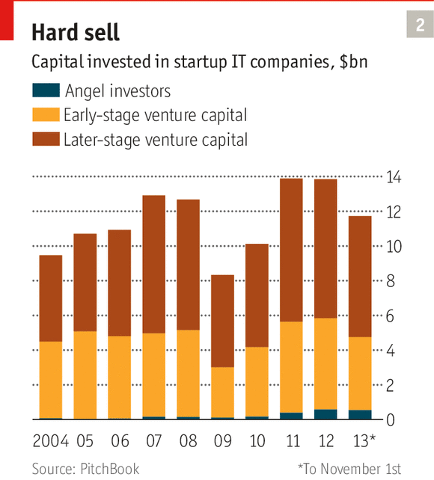
Startups today are in a constant feedback loop, which means they have to be run in a different way from their dotcom predecessors. It was only a question of time until someone wrote down these new management practices, just as Luca Pacioli, a Franciscan friar and mathematician, wrote down the principles of double-entry book-keeping as used by merchants in Venice in the late 15th century.
This time there are actually two competing Paciolis, Mr Blank and Eric Ries. They both observed the same company, IMVU, an instant-messaging firm, where Mr Blank was an investor and Mr Ries the chief technology officer. Their approaches differ somewhat, but they come to much the same conclusion: that the old model of launching a startup or a new product, encapsulated by the phrase “build it and they will come”, no longer works. Instead, firms have to find out what customers want. That involves building something, measuring how users react, learning from the results, then starting all over again until they reach what is known as “product-market fit”.
In his book “Four Steps to the Epiphany” and his more recent “Startup Owner’s Manual” Mr Blank tells readers how to tackle what he calls “customer development” (as opposed to product development), exhorting them to “get out of the building” and find out what people really need. Mr Ries’s “The Lean Startup” is more of a manual for continuously improving an online offering.
Even more than Mr Blank, Mr Ries has given startups a vocabulary to describe what they do. They should start with a “minimum viable product”, or MVP, a sort of trial balloon to gauge the audience’s interest. They should always test their assumptions, aiming for “validated learning”. And if their strategy does not work, they should “pivot”: in essence, throw in the towel and start again with a different product. Mr Ries even prescribes a new form of accounting for innovation: startups should keep meticulous track of their experiments and how these influence “meaningful metrics” (not just a rise in the number of users, but what they do with the product).
Startups also often use a related method called “objectives and key results” (OKR). It was invented by Intel, a chipmaker, and later adopted by such firms as Google and Zynga. The idea is that all parts of a company—the department, the team and even individual employees—not only set themselves clear objectives (increase sales by 25% in the next quarter), but pursue “key results” that help them get there (hire two new sales people or increase clicks by 10%). “Within that framework we can then iterate, which allows us to stay lean,” says Carl Waldekranz, the chief executive of Tictail, a Swedish startup, which makes it easy to build online shopfronts.
Pacioli’s ideas spread because the printing press had just arrived in Venice. His treatise about double-entry book-keeping was one of the first books printed there, in 1494. Mr Ries’s book has also spread his message, but so have his many speeches, YouTube videos and what he calls the “lean movement”. More than 1,000 lean-startup groups worldwide meet regularly to discuss the approach. Outfits such as Lean Startup Machine organise workshops. Others, including Luxr, sell teaching materials. Yet others offer tools to track a startup’s performance continuously.
Having a lean time of it
The lean methodology has caught on quickly, but implementing it is not easy. “Once you get going, there’s no way you can sit down in a relaxed state of mind and think about the next test,” explains Shawn Zvinis, co-founder of Tab, a service to let people keep a virtual tab in London shops. It folded in December, in large part, he says, because it added all kinds of bells and whistles that users did not want.
When building Buffer, a service based in San Francisco that lets users put tweets on hold to be sent later, Joel Gascoigne, the British founder, largely stuck to Mr Ries’s methodology. Even today, two years after the launch of the service, new features are first tried as an MVP and any changes A/B tested. Buffer now has more than 1.2m users, with 13,000 of them paying at least $10 a month for extra features. Yet staying lean has been a struggle: “As an entrepreneur you’re meant to be bullish about your opinion. But lean means that you constantly have to remind yourself that you could be wrong.”
Some people are wondering whether founders of lean startups are still entrepreneurs in the conventional sense, rather than empiricists who try to find a profitable niche. Others question whether lean startups are capable of significant innovation. “Lean provides a useful toolkit, but it can bias you towards the incremental rather than the transformational,” says Scott Nolan of the Founders Fund, a venture-capital firm that makes big technology bets, such as an investment in SpaceX, a space-transport company. “You cannot simply iterate your way into orbit.”
Mr Ries admits that his methodology has limitations. In his book he warns of “analysis paralysis”, when founders lose sight of the strategic forest for all the testing trees. Yet he certainly thinks big. His model is Frederick Winslow Taylor, the father of scientific management in manufacturing. Taylor aimed to reduce waste in material resources; Mr Ries wants to avoid squandering the mental kind. In Taylor’s time, Mr Ries argues, most innovation was devoted to increasing the productivity of workers and machines. Today the world has the capacity to build almost anything imaginable. “The big question of our time is not ‘can it be built?’ but ‘should it be built?’,” he writes.
Staying lean certainly helps to refine founders’ ideas, but to industrialise the rapid creation of companies they need something else: accelerators.

Venture capitalists

From leafy to lofty

Venture capital is adapting itself to the new startup landscape
Jan 18th 2014 | From the print edition
TECH MONEYMEN LIKE altitude. In Silicon Valley the leading venture-capital firms cluster on a leafy hill overlooking Stanford University. And when Benchmark Capital opened a branch in San Francisco, it moved into the top floor of the Warfield building, home to a popular music venue. Although it is in the Tenderloin, one of the city’s seediest districts, it offers a great view of the South of Market area, a breeding-ground for startups.
The bird’s eye view may be similar, but the landscape beneath is shifting. For a start, the internet has democratised not only the founding of startups but their funding as well. When Naval Ravikant wanted to raise $8m for Epinions in 1999 (see article), he went straight to Benchmark Capital and other venture-capital firms on and around Sand Hill Road in Silicon Valley. But because starting up has become so cheap, today’s founders have plenty of other choices, at least in the early stages: their own bank accounts, friends and family, accelerators, angel investors and—the latest addition— crowdfunding sites that allow startups to raise money directly from the general public.
Second, thanks to websites such as AngelList, startup financing has become more transparent. Originally a social network for startups and investors, AngelList is now also a funding exchange. As of early December its 24,000 accredited investors (people with a net worth of more than $1m or income of more than $200,000 a year) between them had put $250m into more than 1,000 startups of the total of 85,000 listed on the site.
Lastly, venture-capital firms are no longer seen as God-like. Some experts now claim that most of them are actually not that good at what they do. “Venture capital has delivered poor returns for more than a decade,” concluded a 2012 report by the Ewing Marion Kauffman Foundation, a charity that supports entrepreneurship. And contrary to public perception, says Diane Mulcahy, one of the authors, venture capitalists (VCs) do not take a lot of risk. In most funds the partners’ own money accounts for only about 1% of total capital. Annual fees of around 2% provide them with a comfortable income even if their investments do not make money.
VCs will continue to play an important, if smaller, role in channelling money to startups, says Ms Mulcahy, but many weaker funds will not survive. The number of actively investing VC firms in America has already dropped from 627 in 2007 to 522 in 2012, according to the National Venture Capital Association. At the same time a new class of smaller and more focused “micro” funds is emerging. They typically raise less than $100m rather than billions, charge lower fees and hope to generate better returns.
Angels could also play a bigger part in funding startups. In August AngelList launched a feature called “syndicates” that allows investors to piggyback on the decisions of some other, often well-known, angel. As of early December 132 syndicates had been created, of which 37 had backing of more than $50,000. Syndicates may help to alleviate one of the most pressing problems for startups in Silicon Valley and elsewhere. Known as “series A crunch”, it refers to the increasing difficulty of raising a first round of venture capital after the seed funding from angels and other sources. There is not enough serious money to go around for the proliferating number of startups.
Times are changing on Sand Hill Road, too. Andreessen Horowitz, launched in 2009, has shaken things up by employing dozens of experts who help portfolio companies with everything from recruiting to public relations. And because startups now need less seed money, some firms have moved up the funding stack, focusing on later-stage rounds. But venture capitalists in the big league remain comfortable. In fact, thanks to the entrepreneurial explosion, they are enjoying a much bigger deal flow, says Bill Gurley of Benchmark in his lofty new quarters in San Francisco.

Accelerators

Getting up to speed

The biggest professional-training system you have never heard of
Jan 18th 2014 | From the print edition

IT FEELS LIKE some prayer meeting. Two middle-aged men start by telling the audience how important it is to pitch in. A booming voice announces the acts, greeted by loud cheers; then some enthusiastic young people jump onto the stage and start talking about their missions. One wants to help women sell their unused clothes and shoes; another to teach children to manage money more responsibly; a third to bring the reinsurance market online at last.
TechStars, a chain of accelerators (in essence, schools for startups), is known for putting on a good show, as it did in London in late September. But such graduation ceremonies can now be watched almost anywhere: everyday is “demo day” somewhere around the world. Accelerators’ champions already see them as the new business schools. “I’d rather get $100,000 and be a case study than pay $100,000 to read case studies,” says Dave McClure, the founder of 500 Startups, an accelerator based in Silicon Valley.
The exact number is unknown, but f6s.com, a website that provides services to accelerators and similar startup programmes, lists more than 2,000 worldwide. Some have already become big brands, such as Y Combinator, the first accelerator, founded in 2005. Others have set up international networks, such as TechStars and Startupbootcamp. Yet others are sponsored by governments (Startup Chile, Startup Wise Guys in Estonia and Oasis500 in Jordan) or big companies. Telefónica, a telecoms giant, operates a chain of 14 “academies” worldwide. Microsoft, too, is building a chain.
Predictably, many observers talk about an “accelerator bubble”. Yet if it is a bubble, it is unlikely ever to deflate completely. Accelerators are too useful for that. Not only do they bring startups up to speed, provide access to a network of contacts and give them a stamp of approval. They also perform a crucial function in the startup supply chain: picking the teams and ideas that are most likely to succeed and serving them up to investors.
Business schools emerged in the second half of the 19th century to meet an educational need not provided for by other institutions. Accelerators are trying to fill a similar gap today. But they also call to mind another sort of educational institution that became popular during the dotcom boom: incubators. The idea was to give startups a home and offer them technical, legal and other services. Yet many of the fledglings did not fly. The incubators often felt too cosy, and their operators had no interest in pushing out their tenants as long as they were paying rent.
Applicants are rigorously screened. For the most recent course 74 were selected from a field of more than 2,600 and paid between $14,000 and $20,000 to attend
The mixed success of incubators was one reason why Paul Graham, a former software entrepreneur and angel investor, chose a different set-up for Y Combinator, which went on to nurture such successes as Dropbox and Airbnb. Founders who take part in its programme have to move to Silicon Valley for the duration, but Y Combinator itself is not much more than an assembly hall in the heart of the region where participants meet for weekly dinners, listen to guest speakers and talk to Mr Graham and his partners.
It started as a summer programme and the roots still show, with courses running for three months, about the length of an academic summer break. Teams all join at the same time, in batches. Applicants are rigorously screened and the best invited for interview. For the latest batch 74 (including six not-for-profits) were selected from a field of more than 2,600. Those lucky few get paid between $14,000 and $20,000 to attend. In return they have to hand over about 7% of their firm’s equity.
Y Combinator is still the most successful startup school. Its boss maintains a steely control reminiscent of Apple’s late Steve Jobs, but others adopt a more open approach. TechStars, the model for most accelerators, has even created a Global Accelerator Network for startup schools. This is not an entirely disinterested move: it aims to create a platform for like-minded organisations in which its programmes will have Ivy League status.
Founded in Boulder, Colorado, by David Cohen and Brad Feld, two angel investors, TechStars is also highly selective and takes an equity stake in the companies it accepts, and it, too, admits new startups in batches for three months at a time. But it feels more like a real school than does Y Combinator: founders toil together in classes of a dozen people, and they have teachers-cum-mentors who serve as sounding boards. The company has replicated its model in five American cities and in London.
The chain’s classroom in Britain’s capital is a floor in Warner Yard, a co-working space in the district of Clerkenwell. Teams share tables, but banter is kept to a minimum. “Get shit done,” reads one scribble on a blackboard. “Wasting two out of seven days is not an option,” proclaims another. Dominating the room is a big digital clock counting down to demo day when they all have to present their projects.
Three months in purgatory
“That clock is basically your life,” says Laurence Aderemi, chief executive of Moni, a mobile service designed to make it easy to send money abroad. He initially sat right in front of the clock, but moved his seat after it appeared in a nightmare. Twelve-hour working days are at the lower end of the scale. If necessary, founders dispense with sleep altogether and work non-stop. Some sever all contact with friends and family during the programme.
Most accelerators do not have much in the way of a fixed curriculum. Managers of startup schools regularly meet up with the founders and organise a few classes on such matters as taxes and payroll. They also make extensive use of mentors, mostly experienced entrepreneurs, investors or other experts who have seen it all before.
For mentoring to work, founders and mentors have to be well matched, so TechStars programmes start with a mentoring marathon: over ten days founders meet more than 100 people for half an hour each. SeedCamp, another accelerator based in London, regularly brings together two dozen invited startups with nearly 400 experts over the course of week.
This can be both useful and confusing. At a recent SeedCamp session the four mentors quizzing the founder of LegalTender, a marketplace for legal services, soon home in on the central problem of such a business: reaching a point where demand and supply feed on each other. But they offer different kinds of remedies: one suggests starting off with recruiting legal firms, another specialising in certain kinds of legal work, and a third working with a professional organisation.
Mentors usually do not get paid, but they seem to enjoy the experience. “It’s rejuvenating my brain,” says Kevin Dykes, a serial entrepreneur who is a regular at Startupbootcamp in Berlin, “but I also want to give back to the community.” Some mentors become paid advisers or even investors. At TechStars they are often the first people to put money into a startup after demo day.
Cynics say that mentoring is just a form of due diligence and a way of creating a “proprietary deal flow”—meaning privileged access to good deals. Some accelerators themselves have funds for additional investments in alumni’s businesses, or work with venture-capital funds that put money in all the startups in a batch, sight unseen. They see it as a bet on an index fund, hoping that among the startups will be a few big winners—an approach to venture investing known as “spray and pray”.
But demo day remains all-important for attracting investors. Startups are told to think about their pitches from the day they enter the programme. The last few weeks are often dominated by rehearsals. The presentations themselves are usually only a few minutes long, but they have to do far more than provide information about what the firm does, the pedigree of the founders and the size of the market. To persuade an investor to ask for a follow-on meeting, they must be masterpieces of storytelling about the startup’s chances of success.
“You have to pull them into your reality-distortion field,” says Paul Murphy, the founder OP3Nvoice, another TechStars London startup that sells technology to search audio and video recordings. The competition is not so much the other firms presenting but the investor’s smartphone, where another message is always demanding attention.
When you add it all up, accelerators are quite different from business schools. “One helps you with that startup, the other provides you with a framework for 20 years,” says Jon Eckhardt, who heads the entrepreneurship centre at the University of Wisconsin-Madison and has co-founded an accelerator. Still, he thinks, for most founders, startup schools are probably worthwhile. Much of the learning takes place among the founders themselves, says Susan Cohen of the University of Richmond, Virginia, who has written a dissertation on the subject. Teams are keen to help each other: the better the batch, the bigger the chances that all its members will attract investors.
But founders may lose a slice of equity and time, which is at a premium in the fast-moving tech world. “You know what I’m tired of? Rich guys launching ‘startup accelerators’ so they can rip off new startup founders,” said Ryan Carson, a British entrepreneur, on his blog. Others worry that startup schools drain scarce talent from fast-growing companies and accelerate too many ideas that struggle to find funding.
More fundamentally, it remains to be seen whether accelerators are good business. For many, making money is not the goal: big companies often launch them to tap into the startup community or as a marketing exercise; governments subsidise them to foster their entrepreneurial ecosystem; and many angels see their investment in them as a way of giving back. But most accelerators that take equity in their startups hope that at least some will return a respectable multiple of the investment.
It will take time to find out whether those hopes are fulfilled. Most accelerators were established after 2010, and most startups that have gone through them are still works in progress. Research about accelerators is in its infancy and there are no generally agreed ways to evaluate their performance.
Still, a financial picture of the industry is starting to emerge. Jed Christiansen, who works for Google in London, tracks 182 accelerators which have nurtured more than 3,000 startups. Between them, those have raised $3.2 billion in follow-on funding and generated “exits” worth $1.8 billion. This landscape is dominated by American firms, with Y Combinator and TechStars franchises leading the pack (see chart 3).
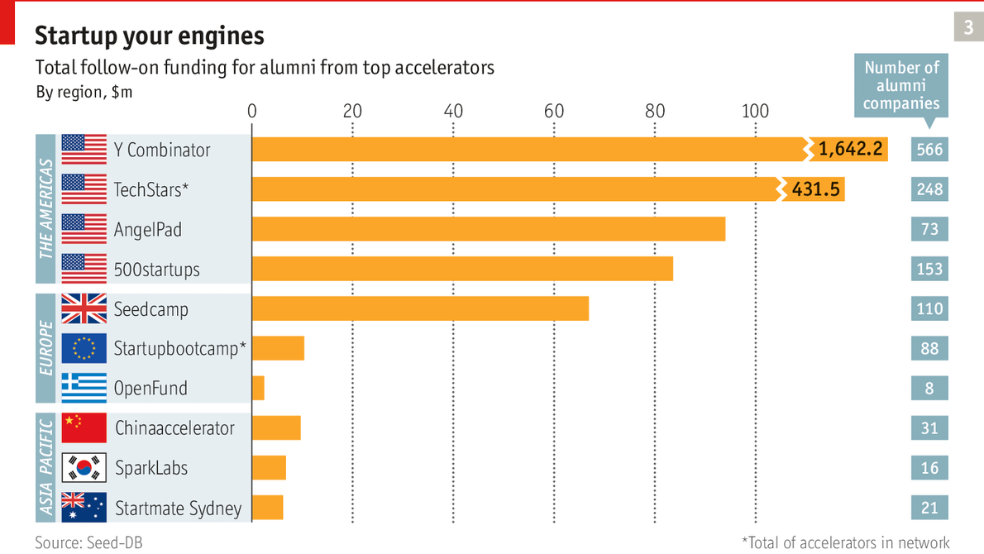
This suggests that accelerators are a winners-take-most market. Founders are highly mobile, and the best will try to get into the leading startup schools, making it harder for the rest to turn a profit. “There will be a washing out,” predicts Alex Farcet, the founder of Startupbootcamp.
But accelerators alone will not ensure success. It takes a much broader ecosystem for a startup to thrive.

Building companies

Rocket machine

How to build companies from a kit
Jan 18th 2014 | From the print edition
WHY BOTHER WITH accelerators? Why not just hire a bunch of clever youngsters, provide them with the necessary cash, support and technology, and tell them to pursue a business idea with a proven success record? That should make it possible to start a new company in weeks, not months or years.
In a nutshell, that is the idea behind Rocket Internet, an e-commerce conglomerate based in Berlin. It controls 75 firms in 50 countries with a total of more than 25,000 employees and a combined annual revenue of more than €3 billion ($4 billion). Together with two similar outfits, Project A and Team Europe, also based in Berlin, it has pioneered a category called “company builders”.
Critics call Rocket a “clone factory”, with some justification. The headquarters near the Brandenburg Gate does not feel like a creative co-working space, more of a boiler room, as call-centres for salespeople peddling penny stocks are known. In 2009 the firm launched CityDeal, a European online-coupon site. Six months later it sold the business to Groupon, the American original, for Groupon shares then worth nearly $126m.
Being branded a plagiarist clearly irks Oliver Samwer, the most active of the three sons of a Cologne lawyer who run Rocket. He explains that consumers are similar everywhere, so the same e-commerce ideas will work the world over. What counts is not so much coming up with ideas but implementing them well. “A bridge is a bridge wherever you are. We are a construction company.”
Rocket prides itself on being ruthless about execution: it has “key performance indicators” for everything. If the firm’s executives miss their sometimes insanely ambitious targets, they quickly incur Mr Samwer’s wrath. But Rocket’s efficiency also owes something to its culture of sharing. Its firms learn from each other, often across countries, and they benefit from common services such as marketing and IT. “Our goal is to build a global galaxy of firms with Rocket at the centre,” says Mr Samwer.
To expand its universe, Rocket lures consultants from firms such as McKinsey and Boston Consulting Group, offers them a reasonably attractive salary and a slice of the equity in its ventures and provides them with the skills they will need to strike out on their own. E-commerce ventures also require tons of cash to build warehouses and buy inventory. In 2012 Rocket raised more than $1 billion from investors such as Kinnevik, a Swedish investment firm, DST Global, a Russian fund, and JPMorgan.
Some of Rocket’s firms look like winners, such as Zalando, a European chain of footwear and clothing sites, and Drafiti, which dominates online fashion in South America. But others shine less, including Home24, which sells furniture on the internet, and Wimdu, an Airbnb clone. Being a privately held firm, Rocket does not have to tell the world whether it is making a profit.
Some see it as the corporate model of the future, others think it may not last. The air is certainly getting thinner for the Samwer brothers. In the past their ventures grew quickly in developing countries and in Europe because American start-ups were slow to expand abroad, but in recent years the Americans have become more globally minded, leaving less scope for Rocket.
Some analysts also question whether in the longer term the firm’s relatively low-risk e-commerce ventures can make decent profits and attract talent. The founders of Project A left in 2011 because they wanted to try riskier ideas. Last March the Samwer brothers set up a separate venture fund to invest in promising new businesses.
Ultimately, Rocket’s fate will depend on Oliver Samwer. A former colleague describes him as “eine absolute Maschine”. He jets tirelessly around the world and calls his colleagues at any time of day or night. “I can sleep anywhere,” he once told a reporter. But if this engine were to stop, the internet’s rocket might come down to Earth.

Business communities

All together now

What entrepreneurial ecosystems need to flourish
Jan 18th 2014 | From the print edition
BLOCK 71 HAS long been slated for demolition. A look at the tenant list for the seven-storey industrial building on Singapore’s Ayer Rajah Crescent helps explain why it is still standing: nearly 100 startups live there officially and perhaps as many again informally. Their often strange monikers are interspersed with the more conventional names of venture-capital firms, accelerators and the like.
It is the world’s most tightly packed entrepreneurial ecosystem, and a perfect place to study the lengths to which a government can go to support startup colonies. “They essentially force-fed entrepreneurship to the young generation,” says Bowei Gai, a Chinese-American entrepreneur who is working on a “World Startup Report” after visiting nearly three dozen ecosystems around the world, starting in New Delhi in January last year and ending in Singapore in September (see map).
The term “ecosystem” for economic clusters was popularised 20 years ago by James Moore, then a business consultant and now a human-rights advocate, who was fond of ecological metaphors. These days the emphasis is less on “eco” than on “system”. For some experts, such as Daniel Isenberg of Babson College, entrepreneurial ecosystems are made up of “domains”, including markets, policy and culture. Others describe them as collections of actors that play certain roles, such as providing talent, finance and infrastructure. Yet others talk about them as a set of “resources” entrepreneurs can draw on.
In some ways, ecosystems can be seen as exploded corporations. Finance departments have been replaced by venture-capital funds, legal ones by law firms, research by universities, communications by PR agencies, and so on. All are nodes in a loose-knit support network for startups that does what in-house product-development teams used to do.
Silicon Valley is the original entrepreneurial ecosystem, but in recent years such communities have popped up all over the world. They often form in places where young people want to live: Berlin, Boulder, London. Perhaps the most unexpected one is Amman’s; despite the political turmoil in the region and a civil war in Syria next door, Jordan’s capital has a few hundred startups. Israel boasts the largest number of startups per person.
Bowei's travels
- Internet firms
- Internet firms per person
- Cities visited
- 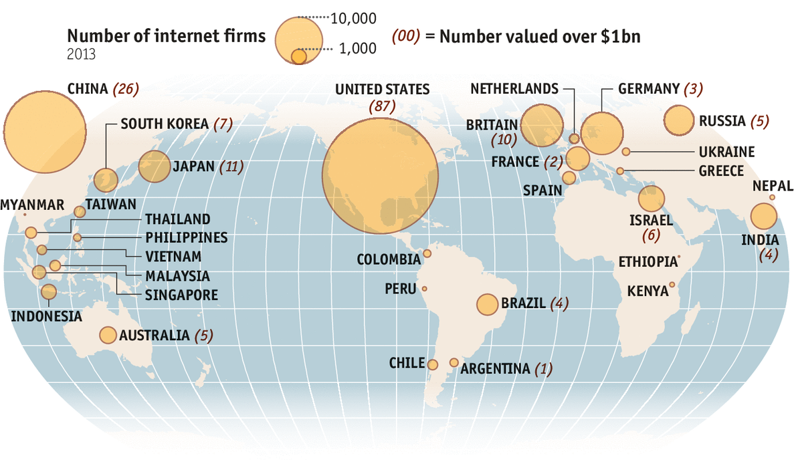
Source: Bowei Gai, World Startup Report
- 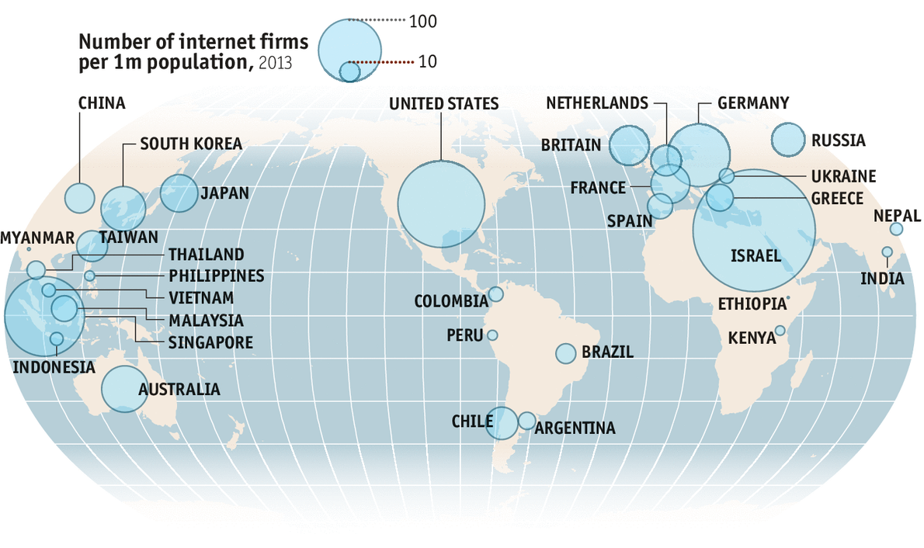
Source: Bowei Gai, World Startup Report
- 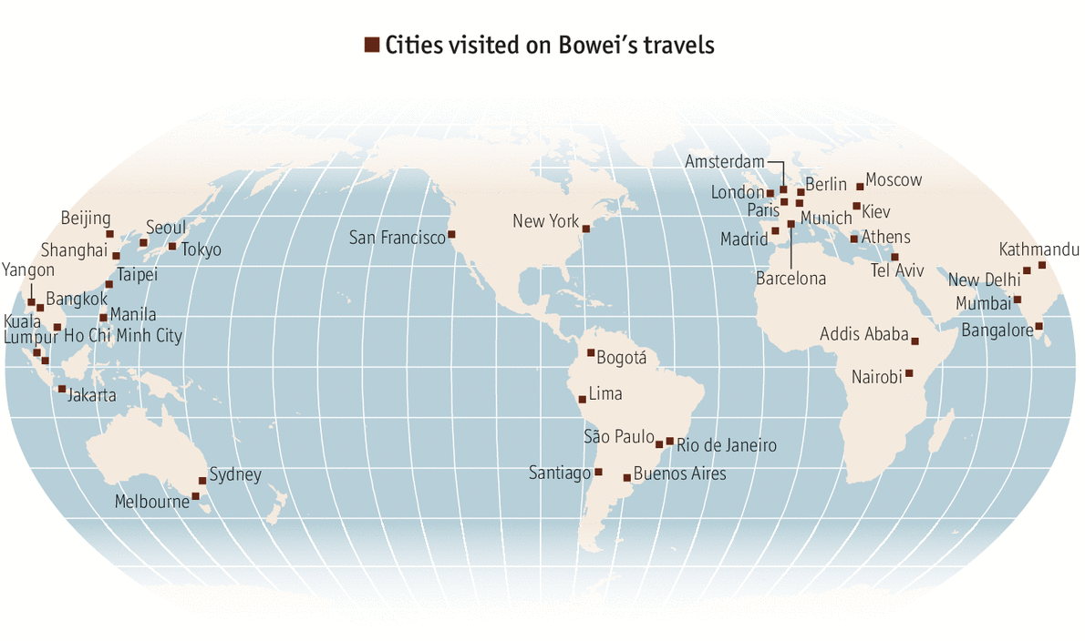
Source: Bowei Gai, World Startup Report
Don’t be selfish
Singapore’s companies are not known for being particularly open, but Block 71 has its own ethos. Vinod Nair of Catapult Ventures, which operates price-comparison websites for financial products, talks freely about problems with government paperwork and immigration rules. Dixon Chan of Burpple, a photo-sharing service for food, admits that his parents were not happy when he started his company. And Ray Wu, a manager at the Joyful Frog Digital Incubator, is remarkably helpful in guiding visitors through Singapore’s startup scene.
Perhaps it comes from reading “Startup Communities” by Brad Feld, co-founder of the TechStars accelerator network. The book is a to-do list for “building an entrepreneurial ecosystem in your city”, as the subtitle puts it. Mr Feld describes startup communities as self-governing bodies of craftsmen akin to medieval guilds. The first point of his “Boulder Thesis” (named after the city in Colorado where he lives) is that entrepreneurs must lead. A second is that a startup community must be open to anyone who wants to join. But the main message is that you must “give before you get”.
For an individual, giving before getting is good business. In a fast-moving and uncertain industry he may need someone’s help some day. “It’s about building social capital,” says Hussein Kanji of Hoxton Ventures, a London venture-capital fund. More important, though, business in ecosystems is not a zero-sum game. Tom Eisenmann of Harvard Business School explains that startup colonies are platforms with strong network effects, a bit like Windows and Facebook: the more members they have and the more activity they generate, the more attractive they become.
This helps explain some of these ecosystems’ other characteristics: their tolerance of failure, the endless succession of startup-related talks, meetings, parties and, above all, the constant hype. But what really gets those network effects going is “exits”—a sale to a bigger company or a listing on a stock exchange. Newly enriched founders often become investors themselves and employees start their own companies. Silicon Valley spawned a succession of “clans” emerging from companies such as Fairchild Semiconductor, Netscape and PayPal.
Government policy can make a big difference. Even in Silicon Valley, defence dollars during the second world war and the cold war primed the pump before venture capital took over. Nor would Singapore have much of an ecosystem to boast of without the benefit of government support.
It is not that Singaporeans are unusually afraid of failure. In a study by the Global Entrepreneurship Monitor, only 43% of respondents in the city-state said it would put them off starting a business, only slightly more than in Israel and fewer than in Germany (49%). But entrepreneurs in Singapore do not enjoy a particularly high social status. Families prefer their offspring to get a safe job with one of the many multinational companies or, even better, with the government.
Investors, too, have generally preferred to put their money abroad rather than into local internet startups. After the collapse of the dotcom bubble in 2000 only a few of the venture-capital firms based in Singapore continued to invest there. And those who did lacked experience, explains Wong Poh Kam, the director of the entrepreneurship centre at the National University of Singapore (NUS), who helped set up many of the city-state’s startup programmes, including Block 71.
It may seem surprising that Singapore’s government cares so much about startups, since the country has enjoyed plenty of foreign direct investment (FDI). But officials such as Low Teck Seng, the chief executive of the city-state’s National Research Foundation (NRF), admit that Singapore can no longer just rely on multinational companies and needs to do more to encourage entrepreneurship.
To speed up this shift, it has taken every conceivable step to make life easier for entrepreneurs. Registering a company now takes hours rather than weeks. Every year the NUS sends 120-150 students on a one-year internship to Silicon Valley and other ecosystems, and many of them go on to become founders. Back home, entrepreneurs are offered matching grants of up to S$50,000 ($40,000) and a place in an incubator to get their startup off the ground.
Investors get an even better deal, allowing them to take all the benefits of a venture yet protecting them against much of the risk—a model successfully pioneered by Israel. The NRF generously tops up investments by accredited incubators: for every S$1 they put in, the agency adds S$5, up to a maximum of S$500,000. Investors also have the right to buy back the government stake at the original price plus a modest interest charge within three years.
The results have been impressive. Mr Gai estimates that the city-state now has about 800 internet firms, or 160 for every million inhabitants, which puts it ahead of countries such as the Netherlands and Spain. It has also presided over a few successful exits, notably Viki, a popular video-streaming site which in September was bought for $200m by Rakuten, a Japanese e-commerce giant.
Yet these numbers do not quite tell the full story. Most successful startups in Singapore are still run by foreigners. Razmig Hovaghimian, Viki’s founder, is an Egyptian-American, and never received any government help. And most of the firms that have raised money from the accredited incubators have yet to find any follow-on funding. Moreover, it is not clear what will happen once Singapore’s government scales back its financial support, which eventually it must if it does not want to subsidise the ecosystem permanently. Some investors are already complaining about plans for a cut in the NRF’s initial investment in information-technology startups to about half its previous level. Medical-equipment and other non-IT firms will get more money.
Singapore’s government could spoil the party in other ways, too. A new media law requires certain websites to register, increasing the risk for investors. And new labour regulations make it harder for firms based in the city-state to bring in workers from abroad, exacerbating the scarcity of skilled developers.
With its huge market and vast pool of venture capital, America is still the destination of choice for founders the world over
This is not to say that Singapore’s ecosystem will fall apart. In fact, the city-state’s efficient bureaucracy has a record of learning from mistakes and proving naysayers wrong. Teo Ser Luck, the minister of state in charge of such matters, is in regular touch with entrepreneurs and investors, and the government recently decided to give over another building near Block 71 to startups.
But ecosystems are more fragile than their leaders’ confident manner suggests. Network effects can easily go the other way. And governments have to tread carefully because national ecosystems increasingly form part of larger global organisms. Founders and investors, already used to entrepreneurial globetrotting, will readily consider moving to another place if it seems to have more to offer.
Often that place is America. With its huge market and vast pool of venture capital, it is still the destination of choice for founders the world over, even though the country’s restrictive immigration policy since September 11th 2001 has made it more difficult for them to settle there. If Asia and Europe do not watch out, their best startups could still end up in Silicon Valley or in one of America’s newer ecosystems, such as Austin, Boulder or New York.

The dark side

Founder’s blues

Are startups just for workaholic white male lumpen-preneurs?
Jan 18th 2014 | From the print edition

A YEAR AGO Jody Sherman shot himself. His online shop, Ecomom, which sold eco-friendly and health products for children, was running out of cash. A few weeks later the business closed its virtual doors. A new owner relaunched it in June.
There is no evidence that entrepreneurs kill themselves more often than people in other high-pressure jobs, but the news of Sherman’s death (which coincided with the suicide of Aaron Swartz, an internet activist) led to a rare moment of self-examination in the startup sphere. In a blog post Jason Calacanis, an outspoken serial entrepreneur, mused whether there was a need to examine if “the pressures of being a founder, the pressure of our community’s relentless pursuit of greatness, in some way contributed to their deaths”.
These pressures form part of the darker side of startups, along with concerns that startup communities, though very international, are made up largely of youngish white males who are not so much entrepreneurs as new kinds of workers. A further worry is that software—and hence startups—are eating not just the world but jobs, too.
Ask founders why they put up with the hardships, and they reply with predictable enthusiasm. “I want to change the world,” says Daan Weddepohl, chief executive of Peerby, a service based in Amsterdam that could indeed make a difference if it takes off. It lets people borrow things they need (a drill, a lawnmower, an icemaker) from their neighbours within half an hour.
But beneath this fervour there is often a world of uncertainty. In essence, a founder’s job is to create something out of nothing, which often means convincing people that there may be something in their idea. “Building a startup is all about building credibility—with investors, partners, customers, the media,” explains Mr Weddepohl, a recent TechStars alumnus.
A big part of that is hype. “Everything is always awesome, but even startups considered successful tend to have huge issues,” says Andreas Klinger, an Austrian who co-founded a (now defunct) London-based online shop for designer clothing.
What makes being a founder stressful is being on an emotional roller-coaster all the time. “In the morning you feel everything is on the right track and in the evening everything seems in the gutter,” says Shawn Zvinis, the co-founder of Tab, a London startup which closed in December. “There are days you don’t want to get out of bed. And you ask yourself: does changing the world feel like this?”
For most founders money is a constant worry. Investors often give them only relatively small sums at a time. To keep costs down and make sure that employees get paid, they draw little money for themselves and live as cheaply as they can. “If you haven’t missed payroll at least once, you are not a real entrepreneur,” goes a startup mantra.
Since many founders have no life outside their company, they consider it their family. That makes it traumatic when a long-standing employee or, worse, a co-founder leaves. “It’s like getting divorced,” says Mr Weddepohl, who has twice parted company with a co-founder.
Attitudes to failure vary by culture, though it is always a personal disaster when, after years of hard slog, a founder realises that the dream is over. But many still want to give it another try. “It’s part of the game. You have to ask yourself what you have learned and move on,” says Gaith Kawar, a Jordanian serial entrepreneur who is on his seventh startup.
Some experiment not only with new services but new work patterns too. At Jimdo, a firm based in Hamburg that makes it easy to build websites, employees came up with an internal set of rules to keep their to-do list manageable and ensure they are “well-rested”. This does not seem to have hurt the firm: it has helped customers to set up 10m websites from offices in San Francisco, Tokyo and Shanghai and employs 170 people.
One-track minds
But on the whole the startup world, even more than other forms of business, leaves little room for life beyond work. That may be one reason why only about 10% of founders are women, according to Compass, a startup research outfit. It does not help that there are hardly any female role models, and that many schools do not encourage girls to take an interest in computing.
The financial side is similarly male-dominated. In 2013 less than 5% of IT investments were made in firms founded by women, according to PitchBook, a research firm (see chart 4). And it is not just women who are underrepresented. Founders may come from all over the world, but most of them are white or pale.
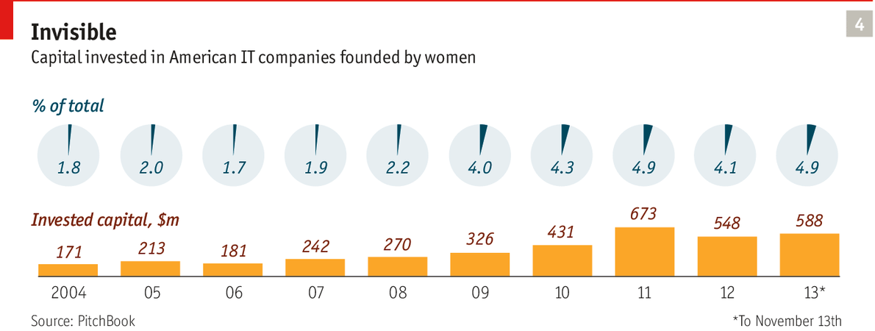
The lack of ethnic diversity is particularly noticeable in accelerators, but their managers say there is little they can do about it: the people who present themselves are “a bunch of white and Asian dudes”, notes Mr Graham, the founder of Y Combinator. This seems likely to limit innovation. Still, a growing number of investors now at least recognise that there is a problem. Having found that only a handful of its applicants were female, Entrepreneur First, a London accelerator for individual founders, decided to launch CodeFirst:Girls, a series of free courses to teach female students how to code. Among the latest batch, four out of 31 founders are women, which is still not great.
A more diverse group of founders might develop a more mature self-image. For the moment many see themselves as the next Steve Jobs or Mark Zuckerberg, but last year Venkatesh Rao of Ribbonfarm, a consultancy, offered a different narrative. “Entrepreneurs are the new labour,” he claimed in a series of well-argued blog posts with the same title. And it is true that many founders do indeed live on “rent and ramen [noodles]”. But Mr Rao’s analysis goes deeper. He sees a connection between today’s entrepreneurs and the artisan steelmakers of the late 19th century. As the market matured, he explains, the Victorian steelworkers’ knowledge became commoditised, making them the nucleus of the new working class. Something similar is now happening to founders, Mr Rao claims.
The lean startup methodology, the accelerators and the standardised term sheets for investments are all signs that the knowledge required to run a startup is becoming codified and commoditised. This has tilted the balance of power between investors and entrepreneurs, he writes. “Investors have won, and their dealings with the entrepreneur class now look far more like the dealings between management and labour.”
Many founders will end up being “acqui-hired”, with a large tech company buying a startup not for the technology but for the team, reckons Mr Rao. That may be no bad thing: a good engineer will quickly get a job that he would have taken twice as long to reach on a conventional career ladder, as well as a significant chunk of cash. But it puts a different light on startups and accelerators, suggesting that they are less about identifying the next Mr Zuckerberg or Mr Jobs than about providing a new system to train workers for the knowledge economy.
A trickle of jobs
Can founders not at least feel good about themselves as job creators? Between 1990 and 2011 information and communication technology (ICT) businesses in America aged between one and five years increased their workforce by 10% a year, according to a recent study by the Ewing Marion Kauffman Foundation. But since most of these businesses are small, so are the absolute numbers of jobs they generate. Although startups often “scale” quickly, they rarely become “massive”, says Erik Brynjolfsson of MIT Sloan School of Management.
In a new book, “The Second Machine Age”, co-written with a colleague, Andrew McAfee, Mr Brynjolfsson contrasts Eastman Kodak, founded in 1880, with Instagram, a photo-sharing app only 18 months old that was bought by Facebook for about $1 billion in 2012. In its heyday Kodak employed over 145,000 people and indirectly provided work for thousands more. It filed for bankruptcy a few months before Instagram was sold. At the time of the sale the photo-sharing firm had 130m customers but just 16 employees. Even Facebook, which now boasts more than 1.2 billion users, employs only about 5,800 people.
Yet it would be wrong to conclude that the entrepreneurial explosion will lead to more unemployment, argues Mr Brynjolfsson. Startups may disrupt existing industries, but they often create the foundation for many new jobs outside their own business. On Etsy, an online marketplace for homemade items, more than 1m people have opened stores to sell their wares. On eLance and oDesk, two freelancing sites, 2.3m and 4.5m members respectively are offering their services.
Most important, digital technology has created endless possibilities for new products. “The answer is not less entrepreneurship but more,” says Mr Brynjolfsson. “We are in no danger of running out of combinations to try.” That cornucopia is now extending from software to hardware.

Hardware startups

Hacking Shenzhen

Why southern China is the best place in the world for a hardware innovator to be
Jan 18th 2014 | From the print edition
OH NO, NOT another accelerator, you may think. But this one is different. On the tables are not just the obligatory laptops and smartphones but circuit boards, cables, screwdrivers and a few items which look only vaguely familiar. One resembles a very old mobile phone with an oddly shaped knob attached to it. Another, a set of small blocks with switches and buttons, calls to mind a disassembled mixer in a recording studio. Yet another might be the microphone of a computer headset, but is mounted on a pair of glasses.
Even more surprisingly, the home of Haxlr8r (pronounced “Hackcelerator”) is not some co-working space in London or San Francisco but the 10th floor of an office building in Shenzhen. The city in the Pearl River Delta, close to Hong Kong, is the world capital of electronics: most of the planet’s digital devices are assembled in factories in and around the city.
Haxlr8r is living proof that, as Karl Popper once said, history repeats itself, but never in the same way. Just as with software services, new technology makes it ever easier to build new types of devices, most of them connected to the internet. The difference is that making hardware remains, well, hard—which is why Haxlr8r is in Shenzhen. That way its teams may avoid the fate of a first generation of hardware startups, mostly based in America. They put their ideas up on Kickstarter and Indiegogo, the leading crowdfunding services, but then endured months of delay or never got as far as manufacturing their devices.
The technologies that allowed software services to be developed more cheaply and quickly were cloud computing, social networks and any number of digital services called application programming interfaces (APIs). For hardware the list includes all of the above plus 3D printers, sensors and microcontrollers which bridge the analogue and the digital worlds. The platform for most connected devices is smartphones. All these elements can be combined in countless ways, creating a Cambrian explosion not just in software but in physical electronic devices too.
When the latest batch of founders arrived at Haxlr8r in August, new wireless chips based on a standard called Bluetooth Low Energy (BLE) had just become widely available. These are cheaper and less power-hungry than the previous generation, and startups do not have to ask Apple for permission to use them to tether their devices to the iPhone (and pay for it). Most teams at Haxlr8r went on to use BLE chips in their contraptions.
The old mobile phone with the knob is actually a wireless tuning device called Roadie—and an example of how technology, personal interest and culture can come together in surprising ways. Bassam Jalgha and Hassane Slaibi are the founders of Beirut’s first hackerspace, a clubhouse for tinkerers. But they are also musicians and know how difficult it is to tune a lute, a popular instrument in Lebanon. So when they came to Shenzhen, they set out to build something that makes it easy to tune string instruments. A smartphone app listens to the sound and tells the motor in the tuning device whether to tighten or loosen a string.
The blocks, called Palette, are indeed the components for a mixer of sorts and are meant to be assembled by designers and photographers who need a physical interface for repetitive tasks on a computer. The microphone, dubbed Vigo, is a “drowsiness meter”: the tip contains a sensor that measures how often a user blinks—a sign of how tired he is, and whether he should stop driving or get a cup of coffee.
Shenzhen is packed with all kinds of suppliers and service providers that can make life easier for hardware startups
Yet most of the value of such devices is not so much in the design but in the software and services that are part of the package. Roadie comes with a smartphone app, Palette, with a program that runs on a PC. Vigo will show the user on a website how his attention fluctuates over time. Such offerings not only make products harder to copy but might allow their makers to earn additional money from subscriptions.
Makers and shakers
When Cyril Ebersweiler and Sean O’Sullivan, two venture capitalists, set up Haxlr8r in September 2011, they chose Shenzhen for a good reason. The district of Futian, the accelerator’s home, has dozens of shopping malls for electronics. The biggest is the Seg market. The bottom floor is reserved for screws, cables and chips, and as you go higher up the products become more finished: circuit boards, networking equipment, personal computers. The sixth floor offers LEDs in all shapes and sizes, from super-thin Christmas garlands to super-bright lamps.
Shenzhen is also packed with all kinds of suppliers and service providers that can make life easier for hardware startups. Having a new circuit board made there takes days, not weeks as it does in America, reports Eszter Ozsvald of Notch, another Haxlr8r startup. Her company is developing small motion trackers. And had Wearpoint not gone to China, it would probably never have found the track pad it needs for its remote control for Google Glass, a head-mounted display.
Being in Shenzhen also allows founders to look at lots of factories, which proved handy for Error! Hyperlink reference not valid., a company that sells fancy handbags with a built-in smartphone charger. “If the workers are not happy, they may leak your intellectual property,” says Dan Salcedo, the firm’s co-founder.
If a factory passes muster, other Haxlr8r startups often go on to use it too. Howard Hunt, the boss of DustCloud, had scouted out a factory to make casings for prototypes of his Dusters, gun-shaped devices for playing open-air laser tag. When he went to pick them up and pay (cash) in early October, the founders of Notch and Wearpoint came along to see whether the factory could also work for them. The meeting showed that people from different cultural backgrounds can communicate perfectly well with a minimum of translation. Each time the Western founders asked a question, the Chinese owner of the factory fetched another plastic sample that met with approval.
Silvia Lindtner of the University of California, Irvine, and Fudan University in Shanghai, who follows the startup scene in China, is not surprised. The two sides complement each other, she says. The founders of hardware startups, often steeped in the open-source culture, partner with factories rooted in the Chinese culture of shanzhai, which translates as “mountain stronghold”. It used to mean pirated electronic goods but now stands for open-source manufacturing.
Haxlr8r is not the only model for plugging into Shenzhen’s extraordinary manufacturing platform. Another is Seeed Studio, a contract manufacturer for makers, as the world’s ever-growing crowd of tinkerers is called. “Haxlr8r is for backpackers who want to do things themselves,” explains Eric Pan, who founded Seeed in 2008. “We on the other hand offer guided tours. And you don’t even have to come here.”
Having worked for about 200 makers last year, Seeed is now one of the world’s biggest manufacturers of open-source hardware. When a maker asks Seeed to build a circuit board, the firm keeps a copy of the design which can then be used without charge by other customers. Most factories in Shenzhen work for big customers and have long assembly lines where workers perform only one task. But makers typically want just a few items and are willing to pay more, so Mr Pan has split his employees into self-organising teams.
Whereas Seeed is a Chinese creation, PCH International is a Western take on Shenzhen. Also based in the city, it started out as a sourcing company with a reputation for being the fastest supplier of parts to electronics makers. Liam Casey, who founded the company in 1996, had criss-crossed the Pearl River Delta, gathering knowledge about supply lines. PCH later added packaging, logistics and manufacturing to its portfolio. Today the firm, which had revenues of $1 billion in 2013, is an “end-to-end platform, a sort of Amazon Web Services for electronics manufacturing”, in the words of Mr Casey. He has even started an accelerator, Highway1, which is based in San Francisco, to generate more things to make for his platform.
Some firms prefer to go it alone, like Zound Industries, a Swedish maker of fashionable headphones, including brands such as Urbanears and Molami. Back in 2008, when production in Shenzhen did not get off the ground because factories failed to deliver, Zound sent one of the founders, who hired a couple of experienced hands to work with manufacturers. Today the firm has 18 employees in the Chinese city and uses five factories which have so far produced nearly 8m headphones.
For the moment Haxlr8r’s latest batch of startups can only dream of such success. In November they had their demo day, held in San Francisco and marking the beginning of their “Kickstarter” campaigns, which essentially consist of a video presenting the project and asking for money. Investors can be surprisingly generous, even for rather odd projects. Petcube managed to raise more than $250,000 for a small, internet-connected metal box with a video camera, microphone and laser pointer inside that lets owners watch their pets from afar and play with them by controlling the laser pointer.
The Kickstarter campaign is only the beginning of a long journey. Founders must get their products certified, find distributors, organise production and avoid getting sued for infringing other people’s intellectual property. “Hardware is really hard,” says Amanda Williams, whose company, Fabule, was part of Haxlr8r’s previous batch. She is back in Shenzhen dealing with manufacturers of the firm’s first product, a programmable lamp.
Some of the contraptions may seem a shade frivolous, but Haxlr8r’s startups also included Babybe, an “emotional prosthetic” designed to help prematurely born babies to catch up. It transmits the mother’s heartbeat, breathing pattern and even her voice to a mattress in the infant’s incubator.
With startups you never know what you will get. But the platforms, the accelerators and the ecosystems that allow them to develop are already emerging in other industries, too.

Platforms

Something to stand on

Proliferating digital platforms will be at the heart of tomorrow’s economy, and even government
Jan 18th 2014 | From the print edition
PROVIDING THE RIGHT platform is sometimes all it takes. Instead of planning new pedestrian plazas by the usual bureaucratic means, New York City’s department of transportation just marks an area on a street with temporary materials and then lets local organisations, architects and citizens decide what to do with it. The programme has so far produced 59 plazas, including the Pearl Street Triangle in Brooklyn, a small urban oasis with big potted plants and shaded seating.
In the physical world, platforms can be simply something to stand or build on, like a New York City street. They can also be basic inputs for many other activities and products. Railways allowed services such as mail order to develop; the power grid brought forth a plethora of electrical household appliances; and standardised containers boosted global trade. Even Barbie dolls can be seen as platforms for all kinds of profitable add-ons, such as shoes, wigs and handbags.
But although physical platforms have been around for a long time, the idea did not attract much attention until the rise of the software industry in the 1980s and 1990s, explains Michael Cusumano, also of MIT Sloan School of Management. The industry quickly split into two parts: operating systems (the platforms) and applications that ran on top of them.
Bill Gates, the founder of Microsoft, realised much earlier than his rivals that power (and thus profit) rests with those who control the operating system, in his case Windows. He also saw that the key to creating a successful platform is building a thriving ecosystem around it to get the network effects going. The more programs that run on Windows, the more users will want it, and therefore the more attractive it will be to developers.
Beyond railways
Some platforms are internal to a company. In the car industry a vehicle’s main components, including steering, suspension and power train, are often shared by different models. Other platforms, such as Windows, serve an entire industry. Yet others are “closed”, meaning that access is tightly controlled, as for Apple’s iPhone. The most widespread are the “open” ones, which everyone can use without asking, such as Linux, the open-source operating system.
Intrigued by Microsoft’s success and its subsequent antitrust woes, academics such as Annabelle Gawer of Imperial College Business School dug deeper and found that platforms are a common feature of complex systems, whether economic or biological. The core building blocks are kept stable so that the other parts can evolve more rapidly by combining and recombining them and adding new ones.
That is what is happening in the startup world: new firms combine and recombine open-source software, cloud computing and social networks to come up with new services. In fact, many of these new services are application programming interfaces (APIs)—mini-platforms that form the basis of another digital product, allowing for endless permutations.
The information-technology industry lends itself to this treatment because bits and bytes can be easily rearranged and replicated at almost no cost. Systems with vertically integrated components such as the mainframe computer tend to give way to architectures with separate horizontal layers such as the personal computer. Today the IT sector looks like a very flat inverted pyramid: the bottom, where economies of scale rule, is made up of just a few powerful platforms; the top, where creativity and agility are at a premium, is becoming ever more fragmented. There is not much in between.
As software eats more and more industries, they will increasingly take on this shape, predicts Philip Evans of Boston Consulting Group. By lowering transaction costs, IT allows big chunks of the economy to reshape themselves and turn into what he calls “stacks”—industry-wide ecosystems that will have large platforms at one end of their value chains and a wide variety of modes of production at the other, from startups to social enterprises and communities to user-generated content.
Stacking up
Outside the IT industry such stacks have only just begun to form. In finance, credit-card networks have long operated as platforms, allowing banks to issue their own plastic money. Yodlee, which aggregates financial data for more than 55m bank customers, now allows startups and other firms to plug into its systems. Some smaller banks, including Bancorp, also see themselves as platforms, keeping the books for innovative online banks such as Simple. Big payment processors, such as First Data and TSYS, are also expected to open up their networks.
In telecommunications and electricity, regulators have pushed firms to go horizontal by forcing them to unbundle their services. As power grids become cleverer, smart-meter apps are likely to appear. A new grid in Amsterdam, for instance, is set up in such a way that startups can use it to develop energy-saving applications. Powerful platforms will also emerge in industries that produce piles of data, such as health care. They can provide startups with opportunities to mine the data to find digital material for new services.
This “platformisation” is spreading even to the very stuff of life. Synthesising DNA is still much more expensive than sequencing it, but the costs are coming down rapidly, and an ecosystem for this ultimate platform is already beginning to form. Half a dozen cities around the world are now home to bio-hackerspaces (such as New York’s Genspace) where genetic hackers learn how to build simple biological machines. Autodesk, a software firm, is developing design tools for DNA, code-named “Project Cyborg”.
As with hardware, America’s west coast and China’s Pearl River Delta may be able to collaborate on this one day—though not everyone would welcome the idea because the implications of such biological machines can be quite scary. Silicon Valley is already home to a few biosynthesis startups, for example Cambrian Genomics, which is developing a machine to print DNA cheaply. Shenzhen is the base of BGI, formerly known as the Beijing Genomics Institute, which does DNA sequencing on an industrial scale.
In business the effects of platforms are already making themselves felt. Companies must either turn themselves into one or become agile ecosystems, complete with startups and accelerators, says John Hagel of the Deloitte Centre for the Edge, a research arm of Deloitte, a professional-services firm. Coca-Cola, for instance, is planning to launch accelerators in nine cities, including Berlin and Istanbul. Such efforts will change the understanding of what constitutes a firm, says Mr Hagel.
The spread of platforms will bring radical changes for workers, too. Many more will become founders or be employed by startups. “They will be labourers in the technological gardens where a thousand flowers bloom, but only a few will grow to become really big,” says Thomas Malone of the MIT Sloan School of Management. And experts note that some people may find it hard to get used to such a fast-moving world of work.
Governments will also have to adapt. Antitrust authorities will need to be alert because platform operators, which are open quasi-monopolists, will have strong incentives to maintain their dominance. The most powerful of them, such as Amazon, Facebook or Google, will amass huge amounts of information and will form the central data banks for the knowledge economy.
No less than companies, governments will have to consider what role they want to play in this new world. Currently they resemble a “vending machine” offering a limited set of choices, says Tim O’Reilly, an internet expert. But they would work much better as a platform for a “thriving bazaar” of government services, offering basic building blocks that others can use.
This suggests that the state needs to limit what it does but do it well. “It has to be both narrower and stronger,” says Paul Romer of New York University. In a future digital world big business and big government may play similar roles, as platform managers and curators of ecosystems. Cities or even governments may offer services to other cities and countries in fields such as online identity and regulatory oversight.
All in all, the impact of platformisation will be monumental. Those who see the current entrepreneurial explosion as merely another dotcom bubble should think again. Today’s digital primordial soup contains the makings of the economy and perhaps even the government of tomorrow.

Business Model Generation

http://www.youtube.com/watch?v=ynQasjpBTCk&list=PLE7B12A2D1B157E2C

Stanford Entrepreneurship

http://ecorner.stanford.edu/authorMaterialInfo.html?mid=2875

