The third industrial revolution

The digitisation of manufacturing will transform the way goods are made—and change the politics of jobs too
Apr 21st 2012 | from the print edition
http://www.economist.com/node/21553017

http://www.economist.com/blogs/schumpeter/2012/04/special-report-manufacturing-and-innovation
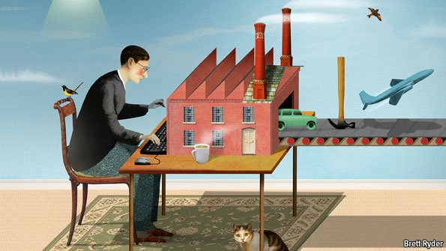
THE first industrial revolution began in Britain in the late 18th century, with the mechanisation of the textile industry. Tasks previously done laboriously by hand in hundreds of weavers’ cottages were brought together in a single cotton mill, and the factory was born. The second industrial revolution came in the early 20th century, when Henry Ford mastered the moving assembly line and ushered in the age of mass production. The first two industrial revolutions made people richer and more urban. Now a third revolution is under way. Manufacturing is going digital. As this week’s special report argues, this could change not just business, but much else besides.
A number of remarkable technologies are converging: clever software, novel materials, more dexterous robots, new processes (notably three-dimensional printing) and a whole range of web-based services. The factory of the past was based on cranking out zillions of identical products: Ford famously said that car-buyers could have any colour they liked, as long as it was black. But the cost of producing much smaller batches of a wider variety, with each product tailored precisely to each customer’s whims, is falling. The factory of the future will focus on mass customisation—and may look more like those weavers’ cottages than Ford’s assembly line.
Towards a third dimension
The old way of making things involved taking lots of parts and screwing or welding them together. Now a product can be designed on a computer and “printed” on a 3D printer, which creates a solid object by building up successive layers of material. The digital design can be tweaked with a few mouseclicks. The 3D printer can run unattended, and can make many things which are too complex for a traditional factory to handle. In time, these amazing machines may be able to make almost anything, anywhere—from your garage to an African village.
The applications of 3D printing are especially mind-boggling. Already, hearing aids and high-tech parts of military jets are being printed in customised shapes. The geography of supply chains will change. An engineer working in the middle of a desert who finds he lacks a certain tool no longer has to have it delivered from the nearest city. He can simply download the design and print it. The days when projects ground to a halt for want of a piece of kit, or when customers complained that they could no longer find spare parts for things they had bought, will one day seem quaint.
Other changes are nearly as momentous. New materials are lighter, stronger and more durable than the old ones. Carbon fibre is replacing steel and aluminium in products ranging from aeroplanes to mountain bikes. New techniques let engineers shape objects at a tiny scale. Nanotechnology is giving products enhanced features, such as bandages that help heal cuts, engines that run more efficiently and crockery that cleans more easily. Genetically engineered viruses are being developed to make items such as batteries. And with the internet allowing ever more designers to collaborate on new products, the barriers to entry are falling. Ford needed heaps of capital to build his colossal River Rouge factory; his modern equivalent can start with little besides a laptop and a hunger to invent.
Like all revolutions, this one will be disruptive. Digital technology has already rocked the media and retailing industries, just as cotton mills crushed hand looms and the Model T put farriers out of work. Many people will look at the factories of the future and shudder. They will not be full of grimy machines manned by men in oily overalls. Many will be squeaky clean—and almost deserted. Some carmakers already produce twice as many vehicles per employee as they did only a decade or so ago. Most jobs will not be on the factory floor but in the offices nearby, which will be full of designers, engineers, IT specialists, logistics experts, marketing staff and other professionals. The manufacturing jobs of the future will require more skills. Many dull, repetitive tasks will become obsolete: you no longer need riveters when a product has no rivets.
The revolution will affect not only how things are made, but where. Factories used to move to low-wage countries to curb labour costs. But labour costs are growing less and less important: a $499 first-generation iPad included only about $33 of manufacturing labour, of which the final assembly in China accounted for just $8. Offshore production is increasingly moving back to rich countries not because Chinese wages are rising, but because companies now want to be closer to their customers so that they can respond more quickly to changes in demand. And some products are so sophisticated that it helps to have the people who design them and the people who make them in the same place. The Boston Consulting Group reckons that in areas such as transport, computers, fabricated metals and machinery, 10-30% of the goods that America now imports from China could be made at home by 2020, boosting American output by $20 billion-55 billion a year.
The shock of the new
Consumers will have little difficulty adapting to the new age of better products, swiftly delivered. Governments, however, may find it harder. Their instinct is to protect industries and companies that already exist, not the upstarts that would destroy them. They shower old factories with subsidies and bully bosses who want to move production abroad. They spend billions backing the new technologies which they, in their wisdom, think will prevail. And they cling to a romantic belief that manufacturing is superior to services, let alone finance.
None of this makes sense. The lines between manufacturing and services are blurring. Rolls-Royce no longer sells jet engines; it sells the hours that each engine is actually thrusting an aeroplane through the sky. Governments have always been lousy at picking winners, and they are likely to become more so, as legions of entrepreneurs and tinkerers swap designs online, turn them into products at home and market them globally from a garage. As the revolution rages, governments should stick to the basics: better schools for a skilled workforce, clear rules and a level playing field for enterprises of all kinds. Leave the rest to the revolutionaries.

Special report: Manufacturing and innovation

A third industrial revolution

As manufacturing goes digital, it will change out of all recognition, says Paul Markillie. And some of the business of making things will return to rich countries
Apr 21st 2012 | from the print edition
http://www.economist.com/node/21552901

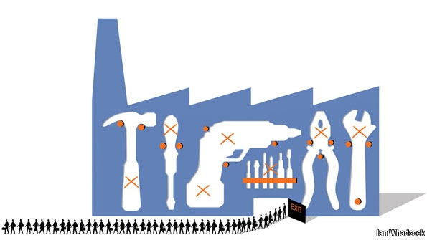
OUTSIDE THE SPRAWLING Frankfurt Messe, home of innumerable German trade fairs, stands the “Hammering Man”, a 21-metre kinetic statue that steadily raises and lowers its arm to bash a piece of metal with a hammer. Jonathan Borofsky, the artist who built it, says it is a celebration of the worker using his mind and hands to create the world we live in. That is a familiar story. But now the tools are changing in a number of remarkable ways that will transform the future of manufacturing.
One of those big trade fairs held in Frankfurt is EuroMold, which shows machines for making prototypes of products, the tools needed to put those things into production and all manner of other manufacturing kit. Old-school engineers worked with lathes, drills, stamping presses and moulding machines. These still exist, but EuroMold exhibits no oily machinery tended by men in overalls. Hall after hall is full of squeaky-clean American, Asian and European machine tools, all highly automated. Most of their operators, men and women, sit in front of computer screens. Nowhere will you find a hammer.

And at the most recent EuroMold fair, last November, another group of machines was on display: three-dimensional (3D) printers. Instead of bashing, bending and cutting material the way it always has been, 3D printers build things by depositing material, layer by layer. That is why the process is more properly described as additive manufacturing. An American firm, 3D Systems, used one of its 3D printers to print a hammer for your correspondent, complete with a natty wood-effect handle and a metallised head.
This is what manufacturing will be like in the future. Ask a factory today to make you a single hammer to your own design and you will be presented with a bill for thousands of dollars. The makers would have to produce a mould, cast the head, machine it to a suitable finish, turn a wooden handle and then assemble the parts. To do that for one hammer would be prohibitively expensive. If you are producing thousands of hammers, each one of them will be much cheaper, thanks to economies of scale. For a 3D printer, though, economies of scale matter much less. Its software can be endlessly tweaked and it can make just about anything. The cost of setting up the machine is the same whether it makes one thing or as many things as can fit inside the machine; like a two-dimensional office printer that pushes out one letter or many different ones until the ink cartridge and paper need replacing, it will keep going, at about the same cost for each item.
Additive manufacturing is not yet good enough to make a car or an iPhone, but it is already being used to make specialist parts for cars and customised covers for iPhones. Although it is still a relatively young technology, most people probably already own something that was made with the help of a 3D printer. It might be a pair of shoes, printed in solid form as a design prototype before being produced in bulk. It could be a hearing aid, individually tailored to the shape of the user’s ear. Or it could be a piece of jewellery, cast from a mould made by a 3D printer or produced directly using a growing number of printable materials.
But additive manufacturing is only one of a number of breakthroughs leading to the factory of the future, and conventional production equipment is becoming smarter and more flexible, too. Volkswagen has a new production strategy called Modularer Querbaukasten, or MQB. By standardising the parameters of certain components, such as the mounting points of engines, the German carmaker hopes to be able to produce all its models on the same production line. The process is being introduced this year, but will gather pace as new models are launched over the next decade. Eventually it should allow its factories in America, Europe and China to produce locally whatever vehicle each market requires.
They don’t make them like that any more
Factories are becoming vastly more efficient, thanks to automated milling machines that can swap their own tools, cut in multiple directions and “feel” if something is going wrong, together with robots equipped with vision and other sensing systems. Nissan’s British factory in Sunderland, opened in 1986, is now one of the most productive in Europe. In 1999 it built 271,157 cars with 4,594 people. Last year it made 480,485 vehicles—more than any other car factory in Britain, ever—with just 5,462 people.
“You can’t make some of this modern stuff using old manual tools,” says Colin Smith, director of engineering and technology for Rolls-Royce, a British company that makes jet engines and other power systems. “The days of huge factories full of lots of people are not there any more.”
As the number of people directly employed in making things declines, the cost of labour as a proportion of the total cost of production will diminish too. This will encourage makers to move some of the work back to rich countries, not least because new manufacturing techniques make it cheaper and faster to respond to changing local tastes.
The materials being used to make things are changing as well. Carbon-fibre composites, for instance, are replacing steel and aluminium in products ranging from mountain bikes to airliners. And sometimes it will not be machines doing the making, but micro-organisms that have been genetically engineered for the task.
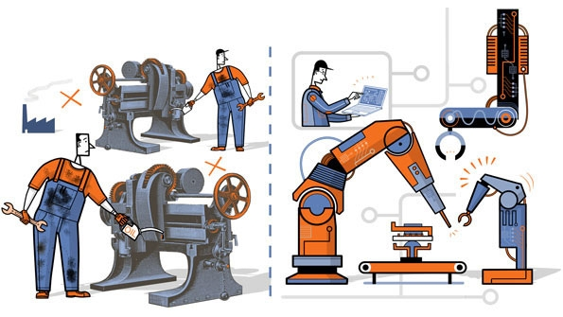
Everything in the factories of the future will be run by smarter software. Digitisation in manufacturing will have a disruptive effect every bit as big as in other industries that have gone digital, such as office equipment, telecoms, photography, music, publishing and films. And the effects will not be confined to large manufacturers; indeed, they will need to watch out because much of what is coming will empower small and medium-sized firms and individual entrepreneurs. Launching novel products will become easier and cheaper. Communities offering 3D printing and other production services that are a bit like Facebook are already forming online—a new phenomenon which might be called social manufacturing.
The consequences of all these changes, this report will argue, amount to a third industrial revolution. The first began in Britain in the late 18th century with the mechanisation of the textile industry. In the following decades the use of machines to make things, instead of crafting them by hand, spread around the world. The second industrial revolution began in America in the early 20th century with the assembly line, which ushered in the era of mass production.
As manufacturing goes digital, a third great change is now gathering pace. It will allow things to be made economically in much smaller numbers, more flexibly and with a much lower input of labour, thanks to new materials, completely new processes such as 3D printing, easy-to-use robots and new collaborative manufacturing services available online. The wheel is almost coming full circle, turning away from mass manufacturing and towards much more individualised production. And that in turn could bring some of the jobs back to rich countries that long ago lost them to the emerging world.

Back to making stuff

Manufacturing still matters, but the jobs are changing
Apr 21st 2012 | from the print edition

FOR OVER 100 YEARS America was the world’s leading manufacturer, but now it is neck-and-neck with China (see chart 1). In the decade to 2010 the number of manufacturing jobs in America fell by about a third. The rise of outsourcing and offshoring and the growth of sophisticated supply chains has enabled companies the world over to use China, India and other lower-wage countries as workshops. Prompted by the global financial crisis, some Western policymakers now reckon it is about time their countries returned to making stuff in order to create jobs and prevent more manufacturing skills from being exported. That supposes two things: that manufacturing is important to a nation and its economy, and that these new forms of manufacturing will create new jobs.
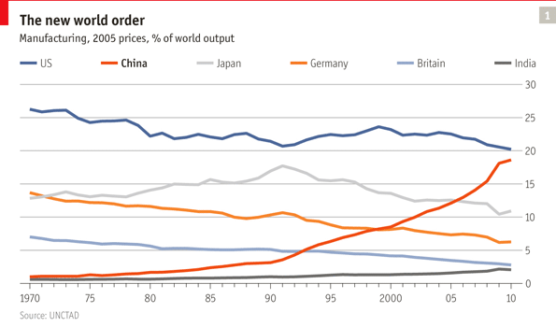
There has been plenty of research to show that manufacturing is good for economies, but in recent years some economists have argued that there is nothing special about making things and that service industries can be just as productive and innovative. It is people and companies, not countries, that design, manufacture and sell products, and there are good and bad jobs in both manufacturing and services. But on average manufacturing workers do earn more, according to a report by Susan Helper of Case Western Reserve University, Cleveland, for the Brookings Institution, a think-tank in Washington, DC (see chart 2).
Manufacturing firms are also more likely than other companies to introduce new and innovative products. Manufacturing makes up only about 11% of America’s GDP, but it is responsible for 68% of domestic spending on research and development. According to Ms Helper, it provides better-paid jobs, on average, than service industries, is a big source of innovation, helps to reduce trade deficits and creates opportunities in the growing “clean” economy, such as recycling and green energy. These are all good reasons for a country to engage in it.
Despite China’s rapid rise, America remains a formidable production power. Its manufacturing output in dollar terms is now about the same as China’s, but it achieves this with only 10% of the workforce deployed by China, says Susan Hockfield, president of the Massachusetts Institute of Technology (MIT) and co-chair of President Barack Obama’s Advanced Manufacturing Partnership, an initiative recently set up with business and universities to create jobs and boost competitiveness.
The “Hammering Man” catches a nostalgia for the kind of manufacturing employment which in the developed world barely exists any more. Factory floors today often seem deserted, whereas the office blocks nearby are full of designers, IT specialists, accountants, logistics experts, marketing staff, customer-relations managers, cooks and cleaners, all of whom in various ways contribute to the factory. And outside the gates many more people are involved in different occupations that help to supply it. The definition of a manufacturing job is becoming increasingly blurred.
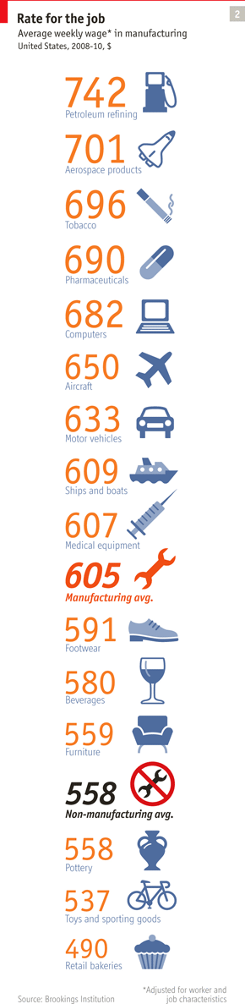
Yet America’s productivity strides raise questions about how many manufacturing jobs, particularly of the white-collar variety, will be created. And some of the manufacturing breakthroughs now in the pipeline will bring down the number of people needed even further. “It is true that if you look at the array of manufacturing technologies that are coming out of MIT, many of them are jobs-free, or jobs-light,” says Ms Hockfield. “But that is no reason not to want to do that type of manufacturing in America, because feeding into jobs-light processes is a huge supply chain in which there are lots of jobs and large economic benefits.”
Companies are also optimistic about a manufacturing revival. “We are standing in front of a potential revolution in manufacturing,” says Michael Idelchik, head of advanced technologies at GE Global Research, the R&D arm of one of the world’s biggest manufacturers. The ideas that will make this happen can come from anywhere, which is why his laboratory, based in bucolic Niskayuna in upstate New York, also has research centres in Bangalore, Munich, Rio de Janeiro and Shanghai. As for the jobs likely to be created, Mr Idelchik thinks people have a myopic view of manufacturing employment: “If you look at everyone who contributes, it is a very large occupation.”
Ghost in the machine
A lot of the jobs that remain on the factory floor will require a high level of skill, says Mr Smith, Rolls-Royce’s manufacturing boss. “If manufacturing matters, then we need to make sure the necessary building blocks are there in the education system.” His concern extends to the firm’s suppliers, because companies in many countries have cut down on training in the economic downturn. To get the people it wants, Rolls-Royce has opened a new Apprentice Academy to double the number of people it can train each year, to 400.
In America firms have cut back on training so savagely that “apprenticeships may well be dead,” reckons Suzanne Berger, one of the leaders of a new MIT research project, Production in the Innovation Economy, which is looking at how companies compete. Many firms feel that it is not worth training people if they are likely to leave to work for someone else. Ms Berger and her colleagues think one promising alternative to apprenticeships is a collaboration between community colleges and local firms to develop training programmes. Sometimes the firms donate manufacturing equipment to the colleges.
The digitisation of manufacturing will make training easier. Companies cannot justify halting production equipment which may be running 24 hours a day so that trainees can play around with it. But computers can simulate production systems in a virtual environment, and products too. At Warwick University in Britain, a room with giant high-resolution screens is used as a virtual-reality chamber to simulate products under development, such as cars, in three dimensions.
Raw materials are put into one end of a machine full of tubes, cogs, belts and electronics, and pills pop out of the other end
A new vehicle today is likely to be drawn up as a three-dimensional “digital prototype” long before it is actually built. It can be walked around, sat in, test-driven in a simulator, taken apart and placed in a virtual factory to work out how to build it. And the same software can be used by others in the company, including advertising staff who want to market the vehicle. The images generated from digital prototypes are now so good they are often used to produce brochures and television ads before a new car is built, says Grant Rochelle, a director of Autodesk, a Silicon Valley software company.
Many people working in factories are providing services that are crucial to manufacturing. “In the future more products will be sold on the basis of service,” says Kumar Bhattacharyya, chairman of the Warwick Manufacturing Group at Warwick University. “If you sell a car with a ten-year warranty you need to make sure it will last for ten years and that you have the services in place to look after it.” Despite high unemployment, some manufacturers say that too few people are choosing engineering and manufacturing careers, but new technologies like 3D printing will help, predicts Lord Bhattacharyya. “If you can build something, people get excited about making things. Then they go and set up companies.”
Come closer
One of the most successful incubators for new firms are industrial clusters, of which Silicon Valley is the best-known and most imitated example. Firms cluster together for a variety of reasons: the skills that are available in a particular area, the concentration of specialist services and the venture capital from investors with a close understanding of their market. Usually there are universities and research laboratories nearby, so the process of coming up with new ideas and the means of turning those ideas into products are closely linked. This relationship is set to become even more intimate with new manufacturing technologies. “We have technologies now we are only able to exploit if we have manufacturing capabilities in some proximity to those innovations,” says Ms Berger. You do not have to move far from her office to find examples.
Boston’s biotechnology cluster consists of pharmaceutical companies big and small, attracted in large part by the research being carried out in the region’s hospitals and universities. In the biological sciences the development of manufacturing capabilities is closely linked to that of the product, says Phillip Sharp, a Nobel prize-winner and co-founder of what is now called Biogen Idec, a Massachusetts-based biotechnology firm with annual revenues of $5 billion. What currently excites the industry, says Mr Sharp, is nanotechnology. This takes its name from the word for a billionth of a metre. When materials are measured at the nanoscale they often have unique properties, some of which can be used in beneficial ways.
Nanotechnology makes it possible to manufacture, on a tiny scale, new therapeutic substances carrying information on their surfaces that can be used to direct them to particular cells in the body. The drugs delivered by such substances could be valuable in treating diseases like cancer. They are being made in small quantities now, says Mr Sharp; the challenge will be to scale up those processes once clinical trials are completed. And that, too, he adds, will depend on both product and manufacturing innovation working together.
Making drugs for the most part remains an old-fashioned batch-manufacturing process. This involves assembling ingredients, often from different countries, processing them in a chemical plant into a batch of drug substance, then turning that substance into pills, liquids or creams in another factory, which might be in yet another country. All this involves a lot of moving around of drums and containers, and plenty of inventory sitting idle. It is time-consuming and expensive.

But in a laboratory in Boston another way of making drugs is being developed. Raw materials are put into one end of a machine full of tubes, cogs, belts and electronics, and pills pop out of the other end. This pilot production line, a joint venture between MIT and Novartis, a giant Swiss-based drugs company, is pioneering a continuous manufacturing process for the pharmaceuticals industry. It is producing a copy of a standard Novartis drug, although not for use yet because the system is still five to ten years away from commercial operation. It relies on a combination of chemistry and engineering, speeding up some processes and slowing down others to make them work together.
The results are encouraging, says Stephen Sofen, the project’s director. The number of discrete operations involved in producing the drug has been cut from 22 to 13; the processing time (even excluding all the moving around of materials) has been shrunk from 300 hours to 40. And instead of testing each batch of material, every pill being made is monitored to ensure it meets the required specification.
Continuous manufacturing could transform the pharmaceuticals industry. “Instead of a giant, purpose-built plant to supply the global market, you could imagine smaller, regionalised plants,” says Mr Sofen. Such factories could respond more rapidly to local demand, especially if a pandemic were to break out. The pilot line in Boston will fit into a shipping container, so it could be deployed anywhere. It can make 10m tablets a year, working around the clock. It might also be used to make customised doses of drugs for particular patients. Continuous manufacturing could make more treatments commercially viable.

Comparative advantage

The boomerang effect

As Chinese wages rise, some production is moving back to the rich world
Apr 21st 2012 | from the print edition

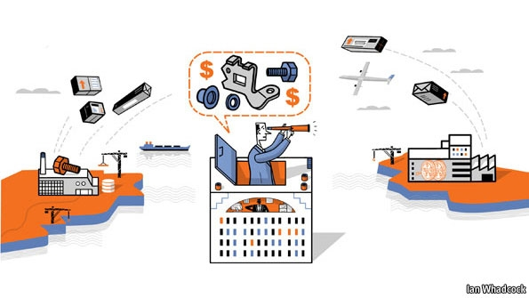
THIRTY YEARS AGO Shenzhen was little more than a village, abutting the border of Hong Kong’s New Territories. When China’s first Special Economic Zone was established in the early 1980s, workshops started to grow and glistening skyscrapers began to rise up. Its population is now around 12m, including perhaps 6m migrant workers. They often live in dormitories close to the factories that have helped make this city one of the richest in China.
One of those factories is known as Foxconn City. Owned by Hon Hai Precision Industry, a Taiwanese company, it is among the largest manufacturing complexes in China, employing some 230,000 people. Some of Apple’s iPhones and iPads are assembled here. In March Apple agreed to improve working conditions at its Chinese factories after an outside audit found abuses of labour codes, including excessive overtime.

Countries that make things more cheaply than others are often accused of running sweatshops, and labour in China was undoubtedly cheap: that was why Hong Kong’s clothing and toy factories moved to the mainland. But with increasing prosperity Chinese workers want more pay, shorter hours and more benefits, just as Taiwanese, Japanese and South Korean workers did before them. Labour costs in China have recently been growing by around 20% a year.
Some labour-intensive businesses are now moving from the coastal regions to inland China, where costs are lower, though the infrastructure may not be up to the mark. A number of firms, especially those making clothes and shoes, have upped sticks and moved to Bangladesh, Cambodia, Indonesia and Vietnam. Nike, for instance, used to make most of its trainers in China, but many of its big suppliers have moved elsewhere, and in 2010 Vietnam became the company’s biggest production base worldwide. Unless some way of making shoes and clothing without manual labour emerges (which, as this report will suggest later, is entirely possible), these businesses will move again in the future; Myanmar looks tempting, provided that reforms there continue.
Yet for some manufacturers low wage costs are becoming less important because labour represents only a small part of the overall cost of making and selling their products. Researchers for the Personal Computing Industry Centre at the University of California, Irvine, took apart an iPad and worked out where all the various bits inside came from and what it had cost to make and assemble them (see chart 3). They found that a 16-gigabyte 2010 iPad priced at $499 contained $154-worth of materials and parts from American, Japanese, South Korean and European suppliers (Apple has more than 150 suppliers in all, many of which also make or finish their parts in China). The researchers estimated the total worldwide labour costs for the iPad at $33, of which China’s share was just $8. Apple is constantly tweaking its products so the figures shift all the time, but not by much.
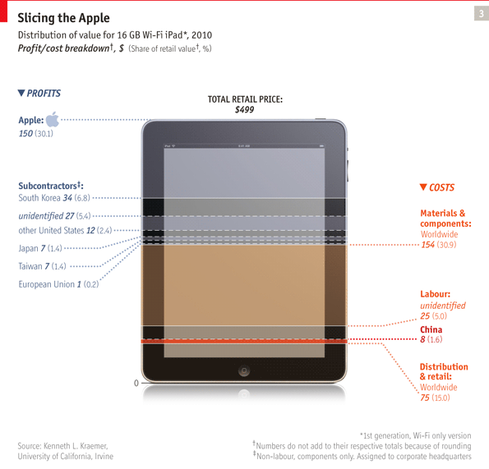
If China accounts for such a small share of the overall labour costs, surely Apple could afford to make iPads in America? It turns out that low wages are not the only attraction. What Shenzhen has to offer on top is 30 years’ experience of producing electronics. It has a network of firms with sophisticated supply chains, multiple design and engineering skills, intimate knowledge of their production processes and the willingness to leap into action if asked to scale up production.
What Shenzhen provides, in other words, is a successful industrial cluster. It works for Apple because many of the electronic parts it uses are commodities. The real innovation lies in designing the product and creating smart software, which is the speciality of another successful cluster, in Silicon Valley, where Apple is based.

Where China scores
Li & Fung, a Hong Kong firm that helps companies find suppliers in Asia, says in a recent research report that clusters like Shenzhen are “an integral part of China’s international competence in manufacturing”. It counts more than 100 industrial clusters in China—including one, in Zhuji in Zhejiang province, that just makes socks. It consists of more than 3,000 small and medium-sized enterprises in the production chain for socks. As long as China’s clusters maintain their edge, these jobs, whether producing iPads or socks, will not go back to America or Europe.
Yet some jobs are returning to developed countries. With Chinese wage costs rising, America’s productivity improvements can help tip the balance, especially when American firms invest in more automation. Yet robots can be used anywhere to reduce labour costs. For example, Terry Gou, Hon Hai’s boss, says he is planning to use more robots for assembly work in China. He is also setting up factories in some of the inland provinces.
Again, wage costs are not the only consideration in transferring production from China back to America. Chesapeake Bay Candle used to ship its scented candles for the American market from China, and then from Vietnam when America raised import tariffs on Chinese-made candles. In June 2011 the company opened a highly automated factory near its base in Maryland, partly because of rising labour costs in Asia and increased shipping charges, but also because having a research and development facility in the American factory allows the company to respond to new trends much faster.
The candle-maker is keeping its factory in China to serve the vast domestic market there. Many firms are adopting this “China plus one” strategy, usually putting an additional production base in a lower-cost country in Asia. The idea is now being extended to repatriating manufacturing facilities to rich countries. This also saves companies from having all their eggs in one basket. A string of natural disasters in recent years has shown that lean supply chains can snap all too easily.
For Peerless AV, a company based in Aurora, Illinois, moving production back from China began with worries about protecting its intellectual property. Peerless makes metal brackets and stands for all sorts of televisions, ranging from screens hung in offices to information displays at railway stations and the giant “video walls” used at music and sporting events. To make lighter, better-looking supports for the thinner screens it saw coming, the company decided in 2002 to produce a range made from aluminium instead of steel. Unable to find an American firm to supply suitable extrusions and castings at the right price, it turned to China. As the flat-screen boom took hold, sales soared—but then the company began to find copies of its products turning up all over the world.
It was these knock-offs that led to a decision to bring production back to America, says Mike Campagna, the firm’s president. Other benefits were to follow. By chance the car industry had gone into a slump and the company was able to pick up the manufacturing equipment it needed at low cost. It also managed to track down people with production experience. For the first time since its launch in 1941, the firm took on debt: $20m-worth to build and equip a new factory, which opened in 2010 to house all its operations under one roof.
“The total cost of manufacturing in China is not as cheap as it might appear to be,” says Mr Campagna. Shipping costs have been rising, containers are expensive and staff have to be maintained in both countries to manage the operation. It is also difficult to react quickly if the market changes. Typically there would be 30 days or so of inventory at each stage of the supply chain: the stock held by the suppliers to the Chinese factory, that factory’s inventory, the content of a shipping container on its way to America, and so on. A design change could take at least six months to implement. Now the company can get a prototype to a customer in a couple of weeks.
Mr Campagna would be happier if the economy were brighter, but says that making 95% of its products in America instead of 65% has transformed the firm’s business. The company used to have 250 workers in America and 400 in China; now it has 350 in America and robots doing hot and dirty jobs, like pouring molten aluminium and laser-cutting steel. The new arrangement, Mr Campagna reckons, “makes us very nimble”. That not only speeds up the production of customised brackets, it also helps with the standard stuff. The company’s standard products used to have a ten-year life cycle, but with new televisions appearing at an ever faster rate its stands and brackets now need replacing every 18 months or so.
Sunshine and silicon
Can repatriation work for commoditised goods too? Until a decade or so ago most of the world’s solar panels were made by American, European and Japanese firms. Then Chinese manufacturers piled into the business, helped by various government-backed incentives. China has now captured more than half the world market for the most widely used solar panels, which rely on photovoltaic cells made from crystalline silicon. But that could change again.
Partly because of China’s onslaught, the bottom dropped out of the market: the price of silicon-based solar panels fell from $1.80 per watt at the start of 2011 to 90 cents by the end of the year, according to GTM Research, a market-research firm. This clobbered some firms that used different solar technologies. One of those casualties was Solyndra, a Californian firm, which manufactured photovoltaic panels in the form of thin-film coatings inside arrays of transparent tubes. Although more expensive than the silicon-based panels, the tubes were able to capture sunlight more effectively at different angles throughout the day. But Solyndra could not compete against the glut of Chinese panels. It filed for Chapter 11 bankruptcy last year, despite having (controversially) received $535m in federal loan guarantees.
The solar-panel producers are slogging it out, often losing money, in anticipation of a huge market to come when solar panels reach “grid parity”—that is, the ability to match fossil fuels in supplying power to national grids without subsidy. Zhengrong Shi, the boss of China’s Suntech Power, which has become the world’s biggest producer of solar panels, thinks that the market is now showing signs of picking up and that China could attain grid parity within three or four years.
What chance, then, for solar-panel producers in Europe and America? For a start, it is not an all-or-nothing choice. To make a solar panel, the silicon is cut into wafers onto which photovoltaic cells are fabricated. The cells are then wired up, encased in frames and covered with glass. Turning the cells into panels might be done more economically in the country where they will be used to save on shipping costs. And fitting the panels to buildings, which accounts for most of the cost of putting in solar power, is always going to be a local business. The installation price in America is currently around $6.50 per watt for a house. So Western firms could import solar cells from China and make a good living installing them. But there are manufacturing advances in the pipeline that might level the cost of producing silicon-based cells in America and China, says Tonio Buonassisi, head of the Photovoltaic Research Laboratory at MIT.

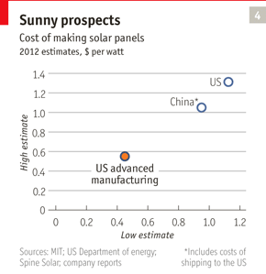
It is possible to work out from publicly available data that the cost of making a complete solar panel in America is around 25% higher than making it in China and shipping it to the west coast of America. Much of China’s cost advantage is thought to come from cheaper raw materials, lower wages and the lower cost of capital. Doug Powell, a researcher at the Photovoltaic Research Laboratory, is undertaking a detailed analysis of production costs in both countries. After factoring in the manufacturing advances already in the pipeline, the cost of an American-made solar panel will fall by more than half to around 50 cents per watt within a decade (see chart 4). Solar panels that can be made for 40-75 cents per watt are expected to provide grid parity in America. The variation reflects regional differences in the amount of sunshine and the price of electricity.
There is nothing to stop China from adopting the same manufacturing breakthroughs, and Mr Powell is investigating the effects of that too. But it is already clear that many of the production innovations now under way would chip away at China’s advantages. For instance, new production methods involve thinner wafers, reducing the amount of silicon required. Cells will become more efficient, simplified production will reduce capital costs and more automation will cut labour costs. “You only really need one breakthrough in each area of innovation to work and we are back in business,” says Mr Buonassisi.
Although Solyndra and others have stumbled, the thin-film technology they used remains attractive. GE, for one, is betting on it. As part of a $600m investment in solar businesses it is completing America’s biggest solar-panel factory near Denver, Colorado. It will use thin-film technology to make larger and lighter panels which it reckons will cut installation costs by about half. Employing just 350 people, the GE facility will be capable of producing enough panels every year to power around 80,000 homes.

Materials

Forging ahead

Manufacturers are increasingly working with new, game-changing ingredients
Apr 21st 2012 | from the print edition

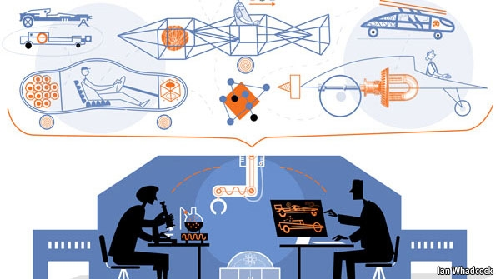
IT IS SMALL enough to be held in your hand and looks like an unremarkable chunk of metal perforated with tiny holes, but it is fiendishly hard to make. That is because it must spin 12,000 times a minute under high pressure at a temperature of 1,600°C, 200°C above the melting point of the material it is made from. And it must survive that twisting inferno long enough to propel an airliner for 24m km (15m miles) before being replaced. In all, 66 of these stubby blades are used in the rear turbine of a Rolls-Royce Trent 1000 engine, and the British company makes hundreds of thousands of these blades a year.
American and European firms have sought salvation in high-end manufacturing from the onslaught of low-cost producers. That increasingly involves becoming more inventive with materials. This article will look at a number of such innovations, including the special casting system for the Rolls-Royce turbine blades as well as the use of carbon fibre, recycled plastic waste, new battery technology and others.
As developing countries become richer and more sophisticated, they too want to make things like aircraft, jet engines and high-performance sports cars. In some cases Western firms subcontract part of the production work to firms in countries trying to build up the capabilities of their industries, usually when those countries are placing big orders. But some things are not for sharing because they are too important to preserve a product’s competitive advantage.
For Rolls-Royce, turbine blades are one of those key technologies. The magic that creates them depends on a deep understanding of materials science and production technology. When metals solidify after casting they normally contain lots of microscopic crystals. That would still leave them strong enough for most things, but it is a potential weakness in a turbine blade. So Rolls-Royce uses a unique system which casts the blade in a nickel-based super-alloy with a continuous and unbroken crystalline structure. This ensures there will be no structural defects.
Air circulates through the blade’s hollow centre and out through precisely positioned holes, formed by a special electronic process because no conventional drill is accurate enough. The holes create a film of air which flows across the surface to prevent the blade from melting. The blade is also covered with a heat-resistant ceramic coating. The makers go to such lengths because a rugged and heat-resistant blade allows a jet engine to run hotter, improving combustion and reducing fuel consumption.
Don’t just sit there, invent something
The new factory in Derby, where Rolls-Royce makes the turbine blades, is also somewhat unusual. Designers, engineers and production staff are housed under one roof rather than in different buildings or even different countries. They were brought together because Rolls-Royce believes that proximity will lead to a better understanding of each other’s roles and greater inventiveness. That will be crucial in the years to come, says Hamid Mughal, Rolls-Royce’s head of manufacturing engineering: “Product technology is the key to survival, and manufacturing excellence provides one of the biggest opportunities in the future.” That combination, Mr Mughal believes, is the only way to keep coming up with breakthroughs: “Incremental increases won’t do it.”
Much the same thinking can be found at GE. It also makes jet engines and has businesses that include energy, lighting, railways and health care. “It became clear to us a number of years ago that we needed to merge materials research and manufacturing technologies,” says Mr Idelchik, its research chief. New products used to begin with design, proceed to materials selection and then to manufacture. “Now it is done simultaneously.”
One product of these efforts is a new industrial battery. This began with research into making a battery tough enough to be used in a hybrid locomotive. A chemistry based on nickel and salt provided the required energy density and robustness. Yet making it work in the laboratory is one thing, commercialising the tricky processes involved to mass-produce the battery quite another. So GE sets up pilot production lines to learn how to put promising ideas into action before building a factory. Some ideas fail at this stage, others fly.
The battery is one that has taken off. Besides hybrid trains it is also suitable for other hybrid vehicles, such as fork lifts, as well as applications like providing back-up power for data centres and to power telecoms masts in remote places. It will be made in a new $100m facility near Niskayuna so that researchers are on hand to continue development. The battery itself consists of a set of standard cells which go into modules that can be connected together for different applications. The modules take up half the space of an equivalent lead-acid battery, are only about a quarter of the weight, will last for 20 years without servicing and work well in freezing or extremely hot conditions, says Glen Merfeld, in charge of energy-storage systems at GE’s laboratory.
One material that particularly interests GE and other manufacturers is carbon fibre. This is already being used to make the large fan blades at the front of some jet engines. It is flexible as a raw material, but when a carbon-fibre cloth is impregnated with epoxy resin, shaped and cured, it can be as strong as steel and only half the weight. That strength comes from the powerful chemical bonds that form between carbon atoms. The fibres can be aligned in different directions, allowing engineers to tailor the strength and flexibility of a composite structure precisely.
The large-scale use of carbon fibre began in aerospace. Both Airbus and Boeing aircraft use it extensively instead of aluminium. Not only is it lighter, there is also a big manufacturing advantage: large sections, like the main area of a wing, can be made in one go rather than being riveted together from lots of individual components.
Look, no hands

It is the strength, lightness and potential saving on manual labour offered by carbon fibre that makes the material attractive for a variety of products. McLaren, a British Formula 1 (F1) team, was the first to use an F1 car with a carbon-fibre structure. John Watson drove it to win the 1981 British Grand Prix at Silverstone. Later that year, in dramatic fashion, he demonstrated its ability to withstand crashes when he emerged unharmed from a pile-up at Monza. Within a few years every F1 team was racing carbon-based cars. But building them, largely by hand, could take 3,000 man-hours.
Now it takes just four hours to build the carbon-fibre chassis and underbody of the MP4-12C, a $275,000 sports car which McLaren launched in 2011 to compete with arch-rival Ferrari on the road as well as on the track. The MP4-12C is built in a clinically clean new factory built next to McLaren’s base in Woking, west of London. Eventually the company will manufacture a range of road cars using carbon fibre. It will get there faster thanks to the development of a partly automated technique for pressing the material in a mould and injecting epoxy resin into it under pressure. This was pioneered jointly with Carbo Tech, an Austrian firm that specialises in composites.
Like many technologies pioneered by motor sport, carbon fibre is now trickling down from supercars into more everyday models. BMW, for one, is launching a new range of electric and hybrid models which use carbon-fibre bodies. The first, a small urban electric car called the BMW i3, will be assembled at a new factory in Leipzig from next year. A carbon-fibre car, being lightweight, will get more mileage out of its battery than a heavier steel one. It might even prove stronger in crash tests.
Another surprisingly strong material could be made from what people throw out. Arthur Huang, the co-founder of Miniwiz Sustainable Energy Development, based in Taiwan, trained as an architect in America. He is making building materials from re-engineered rubbish. One product, Polli-Brick, is a block resembling a square bottle made from recycled PET plastic, which is widely used to make food and drink containers. Because of their shape, Polli-Bricks can lock together without any adhesive to form structures such as walls. These, says Mr Huang, are strong enough to withstand a hurricane, but greatly reduce the carbon footprint of a building and are about a quarter of the price of traditional building materials. Moreover, as they are translucent they can have LED lighting incorporated in them.
A concrete advantage
Another of Mr Huang’s materials is a natural bonding agent extracted from discarded rice husks. This can also be added to help set concrete. The idea is not exactly new; as Mr Huang points out, something similar was added to the mortar used to build the Great Wall of China. He thinks mainland China with its building boom could once again be a big market for this product. A similar material can be extracted from the barley husks left over from brewing. Mr Huang’s vision is for the system to be used in local communities to turn rubbish into useful products.
Increasingly, product engineering will begin at the nanoscale. Nanotechnology is already used to enhance some products. Titanium dioxide, for instance, is used to produce self-cleaning glass in buildings. A film of it only a few nanometres thick is thin enough to be seen through yet powerful enough to react with sunlight to break down organic dirt. The material is also hydrophilic, attracting rain as a sheet of water that washes off the residue. Pilkington, a British company, was the first to launch self-cleaning glass using this technology in 2001.
Increasingly, product engineering will begin at the nanoscale. Nanotechnology is already used to enhance some products
A trawl through the research laboratories at MIT provides many more examples of future products that might use nanoparticles. Among the things Kripa Varanasi and his colleagues are looking at are materials that are extremely water-repellent. These can be used to make superhydrophobic coatings that would greatly improve the efficiency and durability of machines like steam turbines and desalination plants, says Mr Varanasi. Such coatings might also be applied to existing steam turbines, which generate most of the world’s electricity. That could become a big retrofit business, reckons Mr Varanasi.
Nature already uses materials with nanoscale structures to great effect. The fossils that attracted the interest of Angela Belcher were formed some 500m years ago when soft-bodied organisms in the sea began using minerals to grow hard materials in the form of shells and bone. These natural products contain exquisite nanostructures, like the iridescent shells of abalone, says Ms Belcher. If creatures have the ability to make materials like that in their DNA, she concluded, it should be possible to emulate it. That is what her research group at MIT is now trying to do, using genetic engineering.
Odd though it may seem, one of Ms Belcher’s projects involves using viruses to make batteries. Viruses—usually the sort that infect bacteria and are harmless to humans—are a fairly common tool in genetic engineering. To begin with, Ms Belcher and her colleagues genetically engineer the viruses to interact or bind with materials they are interested in. As they do not have millions of years to wait, they employ what amounts to a high-speed Darwinian process: making a billion viruses at a time, selecting those with promise and repeating the process until they get a strain capable of doing what they want.
The team has developed viruses that can produce the elements of a battery, such as the cathode and anode, and used them to make small button-cells, like those that power a watch, but the process has the potential to be scaled up. What makes the technology so attractive, says Ms Belcher, is that it is cheap, uses non-toxic materials and is environmentally friendly.
Two companies founded by Ms Belcher are already making things with viruses. Cambrios Technologies is producing transparent coatings for touch screens and Siluria Technologies (Ms Belcher likes to name her companies after geological time spans) is using viruses to develop catalysts for turning natural gas into oil and plastics. There are also potential applications in solar cells, medical diagnostics and cancer treatment. And all that from an idea inspired by a sea shell.
One of the people at MIT with whom Ms Belcher is working is Gerbrand Ceder, a battery expert who felt that there had to be an easier way to find out about materials than the present long-winded process. The information on ten different properties of a material might be scattered in ten different places. To bring it all together in one place, Mr Ceder and his colleagues, in conjunction with the Lawrence Berkeley National Laboratory, late last year launched a free online service called the Materials Project to catalogue the properties of substances. By March this year it contained details of almost 20,000 different compounds.
The database is designed to allow scientists quickly to identify suitable new materials and predict how they might react together. This promises to speed up the development of new materials in manufacturing. Some new substances can take a decade or more to reach the market. “Because it takes so long, people are wary about investing in it,” says Mr Ceder. “So we have to make the process faster.”

Additive manufacturing

Solid print

Making things with a 3D printer changes the rules of manufacturing
Apr 21st 2012 | from the print edition

INSIDE A LOW-RISE building in a business park at Rock Hill, South Carolina, is a vision of the factory of the future. Several dozen machines are humming away, monitored from a glass-fronted control room by two people looking at computer screens. Some of the machines are the size of a car, others that of a microwave oven, but they all have windows that you can peer into. One is making jewellery, others are producing the plastic grip for an electric drill, the dashboard of a car, an intricate lampshade and a bespoke artificial leg. One is even making parts to build more machines like itself.
This is the headquarters of 3D Systems, a firm founded by Chuck Hull, who in a 1986 patent described a system he had invented for making three-dimensional objects as “stereolithography”. It worked by using a beam of ultraviolet light to solidify a thin layer of liquid plastic, a bit like ink, and repeating the process by adding more liquid plastic. Other forms of 3D printing have since emerged (see article), but they all work as an additive process, building objects up layer by layer.
3D printing was originally conceived as a way to make one-off prototypes, but as the technology is getting better more things are being printed as finished goods (a process known as additive manufacturing). Currently around 28% of the money spent on printing things is for final products, according to Terry Wohlers, who runs a research firm specialising in the field. He predicts that this will rise to just over 50% by 2016 and to more than 80% by 2020. But it will never reach 100%, he thinks, because the ability to make prototypes quickly and cheaply will remain an important part of the mix.
One of a kind
One-off prototypes can be hideously expensive to produce, but a 3D printer can bring down the cost by a huge margin. Lots of consumer goods, mechanical parts, shoes and architects’ models now appear in a 3D-printed form for appraisal by engineers, stylists and clients before getting the go-ahead. Any changes can be swiftly reprinted in a few hours or overnight, whereas waiting for a new prototype to emerge from a machine shop could take weeks. Some designers are already printing ready-to-wear shoes and dresses from plastic and nylon materials. Iris van Herpen, a Dutch fashion designer, has produced striking 3D-printed collections for the catwalks. No one can yet print leather, but they are working on it.
As there are barely any economies of scale in additive manufacturing, the technology is ideally suited to low-volume production. It also allows the mass customisation of finished parts. Millions of dental crowns and shells for hearing aids are already being made individually with 3D printers.
Freed of the constraints of traditional factories, additive manufacturing allows designers to produce things that were previously considered far too complex to make economically. That could be for aesthetic reasons, but engineers are finding practical applications too. For example, fluids flow more efficiently through rounded channels than they do around sharp corners, but it is very difficult to make such channels inside a solid metal structure by conventional means, whereas a 3D printer can do this easily. 3T RPD, a British firm that offers additive-manufacturing services, printed a gearbox for a racing car with smooth internal pathways for hydraulic oil instead of drilled-out right-angle bends. The box not only allows faster gear changes but is some 30% lighter, says Ian Halliday, the firm’s chief executive. A Boeing F-18 fighter contains a number of printed parts such as air ducts, for similar reasons.
Weight savings are part of the attraction of 3D-printed parts. With objects being built up layer by layer, it is possible to use just enough material to make the part work. Building things in a traditional factory requires adding flanges and brackets so that objects can be handled, milled and moulded by machine tools, and to provide surfaces for the parts to be bolted or welded together. A 3D printer is likely to print the item as a complete part that requires no assembly. It can even make mechanical objects with moving parts in one go.
This promises big savings in material costs. In the aerospace industry metal parts are often machined from a solid billet of costly high-grade titanium. This can mean that 90% of the material is cut away, and the swarf is of no use for making aircraft. However, titanium powder can be used to print things like a bracket for an aircraft door or part of a satellite. These can be as strong as a machined part but use only 10% of the raw material, according to researchers at EADS, the European aerospace consortium which is the parent of Airbus.
The ability to produce highly complex designs with powerful computer software and turn them into real objects with 3D printing is creating a new design language. 3D-printed items often have an organic, natural look. “Nature has come up with some very efficient designs, and often it is a good idea to mimic them,” says Wim Michiels, vice-president of Materialise, a Belgian firm that uses additive manufacturing to make a range of products, including medical devices. By incorporating the fine, lattice-like internal structure of natural bone into a metal implant, for instance, it can be made lighter than a machined one without any loss of strength, integrate more easily with the patient’s own bones and can be crafted precisely to fit the intended patient. Last year surgeons in the Netherlands printed a new titanium jaw for a woman suffering from a chronic bone infection.
Many companies are now wondering about the effect that additive manufacturing will have on their business. Some are taking the technology very seriously; GE, for one, is exploring how it might use 3D printing in all its operations. It already has one product in the pipeline, in the form of a small ultrasound scanner. Such scanners are used by doctors to produce an image of features inside the body, such as unborn babies. The size, weight and cost of the imaging consoles has shrunk, but the transducer probe which is placed on the body has remained largely unchanged and is now the most costly part of the system. The probe transmits pulses of high-frequency sound and receives signals back, using the reflections to produce images. It contains tiny piezoelectric structures that are made by painstakingly micro-machining a brittle block of ceramic material.
Now GE has developed an additive system to print the transducer. This will greatly reduce production costs and allow new, inexpensive portable scanners to be developed, not only for medical use but also to inspect critical aerospace and industrial structures for cracks.
Repeat after me
How far could this technology go? Mr Idelchik, of GE Global Research, has his sights set high: “One day we will print an engine.” But a number of manufacturers, such as GE and Rolls-Royce, believe that some form of hybrid printing system will emerge. This would produce the outline of a shape, thus saving on material, which can then be machined for precision.
The Replicator, a robotic rapid-manufacturing system made by Cybaman Technologies, a British firm, already gets close. The size of a large refrigerator, it is capable of both subtractive and additive manufacturing. It uses a laser-based deposition system to build a basic shape which is finished by machining. The Replicator, as befits its name, is also capable of reverse engineering by digitally scanning an object placed inside it to produce the data needed to build an exact replica.
The Replicator is as near as current technology can get to the teleporter of science fiction. It could scan an object in one place and tell another machine on the other side of the world how to build a copy. That means, for instance, that urgently needed spares could be produced in remote places without having to ship anything. Even parts that are no longer available could be replicated, by scanning a broken item, repairing it virtually and then printing a new one. The chances are, though, that digital libraries will appear online for parts and products that are no longer available. Just as the emergence of e-books means books may never go out of print, components could always remain available. Service mechanics could have portable 3D printers in their vans, or hardware stores could offer part-printing services.
3D printers would also be invaluable in remote areas. Deon de Beer of Vaal University of Technology near Johannesburg is working on a project called the Idea 2 Product Lab which uses low-cost 3D printers for training and to spark an interest in design and manufacturing among students. When setting up a similar lab at one of the college’s satellite campuses at Upington, a largely rural area in the Northern Cape, his team found itself short of a particular type of flat spanner. Rather than waiting days for the correct tool to be delivered, it printed one and completed the job.
Instead of a spanner this could have been a small plastic part, perhaps to fix a piece of equipment in a local hospital or to repair an agricultural machine, says Mr de Beer. He believes 3D printers could “produce a new breed of mechanical engineers”, especially in rural regions.
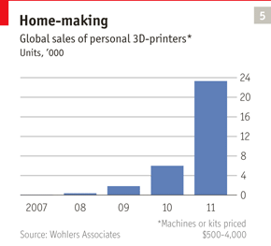
Some people already have 3D printers at home. Industrial 3D-printing systems start at about $15,000 and go up to more than $1m, says Mr Wohlers. But cheaper desktop machines are creating an entirely new market (see chart 5). This is made up of hobbyists, do-it-yourself enthusiasts, tinkerers, inventors, researchers and entrepreneurs. Some 3D-printing systems can be built from kits and use open-source software. But big producers of 3D printers are also entering the market.
3D Systems, which produces a variety of prototyping and industrial machines, is now launching a consumer range of small 3D printers, called the Cube, which can make things like toys, chess pieces and ornaments. They have been developed along with an online platform called Cubify to provide services for a community of users. Priced at $1,299, the Cube prints by depositing a thin layer of material from cartridges, which come in different colours. This cures as a hard plastic. They can produce parts up to 5.5 inches (140mm) cubed at a typical cost in materials of about $3.50. The quality is not up to that of industrial printers, but it is good enough for many people. Higher-quality creations can be uploaded to Cubify’s online printing service.
The new range is not just about printing things, says Abe Reichental, 3D Systems’ chief executive. It is also about simplifying the process of making products and letting people use the power of the web to share ideas. “This is a personal manufacturing revolution,” he says.

Layer by layer

How 3D printers work
Apr 21st 2012 | from the print edition

USING A 3D PRINTER is like printing a letter; hit the print button on a computer screen and a digital file is sent to, say, an inkjet printer which deposits a layer of ink on the surface of a piece of paper to create an image in two dimensions. In 3D printing, however, the software takes a series of digital slices through a computer-aided design and sends descriptions of those slices to the 3D printer, which adds successive thin layers until a solid object emerges. The big difference is that the “ink” a 3D printer uses is a material.
The layers can come together in a variety of ways. Some 3D printers use an inkjet process. Objet, an Israeli 3D-printer company, uses the inkjet head to spray an ultra-thin layer of liquid plastic onto a build tray. The layer is cured by exposure to ultraviolet light. The build tray is then lowered fractionally and the next layer added. Another way is fused deposition modelling, a system used by Stratasys, a company based in Minneapolis. This involves melting plastic in an extrusion head to deposit a thin filament of material to build the layers.
Other systems use powders as the print medium. The powder can be spread as a thin layer onto the build tray and solidified with a squirt of liquid binder. It can also be melted into the required pattern with a laser in a process called laser sintering, a technology which EOS, a German firm, uses in its additive-manufacturing machines. Arcam, a Swedish company, fuses the powder in its printers with an electron beam operating in a vacuum. And these are only some of the variations.
For complicated structures that contain voids and overhangs, gels and other materials are added to provide support, or the space can be left filled with powder that has not been fused. This support material can be washed out or blown away later. The materials that can be printed now range from numerous plastics to metals, ceramics and rubber-like substances. Some machines can combine materials, making an object rigid at one end and soft at the other.
Some researchers are already using 3D printers to produce simple living tissues, such as skin, muscle and short stretches of blood vessels. There is a possibility that larger body parts, like kidneys, livers and even hearts, could one day be printed—and if the bio-printers can use the patient’s own stem cells, his body would be less likely to reject the printed organs after a transplant.
Food can be printed too. Researchers at Cornell University have already succeeded in printing cupcakes. The “killer app” with food, almost everyone agrees, will be printing chocolate.

Collaborative manufacturing

All together now

The advantages of crowdsourcing
Apr 21st 2012 | from the print edition
http://www.economist.com/node/21552902 SEE VIDEO @ THIS LINK
NEW YORK CITY was once the capital of manufacturing in America, with more than 1m people working in the sector in 1950. Today that number has shrunk to a mere 80,000, and they are employed largely by specialist producers in areas such as furnishing, food processing and the cluster that makes up Manhattan’s vibrant garment district. Yet nourished by the city’s entrepreneurial spirit, a new industry is emerging. It might be called social manufacturing.
One of the firms involved is Quirky, which is as trendy as its name suggests. Its new design studio in a converted warehouse near the Hudson river includes a small factory complete with a couple of 3D printers, a laser cutter, milling machines, a spray-painting booth and other bits of equipment. This prototyping shop is central to Quirky’s business of turning other people’s ideas into products.
With the help of a growing online community, Quirky comes up with two new consumer products a week. It works like this: a user submits an idea and if enough people like it (as on Facebook), Quirky’s product-development team makes a prototype. Users review this online and can contribute towards its final design, packaging and marketing, and help set a price for it. Quirky then looks for suitable manufacturers. The product is sold on the Quirky website and, if demand grows, by retail chains. Quirky also handles patents and standards approvals and gives a 30% share of the revenue from direct sales to the inventors and others who have helped.
Quirky’s most successful product so far is called Pivot Power. It is a $29.99 electrical extension lead with adjustable sockets, which makes it easier to plug in different chargers. Jake Zien of Milwaukee came up with the idea when he was at high school, submitted it to Quirky and was helped by 709 people to bring it to market. By early April, with over 200,000 of the gadgets sold, Mr Zien had made $124,000 from his invention.
By using its community as a sounding board, Quirky can quickly establish if there is a market for a product and set the right price before committing itself to making it. Much of the firm’s production is carried out by subcontractors in Asia, particularly China. The speed with which they can turn designs into products is hard to match anywhere else, says Ben Kaufman, Quirky’s chief executive. Additive manufacturing is not yet capable of doing this on a large scale, he points out, but that could change.
Quirky is hoping to make more things in America because it sees benefits in being close to manufacturing technology. “The amount of creativity that happens when you are standing next to a machine that’s making hundreds of thousands of things is much greater than when you are working 4,000 miles away,” says Mr Kaufman. “Your mind is spinning as to what else you can design for the machine to make.”
Shapeways, another online manufacturing community, specialises in 3D-printing services. Founded in 2007 in Eindhoven in the Netherlands, where it maintains a European production centre, the company moved its headquarters to New York City, where it is setting up a second 3D-printing operation. Last year Shapeways shipped 750,000 products, and the numbers are growing rapidly. Shapeways’ users upload their designs to get instant automated quotes for printing with industrial 3D-printing machines in a variety of different materials. Users can also sell their goods online, setting their own prices. Some designs can be customised by buyers, for example by putting their initials on cufflinks.
Easy online access to 3D printing has three big implications for manufacturing, says Peter Weijmarshausen, Shapeways’ chief executive. The first is speed to market: Shapeways had covers for iPads on sale just four days after Apple first launched the device in 2010. Second, the risk of going to market falls to almost zero because entrepreneurs can test ideas before scaling up and tweak the designs in response to feedback from buyers. Some Shapeways products go through 20-30 iterations a year. And third, it becomes possible to produce things that cannot be made in other ways, usually because they are too intricate to be machined.
Can you imagine?

There are plenty of surprises in what people come up with. Recent examples include curious crablike walking devices, some propelled by a small windmill, designed by Theo Jansen, a Dutch artist (the Dutch seem to have a natural affinity with 3D printing). These are printed in one go, complete with all the moving parts. “If you give people access to creative technology in a way that is not scary they will find ways to use it that you cannot imagine,” says Mr Weijmarshausen. And that technology is becoming easier to use all the time. When Shapeways began, half the files uploaded could not be printed because of mistakes or faults. Now the success rate has gone up to 91%, thanks to software that automatically fixes problems.
Rajeev Kulkarni, who runs 3D Systems’ consumer business, wants his firm’s first consumer 3D printer to be simple enough for children to use. Cubify, its online consumer service, also provides 3D printing and e-commerce, and is forming partnerships with organisations such as Freedom Of Creation, a design group that specialises in 3D-printed products.
Once in digital form, things become easy to copy. This means protecting intellectual property will be just as hard as it is in other industries that have gone digital. Online content will need checking for infringements, says Mr Kulkarni. And there will be some tricky areas. For instance, what happens if a visitor to Disney World in Florida takes a series of pictures of Cinderella’s castle, converts them into a 3D digital file and uses that to print and sell models of the castle online? Mr Kulkarni is relaxed: “It is something we will have to figure out, but it should not be a hurdle to innovation.”
The internet is already making life easier for traditional manufacturers by allowing them to buy parts and assemblies from all over the world. One online group, Atlanta-based MFG.com, provides a cornucopia of manufacturing services with more than 200,000 members in 50 countries. Firms use it to connect and collaborate, uploading digital designs, getting quotes and rating the services provided. In some ways, online manufacturing communities like this could turn into the virtual equivalent of an industrial cluster.
As online services and software spread more widely, they will also allow customers to take part in the production process. For instance, Dassault Systèmes, a French software firm, has created an online virtual environment in which employees, suppliers and consumers can work together to turn new ideas into reality. It even provides lifelike manikins on which to try out new things. The way products might fail, how they could be fixed and how they can be taken apart for disposal can also be modelled by computers. Software firms call such services “product life-cycle management” because they extend computer modelling from the conception of a product to its demise, which nowadays means recycling.
Just as digitisation has freed some people from working in an office, the same will happen in manufacturing. Product design and simulation can now be done on a personal computer and accessed via the cloud with devices such as smartphones, says Mr Rochelle of Autodesk, the Silicon Valley software company. It means designers and engineers can work on a product and share ideas with others from anywhere. What does this do for manufacturing? The way Mr Rochelle sees it, “it means the factory of the future could be me, sitting in my home office.”

Automation

Making the future

How robots and people team up to manufacture things in new ways
Apr 21st 2012 | from the print edition
BACK IN THE 1980s, when America’s carmakers feared they might be overwhelmed by Japanese competitors, many in Detroit had a vision of beating their rivals with “lights-out” manufacturing. The idea was that factories would become so highly automated that the lights could be turned off and the robots left to build cars on their own. It never happened. Japan’s advantage, it turned out, lay not in automation but in lean-production techniques, which are mostly people-based.
Many of the new production methods in this next revolution will require fewer people working on the factory floor. Thanks to smarter and more dexterous robots, some lights-out manufacturing is now possible. FANUC, a big Japanese producer of industrial robots, has automated some of its production lines to the point where they can run unsupervised for several weeks. Many other factories use processes such as laser cutting and injection moulding that operate without any human intervention. And additive manufacturing machines can be left alone to print day and night.
Yet manufacturing will still need people, if not so many in the factory itself. All these automated machines require someone to service them and tell them what to do. Some machine operators will become machine minders, which often calls for a broader range of skills. And certain tasks, such as assembling components, remain too fiddly for robots to do well, which is why assembly is often subcontracted to low-wage countries.
Industrial robots are getting better at assembly, but they are expensive and need human experts to set them up (who can cost more than the robot). They have a long way to go before they can replace people in many areas of manufacturing. Investing in robots can be worthwhile for mass manufacturers like carmakers, who remain the biggest users of such machines, but even in highly automated car factories people still do most of the final assembly. And for small and medium-sized businesses robots are generally too costly and too inflexible.
But the next generation of robots will be different. Not only will they be cheaper and easier to set up, they will work with people rather than replacing them. They will fetch and carry parts, hold things, pick up tools, sort items, clean up and make themselves useful in myriad other ways.
Various efforts are under way to produce such robots, especially for smaller companies. Germany’s Fraunhofer Institute, for instance, is involved in a European initiative to develop robots that are safe enough to operate alongside workers (at present, most industrial robots still have to be caged in case they accidentally hit someone) and capable of understanding simple instructions, including voice commands.
The present generation of factory robots is akin to early mainframe computers in offices, reckons Rodney Brooks, a co-founder of iRobot, an American firm whose products include the Roomba, a robotic vacuum-cleaner, as well as military robots. Those big computers were run by experts, a long way away from most users, until personal computers arrived. “But the PC didn’t get rid of office workers, it changed the tasks they did,” says Mr Brooks. Often that meant doing more sophisticated work. In 2008 he founded Heartland Robotics to produce a range of machines that would serve as the equivalent of the PC in robotics.
Mr Brooks’s lips are sealed about what these machines will be like, although his views about the future of robotics provides a clue. As Toyota discovered with lean manufacturing, production-line workers, given the chance, can come up with plenty of good ideas to improve productivity. If people on the factory floor or in workshops are provided with easy-to-use robots they can become more productive, says Mr Brooks. Bring together these new robots with innovative manufacturing technologies, and you could get a manufacturing renaissance.
Millions of small and medium-sized firms will benefit from new materials, cheaper robots, smarter software, an abundance of online services and 3D printers
That would make things easier for start-ups, but scaling up is notoriously difficult because the capital costs of equipping a factory are often too high for investors to stomach, or the payback period is too long. In some businesses advanced production technologies could bring down those costs, reckons Martin Schmidt, an electrical-engineering expert at MIT. Mr Schmidt has started a number of companies that make tiny devices such as miniature sensors. He thinks that the production equipment for such devices might be shrunk too, even to tabletop size, cutting capital costs. In industries where that happens, says Mr Schmidt, “I think we will see some disruption.”
Mass-produced goods will continue to be made in factories using traditional subtractive methods for a long time yet, although with increasing automation and flexibility, as practised by the mass-market carmakers. There will also be some super-high-tech factories, like those of GE and Rolls-Royce, that make smaller quantities of highly specialised products such as jet engines. There will be millions of small and medium-sized firms that will benefit from new materials, cheaper robots, smarter software, an abundance of online services and 3D printers that can economically produce things in small numbers. And there will be countless entrepreneurs in little workshops, homes and, no doubt, garages who will be able to do things they could never have done before.
Getting there
Manufacturing revolutions never happen overnight, but this one is already well under way. There is enough transformative research going on in the biological sciences and in nanotechnology to spawn entirely new industries, like making batteries from viruses. And if the use of carbon-fibre composites were to spread from sports cars to more workaday models, the huge steel-stamping presses and robot welding lines would vanish from car factories.
Additive manufacturing, like anything else digital, is already becoming both cheaper and more effective. The big breakthrough would be in workflow. At present 3D printers make things one at a time or in small batches. But if they could work in a continuous process—like the pill-making machine in the Novartis-MIT laboratory—they could be used on a moving production line. The aim would be to build things faster and more flexibly rather than to achieve economies of scale. Such a line could be used to build products that are too big to fit into existing 3D printers and, because the machine is digitally controlled, a different item could be built on each platform, making mass customisation possible. That would allow the technology to take off.
Can it be done? Back to the EuroMold exhibition, where TNO, an independent research group based in the Netherlands, showed a novel machine with 100 platforms travelling around a carousel in a continuous loop. A variety of 3D-printing heads would deposit plastics, metals or ceramics onto each platform as they pass to make complete products, layer by layer. Scale up the idea, straighten out the carousel and you have a production line with multiple printing heads.
The “Hammering Man” outside the Frankfurt Messe is still bashing away at his piece of metal. But in a decade or two visitors to future industrial fairs may wonder what he is doing.

The Economist

Manufacturing

The new maker rules

Big forces are reshaping the world of manufacturing
Nov 24th 2012 | NEW YORK | from the print edition
“YOU can carry your own head in your hand,” enthuses Bre Pettis, inviting customers to try out a three-dimensional photo booth that will scan their head and then print a miniature plastic version of it as a solid object. This is useful, no doubt, for those about to audition for the role of Zaphod Beeblebrox in “The Hitchhiker’s Guide to the Galaxy”.
Mr Pettis, the founder of MakerBot, a maker of low-cost 3D printers, spoke at the opening of his firm’s first retail store on November 20th in New York. It will sell desktop MakerBots, which make things out of plastic, for just $2,200. It is still early days, but MakerBots and machines like them are “empowering people to make the things they want, rather than buy them from factories,” says Mr Pettis.
Certainly 3D printing is hot. Some firms are already using the technology, which is also known as additive manufacturing because it involves building up material layer by layer. It can be used to make such things as prototype cars, hearing aids, customised dolls and medical implants. On the same day that Mr Pettis opened his store, GE announced it had bought for an undisclosed sum Morris Technologies, a Cincinnati firm that uses industrial 3D printers (which cost $500,000 or more) to print objects for engineers. Morris will be printing metal parts for a new GE jet engine.
Yet 3D printing is just one of many production technologies and trends which are transforming the way companies will be able to make things in the future. The old rules of manufacturing, such as “you must seek economies of scale” and “you must reduce unit-labour costs”, are being cast aside. New machines can print every item differently. More flexible robots are getting cheaper and better at doing all the boring and dirty stuff.
Add to that another 1.8 billion consumers who will join the global marketplace in the next 15 years and “Manufacturing the Future”, a new report by the McKinsey Global Institute, has good cause to be optimistic. Demand will grow not only for basic goods (which are typically made in developing countries) but also for the costly, innovative gadgets and high-tech products that rich countries make. McKinsey reckons that rich countries will keep making such products better than anyone else.
Developing countries will continue to increase their share of global production. Measured by nominal value added, by 2010 China had surpassed Japan to become the second-largest manufacturing nation, after America. A decade earlier it was in fourth place. In the same period, Brazil jumped from 12th to 6th and India from 14th to 10th. Britain slipped from 5th to 9th.
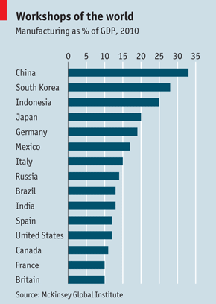
As countries get richer, manufacturing tends to account for a smaller share of their GDP. The point at which this decline starts varies (the share usually peaks at 20-35%), as does the rate of decline. In the 15 largest manufacturing economies, manufacturing’s share of GDP ranges from 33% in China to 10% in Britain (see chart).
Rich countries’ relative position may be slipping, but their absolute manufacturing output is rising quite fast. What has fallen is the number of workers needed on the factory floor. Even though some manufacturing is returning to America and Europe from places where it had been offshored, such as China, this trend will not recreate all the factory jobs that once existed.
The term “manufacturing” nowadays describes a whole range of activities. McKinsey divides it into five categories. The biggest, accounting for 34% of the $10.5 trillion total worldwide manufacturing value-added in 2010, it calls “global innovation for local markets”. This includes industries such as chemicals, machinery and carmaking, where constant innovation is essential and high transport costs for heavy goods make it sensible to produce these things close to customers.
The next-biggest, at 28%, is “regional processing”, which includes industries such as fabricated metals, food and publishing. For obvious reasons, cakes are baked locally: not just because they go stale quickly but also because local tastes vary. “Energy and resource-intensive commodities”, such as wood, paper and petrol, account for 22%; “Innovative global technologies” (chips, computers and medical products) are 9%; and “labour-intensive tradeables” (textiles, clothes and toys) 7%. These last two categories have typically been offshored by rich countries and probably will be for some time.
In the other areas where rich countries compete, there is a dark cloud building. McKinsey sees a fast-growing shortage of people with the skills manufacturers require, particularly as ageing baby-boomers retire. That is why American firms such as Dow and DuPont keep clamouring for better education in science, technology, engineering and mathematics. Yet the rich world still leads in high-tech industries. In 2010 it ran a $726 billion surplus in goods such as cars, chemicals, drugs and machinery, but it had a $342 billion trade deficit in labour-intensive tradeables.
It’s all a blur, really
McKinsey sheds new light on another old saw: is manufacturing superior to services? It is becoming ever harder to tell the two apart, as many manufacturing jobs blur with service jobs. At American “manufacturers”, 34% of jobs are service-like, rising to 55% in the global-innovative-technology sector. If one counts the workers in supporting services and those who provide raw materials, total American manufacturing employment was 17.2m in 2010, rather than the official 11.5m. Remove all service-like jobs and it drops to 7.3m.
In the future, McKinsey predicts there will be more jobs for robots. Since 1990 the cost of automation has fallen relative to labour by 40-50% in the rich world, it says. The rise of the machines will continue in rich countries, and they will make inroads into developing ones. Wages in emerging markets are soaring. One Chinese manufacturer is talking of hiring 1m robots. Still, robots need people to build, program and maintain them. Humans have no cause to hold their heads in their hands.

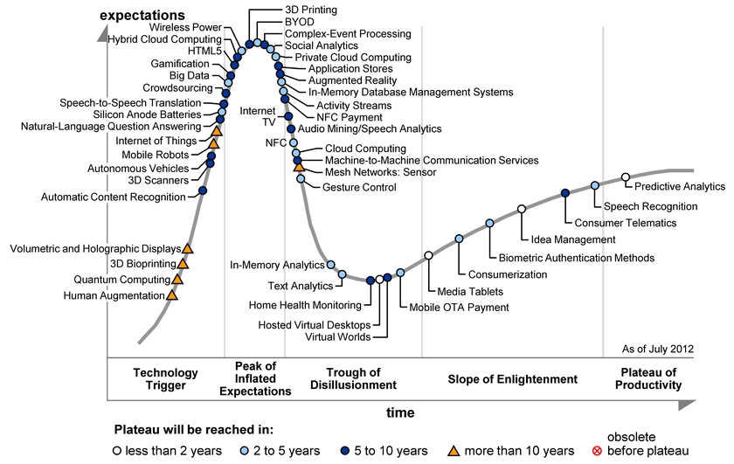

A Way To Invest In Biotech And 3D Printing, All At Once
September 26, 2012 | 12 comments | about: ONVO.PK, includes: DDD, SSYS
Disclosure: I have no positions in any stocks mentioned, and no plans to initiate any positions within the next 72 hours. (More...)
Since last writing about the hype surrounding the 3D printing sector (see "Are You Buying The 3D Printing Hype?"), it seems the rally behind two industry leaders, 3D Systems (DDD) and Stratasys (SSYS), has come to a halt. Shares of DDD experienced a three-month rally in which the price shot up over 40%, hitting a new 52-week high. Arguably, investors taking profits off the table either sparked or perpetuated the ensuing price correction. Since then, shares of 3D Systems sold off on above-average volume and have now settled around $33 after a 25% haircut. Although no material news surfaced during this pullback it has (in a bittersweet way) allowed for some of the metrics to get back in line, such as the trailing P/E of 51, after undergoing a period of inflation from surrounding hype regarding 3D printing technology. Moreover, this pullback could signal that the stock is approaching fair value as price is becoming a more reasonable indicator of the core company valuation, rather than containing a built in "hype" premium.
This brings me to something interesting that crossed my desk as I was researching the sector. A cheaper alternative to buying into the 3D printing trend may perhaps be Organovo (ONVO.PK), a 3D "bio-printing" company that specializes in printing functional human tissue. Referencing the Gartner Hype Cycle (see diagram below), which I briefly discussed in my last article on 3D printing, 3D bio-printing is listed on the up-swinging "technology trigger" phase containing unproven ideas with potential for breakthrough technology. Organovo, the lone leader in the up-and-coming technology of 3D bio-printing, has prompted recent publicity by being featured in financial media giants The Economist and The Wall Street Journal.
Click to enlarge images.
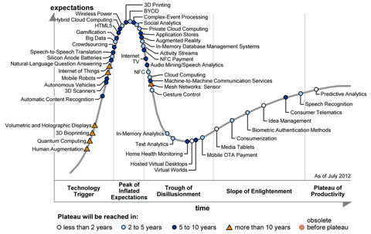
Organovo has developed and commercialized the first 3D bio-printer, called NovoGen MMX, which is capable of creating living tissue used to model specific body parts. The company seeks to employee this technology in the drug development process by using 3D generated tissue for in-vitro testing, which could potentially alter pre-human clinical trials. Ultimately, the long-term aspiration is to one day use the 3D printed models as therapeutic implants for the treatment of damaged tissues and organs.
The NovoGen MMX bioprinter constructs 3D living cells into functional tissue; the latter is comprised entirely of cells, a distinctive feature of the printer. The printer produces layers of "bioink," building blocks made up of 10,000-30,000 living cells in the form of miniature spheres. This bioink is then printed onto a paper layer of biocompatible gels. The desired tissue is printed layer by layer on the biopaper and then cell clusters naturally begin to fuse to each other while the biopaper dissolves, forming a living functional tissue. The image below, courtesy of Zacks'report on ONVO, gives a clearer understanding of the printing process.
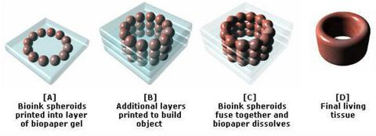
Organovo has two active collaborations, one with Pfizer (PFE) and the other with United Therapeutics (UTHR), which provide all of the company's revenue -- typical of any firm in the early development stages. ONVO possesses a stable balance sheet as it holds approximately $8.5million in cash and cash equivalents, while only bearing around $900,000 in liabilities. However, it holds a warrant liability in the balance sheet of $80.5 million. This warrant liability caused significant changes in the latest income statement as a $34 million expense, a readjustment updating the warranty value to match the change in the balance sheet liability figure. This is a non-cash bearing adjustment, which means it exaggerated the loss incurred during the quarter. During the first half of 2012, the company used $5.4million to fund operations and forecasts expending another $3 million for the remainder of 2012. On average in 2012, the company has an estimated monthly burn rate of $700,000, meaning that it has sufficient resources to fund operations well into the second quarter of 2013 before needing additional financing.
In addition to its solid financial base and promising technology, ONVO is an intriguing stock because it provides exposure to two of the top-performing industries in the market. Its investors are exposed to the excitement of the 3D printing trend that is buzzing with hype, while also directly benefiting from advances as a biotech company. To date in 2012, two of the top five best-performing industries (as per Dow Jones Indexes) are the computer hardware index, which holds both DDD and SSYS, and the biotechnology index, gaining 45% and 43%, respectively. ONVO can be viewed as more "diversified" due to this dual industry exposure, as the rumors of both industries will influence it. Looked at another way, this exposure theoretically mitigates concentration risk but enhances potential alpha, or return on investment (for instance, with the idea that as a platform there are more "shots on goal").
If the hype surrounding the 3D printing technology being the "third industrial revolution" continues to spread like wildfire, investors of all kinds will want to embark on the action by buying the stocks of the scarce publicly traded 3D companies such as DDD, SSYS, ONVO, and the 3D software modeling Autodesk (ADSK). Organovo currently faces no competition in the bio-printing market niche. The company can use this supply and demand advantage to enforce a premium, while also utilizing protective patents as barriers to entry so that any incoming competitor must penetrate the market through ONVO directly. Being the lone name in this 3D printing technology and bio-printing market niche suggests ONVO will command a premium to the valuation an indirect biotechnology or high-technology competitor receives.
Organovo, a firm in early development stages, comes with a lot of risk, but also immeasurable rewards if it pans out. That is the name of the game with the biotech industry. If the product passes clinical trials and wins FDA approval, the share price blows up, catching the interest of a larger pharmaceutical company that comes along with a buyout opportunity. This M&A activity is common in the biotech industry, as recently seen with Bristol-Myers Squibb's (BMY) acquisition of Amylin Pharmaceuticals after the approval of its diabetic drug Bydureon. ONVO could be the talk of such rumors once it starts launching commercial products, its first one being a 3D liver toxicology cell-based assay, which could be as soon as 2014, according to Zacks' investment report. If the products are released, ONVO will be entering into a global cell-based assay market worth $1.6 billion by 2017. The invention of such 3D cell assays would mimic the human organs better than current models and prove to be superior indicators of how drug interaction would work in human clinical trials. Such a breakthrough would bring Organovo one step closer to introducing testing engineered human tissue in the drug discovery process.
The concept of valuing a company with minimal revenue streams will scare investors who prefer the security of a steady income statement. The stock price, of approximately $2/share, has bottomed out after being optimistically valued five times the current amount just three months ago, showing the compelling potential of the company. This overblown assessment seems to have now stabilized as the stock price has hovered around the $2 floor for the last two months. At current price levels, Organovo could prove to be an efficient use of capital to buy into the hot new trend of 3D printing technology, while offering additional exposure to the benefits of the biotechnology industry. Its bio-printing technology has the potential to completely transform drug development, and maybe even eventually print new organs to replace damaged or malfunctioning ones. A company with the combination of financial steadiness and endless potential that Organovo possesses could well be worth the risk of such a speculative investment.

How 3D Printers Are Reshaping Medicine
By Cadie Thompson | CNBC – 8 hours ago
@cnbc on Twitter
Printing off a kidney or another human organ may sound like something out of a science fiction novel, but with the advancements in 3D printing technology, the idea may not be so far-fetched.
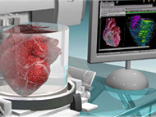BioprintingWhile 3D printing has been successfully used in the health care sector to make prosthetic limbs, custom hearing aids and dental fixtures, the technology is now being used to create more complex structures - particularly human tissue.
Organovo (onvo), a San Diego-based company that focuses on regenerative medicine, is one company using 3D printers, called bioprinters, to print functional human tissue for medical research and regenerative therapies.
"This is disruptive technology," said Mike Renard, Organovo's vice president of commercial operations. "It's always interesting and fun, but never easy."
Traditional 3D printing, also known as additive manufacturing, is a process of making three dimensional solid objects from a digital model. 3D printing is achieved using additive processes, in which an object is created by laying down successive layers of material such as plastic, ceramics, glass or metal to print an object. Companies including Boeing (ba), General Electric (ge) and Honeywell (hon) use this type of 3D printing to manufacture parts.
Bioprinters, though, use a "bio-ink" made of living cell mixtures to form human tissue. Basically, the bio-ink is used to build a 3D structure of cells, layer by layer, to form tissue.
Eventually, medical researchers hope to be able to use the printed tissue to make organs for organ replacement.
However, growing functional organs is still at least 10 years away, said Shaochen Chen, a professor of nano-engineering at the University of California, San Diego, who uses bioprinting in researching regenerative medicine.
But even though developing functional organs may still be a decade off, medical researchers and others are using bioprinting technology to make advancements in other ways.
Researchers in regenerative medicine at Wake Forest University in North Carolina partnered with the Armed Forces Institute for Regenerative Medicine to make a 3-D skin printer that deposits cells directly on a wound to help it heal quicker. Researchers at the university have also had success printing off kidney cells.
Bioengineers at Cornell University have printed experimental knee cartilage, heart valves and bone implants. And the non-medical start-up Modern Meadow, which is backed by investor Peter Thiel, is using bioprinting technology to develop a way to print meat.
Bio-printing is also playing a part in how some pharmaceutical companies conduct medical research, and the technology may also have the potential to save the drug companies a lot of money because it could cut drug testing costs, Chen said.
Medical researchers in the pharmaceutical industry, until lately, have used two-dimensional cell cultures to test drugs during the early stages of development. However, the 2D cell cultures do not reflect human tissue as accurately as 3D printed tissue, meaning the 2D models can create misleading test results.
Testing with 3D tissues, however, provide more precise results, which allows for pharmaceutical companies to determine failed drugs early on before investing more money in development.
And with clinical trials accounting for the largest percentage of the biopharmaceutical industry's budget for the research and development at $31.3 billion, according to a report from the Presidents Council on Science and Technology, it's no surprise that drug companies want to use 3D tissues to help avoid wasted costs.
"It's very, very significant...It takes a lot of time and money developing a successful drug," Chen said. "I think this is a great idea and will save the pharmaceutical industry a lot of troubles ... It could help get drugs to market faster."
And this is where Organovo sees opportunity, Renard said.
Organovo, with the help of the Australian company Invetech, was the first company to launch a commercial 3D bioprinter. The company originally intended to sell its printer, which is called the NovoGen MMX bio-printer, to other companies for use. But after seeing opportunity to cash in on the market for human tissue, the company changed its business model to making tissues for drug companies for medical research and therapeutic applications instead.
"Generally, the drug business can benefit significantly from these 3D tissues ... There's plenty of evidence that their processes are basically broken. They are inefficient and highly suspect," Renard said. "There's a big problem and they are looking for a better solution."
Organovo, which trades on the OTC market, wants to be that solution.
The company has partnered with Pfizer (pfe) and United Therapeutics (uthr), and while Renard would not disclose the details of their partnership, he did say that the companies have a business arrangement in which funding is provided and some rights are shared.
Renard did not disclose any other drug companies that are partnering with Organovo.
But Organovo, which has made blood vessels, lung tissue and recreated tumors using bio-printing, is customizing tissue of all types for its current partners' medical research, Renard said.
"We build custom tissue for them," Renard said. "They may have specific cell lines, disease areas of interests and they want a proprietary model for them ... we can make it."

Bespoke pets

Just press “print”

It will soon be possible to design and build household animals to order
Mar 31st 2012 | SAN MELITO | from the print edition
The Economist
ONE of the most interesting technological trends of the past few years has been the rise of additive manufacturing. This technique, which uses three-dimensional printing to make objects ranging from violins to pilotless aircraft, allows the construction of individual objects at the whim of the designer. Now, a small Californian company, the Gene Duplication Corporation, based in San Melito, proposes to push the technology to its limits. On Sunday it will announce plans to use 3D printing to make bespoke pets.
GeneDupe, as the firm is known colloquially, has previously focused on the genetic engineering of animals. However Paolo Fril, the company's boss, is keen to expand into manufacturing them from scratch. PrintaPet does just that.
The idea of printing organs such as kidneys for transplant has been around for several years. It works by growing separate cultures of individual cell types, and then spraying them out, layer by layer, in combination with a binding agent called a hydrogel, to build up the correct shape.
Printing an organ this way is fairly easy. A kidney, for instance, has only eight cell types. An entire mammalian body, though, has 220 cell types. Laying these down in the correct order is a much more complex problem. To solve it, GeneDupe's researchers used nanotomography, a precise form of CT scanning that has a resolution of 500 nanometres (billionths of a metre), to analyse the position and nature of every single cell in a variety of animals, particularly breeds of dog. This knowledge not only permits existing breeds to be re-created, but allows entirely new combinations of form, colour and behaviour to be invented, at the customer's command.
GeneDupe's Universal Pet Printer is loaded with each of the 220 cell types (grown from stem cells in the company's histology laboratory), and is programmed with a three-dimensional map of the creature it is to create. That is devised by the firm's scientists, based on what the nanotomographic analysis has told them about the results of arranging cells in different ways in an animal's body.
The cells themselves are stored in suspension, in glass reservoirs, and each reservoir is connected to a computer-controlled spray gun. The hydrogels (several sorts are needed) are stored separately. One, known as osteogel, is particularly important, as this solidifies to provide the animal's initial skeleton. Once the new creature is up and running (both literally and metaphorically), the various hydrogels are gradually replaced by natural secretions. In the case of osteogel, that secretion is bone.
The biggest difficulty Dr Fril has encountered is with nerve cells. Unlike most other types of cell, which are small, the protuberances from a nerve cell, known as axons and dendrites, may stretch from the animal's spinal cord to the tips of its toes. To deal with this problem, the pet printer leaves a hole in each layer of cells at every point through which a nerve cell is supposed to pass. The holes are then filled with nerve-growth factor before the next layer is printed, so that when the main body of the nerve cell is sprayed into place it rapidly grows axonal and dendritic protuberances to the right destinations.
Knowing how to print nerve cells, is, in fact, the key to the whole thing. Size apart, a healthy heart, kidney or liver is pretty much the same in a retriever or a Rottweiler. Coat colour, an important consideration for many owners, is easily dealt with by picking the right pattern of melanocyte cells in the skin. But an animal's temperament is a very different matter.
Controlling temperament means laying down the right mixture of nerve cells in the brain, since different types of cell have different effects on personality. Having worked out how to do this, GeneDupe is able to offer pets that have had their behavioural characteristics fine-tuned. If you want a docile Rottweiler, or even an aggressive retriever, you can have one made to your exact specifications. Dr Fril, though, thinks that the most popular modification will be his tweaking of canine scent-marking behaviour so that local lampposts are no longer the preferred sites of relief and communication. Instead, GeneDupe's pooches are pre-wired to recognise the company's proprietary DoggieLoos, which have a distinctive odour that is perceptible to canids, but not humans.
There are still a few technical difficulties to overcome, of course, but Dr Fril plans to start taking orders soon. And he is already looking forward to the firm's next product, custom-printed boyfriends and girlfriends for those who cannot find the right partner by conventional means—a surprisingly large proportion of the population. If all goes well, these will be available by St Valentine's day. If not, customers will probably have to wait until April 1st of next year.

WP

3-D printers could bring manufacturing to your home office
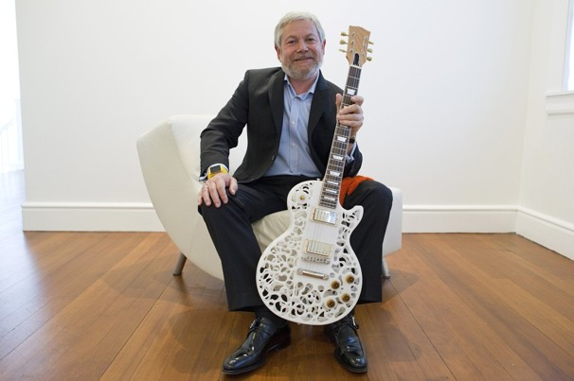
View Photo Gallery — What can be made from 3-D printers?: From models of Les Paul guitars to toy robots, 3-D printers are churning out usable products. Here’s a look at some objects that have been made from 3-D printing.

By Cecilia Kang, Published: January 7
LAS VEGAS — When Ford wants to try out a new transmission part, an engineer sends a digital blueprint of the component to a computer, and what happens next once seemed like the stuff of science fiction.
Inside a device about the size of a microwave oven, a plastic, three-dimensional version of the component begins to take shape before your eyes. After scanning the design blueprint, the gadget fuses together a paper-thin layer of plastic powder. It repeats, putting another layer on top, and then thousands more, before binding the material together with lasers. A few hours later, out pops the auto part, ready to be tested.
At such prices, 3-D printers, once an obscure and expensive innovation, are gaining traction among businesses, with broad implications for manufacturing. Ford is putting them in the hands of every one of its engineers. NASA uses the printers to test parts that could eventually make it to space.
And pretty soon, analysts say, they will be showing up in the home office. Just a few years ago, 3-D printers were as big as industrial refrigerators and cost hundreds of thousands of dollars each. Now anyone can order one online and put it on a desk.
That such technology can be offered so cheaply and compactly may be these gadgets’ true breakthrough.
“You can argue this is the democratization of manufacturing,” said Carl Howe, head of consumer research at Yankee Group, a tech research firm. He predicted that this will be the year when 3-D printers will become inexpensive enough to gain wider interest from small businesses, colleges and consumers.
“Things that used to require tens or hundreds of thousands of dollars for plastic molds, you can now do for $1,500 or less,” Howe said.
This is definitely the year that 3-D printing is making a splash at the International Consumer Electronics Show, the annual bazaar of geek commerce. Last year, only one 3-D printing company showed up at the CES, which aims to showcase gadgets you might buy at Best Buy or Amazon, not at industrial supply stores. This week, four such companies will be there.
One of them — MakerBot, which also supplies devices to Ford — will unveil Tuesday a new 3-D printer designed to be the most advanced ever offered at a price that could make it attractive to the home hobbyist.
The online world of hackers and tech enthusiasts is buzzing about how to use such a powerful tool. Researchers and early adopters have made everything from cute figurines and jewelry to working bicycles. A lot of iPhone cases are being custom-made on 3-D printers.
Some other possibilities have been more controversial.
After the massacre at Sandy Hook Elementary School, a video proposing the use of a 3-D printer to make a copy of a gun that fires real bullets went viral on the Web. University of Texas law student Cody Wilson explained in the video that what he called the Wiki Weapon would create the “first 3-D printable personal defense system.”
“What’s great about the Wiki Weapon is it only needs to be lethal once,” Wilson, who heads a nonprofit called Defense Distributed, says in the video. “We will have the reality of a weapons system that can be printed out from your desk. Anywhere there is a computer, there is a weapon.”
Rep. Steve Israel (D-N.Y.) said the creation of guns through 3-D printing could make undetectable plastic firearms too easy to acquire. At a news briefing in December, he called for the renewal of the Undetectable Firearms Act, which would include bans on plastic guns and firearms made from 3-D-printed parts.
“It is just a matter of time before these three-dimensional printers will be able to replicate an entire gun,” Israel said. “And that firearm will be able to be brought through this security line, through the metal detector, and because there will be no metal to be detected, firearms will be brought on planes without anyone’s knowledge.”
Eventually, 3-D printers are expected to make even more complex parts and machines, or be used in medicine for hip replacements and spinal reconstruction. That stands to revolutionize far more than home hobbies.
“Before, if you were a manufacturer and you wanted to make a product, you had to make 10,000 or 100,000 of them; you had to think in terms of the capital it costs to make that volume,” said Bre Pettis, chief executive of MakerBot. “It takes hours. Now you can iterate on an idea many times in one day and create huge efficiencies.”
And while once such automation primarily threatened to replace workers in repetitive assembly-line jobs, now these technologies are taking aim at higher-level jobs that had seemed suitable only for humans.
“A more productive society is good news, and it allows us to have greater variety and choices,” said Andrew McAfee, principal research scientist at MIT’s Center for Digital Business. “What concerns me are the labor-force consequences of such astonishing changes.”

