International Business Environments
China Focus
Political, Economic and Technology Focus
Dr. Thomas Lairson

Energy

Summary
- The trajectory of China’s energy use is negative
- Energy use will get much worse before it gets better
- Threatens global growth and Chinese competitiveness
- Potential for global conflict is high
- China’s energy use is unsustainable

2001 year of change in China’s energy situation:

- As recently as 2001, China was able to meet most of its energy needs from its own resources.
- Prior to 2001, China’s rapid GDP growth was accompanied by much lower growth rates in energy consumption.
- Reform, TVEs, competition, new technology, profit motive all help reverse the very bad energy intensity of Chinese production during the Maoist era.
- Until the mid 1990s China was able to meet its energy needs and export energy.

After 2001
- After 2001 the energy growth rates increased from about 4% per year to 13% per year.
- Much of this is from the increasing role of heavy industry and this sector’s very high levels of energy intensity and to the inefficiencies of China’s energy system.
- 70% of energy demand in China is from industry, much higher than GDP levels would predict.
- 54% of energy is for heavy industry, up from 39% 5 years ago.
- Chinese heavy industry receives large capital and other subsidies, which undermine incentives to improve energy efficiency. Local officials influence capital allocation to heavy industries to generate economic growth.
- Heavy industry and industry in general is caught up in the process of local officials using various forms of subsidies to promote growth.
- The number of steel enterprises doubled from 2002-2006.
- Creates a system of overcapacity and wasting of energy

Basic Critique of Chinese Energy Usage

Low investment in energy efficiency

- China: 866 million barrels of oil (equivalent) = $1billion of GDP
- US 221 million barrels of energy - $1 billion of GDP
- How many of the world’s most polluted cities are in China?
- China as an energy and environmental pariah

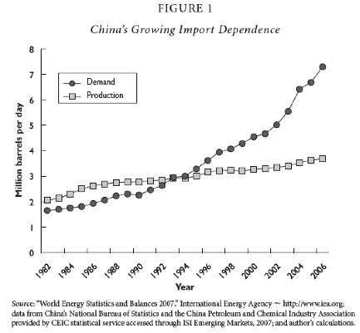

Major question for China’s energy use:

What happens to the Chinese system when residential demand and transportation demand really begin to grow with greater wealth among consumers?
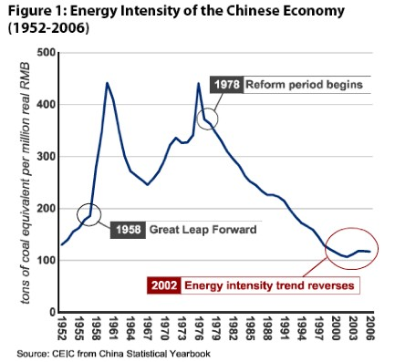

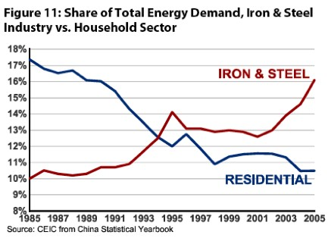

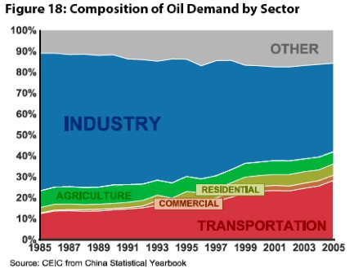

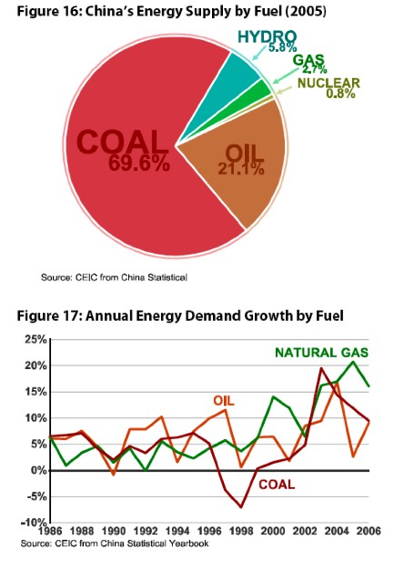

Energy industry in China
- The coal, power, oil and gas industries remain torn between plan and the market.
- Competition has been introduced into some parts of the energy value chain (such as coal extraction and power generation) but state-owned monopolies/oligopolies remain dominant in others (power distribution and most of the oil and gas sectors).
- Upstream prices have mostly been liberalized, but downstream prices remain largely controlled.
- A small number of bureaucrats try to plan supply while markets are determining more and more of the demand.
- The result is a market structure and pricing system that favors supply expansion rather than demand management.
- Very weak national political regulatory and energy management bureaucracy.

China’s energy firms
- Three firms dominate the production of energy in China:
- China National Petroleum Corporation (CNPC), which was formed as a ministry-level SOE in 1988 out of the upstream assets of the Ministry of Petroleum Industry. CNPC is the world’s fifth largest oil producing company.
- The China Petroleum and Chemical Corporation (Sinopec), formed in 1983 out of the downstream assets of the Ministry of Petroleum Industry and Ministry of Chemical Industry, has a much smaller upstream portfolio (ranking 30th globally in oil production) but is dominant in the refining sector. In terms of revenue, but not profits or production, Sinopec is larger than CNPC.
- CNOOC is the smallest of the three by all measures and was established in 1982 to develop China’s offshore resources in cooperation with international oil companies.

Environmental effects
- Heavy industry demands more electricity. 80% of electricity is generated from coal but only 15% of the coal fired plants have flu gas desulphurization (FGD) systems (used to remove SO2 from emission streams) installed and even fewer have them running.
- Installing FGD systems on all coal-fired plants would raise electric rates by 15-20%.
- Enforcement of sulfur taxes and other environmental regulations is left to local officials.

Global Economic Impact of China’s Energy Use

- China is having and will continue to have enormous effects on the rest of the world as a result of its energy situation.
- Magnitude and volatility of demand in global markets
- Volatility comes from cat and mouse game between Chinese firms and government
over retail prices

- Absolute and marginal effects: 1/3 of growth in global energy
demand from 1999-2006 comes from China
- Shift from exporter to net importer of coal

International Political Economy of Energy and Resource Supplies to China

Oil
- 45% from Middle East, 11% from Iran alone
- 28% from Africa (Sudan)
- Expanding relationships with Australia, Brazil, Venezuela, and Canada
- Oil supplies come through the Malacca Straits, kept open by US navy
- CNOOC attempts to buy Unocal in 2005 with loans from state-owned banks
- Chinese tied aid as basis for gaining oil concessions (Anglola)

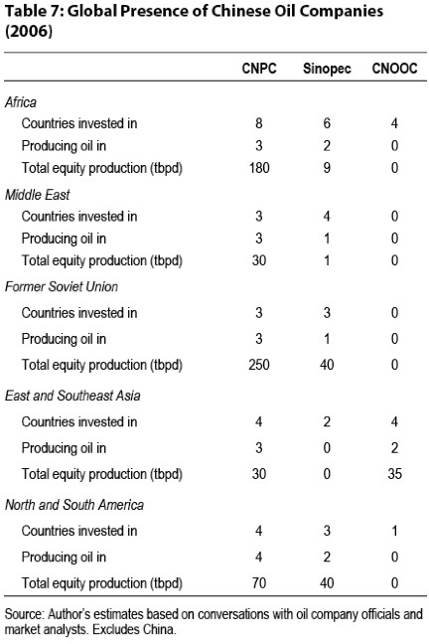
Global Oil Reserves
Country Reserves (Billions barrels)

Saudi Arabia 264

Iran 137

Iraq 115

Kuwait 101

United Arab Emirates 98

Venezuela 80

Russia 74

Kazakhstan 40

Libya 39

Nigeria 36

Mexico 14

China 16

Canada 16

United States 30

Proved reserves are estimated quantities that analysis of geologic and engineering data demonstrates with reasonable certainty are recoverable under existing economic and operating conditions.
Estimates dated January 1, 2007

Almost three-quarters of the world's 1.2 trillion barrels of proven oil reserves—those that can be recovered from known oil fields using existing technology—are located in just seven countries, according to BP. Saudi Arabia's share at the end of last year was more than a fifth of the total. Iran, Iraq, Kuwait and the United Arab Emirates together accounted for over a third. Venezuela and Russia also have big reserves. If last year's production rates were sustained, global oil reserves would run out in just over 40 years' time. America and China would have little over a decade of oil production left before their reserves were exhausted. By contrast, Kuwait's oil fields would last for more than a century.

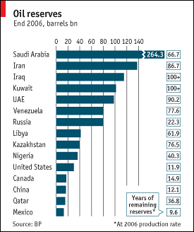

Global environmental effects

- China is the world’s largest emitter of SO2: acid rain, reduced visibility, and respiratory problems.
- Results in considerable tension with Korea and Japan. Hong Kong air quality threatens its competitiveness.
- Effects are felt at lower levels on US west coast.
- China surpassed the US in 2007 as the world's largest emitter of CO2.
- Even in 2030 China will be lower in per capita production of CO2.

Global Environmental Negotiations

- The US has an even larger global energy footprint.
- Negotiations between the US and China on energy issues will very likely be caught up in the political, economic and strategic rivalry between them.
- As a consequence, these negotiations will revolve around estimates of relative gains and not the absolute gains they and the world will reap from effective management of these global problems.
- Leaders will increasingly come to focus on how much each gains relative to the other and less on the mutual gains each can get from stable oil prices, secure sea lanes and a stable international environment.
- Though cooperation to achieve these gains is possible and clearly the desirable outcome, the competitive environment over resources and the scarcity of those resources will hasten a focus on relative gains.

Future Projections:
- Projections of future global energy needs see China equaling the US in energy demand by about 2020.
- This has very serious implications for the entire global economy, the global environment and for international politics and global security.
- China is already the largest contributor to global warming and this position will get much worse.
- Chinese competitiveness as a producer of manufactured goods is threatened
  - Long energy intensive supply chains and logistic systems
  - Cost of moving a 40 foot container from Shanghai to New York in 2000 was $3000; today it is $8000; at $200 barrel for oil price is $15000

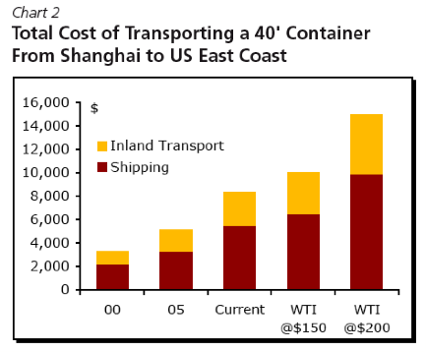

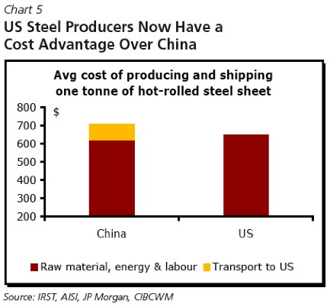

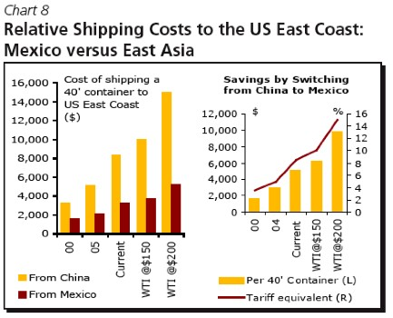
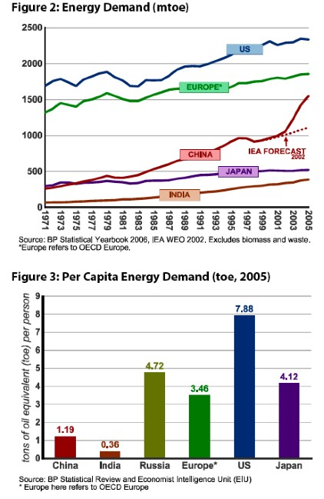
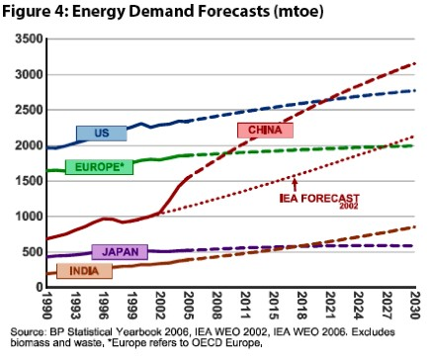

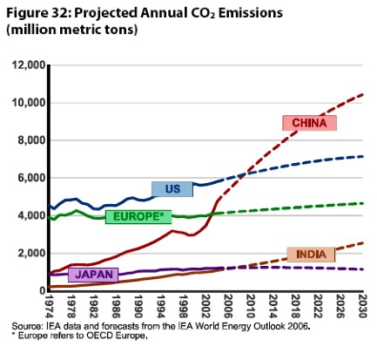
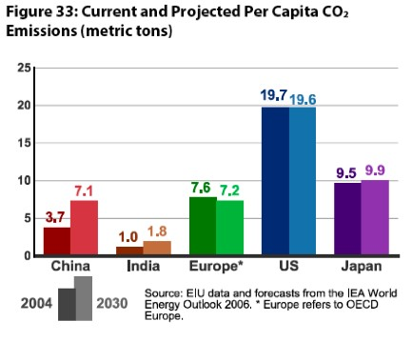

What are the implications of China’s resource situation?

- Huge potential for conflict with other nations. We are entering an era of rising physical needs and increasing scarcity. Scarcity = insecurity.
- Relative gains considerations feed into and flow from insecurity.
- Breakdown of liberal system of resource markets: US operation in Iraq as first step to resource spheres of influence.
- There are enormous and mostly negative political, strategic, military and economic implications of China’s global reach in the search for resources.
- Dislocation of global markets – huge increase in relative prices for resources
- Struggle among nations to avoid relative decline in dynamically changing environment.
- The Economist predicts a much more positive outcome. Why?
- Potential Solutions:
  - End subsidies in China and create incentives for energy efficiency
  - Shift to subsidies for alternative energy production in US and China
  - Mandatory environmental and efficiency standards for autos
  - Cooperation in oil production and distribution – avoid energy spheres

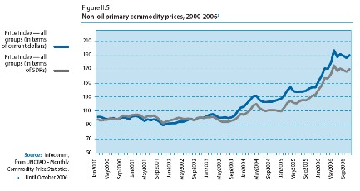
Source: Rosen and Houser, China Energy, May 2007, 6.

