**Wuhan International Business and Management**

September 1

13:30 – 16:45

**Technology and Innovation**

Chinese firms must move closer to global competitive standards for management

What is the global cutting edge for management?

**Use of big data for analysis of business decisions**

Should Chinese firms begin to upgrade ICT capabilities for competitive advantage?

**Business Analytics – basic processes**

Digitization of business events and processes

Organization and aggregation of big data

Analysis and application of big data to decisions and innovation

Incorporate the internet of things – device to device

**Business Analytics: Why do it?**

Why is an information-based system better?

Complex environments and choices require information to clarify the state of the environment

Organizations that collect, distribute and process information should have lower costs than those that do not

All organizations collect and use information; the difference is how well they do this

Business Analytics requires an organizational commitment to develop the resources (hardware, software, training, and organizational restructuring) needed to make it work

Strategic, Competitive and Tactical value for an organization

Business Analytics permits firms to:

Discover new information about firm operations, customers, competitors

Make predictions about events and actions

Measure and evaluate performance

Create new knowledge and insight about products, processes, operations that contribute to strategic planning and tactical choices

Create value in new and innovative ways thereby generating sustainable competitive advantage

**Examples of Technology and Business Data**

Enterprise Resource Planning (ERP)

Supply Chain Management (SCM)

Customer Relationship Management (CRM)

**Does Investment in IT Matter?**

IT is main catalyst for the creation of a new global competitive environment

“greater gaps between the leaders and laggards in an industry, more concentrated and winner-take-all markets, and more churn among rivals in a sector”

Business processes become more digitized:

“a company’s unique business processes can now be propagated with much higher fidelity across the organization by embedding it in enterprise information technology. As a result, an innovator with a better way of doing things can scale up with unprecedented speed to dominate an industry. In response, a rival can roll out further process innovations throughout its product lines and geographic markets to recapture market share. **Winners can win big and fast, but not necessarily for very long.”**

Mid-1990s mark era of explosive increases in IT spending and in productivity

Measures of effects of IT investment on industry:

Increases in concentration, turbulence and performance spread

“In a **concentrated or winner-take-all industry**, just a few companies account for the bulk of the market share. For our study, we focused on the degree to which each industry became more or less concentrated over time. A sector is **turbulen**t if the sales leaders in it are frequently leapfrogging one another in rank order. And finally the **performance spread** in an industry is large when the leaders and laggards differ greatly on standard performance measures such as return on assets, profit margins, and market capitalization per dollar of revenue—the kinds of numbers that matter a lot to senior managers and investors.”

“Were there economy-wide changes in these three measures after the mid-1990s, when IT spending accelerated? If so, were the changes more pronounced in industries that were more IT intensive—that is, where IT made up a larger share of all fixed assets within an industry? In a word, yes.”

**Industry Concentration**: After decades of decline in all industries, industry concentration began to rise in the mid-1990s. Though the absolute level is lower, the rate of rise is faster in high-IT industries than it is for low-IT industries.

**Turbulence**: By this measure, we found consistently more sales turbulence in high-IT industries—and a marked increase in the mid-1990s.

**Performance Spread**: The spread in gross profit margin between the company performing at the 25th percentile in its industry and the company performing at the 75th percentile—an indication of the spread between winners and losers—has grown dramatically in high-IT industries since the mid-1990s.

the changes in dynamics were indeed **greatest in those industries that were more IT intensive**—for instance, consumer electronics and auto parts manufacturers.

IT capabilities and data analytics: permit firms to identify problems with precision, develop solutions quickly and roll-out a solution across an enterprise very rapidly.

Example: CVS finds decline in customer service rankings and is able to trace that to the problems in checking for insurance. Business processes are changed across all 4000 stores simultaneously and customer service rankings increase.

**ERP systems provide competitive advantage – permit identification of process and product innovations and rapid deployment of such innovations – increases competitive dynamics among firms. Those with best IT systems will pull away from rest of the industry.**

**The competitive environment is now populated with firms able to identify problems, make improvements, deploy improvements in rapid fashion and also emulate each other quickly in a system of turbulent innovation. This leads to rapid performance spread.**

**Managers must be able to:**

* Develop, analyze and evaluate Information and communication technology systems
* Identify and develop critical indicators of firm performance
* Develop data-based responses and innovations to problems and issues
* Rapidly deploy and evaluate new processes and products

IT investment must be understood as a:

**catalyst for innovative ideas and as an engine for delivering them**

**Examples of the application of business analytics**

The nature of business analytics must be customized to the business model and strategy of the firm

Retailer 1

Low cost short time-to-market

Business analytics: supply chain management system with close control over suppliers, cost controls, logistics management, RFID system

Retailer 2

Provide strong and rich customer service and support system

Business analytics: Data using details on customer behavior and preferences; develop complex cross-sell systems based on product complementarities linked to customer preferences; customer communications to created differentiated product experience

Furniture manufacturer

Strategy is to link supply chain, manufacturing process and customer ordering system to manage costs, organize and minimize lead time on manufacturing and increase customer flexibility in custom ordering. Ability to manage manufacturing of custom orders allows accurate deliver estimates and integrates delivery services for customer. System permits monitoring of order outcomes and identifying problems.

**How to implement a business analytics system:**

1) Assessment of data and analytical capabilities of the firm:

**Stage 1: Analytically impaired**. Your organization is “flying blind,” plagued by missing or poor-quality data and poorly integrated systems.

**Stage 2: Localized analytics**. Your analytic efforts are isolated, opportunistic and function-specific. Your organization collects transaction data efficiently but often lacks the right data for better decision making.

**Stage 3: Analytical aspirations**. Your organization has executive support for analytics and a proliferation of business intelligence tools and data marts, but most data remains not integrated, non-standardized and inaccessible.

**Stage 4: Analytical companies**. Your organization begins to develop an enterprise-wide analytics capability with high-quality data, an enterprise-wide analytical plan and governance principles.

**Stage 5: Analytical competitors**. Your organization is routinely reaping big benefits from its full-fledged, enterprise-wide analytics architecture, which is fully automated and integrated into processes.

2) Action plan for change

Get the right technology in place

Take an enterprise approach to data management and analytics to effect better decisions. Remove disconnected silos of data, technology or expertise. Your technology portfolio should include:

* Optimized data stores to support core  business processes and discovery.
* Data integration and data quality  software.
* Analytical software with the means to  effectively deploy, explore and share results in a meaningful way.
* Look for specialized relational database software options aligned with your industry

Develop the talent you need

* Develop or recruit analytic thinkers who seek and explore the right data to make discoveries. To make analytics work, analysts must also be able to communicate effectively with leaders and link analytics to key decisions and the bottom line.

Improve the flow and flexibility of data

* High-quality data must be integrated and accessible across your organization. It should also be structured in a flexible way that allows your analysts to discover new insights and provide leaders the information they need to adjust strategies quickly.

Transform the culture

* A strong analytical culture has executive sponsorship and encourages creativity. Experimentation should be seen as part of learning, and employees should be given permission to fail as they learn from trying new things.

Demand fact-based decisions

* An analytical company makes a wide range of decisions. Some are ad hoc; some are automated; some are transformative. The common thread? Evidence backs them all. Managers encourage asking the right questions of the data to get maximum insight.

Develop an analytical center of excellence

* Create an analytical center of excellence (ACE), which promotes the use of analytics and associated best practices. The most effective ACEs address all elements of the organization’s analytic infrastructure: people, process, technology and culture to support the business’ strategy and operations.

Revise your strategies – often

* Your competitors will often duplicate your analytical initiatives. Staying ahead requires continuous review of strategy and development of new skills and capabilities.



**What is Cloud Computing?**

System of software and servers that provide computing power and storage as a service over the internet.

Think of electricity

Shift from electricity provided by a generator in your home or business

To electricity from a wire connected to your house

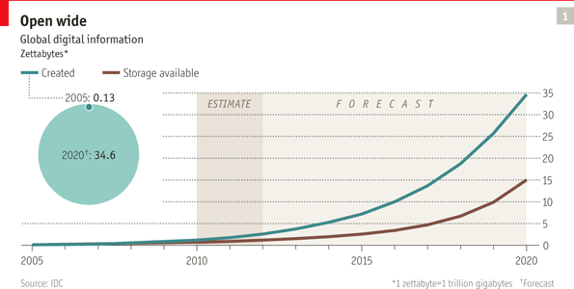

There are several forms of cloud computing:

Consumer sales, storage and syncing across devices – iCloud; iTunes; Kindle

SaaS (Software as a Service) : Salesforce.com for CRM; various HR and ERP

Virtual servers in the Cloud – virtual datacenters

Web Services in the Cloud – real-time and on-demand data management plus Application Programming Interfaces (APIs) for local app creation

**Innovation in China and Everywhere**

Innovation in product and process for the past 20-25 years has been the only sustainable basis for competitive advantage in advanced nations

**Does innovation matter?**

Ask Apple, Blackberry (RIM), Nokia, and Samsung

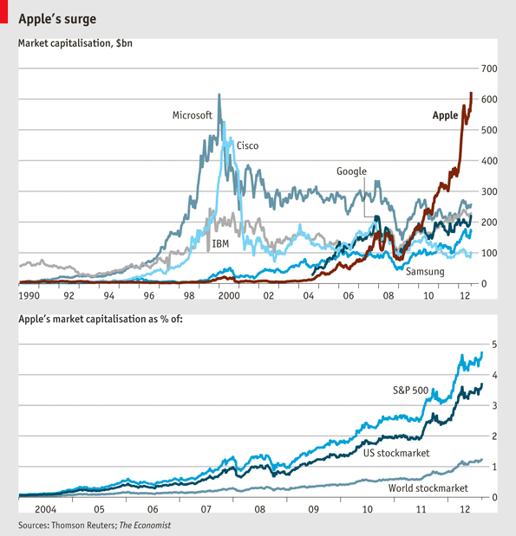

China has adopted an evolving innovation strategy

Capture knowledge and copy

Local innovation

Tencent QQ messaging service

Sina Weibo

Process innovation

Innovation at the global frontier

Telecommunications – Hwawei

Pharmaceuticals

Solar and wind power

High-speed rail

Increasing use of TNC R&D facilities in China – close to customer

Chinese firms must be moving up the innovation ladder to compete in and out of China

Barriers to better Chinese innovation:

* absence of advanced techniques for understanding—analytically, not just intuitively—what customers really want,
* corporate cultures that don’t support risk taking, and
* a scarcity of the sort of internal collaboration that’s essential for developing new ideas.
* Chinese firms lack an international-oriented strategy and management talent for international operations
* Chinese culture of strict rules-based behavior impedes risk-taking and acceptance of failure

**Three examples of innovations in China**

1. General Motors and team-based innovation through trial and error commercialization
2. Astrazeneca and pharmaceutical development
3. Semiconductor innovation - Chinese players have exerted little influence on semiconductor design, technology standards, or chip selection for major product categories such as mobile phones, laptop computers, and LCD televisions. Most decisions about design and functionality come from global champions and reflect the preferences of consumers in Europe, Japan, and the United States. (see semiconductor industry.pdf)

The size of the Chinese market is creating incentives for firms to design for China.

The home governments of leading semiconductor manufacturers have long banned the sale of leading-edge manufacturing technology to China. Current controls by Taiwan and the United States, for example, bar the export of equipment used to make chips below the 65-nanometer threshold. As a result, Chinese manufacturers are at least two generations behind the highest-performing 32-nanometer chips

The Chinese government initially developed 19 centers for semiconductor production, which undermined the capacity for knowledge-sharing. Now they have reduced this to three locations: Chengdu, Dalian, and Shanghai. Cluster and agglomeration effects can boost these efforts.

China has an important model in Taiwan’s success in moving up the semiconductor value chain through building local knowledge capabilities. Major barrier is to break through the IP locked up in global firms. Government strategies for funding knowledge development for breaking into cloud computing, the Internet of Things, and hybrid electric vehicles are significant.

Major struggle between TNCs wanting access to China market and Chinese firms and government seeking knowledge and building Chinese firms.

**Comparing Innovation Environments**

Criteria for comparison (Kaufmann Foundation, 2012)

1. Open and non-discriminatory market access and foreign direct investment policies;

2. Science and R&D policies that spur innovation;

3. Openness to domestic competition and new firm entry;

4. Effective intellectual property rights protection policies;

5. Digital policies enabling the robust deployment of ICT platforms;

6. Open and transparent government procurement policies; and

7. Openness to high-skill immigration.





Some types of innovation

New product or service – iPad

New market for existing product – mobile movies

New combination or bundle of technologies – smart phone (mobile phone + mobile computer)

New business process – fragment supply chain and outsource

New Business Model – sell music through online store @ price per song (ITunes)

New concept - 3D printing

**Terms**

1. Business analytics (predictive analytics) (Business intelligence) (Big data) (Management Information Systems)
2. Datamining
3. GPS
4. Terabyte/Petabyte
5. Cloud Computing
6. Mobile Computing (Apps)
7. 3D Printing
8. Router; WiFi
9. Customer Relationship Management (CRM)
10. Enterprise Resources Planning (ERP)
11. Ubiquitous Computing – Internet of devices
12. Computer Aided Design (CAD); Computer Aided Manufacturing (CAM)